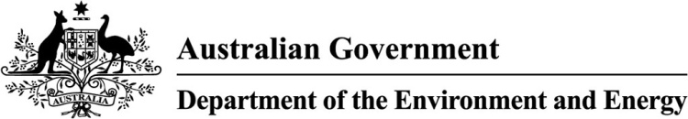

## Product Emissions Standards for outdoor power equipment and marine engines

Operations Plan 2018 to 2021

## Purpose of this Plan

This plan outlines how the Department of the Environment and Energy will support the effective delivery of the product emissions standards for outdoor power equipment and marine engines.

## This plan includes:

* Legislative and regulatory frameworks supporting the emissions standards
* The operational environment the Department works within
* The emissions standards risk profile
* Tools that support staff to deliver the emissions standards
* Governance that guides and oversees the emissions standards
* Timing for delivering the emissions standards

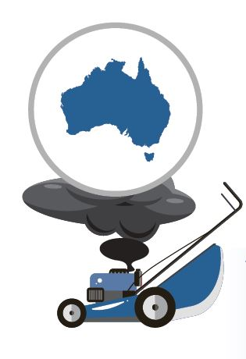

## Our legislative goals

* to set standards to limit and reduce emissions from certain products
* to achieve either or both of the following:
* help maintain and improve air quality, human health and the environment
* assist in giving effect to Australia’s obligations under one or more of the Climate Change Conventions.

## Our objectives

* maintain and improve air quality, human health and the environment by reducing the emissions from outdoor petrol powered equipment and marine engines
* ensure any emission-reduction measures provide for a consistent national approach and are commensurate with international trade requirements and accepted international standards
* ensure that any approach provides a net benefit to the community and meets the objectives of the Australian Government’s regulation reform agenda by minimising the impact and costs on business to the extent possible.

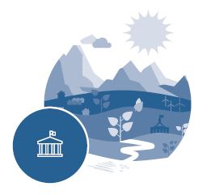The Department strives to be an effective, responsive and trusted regulator.

## Our regulatory principles

* regulatory responses will be consistent, efficient and proportionate to the risk
* decisions and actions will be informed by evidence
* decisions will be fair, reasonable, respectful and reliable
* we will be transparent and accountable for our decisions and actions
* we will monitor, review and report on our effectiveness
* we will continue to improve the way we regulate
* we will engage to listen, learn and respond.

## Our legislative framework

Product Emissions Standards Rules 2017

Product Emissions Standards (Customs) Charges Regulations 2017

Product Emissions Standards (Excise) Charges Regulations 2017

Sets emissions standards for outdoor power equipment and marine engines

Sets the import levies for power equipment and marine engines

Sets the domestic levies for power equipment and marine engines

Allows the Minister to make Rules that sets emissions standards for products and details the administrative arrangements for regulating those products

Allows for a Regulation to be made so that a levy can be imposed on products being imported

Allows for a Regulation to be made so that a levy can be imposed on products domestically manufactured

Allows for a consequential amendment to section 299 of the *Customs Act 1901*

[Product Emissions Standards Act 2017](https://www.legislation.gov.au/Details/C2017A00104)

[Product Emissions Standards (Customs) Charges Act 2017](https://www.legislation.gov.au/Details/C2017A00105)

[*Product Emissions Standards (Excise) Charges Act 2017*](https://www.legislation.gov.au/Details/C2017A00106)

[*Product Emissions Standards (Consequential Provisions) Act 2017*](Product%20Emissions%20Standards%20(Consequential%20Provisions)%20Act%202017)

Allows for a consequential amendment to permanently exempt the Rules from the Trans-Tasman Mutual Recognition Agreement

Trans-Tasman Mutual Recognition Act 1997 (amendment)

## Our operating environment

Consistent & proportionate

Transparent & accountable

Educate, inform & disclose

Evidence-based decisions

Listen, learn & respond

Fair & reasonable

Strive to improve & be trusted

Set the law and make strategic decisions

Set budgets & plan best use of resources

Deliver outcomes & programs

Make connection with similar areas

Seek guidance & share ideas

Undertake corporate reporting

Provide opportunities for staff

Fairness and certainty

Opportunity to add value

Access to exemptions

Access to Australian certification

Education on how to comply

Opportunity to provide intelligence

Effectively administer the law

Capture & share knowledge

Responsive sole regulator

Low burden & efficient

Capable, adaptive & valued

Set a clear agenda for our operations

Communicate with our regulated entities

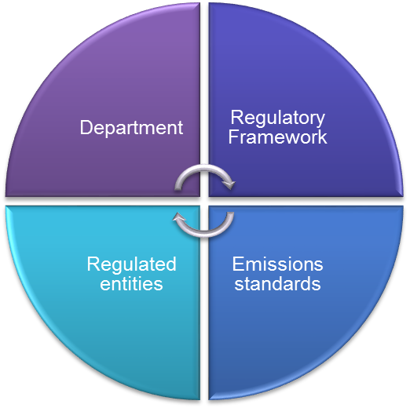

Other stakeholders including community, end-users and Customs Brokers

## We take a risk-based approach

The Department takes a risk-based approach to managing the emissions standards. Our response will be proportionate to risk, severity and attitude. We will look for ways to reduce regulatory burden and focus our efforts on education and awareness raising to help our regulated entities understand their obligations.

Product Emissions Standards Act risk

Product Emissions Standards Act risk

Apply penalties

Assist, help and educate

Maintain awareness and reward

good compliance

Apply

force of law

Regulated entity attitude and behaviour

Risk of harm

High risk to environment sector

* the regulatory arrangement is streamlined and draws on international best practice.
* the Department is the sole regulator and works in partnership with the Department of Home Affairs to identify importers.
* responsible industry are willing to comply and are engaged in the design and delivery of the emissions standards.
* focus on ongoing awareness and education will support compliance.
* products are identified at the border at a regular frequency.
* emissions standards and labelling makes it easy to identify which products are allowed and which are not.
* the Department is committed to continuous monitoring and improvement.

## Tools that help us

Communication

Information Technology & Data

Compliance

Financial management

Risk assessment & management

Workforce planning

Operational monitoring, evaluation & reporting

Approach, objectives & timeframes for communicating what is happening related to the emissions standards

Activities are coherent, consistent & proportionate with clearly defined roles and focussed on education & awareness raising

IT systems which support operations, assessment & analysis

Accountability and transparency in how we recover costs and how expenditure directly relates to managing the standard

Understanding and managing uncertainty to ensure the emissions standards

achieves its objectives

Effective monitoring, evaluation and reporting on performance of the emissions standards operations

while promoting continuous improvement

Getting the right people with the right capabilities in the right place at the right time

**Risk-based approach**

**Governance**

## Delivering the emissions standards

2018

2019

2020

Monitoring, evaluation &

Reporting activities

2021

Import prohibition

Supply prohibition

2025

Entities can apply for Australian certification or exemption

Notice of liability and levy invoice

© Commonwealth of Australia, 2018.

This fact sheet is licensed by Commonwealth of Australia under a Creative Commons Attribution 4.0 International licence.

The views and opinions expressed in this publication are those of the authors and do not necessarily reflect those of the Australian Government or the Minister for the Environment and Energy.