**Plant Health Committee Communiqué—PHC65**

The Plant Health Committee (PHC) held its 65th meeting (in Melbourne) from 2-4 July 2024. The meeting was chaired by Dr Nick Secomb. This document provides an overview of the key topics discussed, and any relevant associated outcomes that were agreed during the meeting.

PHC welcomed to their first meeting, the new Tasmanian Chief Plant Health Officer (Susanna Driessen) who had just commenced in the role, as well as the new Plant Biosecurity Preparedness Working Group (PBPWG) Coordinator (Lana Russell), and new Subcommittee on Plant Health Diagnostics (SPHD) Chair (Kath De Boer). PHC took the opportunity to thank both Juliane Henderson (outgoing SPHD Chair) and Suzy Perry (outgoing PBPWG Coordinator) for their significant contributions and efforts in these vital leadership roles.

Stakeholders may be interested in some of the following meeting topics and can reach out to the PHC secretariat - [PHC@aff.gov.au](mailto:PHC@aff.gov.au) – for additional information.

|  |  |
| --- | --- |
| **Fruit Fly**  **Fruit Fly System audit outcomes**  The Department of Agriculture, Fisheries and Forestry (DAFF) has been conducting fruit fly management system audits on states and territories over the last 24 months (2022-2024). The first series of audits have now been completed and have highlighted the robust fruit fly management systems that jurisdictions have in place.  At the meeting, DAFF presented an overview of the audit process and outcomes, learnings, benefits and recommendations for improvement.  PHC agreed to the Fruit fly management system audit schedule series two commencing in September 2024. | Fruit flies on an orange  Stock image: flies on fruit  Australia’s Fruit Fly Technical Advisory Subcommittee (AFFTAC) is currently progressing updates to the Fruit Fly Protocol Operations Standard No.1 PFAs (Performance Standard and Audit Guideline) to capture feedback and learnings from the first series of audits. Revised documents will be provided to PHC endorsement. |

|  |  |
| --- | --- |
|  |  |
| **Market access and risk assessment**  **Review of SMART’s Varroa destructor movement controls & process.**  PHC were updated on the task to ‘Develop a rapid risk assessment and domestic movement/entry conditions for Varroa mite (*Varroa destructor)*’. Domestic movement conditions for whole hives, supers and stickies and bee products and equipment were finalized with conditions for Queens pending. Importantly, PHC agreed to review their jurisdiction’s movement controls and amend if required.  **Update on Commission Phytosanitary Measures (CPM-18)**  PHC noted the update on the eighteenth meeting of the International Plant Protection Convention (IPPC) Commission on Phytosanitary Measures (CPM). Discussion included:   * the experience of attending the IPPC meeting * the challenges and benefits of Australia’s participation * the importance of having Australian representatives on IPPC committees and panels.   **Update on Draft International Standards for Phytosanitary Measures (ISPMs) - out for consultation**  This item outlined the international standards currently out for consultation, highlighting which may be of interest and relevance to PHC and its subcommittees (e.g. pest risk analysis, surveillance, and phytosanitary certificates). The Commonwealth highlighted the requirement that contracting parties (i.e. Australia) implement adopted ISPMs. They also highlighted that ISPMs can impact and influence Australian domestic policy, so awareness of ISPM texts is important from both an Australian government and state/territory government perspective.  Members were requested to review and provide feedback where applicable. The Commonwealth emphasised the importance of Australia providing comments to ensure specifications are relevant and appropriate to support consistent global implementation of the Convention and ISPMs. The deadline for providing feedback to the IPPC contact point is 16 August 2024. | **Two bees inside a hive working on a comb**  Stock image: bees in hive  **eCert for imports and domestic border clearance**  DAFF presented an item on ePhyto (Electronic Certification Systems). ePhyto is the data exchange of Phytosanitary certifications from one International National Plant Protection Organization (NPPO) to another, and there is a transition to paperless certification (eCerts) for international trade.  DAFF has built a system called EVE to verify eCerts and plans to phase out paper certificates for international import trade. This means that DAFF Accredited persons and state and territory authorities will no longer have access to paper certificates for clearance/assessments of imported goods from selective overseas markets.  The benefits of eCerts, such as faster clearance, reduced fraud, and improved data exchange, were highlighted. From September 2024 the first import markets will move to paperless. |

|  |  |
| --- | --- |
|  |  |
| **Surveillance**  **Surveillance systems and their interoperability**  The Chair of the Subcommittee for National Plant Health Surveillance (SNPHS) provided a presentation on AUSPestCheck and data systems. The presentation included a framework of how each system fits together (e.g. biosecurity system, biosecurity infrastructure and supporting elements).  It was noted that the framework provides a good summary of systems however it needed to be updated to include other ‘data’ systems. PHC agreed to re-establish the Systems Working Group (under SNPHS) to review national operational needs and requirements for information systems.  **National Plant Health Surveillance Program (NPHSP) – Progress, Issues, Future**  The Commonwealth presented this item, noting that the NPHSP is due to end in June 2025. A third-party provider will be engaged to undertake an evaluation of the NPHSP in consultation with state and territory government agencies who provide the operational delivery of the program.  The program remains an important part of the national biosecurity system and is the key tool for early detection of incursions and in which DAFF collects national surveillance data to support trade. Despite significant improvements throughout the life of the program, issues around data quality, consistency and data standards still exist. Members agreed to prioritise NPHSP data management, with a focus on data quality and timeliness of submission to the national collation platform (AUSPestCheck). | **Tree trunk and a hand holding a clipboard**  Stock image: tree inspection  **Future national bee pest surveillance program**  Plant Health Australia (PHA) presented a paper on the future of the National Bee Pest Surveillance Program, which is a government-industry partnership that monitors for exotic bee pests and diseases and exotic pest bees.  Current funding is due to end in December 2024, and PHA provided options for future arrangements. PHC endorsed PHA undertaking further program design for Bee Watch, including exploration of implementation and funding needs. PHA will conduct further consultation with stakeholders in the coming months. |

|  |  |
| --- | --- |
|  |  |
| **Industry and Engagement**  **Plant Industries Biosecurity Committee (PIBC) report**  John McDonald (Chair of the PIBC) attended the meeting to highlight some topics of importance to industry. It was noted that current Red Imported Fire Ant Pest Risk Analysis (PRA) task currently underway is of vital importance to complete.  Also raised was the value of continuing to engage industry in PRA processes (with Guava Root Knot Nematode and Varroa mite cited as examples of where this had happened), and the importance of continued regular communication between PHC and industry on national plant biosecurity issues.  **PIBC industry paper – Huanglongbing (Citrus greening)**  John McDonald (Chair of the PIBC) highlighted the level of concern within industry in relation to this pest and that industry is seeking to take a proactive approach in preparing for any incursion. This pest is number one priority for the citrus industry.  The paper was seeking a partnership between industry and government to develop an Asiatic citrus psyllid/Huanglongbing Response Strategy. PHC endorsed the formation of a government-industry working group to undertake this work.  PHC also approved the Asiatic citrus psyllid as a target for biological control, in accordance with [*Revised guidelines for the introduction of exotic biological control agents for the control of weeds and plant pests*](https://www.agriculture.gov.au/sites/default/files/documents/revised-guidelines-august-2022.pdf). It was noted that as it can take a while to compile the required research and data to support biological control assessments the sooner this is (pre-emptively) commenced the better. Members and observers commended industry for their focus on preparedness in this context. | **Two people standing in front of a projector screen**  Photo: PHC members in workshop  **Plant Biosecurity Research Initiative (PBRI) and PHC workshop**  PBRI Director Jo Luck, joined PHC members and observers for a workshopping session. The focus of the session was to identify priority research themes or initiatives, which may promote and instigate further collaboration between the two groups.  The session focused around four key areas:   * Early warning and risk * Readiness and recovery * Diagnostics and surveillance * Resilient crop protection systems   The outputs from this session where collated into a document for the PHC Deputy Chair to present at an upcoming PBRI forum. It is intended that PHC nominate a representative to progress the shared priority initiative. |

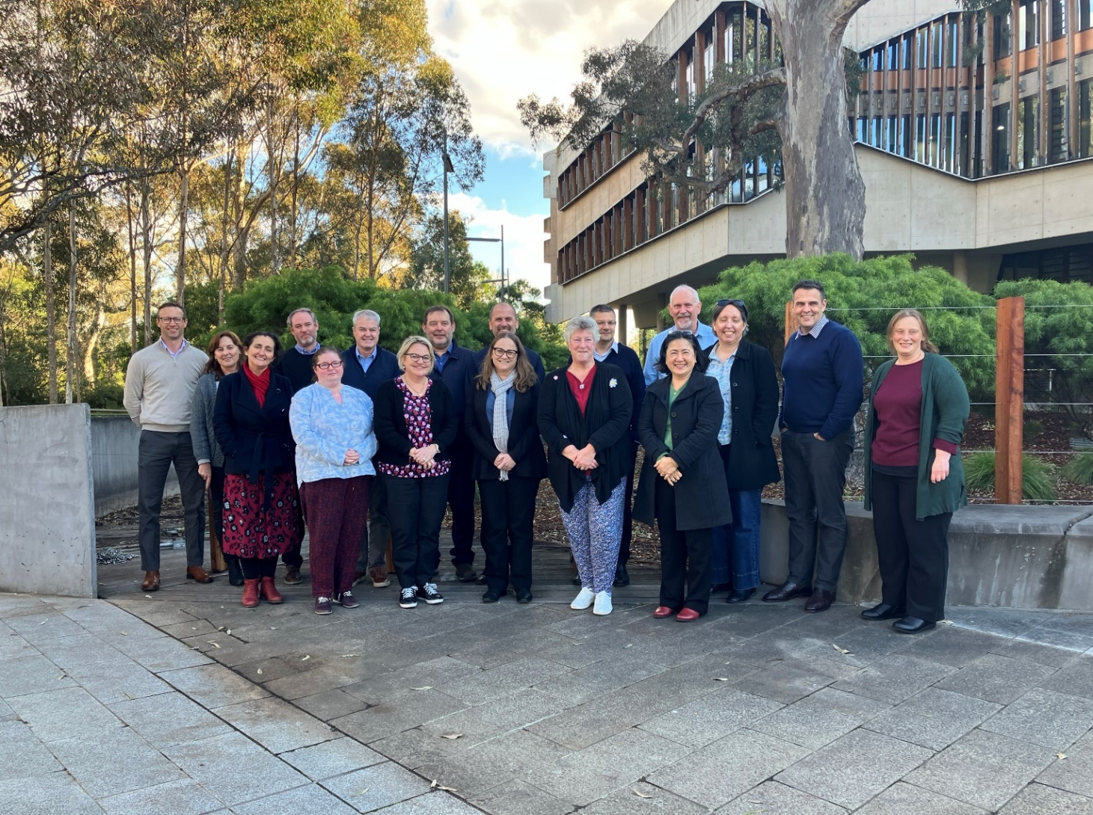

PHC65 group photo (PHC members and observers)

**Who are we?**

[Plant Health Committee](https://www.agriculture.gov.au/agriculture-land/plant/health/committees/phc) (PHC) is Australia’s national peak government plant biosecurity policy and decision-making forum. Members of the committee include Chief Plant Health Managers (or equivalent) in each state and territory, the Australian Chief Plant Protection Officer and invited observers and technical experts. The role of PHC is to develop strategic policy, provide technical and regulatory advice and national leadership on plant biosecurity matters to help maintain and improve plant health in Australia. PHC has a shared purpose to protect our industries, the economy, and our unique environment.

Members contribute to the development of national plant health policy, capacity and capability in Australia by representing their governments on plant health issues and bringing a whole-of-government position to the Committee. To achieve this, the Committee meet on a regular basis to discuss issues, deliberate on presented items and make decisions regarding aspects of the biosecurity system, including:

|  |  |
| --- | --- |
| Plant biosecurity preparednessInterstate tradeEngagement and communicationsSurveillance | Systems and processesDiagnosticsFruit flyFuture focused initiatives |

PHC will next convene for a ‘virtual’ intersessional meeting in September 2024. The next face-to-face meeting (PHC 66) is scheduled for 2-4 December 2024. The Secretariat circulate a call for agenda items to Members and Observers eight weeks prior to the meeting date. All proposals should be supported in the first instance by a PHC Member or the PHC Chair or relate to a standing item. To discuss items for consideration please contact the [PHCExecutiveOfficer@aff.gov.au](mailto:PHCExecutiveOfficer@aff.gov.au) or PHC Secretariat - [PHC@aff.gov.au.](mailto:PHC@aff.gov.au.) Agenda items may include papers, presentations or workshopping items. All papers are due three weeks prior to the meeting date.

|  |  |  |  |
| --- | --- | --- | --- |
| C/o PHC Secretariat  Email: [phc@aff.gov.au](mailto:phc@aff.gov.au) | Australian Government Department of Agriculture | GPO Box 858  Canberra ACT 2601 | [www.agriculture.gov.au](http://www.agriculture.gov.au) |