**Plant Health Committee Communiqué—PHC66**

The Plant Health Committee (PHC) held its 66th meeting (Canberra) from 2-4 December 2024. The meeting was Chaired by Nick Secomb (South Australia). This document provides an overview of the key topics discussed, and any relevant associated outcomes that were agreed during the meeting.

Stakeholders may be interested in some of the following meeting topics and can reach out to the PHC Secretariat – PHC@aff.gov.au – for additional information.

|  |  |
| --- | --- |
| **National policy and preparedness** Review of the Pest Freedom Programs and Regulated Non-Quarantine Pest Policies The Commonwealth Department of Agriculture, Fisheries and Forestry (DAFF) is developing several national plant health policies to guide the Australian Government, state and territory governments, and industry stakeholders. Plant Health Committee agreed for jurisdictions to be consulted to review the National Pest Freedom Programs and the Regulated Non-Quarantine Pest (RNQP) Policy packages. This review is now complete.  **Review of the National Priority Plant Pests**  The National Priority Plant Pests (NPPP) list, established in 2016, supports focus on enhancing national preparedness for significant exotic pests and diseases. In 2024 a review of the list was undertaken by DAFF in collaboration with state/territory representatives. A revised list was presented to and agreed by PHC [National Priority Plant Pests (2024) - DAFF](https://www.agriculture.gov.au/biosecurity-trade/pests-diseases-weeds/plant/national-priority-plant-pests#list). | Image of mottled timber  *Infected timber. Source: DAFF* National action plan for tree and timber pests PHC endorsed the *National Action Plan for Pests of Timber and Trees* and its associated Implementation Schedule, available on the DAFF website; [National action plans for priority plant pests - DAFF (agriculture.gov.au)](https://www.agriculture.gov.au/biosecurity-trade/pests-diseases-weeds/plant/national-action-plans). National Action Plans are a strategic collaboration tool for NPPP preparedness. Through co-identifying projects to improve preparedness, governments, industry and researchers can work together to co-invest in their implementation. |

|  |  |
| --- | --- |
| **Domestic trade** |  |
| **Electronic Plant Health Assurance Certificate (ePHAC)**  The development of an electronic Plant Health Assurance Certificate system (ePHAC) is occurring against a backdrop of a broader review of the Interstate Certification Assurance (ICA) scheme, as well as the potential opportunities for third party certification and accreditation services being posited.  PHC discussed learnings from the ePHAC Market Research report that could inform enhancements around the digital issuance of Plant Health Assurance Certificates as part of the ICA Scheme. Investigating a national ePHAC system remains a priority on the PHC workplan. Endorsement of the Official Control Policy PHC reviewed and endorsed the revised official control policy package drafted by DAFF in consultation with jurisdictions through SMART.  Official control of a pest allows the Australian Government to regulate the pest at Australia’s international border in order to prevent its entry into the country and minimise or avoid phytosanitary requirements for export of plants from areas where the pest is absent. A nationally agreed, updated policy will strengthen domestic biosecurity, trade and further align Australia’s plant health system with international standards and obligations. | Rows of grape vines  *Rows of grapes and vines. Source DAFF*  **CSIRO Safe Trade Project**  The Safe Trade project aims to maintain strong links with national biosecurity stakeholders and governance mechanisms to optimise its capacity to contribute to transformational improvements to the way trade-related plant biosecurity risks are managed within Australia. Proactive communication between PHC and Safe Trade project partners is essential to support this aim.  PHC discussed with the project co-leads progress achieved through Safe Trade this year. PHC provided feedback and advice on two key project activity areas: the preparation of a guideline for developing and implementing low pest prevalence sites as a pathway for inter-state market access, and the co-development with key stakeholders of a vision and roadmap for a modernised domestic biosecurity-trade system. |

|  |  |
| --- | --- |
| Progressing a Nationally Integrated Surveillance System for Plant Pests (NISSPP) The NISSPP project funded by DAFF commenced in April 2022 and concluded in July 2024. This project sought to: (a) Develop a model or models for a NISSPP. (b) Consult with key stakeholders from governments and plant industries on necessary reforms needed for the establishment of a NISSPP. (c) Determine requirements for a phased approach for implementation of reforms to increase the efficiency and efficacy of detecting high priority plant pests to improve eradication, containment or management outcomes. PHC agreed to the Implementation Plan for a NISSPP. Additionally, PHC acknowledged significant efforts being made across both governments and plant industries to develop and support national surveillance activities, however they also noted there is a need for improved mechanisms for shared input into decision-making, resourcing and delivery. | Brown Marmorated Stink Bugs  *Hitchhiker pests: Brown marmorated stink bugs. Source: DAFF*  **Updated PFA Performance Standard (Australia’s National Fruit Fly Management Protocol**  The committee endorsed the updated Performance Standard for fruit fly management system audits. The new standard provides additional information, removes ambiguity and better aligns audit requirements with impacts. |

|  |  |
| --- | --- |
| **Stakeholder and industry engagement** National Priority Plant Pests (NPPP) Repository of Information In 2019–2021, DAFF funded a 2-year project undertaken by Agriculture Victoria titled ‘Streamlining plant pest contingency plans for integration Stage 2’. PHC discussed a future rebrand of the Contingency Planning Portal to the NPPP Resource Portal, noting development of a governance policy through consultation with government and non-governmental stakeholders as the first step. Northern Australian People Capacity and Response Network (NAPCaRN). The NAPCaRN program, which commenced in 2023 includes expert positions, community engagement officers, leadership training, monthly leadership events, a mentoring program, an annual | roundtable, a board internship program to increase diversity of boards/committees, scenario planning, and incident response training. Darren Peck (NAPCaRN Chair) provided the Committee with an update on the NAPCaRN Network and an overview of the recent Roundtable and Industry Toolbox Sessions, which aim to build capacity and capability and opportunities for networking and collaboration. Future plans for the program were outlined, including First Nations Internships, Regional Traineeships and Early Career Veterinarian positions. |

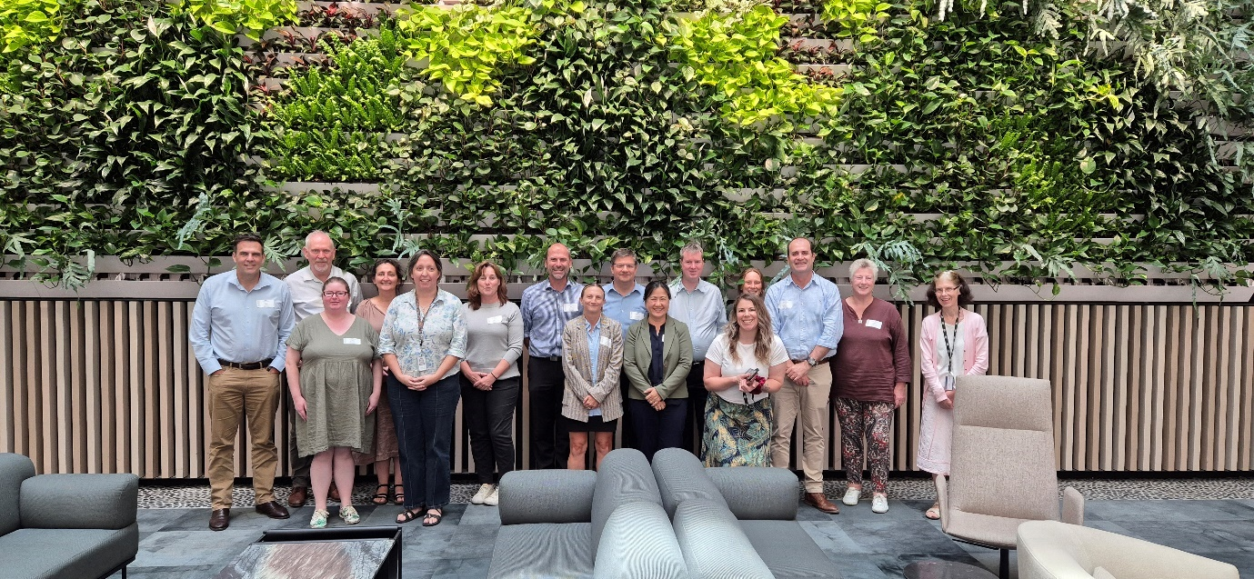

PHC66 group photo (PHC members and observers)

*Note: Some members and observers are not in the photo as they attended the meeting virtually.*

**Who are we?**

The Plant Health Committee (PHC) is Australia’s national peak government plant biosecurity policy and decision-making forum. Members of the committee include Chief Plant Health Managers (or equivalent) in each state and territory, the Australian Chief Plant Protection Officer and invited observers and technical experts. The role of the PHC is to develop strategic policy, provide technical and regulatory advice and national leadership on plant biosecurity matters to help maintain and improve plant health in Australia. The PHC has a shared purpose to protect our industries, the economy and our unique environment.

Members contribute to the development of national plant health policy, capacity and capability in Australia by representing their governments on plant health issues and bringing a whole-of-government position to the Committee. To achieve this, the Committee meet on a regular basis to discuss issues, deliberate on presented items and make decisions regarding aspects of the biosecurity system, including:

|  |  |
| --- | --- |
| Plant biosecurity preparednessInterstate tradeEngagement and communicationsSurveillance | Systems and processesDiagnosticsFruit flyFuture focused initiatives |

The next face-to-face meeting (PHC67) is scheduled for 1-3 July 2025. The Secretariat circulate a call for agenda items to Members and Observers eight weeks prior to the meeting date. All proposals should be supported in the first instance by a PHC Member or the PHC Chair or relate to a standing item. To discuss items for consideration please contact the [PHCExecutiveOfficer@aff.gov.au](mailto:PHCExecutiveOfficer@aff.gov.au) or PHC Secretariat - [PHC@aff.gov.au](mailto:PHC@aff.gov.au). Agenda items may include papers, presentations or workshopping items. All papers are due three weeks prior to the meeting date.’

|  |  |  |  |
| --- | --- | --- | --- |
| C/o PHC Secretariat  Email: phc@aff.gov.au | Australian Government Department of Agriculture | GPO Box 858  Canberra ACT 2601 | www.agriculture.gov.au |