Plant Health Committee Communiqué—PHC67

On the 1-3 July 2025, the Plant Health Committee (PHC) held its 67th meeting in Tasmania. This document provides an overview of the key topics discussed, and relevant associated outcomes that were agreed during the meeting.
Stakeholders who are interested in further details on specific agenda items can contact the PHC Secretariat at PHC@aff.gov.au.

National policy and preparedness  Approval for Wider Consultation of the Pest Freedom and the Regulated Non-Quarantine Pest (RNQP) Policies  The Commonwealth Department of Agriculture, Fisheries and Forestry (DAFF) has developed the Pest Freedom Policy package to establish a national framework for implementing internationally recognised pest management standards. Following a positive consultation process among government agencies. PHC endorsed the revised draft Pest Freedom Programs, Pest Absence National Policy, and Regulated Non-Quarantine Pest (RNQP) National Policy for broader public and industry consultation. These national policies aim to enhance Australia’s biosecurity system, support trade, and align with international plant health standards and obligations.  Varroa mite Transition to Management (T2M)  The Transition to Management (T2M) program for varroa mite is set to conclude in early 2026. | 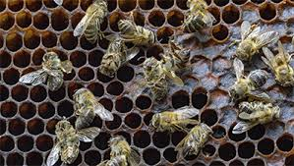Bees destroyed by Varroa mites. Source DAFF  Members were updated on the T2M program and discussed government actions needed to support a successful transition to long-term management by industry and communities now that varroa mite is established in Australia. Discussion focused on the importance of supporting landholders and the community to manage established pests and diseases.  The Committee endorsed the updated Australian Honey Bee Industry Biosecurity Code of Practice and Biosecurity Manual for Beekeepers, which reflects the current biosecurity landscape.

Domestic trade
Safe Trade project update  The four-year Safe Trade project is a partnership between CSIRO, all Australian governments, and the horticulture industry. The project aims to support a transformational improvement in the way trade-related plant biosecurity risks are managed in Australia. The project will enable a set of innovative scientific methods and models to be co-developed by CSIRO and project partners to inform risk management decision making and enable new ways of using data to enhance biosecurity.  At PHC67, the Committee discussed updates with project co-leads, including the revised Risk Management Reform workplan, development of a Pest Risk Analysis tool to support consistent interstate entry conditions, and market access guidelines for low pest prevalence sites. | 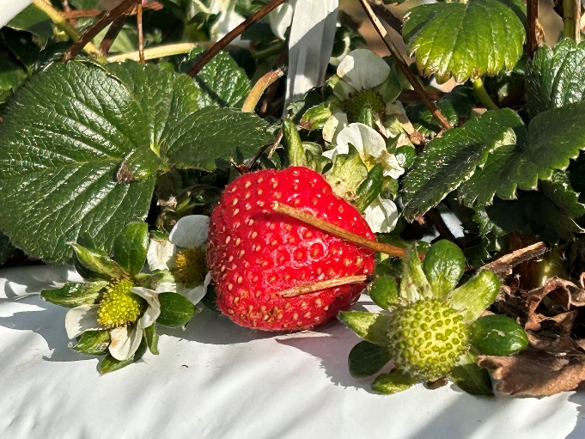  Strawberry plant in a farm. Photo credit: Morag Donaldson (DAFF)  PHC continue to actively support the project and agreed to maintain proactive engagement with the Safe Trade team to align the project with national strategic priorities.

Diagnostics and surveillance  Update on the Australian Plant Pest Database (APPD) and the Pest and Disease Image Library (PaDIL)  The APPD is an important national database that collates information from major Australian reference collections of relevance to plant biosecurity. The PaDIL is a repository of high-quality diagnostic images and tools that assist users in the identification of pests and diseases. The Committee noted the development of strategic road maps to guide national activities and investment to ensure both systems are fit for purpose and meet the needs of the plant biosecurity sector.  The APPD and PaDIL are significant assets to the national biosecurity system, enhancing our diagnostics and surveillance data capabilities. | 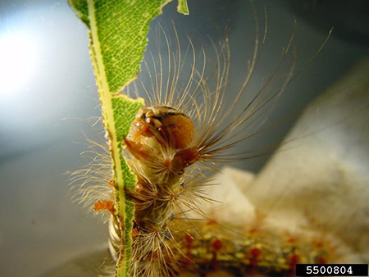  Spongy moth (Lymantria dispar). Source DAFF  Both APPD and PaDIL are supported by a five-year government cost-shared funding arrangement until July 2028.

Stakeholder and industry engagement  Strengthening Stakeholder Engagement in Biosecurity: Insights from PHC67  During the PHC67 field trip to Hobart, Tasmania, the PHC engaged directly with key industry stakeholders to deepen its understanding of the biosecurity challenges faced by growers and to explore more effective avenues for regulatory collaboration. Facilitated by the Department of Natural Resources and Environment Tasmania (NRE-TAS), PHC met with representatives from Fruit Growers Tasmania, Wine Tasmania, and several prominent farms including Pinata Farms, Pooley Wines, Sisu Wines, and Cherries Tasmania Orchards.  Discussions revealed systemic gaps in regulation and enforcement, unclear biosecurity roles, and a perception that biosecurity is solely a government responsibility. These issues contribute to limited industry ownership and engagement. Growers also raised concerns about increasing pest and disease pressures such as thrips, powdery mildew, codling moths, crown gall, and viruses. There is a strong call for improved early detection and containment strategies that do not rely heavily on chemical interventions. | 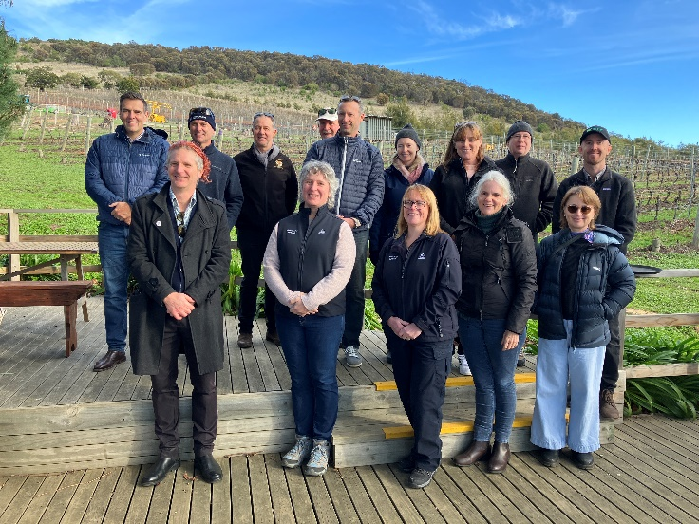  PHC visit to Pooley Wines – Tasmania. Photo Credit Alex Fulton (DAFF)  Stakeholders expressed a desire for clearer communication, more inclusive engagement, and less bureaucratic approaches to biosecurity. The potential loss of Tasmania’s Pest Freedom Area status due to pest incursions was highlighted as a major risk to market access. The PHC recognised the importance of fostering genuine partnerships with industry stakeholders, promoting shared responsibility, and reviewing regulatory frameworks to support traceability and better management of biosecurity.

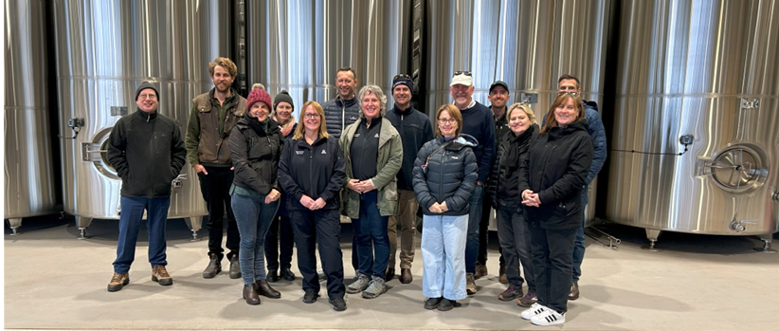
PHC67 group photo (PHC members and observers during an industry visit in Tasmania. Other members and observers
were present for the meeting online)
Who are we?
The Plant Health Committee (PHC) is Australia’s national peak government plant biosecurity policy and decision-making forum. Members of the committee include Chief Plant Health Managers (or equivalent) in each state and territory, the Australian Chief Plant Protection Officer and invited observers and technical experts. The role of the PHC is to develop strategic policy, provide technical and regulatory advice and national leadership on plant biosecurity matters to help maintain and improve plant health in Australia. The PHC has a shared purpose to protect our industries, the economy and our unique environment.

The Committee make decisions regarding aspects of the biosecurity system, including:

Plant biosecurity preparedness  Interstate trade  Engagement and communications  Surveillance | Systems and processes  Diagnostics  Fruit fly  Future focused initiatives

The PHC will next convene for a virtual intersessional meeting on 16 September 2025. The next face-to-face meeting (PHC 68) is scheduled for 2-4 December 2025. Please contact the PHC secretariat at PHC@aff.gov.au for more information.

C/o PHC Secretariat  Email: phc@aff.gov.au | Australian Government Department of Agriculture | GPO Box 858  Canberra ACT 2601 | www.agriculture.gov.au

