Planning and Delivering

Water for the Environment

The Australian Government owns entitlements to water in the Murray-Darling Basin. This water is used to keep our rivers healthy, so they continue to support communities for future generations.

The Commonwealth Environmental Water Office (CEWO) manages this *water for the environment*.

Every year is different. The amount of water available changes from year to year and we adjust our plans accordingly.

We follow an annual cycle of ‘*plan, deliver, measure and review’* to manage water for the environment.

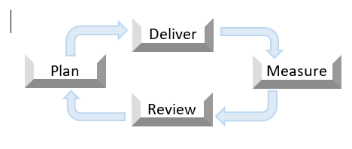

Working together to deliver water

Managing water for the environment involves careful planning among many different people and organisations.

We work closely with local communities, First Nations peoples, water managers, scientists, river operators and landholders to plan our water use.

Local knowledge is key to getting the best possible results – helping to prioritise what needs to be watered each year, river by river, wetland by wetland.

Planning for what the environment needs

Our water use planning starts long before the water starts flowing. We match supply with demand by comparing how much water we are likely to have with what the environment needs.

We plan to achieve specific outcomes with water for the environment, from giving native plants a drink, to providing wildlife refuge during drought, or helping native birds, fish and frogs breed. We may target a specific site, or multiple sites along a river.

We prepare a *Water Management Plan* each year which considers:

• how much water is expected to be available

• the seasonal rainfall outlook, and

• plant, animal, river and wetland health.

Our *Water Management Plan* scopes options for a range of weather scenarios (from dry to wet) so we can adapt to the seasonal conditions. We also take into account:

* the needs of communities and irrigators
* physical limitations of the river
* lessons learned from monitoring the response of plants and animals to previous environmental flows, and
* the Basin Plan annual and long-term objectives.

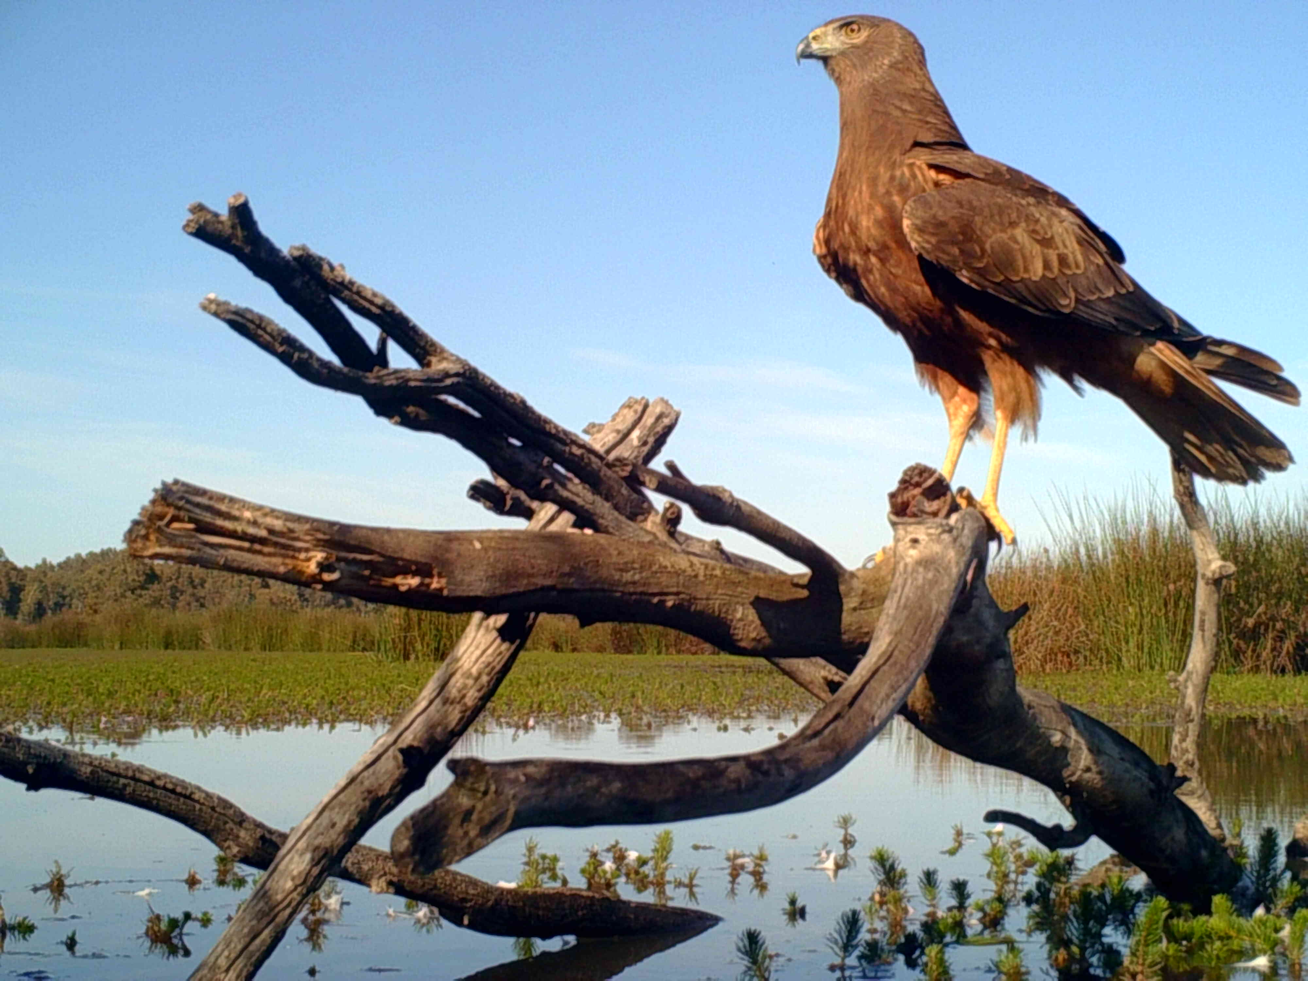

*Swamp Harrier, Barmah Forest. Photo: GBCMA*

Delivering water to the environment

State governments allocate water to entitlement holders throughout the year. This determines how much water we have available to use. We work closely with advisory groups and our delivery partners, local and state water managers, to supply water against the options scoped in our *Water Management Plan*. Our water delivery is coordinated alongside water for the environment managed by state governments.

As well as delivering water to sites (such as wetlands, creeks or whole river systems), we may consider other water management tools to maximise benefits to the environment, such as *carryover* and in limited circumstances, *trade*.

Carryover is when a portion of water is set aside in dams or storages to be used the following year (e.g. in winter/early spring), when the environment most needs it but allocations are typically low.

*Planning water use on the Lachlan River (photo: CEWO)*

Measuring results and reviewing for next year

Monitoring and evaluation are crucial tools to help us best manage water to improve the health of our rivers.

Scientists from Australia’s leading research institutions work with local communities to help us understand how plants and animals respond to water for the environment.

They measure the impact the water is having on rivers, wetlands and floodplains and share their findings with water managers to inform future decision making.

For more information about how science underpins our water management, visit the Flow-MER website [flow-mer.org.au](http://www.flow-mer.org.au/)

Working with First Nations

Traditional knowledge has been used to manage water and Country for many thousands of years.

We recognise the values and knowledge of First Nations peoples in how we use water for the environment. We are committed to continuously

improving how we work with First Nations

across the Basin.

Our Water Management Plan includes objectives for water for the environment identified by First Nations representatives.

Get involved – Contact our Local Engagement Officers

We have Local Engagement Officers across the Basin in Moree, Walgett, Griffith, Albury, Mildura and Berri.

Individuals and groups are encouraged to get in touch with their nearest Local Engagement Officer to submit suggestions for how we use water for the environment.

Website: [www.environment.gov.au/water/cewo](http://www.environment.gov.au/water/cewo)

Email: [ewater@awe.gov.au](mailto:ewater@awe.gov.au)

Twitter: @theCEWH