Carbon + Biodiversity Pilot

Planting Protocol: Northern Tasmania NRM Region
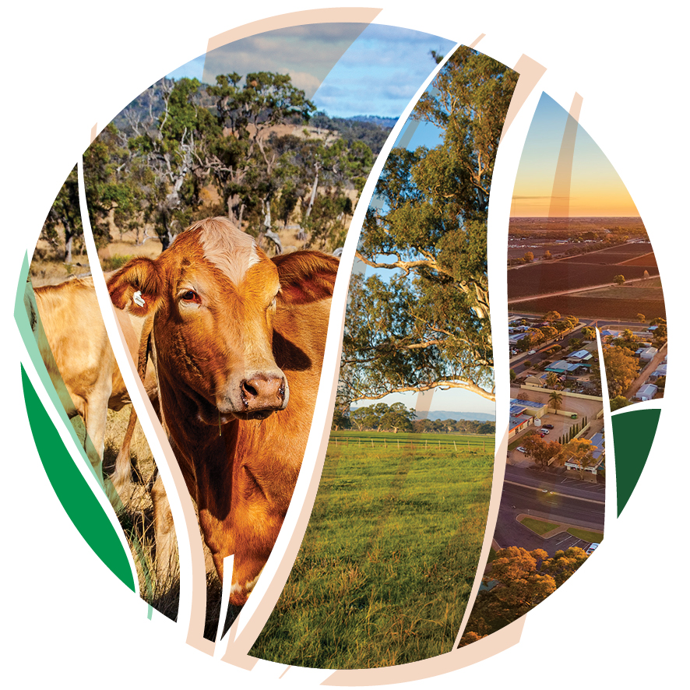
© Commonwealth of Australia 2021
Ownership of intellectual property rights
Unless otherwise noted, copyright (and any other intellectual property rights) in this publication is owned by the Commonwealth of Australia (referred to as the Commonwealth).
Creative Commons licence
All material in this publication is licensed under a Creative Commons Attribution 4.0 International Licence except content supplied by third parties, logos and the Commonwealth Coat of Arms.
Inquiries about the licence and any use of this document should be emailed to copyright@awe.gov.au.

Cataloguing data
This publication (and any material sourced from it) should be attributed as: DAWE 2021, Carbon + Biodiversity Pilot. Planting Protocol: Northern Tasmania NRM Region, Department of Agriculture, Water and the Environment, Canberra, March. CC BY 4.0.
This publication is available at https://www.agriculture.gov.au/ag-farm-food/natural-resources/landcare/sustaining-future-australian-farming/carbon-biodiversity-pilot
Inquiries can be made by email at agstewardship@awe.gov.au.
Department of Agriculture, Water and the Environment
GPO Box 858 Canberra ACT 2601
Telephone 1800 900 090
Web awe.gov.au
Disclaimer
The Australian Government acting through the Department of Agriculture, Water and the Environment has exercised due care and skill in preparing and compiling the information and data in this publication. Notwithstanding, the Department of Agriculture, Water and the Environment, its employees and advisers disclaim all liability, including liability for negligence and for any loss, damage, injury, expense or cost incurred by any person as a result of accessing, using or relying on any of the information or data in this publication to the maximum extent permitted by law.
Acknowledgements
We thank NRM North and Professor Andrew Macintosh, Dr Don Butler, Dr Dean Ansell and Dr Tyrone Lavery from the Australian National University (ANU) for their assistance in preparing this document.

Acknowledgement of Country
We acknowledge the Traditional Owners of Country throughout Australia and their continuing connection to land, sea and community. We pay our respects to them and their cultures and to their elders past, present and emerging.

Contents
Acknowledgement of Country 3
Introduction 5
References 17
Glossary 18
Appendix A: Guidance in identifying the relevant local vegetation communities for your planting 22
Questions and feedback 26

Introduction
This document details the eligibility, design, establishment and maintenance conditions that apply to environmental planting projects under the Carbon + Biodiversity Pilot Program (C+B Pilot). It is intended to complement the program guidelines available on the C+B Pilot website.
The conditions that apply to projects in the Northern Tasmania Natural Resource Management (NRM) region are contained in Tables 1-4 below in the third column, titled ‘C+B Pilot conditions – Northern Tasmania’. The conditions fall into two categories: mandatory (expressed in the tables as ‘must’) and recommended (expressed as ‘should’). All projects must comply with the mandatory conditions. Compliance with the recommended conditions is not mandatory. Words and phrases in italics have defined meanings, which are provided below the first usage of the relevant word or phrase and in the Glossary below the tables.
Further advice on any of the conditions listed here can be obtained from the Department of Agriculture, Water and the Environment, at agstewardship@awe.gov.au.
To assist proponents, relevant requirements that apply to environmental planting projects under the Emissions Reduction Fund (ERF) are provided in the second column, titled ‘Emissions Reduction Fund requirements’. For more information on ERF eligibility visit the Clean Energy Regulator’s website. For information on the environmental plantings method under the ERF click here. You can also contact the Clean Energy Regulator by email at enquiries@cleanenergyregulator.gov.au or by phone on 1300 553 542.
People interested in participating in the C+B Pilot should contact their regional NRM group for advice on the establishment and management of plantings. For Northern Tasmania, your NRM group is:
NRM North
w: https://nrmnorth.org.au/
e: 03 6333 7777
ph: admin@nrmnorth.org.au

Table 1. Eligibility conditions
Consideration | Emissions Reduction Fund requirements | C+B Pilot conditions – Northern Tasmania
Area | Must consist of more than a single row of plantings. | The aggregate area of plantings in a project must be between 5-200 hectares.
Newness and additionality | - The plantings must be new and planting must not commence until the project is registered under the ERF.  - The plantings must not be required to be carried out under a law of the Commonwealth, a State or a Territory.  - The project must not be used to meet a statutory obligation to offset the adverse impacts of another development. | No relevant eligibility conditions.  *In applying to participate in the C+B Pilot, proponents must not include the cost of management actions that are required to be carried out under a law of the Commonwealth or a State or Territory, or are already funded under another Commonwealth, State, Territory or local government environment program.
Land use history | - The planting area must have been clear of forest for at least 5 years.  - The planting area must not contain woody biomass or invasive native scrub that needs to be cleared in order for the planting to occur, other than a known weed species.  - The planting area must not have been previously illegally cleared of native forest, or have contained a wetland that was illegally drained.  - The planting area must not have been legally cleared of native forest, or have contained a wetland that was legally drained, within the previous 7 years (or 5 years if there has been a change of ownership). | No relevant eligibility conditions.
Regulatory approvals | Proponents must obtain all relevant regulatory approvals that are necessary to enable the project to be undertaken.  Regulatory approvals are approvals required under a law of the Commonwealth, a State or a Territory relating to the environment, water or land use and development. | Projects must be able to be registered as an eligible offsets project under the ERF’s Carbon Credits (Carbon Farming Initiative) (Reforestation by Environmental or Mallee Plantings—FullCAM) Methodology Determination 2014.
Consents from other parties | Proponents must obtain the written consent of all eligible interest holders to the registration of the project under the ERF.  Eligible interest holders are people who hold eligible interests in the land on which the project is located.  Eligible interests cover a range of interests held in relation to land, including estates and other registered proprietary interests (e.g. leases, easements and covenants), and mortgages and charges held over the land by a bank, financial institution or other party. | No relevant eligibility conditions.
NRM specific requirements | If the project area is covered by a regional NRM plan, the application for registration under the ERF must be accompanied by a statement about whether the project is consistent with the plan. | No relevant eligibility conditions.

Table 2. Planting design conditions
Consideration | Emissions Reduction Fund requirements | C+B Pilot conditions – Northern Tasmania
Prohibited planting areas | See Table 1, Land use history. | Plantings must not occur in:  - areas that did not naturally support trees and shrubs (e.g. some wetlands, grasslands);  - in ecological communities listed as threatened under relevant State, Territory or Commonwealth legislation (e.g. Natural Temperate Grassland); or  - utility easements.  Utility easements are areas of land that utility providers are legally entitled to use and access for the purposes of providing utility services (e.g. electricity, gas, telecommunications and sewerage).
Plant species composition | Plantings must consist of a mixture of tree and shrub species that:  - are native to the local area of the planting; and  - are sourced from seeds from within the natural distribution of the species and are appropriate to the biophysical characteristics of the area of the planting.  Plantings may be a mix of trees, shrubs, and understorey species that reflect the structure and composition of the local native vegetation community. | Plantings must be either a local vegetation community planting^ or a simple mixed native planting.  A local vegetation community planting is a planting that:  - as far as practical given the planting density, tree proportion and crown cover requirements, reflects the structure and composition of the relevant local vegetation community or communities*; and  - consists of at least two species of trees and four species of shrubs from that vegetation community or those communities.  A simple mixed native planting is a planting that:  - as far as practical given planting density, tree proportion and crown cover requirements, performs similar ecological functions to the relevant local vegetation community or communities and generates benefits for local native biodiversity; and  - consists of at least two species of trees and four species of shrubs that are native to the local area.  ^ Local vegetation community plantings will receive higher biodiversity benefit scores, all else being equal.  *See Appendix A for resources to assist in identification of relevant vegetation communities.  Trees are woody plants that at maturity are generally more than 2m tall and either have a single stem with branches well above the base or, if multi-stemmed from the base (or within 20cm from ground level), their largest stem typically has a diameter greater than 5cm measured 130cm above the ground.  A stem is the ascending axis of a plant and is generally the main structural component of the above-ground portion of trees and shrubs.  Shrubs are woody plants that are:  - generally less than 2m tall if single-stemmed; or  - if multi-stemmed from the base (or within 20cm from ground level), are generally less than 2m tall or, if more than 2m tall, their largest stem typically has a diameter less than 5cm measured 130cm above the ground.  Plantings should include ground cover species where possible. Ground cover plantings must reflect the structure and composition of the local vegetation community.  Ground cover species are herbaceous (non-woody) plants, including grasses and forbs.  Proponents should consider the following with respect to species composition:  - drought resilience and the potential effects of climate change;*  - the availability of tubestock and seed from local nurseries and seed suppliers;  - that a diverse and dense mid-storey provides benefits for native birds; and  - that ground cover plants require effective control of introduced plant species to achieve high survival rates.  *For further information on considering climate change in your plantings see the publication Climate ready revegetation: A guide for natural resource managers available on the web.
Stem density and tree proportion | Plantings must:  - be no more than 5m apart, measured from stem-to-stem; and  - have a stocking density of at least 400 stems per hectare.  *Stocking densities affect the way carbon stocks are modelled. Three model calibrations are available to estimate carbon stocks, which depend on the type of planting and stocking density:  - belt high (high calibration) – must be a belt planting with >1500 stems per hectare;  - belt low (middle calibration) – must be a belt planting with between 400-1500 stems per hectare; and  - block (low calibration) – must be a block planting with ≥400 stems per hectare. | Tree and shrub plantings must:  - be no more than 5m apart, measured from stem-to-stem;  - have a stocking density of at least 400 stems per hectare;  - have a tree proportion of between 50% and 70%;  - be planted such that each 0.2 hectare portion of the planting area has forest potential.  To avoid doubt, groundcover species are not included in stem counts for these purposes.  Tree proportion means the proportion of individual live trees relative to the total of individual live trees and shrubs in a planting.  A 0.2 hectare portion of a planting area has forest potential if the planted trees have the potential to reach 2m or more in height and provide crown cover of at least 20% of the portion.
Dimensions of planting | Plantings can be either belt or block plantings.  - Belt plantings are plantings in a belt configuration that are ≤40m wide, are at least 40m from the nearest other planting (stem-to-stem) and are not affected by material competition from adjacent trees.  - Block plantings are non-belt plantings, other than plantings consisting of a single row. | Individual planting areas must be at least 0.25 hectares (2500m²).  The average width of plantings in a belt configuration must be at least 30m (stem-to-stem) on the short axis of the planting.
Distance from other vegetation, including plantings | The distance to other vegetation determines whether plantings are able to be modelled as belt plantings. Belt plantings must be at least 40m from the nearest other planting (stem-to-stem) and they must not be affected by material competition from adjacent trees. Adjacent trees are trees that lie within 20m of the stems of the closest project tree. There are rules for when adjacent trees are deemed to be causing material competition. | No additional conditions.
Surrounding vegetation in the landscape | No requirement.*  *Proximity to other vegetation affects whether plantings meet the definition of belt plantings and can apply the belt calibrations when modelling abatement. | No additional conditions.
Fire risk | No requirement. | Planting areas:  - must not be within 50m of buildings used for residential or commercial purposes; and  - should not be within 50m of any other buildings.
Regulatory compliance | See Table 1, Regulatory approvals. | Plantings must be sited, established and managed in accordance with all applicable Commonwealth and State laws relating to planning, environment and heritage.*  *Approval may be required under the Forest Practices Act 1985 (Tas) to undertake an environmental planting project.
Workplace health and safety | No requirement. | Proponents should prepare a workplace health and safety plan for their project.
Cultural heritage | No requirement. | In siting, establishing and managing plantings, proponents should consider cultural heritage impacts and follow relevant Commonwealth, State and local guidelines concerning the protection and management of cultural heritage sites. Contact your regional NRM group for further information.

Table 3. Establishment conditions
Consideration | Emissions Reduction Fund requirements | C+B Pilot conditions -Northern Tasmania
Establishment method | Plantings must be established using propagated seedling stock (tubestock) or direct seeding. | No additional conditions
Site preparation – weed control | Not specified. | Where weed control is carried out using herbicides, the herbicides must be applied in accordance with all applicable Commonwealth and State laws and the manufacturer’s instructions.
Site preparation – soil | Not specified. | Soil preparation must not be done by deep-ripping in planting areas with significant biodiversity or natural or cultural heritage values, including areas that contain remnant native vegetation, old native trees, patches of native grass or sites of Indigenous cultural significance.
Site preparation – total grazing pressure | Not specified. | All livestock grazing must be excluded until the tree plantings have become established (approximately 1.5m tall).  Grazing and other significant disturbance by vertebrate pests (e.g. mice, rabbits, goats, deer, pigs) and overabundant native species (including kangaroos) should be managed where they present a threat to the establishment of the site.  Total grazing pressure, including from livestock, vertebrate pests and overabundant native species (including kangaroos) should be managed where they present a threat to the establishment of plants prior to and/or during planting or direct seeding, and be undertaken in a manner that is consistent with applicable Commonwealth, State and local government laws and guidelines.
Timing | Not specified. | No additional requirements.
Tree protection | No requirement.  *Where grazing or another event kills the plantings in ≥5% of the planting area, the proponent is required to notify the Clean Energy Regulator and take actions to mitigate the impacts of the disturbance. This may require the area to be replanted. Proponents will also be required to re-stratify the carbon estimation area. | Plantings should be protected from livestock and other herbivores. If fencing is used:  - the top strand of wire around plantings must not be barbed to reduce the chance of wildlife entanglement; and  - it should be erected prior to planting or direct seeding.
Watering | No requirement. | Proponents should consider watering plantings, particularly tubestock plantings, at the time of establishment.

Table 4. Maintenance
Consideration | Emissions Reduction Fund requirements | C+B Pilot conditions -Northern Tasmania
Longevity | - Plantings must not be harvested other than for ecological purposes.  - Plantings must be maintained for a permanence period of either 25 or 100 years, which commences when the first ACCUs are issued to the project. Proponents get to choose whether to have a 25- or 100-year permanence period. | Plantings must be protected and maintained for the C+B permanence period.  The C+B permanence period means the 25-year period commencing on the day the project is registered under the ERF.
Remedial planting | Replanting may be required if:  - an event kills the plantings in ≥5% of the planting area; or  - mortality results in stem densities falling below 400 stems per hectare. | Throughout the C+B permanence period, each 0.2 hectare portion of the planting area must have either forest potential or forest cover.  Remedial plantings must be established in a planting area if mortality results in a 0.2 hectare portion of a planting area no longer having forest potential or forest cover.  A 0.2 hectare portion of a planting area has forest cover if the planted trees are 2m or more in height and provide crown cover of at least 20% of the portion.  Remedial plantings must be established in a planting area if:  - it was originally designed to reflect the structure and composition of the relevant local vegetation community or communities; and  - mortality results in the planting no longer reflecting the structure and composition of the relevant local vegetation community or communities.  Remedial plantings must be established in a planting area if:  - it was originally designed to perform similar ecological functions to the relevant local vegetation community or communities and generate benefits for local native biodiversity; and  - mortality results in the planting no longer performing similar ecological functions to the relevant local vegetation community or communities and generating benefits for local native biodiversity.
Fallen timber | Up to 10% of fallen timber can be used per calendar year for personal use. Fallen debris can be removed for fire protection. | All fallen timber must be left within the planting. Any fallen timber that is moved from firebreaks, access tracks or fences must be placed within the planting area.
Thinning | Is permitted for ecological purposes, but may affect the method of carbon estimation that is used. | Thinning is not allowed, unless:  - the planting was originally designed to reflect the structure and composition of the relevant local vegetation community or communities and the thinning is necessary to ensure the planting achieves this objective; or  - the planting was originally designed to perform similar ecological functions to the relevant local vegetation community or communities and generate benefits for local native biodiversity and the thinning is necessary to ensure the planting achieves this objective; and  - approval is obtained from the Department of the Agriculture, Water and the Environment before the thinning commences.
Total Grazing Pressure post-establishment | Livestock grazing is permitted if it does not affect forest cover. | Total grazing pressure should be managed where necessary to protect the present and future biodiversity value of the site.  Livestock grazing:  - must not be undertaken until the plantings have become established (approximately 1.5m tall);  - must be limited to pulse or crash grazing; and  - must not be undertaken if it has a material adverse impact on the survival of the plantings.  Management of overabundant native vertebrate species (including kangaroos) should be undertaken only where they present a threat to the establishment and future biodiversity value of the site. Where possible, preventative control measures (e.g. fencing and guards) should be prioritised over lethal control.  All vertebrate pest and overabundant native vertebrate species management must be undertaken consistent with applicable Commonwealth, State and local laws and guidelines.  Fences and other tree protection measures should be well maintained to ensure the exclusion of livestock and other overabundant native vertebrates.
Invertebrate pest control | No requirement. | Invertebrate pests should be managed where necessary to protect the present and future biodiversity value of the site.  Where pest control is carried out using pesticides, the pesticides must be applied in accordance with all applicable Commonwealth and State laws and the manufacturer’s instructions.
Fire | No requirement.  Prescribed burning is permitted but the greenhouse gas emissions from these burns must be accounted for and if it kills the plantings, steps must be taken to mitigate the impacts (this may include replanting). | Fire must not be intentionally introduced to the planting.
Watering |  | Proponents should consider watering plantings, particularly tubestock plantings, during the first summer after planting if there is inadequate rainfall.
Ongoing consistency with NRM plans | If a registered ERF project is changed and, as a consequence, it becomes inconsistent with an applicable regional NRM plan, the proponent must notify the Clean Energy Regulator within 90 days. | No additional conditions.

References
Carbon Credits (Carbon Farming Initiative) (Reforestation by Environmental or Mallee Plantings—FullCAM) Methodology Determination 2014 (Cth) https://www.legislation.gov.au/Details/F2018C00118.
Department of Environment Regulation. 2016. A Guide to Preparing Revegetation Plans for Clearing Permits. Government of Western Australia.
Department of Sustainability and Environment 2006. Revegetation planting standards – Guidelines for establishing native vegetation for net gain accounting. Victorian Government, Department of Sustainability and Environment, East Melbourne.
Greening Australia. Undated. A Revegetation Guide for Temperate Riparian Lands. Department of Sustainability, Environment, Water, Population and Communities and Landcare Australia.
Hancock, N., Harris, R., Broadhurst, L. and Hughes, L. 2018. Climate-ready revegetation. A guide for natural resource managers. Version 2. Macquarie University, Sydney.
Lindenmayer, D.B. 2018. Ten lessons in 20 years: Insights from monitoring fauna and temperate woodland revegetation. Ecological Management and Restoration, 19(S1): 36-43.
Lindenmayer, D.B., Knight, E.J., Crane, M.J., Montague-Drake, R., Michael, D.R., MacGregor, C.I. 2010. What makes a good restoration planting for woodland birds? Biological Conservation, 143:289-301.
Lindenmayer, D.B., Blanchard, W., Crane, M., Michael, D., Sato, C. 2018. Biodiversity benefits of vegetation restoration are undermined by livestock grazing. Restoration Ecology, 26(6): 1156-1164.
Munro, N.T., Lindenmayer, D.B., Fischer, J. 2007. Faunal response to revegetation in agricultural areas of Australia: A review. Ecological Management & Restoration 8(3): 199-207.
NESP Threatened Species Recovery Hub. 2021. What makes an effective planting for supporting biodiversity on farms? How-to Guide. National Environmental Science Program.
NSW Biodiversity Conservation Trust. 2019. Restoring Native Vegetation. Guidelines for Assisted Regeneration and Revegetation. NSW Government.
Vegetation Matters. 2014. North Burnett Riparian Revegetation Guidelines. Burnett Catchment Care Association.

Glossary
Defined terms under the C+B Pilot
C+B permanence period means the 25-year period commencing on the day the project is registered under the ERF.
ERF means the Emissions Reduction Fund. The Emissions Reduction Fund is a voluntary offset certification scheme established under the Carbon Credits (Carbon Farming Initiative) Act 2011 (Cth).
Forest cover—in relation to the C+B Pilot, a 0.2 hectare portion of a planting area has forest cover if the planted trees are 2m or more in height and provide crown cover of at least 20% of the portion.
Forest potential—in relation to the C+B Pilot, a 0.2 hectare portion of a planting area has forest potential if the planted trees have the potential to reach 2m or more in height and provide crown cover of at least 20% of the portion.
Ground cover species means species of herbaceous (non-woody) plants, including grasses and forbs.
Local vegetation community planting means a planting that:
- as far as practical given the planting density, tree proportion and crown cover requirements, reflects the structure and composition of the relevant local vegetation community or communities; and
- meets the minimum local tree and shrub species requirements outlined in Table 2.
Planting means:
- as a verb, to put or set in the ground tree, shrub and (where relevant) ground cover species using propagated seedling stock or direct seeding; and
- as a noun, an area of trees, shrubs and (where relevant) ground cover species established using propagated seedling stock or direct seeding.
Planting area means the area of land on which plantings are established under the C+B Pilot in accordance with the requirements of the Planting Protocol.
Stocking density means the number of live individual trees or shrubs per hectare in a planting area.
Shrub means a species of woody plant that:
- is generally less than 2m tall if single-stemmed; or
- if multi-stemmed from the base (or within 20cm from ground level), is generally less than 2m tall or, if more than 2m tall, its largest stem typically has a diameter less than 5cm measured 130cm above the ground.
Simple mixed native planting means is a planting that:
- as far as practical given planting density, tree proportion and crown cover requirements, performs similar ecological functions to the relevant local vegetation community or communities and generates benefits for local native biodiversity; and
- meets the minimum local tree and shrub species requirements outlined in Table 2.
Stem, in relation to the C+B Pilot, means the ascending axis of a plant and is generally the main structural component of the above-ground portion of trees and shrubs.
Thinning means the selective removal of trees or shrubs for any purpose.
Tree, in relation to the C+B Pilot, means a species of woody plant that at maturity is generally more than 2m tall and either has a single stem with branches well above the base or, if multi-stemmed from the base (or within 20cm from ground level), its largest stem typically has a diameter greater than 5cm measured 130cm above the ground.
Tree proportion means the proportion of individual live trees relative to the total of individual live trees and shrubs in a planting.
Utility easement means an area of land that utility providers are legally entitled to use and access for the purposes of providing utility services (e.g. electricity, gas, telecommunications and sewerage).

Summary of key defined terms relevant to the ERF Environmental Plantings Method
Set out below is a summary of key terms and phrases that are used in, or in relation to, the ERF’s Environmental Plantings Method. Where only a summary is provided, references are provided to the statutory instrument(s) where the full definition can be obtained. Readers should note that terms and phrases that are defined under the ERF do not necessarily have the same meaning under the C+B Pilot. Key terms and phrases that have different meanings under the C+B Pilot are marked below with an asterisk (*).
Belt plantings are plantings in a belt configuration that are at least 40m wide, are at least 40m from the nearest other planting (stem-to-stem) and are not affected by material competition from adjacent trees. For the full definition, see Carbon Credits (Carbon Farming Initiative) (Reforestation by Environmental or Mallee Plantings—FullCAM) Methodology Determination 2014.
Block plantings are non-belt plantings, other than plantings consisting of a single row. For the full definition, see Carbon Credits (Carbon Farming Initiative) (Reforestation by Environmental or Mallee Plantings—FullCAM) Methodology Determination 2014.
Eligible interest, in relation to an offset project under the ERF, refers to a range of interests held in relation to land, including estates and other registered proprietary interests (e.g. leases, easements and covenants), and mortgages and charges held over the land by a bank, financial institution or other party. For the full definition, see sections 43, 44, 45 and 45A of the Carbon Credits (Carbon Farming Initiative) Act 2011 (Cth).
Eligible interest holder, in relation to an offset project under the ERF, means a person who holds an eligible interest in the land on which the project is located.
Forest means land of a minimum area of 0.2 of a hectare on which trees:
- have attained, or have the potential to attain, a crown cover of at least 20% across the area of land; and
- have reached, or have the potential to reach, a height of at least 2 metres.
Forest cover*—land has forest cover if the vegetation on the land includes trees that:
- are 2 metres or more in height; and
- provide crown cover of at least 20% of the land.
Forest potential*—land has forest potential if:
- the land has an area of at least 0.2 hectares; and
- the vegetation on the land includes trees that have the potential:
  - to reach 2 metres or more in height; and
  - to provide crown cover of at least 20% of the land.
FullCAM means the Full Carbon Accounting Model, a calculation tool used by the Australian Government to model Australia’s greenhouse gas emissions from the land sector and to model emissions and removals from vegetation projects under the ERF. For further information, see here.
Planting means:
- as a verb, to put or set in the ground species that are eligible under the Carbon Credits (Carbon Farming Initiative) (Reforestation by Environmental or Mallee Plantings—FullCAM) Methodology Determination 2014 using:
  - propagated seedling stock; or
  - direct seeding, including in rows or broadcast;
for the purposes of growing project trees;
- as a noun, an area of project trees established using direct seeding or propagated seedling stock.
Regulatory approval, in relation to an offset project under the ERF, means an approval, licence or permit (however described) that:
- relates to, or to an element of, the project; and
- is required under a law of the Commonwealth, a State or Territory that relates to:
  - land use or development; or
  - the environment; or
  - water.
Shrub* means a perennial plant that has primary supporting structures consisting of secondary xylem and that does not have, or have the potential for its stem diameter to be measured at breast height (DBH), where DBH is defined as 130 centimetres in height.
Stem means the ascending axis of a plant and the main structural component of the above-ground portion of trees and shrubs.
Stocking density* means the number of live individual trees or shrubs per hectare in a carbon estimation area and/or the number of live individual seedlings or seeds per hectare at establishment.
Tree* means a perennial plant that has primary supporting structures consisting of secondary xylem and that has, or has the potential to for its stem diameter to be measured at 130 centimetres height (i.e. DBH).
Tree proportion means the proportion of individual live trees relative to the total of individual live trees and shrubs in a mixed-species environmental planting.

Appendix A: Guidance in identifying the relevant local vegetation communities for your planting
This Appendix sets out some sources for information on natural vegetation in your region. The sources selected are generally the most up to date, which are accessible online. It is not a comprehensive list, and most parts of Australia are covered by numerous published guides and studies that can also help with plant species selection, particularly for simple mixed native plantings. Sources of native plants and seeds, such as nurseries, can also help, as can your local Natural Resource Management body or Landcare group.
If you have confidence in your understanding of the natural vegetation across your planting areas you may not need more information to decide on an appropriate species mix. For example, if there are enough paddock trees or roadside patches and other reminders of the native vegetation you might have enough to design a local vegetation community planting that closely reflects local ecosystems.
But even if you know your local plants, the data described here, plus other local sources, should be consulted to confirm natural combinations of species in your region, and also to confirm the scientific names and natural range for species you might know best by a common name. The Atlas of Living Australia is a valuable national resource for biodiversity information.
The Tasmanian Government’s “TASVEG” provides comprehensive digital maps that depict the extent of more than 150 vegetation communities across Tasmania. Descriptions of these communities, to be used in conjunction with the mapping, are provided in an accompanying technical manual.
To access vegetation mapping:
- Go to https://dpipwe.tas.gov.au/conservation/development-planning-conservation-assessment/planning-tools/monitoring-and-mapping-tasmanias-vegetation-(tasveg)/tasveg-the-digital-vegetation-map-of-tasmania
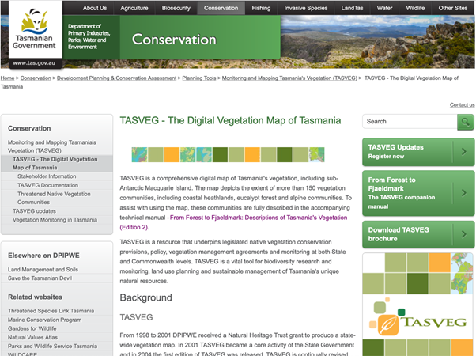
- Click on the link to LISTmap under the heading “How to access TASVEG” to take you to the mapping viewer at https://maps.thelist.tas.gov.au/listmap/app/list/map
- Use the map controls to locate your planting area(s).
- Aerial photography can be added to the map by clicking on “Basemaps” on the right hand side of the screen, select “ESRI Imagery”. To add the TASVEG layer to the map, click on the “Layers” tab on the top right hand side of the page.
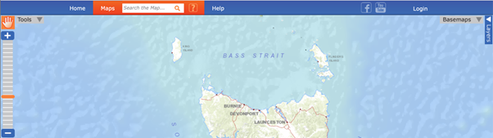
- Click on “Add Layer +” and navigate down to “Plants and Animals”, expand “Communities” and select “TASVEG 4.0” to add the latest official release to the map. The transparency of this vegetation layer can be adjusted by clicking the small arrow to the left of “TASVEG 4.0” on the right hand side of the screen.
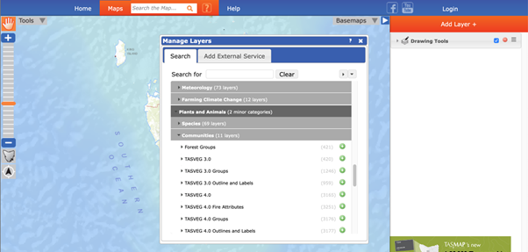
- Click on areas of vegetation closest to the proposed planting area to identify the community present.
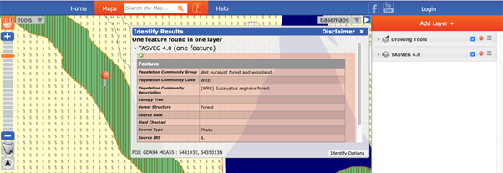
- A popup box will identify a vegetation community and its code – in the example above this is (WRE) Eucalyptus regnans forest.
- To find a list of species typical of this vegetation community, you must search the accompanying technical manuals.
- The description for Eucalyptus regnans forest can be found in the Wet Eucalypt and Forest document.
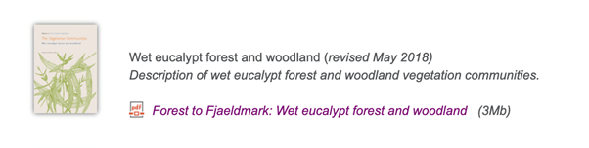
- A detailed description for WRE Eucalyptus regnans forest is provided in the document under the heading “Vegetation composition and structure”.
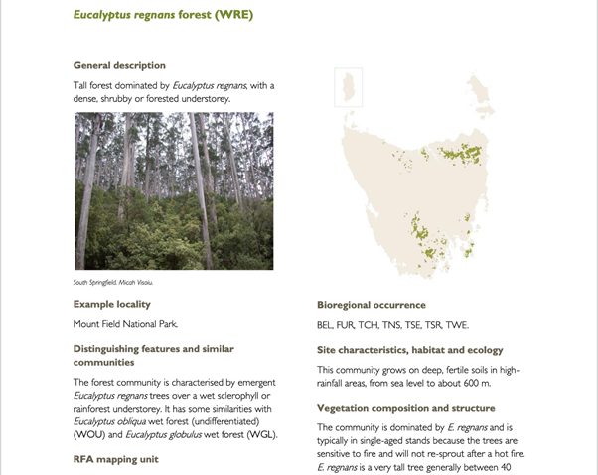

Questions and feedback
Any questions or feedback about this document should be sent to agstewardship@awe.gov.au or you can contact the Department of Agriculture, Water and the Environment on 1800 329 055.

