Carbon + Biodiversity Pilot

Planting Protocol: Riverina NRM Region (New South Wales)
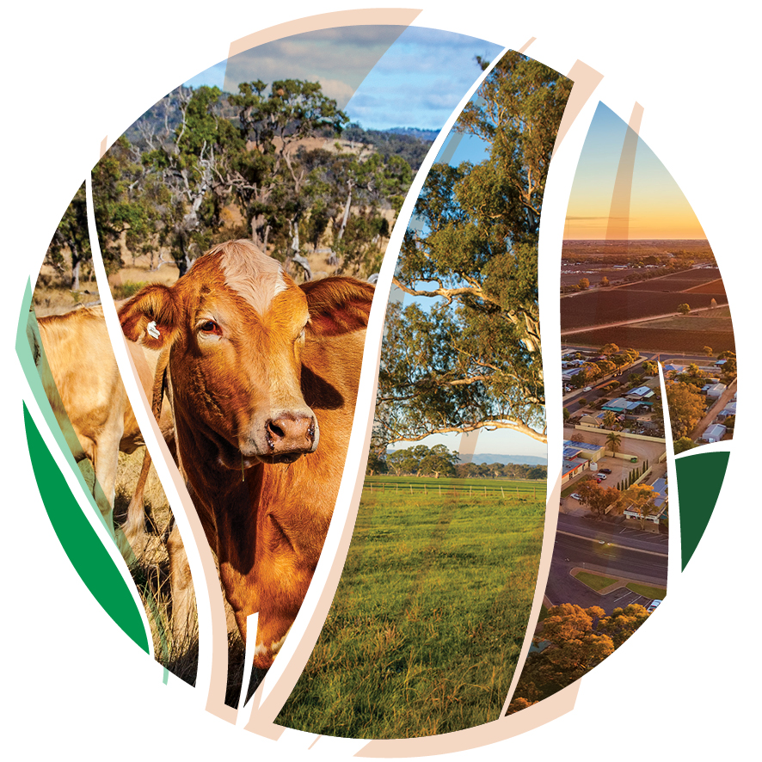
© Commonwealth of Australia 2021
Ownership of intellectual property rights
Unless otherwise noted, copyright (and any other intellectual property rights) in this publication is owned by the Commonwealth of Australia (referred to as the Commonwealth).
Creative Commons licence
All material in this publication is licensed under a Creative Commons Attribution 4.0 International Licence except content supplied by third parties, logos and the Commonwealth Coat of Arms.
Inquiries about the licence and any use of this document should be emailed to copyright@awe.gov.au.

Cataloguing data
This publication (and any material sourced from it) should be attributed as: DAWE 2021, Carbon + Biodiversity Pilot. Planting Protocol: Riverina NRM Region (New South Wales), Department of Agriculture, Water and the Environment, Canberra, December. CC BY 4.0.
This publication is available at https://www.agriculture.gov.au/ag-farm-food/natural-resources/landcare/sustaining-future-australian-farming/carbon-biodiversity-pilot
Inquiries can be made by email at agstewardship@awe.gov.au.
Department of Agriculture, Water and the Environment
GPO Box 858 Canberra ACT 2601
Telephone 1800 900 090
Web awe.gov.au
Disclaimer
The Australian Government acting through the Department of Agriculture, Water and the Environment has exercised due care and skill in preparing and compiling the information and data in this publication. Notwithstanding, the Department of Agriculture, Water and the Environment, its employees and advisers disclaim all liability, including liability for negligence and for any loss, damage, injury, expense or cost incurred by any person as a result of accessing, using or relying on any of the information or data in this publication to the maximum extent permitted by law.
Acknowledgements
We thank the Riverina Local Land Services and Dr Dean Ansell, Professor Don Butler and Professor Andrew Macintosh from the Australian National University (ANU) for their assistance in preparing this document.

Acknowledgement of Country
We acknowledge the Traditional Owners of Country throughout Australia and their continuing connection to land, sea and community. We pay our respects to them and their cultures and to their elders past, present and emerging.
We recognise the Wiradjuri nation in the east of the Riverina, the Nari Nari in the far west and people of all other nations who also live in the Riverina.

Contents
Acknowledgement of Country 3
Introduction 5
References 18
Glossary 19
Appendix A: Minimum tree and shrub species requirements 23
Appendix B: Guidance in identifying the relevant local vegetation communities for your planting 25
Questions and feedback 31

Introduction
This document details the eligibility, design, establishment and maintenance conditions that apply to environmental planting projects under the Carbon + Biodiversity Pilot Program (C+B Pilot). It is intended to complement the program guidelines available on the C+B Pilot website.
The conditions that apply to projects in the Riverina Natural Resource Management (NRM) region are contained in Tables 1-4 below in the third column, titled ‘C+B Pilot conditions – Riverina (NSW)’. The conditions fall into two categories: mandatory (expressed in the tables as ‘must’) and recommended (expressed as ‘should’). All projects must comply with the mandatory conditions. Compliance with the recommended conditions is not mandatory. Words and phrases in italics have defined meanings, which are provided below the first usage of the relevant word or phrase and in the Glossary below the tables.
Further advice on any of the conditions listed here can be obtained from the Department of Agriculture, Water and the Environment, at agstewardship@awe.gov.au.
To assist proponents, the second column, titled ‘Emissions Reduction Fund requirements’, provides a summary of key requirements that apply to environmental planting projects under the Emissions Reduction Fund (ERF). These are not intended to be comprehensive. For more information on the ERF, proponents should visit the Clean Energy Regulator’s website (see here for additional information on the ERF environmental plantings method). You can also contact the Clean Energy Regulator by email at enquiries@cleanenergyregulator.gov.au or by phone on 1300 553 542.
For the avoidance of doubt, C+B Pilot projects must comply with both the ERF requirements and the C+B Pilot conditions in Tables 1-4 below (third column).
People interested in participating in the C+B Pilot should contact their regional NRM group for advice on the establishment and management of plantings. For the Riverina, your NRM group is:
Riverina Local Land Services
Website: https://www.lls.nsw.gov.au/regions/riverina
Email: admin.riverina@lls.nsw.gov.au
Phone: 1300 795 299

Table 1. Eligibility conditions
Consideration | Emissions Reduction Fund requirements | C+B Pilot conditions – Riverina (NSW)
Area | Must consist of more than a single row of plantings. | The aggregate area of plantings in a project must be between 5-200 hectares.
Newness and additionality | - The plantings must be new and the project activity, including site preparation, must not commence until the project is registered under the ERF.  - The plantings must not be required to be carried out under a law of the Commonwealth, a State or a Territory.  - The project must not be used to meet a statutory obligation to offset the adverse impacts of another development. | No relevant eligibility conditions.  *In applying to participate in the C+B Pilot, proponents must not include the cost of management actions that are required to be carried out under a law of the Commonwealth or a State or Territory, or are already funded under another Commonwealth, State, Territory or local government environment program.
Land use history | - The planting area must have been clear of forest cover for at least 5 years prior to the date of application.  - The planting area must not contain woody biomass or an invasive native scrub species that needs to be cleared for planting to occur, other than a known weed species required or authorised by law to be cleared.  - The planting area must not have been previously illegally cleared of native forest, or have contained a wetland that was illegally drained.  - The planting area must not have been legally cleared of native forest, or have contained a wetland that was legally drained, within the previous 7 years (or 5 years if there has been a change of ownership). | No relevant eligibility conditions.
Regulatory approvals | Proponents must obtain all relevant regulatory approvals that are necessary to enable the project to be undertaken.  Regulatory approvals are approvals required under a law of the Commonwealth, a State or a Territory relating to the environment, water or land use and development. | Projects must be able to be registered as an eligible offsets project under the ERF’s Carbon Credits (Carbon Farming Initiative) (Reforestation by Environmental or Mallee Plantings—FullCAM) Methodology Determination 2014.
Legal right to carry out project and consents from other parties | Proponents must have the legal right to carry out the project on the land.  Proponents must obtain written consent to undertake the project from any person who holds an ‘eligible interest’ in the land.  ‘Eligible interests’ cover a range of interests held in relation to land, including estates and other registered proprietary interests (e.g. leases, easements and covenants), and mortgages and charges held over the land by a bank, financial institution or other party. | No relevant eligibility conditions.
NRM specific requirements | If the project area is covered by a regional NRM plan, the application for registration under the ERF must state whether the project is consistent with the plan. | No relevant eligibility conditions.

Table 2. Planting design conditions
Consideration | Emissions Reduction Fund requirements | C+B Pilot conditions – Riverina (NSW)
Prohibited planting areas | See Table 1, Land use history. | Plantings must not occur in:  - areas that did not naturally support trees and shrubs (e.g. some wetlands, grasslands);  - ecological communities listed as threatened under relevant State, Territory or Commonwealth legislation (e.g. Natural Temperate Grassland);  - utility easements; or  - specific areas identified by the Riverina LLS that have the potential to disrupt or exacerbate hydrogeological processes or issues [Contact the Riverina LLS to check if your proposed planting overlaps with these specific areas].  Utility easements are areas of land that utility providers are legally entitled to use and access for the purposes of providing utility services (e.g. electricity, gas, telecommunications and sewerage).
Uniformity of land | The ERF does not require the land included in planting areas to have particular biophysical characteristics. However, under the ERF, planting areas must be mapped and modelled as carbon estimation areas (CEAs). CEAs must meet the uniformity requirements under the environmental plantings method, which require the land in a CEA to: (i) have uniform site characteristics in relation to soil type, aspect and slope; (ii) be planted with the same combination of plant species; and (iii) be established and managed under the same land management regime, including in relation to preparation. Proponents should consider these factors in designing their plantings as it will help reduce the complexity and cost associated with reporting under the ERF. | No additional conditions.
Plant species composition | Plantings must consist of a mixture of tree and shrub species that:  - are native to the local area of the planting; and  - are sourced from seeds from within the natural distribution of the species and are appropriate to the biophysical characteristics of the area of the planting.  Plantings may be a mix of trees, shrubs and understorey species that reflect the structure and composition of the local native vegetation community. | Plantings must be either a local vegetation community planting^ or a simple mixed native planting.  A local vegetation community planting is a planting that:  - as far as practical given planting density, tree proportion and crown cover requirements, reflects the structure and composition of the relevant local vegetation community or communities*; and  - satisfies the minimum tree and shrub species requirements for local vegetation community plantings contained in Appendix A.  A simple mixed native planting is a planting that:  - as far as practical given planting density, tree proportion and crown cover requirements, performs similar ecological functions to the relevant local vegetation community or communities and generates benefits for local native biodiversity; and  - satisfies the minimum tree and shrub species requirements for simple mixed native plantings contained in Appendix A.  For the avoidance of doubt, plantings should include ground cover species where possible.  ^ Local vegetation community plantings will receive higher biodiversity benefit scores, all else being equal.  *See Appendix B for resources to assist in identification of relevant vegetation communities.  Trees are woody plants that at maturity are generally more than 2m tall and either have a single stem with branches well above the base or, if multi-stemmed from the base (or within 20cm from ground level), their largest stem typically has a diameter greater than 5cm measured 130cm above the ground.  A stem is the ascending axis of a plant and is generally the main structural component of the above-ground portion of trees and shrubs.  Shrubs are woody plants that are:  - generally less than 2m tall if single-stemmed; or  - if multi-stemmed from the base (or within 20cm from ground level), are generally less than 2m tall or, if more than 2m tall, their largest stem typically has a diameter less than 5cm measured 130cm above the ground.  Ground cover species are herbaceous (non-woody) plants, including grasses and forbs.  Proponents should consider the following with respect to species composition:  - drought resilience and the potential effects of climate change;*  - the availability of tubestock and seed from local nurseries and seed suppliers;  - that a diverse and dense mid-storey provides benefits for native birds; and  - that ground cover plants require effective control of introduced plant species to achieve high survival rates.  *For further information on considering climate change in your plantings, see the publication Climate ready revegetation: A guide for natural resource managers.
Stem density and tree proportion | Plantings must have a stocking density:  - of at least 200 stems per hectare; and  - that can achieve forest cover.  *Stocking densities affect the way carbon stocks are modelled. Three generic model calibrations are available to estimate carbon stocks, which depend on the type of planting geometry:  - belt high density generic calibration – must be a belt planting with >1500 stems per hectare;  - belt low density generic calibration – must be a belt planting with between 200-1500 stems per hectare; and  - block generic calibration – must be a block planting with ≥200 stems per hectare.  - C+B Pilot projects that model carbon stocks using the block generic calibration and are declared to be alternative assurance projects will not be required to have scheduled third party audits under the ERF. These projects can still be subject to other ERF audits, including compliance audits. | Tree and shrub plantings must:  - be no more than 5m apart, measured from stem-to-stem;  - have a stocking density of at least 400 stems per hectare;  - have a tree proportion of between 35% and 70%; and  - be planted such that each 0.2 hectare portion of the planting area has forest potential.  For the avoidance of doubt, groundcover species are not included in stem counts for these purposes.  Tree proportion means the proportion of individual live trees relative to the total of individual live trees and shrubs in a planting.  A 0.2 hectare portion of a planting area has forest potential if the planted trees have the potential to reach 2m or more in height and provide crown cover of at least 20% of the portion.
Dimensions of planting | Plantings can be either belt or block plantings.  - Belt plantings are plantings in a belt configuration that are ≤40m wide, are at least 40m from the nearest other planting (stem-to-stem) and are not affected by material competition from adjacent trees.  - Block plantings are plantings that do not meet the requirements of a belt planting and consist of more than a single row of trees or shrubs.  * C+B Pilot projects can be either belt or block plantings. However, to be eligible to be declared an alternative assurance project under the ERF (and thereby have no scheduled third party ERF audits), proponents must model the carbon stocks using the block generic calibration. | Individual planting areas must be at least 0.25 hectares (2500m²).  The average width of plantings in a belt configuration must be at least 30m (stem-to-stem) on the short axis of the planting.
Distance from other vegetation, including plantings | The distance to other vegetation determines whether plantings are able to be modelled as belt plantings. Belt plantings must be at least 40m from the nearest other planting (stem-to-stem) and they must not be affected by material competition from adjacent trees. Adjacent trees are trees that lie within 20m of the stems of the closest project tree. There are rules for when adjacent trees are deemed to be causing material competition.  These requirements do not apply to block plantings. | No additional conditions.
Surrounding vegetation in the landscape | No requirement.*  *Proximity to other vegetation affects whether plantings meet the definition of belt plantings and can apply the belt calibrations when modelling abatement. | No additional conditions.
Fire risk | No specific requirements concerning the design of plantings. However, participants are required to provide a permanence plan that explains the steps that will be undertaken to ensure carbon remains stored in the project area for the permanence obligation period.  See Table 4 below for requirements concerning fire management during the permanence obligation period. | Planting areas:  - must not be within 50m of buildings used for residential or commercial purposes; and  - should not be within 50m of any other buildings.
Regulatory compliance | See Table 1, Regulatory approvals. | Plantings must be sited, established and managed in accordance with all applicable Commonwealth and State laws relating to planning, environment and heritage.
Workplace health and safety | No requirement. | Proponents should prepare a workplace health and safety plan for their project.
Cultural heritage | No requirement. | In siting, establishing and managing plantings, proponents should consider cultural heritage impacts and follow relevant Commonwealth, State and local guidelines concerning the protection and management of cultural heritage sites.  Information on Indigenous heritage sites can be obtained from the Aboriginal Heritage Information Management System (AHIMS).  Contact your regional NRM group for further information.

Table 3. Establishment conditions
Consideration | Emissions Reduction Fund requirements | C+B Pilot conditions – Riverina (NSW)
Establishment method | Plantings must be established using propagated seedling stock (tubestock) or direct seeding. | No additional conditions.
Site preparation – weed control | Not specified. | Where weed control is carried out using herbicides, the herbicides must be applied in accordance with all applicable Commonwealth and State laws and the manufacturer’s instructions.
Site preparation – soil | Not specified. | Soil preparation must not be done by deep-ripping or other mechanical methods that involve significant soil disturbance (e.g. mound ploughing) in planting areas with significant biodiversity or natural or cultural heritage values, including areas that contain remnant native vegetation, old native trees, patches of native grass or sites of Indigenous cultural significance.
Site preparation – total grazing pressure | Not specified. | All livestock grazing must be excluded until the tree plantings have become established (approximately 1.5m tall).  Vertebrate pests and overabundant native species (including kangaroos) should be managed where they present a threat to the establishment of the plantings.  In managing overabundant native vertebrate species, preventative control measures (e.g. fencing and guards) should be prioritised over lethal control and any lethal control must only be to the extent necessary to protect the plantings.  All vertebrate pest and overabundant native vertebrate species management must be undertaken in accordance with applicable Commonwealth, State and local laws and guidelines.
Timing | Not specified. | No additional requirements.
Tree protection | No requirement.  *Where grazing or another event kills the plantings in ≥5% of the planting area, the proponent is required to notify the Clean Energy Regulator and take actions to mitigate the impacts of the disturbance. This may require the area to be replanted. Proponents will also be required to re-stratify the carbon estimation area. | Plantings should be protected from livestock and other herbivores. If fencing is used:  - the top strand of wire around plantings must not be barbed to reduce the chance of wildlife entanglement; and  - it should be erected prior to planting or direct seeding.
Watering | No requirement. | Proponents should consider watering plantings, particularly tubestock plantings, at the time of establishment.

Table 4. Maintenance
Consideration | Emissions Reduction Fund requirements | C+B Pilot conditions – Riverina (NSW)
Longevity | Plantings must be maintained for a permanence period of either 25 or 100 years, which commences when the first ACCUs are issued to the project. Proponents can choose a 25- or 100-year permanence period when submitting a project registration application. The permanence period cannot be varied. | Plantings must be protected and maintained for the C+B permanence period.  The C+B permanence period means the 25-year period commencing on the day the project is registered under the ERF.
Remedial planting | Remedial plantings may be required if a planting has failures that impact the carbon stocks and the planting’s ability to achieve forest cover. This will affect the planting and modelling date. Proponents must keep a record of any remedial plantings. | Throughout the C+B permanence period, each 0.2 hectare portion of the planting area should have either forest potential or forest cover.  Remedial plantings should be established in a planting area if mortality results in a 0.2 hectare portion of a planting area no longer having forest potential or forest cover.  A 0.2 hectare portion of a planting area has forest cover if the planted trees are 2m or more in height and provide crown cover of at least 20% of the portion.  Remedial plantings should be established in a planting area if:  - it was originally designed to reflect the structure and composition of the relevant local vegetation community or communities; and  - mortality results in the planting no longer reflecting the structure and composition of the relevant local vegetation community or communities.  Remedial plantings should be established in a planting area if:  - it was originally designed to perform similar ecological functions to the relevant local vegetation community or communities and generate benefits for local native biodiversity; and  - mortality results in the planting no longer performing similar ecological functions to the relevant local vegetation community or communities and generating benefits for local native biodiversity.
Harvesting and other biomass removal | Plantings must not be harvested other than:  - thinning for ecological purposes;  - to remove debris for fire management;  - to remove firewood, fruit, nuts, seeds, or material used for fencing or as craft materials, if those things are not for sale; or  - in accordance with traditional Indigenous practices or native title rights.  No more than 10% of fallen timber may be removed from a CEA in a calendar year for personal use. | Plantings must not be harvested or otherwise cleared, other than thinning for ecological purposes where:  - the planting was originally designed to reflect the structure and composition of the relevant local vegetation community or communities and the thinning is necessary to ensure the planting achieves this objective; or  - the planting was originally designed to perform similar ecological functions to the relevant local vegetation community or communities and generate benefits for local native biodiversity and the thinning is necessary to ensure the planting achieves this objective; and  - approval is obtained from the Department of the Agriculture, Water and the Environment before the thinning commences.  All fallen timber must be left within the planting. Any fallen timber that is moved from firebreaks, access tracks or fences must be placed within the planting area.
Total Grazing Pressure post-establishment | Livestock grazing is permitted provided it does not affect the achievement or maintenance of forest cover in a CEA. | Total grazing pressure must be managed to protect the biodiversity values of the site.  Livestock grazing:  - must not be undertaken until the plantings have become established (approximately 1.5m tall);  - must be limited to pulse or crash grazing; and  - must not be undertaken if it adversely affects the plantings or their biodiversity values.  Management of overabundant native vertebrate species (including kangaroos) should be undertaken only where they present a threat to the biodiversity value of the site. Where possible, preventative control measures (e.g. fencing and guards) should be prioritised over lethal control and any lethal control must only be to the extent necessary to protect the biodiversity values of the site.  All vertebrate pest and overabundant native vertebrate species management must be undertaken in accordance with applicable Commonwealth, State and local laws and guidelines.  Fences and other tree protection measures should be well maintained to ensure the exclusion of livestock and other overabundant native vertebrates.
Invertebrate pest control | Invertebrate pests should be managed as necessary to meet the requirements of the permanence plan. | Invertebrate pests should be managed where necessary to protect the present and future biodiversity value of the site.  Where pest control is carried out using pesticides, the pesticides must be applied in accordance with all applicable Commonwealth and State laws and the manufacturer’s instructions.
Fire | Fire should be managed as necessary to meet the requirements of the permanence plan.  If there is a fire that affects the sequestered (stored) carbon, the proponent must:  - take all reasonable steps to prevent the on-going loss of the sequestered carbon;  - identify the impacted area and quantify the impact; and  - notify the Clean Energy Regulator of the disturbance within 60 days.  Prescribed burning is permitted but the greenhouse gas emissions from these burns must be accounted for and, if a burn kills the plantings, steps must be taken to mitigate the impacts (this may include remedial plantings). | Fire must not be intentionally introduced to the planting if it is likely to adversely affect the biodiversity values of the site, unless it is critical to the protection of life or property.
Watering | No additional requirement but watering should be considered to reduce tree and shrub mortality where necessary. | Proponents should consider watering plantings (particularly tubestock plantings) during the first summer after planting if there is inadequate rainfall.
Ongoing consistency with NRM plans | If a registered ERF project is changed and, as a consequence, it becomes inconsistent with an applicable regional NRM plan, the proponent must notify the Clean Energy Regulator within 90 days. | No additional conditions.

References
Carbon Credits (Carbon Farming Initiative) (Reforestation by Environmental or Mallee Plantings—FullCAM) Methodology Determination 2014 (Cth) https://www.legislation.gov.au/Details/F2018C00118.
Department of Environment Regulation. 2016. A Guide to Preparing Revegetation Plans for Clearing Permits. Government of Western Australia.
Department of Sustainability and Environment 2006. Revegetation planting standards – Guidelines for establishing native vegetation for net gain accounting. Victorian Government, Department of Sustainability and Environment, East Melbourne.
Greening Australia. Undated. A Revegetation Guide for Temperate Riparian Lands. Department of Sustainability, Environment, Water, Population and Communities and Landcare Australia.
Hancock, N., Harris, R., Broadhurst, L. and Hughes, L. 2018. Climate-ready revegetation. A guide for natural resource managers. Version 2. Macquarie University, Sydney.
Lindenmayer, D.B. 2018. Ten lessons in 20 years: Insights from monitoring fauna and temperate woodland revegetation. Ecological Management and Restoration, 19(S1): 36-43.
Lindenmayer, D.B., Knight, E.J., Crane, M.J., Montague-Drake, R., Michael, D.R., MacGregor, C.I. 2010. What makes a good restoration planting for woodland birds? Biological Conservation, 143:289-301.
Lindenmayer, D.B., Blanchard, W., Crane, M., Michael, D., Sato, C. 2018. Biodiversity benefits of vegetation restoration are undermined by livestock grazing. Restoration Ecology, 26(6): 1156-1164.
Munro, N.T., Lindenmayer, D.B., Fischer, J. 2007. Faunal response to revegetation in agricultural areas of Australia: A review. Ecological Management & Restoration 8(3): 199-207.
NESP Threatened Species Recovery Hub. 2021. What makes an effective planting for supporting biodiversity on farms? How-to Guide. National Environmental Science Program.
NSW Biodiversity Conservation Trust. 2019. Restoring Native Vegetation. Guidelines for Assisted Regeneration and Revegetation. NSW Government.
Vegetation Matters. 2014. North Burnett Riparian Revegetation Guidelines. Burnett Catchment Care Association.

Glossary
Defined terms under the C+B Pilot
C+B permanence period means the 25-year period commencing on the day the project is registered under the ERF.
ERF means the Emissions Reduction Fund. The Emissions Reduction Fund is a voluntary offset certification scheme established under the Carbon Credits (Carbon Farming Initiative) Act 2011 (Cth).
Forest cover—in relation to the C+B Pilot, a 0.2 hectare portion of a planting area has forest cover if the planted trees are 2m or more in height and provide crown cover of at least 20% of the portion.
Forest potential—in relation to the C+B Pilot, a 0.2 hectare portion of a planting area has forest potential if the planted trees have the potential to reach 2m or more in height and provide crown cover of at least 20% of the portion.
Ground cover species means species of herbaceous (non-woody) plants, including grasses and forbs.
Local vegetation community planting means a planting that:
- as far as practical given the planting density, tree proportion and crown cover requirements, reflects the structure and composition of the relevant local vegetation community or communities; and
- satisfies the minimum tree and shrub species requirements for local vegetation community plantings in Appendix A.
Planting means:
- as a verb, to put or set in the ground tree, shrub and (where relevant) ground cover species using propagated seedling stock or direct seeding; and
- as a noun, an area of trees, shrubs and (where relevant) ground cover species established using propagated seedling stock or direct seeding.
Planting area means the area of land on which plantings are established under the C+B Pilot in accordance with the requirements of the Planting Protocol.
Stocking density means the number of live individual trees or shrubs per hectare in a planting area.
Shrub means a species of woody plant that:
- is generally less than 2m tall if single-stemmed; or
- if multi-stemmed from the base (or within 20cm from ground level), is generally less than 2m tall or, if more than 2m tall, its largest stem typically has a diameter less than 5cm measured 130cm above the ground.
Simple mixed native planting means is a planting that:
- as far as practical given planting density, tree proportion and crown cover requirements, performs similar ecological functions to the relevant local vegetation community or communities and generates benefits for local native biodiversity; and
- satisfies the minimum tree and shrub species requirements for simple mixed native plantings in Appendix A.
Stem, in relation to the C+B Pilot, means the ascending axis of a plant and is generally the main structural component of the above-ground portion of trees and shrubs.
Thinning means the selective removal of trees or shrubs for ecological purposes, including to maintain species diversity or ground cover.
Tree, in relation to the C+B Pilot, means a species of woody plant that at maturity is generally more than 2m tall and either has a single stem with branches well above the base or, if multi-stemmed from the base (or within 20cm from ground level), its largest stem typically has a diameter greater than 5cm measured 130cm above the ground.
Tree proportion means the proportion of individual live trees relative to the total of individual live trees and shrubs in a planting.
Utility easement means an area of land that utility providers are legally entitled to use and access for the purposes of providing utility services (e.g. electricity, gas, telecommunications and sewerage).

Summary of key defined terms relevant to the ERF Environmental Plantings Method
Set out below is a summary of key terms and phrases that are used in, or in relation to, the ERF’s Environmental Plantings Method. Where only a summary is provided, references are provided to the statutory instrument(s) that contain the full definition. Readers should note that terms and phrases that are defined under the ERF do not necessarily have the same meaning under the C+B Pilot. Key terms and phrases that have different meanings under the C+B Pilot are marked below with an asterisk (*).
Belt plantings are plantings in a belt configuration that are at least 40m wide, are at least 40m from the nearest other planting (stem-to-stem) and are not affected by material competition from adjacent trees. For the full definition, see Carbon Credits (Carbon Farming Initiative) (Reforestation by Environmental or Mallee Plantings—FullCAM) Methodology Determination 2014.
Block plantings are non-belt plantings, other than plantings consisting of a single row. For the full definition, see Carbon Credits (Carbon Farming Initiative) (Reforestation by Environmental or Mallee Plantings—FullCAM) Methodology Determination 2014.
Eligible interest, in relation to an offset project under the ERF, refers to a range of interests held in relation to land, including estates and other registered proprietary interests (e.g. leases, easements and covenants), and mortgages and charges held over the land by a bank, financial institution or other party. For the full definition, see sections 43, 44, 45 and 45A of the Carbon Credits (Carbon Farming Initiative) Act 2011 (Cth).
Eligible interest holder, in relation to an offset project under the ERF, means a person who holds an eligible interest in the land on which the project is located.
Forest means land of a minimum area of 0.2 of a hectare on which trees:
- have attained, or have the potential to attain, a crown cover of at least 20% across the area of land; and
- have reached, or have the potential to reach, a height of at least 2 metres.
Forest cover*—land has forest cover if the vegetation on the land includes trees that:
- are 2 metres or more in height; and
- provide crown cover of at least 20% of the land.
Forest potential*—land has forest potential if:
- the land has an area of at least 0.2 hectares; and
- the vegetation on the land includes trees that have the potential:
  - to reach 2 metres or more in height; and
  - to provide crown cover of at least 20% of the land.
FullCAM means the Full Carbon Accounting Model, a calculation tool used by the Australian Government to model Australia’s greenhouse gas emissions from the land sector and to model emissions and removals from vegetation projects under the ERF. For further information, see here.
Planting means:
- as a verb, to put or set in the ground species that are eligible under the Carbon Credits (Carbon Farming Initiative) (Reforestation by Environmental or Mallee Plantings—FullCAM) Methodology Determination 2014 using:
  - propagated seedling stock; or
  - direct seeding, including in rows or broadcast;
for the purposes of growing project trees;
- as a noun, an area of project trees established using direct seeding or propagated seedling stock.
Regulatory approval, in relation to an offset project under the ERF, means an approval, licence or permit (however described) that:
- relates to, or to an element of, the project; and
- is required under a law of the Commonwealth, a State or Territory that relates to:
  - land use or development; or
  - the environment; or
  - water.
Shrub* means a perennial plant that has primary supporting structures consisting of secondary xylem and that does not have, or have the potential for its stem diameter to be measured at breast height (DBH), where DBH is defined as 130 centimetres in height.
Stem means the ascending axis of a plant and the main structural component of the above-ground portion of trees and shrubs.
Stocking density* means the number of live individual trees or shrubs per hectare in a carbon estimation area and/or the number of live individual seedlings or seeds per hectare at establishment.
Tree* means a perennial plant that has primary supporting structures consisting of secondary xylem and that has, or has the potential to for its stem diameter to be measured at 130 centimetres height (i.e. DBH).
Tree proportion means the proportion of individual live trees relative to the total of individual live trees and shrubs in a mixed-species environmental planting.

Appendix A: Minimum tree and shrub species requirements
Local vegetation community planting
Local vegetation community plantings must:
- as far as practical given the planting density, tree proportion and crown cover requirements, reflect the structure and composition of the relevant local vegetation community or communities; and
- satisfy the minimum tree and shrub species requirements for local vegetation community plantings contained in Table A1.
To satisfy the minimum tree and shrub species requirements, the planting must consist of at least the minimum number of tree and shrub species (Table A1, columns 3 and 4) for the Riverina LLS Planting Region (Table A1, column 1) and landform (Table A1, column 2) in which the planting is located.
A map of the Riverina LLS Planting Regions is provided below.
Please contact Riverina Local Land Services if you need assistance in identifying your planting region or require information on the tree and shrub species that are appropriate for local vegetation community plantings.
Simple mixed native planting
Simple mixed native plantings must:
- as far as practical given planting density, tree proportion and crown cover requirements, perform similar ecological functions to the relevant local vegetation community or communities and generate benefits for local native biodiversity; and
- satisfy the minimum tree and shrub species requirements for simple mixed native plantings contained in Table A2.
To satisfy the minimum tree and shrub species requirements, the planting must consist of at least the minimum number of tree and shrub species (Table A2, columns 3 and 4) for the Riverina LLS Planting Region (Table A2, column 1) and landform (Table A2, column 2) in which the planting is located.
A map of the Riverina LLS Planting Regions is provided below.
Please contact Riverina Local Land Services if you need assistance in identifying your planting region or require information on the tree and shrub species that are appropriate for simple mixed native plantings.

Table A1. Minimum tree and shrub species requirements for local vegetation community plantings
Planting region | Landform | Minimum tree species | Minimum shrub species
1 | Rocky hilltops/Upper slopes/Recharge | 5 | 5
 | Midslope/Lower slope/Dry gullies | 5 | 5
 | Riparian/Periodically water-logged | 4 | 4
 | Saline Discharge Sites | 3 | 3
 | Frost Hollows | 2 | 0
2 | Rocky hilltops/Upper slopes/Recharge | 4 | 4
 | Midslope/Lower slope/Dry gullies | 4 | 4
 | Riparian/Periodically water-logged | 3 | 3
 | Saline Discharge Sites | 3 | 3
3, 4 & 5 | Rocky hilltops/Upper slopes/Recharge | 5 | 5
 | Midslope/Lower slope/Dry gullies | 5 | 5
 | Riparian/Periodically water-logged | 4 | 4
 | Saline Discharge Sites | 3 | 3
6 & 7 | Rocky hilltops/Upper slopes/Recharge | 3 | 3
 | Midslope/Lower slope/Dry gullies | 4 | 4
 | Riparian/Periodically water-logged | 3 | 3
 | Saline Discharge Sites | 3 | 3

Table A2. Minimum tree and shrub species requirements for simple mixed native plantings
Planting region | Landform | Minimum tree species | Minimum shrub species
1 | Rocky hilltops/Upper slopes/Recharge | 4 | 4
 | Midslope/Lower slope/Dry gullies | 4 | 4
 | Riparian/Periodically water-logged | 3 | 3
 | Saline Discharge Sites | 2 | 2
 | Frost Hollows | 2 | 0
2 | Rocky hilltops/Upper slopes/Recharge | 3 | 3
 | Midslope/Lower slope/Dry gullies | 3 | 3
 | Riparian/Periodically water-logged | 2 | 2
 | Saline Discharge Sites | 2 | 2
3, 4 & 5 | Rocky hilltops/Upper slopes/Recharge | 4 | 4
 | Midslope/Lower slope/Dry gullies | 4 | 4
 | Riparian/Periodically water-logged | 3 | 3
 | Saline Discharge Sites | 2 | 2
6 & 7 | Rocky hilltops/Upper slopes/Recharge | 2 | 2
 | Midslope/Lower slope/Dry gullies | 3 | 3
 | Riparian/Periodically water-logged | 2 | 2
 | Saline Discharge Sites | 2 | 2

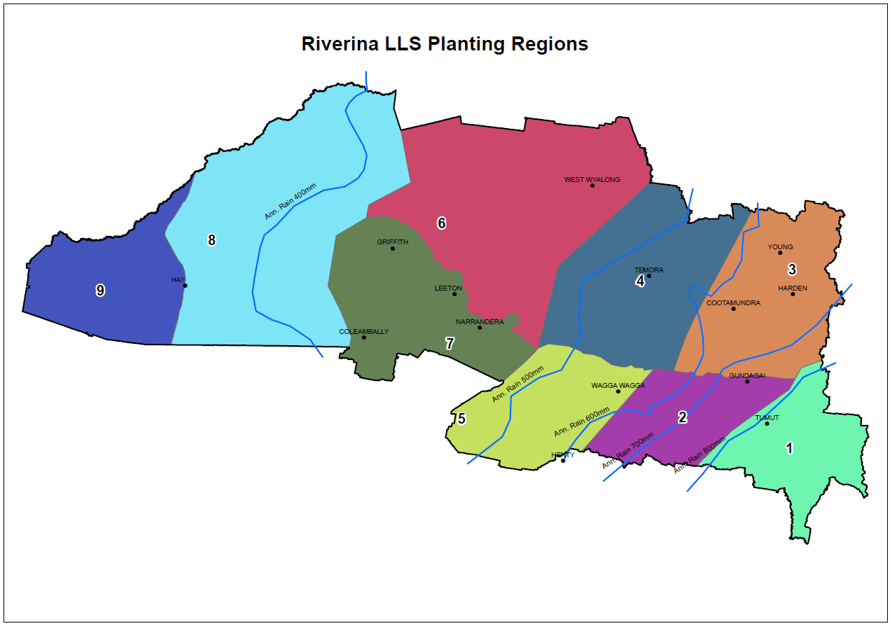

Appendix B: Guidance in identifying the relevant local vegetation communities for your planting
This Appendix sets out some sources for information on natural vegetation in your region. The sources selected are generally the most up to date, which are accessible online. It is not a comprehensive list, and most parts of Australia are covered by numerous published guides and studies that can also help with plant species selection, particularly for simple mixed native plantings. Sources of native plants and seeds, such as nurseries, can also help, as can your local Natural Resource Management body or Landcare group.
If you have confidence in your understanding of the natural vegetation across your planting areas you may not need more information to decide on an appropriate species mix. For example, if there are enough paddock trees or roadside patches and other reminders of the native vegetation you might have enough to design a local vegetation community planting that closely reflects local ecosystems.
But even if you know your local plants, the data described here, plus other local sources, should be consulted to confirm natural combinations of species in your region, and also to confirm the scientific names and natural range for species you might know best by a common name. The Atlas of Living Australia is a valuable national resource for biodiversity information.
The following guidance involves two web application provided by the New South Wales government for information on vegetation associations. The State’s most detailed information on plant species associations is assembled for ‘Plant Community Types’ (PCTs).
To find PCTs relevant to your planting area
- Go to https://www.seed.nsw.gov.au/ and enter “SVTM riverina” into the search box. (Alternatively, click on this link to go directly to the map – go to Step 3).
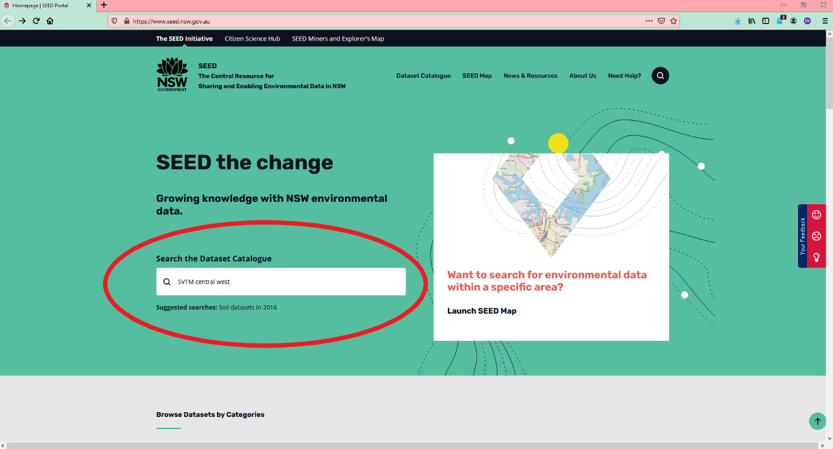

- On the search results page select “Show on Seed Map” under the top entry.
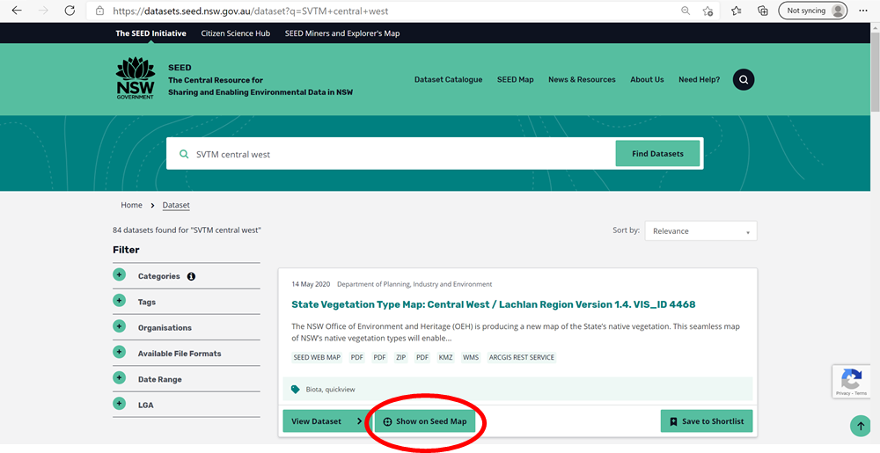
- In the map view, click on the blue button “I want to” and select a preferred way to locate your property, for example ‘Find an Address’, or alternatively use the map controls to navigate to your planting area.
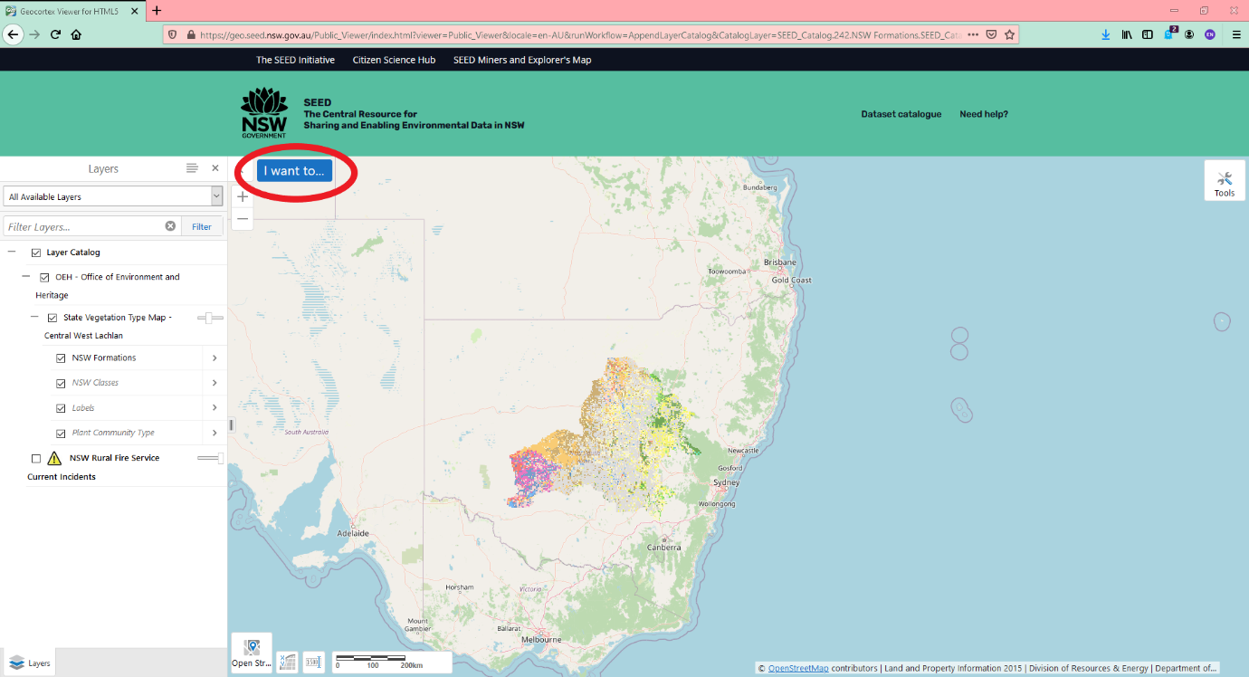

- The details displayed on the PCT map depend on the scale you are viewing it at. If you cannot see labels indicating PCT types overlaid on the coloured PCT symbology you need to zoom in to a closer, larger scale. In the image below, the PCTs (listed according to their unique ID) can be seen in the left of the screen.
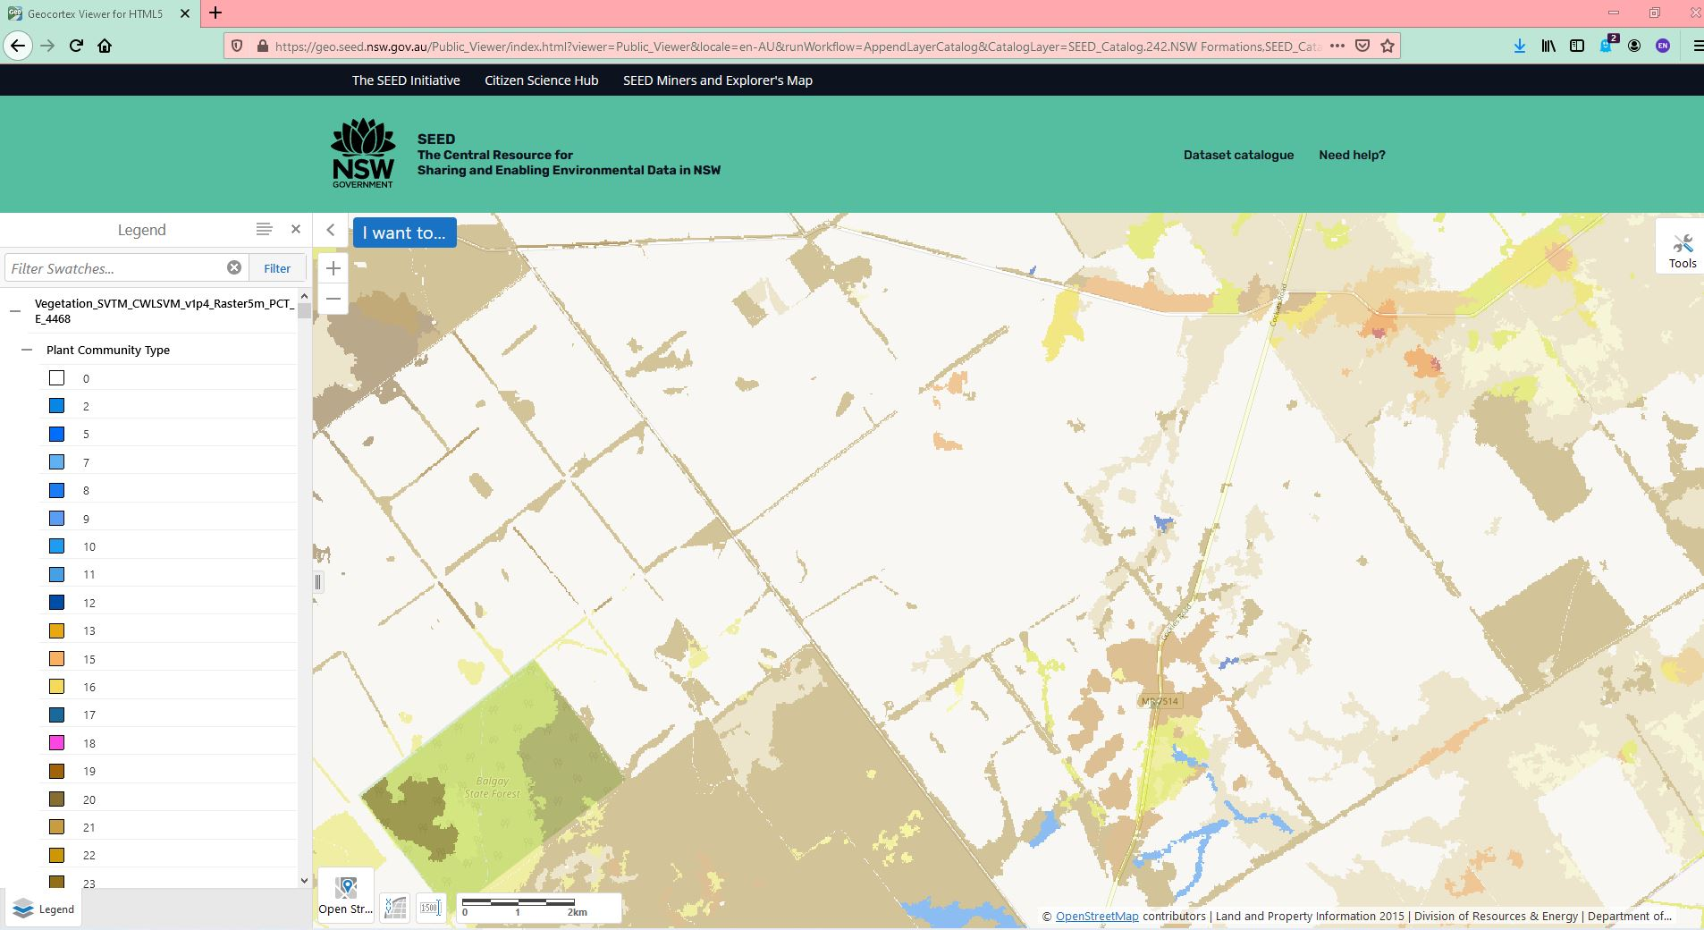
- For further detail, click on the Panel Actions Menu (the four lines next to Layers – see image below), then select Show Layer List, and ensure Labels and Plant Community Type are selected.

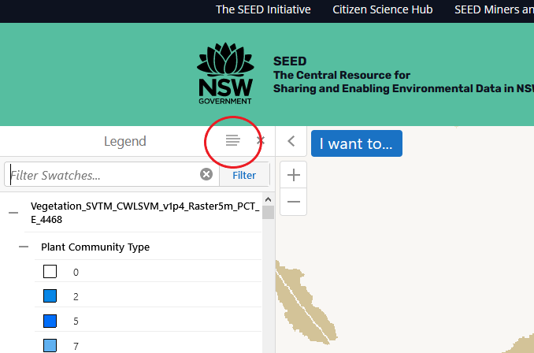

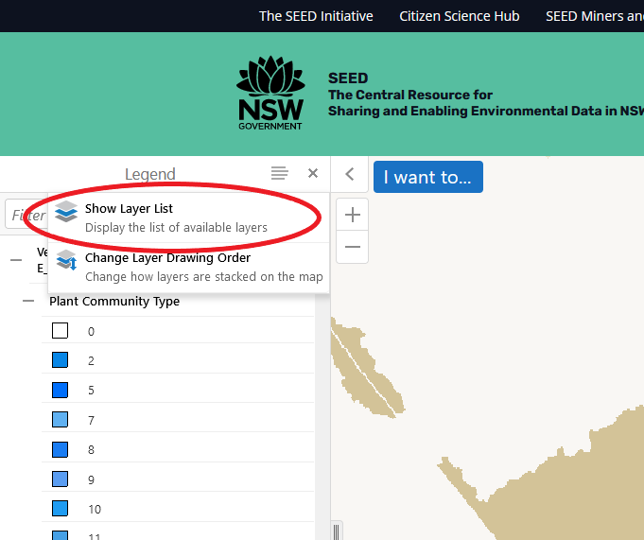

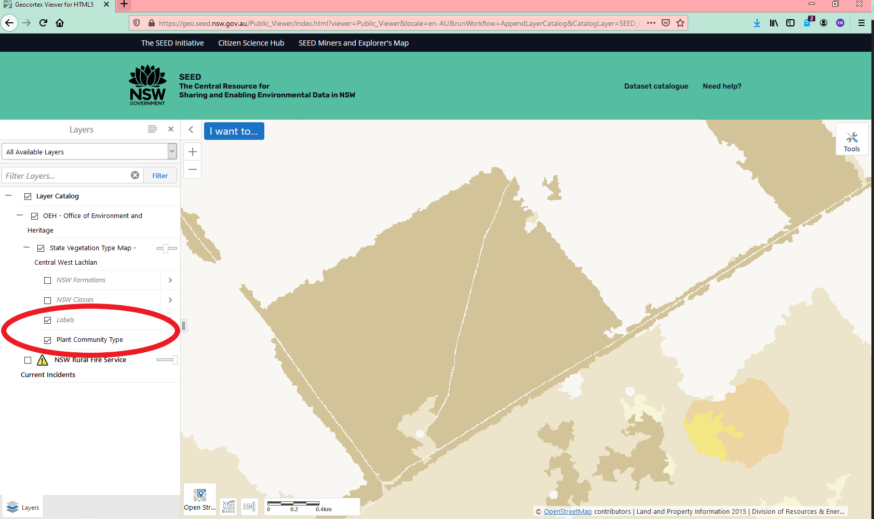

- Note the PCT names and/or identification numbers that occur in your planting area. If none are listed on or near your planting area, note the closest PCTs that are similar to your planting site in terms of soil, landform and aspect.
To find which species are characteristic of the PCTs
- A second NSW government application called BioNet is now required to help you find out which species of plants are typically found in the plant communities of PCTs likely to have occurred in your planting area. Access to BioNet is free but requires user registration, which is simple to do, if you are a new user. Click on ‘Register here’ and follow the steps.
- After signing into the BioNet app select the PCT DATA tab to source detailed information for a particular PCT or to filter the long list of possible PCTs based on other information such as regional location and plant species names.
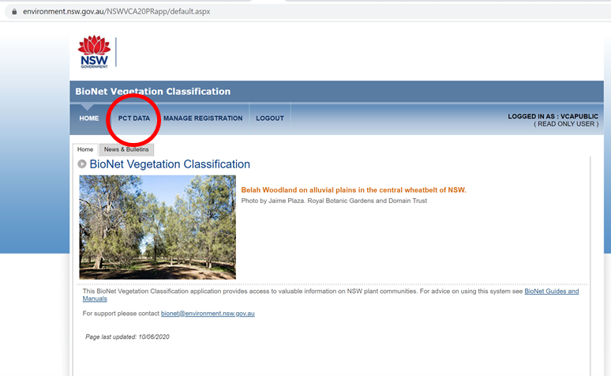
- PCT information is easiest to access in BioNet if you know the PCT name or PCT number you’re searching for. Using the PCT information you hopefully identified in the previous steps, enter the PCT name into the PCT Name field, or enter the PCT number into the field labelled “Plant Community Type ID” and click “Search” button at the bottom of the form.
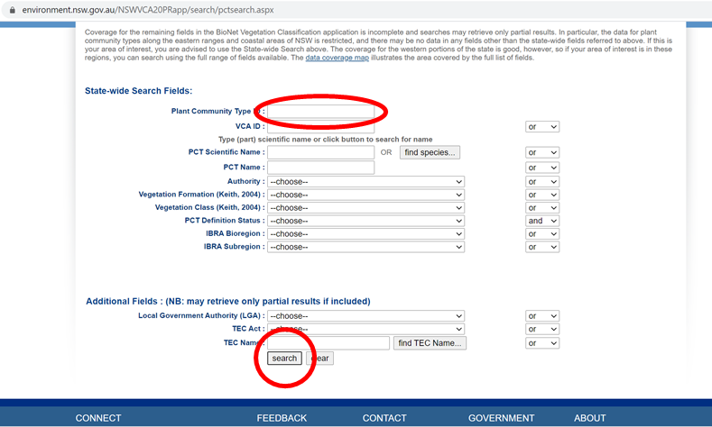
- The description of the PCT opens in a new window and includes lists of important species under the “Scientific description” tab. This information can be used in designing your planting. You can also use this resource to find useful information on ecology and landscape position on the “Distribution information” tab, and lists of significant biodiversity values under “Threatened Biodiversity, TECs & Benchmarks” tab.
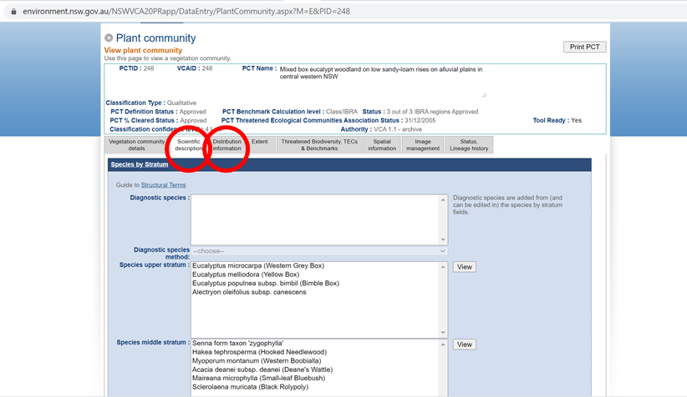

Questions and feedback
Any questions or feedback about this document should be sent to agstewardship@awe.gov.au or you can contact the Department of Agriculture, Water and the Environment on 1800 329 055.

