Report prepared by


Report prepared for
Department of the Environment and Energy

Plastics infrastructure analysis update

Project report
Final report

11 November 2019

Project title: | Plastics infrastructure analysis update
Report title: | Project report (Final report)
Client: | Department of the Environment and Energy
Author: | Kyle O’Farrell
Reviewer: | Fiona Harney
Project reference: | A21507
Document reference: | R01-02
Date: | 11 November 2019
Report citation: | N/A
Disclaimer
This report has been prepared on behalf of and for the exclusive use of the Department of the Environment and Energy, and is subject to and issued in accordance with the agreement between the Department of the Environment and Energy and Envisage Works. Envisage Works accepts no liability or responsibility whatsoever for any use of or reliance upon this report by any third party.
Envisage Works contact details
ABN: 12 584 231 841
Post: PO Box 7050, Reservoir East VIC 3073
E-mail: admin@envisageworks.com.au
Phone: +61 (0)3 9016 5490

CONTENTS
Glossary / Abbreviations iv
1 Introduction 1
1.1 Project purpose and scope 1
1.2 Definition of ‘plastic’ 1
1.3 Definitions of ‘recycling’, ‘reprocessing’ and ‘recovery’ 2
1.4 Major scope exclusions 3
1.5 Data limitations and assumptions 3
2 Plastics flow diagram 4
3 Plastics flows in Australia 5
3.1 Consumption 5
3.2 End-of-life 9
3.3 Recovery 10
4 Recovered plastics grades and exports 17
4.1 Scrap plastic grades and markets 17
4.2 Scrap plastics exports 19
4.3 Recycled plastics product types 23
5 Sorting and reprocessing infrastructure 24
5.1 Reprocessor numbers by state/territory 24
5.2 Reprocessing by state/territory 26
5.3 Reprocessing level by Australian reprocessors 27
5.4 Reprocessing facility throughputs 29
5.5 Top ten plastics reprocessors in Australia 30
5.6 Major changes in plastics reprocessor capacity 31
6 Scrap plastics to energy recovery and chemical recycling 32
6.1 Waste plastics to refuse derived fuels 32
6.2 Chemical recycling of plastics and plastics to fuels 32
7 References 34

Glossary / Abbreviations

ABS/SAN | Acrylonitrile butadiene styrene and styrene acrylonitrile (PIC 7).
Bioplastics | Plastics that are biobased, biodegradable or both. Bioplastics fall into three broad groupings, which are: biobased (but not biodegradable); biodegradable (but not biobased); or biobased and biodegradable. Conventional polymers (e.g. PET and HDPE) can also be fully or partially ‘biobased’.
Commercial and Industrial (C&I) | Material from all commercial and industry sources other than construction and demolition (C&D) related sources.
Construction and Demolition (C&D) | Material from the construction, refurbishment and building demolition industries.
Consumption | Total use of product by Australian industry and consumers. Includes locally made and used product, imported product and locally utilised recyclate. Does not include locally made product that is exported for sale.
Converter | Company which converts polymer resin, either virgin resin or recycled content resin, into plastic products.
Diversion rate | Recycling as a proportion of end-of-life disposal.
Domestic | Material from domestic (household) sources.
Export for reprocessing | Material sent for reprocessing overseas.
EXW / ExWorks | Incoterm (trade term) defining the sale (transfer of ownership) of goods at the gate of the seller. The buyer must carry out all tasks of export & import clearance. Carriage & insurance is to be arranged by the buyer.
Feedstock (chemical) recycling | The use of chemical processes such as pyrolysis to convert scrap plastics into a hydrocarbon gas or liquid (often a polymer to monomer conversion) that is usable as a fuel or as an input for manufacturing plastics resins.
Flexible plastics | Plastic material that does not hold a three-dimensional shape during sorting and transport.
Household | Material from domestic (household) sources.
In the gate | Material entering a facility for reprocessing. This may include material that is unusable due to contamination.
Internal use | Recyclate processed and used within the one company.
Local use | Recyclate used within Australia by an Australian company in the manufacture of a new product.
Local/Locally | In Australia.
Mechanical recycling | The use of physical processes such as sorting, chipping, grinding, washing and extruding to convert scrap plastics to a usable input for the manufacture of new products.
MRF | Material Recovery Facility – a facility for the sorting of recyclables (typically packaging) into various product streams.
Municipal solid waste (MSW) | Household solid waste plus material from public place recycling and other council services.
Non-packaging / durable | Long-term use item; not designed to be single use or disposable within a 12-month period.
Other | Other polymers types not specifically defined, including various acrylics, acetals, polyethylene oxide, polyisobutylene and other polymers of propylene (other than PP), and polymers of styrene (other than PS, P-ES and ABS/SAN).
Out the gate | Material leaving a facility following reprocessing, and excludes most contamination.
Out-throws | Gross contamination of scrap plastics entering a reprocessing facility with non-plastic or otherwise unrecoverable materials. For example, the contamination of a mixed plastic packaging bales, as produced by MRFs, with paper, cardboard or metal packaging.
Packaging | Plastic material used for the containment, protection, marketing or handling of product. Includes primary, secondary and tertiary/freight packaging in both consumer and industrial packaging applications.
PEF / Process engineered fuel | Process engineered fuel. A high timber content refuse derived fuel (RDF) typically manufactured from construction and demolition waste.
PE-HD or HDPE | High density polyethylene (PIC 2). Typically referred to as HDPE.
PE-LD/LLD or LDPE/LLDPE | Both low density polyethylene and linear low density polyethylene (PIC 4). Typically referred to as LDPE/LLDPE.
PE-LD or LDPE | Low density polyethylene (PIC 4). Typically referred to as LDPE.
PE-LLD or LLDPE | Linear low density polyethylene (PIC 4). Typically referred to as LLDPE.
PET | Polyethylene terephthalate (PIC 1).
PIC | Plastics identification code. Also known overseas as the Resin Identification Code (RIC).
PU or PUR | Polyurethane (PIC 7).
Post-consumer domestic | Used material from household sources. Mostly packaging material from kerbside recycling collections.
Post-consumer industrial | Used material from non-household sources.
PP | Polypropylene (PIC 5).
Pre-consumer industrial | Scrap off-cuts and off-specification items in the manufacturing industry which are not used by the consumer which are collected for reprocessing at a different site. Does not include material that is recycled directly back into manufacturing processes at the same site. Does not include material that has reached the end consumer, whether domestic or industrial.
PS | Polystyrene (PIC 6).
PS-E or EPS | Expanded polystyrene (PIC 6). Typically referred to as EPS.
PVC | Polyvinyl chloride (PIC 3).
Recovery | The amount of material collected for reprocessing. Typically includes some contaminate materials and also materials intended for reprocessing but which are lost during the overall recycling process.
Recyclate | Scrap material either before or after reprocessing.
Recycling | A general term covering the process chain of collection, sorting, reprocessing and the manufacture of new products. In this report where the terms ‘recycling’ or ‘recycling rate’ are used this typically refers to recyclate at the point of entering a plastics reprocessing facility, or when sent directly to export.
Reprocess | Process(es) by which aggregated end-of-life materials are converted into a raw material that can be used as an input into new product manufacturing.
Resin | Raw polymer material.
Sorting | A process typically between collection (recovery) and reprocessing in which collected end-of-life materials are sorted (or disassembled) into more usable and economically valuable material fractions.
Virgin | All-new polymer material containing no recycled material. Also called ‘primary’ material.
Waste plastics export | Export of (typically baled) scrap plastics material sent offshore for reprocessing.
XPS | Extruded polystyrene (PIC 6).

Introduction

Project purpose and scope
The purpose and scope of this project is to inform, in relation to plastics consumed in Australia and subsequently recovered either locally or overseas, across the following areas:
- A simple flow diagram including source streams, sorting and processing, landfilling and other key flows.
- Brief descriptions of the flows of the relevant materials in society, with tonnages where available – onshore manufacture, imports, uses, waste streams.
- Brief descriptions of the types and grades of waste materials and where they come from (to the extent this is relevant to waste infrastructure).
- Descriptions of the waste infrastructure types and wastes received, including information on capacity and quantities received to the extent this is available.
- Descriptions of recycled product types.
- Descriptions of recycled product markets.
The structure of this report largely parallels each of the scope elements outlined above.
This report is based on 2017–18 financial year data and is an update of an initial report published in June 2018. The June 2018 report was based on 2016–17 financial year data.

Definition of ‘plastic’
For clarity, the definition of a ‘plastic’ that has been applied in the survey scope coverage and this report is:
A plastic material is any of a wide range of synthetic or semi-synthetic organic solids that are mouldable. Plastics are typically organic polymers of high molecular mass, but they often contain other substances. They are usually synthetic, most commonly derived from petrochemicals, but many are either partially natural or fully natural (i.e. biobased).
The polymer types covered in the report are summarised in the following table.
Table 1 – Polymer types and Plastics identification code (PIC)
PIC | Polymer type | Common abbreviation
1 | Polyethylene terephthalate | PET
2 | High density polyethylene | HDPE or PE-HD
3 | Poly-vinyl chloride (PVC) | PVC
4 | Low / linear low density polyethylene | LDPE or PE-LD
5 | Polypropylene (PP) | PP
6 | Polystyrene and expanded polystyrene | PS and EPS
7 | Acrylonitrile butadiene styrene / styrene acrylonitrile / acrylonitrile styrene acrylate | ABS/SAN/ASA
7 | Polyurethane (PU) | PU
7 | Polyamide (nylon) | Nylon
7 | Bioplastic | -
7 | Other aggregated polymer types | -

The plastic resin types which make up most of the ‘other aggregated’ category are various acrylics, acetals, polyethylene oxide, polyisobutylene and other polymers of propylene (other than PP), and polymers of styrene (other than PS, PS-E and ABS/SAN).

Definitions of ‘recycling’, ‘reprocessing’ and ‘recovery’
In the plastics industry, the term ‘recycling’ is used to cover a range of activities including collection, sorting, reprocessing, export for reprocessing and manufacture of new products. To avoid double-counting of material flowing through the system to local plastics reprocessors, the focus of data gathering in this survey was placed on the reprocessing stage of the plastics life cycle.
The applied definition of Australian based (local) plastics reprocessing is the off-site sourcing of waste plastics (including returned product, baled plastics sourced from MRFs, and other aggregated plastic products) which are then converted into either a finished or semi-finished product, or into a chipped format or similar.
In-house recovery/regrind, or the baling and compaction of plastics where further reprocessing is required (e.g. size reduction) before the recyclate can be used to manufacture a new product, is not reported as reprocessing.
Plastic scrap that is collected and exported for reprocessing and use overseas is defined as reprocessed. Sorting, reprocessing and manufacturing losses that occur overseas are not estimated.
The term ‘recovery’ as used in this report is defined as the amount of material collected for reprocessing (i.e. in-the-gate of reprocessors or to export). Typically, recovery includes some contaminate materials, out-throws, and materials intended for reprocessing but which are lost during overall recycling process.

Major scope exclusions
Major plastic product exclusions from this report are:
- Tyres.
- Paints, adhesives and other plastic films/coatings.
Synthetic fibre consumption and recovery are included in the plastics flows estimates provided in Section 2 and 3 of this report. This includes estimates of polyesters and polyamides (nylon) into clothing, and export of clothing for recycling or reuse overseas.
While it is not a specific scope exclusion it is also noted that there was no recycling of fibre reinforced plastics identified during 2017–18. Common examples of fibre reinforced plastics include glass fibre reinforced polypropylene automotive components (e.g. bumper bars), and wood fibre reinforced plastic synthetic lumber composites. Some automotive plastics recycling does occur (around 1 000 tonnes in 2017–18), and a proportion of this might include glass fibre reinforced composites. However, the proportion of composites, if any, is unknown.

Data limitations and assumptions
In the tables presented in this report, minor discrepancies may occur between summed totals presented in tables, and the apparent sums of the component items in tables, as summed totals are calculated using component item values prior to rounding.
Data in this report should be interpreted as having a maximum of three significant figures. However, to obtain a balance between the proper statement of the accuracy of the data, while minimising the apparent summation discrepancies previously mentioned, weight data in this report has generally been rounded to the nearest 1 000 tonnes.

Plastics flow diagram
Figure 1 – Australian plastics flows in 2017–18
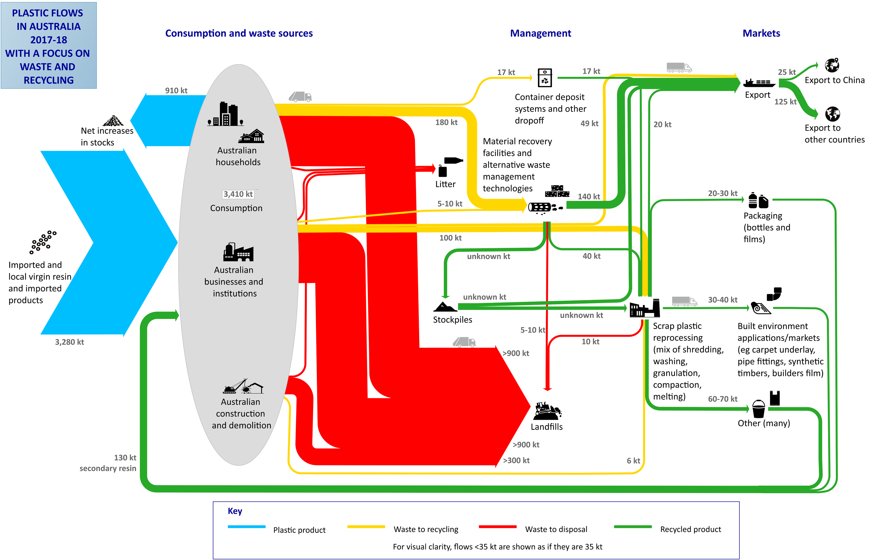

Plastics flows in Australia

Consumption
The main focus of this report is on the end-of-life fates and processing of plastic products. However, information on the consumption of new plastic products provides important context to understanding end-of-life arisings and outcomes. This section provides a high-level review of Australian plastics consumption in 2017–18, by polymer type and application area.

Consumption by polymer type
Outlined in Table 2 below is the estimated consumption of plastics in Australia during 2017–18, which totalled 3.4 million tonnes. This compares with an estimated consumption of 3.0 million tonnes in 2016–17.
Of this consumption, 38% was sourced from locally manufactured products from virgin resin (using both locally manufactured and imported resins), 4% was sourced from locally manufactured products made from processed recyclate, and 58% was sourced through imports of finished and semi-finished goods.

Table 2 – Australian plastics consumption by polymer type and source in 2017–18 (tonnes)
Polymer type | Local use of locally manufactured + imported resins | Imports of plastics in finished and semi-finished goods | Locally processed recyclate into local use | Australian consumption
PET (1) | 114 000 | 223 000 | 18 000 | 355 000
PE-HD (2) | 378 000 | 236 000 | 43 000 | 657 000
PVC (3) | 234 000 | 172 000 | 4 000 | 410 000
PE-LD/LLD (4) | 199 000 | 172 000 | 29 000 | 400 000
PP (5) | 176 000 | 274 000 | 19 000 | 469 000
PS (6) | 13 000 | 49 000 | 2 000 | 64 000
PS-E (6) | 51 000 | 35 000 | 2 000 | 87 000
ABS/SAN/ASA (7) | 10 000 | 57 000 | 1 000 | 67 000
PU (7) | 36 000 | 45 000 | 7 000 | 87 000
Nylon (7) | 11 000 | 115 000 | 0 | 126 000
Bioplastic (7) | 1 000 | 0 | 0 | 1 000
Other (7) | 75 000 | 142 000 | 1 000 | 218 000
Unknown polymer | 6 000 | 463 000 | 0 | 468 000
Total | 1 301 000 | 1 981 000 | 125 000 | 3 407 000
Source: Envisage Works (2019).
Figure 2 – Australian plastics consumption by polymer type and source in 2017–18 (tonnes)
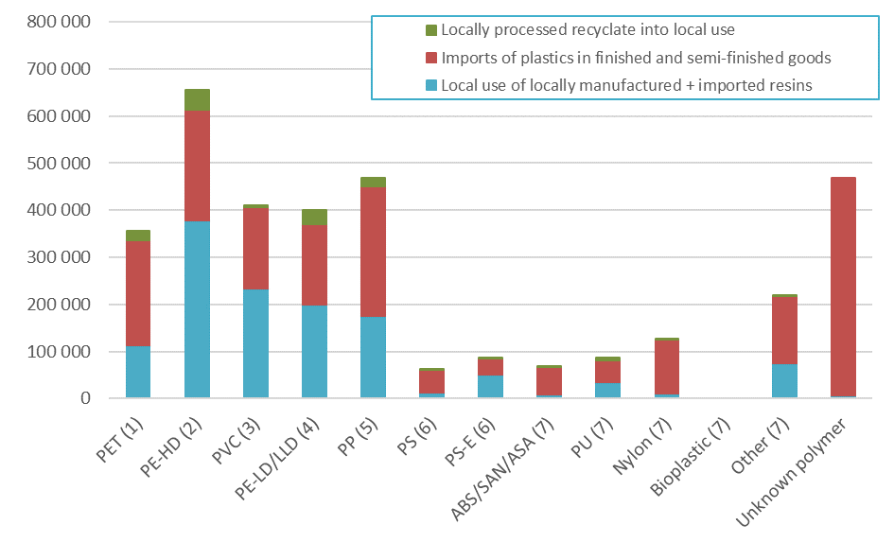
Source: Envisage Works (2019).

Consumption by application area
Presented in Table 3, Table 4 and Figure 3 is national plastics consumption in 2017–18 by application area. Consumption estimates of under 1 000 tonnes are reported as “<1000”.
Table 4 shows that the consumption of PET is predominately split between packaging and other applications (mainly clothing and textiles). HDPE and LDPE are mainly consumed in packaging applications, with PVC consumption dominated by built environment applications. PP consumption is primarily automotive, packaging and other application areas. A large proportion of PS goes into electrical and electronic applications, and EPS is spread more evenly across built environment, electrical & electronic and packaging applications.

Table 3 – Application area destinations of all plastics by polymer type in 2017–18 (tonnes)
Polymer type | Agriculture | Automotive | Built environment | Electrical & electronic | Packaging – municipal | Packaging – C&I | Other applic. area | Unidentified applications | Total
PET (1) | 3 000 | 5 000 | 26 000 | <1 000 | 117 000 | 12 000 | 145 000 | 49 000 | 355 000
PE-HD (2) | 26 000 | 7 000 | 86 000 | 9 000 | 230 000 | 134 000 | 124 000 | 39 000 | 656 000
PVC (3) | <1 000 | 20 000 | 277 000 | 37 000 | 21 000 | 0 | 38 000 | 16 000 | 410 000
PE-LD/LLD (4) | 51 000 | <1 000 | 11 000 | 6 000 | 144 000 | 139 000 | 27 000 | 20 000 | 400 000
PP (5) | 7 000 | 79 000 | 27 000 | 19 000 | 163 000 | 6 000 | 117 000 | 51 000 | 469 000
PS (6) | <1 000 | 0 | 7 000 | 34 000 | 15 000 | <1 000 | 8 000 | <1 000 | 64 000
PS-E (6) | 0 | 0 | 36 000 | 25 000 | 10 000 | 13 000 | 3 000 | 1 000 | 87 000
ABS/SAN/ASA (7) | 0 | 37 000 | 1 000 | 17 000 | 3 000 | 0 | 8 000 | <1 000 | 67 000
PU (7) | 0 | 24 000 | 25 000 | 1 000 | 0 | 0 | 35 000 | 2 000 | 87 000
Nylon (7) | 3 000 | 16 000 | 17 000 | 0 | <1 000 | 0 | 77 000 | 13 000 | 125 000
Bioplastic (7) | <1 000 | 0 | 0 | 0 | <1 000 | 0 | 0 | <1 000 | 1 000
Other (7) | <1 000 | 21 000 | 44 000 | 3 000 | 8 000 | 0 | 40 000 | 102 000 | 218 000
Unknown polymer | <1 000 | 10 000 | 21 000 | 38 000 | 80 000 | 0 | 216 000 | 103 000 | 468 000
Total | 91 000 | 220 000 | 579 000 | 189 000 | 790 000 | 304 000 | 838 000 | 396 000 | 3 407 000
Source: Envisage Works (2019).

Table 4 – Application area destinations of all plastics by polymer type in 2017–18 (%)
Polymer type | Agriculture | Automotive | Built environment | Electrical & electronic | Packaging – municipal | Packaging – C&I | Other applic. area | Unidentified applications | Total
PET (1) | 0.7% | 1.3% | 7.4% | 0.0% | 32.9% | 3.3% | 40.8% | 13.7% | 100.0%
PE-HD (2) | 4.0% | 1.1% | 13.1% | 1.4% | 35.0% | 20.5% | 19.0% | 5.9% | 100.0%
PVC (3) | 0.0% | 5.0% | 67.6% | 9.1% | 5.1% | 0.0% | 9.3% | 3.9% | 100.0%
PE-LD/LLD (4) | 12.8% | 0.0% | 2.8% | 1.5% | 36.1% | 34.9% | 6.8% | 5.1% | 100.0%
PP (5) | 1.5% | 16.8% | 5.8% | 4.0% | 34.8% | 1.3% | 25.1% | 10.8% | 100.0%
PS (6) | 0.1% | 0.0% | 11.1% | 52.8% | 23.0% | 0.0% | 11.9% | 1.0% | 100.0%
PS-E (6) | 0.0% | 0.0% | 41.0% | 28.5% | 11.2% | 14.5% | 3.5% | 1.3% | 100.0%
ABS/SAN/ASA (7) | 0.0% | 55.6% | 1.8% | 25.6% | 5.1% | 0.0% | 11.7% | 0.2% | 100.0%
PU (7) | 0.0% | 27.8% | 28.8% | 1.2% | 0.0% | 0.0% | 40.0% | 2.2% | 100.0%
Nylon (7) | 2.1% | 12.7% | 13.9% | 0.0% | 0.1% | 0.0% | 61.2% | 10.1% | 100.0%
Bioplastic (7) | NR | 0.0% | 0.0% | 0.0% | NR | 0.0% | 0.0% | NR | 100.0%
Other (7) | 0.2% | 9.9% | 20.3% | 1.2% | 3.6% | 0.0% | 18.2% | 46.7% | 100.0%
Unknown polymer | 0.1% | 2.0% | 4.5% | 8.1% | 17.1% | 0.0% | 46.1% | 22.1% | 100.0%
Total | 2.7% | 6.4% | 17.0% | 5.5% | 23.2% | 8.9% | 24.6% | 11.6% | 100.0%
Source: Envisage Works (2019).
NR: Not reported.

Figure 3 – Application area destinations of all plastics by polymer type in 2017–18 (tonnes)
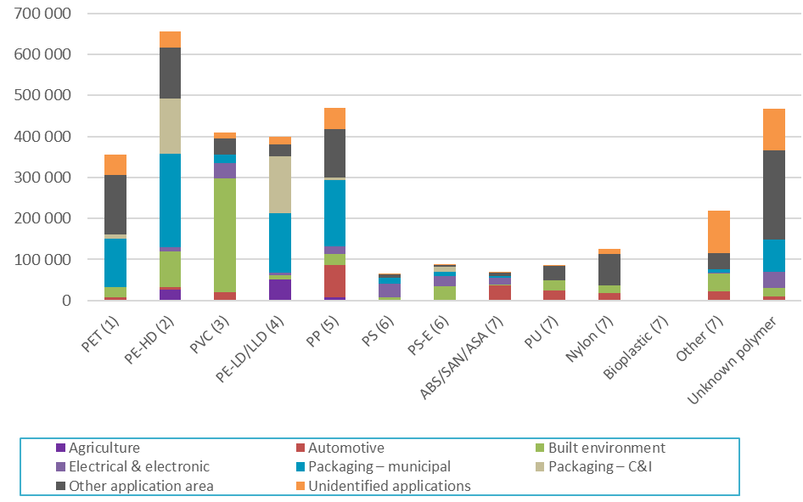
Source: Envisage Works (2019).

End-of-life
The national waste report (Blue Environment, 2018, p. 31) provides estimates of total plastics reaching end-of-life and entering waste streams in 2016–17. Total plastics waste generation is estimated at 2.5 million tonnes, with 300 000 tonnes to recycling, about 25 000 tonnes to energy recovery, and around 2.2 million tonnes to landfill. This allows the calculation of an estimated plastics recycling rate of 12% in 2016–17, in which end-of-life plastics arisings are estimated based on audits of plastics to landfill, plus plastics recovered for recycling.
It is worth noting that for the recycling rate calculations undertaken in Sections 3.3.2 and 3.3.3 of this report the ‘recycling rate’ is an approximation calculated by dividing plastics recovery in any given year, by consumption in that year. The value calculated using this method is 9.4%. A true recycling rate (or diversion rate) is calculated by dividing recovery by end-of-life arisings (i.e. the quantity of plastics that is available to be diverted to recycling from landfill).
The approximation of dividing recovery by consumption is adequate for short-lived plastic applications, such as packaging. However, it is less appropriate for plastics going into longer lived applications, such as the built environment, as it would be generally anticipated that in any given year less plastic is reaching end-of-life, than is going into use.
The estimate of total waste generation of 2.5 million tonnes appears reasonably consistent with the plastics consumption estimates provided in Section 3.1 of 3.4 million tonnes (2017–18 financial year data), allowing for plastics consumption into medium to longer term applications (greater than 12 months), ongoing growth in plastics consumption, and the use of plastics in applications that often do not enter waste streams at end-of-life (e.g. underground pipes).
The Australian ratio of plastics reaching end-of-life to primary plastics consumption (noting that this data is 2016–17 and 2017–18, respectively) is 76%. This is similar to a relatively recent global end-of-life to consumption ratio estimate of 74% in 2015 (Geyer, et al., 2017, p. 2).

Recovery

Recovery by waste stream
When assessed from a waste/disposal stream perspective, discarded materials are often divided into three waste streams, which are:
- Municipal sector – This sector is dominated by kerbside recycling.
- Commercial and industrial (C&I) sector – This sector includes both manufacturing scrap and post-consumer industrial.
- Construction and demolition (C&D) sector.
Presented in Table 5 and Figure 4 is plastics recycling by waste stream during 2017–18, during which period there were 320 000 tonnes of plastics recovered by local reprocessors or sent to export. In aggregate 51% of plastics were recovered from the municipal sector, 47% from the C&I sector, and 2% from the C&D sector.

Table 5 – Waste stream sources of recyclate by polymer type in 2017–18 (tonnes)
Polymer type | Municipal | Commercial and Industrial | Construction and demolition | Total
PET (1) | 60 000 | 15 000 | 0 | 75 000
PE-HD (2) | 72 000 | 25 000 | 2 000 | 98 000
PVC (3) | 2 000 | 3 000 | 1 000 | 6 000
PE-LD/LLD (4) | 2 000 | 54 000 | 0 | 57 000
PP (5) | 23 000 | 14 000 | 0 | 38 000
PS (6) | 2 000 | 4 000 | 1 000 | 7 000
PS-E (6) | 2 000 | 4 000 | 1 000 | 7 000
ABS/SAN/ASA (7) | 0 | 6 000 | 0 | 6 000
PU (7) | 0 | 6 000 | 1 000 | 7 000
Nylon (7) | 0 | 8 000 | 0 | 8 000
Bioplastic (7) | 0 | 0 | 0 | 0
Other (7) | 0 | 3 000 | 0 | 3 000
Unknown polymer | 0 | 10 000 | 0 | 10 000
Totals | 163 000 | 151 000 | 6 000 | 320 000
Source: Envisage Works (2019).
It's noted that there was no recycling of fibre reinforced plastics directly identified through the survey of Australian plastics recyclers

Figure 4 – Waste stream sources of recyclate by polymer type in 2017–18 (tonnes)
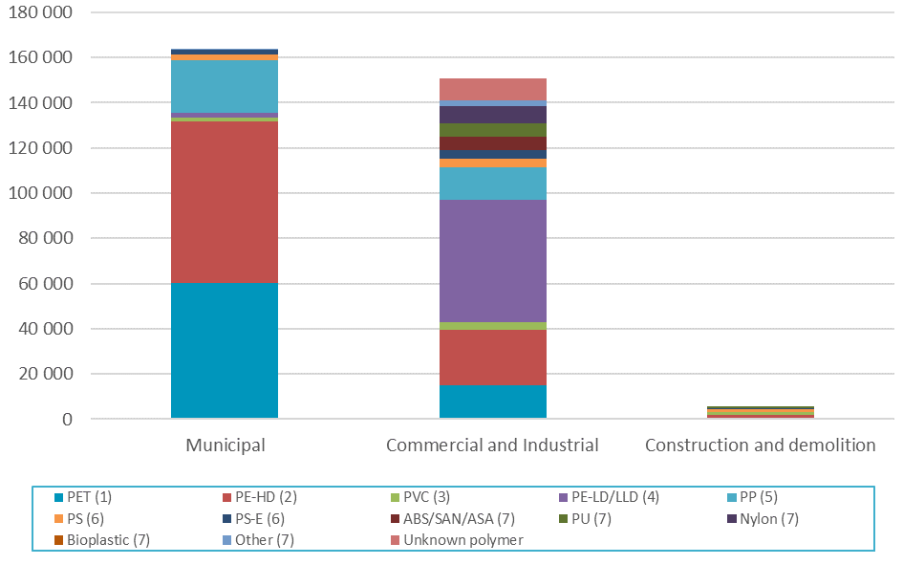
Source: Envisage Works (2019).

Recovery by polymer type
Presented in Table 6 and Figure 5 are plastics recycling rates by polymer type during 2017–18. The overall national recycling rate was 9.4%, a small decrease on the national recycling rate in 2016–17 of 9.8%.
Among the major polymer types the highest recycling rates were for PET (21%), HDPE (15%) and LD/LLDPE (14%). This reflects the relatively high proportion of the consumption of these polymer types going into packaging applications (both rigid and flexible), with the generally higher recycling rates of plastics going into packaging applications relative to other application areas.
Table 6 – Plastics consumption and recovery by polymer type in 2017–18 (tonnes and % recycling rate)
Polymer type | Recovery | Consumption | Recycling rate
PET (1) | 75 000 | 355 000 | 21.1%
PE-HD (2) | 98 000 | 656 000 | 15.0%
PVC (3) | 6 000 | 410 000 | 1.4%
PE-LD/LLD (4) | 57 000 | 400 000 | 14.3%
PP (5) | 38 000 | 469 000 | 8.0%
PS (6) | 7 000 | 64 000 | 11.5%
PS-E (6) | 7 000 | 87 000 | 7.6%
ABS/SAN/ASA (7) | 6 000 | 67 000 | 8.7%
PU (7) | 7 000 | 87 000 | 7.6%
Nylon (7) | 8 000 | 125 000 | 6.1%
Bioplastics (7) | 0 | 0 | 0.0%
Other (7) | 3 000 | 218 000 | 1.2%
Unknown polymer | 10 000 | 468 000 | 2.1%
Total | 320 000 | 3 407 000 | 9.4%
Source: Envisage Works (2019).

Figure 5 – Plastics consumption and recovery by polymer type in 2017–18 (tonnes and % recycling rate)
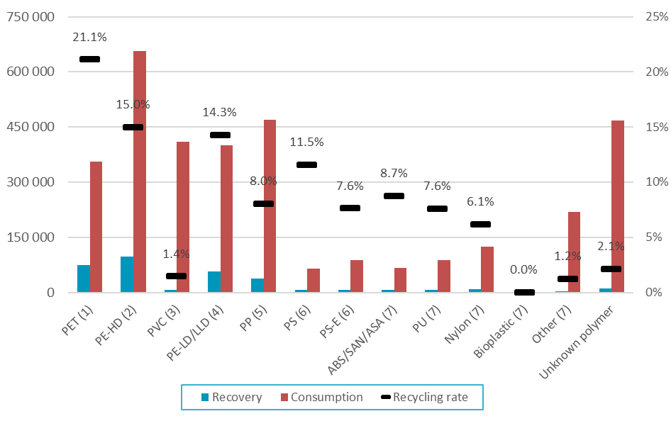
Source: Envisage Works (2019).

Recovery by application area
Presented in Table 7 and Figure 6 is summary data of plastics recovery across all application areas of plastics. Plastic packaging has the largest quantities of recovery, and the highest recycling rate of 20.6% (combined municipal and C&I). Packaging recovery is relatively good compared to all other application areas for plastics. All other recycling rates are well under 10%.

Table 7 – Plastics recovery and consumption by application area in 2017–18 (tonnes and % recycling rate)
Application area | Recovery | Consumption | Recycling rate
Agriculture | 6 000 | 91 000 | 7.0%
Automotive | 1 000 | 220 000 | 0.3%
Built environment | 6 000 | 579 000 | 1.0%
Electrical & electronic | 10 000 | 189 000 | 5.5%
Packaging – municipal | 163 000 | 790 000 | 20.7%
Packaging – C&I | 62 000 | 304 000 | 20.5%
Other application area | 58 000 | 838 000 | 7.0%
Unidentified applications | 13 000 | 396 000 | 3.2%
Total | 320 000 | 3 407 000 | 9.4%
Source: Envisage Works (2019).

It is important to note that the ‘recycling rate’ presented in the table above is an approximation calculated by dividing plastics recovery for recycling in any given year, by consumption in that year. A true recycling rate (or diversion rate) is calculated by dividing recycling recovery by end-of-life arisings (i.e. the quantity of plastics that is available to be diverted to recycling from landfill).
The aggregated plastics recycling rate for 2016–17 is estimated in the Australian National Waste Report 2018 (Blue Environment, 2018, p. 31) at 12%, in which end-of-life plastics arising are estimated based on audits of plastics to landfill, plus plastics recovered for recycling.
The approximation of dividing recycling by consumption is adequate for short-lived plastic applications, such as packaging. However, it is less appropriate for plastics going into longer lived applications, such as the built environment, as it would be generally anticipated that in any given year, less plastic is reaching end-of-life than is going into use. For this reason, the estimated recycling rates in these longer lived applications will be conservative and the true recycling rates will be marginally higher.

Figure 6 – Plastics recovery and consumption by application area in 2017–18 (tonnes and % recycling rate)
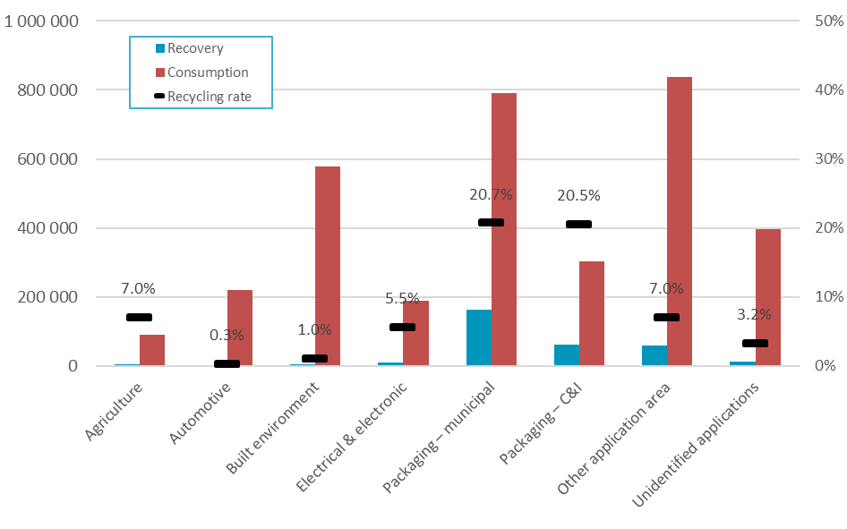
Source: Envisage Works (2019).

Recovery by export and local destination
Presented in Table 8 is overall plastics recycling, in terms of the destination of recovered recyclate for reprocessing (i.e. local reprocessing or export for reprocessing).
In total, 39% of recovered plastic scrap is processed locally and then used by local manufacturers in new products, 7% is processed locally and then sold to export markets, and 54% of collected scrap plastics is exported directly overseas without any local reprocessing being undertaken.

Table 8 – Australian plastics recycling destination by polymer type in 2017–18 (tonnes)
Polymer type | Locally reprocessed to local use | Locally reprocessed to export | Direct to overseas | Total recovery
PET (1) | 18 000 | 1 000 | 56 000 | 75 000
PE-HD (2) | 43 000 | 8 000 | 47 000 | 98 000
PVC (3) | 4 000 | 0 | 1 000 | 6 000
PE-LD/LLD (4) | 29 000 | 7 000 | 22 000 | 57 000
PP (5) | 19 000 | 1 000 | 18 000 | 38 000
PS (6) | 2 000 | 1 000 | 5 000 | 7 000
PS-E (6) | 2 000 | 3 000 | 2 000 | 7 000
ABS/SAN/ASA (7) | 1 000 | 0 | 5 000 | 6 000
PU (7) | 7 000 | 0 | 0 | 7 000
Nylon (7) | 0 | 0 | 7 000 | 8 000
Bioplastic (7) | 0 | 0 | 0 | 0
Other (7) | 1 000 | 1 000 | 1 000 | 3 000
Unknown polymer | 0 | 0 | 10 000 | 10 000
Total | 125 000 | 21 000 | 174 000 | 320 000
Source: Envisage Works (2019).

Energy recovery
The data previously outlined in Section 3.3 includes scrap plastics sent to energy recovery (primarily in SA). The combustion of waste plastics for energy recovery in 2017–18 is estimated to be around 10 000 tonnes (Envisage Works, 2019).

Recovered plastics grades and exports

Scrap plastic grades and markets
As outlined in Section 3.3.3 scrap plastics recovery is dominated by municipal kerbside collections of rigid plastic packaging (51% of total recovery), and C&I packaging (20% of total recovery). Significant components of C&I packaging recovery are: pallet film (mainly LDPE/LLDPE), pre-consumer packaging manufacturing scrap, HDPE and PP plastic drums and other rigid forms of business-to-business packaging, and EPS foam packaging.
Plastics collected through municipal kerbside collections are generally sent to MRFs and sorted from commingled recycling into either a single mixed plastics grade (PIC 1–7), or more commonly three grades, which are PET (PIC 1), HDPE (PIC 2) and the residual mixed plastics grade (PIC 3–7, including LDPE, with some residual PIC 1 and 2).

Figure 7 – Recovered plastics commodity values EXW ($/tonne) – June 2017 to August 2019
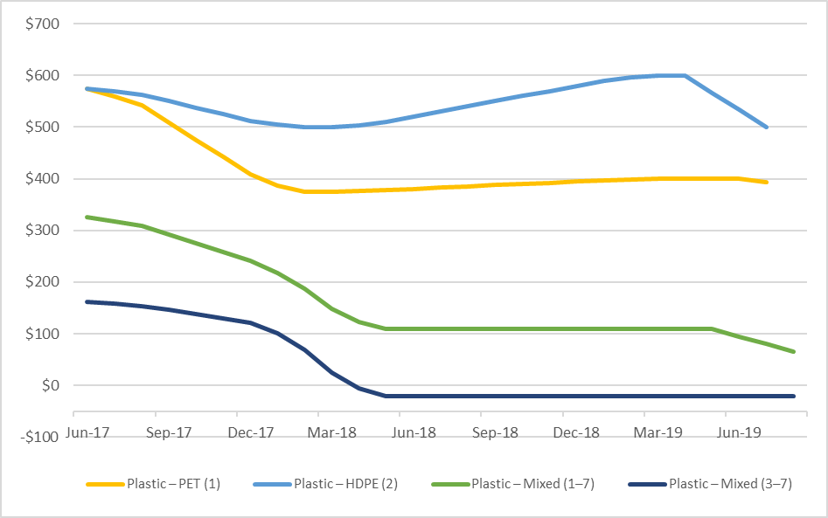
Source: SV (2019).
Plastic packaging prices are presented in Figure 7. Sorted PET and HPDE prices are down from longer term averages, and currently trading (as of August 2019) at around $400 /tonne (EXW) and $500 /tonne (EXW) respectively (SV, 2019).
The price of mixed plastics packaging has experienced much more significant falls than either PET or HDPE over the past year. Between mid-2015 and mid-2017 the price was generally in the range $300–$350 /tonne (EXW) for mixed plastics (1–7). Since then the price paid for this material has dropped sharply. By the end of March this year, the price had fallen to around $0 /tonne for mixed plastics coded 3–7 (which has been polymer sorted to remove PET (1) and HDPE (2)) and around $65 /tonne for mixed plastics coded 1–7 (i.e. no polymer sorting undertaken). The price is not anticipated to recover significantly for either of these product streams across the rest of 2019.
There are currently strong local and export markets for single polymer PET material that is collected and sorted to specification. The exception to this is the recovery of PET packaging that has modified polymer layers or film barriers (intended to improve barrier properties to light, moisture, carbon dioxide or oxygen), such as those going into some food and beverage packaging applications. This can hamper recycling and affect prices received.
It is understood that local reprocessing capacity constraints are placing a ceiling on the closed loop recycling of PET beverage packaging (and HDPE beverage packaging) back into beverage packaging. However, substantial new capacity is planned, see Section 5.6 for the available details on this new capacity.
The situation is similar for HDPE, as markets for clean material are fairly strong, but with some fall in prices over the last few months. Despite the loss of China as a market for this material (unless a contaminant level of 0.5% or less can be achieved), strong local and south-east Asian market destinations remain.
Prices for good quality LDPE film from C&I sources (e.g. pallet wrap and similar) are understood to have fallen over the last six months. However, reasonable quality data on market prices is not available. Mixed LDPE and other films from consumer packaging sources has little or no value.
Many local plastic recyclers seek post-industrial (rather than post-consumer) waste plastic as it is a more consistent feedstock with a single known polymer origin. By contrast, once the PET and HDPE fractions of the plastics are sorted, kerbside material is a mix of polymers coded 3–7 in poorly specified ratios (but still including significant proportions of PET and HDPE). This severely restricts the applications for this material.
Several plastic recyclers are geared to take mixed kerbside plastics and make a mixed polymer product suitable for applications such as posts, seating and boardwalks. The ability of these recyclers to accept mixed plastics is limited by demand for the finished products.
The key to resolving the market challenges for mixed plastic is a combination of:
- Better packaging design to specify more recyclable polymers (e.g. PET, HDPE, LDPE and PP) and to ensure that all components, such as labels, caps and adhesives, are compatible in the recycling system. As strong markets exist for PET, HDPE, LDPE and PP, the preferred use of these plastics in consumer packaging, without other polymer additives, would see more packaging sorted and sold at higher prices.
- More diligent sorting of the recycled material by automated and manual means. This could be achieved, for example, by upgrading polymer sorting equipment to positively identify and sort additional polymer types, such as; LDPE, polypropylene and polystyrene packaging, and additionally, to improve the current positive polymer sorting of PET and HDPE to increase sorting recovery rates. This would reduce the amount of mixed, low value plastic product being generated.
- Drive recycled content plastic products market pull-through with more supportive procurement practices from governments at all levels and major businesses, particularly those with a product stewardship exposure.
- The potential introduction of chemical recycling technologies to enable the recycling of mixed polymer, composite and other hard to recycle plastic products (e.g. textiles). See Section 6 for an overview of chemical recycling.
- Highly contaminated or composite scrap plastics to waste to energy.

Scrap plastics exports
In 2018–19 approximately 187 000 tonnes of scrap plastics were reported as exported from Australia under the HS 3915 working tariff export codes that cover exports of scrap plastics, compared with 158 000 tonnes in 2017–18, and 182 000 tonnes in 2016–17 (Blue Environment, 2019).
Note that the estimated 195 000 tonnes of exports of plastics in 2017–18 previously reported in Section 3.3.4 include estimates for scrap plastics exports other than those in HS 3915, mainly plastics in used clothing and e-waste.
Outlined in Table 9 are the four HS 3915 working tariff export codes that cover exports of scrap plastics and should be used when exporters send these waste-derived materials overseas. Note these are not always used as they are meant to.

Table 9 – Scrap plastics classified under each HS 3915 tariff code
Harmonised system (HS) tariff code | Overview of scrap plastics generally classified to each code
39151000 Waste, parings and scrap, of plastics –Of polymers of ethylene | No consistent classifications for exported polymers with inconsistent use of descriptors by local exporters and their freight forwarders, however, probably primarily consists of sorted HDPE packaging from municipal sources (e.g. milk bottles) and LDPE/LLDPE film packaging from C&I sources (e.g. pallet wrap).  May contain sorted PET bottles, even though PET is a polyester and not a polyethylene group plastic.
39152000 Waste, parings and scrap, of plastics –Of polymers of styrene | No consistent classifications for exported polymers with inconsistent use of descriptors by local exporters and their freight forwarders, however, probably primarily consists of sorted PS (from MSW sources) and EPS packaging (from C&I sources).
39153000 Waste, parings and scrap, of plastics –Of polymers of vinyl chloride | Only very low quantities exported, but probably primarily consists of post-industrial scrap from PVC product manufacturers (C&I sources).
39159092 Waste, parings and scrap, of plastics –Of other plastics | No consistent classifications for exported polymers with inconsistent use of descriptors by local exporters and their freight forwarders, however, probably primarily consists of mixed plastics packaging, across PET, HDPE, PVC, LDPE, PP and PS from MSW sources.  Also may include some disassembled and sorted e-waste plastics exports recovered (primarily) through the National TV and Computer Recycling Scheme (NTCRS).

Export code 39151000
The 39151000 code is dominated by exports of LD/LLDPE tertiary freight packaging film, which is primarily pallet wrap sourced through commercial collections of this material from major retailers and other business to business generators of this film. Over the last decade C&I film collections have become reasonably well established in most states where sufficient quantities are generated at commercial facilities to justify baling and collection. This packaging film is generally quite clean with low contamination levels, and is reasonably sought after.
Another significant contributor to the HS 39151000 code is baled milk and coloured HPDE bottles, sourced from material recovery facilities (MRFs) which undertake polymer specific sorting. This is defined as MSW packaging material. Opaque HDPE milk bottle bales are highly sought after both locally and internationally, and much of this material generated locally goes to local reprocessors and subsequently to local HDPE product manufacturers.
A proportion of baled PET bottles (MSW/packaging) may also be exported under 39151000, due to the presence of ‘polyethylene’ in its name, however PET is actually a polyester, and should arguably be exported under the 39159092 code. The proportion of PET exported under the 39151000 code versus the 39159092 code is unknown.

Export code 39152000
A significant contributor to the 39152000 code is exports of EPS packaging material, primarily sourced from C&I sources, and consisting of produce boxes from fruit and vegetable markets, supermarkets and other retail outlets. Smaller quantities of EPS packaging is also collected from electrical and electronic retail outlets, as well as other retail outlets that retain EPS packaging on large products, often as a value add service to customers. There is very little EPS packaging recovered nationally through MSW collections.
Another significant contributor to 39152000 is pre-consumer manufacturer scrap, which is high quality manufacturing scrap generated by PS and EPS product (both packaging and non-packaging) manufacturers.
A minor contributor to the HS 39152000 code is PS packaging (rigid containers) collected through MSW collections (MSW/packaging), however this material rarely sorted locally into a PS only bale, and is usually exported as a mixed polymer product, probably under 39159092.
Another potential source of PS exports is from e-waste processing (C&I/non-packaging), however again, this material is rarely sorted into a PS only bale and is more likely to be exported as a mixed polymer product under 39159092.

Export code 39153000
There is very little PVC scrap material exported from Australia. The small quantities that are exported are probably almost entirely very clean pre-consumer scrap from PVC product manufacturers. This is C&I/non-packaging material.

Export code 39159092
The 39159092 code is dominated by exports of mixed polymer material sourced from kerbside collections (municipal solid waste / MSW). This material is typically either a full PIC 1–7 mix (primarily PET and HDPE rigid packaging), produced by MRF operators that do not undertake any polymer sorting. The other major product is a PIC 3–7 mix, coming out of MRFs that do undertake a (typically) three-way polymer sort, for PET, HDPE and all other rigid plastic containers. The 3–7 mix still contains quantities of PET and HPDE. These mixed polymer MSW packaging mixed baled products often contain high levels of contamination with plastics films, glass fragments, labels, liquid paper board (LPB) packaging and any other rigid non-metal items that enter MRFs.
The other major contributors to 39159092 are probably baled PET bottles, sorted e-waste plastics (including whole computer peripherals such as keyboards and mice), pre-consumer manufacturing scraps of many types, and all other scrap plastics that cannot be readily allocated to the other three codes as previously outlined.
Provided in Figure 8 and Figure 9 on the following page are scrap plastics exports to all receiving countries.

Figure 8 – Australian exports of HS 3915 codes (scrap plastics) from July 2017 to May 2019
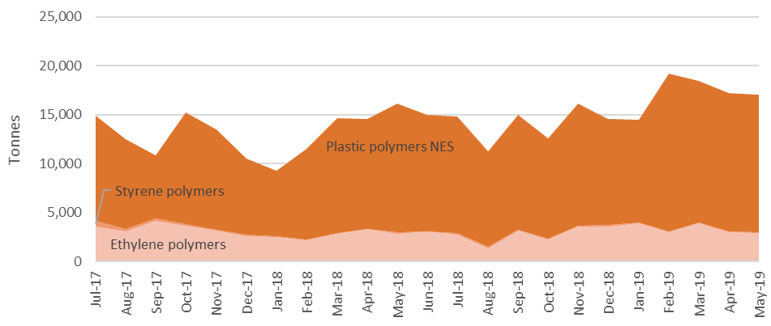
Source: Blue Environment (2019).

Figure 9 – Top 10 countries receiving Australian exports of HS 3915 codes (scrap plastics) from July 2017 to May 2019
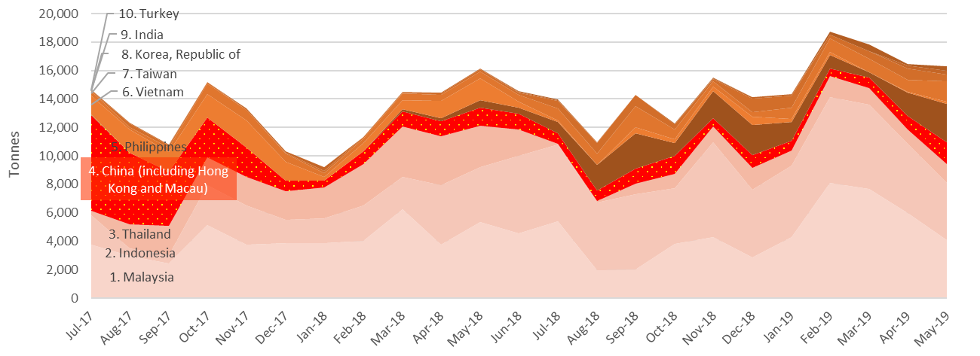
Source: Blue Environment (2019).

Across the four 3915 export codes and the 2018–19 year there were 187 kt of scrap plastics exported. These exports were mostly sent to the following countries:
- Indonesia received 63 kt (34% of exports)
- Malaysia received 55 kt (30% of exports)
- Philippines received 17 kt (9% of exports)
- Thailand received 11 kt (6% of exports)
- Taiwan received 11 kt (6% of exports)
- China received (only) 10 kt (5% of exports).

Recycled plastics product types
After reprocessing, recycled plastics are used to manufacture new products, with new applications typically quite different from those of the original use. The applications for recycled plastics are only slowly growing in Australia, and the size of the manufacturing base is small relative to the potential scrap plastics supply. Outlined in Table 10 are many of the uses of recycled plastics in Australia.

Table 10 – Typical uses of recycled plastics in Australia
Polymer | Major uses of recycled polymer | Minor uses of recycled polymer
PET | Beverage bottles | Timber substitutes, geo-textiles, pallets and fence posts.
PE-HD | Films, pallets, wheelie bins, irrigation hose and pipes | Cable covers, extruded sheet, moulded products, shopping and garbage bags, slip sheets, drip sheets for water, wood substitutes and mixed plastics products (e.g. fence posts, bollards, kerbing, marine structures and outdoor furniture), materials handling and roto-moulded water tanks.
PVC | Pipe, floor coverings | Hose applications and fittings, pipes including foam core pipes, profiles and electrical conduit, general extrusion and injection moulding, clothing, fashion bags and shoes.
PE-LD/LLD | Film (incl. builders’ and agricultural film, concrete lining, freight packaging, garbage bags, shopping bags), agricultural piping | Binder additive to asphalt, Trickle products, vineyard cover, pallets, shrink wrap, roto-moulding, slip sheets, irrigation tube, timber substitutes, cable covers, builders’ film, garbage bags, carry bags, and other building industry applications.
PP | Crates boxes and plant pots | Electrical cable covers, building panels and concrete reinforcement stools (bar chairs and shims), furniture, irrigation fittings, agricultural and garden pipe, drainage products (such as drain gates) and tanks, builders’ film, kerbing, bollards, concrete reinforcing and a wide variety of injection moulded products.
PS | Bar chairs and industrial spools | Office accessories, coat hangers, glasses, building components, industrial packing trays, wire spools and a range of extrusion products.
PS-E | Waffle pods for under slab construction of buildings | Synthetic timber applications (including photo frames, decorative architraves, fence posts), XPS (extruded polystyrene) insulation sheeting, and lightweight concrete.
ABS/SAN | Injection moulded products | Automotive components, laminate edging, sheet extrusion, coffin handles, drainage covers, auto parts and a range of injection moulded products.
Polyurethane | Carpet underlay | Mattresses
Nylon | Injection moulded products | Furniture fittings, wheels and castors and a range of injection moulded products.
Other and mixed | Timber substitute products in general and piping | Fence posts, bollards, garden stakes, kerbing, marine structures, post and rail systems, scaffold pads, piggery boards, shipping dunnage, rail bridge transoms.

Sorting and reprocessing infrastructure

Reprocessor numbers by state/territory
Presented in Table 11 is the available data on the numbers of reprocessors identified as operating in each state or territory. Data is provided for 58 reprocessing facilities nationally, out of 66 reprocessors known to be operating during 2017–18.
Many reprocessors handle more than one polymer type, resulting in improved depth to the reprocessing market. For example, in NSW there are 14 reprocessing facilities included in the survey dataset, however between them these facilities handled a total of 30 polymer types in aggregate across the facilities.
Almost all plastics recycling in Australia is undertaken mechanically, where the use of physical processes such as sorting, chipping, grinding, washing and extruding to convert scrap plastics to a usable input for the manufacture of new products is undertaken.
Mechanical recycling of polymer sorted scrap is much more developed in Australia and internationally than chemical recycling because it maintains the economic value of the polymer at a relatively high level and reduces the amount of energy required to manufacture new plastic products. An overview of chemical recycling is provided in Section 6 of this report.
Mechanical recycling is also the most economically viable for plastics that are available in large quantities, in a clean and homogenous (or sortable) form, and in locations with reasonable access to recycling facilities. Mixed polymer plastics can also be recycled mechanically, however, they are more challenging as they either need to be separated or recycled into a reduced range of mixed polymer product types. These mixed polymer products often have long lifespans, and may be recycled back into similar products at end of life.

Table 11 – Reprocessor counts by facility location and polymer types reprocessed in 2017–18
 | ACT | NSW | NT | QLD | SA¹ | TAS | VIC | WA | Total
Number of reprocessors | 0 | 14 | 0 | 9 | 6 | 2 | 25 | 2 | 58
Polymer reprocessed | Number of reprocessors in the jurisdiction reprocessing the polymer type
PET (1) | 0 | 3 | 0 | 1 | N/A | 0 | 6 | 1 | 11
PE-HD (2) | 0 | 7 | 0 | 5 | N/A | 2 | 13 | 2 | 29
PVC (3) | 0 | 3 | 0 | 1 | N/A | 1 | 5 | 0 | 10
PE-LD/LLD (4) | 0 | 4 | 0 | 3 | N/A | 0 | 11 | 2 | 20
PP (5) | 0 | 3 | 0 | 4 | N/A | 1 | 10 | 2 | 20
PS (6) | 0 | 2 | 0 | 1 | N/A | 0 | 8 | 0 | 11
PS-E (6) | 0 | 3 | 0 | 3 | N/A | 1 | 4 | 1 | 12
ABS/SAN/ASA (7) | 0 | 2 | 0 | 1 | N/A | 0 | 6 | 1 | 10
PU (7) | 0 | 1 | 0 | 0 | N/A | 0 | 1 | 0 | 2
Nylon (7) | 0 | 1 | 0 | 0 | N/A | 0 | 3 | 0 | 4
Biolastics (7) | 0 | 0 | 0 | 0 | N/A | 0 | 0 | 0 | 0
Other (7) | 0 | 1 | 0 | 0 | N/A | 0 | 2 | 2 | 5
Unknown polymer | 0 | 0 | 0 | 0 | N/A | 0 | 0 | 0 | 0
Total count | 0 | 30 | 0 | 19 | N/A | 5 | 69 | 11 | 134
1. SA data on the number of reprocessors handling each polymer type not available to be reported.
Source: Envisage Works (2019).

Reprocessing by state/territory
Presented in Table 12 and Figure 10 is data on recyclate movements to intrastate (same state), interstate and overseas reprocessors by source jurisdiction in 2017–18. Victoria and NSW have the largest reprocessing sectors with both jurisdictions locally reprocessing 37% and 30% respectively of recyclate that is recovered in each jurisdiction. SA and Queensland have smaller reprocessing sectors but reprocess around 61% and 53% respectively of recyclate generated locally within each state.

Table 12 – Recyclate to intrastate (same state), interstate and overseas reprocessors by source jurisdiction in 2017–18 (tonnes)
Destination jurisdiction | Source jurisdiction
 | ACT | NSW | NT | QLD | SA | TAS | VIC | WA | Total
ACT | 0 | 0 | 0 | 0 | 0 | 0 | 0 | 0 | 0
NSW | 600 | 26 100 | 0 | 3 400 | 3 600 | 100 | 1 300 | 300 | 35 500
NT | 0 | 0 | 0 | 0 | 0 | 0 | 0 | 0 | 0
QLD | 0 | 0 | 0 | 20 500 | 0 | 0 | 0 | 0 | 20 500
SA | 0 | 1 200 | 0 | 0 | 20 300 | 0 | 100 | 0 | 21 600
TAS | 0 | 0 | 0 | 0 | 0 | 900 | 0 | 0 | 900
VIC | 0 | 2 000 | 0 | 200 | 1 700 | 300 | 50 700 | 600 | 55 500
WA | 0 | 0 | 0 | 0 | 0 | 0 | 0 | 4 000 | 4 000
Overseas | 2 800 | 56 800 | 1 200 | 14 600 | 7 700 | 1 500 | 85 000 | 12 300 | 182 000
Total | 3 500 | 86 100 | 1 200 | 38 700 | 33 300 | 2 800 | 137 200 | 17 100 | 320 000
Source: Envisage Works (2019).

Figure 10 – Recyclate to intrastate (same state), interstate and overseas reprocessors by source jurisdiction in 2017–18 (tonnes)
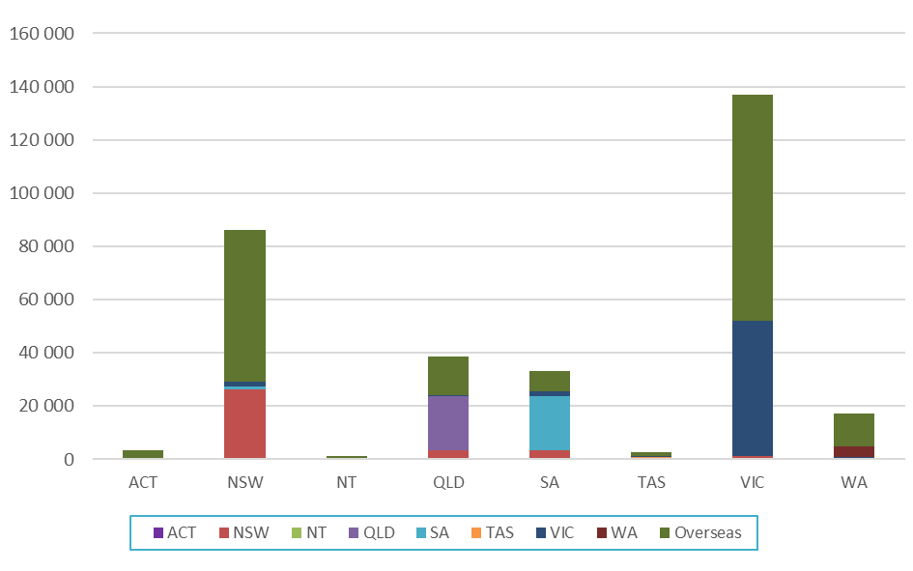

Reprocessing level by Australian reprocessors
Australian reprocessors undertake different levels of plastics reprocessing, from simple shredding, through to more advanced washing, granulating, pelletising and new product manufacturing activities. This processed scrap plastic can then be used internally (for new product manufacture), sold to local Australian manufacturers, or sold into export markets.
Presented in Table 13 and Figure 11 are estimates on the primary processing activity by Australian reprocessors in 2017–18, along with the local/export fates of the material. Note that many reprocessors process scrap plastics for internal product manufacturing, and sale to both local and overseas buyers.
In total, around 20% of recovered plastic scrap is processed for internal use, 65% is processed and then sold to local product manufacturers, and the remaining 15% is processed and then sold into export markets.
Around two thirds of the facilities for which the primary processing activity is known (36 out of 55 facilities) undertake reprocessing that then supplies a proportion of internal product manufacturing.

Table 13 – Primary processing activity by Australian reprocessors in 2017–18 (tonnes)
Primary processing activity | # facilities | Internal use | Local use | Export | Total
Sorting and shredding/granulation | 16 | 0 | 36 700 | 5 800 | 42 500
Sorting, shredding/granulation and pelletising | 2 | 0 | 9 300 | 900 | 10 200
Sorting, shredding/granulation and product manufacture | 31 | 17 400 | 42 200 | 1 200 | 60 800
Compaction and extrusion | 1 | 0 | 0 | 2 000 | 2 000
Compaction, extrusion and product manufacture | 5 | 800 | 0 | 300 | 1 100
Unknown | N/A | 11 500 | 7 200 | 10 400 | 29 100
Total | 55 | 29 700 | 95 400 | 20 500 | 145 700
Source: Envisage Works (2019).

Figure 11 – Primary processing activity by Australian reprocessors in 2017–18 (tonnes)
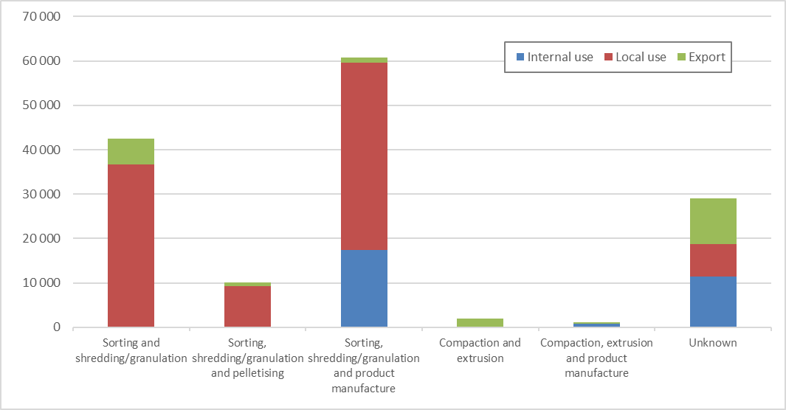
Source: Envisage Works (2019).

Reprocessing facility throughputs
Presented in Table 14 and Figure 12 are estimates of Australian plastics reprocessors categorised into throughput ranges for production in 2017–18. Note that potential facility capacity estimates are not available.
There were only eight facilities nationally identified as having a reprocessing throughput of more than 5 000 tonnes in 2017–18. These eight facilities reprocessed around half of all scrap plastics in Australia in 2017–18.

Table 14 – Reprocessing facility throughput in 2017–18 (tonnes)
Primary processing activity | # facilities | Internal use | Local use | Export | Total
<500 tonnes/yr | 24 | 2 700 | 1 200 | 600 | 4 400
500–1000 tonnes/yr | 6 | 1 800 | 1 600 | 600 | 4 100
1000–2000 tonnes/yr | 6 | 1 900 | 4 700 | 1 500 | 8 100
2000–5000 tonnes/yr | 11 | 3 700 | 24 900 | 4 600 | 33 200
>5000 tonnes/yr | 8 | 8 200 | 55 900 | 2 700 | 66 800
Unknown | N/A | 11 500 | 7 200 | 10 400 | 29 100
Total | 55 | 29 700 | 95 400 | 20 500 | 145 700
Source: Envisage Works (2019).

Figure 12 – Reprocessing facility throughput in 2017–18 (tonnes)
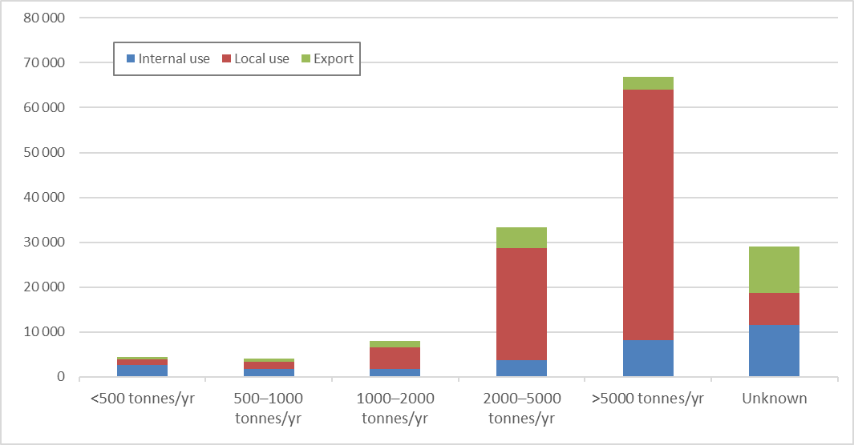
Source: Envisage Works (2019).

Top ten plastics reprocessors in Australia
Summarised in the following table is an alphabetical list of the ten plastics reprocessors in Australia that had the largest throughput during 2017–18. All of these companies had a throughput of at least 2,500 tonnes/yr.

Table 15 – Top ten Australian plastics reprocessing facilities in 2017–18 (by throughput)
Company | Locations
Action Products | QLD
Astron Sustainability | NSW/QLD/VIC
Cryogrind | VIC
Dunlop Flooring | NSW/VIC
GT Recycling | VIC
Martogg Group of Companies | NSW/QLD/VIC
Olympic Polymer Processors | VIC
Polymer Processors | VIC
Resitech Industries | QLD
Visy Recycling | NSW
Source: Envisage Works (2019).

Major changes in plastics reprocessor capacity
There are a number of significant new plastics reprocessing facilities that have recently been commissioned or are anticipated to commence in the next one to two years. The publicly available details on some of these facilities are summarised in the following table.

Table 16 – Major new Australian plastics reprocessing facilities
Facility name | Location | Reported capacity  (tonnes/yr) | Highest reprocessing level | Other comments
Advanced Circular Polymers (ACP) | Somerton VIC | Up to 70 000 tonnes | Sorting and shredding/granulation | Non-food grade flake production
Astron Sustainability | Unknown | 10 000–20 000 tonnes | Sorting, shredding/granulation and pelletising | Food grade rPET and rHDPE production
Martogg LCM | Unknown | 10 000–20 000 tonnes | Sorting, shredding/granulation and pelletising | Food grade rPET production
Recycled Plastics Australia | Kilburn SA | 10 000–20 000 tonnes | Sorting, shredding/granulation and pelletising | Non-food grade flake and pellet production
Source: Envisage Works (2019).

Scrap plastics to energy recovery and chemical recycling

Waste plastics to refuse derived fuels
Energy can be recovered from waste plastics through controlled combustion or conversion to a liquid fuel (See Section 6.2). Energy recovery may be a good option for plastics that are not suitable for mechanical recycling, such as contaminated products. There is now some controlled combustion occurring in Australia, however there is no commercial conversion to liquid fuels.
These types of fuels are often referred to as refuse derived fuels (RDF), which can be produced from wide range of combustible wastes from municipal, C&I and C&D waste streams.
There is growing energy recovery from plastics in Australia, dominated by the manufacture of a C&D waste based fuel (called a 'process engineered fuel' or PEF) that is processed in South Australia and New South Wales, for combustion in local and overseas cement kilns. Timber is the main energy source in this fuel. The quantity of waste plastics recovered nationally into refuse derived fuels is almost certainly well under 10 000 tonnes in 2017–18.
The split between the local and export fate of this material in unknown. Receiving countries for the exported PEF include the Philippines and Malaysia.
There is also the thermal treatment of medical waste, which contains a reasonably high proportion of plastics, however this is typically undertaken without energy recovery.

Chemical recycling of plastics and plastics to fuels
The chemical recycling of plastics, also called feedstock recycling, is the chemical processing (rather than mechanical) of post-consumer waste plastics to mixtures of chemicals that are typically quite different from the original plastic. There is a diverse range of chemical recycling technologies (mostly under development or early commercialisation) that can process waste plastics into a range of hydrocarbon products. It is important to note that the commercial viability of these technologies is a developing area.
While mechanical recycling offers a pathway for recycling relatively pure plastics, typically retaining much of the embodied material and energy value for use in new products, it is less suitable for plastic products made out of multiple polymer types or that are contaminated with other materials. And it has had very little success with recycling the huge quantity and diversity of plastic fibre-based materials, including clothing and carpets.
Even with relatively easy to collect and mechanically recycle plastic products, such as PET beverage bottles and HDPE dairy bottles, the limits of mechanical recycling to supply Australian demand for recycled content polymers are already being approached. This is the case even though there is less than a 20% post-consumer recycled content in these packaging formats (Envisage Works, 2019).
Chemical recycling typically converts the plastic polymers to a mixture of shorter chain liquid or gaseous hydrocarbons that are suitable for further purification, separation and chemical synthesis processes, potentially similar to the processing of crude oil into fuels and chemicals.
There is a Closed Loop Partners (2019) report that provides a good summary the current plastics chemical recycling technology landscape. The technology groups and products outlined in that report are reproduced in Figure 13.

Figure 13 – Plastics recycling technology groups and potential products
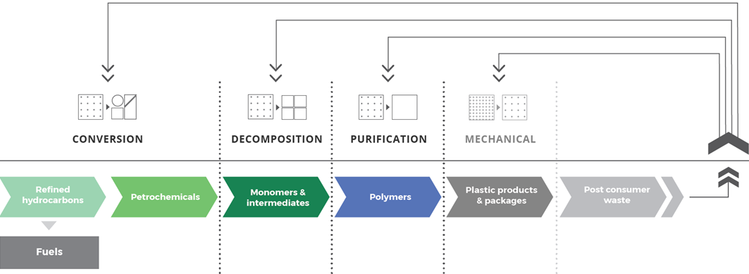
Source: Closed Loop Partners (2019, p. 25)

In Australia there is around 2.5 million tonnes of synthetic plastic products reaching end-of-life each year (excluding tyres), and only around 12% of this material was mechanically recycled in 2016–17 (Blue Environment, 2018, p. 31). There is a huge opportunity to recovery more of this material.
The recovered hydrocarbon mix could be used as a feedstock input into refineries. For example, the Mobil Altona Refinery in Victoria produces around 5 million tonnes of fuels and other chemicals each year. However, only a few percent of production goes into plastic resin manufacturing.
It is important to note that refineries globally are likely to be conservative about shifting feedstocks from virgin crude oil and gas to recovered hydrocarbons, for economic and technical reasons. However, the environmental impacts of climate change may force action over the next 5–10 years.
Hydrocarbons recovered from plastics are generally very low in sulphur, which could be a useful bonus for oil refineries. This is especially the case with fuel oil for ships moving to low sulphur fuel globally in 2020, removing this last major remaining low-cost disposal route for fossil hydrocarbon generated sulphur to the open environment.
The recovered hydrocarbon mixes are more likely initially to be diverted into small scale specialty chemical manufacturing facilities, which may produce a very diverse range of chemicals and/or fuels.
Many of the chemical recycling technologies are suitable for either biobased or fossil-based hydrocarbons, so could be part of the transition to lower dependency on non-renewable resources, and do not ‘lock-in’ dependency on fossil reserves. These technologies may rather be an enabler of the decoupling of hydrocarbon fuels and plastics from dependency on fossil hydrocarbons, to a renewably based hydrocarbon fuel and plastics paradigm.

References
Blue Environment, 2018. Australian National Waste Report 2018, Melbourne: Report prepared by Blue Environment and Randell Environmental Consulting on behalf of the Department of the Environment and Energy.
Blue Environment, 2019. ABS waste data export from Australia, Melbourne: Report prepared by Blue Environment on behalf of the Department of the Environment and Energy.
Closed Loop Partners, 2019. Accelerating circular supply chains for plastics, s.l.: Closed Loop Partners.
Envisage Works, 2019a. 2017–18 Australian Plastics Recycling Survey – National report, Melbourne: Prepared by Envisage Works and Sustainable Resource Use on behalf of the Department of the Environment and Energy.
Geyer, R., Jambeck, J. R. & Law, K. L., 2017. Production, use, and fate of all plastics ever made. Science Advances, 3(7), p. e1700782.
SV, 2019. Recovered Resources Market Bulletin – September 2019, Melbourne: Report prepared by Envisage Works, Industry Edge and Sustainable Resource Use on behalf of Sustainability Victoria.

Plastics identification code.
EXW – Ex. Works. This is an Incoterm (trade term) defining the sale (transfer of ownership) of goods at the gate of the seller, which is define as the outgoing MRF gate in this report.
The use of chemical processes such as pyrolysis to convert scrap plastics into a hydrocarbon gas or liquid (often a polymer to monomer conversion) that is usable as a fuel or as an input for manufacturing plastics resins.

