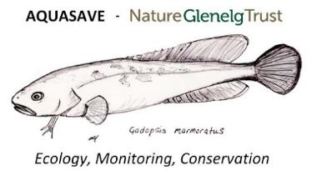



The population status of Murray crayfish in the Edward/Kolety-Wakool system to inform water management

**Nick Whiterod, Dean Gilligan and Sylvia Zukowski**

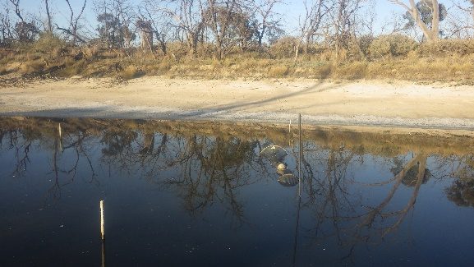Report to Commonwealth Environmental Water Office



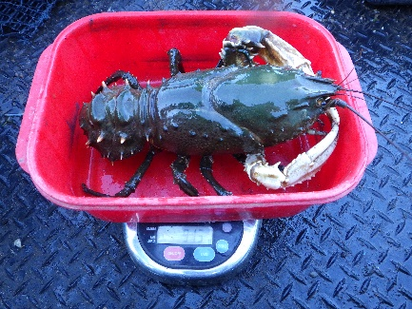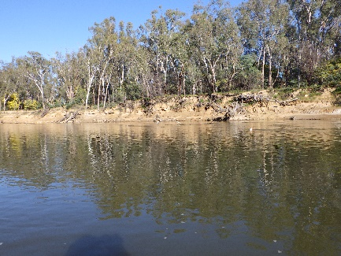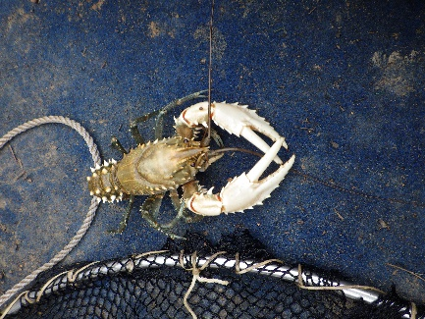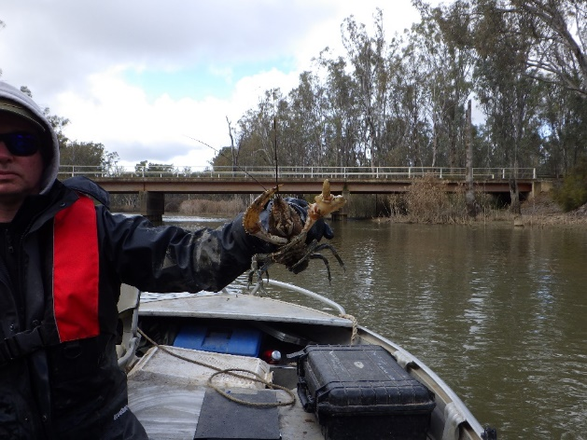

**April 2021**

*This report may be cited as:*

Whiterod, N., Gilligan, D. M., and Zukowski, S. (2021). The population status of Murray crayfish in the Edward/Kolety-Wakool system to inform water management. Report to the Commonwealth Environmental Water Office. Aquasave–Nature Glenelg Trust and NSW DPI (Fisheries), Victor Harbor.

**The population status of Murray crayfish in the Edward/Kolety-Wakool system to inform water management** is licensed by the Commonwealth of Australia for use under a Creative Commons By Attribution 3.0 Australia license with the exception of the Coat of Arms of the Commonwealth of Australia, the logo of the agency responsible for publishing the report, content supplied by third parties, and any images depicting people. For license conditions see: <http://creativecommons.org/licenses/by/3.0/au/>

The Commonwealth of Australia has made all reasonable efforts to identify content supplied by third parties using the following format ‘© Copyright’.

**Disclaimer**

The views and opinions expressed in this publication are those of the authors and do not necessarily reflect those of the Australian Government or the Ministers for the Department of Agriculture, Water and the Environment.

While reasonable efforts have been made to ensure that the contents of this publication are factually correct, the Commonwealth does not accept responsibility for the accuracy or completeness of the contents, and including Aquasave–NGT and NSW DPI (Fisheries), shall not be liable for any loss or damage that may be occasioned directly or indirectly through the use of, or reliance on, the contents of this publication.

**Correspondence in relation to this report contact:**

Dr Nick Whiterod

Aquatic Ecologist

Aquasave‒Nature Glenelg Trust

MOB: 0409023771

nick.whiterod@aquasave.com.au

**Acknowledgements**

This project was funded by the Australian Government through the Commonwealth Environmental Water Office (CEWO), Department of Agriculture, Water and the Environment. Thanks to Katherine Reid and Damian McRae (CEWO) for initiating and managing the project and reviewing drafts of the report. Field assistance was provided by Ruan Gannon and Cory Young (Aquasave−NGT) and Tim McGarry and Duncan McLay (NSW DPI (Fisheries)). Thanks to Martin Asmus and Paul O’Connor (NSW DPI (Fisheries)) for provision of previous sampling data. All sampling in 2020 was undertaken in accordance with NSW DPI Scientific Collection Permit (P18/0023-2.0), Animal Research Authority (The Secretary’s Animal Care and Ethics Committee), and NSW National Parks & Wildlife Service Scientific Licence (SL1021143) to permit sampling within Murray Valley National Park.

*Acknowledgement of the Traditional Owners of the Murray–Darling Basin*

We respectfully acknowledge the Traditional Owners, their Elders past and present, their Nations of the Murray–Darling Basin, and their cultural, social, environmental, spiritual, and economic connection to their lands and waters.

**Background**

The Murray crayfish *Euastacus armatus* is the second largest freshwater crayfish in the world and a valuable recreationally fished species in the southern Murray-Darling Basin (MDB), Australia (Figure 1). The species is endemic to the Murrumbidgee and Murray River Catchments, including the mid-Murray River anabranches such as those across the Edward/Kolety-Wakool system (Gilligan et al. 2007). The species has experienced significant declines in distribution and abundance over the past 70 years (Forbes et al. 2020; Whiterod and Zukowski 2017; Whiterod and Zukowski 2019; Whiterod et al. 2017; Whiterod et al. 2018; Zukowski et al. 2018). These declines have been attributed to river regulation, pollution and overfishing (Gilligan et al. 2007). Increasingly, the impacts of hypoxic blackwater disturbance appear to have been realised on the species. Whilst blackwater is a natural occurrence, the magnitude and prolonged nature of the 2010−11 event was unprecedented (Whitworth et al. 2012). In response, a 81% reduction in Murray crayfish relative abundance was observed in impacted areas of the Murray River (McCarthy et al. 2014).

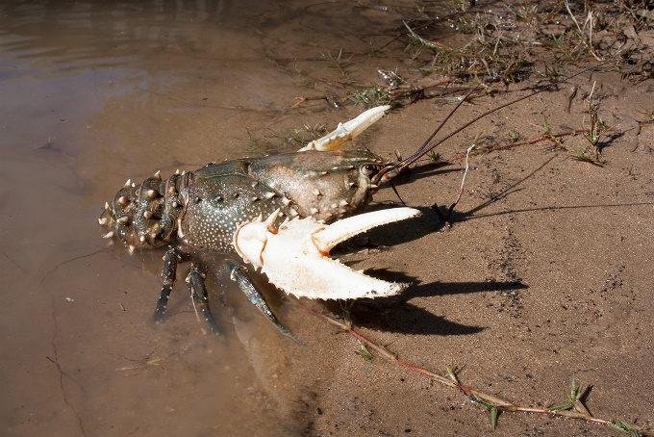*Figure 1. Murray crayfish Euastacus armatus [Nick Whiterod].*

The species is now threatened across much of its historical range. Acknowledgement of historical declines, the impacts of the 2010−11 blackwater disturbance and unexplained declines in the Murrumbidgee River, prompted listing of the species as Vulnerable and recreational fisheries were closed in impacted areas of NSW (NSW DPI 2014). Recreational fishing/take of Murray crayfish in the Edward/Kolety River system and its tributaries is currently not permitted at any time of the year (DPI 2020). Since this time, there has been research into genetic status (Whiterod et al. 2017), development and utilization of a population model (Todd et al. 2018) and population monitoring to address knowledge deficiencies. Monitoring has included continuation of targeted sampling in specific portions of its range (Noble and Fulton 2017; Whiterod et al. 2018) as well as state-wide benchmarking across SA (Whiterod and Zukowski 2019), Victoria (Whiterod and Zukowski 2017) and NSW (NSW DPI (Fisheries) and Aquasave−NGT, unpublished data). From this combined work, it is evident that the species remains absent from some areas but may be slowly rebuilding in others (cf. Todd et al. 2018), and proactive management actions are required to aid conservation of the species.

Under the Murray Darling Basin Plan (MDBA 2012), environmental water is to be managed to maintain and restore the health of water-dependent species and ecosystems (MDBA 2019), with Murray crayfish identified as a target species in Long-term Water Plans for both the Murrumbidgee and Murray & lower Darling surface water resource plan areas(NSW DPIE 2019a; NSW DPIE 2019b). This has included the Edward/Kolety-Wakool system where Commonwealth environmental water has been delivered since 2009 to sustain base flows and freshes, extend the duration natural flow events, deliver environmental water from irrigation canal escapes to create local refuges during hypoxic blackwater events, and contribute to flows in ephemeral watercourses (Watts et al. 2019; Watts et al. 2015). Since 2017, winter environmental flows have been provided to maintain longitudinal connectivity and prevent disconnection of the smaller tributaries into series of disconnected pools. It has been demonstrated that winter flows benefit other native species, however for Murray crayfish this is yet to be evaluated. Guidance on further flow management strategies is lacking for the species, due to a lack of understanding of its specific flow requirements (Gilligan et al. 2007). In 2020, the Commonwealth Environmental Water Office (CEWO) commissioned this project to address several specific objectives (see below) that seek to inform its approach to the delivery of environmental water in the Edward/Kolety-Wakool system.

A 2020 NSW state-wide Murray crayfish stock assessment, including several sites in the Edward/Kolety-Wakool system, allows comparison with benchmarking undertaken during 2012−14. Complimenting the state-wide stock assessment with additional targeted sampling within the Edward/Kolety-Wakool system provided an opportunity to gain a better understanding of temporal trends across the Edward/Kolety-Wakool system, and broader comparison with the outcomes of the 2020 stock assessment. The specific objectives of this project were to:

* Undertake targeted sampling in the Edward/Kolety-Wakool system, including in Stevens Weir weirpool;
* Provide access to benchmarking sites from 2012−2014 (15 sites) and 2020 (7 sites) along with 2015 sampling for comparative purposes;
* Prepare a report to the CEWO that (a) includes an analysis of the data collected, (b) draws on other available data and knowledge, and (c) provides insight into the:
  + Present status of Murray crayfish in the Edward/Kolety-Wakool system, specifically in relation to the Stevens Weir weirpool and compared to the population across the broader range of the Murray crayfish;
  + Anticipated flow requirements of the species; and
  + Management of the species and the Edward/Kolety River and mid-Murray tributaries specifically relating to the following questions?
    - Does the delivery of environmental water significantly impact the abundance of the Murray crayfish within and below Stevens Weir pool?
    - What are the potential impacts (positive and negative) of delivering winter flows on Murray crayfish?
    - How does removing/lowering Stevens Weir during winter influence (a) Murray crayfish in the weir pool and (b) other environmental assets in the rest of the Edward/Kolety-Wakool River system (including the Yallakool-Wakool and Colligen-Niemur River systems).

The assessment of the status of Murray Crayfish in the Edward/Kolety-Wakool system provided by the present study provides an opportunity a platform for greater incorporation of the needs of the species in the water management in the system.

**Methods**

*Study sites*

The study focused on the Edward/Kolety-Wakool system of the Murray River Catchment (Figure 2 and Table 1). These mid-Murray anabranches inflow from the Murray River near Picnic Point within the Barmah-Millewa Forest and travel north and then northwest before discharging back into the Murray River. The system is a complex network of interconnected streams, ephemeral creeks, flood-runners and wetlands (Watts et al. 2019). The system is highly regulated through a range of flow management infrastructure, irrigation channel offtakes and outfalls as well as releases from major upland storages (Baumgartner et al. 2014). The Stevens Weir on the Edward/Kolety River is a major regulatory structure, which creates an approximately 35 km weirpool upstream of the structure.

*Table 1.* *Survey sites in the Edward/Kolety-Wakool system sampled in 2020. For each waterway, sites are listed from upstream to downstream, with Edward/Kolety River sites in the Stevens Weir weirpool indicated by (wp).*

|  |  |  |  |  |  |
| --- | --- | --- | --- | --- | --- |
| Site no. | Waterway | Site Name | Date sampled | Latitude | Longitude |
| 1 | Edward/Kolety River | 5km downstream Edward Regulator | 20/8/2020 | -35.812 | 144.963 |
| 2 | Edward/Kolety River | Four Posts | 5/8/2020 | -35.602 | 144.993 |
| 3 | Edward/Kolety River | Powerlines | 7/9/2020 | -35.572 | 144.994 |
| 4 | Edward/Kolety River | Twin Rivers (wp) | 19/8/2020 | -35.541 | 144.990 |
| 5 | Edward/Kolety River | Deniliquin (wp) | 18/8/2020 | -35.517 | 144.962 |
| 6 | Edward/Kolety River | Many Waters (wp) | 9/9/2020 | -35.483 | 144.870 |
| 7 | Edward/Kolety River | Greg Graeme Reserve (wp) | 19/8/2020 | -35.446 | 144.797 |
| 8 | Edward/Kolety River | ds Stephens Weir (Phils property) | 9/9/2020 | -35.422 | 144.744 |
| 9 | Edward/Kolety River | Moulamein | 3/8/2020 | -35.091 | 144.010 |
| 10 | Edward/Kolety River | Kyalite State Forest | 29/7/2020 | -34.971 | 143.533 |
| 11 | Gulpa Creek | Gulpa Runner | 17/8/2020 | -35.754 | 144.906 |
| 12 | Yallakool Creek | Yallakool/Back Creek Junction | 30/7/2020 | -35.461 | 144.771 |
| 13 | Colligen Creek | Coll2 | 4/8/2020 | -35.417 | 144.586 |
| 14 | Wakool River | Fasham’s | 18/8/2020 | -35.542 | 144.365 |
| 15 | Wakool River | Kyalite | 29/7/2020 | -34.954 | 143.478 |

Under regulated conditions, flows in the Edward/Kolety River and tributaries remain within the channel, whereas during high flows there is connectivity between the river channels, floodplains and several large forests including the Barmah-Millewa Forest, Koondrook-Perricoota Forest and Werai Forest, which represent potential sources of hypoxic blackwater under certain conditions (e.g., overbank flows during summer).

Between 1986 and 2017, Murray crayfish populations have been sampled at 25 sites. This included four sites surveyed in 1986 (O’Connor 1986), 21 sites as part of state-wide benchmarking over 2012‒2014 (NSW DPI (Fisheries), unpublished data), four sites (repeat sampled on 4 occasions) in 2015 for a population size estimate study (Zukowski et al. 2018) and five sites sampled by NSW DPI (Fisheries) in 2017 as part of ongoing monitoring (NSW DPI (Fisheries), unpublished data). As part of the present study (and complimentary state-wide benchmarking), 15 of the sites previously surveyed were revisited (Figure 2 and Table 1). The 2020 sites were surveyed during winter months when Murray crayfish catches are highest (Zukowski et al. 2012).

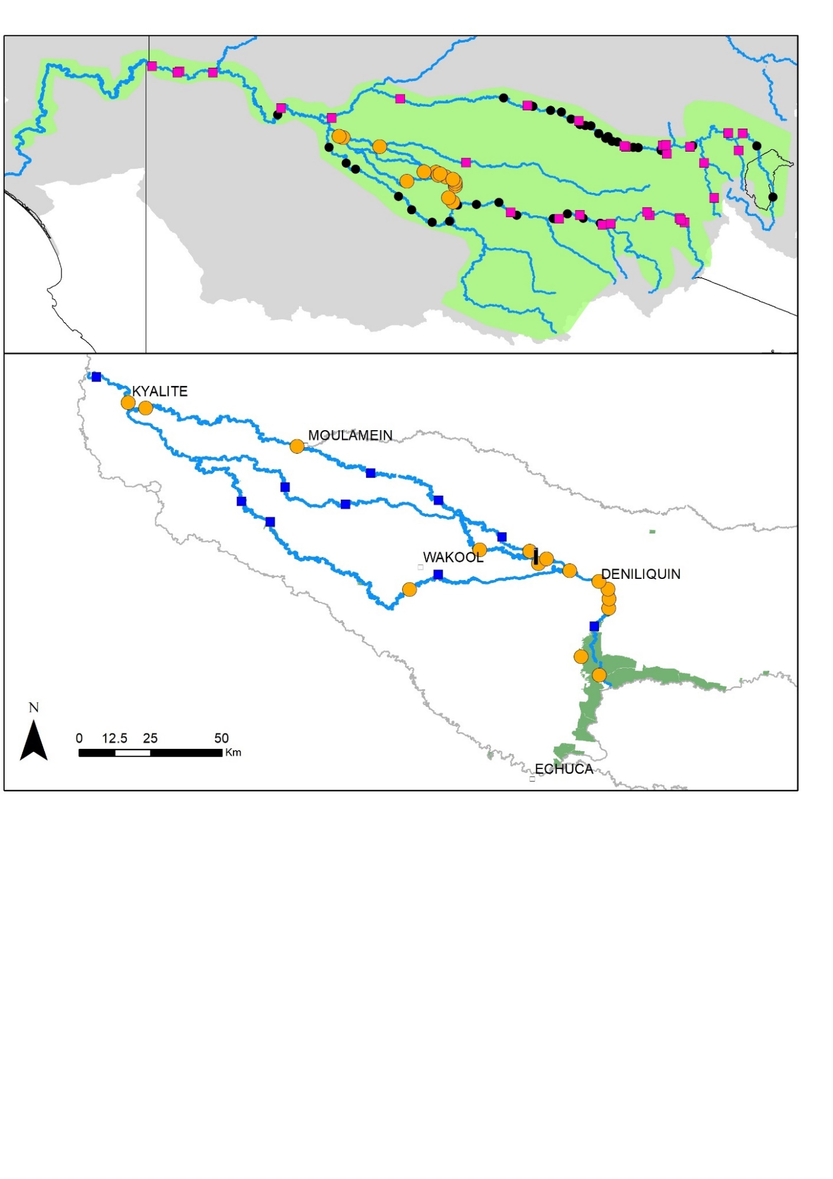

**(b)**

**(a)**

*Figure 2. (a) Sites sampled as part of long-term monitoring of the Murrumbidgee and Murray rivers (black dots), the 2020 stock assessment (pink squares) and the present study (orange circles) and (b) present sites along with historical sites (blue squares) in the Edward/Kolety River-Wakool system (data provided by NSW DPI (Fisheries) and Aquasave−NGT).*

*Survey protocol and data collection*

Consistent with benchmark and stock assessment sampling, the targeted survey sites were sampled using two types of sampling gear (hoop and Munyana nets) to maximise the probability of detection. At each site, 20 replicate single hoop nets (700mm diameter with a mesh size of 13mm) baited with approximately 300g of ox liver or common carp (*Cyprinus carpio*) were set and checked hourly (and deployed at the same location) for a total of three hours (60 hoop net hauls per site) during daytime hours (0800–1700) following established protocols (Whiterod and Zukowski 2017). At each site, 10 Munyana nets, a type of commercially available crab net (Munyana net, Wishart, Queensland: 60mm mesh, two 0.76m diameter steel hoops and two 0.18m × 0.12m openings), were baited (300g ox liver or common carp) were deployed. Water quality parameters (water temperature, pH, dissolved oxygen concentration and electrical conductivity) (YSI 556 multi-probe) and percentage cover of habitat were recorded at each site.

Sampled Murray crayfish were sexed, weighed (W, in g) using waterproof scales (A&D weighting, Tokyo, Japan) and occipital carapace length (OCL, measured from the rear of the eye socket to the middle of the rear of the carapace, to the nearest 0.1 mm) was measured using Vernier calipers (Kinchrome, Scoresby, Victoria, Australia) (Figure 3).

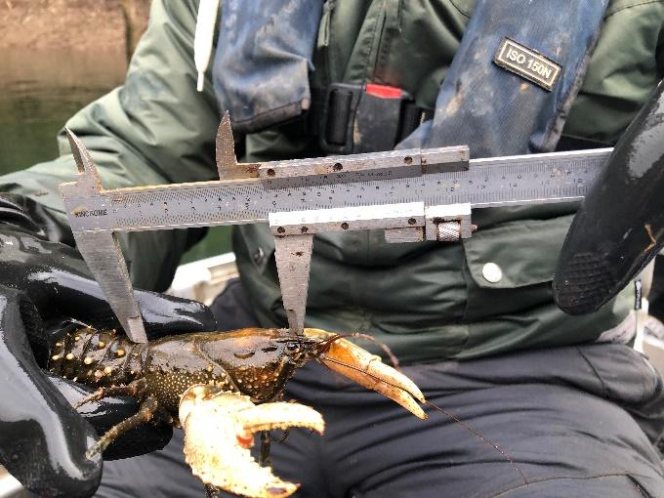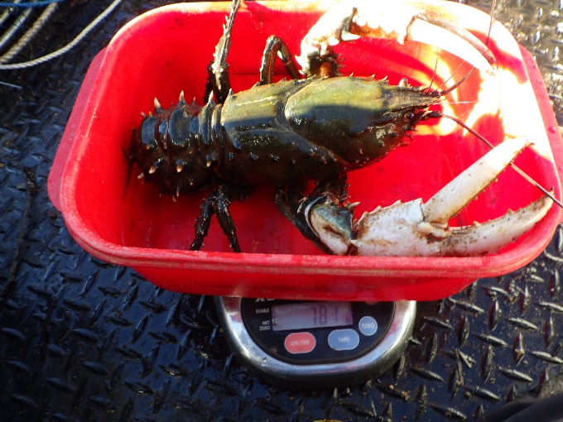

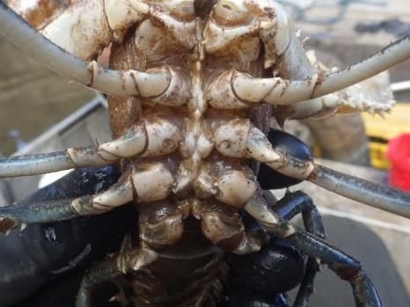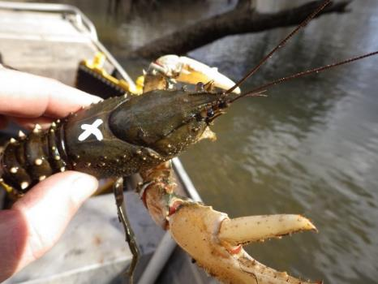

*Figure 3. Processing sampled Murray crayfish: measuring length (top left); weight (top right); temporarily marking (to detect recaptures) (bottom left); and sexing (female gonopores highlighted with green circles) (bottom right).*

The stage of maturity (stages 1–3: following Turvey and Merrick 1997) and the presence of eggs was recorded for females . Additionally, each crayfish was marked using a Uni PAINT PX-20 marker (Mitsubishi Pencil Co. Ltd, Milton Keynes, UK: see Ramalho et al. 2010) to identify potential recaptures (during sampling event) before being returned to the water at the point of capture. These marks persist for months (potentially until the next moult which occurs annually in adult crayfish) and have been employed successfully for a medium-term mark-recapture study on the species (Zukowski et al. 2018).

*Data treatment and reporting*

The catch data was summarised in terms of sex ratio (males to females), length structure (using 10mm bin classes) grouped across all sites (due to low numbers). Further, the length-at-age relationship (*L*age= 192.8*(1 – *e*(-0.0843(age + 0.3752)), where the *L*age is the occipital carapace length at a certain age) for the Murray population (Gilligan et al. 2007; O’Connor 1986), was used to provide insight into age structure across sampled sites. The percentage of sexually mature females in each 10mm bin class was determined, and then fitted by means of the logistic equation (Zukowski et al. 2012; Zukowski et al. 2013):

$$M=\frac{100}{1+{\left(\frac{L}{{SOM}_{50}}\right)}^{b}}$$

Where *M* is the percentage of females in a size class, *L* is the OCL (mm), *SOM*50 is the length at which 50% of females are mature (*SOM*), and *b* is a constant. These analyses were performed using Systat, v12 (Systat Software Inc. Richmond, CA, USA).

For comparative purposes, catch data from hoop nets only was collated from previous surveys, the 2020 stock assessment and the targeted survey of the Edward/Kolety-Wakool system and presented as catch-per-unit-effort (CPUE) abundance (as crayfish net-1 h-1; hereby referred to as relative abundance) to allow insight into spatial and temporal trends.

**Results**

*Catch summary*

In 2020, a total of 42 Murray crayfish were sampled from sites within the Edward/Kolety-Wakool system (Figure 4). Murray crayfish were recorded at only seven of the 15 sampling sites, with the majority of individuals recorded at one site, Edward/Kolety River – Deniliquin (n=24). Six crayfish were recorded at Edward/Kolety River – Four Posts site, four crayfish at two sites (Edward/Kolety River – downstream Stevens Weir (Phils property); Edward/Kolety River – Twin Rivers) and less than two crayfish were recorded from the remainder of sites (Edward/Kolety River – Powerlines, n=2; Edward/Kolety River – 5km downstream Edward Regulator, n=1; Colligen Creek – Coll2, n=1). Relative abundance ranged from zero to 0.27 CPUE across the 15 sampling sites.

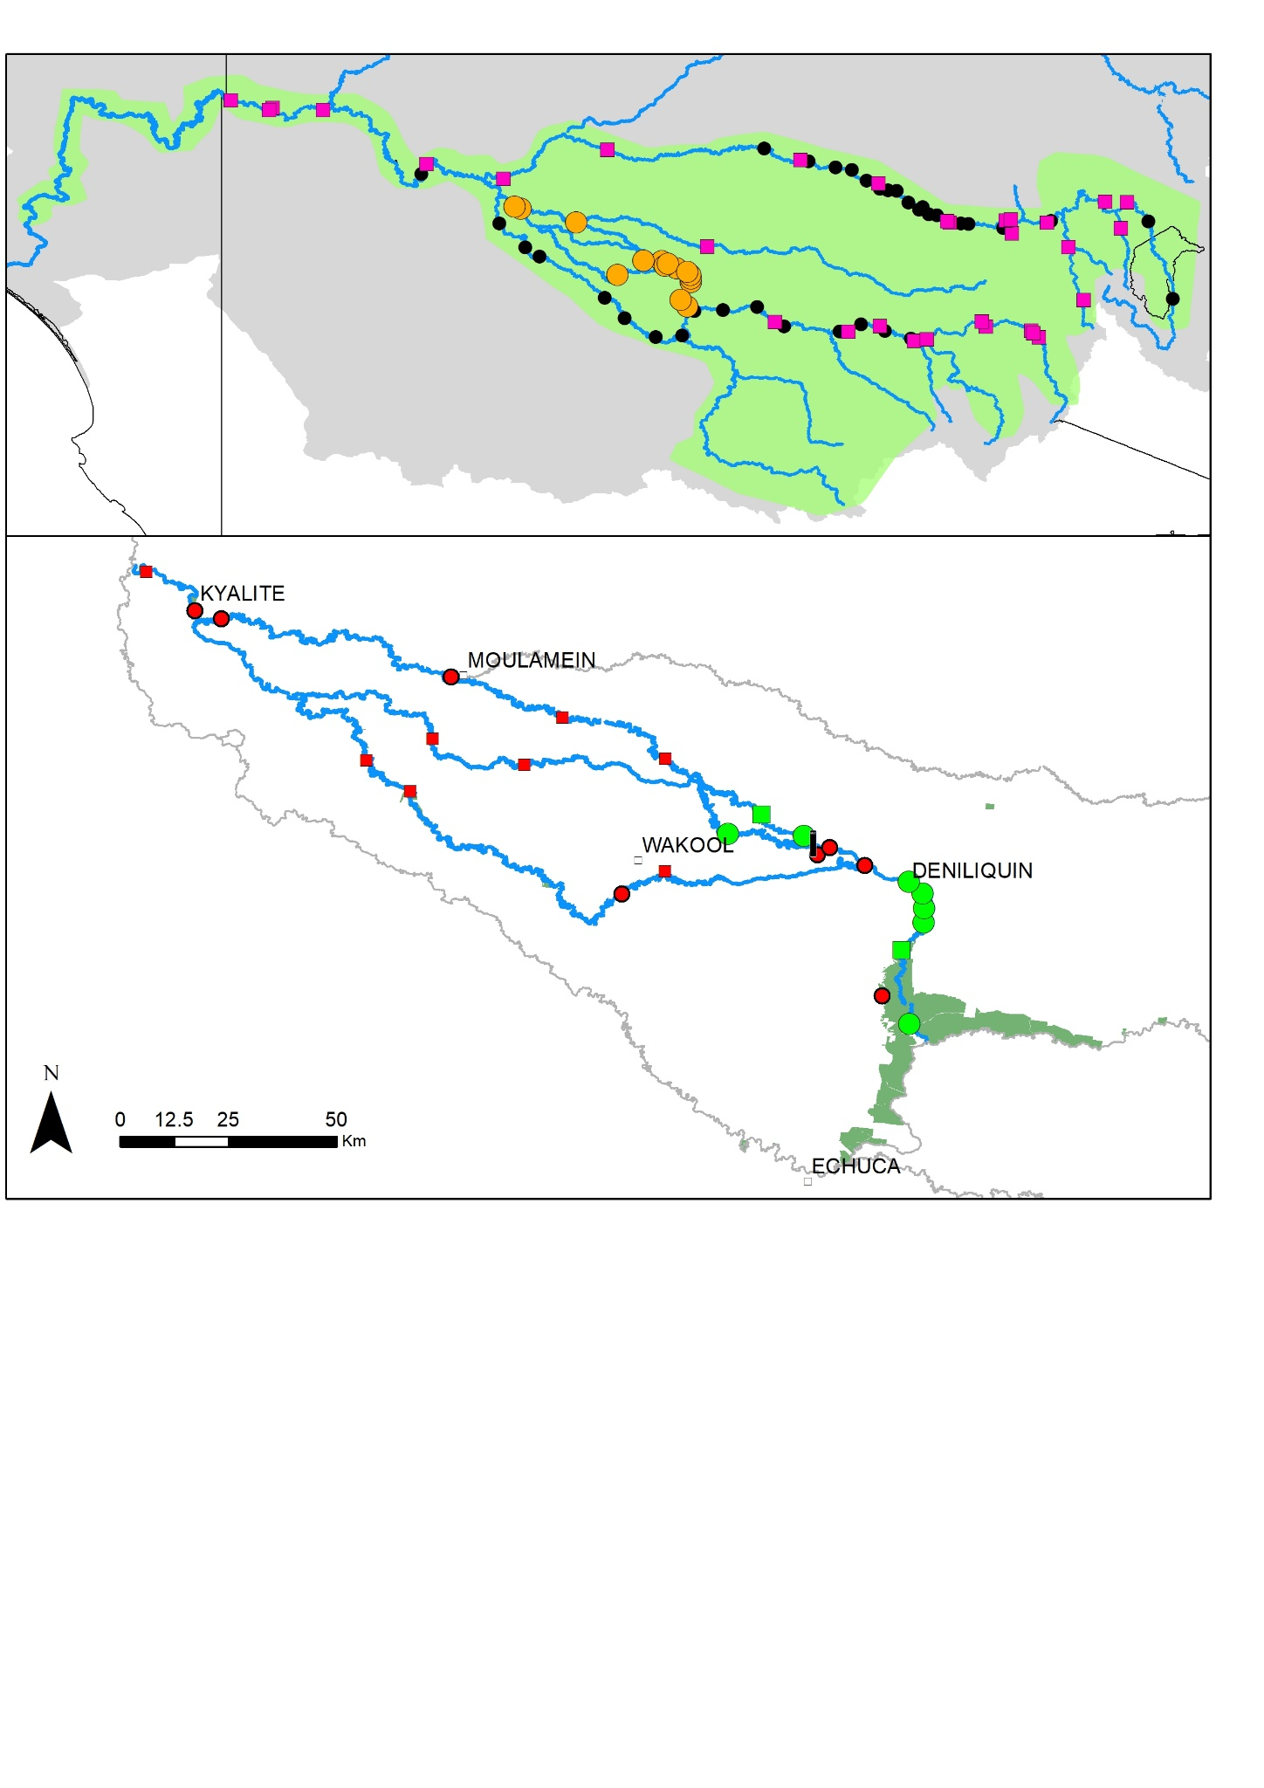

*Figure 4. Presence (green) and absence (red) of Murray crayfish at sites across the Edward/Kolety-Wakool system during the present study (circles) and previously (squares). Note this all from both hoop and Munyana nets.*

Sampled crayfish ranged between 49‒140mm OCL and 56.6‒1305g (Figure 5). All Murray crayfish sampled appeared in good health with no obvious deformities, disease, or parasite infestations apparent. There were 19 males and 22 females sampled (sex ratio was 0.86 : 1, males : females). Of the 22 females recorded, ten were sexually mature and all but one was carrying eggs (i.e., in berry) with three being in full berry and remaining individuals having less than half egg capacity. The *SOM*50 was estimated at 87.51±0.86mm OCL, indicating that, on average, 50% of females are sexually mature at this length.

Using the established age-length relationship, the indicative age of sampled crayfish is between three and 15 years. The length structure (of all individuals caught), was predominately represented (i.e., 46% of catch) by individuals between 80‒100mm (indicatively between 6‒8 years old).

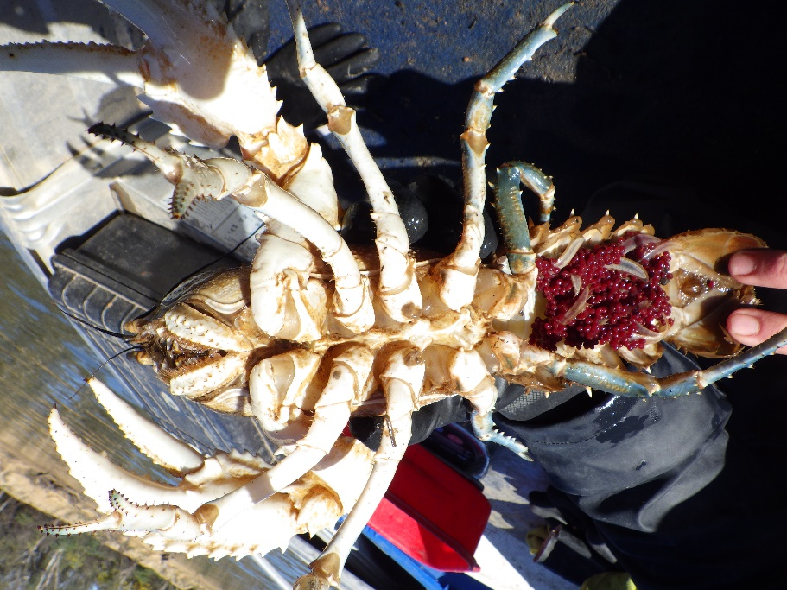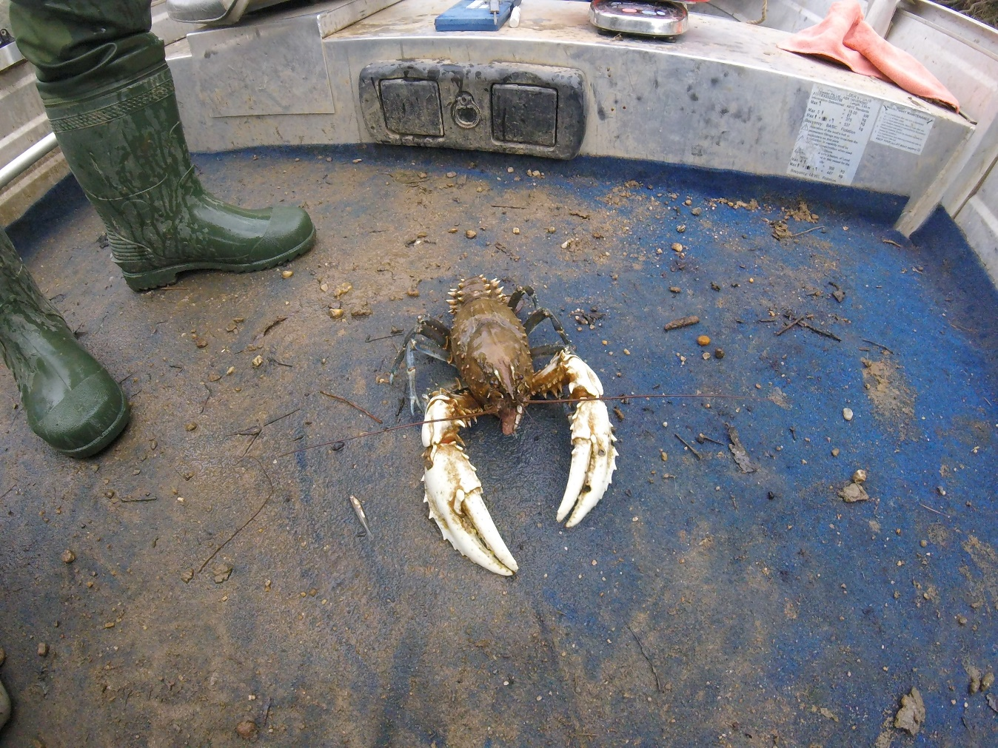

*Figure 5. Sampled Murray crayfish: mature females carrying eggs (in berry) (left) and large male (right).*

*Environmental descriptors*

At the time of sampling, water quality parameters and habitat cover were broadly suitable for the species at all sites (Figure 6). Namely, pH (7.82−8.15) dissolved oxygen (9.6−10.8mgL-1), electrical conductivity (EC, 52−137µScm-1) and water temperature (11.8−12.8°C) were all unlikely to be impacting on the species. Further, all sites maintained low to moderate habitat cover deemed suitable for the species.

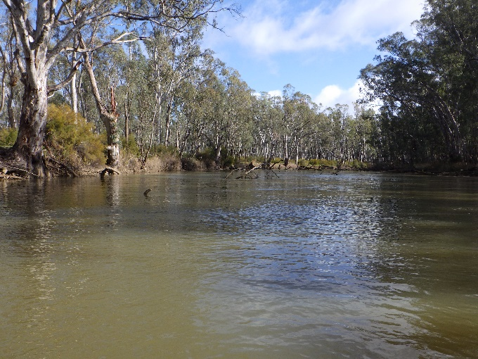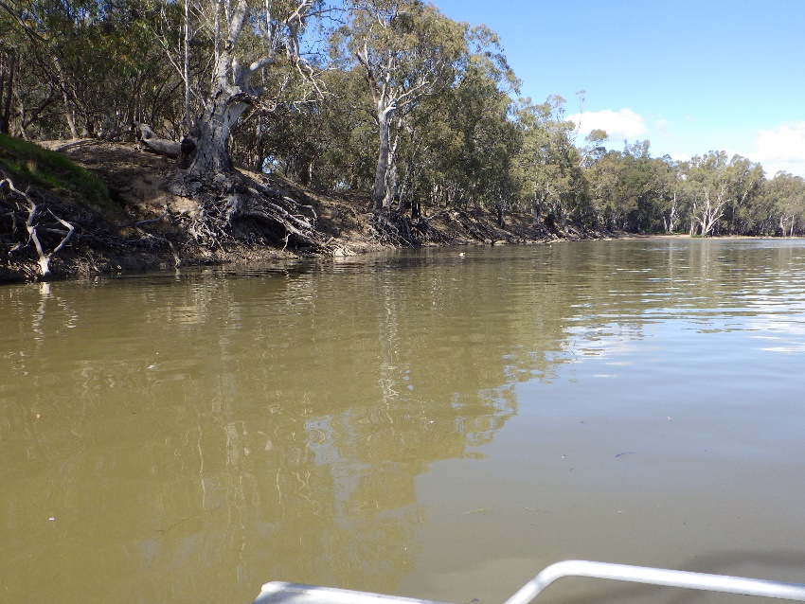

*Figure 6. Sites sampled for Murray crayfish during 2020: Edward/Kolety River – 5km downstream Edward Regulator (left); Edward/Kolety River – Deniliquin (right).*

*Changes over time*

The long-term dataset (of hoop net only data) in the Edward/Kolety River and mid-Murray anabranches represents patchy and infrequent snapshots of the status of the species, with 55 sampling events of 25 sites occurring over 1986 to 2020 (Table 2). In 1986, the relative abundance of Murray crayfish was relatively low (0-0.12 CPUE) across the four surveyed sites. Between 2012 to 2020, it is evident that relative abundance had declined over time. For some sites, this decline was relatively gradual (e.g., Edward/Kolety River – Greg Graham Reserve), whilst at others relative abundance dropped over the past three sampling periods (i.e., 2015→2020). For instance, relative abundance dropped from 0.34 CPUE (2015), 0.17 (2017) to 0.03 (2020) at the Edward/Kolety River – Twin Rivers and roughly half at the Edward/Kolety River – Deniliquin (2015: 0.55 CPUE; 2017: 0.15; 2020: 0.27) and Edward/Kolety River – downstream Stephens Weir (Phils property, 2015: 0.17 CPUE; 2017: 013; 2020: 0.07) sites. For other sites where at least two sampling events are available, such as Edward River – Four Posts (2014: 0.12 CPUE; 2020: 0.03), Edward/Kolety River – Many Waters (2014: 0.06 CPUE; 2020: zero), Edward/Kolety River – Moulamein (2014: 0.02 CPUE; 2017: 0.02; 2020: zero), Edward/Kolety River – Powerlines (2014: 0.2 CPUE; 2020: zero), similar declining trends are apparent. Overall, the species appears absent (i.e., not detected at all between 2012 and 2020, or not detected in 2020) from 54% of the 26 survey sites. The species appears restricted to the Edward/Kolety River at Deniliquin (within the Stevens Weir weirpool); the free-flowing section from the Murray River junction to the top of the Stevens Weir weirpool and directly below Stephens Weir; and at least part of the way along Colligen Creek.

Further insight into population status is provided by comparing the length structure of individuals sampled over time (Figure7). Comparing 2020, with the previous years, a shift from a length structure with larger crayfish to one with greater representation of smaller individuals. For instance, advanced juveniles (e.g., <70mm OCL) were more represented in 2017 (25.0% of population) and 2020 (12.2%) than previous years (2012: 8.6%; 2013: 2.0%; 2014: 6.3%; 2015:0.7%). Similarly, there were fewer large individuals (>100mm OCL) in 2017 (21.0% of population) and 2020 (36.6%) compared to other years (2012: 60.0%; 2013: 42.0%; 2014: 52.9%; 2015: 67.4%).

*Table 2.* *Survey sites in the Edward/Kolety-Wakool system sampled in 2020. For each waterway, sites are listed from upstream to downstream, with Edward/Kolety River sites in the Stevens Weir weirpool indicated by (wp).*

|  |  |  |  |  |  |  |  |  |
| --- | --- | --- | --- | --- | --- | --- | --- | --- |
| River | Location | 1986 | 2012 | 2013 | 2014 | 2015 | 2017 | 2020 |
| Edward/Kolety River | 5km downstream Edward Regulator | ns | ns | 0.02 | 0.01 | ns | ns | 0.02 |
| Edward/Kolety River | Edward River d/s Gulpa Ck | ns | ns | ns | 0* | ns | ns | ns |
| Edward/Kolety River | Four Posts | ns | ns | ns | 0.12 | ns | ns | 0.03 |
| Edward/Kolety River | Powerlines | ns | ns | ns | 0.2 | ns | ns | 0* |
| Edward/Kolety River | Twin Rivers (wp) | 0 | ns | ns | 0.61 | 0.34 | 0.17 | 0.03 |
| Edward/Kolety River | Deniliquin (wp) | ns | 0.27 | 0.28 | ns | 0.55 | 0.15 | 0.27 |
| Edward/Kolety River | Many Waters (wp) | ns | ns | ns | 0.06 | ns | ns | 0 |
| Edward/Kolety River | Greg Graham Reserve (wp) | ns | ns | 0.09 | 0.05 | 0.03 | 0 | 0 |
| Edward/Kolety River | ds Stephens Weir (Phils property) | ns | ns | Ns | 0.26 | 0.17 | 0.13 | 0.07 |
| Edward/Kolety River | Moona | ns | ns | 0.04 | ns | ns | ns | ns |
| Edward/Kolety River | Werai State Forest | 0 | 0 | 0 | ns | ns | ns | ns |
| Edward/Kolety River | Papanue | ns | ns | ns | 0 | ns | ns | ns |
| Edward/Kolety River | Moulamein | 0.12 | 0 | ns | 0.02 | ns | 0.02 | 0 |
| Edward/Kolety River | Kyalite State Forest | 0.006 | ns | ns | 0* | ns | ns | 0 |
| Edward/Kolety River | Allandale | ns | ns | ns | 0 | ns | ns | ns |
| Gulpa Creek | Gulpa Runner | ns | ns | ns | ns | ns | ns | 0 |
| Yallakool Creek | Yallakool/Back Creek Junction | ns | ns | ns | ns | ns | ns | 0 |
| Colligen Creek | Coll2 | ns | ns | ns | ns | ns | ns | 0* |
| Niemur River | Ventura | ns | 0 | ns | ns | ns | ns | ns |
| Niemur River | Nacurrie Road bridge | ns | ns | 0 | ns | ns | ns | ns |
| Wakool River | Wakool reserve bridge | ns | 0 | ns | ns | ns | ns | ns |
| Wakool River | Fasham's | ns | ns | ns | ns | ns | ns | 0 |
| Wakool River | Gee Gee Bridge | ns | 0 | 0 | ns | ns | ns | ns |
| Wakool River | Oberon | ns | ns | 0 | ns | ns | ns | ns |
| Wakool River | Kyalite | ns | 0 | ns | ns | ns | ns | 0 |
| Total numbers caught | | 19 | 35 | 50 | 189 | 141 | 28 | 42 |

*Sites where at least one individual was collected in Munyana nets despite registering as 0 CPUE for hoop nets.

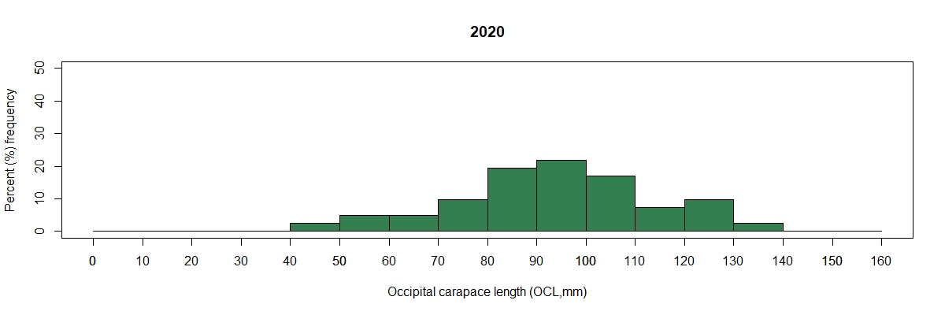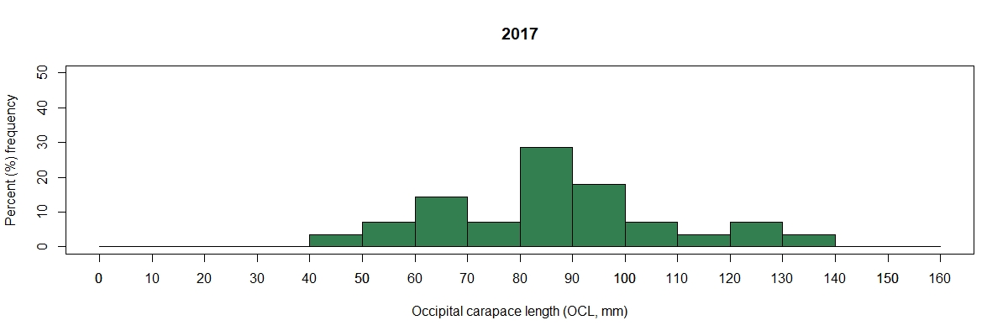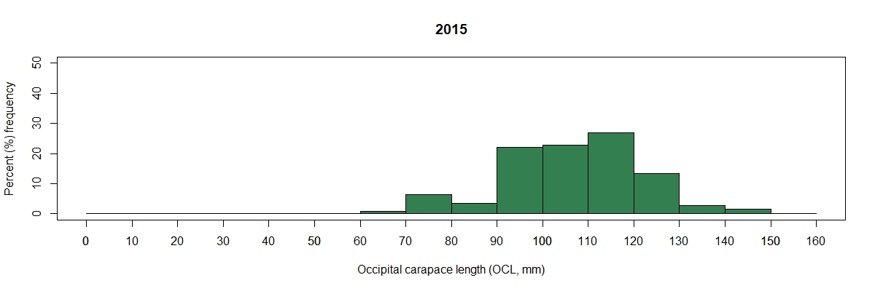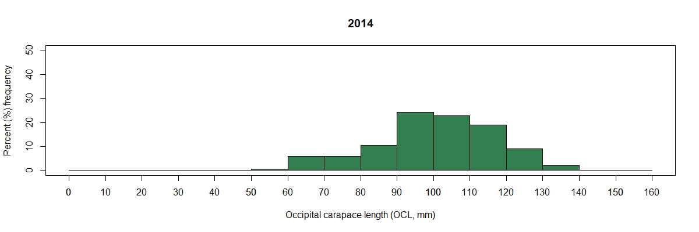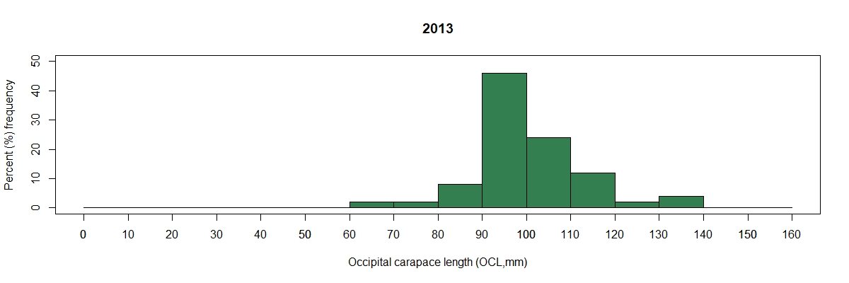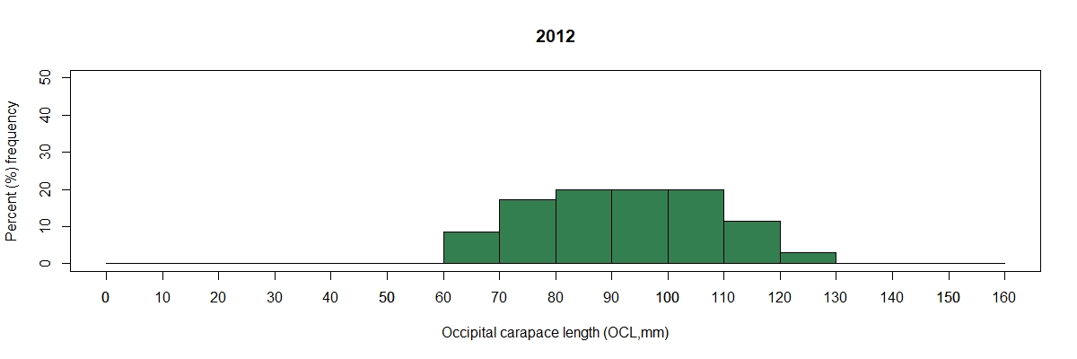

**2012**

n=35

**2013**

n=50

n=189

**2014**

n=141

**2015**

**2017**

n=28

n=42

**2020**

*Figure 7. Length structure of Murray crayfish sampled across the Edward/Kolety-Wakool system in 2012, 2013, 2014, 2015 and 2020 (all sites combined during each sampling period).*

**Discussion**

*Status of the species in the Edward/Kolety-Wakool system*

The present study has provided timely assessment of the status of Murray crayfish in the Edward/Kolety-Wakool system. It is apparent that the population, which was likely impacted by the 2010‒11 hypoxic blackwater disturbance, has declined considerably over the subsequent period from 2012 to 2020. This has been realised as a reduction in sites where the species occurs as well as a decline in relative abundance across those sites where temporal comparison is possible. Although historically broadly and continuously distributed across the Edward/Kolety-Wakool system, as of 2020, Murray crayfish are now only consistently present within the upstream extent of the system, being only patchily distributed and very uncommon elsewhere. Its present range includes the Edward/Kolety River at Deniliquin (within the Stevens Weir weirpool); the free-flowing section from the Murray River junction to the top of the Stevens Weir weirpool; directly below Stephens Weir, and at least part of the way along Colligen Creek. The species has not been detected at any sites sampled in the Wakool River and Yallakool Creek in 2020, or during sampling of Wakool and Niemur rivers sites during 2012−14. The length structure of the population reveals a lower proportion of larger crayfish (>100mm OCL) and, encouragingly, a greater representation of small, advanced juveniles between 2020 (and 2017) compared to previous sampling events 2012−15). Taken together, these outcomes raise concern regarding the viability of the species in the Edward/Kolety-Wakool system.

Murray crayfish are susceptible to hypoxic blackwater disturbance, as it results in dissolved oxygen concentrations well below the thresholds that the species can tolerate (Geddes et al. 1993). The prolonged and extreme 2010‒11 blackwater event in the southern MDB (Whitworth et al. 2012), led to demonstrated population declines of the species in the Murray River (McCarthy et al. 2014; Whiterod et al. 2018). There is insufficient pre-2010 data to demonstrate similar declines within the Edward/Kolety-Wakool system, but it can be confidently assumed to have occurred. It is highly probable that hypoxic blackwater also contributed to the observed declines in the Murray crayfish population between 2015 and 2020 demonstrated by the present study (although again it is not possible to establish definitive causal links). Between August and November 2016, large unregulated flows created overbank flooding, causing a spike in dissolved organic carbon (DOC) and hypoxic conditions over much of the system for an extended period (Watts et al. 2017b). Dissolved oxygen concentrations were below 2mgL-1 from mid-October until mid-November 2016 in many areas, and at some sites, anoxic conditions (approaching zero oxygen) were experienced. Whilst Murray crayfish can temporarily avoid adverse water quality during hypoxic blackwater events by emerging from the water (with anecdotal reports of this occurring during 2016), by doing so they remain susceptible to direct and indirect mortality (desiccation, predation, illegal harvest). It is assumed that mortality during the 2016 blackwater event explains the decline in relative abundance, and the lower representation of larger crayfish in 2020 (as these individuals may have been more susceptible), observed in the present study. However, from the few data points that are available, relative abundance appears to have been in decline at most locations in the years preceding the 2016 hypoxic blackwater event. Therefore, additional underlying drivers of decline are also apparent. The inherent traits of the species – limited dispersal, slow growth, late sexual maturity (i.e. 8–9 years) and low egg production result in the capacity for only gradual recovery, thus requiring a long-term commitment (Whiterod et al. 2018).

Local declines experienced in the Edward/Kolety-Wakool system between 2015 and 2020 were not mirrored across other regions of NSW. Comparison of data from state-wide stock assessments undertaken in 2012−14 and 2020 reveal relative abundance remained stable over time (NSW DPI (Fisheries) and Aquasave‒NGT, in prep). For instance, relative abundance within reaches of the Murray and Murrumbidgee Rivers impacted and not-impacted by the 2010−11 hypoxic blackwater, and either opened or closed to recreational fishing all remained fairly consistent over this period, with relative abundance within a reach of the Murrumbidgee River between Berembed Weir to Darlington Point increasing (Whiterod et al. 2018; NSW DPI (Fisheries) and Aquasave−NGT, in prep). Therefore, there is a need to address the apparent continuing local decline of Murray crayfish specific to the Edward/Kolety-Wakool system.

*Anticipated flow requirements of the species*

The flow requirements of Murray crayfish are largely unknown (Gilligan et al. 2007), although some insight is available from conceptual modelling of the closely-related Glenelg spiny freshwater crayfish *Euastacus bispinous* (Whiterod et al. 2014). Naturally, water levels and flow velocities would be highest in winter and lowest in summer across the system. Broadly, it is anticipated that the species has an overarching requirement for well-oxygenated flowing water for survival. With elevated water levels during the critical late autumn and winter moulting and brooding periods important in providing cover for these sensitive life-stages.

High flow velocity microhabitats with high dissolved oxygen concentrations are the most fundamental environmental requirement. Consistently, Murray crayfish are largely absent from most weir pools and impoundments throughout their range (Gilligan et al. 2007; McCarthy 2005; Zukowski 2012) and are rarely present in floodplain wetland habitats (NSW DPI (Fisheries), unpublished data). Further, McCarthy (2005) provided evidence of preferential occupancy of high velocity mesohabitats at hydraulically diverse locations. High flow velocity helps maintain high dissolved oxygen concentrations throughout the entire water column. High flow velocities also achieve sediment scouring vital for a return of channel diversity in sediment affected reaches. It may also aid the chemo-sensory abilities of Murray crayfish to locate food sources upstream. Creation and maintenance of high velocity mesohabitats within stream networks can be achieved through the provision of baseflows of sufficient magnitude to create turbulent mixing of the water column. Managing hydraulically uniform weirpools to create high velocity mesohabitats is particularly important.

It is anticipated that high water levels provide benefits for moulting individuals in autumn (April to May) and brooding females in winter (May to August). High water levels enhance access to complex bank habitats (i.e. exposed root masses of living trees) and decrease exposure of existing burrows and burrowing sites (Whiterod et al. 2014), thereby offering greater cover and protection. Environmental water management has a role in maintaining high water levels through late April until at least August to achieve these outcomes. It is thought that moulting and mating is cued by a rapid decrease in water temperature in May. This could be assisted through delivery of late autumn environmental watering. A critically important aspect of the flow requirements of Murray crayfish is ensuring that hypoxic blackwater disturbance does not continue to impact populations of the species. Indeed, mitigating the magnitude of hypoxic blackwater disturbance is perhaps the most important flow management consideration for the species.

The existence of any specific eco-hydrological relationships between hydrology and recruitment success and dispersal are completely unknown. If recruitment success and/or dispersal are found to be reliant on any particular aspect of hydrology, then knowledge of temporal aspects (recurrence rates) of the flow requirements of the species will become important. For instance, do populations require specific flow characteristics every year? Or, given they are a long-lived species, is it necessary to provide them at a particular interval (e.g. 1 in 3 years)? Clearly, revision of the conceptual models to specifically relate to Murray crayfish in the Edward/Kolety-Wakool system is necessary. These can only be informed by further detailed research into the flow requirements of the species. Once this knowledge is generated, the population model of Todd et al. (2018) will be useful for modelling aspects of recurrence rates required to achieve population growth and maintenance.

*Current management of Stevens Weir pool*

The Stevens Weir weirpool currently experiences modified hydraulic flow characteristics and altered timing of high and low water levels. Pre-river regulation and development of water resources, this reach of the Edward River would have experienced low flows over summer, with higher flows in winter-spring. Under current regulated operation, water levels in the weirpool are maintained at higher levels, with relatively slow flow velocities, for the duration of the irrigation season from mid August to early May each year. This operation aims to provide sufficient water head to provide flows to Wakool Canal, a large irrigation supply channel, and to allow flows to be regulated to meet regulated flow target rates for the Wakool/Yallakool offtakes and the Colligen Creek offtake. In May, the weir pool is usually lowered to provide a period of drying (so far as temperature, flow and rainfall conditions allow), including for hydraulically connected wetlands and for the banks of the Edward River itself, to compensate for the inverted hydraulic regime experienced over summer.

This management operation has been amended since the advent of environmental watering in the system, in that – subject to engineering maintenance of Stevens Weir itself (which requires full drawdown in some years to conduct maintenance over the irrigation ‘off-season’ in winter) – in some years the weir pool is only partially drawn down, so as to enable small winter baseflows to be provided into the Yallakool and Colligen creeks for the purpose of providing frost control to submerged aquatic macrophytes, and to augment habitat for native fish (refer below).

*Implications for current environmental watering strategies*

As noted earlier in this report, at the commencement of the project we had intended to provide advice relating to the following management questions: (i) does the delivery of environmental water significantly impact the abundance of the Murray crayfish within and below Stevens Weir pool? (ii) what are the potential impacts (positive and negative) of delivering winter flows on Murray crayfish?, and (iii) How does removing/lowering Stevens Weir during winter influence (a) Murray crayfish in the weir pool and (b) other environmental assets in the rest of the Edward/Kolety-Wakool River system (including the Yallakool-Wakool and Colligen-Niemur River systems)? However, at the conclusion of the project, it is clear that more data is required to be able to properly answer these questions without overreaching on the currently limited amount of data available. Whilst it is presently not possible to robustly evaluate how environmental watering is influencing Murray crayfish in the system, some insight is offered in the discussion below on the basis of the anticipated flow requirements of the species.

Environmental watering is provided across the Edward/Kolety-Wakool system with the broad aim of recreating flow and wetland inundation regimes that maintain and enhance native species (Watts et al. 2019; Watts et al. 2015). In light of the noted impacts on the species (i.e., 2010‒11 and 2016‒17 blackwater events and recreational harvest up until the closure of the fishery in 2014) it is doubtful that the environmental watering would be significantly negatively impacted the species. Rather, the anticipated flow requirements of the species forecast that environmental watering will improve conditions for Murray crayfish by mimicking natural flow regimes as to enhance habitat suitability and promote early life stage survival and development. An important aspect of this likely benefit is the ability of environmental watering to enhance (or create) flowing habitats during release events – further investigation into these hydraulic dynamics is required. Another key aspect is how environmental water can be used to mitigate the impacts of hypoxic blackwater in waterways (as opposed to floodplain wetland habitats), where Murray crayfish occur. The release of environmental watering from Mulwala canal escapes was shown to provide some mitigation of the hypoxic conditions during both the 2010‒11 and 2016‒17 blackwater events (Watts et al. 2017a; Watts et al. 2017b). Relevantly, releases from the Edward Escape had a positive influence on dissolved oxygen concentration in the Edward River downstream of the escape, which corresponds with much of the contemporary range of the species in the system. The extent to which these Edward Escape releases benefited Murray crayfish is unknown, but it is possible that they allowed some individuals to persist – the response of the species could be explored during future escape releases.

The winter environmental watering regime currently implemented across the system has been shown to improve water quality and connectivity in tributaries (e.g., Wakool River, Yallakool Creek) as well as increasing river productivity and assisting with the broader movement of native fish within the system (Watts et al. 2019). To deliver winter flows to the tributaries, water is delivered into the Edward River (and Gulpa Creek) from the Murray River before being released through the Yallakool and Colligen creeks regulators from the Stevens Weir weirpool. These diversions require the weir to be at a minimum supply level (that is, partially filled), which represents a trade-off aimed at balancing environmental water needs over a larger area than just the weir pool itself. A higher weir level would be required to also enable the Wakool River regulator to be used for winter flows. However, this is not sought during winter flows to enable the objective of providing a period of some bank drying within the weir pool to also be met. Winter flows are also delivered as low base flows, which again enables the objective of providing a period of some bank drying along waterways to also be met.

The benefits of the winter environmental flow regime to some native species has been demonstrated within the system. For example, Watts et al (2020) in the 2019‒20 detected the strongest cohort of Murray cod aged one year or older and suggest that winter flows may have provided important over-wintering refuge habitat for the record number of larval and juvenile Murray cod recorded in 2018‒19. Winter flows also enabled the movement of golden and silver perch within the system (Watts et al. 2021 in prep). Recommendations have been made to prevent cease to flow conditions during winter whenever possible to protect a range of environmental assets in the system (Watts et al. 2020) and at a Basin scale. However, the benefits of winter flows for Murray crayfish are yet to be evaluated through scientific studies.

Based on the conceptual flow requirements and the contemporary range of the species, it is expected the higher in-channel winter flows will enhance flowing habitat, hydraulic diversity and improve flow velocity in microhabitats throughout much of the upper ~50 km section of the Edward River (e.g., from the Murray River to Wakool offtake), and potentially in areas of an additional~500 km’s of instream habitat in the Yallakool-Wakool (~300 km) and Colligen-Niemur systems (~200 km’s), affording a range of environmental benefits within these parts of the system.

Yet, the necessity of maintaining Stevens Weir at a higher supply level to achieve these winter flows reduces hydraulic diversity and eliminates high velocity microhabitats throughout much of the ~35 km weirpool, to the detriment of Murray crayfish populations. Further, the environmental watering in the Wakool River and Yallakool and Colligen creeks has little influence on Murray crayfish as they are currently absent or very rare within each of these tributary streams.

The option of lowering (or removal) of Stevens Weir would likely improve flow velocity and hydraulic diversity within the weirpool (cf. Bice et al. 2017), enhancing the suitability of habitat for Murray crayfish. However, this ‘free flowing period’ through the weir would be, for river operations reasons, a maximum of 6‒8 weeks in duration only with the weir needing to be refilled by the end of July to enable irrigation deliveries to commence in early August each year. The benefits from providing such a short ‘free flowing period’ to Murray crayfish in the weir pool has not been be evaluated through scientific studies.

The lowering (or removal) of Stevens Weir could only be achieved at the expense of the environmental values and water users in the Yallakool-Wakool and Colligen-Niemur systems. The compromise of temporary adjustments to weir pool height, may or may not meet the environmental requirements of Murray crayfish. Therefore, preliminary assessments of the outcomes of short-term trials are advised. Put simply, the trade off in decision making is the choice between ~35 km of habitat for a period of 6‒8 weeks by lowering the weir pool, versus ~500 km’s of habitat for a range of flora and fauna provided by the instream connectivity enabled if the weir pool is kept in and winter flows are provided.

Whilst we present simple anticipated responses of Murray crayfish, it is acknowledged that a complex balance is required for environmental watering to achieve multiple benefits across the system. The targeted research into the flow requirements of the species recommended above will help to refine the predictions detailed above and establish a preferred long-term environmental watering plan for the species.

*Recovering Murray crayfish in the* *Edward/Kolety-Wakool system*

There is a shared responsibility to address the outcomes of the present study. A number of recommendations are offered to help recover the species in the Edward/Kolety-Wakool system. Firstly, meaningful incorporation of the needs of the species into environmental water strategies for the system is required. This will necessitate specific conceptual models of the flow requirements of various life stages of Murray crayfish informed through targeted research and monitoring. Key questions in need of further detailed study and analysis are the relationships between hydrology and population growth, particularly regarding requirements for water level, flow velocity, seasonality of flows and their influence on recruitment success and dispersal. These assessments can only be achieved through multiple years of data collection at groups of sites that represent both control and treatment groups, or at a much larger number of sites concurrently experiencing a diversity of hydrological conditions. Secondly, routine monitoring of the condition of Murray crayfish populations in the system should be implemented. This should include more comprehensive survey of sites across the system. The present study surveyed only half of all sites previously sampled in the system, and there is a need for more intensive sampling of those areas where the species persists to gain insight into the extent of fragmentation of the remaining population. Additionally, annual condition monitoring (of 5‒10 sites), following a similar method to the present study, could occur to track population trajectories over time. The targeted estimates of population size (Zukowski et al. 2018) could be repeated. As Zukowski et al. (2018) demonstrated, this monitoring can be collaborative with key stakeholders (e.g., traditional owners, angling associations, community). Event-based monitoring could also be undertaken during disturbances or regime changes to evaluate responses to specific hypoxic disturbance or management actions.

Thirdly, evaluation of the merits of conservation translocation of the species into the Edward/Kolety-Wakool system is warranted. This may include (a) reinforcement of depleted populations, or (b) reintroduction into areas where the species has been locally extirpated (IUCN/SSC 2013). High priority options would be the establishment of populations within each of the upper Wakool River and Yallakool Creek, as these would represent conservation offsets in the event that manipulations of the Stevens Weir weirpool are untenable. Relevantly, the success of reintroductions to the Murray River has been demonstrated in the medium-term (Whiterod and Zukowski 2019; Whiterod et al. 2021). A robust translocation strategy, relying on genetic analyses, population monitoring and modelling of release scenarios and population monitoring, has been established, which could be applied to sites in the system. Crucially, this strategy is dependent on maintaining suitable habitat for the species at (either reinforced or reintroduced) sites, and it will require detailed evaluation to assess feasibility. Lastly, the conservation of Murray crayfish in the system would benefit from the involvement of a wide range of managers and stakeholders (cf. Scheele et al. 2018). There are opportunities to raise the profile and actively involve stakeholders to identify and implement management actions. This is particularly relevant as the closure of the recreational fishery creates the risk of the species suffering from lack of awareness (e.g., out of mind, out of sight) that could hamper management efforts.

The present study illustrates that the Murray crayfish population in the Edward/Kolety-Wakool system is in a state of decline. It is now a responsibility to consider the species in management of the system and implement actions to redress declines and aid recovery.

**References**

Baumgartner L. J., Conallin J., Wooden I., Campbell B., Gee R., Robinson W. A., Mallen‐Cooper M. (2014). Using flow guilds of freshwater fish in an adaptive management framework to simplify environmental flow delivery for semi‐arid riverine systems. *Fish and Fisheries* 15, 410-427

Bice C. M., Gibbs M. S., Kilsby N. N., Mallen-Cooper M., Zampatti B. P. (2017). Putting the “river” back into the lower River Murray: quantifying the hydraulic impact of river regulation to guide ecological restoration. *Transactions of the Royal Society of South Australia* 141, 108-131

DPI N. (2020). 'NSW Recreational Freshwater Fishing Guide 2020-21.' New South Wales Department of Primary Industries, Nowra.

Forbes J., Todd C., Baumgartner L., Watts R., Robinson W., Steffe A., Murphy J., Asmus M., Thiem J. (2020). Simulation of different fishery regulations to prevent population decline in a large freshwater invertebrate, the Murray crayfish (*Euastacus armatus*). *Marine and Freshwater Research* 71, 962-971. 10.1071/MF19109.

Geddes M. C., Musgrove R. J., Campbell N. J. H. (1993). The feasibility of re-establishing the River Murray crayfish, *Euastacus armatus*, in the lower River Murray. *Freshwater Crayfish* 9, 368-379

Gilligan D., Rolls R., Merrick J., Lintermans M., Duncan P., Koehn J. (2007). 'Scoping the knowledge requirements for Murray crayfish (*Euastacus armatus*).' NSW Department of Primary Industries, Cronulla.

IUCN/SSC (2013). 'Guidelines for Reintroductions and Other Conservation Translocations, Version 1.0.' International Union for Conservation of Nature (IUCN) Species Survival Commission, Gland, Switzerland.

McCarthy B. (2005). 'Distribution of Murray Crayfish (*Euastacus armatus*) in the Mallee Region 2004.' Murray-Darling Freshwater Research Centre, 2/2005, Mildura.

McCarthy B., Zukowski S., Whiterod N., Vilizzi L., Beesley L., King A. (2014). Hypoxic blackwater event severely impacts Murray crayfish (*Euastacus armatus*) populations in the Murray River, Australia. *Austral Ecology* 39, 491-500

MDBA (2012). 'The Proposed Basin Plan–a revised draft.' Murray-Darling Basin Authority, Canberra.

MDBA (2019). 'Basin-wide environmental watering strategy.' Murray-Darling Basin Authority, Canberra.

Noble M. M., Fulton C. J. (2017). Habitat specialization and sensitivity to change in a threatened crayfish occupying upland streams. *Aquatic Conservation: Marine and Freshwater Ecosystems* 27, 90-102

NSW DPI (2014). 'Species impact statement ‐ recreational fishing for Murray crayfish (*Euastacus armatus*).' NSW Department of Primary Industries, Sydney.

NSW DPIE (2019a). 'Murray-Lower Darling Long-Term Water Plan Part A: Murray-Lower Darling.' NSW Department of Planning, Industry and Environment, Parramatta.

NSW DPIE (2019b). 'Murrumbidgee Long-Term Water Plan Part A: Murrumbidgee catchment.' NSW Department of Planning, Industry and Environment, Parramatta.

O’Connor P. (1986). The biology of the Murray crayfish, *Euastacus armatus* (Decapoda: Parastacidae) and recommendations for the future management of the fishery. Unpublished NSW Department of Agriculture data summary, NSW Fisheries, Narrandera, NSW. And a number of un-submitted draft PhD thesis chapters.

Ramalho R. O., McClain W., Anastácio P. M. (2010). An effective and simple method of temporarily marking crayfish. *Freshwater Crayfish* 17, 57-60

Scheele B. C., Legge S., Armstrong D., Copley P., Robinson N., Southwell D., Westgate M. J., Lindenmayer D. B. (2018). How to improve threatened species management: an Australian perspective. *Journal of Environmental Management* 223, 668-675

Todd C. R., Whiterod N. S., Raymond S., Zukowski S., Asmus M. A., Todd M. (2018). Integrating fishing and conservation in a risk framework: A stochastic population model to guide proactive management of a threatened freshwater crayfish. *Aquatic Conservation: Marine and Freshwater Ecosystems* 28, 954-968

Turvey P., Merrick J. R. (1997). Reproductive biology of the freshwater crayfish, *Euastacus spinifer* (Decapoda: Parastacidae), from the Sydney region, Australia. *Proceedings of the Linnean Society of New South Wales* 118, 131-155

Watts R. J., Bond N. R., Grace M. R., Healy S., Howitt J. A., Liu X., McCasker N. G., Thiem J. D., Trethewie J. A., Wright D. W. (2019). 'Commonwealth Environmental Water Office Long Term Intervention Monitoring Project: Edward/Kolety-Wakool River System Selected Area Technical Report, 2018-19.' Report prepared for Commonwealth Environmental Water Office, Commonwealth of Australia. Charles Sturt University, Thurgoona.

Watts R. J., Bond N. R., Healy S., Liu X., McCasker N. G., Siebers A., Sutton N., Thiem J. D., Trethewie J. A., Vietz G., Wright D. W. (2020). 'Commonwealth Environmental Water Office Monitoring, Evaluation and Research Project: Edward/Kolety-Wakool River System Selected Area Technical Report, 2019-20.' Report prepared for Commonwealth Environmental Water Office, Commonwealth of Australia. Charles Sturt University, Thurgoona.

Watts R. J., Kopf R. K., McCasker N., Howitt J. A., Conallin J., Wooden I., Baumgartner L. (2017a). Adaptive management of environmental flows: using irrigation infrastructure to deliver environmental benefits during a large hypoxic blackwater event in the southern Murray–Darling Basin, Australia. *Environmental Management* 61, 469-480

Watts R. J., McCasker N. G., Howitt J. A., Thiem J. D., Grace M. R., Kopf R. K., Healy S., Bond N. R. (2017b). 'Commonwealth Environmental Water Office Long Term Intervention Monitoring Project: Edward/Kolety-Wakool River System Selected Area Evaluation Report, 2016-17.' Report prepared for Commonwealth Environmental Water Office, Commonwealth of Australia. Charles Sturt University, Thurgoona.

Watts R. J., McCasker N. G., Thiem J. D., Howitt J. A., Grace M. R., Kopf R. K., Healy S., Bond N. R. (2015). 'Commonwealth Environmental Water Office Long Term Intervention Monitoring Project: Edward-Wakool Selected Area Synthesis Report, 2014-15.' Report prepared for Commonwealth Environmental Water Office, Commonwealth of Australia. Institute for Land, Water and Society, Charles Sturt University, Thurgoona.

Whiterod N., Farrington L., Veale L., Sweeney O. (2014). 'Flow requirements of Glenelg spiny freshwater crayfish *Euastacus bispinosus* in the Glenelg River Catchment.' A report to the Glenelg Hopkins Catchment Management Authority. Aquasave–Nature Glenelg Trust, Goolwa Beach, South Australia.

Whiterod N., Zukowski S. (2017). 'The status of the Murray crayfish recreational fishery in Victoria.' Aquasave-Nature Glenelg Trust, Areport funded by the Victorian Government using Recreational Fishing Licence fees. Goolwa Beach.

Whiterod N., Zukowski S. (2019). It’s not there, but it could be: a renewed case for reintroduction of a keystone species into the Lower River Murray. *Transactions of Royal Society of South Australia* 143, 51-66

Whiterod N. S., Asmus M., Zukowski S., Gilligan D., Daly T. (2021). Reintroduction to re-establish locally extirpated populations of the second largest freshwater crayfish in the world (Murray Crayfish *Euastacus armatus*). In 'Global conservation translocation perspectives: 2021. Case studies from around the globe'. (Ed. P. S. Soorae). (IUCN SSC Conservation Translocation Specialist Group: Gland, Switzerland).

Whiterod N. S., Zukowski S., Asmus M., Gilligan D., Miller A. D. (2017). Genetic analyses reveal limited dispersal and recovery potential in the large freshwater crayfish *Euastacus armatus* from the southern Murray–Darling Basin. *Marine and Freshwater Research* 68, 213-225

Whiterod N. S., Zukowski S., Asmus M. A., Todd C. R., Gwinn D. (2018). Take the long way home: minimal recovery in a K-selected freshwater crayfish impacted by significant population loss. *Ecological Indicators* 89, 622-630

Whitworth K. L., Baldwin D. S., Kerr J. L. (2012). Drought, floods and water quality: Drivers of a severe hypoxic blackwater event in a major river system (the southern Murray–Darling Basin, Australia). *Journal of Hydrology* 450, 190-198

Zukowski S. (2012). Impacts of fishing regulations on the sustainability of Murray crayfish (*Euastacus armatus*), Australia: social and biological perspectives. PhD Thesis. Charles Sturt University.

Zukowski S., Asmus M., Whiterod N., Conallin A., Campbell J., Fisher I., Bright T. (2018). Collaborating with recreational fishers to inform fisheries management – estimating population size for an iconic freshwater crayfish. *Ecological Management and Restoration* 19, 85-88

Zukowski S., Watts R., Curtis A. (2012). Linking biology to fishing regulations: Australia's Murray crayfish (*Euastacus armatus*). *Ecological Management & Restoration* 13, 183-190

Zukowski S., Whiterod N., Watts R. (2013). Comparing Murray crayfish (*Euastacus armatus*) population parameters between recreationally fished and non-fished areas. *Freshwater Crayfish* 19, 153-160