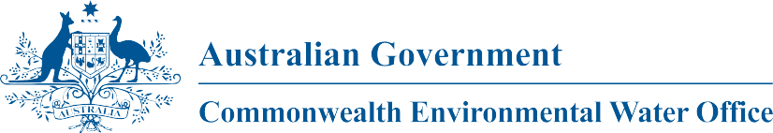

**Commonwealth Environmental Water**

Portfolio Management Plan

Barwon-Darling

2018-19

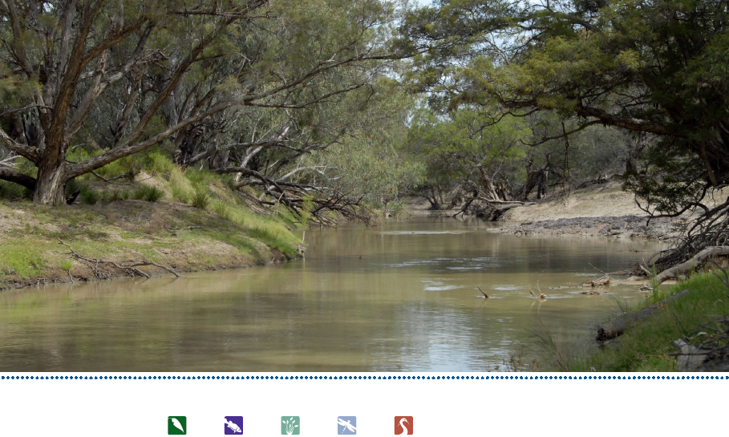

Front cover image credit: Barwon River, Photo by Commonwealth Environmental Water Office

Back cover image credit: Brewarrina Fishway, Photo by Commonwealth Environmental Water Office

**Acknowledgement of the traditional owners of the Murray-Darling Basin**

The Commonwealth Environmental Water Office respectfully acknowledges the traditional owners, their Elders past and present, their Nations of the Murray-Darling Basin, and their cultural, social, environmental, spiritual and economic connection to their lands and waters.

© Copyright Commonwealth of Australia, 2018.



Commonwealth Environmental Water Portfolio Management Plan: Barwon-Darling 2018-19 is licensed by the Commonwealth of Australia for use under a Creative Commons Attribution 4.0 International licence with the exception of the Coat of Arms of the Commonwealth of Australia, the logo of the agency responsible for publishing the report, content supplied by third parties, and any images depicting people. For licence conditions see: https://creativecommons.org/licenses/by/4.0/

This report should be attributed as ‘Commonwealth Environmental Water Portfolio Management Plan: Barwon-Darling 2018–19, Commonwealth of Australia, 2018’.

The Commonwealth of Australia has made all reasonable efforts to identify content supplied by third parties using the following format ‘© Copyright’ noting the third party.

The views and opinions expressed in this publication are those of the authors and do not necessarily reflect those of the Australian Government or the Minister for the Environment.

While reasonable efforts have been made to ensure that the contents of this publication are factually correct, the Commonwealth does not accept responsibility for the accuracy or completeness of the contents, and shall not be liable for any loss or damage that may be occasioned directly or indirectly through the use of, or reliance on, the contents of this publication.

# Commonwealth environmental water portfolio management planning

## Commonwealth Environmental Water Holder

The Commonwealth Environmental Water Holder is a statutory position established under the *Water Act 2007* and is responsible for managing the Commonwealth’s environmental water holdings. This water must be managed to protect and restore the rivers, wetlands and floodplains (and the native animals and plants they support) of the Murray–Darling Basin. Ms Jody Swirepik is the current Commonwealth Environmental Water Holder. Ms Swirepik is supported by staff of the Commonwealth Environmental Water Office. The Office employs six local engagement officers who live and work in regional centres across the Murray–Darling Basin.

## Commonwealth environmental water

Commonwealth environmental water holdings are water entitlements that have been acquired by the Australian Government through investments in water-saving infrastructure and purchases on the water market. The holdings are a mix of entitlement types held across 19 catchments. The rules governing the entitlements vary across states and across catchments. Commonwealth environmental water entitlements are subject to the same fees, allocations, carryover and other rules as equivalent entitlements held by other water users.

There are broadly three options for managing Commonwealth environmental water:

* delivering water to a river or wetland to meet an identified environmental demand
* leaving water in storage and carrying it over for use in the next water year (referred to as ‘carryover’)
* trading water, that is, selling water and using the proceeds to buy water in another catchment or in a future year, or investing in complementary ‘environmental activities’.

## Purpose of the document

This document sets out the plans for managing the Commonwealth environmental water portfolio in the Barwon-Darling for 2018–19. Efficient and effective management of Commonwealth environmental water requires the utilisation of all portfolio management options. By taking a multi-year approach to planning, portfolio management tools such as use, carryover and trade can be managed for maximising environmental outcomes.

The portfolio management plans support transparent, coordinated and adaptive management of Commonwealth environmental water, consistent with the Basin-wide environmental watering strategy and having regard to the Basin annual environmental watering priorities.

To learn more about the planning approach see *Portfolio Management Planning: Approach to planning for the use, carryover and trade of Commonwealth environmental water, 2018–19* (available at: <http://www.environment.gov.au/water/cewo/publications> under ‘Planning approach’).

## Delivery partners

Commonwealth environmental water is managed in conjunction with and delivered by a range of partners. This portfolio management plan has been developed in consultation with our delivery partners, including Queensland Departments of Natural Resources, Mines and Energy and Fisheries, New South Wales Office of Environment and Heritage (NSW OEH), New South Wales Department of Primary Industries – Water and Fisheries, Sunwater and WaterNSW.

## Your input

The management of Commonwealth environmental water relies on considerable advice and assistance from local organisations, state governments and others. Individuals and groups within the Murray–Darling Basin community are encouraged to submit suggestions for the management of Commonwealth environmental water. Please contact the Office via: ewater@environment.gov.au

# Table of contents

Commonwealth environmental water portfolio management planning 1

Commonwealth Environmental Water Holder 1

Commonwealth environmental water 1

Purpose of the document 1

Delivery partners 1

Your input 2

Table of contents 3

1. Environmental watering in Barwon-Darling 4

1.1. The Barwon-Darling catchment 4

1.2. Environmental objectives in the Barwon-Darling catchment 5

1.3. Environmental flow requirements 7

1.4. Monitoring and adaptive management 7

2. Portfolio management in 2018–19 8

2.1. Antecedent and current catchment conditions and the demand for environmental water in 2018–19 8

2.2. Water availability in 2018–19 10

2.3. Overall purpose of managing environmental water based on supply and demand 11

2.4. Water Delivery in 2018–19 12

2.5. Trading water in 2018–19 12

2.6. Carrying over water for use in 2019–20 12

2.7. Identifying Investment Opportunities 12

3. Next steps 16

3.1. From planning to decision making 16

3.2. Further information 16

Bibliography 17

Attachment A – Expected outcomes from the Basin-wide environmental watering strategy 19

Attachment B – Operational details for watering 21

Operational considerations in the Barwon-Darling catchment 21

Potential watering actions under different levels of water resource availability 21

Potential watering actions – standard operating arrangements 22

Attachment C – Long-term water availability 23

Commonwealth environmental water holdings 23

Other sources of environmental water 23

Planned environmental water 23

# 

# Environmental watering in Barwon-Darling

## The Barwon-Darling catchment

The Barwon–Darling catchment covers 699,500 square km comprising the catchments of the Paroo, Warrego, Condamine–Balonne and Moonie systems to the north, and the Border Rivers, Gwydir, Namoi and Macquarie–Castlereagh systems to the east (MDBA 2016).

The Barwon River flows south-west through a relatively narrow floodplain with a tightly meandering channel and a highly-variable flow pattern and capacity. Capacity increases downstream of Collarenebri, after the Little Weir, Boomi, Moonie, Gwydir and Mehi rivers have joined the Barwon.

Downstream of Collarenebri, the Barwon River continues south-west, and is joined by more creeks and rivers including the Namoi River. Beyond Walgett the river turns in a westerly direction and flows unrestricted across alluvial plains. It becomes less sinuous but there are many anabranches and effluent channels which split and re-join the major channel.

The Darling River flows south-west within a deeply incised channel towards Wilcannia. Below Wilcannia the Darling reaches the Menindee Lakes, at the artificial storage of Lake Wetherel (MDBA 2017).

There are no major public water storages along the river but there are large private off river storages that store water from harvesting of floodplain run-off, and retention of irrigation tailwater (NSW DPI 2012). There are 14 major weirs along the main stem of the Barwon-Darling system from the Macintyre junction to upstream of Menindee Lakes, which create a barrier for fish passage. Only the Brewarrina Weir contains an effective fishway.

*Barwon-Darling River channel*

The Barwon-Darling River channel connects the rivers, lakes and wetlands in the northern Murray-Darling Basin, providing a critical dry period refuge and movement corridor for fish and waterbirds, as well as habitats for other aquatic species including turtles, mussels, river snail and shrimp. This longitudinal connectivity is particularly important for regional communities of native fish and other aquatic species.

Diverse in-stream habitats including channels, deep pools, riffles, benches, snags, gravel beds and aquatic and riparian vegetation support a significant native fish community. There are more than 1,000 refugial waterholes between Walgett and Wilcannia (NSW DPI 2015).

*Lowland Darling River aquatic ecological community*

The Lowland Darling River aquatic ecological community has particular significance because the northern Basin is important for protecting the overall biodiversity of fish communities across the Basin. This community is listed as endangered under the *NSW Fisheries Management Act 2004*. Its fish community includes 25 resident species, and it is a stronghold for many species that are threatened in the south. It contains important remnant populations of olive perchlet, purple spotted gudgeon and freshwater catfish. There are also a number of species located in the north that are not present in the south, including Rendahl’s tandan, Hyrtl’s tandan, spangled perch, Darling River hardyhead and desert rainbowfish.

*Barwon-Darling Wetlands*

The Barwon-Darling River supports a high density and wide variety of wetlands that receive flows from the main river prior to overbank inundation. More than 580 wetlands were mapped between Mungindi and Menindee from aerial photographs, including anabranches, flood runners, billabongs, deflation basins, lakes and swamps (Brennan et al. 2002).

*Talyawalka Anabranch-Teryaweynya Creek*

Talyawalka Anabranch-Teryaweynya Creek is a nationally important wetland system to the west of the main Darling River channel between Wilcannia and Menindee. The channels and lakes of Talyawalka Anabranch and its distributary Teryaweynya Creek support extensive areas of floodplain vegetation and black box woodland. When inundated the system’s lakes provide habitat for large numbers of waterbirds. Poopelloe Lake, Talyawalka Creek and Pelican Lake (in the Teryaweynya system), along with the Darling River floodplain near Louth are known or predicted to support 20,000 or more waterbirds (Kingsford et al. 1997).

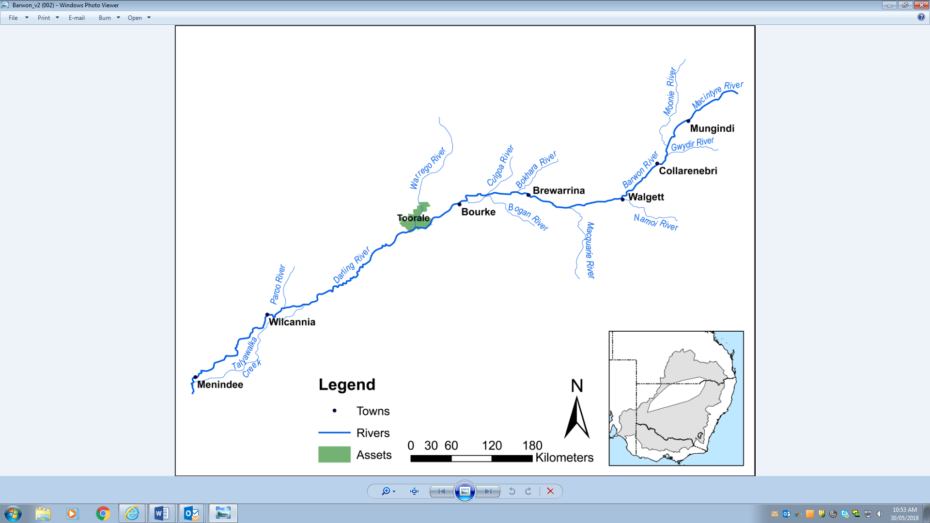**Figure 1:** Map of the Barwon-Darling catchment

## Environmental objectives in the Barwon-Darling catchment

The long-term environmental objectives for the Murray-Darling Basin are described in the Basin Plan’s environmental watering plan and the Basin-wide environmental watering strategy, which includes ‘quantified environmental expected outcomes’ at both a Basin-scale and for each catchment. The expected outcomes relevant for the Barwon-Darling are described in Attachment A.

Basin state governments are also developing long-term watering plans for each catchment. These plans will identify the priority environmental assets and ecosystem functions in the catchment, the objectives and targets for these assets and functions, and their watering requirements. Once developed, these plans will provide the key information on the long-term environmental water demands in the catchment. Prior to the development of long-term watering plans, the Office will continue to draw on existing documentation on environmental water demands developed by state governments, local natural resource management agencies and the Murray–Darling Basin Authority.

Based on these strategies and plans, and in response to best available knowledge drawing on the results of environmental watering monitoring programs, the objectives for environmental watering in the Barwon-Darling care summarised in Table 1 below. The objectives for water-dependent ecosystems will continue to be revised as part of the Commonwealth Environmental Water Office’s commitment to adaptive management.

Table 1: Summary of objectives being targeted by environmental watering in the Barwon-Darling

|  |  |
| --- | --- |
| **BASIN-WIDE OUTCOMES**  **(Outcomes in red link to the Basin-wide Environmental Watering Strategy)** | **EXPECTED OUTCOMES FOR BARWON-DARLING RIVERS ASSETS** |
| **IN-CHANNEL ASSETS** |
|
| **VEGETATION** | Maintain riparian and in-channel vegetation condition, growth and survival |
| **WATERBIRDS** |  |
| **FISH** | Provide flows that improve habitat conditions and support different life stages (migration, spawning, recruitment, refuge) |
| **INVERTEBRATES** | Provide habitat (e.g. pools and riffles) and conditions (low flows, freshes, scouring flows) to maintain /improve micro and macroinvertebrate condition and diversity. |
| **OTHER VERTEBRATES** | Provide habitat and conditions to support survival and recruitment of native aquatic fauna (e.g. native water rat, frogs, turtles) |
| **CONNECTIVITY** | Support longitudinal connectivity in the Barwon-Darling and connection with its tributaries | Support lateral and longitudinal (anabranches) connectivity between the river and wetlands and floodplains |
| **PROCESSES** | Support primary production, nutrient and carbon cycling and biotic dispersal and movement |
| **WATER QUALITY** | Maintain water quality within channels and pools | Support more natural water temperature, flow regimes and connectivity to support nutrient cycling and water quality benefits |
| **RESILIENCE** | Provide refuge habitat for fish and other aquatic fauna |

Information sourced from MDBA 2014

## Environmental flow requirements

Not all environmental demands can and will be met through the use of Commonwealth environmental water. Some demands are met by regulated water deliveries for consumptive purposes from the northern NSW tributaries (Border Rivers, Gwydir, Namoi and Macquarie valleys), while others are met by large unregulated/natural flows events. Figure 2 shows the broad environmental demands that are in scope for Commonwealth environmental water. Importantly, these are broad, indicative demands and individual watering events may contribute to particular opportunities.

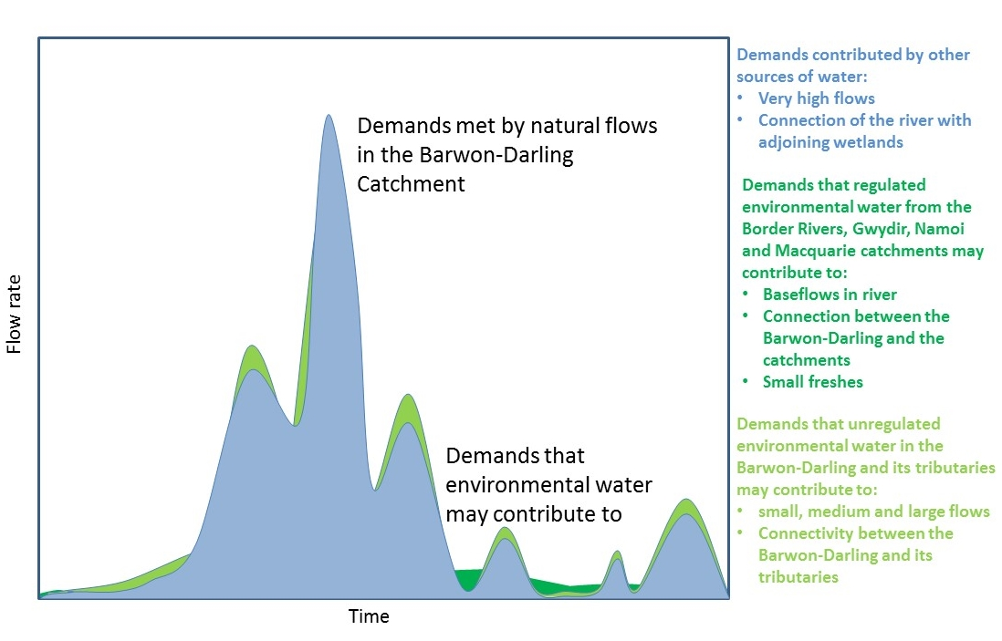

Figure 2: Scope of demands that environmental water may contribute to in the Barwon-Darling

Based on the above objectives specific watering requirements (flow magnitude, duration, timing and frequency) have been identified as being in scope for Commonwealth environmental water. These water requirements are described in Table 2. As with the objectives, the environmental water requirements will continue to be reviewed and revised in response to new knowledge.

## Monitoring and adaptive management

Operational monitoring is undertaken for all Commonwealth environmental watering actions and involves collecting on-ground data with regard to environmental water delivery such as volumes delivered, impact on the river systems hydrograph, area of inundation and river levels. It can also include observations of environmental outcomes including monitoring fish condition and water quality.

DPI Fisheries have been contracted to undertake monitoring of native fish condition and movement in the Barwon-Darling as part of a coordinated flow release (i.e. the northern connectivity event) described in Section 2.1. This work is monitoring the change in fish condition and movement due to environmental flows. The results of this project will be used to inform future environmental water management. The final report for this project will be made public once the project is completed. Preliminary results suggested that:

* the high diversity of fish species but low numbers found was consistent with the Darling fish population being in moderate condition and having a good platform for recovery
* fish were stressed where the river had ceased-to-flow
* the proportion of fish with health conditions was highest at the two sites immediately downstream of Wilcannia (Moorabin and Billilla) where the river had ceased-to-flow for longest, and algae levels were high.

The Long Term Intervention Monitoring (LTIM) Project is also being undertaken at the junction of the Warrego and Darling rivers. It aims to understand the environmental response from Commonwealth environmental watering with respect to the targeted objectives. Monitoring information is also provided by state governments.

The LTIM project at the junction of the Warrego and Darling Rivers Selected Area (at Toorale) aims to evaluate the contribution of Commonwealth environmental water delivery in relation to the expected outcomes at the local and Basin scale. At Toorale, this includes considering both local catchment-based Commonwealth unregulated flow contributions and residual inflows from upstream unregulated and regulated sources. This includes water quality monitoring at sites along the Darling River. Some of the key findings of this monitoring include:

* Approximately 8,720 ML of Commonwealth environmental water contributed to four flow events down the Darling River, which provided connecting flows through to Louth*.*
* These flow events inundated 173 benches, 20 anabranch channels and 33,269 individual snags. Inundation of these features provided additional habitat for biota, and allowed for the exchange of organic matter and nutrients between these features and the river channel, which stimulated food webs.
* Environmental flows from the Warrego at Toorale increased the connectivity along and between the Warrego and Darling Rivers, which is important for fish movement. The Warrego flows also improved the water quality in the Darling River.

Information on the monitoring activities is available at [https://www.environment.gov.au/water/cewo/catchment/northern-unregulated-rivers/monitoring](https://www.environment.gov.au/water/cewo/catchment/northern-unregulated-rivers/monitoring%20)

The CEWO also makes use of monitoring undertaken by state partners. For example, our partners provide updates on the condition of important in-channel and riparian habitats. The outcomes from these monitoring activities, and any other available relevant data, are used in adaptive management to inform portfolio planning and decision-making as outlined in Section 2.

# Portfolio management in 2018–19

In planning for the management of Commonwealth environmental water, the Commonwealth Environmental Water Office aims to maximise the outcomes achieved from the available water. This includes consideration of the urgency of demands (based on targeted objectives and watering requirements, watering history and asset condition) and the available supply under different resource scenarios. Plans for water delivery, trade and carryover are then made in a multi-year context, with an assessment also undertaken of need for water in future years.

This planning process is outlined in full in Table 2 below and summarised in the sections below.

Event based mechanisms may be considered in 2018-19 to allow more active management of unregulated entitlements to help achieve greater ecological outcomes in the Barwon-Darling. The implementation of an event based mechanism in the Barwon-Darling will be subject to the NSW government providing environmental protection measures such as temporary water restrictions. The establishment of active management arrangements including a river operator and transparent operating protocol for the Barwon-Darling would also help to implement an event based mechanism.

## Antecedent and current catchment conditions and the demand for environmental water in 2018–19

For the first half of 2017-18, most of the Northern Basin was experiencing below average to very much below average rainfall conditions, resulting in very low to no flows across all systems (BOM 2018). At the same time, some areas were experiencing record hot temperatures during spring and early summer, including very warm nights, which exacerbated no flow conditions. From 28 January 2018 to the 6 May 2018 there was no flow at Wilcannia, increasing pressure on town water supplies and stock and domestic supply.

At the end of February and early March 2018, a deep trough extended from the northwest, through to central and southeastern Queensland producing rainfall across the west and southern inland areas (BOM 2018). In response, the NSW Government placed a temporary restriction on pumping order on natural flows entering the Barwon-Darling to replenish town water supplies and provide stock and domestic supply for landholders, inhibiting A, B and C class licence access until 31 March above Boorooma and until 28 April below Boorooma. This resulted in natural flows from the Moonie, Condamine-Balonne/Culgoa, and Warrego breaking the cease to flow event in the Barwon-Darling River as shown in the following graph.

**Graph 1:** Flows in the Darling River from January 2018 to May 2018 (NSW DPI, 2018)

From an environmental perspective, these natural flows provided great benefit in wetting the system following extended dry periods, filling up pools, connecting reaches of waterway and improving water quality. However, as evident by the recession of flows, it takes quite a large volume of water to re-start the Barwon-Darling River, particularly downstream of Bourke, with very little of the natural flow making it to Wilcannia (NSW DPI, 2018).

Releases of Commonwealth and NSW environmental water from Glenlyon Dam (Border Rivers) and Copeton Dam (Gwydir,) known as the northern connectivity event, increased flows in the Barwon-Darling in April to June 2018. The purpose of these releases was to benefit native fish along rivers in the northern Murray-Darling Basin by improving longitudinal connectivity, and therefore providing fish with improved food sources, and opportunities to move and disperse to better habitats. The flow of water for the environment was protected by a further temporary restriction on pumping of A, B and C class until 22 June. This restriction was imposed by the NSW government in recognition of the environmental need and community benefit of the flow, with no natural inflows to the system environmental water replenished over 2,000 km of habitat along the Barwon-Darling River. This flow peaked in the Barwon River at 1,200 ML/day at Collarenebri, 1,200 ML/day at Walgett, 1000 ML/day at Brewarrina and achieved 500 ML/day at Wilcannia.

If conditions are dry in 2018-19 there is likely to be an environmental demand for low flows. Subject to antecedent conditions, water availability, and urgency of environmental demands, there may be opportunities to coordinate releases across multiple rivers in the northern Basin in 2018-19 to meet broader environmental demands. However, because of the volume of water required it is only occasionally possible to release environmental water from the tributary dams to flow the length of the Barwon-Darling, perhaps once or twice in a decade.

The environmental demands in the tributaries of the Barwon-Darling are described in the portfolio management plans for the individual catchments.

There is ongoing environmental demands in the Barwon-Darling for flows over 6,000 ML/day at Bourke. This is outside the scope of what Commonwealth environmental watering can achieve and will only be met by wet conditions.

**Murray–Darling Basin Plan environmental watering priorities and the Murray–Darling Basin-wide environmental watering strategy**

The Murray–Darling Basin Authority publish the Basin annual environmental watering priorities each year and in 2017–18 also published multi-year priorities. Commonwealth environmental water in the Barwon-Darling will contribute to the following multi-year environmental watering priorities and the 2018–19 Basin annual environmental watering priorities.

**Rolling, multi-year priorities**

* Support lateral and longitudinal connectivity;
* Improve flow regimes and connectivity to maximise the ecological function of the Barwon-Darling river system for native fish;
* Support viable populations of threatened native fish, maximise opportunities for range expansion and establish new populations.

**2018-19 Annual Priorities**

* Coordinate replenishment flows across multiple tributaries to maintain habitat condition and regulate water quality, carbon and nutrients in refuges along the Barwon-Darling watercourse;
* Improve flow regimes and connectivity to maximise the ecological function of the Barwon-Darling river system for native fish;
* Support viable populations of threatened native fish, maximise opportunities for range expansion and establish new populations.

In making decisions on the use of Commonwealth environmental water the CEWH will have regard to these priorities while also considering water resource availability and environmental demand. In contributing to these demands, the Commonwealth Environmental Water Office will also be aiming to contribute to the expected outcomes in the Basin-wide environmental watering strategy (see Attachment A).

## Water availability in 2018–19

Water availability in the Barwon-Darling in 2018-19 is subject to natural rainfall and flows from the tributaries. The Commonwealth Environmental Water Holder holds unregulated entitlements on the Barwon-Darling River at Collarenebri and Toorale. Additional environmental water may be available to contribute to Barwon-Darling flows. Refer to the Portfolio Management Plans for the intersecting streams and individual Northern Catchments for potential water availability in these catchments.

Information on allocations to Commonwealth environmental water holdings can be found at <http://www.environment.gov.au/water/cewo/portfolio-mgt/holdings-catchment> and is updated monthly.

**Water resource availability scenarios**

Commonwealth environmental water is not managed in isolation. When considering the available resource to meet environmental demands, it is necessary to also factor in the resources managed by other entities and available to contribute to environmental objectives. Relevant resources include unregulated flows and contributions from the tributaries to the Barwon-Darling. Further detail on sources of environmental water in the Barwon-Darling is provided in Attachment C.

By combining the forecasts of water potentially available to the Commonwealth with streamflow forecasts, water resource availability scenarios can be developed ranging from very low to very high. Based on available information all resource availability scenarios are in scope for 2018–19.

## Overall purpose of managing environmental water based on supply and demand

Environmental water needs (demand) and water availability (supply) both influence the overall purpose of Commonwealth environmental water management. Under different combinations, the management purpose can range from ‘avoiding damage’ to the environment to ‘improving’ ecological health. This in turn informs the mix of portfolio management options that are suitable for maximising outcomes. Figure 3 below shows how current demands and forecasted supply are considered together.

The overall ‘purpose’ for managing the Commonwealth’s water portfolio in the Barwon-Darling for 2018–19 is to protect fish refuge pools, increase access to habitat and improve water quality. This includes providing water to the Lowland Darling River aquatic ecological community listed as endangered under the NSW Fisheries management Act.

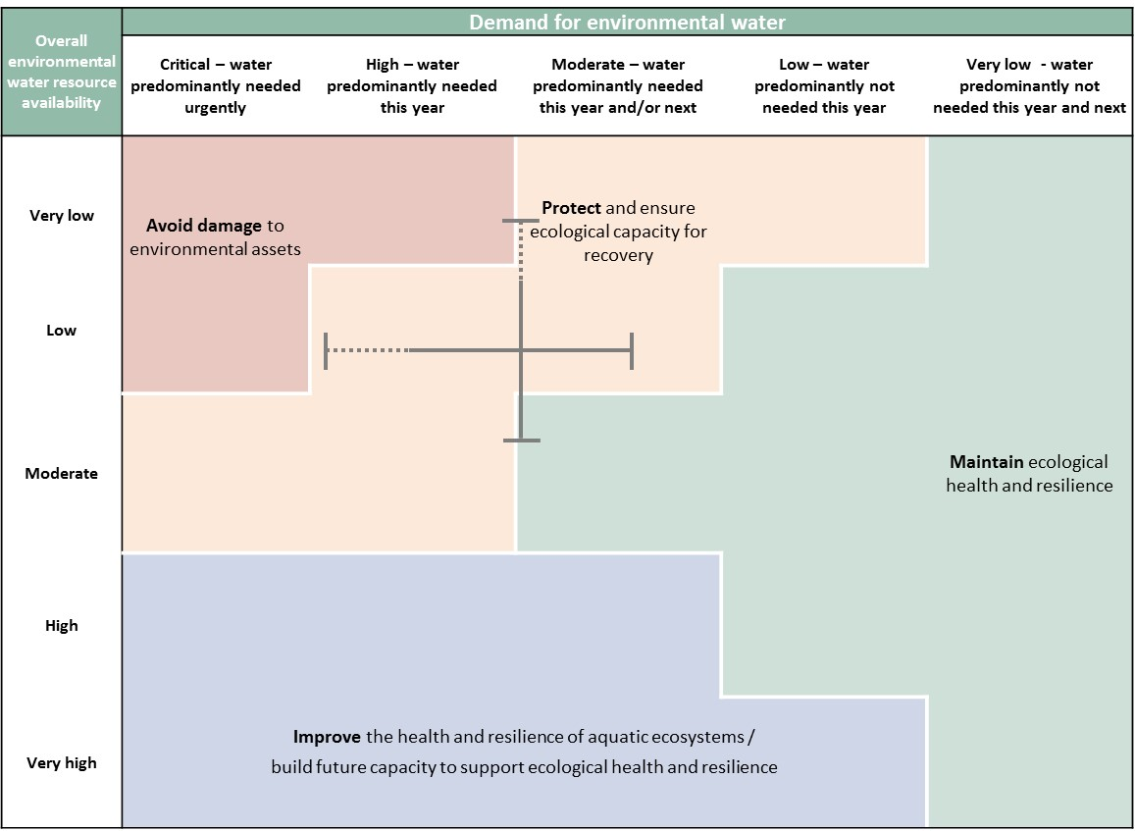

Figure 3: Determining a broad purpose for portfolio management in the Barwon-Darling for 2018–19. Note: grey lines represent potential range in demand and resource availability.

Further detail on how the overall purpose for portfolio management changes under different supply and demand scenarios is provided in *Portfolio Management Planning: Approach to planning for the use, carryover and trade of Commonwealth environmental water, 2018–19* (available at: <http://www.environment.gov.au/water/cewo/publications>).

## Water Delivery in 2018–19

Consistent with the demands and purpose described above the following are the ecological process that are a priority for active management of environmental water in the Barwon-Darling for 2018–19 (see also Table 2 for supporting information regarding the basis for determining these watering intentions):

* Dry spell breaking small pulse along the Barwon-Darling to refresh refuge pools
* Fresh to inundate snags and benches, enable some fish movement and recruitment along the Barwon-Darling

Environmental water from unregulated flows will also contribute to ecological outcomes in the Barwon-Darling. These flows are particularly important for fish as they contain the natural cues and nutrients fish require for their lifecycles as this water is from natural flows (it is not delivered from dams).

**Stakeholder Feedback**

Input on environmental demands and active management options for the Barwon-Darling has been provided by the MDBA, NSW OEH, Eco Logical and NSW DPI Fisheries during 2017–18 and in previous years.

## Trading water in 2018–19

There is low potential to trade in this catchment as trade requirements need further investigation.

Planning on water trade considers supply and demand within the catchment and across the Basin. As part of the planning process, the Commonwealth Environmental Water Office undertakes a Basin-wide analysis to identify opportunities to use allocation trade to better match differing demands across catchments.

Further information will be provided to the market ahead of any trade of Commonwealth environmental water at: <http://www.environment.gov.au/water/cewo/trade/current-trading-actions>.

For more information on the rules and procedures governing the trade of Commonwealth environmental water, see the *Commonwealth environmental water Trading Framework* available at: http://www.environment.gov.au/water/cewo/publications/water-trading-framework-nov2016.

## Carrying over water for use in 2019–20

The volume of water carried over in the tributaries for use in the Barwon-Darling in 2019–20 will depend upon resource availability and demand throughout the year.

Carryover volumes will be adjusted throughout the year as the season unfolds in response to both current and future demands and the water available to meet these demands. These decisions will be based upon best information available at the time.

More information on how the Commonwealth makes decisions on carryover is here: <http://www.environment.gov.au/water/cewo/portfolio-mgt/carryover>

## Identifying Investment Opportunities

Under the Water Act the Commonwealth Environmental Water Holder (CEWH) has the flexibility to use the proceeds from the sale of water allocations to fund environmental activities in the Basin. ‘Environmental activities’ should improve the capacity of the CEWH to meet the objectives of the Basin Plan environmental watering plan.

Environmental Activities must also be consistent with:

* the CEWH’s obligation to exercise its functions to protect and restore environmental assets; and
* the requirement to use Special Account funds (including trade proceeds) to cover costs incurred in the performance of the CEWH’s functions

The CEWH is in the process of developing an Investment Framework to guide decisions on what types of environmental activities may be considered when investing the proceeds from the sale of environmental water allocations.

**Table 2**: Environmental demands, priority for active management of environmental watering in 2018–19 and outlook for coming year in the Barwon-Darling.

|  |  |  |  |  |  |  |
| --- | --- | --- | --- | --- | --- | --- |
| Environmental assets | **Indicative demand (for all sources of water in the system)** | | | **Watering history** | | **201819** |
| **Physical and process assets** | **Flow/Volume** | **Required frequency** | **(from all sources of water)** | **Environmental demands for water** | **Potential Commonwealth environmental water contribution** |
| **Dry spell breaking low flow pulse over extended river reach** | Dry period refuge (waterholes) | 20-30 GL* tributary inflow for 10 to 20 days  Indicative trigger:  > 40 days nil flow at Bourke  > 120-150 days nil flow forecast at Wilcannia  > 150 days nil flow forecast for the reach between Wilcannia and Menindee Lakes (estimated from Wilcannia gauge) | As required to offset an unusually long nil flow spell | Flow requirements were met in 2016-17. Not met in 2017-18 as max dry spell 66 days at Bourke | High | End of system regulated delivery from Gwydir and/or Border Rivers, Macquarie and Namoi catchments may be possible if sufficient water available and high environmental demand. |
| **Water Quality** | Water quality – suppress persistent stratification to reduce algae outbreaks | 450 ML/day at Bourke  350 ML/day at Wilcannia  Oct to April | As required | Flow requirements met in 2016-17 and 2017-18 | High | End of system regulated delivery from Gwydir and/or Border Rivers, Macquarie and Namoi catchments may be possible if sufficient water available and high environmental demand.  Flows at this level could potentially be enhanced by Commonwealth A/B class access in the Barwon-Darling |
| Algal suppression flows | 2,000 ML/day at Wilcannia for 5 days between Oct to April | Annual | Flow requirements met in 2016-17 and 2017-18 | High | Requires other sources of water  Flows could be enhanced by directing Commonwealth environmental water from entitlements on the NSW Warrego (Toorale) to the Darling. Subject to trigger flows in the Warrego River and use in the Darling being the priority under CEWO's use strategy for the Toorale entitlements.  Flows at this level could potentially be enhanced by Commonwealth A/B class access in the Barwon-Darling |
| **Increasing available fish habitat along the Barwon-Darling** | Increase fish access to habitat, small scale movement, water quality and spawning in small bodied fish | 500 ML/day Barwon River at Walgett for 7 – 20 days | 1 - 3 times a year in an average of 8-9 years out of 10 | Flow requirements met in 2017-18 and for last 10 years | Low | End of system regulated delivery and or unregulated access Gwydir and/or Border Rivers, Macquarie and Namoi if water availability improves.  Flows at this level could potentially be enhanced by Commonwealth A/B class access in the Barwon-Darling |
| 500 ML/day Darling River at Bourke for 7 – 20 days | 1 - 2 times a year in an average of 8-9 years out of 10 | Flow requirements met in 2017-18 and for last 10 years | Low |
| 350 ML/day Darling River at Louth for 7 – 14 days | 1 – 2 times a year in an average of 8-9 years out of 10 | Flow requirements met in 2017-18 and for last 10 years | Low | Flows could be enhanced by directing Commonwealth environmental water from entitlements on the NSW Warrego (Toorale) to the Darling. Subject to trigger flows in the Warrego River and use in the Darling being the priority under CEWO's use strategy for the Toorale entitlements.  Flows at this level could potentially be enhanced by Commonwealth A/B class access in the Barwon-Darling |
| Fish condition and small scale movement | 2,500 ML/day at Bourke | As required after dry spell | N/A | High | End of system regulated delivery from Gwydir and/or Border Rivers, Macquarie and Namoi catchments may be possible if sufficient water available and high environmental demand.  Flows at this level could potentially be enhanced by Commonwealth A/B class access in the Barwon-Darling |
| **In channel freshes ̶**  **Longitudinal connectivity (1)** | Small scale fish movement/ access to habitat (snags, in channel benches Brewarrina to Bourke) | 6,000 ML/day Darling River at Bourke for 14 days | 8 to 9 in 10 years | Flow requirements not met in 2017-18. Met for 5 years out of the last 10 years | **Out of scope for active management.**  Benefit of supplying additional CEW would be negligible; sources of additional water are too far upstream. | **Low (as not ready for implementation) High (in future)**  Flows near this level could potentially be enhanced by additional B/C class access in the Barwon-Darling, unregulated access in tributaries and/or end of system regulated deliveries. Low immediate priority because trade and operational requirements need further investigation. |
| 500 ML/d with a minimum peak of 1,500 ML/d Darling River at Bourke (Sept to April) for 50 days with the peak flow for 14 days | average of 7- 8 out of 10 years | Flow requirements not met in 2017-18. Met for 6 years out of the last 10 years | High | End of system regulated delivery from Gwydir and/or Border Rivers, Macquarie and Namoi catchments may be possible if sufficient water available and high environmental demand.  Flows at this level could potentially be enhanced by Commonwealth A/B class access in the Barwon-Darling  EM |
| Access to snags and benches, some fish recruitment (Brewarrina to Tilpa) | 6,000 ML/day Darling River at Louth (Aug to May) for 20 days | 7 in 10 years | Flow requirements not met in 2017-18. Met for 5 years out of the last 10 years | High | Flows could be enhanced by directing Commonwealth environmental water from entitlements on the NSW Warrego (Toorale) to the Darling. Subject to trigger flows in the Warrego River and use in the Darling being the priority under CEWO's use strategy for the Toorale entitlements.  Flows at this level could potentially be enhanced by A/B/C class access in the Darling at Toorale |
| Fish movement and increased access to habitat (snags, in channel benches and a few wetlands) | 10,000 ML/day Darling River at Bourke for 14 days between August and May | 6 – 8 in 10 years | Flow requirements meet 4 times in last 10 years | **Out of scope for active management.**  Benefit of supplying additional CEW would be negligible; sources of additional water are too far upstream. | **Low (as not ready for implementation) High (in future)**  Flows near this level could potentially be enhanced by additional B/C class access in the Barwon-Darling, unregulated access in tributaries and/or end of system regulated deliveries. Low immediate priority because trade and operational requirements need further investigation. |
| **In channel freshes**  **Lateral connectivity** | Lateral connectivity with Talyawalka Anabranch | Above 30,000 ML/day at Wilcannia. Requires flows for over 60 days | Once in 10 years | Flow requirements partially meet twice in last 10 years. | Contribution of CEW would be small relative to volumes required | **Low because of the volume required**  Flows could be enhanced by directing Commonwealth environmental water from entitlements on the NSW Warrego (Toorale) to the Darling. Subject to trigger flows in the Warrego River and use in the Darling being the priority under CEWO's use strategy for the Toorale entitlements.  Flows at this level could potentially be enhanced by a small volume because of A/B/C class access in the Darling at Toorale |
| *Indicative volume, very variable depending on antecedent conditions |  |  |  | **Carryover potential** | There is no option for carryover allocations in unregulated systems like the Barwon-Darling. There is potential for carryover in the Barwon-Darling tributaries, refer to individual catchment portfolio management plans. | |
|  |  |  |  | **Trade potential** | There is low potential to trade in this catchment as trade requirements need further investigation. | |

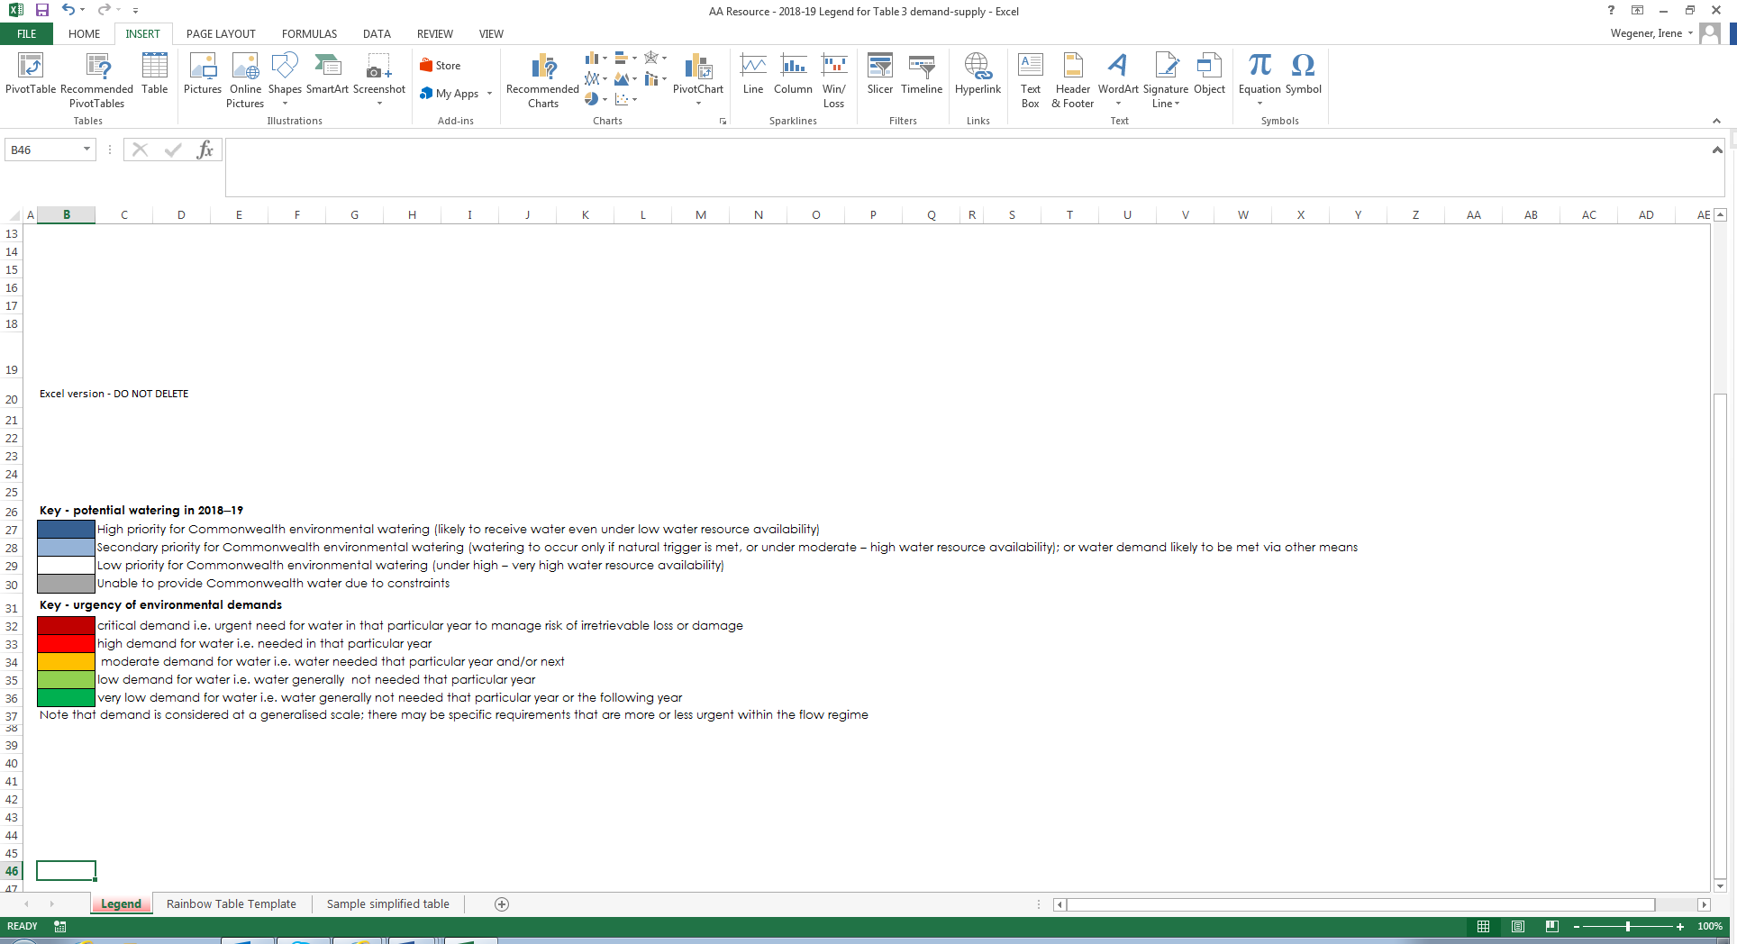

# Next steps

## From planning to decision making

It is important to distinguish between planning and operational decision making. As shown in Figure 4, planning allows the Office to manage the environmental water portfolio in a holistic manner and is an exercise in developing a broad approach or intention, based on the key drivers (demand and supply).

Decision making throughout each year builds on the intention by considering in more detail the specific prevailing factors and additional factors such as costs, risks, and constraints to water delivery and market conditions.

A figure showing the factors which influence decisions involving the delivery, carryover and trade of Commonwealth environmental water, including known and anticipated environmental demands; the forecast climatic conditions; current dam storage levels; and opportunities for environmental watering at specific sites including a cost versus benefit assessment of each watering option. The physical and operational constraints to water delivery include environmental and operational risks, water account rules, carryover limits, long-term yield of entitlements and water market conditions.

Figure 4: Planning and decision making for Commonwealth environmental water use

## Further information

For further information on how the Office plans for water use, carryover and trade, please visit our web site: <http://www.environment.gov.au/water/cewo>

or the sites below:

* Water use: [www.environment.gov.au/topics/water/commonwealth-environmental-water-office/assessment-framework](http://www.environment.gov.au/topics/water/commonwealth-environmental-water-office/assessment-framework)
* Carryover: <http://www.environment.gov.au/topics/water/commonwealth-environmental-water-office/portfolio-management/carryover>
* Trade: <http://www.environment.gov.au/water/cewo/trade/trading-framework>

# 

# Bibliography

Brandis, K and Bino, G (2016). *A review of the relationships between flow and waterbird ecology in the Condamine-Balonne and Barwon-Darling river system Systems*. Murray-Darling Basin Authority, Canberra. <https://www.mdba.gov.au/publications/independent-reports/flow-waterbird-ecology>

Brennan S, O’Brien M, Thoms M and Maher S (2002). *The Physical Character and Flow Criteria for Wetlands Along the Barwon-Darling River*, CRC for Freshwater Ecology Technical Report to NSW Department of Land and Water Conservation.

Casanova, M (2015). *Review of Water Requirements for Key Floodplain Vegetation for the Northern Basin: Literature review and expert knowledge assessment*. Report prepared for the MDBA by Charophyte Services, Lake Bolac. [http://www.mdba.gov.au/publications/independent-reports/review-](http://www.mdba.gov.au/publications/independent-reports/review-water-requirements-key-floodplain-vegetation-northern-basin)  [water-requirements-key-floodplain-vegetation-northern-basin](http://www.mdba.gov.au/publications/independent-reports/review-water-requirements-key-floodplain-vegetation-northern-basin)

Eco Logical Australia (2015). *Commonwealth Environmental Water Office Long Term Intervention Monitoring Project. Junction of the Warrego and Darling rivers Selected Area; Annual Evaluation Report – Year 1*. Report prepared for the Commonwealth Environmental Water Office, Department of the Environment, Commonwealth of Australia.<https://environment.gov.au/water/cewo/catchment/northern-unregulated-rivers/monitoring>

Eco Logical Australia (2016). *Vegetation of the Barwon-Darling and Condamine-Balonne floodplain systems of New South Wales: Mapping and survey of plant community types*. Prepared for the Murray-Darling Basin Authority. [http://www.mdba.gov.au/publications/independent-reports/vegetation-](http://www.mdba.gov.au/publications/independent-reports/vegetation-barwon-darling-condamine-balonne-floodplain-systems-new)  [barwon-darling-condamine-balonne-floodplain-systems-new](http://www.mdba.gov.au/publications/independent-reports/vegetation-barwon-darling-condamine-balonne-floodplain-systems-new)

Eco Logical Australia (2017a). *Commonwealth Environmental Water Office Long Term Intervention Monitoring Project. Junction of the Warrego and Darling rivers selected area; 2015-16 Final Evaluation Report*. Report prepared for the Commonwealth Environmental Water Office, Department of the Environment and Energy, Commonwealth of Australia. <https://environment.gov.au/water/cewo/catchment/northern-unregulated-rivers/monitoring>

Eco Logical Australia (2017b). *Aquatic fauna use of the Warrego River Western Floodplain*. Report prepared for the Commonwealth Environmental Water Office, Department of the Environment and Energy, Commonwealth of Australia. <https://environment.gov.au/water/cewo/catchment/northern-unregulated-rivers/monitoring>

Eco Logical Australia (2018). *Commonwealth Environmental Water Office Long Term Intervention Monitoring Project. Junction of the Warrego and Darling rivers selected area; 2016-17 Final Evaluation Report*. Report prepared for the Commonwealth Environmental Water Office, Department of the Environment and Energy, Commonwealth of Australia. <https://environment.gov.au/water/cewo/catchment/northern-unregulated-rivers/monitoring>

Kingsford R, Bedward M and Porter J (1994). *Waterbirds and Wetlands in Northwestern New South Wales*. National Parks and Wildlife Service Occasional Paper No 19. NSW National Parks and Wildlife Service, Hurstville.

Kingsford, R.T, Thomas, R.F and Wong, P.S (1997). *Significant wetlands for waterbirds in the Murray- Darling Basin.* NSW National Parks and Wildlife Service, Hurstville.

R.T. Kingsford, G. Bino, J. Porter and K. Brandis (2013), *Waterbird communities in the Murray-Darling Basin (1983-2012)*. Murray-Darling Basin Authority (2014), Canberra. <http://www.mdba.gov.au/sites/default/files/pubs/Waterbird-communities-mdb-aug-2013.pdf>

Murray-Darling Basin Authority (MDBA) (2012). *Assessment of environmental water requirements for the proposed Basin Plan:* Murray-Darling Basin Authority, Canberra. [http://www.mdba.gov.au/publications/mdba-reports/assessing-environmental-](http://www.mdba.gov.au/publications/mdba-reports/assessing-environmental-water-requirements-basins-rivers)  [water-requirements-basins-rivers](http://www.mdba.gov.au/publications/mdba-reports/assessing-environmental-water-requirements-basins-rivers)

MDBA (2014). *Basin-wide Environmental Watering Strategy 2014*. MDBA Publication No 20/14. Murray– Darling Basin Authority, Canberra

MDBA (2016). *The Northern Basin Review: Understanding the economic, social and environmental outcomes from water recovery in the northern Basin.* Murray-Darling Basin Authority, Canberra [https://www.mdba.gov.au/sites/default/files/pubs/Northern-basin-review-report-FINAL.pdf.](https://www.mdba.gov.au/sites/default/files/pubs/Northern-basin-review-report-FINAL.pdf)

MDBA (2017). *Ecological needs of low flows in the Barwon-Darling*. Murray-Darling Basin Authority, Canberra

Nairn, L.C. and Kingsford R.T (2012). *Wetland distribution and land use in the Murray-Darling basin*. A report to the Australian Floodplain Association. Australian Wetlands, Rivers and Landscapes Centre, University of NSW, Sydney. [https://www.ecosystem.unsw.edu.au/content/wetland-distribution-and-land-use-](https://www.ecosystem.unsw.edu.au/content/wetland-distribution-and-land-use-in-the-murray-darling-basin)  [in-the-murray-darling-basin](https://www.ecosystem.unsw.edu.au/content/wetland-distribution-and-land-use-in-the-murray-darling-basin)

NSW Department of Primary Industries (NSW DPI) (2007). *Endangered ecological communities in NSW– Lowland Darling River aquatic ecological community. Primefact: 173*. NSW Department of Primary Industries, Port Stephens, NSW.

NSW DPI (2012). *Water Sharing Plan for the Barwon-Darling Unregulated and Alluvial Water Sources Background document*. NSW Department of Primary Industries <http://www.water.nsw.gov.au/__data/assets/pdf_file/0006/549024/wsp_barwon_darling_background_document.pdf>

NSW DPI (2015a). *Fish and flows in the Northern Basin: responses of fish to changes in flows in the Northern Murray-Darling Basin*. Stage 2 Report prepared for the Murray-Darling Basin Authority by NSW DPI, Tamworth. [http://www.mdba.gov.au/publications/independent-reports/fish-flows-northern-basin-](http://www.mdba.gov.au/publications/independent-reports/fish-flows-northern-basin-responses-fish-changes-flows-northern)  [responses-fish-changes-flows-northern](http://www.mdba.gov.au/publications/independent-reports/fish-flows-northern-basin-responses-fish-changes-flows-northern)

NSW DPI (2015b). *Fish and Flows in the Northern Basin: responses of fish to changes in flow in the Northern Murray-Darling Basin – Reach Scale Report*. Stage 3 report prepared for the Murray-Darling Basin Authority by NSW DPI, Tamworth. [http://www.mdba.gov.au/publications/independent-reports/fish-](http://www.mdba.gov.au/publications/independent-reports/fish-flows-northern-basin-responses-fish-changes-flows-northern)  [flows-northern-basin-responses-fish-changes-flows-northern](http://www.mdba.gov.au/publications/independent-reports/fish-flows-northern-basin-responses-fish-changes-flows-northern)

NSW DPI (2018) *Draft Northern Connectivity Event Native fish condition and movement in the Barwon-Darling Progress Report,* Prepared for the Commonwealth Environmental Water Office, Canberra.

Queensland Department of Science, Information Technology and Innovation (Queensland DSITI) (2015). *Waterhole refuge mapping and persistence analysis in the Lower Balonne and Barwon- Darling rivers.* Department of Science, Information Technology and Innovation, Brisbane. [http://www.mdba.gov.au/publications/independent-reports/waterhole-refuge-mapping-persistence-analysis-](http://www.mdba.gov.au/publications/independent-reports/waterhole-refuge-mapping-persistence-analysis-lower-balonne-barwon)  [lower-balonne-barwon](http://www.mdba.gov.au/publications/independent-reports/waterhole-refuge-mapping-persistence-analysis-lower-balonne-barwon)

Sheldon F, Bunn S, Hughes J, Arthington A, Balcombe S and Fellows C (2010) *Ecological roles and threats to aquatic refugia in arid landscapes: dryland river waterholes*. Marine and Freshwater Research, 61, 885–895

Sheldon F (2017) Characterising the ecological effects of changes in the ‘low-flow hydrology’ of the Barwon-Darling River. Australian Rivers Institute, Griffith University. <https://environment.gov.au/water/cewo/publications/characterising-eco-effects-changes-barwon-darling-2017>

# Attachment A – Expected outcomes from the Basin-wide environmental watering strategy

Expected outcomes from the Basin-wide environmental watering strategy (MDBA 2014) that are relevant to the Barwon-Darling are described below.

**River Flows and Connectivity**

|  |
| --- |
| **Connectivity outcome** |
| Baseflows are at least 60% of natural levels |
| 10 percent overall increase inflows to the Barwon-Darling |
| 10 to 20% increase of freshes and bank-full events |

**Vegetation condition and extent**

* + Maintain current extent of river red gum, black box, coolibah forest and woodlands
  + No decline in the condition of black box, river red gum and coolibah.

|  |  |  |  |  |
| --- | --- | --- | --- | --- |
| **Catchment** | **Area of river red gum (ha)\*** | **Area of black box (ha)\*** | **Area of coolibah (ha)\*** | **Non–woody water dependent vegetation** |
| Barwon Darling | 7,800# | 11,700# | 14,900# | Fringing/within the Barwon and Darling rivers |

Area estimates (ha) are from: Cunningham SC, White M, Griffioen P, Newell G and MacNally R 2013, ‘Mapping vegetation types across the Murray-Darling Basin’, Murray-Darling Basin Authority, Canberra # considered to be an underestimate due to technical limitations in determining the lateral extent of floodplain inundation achieved through Basin Plan implementation

**Water birds**

|  |  |  |
| --- | --- | --- |
| **Environmental asset** | **Total abundance and diversity** | **In scope for Commonwealth environmental watering** |
| Talyawalka system | * | No |

**Native Fish**

* + No loss of native species
  + Improved population structure of key species through regular recruitment, including:
    1. Short-lived species with distribution and abundance at pre-2007 levels and breeding success every 1–2 years
    2. Moderate to long-lived with a spread of age classes and annual recruitment in at least 80 per cent of years
    3. Increased movements of key species
    4. Expanded distribution of key species and populations

**Key Native fish species in the Barwon-Darling**

|  |  |  |
| --- | --- | --- |
| **Species** | **Specific outcomes** | **In-scope for Commonwealth water in the Barwon-Darling** |
| Silver perch (*Galaxias rostratus*) | Expand the core range of at least 2 existing populations (Barwon–Darling is a candidate site) | Limited scope through improved in- stream flows in unregulated flow events and breaking cease to flow and improving access to fish habitat through held water releases from tributaries. |
| Southern purple-spotted gudgeon (*Mogurnda adspersa*) | Establish or improve the core range of 2–5 additional populations – (the Barwon– Darling is a priority sites). |
| Murray cod (*Maccullochella peelii*) | A 10–15 per cent increase of mature fish in key populations |
| Golden perch (*Macquaria ambigua*) | A 10–15 per cent increase of mature fish in key populations |

**Important environmental assets for native fish in the Barwon-Darling**

|  |  |  |  |  |  |
| --- | --- | --- | --- | --- | --- |
| **Key site/ environmental asset** | **Key movement corridor** | **High biodiversity** | **Hydrodynamic diversity** | **Threatened species** | **Dry period refuge** |
| Barwon-Darling River (Mungindi to Menindee) | * | * | * | * | * |
| Talyawalka anabranch [Darling] | * |  | * |  | * |

# Attachment B – Operational details for watering

## Operational considerations in the Barwon-Darling catchment

The Barwon-Darling is an unregulated catchment with inflows from the intersecting streams and northern catchments including the Border Rivers, Gwydir, Namoi and Macquarie. It is a complex catchment in terms of providing environmental water as the inflows to the catchment are dependent on the use of water in the tributaries and unregulated flows. The length of the catchment, over 2,000 km, means there will always be a large amount of “losses” to the river as water travels through the system, this is accounted for in planning for any provision of environmental water.

Environmental water can be legal taken by other licence holders as there are no return flow or protection of environmental water in the catchment. In 2018, the NSW Government agreed to the protection of environmental water from the Border Rivers and Gwydir in order to provide water past Bourke to Wilcannia. Any future provision of environmental water will consider the available options to protect this water from legal take. The Barwon-Darling is an area of policy focus and review by the NSW and Commonwealth governments. The provision of environmental water will be adapted to any applicable changes in policy.

In hot dry times the river can dry down to a serious of pools. These pools provide important refuge for fish and other aquatic species. Providing water when the system is very dry can potentially cause water quality issues if pools are turned over and the water is traveling over long distances over hot dry river beds, this is a consideration in providing water.

## Potential watering actions under different levels of water resource availability

Under certain levels of water resource availability, active watering actions may not be pursued for a variety of reasons, including that environmental demand may be met by unregulated flows and that constraints and/or risks may limit the ability to deliver environmental water. Table 4 identifies the range of potential watering actions in Barwon-Darling and the levels of water resource availability that relate to these actions.

Table 3: Summary of potential watering actions for the Barwon-Darling

|  |  |  |  |  |  |  |
| --- | --- | --- | --- | --- | --- | --- |
| **Broad Asset** | **Indicative demand** | **Applicable level(s) of resource availability** | | | | |
| **Very Low** | **Low** | **Moderate** | **High** | **Very High** |
| Dry spell breaking small pulse along the Barwon-Darling to refresh refuge pools | Moderate | Dependent on resource availability in the tributaries refer to individual catchment portfolio management plans | | | | |
| Fresh to inundate snags and benches, enable some fish movement and recruitment along the Barwon-Darling | Low |

## Potential watering actions – standard operating arrangements

Table 3 identifies the range of potential watering actions in Barwon-Darling in the Murray-Darling Basin that give effect to the long-term demands and flow regime identified as being in scope for the contribution of Commonwealth environmental water in any given year. The standard considerations associated with these actions are set out below.

**Watering Action [1]:** Dry spell breaking small pulse along the Barwon-Darling to refresh refuge pools

*Standard operational considerations:* Risks to water quality in delivering and not delivering water. Protection of water from legal take. There will be very high losses along the river, consider providing water from multiple catchments to provide water at mutiple places along the river. Consider providing water in conunction with a natural flow to minimise losses and increase the distance covered by the water.

*Typical extent:* Potentially sections of the Barwon-Darling downstream of the Border Rivers, Gwydir, Namoi and Macquarie catchemnts subject to water avaliblity and environmental demand.

*Approvals:* If possible have the environmental water protected from legal take*.*

**Watering Action [2]:** Fresh to inundate snags and benches, enable some fish movement and recruitment along the Barwon-Darling

*Standard operational considerations:* Risks to water quality in delivering and not delivering water. Protection of water from legal take. There will be very high losses along the river, consider providing water from multiple catchments to provide water at mutiple places along the river. Consider providing water in conunction with a natural flow to minimise losses and increase the distance covered by the water and the habitat avalible for fish.

*Typical extent:* Potentially sections of the Barwon-Darling downstream of the Border Rivers, Gwydir, Namoi and Macquarie catchemnts subject to water avaliblity and environmental demand.

*Approvals:* If possible have the environmental water protected from legal take*.*

# Attachment C – Long-term water availability

## Commonwealth environmental water holdings

The Commonwealth holds unregulated river access entitlements in the Barwon-Darling at Collarenebri and Toorale.

The full list of Commonwealth environmental water holdings can be found at [www.environment.gov.au/topics/water/commonwealth-environmental-water-office/about-commonwealth-environmental-water/how-much](http://www.environment.gov.au/topics/water/commonwealth-environmental-water-office/about-commonwealth-environmental-water/how-much) and is updated monthly.

## Other sources of environmental water

Other potential sources of held environmental water that may be used to complement Commonwealth environmental water delivery in the Barwon-Darling include a small entitlement recovered by the NSW Government in the Barwon-Darling (1 448 ML). This small entitlement can be used to further a number of environmental outcomes as well as Aboriginal, cultural and heritage outcomes.

Regulated and unregulated water held by the Commonwealth and NSW in the intersecting streams and northern NSW tributaries (Border Rivers, Gwydir, Namoi and Macquarie valleys) also provide flows into the Barwon-Darling.

## Planned environmental water

In addition to water entitlements held by environmental water holders, environmental demands may also be met via natural or unregulated flows and water provided for the environment under rules in state water plans (referred to as ‘planned environmental water’).

* Barwon-Darling – B and C class access in the Barwon-Darling and supplementary access in northern NSW tributaries may be restricted in response to prolonged dry conditions in order to maintain flows in the Barwon-Darling for algal suppression, fish passage and to meet critical town water supply needs. Application of these provisions is at the discretion of the NSW Water Minister.
* Planned environmental in the intersecting streams and northern NSW tributaries will also provide flows into the Barwon-Darling.

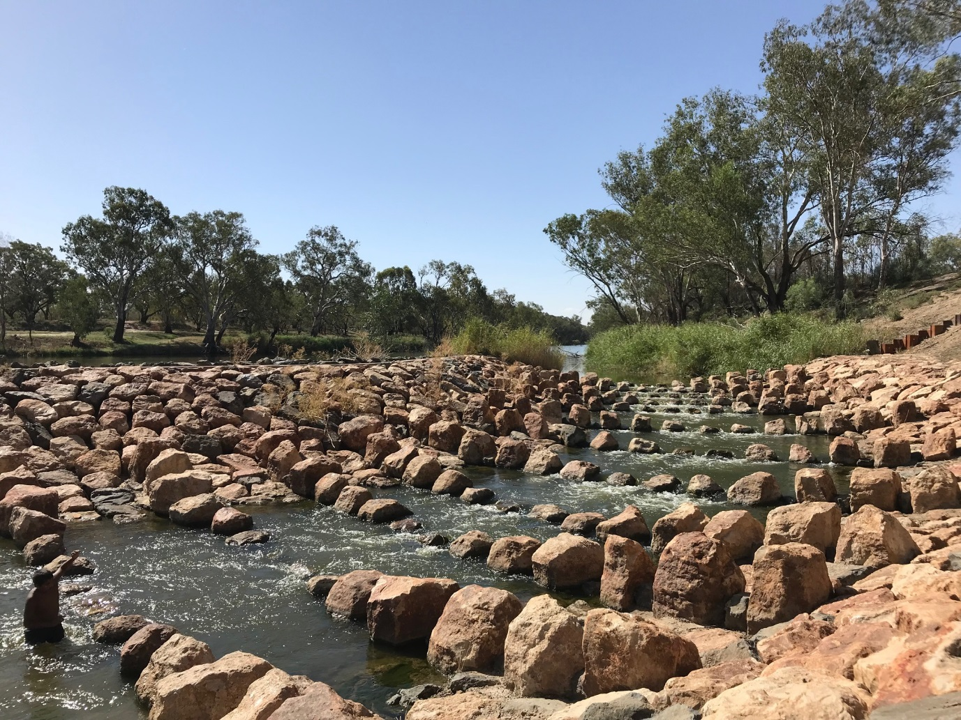

For more information about Commonwealth environmental water, please contact us at:

1800 803 772

[ewater@environment.gov.au](mailto:ewater@environment.gov.au)

[www.environment.gov.au/water/cewo](http://www.environment.gov.au/water/cewo)

@theCEWH

GPO Box 787, Canberra ACT 2601