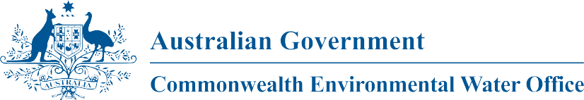

**Commonwealth Environmental Water**

Portfolio Management Plan

Gwydir Valley

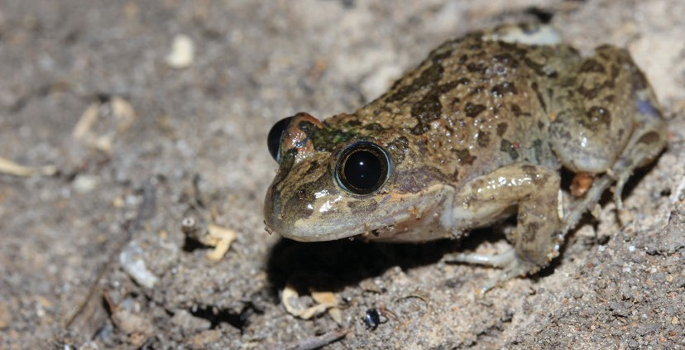2017–18

Front cover image credit: Marsh frog, *Limnodynastes fletcheri*. Photo by Dan McKenzie, Eco Logical Australia.

Back cover image credit: Plumed Whistling Ducks, Gwydir wetlands. Photo by Peter Knock, Eco Logical Australia.

The Commonwealth Environmental Water Office respectfully acknowledges the traditional owners, their Elders past and present, their Nations of the Murray-Darling Basin, and their cultural, social, environmental, spiritual and economic connection to their lands and waters.

**© Copyright Commonwealth of Australia, 2017.**

*Commonwealth Environmental Water Portfolio Management Plan: Gwydir Valley 2017–18* is licensed by the Commonwealth of Australia for use under a Creative Commons Attribution 4.0 International licence with the exception of the Coat of Arms of the Commonwealth of Australia, the logo of the agency responsible for publishing the report, content supplied by third parties, and any images depicting people. For licence conditions see: https://creativecommons.org/licenses/by/4.0/

This report should be attributed as ‘*Commonwealth Environmental Water Portfolio Management Plan: Gwydir Valley 2017–18*, Commonwealth of Australia, 2017’.

The Commonwealth of Australia has made all reasonable efforts to identify content supplied by third parties using the following format ‘© Copyright’ noting the third party.

The views and opinions expressed in this publication are those of the authors and do not necessarily reflect those of the Australian Government or the Minister for the Environment and Energy.

While reasonable efforts have been made to ensure that the contents of this publication are factually correct, the Commonwealth does not accept responsibility for the accuracy or completeness of the contents, and shall not be liable for any loss or damage that may be occasioned directly or indirectly through the use of, or reliance on, the contents of this publication.

# Commonwealth environmental water portfolio management planning

## Commonwealth Environmental Water Holder

The Commonwealth Environmental Water Holder is a statutory position established under the *Water Act 2007* and is responsible for managing the Commonwealth’s environmental water holdings. This water must be managed to protect and restore the rivers, wetlands and floodplains (and the native animals and plants they support) of the Murray-Darling Basin. Mr David Papps is the current Commonwealth Environmental Water Holder. He is supported by staff of the Commonwealth Environmental Water Office. The Office employs six local engagement officers who live and work in regional centres across the Murray-Darling Basin.

## Commonwealth environmental water

Commonwealth environmental water holdings are water entitlements that have been acquired by the Australian Government through investments in water-saving infrastructure and purchases on the water market. The holdings are a mix of entitlement types held across 19 catchments. The rules governing the entitlements vary across states and across catchments. Commonwealth environmental water entitlements are subject to the same fees, allocations, carryover and other rules as equivalent entitlements held by other water users.

There are broadly three options for managing Commonwealth environmental water:

* delivering water to a river or wetland to meet an identified environmental demand
* leaving water in storage and carrying it over for use in the next water year (referred to as ‘carryover’)
* trading water, that is, selling water and using the proceeds to buy water in another catchment or in a future year, or investing in complementary ‘environmental activities’.

## Purpose of the document

This document sets out the plans for managing the Commonwealth environmental water portfolio in the Gwydir River Valley for 2017–18. Efficient and effective management of Commonwealth environmental water requires the utilisation of all portfolio management options. By taking a multi-year approach to planning, portfolio management tools such as use, carryover and trade can be managed for maximising environmental outcomes.

The portfolio management plans support transparent, coordinated and adaptive management of Commonwealth environmental water, consistent with the Basin-wide environmental watering strategy and having regard to the Basin annual environmental watering priorities.

To learn more about the planning approach see *Portfolio Management Planning: Approach to planning for the use, carryover and trade of Commonwealth environmental water, 2017–18* (available at: <http://www.environment.gov.au/water/cewo/publications>under ‘Planning approach’).

## Delivery partners

Commonwealth environmental water is managed in conjunction with and delivered by a range of partners. This portfolio management plan has been developed in consultation with our delivery partners, including New South Wales Office of Environment and Heritage (NSW OEH), Department of Primary Industries – Water, and Water NSW, and after considering advice from the Gwydir Valley Environmental Contingency Allowance Operations Advisory Committee (ECAOAC).

## Your input

The management of Commonwealth environmental water relies on considerable advice and assistance from local organisations, state governments and others. Individuals and groups within the Murray-Darling Basin community are encouraged to submit suggestions for the management of Commonwealth environmental water. Please contact the Office via: [ewater@environment.gov.au.](mailto:ewater@environment.gov.au)

# Table of contents

Commonwealth environmental water portfolio management planning 2

Commonwealth Environmental Water Holder 2

Commonwealth environmental water 2

Purpose of the document 2

Delivery partners 2

Your input 2

Table of contents 3

1. Environmental watering in Gwydir River Valley 4
   1. The Gwydir catchment 4
   2. Environmental objectives in the Gwydir catchment 5
   3. Environmental flow requirements 7
   4. Monitoring and adaptive management 7
2. Portfolio management in 2017–18 9
   1. Antecedent and current catchment conditions and the demand for environmental

water in 2017–18 9

* 1. Water availability in 2017–18 10
  2. Overall purpose of managing environmental water based on supply and demand 11
  3. Water Delivery in 2017–18 13
  4. Trading water in 2017–18 14
  5. Carrying over water for use in 2018–19 14
  6. Identifying Investment Opportunities 14

1. Next steps 21
   1. From planning to decision making 21
   2. Further information 21

Bibliography 22

Attachment A – Expected outcomes from the Basin-wide environmental

watering strategy 23

Attachment B – Library of watering actions 25

Operational considerations in the Gwydir River Valley 25

Potential watering actions under different levels of water resource availability 25

Potential watering actions – standard operating arrangements 27

Attachment C – Long-term water availability 29

Commonwealth environmental water holdings 29

Other sources of environmental water 29

Planned environmental water 29

# Environmental watering in Gwydir River Valley

## The Gwydir catchment

Flows in the Gwydir River Valley are driven by rainfall in the upper catchment. Almost the entire runoff for the catchment is generated above Pallamallawa, with the western floodplains contributing minimal runoff due to low slopes, absorbent soils and high evaporation rates (Pietsch, 2006). Copeton Dam is the major regulated water storage in the Gwydir River Valley with a storage capacity of 1 364 GL. It regulates about

55 percent of Gwydir system inflows (active storage in Copeton Dam is 1 345 GL (CSIRO, 2007)). Downstream re-regulating structures at Tareelaroi, Boolooroo and Tyreel divert flows from the Gwydir River into the Mehi River, Carole Creek and Lower Gwydir River/Gingham Watercourse, respectively (Wilson et al., 2009). A number of unregulated tributaries flow into the Gwydir River below the dam; the Horton River is the primary source of unregulated flows.

The principal wetland areas of the Gwydir River Valley targeted by environmental water are the lower Gwydir, Gingham Watercourse and Mallowa Wetlands (NSW DECCW, 2011). The Gwydir Wetlands is a key asset in the Gwydir River Valley, which forms an inland terminal wetland in the downstream reaches of the Gwydir River and Gingham Watercourse, below Moree. Four sites in the lower Gwydir and Gingham are internationally recognised under the Ramsar Convention and other international agreements for migratory species for their special habitat value for waterbirds. These are ‘Windella’, ‘Crinolyn’ and ‘Goddard’s Lease’ on the Gingham Watercourse and ‘Old Dromana’ on the Lower Gwydir Watercourse (NSW OEH, 2012).

When flooded, the wetland sustains up to hundreds of thousands of breeding colonial waterbirds. The primary ecological features of the wetlands are large expanses of vegetation, including large areas of coolibah woodland, water couch and the largest stand of marsh club-rush in New South Wales (NSW) (NSW DECCW, 2011, Bowen and Simpson, 2010).

The Mallowa Creek breaks off the Mehi River approximately 50 km downstream of Moree. Prior to the construction of the Mallowa Regulator in 1983, many fresh flows would have passed through Mallowa Creek and sections of the floodplain. These fresh flows are now diverted down the Mehi River. While not as extensive as the Gwydir Wetlands, the Mallowa Wetlands supports a diverse wetland and floodplain vegetation assemblage that is representative of native vegetation of the Gwydir River Valley. Importantly, it also has less of a Lippia presence. The native vegetation of the Mallowa Creek provides valuable habitat for waterbirds, woodland birds and other fauna (Torrible et al., 2009).

The Gwydir and Mallowa Wetlands play a substantial part in the biological and ecological functioning of the Murray-Darling Basin, as the major wetlands in the Basin are not inundated simultaneously and therefore habitat availability varies across the Basin spatially and temporally. Since flooding in the Gwydir Wetlands is not always synchronous with flooding of other Murray-Darling Basin wetlands, such as the Macquarie Marshes or Narran Lake, the Gwydir Wetlands play an important role on a regional scale.

The Mehi River and Carole Creek are major distributaries of the Gwydir River. Moomin Creek branches off the Mehi River downstream of Moree and re-joins the River just before its confluence with the Barwon River at Collarenebri. Carole Creek connects to the Barwon River through the Gil Gil Creek in the Border Rivers catchment. The Mehi River and Carole-Gil Gil Creek transport about 6 per cent of the average flow at Pallamallawa to the Barwon River (Pietsch, 2006).

The Sustainable Rivers Audit found that the lowland zone of the Gwydir Valley was rated as poor for both fish and macroinvertebrates (Davies et al., 2012). Native fish populations in the Gwydir catchment and across the Murray-Darling Basin have been affected by changes in the natural flow regime, reduction in habitat quality and availability, and barriers to migration (Copeland et al., 2003). Changes in the frequency, size, duration and timing of flow events have negatively affected the availability of food, habitat and breeding opportunities for native fish (Rolls et al., 2013, Baumgartner et al., 2013). The majority of native fish species in the lower Gwydir spawn during the spring and summer season with rises in water temperature and/or water levels. Up to 20 native fish species occur in the Gwydir catchment with most species still occurring in the middle Gwydir catchment (Wilson et al., 2009, NSW DECCW, 2008).

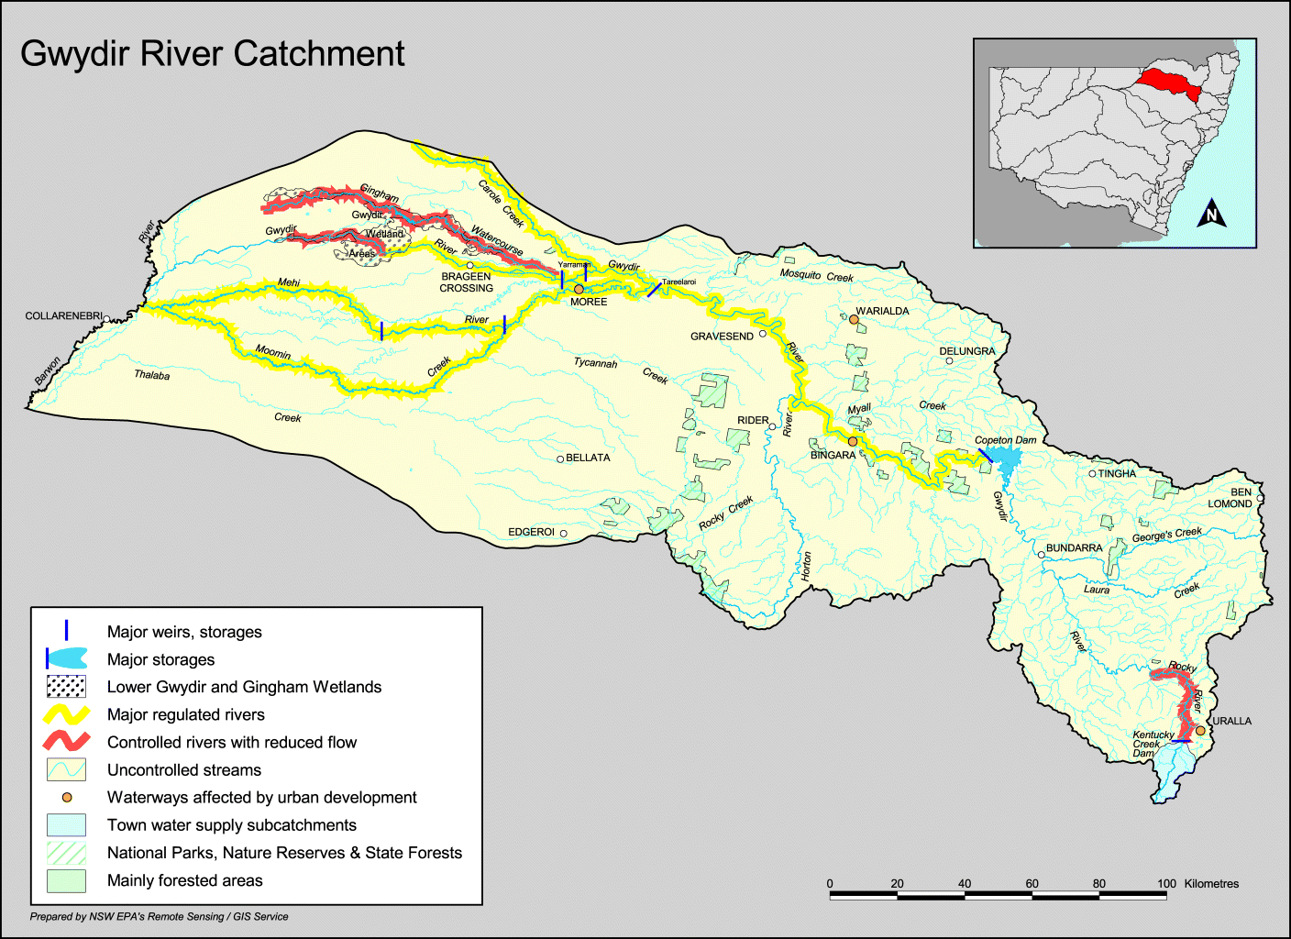

Figure 1: Map of the Gwydir River Valley (produced by the NSW OEH).

## Environmental objectives in the Gwydir catchment

The long-term environmental objectives for the Murray-Darling Basin are described in the Basin Plan’s Environmental Watering Plan and the Basin-wide environmental watering strategy, which includes ‘quantified environmental expected outcomes’ at both a Basin-scale and for each catchment. The expected outcomes relevant for the Gwydir catchment are described in Attachment A.

Basin state governments are also developing long-term watering plans for each catchment. These plans will identify the priority environmental assets and ecosystem functions in the catchment, the objectives and targets for these assets and functions, and their watering requirements. Once developed, these plans will provide the key information on the long-term environmental water demands in the catchment. Prior to the development of long-term watering plans, the Office will continue to draw on existing documentation on environmental water demands developed by state governments, local natural resource management agencies and the Murray-Darling Basin Authority.

Based on these strategies and plans, and in response to best available knowledge drawing on the results of environmental watering monitoring programmes, the objectives for environmental watering in the Gwydir catchment are summarised in Table 1 below. The objectives for water-dependent ecosystems will continue to be revised as part of the Commonwealth Environmental Water Office’s commitment to adaptive management.

**Table 1:** Summary of objectives being targeted by environmental watering in the Gwydir River Valley

|  |  |  |  |  |  |  |
| --- | --- | --- | --- | --- | --- | --- |
| **BASIN-WIDE OUTCOMES**  **(Outcomes in red link to the Basin-wide Environmental Watering Strategy)** | **EXPECTED OUTCOMES FOR GWYDIR ASSETS** | | | | | |
| **IN-CHANNEL ASSETS** | | | **OFF-CHANNEL ASSETS** | | |
| **Mehi River,** | **Carole Creek** | **Lower Gwydir river channel** | **Gingham Wetlands** | **Gwydir Wetlands** | **Mallowa Wetlands** |
| **OVERALL** | Contribute to flow variability, hydrological connectivity, in-stream habitat condition and diversity, water quality, primary productivity, native aquatic species condition and reproduction  Under sustained low inflows provide hydrological connectivity to in-stream habitat, to ensure the persistence of pools as refuge; and to reduce the risk of degrading water quality conditions (particularly low dissolved oxygen levels) | | | Promote recovery of wetland vegetation, provide habitat for threatened species as well as survival and reproduction opportunities for a range of waterbird and native aquatic species (e.g. fish, frogs, turtles, invertebrates) | | |
| **VEGETATION** | Contributed to riparian native vegetation diversity, extent and condition. | | | Enable recruitment of trees and support growth of understorey species within river red gum, black box and coolibah communities on floodplains that received overbank flooding during 2016 by inundating the floodplains again | | |
| **WATERBIRDS** | Improve the abundance and diversity of the Basin’s waterbird population  Support waterbird breeding events (reproduction and fledging) to successful completion. | | | | | |
| **FISH** | Improve flow regimes and connectivity to maximise the ecological function of the Barwon-Darling river system for native fish  Support viable populations of threatened native fish and maximise opportunities for range expansion and the establishment of new populations | | | | | |
| **MACROINVERTEBRATES** | Support recruitment and maintain macroinvertebrate diversity and habitat | | | | | |
| **PROCESSES** | Hydrological connectivity, including end of system flows  Mobilisation and dispersal of biotic and abiotic materials  Primary production, decomposition, nutrient and carbon cycling | | | Primary production, decomposition, nutrient and carbon cycling | | |
| **WATER QUALITY** | Maintain water quality within channels and pools | | | | | |
| **RESILIENCE** | Provide drought refuge habitat (particularly for fish and other aquatic fauna) | | | | | |

Information sourced from: CEWO 2014, MDBA 2012, MDBA 2014 (a and b)

## Environmental flow requirements

Not all environmental demands can and will be met through the use of held environmental water. Some demands are met by regulated water deliveries for consumptive purposes, while others are met by large unregulated/natural flows events or are beyond what can be delivered within operational constraints.

Figure 2 shows the broad environmental demands that are in scope for Commonwealth environmental water. Importantly, these are broad, indicative demands and individual watering events may contribute to particular opportunities, such as using infrastructure to deliver water to individual wetlands that would otherwise not be possible due to constraints. Also, there may be opportunities for Basin State governments to remove or modify constraints, which will improve the efficiency and/or effectiveness of environmental watering. Further information on delivery constraints are described in Attachment B.

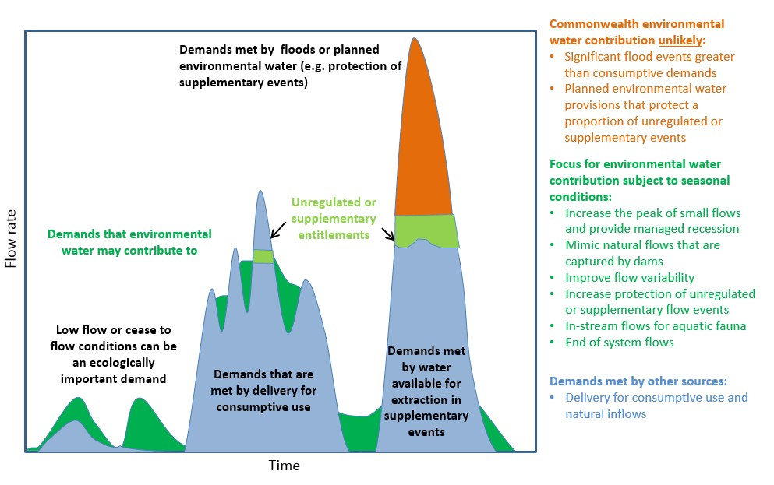

**Figure 2:** Scope of demands that environmental water may contribute to in the Gwydir River Valley

Based on the above objectives sought and delivery constraints, specific watering requirements (flow magnitude, duration, timing and frequency) have been identified as being in scope for Commonwealth environmental water. These water requirements are described in Table 3. As with the objectives, the environmental water requirements will continue to be reviewed and revised in response to new knowledge.

## Monitoring and adaptive management

Operational monitoring is undertaken for all Commonwealth environmental watering actions and involves collecting on-ground data with regard to environmental water delivery such as volumes delivered, impact on the river systems hydrograph, area of inundation and river levels. It can also include observations of environmental outcomes.

Long-term intervention monitoring is also being undertaken in the Gwydir catchment. It aims to understand the environmental response from Commonwealth environmental watering with respect to targeted objectives and expected outcomes.

Information on the monitoring activities is available at [http://www.environment.gov.au/water/cewo/catchment/gwydir/monitoring.](http://www.environment.gov.au/water/cewo/catchment/gwydir/monitoring) Monitoring information is also provided by state governments.

Key findings and recommendations from the Gwydir Long Term Intervention Monitoring include:

#### River channels

* + - Environmental water increased longitudinal connectivity in Carole Creek and the Gwydir, lower Gwydir, Gingham and Mehi River channels during 2015–16.
    - Commonwealth environmental water was responsible for all significant flow in Mallowa Creek during 2015–16.
    - Environmental water was released down the lower Gwydir, Gingham, Mehi and Carole channels in April 2016 providing critical connection between isolated refuge pools, sustaining native fish, invertebrate and other aquatic animal communities.
    - Environmental water improved water quality, stimulated primary productivity and helped to maintain regional scale aquatic invertebrate diversity.

#### Gwydir Wetlands

* + - Environmental water maintained waterholes in the Gingham watercourse and Gwydir wetlands that contain several threatened species of native fish.
    - A total area of 472 ha of the Gingham and Gwydir wetlands was inundated in August to October 2015, as a result of residual environmental watering and rainfall the previous water year.
    - Residual inundation in the Gingham and Gwydir wetlands from environmental water delivered in 2014–15 helped maintain native vegetation communities and provided habitat for waterbirds and frogs early in 2015–16.
    - In the Mallowa system, 204 ha of wetlands were inundated with Commonwealth environmental water during 2015–16, promoting the growth of native vegetation communities

The outcomes from these monitoring activities are used to inform portfolio management planning and adaptive management decision-making as outlined in Section 2.

# Portfolio management in 2017–18

In planning for the management of Commonwealth environmental water, the Commonwealth Environmental Water Office aims to maximise the outcomes achieved from the available water. This includes consideration of the urgency of demands (based on targeted outcomes and watering requirements, watering history and asset condition) and the available supply under different resource scenarios. The available environmental water to NSW will also be taken into account. Plans for water delivery, trade and carryover are then made in a multi-year context, with an assessment also undertaken of need for water in future years.

This planning process is outlined in full in Table 3 below and summarised in the sections below.

## Antecedent and current catchment conditions and the demand for environmental water in 2017–18

Between 2002 and 2010 the Gwydir River Valley experienced an extended period of drought, which, coupled with river regulation, had a significant impact on the environmental condition of the valley. Watering through 2010–16 has targeted restoring and maintaining wetland vegetation in good condition, particularly key plant species such as water couch-spike rush and lignum shrubland. This environmental watering has also been to improve and increase habitat for a range of fauna species, such as waterbirds.

Monitoring of three successive years of extended inundation between 2010–13, showed that the wetland vegetation extent and condition of communities, such as the marsh club-rush sedgeland (listed as critically endangered under the NSW *Threatened Species Conservation Act 1995*), recovered well. Improved inflows also supported recruitment of native fish and frog species in the Gwydir system. Large numbers of colonial nesting waterbirds (predominantly ibis and egrets) also bred in the wetlands in response to the widespread flooding across the lower Gwydir floodplain in 2011–12.

A large environmental water action in 2014–15 was provided to consolidate the recovery of wetland vegetation in the Lower Gwydir River and Gingham Watercourse. In the years following, the Gwydir Valley ECAOAC has supported a strategy of following natural cues for delivery into the wetland areas of the valley. A series of small supplementary events in the 2015–16 summer provided an opportunity to contribute to the reactive watering of the Gwydir Wetlands. In September 2016, water flowed into the Gwydir Wetlands as a result of unseasonally heavy spring rainfall. To build on this inundation environmental water was delivered from storage to the Gingham and lower Gwydir over the warmer summer months. The Gwydir Wetlands are considered to have a moderate demand for water in 2017–18.

The Mallowa Wetlands received water from small unregulated flows in 2011–12 after a long dry period and the vegetation responded well. Recovery of wetland vegetation was targeted with environmental watering in 2012–13, 2013–14 and 2014–15. Environmental water was delivered to maintain the current extent of wetland vegetation in a healthy, dynamic and resilient condition providing important refuge habitat for a range of native species.

Monitoring has shown that watering in the Mallowa has initiated a very good vegetation response and also resulted in a frog breeding event. The Mallowa Wetlands was the only large wetland site north of the Macquarie Marshes to be watered during the summer of 2013–14, and provided important drought refuge for foraging waterbirds. Monitoring and reports from landholders noted that a large diversity of waterbirds were observed in the area. In 2015–16 environmental water contributed to small reactive watering of the Mallowa during the hotter summer months. During January – April 2017 Commonwealth environmental water was provided to the Mallowa Wetlands, in order continue support of wetland vegetation recovery. As a result the Mallowa Wetlands have a low demand for water in 2017–18.

In addition to the wetland recovery in the Gwydir Valley, the Commonwealth is working towards building a healthier in-stream ecological environment by contributing environmental water to in-stream freshes in the mainstream and effluent watercourses of the Gwydir system. These flows are provided in a way that mimics the natural flow rise and recession to stimulate fish breeding activity. Monitoring of the first fish flow trial showed that Commonwealth environmental water was successful at stimulating breeding in populations of bony bream, and spangled perch. During 2015–16, environmental water contributed to small reactive delivery for in stream aquatic ecology by following natural flow cues.

In-stream environmental watering actions in the Mehi River and Carole Creak in 2013–14 and 2014–15 also achieved good connectivity with the Barwon-Darling River contributing to environmental outcomes for native fish during low flow conditions. Benefits of these flows included connectivity between refuge pools and water quality (salinity). There is a growing awareness of the importance of connecting flows across the northern basin. These flows provide hydrological connections that link a diversity of aquatic environments for feeding, breeding, dispersal, migration and re-colonisation, which is essential for the survival of native fish populations and other aquatic fauna.

By early autumn 2016 a sequence of dry months required a dry river refuge protection flow to be provided to the Gwydir River, Gingham Watercourse, Mehi River and Carole Creek. This flow was slowly fed into the system during late April / early May to refresh refuge waterholes in order to protect in-stream aquatic ecology. The demand for water in 2017–18 is considered moderate for these assets.

### Murray-Darling Basin-wide environmental watering strategy and 2017–18 annual priorities

In contributing to these demands, the Commonwealth Environmental Water Office will also be aiming to contribute to the expected outcomes in the Basin-wide environmental watering strategy (see Attachment A) and the following 2017–18 Basin annual environmental watering priorities relevant to the Gwydir River Region.

* + - Improve flow regimes and connectivity to maximise the ecological function of the Barwon-Darling river system for native fish
    - Support viable populations of threatened native fish and maximise opportunities for range expansion and the establishment of new populations
    - Improve the abundance and diversity of the Basin’s waterbird population
    - Enable recruitment of trees and support growth of understorey species within river red gum, black box and coolibah communities on floodplains that received overbank flooding during 2016 by inundating the floodplains again

The Commonwealth Environmental Water Holder will not inundate private land without prior approval from land holders while contributing to the Basin annual environmental watering priorities.

## Water availability in 2017–18

### Forecasts of Commonwealth water allocations

The volume of Commonwealth environmental water likely to be carried over in the Gwydir catchment for use in 2017–18 is estimated to be 78 GL.

Allocations against Commonwealth water entitlements in the Gwydir catchment are determined by the NSW government and will vary depending on inflows. The following forecasts in Table 2 are based on the best available information including State forecasts and historical inflow scenarios.

**Table 2**: Forecasts of Commonwealth water allocations (including carryover) in 2017–18 in the Gwydir catchment as at 31 May 2017.

|  |  |  |  |  |  |  |
| --- | --- | --- | --- | --- | --- | --- |
| **Entitlement type** | **Forecasts of Commonwealth water allocations (including carryover) in 2017–18 (GL)** | | | | | |
| **Very dry** |  |  |  | **Very wet** | |
| **95**  **percentile** | **90**  **percentile** | **75**  **percentile** | **50**  **percentile** | **25**  **percentile** | **10**  **percentile** |
| Gwydir (general/high security) | 83 | 83 | 83 | 99 | 122 | 139 |
| Gwydir (supplementary) | Up to 20.5 | Up to 20.5 | Up to 20.5 | Up to 20.5 | Up to 20.5 | Up to 20.5 |

Notes:

1. Forecasts for regulated catchments are given to the nearest whole gigalitre except where the entitlement held by the Commonwealth is below 1 GL.
2. Allocation rate scenarios are based on long term average allocation rates.
3. Carryover is not available for High Security entitlements. General security entitlements have continuous accounting and water will be forfeit whenever the amount of water in storage exceeds 150 per cent of entitlement. Use limits of 300 per cent of entitlement and 300 per cent of entitlement over 3 years also apply.

Information on allocations to Commonwealth environmental water holdings can be found at <http://www.environment.gov.au/water/cewo/portfolio-mgt/holdings-catchment>and is updated monthly.

### Water resource availability scenarios

Commonwealth environmental water is not managed in isolation. When considering the available resource to meet environmental demands, it is necessary to also factor in the resources managed by other entities and available to contribute to environmental outcomes. Relevant resources include NSW Riverbank and Environmental Contingency Allowance, planned environmental water, natural and unregulated flows, conveyance water and consumptive water. Further detail on sources of environmental water in the Gwydir River Valley is provided in Attachment C.

By combining the forecasts of water held by the Commonwealth with streamflow forecasts, as well as taking into account operational considerations, water resource availability scenarios can be developed ranging from very low to very high. Based on available information moderate to high resource availability scenarios are in scope for 2017–18, with very high resource availability only possible if conditions become wet.

## Overall purpose of managing environmental water based on supply and demand

Environmental water needs (demand) and water availability (supply) both influence the overall purpose of Commonwealth environmental water management. Under different combinations, the management purpose can range from ‘avoiding damage’ to the environment to ‘improving’ ecological health. This in turn informs the mix of portfolio management options that are suitable for maximising outcomes. Figure 3Figure 3 shows how current demands and forecasted supply are considered together.

The overall ‘purpose’ for managing the Commonwealth’s water portfolio in the Gwydir catchment for 2017– 18 is to protect wetland vegetation of the Gwydir Wetlands and ensuring their ecological capacity for recovery, while maintaining the ecological health and resilience of other important sites in the catchment, including in stream aquatic ecology.

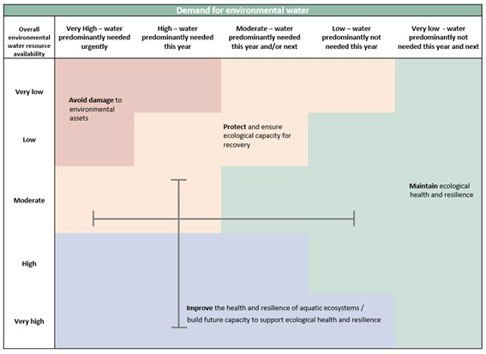

**Figure 3:** Determining a broad purpose for portfolio management in the Gwydir River Valley for 2017–18. Note: grey lines represent potential range in demand and resource availability.

Further detail on how the overall purpose for portfolio management changes under different supply and demand scenarios is provided in *Portfolio Management Planning: Approach to planning for the use, carryover and trade of Commonwealth environmental water, 2017–18* (available at: <http://www.environment.gov.au/water/cewo/publications>).

## Water Delivery in 2017–18

Consistent with the demands and purpose described above, the Office is considering supplying environmental water to the following watering actions for 2017–18 (see also Table 3 for supporting information regarding the basis for determining these watering intentions).

The overall focus of Commonwealth environmental watering under all resource availability scenarios during 2017–18 is to follow natural cycles of drying and wetting by contributing to wetland watering, and to provide in-stream flows across the catchment to support native fish populations and to make water available to protect critical refuge habitat during extreme dry river conditions. Natural flow events from tributaries, such as an inflow from the Horton River, can be particularly ecologically significant and may be augmented with environmental water.

In the wetlands, environmental watering aims to support the highly water dependant semi-permanent wetland communities by contributing through a reactive watering approach – activating access to supplementary water and offsetting a component of the consumptive extraction up to an approved volume with held environmental water called from storage. When supplementary water access is made available, a proportion of the Commonwealth supplementary licence may be activated for each watercourse (up to 14 100 ML in the Gingham / Gwydir and up to 5 000 ML in the Mehi / Mallowa). To complement the supplementary flows, and to offset a component of the natural flow that may be extracted from event, a small volume of General Security water will be provided on the tail of the flows.

As natural flows and water availability in storage increase during wetter years, wetland watering may target a broader system wide inundation watering that also includes flood dependent coolibah and red gum woodlands, lignum and black box shrublands. These larger actions aim to build resilience during the boom times in order to protect system during drier times.

In addition to the wetland watering targets, environmental watering also aims to provide an in-stream flow regime that supports native fish populations and aquatic ecological processes. The triggers for providing in- stream flows can include seasonal or species specific flow requirements to support breeding and recruitment or to provide or maintain aquatic ecological optimal conditions for native fish and other aquatic fauna, which may also include an early season stimulus trigger flow in late winter / early spring – or building instream carbon/other nutrient levels so that conditions are primed for fish breeding should natural conditions provided opportunity later in the season.

A key part of ensuring ongoing system health is managing drought refuge for in-stream aquatic ecology during extended drying sequences. To do this environmental water is available from storage to refresh drought refuges and reduce the risk of degrading water quality to contribute to the survival of aquatic species during dry periods.

Should colonial waterbird breeding commence within the Gwydir Wetlands, environmental water can be made available to augment natural flows to support key waterbird species to complete life cycles in low lying wetlands, for example to support a natural waterbird breeding event through to completion (a reserve volume of 10–15 GL is maintained for this purpose).

### Stakeholder Feedback

The Gwydir Valley ECAOAC met in May 2017 to consider the priorities and targets for environmental watering in the Gwydir catchment over the next 3 seasons.

The ECAOAC are focused on how to best manage existing carryover over several seasons to ensure sufficient volumes will be available to meet environmental demands should dry conditions prevail. With this in mind, the ECAOAC endorsed a ‘reactive’ (respond to natural triggers) approach to wetland watering during 2017–18, with the addition of flows targeting native fish outcomes. A consensus plan for management was informed by discussions between the ECAOAC members and observers which includes Gwydir valley landholders, water users, scientists, independent environmental advisors and Aboriginal representatives. The demands identified in this report are consistent with the approach endorsed by the ECAOAC.

## Trading water in 2017–18

The *Water Act 2007* provides for the trade of Commonwealth environmental water (allocations and entitlements) and specifies the conditions under which sales may occur. To improve environmental outcomes must be the primary reason for trade of Commonwealth Environmental water. The Commonwealth Environmental Water Holder has no plans to trade entitlements in 2017–18.

Planning on water trade considers supply and demand within the catchment and across the Basin. In the Gwydir Catchment, inflows and allocations are highly variable. Where possible, retaining an account balance that will provide for environmental watering in future years under a range of climate scenarios is particularly important given the possibility of low to very low annual water allocation.

The Commonwealth Environmental Water Holder regularly assesses the environmental demand and supply position throughout the year, considering factors such as environmental condition and demand, current and forecast climate conditions, water availability, carryover capacity and market conditions. Any potential allocation trade would be subject to an assessment of the level of supply or demand for consumptive use within the Gwydir Catchment water market. Should a decision be made to seek a trade, then further information will be made widely available at [http://www.environment.gov.au/water/cewo/trade/current-](http://www.environment.gov.au/water/cewo/trade/current-trading-actions)  [trading-actions.](http://www.environment.gov.au/water/cewo/trade/current-trading-actions)

For more information on the rules and procedures governing the trade of Commonwealth environmental water, refer to the *Commonwealth environmental water Trading Framework* at: [http://www.environment.gov.au/water/cewo/publications/water-trading-framework-dec2014.](http://www.environment.gov.au/water/cewo/publications/water-trading-framework-dec2014)

## Carrying over water for use in 2018–19

The volume of water carried over for use in 2018–19 will depend upon resource availability and demand throughout the year. A minimum carryover target of 30 GL is being reserved to meet minimum water requirements such as maintenance of drought refuges should low inflows result in low allocations in subsequent years. A minimum allocation of 4.5 GL to high security accounts is likely in each water year. As documented in Table 3 below, potential demands in 2018–19 include:

* Wetland watering to the Gwydir Wetlands (up to 10 000 ML) and Mallowa Wetlands (up to 5 000 ML)
* Dry river flows to protect drought refuge during very low flow periods (up to 4 000 ML)
* Maintenance flows to enhance native fish populations, and to provide connection with the Barwon River (up to 15 000 ML).

Carryover volumes will be adjusted throughout the year as the season unfolds in response to both current and future demands and the water available to meet these demands. These decisions will be based upon best information available at the time. More information on how the Commonwealth makes decisions on carryover is at: [http://www.environment.gov.au/water/cewo/portfolio-mgt/carryover.](http://www.environment.gov.au/water/cewo/portfolio-mgt/carryover)

## Identifying Investment Opportunities

Changes to the *Water Act 2007* in 2016 have increased the flexibility for the Commonwealth Environmental Water Holder (CEWH) to use the proceeds of water allocation sales to invest in environmental activities.

Under these amendments environmental activities must improve environmental outcomes and be undertaken for the purpose of protecting and restoring environmental assets in the Basin.

The CEWH will publically release a Discussion Paper seeking feedback on what type of activities stakeholders would like the CEWH to consider when developing a framework for future investment in environmental activities.

It should be noted that proceeds of past water sales must be managed based on the legislation in place at that time, and are not available to be used for these activities.

**Table 3a**: Environmental demands, priority for watering in 2017–18 and outlook for coming years in the Gwydir River Valley – **MODERATE WATER RESOURCE AVAILABILITY IN 2017–18**

|  |  |  |  |  |  |  |  |  |  |  |  |  |  |  |
| --- | --- | --- | --- | --- | --- | --- | --- | --- | --- | --- | --- | --- | --- | --- |
| **Environmental assets** | | **Indicative demand (for all sources of water in the system)1** | **Required frequency (maximum dry interval)** | **Watering history (from all sources of water)** | | | | | **2017–18** | | | **Implications for future demands** | | |
| **Predominant urgency of environmental demand for water** | **Purpose under Moderate resource availability** | **Potential Commonwealth environmental water contribution?** | **Likely urgency of demand in 2018–**  **19 if watering occurred as planned in 2017-**  **18** | **2019–20**  **Range of likely demand** | –Met in 2018–19 |
| **2012–13** | **2013–14** | **2014–15** | **2015–16** | **2016–17** |
| wet | moderate | drying | drying | moderate | Not met in 2018–19 |
| Wetland Watering | Gwydir Wetlands  (incl Gingham Watercourse  ) | * 45 GL during October to March * 60 GL during October to March * 80 GL during October and March, (*constraints currently limiting ability to deliver to this demand with regulated flows) | 7/8 in 10 years (5 years)  6 in 10 years  (5 years)  4 in 10 years (6 years) | Extensive watering | Drying period | 1st Return watering  (60 GL) | Drying period – small contributio n to supplemen tary flows | Watering > 60 GL ~ 80  GL to the wetlands | MODERATE  Watering has occurred for 4 of the last 6 water years  45 GL demand in scope | **Maintain** | Environmental water could partially contribute to this demand.  Respond to natural flow triggers | Moderate / high | Moderate | |
| High | |
| Mallowa | 10–20 GL  All year (most likely spring to autumn) | 3 consecutive in  6 years | 1st Watering | 2nd Watering | 3rd Watering | Small contributio n to reactive flows | Small late summer watering | LOW  Watering has occurred 4 of the last 5 water years, including small reactive flows in 2015– 16.  Dry sequence is within requirements  Respond to natural flow events (supplementary) | **Maintain** | Environmental water could partially contribute to this demand.  Respond to natural flow triggers  Diversion of supplementary entitlement if available into the Mallowa | Low | Low | |
| Moderate | |
| Aquatic in-stream ecology | Mehi River | - 15–20 GL, all  year (most likely winter / spring)  (breeding / stimulation flow)  - 5 GL demand for maintenance | 5 in 10 years  Second and thrid year following a stimulation / breeding event flow | Met by natural flows | 1st fish flow trial | 2nd fish flow | Small contributio n to supplemen tary flow event | Small contributio n to supplemen tary flow event | MODERATE  Contribution to requirements in 3 out of the last 4 water years including a very small contribution to natural flows during 2015–16 | **Maintain** | Environmental water could partially contribute to this demand | Moderate | Low | |
| High | |
| Carole Creek | 5–10 GL  All year (most likely spring to autumn) | 5 in 10 years | Met by natural flows | 1st fish flow trial | 2nd fish flow | Small contributio n to supplemen tary flow event | Small contributio n to supplemen tary flow event | MODERATE | **Maintain** | Environmental water could partially contribute to this demand.  Given limited volumes available potential contribution to this demand has a lower priority than contribution to the Mehi | Low | Low | |
| High | |

|  |  |  |  |  |  |  |  |  |  |  |  |  |  |  |
| --- | --- | --- | --- | --- | --- | --- | --- | --- | --- | --- | --- | --- | --- | --- |
| **Environmental assets** | | **Indicative demand (for all sources of water in the system)2** | **Required frequency (maximum dry interval)** | **Watering history (from all sources of water)** | | | | | **2017–18** | | | **Implications for future demands** | | |
| **Predominant urgency of environmental demand for water** | **Purpose under Moderate resource availability** | **Potential Commonwealth environmental water contribution?** | **Likely urgency of demand in 2018–**  **19 if watering occurred as planned in 2017–**  **18** | **2019–20**  **Range of likely demand** | Met in 2018–19 |
| **2012–13** | **2013–14** | **2014–15** | **2015–16** | **2016–17** |
| wet | moderate | drying | drying | moderate | Not met in 2018–19 |
|  | Gwydir River Downstream of Copeton Dam | Improve natural character of flows downstream of the dam | All years  (Spring to Autumn) | Required volumes Met.  Natural flow pattern not met. | Required volumes Met.  Natural flow pattern not met. | Required volumes Met.  Natural flow pattern not met. | Required volumes Met.  Natural flow pattern not met. | Required volumes Met.  Natural flow pattern not met | MODERATE | **Maintain** | Environmental water could partially contribute to this demand.  (Early Season Stimulus Trigger) | Moderate | Moderate | |
| Moderate | |
| Aquatic in-stream ecology  (Cont.) | Ballin Boora Creek | Baseflow  800 ML (most likely  spring to autumn) | Subject to examination of requirement/ due diligence  Stock and domestic flows pipeline creates demand in the creek system. | Stock and domestic flows | Stock and domestic flows | Stock and domestic flows | Not met | Not met | HIGH  (zero flow during 2015– 16) | **Protect** | Water required this year or next  Contribution will be considered if examination / due diligence requirements are met during 2017–18 | High (Critical if no  watering in 2017–  18) | Moderate | |
| Critical | |
| Dry river flows or bird breeding support flows | | - Up to 8 GL to protect critical aquatic refuge habitat during extended drying sequences | As required, All years | Not Required | Not Required | Not Required | Flows to protect critical habitat in Gwydir, Carole and Mehi in April – May 2016 | Not Required | HIGH  Protect critical habitat during extended drying sequence | **Protect** | Respond to natural conditions to protect critical in-stream aquatic refuge habitat if required | High | High | |
| High | |
| - 10–15 GL  reserve to suppory to support threatened colonial waterbird breeding | As required, All years | Not Required | Not Required | Not Required | Not Required | Not Required | MODERATE | **Maintain** | Meet if required by natural events | MODERATE | MODERATE | |
| MODERATE | |

|  |  |  |  |  |
| --- | --- | --- | --- | --- |
| **Key - events in previous years**  means demand was met by Commonwealth environmental water or any other source  means demand was partially met by Commonwealth environmental water or any other source (may be used to indicate infrastructure assisted delivery) means water not provided (or not required)  Note that not all demands require water every year; drying phases are important for floodplains and temporary wetlands or streams  **Key - potential watering in 2017-18**  means a high priority for Commonwealth environmental watering (full or partial contribution, and subject to seasonal and operational considerations) means a secondary priority for Commonwealth environmental watering, likely to be met via other means (other water holders, or natural flows) means a low priority for Commonwealth environmental watering  **Key - urgency of environmental demands**  means critical demand i.e. urgent need for water in that particular year to manage risk of irretrievable loss or damage means high demand for water i.e. needed in that particular year  means moderate demand for water i.e. water needed that particular year and/or next means low demand for water i.e. water generally not needed that particular year  means very low demand for water i.e. water generally not needed that particular year or the following year  Note that demand is considered at a generalised scale; there may be specific requirements that are more or less urgent within the flow regime | **Carryover potential** | Moderate proportion of allocations carried into 2018–19.  Minimum carryover target of 30 GL. | Low to moderate proportion of allocations may be carried over to 2019–20, but will depend upon resource availability and demands | Level of carryover will depend on environmental demands and resource availability. |
| **Trade potential** | There may be a need to adjust the availability of allocations through trade. Any potential allocation trade would be subject to an assessment of supply and demand within the water market in the Gwydir. | | |

**Table 3b**: Environmental demands, priority for watering in 2017–18 and outlook for coming years in the Gwydir River Valley – **HIGH / VERY HIGH WATER RESOURCE AVAILABILITY IN 2017–18**

|  |  |  |  |  |  |  |  |  |  |  |  |  |  |  |
| --- | --- | --- | --- | --- | --- | --- | --- | --- | --- | --- | --- | --- | --- | --- |
| **Environmental assets** | | **Indicative demand (for all sources of water in the system)3** | **Required frequency (maximum dry interval)** | **Watering history (from all sources of water)** | | | | | **2017–18** | | | **Implications for future demands** | | |
| **Predominant urgency of environmental demand for water** | **Purpose under high to very high resource availability** | **Potential Commonwealth environmental water contribution?** | **Likely urgency of demand in 2018–**  **19 if watering occurred as planned in 2017–**  **18** | **2019–20**  **Range of likely demand** | Met in 2018–19 |
| **2012–13** | **2013–14** | **2014–15** | **2015–16** | **2016–17** |
| wet | moderate | drying | drying | moderate | Not met in 2018–19 |
| Wetland Watering | Gwydir Wetlands  (incl Gingham Watercourse  ) | * 45 GL during October to March * 60 GL during October to March * 80 GL during October and March, (*constraints currently limiting ability to deliver to this demand with regulated flows) | 7/8 in 10 years (5 years)  6 in 10 years  (5 years)  4 in 10 years (6 years) | Extensive watering | Drying period | 1st Return watering  (60 GL) | Drying period – small contributio n to supplemen tary flows | Watering > 60 GL ~ 80  GL to the wetlands | MODERATE  Watering has occurred for 4 of the last 6 water years  45 GL demand in scope | **Improve** | Environmental water could partially contribute to this demand.  Respond to natural flow triggers | Moderate | Moderate | |
| High | |
| Mallowa | 10–20 GL  All year (most likely spring to autumn) | 3 consecutive in  6 years | 1st Watering | 2nd Watering | 3rd Watering | Small contributio n to reactive flows | 7 GL late summer watering | LOW  Watering has occurred 4 of the last 5 water years, including small reactive flows in 2015– 16.  Dry sequence is within requirements  Respond to natural flow events (supplementary) | **Maintain** | Environmental water could partially contribute to this demand.  Drying phase -Respond to natural flow triggers  Diversion of supplementary entitlement if available into the Mallowa | Low | Low | |
| Moderate | |
| Aquatic in-stream ecology | Mehi River | - 15–20 GL, all  year (most likely spring to autumn)  (breeding / stimulation flow)  - 5 GL demand for maintenance | 5 in 10 years  Second and thrid year following a stimulation / breeding event flow | Met by natural flows | 1st fish flow trial | 2nd fish flow | Small contributio n to supplemen tary flow event | Small contributio n to supplemen tary flow event | MODERATE  Contribution to requirements in 3 out of the last 4 water years including a very small contribution to natural flows during 2015–16 | **Improve** | Environmental water could partially contribute to this demand | Moderate | Low | |
| High | |
| Carole Creek | 5–10 GL  All year (most likely spring to autumn) | 5 in 10 years | Met by natural flows | 1st fish flow trial | 2nd fish flow | Small contributio n to supplemen tary flow event | Small contributio n to supplemen tary flow event | MODERATE  2 years of delivery - stimulation of fish breeding  Lower section of the Carole may dry down to refuge pools | **Improve** | Environmental water could partially contribute to this demand.  Given limited volumes available potential contribution to this demand has a lower priority than contribution to the Mehi | Low | Low | |
| High | |

|  |  |  |  |  |  |  |  |  |  |  |  |  |  |  |
| --- | --- | --- | --- | --- | --- | --- | --- | --- | --- | --- | --- | --- | --- | --- |
| **Environmental assets** | | **Indicative demand (for all sources of water in the system)4** | **Required frequency (maximum dry interval)** | **Watering history (from all sources of water)** | | | | | **2017-18** | | | **Implications for future demands** | | |
| **Predominant urgency of environmental demand for water** | **Purpose under low to very low resource availability** | **Potential Commonwealth environmental water contribution?** | **Likely urgency of demand in 2018–**  **19 if watering occurred as planned in 2017-**  **18** | **2019–20**  **Range of likely demand** | Met in 2018–19 |
| **2012–13** | **2013–14** | **2014–15** | **2015–16** | **2016–17** |
| wet | moderate | drying | drying | moderate | Not met in 2018–19 |
|  | Gwydir River Downstream of Copeton Dam | Improve natural character of flows downstream of the dam | All years  (Spring to Autumn) | Required volumes Met.  Natural flow pattern not met. | Required volumes Met.  Natural flow pattern not met. | Required volumes Met.  Natural flow pattern not met. | Required volumes Met.  Natural flow pattern not met. | Required volumes Met.  Natural flow pattern not met | MODERATE | **Improve** | Environmental water could partially contribute to this demand.  (Early Season Stimulus Trigger) | Moderate | Moderate | |
| Moderate | |
| Aquatic in-stream ecology  (Cont.) | Ballin Boora Creek | Baseflow  800 ML (most likely  spring to autumn) | Subject to examination of requirement/ due diligence  Stock and domestic flows pipeline creates demand in the creek system. | Stock and domestic flows | Stock and domestic flows | Stock and domestic flows | Not met | Not met | HIGH  (zero flow during 2015– 16) | **Improve** | Water required this year or next  Contribution will be considered if examination / due diligence requirements are met during 2016–17 | High (Critical if no  watering in 2016–  17) | Moderate | |
| Critical | |
| Dry river flows or bird breeding support flows | | -Up to 8 GL to protect critical aquatic refuge habitat during extended drying sequences | As required, All years | Not Required | Not Required | Not Required | Flows to protect critical habitat in Gwydir, Carole and Mehi in April – May 2016 | Not Required | HIGH  Protect critical habitat during extended drying sequence | **Improve** | Respond to natural conditions to protect critical in-stream aquatic refuge habitat if required  (Unlikely in high scenario) | High | High | |
| High | |
| - 10–15 GL  reserve to suppory to support threatened colonial waterbird breeding | As required, All years | Not Required | Not Required | Not Required | Not Required | Not Required | MODERATE  Waterbird breeding trigger unlikely during low resource availability | **Improve** | (Unlikely in high scenarios) | MODERATE | MODERATE | |
| MODERATE | |

|  |  |  |  |  |
| --- | --- | --- | --- | --- |
| **Key - events in previous years**  means demand was met by Commonwealth environmental water or any other source  means demand was partially met by Commonwealth environmental water or any other source (may be used to indicate infrastructure assisted delivery) means water not provided (or not required)  Note that not all demands require water every year; drying phases are important for floodplains and temporary wetlands or streams  **Key - potential watering in 2017-18**  means a high priority for Commonwealth environmental watering (full or partial contribution, and subject to seasonal and operational considerations) means a secondary priority for Commonwealth environmental watering, likely to be met via other means (other water holders, or natural flows) means a low priority for Commonwealth environmental watering  **Key - urgency of environmental demands**  means critical demand i.e. urgent need for water in that particular year to manage risk of irretrievable loss or damage means high demand for water i.e. needed in that particular year  means moderate demand for water i.e. water needed that particular year and/or next means low demand for water i.e. water generally not needed that particular year  means very low demand for water i.e. water generally not needed that particular year or the following year  Note that demand is considered at a generalised scale; there may be specific requirements that are more or less urgent within the flow regime | **Carryover potential** | Moderate proportion of allocations carried into 2018–19.  Minimum carryover target of 30 GL. | A moderate proportion of allocations may be carried over to 2019–20, but will depend upon resource availability and demands | Level of carryover will depend on environmental demands and resource availability. |
| **Trade potential** | Market activity may be thin and opportunities to trade allocation would be subject to an assessment of supply and demand within the water market in the Gwydir | | |

# Next steps

## From planning to decision making

It is important to distinguish between planning and operational decision making. As shown in Figure 4, planning allows the Office to manage the environmental water portfolio in a holistic manner and is an exercise in developing a broad approach or intention, based on the key drivers (demand and supply).

Decision making throughout each year builds on the intention by considering in more detail the specific prevailing factors and additional factors such as costs, risks, and constraints to water delivery and market conditions.

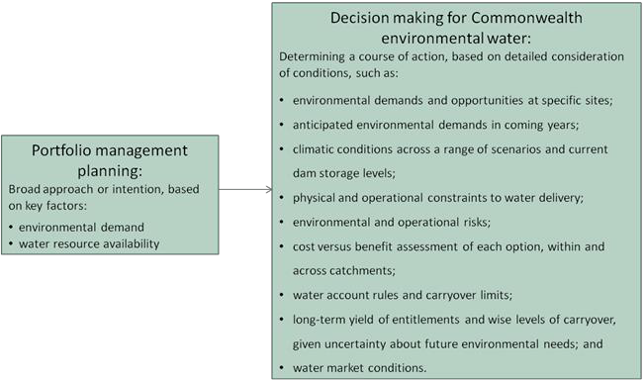

**Figure 4:** Planning and decision making for Commonwealth environmental water use

## Further information

For further information on how the Office plans for water use, carryover and trade, please visit our web site: <http://www.environment.gov.au/water/cewo>

or the sites below:

* Water use: [www.environment.gov.au/topics/water/commonwealth-environmental-water-](http://www.environment.gov.au/topics/water/commonwealth-environmental-water-office/assessment-framework)  [office/assessment-framework](http://www.environment.gov.au/topics/water/commonwealth-environmental-water-office/assessment-framework)
* Carryover: [http://www.environment.gov.au/topics/water/commonwealth-environmental-water-](http://www.environment.gov.au/topics/water/commonwealth-environmental-water-office/portfolio-management/carryover)  [office/portfolio-management/carryover](http://www.environment.gov.au/topics/water/commonwealth-environmental-water-office/portfolio-management/carryover)
* Trade: *Discussion Paper – Trade of Commonwealth Environmental Water* and *Commonwealth Environmental Water Trading Framework:*  <http://www.environment.gov.au/water/cewo/trade/trading-framework>

# Bibliography

Baumgartner, L. J., Conallin, J., Wooden, I., Campbell, B., Gee, R., Robinson, W. A. and Mallen‐

Cooper, M. (2013). Using flow guilds of freshwater fish in an adaptive management framework to

simplify environmental flow delivery for semi‐arid riverine systems. Fish and Fisheries, Early View

(Online Version of Record).

Bowen, S. & Simpson, S. L. (2010). Changes in Extent and Condition of the Vegetation Communities of the Gwydir Wetlands and Floodplain 1996-2008: Final Report to the NSW Wetland Recovery Program. Sydney: NSW Department of Environment Climate Change and Water Sydney.

Commonwealth Environmental Water Office (2014). Commonwealth environmental water use options 2014–15: Gwydir River Valley. Commonwealth of Australia 2014. [http://www.environment.gov.au/resource/commonwealth-environmental-water-annual-use-](http://www.environment.gov.au/resource/commonwealth-environmental-water-annual-use-options-gwydir-river-valley)  [options-gwydir-river-valley](http://www.environment.gov.au/resource/commonwealth-environmental-water-annual-use-options-gwydir-river-valley)

Commonwealth Environmental Water Office (2015). Commonwealth Environmental Water Office Long Term Intervention Monitoring Project: Gwydir River System Selected Area, Commonwealth of Australia 2014’

Copeland, C., Neller, S., Schooneveldt-Reid, E., Wales, N. S. & Fisheries, N. (2003). Fish Everywhere: An oral history of fish and their habitats in the Gwydir River, NSW DPI Fisheries.

CSIRO (2007) Water availability in the Gwydir. A report to the Australian Government from the CSIRO Murray-Darling Basin Sustainable Yields Project. CSIRO, Australia. 133pp.

Davies, P., Stewardson, M., Hillman, T., Roberts, J. & Thomes, M. (2012). Sustainable Rivers Audit 2: The ecological health of rivers in the Murray–Darling Basin at the end of the Millennium Drought (2008– 2010). Volume 2., Canberra, Murray-Darling Basin Authority.

Murray-Darling Basin Authority (2014 (a)), Development of the benchmark model for calculation of supply contributions, Preliminary draft as on 9 April 2014, Canberra.

Murray-Darling Basin Authority (2014 (b)), Basin-wide environmental watering strategy, Canberra. Murray-Darling Basin Authority (2013), Constraints Management Strategy 2013 to 2024, Canberra.

Murray-Darling Basin Authority (2012), Assessment of environmental water requirements for the proposed Basin Plan: Gwydir Wetlands, [http://www.mdba.gov.au/what-we-do/basin-](http://www.mdba.gov.au/what-we-do/basin-plan/development/bp-science/assessing-environmental-water-requirements)  [plan/development/bp-science/assessing-environmental-water-requirements,](http://www.mdba.gov.au/what-we-do/basin-plan/development/bp-science/assessing-environmental-water-requirements) Canberra.

NSW Department of Environment, Climate Change and Water (2008). Final report on the Gwydir waterbird and fish habitat study. NSW Wetland Recovery Program. Rivers and Wetlands Unit, NSW Department of Environment and Climate Change, Sydney.

NSW Department of Environment, Climate Change and Water (2011). Gwydir Wetlands Adaptive Environmental Management Plan., NSW Department of Environment Climate Change and Water, Sydney.

NSW Department of Environment and Heritage (2012). Gwydir Wetlands: Gingham and Lower Gwydir (Big Leather) Watercourses Ramsar site [Online].

Pietsch, T. J. (2006). Fluvial geomorphology and late quaternary geochronology of the Gwydir fan- plain. PhD, University of Wollongong.

Rolls, R. J., Growns, I. O., Khan, T. A., Wilson, G. G., Ellison, T. L., Prior, A. & Waring, C. C. (2013). Fish recruitment in rivers with modified discharge depends on the interacting effects of flow and thermal regimes. Freshwater Biology, 58, 1804-1819.

Roberts, J. and Masrton, F. (2011). Water regime for wetlands and floodplain plants: A source book for the Murray-Darling Basin.

Torrible, L., Sainty, G. & Horcroft, D. (2009). Assessment of the Water Dependent Vegetation and Fauna of the Mallowa Creek, results from a field visit Feb 2009. IRPEC Pty Ltd.

Wilson, G. G., Bickel, T. O., Berney, P. J. & Sisson, J. L. (2009). Managing environmental flows in an agricultural landscape: the Lower Gwydir floodplain. Final Report to the Commonwealth Department of Environment, Water, Heritage and the Arts

# Attachment A – Expected outcomes from the Basin-wide environmental watering strategy

Expected outcomes from the Basin-wide environmental watering strategy (MDBA 2014) that are relevant to the Gwydir are described below.

### RIVER FLOWS AND CONNECTIVITY

Baseflows are at least 60 per cent of the natural level.

Contributing to a 10 per cent overall increase in flows in the Barwon–Darling.

A 10–20 per cent increase in the frequency of freshes, bankfull and lowland floodplain flows.

### VEGETATION

Maintain the current extent of water-dependent vegetation near river channels and on low-lying areas of the floodplain.

No decline in the condition of river red gum, black box and coolibah. Improve condition of lignum shrublands in the lower Gwydir catchment.

Improved recruitment of trees within black box, river red gum and coolibah communities.

Increased periods of growth for non-woody vegetation communities that closely fringe or occur within the river and creek channels, and for marsh club-rush and water couch in the Gwydir Wetlands.

### Vegetation extent

|  |  |  |  |  |
| --- | --- | --- | --- | --- |
| **Area of river red gum (ha)** | **Area of black box (ha)** | **Area of coolibah (ha)** | **Shrublands** | **Non–woody water dependent vegetation** |
| 4 500 | 600 | 6 500 | Lignum in the Lower Gwydir | Closely fringing or occurring within the Gwydir River and marsh club-rush and water couch in the Gwydir Wetlands |

**WATERBIRDS**

Maintain current species diversity.

Increase Basin-wide abundance of waterbirds by 20–25 per cent by 2024.

A 30–40 per cent increase in nests and broods (Basin-wide) for other waterbirds.

Up to 50 per cent more breeding events (Basin-wide) for colonial nesting waterbird species.

### Important Basin environmental assets for waterbirds in the Gwydir River Valley

|  |  |  |  |  |  |
| --- | --- | --- | --- | --- | --- |
| Environmental asset | Total abundance and diversity | Drought refuge | Colonial waterbird breeding | Shorebird abundance | In scope for C’th e- watering? |
| Gwydir Wetlands | Yes |  | Yes |  | Yes |

**FISH**

No loss of native species.

Improved population structure of key species through regular recruitment, including:

* Short-lived species with distribution and abundance at pre-2007 levels and breeding success every 1–2 years.
* Moderate to long-lived with a spread of age classes and annual recruitment in at least 80 per cent of years.

Increased movements of key species.

Expanded distribution of key species and populations.

### Key species for the Gwydir River Valley include:

|  |  |  |
| --- | --- | --- |
| Species | Specific outcomes | In-scope for C’th e- watering? |
| Freshwater catfish (*Tandanus tandanus*) | Expand the core range of existing populations in the Gwydir | Yes |
| Golden Perch (*Macquaria ambigua*) | A 10–15 per cent increase of mature fish (of legal take size) in key populations | Yes |
| Murray cod (*Maccullochella peelii peelii*) | A 10–15 per cent increase of mature fish (of legal take size) in key populations | Yes |
| Olive perchlet (*Ambassis agassizii*) | - | Yes |
| River blackfish (*Gadopsis marmoratus*) | Expand the range of current populations in the upland systems of the Gwydir | No |
| Southern purple-spotted gudgeon (*Mogurnda adspersa*) | Expand the range (or core range) of populations in the Gwydir.  Establish additional populations | Yes |

# Attachment B – Library of watering actions

## Operational considerations in the Gwydir River Valley

The delivery of environmental water in the Gwydir River Valley is currently constrained by the release capacities from storages, channel capacity, proximity of cropping to watercourses, control structures and various operating practices and system constraints. These constraints have been identified in the MDBA’s constraints management strategy (MDBA 2013).

The distribution of regulated flow in the low lying wetlands depends on the amount of extraction between the control structures and the wetlands. Where possible, environmental deliveries will be planned to mimic patterns of natural inundation and ensure core wetland areas receive water during the warmer summer months for a sufficient period of time. However, spring and early summer deliveries of environmental water to the wetlands are constrained by risks to crops within wetland areas during the harvest period.

During periods of peak demand channel capacity is a significant constraint in meeting both consumptive and environmental demand. Where channel capacity is likely to be exceeded river operators may rationalise available capacity between water users. This can be compounded by cropping and harvest cycles pushing environmental water deliveries later in the season reducing the available time window for delivery to core wetland areas. Under these circumstances the ecological objectives of environmental water may be at risk due to compromised delivery of environmental water.

In-stream watering actions, particularly in the Mehi River and Carole Creek, may be timed to occur prior to the main period for the delivery of irrigation water. Delivery of irrigation water following an in stream action may contribute to environmental outcomes. While environmental objectives for such actions target the length of the system the environmental water delivery must be accounted for at a single point in the system. Extractions downstream of the accounting point may reduce the environmental outcomes in the lower reaches of the system. In-stream deliveries to the Mehi River and Carole Creek have the potential to contribute to environmental outcomes in the Barwon- Darling system.

Operational considerations such as delivery methods, opportunities, constraints and risks will differ depending on the inflow scenario. These considerations will be assessed throughout the year as decisions to make water available for use are made and implemented. This includes refining the ecological objectives, assessing operational feasibility and potential risks and the ongoing monitoring of the seasonal outlook and river conditions.

Environmental water may be made available for some watering options from the NSW OEH either as adaptive environmental water or discretionary planned environmental water to deliver common and complementary environmental outcomes.

Watering options have been developed in consideration of the release capacities outlined in the *Water Sharing Plan for the Gwydir Regulated River Water Source*. The Murray-Darling Basin Authority has recently published [*Preliminary Overview of Constraints to Environmental Water Delivery in the*](http://www.mdba.gov.au/media-pubs/publications/constraints-overview) [*Murray– Darling Basin*](http://www.mdba.gov.au/media-pubs/publications/constraints-overview) (MDBA, 2013b)and [*Constraints Management Strategy 2013 to 2024*](http://www.mdba.gov.au/what-we-do/water-planning/managing-constraints) (MDBA, 2013a) which also provide further information about constraints to environmental water delivery in the Gwydir catchment.

## Potential watering actions under different levels of water resource availability

Under certain levels of water resource availability, watering actions may not be pursued for a variety of reasons, including that environmental demand may be met by unregulated flows and that constraints and/or risks may limit the ability to deliver environmental water. Table 4 identifies the range of potential watering actions in Gwydir catchment and the levels of water resource availability that relate to these actions.

**Table 4:** Summary of potential watering actions for the Gwydir River Valley

|  |  |  |  |  |  |  |
| --- | --- | --- | --- | --- | --- | --- |
| **Applicable level(s) of resource availability** | | **Very Low** | **Low** | **Moderate** | **High** | **Very High** |
| **1. Wetland watering** | **Gwydir Wetlands** | Provide base flows to protect core semi- permanent wetland vegetation and maintain drought refuge habitat | Contribute to base flows and freshes to provide connectivity between wetlands, maintain vegetation extent and condition, and support opportunities for reproduction for a range of waterbird and other native aquatic species. | | |  |
| **Mallowa Wetlands** | Contribute to base flows and freshes to provide connectivity between wetlands, maintain vegetation extent and condition, and support opportunities for reproduction for a range of waterbird and other native aquatic species. | | | |  |
| **2. In stream aquatic ecology** | **Gwydir River, Mehi River,**  **Carole Creek**  **and Ballin Boora Creek** | Contribute to base flows to refresh drought refuges and reduce the risk of degrading water quality. | | Contribute to natural and/or regulated flows to support hydrological connectivity increasing fish habitat availability, supporting ecosystem processes, improving native fish condition and supporting opportunities for breeding. | |  |
| **3. Dry river flows or bird breeding support flows** | **In-stream low flow base flow (downstream of Copeton Dam to lower Mehi River)** | Contribute to base flows to refresh drought refuges and reduce the risk of degrading water quality. | |  | | |
| **Waterbird reproduction and fledging contingency** |  | | If required, augment natural flows to support key species to complete life cycles in low lying wetlands for example water bird reproduction and fledging. | | |

Note: Under certain resource availabilities, options may not be pursued for a variety of reasons including that environmental demand may be met by unregulated flows, and that constraints and/or risks may limit the ability to deliver environmental water.

26

## Potential watering actions – standard operating arrangements

Table 4 identifies the range of potential watering actions in Gwydir River Valley n the Murray-Darling Basin that give effect to the long-term demands and flow regime identified as being in scope for the contribution of Commonwealth environmental water in any given year. The standard considerations associated with these actions are set out below.

### Wetland vegetation maintenance following natural cycles of wetting and drying

*Watering action:* Contribute to wetland watering of Gwydir, Gingham and Mallowa watercourses following natural cycles of drying and wetting.

*Standard operational considerations:*

* Contributing to wetlands vegetation maintenance by reactive watering - activating access to supplementary water and offsetting a component of the consumptive extraction up to an approved volume with held environmental water called from storage.
* When supplementary water access is made available, take a proportion of the Commonwealth supplementary licence for each watercourse (up to 14 100 ML in the Gingham/ Gwydir and up to 5 000 ML in the Mehi / Mallowa).
* To compliment the supplementary flows, and to offset a component of the natural flow that may be extracted from event, order a small volume of General Security water to be provided on the tail of the flows.

*Typical extent:* This watering action could contribute flows required to inundate small areas of wetland vegetation in the Gwydir, Gingham and Mallowa wetland systems.

*Approvals:* This option will be coordinated with NSW OEH to ensure complementary delivery. NSW OEH manages held and planned environmental water for NSW (the Environmental Contingency Allowance). Achieving the target flows outlined above will require an initial announcement of supplementary water access and proportional split between watercourses. Approval to order General Security water will also be required, with coordination between NSW OEH and the Commonwealth to apportion any shared volumes of held in environmental water proposed for use.

### Contributing to in-stream aquatic ecology

*Watering action:* Contributing to in-stream flows to maintain in-stream aquatic ecology to protect the habitat for aquatic species (fish, frogs, crustaceans and macroinvertebrates) and aquatic and riparian vegetation maintenance by reactive watering - activating access to supplementary water and offsetting a component of the consumptive extraction up to an approved volume with held environmental water called from storage.

*Standard operational considerations:*

* Contributing to in-stream and riparian vegetation maintenance by reactive watering - activating access to supplementary water and offsetting a component of the consumptive extraction up to an approved volume with held environmental water called from storage.
* When supplementary water access is made available, take a proportion of the Commonwealth supplementary licence for each watercourse (up to 14 100 ML in the Gingham/ Gwydir and up to 5 000 ML in the Mehi / Mallowa).
* To compliment the supplementary flows, and to offset a component of the natural flow that may be extracted from event, order a small volume of General Security water to be provided on the tail of the flows.

27

*Typical extent:* This watering action could contribute flows within channel in the lower Gwydir River, Mehi River and Carole Creeks. In moderate to high water resource scenarios flows in the Mehi River and Carole Creek may provide connectivity with the Barwon-Darling River.

*Approvals:* This option will be coordinated with NSW OEH to ensure complementary delivery. NSW OEH manages held and planned environmental water for NSW (the Environmental Contingency Allowance). Achieving the target flows outlined above will require an initial announcement of supplementary water access and proportional split between watercourses. Approval to order General Security water will also be required, with coordination between NSW OEH and the Commonwealth to apportion any shared volumes of held in environmental water proposed for use.

### Dry river flows or bird breeding support flows

*Watering action:* Provide environmental water from storage to:

* + contribute to base flows to refresh drought refuges and reduce the risk of degrading water quality to assist survival of aquatic species during dry periods; or
  + augment natural flows to support key waterbird species to complete life cycles in low lying wetlands, for example to support a natural waterbird breeding event through to completion.

*Standard operational considerations:*

* *Very dry to Dry scenario:* Contribute to in-stream baseflows in the Gwydir River for drought refuge – release from storage during periods of extreme low flows. Releases would be small and within release capacities, even at low storage levels. Where practicable releases would be coordinated with small tributary inflows to maximise environmental benefit.
* *Moderate to Very high scenario:* Augment flows to the Gwydir Wetlands to support the completion of a waterbird breeding event where there is a risk of changing water levels compromising breeding outcomes (e.g. risk of nest abandonment).

*Typical extent:* This watering action could contribute flows within the Gwydir River (for in-stream baseflow contingency) or the lower Gwydir and Gingham watercourses (for waterbird breeding contingency).

*Approvals:* These options will be coordinated with NSW OEH to ensure complementary delivery. NSW OEH manages held and planned environmental water for NSW (the Environmental Contingency Allowance).

# Attachment C – Long-term water availability

## Commonwealth environmental water holdings

The Commonwealth holds the following entitlements in the Gwydir River Valley:

* Gwydir (high security)
* Gwydir (general security)
* Gwydir (supplementary)

The full list of Commonwealth environmental water holdings can be found at [www.environment.gov.au/topics/water/commonwealth-environmental-water-office/about-](http://www.environment.gov.au/topics/water/commonwealth-environmental-water-office/about-commonwealth-environmental-water/how-much)  [commonwealth-environmental-water/how-much](http://www.environment.gov.au/topics/water/commonwealth-environmental-water-office/about-commonwealth-environmental-water/how-much) and is updated monthly.

## Other sources of environmental water

Other potential sources of held environmental water that may be used to complement Commonwealth environmental water delivery in the Gwydir include:

* Environmental Water Allowance (NSW OEH)
* NSW RiverBank Environmental Water Licences (NSW OEH)

## Planned environmental water

In addition to water entitlements held by environmental water holders, environmental demands may also be met via natural or unregulated flows and water provided for the environment under rules in state water plans (referred to as ‘planned environmental water’).

The *Water Sharing Plan for the Gwydir Regulated River Water Source* provides for planned environmental water and stock and domestic releases (replenishment flows).

The water sharing plan sets water aside in an ‘environmental contingency allowance’ (ECA) of

45 000 ML, multiplied by the available water determination for general security access licences (e.g. if the general security allocation is 20 per cent 9 000 ML will be set aside [45 000 ML x 0.2 = 9 000 ML]). The maximum ECA account balance, at any time, is limited to 90 000 ML. Releases may be made for a wide range of purposes related to wetland or river health or for the direct benefit of birds, fish or other fauna. The ECA account is managed by the NSW OEH with advice provided by the Gwydir Valley ECAOAC.

The Gwydir Wetlands often benefit from unregulated tributary flows (downstream of Copeton Dam) protected under the water sharing plan. The water sharing plan protects up to 500 ML/day of inflows from tributaries downstream of Copeton Dam for the Gwydir Wetlands (referred to as 3T Water). In addition 50 per cent of high unregulated flows are protected for the environment with the remaining flow shared across supplementary licences.

Regulated stock and domestic replenishment flows are provided for in the Water Sharing Plan for use in several systems within the valley. Many of these are no longer required due to the construction of Stock and Domestic pipelines. The Plan allows for flows to the following watercourses if required:

* up to 6 GL per year to the Gingham Watercourse (no longer required - replaced with a stock and domestic pipeline). *No planned delivery in 2017–18 as requirements are to be met by stock and domestic pipeline.*
* up to 4 GL per water year to the lower Gwydir River. *No planned delivery in 2017–18 as requirements are to be met by stock and domestic pipeline.*
* up to 6 GL per water year to Mallowa Creek. *No planned delivery in 2017–18 as requirements are to be met by stock and domestic pipeline.*
* up to 4 GL per water year to Thalaba Creek.
* up to 1GL per water year to Ballin Boora Creek. *No planned delivery in 2017–18 as requirements are to be met by stock and domestic pipeline.*

These regulated and unregulated flows offer opportunities to piggy back Commonwealth environmental water and increase the potential for environmental objectives to be achieved.

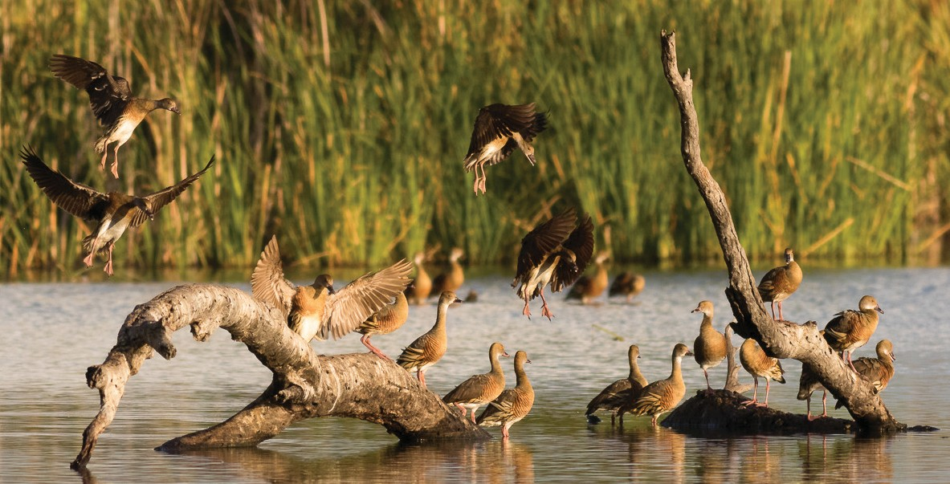For more information about Commonwealth environmental water, please contact us at:

 1800 803 772

@: [ewater@environment.gov.au](mailto:ewater@environment.gov.au)

[www.environment.gov.au/water/cewo](http://www.environment.gov.au/water/cewo)

@theCEWH



 GPO Box 787, Canberra, ACT, 2601