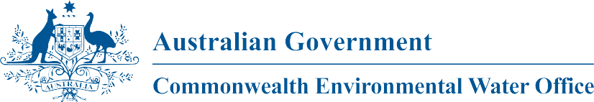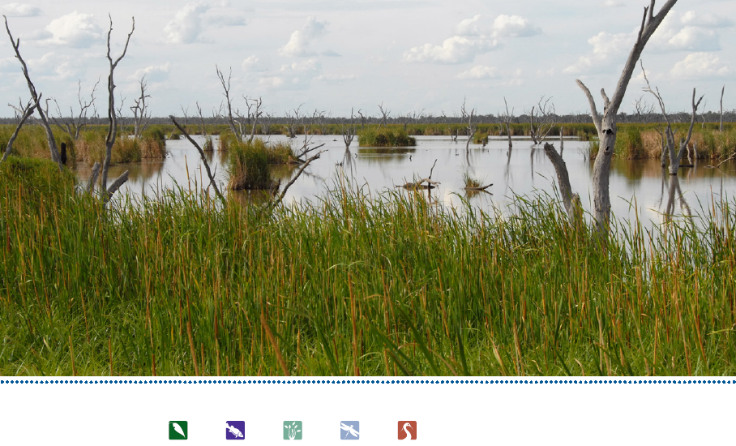

**Commonwealth Environmental Water**

Portfolio Management Plan

Gwydir River Valley

2018-19

Front cover image credit: Little Pied Cormarant in the Gwydir, Photo by P Knock, Eco Logical

Back cover image credit: Gwydir Wetlands, Photo by Commonwealth Environmental Water Office

**Acknowledgement of the traditional owners of the Murray-Darling Basin**

The Commonwealth Environmental Water Office respectfully acknowledges the traditional owners, their Elders past and present, their Nations of the Murray-Darling Basin, and their cultural, social, environmental, spiritual and economic connection to their lands and waters.

© Copyright Commonwealth of Australia, 2018.



Commonwealth Environmental Water Portfolio Management Plan: Gwydir River Valley 2018–19 is licensed by the Commonwealth of Australia for use under a Creative Commons Attribution 4.0 International licence with the exception of the Coat of Arms of the Commonwealth of Australia, the logo of the agency responsible for publishing the report, content supplied by third parties, and any images depicting people. For licence conditions see: https://creativecommons.org/licenses/by/4.0/

This report should be attributed as ‘Commonwealth Environmental Water Portfolio Management Plan: Gwydir River Valley 2018–19, Commonwealth of Australia, 2018’.

The Commonwealth of Australia has made all reasonable efforts to identify content supplied by third parties using the following format ‘© Copyright’ noting the third party.

The views and opinions expressed in this publication are those of the authors and do not necessarily reflect those of the Australian Government or the Minister for the Environment.

While reasonable efforts have been made to ensure that the contents of this publication are factually correct, the Commonwealth does not accept responsibility for the accuracy or completeness of the contents, and shall not be liable for any loss or damage that may be occasioned directly or indirectly through the use of, or reliance on, the contents of this publication.

# Commonwealth environmental water portfolio management planning

## Commonwealth Environmental Water Holder

The Commonwealth Environmental Water Holder is a statutory position established under the *Water Act 2007* and is responsible for managing the Commonwealth’s environmental water holdings. This water must be managed to protect and restore the rivers, wetlands and floodplains (and the native animals and plants they support) of the Murray–Darling Basin. Ms Jody Swirepik is the current Commonwealth Environmental Water Holder. Ms Swirepik is supported by staff of the Commonwealth Environmental Water Office (CEWO). The CEWO employs six local engagement officers who live and work in regional centres across the Murray–Darling Basin.

## Commonwealth environmental water

Commonwealth environmental water holdings are water entitlements that have been acquired by the Australian Government through investments in water-saving infrastructure and purchases on the water market. The holdings are a mix of entitlement types held across 19 catchments. The rules governing the entitlements vary across states and across catchments. Commonwealth environmental water entitlements are subject to the same fees, allocations, carryover and other rules as equivalent entitlements held by other water users.

There are broadly three options for managing Commonwealth environmental water:

* delivering water to a river or wetland to meet an identified environmental demand
* leaving water in storage and carrying it over for use in the next water year (referred to as ‘carryover’)
* trading water, that is, selling water and using the proceeds to buy water in another catchment or in a future year, or investing in complementary ‘environmental activities’.

## Purpose of the document

This document sets out the plans for managing the Commonwealth environmental water portfolio in the Gwydir River Valley for 2018–19. Efficient and effective management of Commonwealth environmental water requires the utilisation of all portfolio management options. By taking a multi-year approach to planning, portfolio management tools such as use, carryover and trade can be managed for maximising environmental outcomes.

The portfolio management plans support transparent, coordinated and adaptive management of Commonwealth environmental water, consistent with the Basin-wide environmental watering strategy and having regard to the Basin annual environmental watering priorities.

To learn more about the planning approach see *Portfolio Management Planning: Approach to planning for the use, carryover and trade of Commonwealth environmental water, 2018–19* (available at: <http://www.environment.gov.au/water/cewo/publications> under ‘Planning approach’).

## Delivery partners

Commonwealth environmental water is managed in conjunction with and delivered by a range of partners. This portfolio management plan has been developed in consultation with our delivery partners, including New South Wales Office of Environment and Heritage (NSW OEH), Department of Primary Industries – Water (DOI-Water), and Water NSW, and after considering advice from the Gwydir Valley Environmental Contingency Allowance Operations Advisory Committee (ECAOAC).

## Your input

The management of Commonwealth environmental water relies on considerable advice and assistance from local organisations, state governments and others. Individuals and groups within the Murray–Darling Basin community are encouraged to submit suggestions for the management of Commonwealth environmental water. Please contact the CEWO via: [ewater@environment.gov.au](mailto:ewater@environment.gov.au).

# Table of contents

Commonwealth environmental water portfolio management planning 1

Commonwealth Environmental Water Holder 1

Commonwealth environmental water 1

Purpose of the document 1

Delivery partners 1

Your input 2

Table of contents 3

1. Environmental watering in Gwydir River Valley 4

1.1. The Gwydir River Valley 4

1.2. Environmental objectives in the Gwydir River Valley 5

1.3. Environmental flow requirements 7

1.4. Monitoring and adaptive management 8

2. Portfolio management in 2018–19 10

2.1. Antecedent and current catchment conditions and the demand for environmental water in 2018–19 10

2.2. Water availability in 2018–19 12

2.3. Overall purpose of managing environmental water based on supply and demand 13

2.4. Water Delivery in 2018–19 14

2.5. Trading water in 2018–19 15

2.6. Carrying over water for use in 2019–20 15

2.7. Identifying Investment Opportunities 16

3. Next steps 20

3.1. From planning to decision making 20

3.2. Further information 20

Bibliography 21

Attachment A – Expected outcomes from the Basin-wide environmental watering strategy 22

Attachment B – Operational details for watering 24

Operational considerations in the Gwydir River Valley catchment 24

Potential watering actions under different levels of water resource availability 24

Potential watering actions – standard operating arrangements 26

Attachment C – Long-term water availability 28

Commonwealth environmental water holdings 28

Other sources of environmental water 28

Planned environmental water 28

# 

# Environmental watering in Gwydir River Valley

## The Gwydir River Valley

Flows in the Gwydir River Valley are driven by rainfall in the upper catchment. Almost the entire runoff for the catchment is generated above Pallamallawa, with the western floodplains contributing minimal runoff due to low slopes, absorbent soils and high evaporation rates. Copeton Dam is the major regulated water storage in the Gwydir River Valley with a storage capacity of 1 364 GL. It regulates about 55  percent of Gwydir system inflows (active storage in Copeton Dam is 1 345 GL. Downstream re-regulating structures at Tareelaroi, Boolooroo and Tyreel divert flows from the Gwydir River into the Mehi River, Carole Creek and Lower Gwydir River/Gingham Watercourse, respectively. A number of unregulated tributaries flow into the Gwydir River below the dam; the Horton River is the primary source of unregulated flows.

The principal wetland areas of the Gwydir River Valley targeted by environmental water are the lower Gwydir, Gingham Watercourse and Mallowa Wetlands. The Gwydir Wetlands is a key asset in the Gwydir River Valley, which forms an inland terminal wetland in the downstream reaches of the Gwydir River and Gingham Watercourse, below Moree. Four sites in the lower Gwydir and Gingham are internationally recognised under the Ramsar Convention and other international agreements for migratory species for their special habitat value for waterbirds. These are ‘Windella’, ‘Crinolyn’ and ‘Goddard’s Lease’ on the Gingham Watercourse and ‘Old Dromana’ on the Lower Gwydir Watercourse. When flooded, the wetland sustains up to hundreds of thousands of breeding colonial waterbirds. The primary ecological features of the wetlands and reasons for its Ramsar listing are large expanses of vegetation, including large areas of coolibah woodland, water couch and the largest stand of marsh club-rush in New South Wales (NSW). The environmental demands identified subsequently are important for helping support the ecological character of the Ramsar site.

Several native fish species identified as threatened in NSW and/or Commonwealth legislation have been observed or are predicted to occur in the Gwydir watercourses targeted by Gwydir environmental watering. These include olive perchlet and freshwater catfish (endangered populations) and purple spotted gudgeon (endangered species) listed under the *Fisheries Management Act 1994* (NSW) (FMAct) and silver perch and Murray Cod (respectively critically endangered and vulnerable under the *Environment Protection and Biodiversity Conservation Act 1999*). The aquatic community of the Gwydir also forms part of the *Lowland Darling River aquatic ecological community*, which is listed as endangered under theFM Act. This community includes 21 native fish species and hundreds of native invertebrate species that are found within the Darling River and its associated streams, wetlands and anabranches within NSW.

The Mallowa Creek breaks off the Mehi River approximately 50 km downstream of Moree. Prior to the construction of the Mallowa Regulator in 1983, many fresh flows would have passed through Mallowa Creek and sections of the floodplain. These fresh flows are now diverted down the Mehi River. While not as extensive as the Gwydir Wetlands, the Mallowa Wetlands supports a diverse wetland and floodplain vegetation assemblage that is representative of native vegetation of the Gwydir River Valley. Importantly, it also has less of a Lippia presence. The native vegetation of the Mallowa Creek provides valuable habitat for waterbirds, woodland birds and other fauna.

The Gwydir and Mallowa Wetlands play a substantial part in the biological and ecological functioning of the Murray-Darling Basin, as the major wetlands in the Basin are not inundated simultaneously and therefore habitat availability varies across the Basin spatially and temporally. Since flooding in the Gwydir Wetlands is not always synchronous with flooding of other Murray-Darling Basin wetlands, such as the Macquarie Marshes or Narran Lake, the Gwydir Wetlands play an important role on a regional scale.

The Mehi River and Carole Creek are major distributaries of the Gwydir River. Moomin Creek branches off the Mehi River downstream of Moree and re-joins the River just before its confluence with the Barwon River at Collarenebri. Carole Creek connects to the Barwon River through the Gil Gil Creek in the Border Rivers catchment. The Mehi River and Carole-Gil Gil Creek transport about 6 per cent of the average flow at Pallamallawa to the Barwon River.

The Sustainable Rivers Audit found that the lowland zone of the Gwydir Valley was rated as poor for both fish and macroinvertebrates. Native fish populations in the Gwydir catchment and across the Murray-Darling Basin have been affected by changes in the natural flow regime, reduction in habitat quality and availability, and barriers to migration. Changes in the frequency, size, duration and timing of flow events have negatively affected the availability of food, habitat and breeding opportunities for native fish. The majority of native fish species in the lower Gwydir spawn during the spring and summer season with rises in water temperature and/or water levels. Up to 20 native fish species occur in the Gwydir catchment with most species still occurring in the middle Gwydir catchment.

A number of the rivers and creeks in the Gwydir River Valley may contribute water to the Barwon-Darling at various times. The northern connectivity event in 2017-18 is an example. The Barwon-Darling connects rivers, lakes and wetlands across the northern Basin, providing critical drought refuge and a movement corridor for fish and waterbirds, and habitat for other aquatic species including turtles, mussels, and shrimp. Flows that connect the Barwon-Darling and the northern tributaries may help to support healthy and diverse populations of native fish and other fauna, including in the Gwydir River. More information about the Barwon-Darling is described in the *Commonwealth Environmental Water Portfolio Management Plan: Barwon-Darling 2018–19.*

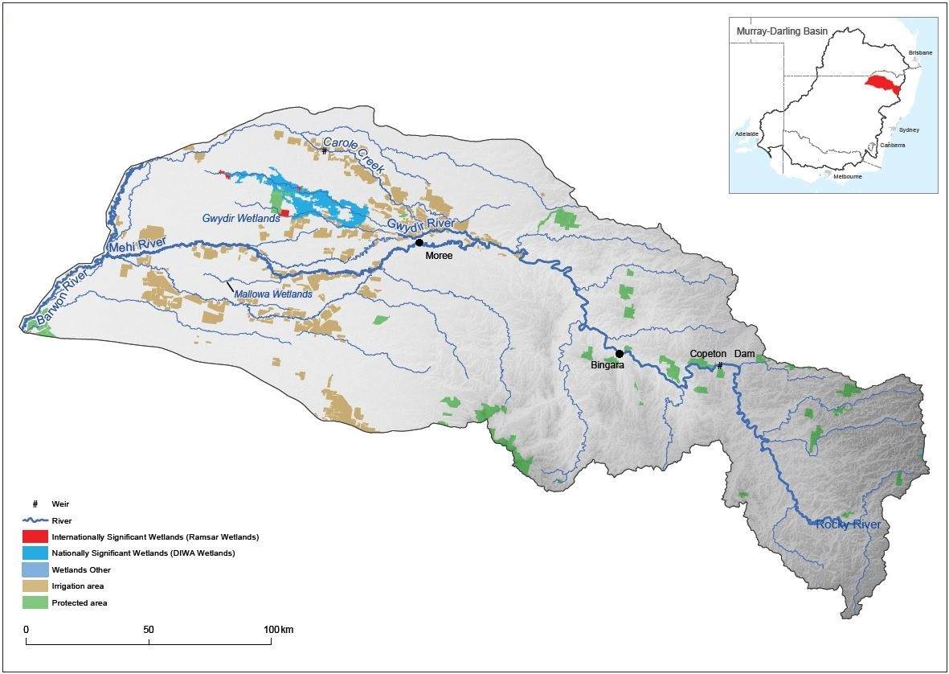

Figure 1: Map of the Gwydir River Valley

## Environmental objectives in the Gwydir River Valley

The long-term environmental objectives for the Murray-Darling Basin are described in the Basin Plan’s environmental watering plan and the Basin-wide environmental watering strategy, which includes ‘quantified environmental expected outcomes’ at both a Basin-scale and for each catchment. The expected outcomes relevant for the Gwydir River Valley are described in Attachment A.

Basin state governments are also developing long-term watering plans for each catchment. These plans will identify the priority environmental assets and ecosystem functions in the catchment, the objectives and targets for these assets and functions, and their watering requirements. Once developed, these plans will provide the key information on the long-term environmental water demands in the catchment. Prior to the development of long-term watering plans, the CEWO will continue to draw on existing documentation on environmental water demands developed by state governments, local natural resource management agencies and the Murray–Darling Basin Authority.

Based on these strategies and plans, and in response to best available knowledge drawing on the results of environmental watering monitoring programs, the objectives for environmental watering in Gwydir River Valley are summarized in Table 1 below. The objectives for water-dependent ecosystems will continue to be revised as part of the CEWO’s commitment to adaptive management.

Table 1: Summary of objectives being targeted by environmental watering in the Gwydir River Valley

| * **BASIN-WIDE OUTCOMES**   **(Outcomes in red link to the Basin-wide Environmental Watering Strategy)** | **EXPECTED OUTCOMES FOR GWYDIR ASSETS** | | | | | |
| --- | --- | --- | --- | --- | --- | --- |
| **IN-CHANNEL ASSETS** | | | **OFF-CHANNEL ASSETS** | | |
| **Mehi River** | **Carole Creek** | **Lower Gwydir river channel** | **Gingham Wetlands** | **Gwydir Wetlands** | **Mallowa Wetlands** |
| **OVERALL** | Contribute to flow variability, hydrological connectivity, in-stream habitat condition and diversity, water quality, primary productivity, native aquatic species condition and reproduction  Under sustained low inflows provide hydrological connectivity to in-stream habitat, to ensure the persistence of pools as refuge; and to reduce the risk of degrading water quality conditions (particularly low dissolved oxygen levels) | | | Promote recovery of wetland vegetation, provide habitat for threatened species as well as survival and reproduction opportunities for a range of waterbird and native aquatic species (e.g. fish, frogs, turtles, invertebrates) | | |
| **VEGETATION** | Contributed to native riparian vegetation diversity, extent and condition. | | | Enable recruitment of trees and support growth of understorey species within river red gum, black box and coolibah communities on floodplains that received overbank flooding during 2016 by inundating the floodplains again | | |
| **WATERBIRDS** | Improve the abundance and diversity of the Basin’s waterbird population  Support waterbird breeding events (reproduction and fledging) to successful completion. | | | | | |
| **FISH** | Improve flow regimes and connectivity to maximise the ecological function of the Barwon-Darling river system for native fish  Support viable populations of threatened native fish and maximise opportunities for range expansion and the establishment of new populations | | | | | |
| **MACROINVERTEBRATES** | Support recruitment and maintain macroinvertebrate diversity and habitat | | | | | |
| **PROCESSES** | Hydrological connectivity, including end of system flows  Mobilisation and dispersal of biotic and abiotic materials  Primary production, decomposition, nutrient and carbon cycling | | | Primary production, decomposition, nutrient and carbon cycling | | |
| **WATER QUALITY** | Maintain water quality within channels and pools | | | | | |
| **RESILIENCE** | Provide drought refuge habitat (particularly for fish and other aquatic fauna) | | | | | |

Information sourced from: CEWO 2014, MDBA 2012, MDBA 2014 (a and b)

## Environmental flow requirements

Not all environmental demands can and will be met through the use of held environmental water. Some demands are met by regulated water deliveries for consumptive purposes, while others are met by large unregulated/natural flows events or are beyond what can be delivered within operational constraints. Figure 2 shows the broad environmental demands that are in scope for Commonwealth environmental water. Importantly, these are broad, indicative demands and individual watering events may contribute to particular opportunities, such as using infrastructure to deliver water to individual wetlands that would otherwise not be possible due to constraints. Also, there may be opportunities for Basin State governments to remove or modify constraints, which will improve the efficiency and/or effectiveness of environmental watering. Further information on delivery constraints are described in Attachment B.

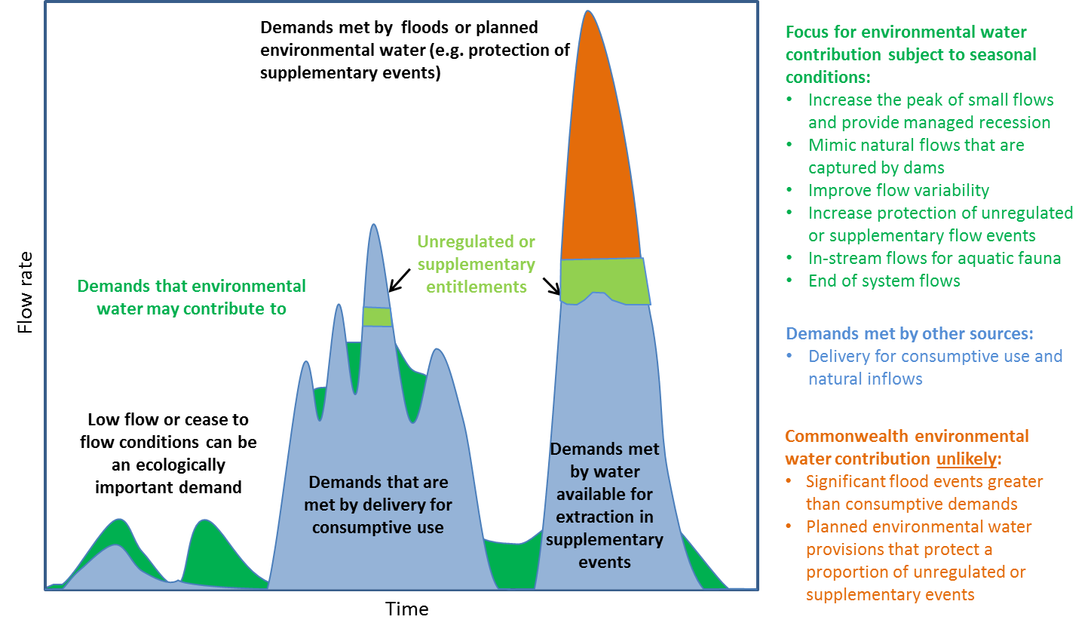

Figure 2: Scope of demands that environmental water may contribute to in the Gwydir River Valley

Based on the above objectives and delivery constraints, specific watering requirements (flow magnitude, duration, timing and frequency) have been identified as being in scope for Commonwealth environmental water. These water requirements are described in Table 3. As with the objectives, the environmental water requirements will continue to be reviewed and revised in response to new knowledge.

## Monitoring and adaptive management

Operational monitoring is undertaken for all Commonwealth environmental watering actions and involves collecting on-ground data with regard to environmental water delivery such as volumes delivered, impact on the river systems hydrograph, area of inundation and river levels. It can also include observations of environmental outcomes.

Long-term intervention monitoring is also being undertaken in the Gwydir catchment. It aims to understand the environmental response from Commonwealth environmental watering with respect to targeted objectives and expected outcomes.

Information on the monitoring activities is available at <http://www.environment.gov.au/water/cewo/catchment/gwydir/monitoring>. Monitoring information is also provided by state governments.

Key findings and recommendations from the Gwydir Long Term Intervention Monitoring include:

***River channels***

* Breeding and recruitment of native fish species in response to environmental water, including recruitment of threatened freshwater catfish, observed by our monitoring for the first time in 2016-17.
* Environmental water has been shown to improve water quality, stimulate primary productivity and help to maintain regional scale aquatic invertebrate diversity.
* The association shown between increased river discharge and activity of freshwater catfish and Murray cod during the 2016-17 informed the development of an early season stimulus flow for fish breeding and allow access to breeding habitat (delivered in 2017-18).
* Positive ecological outcomes can be achieved by using relatively small amounts of environmental water delivered at critical times. Deliveries of environmental water that connected refuge pools and maintained water quality helped ensure the survival of aquatic species during low to no flow periods, including several listed native fish species.
* Environmental water increased longitudinal connectivity in the Gwydir, lower Gwydir and Mehi River channels during 2016–17, 2015-16 and 2014-15.

***Wetlands***

* The current practice of using environmental water based on natural flow cues is working in the lower Gwydir river system, and more broadly that the long-term environmental watering strategy being employed in the Gwydir river system has been shown to be effective.
* Semi-permanent wetland vegetation species such as water couch, spike-rush, tussock rush, lignum and river cooba, and floodplain species such as coolibah and river red gum were maintained during 2016-17, 2015-16, and 2014-15.
* Significant increases in both waterbird species diversity and total abundance have been observed at sites that received environmental water. In addition, breeding of several species of waterbirds has also been observed, contributing to the continued survival of these species in this system.
* A viable population of the threatened olive perchlet exists in the Gingham waterhole. This population should present a target for future environmental water delivery to try and maintain suitable conditions in the waterhole and promote their dispersal to other nearby waterholes if possible
* Invertebrate communities and primary production respond to flow differently in the Gingham and Lower Gwydir wetlands. Both systems should be targeted with environmental water to promote regional scale biodiversity and productivity. Repeated wet-dry cycles in the Gwydir wetlands stimulated microinvertebrate productivity to densities 15 times higher than the permanently inundated Gingham sites. This suggests multiple dry phases within the water year can stimulate microinvertebrates as an important food source for larval fish.
* Environmental water has been shown to prolong inundation in core areas of the Gingham and Lower Gwydir wetlands, maintaining wetland vegetation and promoting waterbird and frog breeding, including Ramsar listed sections of the Gwydir Wetlands.
* Environmental water helped to increase invertebrate densities in wetland sites, providing food resources of native fish, waterbirds and frogs.

The outcomes from these monitoring activities are used to inform portfolio management planning and adaptive management decision-making as outlined in Section 2.

# Portfolio management in 2018–19

In planning for the management of Commonwealth environmental water, the CEWO aims to maximise the outcomes achieved from the available water. This includes consideration of the urgency of demands (based on targeted objectives and watering requirements, watering history and asset condition) and the available supply under different resource scenarios. Plans for water delivery, trade and carryover are then made in a multi-year context, with an assessment also undertaken of need for water in future years.

This planning process is outlined in full in Table 3 below and summarised in the sections below.

## Antecedent and current catchment conditions and the demand for environmental water in 2018–19

Between 2002 and 2010 the Gwydir River Valley experienced an extended period of drought, which, coupled with river regulation, had a significant impact on the environmental condition of the valley. Watering through 2010–17 has targeted restoring and maintaining wetland vegetation in good condition, particularly key plant species such as water couch-spike rush and lignum shrubland. Monitoring in the Gwydir has shown that the wetland vegetation extent and condition of communities, such as the marsh club-rush sedgeland (listed as critically endangered under the NSW *Threatened Species Conservation Act 1995*), have recovered well. Improved inflows also supported recruitment of native fish and frog species in the Gwydir system.

*Gwydir Wetlands*

A large environmental water action in 2014–15 consolidated the recovery of wetland vegetation in the Lower Gwydir River and Gingham Watercourse. In the years following, delivery of environmental water has been guided by natural cycles of drying and wetting to maintain and protect wetland assets, including parts of the internationally important Gwydir Wetlands. In summer 2015–16, environmental water was delivered to the Gwydir Wetlands following a series of small supplementary events. The strategy of using natural cues has been supported by the Gwydir Valley ECAOAC.

In September 2016, water flowed into the Gwydir Wetlands as a result of unseasonal heavy spring rainfall. To build on this inundation environmental water was delivered from storage to the Gingham and lower Gwydir over the warmer summer months. Environmental water (30GL) delivered into the Gingham and Gwydir wetlands prolonged the inundation in the semi-permanent wetland areas by several months, maintaining waterbird and supporting frog breeding. Around 3 234 ha of wetland areas was inundated by the natural flows in spring 2016, less than half the area inundated by the last large environmental delivery into the Gwydir wetlands in 2014–15 (~6 342 ha). During 2017–18 a small contribution of environmental water (8 GL) was provided to the Gwydir Wetlands.

The demand for a large inundation event, similar in scale to the 2014–15 delivery, is high for 2018–19.

*Mallowa Wetlands*

The Mallowa Wetlands have been a target for environmental flows following the closure of the stock and domestic supply into the system as part of water recovery projects. The restoration of wetland vegetation in the system began with environmental watering in 2012–13, 2013–14 and 2014–15. Environmental water was delivered to maintain the current extent of wetland vegetation in a healthy, dynamic and resilient condition providing important refuge habitat for a range of native species.

Monitoring has shown that watering in the Mallowa has initiated a very good vegetation response and also resulted in a frog breeding event. The Mallowa Wetlands was the only large wetland site north of the Macquarie Marshes watered during the summer of 2013–14, and provided important drought refuge for foraging waterbirds. Monitoring and reports from landholders noted that a large diversity of waterbirds were observed in the area. In 2015–16 environmental water contributed to small reactive watering of the Mallowa during the hotter summer months. During January – April 2017 Commonwealth environmental water was provided to the Mallowa Wetlands, in order continue support of wetland vegetation recovery.

The last significant flow into the Mallowa occurred in 2014–15 with a delivery over 10 GL. During 2016-17 deliveries into the Mallowa aimed to meet the broad inundation demand but could only partly contribute to the demand due to higher than anticipated losses as a result of operational issues outside of the control of the Commonwealth. Given the last time this demand was met was 2014-15, the demand for a large (10-20 GL) flow event in the Mallowa is high.

*River channels*

In addition to the wetland recovery in the Gwydir Valley, the Commonwealth is working towards building a healthier in-stream ecological environment by contributing environmental water to in-stream freshes in the mainstream and effluent watercourses of the Gwydir system. These flows are provided in a way that mimics the natural flow rise and recession to stimulate fish breeding activity. Monitoring of the first fish flow trial showed that Commonwealth environmental water was successful at stimulating breeding in populations of bony bream, and spangled perch. During 2015–16, environmental water contributed to a small reactive delivery for in stream aquatic ecology by following natural flow cues.

In-stream environmental watering actions in the Mehi River and Carole Creak in 2013–14 and 2014–15 also achieved good connectivity with the Barwon-Darling River contributing to environmental outcomes for native fish during low flow conditions. Benefits of these flows included connectivity between refuge pools and water quality (salinity).

By early autumn 2016, following a sequence of dry months, a dry river refuge protection flow was provided to the Gwydir River, Gingham Watercourse, Mehi River and Carole Creek. This flow was slowly fed into the system during late April / early May to refresh refuge waterholes in order to protect in-stream aquatic ecology.

Findings from the Long Term Intervention Monitoring evaluations of environmental flows in the Gwydir have contributed to the adaptive management of flows targeting native fish abundance and condition. In particular, in-channel flow strategies that aim to effectively ‘charge’ the system with resources to facilitate recruitment may be of more benefit than those that target flow releases purely at stimulating breeding and/or dispersing larvae. Responding to this demand, an early season stimulus flow was implemented during spring 2017, with preliminary indications suggesting that the flow achieved the desired outcomes. In addition, monitoring of endangered freshwater catfish during 2016-17 showed recruitment in the Lower Gwydir and Mehi for the first time during since environmental watering began. To support this population of native fish, our science partners suggested we provide a low stable flow during late spring / early summer to provide favorable habitat conditions for the freshwater catfish to breed and recruit. Again, all early indications from fish monitoring in March 2018 suggests that the strategy was successful, with new freshwater catfish recruits being observed (pers comm Gavin Butler, April 2018).

*Barwon-Darling*

There is a growing awareness of the importance of connecting flows across the northern Basin, to support habitat, water quality, native fish and other aquatic species in the Barwon-Darling and its tributary systems, including the Gwydir Valley rivers. Subject to antecedent conditions, water availability, and urgency of environmental demands, there may be opportunities to coordinate releases across multiple rivers in the northern Basin to meet broader environmental demands. The environmental demands in the Barwon-Darling are described in the *Commonwealth Environmental Water Portfolio Management Plan: Barwon-Darling 2018–19*.

**Murray–Darling Basin Plan environmental watering priorities and the Murray–Darling Basin-wide environmental watering strategy.**

The Murray-Darling Basin Authority publish the *Basin annual environmental watering* priorities each year and in 2017–18 also published multi-year priorities. Commonwealth environmental water in the Gwydir will contribute to the following multi-year environmental watering priorities and the 2018–19 Basin annual environmental watering priorities.

**Rolling, multi-year priorities**

• Support lateral and longitudinal connectivity;

• Maintain and improve the condition and promote recruitment of forests and woodlands;

• Improve the condition and extent of lignum shrublands;

• Improve the abundance and maintain the diversity of the Basin’s waterbird population;

• Improve flow regimes and connectivity to maximise the ecological function of the Barwon-Darling river system for native fish;

• Support viable populations of threatened native fish, maximise opportunities for range expansion and establish new populations.

**2018-19 Annual Priorities**

• Support opportunities for lateral connectivity between the river and adjacent low-lying floodplains and wetlands to reinstate natural nutrient and carbon cycling process;

• Coordinate replenishment flows across multiple tributaries to maintain habitat condition and regulate water quality, carbon and nutrients in refuges along the Barwon-Darling watercourse;

• Enable growth and maintain the condition of lignum shrublands;

• Provide flows to improve habitat and support waterbird breeding;

• Improve flow regimes and connectivity to maximise the ecological function of the Barwon-Darling river system for native fish;

• Support viable populations of threatened native fish, maximise opportunities for range expansion and establish new populations.

The Commonwealth Environmental Water Holder will not inundate private land without prior approval from land holders while contributing to the Basin annual environmental watering priorities.

In contributing to these demands, the Commonwealth Environmental Water Office will also be aiming to contribute to the expected outcomes in the Basin-wide environmental watering strategy (see Attachment A).

## Water availability in 2018–19

**Forecasts of Commonwealth water allocations**

Allocations against Commonwealth water entitlements in the Gwydir River Valley are determined by state governments and will vary depending on inflows. The following forecasts in Table 2 are based on the best available information including State forecasts and historical inflow scenarios.

Table 2: Forecasts of Commonwealth water allocations (including carryover) in 2018–19 in the Gwydir River Valley as at 30 April 2018.

|  |  |  |  |  |  |  |
| --- | --- | --- | --- | --- | --- | --- |
| **Entitlement type** | **Forecasts of Commonwealth water allocations (including carryover) in 2018–19 (GL)** | | | | | |
| **Very dry Very wet** | | | | | |
| **95 percentile** | **90 percentile** | **75 percentile** | **50 percentile** | **25 percentile** | **10 percentile** |
| Gwydir (general/high security) | 72 | 72 | 72 | 89 | 112 | 139 |
| Gwydir (supplementary) | Up to 20.5 | Up to 20.5 | Up to 20.5 | Up to 20.5 | Up to 20.5 | Up to 20.5 |

Notes:

1. Forecasts for regulated catchments are given to the nearest whole gigalitre except where the entitlement held by the Commonwealth is below 1 GL.
2. Allocation rate scenarios are based on long term average allocation rates.
3. Carryover is not available for High Security entitlements. General security entitlements have continuous accounting and water will be forfeit whenever the amount of water in storage exceeds 150 per cent of entitlement. Use limits of 300 per cent of entitlement and 300 per cent of entitlement over 3 years also apply.

The volume of Commonwealth environmental water likely to be carried over in Gwydir River Valley for use in 2018–19 is estimated to be approximately 68 GL.

Information on allocations to Commonwealth environmental water holdings can be found at <http://www.environment.gov.au/water/cewo/portfolio-mgt/holdings-catchment> and is updated monthly.

**Water resource availability scenarios**

Commonwealth environmental water is managed with other water in the system and is not managed in isolation. When considering the available resource to meet environmental demands, it is necessary to also factor in the resources managed by other entities and available to contribute to environmental outcomes. Relevant resources include NSW Riverbank and Environmental Contingency Allowance, planned environmental water, natural and unregulated flows, conveyance water and consumptive water. Further detail on sources of environmental water in the Gwydir River Valley is provided in Attachment C.

By combining the forecasts of water held by the Commonwealth with streamflow forecasts, as well as taking into account operational considerations, water resource availability scenarios can be developed ranging from very low to very high. Based on available information moderate to high resource availability scenarios are in scope for 2018–19, with very high resource availability only possible if conditions become wet.

## Overall purpose of managing environmental water based on supply and demand

Environmental water needs (demand) and water availability (supply) both influence the overall purpose of Commonwealth environmental water management. Under different combinations, the management purpose can range from ‘avoiding damage’ to the environment to ‘improving’ ecological health. This in turn informs the mix of portfolio management options that are suitable for maximising outcomes.

The overall ‘purpose’ for managing the Commonwealth’s water portfolio in the Gwydir catchment for 2018‑19 is to protect wetland vegetation of the Gwydir Wetlands and Mallowa, ensuring their ecological capacity for recovery, while maintaining the ecological health and resilience of other important sites in the catchment, including in stream aquatic ecology.

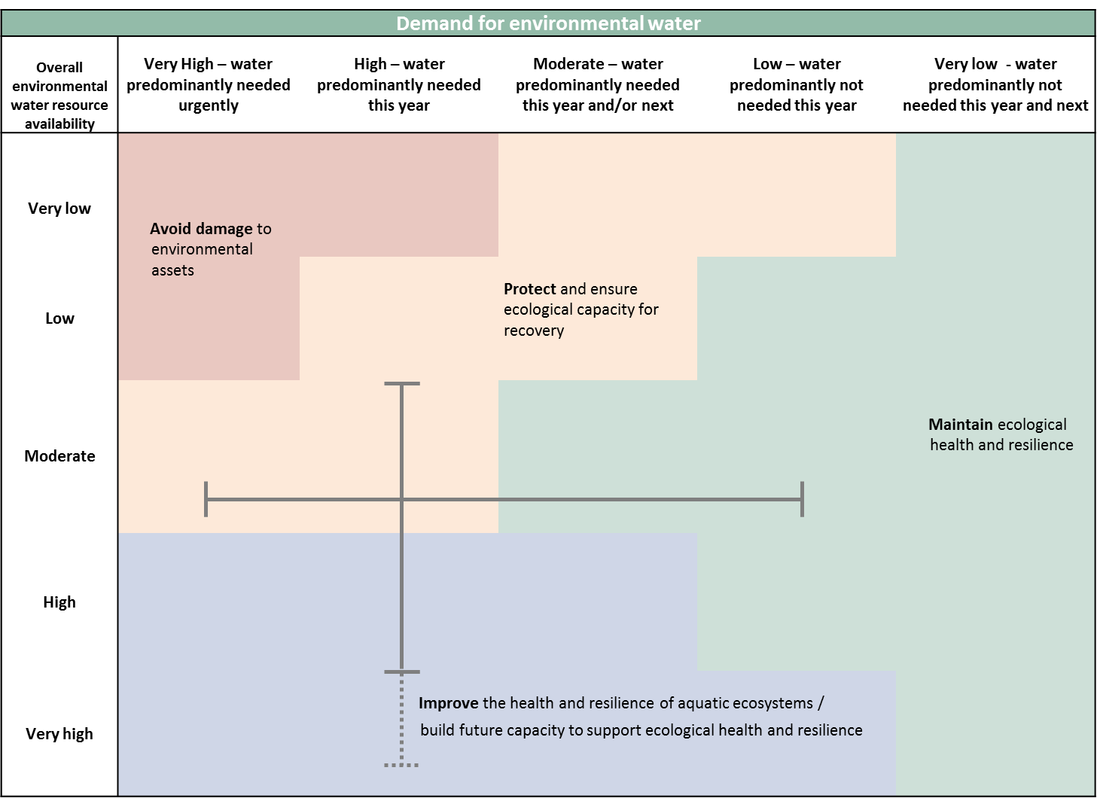

Figure 3: Determining a broad purpose for portfolio management in the Gwydir River Valley for 2018–19. Note: grey lines represent potential range in demand and resource availability.

Further detail on how the overall purpose for portfolio management changes under different supply and demand scenarios is provided in *Portfolio Management Planning: Approach to planning for the use, carryover and trade of Commonwealth environmental water, 2018–19* (available at: <http://www.environment.gov.au/water/cewo/publications>).

## Water Delivery in 2018–19

Consistent with the demands and purpose described above, the CEWO is considering supplying environmental water to the following watering actions for 2018–19 (see also Table 3 for supporting information regarding the basis for determining these watering intentions).

In the wetlands, environmental watering aims to support the highly water dependant semi-permanent wetland communities by contributing through a proactive watering approach – following two dry summer seasons, wetland watering may target a broader system wide inundation watering that includes flood dependent coolibah and red gum woodlands, lignum and black box shrublands. These larger actions aim to build resilience during the boom times in order to protect system during drier times. This approach in the Gwydir Wetlands calls for a large proactive environmental delivery in 2018–19 from stored supplies in Copeton Dam. When supplementary water access is made available, a proportion of the Commonwealth supplementary licence may be activated for each watercourse (up to 14 100 ML in the Gingham / Gwydir and up to 5 000 ML in the Mehi / Mallowa).

In addition to the wetland watering targets, environmental watering also aims to provide an in-stream flow regime that supports native fish populations and aquatic ecological processes. The triggers for providing in-stream flows can include seasonal or species specific flow requirements to support breeding and recruitment or to provide or maintain aquatic ecological optimal conditions for native fish and other aquatic fauna, which may also include an early season stimulus trigger flow in late winter / early spring – or building instream carbon/other nutrient levels so that conditions are primed for fish breeding should natural conditions provided opportunity later in the season. Should a large system wide watering of the wetlands occur during 2018–19, the requirement for early season flows is a lower priority for additional water, as existing deliveries for wetlands actions will likely meet early season fish flow demands.

A key part of ensuring ongoing system health is managing drought refuge for in-stream aquatic ecology during extended drying sequences. To do this environmental water is available from storage to refresh drought refuges and reduce the risk of degrading water quality to contribute to the survival of aquatic species during dry periods.

Should colonial waterbird breeding commence within the Gwydir Wetlands, environmental water can be made available to augment natural flows to support key waterbird species to complete life cycles in low lying wetlands, for example to support a natural waterbird breeding event through to completion (a reserve volume of 10–15 GL is maintained for this purpose).

**Stakeholder Feedback**

The Gwydir Valley ECAOAC met in April 2018 to consider the priorities and targets for environmental watering in the Gwydir catchment over the next 3 seasons.

The ECAOAC are focused on how to best manage existing carryover over several seasons to ensure sufficient volumes will be available to meet environmental demands should dry conditions prevail. With this in mind, the ECAOAC recommended a ‘proactive’ approach to wetland watering during 2018–19, including a large system wide watering of the Gwydir Wetlands and Mallowa Watercourse. A consensus plan for management was informed by discussions between the ECAOAC members and observers which includes Gwydir valley landholders, water users, scientists, independent environmental advisors and Aboriginal representatives. The demands and priorities identified in this report are consistent with the approach endorsed by the ECAOAC.

## Trading water in 2018–19

No specific requirements for sale or purchase of water in the Gwydir Valley have been identified, however, environmental water requirements will be reviewed periodically throughout the water year.

Planning on water trade considers supply and demand within the catchment and across the Basin. As part of the planning process, the CEWO undertakes a Basin-wide analysis to identify opportunities to use allocation trade to better match differing demands across catchments.

Further information will be provided to the market ahead of any trade of Commonwealth environmental water at: <http://www.environment.gov.au/water/cewo/trade/current-trading-actions>.

For more information on the rules and procedures governing the trade of Commonwealth environmental water, see the *Commonwealth environmental water Trading Framework* available at: <http://www.environment.gov.au/water/cewo/publications/water-trading-framework-nov2016>.

## Carrying over water for use in 2019–20

The volume of water carried over for use in 2019–20 will depend upon resource availability and demand throughout the year. A minimum carryover target of 17 GL is being reserved to meet minimum water requirements such as maintenance of in stream and wetland drought refuges should low inflows result in low allocations in subsequent years. If all the the proposed water use during 2018–19 is delivered, carryover into 2019-20 will be approximately 17 GL.

Esimated carryover into 2019-20 assumes low inflows, and is likely to be exceeded. A minimum allocation of 4.5 GL to high security accounts is likely in each water year. Also opportunities to use supplementary water during 2018–19 may mean less water is drawn from water in storage to meet the demands in 2018-19 and additional allocations to General Secuirty accounts is also possible. If the drought refuge flows are not required during 2018–19 an additional 4 000 ML will be carried over. As documented in Table 3 below, potential demands in 2019–20 include:

* Dry river flows to protect drought refuge during very low flow periods (up to 4 000 ML)
* Maintenance flows to enhance native fish populations, and to provide connection with the Barwon River during 2019-20 (up to 12 500 ML).

Carryover volumes will be adjusted throughout the year as the season unfolds in response to both current and future demands and the water available to meet these demands. These decisions will be based upon best information available at the time. More information on how the Commonwealth makes decisions on carryover is at: <http://www.environment.gov.au/water/cewo/portfolio-mgt/carryover>.

## Identifying Investment Opportunities

Under the Water Act the Commonwealth Environmental Water Holder (CEWH) has the flexibility to use the proceeds from the sale of water allocations to fund environmental activities in the Basin. ‘Environmental activities’ should improve the capacity of the CEWH to meet the objectives of the Basin Plan environmental watering plan.

Environmental Activities must also be consistent with:

* the CEWH’s obligation to exercise its functions to protect and restore environmental assets; and
* the requirement to use Special Account funds (including trade proceeds) to cover costs incurred in the performance of the CEWH’s functions.

The CEWH is in the process of developing an Investment Framework to guide decisions on what types of environmental activities may be considered when investing the proceeds from the sale of environmental water allocations.

**Table 3**: Environmental demands, priority for watering in 2018–19 and outlook for coming year in the Gwydir River Valley.

|  |  |  |  |  |  |  |  |  |  |
| --- | --- | --- | --- | --- | --- | --- | --- | --- | --- |
| **Environmental assets** | | **Indicative demand (for all sources of water in the system)** | | **Watering history** | | | **2018–19** | | **Implications for future demands** |
| **Flow/Volume** | **Required frequency (maximum dry interval)** | **(from all sources of water)** | | | **Environmental demands for water** | **Potential Commonwealth environmental water contribution?** | **Likely urgency of demand in 2019–20 if watering occurred as planned in 2018–19** |
|
|
| Wetland Watering | Gwydir Wetlands  (incl Gingham Watercourse)  • Includes areas of Ramsar listed wetlands  • Nationally significant wetlands  • Waterbird breeding and habitat  • Habitat and breeding ground for frogs  Native fish habitat | 45 GL during October to March  60 GL during October to March  80 GL during October and March, (*constraints currently limiting ability to deliver to this demand with regulated flows) | 7/8 in 10 years (5 years)  6 in 10 years (5 years)  4 in 10 years (6 years) | The Gwydir Wetlands experienced drying conditions during 2017-18 and 2015-16. In 2016-17 spring rainfall resulted in a broad area of inundation across the Gwydir and Gingham floodplains. By late summer in early 2017 much of this inundation had dried back to core semi-permanent wetland areas. Therefore the environmental demand for a large prolonged 60 GL watering event has been assessed as high. | | | High  Watering has occurred for 1 of the last 3 water years  60 GL demand in scope | A high priority for watering in 2018–19, even in low resource availability. | Low |
| Mallowa  Waterbird breeding and habitat  • Habitat and breeding ground for frogs | 10–20 GL  All year (most likely spring to autumn) | 3 consecutive in 6 years | 2014-15 was the last large environmental flows into the Mallowa. Small contributions of environmental flows have been provided in recent years. Demand for a 10-20 GL event could not be met in 2016-17 due to delivery complications. Therefore the environmental demand has been assessed as high. | | | High  Demand has not been met in the past 3 water years  15 - 20 GL demand in scope | A high priority for watering in 2018–19, even in low resource availability subject to operational feasibility. | Moderate |
| Aquatic in-stream ecology | Mehi River  • Waterbird breeding and habitat  • Habitat and breeding ground for frogs  Native fish habitat | 7–10 GL, all year (most likely winter / spring)  (breeding / stimulation flow)  5 GL demand for maintenance | 5 in 10 years  Second and thrid year following a stimulation / breeding event flow | Environmental water contributed to this demand during 2017–18. The early season stimulus flow for fish and the stable spring low flow successfully contributed to meeting this demand during 2017–18. Therefore the environmental demand has been assesse as moderate | | | Moderate | Environmental water for wetlands could partially contribute to this demand | Moderate |
| Carole Creek  • Waterbird breeding and habitat  • Habitat and breeding ground for frogs  • Native fish habitat | 5–10 GL  All year (most likely spring to autumn) | 5 in 10 years | Very low and cease-to-flow conditions in 2014-15 and 2015-16. Small to moderate River pulse achieved in 2016-17 and baseflows maintained mostly in 2017-18. Therefore the environmental demand has been assessed as low. | | | Low | Environmental water for wetlands could partially contribute to this demand | Moderate |
| Ballin Boora  • Waterbird breeding and habitat  • Habitat and breeding ground for frogs  • Native fish habitat | Baseflow  800 ML (most likely spring to autumn) | Subject to examination of requirement/ due diligence  Stock and domestic flows pipeline creates demand in the creek system. | Nil flows from managed water sources for at least 3 water years. Therefore the environmental demand has been assessed as high. | | | High | A high priority for watering in 2018–19, even in low resource availability.  (Although ongoing watering is not yet feasible, a trial watering may be possible during 2018-19. Watering is subject to further examination of environmental demand and operational requirements) | Moderate |
| Gwydir River Downstream of Copeton Dam  • Native fish habitat | Improve natural character of flows downstream of the dam | All years  (Spring to Autumn) | Required volumes met. Natural flow pattern not met. Therefore the environmental demand has been assessed as moderate. | | | Moderate | Environmental water could partially contribute to this demand.  (Environmental flows will form the majority of the regulated deliveries so there will be a greater opportunity to influence the character of the releases) | Moderate |
| Dry river flows or bird breeding support flows | Protect critical aquatic refuge habitat during extended drying sequences  • Native fish habitat | Up to 8 GL | As required, All years | Flows to protect critical habitat in Gwydir, Carole and Mehi met demands in April – May 2016. Refuge flows not required in 2016–17.The northern connectivity event in April – May 2018 contributed to meeting this demand in the Mehi River and Carole Creek. May be required every year depending on conditions so demand has been assessed as high. | | | High | Respond to natural conditions to protect critical in-stream aquatic refuge habitat, if required | High |
| Support threatened colonial waterbird breeding  • Waterbird breeding and habitat | 10–15 GL | As required, All years | Colonial waterbird breeding requirement has not been triggered in the past 5 years, therefore the demand has been assessed as moderate. | | | Moderate | Respond to naturally triggered bird breeding, if required | Moderate |
|  |  |  |  |  |  |  | **Carryover potential** | Available allocations to be carried into 2018–19 will be identified in Gwydir environmental water holdings at <https://www.environment.gov.au/water/cewo/about/water-holdings>. | Moderate proportion of available allocations expected to be carried into 2019–20, subject to Commonwealth Environmental Water Holdings at 30 June 2019, water resource availability and environmental watering actions undertaken in 2018-19. |
|  | |  |  |  |  |  | **Trade potential** | No urgency to augment available allocations, therefore limited potential for allocation purchase. Moderate to high demands means allocation sale unlikely. | No expected urgency to augment available allocations. Potential to trade will depend on environmental demands and resource availability. |

Note: Contributions to meet Barwon-Darling environmental requirements may be considered subject to water availability, antecedent conditions, and environmental demands. Refer to *Commonwealth Environmental Water Portfolio Management Plan: Barwon-Darling 2018–19.*

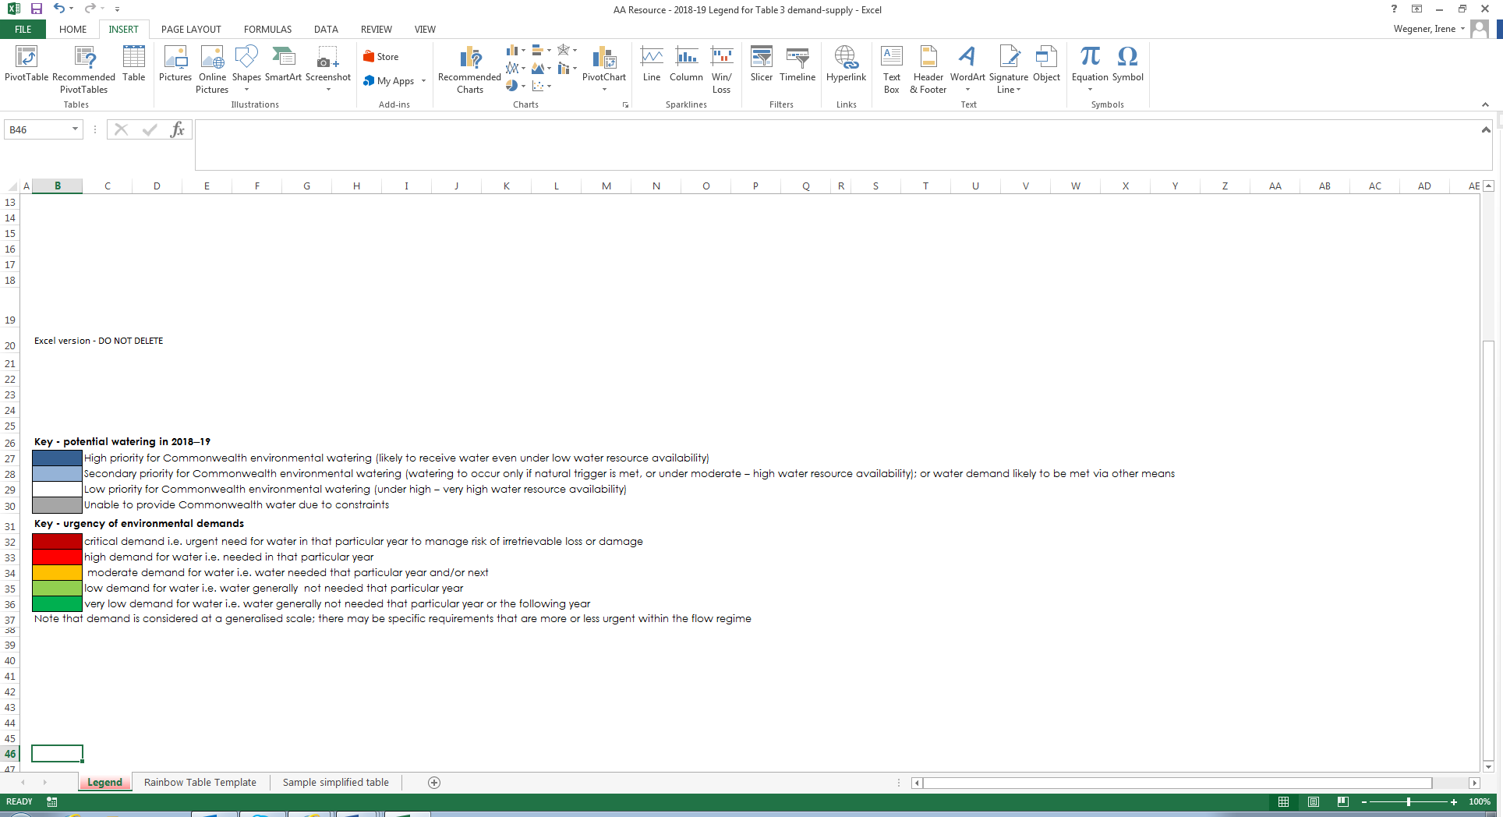

# Next steps

## From planning to decision making

It is important to distinguish between planning and operational decision making. As shown in Figure 4, planning allows the CEWO to manage the environmental water portfolio in a holistic manner and is an exercise in developing a broad approach or intention, based on the key drivers (demand and supply).

Decision making throughout each year builds on the intention by considering in more detail the specific prevailing factors and additional factors such as costs, risks, and constraints to water delivery and market conditions.

Figure shows the link between portfolio management planning and decision making on environmental water use.

Figure 4: Planning and decision making for Commonwealth environmental water use

## Further information

For further information on how the CEWO plans for water use, carryover and trade, please visit our web site: <http://www.environment.gov.au/water/cewo>

or the sites below:

* Water use: [www.environment.gov.au/topics/water/commonwealth-environmental-water-office/assessment-framework](http://www.environment.gov.au/topics/water/commonwealth-environmental-water-office/assessment-framework)
* Carryover: <http://www.environment.gov.au/topics/water/commonwealth-environmental-water-office/portfolio-management/carryover>
* Trade: <http://www.environment.gov.au/water/cewo/trade/trading-framework>

# 

# Bibliography

Baumgartner, L. J., Conallin, J., Wooden, I., Campbell, B., Gee, R., Robinson, W. A. and Mallen‐Cooper, M. (2013). Using flow guilds of freshwater fish in an adaptive management framework to simplify environmental flow delivery for semi‐arid riverine systems. Fish and Fisheries, Early View (Online Version of Record).

Bowen, S. & Simpson, S. L. (2010). Changes in Extent and Condition of the Vegetation Communities of the Gwydir Wetlands and Floodplain 1996-2008: Final Report to the NSW Wetland Recovery Program. Sydney: NSW Department of Environment Climate Change and Water Sydney.

Commonwealth Environmental Water Office (2014). Commonwealth environmental water use options 2014–15: Gwydir River Valley. Commonwealth of Australia 2014. <http://www.environment.gov.au/resource/commonwealth-environmental-water-annual-use-options-gwydir-river-valley>

Commonwealth Environmental Water Office (2015). Commonwealth Environmental Water Office Long Term Intervention Monitoring Project: Gwydir River System Selected Area, Commonwealth of Australia 2014’

Copeland, C., Neller, S., Schooneveldt-Reid, E., Wales, N. S. & Fisheries, N. (2003). Fish Everywhere: An oral history of fish and their habitats in the Gwydir River, NSW DPI Fisheries.

CSIRO (2007) Water availability in the Gwydir. A report to the Australian Government from the CSIRO Murray-Darling Basin Sustainable Yields Project. CSIRO, Australia. 133pp.

Davies, P., Stewardson, M., Hillman, T., Roberts, J. & Thomes, M. (2012). Sustainable Rivers Audit 2: The ecological health of rivers in the Murray–Darling Basin at the end of the Millennium Drought (2008–2010). Volume 2., Canberra, Murray-Darling Basin Authority.

Murray-Darling Basin Authority (2014 (a)), Development of the benchmark model for calculation of supply contributions, Preliminary draft as on 9 April 2014, Canberra.

Murray-Darling Basin Authority (2014 (b)), Basin-wide environmental watering strategy, Canberra.

Murray-Darling Basin Authority (2013), Constraints Management Strategy 2013 to 2024, Canberra.

Murray-Darling Basin Authority (2012), Assessment of environmental water requirements for the proposed Basin Plan: Gwydir Wetlands, <http://www.mdba.gov.au/what-we-do/basin-plan/development/bp-science/assessing-environmental-water-requirements>, Canberra.

NSW Department of Environment, Climate Change and Water (2008). Final report on the Gwydir waterbird and fish habitat study. NSW Wetland Recovery Program. Rivers and Wetlands Unit, NSW Department of Environment and Climate Change, Sydney.

NSW Department of Environment, Climate Change and Water (2011). Gwydir Wetlands Adaptive Environmental Management Plan., NSW Department of Environment Climate Change and Water, Sydney.

NSW Department of Environment and Heritage (2012). Gwydir Wetlands: Gingham and Lower Gwydir (Big Leather) Watercourses Ramsar site [Online].

Pietsch, T. J. (2006). Fluvial geomorphology and late quaternary geochronology of the Gwydir fan-plain. PhD, University of Wollongong.

Rolls, R. J., Growns, I. O., Khan, T. A., Wilson, G. G., Ellison, T. L., Prior, A. & Waring, C. C. (2013). Fish recruitment in rivers with modified discharge depends on the interacting effects of flow and thermal regimes. Freshwater Biology, 58, 1804-1819.

Roberts, J. and Masrton, F. (2011). Water regime for wetlands and floodplain plants: A source book for the Murray-Darling Basin.

Torrible, L., Sainty, G. & Horcroft, D. (2009). Assessment of the Water Dependent Vegetation and Fauna of the Mallowa Creek, results from a field visit Feb 2009. IRPEC Pty Ltd.

Wilson, G. G., Bickel, T. O., Berney, P. J. & Sisson, J. L. (2009). Managing environmental flows in an agricultural landscape: the Lower Gwydir floodplain. Final Report to the Commonwealth Department of Environment, Water, Heritage and the Arts

# Attachment A – Expected outcomes from the Basin-wide environmental watering strategy

Expected outcomes from the Basin-wide environmental watering strategy (MDBA 2014) that are relevant to the Gwydir are described below.

**RIVER FLOWS AND CONNECTIVITY**

Baseflows are at least 60 per cent of the natural level.

Contributing to a 10 per cent overall increase in flows in the Barwon–Darling.

A 10–20 per cent increase in the frequency of freshes, bankfull and lowland floodplain flows.

**VEGETATION**

Maintain the current extent of water-dependent vegetation near river channels and on low-lying areas of the floodplain.

No decline in the condition of river red gum, black box and coolibah.

Improve condition of lignum shrublands in the lower Gwydir catchment.

Improved recruitment of trees within black box, river red gum and coolibah communities.

Increased periods of growth for non-woody vegetation communities that closely fringe or occur within the river and creek channels, and for marsh club-rush and water couch in the Gwydir Wetlands.

**Vegetation extent**

| Area of river red gum (ha) | Area of black box (ha) | Area of coolibah (ha) | Shrublands | Non–woody water dependent vegetation |
| --- | --- | --- | --- | --- |
| 4 500 | 600 | 6 500 | Lignum in the Lower Gwydir | Closely fringing or occurring within the Gwydir River and marsh club-rush and water couch in the Gwydir Wetlands |

**WATERBIRDS**

Maintain current species diversity.

Increase Basin-wide abundance of waterbirds by 20–25 per cent by 2024.

A 30–40 per cent increase in nests and broods (Basin-wide) for other waterbirds.

Up to 50 per cent more breeding events (Basin-wide) for colonial nesting waterbird species.

**Important Basin environmental assets for waterbirds in the Gwydir River Valley**

| Environmental asset | Total  abundance and diversity | Drought refuge | Colonial  waterbird  breeding | Shorebird abundance | In scope for C’th e-watering? |
| --- | --- | --- | --- | --- | --- |
| Gwydir Wetlands | Yes |  | Yes |  | Yes |

**FISH**

No loss of native species.

Improved population structure of key species through regular recruitment, including:

* Short-lived species with distribution and abundance at pre-2007 levels and breeding success every 1–2 years.
* Moderate to long-lived with a spread of age classes and annual recruitment in at least 80 per cent of years.

Increased movements of key species.

Expanded distribution of key species and populations.

**Key species for the Gwydir River Valley include:**

| Species | Specific outcomes | In-scope for C’th e-watering? |
| --- | --- | --- |
| Freshwater catfish (*Tandanus tandanus*) | Expand the core range of existing populations in the Gwydir | Yes |
| Golden Perch (*Macquaria ambigua*) | A 10–15 per cent increase of mature fish (of legal take size) in key populations | Yes |
| Murray cod (*Maccullochella peelii*) | A 10–15 per cent increase of mature fish (of legal take size) in key populations | Yes |
| Olive perchlet (*Ambassis agassizii*) | - | Yes |
| River blackfish (*Gadopsis marmoratus*) | Expand the range of current populations in the upland systems of the Gwydir | No |
| Southern purple-spotted gudgeon (*Mogurnda adspersa*) | Expand the range (or core range) of populations in the Gwydir. Establish additional populations | Yes |

# Attachment B – Operational details for watering

## Operational considerations in the Gwydir River Valley catchment

The delivery of environmental water in the Gwydir River Valley is currently constrained by the release capacities from storages, channel capacity, proximity of cropping to watercourses, control structures and various operating practices and system constraints. These constraints have been identified in the MDBA’s constraints management strategy (MDBA 2013).

The distribution of regulated flow in the low lying wetlands depends on the amount of extraction between the control structures and the wetlands. Where possible, environmental deliveries will be planned to mimic patterns of natural inundation and ensure core wetland areas receive water during the warmer summer months for a sufficient period of time. However, spring and early summer deliveries of environmental water to the wetlands are constrained by risks to crops within wetland areas during the harvest period.

During periods of peak demand channel capacity is a significant constraint in meeting both consumptive and environmental demand. Where channel capacity is likely to be exceeded river operators may rationalise available capacity between water users. This can be compounded by cropping and harvest cycles pushing environmental water deliveries later in the season reducing the available time window for delivery to core wetland areas. Under these circumstances the ecological objectives of environmental water may be at risk due to compromised delivery of environmental water.

In-stream watering actions, particularly in the Mehi River and Carole Creek, may be timed to occur prior to the main period for the delivery of irrigation water. Delivery of irrigation water following an in stream action may contribute to environmental outcomes. While environmental objectives for such actions target the length of the system the environmental water delivery must be accounted for at a single point in the system. Extractions downstream of the accounting point may reduce the environmental outcomes in the lower reaches of the system. In-stream deliveries to the Mehi River and Carole Creek have the potential to contribute to environmental outcomes in the Barwon-Darling system.

Operational considerations such as delivery methods, opportunities, constraints and risks will differ depending on the inflow scenario. These considerations will be assessed throughout the year as decisions to make water available for use are made and implemented. This includes refining the ecological objectives, assessing operational feasibility and potential risks and the ongoing monitoring of the seasonal outlook and river conditions.

Environmental water may be made available for some watering options from NSW OEH either as adaptive environmental water or discretionary planned environmental water to deliver common and complementary environmental outcomes.

Watering options have been developed in consideration of the release capacities outlined in the *Water Sharing Plan for the Gwydir Regulated River Water Source*. The Murray-Darling Basin Authority has recently published [*Preliminary Overview of Constraints to Environmental Water Delivery in the Murray–Darling Basin*](http://www.mdba.gov.au/media-pubs/publications/constraints-overview)(MDBA, 2013b)and [*Constraints Management Strategy 2013 to 2024*](http://www.mdba.gov.au/what-we-do/water-planning/managing-constraints) (MDBA, 2013a) which also provide further information about constraints to environmental water delivery in the Gwydir catchment.

## Potential watering actions under different levels of water resource availability

Under certain levels of water resource availability, watering actions may not be pursued for a variety of reasons, including that environmental demand may be met by unregulated flows and that constraints and/or risks may limit the ability to deliver environmental water. Table 4 identifies the range of potential watering actions in Gwydir River Valley and the levels of water resource availability that relate to these actions.

Table 4: Summary of potential watering actions for the Gwydir River Valley

|  |  |  |  |  |  |  |
| --- | --- | --- | --- | --- | --- | --- |
| **Applicable level(s) of resource availability** | | **Very Low** | **Low** | **Moderate** | **High** | **Very High** |
| **1. Wetland watering** | **Gwydir Wetlands** | Provide base flows to protect core semi-permanent wetland vegetation and maintain drought refuge habitat | Contribute to base flows and freshes to provide connectivity between wetlands, maintain vegetation extent and condition, and support opportunities for reproduction for a range of waterbird and other native aquatic species. | | |  |
| **Mallowa Wetlands** | Contribute to base flows and freshes to provide connectivity between wetlands, maintain vegetation extent and condition, and support opportunities for reproduction for a range of waterbird and other native aquatic species. | | | |  |
| **2. In stream aquatic ecology** | **Gwydir River,**  **Mehi River,**  **Carole Creek**  **and Ballin Boora Creek** | Contribute to base flows to refresh drought refuges and reduce the risk of degrading water quality. | | Contribute to natural and/or regulated flows to support hydrological connectivity increasing fish habitat availability, supporting ecosystem processes, improving native fish condition and supporting opportunities for breeding. | |  |
| **3. Dry river flows or bird breeding support flows** | **In-stream low flow base flow (downstream of Copeton Dam to lower Mehi River)** | Contribute to base flows to refresh drought refuges and reduce the risk of degrading water quality. | |  | | |
| **Waterbird reproduction and fledging contingency** |  | | If required, augment natural flows to support key species to complete life cycles in low lying wetlands for example water bird reproduction and fledging. | | |

Note: Under certain resource availabilities, options may not be pursued for a variety of reasons including that environmental demand may be met by unregulated flows, and that constraints and/or risks may limit the ability to deliver environmental water.

## Potential watering actions – standard operating arrangements

Table 4 identifies the range of potential watering actions in Gwydir River Valley n the Murray-Darling Basin that give effect to the long-term demands and flow regime identified as being in scope for the contribution of Commonwealth environmental water in any given year. The standard considerations associated with these actions are set out below.

**1. Wetland vegetation maintenance following natural cycles of wetting and drying**

*Watering action:* Contribute to wetland watering of Gwydir, Gingham and Mallowa watercourses following natural cycles of drying and wetting.

*Standard operational considerations:*

* Contributing to wetlands vegetation maintenance by proactive watering – delivery of an approved volume of held environmental water called from storage to inundate semi-permanent wetland vegetation in the Gwydir Wetlands and/or Mallowa Watercourse
* If supplementary water access is made available, take a proportion of the Commonwealth supplementary licence for each watercourse (up to 14 100 ML in the Gingham/ Gwydir and up to 5 000 ML in the Mehi / Mallowa)

*Typical extent:* This watering action could contribute flows required to inundate small areas of wetland vegetation in the Gwydir, Gingham and Mallowa wetland systems.

*Approvals:* This option will be coordinated with NSW OEH to ensure complementary delivery. NSW OEH manages held and planned environmental water for NSW (the Environmental Contingency Allowance). Achieving the target flows outlined above will require an initial announcement of supplementary water access and proportional split between watercourses. Approval to order General Security water will also be required, with coordination between NSW OEH and the Commonwealth to apportion any shared volumes of held in environmental water proposed for use.

**2. Contributing to in-stream aquatic ecology**

*Watering action:* Contributing to in-stream flows to maintain in-stream aquatic ecology to protect the habitat for aquatic species (fish, frogs, crustaceans and macroinvertebrates) and aquatic and riparian vegetation maintenance by reactive watering - activating access to supplementary water

*Standard operational considerations:*

* Contributing to in-stream and riparian vegetation maintenance by reactive watering - activating access to supplementary water when it is called
* When supplementary water access is made available, take a proportion of the Commonwealth supplementary licence for each watercourse (up to 14 100 ML in the Gingham/ Gwydir and up to 5 000 ML in the Mehi / Mallowa)

*Typical extent:* This watering action could contribute flows within channel in the lower Gwydir River, Mehi River and Carole Creeks. In moderate to high water resource scenarios flows in the Mehi River and Carole Creek may provide connectivity with the Barwon-Darling River.

*Approvals:* This option will be coordinated with NSW OEH to ensure complementary delivery. NSW OEH manages held and planned environmental water for NSW (the Environmental Contingency Allowance). Achieving the target flows outlined above will require an initial announcement of supplementary water access and proportional split between watercourses. Approval to order General Security water will also be required, with coordination between NSW OEH and the Commonwealth to apportion any shared volumes of held in environmental water proposed for use.

**3. Dry river flows or bird breeding support flows**

*Watering action:* Provide environmental water from storage to:

* contribute to base flows to refresh drought refuges and reduce the risk of degrading water quality to assist survival of aquatic species during dry periods; or
* augment natural flows to support key waterbird species to complete life cycles in low lying wetlands, for example to support a natural waterbird breeding event through to completion.

*Standard operational considerations:*

* *Very dry to dry scenario:*Contribute to in-stream baseflows in the Gwydir River for drought refuge – release from storage during periods of extreme low flows. Releases would be small and within release capacities, even at low storage levels. Where practicable releases would be coordinated with small tributary inflows to maximise environmental benefit.
* *Moderate to very high scenario:*Augment flows to the Gwydir Wetlands to support the completion of a waterbird breeding event where there is a risk of changing water levels compromising breeding outcomes (e.g. risk of nest abandonment).

*Typical extent:* This watering action could contribute flows within the Gwydir River (for in-stream baseflow contingency) or the lower Gwydir and Gingham watercourses (for waterbird breeding contingency).

*Approvals:* These options will be coordinated with NSW OEH to ensure complementary delivery. NSW OEH manages held and planned environmental water for NSW (the Environmental Contingency Allowance).

# Attachment C – Long-term water availability

## Commonwealth environmental water holdings

The Commonwealth holds the following entitlements in the Gwydir River Valley:

* Gwydir (high security)
* Gwydir (general security)
* Gwydir (supplementary)

The full list of Commonwealth environmental water holdings can be found at [www.environment.gov.au/topics/water/commonwealth-environmental-water-office/about-commonwealth-environmental-water/how-much](http://www.environment.gov.au/topics/water/commonwealth-environmental-water-office/about-commonwealth-environmental-water/how-much) and is updated monthly.

## Other sources of environmental water

Other potential sources of held environmental water that may be used to complement Commonwealth environmental water delivery in the Gwydir include:

* Environmental Water Allowance (NSW OEH)
* NSW RiverBank Environmental Water Licences (NSW OEH)

## Planned environmental water

In addition to water entitlements held by environmental water holders, environmental demands may also be met via natural or unregulated flows and water provided for the environment under rules in state water plans (referred to as ‘planned environmental water’).

The *Water Sharing Plan for the Gwydir Regulated River Water Source* provides for planned environmental water and stock and domestic releases (replenishment flows).

The water sharing plan sets water aside in an ‘environmental contingency allowance’ (ECA) of 45 000 ML, multiplied by the available water determination for general security access licences (e.g. if the general security allocation is 20 per cent 9 000 ML will be set aside [45 000 ML x 0.2 = 9 000 ML]). The maximum ECA account balance, at any time, is limited to 90 000 ML. Releases may be made for a wide range of purposes related to wetland or river health or for the direct benefit of birds, fish or other fauna. The ECA account is managed by the NSW OEH with advice provided by the Gwydir Valley ECAOAC.

The Gwydir Wetlands often benefit from unregulated tributary flows (downstream of Copeton Dam) protected under the water sharing plan. The water sharing plan protects up to 500 ML/day of inflows from tributaries downstream of Copeton Dam for the Gwydir Wetlands (referred to as 3T Water). In addition 50 per cent of high unregulated flows are protected for the environment with the remaining flow shared across supplementary licences.

Regulated stock and domestic replenishment flows are provided for in the Water Sharing Plan for use in several systems within the valley. Many of these are no longer required due to the construction of Stock and Domestic pipelines. The Plan allows for flows to the following watercourses if required:

* up to 6 GL per year to the Gingham Watercourse (no longer required - replaced with a stock and domestic pipeline). *No planned delivery in 2017–18 as requirements are to be met by stock and domestic pipeline.*
* up to 4 GL per water year to the lower Gwydir River. *No planned delivery in 2018–19 as requirements are to be met by stock and domestic pipeline.*
* up to 6 GL per water year to Mallowa Creek. *No planned delivery in 2018–19 as requirements are to be met by stock and domestic pipeline.*
* up to 4 GL per water year to Thalaba Creek.
* up to 1GL per water year to Ballin Boora Creek. *No planned delivery in 2018–19 as requirements are to be met by stock and domestic pipeline.*

These regulated and unregulated flows offer opportunities to piggy back Commonwealth environmental water and increase the potential for environmental objectives to be achieved.

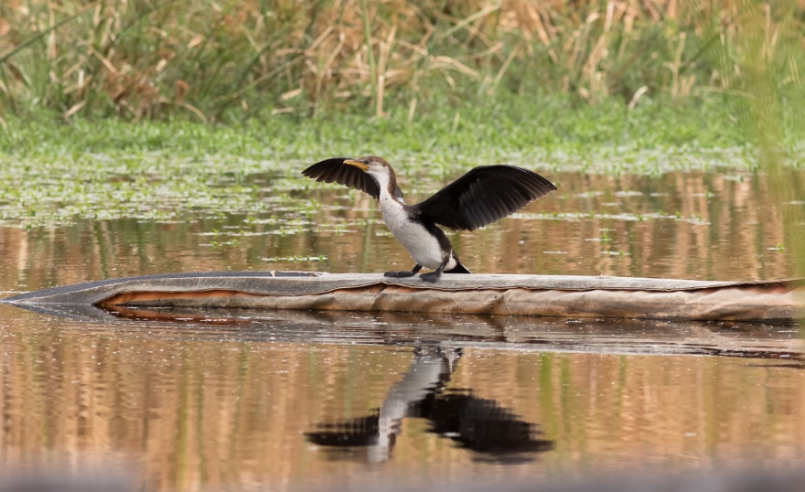

For more information about Commonwealth environmental water, please contact us at:

1800 803 772

[ewater@environment.gov.au](mailto:ewater@environment.gov.au)

[www.environment.gov.au/water/cewo](http://www.environment.gov.au/water/cewo)

@theCEWH

GPO Box 787, Canberra ACT 2601