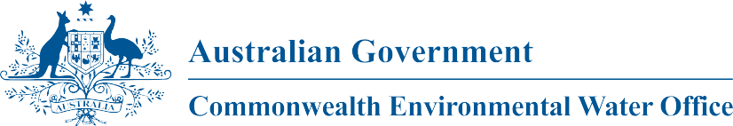

Commonwealth Environmental Water
Portfolio Management Plan
Lachlan River
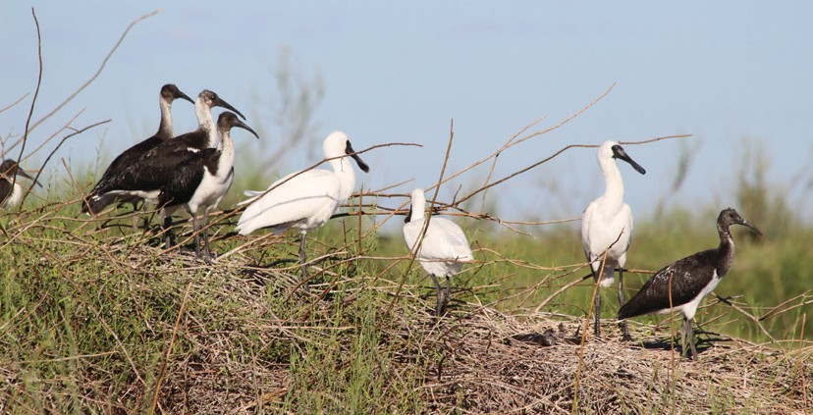
2017–18

Front cover image credit: Royal spoonbill and straw-necked ibis chicks. Photo by Commonwealth Environmental Water Office. Back cover image credit: Night heron chick, Moon Moon Swamp. Photo by Commonwealth Environmental Water Office.
The Commonwealth Environmental Water Office respectfully acknowledges the traditional owners, their Elders past and present, their Nations of the Murray-Darling Basin, and their cultural, social, environmental, spiritual and economic connection to their lands and waters.

© Copyright Commonwealth of Australia, 2017.

Commonwealth Environmental Water Portfolio Management Plan: Lachlan River 2017–18 is licensed by the Commonwealth of Australia for use under a Creative Commons Attribution 4.0 International licence with the exception of the Coat of Arms of the Commonwealth of Australia, the logo of the agency responsible for publishing the report, content supplied by third parties, and any images depicting people. For licence conditions see: https://creativecommons.org/licenses/by/4.0/

This report should be attributed as ‘Commonwealth Environmental Water Portfolio Management Plan: Lachlan River 2017–18, Commonwealth of Australia, 2017’.

The Commonwealth of Australia has made all reasonable efforts to identify content supplied by third parties using the following format ‘© Copyright’ noting the third party.

The views and opinions expressed in this publication are those of the authors and do not necessarily reflect those of the Australian Government or the Minister for the Environment and Energy.

While reasonable efforts have been made to ensure that the contents of this publication are factually correct, the Commonwealth does not accept responsibility for the accuracy or completeness of the contents, and shall not be liable for any loss or damage that may be occasioned directly or indirectly through the use of, or reliance on, the contents of this publication.

Commonwealth environmental water portfolio management planning

Commonwealth Environmental Water Holder

The Commonwealth Environmental Water Holder is a statutory position established under the Water Act 2007 and is responsible for managing the Commonwealth’s environmental water holdings. This water must be managed to protect and restore the rivers, wetlands and floodplains (and the native animals and plants they support) of the Murray-Darling Basin. Mr David Papps is the current Commonwealth Environmental Water Holder. He is supported by staff of the Commonwealth Environmental Water Office (the Office). The Office employs six local engagement officers who live and work in regional centres across the Murray- Darling Basin.

Commonwealth environmental water

Commonwealth environmental water holdings are water entitlements that have been acquired by the Australian Government through investments in water-saving infrastructure and purchases on the water market. The holdings are a mix of entitlement types held across 19 catchments. The rules governing the entitlements vary across states and across catchments. Commonwealth environmental water entitlements are subject to the same fees, allocations, carryover and other rules as equivalent entitlements held by other water users.

There are broadly three options for managing Commonwealth environmental water:

- delivering water to a river or wetland to meet an identified environmental demand;
- carrying water over for use in the next water year (referred to as ‘carryover’); and
- trading water, that is, selling water and using the proceeds to buy water in another catchment or in a future year, or investing in complementary ‘environmental activities’.

Purpose of the document

This document sets out the plans for managing the Commonwealth environmental water portfolio in the Lachlan catchment for 2017–18. Efficient and effective management of Commonwealth environmental water requires the utilisation of all portfolio management options. By taking a multi-year approach to planning, portfolio management tools such as use, carryover and trade can be managed for maximising environmental outcomes.

The portfolio management plans support transparent, coordinated and adaptive management of Commonwealth environmental water, consistent with the Basin-wide environmental watering strategy and having regard to the Basin annual environmental watering priorities. To learn more about the planning approach see Portfolio Management Planning: Approach to planning for the use, carryover and trade of Commonwealth environmental water, 2017–18 (available at: http://www.environment.gov.au/water/cewo/publications under ‘Planning approach’).

Delivery partners

Commonwealth environmental water is managed in conjunction with and delivered by a range of partners. This portfolio management plan has been developed in consultation with our delivery partners, including New South Wales Office of Environment and Heritage and WaterNSW.

Your input

The management of Commonwealth environmental water relies on considerable advice and assistance from local organisations, state governments and others. Individuals and groups within the Murray-Darling Basin community are encouraged to submit suggestions for the management of Commonwealth environmental water. Please contact the Office via: ewater@environment.gov.au.

Table of contents
Commonwealth environmental water portfolio management planning 1
Commonwealth Environmental Water Holder 1
Commonwealth environmental water 1
Purpose of the document 1
Delivery partners 1
Your input 1
Table of contents 2
- Environmental watering in the Lachlan catchment 3
  - The Lachlan catchment 3
  - Environmental objectives in the Lachlan catchment 5
  - Environmental flow requirements 7
  - Monitoring and adaptive management 7
- Portfolio management in 2017–18 8
  - Antecedent and current catchment conditions and the demand for environmental
water in 2017–18 8
  - Water availability in 2017–18 9
  - Overall purpose of managing environmental water based on supply and demand 10
  - Water Delivery in 2017–18 11
  - Trading water in 2017–18 11
  - Carrying over water for use in 2018–19 12
  - Identifying Investment Opportunities 12
- Next steps 19
  - From planning to decision making 19
  - Further information 19
Bibliography 20
Attachment A – Expected outcomes from the Basin-wide environmental
watering strategy 21
Attachment B – Library of watering actions 24
Operational considerations in the Lachlan catchment 24
Potential watering actions under different levels of water resource availability 24
Potential watering actions – standard operating arrangements 28
Attachment C – Long-term water availability 30
Commonwealth environmental water holdings 30
Other sources of environmental water 30
Attachment D – Summary of the Lachlan Decision Support System 31

Environmental watering in the Lachlan catchment

The Lachlan catchment

Flows in the Lachlan River valley (Figure 1) are driven by rainfall runoff in the upper catchment, which includes by Wyangala Dam catchment and three main unregulated tributary river systems; Mandagery Creek and the Belubula and Boorowa Rivers. Delivering water in the Lachlan River Valley is complex as it is a very long system with many meandering anabranches and distributary creeks that terminate in wetlands.

Flow attenuation in the system is high due to the low gradient of the system and it can take 90 days for a flow event from Wyangala Dam to reach the end of the river system at Great Cumbung Swamp (BWR 2011). This creates a challenge for water managers when trying to deliver environmental water. Not all environmental water is sourced from dam releases – unregulated tributary inflows can be ordered and accounted for as environmental water and allowed to reach assets by bypassing regulating structures.

Water supplies in the Lachlan River are regulated by Wyangala Dam (1220 GL), Lake Cargelligo (36 GL) and Lake Brewster (154 GL) (MDBA 2012b). Lake Cargelligo and Lake Brewster are lower in the valley than Wyangala Dam and can reduce the travel times for water delivery to the lower reaches of the Lachlan River Valley, making delivery more efficient.

Environmental water delivery within the valley occurs in two main ways. During in-channel river flows, Commonwealth environmental water is gravity-fed or regulated using infrastructure into anabranches, creeks and wetlands. During high river flows water passes overbank into floodplain and wetland sites. Where possible, environmental water will be managed to benefit multiple sites en route to maximise the efficiency and effectiveness of water delivery.

The Water Sharing Plan for the Lachlan Regulated River Water Source 2016 (NSW Government, 2017) provides for planned environmental water and stock and domestic (replenishment flow) releases. Planned environmental water offers opportunities to ‘piggy back’ Commonwealth environmental water onto these river flows and increases the potential for environmental objectives to be achieved.

Figure 2 shows the Lower Lachlan River catchment downstream of Lake Cargelligo. The major distributaries of the Lachlan are also shown, including Willandra Creek, Moolbong creek, Middle Creek, Merrowie Creek, Merrimajeel Creek, and Muggabah Creek. The map includes the location of several key environmental assets including the Great Cumbung Swamp, Lower Lachlan Swamps and Booligal Wetlands.

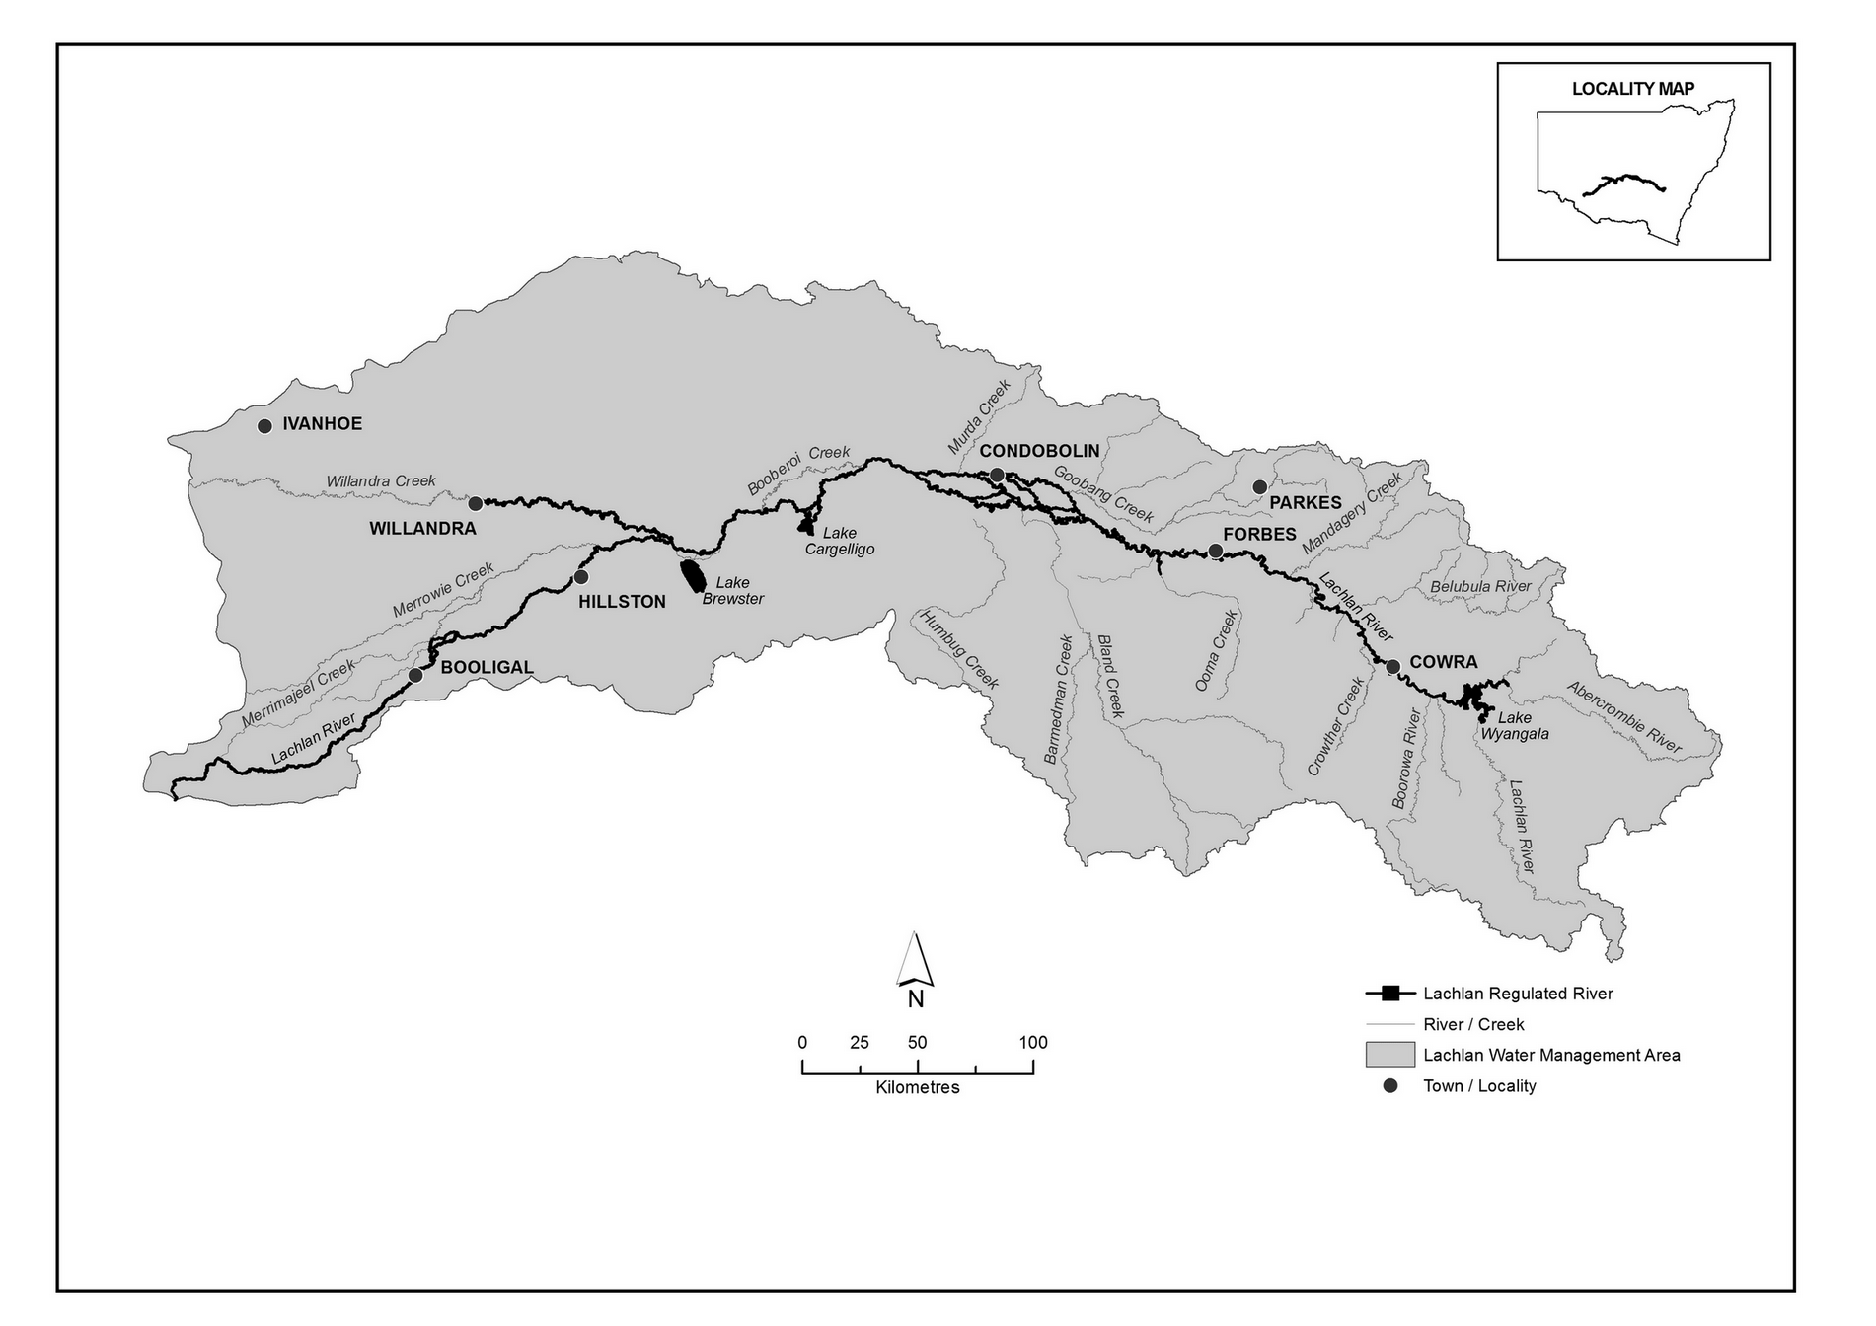

Figure 1: Overview map of the Lachlan Regulated River Water Source (NSW Government, 2016).

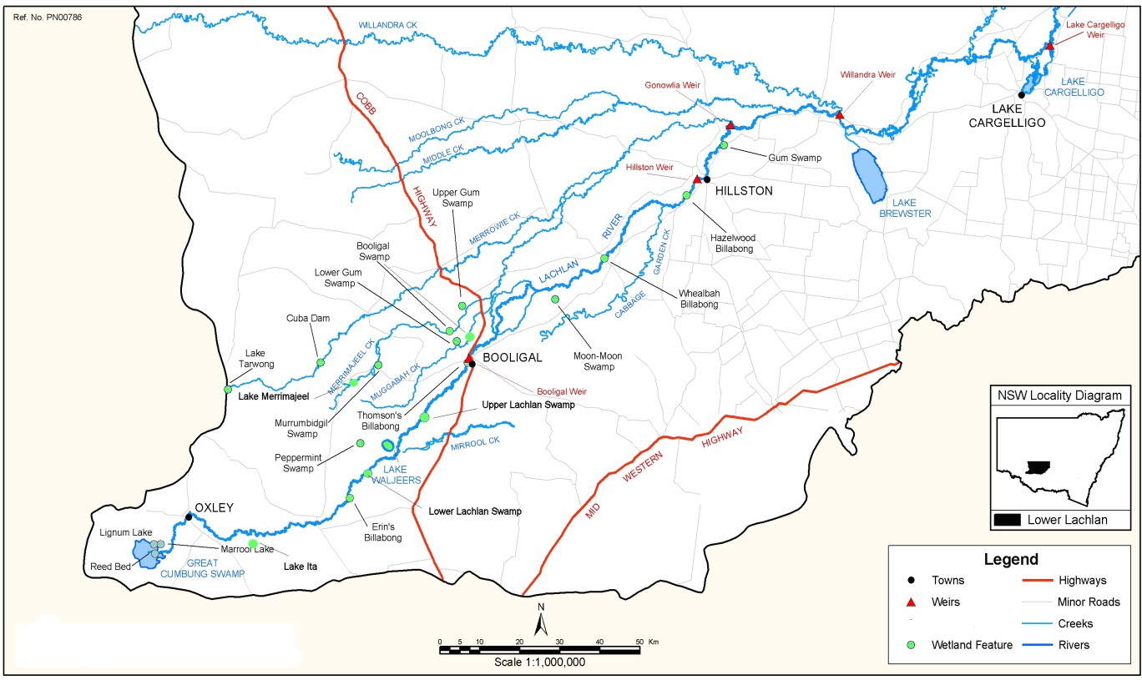

Figure 2: Map of the Lower Lachlan catchment (BWR 2011)

Environmental objectives in the Lachlan catchment

The long-term environmental objectives for the Murray-Darling Basin are described in the Basin Plan’s environmental watering plan and the Basin-wide environmental watering strategy, which includes ‘quantified environmental expected outcomes’ at both Basin-scale and for each catchment. The expected outcomes relevant for the Lachlan catchment are described in Attachment A.

Basin state governments are also developing long-term watering plans for each catchment. These plans will identify the priority environmental assets and ecosystem functions in the catchment, the objectives and targets for these assets and functions, and their watering requirements. Once developed, these plans will provide the key information on the long-term environmental water demands in the catchment. Prior to the development of long-term watering plans, the Commonwealth Environmental Water Office (the Office) will continue to draw on existing documentation on environmental water demands developed by state governments, local natural resource management agencies and the Murray-Darling Basin Authority.

Based on these strategies and plans, and in response to best available knowledge drawing on the results of environmental watering monitoring programmes, the objectives for environmental watering in the Lachlan catchment are summarised in Table 1 below. The objectives for water-dependent ecosystems will continue to be revised as part of the Office’s commitment to adaptive management.

Table 1: Summary of objectives being targeted by environmental watering in the Lachlan catchment

BASIN-WIDE OUTCOMES  (Outcomes in red link to the Basin-wide Environmental Watering Strategy) | OBJECTIVES FOR LACHLAN ASSETS
 | IN-CHANNEL ASSETS | OFF-CHANNEL ASSETS
 | Lachlan River | Great Cumbung Swamp | Lachlan Swamps |  | Booligal Wetlands | Merrowie Creek | Willandra Creek
VEGETATION | - Maintain riparian, floodplain and in- channel vegetation condition  - Improve the recruitment of trees within river red gum communities  - Increased periods of growth for non- woody vegetation communities that closely fringe or occur within the river and creek channels | - Improve the condition of black box, river red gum and lignum shrublands  - Increase periods of growth for non-woody vegetation communities, including common reed (Phragmites) and cumbungi (Typha spp)  - Maintain condition and extent of wetland, stream and riparian vegetation
WATERBIRDS | Provide opportunities for nesting and foraging habitat to maintain the condition of waterbirds
 |  |  |  | Provide opportunities for waterbird breeding and support naturally triggered colonial bird breeding events that are in danger of failing due to fluctuations in water levels
FISH | Protect natural flow events that support habitat and food sources and provide natural cues to promote movement, reproduction, and larval dispersal of native fish | - No loss of native species  - Provide flow cues to support habitat and food sources and promote increased movement, recruitment and survival of native fish (particularly for floodplain specialists)  - Improved population structure of key species through regular recruitment, including  - short-lived species with distribution and abundance at pre-2007 levels - breeding success every 1-2 years  - moderate to long-lived species with a spread of age classes and annual recruitment in at least 80 per cent of years
OTHER VERTEBRATES | Contribute to restoration/protection of frog diversity and populations through provision of habitat to support breeding and recruitment. Provide refuge habitat for frogs, turtles and other vertebrates
CONNECTIVITY | Support longitudinal connectivity along the Lachlan River, including end of system flows  Support lateral connectivity (within constraints) to wetlands and floodplains | Support lateral connectivity (within constraints) between the river channel and wetlands and floodplains
PROCESSES | Support primary productivity, nutrient and carbon cycling, biotic dispersal and movement
WATER QUALITY | Provide refuge habitat from adverse water quality events (e.g. hypoxic blackwater) | - Support water quality in off-channel assets in terms of dissolved oxygen and salinity  - Support transport of salt and nutrients off the floodplain into the river channel and downstream
RESILIENCE |  | Provide drought refuge habitat
Information sourced from: Roberts and Marston (2011), MDBA (2012a), MDBA (2012b), MDBA (2012c) and MDBA (2015)
6

Environmental flow requirements

Not all environmental demands can and will be met through the use of held environmental water. Some demands are met by regulated water deliveries for consumptive purposes while others are met by large unregulated/natural flows events or are beyond what can be delivered within operational constraints.
Figure shows the broad environmental demands that are in scope for Commonwealth environmental water. Importantly, these are broad, indicative demands and individual watering events may contribute to particular opportunities, such as using infrastructure to deliver water to individual wetlands that would otherwise not be possible due to constraints. Also, there may be opportunities for Basin State governments to remove or modify constraints, which will improve the efficiency and/or effectiveness of environmental watering. Further information on delivery constraints are described in Attachment B.

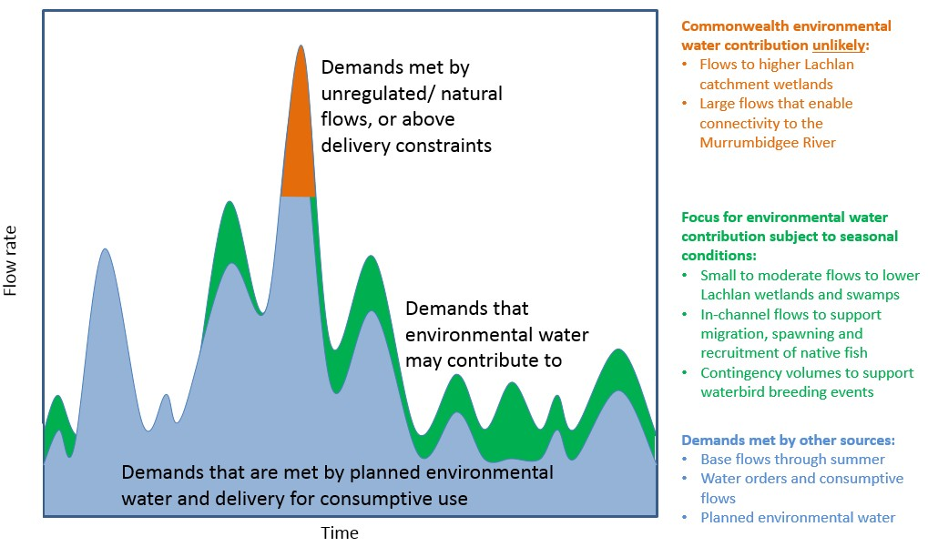

Figure 3: Scope of demands that environmental water may contribute to in the Lachlan catchment.

Based on the above objectives sought and delivery constraints, specific watering requirements (flow magnitude, duration, timing and frequency) have been identified as being in scope for Commonwealth environmental water. These water requirements are described in Table 3. As with the objectives, the environmental water requirements will continue to be reviewed and revised in response to new knowledge.

Monitoring and adaptive management

Operational monitoring is undertaken for all Commonwealth environmental watering actions and involves collecting on-ground data with regard to environmental water delivery such as volumes delivered, impact on the river system’s hydrograph, area of inundation and river levels. It can also include observations of environmental outcomes. Intervention monitoring is also being undertaken at multiple locations in the Lower Lachlan catchment. It aims to understand the environmental response from Commonwealth environmental watering with respect to the targeted objectives. Information on the monitoring activities is available at http://www.environment.gov.au/water/cewo/catchment/lachlan/monitoring. Monitoring information is also provided by state governments. The outcomes from these monitoring activities are used to inform portfolio management planning and adaptive management decision-making as outlined in Section 2.

Portfolio management in 2017–18
In planning for the management of Commonwealth environmental water, the Commonwealth Environmental Water Office aims to maximise the outcomes achieved from the available water. This includes consideration of the urgency of demands (based on targeted objectives and watering requirements, watering history and asset condition) and the available supply under different resource scenarios. Plans for water delivery, trade and carryover are then made in a multi-year context, with an assessment also undertaken of need for water in future years.

This planning process is outlined in full in Table 3 below and summarised in the sections below.

Antecedent and current catchment conditions and the demand for environmental water in 2017–18

Under drying conditions in the three watering years from 2012–13 to 2014–15, zero General Security allocations were announced. In 2015–16 catchment conditions were moderate (in contrast to dry conditions associated with El Niño across most of the Murray-Darling Basin) and General Security allocations of 25 per cent were received. Following above average rainfall in winter-early spring 2015, a planned environmental water event (translucent release) was triggered. NSW and Commonwealth environmental water was used before and after the peak, contributing to a volume of approximately 60 GL passing Booligal. In 2016–17, another translucent release was triggered in July 2016, prior to the very high rainfall conditions that resulted in flooding from September 2016.

Environmental water demands for environmental assets in the catchment in 2017–18 are summarised below:

Great Cumbung Swamp: Environmental water is not essential this year as the translucent flow in 2015 and inundation in 2016 has assisted in the recovery of the wetlands, and vegetation demands have been met.
Lower Lachlan Swamps: There is low demand for water for this system, due to inundation in 2016.
Booligal Wetlands: Watering may be required this year to continue to maintain habitat in Merrrimajeel and Muggabah Creeks. Commonwealth environmental water may piggyback natural inflows to Merrimajeel or Muggabah Creeks to contribute to the inundation of wetlands and aquatic vegetation and the maintenance of waterbird habitat.
Merrowie Creek: Assets along Merrowie Creek received water during the flooding in 2016, resulting in waterbird breeding and positive vegetation outcomes. Commonwealth environmental water may be used to capitalise on this inundation.
Booberoi Creek: This anabranch receives a continuous supply of very low replenishment flows, and has not previously received environmental water. The demand for this reach is currently being assessed.
Willandra Creek: Willandra Creek received water through translucent flows in 2015, and inundation of assets in 2016 resulting in healthy vegetation responses. There is very low demand for water for this system so watering is not required this year.

Lachlan River (in-channel): Flows to benefit native fish habitat, breeding and movement have been undertaken in the last three watering years and could be undertaken in most years, depending on environmental water availability.
Maintain inundation of key native fish or waterbird habitat at critical times: This type of watering is opportunistic. A contingency volume is planned to support the completion of waterbird or other native animal breeding events, if triggered by other flows in the system. Waterbird habitat has been maintained and large colonial breeding events occurred at multiple locations in 2016–17.
Water Quality: This type of watering depends of conditions arising that require the use of this contingency, such as very wet conditions resulting in a hypoxic blackwater event.

Murray-Darling Basin-wide environmental watering strategy and 2017–18 annual priorities
In contributing to these demands, the Commonwealth Environmental Water Office will also be aiming to contribute to the expected outcomes in the Basin-wide environmental watering strategy (see Attachment A) and the following 2017–18 Basin annual environmental watering priorities relevant to the Lachlan River Region.
    - Support Basin-scale population recovery of native fish by reinstating flows that promote key ecological processes across local, regional and system scales for the southern connected Basin
    - Support viable populations of threatened native fish and maximise opportunities for range expansion and the establishment of new populations
    - Improve the abundance and diversity of the Basin’s waterbird population
    - Enable recruitment of trees and support growth of understorey species within river red gum, black box and coolibah communities on floodplains that received overbank flooding during 2016 by inundating the floodplains again
The Commonwealth Environmental Water Holder will not inundate private land without prior approval from land holders while contributing to the Basin annual environmental watering priorities.

Water availability in 2017–18

Forecasts of Commonwealth water allocations
The volume of Commonwealth environmental water likely to be carried over in Lachlan catchment for use in 2017–18 is estimated to be approximately 84 GL. Allocations against Commonwealth water entitlements in the Lachlan catchment are determined by the NSW government and will vary depending on inflows. The following forecasts in Table 2 are based on the best available information including State forecasts and historical inflow scenarios.

Table 2: Forecasts of Commonwealth water allocations (including carryover) in 2017–18 in the Lachlan catchment as at 31 May 2017

Entitlement type | Forecasts of Commonwealth water allocations (including carryover) in 2017–18 (GL)1
 | Very dry |  |  |  |  | Very wet
 | 95  percentile | 90  percentile | 75  percentile | 50  percentile | 25  percentile | 10  percentile
Lachlan (general/high security)2 | 85 | 85 | 85 | 127 | 175 | 175
Notes:
- Forecasts for regulated catchments are given to the nearest whole gigalitre except where the entitlement held by the Commonwealth is below 1 GL.
- Figures include a carryover account balance of ~84 GL
Information on allocations to Commonwealth environmental water holdings can be found at http://www.environment.gov.au/water/cewo/portfolio-mgt/holdings-catchment and is updated monthly.

Water resource availability scenarios
Commonwealth environmental water is not managed in isolation. When considering the available resource to meet environmental demands, it is necessary to also factor in the resources managed by other entities and available to contribute to environmental objectives. Relevant resources include held environmental water managed by state government agencies, planned environmental water, including account-based and unregulated flows, conveyance water and consumptive water. Further detail on sources of environmental water in the Lachlan catchment is provided in Attachment C.
By combining the forecasts of water held by the Commonwealth with streamflow forecasts, as well as taking into account operational considerations, water resource availability scenarios can be developed ranging from very low to very high. Based on available information moderate to very high water resource availability scenarios are likely to be in scope for 2017–18. Very high resource availability is possible if conditions become wet.

Overall purpose of managing environmental water based on supply and demand

Environmental water needs (demand) and water availability (supply) both influence the overall purpose of Commonwealth environmental water management. Under different combinations, the management purpose can range from ‘avoiding damage’ to the environment to ‘improving’ ecological health. This in turn informs the mix of portfolio management options that are suitable for maximising outcomes. Figure 4 shows how current demands and forecasted supply are considered together.

The overall ‘purpose’ for managing the Commonwealth’s water portfolio in the Lachlan catchment for 2017–18 is to maintain and improve the health and resilience of aquatic ecosystems and build future capacity to support ecological health and resilience. This purpose will be achieved in 2017–18 by following natural seasonal cues to: support native fish populations using natural triggers for watering; contribute to contingencies for waterbird breeding and water quality; and to capitalise on natural inflows or planned environmental water to support waterbird habitat.

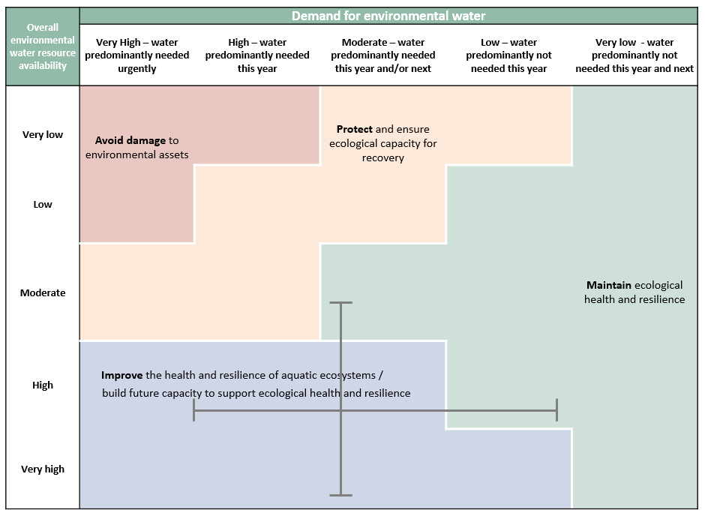

Figure 4: Determining a broad purpose for portfolio management in the Lachlan catchment for 2017–18.
Note: grey lines represent potential range in demand and resource availability.

Further detail on how the overall purpose for portfolio management changes under different supply and demand scenarios is provided in Portfolio Management Planning: Approach to planning for the use, carryover and trade of Commonwealth environmental water, 2017–18 (available at: http://www.environment.gov.au/water/cewo/publications).

Water Delivery in 2017–18

In 2016, a large flood event inundated assets in the Lower Lachlan and the vegetation demands for these assets were met or exceeded. As a result, the approach to planning in 2017-18 for vegetation condition is to follow natural cues and inflow scenarios to mimic seasonal inundation of key environmental assets, if these occur. Alternatively, assets that would benefit from follow-up watering to capitalise on the response from flooding conditions, may be prioritised for watering if the inflow scenario does not meet the demand. Refer to Table 3 for supporting information regarding the basis for determining these watering intentions.

Consistent with the demands and purpose described above, the Office is considering supplying environmental water to the following watering actions for 2017–18 .

The aim would be to augment planned environmental water, where seasonally appropriate, to provide flows to support and provide habitat for waterbirds and native aquatic biota (including fish, turtles, frogs and invertebrates). Actions for native fish will be guided by expert advice and the concepts developed for relevant fish functional groups (see NSW DPI (2015) and Ellis et al, 2016). The volume of environmental water required would be dependent on the size of any natural flow event which ideally is used as a trigger for delivery (the larger the natural event, the less environmental water required). These in-channel actions would also serve the purpose of providing an end of system flow to the Great Cumbung Swamp.

A focus of Commonwealth environmental watering to date has been to maintain core habitat in the Great Cumbung Swamp and Booligal wetlands, when required. As vegetation demands have been met through unregulated flows in 2016, it is expected that watering for these systems will follow natural cues.

All use of Commonwealth environmental water will be within standard operating limits and system constraints. For any proposed action on private property, NSW OEH will seek consent from landholders before the commencement of this event. Landholders will be involved in monitoring of the flow front/extent.

Watering actions that contribute to maintaining waterbird habitat within the Lachlan catchment, and potentially link to waterbird habitat in other parts of the Basin (e.g. via waterbird flyways across the Macquarie, Lachlan, Murrumbidgee, Gwydir, Namoi and Mid-Murray catchments (see Waterbird breeding
& movements (CSIRO, 2016)), may also be targeted under moderate - wetter scenarios.

Depending on the inflow scenario, distributaries such as Merrowie Creek and other smaller anabranches such as Booberoi Creek would be considered. The demand in the Booberoi Creek system and feasibility for delivery is currently being considered.

Stakeholder Feedback

Stakeholder feedback has recommended that:

- actions for fish consider watering on an annual basis, as compared to discrete events, and that events capitalise on natural triggers such as natural inflows and temperature.
- anabranches such as Booberoi Creek be evaluated for their potential demand for environmental watering, and the potential environmental outcomes achievable.

Trading water in 2017–18

The Water Act 2007 provides for the trade of Commonwealth environmental water (allocations and entitlements) and specifies the conditions under which sales may occur. To improve environmental outcomes must be the primary reason for trade of Commonwealth Environmental water. The Commonwealth Environmental Water Holder has no plans to trade entitlements in 2017–18.

Planning on water trade considers supply and demand within the catchment and across the Basin. In the Lachlan catchment, inflows and allocations are highly variable. Where possible, retaining an account balance that will provide for environmental watering in future years under a range of climate scenarios is particularly important given the possibility of low to very low annual water allocation.

The Commonwealth Environmental Water Holder regularly assesses the environmental demand and supply position throughout the year, considering factors such as environmental condition and demand, current and forecast climate conditions, water availability, carryover capacity and market conditions. Any potential allocation trade would be subject to an assessment of the level of supply or demand for consumptive use within the Lachlan catchment water market.

Should a decision be made to seek a trade, then further information will be made widely available at http://www.environment.gov.au/water/cewo/trade/current-trading-actions.

For more information on the rules and procedures governing the trade of Commonwealth environmental water, refer to the Commonwealth environmental water Trading Framework at: http://www.environment.gov.au/water/cewo/publications/water-trading-framework-dec2014.

Carrying over water for use in 2018–19

The volume of water carried over for use in 2018–19 will depend upon resource availability and demand throughout the year. A minimum carryover target of 10 GL is reserved to meet early season water requirements and as a risk management strategy for low flow baseflows under very dry conditions in 2018–
19. As documented in Table 3 below, potential demands in 2018–19 include:

- Watering of key wetlands to maintain waterbird habitat
- Watering of the river channel and other key sites for native fish outcomes
- Contingencies for waterbird breeding and water quality
This volume is also reserved as a contingency volume for use in 2018–19 should there be a critical need for environmental water (e.g. cyanobacteria bloom). Should allocations be available under wetter conditions, the volumes assigned for actions may be increased (see Table 4).

Carryover volumes will be adjusted throughout the year as the season unfolds in response to both current and future demands and the water available to meet these demands. These decisions will be based upon the best information available at the time.

More information on how the Commonwealth makes decisions on carryover is at: http://www.environment.gov.au/water/cewo/portfolio-mgt/carryover’.

Identifying Investment Opportunities

Changes to the Water Act 2007 in 2016 have increased the flexibility for the Commonwealth Environmental Water Holder (CEWH) to use the proceeds of water allocation sales to invest in environmental activities. Under these amendments environmental activities must improve environmental outcomes and be undertaken for the purpose of protecting and restoring environmental assets in the Basin.

The CEWH will publically release a Discussion Paper seeking feedback on what type of activities stakeholders would like the CEWH to consider when developing a framework for future investment in environmental activities.
It should be noted that proceeds of past water sales must be managed based on the legislation in place at that time, and are hence not available to be used for such activities.

























































Table 3a: Environmental demands, priority for watering in 2017–18 and outlook for coming years in the Lachlan catchment –VERY DRY/DRY INFLOW SCENARIO / MOD-HIGH ALLOCATIONS in 2017– 18

Environmental assets | Indicative demand  (for all sources of water in the system) |  | Watering history (from all sources of water) |  |  |  | 2017–18 |  |  | Implications for future demands
 |  |  |  |  |  |  | Predominant urgency of environmental demand for water | Purpose | Potential Commonwealth environmental water contribution? | Likely urgency of demand in 2018–19 if watering occurred as planned in 2017–18 | 2019–20  Range of likely demand | Met in 2018–19
 | Flow/volume | Required frequency (maximum dry interval) | 2013–14 | 2014–15 | 2015–16 | 2016–17
 |  |  | (drying) | (drying) | (moderate) | (very wet) |  |  |  |  |  | Not met in 2018–  19
Great Cumbung Swamp (Clear Lake, Lignum Lake, Reed beds) | Small fresh event (17-18 GL @ Booligal Weir) targeting wetland vegetation and waterbird habitat | 5 in 10 years (unknown) |  |  |  |  | LOW | N/A | Option unlikely to be undertaken under this scenario | Moderate | Low
 |  |  |  |  |  |  |  |  |  |  | High
 | Medium scale event (50-60 GL @ Booligal Weir) | 3 in 10 years (unknown) |  |  |  |  | VERY LOW | N/A | Option unlikely to be undertaken under this scenario | Low | Very Low
 |  |  |  |  |  |  |  |  |  |  | Moderate
 | Large inundation event (~100-125 GL @ Booligal Weir) | 2 in 10 years (unknown) |  |  |  |  | VERY LOW | N/A | Option unlikely to be undertaken under this scenario | Very Low | Very Low
 |  |  |  |  |  |  |  |  |  |  | Low
Lower Lachlan Swamps (Lake Waljeers, Ryans Lake, Lake Bullogal, Peppermint Swamp, Lake Ita and Baconian Swamp) | Small fresh event (17-18 GL  @ Booligal Weir) targeting wetland vegetation | 5 in 10 years (unknown) |  |  |  |  | LOW | N/A | Option unlikely to be undertaken under this scenario | Moderate | Low
 |  |  |  |  |  |  |  |  |  |  | High
 | Medium scale event (50-60 GL @ Booligal Weir) | 3 in 10 years (unknown) |  |  |  |  | VERY LOW | N/A | Option unlikely to be undertaken under this scenario | Low | Very Low
 |  |  |  |  |  |  |  |  |  |  | Moderate
 | Large inundation event (~100-125 GL @ Booligal Weir) | 2 in 10 years (unknown) |  |  |  |  | VERY LOW | N/A | Option unlikely to be undertaken under this scenario | Very Low | Very Low
 |  |  |  |  |  |  |  |  |  |  | Low
Booligal Wetlands (incl. Muggabah and Merrimajeel Cks, Moon Moon, Upper Gum, Lower Gum, Booligal and Murrumbidgil Swamps, Lake Merrimajeel) | Small fresh event (7-8 GL @ Booligal Weir) and delivery to distributaries via Torriganny Weir targeting wetland vegetation and waterbird habitat | 7 in 10 years (unknown) |  |  |  |  | MODERATE | N/A | Option unlikely to be undertaken under this scenario | High | Moderate
 |  |  |  |  |  |  |  |  |  |  | Critical
 | Medium scale event (50-60 GL @ Booligal Weir) and delivery to distributaries via Torriganny Weir | 3 in 10 years (unknown) |  |  |  |  | VERY LOW | N/A | Option unlikely to be undertaken under this scenario | Low | Very Low
 |  |  |  |  |  |  |  |  |  |  | Moderate
 | Large inundation event (~100-125 GL @ Booligal Weir) and delivery to distributaries via Torriganny Weir | 2 in 10 years (unknown) |  |  |  |  | VERY LOW | N/A | Option unlikely to be undertaken under this scenario | Very Low | Very Low
 |  |  |  |  |  |  |  |  |  |  | Low








































Environmental assets | Indicative demand  (for all sources of water in the system) |  | Watering history (from all sources of water) |  |  |  | 2017–18 |  |  | Implications for future demands
 |  |  |  |  |  |  | Predominant urgency of environmental demand for water | Purpose | Potential Commonwealth environmental water contribution? | Likely urgency of demand in 2018–19 if watering occurred as planned in 2017–18 | 2019–20  Range of likely demand | Met in 2018–19
 | Flow/volume | Required frequency (maximum dry interval) | 2013–14 | 2014–15 | 2015–16 | 2016–17
 |  |  | (drying) | (drying) | (moderate) | (very wet) |  |  |  |  |  | Not met in 2018–  19
Merrowie Creek (incl. Cuba Dam, Lake Tarwong, Chillichil Swamp) | Small fresh event (7-8 GL @ Merrowie offtake) targeting wetland vegetation and waterbird habitat | 3 in 10 years (unknown) |  |  |  |  | HIGH | Improve | Will be met if larger event proceeds | Very Low | Very Low
 |  |  |  |  |  |  |  |  |  |  | Low
 | Medium scale event (13-15 GL @Merrowie offtake) | 2 in 10 years (unknown) |  |  |  |  | HIGH | Improve | Demand has been increased in order to capitalise on demand being met in previous year.  High potential for watering | Very Low | Very Low
 |  |  |  |  |  |  |  |  |  |  | Low
Willandra Creek | Small fresh event (up to 18 GL @ Homestead Weir) targeting wetland vegetation | 1-2 in 10  years (unknown) |  |  |  |  | VERY LOW | N/A | Option unlikely to be undertaken under this scenario | Very Low | Very Low
 |  |  |  |  |  |  |  |  |  |  | Low
Booberoi Creek - This asset has not previously received environmental water and further investigations will be undertaken to determine indicative demand and feasibility of watering | Support baseflows | tba |  |  |  |  | HIGH | Maintain | High potential for watering | HIGH | High
 |  |  |  |  |  |  |  |  |  |  | High
 | Pulse | tba |  |  |  |  | HIGH | N/A | Option unlikely to be undertaken under this scenario | HIGH | High
 |  |  |  |  |  |  |  |  |  |  | High
Native fish flows - Protect tributary inflows (natural trigger), or deliver upon environmental trigger (e.g. timing or temperature) being reached, to target outcomes for Murray cod and golden perch | Up to 20 GL | Whenever viable opportunities arise |  |  |  |  | HIGH  an event of this type may be undertaken every year, if account balance allows | Protect | High potential for watering, should opportunities arise | High | High
 |  |  |  |  |  |  |  |  |  |  | High
Maintain inundation of waterbird habitat following unregulated events at key times | Volumes and flow rates to be determined based on specific habitat requirements | Whenever viable opportunities arise |  |  |  |  | CRITICAL  Undertaken where opportunities and sufficient water account balance allows | N/A | Option unlikely to be required under this scenario | Critical | Critical
 |  |  |  |  |  |  |  |  |  |  | Critical
Water quality contingency  – cyanobacteria | Variable | As required |  |  |  |  | CRITICAL  Undertaken when required and sufficient water account balance allows | Protect | Undertaken as required | Critical | Critical
 |  |  |  |  |  |  |  |  |  |  | Critical
 |  |  |  |  |  |  |  | Carryover potential | A moderate proportion of available allocations expected to be carried into 2018–19 | A moderate proportion of available allocations may be carried over to 2019–20 | Level of carryover will depend on environmental demands and resource availability.
 |  |  |  |  |  |  |  | Trade potential | There may be a need to adjust the availability of allocations through trade. Any potential allocation trade would be subject to an assessment of supply and demand within the water market in the Lachlan

















































Table 3b: Environmental demands, priority for watering in 2017-18 and outlook for coming years in the Lachlan – MEDIAN INFLOW SCENARIO / MOD-HIGH ALLOCATIONS in 2017– 18

Environmental assets | Indicative demand  (for all sources of water in the system) |  | Watering history (from all sources of water) |  |  |  | 2017–18 |  |  | Implications for future demands
 |  |  |  |  |  |  | Predominant urgency of environmental demand for water | Purpose | Potential Commonwealth environmental water contribution? | Likely urgency of demand in 2017–18 if watering occurred as planned in 2016–17 | 2018–19  Range of likely demand | Met in 2017–18
 | Flow/volume | Required frequency (maximum dry interval) | 2013–14 | 2014–15 | 2015–16 | 2016–17
 |  |  | (drying) | (dry) | (moderate) | (very wet) |  |  |  |  |  | Not met in 2017–  18
Great Cumbung Swamp (Clear Lake, Lignum Lake, Reed beds) | Small fresh event (17-18 GL @ Booligal Weir) targeting wetland vegetation and waterbird habitat | 5 in 10 years (unknown) |  |  |  |  | HIGH | N/A | Demand increased under this scenario to capitalise on 16-17 flows  Demand expected to be met through inflows | Low | Low
 |  |  |  |  |  |  |  |  |  |  | Moderate
 | Medium scale event (50-60 GL  @ Booligal Weir) | 3 in 10 years (unknown) |  |  |  |  | MODERATE | N/A | Demand increased under this scenario to capitalise on 16-17 flows  Demand expected to be met through inflows | Low | Very Low
 |  |  |  |  |  |  |  |  |  |  | Moderate
 | Large inundation event (~100- 125 GL @ Booligal Weir) | 2 in 10 years (unknown) |  |  |  |  | VERY LOW | N/A | Option unlikely to be undertaken under this scenario | Very Low | Very Low
 |  |  |  |  |  |  |  |  |  |  | Low
Lower Lachlan Swamps (Lake Waljeers, Ryans Lake, Lake Bullogal, Peppermint Swamp, Lake Ita and Baconian Swamp) | Small fresh event (17-18 GL @ Booligal Weir) targeting wetland vegetation | 5 in 10 years (unknown) |  |  |  |  | HIGH | N/A | Demand increased under this scenario as there is an opportunity to capitalise on 16- 17 flows  Demand expected to be met through inflows | Low | Low
 |  |  |  |  |  |  |  |  |  |  | Moderate
 | Medium scale event (50-60 GL  @ Booligal Weir) | 3 in 10 years (unknown) |  |  |  |  | MODERATE | N/A | Demand increased under this scenario to capitalise on 16-17 flows  Demand expected to be met through inflows | Low | Very Low
 |  |  |  |  |  |  |  |  |  |  | Moderate
 | Large inundation event (~100- 125 GL @ Booligal Weir) | 2 in 10 years (unknown) |  |  |  |  | VERY LOW | N/A | Option unlikely to be undertaken under this scenario | Very Low | Very Low
 |  |  |  |  |  |  |  |  |  |  | Low
Booligal Wetlands (incl. Muggabah and Merrimajeel Cks, Moon Moon, Upper Gum, Lower Gum, Booligal and Murrumbidgil Swamps, Lake Merrimajeel) | Small fresh event (7-8 GL @ Booligal Weir) and delivery to distributaries via Torriganny Weir targeting wetland vegetation and waterbird habitat | 7 in 10 years (unknown) |  |  |  |  | HIGH | N/A | Demand expected to be met through inflows | Moderate | Moderate
 |  |  |  |  |  |  |  |  |  |  | High
 | Medium scale event (50-60 GL  @ Booligal Weir) and delivery to distributaries via Torriganny Weir | 3 in 10 years (unknown) |  |  |  |  | MODERATE | N/A | Demand expected to be met through inflows | Low | Very Low
 |  |  |  |  |  |  |  |  |  |  | Moderate
 | Large inundation event (~100- 125 GL @ Booligal Weir) and delivery to distributaries via Torriganny Weir | 2 in 10 years (unknown) |  |  |  |  | VERY LOW | N/A | Option unlikely to be undertaken under this scenario | Very Low | Very Low
 |  |  |  |  |  |  |  |  |  |  | Low
Merrowie Creek (incl. Cuba Dam, Lake | Small fresh event (7-8 GL @ Merrowie offtake) targeting | 3 in 10 years (unknown) |  |  |  |  |  | Protect | Will be met if larger event proceeds | Very Low














Environmental assets | Indicative demand  (for all sources of water in the system) |  | Watering history (from all sources of water) |  |  |  | 2017–18 |  |  | Implications for future demands
 |  |  |  |  |  |  | Predominant urgency of environmental demand for water | Purpose | Potential Commonwealth environmental water contribution? | Likely urgency of demand in 2017–18 if watering occurred as planned in 2016–17 | 2018–19  Range of likely demand | Met in 2017–18
 | Flow/volume | Required frequency (maximum dry interval) | 2013–14 | 2014–15 | 2015–16 | 2016–17
 |  |  | (drying) | (dry) | (moderate) | (very wet) |  |  |  |  |  | Not met in 2017–  18
Tarwong, Chillichil Swamp) | wetland vegetation and waterbird habitat |  |  |  |  |  | HIGH |  |  |  | Very Low
 |  |  |  |  |  |  |  |  |  |  | Low
 | Medium scale event (13-15 GL  @ Merrowie offtake) | 2 in 10 years (unknown) |  |  |  |  | HIGH | Improve | Urgency of demand increased under this scenario as there is an opportunity to capitalise on the vegetation response from the 16-17 flood. | Very Low | Very Low
 |  |  |  |  |  |  |  |  |  |  | Very Low
Willandra Creek | Small fresh event (up to 18 GL  @ Homestead Weir) targeting wetland vegetation | 1-2 in 10 years (unknown) |  |  |  |  | VERY LOW | N/A | Option unlikely to be undertaken under this scenario | Very Low | Very Low
 |  |  |  |  |  |  |  |  |  |  | Low
Booberoi Creek - This asset has not previously received environmental water and further investigations will be undertaken to determine indicative demand and feasibility of watering | Support baseflows | tba |  |  |  |  | HIGH | Maintain | High potential for watering, if demands not met through inflows. | High | High
 |  |  |  |  |  |  |  |  |  |  | High
 | Pulse | tba |  |  |  |  | HIGH | Improve | High potential for watering, if demands not met through inflows. | High | High
 |  |  |  |  |  |  |  |  |  |  | High
Native fish flows - Protect tributary inflows (natural trigger), or deliver upon environmental trigger (e.g. timing or temperature) being reached, to target outcomes for Murray cod and golden perch | Up to 20 GL | Whenever viable opportunities arise |  |  |  |  | HIGH  an event of this type may be undertaken every year, if account balance allows | Protect | High potential for watering, if demands not met through inflows. | High | High
 |  |  |  |  |  |  |  |  |  |  | High
Maintain inundation of key waterbird habitat following unregulated events at key times | Volumes and flow rates to be determined based on specific habitat requirements | Whenever viable opportunities arise |  |  |  |  | CRITICAL  Undertaken where opportunities and sufficient water account balance allows | Protect | Opportunistic  An appropriate use of water should opportunities arise | Critical | Critical
 |  |  |  |  |  |  |  |  |  |  | Critical
Water quality contingency – (hypoxic blackwater/ cyanobacteria) | Variable | As required |  |  |  |  | CRITICAL | N/A | Unlikely to be required | Critical | Critical
 |  |  |  |  |  |  |  |  |  |  | Critical
 |  |  |  |  |  |  |  | Carryover potential | A moderate proportion of available allocations expected to be carried into 2018-19 | A moderate proportion of available allocations may be carried over to 2019-20 | Level of carryover will depend on environmental demands and resource availability.
 |  |  |  |  |  |  |  | Trade potential | There may be a need to adjust the availability of allocations through trade. Any potential allocation trade would be subject to an assessment of supply and demand within the water market in the Lachlan
























































Table 3c: Environmental demands, priority for watering in 2017-18 and outlook for coming years in the Lachlan – WET-VERY WET INFLOW SCENARIO / MOD-HIGH ALLOCATIONS in 2017-18

Environmental assets | Indicative demand  (for all sources of water in the system) |  | Watering history (from all sources of water) |  |  |  | 2017–18 |  |  | Implications for future demands
 |  |  |  |  |  |  | Predominant urgency of environmental demand for water | Purpose under | Potential Commonwealth environmental water contribution? | Likely urgency of demand in 2018–19 if watering occurred as planned in 2017–18 | 2019–20  Range of likely demand | Met in 2018–19
 | Flow/volume | Required frequency (maximum dry interval) | 2013–14 | 2014–15 | 2015–16 | 2016–17
 |  |  | (drying) | (drying) | (moderate) | (very wet) |  |  |  |  |  | Not met in 2018–  19
Great Cumbung Swamp (Clear Lake, Lignum Lake, Reed beds) | Small fresh event (17-18 GL  @ Booligal Weir) targeting wetlands vegetation and waterbird habitat | 5 in 10 years (unknown) |  |  |  |  | HIGH | N/A | Demand expected to be met through inflows | Low | Low
 |  |  |  |  |  |  |  |  |  |  | Moderate
 | Medium scale event (50-60 GL @ Booligal Weir) | 3 in 10 years (unknown) |  |  |  |  | HIGH | N/A | Demand expected to be met through inflows | Low | Very Low
 |  |  |  |  |  |  |  |  |  |  | Moderate
 | Large inundation event (~100-125 GL @ Booligal Weir) | 2 in 10 years (unknown) |  |  |  |  | HIGH | N/A | Demand may be met through inflows | Very Low | Very Low
 |  |  |  |  |  |  |  |  |  |  | Low
Lower Lachlan Swamps (Lake Waljeers, Ryans Lake, Lake Bullogal, Peppermint Swamp, Lake Ita and Baconian Swamp) | Small fresh event (17-18 GL  @ Booligal Weir) targeting wetland vegetation | 5 in 10 years (unknown) |  |  |  |  | HIGH | N/A | Demand expected to be met through inflows | Low | Low
 |  |  |  |  |  |  |  |  |  |  | Moderate
 | Medium scale event (50-60 GL @ Booligal Weir) | 3 in 10 years (unknown) |  |  |  |  | HIGH | N/A | Demand expected met through inflows | Very Low | Very Low
 |  |  |  |  |  |  |  |  |  |  | Low
 | Large inundation event (~100-125 GL @ Booligal Weir) | 2 in 10 years (unknown) |  |  |  |  | HIGH | N/A | Demand may be met through inflows | Very Low | Very Low
 |  |  |  |  |  |  |  |  |  |  | Low
Booligal Wetlands (incl. Muggabah and Merrimajeel Cks, Moon, Upper Gum, Lower Gum, Booligal and Murrumbidgil Swamps, Lake Merrimajeel) | Small fresh event (7-8 GL @ Booligal Weir) and delivery to distributaries via Torriganny Weir targeting wetlands vegetation and waterbird habitat | 7 in 10 years (unknown) |  |  |  |  | HIGH | N/A | Demand expected to be met through inflows | Moderate | Moderate
 |  |  |  |  |  |  |  |  |  |  | High
 | Medium scale event (50-60 GL @ Booligal Weir) and delivery to distributaries via Torriganny Weir | 3 in 10 years (unknown) |  |  |  |  | HIGH | N/A | Demand expected to be met through inflows | Low | Very Low
 |  |  |  |  |  |  |  |  |  |  | Moderate
 | Large inundation event (~100-125 GL @ Booligal Weir) and delivery to distributaries via Torriganny Weir | 2 in 10 years (unknown) |  |  |  |  | HIGH | N/A | Demand may be met through inflows | Very Low | Very Low
 |  |  |  |  |  |  |  |  |  |  | Low


























Environmental assets | Indicative demand  (for all sources of water in the system) |  | Watering history (from all sources of water) |  |  |  | 2017–18 |  |  | Implications for future demands
 |  |  |  |  |  |  | Predominant urgency of environmental demand for water | Purpose under | Potential Commonwealth environmental water contribution? | Likely urgency of demand in 2018–19 if watering occurred as planned in 2017–18 | 2019–20  Range of likely demand | Met in 2018–19
 | Flow/volume | Required frequency (maximum dry interval) | 2013–14 | 2014–15 | 2015–16 | 2016–17
 |  |  | (drying) | (drying) | (moderate) | (very wet) |  |  |  |  |  | Not met in 2018–  19
Merrowie Creek (incl. Cuba Dam, Lake Tarwong, Chillichil Swamp) | Small fresh event (7-8 GL @ Merrowie offtake) targeting wetlands vegetation and waterbird habitat | 3 in 10 years (unknown) |  |  |  |  | HIGH | N/A | Urgency has been increased to capitalise on the demand being met in 16-17.  Demand expected to be met through inflows | Very Low | Very Low
 |  |  |  |  |  |  |  |  |  |  | Low
 | Medium scale event (13-15 GL @ Merrowie offtake) | 2 in 10 years (unknown) |  |  |  |  | HIGH | N/A | Demand may be met through inflows | Very Low | Very Low
 |  |  |  |  |  |  |  |  |  |  | Very Low
Willandra Creek | Small fresh event (up to 18 GL @ Homestead Weir) targeting wetland vegetation | 1-2 in 10 years (unknown) |  |  |  |  | VERY LOW | N/A | Demand may be met through inflows | Very Low | Very Low
 |  |  |  |  |  |  |  |  |  |  | Very Low
Booberoi Creek - This asset has not previously received environmental water and further investigations will be undertaken to determine indicative demand and feasibility of watering | Baseflow |  |  |  |  |  | HIGH | N/A | Demand may be met through inflows | High | High
 |  |  |  |  |  |  |  |  |  |  | High
 | Pulse |  |  |  |  |  | HIGH | N/A | Demand may be met through inflows | High | High
 |  |  |  |  |  |  |  |  |  |  | High
Native fish flows - Protect tributary inflows (natural trigger), or deliver upon environmental trigger (e.g. timing or temperature) being reached, to target outcomes for Murray cod and golden perch | Variable depending on outcomes sought | Variable frequency |  |  |  |  | HIGH  an event of this type may be undertaken every year, if account balance allows | Improve | High potential for watering | High | High
 |  |  |  |  |  |  |  |  |  |  | High
Maintain inundation of key waterbird habitat following unregulated events at key times | Volumes and flow rates to be determined based on specific habitat requirements | Whenever viable opportunities arise |  |  |  |  | CRITICAL  Undertaken where opportunities and sufficient water account balance allows | Protect | Opportunistic  An appropriate use of water should opportunities arise | Critical | Critical
 |  |  |  |  |  |  |  |  |  |  | Critical
Water quality contingency – hypoxic blackwater | Variable | As required |  |  |  |  | CRITICAL  Undertaken when required and sufficient water account balance allows | Protect | Undertaken as required | Critical | Critical
 |  |  |  |  |  |  |  |  |  |  | Critical
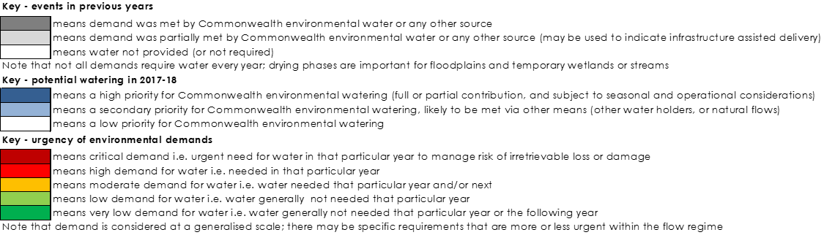 |  |  |  |  |  |  |  | Carryover potential | A moderate proportion of available allocations expected to be carried into 2018-19 | A moderate proportion of available allocations may be carried over to 2019–20 | Level of carryover will depend on environmental demands and resource availability.
 |  |  |  |  |  |  |  | Trade potential | Market activity may be thin and opportunities to trade allocation would be subject to an assessment of supply and demand within the water market in the Lachlan.

Next steps

From planning to decision making

It is important to distinguish between planning and operational decision making. As shown in Figure 4, planning allows the Office to manage the environmental water portfolio in a holistic manner and is an exercise in developing a broad approach or intention, based on the key drivers (demand and supply).

Decision making throughout each year builds on the intention by considering in more detail the specific prevailing factors and additional factors such as costs, risks, and constraints to water delivery and market conditions.

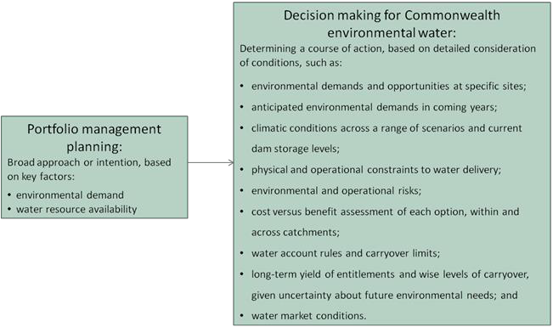

Figure 5: Planning and decision making for Commonwealth environmental water use

Further information

For further information on how the Office plans for water use, carryover and trade, please visit our web site: http://www.environment.gov.au/water/cewo or the sites below:

- Water use: www.environment.gov.au/topics/water/commonwealth-environmental-water- office/assessment-framework

- Carryover: http://www.environment.gov.au/topics/water/commonwealth-environmental-water- office/portfolio-management/carryover

- Trade: Discussion Paper – Trade of Commonwealth Environmental Water and Commonwealth Environmental Water Trading Framework: http://www.environment.gov.au/water/cewo/trade/trading-framework

Bibliography
Barma Water Resources (2011), Environmental Water Delivery: Lachlan River. Prepared for Commonwealth Department of the Environment, Canberra. http://www.environment.gov.au/resource/environmental-water-delivery-lachlan-river
CSIRO (2016), Waterbird breeding and movements: Knowledge for water managers https://research.csiro.au/ewkrwaterbirds/
Dyer, F., Broadhurst, B., Thiem, J., Thompson, R., Driver, P., Bowen, S., Asmus, M and Lenehan, J. (2015). Commonwealth Environmental Water Office Long Term Intervention Monitoring Project: Lower Lachlan river system Selected Area 2014-15 Annual Monitoring and Evaluation Report.
Commonwealth of Australia, 2015. http://www.environment.gov.au/system/files/resources/c7cafabc-1d0b-460d-8731- 453830231bb8/files/lachlan-ltim-report.pdf
Dyer, F., Broadhurst, B., Tschierschke, A., Thiem, J., Thompson, R., Driver, P., Bowen, S., Asmus, M, Wassens, S., and Walcott, A. (2016). Commonwealth Environmental Water Office Long Term Intervention Monitoring Project: Lower Lachlan river system Selected Area 2015-16 Monitoring and Evaluation Synthesis Report. Commonwealth of Australia, 2016.
http://www.environment.gov.au/water/cewo/publications/lachlan-ltim-report-2015-16
Ellis, I., Cheshire, K., Townsend, A., Copeland, C. Danaher, K. and Webb, L. (2016). Fish and Flows in the Murray River Catchment - A review of environmental water requirements for native fish in the Murray River Catchment. NSW Department of Primary Industries, Queanbeyan.

http://www.dpi.nsw.gov.au/ catchment.pdf
data/assets/pdf_file/0003/664356/fish-and-flows-in-the-murray-river-

Murray-Darling Basin Authority (MDBA) (2012a), Assessment of environmental water requirements for the proposed Basin Plan: Booligal Wetlands
http://www.mdba.gov.au/what-we-do/basin-plan/development/bp-science/assessing- environmental-water-requirements
Murray-Darling Basin Authority (MDBA) (2012b), Assessment of environmental water requirements for the proposed Basin Plan: Great Cumbung Swamp
http://www.mdba.gov.au/what-we-do/basin-plan/development/bp-science/assessing- environmental-water-requirements
Murray-Darling Basin Authority (MDBA) (2012c), Assessment of environmental water requirements for the proposed Basin Plan: Lachlan Swamp
http://www.mdba.gov.au/what-we-do/basin-plan/development/bp-science/assessing- environmental-water-requirements
Murray-Darling Basin Authority (MDBA) (2014), Basin Wide Environmental Watering Strategy
http://www.mdba.gov.au/sites/default/files/pubs/Final-BWS-Nov14.pdf
Murray-Darling Basin Authority (MDBA) (2015), 2015-16 Basin Annual Environmental Watering Priorities http://www.mdba.gov.au/publications/mdba-reports/basin-annual-environmental-watering- priorities-2015-16
New South Wales Department of Primary Industries (2015). Fish and Flows in the Northern Basin: responses of fish to changes in flow in the Northern Murray-Darling Basin – Reach Scale Report. Final report prepared for the Murray-Darling Basin Authority. NSW Department of Primary Industries, Tamworth.
http://www.mdba.gov.au/sites/default/files/pubs/fish-and-flows-nb-stage-3-final-report.pdf
New South Wales Government (2017). Water Sharing Plan for the Lachlan Regulated River Water Source 2016. Current version for 6 January 2017 to date (accessed 3 March 2017) http://www.legislation.nsw.gov.au/#/view/regulation/2016/365/full
Roberts, J. and Marston, F. (2011), Water regime for wetlands and floodplain plants: A source book for the Murray-Darling Basin.

Attachment A – Expected outcomes from the Basin-wide environmental watering strategy
Expected outcomes from the Basin-wide environmental watering strategy (MDBA 2014) that are relevant to the Lachlan catchment are described below.

RIVER FLOWS AND CONNECTIVITY
Baseflows are at least 60 per cent of the natural level.
A 10–20 per cent increase in the frequency of freshes, bankfull and lowland floodplain flows.

VEGETATION
Maintain the current extent of water-dependent vegetation near river channels and on low-lying areas of the floodplain.
Improve condition of black box, river red gum and lignum shrublands. Improved recruitment of trees within black box and river red gum communities.
Increased periods of growth for non-woody vegetation communities that closely fringe or occur within the river and creek channels, and for common reed and cumbungi in the Great Cumbung Swamp.

Vegetation extent

Area of river red gum (ha) | Area of black box (ha) | Area of coolibah (ha) | Shrublands | Non–woody water dependent vegetation
41,300 | 58,000 | N/A | Lignum in the Lower Lachlan | Closely fringing or occurring within the Lachlan River and Willandra Creek; and Common reed and Cumbungi in the Great Cumbung Swamp
Black box condition

Vegetation condition score |  | Percent of vegetation assessed (within the managed floodplain)
0 –6 | >6 –10
72 per cent | 28 per cent | 45 per cent
River red gum condition

Vegetation condition score |  |  |  |  | Percent of vegetation assessed (within the managed floodplain)
0 – 2 | >2 – 4 | >4 – 6 | >6 – 8 | >8 – 10
3 per cent | 8 per cent | 21 per cent | 41 per cent | 26 per cent | 93 per cent
WATERBIRDS
Maintain current species diversity.
Increase Basin-wide abundance of waterbirds by 20–25 per cent by 2024.
A 30–40 per cent increase in nests and broods (Basin-wide) for other waterbirds.
Up to 50 per cent more breeding events (Basin-wide) for colonial nesting waterbird species.

Important Basin environmental assets for waterbirds in the Lachlan

Environmental asset | Total abundance and diversity | Drought refuge | Colonial waterbird breeding | Shorebird abundance | In scope for Commonwealth watering
Booligal wetlands | * |  | * |  | Yes
Great Cumbung Swamp | * |  | * |  | Yes
Lake Brewster | * |  | * |  | Yes*
Lake Cowal | * |  | * |  | No
- As a regulated water storage that also support large Pelican colonies at time, environmental water may be used to order past Brewster flows that would otherwise inundate nesting colonies.

FISH
No loss of native species.
Improved population structure of key species through regular recruitment, including;
- Short-lived species with distribution and abundance at pre-2007 levels and breeding success every 1–2 years;

- Moderate to long-lived with a spread of age classes and annual recruitment in at least 80 per cent of years.

Increased movements of key species.
Expanded distribution of key species and populations. Key fish species for the Lachlan include:
Species | Specific outcomes | In-scope for Commonwealth watering in the Lachlan?
Flathead galaxias (Galaxias rostratus) | Considered extinct. Reintroduction using southern populations may be an option in the longer term, with the Lachlan a potential candidate site. | Only if re-introduced.
Freshwater catfish (Tandanus tandanus) | - | Yes
Golden Perch (Macquaria ambigua) | A 10–15 per cent increase of mature fish (of legal take size) in key populations | Yes
Macquarie perch (Macquaria australasica) | Range expansion of at least 2 current populations in the Lachlan is a priority. Establish 1–3 additional riverine populations within the Lachlan catchment | Yes
Murray cod (Maccullochella peelii peelii) | A 10–15 per cent increase of mature fish (of legal take size) in key populations | Yes
Olive perchlet (Ambassis agassizii) | Expand the range (or core range) of existing populations in the Lachlan River. | Yes

Species | Specific outcomes | In-scope for Commonwealth watering in the Lachlan?
River blackfish (Gadopsis marmoratus) | - | No
Silver perch (Bidyanus bidyanus) | - | No
Southern purple-spotted gudgeon (Mogurnda adspersa) | Establish/improve core range of populations in the Lachlan. | Only if populations are established
Southern pygmy perch (Nannoperca australis) | Expand the range of the Lachlan populations. Establish 1–3 additional populations in the Lachlan catchment. | Yes
Trout cod (Maccullochella macquariensis) | Establish additional populations in the Lachlan | Only if additional populations are established

Important Basin environmental assets for native fish in the Lachlan

Environmental asset | Key movement corridors | High Biodiversity | Site of other Significance | Key site of hydrodynamic diversity | Threatened species | Dry period / drought refuge | In-scope for C’th water
Lachlan River – Condobolin to Booligal | * | * | * | * | * | * | Y

Attachment B – Library of watering actions

Operational considerations in the Lachlan catchment

The delivery of environmental water in the Lachlan River is currently constrained by the release capacities from storages, channel capacities, and system constraints.

The river channel capacity constraints (NSW Government, 2017) and operational considerations include:

- 15,000 ML/day between Wyangala Dam and Jemalong Weir (the maximum valve capacity of Wyangala Dam below Spillway is 6,000 ML/d),

- 10,000 ML/day between Jemalong Weir and Condobolin,

- 7,000 ML/day between Condobolin and Lake Cargelligo Weir,

- 2,400 ML/day between Lake Cargelligo Weir and Willandra Weir,

- 2,000 ML/day between Willandra Weir and Middle Creek Offtake,

- 1,500 ML/day between Middle Creek Offtake and Hillston Weir,

- 1,500 ML/day between Hillston Weir and Whealbah,

- 1,000 ML/day between Whealbah and Torriganny Weir,

- 500 ML/day in Willandra Creek,

- 390 ML/day in the Wallamundry Creek system,

- 2,000 ML/day in Goobang/Bumbuggan Creeks,

- 800 ML/day between Booligal Weir and Corrong,

- 600 ML/day downstream of Corrong.

In order to release environmental water at required flow rates to meet hydrographs or timing requirements, the following storage considerations apply:

  - Releases from Brewster weir if controlled through the conduit is 1200 ML/day or if over the weir sill is 10,000 ML/day.
  - Discharge capacity at Lake Cargelligo is 1000 ML/day.
  - Discharge capacity at Lake Brewster is 2000 ML/day.
  - Wyangala Dam hydro-electric power station operating range is between 350 ML/day to about 3000 ML/day, rates above this are released from the valves.
  - Achieving inundation of some off-channel assets, such as the Lower Lachlan Swamp system, requires overbank flows of a certain magnitude, which may not be achievable under very low water resource availabilities.

Potential watering actions under different levels of water resource availability

Under certain levels of water resource availability, watering actions may not be pursued for a variety of reasons, including that environmental demand may be met by unregulated flows and that constraints and/or risks may limit the ability to deliver environmental water. Table 4 identifies the range of potential watering actions in the Lachlan catchment and the levels of water resource availability that relate to these actions.

Table 4: Summary of potential watering actions for the Lachlan catchment

Broad Asset | Indicative volume of CEW | Applicable level(s) of inflow scenario
 |  | Very Dry | Dry | Median | Wet | Very Wet
Great Cumbung Swamp | Demand may be met through main channel action, or scalable if undertaken as a standalone action  Very Low - Low – up to 10 GL Moderate - High – up to 100 GL  Very High – unregulated flows likely to meet demand, or demand has been met. | Providing flow to the terminal wetlands of the Great Cumbung Swamp to maintain vegetation condition and waterbird habitat in core areas. Provide hydrological connectivity to reconnect and refill low-lying wetlands. Flows along the length of the system also provide improved condition and maintenance of aquatic and riparian vegetation, and maintains aquatic habitat for native fish. Primary production, decomposition, nutrient and carbon cycling may also be enhanced.
Lower Lachlan swamps | Moderate - High – between 10 - 100 GL  Very High – unregulated flows likely to meet demand, or demand has been met. | Providing flow to the wetlands in the Lower Lachlan to maintain vegetation condition, provide drought refugia and habitat for aquatic vertebrates.
Lachlan River – main channel | Up to 10 GL under all scenarios  High - Very High – unregulated flows may contribute to demand, however delivery may need to be managed to create the desired hydrograph. | Protecting tributary inflows to provide a trigger for native fish to migrate and spawn and to support recruitment. Provide a release from storage, or augment natural flows, to meet species specific requirements for habitat or breeding (e.g. olive perchlet and golden perch) using environmental triggers for delivery (water temperature or inflows). This action contributes to the delivery volume for the terminal wetlands (Great Cumbung Swamp).

25

Broad Asset | Indicative volume of CEW | Applicable level(s) of inflow scenario
 |  | Very Dry | Dry | Median | Wet | Very Wet
Booligal Wetlands | Very Low - Low – under 5 GL  Moderate - High – up to 100 GL  Very High – unregulated flows likely to meet demand, or demand has been met. | Contributing to inundation of wetlands and aquatic vegetation condition via piggybacking replenishment flows or natural inflows to Merrimajeel or Muggabah Creek, and maintaining waterbird habitat. Provide hydrological connectivity to reconnect and refill low-lying wetlands, and support River red gum and lignum condition and recruitment.
 | Up to 5 GL |  |  | Breeding event contingency: Maintain wetland water levels and acceptable levels of water quality to support the completion of a naturally-triggered waterbird breeding event, or other native aquatic vertebrates.
Merrowie Creek | Up to 10 GL | Contribute to inundation of wetlands and waterbird habitat via augmenting natural flows/planned water.
Booberoi Creek | tba | Demand currently being assessed for feasibility of watering this anabranch.
Willandra Creek | Up to 8 GL | Contribute to inundation of wetlands via augmenting natural flows/planned water.

Broad Asset | Indicative volume of CEW | Applicable level(s) of inflow scenario
 |  | Very Dry | Dry |  | Median | Wet |  | Very Wet
Water quality – hypoxic blackwater/cyanoba cteria | Variable | Manage flow rate to reduce stratification, and provide a diluting flow, if required. |  |  |  |  | Contribute to slowing the discharge of low dissolved oxygen water from the floodplain back in to the river channel, and maintain a steady in channel dilution flow until dissolved oxygen levels rise to safe levels for fish and other aquatic species.
Note: Under Wet or Very Wet inflow scenarios, some options may not be pursued for a variety of reasons including that environmental demand may be met by unregulated flows and that constraints and/or risks may limit the ability to deliver environmental water. Options that remain viable under a Very Wet scenario are those that require a specific hydrograph, or are timing specific.

Potential watering actions – standard operating arrangements

Table 4 identifies the range of potential watering actions in the Lachlan catchment that give effect to the long-term demands and flow regime identified as being in scope for the contribution of Commonwealth environmental water in any given year. The standard considerations associated with these actions are set out below.

Great Cumbung Swamp
Watering action: Provide hydrological connectivity to reconnect and refill low-lying wetlands.
Standard operational considerations: To ensure flow predominantly in-channel in order to meet targets in the lower Lachlan, see table 4 for channel capacity of distributaries.
Typical extent: This watering action could contribute flows required to inundate the Great Cumbung Swamp supplied from Lake Brewster if available, or Wyangala dam. Water would be directed to the Great Cumbung Swamp by operation of Booligal Weir.
Approvals: In order to achieve maximum duration of inundation in central lakes of the Great Cumbung Swamp including Clear Lake and Blindbungi, negotiation with landholders will be necessary to operate private regulating structures to maintain the water levels, and move water within the swamp.
Agreement from landholders whose properties might be inundated by environmental flows may be required.

Lower Lachlan swamps
Watering action: Provide hydrological connectivity to reconnect and refill low-lying wetlands.
Standard operational considerations: The Lower Lachlan swamps can be watered separately to the Great Cumbung Swamp, but in practical terms they are generally watered in the same watering action.
Typical extent: This watering action could contribute flows required to inundate the Booligal Wetlands, Lower Lachlan Swamp and Great Cumbung Swamp supplied from Lake Brewster. Water would be directed to Booligal Wetlands by operation of Booligal Weir.

Approvals: Agreement from landholders whose properties might be inundated by environmental flows may be required.

Lachlan River - native fish flow
Watering action: Protecting natural tributary inflows from regulation to deliver natural flow variability and allowing it to flow the length of the Lachlan River system. This protects the integrity of natural chemical signatures that provide cues for native fish migration and spawning. Releases from storage or augmenting natural flows can also meet specific flow requirements for native fish species.
Standard operational considerations: Target volumes and flow rates will be dependent on the characteristics of inflow events in the upper tributaries, prevailing flow conditions and operational considerations. For releases from storage, meeting flow rates will be dependent on operational considerations e.g. other orders in the system.
Typical extent: Lachlan River (channel only) below Wyangala dam to Great Cumbung Swamp, supplied from upper tributary creek inflows, planned water and/or releases from storage.
Approvals: N/A

28

Booligal wetlands
Watering action: Provide hydrological connectivity to reconnect and refill low-lying wetlands.
Standard operational considerations: See channel capacities (Attachment B) and Contingency for breeding events (below).
Typical extent: This watering action could contribute flows to assets in the Merrimajeel Creek and Muggabah Creek systems supplied from Lake Brewster, directed by operation of Torriganny Weir.
Approvals: Agreement from landholders whose properties might be inundated by environmental flows may be required.

Merrowie Creek
Watering action: Provide hydrological connectivity to reconnect and refill low-lying wetlands.
Standard operational considerations: See channel capacities (Attachment B).
Typical extent: This watering action could contribute flows required to inundate assets in the Merrowie Creek system supplied from Lake Brewster, directed by operation of Gonowlia Weir.
Approvals: Agreement from landholders whose properties might be inundated by environmental flows may be required.

Booberoi Creek
Watering action: Provide hydrological connectivity to the main channel.
Standard operational considerations: To be determined. An action of this type has not been undertaken to date.
Typical extent: This watering action could contribute flows required to reconnect the anabranch with the main stem of the Lachlan River
Approvals: To be determined.

Willandra Creek
Watering action: Provide hydrological connectivity to reconnect and refill low-lying wetlands.
Standard operational considerations: See channel capacities (Attachment B).
Typical extent: This watering action could contribute flows required to inundate Morrisons Lake.
Approvals: Agreement from landholders whose properties might be inundated by environmental flows may be required.

Contingency for breeding events
Watering action: Maintain wetland water levels and acceptable levels of water quality to support the completion of a significant breeding event of waterbirds or other native aquatic vertebrates in a wetland. Adequate water account balance is required in order to undertake this action.
Standard operational considerations: This contingency is not to trigger a breeding event for waterbirds or other native animals but for use when a breeding event is already underway and considered in danger of failure due to receding water levels.
Typical extent: Booligal wetlands, Merrowie Creek, Lachlan Swamp, and Great Cumbung Swamp.
Approvals: Agreement from landholders whose properties might be inundated by environmental flows may be required.

Water quality – hypoxic blackwater/cyanobacteria
Watering action: Provide diluting or flushing flows to affected reaches. Provide flows to increase dissolved oxygen levels to reduce mortality of aquatic species.
Standard operational considerations: Dependent on volumes required.
Typical extent: Variable, depending on the source of the poor water quality.
Approvals: Agreement from landholders whose properties might be further inundated by environmental flows may be required.

Attachment C – Long-term water availability

Commonwealth environmental water holdings

The Commonwealth holds the following entitlements in the Lachlan catchment:

- High Security

- General Security

The full list of Commonwealth environmental water holdings can be found at www.environment.gov.au/topics/water/commonwealth-environmental-water-office/about- commonwealth-environmental-water/how-much and is updated monthly.

Other sources of environmental water

Other potential sources of held environmental water that may be used to complement Commonwealth environmental water delivery in the Lachlan catchment include:

- Riverbank water (New South Wales Office of Environment and Heritage)

- Adaptive Environmental Water (New South Wales Office of Environment and Heritage)

Planned environmental water

In addition to water entitlements held by environmental water holders, environmental demands may also be met via natural or unregulated flows and water provided for the environment under rules in state water plans (referred to as ‘planned environmental water’).

- Environmental Water Allowance (New South Wales Office of Environment and Heritage)

- Water Quality Allowance (New South Wales Office of Environment and Heritage)

- Translucent releases (New South Wales Department of Primary Industries - Water)

Attachment D – Summary of the Lachlan Decision Support System

Large scale wetlands

Target sites
Lachlan Swamp (North side), and the Great Cumbung Swamp.

This requires overbank flows downstream of Whealbah to inundate Lake Waljeers and Peppermint Swamp. Flows would also benefit the in-channel system downstream of Lake Brewster and reach the Great Cumbung Swamp at the terminus of the system.

Objectives
- Provide flow variability and longitudinal connectivity to support refuge habitats; provide lateral connectivity and associated outcomes (i.e. fish migration, carbon inputs);
- Support vegetation communities within or closely fringing the river channel as well as some low lying areas of the floodplain;
- Improve the condition of emergent, submergent, semi-permanent wetland vegetation and riparian vegetation communities; and
- Provide foraging opportunities for a range of waterbird species and maintain waterbird drought refuges.

Hydrology
In order to maximise the delivery volume, consideration would be given to delivery in conjunction with natural inflows, replenishment flows or other planned environmental water. This delivery could also be conducted in conjunction with other environmental deliveries (Strategy 2 or 3) to minimise transmission losses. In order to minimise carp breeding, the flow can be delivered in late winter. If wet conditions prevail, the demand for this action may be met through natural flows. The target frequency of watering these assets is 7 in 10 years, with the maximum duration between watering is considered to be 3 years, before vegetation would become drought stressed. Up to 25 GL would be considered to target these assets, therefore over 45 GL should be held in accounts in order to fulfil other demands during the watering year.

Wetlands which provide habitat for waterbirds

Target sites
Muggabah Creek and Merrimajeel Creek (Booligal Wetlands), Great Cumbung Swamp and Merrowie Creek.

This requires an assessment of waterbird nesting requirements to maintain adequate water levels under nests, or reduce possibility of inundation, to support naturally triggered waterbird breeding events through to fledging.

Objectives
- Improve the condition of emergent, submergent, semi-permanent wetland vegetation and riparian vegetation communities;
- Provide foraging opportunities for a range of waterbird species and maintain drought refuges; and
- Extend natural flow events to improve the success of waterbird breeding and recruitment.

Hydrology
In order to maximise the delivery volume, consideration would be given to delivery in conjunction with natural flows, replenishment flows or other planned environmental water. The target frequency of watering these assets ranges from 2 in 10 years, to 7 in 10 years, as some sites are key breeding sites for waterbirds and require the vegetation to be maintained in event ready condition. If a waterbird breeding event occurs, a contingency volume (approximately 5 GL for Booligal wetlands and 12 GL for Merrowie Creek) would be triggered for use if existing flows are inadequate to meet the breeding requirements through to fledging. There is no specific maximum duration between breeding events, as it occurs opportunistically if conditions are suitable, and breeding is not necessarily required every year to maintain a viable population.

In-channel watering for native fish outcomes

Target sites
Lachlan River downstream of the Boorowa River confluence. As the environmental water intained in-channel, the flow also contributes to the Great Cumbung Swamp asset.

Objectives
- Improve the condition of emergent, submergent, semi-permanent wetland vegetation and riparian vegetation communities;
- Provide short-term, in-channel connectivity that maintains in-stream habitats and facilitate native fish movement;
- Support native fish breeding opportunities; and
- Support small-scale recruitment, particularly for short-lived fish species.

Hydrology
Protection of natural inflows are ideally the first option for consideration, as the flow maintains the natural chemical signature. In the event that unregulated tributary inflows are considered unlikely to occur in the timeframe, a release from storage would be considered, with the caveat that tributary inflows would substitute for releases from storage. If other planned water is in the system, the dam is spilling, or a large scale wetland watering event has occurred (Strategy 1) this additional flow may fulfil this requirement.

The volume required depends on the desired hydrograph and other orders in the system. Timing of the delivery would most likely be in spring- early summer once water temperatures and other parameters are suitable for species to spawn. Flow for dispersal and recruitment will also be considered as part of an annual hydrograph. An account balance of approximately 30 GL should be available to proceed with this action. The target frequency would be most years (8 out of 10). The maximum duration between events and the target volume depends on the population. Up to 15 GL of use would be considered for this strategy.

Distributary watering

Target sites
Willandra Creek, primarily Homestead to Morrison’s Lake

This distributary receives a greater share of water than it did under pre-development condition, due to the lower commence to flow of the Willandra Creek off-take channel.

Objectives
- Support vegetation communities within or closely fringing the river channel as well as some low lying areas of the floodplain;
- Improve the condition of emergent, submergent, semi-permanent wetland vegetation and riparian vegetation communities; and
- Provide foraging opportunities for a range of waterbird species and maintaining waterbird drought refuges.

Hydrology
In order to maximise the delivery volume, consideration would be given to opportunistic delivery in conjunction with larger scale natural inflows, replenishment flows or other planned environmental water to reach downstream assets. Delivery could also be undertaken in conjunction with large scale watering of the Lower Lachlan system. If wet conditions prevail, the demand for this action would be met through natural flows. The target frequency of watering this asset is 1-2 in 10 years. Provision of an additional volume in addition to inflows would be considered to meet a demand of up to 18 GL.

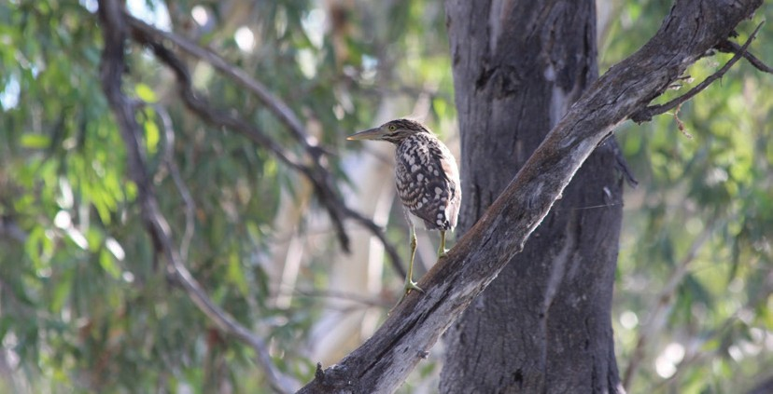
For more information about Commonwealth environmental water, please contact us at:
 1800 803 772
@: ewater@environment.gov.au
www.environment.gov.au/water/cewo
@theCEWH
 GPO Box 787, Canberra, ACT, 2601

