

**Commonwealth Environmental Water**

Portfolio Management Plan

Lachlan River Valley

2018-19

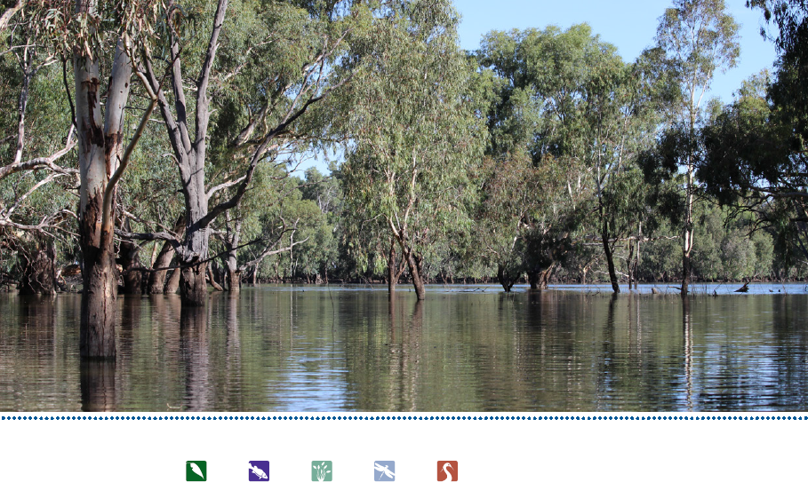

Front cover image credit: Moon Moon Swamp, Photo by Commonwealth Environmental Water Office

Back cover image credit: Murray cod at Wallanthery, Photo by M.Asmus, DPI Fisheries. Strawnecked ibis nests, Photo by J Spencer

**Acknowledgement of the traditional owners of the Murray-Darling Basin**

The Commonwealth Environmental Water Office respectfully acknowledges the traditional owners, their Elders past and present, their Nations of the Murray-Darling Basin, and their cultural, social, environmental, spiritual and economic connection to their lands and waters.

© Copyright Commonwealth of Australia, 2018.



Commonwealth Environmental Water Portfolio Management Plan: Lachlan River Valley 2018–19 is licensed by the Commonwealth of Australia for use under a Creative Commons Attribution 4.0 International licence with the exception of the Coat of Arms of the Commonwealth of Australia, the logo of the agency responsible for publishing the report, content supplied by third parties, and any images depicting people. For licence conditions see: https://creativecommons.org/licenses/by/4.0/

This report should be attributed as ‘Commonwealth Environmental Water Portfolio Management Plan: Lachlan River Valley 2018–19, Commonwealth of Australia, 2018’.

The Commonwealth of Australia has made all reasonable efforts to identify content supplied by third parties using the following format ‘© Copyright’ noting the third party.

The views and opinions expressed in this publication are those of the authors and do not necessarily reflect those of the Australian Government or the Minister for the Environment.

While reasonable efforts have been made to ensure that the contents of this publication are factually correct, the Commonwealth does not accept responsibility for the accuracy or completeness of the contents, and shall not be liable for any loss or damage that may be occasioned directly or indirectly through the use of, or reliance on, the contents of this publication.

# Commonwealth environmental water portfolio management planning

## Commonwealth Environmental Water Holder

The Commonwealth Environmental Water Holder is a statutory position established under the *Water Act 2007* and is responsible for managing the Commonwealth’s environmental water holdings. This water must be managed to protect and restore the rivers, wetlands and floodplains (and the native animals and plants they support) of the Murray–Darling Basin. Ms Jody Swirepik is the current Commonwealth Environmental Water Holder. Ms Swirepik is supported by staff of the Commonwealth Environmental Water Office (the Office). The Office employs six local engagement officers who live and work in regional centres across the Murray–Darling Basin.

## Commonwealth environmental water

Commonwealth environmental water holdings are water entitlements that have been acquired by the Australian Government through investments in water-saving infrastructure and purchases on the water market. The holdings are a mix of entitlement types held across 19 catchments. The rules governing the entitlements vary across states and across catchments. Commonwealth environmental water entitlements are subject to the same fees, allocations, carryover and other rules as equivalent entitlements held by other water users.

There are broadly three options for managing Commonwealth environmental water:

* delivering water to a river or wetland to meet an identified environmental demand
* leaving water in storage and carrying it over for use in the next water year (referred to as ‘carryover’)
* trading water, that is, selling water and using the proceeds to buy water in another catchment or in a future year, or investing in complementary ‘environmental activities’.

## Purpose of the document

This document sets out the plans for managing the Commonwealth environmental water portfolio in the Lachlan catchment for 2018–19. Efficient and effective management of Commonwealth environmental water requires the utilisation of all portfolio management options. By taking a multi-year approach to planning, portfolio management tools such as use, carryover and trade can be managed for maximising environmental outcomes.

The portfolio management plans support transparent, coordinated and adaptive management of Commonwealth environmental water, consistent with the Basin-wide environmental watering strategy and having regard to the Basin annual environmental watering priorities.

To learn more about the planning approach see *Portfolio Management Planning: Approach to planning for the use, carryover and trade of Commonwealth environmental water, 2018–19* (available at: <http://www.environment.gov.au/water/cewo/publications> under ‘Planning approach’).

## Delivery partners

Commonwealth environmental water is managed in conjunction with and delivered by a range of partners. This portfolio management plan has been developed in consultation with our delivery partners, including NSW Office or Environment and Heritage.

## Your input

The management of Commonwealth environmental water relies on considerable advice and assistance from local organisations, state governments and others. Individuals and groups within the Murray–Darling Basin community are encouraged to submit suggestions for the management of Commonwealth environmental water. Please contact the Office via: [ewater@environment.gov.au](mailto:ewater@environment.gov.au).

# Table of contents

Commonwealth environmental water portfolio management planning 1

Commonwealth Environmental Water Holder 1

Commonwealth environmental water 1

Purpose of the document 1

Delivery partners 1

Your input 1

Table of contents 2

1. Environmental watering in the Lachlan River 4

1.1. The Lachlan catchment 4

1.2. Environmental objectives in the Lachlan catchment 7

1.3. Environmental flow requirements 10

1.4. Monitoring and adaptive management 10

2. Portfolio management in 2018–19 12

2.1. Antecedent and current catchment conditions and the demand for environmental water in 2018–19 12

2.2. Water availability in 2018–19 14

2.3. Overall purpose of managing environmental water based on supply and demand 16

2.4. Water Delivery in 2018–19 17

2.5. Trading water in 2018–19 18

2.6. Carrying over water for use in 2019–20 18

2.7. Identifying Investment Opportunities 18

3. Next steps 22

3.1. From planning to decision making 22

3.2. Further information 22

Bibliography 23

Attachment A – Expected outcomes from the Basin-wide environmental watering strategy 25

3.2.1. River flows and connectivity 25

3.2.2. Vegetation 25

3.2.3. Vegetation extent 25

3.2.4. Waterbirds 26

3.2.5. Important Basin environmental assets for waterbirds in the Lachlan 26

3.2.6. Fish 26

3.2.7. Important Basin environmental assets for native fish in the Lachlan 27

Attachment B – Operational details for watering 28

Operational considerations in the Lachlan catchment 28

Potential watering actions under different levels of water resource availability 28

Potential watering actions – standard operating arrangements 31

Watering Action: Lachlan River - native fish flow 31

Watering Action: Booberoi Creek 31

Watering Action: Willandra Creek 31

Watering Action: Merrowie Creek 31

Watering Action: Contingency for breeding events 31

Watering Action: Booligal Wetlands 32

Watering Action: Lower Lachlan swamps 32

Watering Action: Great Cumbung Swamp 32

Water quality – hypoxic water conditions/cyanobacteria 32

Attachment C – Long-term water availability 33

Commonwealth environmental water holdings 33

Other sources of environmental water 33

Planned environmental water 33

Attachment D – Summary of the Lachlan Decision Support System 34

Large scale wetlands 34

Wetlands which provide habitat for waterbirds 34

In-channel watering for native fish outcomes 35

Distributary watering 35

# 

# Environmental watering in the Lachlan River

## The Lachlan catchment

*Ngangadha garraygu bila-galang-gu!*

*Yandhu garraybu bilagalangbu ngangagirri nginyalgir!*

Look after the land and the rivers!

Then the land and the rivers will look after you!

*Excerpt of Instruction given by Wiradjuri Elder Pastor Cecil Grant (Wongomaa)*

Flows in the Lachlan River valley (Figure 1) are driven by rainfall runoff in the upper catchment, which includes the Wyangala Dam catchment and three main unregulated tributary river systems; Mandagery Creek, and the Belubula and Boorowa Rivers. Delivering water in the Lachlan River Valley is complex as it is a very long system with many meandering anabranches and distributary creeks that terminate in wetlands.

Flow attenuation in the system is high due to the low gradient of the system and it can take 90 days for a flow event from Wyangala Dam to reach the end of the river system at Great Cumbung Swamp (BWR 2011). This creates a challenge for water managers when trying to deliver environmental water. Not all environmental water is sourced from dam releases – unregulated tributary inflows can be ordered and accounted for as environmental water and allowed to reach assets by bypassing regulating structures.

Water supplies in the Lachlan River are regulated by Wyangala Dam (1220 GL), Lake Cargelligo (36 GL) and Lake Brewster (154 GL) (MDBA 2012b). Lake Cargelligo and Lake Brewster are lower in the valley than Wyangala Dam and can reduce the travel times for water delivery to the lower reaches of the Lachlan River Valley, making delivery more efficient. However, storing water in these modified lake storages is less efficient than in the dam, due to the higher evaporation rates.

Environmental water delivery within the valley occurs in two main ways. During in-channel river flows, Commonwealth environmental water is gravity-fed or regulated using infrastructure into anabranches, creeks and wetlands. During high river flows water passes overbank into floodplain and wetland sites. Where possible, environmental water will be managed to benefit multiple sites en route to maximise the efficiency and effectiveness of water delivery.

The Water Sharing Plan for the Lachlan Regulated River Water Source 2016 (NSW Government, 2017) provides for planned environmental water and stock and domestic (replenishment flow) releases. Planned environmental water offers opportunities to ‘piggy back’ Commonwealth environmental water following these river flows and increases the potential for environmental objectives to be achieved.

Figure 2 shows the Lower Lachlan River catchment downstream of Lake Cargelligo. The major distributaries of the Lachlan are also shown, including Willandra Creek, Moolbong creek, Middle Creek, Merrowie Creek, Merrimajeel Creek, and Muggabah Creek. The map includes the location of several key environmental assets including the Great Cumbung Swamp, Lower Lachlan Swamps and Booligal Wetlands, the site of the major colonial waterbird breeding event in recent years.

The traditional people of the Lachlan catchment are mainly the Wiradjuri nation with other parts of the catchment being the traditional lands of the Nari Nari, Ngiyampaa and Yita Yita nations. The cultural knowledge of Indigenous Elders have helped to shape watering events such as in the Booberoi Creek anabranch in 2017 and 2018, where populations of a culturally significant species, the eel-tailed catfish, persist.

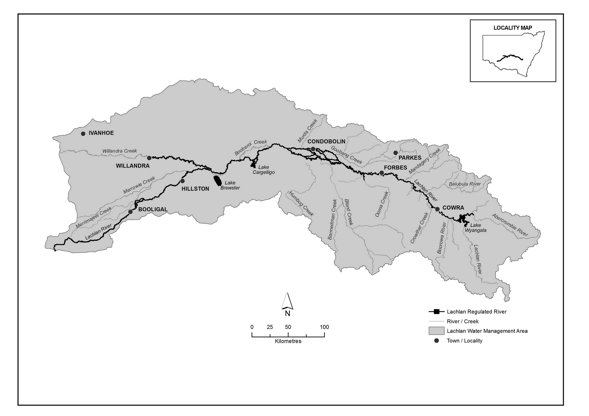

**Figure 1:** Overview map of the Lachlan Regulated River Water Source (NSW Government, 2016).

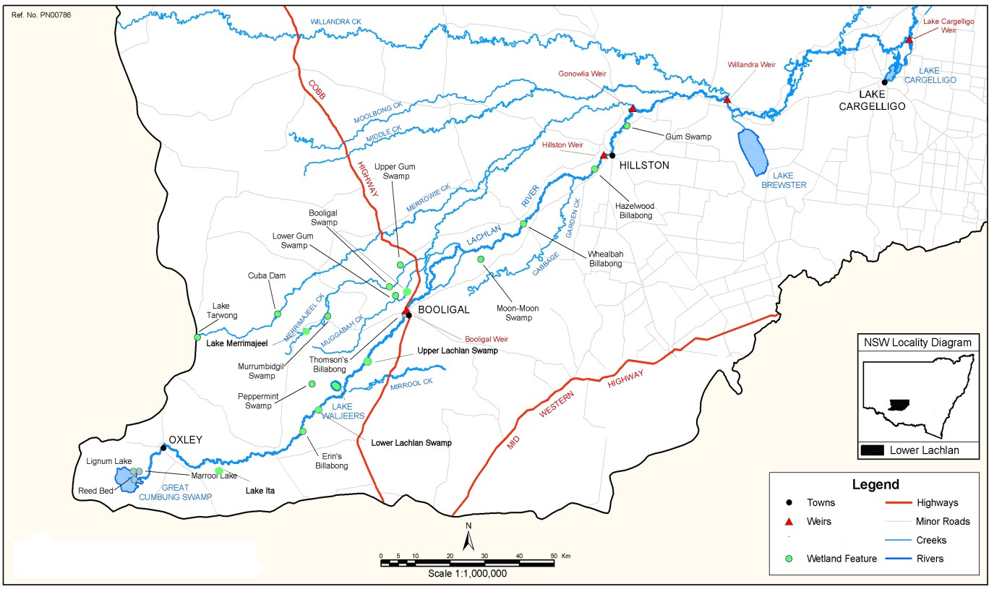

**Figure 2:** Map of the Lower Lachlan catchment (BWR 2011)

## Environmental objectives in the Lachlan catchment

The long-term environmental objectives for the Murray-Darling Basin are described in the Basin Plan’s environmental watering plan and the Basin-wide environmental watering strategy, which includes ‘quantified environmental expected outcomes’ at both a Basin-scale and for each catchment. In addition, the Basin annual environmental watering priorities (MDBA, 2017) represent annual steps to guide environmental watering to meet the long-term outcomes in the Basin-wide environmental watering strategy. The current priorities and expected outcomes relevant for the Lachlan catchment are described in Attachment A and Table 3.

Basin state governments are also developing Long-Term Watering Plans for each catchment. These plans will identify the priority environmental assets and ecosystem functions in the catchment, the objectives and targets for these assets and functions, and their watering requirements. Once developed, these plans will provide the key information on the long-term environmental water demands in the catchment. Prior to the development of long-term watering plans, the Office will continue to draw on existing documentation on environmental water demands developed by state governments, local natural resource management agencies and the Murray–Darling Basin Authority.

Based on these strategies and plans, and in response to best available knowledge drawing on the results of environmental watering monitoring programs, the objectives for environmental watering in the Lachlan catchment are summarised in Table 1 below. The objectives for water-dependent ecosystems will continue to be revised as part of the Commonwealth Environmental Water Office’s commitment to adaptive management. Watering actions to achieve those objectives may be designed to include, but not be limited to, various components of a flow regime including those shown in Figure 3.

Table 1: Summary of objectives being targeted by environmental watering in the Lachlan catchment

|  |  |  |  |  |  |  |  |
| --- | --- | --- | --- | --- | --- | --- | --- |
| **BASIN-WIDE OUTCOMES**  **(Outcomes in red link to the Basin-wide Environmental Watering Strategy)** | **OBJECTIVES FOR LACHLAN ASSETS** | | | | | | |
| **IN-CHANNEL ASSETS** | **OFF-CHANNEL ASSETS** | | | | | |
| **Lachlan River** | **Great Cumbung Swamp** | **Lachlan Swamps** | | **Booligal Wetlands** | **Merrowie Creek** | **Willandra Creek** |
| **VEGETATION** | * Maintain riparian, floodplain and in- channel vegetation condition * Improve the recruitment of trees within river red gum communities * Increased periods of growth for non- woody vegetation communities that closely fringe or occur within the river and creek channels | * Improve the condition of black box, river red gum and lignum shrublands * Increase periods of growth for non-woody vegetation communities, including common reed (*Phragmites*) and cumbungi (*Typha* spp) * Maintain condition and extent of wetland, stream and riparian vegetation | | | | | |
| **WATERBIRDS** | Provide opportunities for nesting and foraging habitat to maintain the condition of waterbirds | | | | | | |
|  | | | Provide opportunities for waterbird breeding and support naturally triggered colonial bird breeding events that are in danger of failing due to fluctuations in water levels | | |  |
| **FISH** | Protect natural flow events that support habitat and food sources and provide natural cues to promote movement, reproduction, and larval dispersal of native fish | * No loss of native species * Provide flow cues to support habitat and food sources and promote increased movement, recruitment and survival of native fish (particularly for floodplain specialists) * Improved population structure of key species through regular recruitment, including   + short-lived species with distribution and abundance at pre-2007 levels - breeding success every 1-2 years   + moderate to long-lived species with a spread of age classes and annual recruitment in at least 80 per cent of years | | | | | |
| **OTHER VERTEBRATES** | Contribute to restoration/protection of frog diversity and populations through provision of habitat to support breeding and recruitment. Provide refuge habitat for frogs, turtles and other vertebrates | | | | | | |
| **CONNECTIVITY** | Support longitudinal connectivity along the Lachlan River, including end of system flows  Support lateral connectivity (within constraints) to wetlands and floodplains | Support lateral connectivity (within constraints) between the river channel and wetlands and floodplains | | | | | |
| **PROCESSES** | Support primary productivity, nutrient and carbon cycling, biotic dispersal and movement | | | | | | |
| **WATER QUALITY** | Provide refuge habitat from adverse water quality events (e.g. hypoxic blackwater) | * Support water quality in off-channel assets in terms of dissolved oxygen and salinity * Support transport of salt and nutrients off the floodplain into the river channel and downstream | | | | | |
| **RESILIENCE** | Provide drought refuge habitat | | | | | |

Information sourced from: Roberts and Marston (2011), MDBA (2012a), MDBA (2012b), MDBA (2012c) and MDBA (2017)

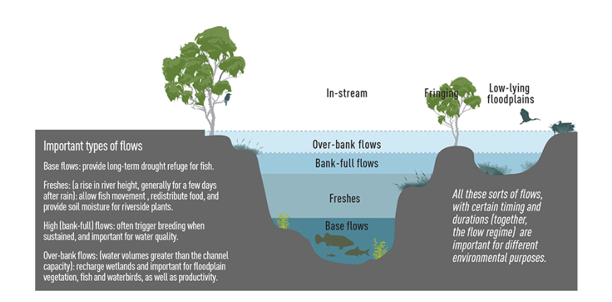

**Figure 3:** An illustrative river cross-section showing components of a flow regime (MDBA 2014)

## Environmental flow requirements

Not all environmental demands can and will be met through the use of held environmental water. Some demands are met by regulated water deliveries for consumptive purposes, while others are met by large unregulated/natural flow events or are beyond what can be delivered within operational constraints. Figure 4 shows the broad environmental demands that are in scope for Commonwealth environmental water. Importantly, these are broad, indicative demands and individual watering events may contribute to particular opportunities, such as using infrastructure to deliver water to individual wetlands that would otherwise not be possible due to constraints. Also, there may be opportunities for Basin State governments to remove or modify constraints, which will improve the efficiency and/or effectiveness of environmental watering. Further information on delivery constraints are described in Attachment B.

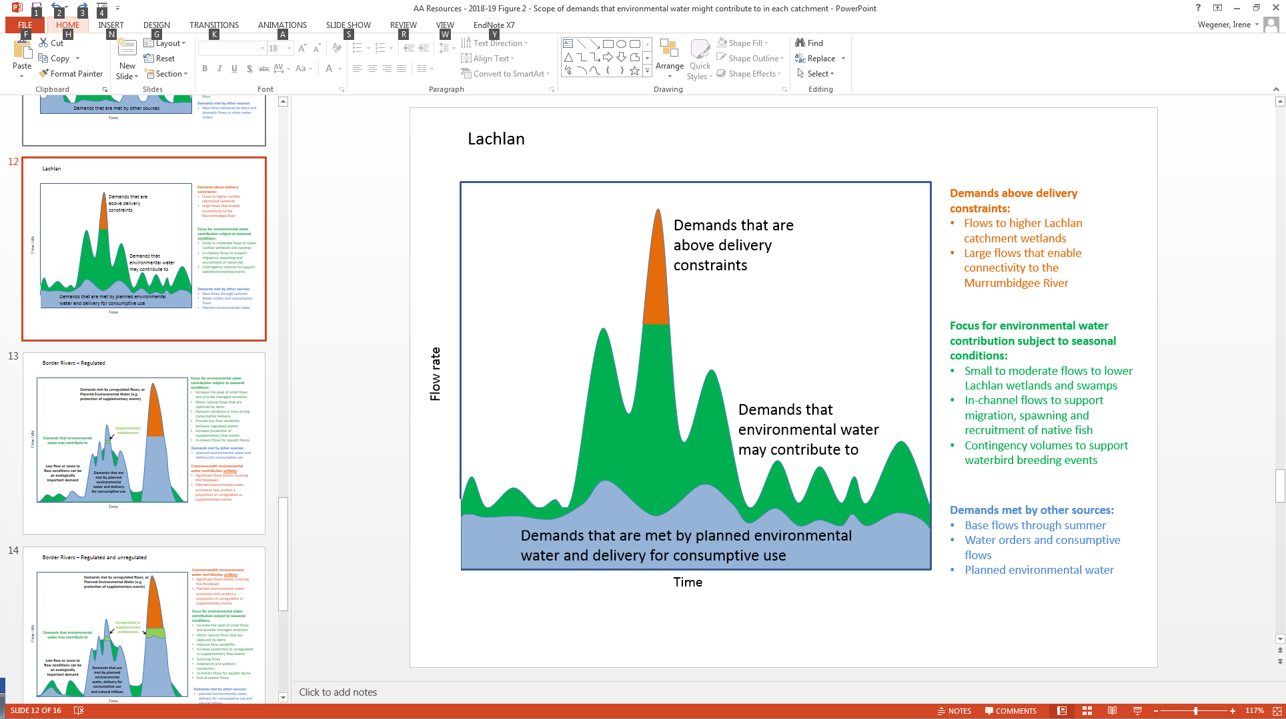

Figure 4: Scope of demands that environmental water may contribute to in the Lachlan catchment

Based on the above objectives and delivery constraints, specific watering requirements (flow magnitude, duration, timing and frequency) have been identified as being in scope for Commonwealth environmental water. These water requirements are described in Table 3. As with the objectives, the environmental water requirements will continue to be reviewed and revised in response to new knowledge.

## Monitoring and adaptive management

Operational monitoring is undertaken for all Commonwealth environmental watering actions and involves collecting on-ground data with regard to environmental water delivery such as volumes delivered, impact on the river system’s hydrograph, area of inundation and river levels. It can also include observations of environmental outcomes.

The Long-Term Intervention Monitoring (LTIM) Project is being undertaken in the lower Lachlan. It aims to understand the environmental response from Commonwealth environmental watering with respect to the targeted objectives. Information on the monitoring activities is available on the CEWO website at <http://www.environment.gov.au/water/cewo/catchment/lachlan/monitoring>. Monitoring information is also provided by state governments.

Key findings and recommendations from the first three years (2014–17) of Long-Term Intervention Monitoring (LTIM) in the lower Lachlan include:

Fish: The widespread flooding in 2016-17 had a significant effect on the riverine fish community (CEWO, 2017). There was a substantial increase in the number of carp caught in 2017 compared with the previous years of monitoring. There was also a reduction in the numbers of large bodied native fish, such as Murray cod and golden perch. Murray cod and golden perch are known to be susceptible to poor water quality and the very low dissolved oxygen concentrations that were observed in the river are likely to have resulted in the loss of significant numbers of fish, particularly Murray cod and compounded by reduced spawning effort.

The provision of refuge flows during hypoxic blackwater conditions is likely to have provided the most benefit to the targeted mid-Lachlan reach (which is upstream of the LTIM monitoring sites). However, the refuge flows are unlikely to have made much difference to large bodied native fish in the Lower Lachlan river system. At the time of delivery dissolved oxygen concentrations had been dangerously low for several weeks which is sufficient time to have killed fish. The presence of some Murray cod and golden perch in the river in early 2017 indicates that some water quality refuges must have been available during the flood event.

Monitoring dissolved oxygen levels: In the mid Lachlan, early warning of the poor water quality was hampered by a paucity of continuous monitoring data that could be used to trigger a response, such as the provision of refuge flows. It would be valuable to have water quality monitoring equipment in the reach from Wyangala Dam to Lake Brewster to inform water management decisions. Ideally this would be sited with existing gauging infrastructure in the Lachlan catchment. Gauges should be fitted with continuous dissolved oxygen loggers, as they are in other New South Wales catchments such as the Edward-Wakool and Murrumbidgee systems with real time data on demand.

Waterbirds: The experiences of waterbird breeding in the Lachlan catchment in 2015-16 (birds abandoned nesting sites despite provision of flows) and 2016-17 (birds successfully finished breeding with the provision of flows) highlight the importance of regional weather patterns, and the value of extensive flooding to provide foraging areas and habitat for food resources to thrive in a successful breeding event. The strategy of using environmental water to support breeding events once they have established (rather than trying to trigger a breeding event) is therefore sound. The management of water levels at the second waterbird colony site in the Booligal Wetlands in 2016-17 demonstrates the value of this approach and the successful outcome can be attributed to the use of environmental water.

Vegetation: The widespread natural flooding of all floodplain and wetland sites in 2016-17 has had benefits for vegetation within the catchment. The flood built on the actions in 2014-15 and 2015-16 that were designed to support the survival and growth of wetland vegetation and habitat values for waterbirds. The long duration of flooding in some locations (the wetlands of the lower part of the Selected Area still held significant amounts of water in June 2017) has started to stress some of the lower lying vegetation and a drying phase is required before environmental water should be delivered to these locations. This meant that the vegetation in the catchment was not the primary target for watering in 2017-18.

The outcomes from these monitoring activities are used to inform portfolio management planning and adaptive management decision-making as outlined in Section 2.

# Portfolio management in 2018–19

In planning for the management of Commonwealth environmental water, the Commonwealth Environmental Water Office aims to maximise the outcomes achieved from the available water. This includes consideration of the urgency of demands (based on targeted objectives and watering requirements, watering history and asset condition) and the available supply under different resource scenarios. Plans for water delivery, trade and carryover are then made in a multi-year context, with an assessment also undertaken of need for water in future years.

This planning process is outlined in full in Table 3 below and summarised in the sections below.

## Antecedent and current catchment conditions and the demand for environmental water in 2018–19

**Lachlan River - native fish flows:** Flows to benefit native fish habitat, breeding and movement have been undertaken in the last four watering years. Recovery from the hypoxic conditions from the 2016 floods will be an ongoing investment of environmental water. Deliveries to support native fish lifecycle could be undertaken in most years, depending on environmental water availability.

**Water Quality**: This type of watering depends on conditions arising that require the use of this contingency, such as very wet conditions resulting in a hypoxic water quality event.

**Wallaroi/Wallamundry/Nerathong anabranches:** These systems have not previously received environmental water. Demand is currently being assessed.

**Booberoi Creek:** This anabranch receives a continuous supply of low replenishment flows, and received environmental water for the first time in 2017. Redirecting flows into this system will be considered based on flows in the main channel. Return flows into the main channel may be recredited to accounts.

**Lower Lachlan Swamps:** There is low demand for water for this system, due to inundation in 2016.

**Lake Brewster:** Watering is provided as a contingency for pelican breeding events and to support aquatic vegetation.

**Willandra Creek**: Willandra Creek received water through translucent flows in 2015, and inundation of assets in 2016 resulting in healthy vegetation responses. There is very low demand for water for this system so watering is not required this year.

**Merrimajeel Creek:** Watering may be required this year to continue to maintain habitat in Merrimajeel Creek. Commonwealth environmental water may piggyback natural inflows to Merrimajeel Creek to contribute to the inundation of wetlands and aquatic vegetation and the maintenance of waterbird habitat.

**Muggabah Creek:** As for Merrimajeel Creek above.

**Merrowie Creek:** Assets along Merrowie Creek received water during the flooding in 2016, resulting in waterbird breeding and positive vegetation outcomes. Commonwealth environmental water may be used to capitalise on this inundation.

**Booligal Wetlands:** This type of watering is opportunistic. A contingency volume is planned to support the completion of waterbird or other native animal breeding events, if triggered by other flows in the system. Waterbird habitat has been maintained and large colonial breeding events occurred at multiple locations in 2016–17.

**Great Cumbung Swamp:** Environmental water is not essential this year as inundation in 2016 has assisted in the recovery of the wetlands, and vegetation demands for the core reedbeds have been met. While the Cumbung does not constitute high demand in 2018-19, it is likely that small volumes of Commonwealth environmental water from upstream actions will contribute to flows and related environmental outcomes, in the Cumbung.

**Lake Cowal and other lake systems within the catchment:** While Lake Cowal receives unregulated flows via the Bland Creek system, the demand for and feasibility of delivering environmental water to downstream parts of this system close to the Lachlan River is yet to be assessed.

**Murray–Darling Basin Plan environmental watering priorities and the Murray–Darling Basin-wide environmental watering strategy**

The Murray–Darling Basin Authority publish the Basin annual environmental watering priorities each year and in 2017–18 also published multi-year priorities. Commonwealth environmental water in the Lachlan catchment will contribute to the following multi-year environmental watering priorities and the 2018–19 Basin annual environmental watering priorities.

**Rolling, multi-year priorities**

* Support lateral and longitudinal connectivity;
* Maintain and improve the condition and promote recruitment of forests and woodlands;
* Improve the condition and extent of lignum shrublands;
* Improve the abundance and maintain the diversity of the Basin’s waterbird population;
* Support viable populations of threatened native fish, maximise opportunities for range expansion and establish new populations.

**2018-19 Annual Priorities**

* Support opportunities for lateral connectivity between the river and adjacent low-lying floodplains and wetlands to reinstate natural nutrient and carbon cycling process;
* Enable growth and maintain the condition of lignum shrublands;
* Provide flows to improve habitat and support waterbird breeding;
* Support viable populations of threatened native fish, maximise opportunities for range expansion and establish new populations.

In contributing to these demands, the Commonwealth Environmental Water Office will also be aiming to contribute to the expected outcomes in the Basin-wide environmental watering strategy (see Attachment A).

## Water availability in 2018–19

**Forecasts of Commonwealth water allocations**

Allocations against Commonwealth water entitlements in the Lachlan catchment are determined by the New South Wales state government and will vary depending on inflows. The following forecasts in Table 2 are based on the best available information including state forecasts and historical inflow scenarios.

Table 2: Forecasts of Commonwealth water allocations (including carryover) in 2018–19 in the Lachlan catchment as at 30 April 2018

|  |  |  |  |  |  |  |
| --- | --- | --- | --- | --- | --- | --- |
| **Entitlement type** | **Forecasts of Commonwealth water allocations (including carryover) in 2018–19 (GL)1** | | | | | |
| **Very dry Very wet** | | | | | |
| **95 percentile** | **90 percentile** | **75 percentile** | **50 percentile** | **25 percentile** | **10 percentile** |
| Lachlan (general/high security) | 55 | 55 | 55 | 105 | 142 | 159 |

Notes:

1. Forecasts for regulated catchments are given to the nearest whole gigalitre.
2. Allocation rate scenarios are based on long term average allocation rates.

The volume of Commonwealth environmental water likely to be carried over in the Lachlan catchment for use in 2018–19 is estimated to be 54 GL.

Information on allocations to Commonwealth environmental water holdings can be found at <http://www.environment.gov.au/water/cewo/portfolio-mgt/holdings-catchment> and is updated monthly.

**Water resource availability scenarios**

Commonwealth environmental water is not managed in isolation. When considering the available resource to meet environmental demands, it is necessary to also factor in the resources managed by other entities and available to contribute to environmental objectives. Relevant resources include held environmental water managed by state government agencies, planned environmental water, natural and unregulated flows, translucent events, conveyance water and consumptive water. Further detail on sources of environmental water in Lachlan catchment is provided in Attachment C.

By combining the forecasts of water held by the Commonwealth with streamflow forecasts, as well as taking into account operational considerations, water resource availability scenarios can be developed ranging from very low to very high. Based on available information low to moderate resource availability scenarios are in scope for 2018–19. High resource availability is only possible if conditions become wet.

## Overall purpose of managing environmental water based on supply and demand

Environmental water needs (demand) and water availability (supply) both influence the overall purpose of Commonwealth environmental water management. Under different combinations, the management purpose can range from ‘avoiding damage’ to the environment to ‘improving’ ecological health. This in turn informs the mix of portfolio management options that are suitable for maximising outcomes.

Figure shows how current demands and forecasted supply are considered together. The overall ‘purpose’ for managing the Commonwealth’s water portfolio in the Lachlan catchment for 2018–19 is to continue to support the native fish populations remaining after hypoxic conditions in the mid-Lachlan, and maintaining the resilience of the Booligal Wetlands to support vegetation outcomes and habitat for waterbirds.

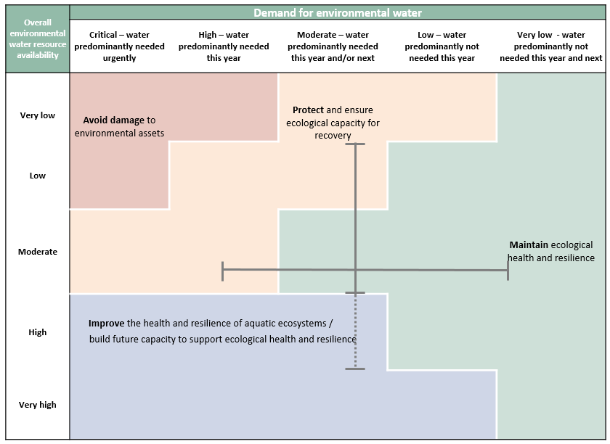

Figure 5: Determining a broad purpose for portfolio management in the Lachlan catchment for 2018–19. Note: grey lines represent potential range in demand and resource availability.

Further detail on how the overall purpose for portfolio management changes under different supply and demand scenarios is provided in *Portfolio Management Planning: Approach to planning for the use, carryover and trade of Commonwealth environmental water, 2018–19* (available at: <http://www.environment.gov.au/water/cewo/publications>).

## Water Delivery in 2018–19

Consistent with the demands and purpose described above, the Office is considering supplying environmental water to the following watering actions for 2018–19 (see also Table 3 for supporting information regarding the basis for determining these watering intentions). In 2016, a large flood event inundated assets in the Lower Lachlan and the vegetation demands for these assets were met or exceeded. In 2017, the environmental watering therefore focused on outcomes for native fish and for providing lateral connectivity to anabranches. The approach to planning in 2018-19 for vegetation condition is to follow natural cues and inflow scenarios to mimic seasonal inundation of key environmental assets, if these occur. Alternatively, assets in need of rehabilitation that would benefit from follow-up watering to capitalise on the response from flooding conditions, may be prioritised for watering if the inflow scenario does not meet the demand. Refer to Table 3 for supporting information regarding the basis for determining these watering intentions.

Consistent with the demands and purpose described above, the Office is considering supplying environmental water to the following watering actions for 2018-19. The aim would be to augment planned environmental water, where seasonally appropriate, to provide flows to support and provide habitat for waterbirds and native aquatic biota (including fish, turtles, frogs and invertebrates). Actions for native fish will be guided by expert advice and the concepts developed for relevant fish functional groups (see NSW DPI (2015) and Ellis et al, 2016). The volume of environmental water required would be dependent on the size of any natural flow event which ideally is used as a trigger for delivery (the larger the natural event, the less environmental water required). These in-channel actions would also serve the purpose of providing an end of system flow to the Great Cumbung Swamp.

A focus of Commonwealth environmental watering to date has been to maintain core habitat in the Great Cumbung Swamp and Booligal Wetlands, when required. As vegetation demands have been met through unregulated flows in 2016 and additional water for rehabilitation is not required at this time, it is expected that watering for these systems will follow natural cues.

All use of Commonwealth environmental water will be within standard operating limits and system constraints. For any proposed action on private property, NSW OEH will seek consent from landholders before the commencement of the event. Landholders will be involved in monitoring of the flow front/extent.

Watering actions that contribute to maintaining waterbird habitat within the Lachlan catchment, and potentially link to waterbird habitat in other parts of the Basin (e.g. via waterbird flyways across the Macquarie, Lachlan, Murrumbidgee, Gwydir, Namoi and Mid-Murray catchments (see [Waterbird breeding](https://research.csiro.au/ewkrwaterbirds/) [and movements](https://research.csiro.au/ewkrwaterbirds/) (CSIRO, 2016)), may also be targeted under moderate - wetter scenarios.

Depending on the inflow scenario, distributaries such as Merrowie Creek and other distributaries and anabranches would be considered for watering in conjunction with stock and domestic replenishment flows where applicable. The demand in the Wallaroi, Wallamundry and Nerathong system and feasibility for delivery is currently being considered based on a proposal for environmental watering from the NSW Department of Primary Industries – Fisheries.

**Stakeholder feedback**

Stakeholder feedback has recommended that:

* actions for fish consider watering on an annual basis, as compared to discrete events, and that events capitalise on natural triggers such as natural inflows and temperature.
* anabranches and distributaries such as Wallaroi, Wallamundry and Nerathong Creek be evaluated for their potential demand for environmental watering
* increased flows through the Booberoi Creek anabranch be undertaken where feasible.

## Trading water in 2018–19

No specific requirements for sale or purchase of water in the Lachlan Valley have been identified, however, environmental water requirements will be reviewed periodically throughout the water year. Further information will be provided to the market ahead of any trade of Commonwealth environmental water at: <http://www.environment.gov.au/water/cewo/trade/current-trading-actions>.

Planning on water trade considers supply and demand within the catchment and across the Basin. As part of the planning process, the Commonwealth Environmental Water Office undertakes a Basin-wide analysis to identify opportunities to use allocation trade to better match differing demands across catchments. As a disconnected catchment, the Lachlan Valley is unable to utilise inter-valley trade of Commonwealth environmental water allocations that may be undertaken in the southern-connected Basin to augment environmental water delivery.

For more information on the rules and procedures governing the trade of Commonwealth environmental water, see the *Commonwealth environmental water Trading Framework* available at: <http://www.environment.gov.au/water/cewo/publications/water-trading-framework-nov2016>.

## Carrying over water for use in 2019–20

The volume of water carried over for use in 2019–20 will depend upon resource availability and demand throughout the year. As the 2018–19 water year progresses, a carryover target will be determined for the Lachlan catchment, sufficient to meet early season requirements. As documented in Table 3 below, potential demands in 2019–20 include:

* Watering of key wetlands to maintain waterbird habitat
* Watering of the river channel and other key sites for native fish outcomes
* Contingencies for waterbird breeding and water quality

This volume is also reserved as a contingency volume for use in 2018–19 should there be a critical need for environmental water (e.g. hypoxic water conditions or cyanobacteria bloom). Should allocations be available under wetter conditions, the volumes assigned for actions may be increased (see Table 4). More information on how the Commonwealth makes decisions on carryover is here: <http://www.environment.gov.au/water/cewo/portfolio-mgt/carryover>

## Identifying Investment Opportunities

Under the *Water Act* the Commonwealth Environmental Water Holder (CEWH) has the flexibility to use the proceeds from the sale of water allocations to fund environmental activities in the Basin. ‘Environmental activities’ should improve the capacity of the CEWH to meet the objectives of the Basin Plan environmental watering plan.

Environmental Activities must also be consistent with:

* the CEWH’s obligation to exercise its functions to protect and restore environmental assets; and
* the requirement to use Special Account funds (including trade proceeds) to cover costs incurred in the performance of the CEWH’s functions.

The CEWH is in the process of developing an Investment Framework to guide decisions on what types of environmental activities may be considered when investing the proceeds from the sale of environmental water allocations.

**Table 3**: Environmental demands, priority for watering in 2018–19 and outlook for coming year in the Lachlan catchment

|  |  |  |  |  |  |  |
| --- | --- | --- | --- | --- | --- | --- |
| **Environmental assets** | **Indicative demand (for all sources of water in the system)** | | **Watering history** | **201819** | | **Implications for future delivery** |
| **Flow/Volume** | **Required frequency (maximum dry interval)** | **(from all sources of water)** | **Environmental demand for water** | **Potential Commonwealth environmental water contribution?** | **Likely environmental demand in 2019–20 if watering occurred as planned in 201819** |
|
|
| **Lachlan River - Native fish flows** Protect tributary inflows (natural trigger), or deliver upon environmental trigger (e.g. timing or temperature) being reached, to target outcomes for native fish. Population in recovery (particularly large bodied natives) from hypoxic blackwater in 2016. | Variable[1], based on conceptual hydrographs provided by DPI Fisheries | Seasonal | Flows specifically targeting native fish outcomes have occurred in 2014, 2015 and 2017. | Watering required most years | Watering required to support native fish populations. Option to be considered under all water resource availabilities. | Watering required most years |
| **Wallaroi/Wallamundry/Nerathong anabranches** Lateral connectivity to anabranch systems and refuges  Native fish outcomes | Indicative demand for these systems is yet to be established. | As required | These systems receive water from consumptive demand and replenishment flows however have not received managed environmental flows. | Natural cues apply | Natural cues apply under all water resource availabilities. | Natural cues apply |
| **Booberoi Creek** Maintains a population of eel-tailed catfish (*Tandanus tandanus*)  Has local cultural significance | Up to 100 ML/day at Booberoi Offtake (412189) with return flows at Booberoi Creek return monitored | A variable frequency and timing is desired, to create flow pulses above baseflow. | This anabranch is required to be supplied with 12,000 ML annually as a replenishment flow under the Lachlan Water Sharing Plan which is delivered as a daily average flow rate. The first environmental water delivery occurred in November 2017 as part of a main channel action. | Watering required | Watering to be considered to support native fish populations, particularly remnant eel-tailed catfish population. Option to be considered under a low or moderate water resource availability. | Watering required |
| **Lake Brewster** Habitat for breeding pelican colony  Wetland vegetation support water quality outcomes | Flows into Lake Brewster are managed to avoid inundation of nests during pelican breeding | As required | This asset is primarily a managed storage. OEH have used small volumes to support pelican breeding in 2016 and 2017. Small volumes of CEW was re-regulated from a main channel event into Lake Brewster in 2017 to support wetland vegetation. | Contingency | Watering required to support breeding events to completion. Option to be considered under all water resource availabilities, however more likely to be triggered under moderate or high water resource availability. | Contingency |
| **Willandra Creek**  Lateral connectivity to major distributary | Small fresh event (up to 18GL) @ Homestead weir targeting low-lying wetland vegetation and habitat | 1-2 years every 10 years (unknown) | Distributary receives stock and domestic flows. Demand met in three of the last 4 years. | Natural cues apply | A low priority for environmental water. Asset receives more water under regulated conditions than naturally | Natural cues apply |
| **Merrimajeel Creek**  Lateral connectivity to major distributaries  Foraging and nesting habitat for waterbirds | Small fresh event (7-8 GL at Torriganny weir) targeting wetland vegetation and habitat | 7 years every 10 years (unknown) | Distributary system was extensively flooded, triggering a major bird breeding event in late 2016. Distributary receives stock and domestic flows. | Watering required most years | Watering required this year or next. This event is scaleable and is an option to be considered under all water resource availabilities. | Watering required this year or next |
| Medium scale event (50-60 GL Torriganny weir) targeting wetland vegetation and habitat | 3 years every 10 years (unknown) | This demand has been met in three of the previous four years | Natural cues apply | This event is scaleable and is an option to be considered under a moderate water resource availability. A low priority for CEW under a high water resource availability as demands will be met through other sources of water. | Natural cues apply |
| Large scale event (~100-125 GL Torriganny weir) targeting wetland vegetation and habitat | 2 years every 10 years (unknown) | Events of this magnitude have occurred in flood years (2012 and 2016) | Natural cues apply | A low priority for environmental water. | Natural cues apply |
| **Merrowie Creek (incl. Cuba Dam, Lake Tarwong, Chillichil Swamp)**  Lateral connectivity to major distributaries  Foraging and nesting habitat for waterbirds | Small fresh event (7-8 GL at Ganowlia weir(412196)) for targeting low-lying wetland vegetation and habitat | 3 years every 10 years (unknown) | This demand was met in three of the previous four years. | Watering required this year or next | Option to be considered under a low to moderate water resource availability. A low priority for CEW under a high water resource availability as demand will be met through other sources of water | Watering required this year or next |
| Medium scale event (13-15 GL at Ganowlia weir (412196)) for targeting low-lying wetland vegetation and habitat | 2 years every 10 years (unknown) | An event of this magnitude to target assets at the end of the system such as Lake Tarwong have only been met in wet years, with a partial wetting of the system in 2013 and 2014. | Natural cues apply | Option to be considered under a low to moderate water resource availability. A low priority for CEW under a high water resource availability as demand will be met through other sources of water | Natural cues apply |
| **Booligal Wetlands (incl. Moon Moon, Upper Gum, Lower Gum, Booligal and Murrumbidgil Swamps, Lake Merrimajeel and wetlands on Muggabah and Merrimajeel Cks)**  Habitat for large scale waterbird colonies (100,000 + nests)  Nationally significant wetland complex | If colony indicates breeding is imminent (lignum trampling etc), provide a stable flow rate to Merrimajeel Creek at the Blockbank (412129) to provide at least 0.8 metres of depth below nests until chicks have fledged | As required | The traditional colony site for predominately straw-necked ibis was supported using environmental water during breeding events in 2012 and 2016. Was provided in 2015 but the colony did not progress. | Water to be provided if colony at risk of nest abandonment | Watering required, if feasible. Option to be considered under all resource availabilities, should breeding commence. | Water to be provided if colony at risk of nest abandonment |
| **Lachlan Swamps (Lake Waljeers, Ryans Lake, Lake Bullogal, Peppermint Swamp, Lake Ita and Baconian Swamp)**  Lateral connectivity  (In practice, these assets would be targeted at the same time as watering of the Great Cumbung Swamp due to the volumes required) | Small fresh event (18 GL at Booligal (412005) days plus a gradual recession targeting low-lying wetland vegetation and habitat | 5 years every 10 years (unknown) | This demand was met in three of the previous four years. | Natural cues apply | A low priority for environmental water. Option to be considered under a moderate to high water resource availability in future years. | Natural cues apply |
| Medium scale event (50-60 GL) at Booligal (412005) targeting low-lying wetland vegetation and habitat | 3 years every 10 years (unknown) | This demand was met in three of the previous four years. | Natural cues apply | A low priority for environmental water. Option to be considered under a high water resource availability in future years. | Natural cues apply |
| Large inundation event (~100-125 GL @ Booligal (412005)) to create overbank flows into wetland habitats | 2 years every 10 years (unknown) | This demand has been met in wet years (2011 and 2016) and partially met with translucent flows in 2015. | Natural cues apply | A low priority for environmental water. Option to be considered under a high water resource availability in future years. | Natural cues apply |
| **Great Cumbung Swamp (Clear Lake, Lignum Lake, Reed beds)**  Foraging and nesting habitat for waterbirds  Nationally significant wetland complex | Small fresh event (18 GL) at Booligal weir (412005) targeting low-lying wetland vegetation and habitat | 5 years every 10 years (unknown) | This demand was met in three of the previous four years. | Natural cues apply | A low priority for environmental water. This event is scaleable and is an option to be considered under a moderate or high water resource availability in future years. | Natural cues apply |
| Medium scale event (50-60 GL) at Booligal weir (412005) targeting low-lying wetland vegetation and habitat | 3 years every 10 years (unknown) | This demand was met in three of the previous four years. | Natural cues apply | A low priority for environmental water. This event is scaleable and is an option to be considered under a moderate or high water resource availability in future years. | Natural cues apply |
| Large inundation event (~100-125 GL @ Booligal (412005)) to create overbank flows into wetland habitats and red gum and blackbox communities | 2 years every 10 years (unknown) | This demand has been met in wet years (2011 and 2016) and partially met with translucent flows in 2015. | Natural cues apply | A low priority for environmental water. This event is scaleable and is an option to be considered under a moderate or high water resource availability in future years. | Natural cues apply |
| **Lake Cowal and other lake systems within the catchment**  Provide habitat for native fish and colonial nesting waterbirds | Demand yet to be assessed | Various and may be linked to delivery of operational flows | Various. Systems may receive natural inflows and be a source of floodwater return to the Lachlan River. | Various - may have limited capacity to deliver Commonwealth environmental water to some assets | | |
| **Water quality**  Provide diluting flows or manage flow regime and timing to mitigate against poor water quality | Variable | As required | Water Quality Allowance (WQA) used in 2016-17 along with NSW and Cth held water to create refuges and provide better quality water during a hypoxic blackwater event. | Contingency | Option to be considered under all water resource availabilities, if water quality poses a risk to assets or objectives. | Contingency |
|  |  |  |  | **Carryover potential** | Moderate proportion of available allocations expected to be carried into 2019–20, subject to Commonwealth Environmental Water Holdings at 30 June 2019, water resource availability and environmental watering actions undertaken in 2018–19. | Available allocations to be carried into 2018–19 will be identified in Lachlan environmental water holdings at <https://www.environment.gov.au/water/cewo/about/water-holdings>. |
|  |  |  |  | **Trade potential** | Potential for the commercial trade of Commonwealth water allocation will be reviewed throughout the water year. The Commonwealth Environmental Water Holder will inform the market of any intention to trade allocation if the conditions precedent for a sale or purchase are met. | No expected urgency to augment available allocations. Potential to trade will depend on environmental demands and resource availability. |

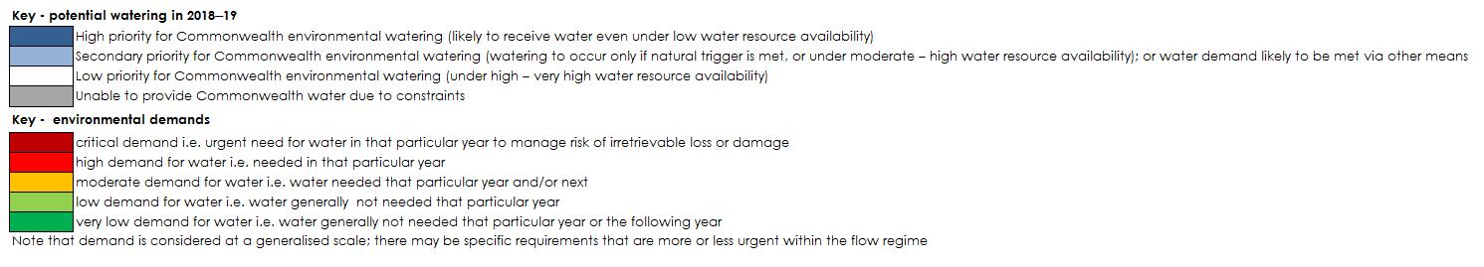

# Next steps

## From planning to decision making

It is important to distinguish between planning and operational decision making. As shown in Figure 4, planning allows the Office to manage the environmental water portfolio in a holistic manner and is an exercise in developing a broad approach or intention, based on the key drivers (demand and supply).

Decision making throughout each year builds on the intention by considering in more detail the specific prevailing factors and additional factors such as costs, risks, and constraints to water delivery and market conditions.



Figure 6: Planning and decision making for Commonwealth environmental water use

## Further information

For further information on how the Office plans for water use, carryover and trade, please visit our web site: <http://www.environment.gov.au/water/cewo> or the sites below:

* Water use: [www.environment.gov.au/topics/water/commonwealth-environmental-water-office/assessment-framework](http://www.environment.gov.au/topics/water/commonwealth-environmental-water-office/assessment-framework)
* Carryover: <http://www.environment.gov.au/topics/water/commonwealth-environmental-water-office/portfolio-management/carryover>
* Trade: <http://www.environment.gov.au/water/cewo/trade/trading-framework>

# 

# Bibliography

Barma Water Resources (2011), *Environmental Water Delivery: Lachlan River*. Prepared for Commonwealth Department of the Environment, Canberra. <http://www.environment.gov.au/resource/environmental-water-delivery-lachlan-river>

Brandis, K (2016), *Response of straw-necked ibis (Threskiornis spinicollis) to Commonwealth environmental watering in the lower Lachlan, 2015*. Report prepared by the Centre for Ecosystem Science, University of New South Wales for the Commonwealth Environmental Water Office 2016.

Commonwealth Environmental Water Office (2017). *Blackwater Review* - Environmental water used to moderate low dissolved oxygen levels in the southern Murray Darling Basin during 2016/17. <http://www.environment.gov.au/water/cewo/publications/blackwater-review>

CSIRO (2016), Waterbird breeding and movements: Knowledge for water managers <https://research.csiro.au/ewkrwaterbirds/>

Dyer, F., Broadhurst, B., Thiem, J., Thompson, R., Driver, P., Bowen, S., Asmus, M and Lenehan, J. (2015). *Commonwealth Environmental Water Office Long Term Intervention Monitoring Project: Lower Lachlan river system Selected Area 2014-15 Annual Monitoring and Evaluation Report.* Commonwealth of Australia, 2015. <http://www.environment.gov.au/system/files/resources/c7cafabc-1d0b-460d-8731-453830231bb8/files/lachlan-ltim-report.pdf>

Dyer, F., Broadhurst, B., Tschierschke, A., Thiem, J., Thompson, R., Driver, P., Bowen, S., Asmus, M, Wassens, S., and Walcott, A. (2016). *Commonwealth Environmental Water Office Long Term Intervention Monitoring Project: Lower Lachlan river system Selected Area 2015-16 Monitoring and Evaluation Synthesis Report*. Commonwealth of Australia, 2016. <http://www.environment.gov.au/water/cewo/publications/lachlan-ltim-report-2015-16>

Dyer, F., Broadhurst, B., Tschierschke, A., Thiem, J., Thompson, R., Bowen, S., Asmus, M., Brandis, K., Lyons, M., Spencer, J., Callaghan, D., Driver, P., Lenehan, J. (2017). *Commonwealth Environmental Water Office Long Term Intervention Monitoring Project: Lower Lachlan river system Selected Area 2016-17 Monitoring and Evaluation Report*. Commonwealth of Australia, 2017. <http://www.environment.gov.au/water/cewo/publications/ltim-lachlan-annual-report-2016-17>

Ellis, I., Cheshire, K., Townsend, A., Copeland, C. Danaher, K. and Webb, L. (2016). *Fish and Flows in the Murray River Catchment - A review of environmental water requirements for native fish in the Murray River Catchment.* NSW Department of Primary Industries, Queanbeyan. <http://www.dpi.nsw.gov.au/__data/assets/pdf_file/0003/664356/fish-and-flows-in-the-murray-river-catchment.pdf>

Murray-Darling Basin Authority (MDBA) (2012a), *Assessment of environmental water requirements for the proposed Basin Plan: Booligal Wetlands* <http://www.mdba.gov.au/what-we-do/basin-plan/development/bp-science/assessing-environmental-water-requirements>

Murray-Darling Basin Authority (MDBA) (2012b), *Assessment of environmental water requirements for the proposed Basin Plan: Great Cumbung Swamp* <http://www.mdba.gov.au/what-we-do/basin-plan/development/bp-science/assessing-environmental-water-requirements>

Murray-Darling Basin Authority (MDBA) (2012c), *Assessment of environmental water requirements for the proposed Basin Plan: Lachlan Swamp*<http://www.mdba.gov.au/what-we-do/basin-plan/development/bp-science/assessing-environmental-water-requirements>

Murray-Darling Basin Authority (MDBA) (2014), *Basin Wide Environmental Watering Strategy* <http://www.mdba.gov.au/sites/default/files/pubs/Final-BWS-Nov14.pdf>

Murray-Darling Basin Authority (MDBA) (2017), *2017-18 Basin Annual Environmental Watering Priorities* [*https://www.mdba.gov.au/publications/mdba-reports/basin-annual-environmental-watering-priorities-2017-18*](https://www.mdba.gov.au/publications/mdba-reports/basin-annual-environmental-watering-priorities-2017-18)

Murray-Darling Basin Authority (MDBA) (2018), Basin environmental watering priorities – Overview and technical summaries

New South Wales Department of Primary Industries (2015). *Fish and Flows in the Northern Basin: responses of fish to changes in flow in the Northern Murray-Darling Basin – Reach Scale Report*. Final report prepared for the Murray-Darling Basin Authority. NSW Department of Primary Industries, Tamworth. <http://www.mdba.gov.au/sites/default/files/pubs/fish-and-flows-nb-stage-3-final-report.pdf>

New South Wales Government (2017). *Water Sharing Plan for the Lachlan Regulated River Water Source 2016*. Current version for 6 January 2017 to date (accessed 21 June 2018) <http://www.legislation.nsw.gov.au/#/view/regulation/2016/365/full>

Roberts, J. and Marston, F. (2011), *Water regime for wetlands and floodplain plants: A source book for the Murray-Darling Basin.*

# Attachment A – Expected outcomes from the Basin-wide environmental watering strategy

Expected outcomes from the Basin-wide environmental watering strategy (MDBA 2014) that are relevant to the Lachlan catchment are described below.

### River flows and connectivity

Baseflows are at least 60 per cent of the natural level.

A 10–20 per cent increase in the frequency of freshes, bankfull and lowland floodplain flows.

### Vegetation

Maintain the current extent of water-dependent vegetation near river channels and on low-lying areas of the floodplain.

Improve condition of black box, river red gum and lignum shrublands. Improved recruitment of trees within black box and river red gum communities.

Increased periods of growth for non-woody vegetation communities that closely fringe or occur within the river and creek channels, and for common reed and cumbungi in the Great Cumbung Swamp.

### Vegetation extent

|  |  |  |  |  |
| --- | --- | --- | --- | --- |
| **Area of river red gum (ha)** | **Area of black box (ha)** | **Area of coolibah (ha)** | **Shrublands** | **Non–woody water dependent vegetation** |
| 41,300 | 58,000 | N/A | Lignum in the Lower Lachlan | Closely fringing or occurring within the Lachlan River and Willandra Creek; and Common reed and Cumbungi in the Great Cumbung Swamp |

**Black box condition**

|  |  |  |
| --- | --- | --- |
| **Vegetation condition score** | | **Percent of vegetation assessed (within the managed floodplain)** |
| **0 –6** | **>6 –10** |
| 72 per cent | 28 per cent | 45 per cent |

**River red gum condition**

|  |  |  |  |  |  |
| --- | --- | --- | --- | --- | --- |
| **Vegetation condition score** | | | | | **Percent of vegetation assessed (within the managed floodplain)** |
| **0 – 2** | **>2 – 4** | **>4 – 6** | **>6 – 8** | **>8 – 10** |
| 3 per cent | 8 per cent | 21 per cent | 41 per cent | 26 per cent | 93 per cent |

### Waterbirds

Maintain current species diversity.

Increase Basin-wide abundance of waterbirds by 20–25 per cent by 2024.

A 30–40 per cent increase in nests and broods (Basin-wide) for other waterbirds.

Up to 50 per cent more breeding events (Basin-wide) for colonial nesting waterbird species.

### Important Basin environmental assets for waterbirds in the Lachlan

|  |  |  |  |  |  |
| --- | --- | --- | --- | --- | --- |
| Environmental asset | Total abundance and diversity | Drought refuge | Colonial waterbird breeding | Shorebird abundance | In scope for Commonwealth watering |
| Booligal wetlands | * |  | * |  | Yes |
| Great Cumbung Swamp | * |  | * |  | Yes |
| Lake Brewster | * |  | * |  | Yes* |
| Lake Cowal | * |  | * |  | No |

* As a regulated water storage that also support large Pelican colonies at times, environmental water may be used to manage the flow regime in Lake Brewster to avoid inundation of nesting colonies.

### Fish

No loss of native species.

Improved population structure of key species through regular recruitment, including;

* Short-lived species with distribution and abundance at pre-2007 levels and breeding success every 1–2 years;
* Moderate to long-lived with a spread of age classes and annual recruitment in at least 80 per cent of years.

Increased movements of key species.

Expanded distribution of key species and populations.

Key fish species for the Lachlan include:

|  |  |  |
| --- | --- | --- |
| Species | Specific outcomes | In-scope for Commonwealth watering in the Lachlan? |
| Flathead galaxias (*Galaxias rostratus*) | Considered extinct. Reintroduction using southern populations may be an option in the longer term, with the Lachlan a potential candidate site. | Only if re-introduced. |
| Freshwater catfish (*Tandanus tandanus*) |  | Yes |
| Golden Perch (*Macquaria ambigua*) | A 10–15 per cent increase of mature fish (of legal take size) in key populations | Yes |
| Macquarie perch (*Macquaria australasica*) | Range expansion of at least 2 current populations in the Lachlan is a priority. Establish 1–3 additional riverine populations within the Lachlan catchment | Yes |
| Murray cod (*Maccullochella peelii peelii*) | A 10–15 per cent increase of mature fish (of legal take size) in key populations | Yes |
| Olive perchlet (*Ambassis agassizii*) | Expand the range (or core range) of existing populations in the Lachlan River. | Yes |
| River blackfish (*Gadopsis marmoratus*) | - | No |
| Silver perch (*Bidyanus bidyanus*) | - | Yes |
| Southern purple-spotted gudgeon (*Mogurnda adspersa*) | Establish/improve core range of populations in the Lachlan. | Only if populations are established |
| Trout cod (*Maccullochella macquariensis*) | Establish additional populations in the Lachlan | Only if additional populations are established |

### Important Basin environmental assets for native fish in the Lachlan

|  |  |  |  |  |  |  |  |
| --- | --- | --- | --- | --- | --- | --- | --- |
| Environmental asset | Key movement corridors | High Biodiversity | Site of other Significance | Key site of hydrodynamic diversity | Threatened species | Dry period / drought refuge | In-scope for C’th water |
| Lachlan River – Condobolin to Booligal | * | * | * | * | * | * | Y |

# Attachment B – Operational details for watering

## Operational considerations in the Lachlan catchment

The delivery of environmental water in the Lachlan River is currently constrained by the release capacities from storages, channel capacities, and system constraints.

The river channel capacity constraints (NSW Government, 2017) and operational considerations include:

1. 15,000 ML/day between Wyangala Dam and Jemalong Weir (the maximum valve capacity of Wyangala Dam below Spillway is 6,000 ML/d), (NB: once the dam is below 55% releases can only be made through the valves and the hydro scheme)
2. 10,000 ML/day between Jemalong Weir and Condobolin,
3. 7,000 ML/day between Condobolin and Lake Cargelligo Weir,
4. 2,400 ML/day between Lake Cargelligo Weir and Willandra Weir,
5. 2,000 ML/day between Willandra Weir and Middle Creek Offtake,
6. 1,500 ML/day between Middle Creek Offtake and Hillston Weir,
7. 1,500 ML/day between Hillston Weir and Whealbah, (CTF for Moon Moon Swamp is ~1,600ML/D @ Whealbah)
8. 1,000 ML/day between Whealbah and Torriganny Weir,
9. 500 ML/day in Willandra Creek,
10. 390 ML/day in the Wallamundry Creek system,
11. 2,000 ML/day in Goobang/Bumbuggan Creeks,
12. 800 ML/day between Booligal Weir and Corrong, (CTF for Lower Lachlan Swamp is 825-850ML/D @ Booligal)
13. 600 ML/day downstream of Corrong. (~675ML/D @ Corrong is CTF for Lake Ita)

In order to release environmental water at required flow rates to meet hydrographs or timing requirements, the following storage considerations apply:

* 1. Releases from Brewster weir if controlled through the conduit is 1200 ML/day or if over the weir sill is 10,000 ML/day (releases over the spillway constrained due to operational/OH&S issues around the shutters, and also due to it being difficult to accurately measure volumes).
  2. Discharge capacity at Lake Cargelligo is 1000 ML/day. (declines significantly as lake level drops)
  3. Discharge capacity at Lake Brewster is 2000 ML/day. (declines as storage level drops)
  4. Wyangala Dam hydro-electric power station operating range is between 350 ML/day to about 3000 ML/day, rates above this are released from the valves.
  5. Achieving inundation of some off-channel assets, such as the Lower Lachlan Swamp system, requires overbank flows of a certain magnitude, which may not be achievable under very low water resource availabilities.

## Potential watering actions under different levels of water resource availability

Under certain levels of water resource availability, watering actions may not be pursued for a variety of reasons, including that environmental demand may be met by unregulated flows and that constraints and/or risks may limit the ability to deliver environmental water. Table 4 identifies the range of potential watering actions in the Lachlan catchment and the levels of water resource availability that relate to these actions.

Table 4: Summary of potential watering actions for the Lachlan catchment

| **Broad Asset** | **Indicative volume of CEW** | **Applicable level(s) of inflow scenario** | | | | | |
| --- | --- | --- | --- | --- | --- | --- | --- |
| **Very Dry** | **Dry** | **Median** | | **Wet** | **Very Wet** |
| **Booberoi Creek** | Up to 5 GL | Providing increased flows above stock and domestic to increase variability and connectivity to the main channel to support remnant native fish populations and provide refuge | | | | | |  |
| **Lachlan River – main channel** | Scaleable use under all scenarios for fish outcomes  High - Very High – unregulated flows may contribute to demand, however delivery may need to be managed to create the desired hydrograph. | Protecting tributary inflows to provide a trigger for native fish to migrate and spawn and to support recruitment. Provide a release from storage, or augment natural flows, to meet species specific requirements for habitat or breeding (e.g. olive perchlet and golden perch) using environmental triggers for delivery (water temperature or inflows). This action contributes to the delivery volume for the terminal wetlands (Great Cumbung Swamp). | | | | | |
| **Booligal Wetlands** | Very Low - Low – under 5 GL  Moderate - High – up to 25 GL  Very High – unregulated flows likely to meet demand, or demand has been met. | Contributing to inundation of wetlands and aquatic vegetation condition via piggybacking replenishment flows or natural inflows to Merrimajeel or Muggabah Creek, and maintaining waterbird habitat. Provide hydrological connectivity to reconnect and refill low-lying wetlands, and support River red gum and lignum condition and recruitment. | | | | | |
| Up to 5 GL | Breeding event contingency: Maintain wetland water levels and acceptable levels of water quality to support the completion of a naturally-triggered waterbird breeding event, or other native aquatic vertebrates. | | | | | |
| **Merrowie Creek** | Up to 10 GL | Contribute to inundation of wetlands and waterbird habitat via augmenting natural flows/planned water. | | | | | |
| **Willandra Creek** | Up to 8 GL | Contribute to inundation of wetlands via augmenting natural flows/planned water. | | | | | |
| **Water quality – hypoxic water conditions/cyanobacteria** | Variable | Manage flow rate to reduce stratification, and provide a diluting flow, if required. | | | Contribute to slowing the discharge of low dissolved oxygen water from the floodplain back in to the river channel, and maintain a steady in channel dilution flow until dissolved oxygen levels rise to safe levels for fish and other aquatic species. | | |
| **Lower Lachlan swamps** | Moderate - High – between 10 - 60 GL  Very High – unregulated flows likely to meet demand, or demand has been met. | Providing flow to the wetlands in the Lower Lachlan to maintain vegetation condition, provide drought refugia and habitat for aquatic vertebrates. | | | | | |
| **Great Cumbung Swamp** | Demand may be met through main channel action, or scalable if undertaken as a standalone action  Very Low - Low – up to 10 GL Moderate - High – up to 60 GL  Very High – unregulated flows likely to meet demand, or demand has been met. | Providing flow to the terminal wetlands of the Great Cumbung Swamp to maintain vegetation condition and waterbird habitat in core areas. Provide hydrological connectivity to reconnect and refill low-lying wetlands. Flows along the length of the system also provide improved condition and maintenance of aquatic and riparian vegetation, and maintains aquatic habitat for native fish. Primary production, decomposition, nutrient and carbon cycling may also be enhanced. | | | | | |

**Note:** Under Wet or Very Wet inflow scenarios, some options may not be pursued for a variety of reasons including that environmental demand may be met by unregulated flows and that constraints and/or risks may limit the ability to deliver environmental water. Options that remain viable under a Very Wet scenario are those that require a specific hydrograph, or are timing specific.

## Potential watering actions – standard operating arrangements

Table 4 identifies the range of potential watering actions in Lachlan catchment in the Murray-Darling Basin that give effect to the long-term demands and flow regime identified as being in scope for the contribution of Commonwealth environmental water in any given year. The standard considerations associated with these actions are set out below.

### Watering Action: Lachlan River - native fish flow

Watering action: Protecting natural tributary inflows from regulation to deliver natural flow variability and allowing it to flow the length of the Lachlan River system. This protects the integrity of natural chemical signatures that provide cues for native fish migration and spawning. Releases from storage or augmenting natural flows can also meet specific flow requirements for native fish species.

Standard operational considerations: Target volumes and flow rates will be dependent on the characteristics of inflow events in the upper tributaries, prevailing flow conditions and operational considerations. For releases from storage, meeting flow rates will be dependent on operational considerations e.g. other orders in the system.

Typical extent: Lachlan River (channel only) below Wyangala dam to Great Cumbung Swamp, supplied from upper tributary creek inflows, planned water and/or releases from storage.

Approvals: N/A

### Watering Action: Booberoi Creek

Watering action: Provide hydrological connectivity to the main channel.

Standard operational considerations: A variation to the standard delivery regime was undertaken in this system in 2017 to increase the daily flow rate. This type of action could be attempted in future if flows in the main channel support it.

Typical extent: This watering action could contribute flows required to increase connection of the anabranch to the main stem of the Lachlan River.

Approvals: Landholders supportive of action undertaken.

### Watering Action: Willandra Creek

Watering action: Provide hydrological connectivity to reconnect and refill low-lying wetlands.

Standard operational considerations: See channel capacities (Attachment B).

Typical extent: This watering action could contribute flows required to inundate Morrisons Lake.

Approvals: Agreement from landholders whose properties might be inundated by environmental flows may be required.

### Watering Action: Merrowie Creek

Watering action: Provide hydrological connectivity to reconnect and refill low-lying wetlands.

Standard operational considerations: See channel capacities (Attachment B).

Typical extent: This watering action could contribute flows required to inundate assets in the Merrowie Creek system supplied from Lake Brewster, directed by operation of Gonowlia Weir.

Approvals: Agreement from landholders whose properties might be inundated by environmental flows may be required.

### Watering Action: Contingency for breeding events

Watering action: Maintain wetland water levels and acceptable levels of water quality to support the completion of a significant breeding event of waterbirds or other native aquatic vertebrates in a wetland. Adequate water account balance is required in order to undertake this action.

Standard operational considerations: This contingency is not to trigger a breeding event for waterbirds or other native animals but for use when a breeding event is already underway and considered in danger of failure due to receding water levels.

Typical extent: Booligal wetlands, Merrowie Creek, Lachlan Swamp, and Great Cumbung Swamp.

### Watering Action: Booligal Wetlands

Watering action: Provide hydrological connectivity to reconnect and refill low-lying wetlands.

Standard operational considerations: See channel capacities (Attachment B) and Contingency for breeding events (below).

Typical extent: This watering action could contribute flows to assets in the Merrimajeel Creek and Muggabah Creek systems supplied from Lake Brewster, directed by operation of Torriganny Weir.

Approvals: Agreement from landholders whose properties might be inundated by environmental flows may be required.

### Watering Action: Lower Lachlan swamps

Watering action: Provide hydrological connectivity to reconnect and refill low-lying wetlands.

Standard operational considerations: The Lower Lachlan swamps can be watered separately to the Great Cumbung Swamp, but in practical terms they are generally watered in the same watering action.

Typical extent: This watering action could contribute flows required to inundate the Booligal Wetlands, Lower Lachlan Swamp and Great Cumbung Swamp supplied from Lake Brewster. Water would be directed to Booligal Wetlands by operation of Booligal Weir.

Approvals: Agreement from landholders whose properties might be inundated by environmental flows may be required.

### Watering Action: Great Cumbung Swamp

Watering action: Provide hydrological connectivity to reconnect and refill low-lying wetlands.

Standard operational considerations: To ensure flow predominantly in-channel in order to meet targets in the lower Lachlan, see table 4 for channel capacity of distributaries.

Typical extent: This watering action could contribute flows required to inundate the Great Cumbung Swamp supplied from Lake Brewster if available, or Wyangala dam. Water would be directed to the Great Cumbung Swamp by operation of Booligal Weir.

Approvals: In order to achieve maximum duration of inundation in central lakes of the Great Cumbung Swamp including Clear Lake and Blindbungi, negotiation with landholders will be necessary to operate private regulating structures to maintain the water levels, and move water within the swamp.

Agreement from landholders whose properties might be inundated by environmental flows may be required.

### Water quality – hypoxic water conditions/cyanobacteria

Watering action: Provide diluting or flushing flows to affected reaches. Provide flows to increase dissolved oxygen levels to reduce mortality of aquatic species.

Standard operational considerations: Dependent on volumes required.

Typical extent: Variable, depending on the source of the poor water quality.

Approvals: Agreement from landholders whose properties might be further inundated by environmental flows may be required.

# Attachment C – Long-term water availability

## Commonwealth environmental water holdings

The Commonwealth holds the following entitlements in the Lachlan catchment:

* High Security 0.9 GL
* General Security 86.9 GL

The full list of Commonwealth environmental water holdings can be found at [www.environment.gov.au/topics/water/commonwealth-environmental-water-office/about-commonwealth-environmental-water/how-much](http://www.environment.gov.au/topics/water/commonwealth-environmental-water-office/about-commonwealth-environmental-water/how-much) and is updated monthly.

## Other sources of environmental water

Other potential sources of held environmental water that may be used to complement Commonwealth environmental water delivery in the Lachlan catchment include:

* Riverbank water (New South Wales Office of Environment and Heritage)
* Adaptive Environmental Water (New South Wales Office of Environment and Heritage)

## Planned environmental water

In addition to water entitlements held by environmental water holders, environmental demands may also be met via natural or unregulated flows and water provided for the environment under rules in state water plans (referred to as ‘planned environmental water’).

* Environmental Water Allowance (New South Wales Office of Environment and Heritage)
  + Lake Brewster ECA 10 GL allocated annually if GS accounts hold more than 50%
  + Wyangala ECA 10 GL allocated annually if GS accounts hold more than 50%
* Water Quality Allowance (New South Wales Office of Environment and Heritage)
  + 20 GL allocated annually
* Translucent releases (New South Wales Department of Industry - Water)

# Attachment D – Summary of the Lachlan Decision Support System

## Large scale wetlands

*Target sites*

Lachlan Swamp (North side), and the Great Cumbung Swamp.

This requires overbank flows downstream of Whealbah to inundate Lake Waljeers and Peppermint Swamp. Flows would also benefit the in-channel system downstream of Lake Brewster and reach the Great Cumbung Swamp at the terminus of the system.

*Objectives*

* Provide flow variability and longitudinal connectivity to support refuge habitats; provide lateral connectivity and associated outcomes (i.e. fish migration, carbon inputs);
* Support vegetation communities within or closely fringing the river channel as well as some low lying areas of the floodplain;
* Improve the condition of emergent, submergent, semi-permanent wetland vegetation and riparian vegetation communities; and
* Provide foraging opportunities for a range of waterbird species and maintain waterbird drought refuges.

*Hydrology*

In order to maximise the delivery volume, consideration would be given to delivery in conjunction with natural inflows, replenishment flows or other planned environmental water. This delivery could also be conducted in conjunction with other environmental deliveries (Strategy 2 or 3) to minimise transmission losses. In order to minimise carp breeding, the flow can be delivered in late winter. If wet conditions prevail, the demand for this action may be met through natural flows. The target frequency of watering these assets is 7 in 10 years, with the maximum duration between watering is considered to be 3 years, before vegetation would become drought stressed. Up to 25 GL would be considered to target these assets, therefore over 45 GL should be held in accounts in order to fulfil other demands during the watering year.

## Wetlands which provide habitat for waterbirds

*Target sites*

Muggabah Creek and Merrimajeel Creek (Booligal Wetlands), Great Cumbung Swamp and Merrowie Creek.

This requires an assessment of waterbird nesting requirements to maintain adequate water levels under nests, or reduce possibility of inundation, to support naturally triggered waterbird breeding events through to fledging.

*Objectives*

* Improve the condition of emergent, submergent, semi-permanent wetland vegetation and riparian vegetation communities;
* Provide foraging opportunities for a range of waterbird species and maintain drought refuges; and
* Extend natural flow events to improve the success of waterbird breeding and recruitment.

*Hydrology*

In order to maximise the delivery volume, consideration would be given to delivery in conjunction with natural flows, replenishment flows or other planned environmental water. The target frequency of watering these assets ranges from 2 in 10 years, to 7 in 10 years, as some sites are key breeding sites for waterbirds and require the vegetation to be maintained in event ready condition. If a waterbird breeding event occurs, a contingency volume (approximately 5 GL for Booligal wetlands and 12 GL for Merrowie Creek) would be triggered for use if existing flows are inadequate to meet the breeding requirements through to fledging. There is no specific maximum duration between breeding events, as it occurs opportunistically if conditions are suitable, and breeding is not necessarily required every year to maintain a viable population.

## In-channel watering for native fish outcomes

*Target sites*

Lachlan River downstream of the Boorowa River confluence. As the environmental water is retained in-channel, the flow also contributes to the Great Cumbung Swamp asset.

*Objectives*

* Improve the condition of emergent, submergent, semi-permanent wetland vegetation and riparian vegetation communities;
* Provide short-term, in-channel connectivity that maintains in-stream habitats and facilitate native fish movement;
* Support native fish breeding opportunities; and
* Support small-scale recruitment, particularly for short-lived fish species.

*Hydrology*

Protection of natural inflows are ideally the first option for consideration, as the flow maintains the natural chemical signature. In the event that unregulated tributary inflows are considered unlikely to occur in the timeframe, a release from storage would be considered, with the caveat that tributary inflows would substitute for releases from storage. If other planned water is in the system, the dam is spilling, or a large scale wetland watering event has occurred (Strategy 1) this additional flow may fulfil this requirement.

The volume required depends on the desired hydrograph and other orders in the system. Timing of the delivery would most likely be in spring- early summer once water temperatures and other parameters are suitable for species to spawn. Flow for dispersal and recruitment will also be considered as part of an annual hydrograph. An account balance of approximately 30 GL should be available to proceed with this action. The target frequency would be most years (8 out of 10). The maximum duration between events and the target volume depends on the population. Up to 15 GL of use would be considered for this strategy.

## Distributary watering

*Target sites*

Willandra Creek, primarily Homestead to Morrison’s Lake

This distributary receives a greater share of water than it did under pre-development condition, due to the lower commence to flow of the Willandra Creek off-take channel.

*Objectives*

* Support vegetation communities within or closely fringing the river channel as well as some low lying areas of the floodplain;
* Improve the condition of emergent, submergent, semi-permanent wetland vegetation and riparian vegetation communities; and
* Provide foraging opportunities for a range of waterbird species and maintaining waterbird drought refuges.

*Hydrology*

In order to maximise the delivery volume, consideration would be given to opportunistic delivery in conjunction with larger scale natural inflows, replenishment flows or other planned environmental water to reach downstream assets. Delivery could also be undertaken in conjunction with large scale watering of the Lower Lachlan system. If wet conditions prevail, the demand for this action would be met through natural flows. The target frequency of watering this asset is 1-2 in 10 years. Provision of an additional volume in addition to inflows would be considered to meet a demand of up to 18 GL.

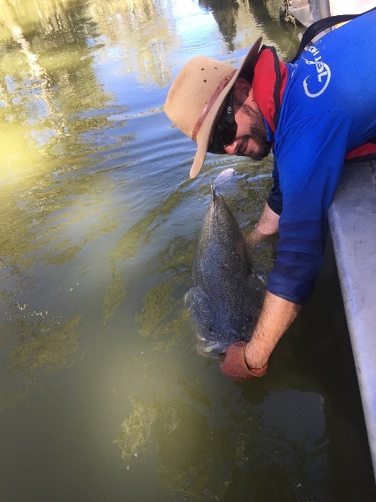 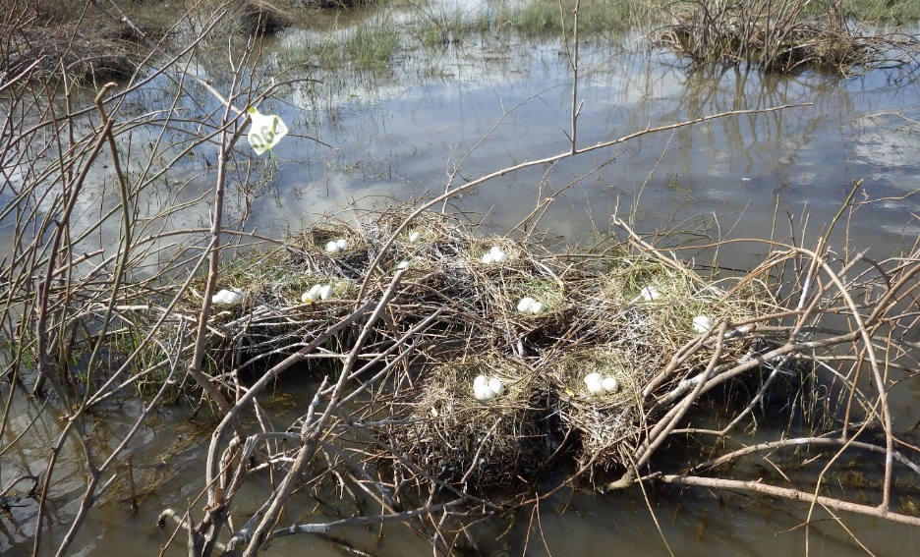

For more information about Commonwealth environmental water, please contact us at:

1800 803 772

[ewater@environment.gov.au](mailto:ewater@environment.gov.au)

[www.environment.gov.au/water/cewo](http://www.environment.gov.au/water/cewo)

@theCEWH

GPO Box 787, Canberra ACT 2601

1. See Ellis et al (2016)