

**Commonwealth Environmental Water**

Portfolio Management Plan

Macquarie River Valley

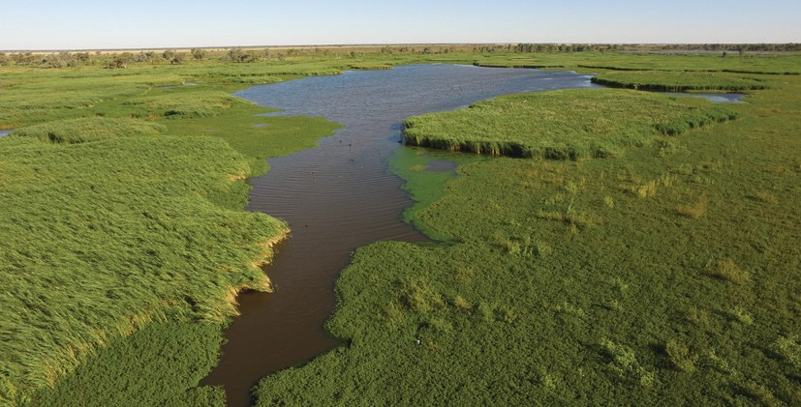2017–18

Front cover image credit: Loudens Lagoon in the Macquarie Marshes. Photo by Commonwealth Environmental Water Office. Back cover image credit: Straw-necked ibis at Monkeygar Swamp. Photo by Heather McGinness (CSIRO).

The Commonwealth Environmental Water Office respectfully acknowledges the traditional owners, their Elders past and present, their Nations of the Murray-Darling Basin, and their cultural, social, environmental, spiritual and economic connection to their lands and waters.

**© Copyright Commonwealth of Australia, 2017.**

*Commonwealth Environmental Water Portfolio Management Plan: Macquarie River Valley 2017–18* is licensed by the Commonwealth of Australia for use under a Creative Commons Attribution 4.0 International licence with the exception of the Coat of Arms of the Commonwealth of Australia, the logo of the agency responsible for publishing the report, content supplied by third parties, and any images depicting people. For licence conditions see: https://creativecommons.org/licenses/by/4.0/

This report should be attributed as ‘*Commonwealth Environmental Water Portfolio Management Plan: Macquarie River Valley 2017–18*, Commonwealth of Australia, 2017’.

The Commonwealth of Australia has made all reasonable efforts to identify content supplied by third parties using the following format ‘© Copyright’ noting the third party.

The views and opinions expressed in this publication are those of the authors and do not necessarily reflect those of the Australian Government or the Minister for the Environment and Energy.

While reasonable efforts have been made to ensure that the contents of this publication are factually correct, the Commonwealth does not accept responsibility for the accuracy or completeness of the contents, and shall not be liable for any loss or damage that may be occasioned directly or indirectly through the use of, or reliance on, the contents of this publication.

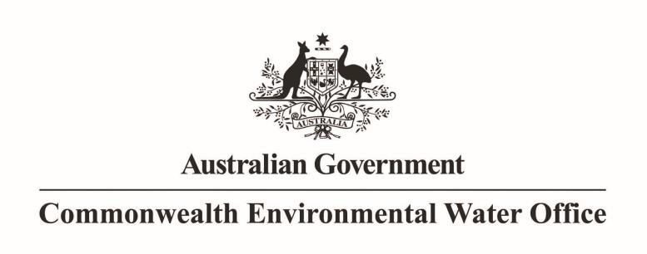

**Commonwealth Environmental Water Portfolio Management Plan**

**Macquarie River Valley 2017–18**

# Commonwealth environmental water portfolio management planning

## Commonwealth Environmental Water Holder

The Commonwealth Environmental Water Holder is a statutory position established under the *Water Act 2007* and is responsible for managing the Commonwealth’s environmental water holdings. This water must be managed to protect and restore the rivers, wetlands and floodplains (and the native animals and plants they support) of the Murray-Darling Basin. Mr David Papps is the current Commonwealth Environmental Water Holder. He is supported by staff of the Commonwealth Environmental Water Office. The Office employs six local engagement officers who live and work in regional centres across the Murray-Darling Basin.

## Commonwealth environmental water

Commonwealth environmental water holdings are water entitlements that have been acquired by the Australian Government through investments in water-saving infrastructure and purchases on the water market. The holdings are a mix of entitlement types held across 19 catchments. The rules governing the entitlements vary across states and across catchments. Commonwealth environmental water entitlements are subject to the same fees, allocations, carryover and other rules as equivalent entitlements held by other water users.

There are broadly three options for managing Commonwealth environmental water:

* delivering water to a river or wetland to meet an identified environmental demand
* leaving water in storage and carrying it over for use in the next water year (referred to as ‘carryover’)
* trading water, that is, selling water and using the proceeds to buy water in another catchment or in a future year, or investing in complementary ‘environmental activities’.

## Purpose of the document

This document sets out the plans for managing the Commonwealth environmental water portfolio in the Macquarie River Valley for 2017–18. Efficient and effective management of Commonwealth environmental water requires the utilisation of all portfolio management options. By taking a multi-year approach to planning, portfolio management tools such as use, carryover and trade can be managed for maximising environmental outcomes.

The portfolio management plans support transparent, coordinated and adaptive management of Commonwealth environmental water, consistent with the Basin-wide environmental watering strategy and having regard to the Basin annual environmental watering priorities.

To learn more about the planning approach see *Portfolio Management Planning: Approach to planning for the use, carryover and trade of Commonwealth environmental water, 2017–18* (available at: <http://www.environment.gov.au/water/cewo/publications>under ‘Planning approach’).

## Delivery partners

Commonwealth environmental water is managed in conjunction with and delivered by a range of partners. This portfolio management plan has been developed in consultation with our delivery partners, including the NSW Office of Environment and Heritage (OEH), the Department of Primary Industries – Fisheries, WaterNSW, and the Macquarie Cudgegong Environmental Flows Reference Group (the Macquarie Cudgegong EFRG).

## Your input

The management of Commonwealth environmental water relies on considerable advice and assistance from local organisations, state governments and others. Individuals and groups within the Murray-Darling Basin community are encouraged to submit suggestions for the management of Commonwealth environmental water. Please contact the Office via: [ewater@environment.gov.au.](mailto:ewater@environment.gov.au)

# Table of contents

Commonwealth environmental water portfolio management planning 1

Commonwealth Environmental Water Holder 1

Commonwealth environmental water 1

Purpose of the document 1

Delivery partners 1

Your input 1

Table of contents 2

1. Environmental watering in Macquarie River Valley 3
   1. The Macquarie River Valley 3
   2. Environmental objectives in the Macquarie River Valley 5
   3. Environmental flow requirements 6
   4. Monitoring and adaptive management 6
2. Portfolio management in 2017–18 8
   1. Antecedent and current catchment conditions and the demand for environmental

water in 2017–18 8

* 1. Water availability in 2017–18 10
  2. Overall purpose of managing environmental water based on supply and demand 11
  3. Proposed Environmental Water Delivery in 2017–18 12
  4. Trading water in 2017–18 14
  5. Carrying over water for use in 2018–19 14
  6. Identifying Investment Opportunities 15

1. Next steps 23
   1. From planning to decision making 23
   2. Further information 23

Bibliography 24

Attachment A – Expected outcomes from the Basin-wide environmental

watering strategy 26

Attachment B – Library of watering actions 29

Operational considerations in the Macquarie River Valley 29

Potential watering actions under different levels of water resource availability 29

Potential watering actions – standard operating arrangements 33

Attachment C – Long-term water availability 39

Commonwealth environmental water holdings 39

Other sources of environmental water 39

Planned environmental water 39

# Environmental watering in Macquarie River Valley

## The Macquarie River Valley

Macquarie River flows are heavily influenced by large rainfall events in the upper catchment and flows in tributary systems. The river is formed when the Campbells and Fish rivers join above Bathurst in Central Western New South Wales (NSW) followed by tributary flows from the Winburndale River, Turon River and Pyrmul Creek. The Macquarie River then flows into Burrendong Dam, south east of Wellington (Figure 1). Below the dam, tributary flows are provided by the Bell River, which enters at Wellington; Little River and Wambangalong Creek, which enter upstream of Dubbo; and the Talbragar River and Coolbaggie Creek, which enter just downstream of Dubbo. Subsequently, as the land flattens further west of Dubbo, the Macquarie River provides flows to distributary creeks, wetlands and rich alluvial river flats associated with braided channels. At this point, water flows are slow resulting mainly from extensive silt deposits and high attenuation.

Two major storages, Windamere Dam (capacity 368 gigalitres (GL) on the Cudgegong River, and Burrendong Dam on the Macquarie River (storage capacity of 1 188 GL, with additional storage capacity of 489 GL in the flood mitigation zone), regulate catchment water supplies. Commonwealth environmental water delivery is gravity fed from Burrendong Dam into the Macquarie River to downstream environmental assets such as the Macquarie Marshes and distributary creeks. Regulating structures are utilised to manage the diversion of water into distributary creeks at lower rates, or overbank at high flow rates onto floodplains and wetlands.

The primary environmental asset in the catchment is the Macquarie Marshes complex on the lower reaches of the Macquarie River, parts of which are listed as a *Wetland of International Importance* under the Ramsar Convention. The Marshes are a large and diverse wetland system that provide habitat for hundreds of species of plants and animals and have supported some of Australia’s largest waterbird breeding events.

Other assets in the catchment include the Macquarie River channel, the unregulated component of the lower Macquarie River downstream of Warren Town Weir and the distributary creek system to the west of the Marshes.

The Macquarie Marshes and Macquarie River support a number of species listed as endangered or vulnerable under the *Environment Protection and Biodiversity Conservation Act 1999*, for example, the Australian painted snipe, Australasian bittern, Murray cod, trout cod and spike rush.

The *Water Sharing Plan for the Macquarie and Cudgegong Regulated Rivers Water Source (2016)* provides for planned environmental water and stock and domestic (replenishment) flows. There is also additional held environmental water entitlement held by the NSW Government. These other water sources offer opportunities to align Commonwealth environmental water deliveries to increase the potential for environmental objectives to be achieved jointly and assist with delivery efficiency and effectiveness.

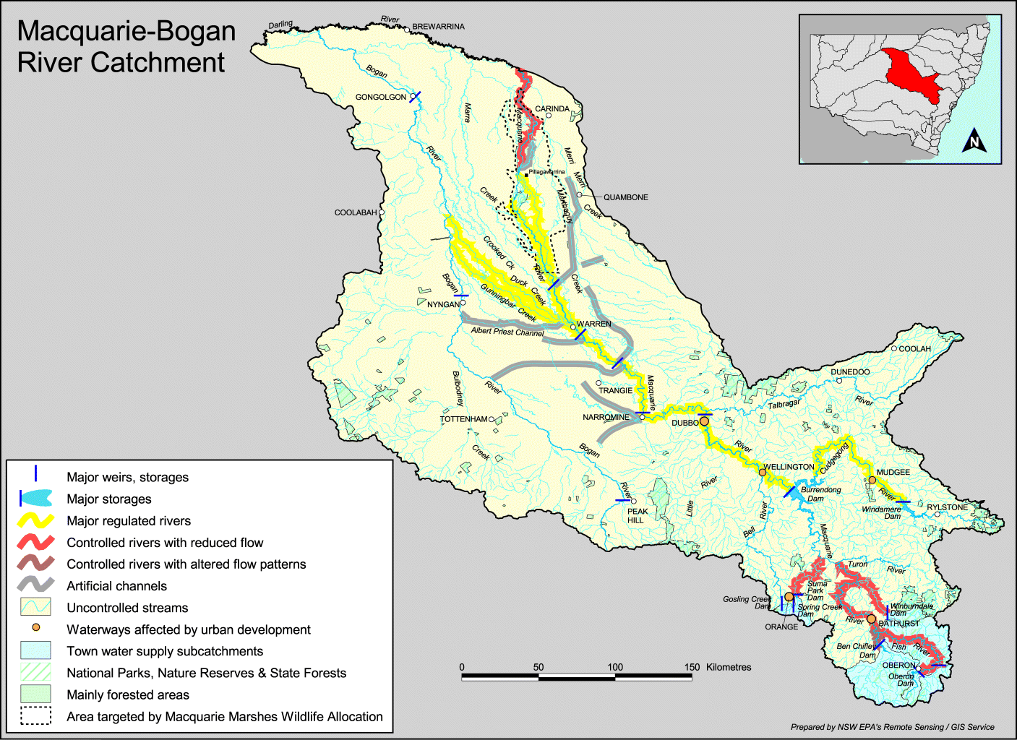

**Figure 1:** Map of the Macquarie River Valley (produced by the NSW Office of Environment and Heritage).

4

## Environmental objectives in the Macquarie River Valley

The long-term environmental objectives for the Murray-Darling Basin are described in the the Basin-wide Environmental Watering Strategy, which includes ‘quantified environmental expected outcomes’ at both a Basin-scale and for each catchment. The expected outcomes relevant for the Macquarie-Castlereagh Water Resource Plan Area are described in Attachment A.

Basin state governments are also developing long-term watering plans for each water resource plan area. These plans will identify the priority environmental assets and ecosystem functions in the catchment, the objectives and targets for these assets and functions, and their watering requirements. Once developed, these plans will provide the key information on the long-term environmental water demands in the catchment. Prior to the development of long-term watering plans, the Office will continue to draw on existing documentation on environmental water demands developed by state governments, local natural resource management agencies and the Murray-Darling Basin Authority.

**Table 1:** Summary of objectives being targeted by the Commonwealth Environmental Water Office by environmental watering in the Macquarie-Castlereagh Water Resource Plan Area.

|  |  |  |  |
| --- | --- | --- | --- |
| **BASIN-WIDE MATTERS**  **(Matters in red link to the Basin-wide Environmental Watering Strategy)** | **OBJECTIVES FOR MACQUARIE ASSETS** | | |
| **IN-CHANNEL ASSETS** | **OFF-CHANNEL ASSETS** | |
| **Macquarie River** | **Macquarie Marshes** | **Distributary creeks** |
| **VEGETATION** | Maintain riparian and in- channel vegetation condition, growth and survival (extent) | Maintain, and in some cases improve, floodplain and wetland vegetation condition, growth and survival | Support the condition, growth and survival of riparian and in-channel vegetation |
| **WATERBIRDS** |  | Provide suitable habitat to increase waterbird abundance and reproduction, and maintain current species diversity |  |
| **FISH** | Support opportunities for the movement and increased distribution, reproduction and recruitment of native fish | | Support the movement and habitat requirements of native fish |
| **MACROINVERTEBRATES** | Support recruitment and maintain macroinvertebrate diversity and habitat | | |
| **OTHER VERTEBRATES** | Support opportunities for the reproduction and recruitment of other native aquatic species, including frogs and turtles | | Support the reproduction of other native aquatic species including frogs |
| **CONNECTIVITY** | Support longitudinal connectivity, in particular increase connectivity with the Barwon-Darling | Support connectivity, particularly lateral between the river and floodplain | Support connectivity, particularly with the lower Macquarie River and Barwon River |
| **PROCESSES** | Support key ecosystem functions and promote productivity, including on the floodplain | | |
| **WATER QUALITY** | Maintain water quality within channels and pools | | |
| **RESILIENCE** | Provide drought refuge habitat (particularly for fish) | | |

Information sourced from: Murray-Darling Basin Authority (2012); Murray-Darling Basin Authority (2014); Barma Water Resources in association with IRPEC Pty Ltd and Paul Wettin (2011); Torrible et al. (2011); Commonwealth Environmental Water Office (2014); and Jenkins et al. (2012).

## Environmental flow requirements

Not all flow-related environmental demands can or will be met through the use of held environmental water alone. Some demands are currently met by regulated water deliveries for consumptive purposes, while others are met by large unregulated/natural flows events that are beyond what can be delivered within regulated system operational constraints. Figure 2 shows the broad environmental demands that are in scope for Commonwealth environmental water. Importantly, these are broad, indicative demands and individual watering events may contribute to particular opportunities. Also, there may be opportunities for Basin state governments to remove or modify operational constraints, which will improve the efficiency and/or effectiveness of environmental watering. Further information on delivery constraints are described in Attachment B.

**Commonwealth environmental water contribution unlikely:**

Demands that are met by planned environmental

water and delivery for consumptive use

Demands met by

unregulated/ natural flows, or above delivery constraints

Demands that

environmental water may contribute to

Time

* + - Flows above 3 500-4 000 ML/day at Marebone Weir
    - Overbank flows in the Macquarie River channel between Burrendong Dam and Marebone Weir
    - Large flows onto entire Macquarie Marshes and distributary creeks floodplain

Flow rate

**Focus for environmental water contribution subject to seasonal conditions:**

* + - Small to moderate Macquarie Marshes floodplain events
    - Small to moderate mid- Macquarie River flows
    - Small to moderate flows to distributary creeks system
    - End of system flows to Barwon River

**Demands met by other sources:**

* + - Base flows delivered as stock and domestic flows

**Figure 2:** Scope of demands that environmental water may contribute to in the Macquarie River Valley.

Based on the above objectives sought and delivery constraints, specific watering requirements (flow magnitude, duration, timing and frequency) have been identified for Commonwealth environmental water. These water requirements are described in Table 3. As with the objectives and targeted outcomes, the environmental water requirements will continue to be reviewed and revised in response to new knowledge.

## Monitoring and adaptive management

Operational monitoring is undertaken for all Commonwealth environmental watering actions and involves collecting on-ground data with regard to environmental water delivery such as volumes delivered, impact on the hydrograph of the river system, area of inundation and river levels. It can also include observations of environmental outcomes.

In the Macquarie-Castlereagh catchment, this is primarily achieved by the collaborative efforts and resources of NSW agencies and the Office, and includes:

* prioritised environmental monitoring of vegetation, waterbirds and frogs by NSW Office of Environment and Heritage (NSW OEH) and native fish by the NSW Department of Primary Industries – Fisheries (NSW DPI Fisheries)
* hydrology (flow gauging) by NSW Department of Primary Industries - Water
* short-term intervention monitoring funded by the Office in the Macquarie catchment in 2014–15 (native fish) and 2016–17 (waterbird colonies and native fish). This monitoring aimed to understand the environmental responses to different watering actions, with respect to targeted objectives and expected outcomes.
* operational surveillance of flow events by staff from the Office, NSW OEH and WaterNSW
* other aspects such as shallow groundwater and processes/functions by various others including researchers, landholders and agencies.

The Macquarie Marshes has also been identified as a priority research site for the Murray-Darling Basin Environmental Water Knowledge and Research Project (EWKR), which seeks to improve the science available to support environmental water management in the Murray-Darling Basin.

Information on short-term monitoring activities and the EWKR project can be found at [http://www.environment.gov.au/water/cewo/catchment/macquarie/monitoring.](http://www.environment.gov.au/water/cewo/catchment/macquarie/monitoring)

Key findings and recommendations from fish (Stocks et al. 2015), frog (NSW OEH 2017) and waterbird (Spencer et al. 2016, CSIRO 2017, UNSW 2017) monitoring include:

* Spring/early summer deliveries of environmental water in the Macquarie River have been associated with peaks in hatch date frequencies of some small-bodied opportunistic species such as Australian smelt, un-specked hardyhead and Murray-Darling rainbowfish, particularly on the receding tail of flows or during sustained periods of increased flow.
* Environmental water delivered in spring and early summer may help to support native fish recruitment for species such as Murray cod and eel-tailed catfish, by increasing flows and boosting primary production in the Macquarie River.
* Connectivity between the lower Macquarie River (downstream of the Macquarie Marshes) and the Barwon River is important for allowing the movement of native fish between rivers for spawning, movement and recruitment (e.g. for bony bream, golden perch, spangled perch), and future delivery of environmental water should aim to support connectivity.
* Local weather conditions influence the activity of some frog species, as well as inundation extent. Increased inundation extent is associated with an increase in the number of sites with good breeding conditions, resulting in greater numbers of calling flow-responsive species breeding. Flooding events are very important for increasing the overall abundance of flow-responsive frog species, by supporting breeding and enabling frogs to move between wetlands, thus connecting isolated populations. Environmental water delivery is important to provide habitat and help maintain inundation to complete metamorphosis.
* Delivery of environmental water over the winter-spring months can provide suitable wetland habitat for nationally threatened and internationally recognised migratory species of waterbirds. Late winter and early spring delivery (maintained into summer if possible) will coincide with warmer temperatures and the peak activity of most waterbird species and their food supplies. A slow, steady contraction of inundated area is preferable.

The outcomes from these monitoring activities inform portfolio management planning and adaptive management decision-making as outlined in Section 2.

# Portfolio management in 2017–18

In planning for the management of Commonwealth environmental water, the Office aims to maximise the outcomes achieved from the available water. This includes consideration of the urgency of demands (based on targeted objectives and watering requirements, watering history and asset condition) and the available supply under different resource scenarios. Plans for water delivery, trade and carryover are then made in a multi-year context, with an assessment also undertaken of need for water in future years.

This planning process is outlined in full in Table 3 below and summarised in the sections below.

## Antecedent and current catchment conditions and the demand for environmental water in 2017–18

The Macquarie catchment experienced hot and dry conditions between spring 2012 and autumn 2016, with very much below average rainfall over the period, and above average to very much above average maximum temperatures across the region. A combination of NSW and Commonwealth environmental water was delivered to the Macquarie River and Macquarie Marshes during these dry years to help support native fish in the river channel and the inundation of core wetland areas in the Marshes.

Conditions began to change in May 2016, with above average to highest on record rainfall across the catchment over winter and spring, with particularly high rainfall in June and September 2016. Maximum temperatures were average to below average over winter. Burrendong Dam filled to 100 per cent of capacity on 4 September 2016 (up from 11 per cent of capacity in early May). Good rainfall, tributary flows and releases under airspace operations of the Flood Mitigation Zone (FMZ) in Burrendong Dam in late 2016 and early 2017 contributed to widespread inundation in the Macquarie Marshes. All areas of river red gum woodland in the Marshes were inundated, improving the condition of wetland vegetation. Flooding triggered large-scale colonial and general waterbird breeding, with at least 21 colonies recorded in the Marshes. Managed environmental water (a mix of NSW and Commonwealth water sources) was delivered immediately following the cessation of Flood Mitigation Zone flows to maintain water levels in key colonial waterbird colonies and foraging areas.

Conditions began to dry again over summer 2016–17, with average to very much below average rainfall, and very much above average to highest on record maximum temperatures. However, rainfall in March 2017 was average to above average across the catchment. Environmental water (Commonwealth and NSW) was delivered in April and May 2017 as part of two separate watering actions to support native fish in response to natural tributary flows resulting from increased rainfall. Environmental water was used to: support the post spawning dispersal of native fish in the mid-Macquarie River and Marshes; and to provide connectivity between the lower Macquarie and Barwon rivers to provide opportunities for the movement of native fish between the catchments.

Given the dry conditions leading up to winter 2016, the potential for further dry conditions in the future, and the need to build resilience and support further recovery in the system, there are a number of environmental demands that require water in 2017–18.

Environmental water demands for environmental assets in the Macquarie catchment in 2017–18 are represented in Table 3 and are summarised below:

***Mid-Macquarie River (*Burrendong – Marebone Weir)*:*** The level of demand is related to the flow rate. Small flows to maintain refugia for native fish remain a high demand as they are required continuously. However, these flows are often met by other sources. There is a moderate demand for water in 2017–18 to contribute to freshes that will support the movement and breeding of native fish (flow generalists, in- channel specialists and flow specialists). The demand for large freshes and bank full flows to drown out weirs and allow for the movement of native fish is considered to be very low (required approximately twice in ten years), after being met by high flows in spring 2016.

***Lower Macquarie River* (Marshes – Barwon River)*:*** The level of demand is related to the flow rate. There is a moderate to high demand for water in 2017–18 to provide seasonal freshes and a fish connection flow in the lower Macquarie River1. This demand was met in 2016–17, however, it was only partially achieved with limited connectivity between 2012–13 and 2015–16. In-channel seasonal freshes are ideally provided annually. Connectivity through the system is important for all native fish, which need to move as part of their life cycle to feed, find shelter, and maintain good body condition. The capacity to support connection between the lower Macquarie River and the Barwon River is contingent on suitable conditions in both these systems, water availability and operational feasibility. Following good flows and connectivity in 2016–17, there is a low demand in 2017–18 to provide water to inundate the floodplain in the lower Macquarie River, which is likely required one in every three years.

***Macquarie Marshes 1:1 to 2:3 year inundation zones (reed beds, lagoons, mixed marsh, water couch)*:** High demand. Ideally, annual wetting is required to maintain these communities. There were positive responses in these vegetation communities following good inundation in 2016–17. For example, there was strong growth and expansion of reedbeds and evidence of recovery in areas of the north marsh reedbed and Monkeygar that were burnt in 2015–16. Watering in 2017–18 is required for these vegetation communities to continue recovering post fire and from previous dry years.

***Macquarie Marshes 1:2 to 2:5 year inundation zones (reeds, water couch, mixed marsh, river red gum forest, river cooba)*:** Moderate demand. These areas of the Marshes were inundated in 2016–17, with many areas wet for over 90 days. A positive response was observed in water couch and mixed marsh vegetation communities, particularly in the Southern and Northern Marshes. However, conditions were dry between 2013–14 and 2015–16, with demands only being partially or not met during that time. These vegetation communities ideally require water eight in ten years, with some species having a maximum dry interval of two to three years. Wetting is required again in 2017–18 to build on the benefits of inundation in spring 2016 and summer 2017, maintain soil moisture and groundwater levels, support vegetation recruitment, and to build resilience to help sustain and prevent further loss in these communities.

***Macquarie Marshes 1:3 to 1:4 year inundation zones (river red gum woodland, river cooba, inner coolibah woodland)*:** Low demand. These areas were sufficiently watered in 2012–13 and again in 2016–

17. These communities are ideally inundated one in three years, with some species requiring water every three to four years. Some of these communities had been showing signs of stress before being inundated in 2016 (e.g. river red gum woodland in the Northern Marshes). Some improvements in tree condition were observed in March 2017. Water will be required again in the next two to three years to maintain condition.

***Macquarie Marshes 1:5 to 1:10 year inundation zones (outer river red gum woodland, coolibah and black box)*:** Low demand. Much of this area was inundated in 2016–17 with the approximate 1:8 year inundation event. Before that time this zone had not been inundated since 2010–11. Some species require water every four to five years and the condition of river red gum trees further away from watercourses had declined during those dry years. Wetting may be required again in the next few years to maintain condition. These areas are difficult to reach with environmental water alone.

***Distributary creeks*:** Low demand. Demands in the distributary creeks are considered to have been met in 2016–17, although they were only partially or not met (depending on the creek) in the preceding three years, which were particularly dry. Although the required watering frequencies are not well known for the distributary creeks, they may require further water in the next one to three years to provide benefits for native vegetation and to provide connectivity with the Barwon-Darling system.

1 There is a growing awareness of the importance of connecting flows across the northern basin. These connecting flows support populations of native fish and aquatic fauna in the Barwon-Darling and the northern tributaries including the Macquarie River. These flows provide hydrological connections that link a diversity of aquatic environments for feeding, breeding, dispersal, migration and re-colonisation, which is essential for the survival of native fish populations and other aquatic fauna.

### Murray-Darling Basin-wide environmental watering strategy and 2017–18 annual priorities

In contributing to these demands, the Office will also be aiming to contribute to the expected outcomes in the Basin-wide environmental watering strategy (see Attachment A) and the following 2017–18 Basin annual environmental watering priorities relevant to the Macquarie catchment.

* Improve flow regimes and connectivity to maximise the ecological function of the Barwon-Darling river system for native fish
* Support viable populations of threatened native fish and maximise opportunities for range expansion and the establishment of new populations
* Improve the abundance and diversity of the Basin’s waterbird population
* Enable recruitment of trees and support growth of understorey species within river red gum, black box and coolibah communities on floodplains that received overbank flooding during 2016 by inundating the floodplains again.

The Commonwealth Environmental Water Holder will not inundate private land without prior approval from land holders while contributing to the Basin annual environmental watering priorities.

## Water availability in 2017–18

### Forecasts of Commonwealth water allocations

The volume of Commonwealth environmental water likely to be carried over in the Macquarie River Valley for use in 2017–18 is estimated to be 79 GL.

Allocations against Commonwealth water entitlements in the Macquarie River Valley are determined by state governments and will vary depending on inflows. The following forecasts in Table 2 are based on the best available information including state forecasts and historical inflow scenarios.

**Table 2**: Forecasts of Commonwealth water allocations (including carryover) in 2017–18 in the Macquarie River Valley as at 31 May 2017.

|  |  |  |  |  |  |  |
| --- | --- | --- | --- | --- | --- | --- |
| **Entitlement type** | **Forecasts of Commonwealth water allocations (including carryover) in 2017–18 (GL)** | | | | | |
| **Very dry** |  |  |  |  | **Very wet** |
| **95**  **percentile** | **90**  **percentile** | **75**  **percentile** | **50**  **percentile** | **25**  **percentile** | **10**  **percentile** |
| Macquarie (general security) | 112 | 113 | 119 | 167 | 205 | 205 |
| Macquarie (supplementary) | Up to 8 GL | Up to 8 GL | Up to 8 GL | Up to 8 GL | Up to 8 GL | Up to 8 GL |

Notes:

1. Forecasts for regulated catchments are given to the nearest whole gigalitre.
2. Allocation rate scenarios are based on long term average allocation rates.

Information on allocations to Commonwealth environmental water holdings can be found at <http://www.environment.gov.au/water/cewo/portfolio-mgt/holdings-catchment>and is updated monthly.

### Water resource availability scenarios

Commonwealth environmental water is not managed in isolation. When considering the available resource to meet environmental demands, it is necessary to also factor in the resources managed by other entities and available to contribute to environmental objectives. Relevant resources include held environmental water managed by state government agencies, active and translucent allowances under the Water Sharing Plan planned environmental water, tributary, natural and other unregulated flows (‘surplus flows’ from the Regulated system), conveyance water and consumptive water. Further detail on sources of environmental water in the Macquarie River Valley is provided in Attachment C.

By combining the forecasts of water held by the Commonwealth with streamflow forecasts, as well as taking into account operational considerations, water resource availability scenarios can be developed ranging from very low to very high. Based on available information moderate to high resource availability scenarios are in scope for 2017–18, with very high resource availability only possible if conditions become wet.

## Overall purpose of managing environmental water based on supply and demand

Environmental water needs (demand) and water availability (supply) both influence the overall purpose of Commonwealth environmental water management. Under different combinations, the management purpose can range from ‘avoiding damage’ to the environment to ‘improving’ ecological health. This in turn informs the mix of portfolio management options that are suitable for maximising outcomes.

Figure 3 shows how current demands and forecasted supply are considered together.

The overall ‘purpose’ for managing the Commonwealth’s water portfolio in the Macquarie River Valley for 2017–18 is to maintain and improve the health and resilience of aquatic ecosystems in the Macquarie River and Macquarie Marshes.

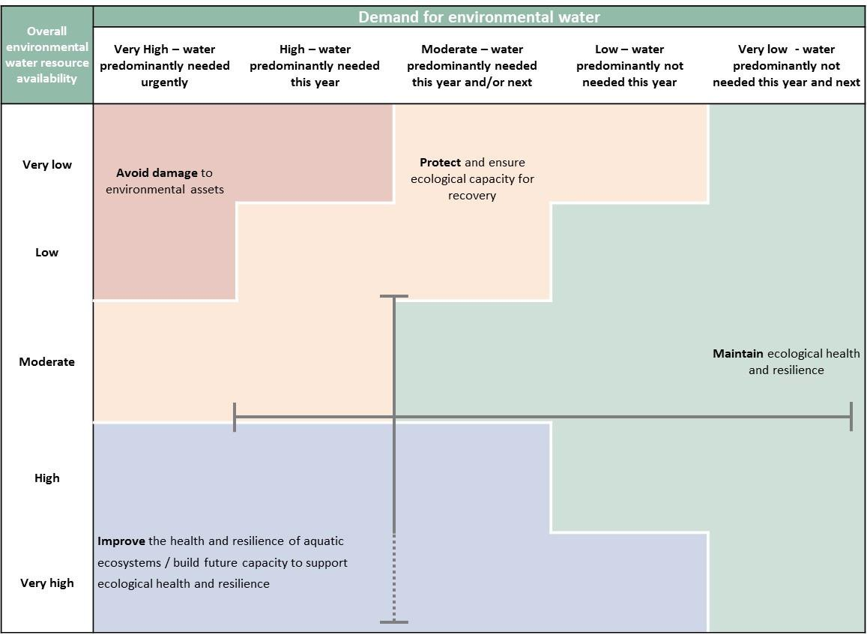

**Figure 3:** Determining a broad purpose for portfolio management in the Macquarie River Valley for 2017–18. Note: grey lines represent potential range in demand and resource availability.

Further detail on how the overall purpose for portfolio management changes under different supply and demand scenarios is provided in *Portfolio Management Planning: Approach to planning for the use, carryover and trade of Commonwealth environmental water, 2017–18* (available at: <http://www.environment.gov.au/water/cewo/publications>).

## Proposed Environmental Water Delivery in 2017–18

As in previous years, the use of Commonwealth (and NSW) environmental water will be adaptively managed throughout 2017–18, in response to changing water resource availability and environmental conditions and demands.

Following an increase in available water in 2016, there are opportunities going into 2017–18 to provide follow up flows in the Macquarie catchment that will help to further improve the condition and resilience of key assets. Building greater resilience in the system will help assets to maintain condition and function in dry years, and to respond well in wetter years. Providing environmental water in the next year will also help to support the successful recruitment of vegetation, waterbirds, fish and frogs following an increase in growth and reproduction in 2016, which will help to improve abundance and diversity in the coming years.

Considering that the Macquarie catchment has experienced a number of very dry years during the millennium drought and again between 2013–14 and 2015–16, the range of likely actions for the delivery of environmental water in 2017–18 reflects the need to continue improving the condition of assets and build resilience in the ecological systems. A number of actions have been developed across the range of potential water resource availability scenarios to enable Commonwealth environmental water to be adaptively managed throughout 2017–18 and into the following years.

Consistent with the demands and purpose described above, the Office is considering supplying environmental water to the following four watering event components for 2017–18 (see also Table 3 for supporting information regarding the basis for determining these watering intentions).

Given the high water availability currently, this plan includes the following components:

1. 2017–18 winter/spring inundation event: a portion of the available water may be used (in combination with NSW environmental water) to deliver a total flow of 135 GL to the Macquarie Marshes (Action 9 – Appendix 3). Environmental water would target the inundation of approximately 19 000 hectares of the Macquarie Marshes to support wetland vegetation (reeds, water couch, mixed marsh, river red gum forest and river cooba), and to provide habitat for waterbirds, fish and frogs.

Delivering 135 GL of environmental water to the Macquarie Marshes would also meet baseflow requirements in the mid-Macquarie River (Action 1 – Appendix 3). The hydrograph is also expected to be managed to provide movement and spawning opportunities at a suitable time for native fish (flow generalists and in-channel specialists) in the mid-Macquarie River (Actions 2 and 3 – Appendix 3). Flows delivered to the Macquarie Marshes may also help contribute to seasonal freshes in the lower Macquarie River, and support some connectivity with the Barwon River (Action 6 – Appendix 3).

1. Native fish connection flow contingency: there may be opportunities to provide environmental water to support connection between the lower Macquarie and Barwon river systems (Action 7 – Appendix 3). This flow, kept as an optional contingency flow, would provide opportunities for the movement of native fish both into and out of the Macquarie catchment, and may require up to 50 GL of environmental water. This flow is contingent on suitable conditions in the Barwon and Macquarie catchments and operational feasibility.
2. Native fish breeding flow contingency: should there be a sufficient increase in available water, there may be opportunities to augment tributary events to support the breeding, movement and dispersal of native fish in the mid-Macquarie River (Action 4 – Appendix 3). The volume of Commonwealth environmental water required would be dependent on the volume of other water in the system, however, it is expected that approximately 10 GL (Commonwealth and NSW environmental water) would be required. This watering action could probably be linked with the winter/spring inundation action described above (Component 2) or to a sufficiently-size tributary event in summer or autumn.
3. Carryover strategy: a carryover strategy has been developed for the Macquarie catchment. Refer to Section 2.6 for details.

The delivery of environmental water to support the Macquarie Marshes is quite scalable, depending on the volume of water available and catchment conditions (Action 9 – Appendix 3). Should very wet conditions prevail in 2017–18, environmental water may be targeted at broader areas of the Macquarie Marshes, for example to inundate up to 50 000 hectares (requires ~250 GL), or to provide additional water on the recession of larger flows. Additional water may also be delivered as a waterbird breeding contingency to support a naturally triggered colonial waterbird breeding event should one occur (Action 10 – Appendix 3). Delivery of environmental water to the Macquarie Marshes under wetter conditions could also contribute to meeting larger environmental demands in the lower Macquarie River, which would contribute to floodplain inundation and connectivity with the Barwon River (Action 8 – Appendix 3). Additional water could also be used to ensure there is adequate water to meet environmental demands in future, particularly if conditions become drier in future years.

When available, supplementary entitlements may be used to contribute to meeting environmental demands and to build on the benefits of naturally triggered flow events in the system.

Any watering actions that contribute to maintaining waterbird habitat or support waterbird breeding within the Macquarie catchment may also benefit waterbird populations more broadly (e.g. via waterbird flyways across the Lachlan, Murrumbidgee, mid-Murray, Gwydir, Namoi and Border Rivers catchments).

### Stakeholder Feedback

The Macquarie Cudgegong EFRG, with NSW OEH, has provided valuable and groundtruthed advice that has informed planning for the management of Commonwealth environmental water in the catchment. The Macquarie Cudgegong EFRG has recommended that under a ‘worst case scenario’ (i.e. return to dry conditions and minimal additional allocations) that:

* Environmental water should be used to deliver a flow of 135 GL to inundate up to 19 000 ha in the Macquarie Marshes (including Eastern, Northern and Southern Marshes). This flow would help to support further recovery of reed beds burnt in 2016, support recruitment of vegetation, waterbirds, fish and frogs following inundation in 2016 (e.g. by providing foraging habitat), and further build resilience in the system. Deliveries could commence in early winter, if required, to help prime the wetland system. This water can be delivered in a way to provide movement opportunities in late winter for fish such as Murray cod, and provide spawning and dispersal opportunities for in-channel specialists and flow generalists when temperatures are warmer. This is consistent with event component 1 above.
* The Macquarie Cudgegong EFRG has recommended a 50 GL contingency to support connection between the lower Macquarie River and the Barwon River, subject to suitable flow conditions in these systems, water availability and operational feasibility. This flow would facilitate opportunities for the movement of native fish between the lower Macquarie and Barwon rivers. (Component 2)
* Should additional water become available during the year, the Macquarie Cudgegong EFRG recommended that the first 10 GL be set aside as a second contingency to further support native fish opportunities in the mid-Macquarie River. Use of this contingency would be subject to suitable tributary triggers, and would provide opportunities for the breeding, recruitment, movement and dispersal of small and large bodied native fish. (Component 3)
* It was also recommended that any additional allocation be used to ensure a minimum Marshes inundation event of approximately 19 000 ha (event size approximately 100 000 ML over 5 months) to meet core vegetation demands over the next three years. (Components 1 and 4)

The Office is working to improve engagement with the Traditional Owners about environmental water planning in the Macquarie. In May 2017, representatives of the Ngiyampaa Wayilwan elders met in the Macquarie Marshes with representatives from the Office and NSW OEH to talk about how to gather and collate traditional ecological knowledge, how to work together to improve Traditional Owner engagement in the planning, delivery and monitoring of Commonwealth environmental water in future.

## Trading water in 2017–18

The *Water Act 2007* provides for the trade of Commonwealth environmental water (allocations and entitlements) and specifies the conditions under which sales may occur. To improve environmental outcomes must be the primary reason for trade of Commonwealth Environmental water. The Commonwealth Environmental Water Holder has no plans to trade entitlements in 2017–18.

Planning on water trade considers supply and demand within the catchment and across the Basin. In the Macquarie catchment, inflows and allocations are highly variable. Where possible, retaining an account balance that will provide for environmental watering in future years under a range of climate scenarios is particularly important given the possibility of low to very low annual water allocation.

The Commonwealth Environmental Water Holder regularly assesses the environmental demand and supply position throughout the year, considering factors such as environmental condition and demand, current and forecast climate conditions, water availability, carryover capacity and market conditions. Any potential allocation trade would be subject to an assessment of the level of supply or demand for consumptive use within the Macquarie catchment water market.

Should a decision be made to seek a trade, then further information will be made widely available at [http://www.environment.gov.au/water/cewo/trade/current-trading-actions.](http://www.environment.gov.au/water/cewo/trade/current-trading-actions)

For more information on the rules and procedures governing the trade of Commonwealth environmental water, refer to the *Commonwealth environmental water Trading Framework* at: [http://www.environment.gov.au/water/cewo/publications/water-trading-framework-dec2014.](http://www.environment.gov.au/water/cewo/publications/water-trading-framework-dec2014)

## Carrying over water for use in 2018–19

The volume of water carried over for use in 2018–19 will depend upon resource availability and demand throughout the year. A minimum carryover target of 85 GL of Commonwealth environmental water is being reserved to meet minimum water requirements in 2018–19 and as a risk management strategy should low inflows result in low allocations in future years.

This volume is also reserved as a contingency volume for use in 2018–19 should there be insufficient allocations available and there is a critical need for environmental water (e.g. waterbird breeding event, native fish movement and breeding opportunities).

In the Macquarie catchment, water availability can be highly variable between years, therefore carrying water over between years is important to help meet environmental demands in years when water availability is lower. A three-year carryover strategy developed in collaboration with NSW OEH and the Macquarie Cudgegong EFRG, which will endeavour to ensure that minimum environmental demands such as the inundation of inner permanent and semi-permanent vegetation, can be met over the next three years. This ensures water is available to maintain wetlands and build resilience particularly if conditions begin to dry again (Tables 3a and b).

A similar strategy was developed in 2012 following the autumn dam spill of that year. This successfully enabled delivery of minimum volumes of 60GL and 30 GL of environmental water during the subsequent dry years to help maintain core areas of the Macquarie Marshes and drought refuges. Delivering environmental water during the drier years of 2013, 2014 and 2015 also provided opportunities for native fish in the mid- Macquarie River, supported refuge habitat for waterbirds, fish and frogs, and helped build resilience so that the system was more responsive in wetter years. However, following several dry years with low water availability, volumes were insufficient to maintain all core areas of the Marshes. Particularly dry conditions meant that water could not be delivered to some assets, such as outer areas of floodplain vegetation in the Macquarie Marshes, which remained in poor condition. Good rainfall and flooding in 2016 helped to meet a number of those demands that were assessed as high or critical going into 2016–17.

As documented in Table 3 below, potential demands in 2018–19 include:

* Wetland watering between June and April to the Macquarie Marshes to inundate the 19 000 ha (~100 GL event size) pink inundation zone (reeds, water couch, mixed marsh, river red gum forest, river cooba)(Figure 4)
* Small flows between spring and autumn, and/or during winter as fish conditioning/maintenance flows in the Macquarie River
* Instream flows in the lower Macquarie River, providing connectivity to the Barwon-Darling (contingency

– subject to conditions in Macquarie and Barwon rivers and operational feasibility)

* Spring flows in the mid-Macquarie River, targeting native fish movement and breeding (contingency only)
* Flows to support colonial waterbird breeding (contingency only – should an event be triggered naturally)

Carryover volumes will be adjusted throughout the year as the season unfolds in response to both current and future demands and the water available to meet these demands. These decisions will be based on the best information available at the time. More information on how the Commonwealth makes decisions on carryover is at <http://www.environment.gov.au/water/cewo/about/carryover>

## Identifying Investment Opportunities

Changes to the Water Act 2007 in 2016 have increased the flexibility for the Commonwealth Environmental Water Holder (CEWH) to use the proceeds of water allocation sales to invest in environmental activities.

Under these amendments environmental activities must improve environmental outcomes and be undertaken for the purpose of protecting and restoring environmental assets in the Basin.

The CEWH will release a Discussion Paper seeking feedback on what type of activities stakeholders would like the CEWH to consider when developing a framework for future investment in environmental activities.

It should be noted that proceeds of past water sales must be managed based on the legislation in place at that time and are not available to be used for such activities.

It should be noted that proceeds of past water sales must be managed based on the legislation in place at that time, and are not available to be used for these activities.

### Table 3a: Environmental demands, priority for watering in 2017–18 and outlook for coming years in the Macquarie River Valley – MODERATE WATER RESOURCE AVAILABILITY (Moderate to high carryover; low to moderate inflows and allocations) in 2017–18

|  |  |  |  |  |  |  |  |  |  |  |  |  |  |
| --- | --- | --- | --- | --- | --- | --- | --- | --- | --- | --- | --- | --- | --- |
| **Environmental assets** | ***Values*** | **Indicative demand (for all sources of water in the system)** | **Required frequency (maximum dry interval)** | **Management area** | **Watering history (from all sources of water) 6** | | | **2017–18** | | | **Implications for future demands** | | |
| **2014–15** | **2015–16** | **2016–17** | **Predominant urgency of environmental demand for water** | **Purpose under moderate resource availability** | **Potential Commonwealth environmental water contribution?** | **Likely urgency of demand in 2018–**  **19 if watering occurred as planned in 2017–18** | **2019–20**  **Range of likely demand** | Met in 2018–19 |
| (dry) | (dry) | (wet) | Not met in 2018–19 |
| **Mid- Macquarie River (Burrendong – Marebone Weir) 1** | Fish refuge: all guilds Aquatic ecosystems | **Baseflows:** small very regular flows through to end of system, wetting holes and in- stream storages. | Ideally: continuous flow  (Max interval: continuous flow) | N/A | Met | Met | Met | HIGH  Minimum baseflows are ideally required continuously to maintain instream habitat, and so will be required again in 2017–  18. Usually met through operational flows  unless resource levels are critical. | **Protect** | This demand would be met by other water sources under a moderate scenario. | High | High | |
| Critical | |
| Fish spawning– flow generalists  + in-channel specialists | **Small freshes:** up to 800–  1 000 ML/day for at least 14 days at Baroona in spring (Oct–Nov) through to mid- autumn; and conditioning flow in winter (July to mid- August). | Ideally: annually (Max interval: 3 years for large-bodied generalists; 5 years in- channel specialists; 1 year for  small- bodied) | N/A | Met in spring but not winter | Met in winter and early spring. River drying down over summer | Met | MODERATE  Respond to natural tributary flows and water temperature. | **Maintain** | Potential use subject to tributary flows | Moderate | Moderate | |
| High | |
| Flow specialists guild movement and breeding | **Priming flow:** >5 000 ML total flows at Baroona over 3 days with approx. 7 day recession (tributary pulse).  **Spawning pulse:** initial peak  ≥ 5 000 ML/day at Baroona for >2 days with event lasting for >7 days. (35–40 day total pulse)  **Dispersal flow:** Initial pulse  >3 000 ML total flows over 3 days at Baroona.  Second pulse min.  2 000ML/day peak with recession. Approx 10d duration total events. (Oct–March)  Water temperature for all pulses ≥19oC. | Ideally: 1 in  3 years (up to twice per year)  (Max interval: 5 years) | N/A | Not met | Not met | Partially met u/s of Narromine due to depressed temperatures.  Met downstream of Narromine where temperatures normalise | MODERATE  While flows in spring 2016 were sufficient to meet the required flow targets, temperatures were not appropriate for much of this time for native fish spawning.  Respond to natural tributary flows, water temperature, and significant river rises that will cue movement and spawning of flow specialists. | **Maintain** | Potential use subject to tributary flows. Use of supplementary entitlements relevant. | Low | Low | |
| Moderate | |
| Fish movement In stream + riparian vegetation | **Large freshes and bankfull:** 10 000–20 000 ML/day at Baroona for a minimum of 3 days (to drown out key weirs). | Ideally: 2 in  10 years (Max interval: Unknown) | N/A | Not met | Flows above 10 000  ML/day at Baroona for 3 days in June | Flows >10 000 ML/day at Baroona for 6 days and again for 3 days in early Sept, and for 28 days from mid-Sept-Oct | VERY LOW  Based on flows at Dubbo, achieved multiple times in 2016.  Drown out 2010–11,  2011–12 and 2016–17. | **Maintain** | Insufficient water.  Only able to contribute to this demand when coordinated with major tributary flow event. | Low | Low | |
| Low to moderate | |

|  |  |  |  |  |  |  |  |  |  |  |  |  |  |
| --- | --- | --- | --- | --- | --- | --- | --- | --- | --- | --- | --- | --- | --- |
| **Environmental assets** | ***Values*** | **Indicative demand (for all sources of water in the system)** | **Required frequency (maximum dry interval)** | **Management area** | **Watering history (from all sources of water) 6** | | | **2017–18** | | | **Implications for future demands** | | |
| **2014–15** | **2015–16** | **2016–17** | **Predominant urgency of environmental demand for water** | **Purpose under moderate resource availability** | **Potential Commonwealth environmental water contribution?** | **Likely urgency of demand in 2018–**  **19 if watering occurred as planned in 2017–18** | **2019–20**  **Range of likely demand** | Met in 2018–19 |
| (dry) | (dry) | (wet) | Not met in 2018–19 |
| **Lower Macquarie River (Marshes – Barwon River)**  **1,2** | Instream aquatic ecosystems Fish Connectivity | **Seasonal freshes:** in-channel flows  Minimum 20 ML/day at Bells Bridge for 45 days. | Ideally: annually (Max interval: Unknown, possibly 2 years) | N/A | Minimal connection (26 days  autumn 2015) | Short-term connection only  (25 days  autumn 2016) | Flows > 20 ML/day for ~169 days between early Aug 2016 and mid Jan 2017 (peak of  8,352 ML/day) | MODERATE-HIGH  Good connectivity achieved in 2016–17. Before this there had been limited connectivity achieved since 2012–13. | **Maintain** /  **Protect** | Possible use subject to tributary flows. Needs may be partially met by other flows. | Moderate to high | Moderate to high | |
| High | |
| Fish Connectivity | **System connectivity between the Macquarie and Barwon catchments:** † for example in-channel flow targeting rates of 50–100 ML/day at Bells Bridge (minimum depth of 50 cm) to connect the lower Macquarie River and the Barwon River for approximately 10 days. | Opportunistic (Max interval unknown, possibly 1 in 5 years) | N/A | Flows >50 ML/d  in winter 2014, but only for 3 days. | Flows <50 ML/d | Suitable connection achieved in spring 2016 and  in autumn 2017 | MODERATE-HIGH  Good connectivity achieved in 2016–17. Before this there had been limited connectivity achieved since 2012–13. | **Maintain** /  **Protect** | Possible use subject to suitable conditions and operational feasibility. | Low to moderate | Low to moderate | |
| Moderate to high | |
| Floodplain vegetation Connectivity | 15–30 GL at Bells Bridge to inundate floodplain and lower reach of Macquarie River. | Ideally: 1 in  3 years  (Max interval: 7 years) | N/A | 1 929 ML total annual flow at Bells Bridge | 2 727 ML total annual flow at Bells Bridge | Met. Total of  26.8 GL flow at Bells Bridge between early Aug 2016 and mid Jan 2017 | LOW  Good connectivity was achieved with the lower reach and floodplain of the Macquarie River in 2016–17 and previously  in 2012–13. | **Maintain** | Insufficient water to contribute to this demand. | Moderate | Low | |
| High | |
| **Macquarie Marshes 3,4** | Blue and Purple inundation zones (4 000 to  9 000 ha) | 30–60 GL at Marebone over 5 months between June and April to inundate reed beds, lagoons, mixed marsh, and water couch. | Ideally: annually (Max interval: 2 years) | Northern Marshes | Not met | Met | Met | HIGH  Watering required to maintain wetland vegetation with annual watering requirements and build on benefits of inundation in 2016– 17. | **Protect** | High priority for watering in 2017–  18 | High | High | |
| Southern Marshes | Met | Met | Met |
| High to critical | |
| Eastern Marshes | Met | Not met | Met |
| Pink inundation zone (19 000 ha) | 100 GL at Marebone over 5 months between June and April to inundate reeds, water couch, mixed marsh, river red gum forest, river cooba. | Ideally: 8 in  10 years (Max interval: Groundcover  – 2 years;  trees 4–7 years) | Northern Marshes | Not met | Partially met | Met in 2016 | MODERATE  Only partially or not watered between 2012–13 and 2016–16  so may require further watering to maintain vegetation. | **Maintain** | High priority for watering subject to available water | Moderate to high | Moderate | |
| Southern Marshes | Not met | Partially met | Met in 2016 |
| High | |
| Eastern Marshes | Not met | Not met | Met in 2016 |
| Red inundation zone (50 000 ha) | 250 GL at Marebone over 5 months between June and April to inundate river red gum woodland, river cooba, inner coolibah woodland | Ideally: 1 in 3 years  (Max interval: 4–7 years) | Northern Marshes | Not met | Not met | Met in 2016 | LOW  Last large-scale inundation in winter- spring 2016. | **Maintain** | Insufficient water available to contribute to this demand | Low | Moderate | |
| Southern Marshes | Not met | Not met | Met in 2016 |
| Moderate to high | |
| Eastern Marshes | Not met | Not met | Met in 2016 |

† Broader system connectivity may be achieved by other flows in the system and operational management of environmental/other water (e.g. via the Bogan River, Gunningbar Creek, the Castlereagh River, and Marthaguy Creek (including through the Gum Cowal).

1. Sourced from information and advice provided by NSW DPI Fisheries (Sam Davis, pers. comm. 2015, 2016, 2017)

|  |  |  |  |  |  |  |  |  |  |  |  |  |  |
| --- | --- | --- | --- | --- | --- | --- | --- | --- | --- | --- | --- | --- | --- |
| **Environmental assets** | ***Values*** | **Indicative demand (for all sources of water in the system)** | **Required frequency (maximum dry interval)** | **Management area** | **Watering history (from all sources of water) 6** | | | **2017–18** | | | **Implications for future demands** | | |
| **2014–15** | **2015–16** | **2016–17** | **Predominant urgency of environmental demand for water** | **Purpose under moderate resource availability** | **Potential Commonwealth environmental water contribution?** | **Likely urgency of demand in 2018–**  **19 if watering occurred as planned in 2017–18** | **2019–20**  **Range of likely demand** | Met in 2018–19 |
| (dry) | (dry) | (wet) | Not met in 2018–19 |
| Orange and green inundation zones (81 000 to  145 000 ha) | 400 to 700 GL at Marebone over 5 months between June and April to inundate outer river red gum (RRG) woodland, coolibah, and black box | Ideally: 1in 4 years (RRG), or 1 in 8 years (other veg) (Max interval: 7 years (RRG)  20 years (other veg)) | Northern Marshes | Not met | Not met | Met in 2016 | LOW  Inflows in 2016 inundated areas that were last sufficiently inundated in 2010–11.  Some inundation occurred in 2011–12  and 2012–13. | **Maintain** | Insufficient water available to contribute to this demand | Low | Low | |
| Southern Marshes | Not met | Not met | Met in 2016 |
| Moderate | |
| Eastern Marshes | Not met | Not met | Met in 2016 |
| **Unregulated Distributary creeks5 Marra Creek Lower Crooked Creek‡** | Fish  In channel and riparian vegetation Increased frequency and duration of connectivity to Barwon-Darling | Baseflows and freshes to Marra Creek and/or the lower Crooked Creek.  Volumes required dependent on which creeks are targeted.  Some connectivity may be provided by replenishment flows. | Required frequency unknown (1 in 1–3  years based on key vegetation) | N/A | Stock and domestic replenishment flows only (Marra Creek) | Stock and domestic replenishment flows only (Marra Creek).  Very small events. No connectivity | Met in 2016. | LOW  Flows over winter- spring and into summer will have provided connectivity and supported riparian vegetation and native fish. | **Maintain** | Possible use, depending on water available and recent watering in the Macquarie Marshes. | Low to moderate | Low | |
| High | |
|  | | | | | | | | | **Carryover potential** | Moderate to high proportion of allocations carried into 2018–19 (minimum target of 85 GL). | Moderate proportion of allocations may be carried over to 2019–20. | Level of carryover will depend on environmental demands and resource availability. | |
| **Trade potential** | There may be a need to adjust the availability of allocations through trade. Any potential allocation trade would be subject to an assessment of supply and demand within the water market in the Macquarie | | | |

1. Sourced from Barma Water Resources et al. (2011)
2. Sourced from advice from NSW Office of Environment and Heritage (Tim Hosking and Debbie Love, pers. comm. 2015, 2016, 2017), NSW Department of Environment, Climate Change and Water (2010), and MDBA (2012)
3. Based on inundation zones as mapped by Thomas et al. (2015).
4. Sourced from Torrible et al. (2011)
5. All watering history sourced from advice from NSW Office of Environment and Heritage (Tim Hosking and Debbie Love, pers. comm. 2015, 2016, 2017), NSW OEH Statement of annual environmental watering priorities, WaterNSW Water Balance Reports, and data from the following gauges (WaterNSW 2017):
   * 421090: Macquarie River at d/s Marebone Weir
   * 421001: Macquarie River at Dubbo (in the absence of available data at Wellington)
   * 421147: Macquarie River at Pillicawarrina

**Key - events in previous years**

* 421088: Marebone Break at d/s regulator
* 421107: Marra Creek at Billybongbone Bridge
* 421097: Marra Creek at Carinda Road
* 421146: Gum Cowal at Bifurcation
* 421127: Macquarie River at Baroona
* 421016: Crooked Creek at Profile
* 421012: Macquarie River at Carinda (Bells Bridge)
* 421022: Macquarie River at Oxley Station
* 421152: Gum Cowal at Oxley

means demand was met by Commonwealth environmental water or any other source

means demand was partially met by Commonwealth environmental water or any other source (may be used to indicate infrastructure assisted delivery) means water not provided (or not required)

Note that not all demands require water every year; drying phases are important for floodplains and temporary wetlands or streams

**Key - potential watering in 2017-18**

means a high priority for Commonwealth environmental watering (full or partial contribution, and subject to seasonal and operational considerations) means a secondary priority for Commonwealth environmental watering, likely to be met via other means (other water holders, or natural flows) means a low priority for Commonwealth environmental watering

**Key - urgency of environmental demands**

means critical demand i.e. urgent need for water in that particular year to manage risk of irretrievable loss or damage means high demand for water i.e. needed in that particular year

means moderate demand for water i.e. water needed that particular year and/or next means low demand for water i.e. water generally not needed that particular year

means very low demand for water i.e. water generally not needed that particular year or the following year

Note that demand is considered at a generalised scale; there may be specific requirements that are more or less urgent within the flow regime

‡ Note: Gunningbar, Duck and the Upper Crooked creeks are not currently a target for environmental watering

**Table 3b**: Environmental demands, priority for watering in 2017–18 and outlook for coming years in the Macquarie River Valley – **HIGH/VERY HIGH WATER RESOURCE AVAILABILITY (Moderate to high carryover; moderate to high inflows and allocations) IN 2017–18**

|  |  |  |  |  |  |  |  |  |  |  |  |  |  |
| --- | --- | --- | --- | --- | --- | --- | --- | --- | --- | --- | --- | --- | --- |
| **Environmental assets** | ***Values*** | **Indicative demand (for all sources of water in the system)** | **Required frequency (maximum dry interval)** | **Management Area** | **Watering history (from all sources of water) 6** | | | **2017–18** | | | **Implications for future demands** | | |
| **2014–15** | **2015–16** | **2016–17** | **Predominant urgency of environmental demand for water** | **Purpose under high/very high resource availability** | **Potential Commonwealth environmental water contribution?** | **Likely urgency of demand in 2018–19 if**  **watering occurred as planned in 2017–**  **18** | **2019–20**  **Range of likely demand** | Met in 2018–19 |
| (dry) | (dry) | (wet) | Not met in 2018–19 |
| **Mid- Macquarie River (Burrendong – Marebone Weir) 1** | Fish refuge: all guilds Aquatic ecosystems | **Baseflows:** small very regular flows through to end of system, wetting holes and in- stream storages. | Ideally: continuous flow  (Max interval: continuous flow) | N/A | Met | Met | Met | HIGH  Minimum baseflows are ideally required continuously to maintain instream habitat, and so will be required again in 2017–18. Usually met through operational flows unless resource levels are critical. | **Improve** | This demand would be met by other water sources under a moderate scenario. | High | High | |
| Critical | |
| Fish spawning– flow generalists  + in-channel specialists | **Small freshes:** up to 800–  1 000 ML/day for at least 14 days at Baroona in spring (Oct-Nov) through to mid- autumn; and conditioning flow in winter (July to mid- August). | Ideally: annually (Max interval: 3 years for large-bodied generalists; 5 years in- channel specialists; 1 year for  small- bodied) | N/A | Met in spring but not winter | Met in winter and early spring. River drying down over summer | Met | MODERATE  Respond to natural tributary flows and water temperature. | **Improve** | Potential use subject to tributary flows and water availability.  Needs may be met by other flows. | Moderate | Moderate | |
| High | |
| Flow specialists guild movement and breeding | **Priming flow:** >5 000 ML total flows at Baroona over 3 days with approx. 7 day recession (tributary pulse).  **Spawning pulse:** initial peak  ≥ 5 000 ML/day at Baroona for >2 days with event lasting for >7 days. (35–40 day total pulse)  **Dispersal flow:** Initial pulse  >3 000 ML total flows over 3 days at Baroona.  Second pulse min.  2 000ML/day peak with recession. Approx 10d duration total events. (Oct–March)  Water temperature for all pulses ≥19oC. | Ideally: 1 in  3 years (up to twice per year)  (Max interval: 5 years) | N/A | Not met | Not met | Partially met u/s of Narromine due to depressed temperatures.  Met downstream of Narromine where temperatures normalise | MODERATE  While flows in spring 2016 were sufficient to meet the required flow targets, temperatures were not appropriate for much of this time for native fish spawning.  Respond to natural tributary flows, water temperature, and significant river rises that will cue movement and spawning of flow specialists. | **Improve** | High priority for watering depending on tributary inflows and water availability. Use of supplementary entitlements relevant. | Low | Very low to low | |
| Moderate | |
| Fish movement In stream + riparian vegetation | **Large freshes and bankfull:** 10 000–20 000 ML/day at Baroona for a minimum of 3 days (to drown out key weirs). | Ideally: 2 in  10 years (Max interval: Unknown) | N/A | Not met | Flows above 10 000 ML/day at Baroona for 3 days in June | Flows >10 000 ML/day at Baroona for 6 days and again for 3 days in early Sept, and for 28 days from mid-Sept-Oct | VERY LOW  Based on flows at Dubbo, achieved multiple times in 2016.  Drown out 2010–11,  2011–12 and 2016–17. | **Maintain** | Possible use dependent on available water.  Subject to major tributary event. | Very low | Very low | |
| Low | |

|  |  |  |  |  |  |  |  |  |  |  |  |  |  |
| --- | --- | --- | --- | --- | --- | --- | --- | --- | --- | --- | --- | --- | --- |
| **Environmental assets** | ***Values*** | **Indicative demand (for all sources of water in the system)** | **Required frequency (maximum dry interval)** | **Management Area** | **Watering history (from all sources of water) 6** | | | **2017–18** | | | **Implications for future demands** | | |
| **2014–15** | **2015–16** | **2016–17** | **Predominant urgency of environmental demand for water** | **Purpose under high/very high resource availability** | **Potential Commonwealth environmental water contribution?** | **Likely urgency of demand in 2018–19 if**  **watering occurred as planned in 2017–**  **18** | **2019–20**  **Range of likely demand** | Met in 2018–19 |
| (dry) | (dry) | (wet) | Not met in 2018–19 |
| **Lower Macquarie River (Marshes – Barwon River)**  **1,2** | Instream aquatic ecosystems Fish Connectivity | **Seasonal freshes:** in-channel flows  Minimum 20 ML/day at Bells Bridge for 45 days. | Ideally: annually (Max interval: Unknown, possibly 2 years)  Max unknown, possibly 1 in 5 years | N/A | Minimal connection (26 days  autumn 2015) | Short-term connection only  (25 days  autumn 2016) | Flows > 20 ML/day for ~169 days between early Aug 2016 and mid Jan 2017 (peak of  8,352 ML/day) | MODERATE-HIGH  Good connectivity achieved in 2016–17. Before this there had been limited connectivity achieved since 2012–13. | **Improve** | High priority for watering depending on tributary inflows and water availability. Needs may be met by other flows.  System connectivity flow also subject to suitable conditions and operational feasibility. | Moderate to high | Moderate to high | |
| High | |
| Fish Connectivity | **System connectivity between the Macquarie and Barwon catchments:** § for example in-channel flow targeting rates of 50–100 ML/day at Bells Bridge (minimum depth of 50 cm) to connect the lower Macquarie River and the Barwon River for approximately 10 days. | Opportunistic (Max interval unknown, possibly 1 in 5 years) | N/A | Flows >50 ML/d in winter 2014, but only  for 3 days. | Flows <50 ML/d | Suitable connection achieved in spring 2016 and  in autumn 2017 | MODERATE-HIGH  Good connectivity achieved in 2016–17. Before this there had been limited connectivity achieved since 2012–13. | **Maintain** /  **Protect** | High priority for watering subject to suitable conditions and operational feasibility. | Low to moderate | Low to moderate | |
| Moderate to high | |
| Floodplain vegetation Connectivity | 15–30 GL at Bells Bridge to inundate floodplain and lower reach of Macquarie River. | Ideally: 1 in  3 years  (Max interval: 7 years) | N/A | 1 929 ML total annual flow at Bells Bridge | 2 727 ML total annual flow at Bells Bridge | Met. Total of  26.8 GL flow at Bells Bridge between early Aug 2016 and mid Jan 2017 | LOW  Good connectivity was achieved with the lower reach and floodplain of the Macquarie River in 2016–17 and previously  in 2012–13. | **Maintain / Improve** | Potential use subject to tributary flows and water availability.  Needs may be met by other flows. | Low | Low | |
| Moderate | |
| **Macquarie Marshes 3,4** | Blue and Purple inundation zones (4 000 to  9 000 ha) | 30–60 GL at Marebone over 5 months between June and April to inundate reed beds, lagoons, mixed marsh, and water couch. | Ideally: annually (Max interval: 2 years) | Northern Marshes | Not met | Met | Met | HIGH  Watering required to maintain wetland vegetation with annual watering requirements and build on benefits of inundation in 2016–17. | **Improve** | High priority for watering in 2017–  18 | High | High | |
| Southern Marshes | Met | Met | Met |
| High to critical | |
| Eastern Marshes | Met | Not met | Met |
| Pink inundation zone (19 000 ha) | 100 GL at Marebone over 5 months between June and April to inundate reeds, water couch, mixed marsh, river red gum forest, river cooba. | Ideally: 8 in  10 years (Max interval: Groundcover  – 2 years;  trees 4–7 years) | Northern Marshes | Not met | Partially met | Met in 2016 | MODERATE  Only partially or not watered between 2012–  13 and 2016–16 so may require further watering to maintain vegetation. | **Improve** | High priority for watering in 2017–  18 | Moderate to high | Moderate | |
| Southern Marshes | Not met | Partially met | Met in 2016 |
| High | |
| Eastern Marshes | Not met | Not met | Met in 2016 |

§ Broader system connectivity may be achieved by other flows in the system and operational management of environmental/other water (e.g. via the Bogan River, Gunningbar Creek, the Castlereagh River, and Marthaguy Creek (including through the Gum Cowal).

|  |  |  |  |  |  |  |  |  |  |  |  |  |  |
| --- | --- | --- | --- | --- | --- | --- | --- | --- | --- | --- | --- | --- | --- |
| **Environmental assets** | ***Values*** | **Indicative demand (for all sources of water in the system)** | **Required frequency (maximum dry interval)** | **Management Area** | **Watering history (from all sources of water) 6** | | | **2017–18** | | | **Implications for future demands** | | |
| **2014–15** | **2015–16** | **2016–17** | **Predominant urgency of environmental demand for water** | **Purpose under high/very high resource availability** | **Potential Commonwealth environmental water contribution?** | **Likely urgency of demand in 2018–19 if**  **watering occurred as planned in 2017–**  **18** | **2019–20**  **Range of likely demand** | Met in 2018–19 |
| (dry) | (dry) | (wet) | Not met in 2018–19 |
|  | Red inundation zone (50 000 ha) | 250 GL at Marebone over 5 months between June and April to inundate river red gum woodland, river cooba, inner coolibah woodland | Ideally: 1 in 3 years  (Max interval: 4–7 years) | Northern Marshes | Not met | Not met | Met in 2016 | LOW  Last large-scale inundation in winter- spring 2016. | **Maintain / Improve** | High priority for watering in 2017–  18 | Low | Very low | |
| Southern Marshes | Not met | Not met | Met in 2016 |
| Low | |
| Eastern Marshes | Not met | Not met | Met in 2016 |
| Orange and green inundation zones (81 000 to  145 000 ha) | 400 to 700 GL at Marebone over 5 months between June and April to inundate outer river red gum (RRG) woodland, coolibah, and black box | Ideally: 1in 4 years (RRG), or 1 in 8 years (other veg) (Max interval: 7 years (RRG)  20 years (other veg)) | Northern Marshes | Not met | Not met | Met in 2016 | LOW  Inflows in 2016 inundated areas that were last sufficiently inundated in 2010–11. Some  inundation occurred in 2011–12 and 2012–13. | **Maintain / Improve** | Possible use depending on water availability and other higher urgency demands having been met.  Water may be provided on the tail of an unregulated flow, depending on flow rates and duration of flows. | Low | Very low | |
| Southern Marshes | Not met | Not met | Met in 2016 |
| Low | |
| Eastern Marshes | Not met | Not met | Met in 2016 |
| **Unregulated Distributary creeks5 Marra Creek Lower Crooked Creek\*\*** | Fish  In channel and riparian vegetation Increased frequency and duration of connectivity to Barwon-Darling | Baseflows and freshes to Marra Creek and/or the lower Crooked Creek.  Volumes required dependent on which creeks are targeted.  Some connectivity may be provided by replenishment flows. | Required frequency unknown (1 in 1–3  years based on key vegetation) | N/A | Stock and domestic replenishment flows only (Marra Creek) | Stock and domestic replenishment flows only (Marra Creek). Very small events. No connectivity | Met in 2016. | LOW  Flows over winter-spring and into summer will have provided connectivity and supported riparian vegetation and native fish. | **Maintain / Improve** | Possible use depending on water availability and other higher urgency demands having been met.  Use of supplementary entitlement relevant. May be met by tributary flows. | Low to moderate | Low | |
| Moderate | |
|  | | | | | | | | | **Carryover potential** | Moderate to high proportion of allocations carried into 2018–19 (minimum target of 85 GL). | Moderate proportion of allocations may be carried over to 2019–20, but will depend on resource availability and demands. | Level of carryover will depend on environmental demands and resource availability. | |
| **Trade potential** | Market activity may be thin and opportunities to trade allocation would be subject to an assessment of supply and demand within the water market in the Macquarie. | | | |

See references at Table 3a

**Key - events in previous years**

means demand was met by Commonwealth environmental water or any other source

means demand was partially met by Commonwealth environmental water or any other source (may be used to indicate infrastructure assisted delivery) means water not provided (or not required)

Note that not all demands require water every year; drying phases are important for floodplains and temporary wetlands or streams

**Key - potential watering in 2017-18**

means a high priority for Commonwealth environmental watering (full or partial contribution, and subject to seasonal and operational considerations) means a secondary priority for Commonwealth environmental watering, likely to be met via other means (other water holders, or natural flows) means a low priority for Commonwealth environmental watering

**Key - urgency of environmental demands**

means critical demand i.e. urgent need for water in that particular year to manage risk of irretrievable loss or damage means high demand for water i.e. needed in that particular year

means moderate demand for water i.e. water needed that particular year and/or next means low demand for water i.e. water generally not needed that particular year

means very low demand for water i.e. water generally not needed that particular year or the following year

Note that demand is considered at a generalised scale; there may be specific requirements that are more or less urgent within the flow regime

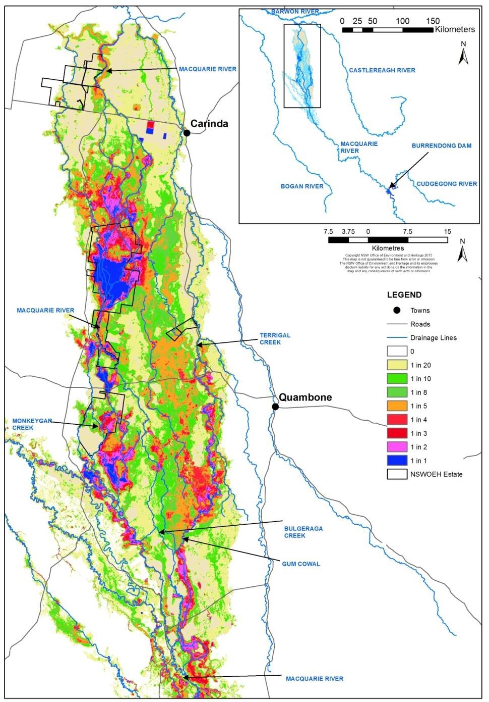a) b)

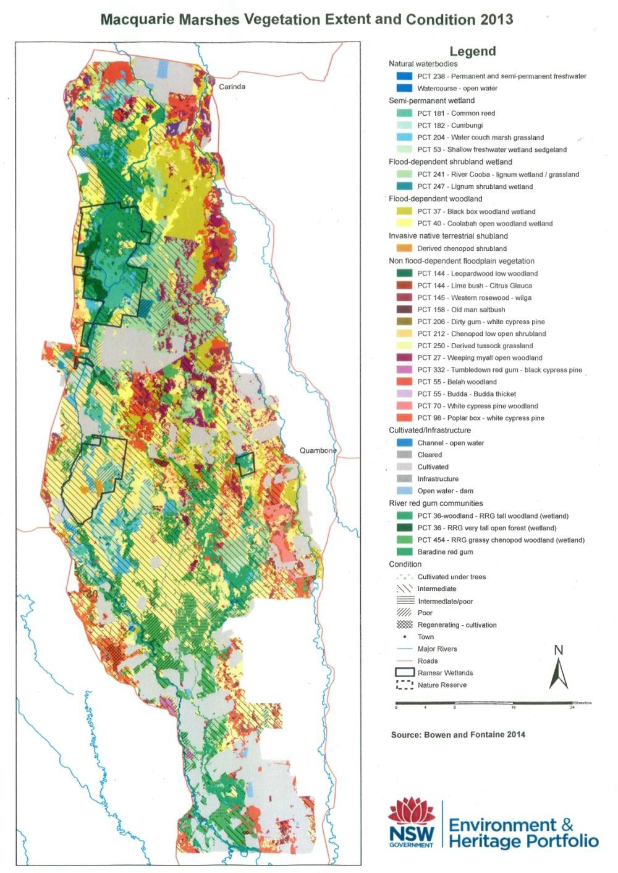

**Figure 4:** a) Vegetation mapping of the Macquarie Marshes (Bowen and Fontaine 2015) and b) Inundation frequencies of the Macquarie Marshes 1988–2008 (Thomas et al. 2015).

22

# Next steps

## From planning to decision making

It is important to distinguish between planning and operational decision making. As shown in Figure 5, planning allows the Office to manage the environmental water portfolio in a holistic manner and is an exercise in developing a broad approach or intention, based on the key drivers (demand and supply).

Decision making throughout each year builds on the intention by considering in more detail the specific prevailing factors and additional factors such as costs, risks, and constraints to water delivery and market conditions.

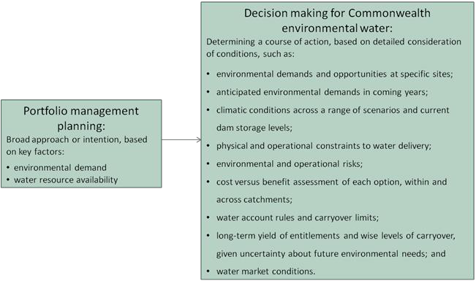

**Figure 5:** Planning and decision making for Commonwealth environmental water use

## Further information

For further information on how the Office plans for water use, carryover and trade, please visit our web site: <http://www.environment.gov.au/water/cewo>

or the sites below:

* Water use: [www.environment.gov.au/topics/water/commonwealth-environmental-water-](http://www.environment.gov.au/topics/water/commonwealth-environmental-water-office/assessment-framework)  [office/assessment-framework](http://www.environment.gov.au/topics/water/commonwealth-environmental-water-office/assessment-framework)
* Carryover: [http://www.environment.gov.au/topics/water/commonwealth-environmental-water-](http://www.environment.gov.au/topics/water/commonwealth-environmental-water-office/portfolio-management/carryover)  [office/portfolio-management/carryover](http://www.environment.gov.au/topics/water/commonwealth-environmental-water-office/portfolio-management/carryover)
* Trade: *Discussion Paper – Trade of Commonwealth Environmental Water* and *Commonwealth Environmental Water Trading Framework:*  <http://www.environment.gov.au/water/cewo/trade/trading-framework>

# Bibliography

Barma Water Resources in association with IRPEC Pty Ltd and Paul Wettin (2011). *Environmental Water Delivery: Macquarie River*. Prepared for the Commonwealth Environmental Water Office, Canberra. Unpublished.

Brandis, K. (2017). *High resolution monitoring of waterbird colonies in the Macquarie Marshes*. Draft final report, May 2017. Centre for Ecosystem Science, University of NSW.

Bureau of Meteorology (2017). *Archive – twelve monthly maximum temperature decile for New South Wales/ACT.*  [http://www.bom.gov.au/jsp/awap/temp/archive.jsp?colour=colour&map=maxdecile&year=2013&](http://www.bom.gov.au/jsp/awap/temp/archive.jsp?colour=colour&amp;map=maxdecile&amp;year=2013&amp;month=6&amp;period=12month&amp;area=ns)  [month=6&period=12month&area=ns](http://www.bom.gov.au/jsp/awap/temp/archive.jsp?colour=colour&amp;map=maxdecile&amp;year=2013&amp;month=6&amp;period=12month&amp;area=ns)

Bureau of Meteorology (2017). *Forty-eight-monthly rainfall deciles for New South Wales / ACT – 1 July 2012 to 30 June 2016.*

[http://www.bom.gov.au/jsp/awap/rain/index.jsp?colour=colour&time=history%2Fns%2F20120801201](http://www.bom.gov.au/jsp/awap/rain/index.jsp?colour=colour&amp;time=history%2Fns%2F2012080120160731&amp;step=7&amp;map=decile&amp;period=48month&amp;area=ns)  [60731&step=7&map=decile&period=48month&area=ns](http://www.bom.gov.au/jsp/awap/rain/index.jsp?colour=colour&amp;time=history%2Fns%2F2012080120160731&amp;step=7&amp;map=decile&amp;period=48month&amp;area=ns)

Bureau of Meteorology (2017). *Monthly rainfall deciles for New South Wales/ACT – June 2016*. [http://www.bom.gov.au/jsp/awap/rain/index.jsp?colour=colour&time=history%2Fns%2F20160701201](http://www.bom.gov.au/jsp/awap/rain/index.jsp?colour=colour&amp;time=history%2Fns%2F2016070120160731&amp;step=7&amp;map=decile&amp;period=month&amp;area=ns)  [60731&step=7&map=decile&period=month&area=ns](http://www.bom.gov.au/jsp/awap/rain/index.jsp?colour=colour&amp;time=history%2Fns%2F2016070120160731&amp;step=7&amp;map=decile&amp;period=month&amp;area=ns)

Bureau of Meteorology (2017). *Monthly rainfall deciles for New South Wales/ACT – September 2016*. [http://www.bom.gov.au/jsp/awap/rain/index.jsp?colour=colour&time=history%2Fns%2F20160801201](http://www.bom.gov.au/jsp/awap/rain/index.jsp?colour=colour&amp;time=history%2Fns%2F2016080120160831&amp;step=4&amp;map=decile&amp;period=month&amp;area=ns)  [60831&step=4&map=decile&period=month&area=ns](http://www.bom.gov.au/jsp/awap/rain/index.jsp?colour=colour&amp;time=history%2Fns%2F2016080120160831&amp;step=4&amp;map=decile&amp;period=month&amp;area=ns)

Bureau of Meteorology (2017). *Three monthly rainfall deciles for New South Wales/ACT – 1 June to 31 August 2016*. [http://www.bom.gov.au/jsp/awap/rain/index.jsp?colour=colour&time=history%2Fns%2F20160701201](http://www.bom.gov.au/jsp/awap/rain/index.jsp?colour=colour&amp;time=history%2Fns%2F2016070120160930&amp;step=5&amp;map=decile&amp;period=3month&amp;area=ns)  [60930&step=5&map=decile&period=3month&area=ns](http://www.bom.gov.au/jsp/awap/rain/index.jsp?colour=colour&amp;time=history%2Fns%2F2016070120160930&amp;step=5&amp;map=decile&amp;period=3month&amp;area=ns)

Bureau of Meteorology (2017). *Three monthly rainfall deciles for New South Wales/ACT – 1 December 2016 to 28 February 2017.*  [http://www.bom.gov.au/jsp/awap/rain/index.jsp?colour=colour&time=history%2Fns%2F20170101201](http://www.bom.gov.au/jsp/awap/rain/index.jsp?colour=colour&amp;time=history%2Fns%2F2017010120170331&amp;step=2&amp;map=decile&amp;period=3month&amp;area=ns)  [70331&step=2&map=decile&period=3month&area=ns](http://www.bom.gov.au/jsp/awap/rain/index.jsp?colour=colour&amp;time=history%2Fns%2F2017010120170331&amp;step=2&amp;map=decile&amp;period=3month&amp;area=ns)

Bureau of Meteorology (2017). *Three monthly maximum temperature decile for New South Wales/ACT – 1 June to 31 August 2016*. [http://www.bom.gov.au/jsp/awap/temp/index.jsp?colour=colour&time=history%2Fns%2F2016070120](http://www.bom.gov.au/jsp/awap/temp/index.jsp?colour=colour&amp;time=history%2Fns%2F2016070120160930&amp;step=5&amp;map=maxdecile&amp;period=3month&amp;area=ns)  [160930&step=5&map=maxdecile&period=3month&area=ns](http://www.bom.gov.au/jsp/awap/temp/index.jsp?colour=colour&amp;time=history%2Fns%2F2016070120160930&amp;step=5&amp;map=maxdecile&amp;period=3month&amp;area=ns)

Bureau of Meteorology (2017). *Three monthly maximum temperature decile for New South Wales/ACT – 1 December 2016 to 28 February 2017*. [http://www.bom.gov.au/jsp/awap/temp/index.jsp?colour=colour&time=history%2Fns%2F2017010120](http://www.bom.gov.au/jsp/awap/temp/index.jsp?colour=colour&amp;time=history%2Fns%2F2017010120170331&amp;step=2&amp;map=maxdecile&amp;period=3month&amp;area=ns)  [170331&step=2&map=maxdecile&period=3month&area=ns](http://www.bom.gov.au/jsp/awap/temp/index.jsp?colour=colour&amp;time=history%2Fns%2F2017010120170331&amp;step=2&amp;map=maxdecile&amp;period=3month&amp;area=ns)

Bureau of Meteorology (2017). *Twelve monthly maximum temperature decile for New South Wales/ACT.*  [http://www.bom.gov.au/jsp/awap/temp/index.jsp?colour=colour&time=latest&step=0&map=maxd](http://www.bom.gov.au/jsp/awap/temp/index.jsp?colour=colour&amp;time=latest&amp;step=0&amp;map=maxdecile&amp;period=12month&amp;area=ns)  [ecile&period=12month&area=ns](http://www.bom.gov.au/jsp/awap/temp/index.jsp?colour=colour&amp;time=latest&amp;step=0&amp;map=maxdecile&amp;period=12month&amp;area=ns)

Bureau of Meteorology (2017). *Monthly rainfall deciles for New South Wales / ACT.*  [http://www.bom.gov.au/jsp/awap/rain/index.jsp?colour=colour&time=latest&step=1&map=decile&](http://www.bom.gov.au/jsp/awap/rain/index.jsp?colour=colour&amp;time=latest&amp;step=1&amp;map=decile&amp;period=month&amp;area=ns)  [period=month&area=ns](http://www.bom.gov.au/jsp/awap/rain/index.jsp?colour=colour&amp;time=latest&amp;step=1&amp;map=decile&amp;period=month&amp;area=ns)

Commonwealth Environmental Water Office (2014). *Commonwealth environmental water use options 2014–15: Macquarie River Valley*. Commonwealth of Australia 2014.

Department of Primary Industries – Office of Water (2017). *Burrendong Dam real time data*. <http://realtimedata.water.nsw.gov.au/water.stm>

Jenkins, K., Kingsford, R., Wolfenden, B., Shiquan, R., and Driver, P. (2012). *Invertebrate monitoring and modelling in the Macquarie Marshes.* NSW Department of Primary Industries, Sydney.

McGinness, H., Martin, J., Robinson, F., Davies, M., Piper, M., Keyte, P., Suter, S., Spencer, J., Rees, J., Webster, E., Brandis, K., Kingsford, R., Doerr, V., Mac Nally, R. (2017). *Waterbird movements and breeding success in the Macquarie Marshes, NSW 2016–17.* Progress Report May 2017, submitted to the Commonwealth Environmental Water Office (CEWO), Department of Environment and Energy. CSIRO, Canberra.

Murray-Darling Basin Authority (2012). *Assessment of environmental water requirements for the proposed Basin Plan: Macquarie Marshes*. <http://www.mdba.gov.au/sites/default/files/archived/proposed/EWR-Macquarie-Marshes.pdf>

Murray-Darling Basin Authority (2014). *Basin-wide environmental watering strategy.*

<http://www.mdba.gov.au/sites/default/files/pubs/Final-BWS-Nov14.pdf>

NSW Department of Environment, Climate Change and Water (2010). *Macquarie Marshes Adaptive Environmental Management Plan*. Synthesis of information projects and actions. DECCW, June 2010.

NSW Office of Environment and Heritage (2017). *Summary of observations from two years of monitoring frogs in the Macquarie Marshes*. NSW Office of Environment and Heritage, February 2017.

Ocock, J. and Spencer, J. (2016). *OEH frog surveys in the Macquarie Marshes – spring 2015*. NSW Office of Environment and Heritage, February 2016.

Spencer, J., Hosking, T., Ocock, J. and Suter, S. (2016). *OEH waterbird surveys in the Macquarie Marshes – spring 2015*. NSW Office of the Environment and Heritage, February 2016.

Thomas, R. F., Kingsford, R. T., Lu, Y., Cox, S. J., Sims, N. C. and Hunter, S. J., (2015). Mapping inundation in the heterogeneous floodplain wetlands of the Macquarie Marshes, using Landsat Thematic Mapper. *Journal of Hydrology*, 524, 194–213.

Torrible, L., Wettin, P., Barma, D., Wilson, G., Hobcroft, D., and O’Cock, J. (2011). *Post flood assessment and determination of environmental water requirements for Gunningbar Creek, Lower Crooked Creek, Marra Creek and the lower Macquarie River*. Prepared by IRPEC Pty for BWR on behalf of the Australian Government Department of Sustainability, Environment, Water, Population and Communities.

WaterNSW (2017). *Burrendong Dam – facts and history*. <http://www.waternsw.com.au/supply/visit/burrendong-dam>

WaterNSW (2017). *Windamere Dam – facts and history*. <http://www.waternsw.com.au/supply/visit/windamere-dam>

# Attachment A – Expected outcomes from the Basin-wide environmental watering strategy

Expected outcomes from the Basin-wide environmental watering strategy (MDBA 2014) that are relevant to the Macquarie River Valley are described below.

### RIVER FLOWS AND CONNECTIVITY

Baseflows are at least 60 per cent of the natural level

Contributing to a 10 per cent overall increase in flows in the Barwon–Darling A 10–20 per cent increase in the frequency of freshes and bankfull flows **VEGETATION**

Maintain the current extent of water-dependent vegetation near river channels and on low-lying areas of the floodplain.

No decline in the condition of river red gum, black box and coolibah across the Basin Improved recruitment of trees within black box, river red gum and coolibah communities Improve condition of lignum shrublands in the Macquarie Marshes

Increased periods of growth for non-woody vegetation communities that closely fringe or occur within the river and creek channels, and for common reed and cumbungi in the Macquarie Marshes.

### Vegetation extent

|  |  |  |  |  |
| --- | --- | --- | --- | --- |
| **Area of river red gum (ha)** | **Area of black box (ha)** | **Area of coolibah (ha)** | **Shrublands** | **Non–woody water dependent vegetation** |
| 58 200 | 57 100 | 32 200 | Lignum in the Macquarie Marshes | Closely fringing or occurring within the Bogan, Castlereagh, Macquarie and Talbragar rivers; and common reed, cumbungi and water couch in the Macquarie Marshes |

**WATERBIRDS**

Maintain current species diversity

Increase Basin-wide abundance of waterbirds by 20–25 per cent by 2024

A 30–40 per cent increase in nests and broods (Basin-wide) for other waterbirds

Up to 50 per cent more breeding events (Basin-wide) for colonial nesting waterbird species

### Important Basin environmental assets for waterbirds in the Macquarie

|  |  |  |  |  |  |
| --- | --- | --- | --- | --- | --- |
| Environmental asset | Total abundance and diversity | Drought refuge | Colonial waterbird breeding | Shorebird abundance | In scope for Cth e- watering |
| Macquarie Marshes | Yes | Yes | Yes | Yes | Yes |

**FISH**

No loss of native species

Improved population structure of key species through regular recruitment, including:

* Short-lived species with distribution and abundance at pre-2007 levels and breeding success every one to two years
* Moderate to long-lived with a spread of age classes and annual recruitment in at least 80 per cent of years

Increased movements of key species

Expanded distribution of key species and populations

### Key species for the Macquarie include:

|  |  |  |
| --- | --- | --- |
| Species | Specific outcomes | In-scope for Cth e-water in the Macquarie? |
| Flathead galaxias (*Galaxias rostratus*) | Considered extinct. Reintroduction using southern populations may be an option in the longer term, with the Macquarie a potential candidate site. | Possibly (Once widespread. Current extent unknown in Macquarie. Potential for re- introduction) |
| Freshwater catfish (*Tandanus tandanus*) | Expand the core range of existing populations in the Macquarie | Yes |
| Golden Perch (*Macquaria ambigua*) | A 10–15 per cent increase of mature fish (of legal take size) in key populations | Yes |
| Murray cod (*Maccullochella peelii peelii*) | A 10–15 per cent increase of mature fish (of legal take size) in key populations | Yes |
| Olive perchlet (*Ambassis agassizii*) | Establish additional populations in the Macquarie | Possibly (Once widespread. Current extent unknown in Macquarie. Potential for re- introduction) |
| Silver perch (*Bidyanus bidyanus*) | Expand the core range in the Macquarie catchments | Yes |
| Southern purple-spotted gudgeon (*Mogurnda adspersa*) | Expand the range (or core range) of populations in the Macquarie. Establish additional populations | Yes |
| Trout cod (*Maccullochella macquariensis*) | The distribution of trout cod in the Northern Basin is limited to the Macquarie catchment downstream of Burrendong Dam. Range expansion of the current population is a priority.  Establish additional populations | Yes |

**Important Basin environmental assets for native fish in the Macquarie**

|  |  |  |  |  |  |  |  |
| --- | --- | --- | --- | --- | --- | --- | --- |
| Environmental asset | Key movement corridors | High Biodiversity | Site of other Significance | Key site of hydrodynamic diversity | Threatened species | Dry period / drought refuge | In-scope for Cth e-water |
| Macquarie River – below Burrendong Dam to Warren | Yes | Yes |  |  | Yes | Yes | Yes |
| Macquarie Marshes to Barwon, including lateral connectivity at the marshes | Yes |  |  |  | Yes | Yes | Yes |
| Lower Bogan River to junction with the Darling River | Yes |  |  |  | Yes | Yes | Yes |

# Attachment B – Library of watering actions

## Operational considerations in the Macquarie River Valley

The delivery of environmental water in the Macquarie River Valley is currently constrained by the release capacities from storages, channel capacities, and system constraints.

Watering actions will be developed in consideration of the following constraints:

* Burrendong Dam storage capacity of 1 188 000 ML and outlet capacity of 8 200 ML/day (WaterNSW 2015)
* South Dubbo weir drown out at > 14 385 ML/day
* Marebone Choke – third party impact at prolonged flows > 4 000 ML/day
* Crooked Creek off take capacity of 100 ML/day
* structures such as banks, weirs, regulators and diversion channels in the Macquarie Marshes.

The Commonwealth Environmental Water Office will develop watering options within existing water delivery and channel capacity constraints unless the agreement of all affected parties has been obtained for an alternative delivery approach.

## Potential watering actions under different levels of water resource availability

Under certain levels of water resource availability, watering actions may not be pursued for a variety of reasons, including that environmental demand may be met by unregulated flows and that constraints and/or risks may limit the ability to deliver environmental water. Table 4 identifies the range of potential watering actions in the Macquarie River Valley and the levels of water resource availability that relate to these actions.

**Table 4:** Summary of potential watering actions for the Macquarie River Valley

|  |  |  |  |  |  |  |
| --- | --- | --- | --- | --- | --- | --- |
| **Broad Asset** | **Indicative demand** | **Applicable level(s) of resource availability** | | | | |
| **Very Low** | **Low** | **Moderate** | **High** | **Very High** |
| **Mid- Macquarie River** | Baseflows: small, very regular flows through to end of system, wetting holes and instream storages. | *1. Minimum baseflows*: contribute to flows to maintain connectivity during extreme dry conditions to provide native fish refuge if regulated flows cease | |  |  |  |
| Small freshes: up to 800– 1 000 ML/day for at least 14 days at Baroona in spring (Oct-Nov) to mid-  autumn; and conditioning flow in winter (July to mid- August. | *2. Native fish maintenance flow*: contribute to flows (baseflows and freshes) in the mid- Macquarie River for the maintenance and conditioning of native fish (flow generalists and in-channel specialists) (July to mid-August)* | | | |  |
| *3. Native fish flow (flow generalists + in-channel specialists)*: contribute to river flows (baseflows and freshes) in the mid-Macquarie River to provide habitat for native fish (all guilds) and to provide spawning opportunities for flow generalists and in-channel specialists (spring)* | | | |  |
| Priming flow:>5 000 ML total flows at Baroona over 3 days with approx. 7 day recession (tributary pulse).  Spawning pulse: initial peak ≥ 5 000 ML/day at Baroona for >2 days with event lasting for >7 days. (35–40 day total pulse)  Dispersal flow: Initial pulse  >3 000 ML total flows over 3 days at Baroona.  Second pulse min.  2 000ML/day peak with recession. Approx 10d duration total events.  (Oct-March)  Water temperature for all pulses ≥19oC. |  |  | *4. Native fish flow (flow specialists)*: contribute to river flows (freshes) in the mid-Macquarie River to support native fish populations (flow specialists), including movement, reproduction and recruitment* | |  |

30

|  |  |  |  |  |  |  |
| --- | --- | --- | --- | --- | --- | --- |
| **Broad Asset** | **Indicative demand** | **Applicable level(s) of resource availability** | | | | |
| **Very Low** | **Low** | **Moderate** | **High** | **Very High** |
|  | Large freshes and bankfull: 10 000–20 000 ML/day at Baroona for a minimum of 3 days (to drown out key weirs). |  |  |  | *5. Native fish passage flow*: contribute to river flows (freshes) in the mid-Macquarie River to drown key weirs and provide movement, spawning and recruitment opportunities for flow specialists and generalists * | |
| **Lower Macquarie River** | Seasonal freshes: in- channel flows  Minimum 20 ML/day at Bells Bridge for 45 days. |  | *6.* Contribute to flows (seasonal freshes) to provide connectivity to the lower Macquarie River and through to the Barwon-Darling, maintain aquatic ecosystems, and provide opportunities for native fish. *# | |  |  |
| System connectivity between Macquarie and Barwon catchments: minimum 50–100 ML/day at Bells Bridge for approximately 10 days (min. 50 cm depth) |  |  | 7. *Native fish system connection flow:* contribute to river flows in the lower Macquarie River system to provide connection with the Barwon River, allowing opportunities for the movement of native fish. | | |
| 15–30 GL at Bells Bridge to inundate floodplain and lower reach of Macquarie River |  |  |  | *8.* Contribute to flows to inundate floodplain and the lower reach of the lower Macquarie River through to the Barwon-Darling, provide connectivity, and support floodplain vegetation* | |
| **Macquarie Marshes** | Flows between 60 and 700 GL at Marebone over  five months between June and April  (wetland inundation action scalable depending on water resource availability scenario and target extent | *9. Wetland inundation:* Contribute to flows to the Macquarie Marshes to inundate wetland vegetation and provide habitat and recruitment opportunities for waterbirds, fish and frogs | | | | |
|  |  | *10. Waterbird breeding contingency:* Contribute to flows to the Macquarie Marshes to maintain inundation in key waterbird reproduction areas to support a naturally triggered breeding event | | |

|  |  |  |  |  |  |  |
| --- | --- | --- | --- | --- | --- | --- |
| **Broad Asset** | **Indicative demand** | **Applicable level(s) of resource availability** | | | | |
| **Very Low** | **Low** | **Moderate** | **High** | **Very High** |
| **Distributary creeks** | Baseflows and freshes targeting fish, vegetation and connectivity with the Barwon River |  |  | *11. Restoring natural flow variability:* Contribute to flows (baseflows and freshes) in Marra Creek and/or Lower Crooked Creek to support hydrological connectivity, vegetation and native fish populations | |  |

Note: Under certain resource availabilities, options may not be pursued for a variety of reasons including that environmental demand may be met by unregulated flows and that constraints and/or risks may limit the ability the deliver environmental water.

* Could be coordinated with environmental water delivery to the Macquarie Marshes, depending on timing and/or volumes. Providing connectivity via Marthaguy Creek may be achieved by coordinating with water delivered to the East Marsh.

# Targeted connection to the Barwon may be subject to conditions such as fish spawning/recruitment in the Barwon, tributary inflows, water availability and protection of environmental water.

## Potential watering actions – standard operating arrangements

Table 3 identifies the range of potential watering actions in the Macquarie River Valley in the Murray- Darling Basin that give effect to the long-term demands and flow regime identified as being in scope for the contribution of Commonwealth environmental water in any given year. The standard considerations associated with these actions are set out below.

### Mid-Macquarie River minimum baseflows

*Watering action:* Contribute to flows to maintain connectivity during extreme dry conditions to provide native fish refuge if regulated flow releases from Burrendong Dam cease.

*Standard operational considerations:* Target flow rates would be dependent on conditions in the system, the volume of water available to be delivered and operational considerations.

*Typical extent:* This watering action would contribute flows to the mid-Macquarie River downstream of Burrendong Dam to downstream of Warren.

*Approvals:* Consult with NSW agencies (WaterNSW, NSW OEH and NSW DPI Fisheries) before implementing this action.

### Native fish maintenance flow

*Watering action:* Contribute to flows (small freshes) in the mid-Macquarie River for the maintenance and conditioning of native fish (flow generalists and in-channel specialists) (July to mid-August).

*Standard operational considerations:*

* The flow limit for this action is 4 000 ML/day at Marebone Weir
* The timing of the flow is very important. Conditioning flows should ideally be delivered before mid- August to avoid favouring carp and providing a competitive advantage over native fish species. However, late winter pulses may be beneficial for movement of species such as Murray cod.
* This action would take advantage of in-stream flows by supplementing tributary flows and/or consumptive orders to create the desired flow increase and recession.
* This action could be coordinated with environmental water delivery to the Macquarie Marshes, depending on appropriate timing and volumes.

*Typical extent:* This watering action would be targeted at contributing flows to the mid-Macquarie River downstream of Burrendong Dam, but would also provide flows into the Macquarie Marshes.

*Approvals:* Consult with NSW agencies (WaterNSW, NSW OEH and NSW DPI Fisheries) before implementing this action.

### Native fish flow (flow generalists + in-channel specialists)

*Watering action:* Contribute to river flows (small freshes) in the mid-Macquarie River to provide habitat for native fish (all guilds) and to provide spawning opportunities for flow generalists and in-channel specialists.

*Standard operational considerations:*

* The flow limit for this action is 4 000 ML/day at Marebone Weir.
* This action would take advantage of in-stream flows by supplementing tributary flows and/or consumptive orders to create the desired flow increase and recession.
* Commonwealth supplementary entitlements could contribute to meeting this demand.
* This action could be coordinated with environmental water delivery to the Macquarie Marshes, depending on appropriate timing and volumes.

33

* If a small to medium sized fresh is moving through Marthaguy Creek, environmental water could be directed down Gum Cowal and the Eastern Marshes to support connectivity (targeting 5–7 days of connection of at least 0.5 m depth, with the Gum Cowal regulator fully open to ensure fish passage).
* If Marthaguy Creek is not flowing, environmental water could be directed down the mainstem Macquarie River into the Macquarie Marshes to benefit and maintain other downstream assets. The Marebone regulator would need to be operated to facilitate fish passage either via the fishway or by ensuring the liftgates are fully clear of the water, and flow velocity is low through the open gates to allow fish to pass.

*Typical extent:* This watering action would be targeted at contributing flows to the mid-Macquarie River downstream of Burrendong Dam, but would also provide flows into the Macquarie Marshes. Additional areas may be targeted in the Marshes and Marthaguy Creek depending on conditions to support connectivity.

*Approvals:* Consult with NSW agencies (WaterNSW, NSW OEH and NSW DPI Fisheries) before implementing this action.

### Native fish flow (flow specialists)

*Watering action:* Contribute to river flows (freshes) in the mid-Macquarie River to support native fish populations (flow specialists), including movement, reproduction and recruitment.

*Standard operational considerations:*

* The flow limit for this action is 4 000 ML/day at Marebone Weir.
* Triggers are based on tributary inputs, flow rates at Baroona and water temperatures of at least 19 degrees celcius.
* Two pulses consisting of a priming flow and then a spawning pulse may be required. This action would take advantage of in-stream flows by supplementing tributary flows and other water in the system to create the desired flow pulses and recessions.
* This action may include a dispersal/recruitment flow consisting of an initial pulse from tributary flows meeting required triggers, followed by a second peak with an appropriate recesssion.
* This action could be coordinated with environmental water delivery to the Macquarie Marshes, depending on appropriate timing and volumes.
* Commonwealth supplementary entitlements could contribute to meeting this demand by protecting some of the flow pulse.

*Typical extent:* This watering action would be targeted at contributing flows to the mid-Macquarie River downstream of Burrendong Dam, but would also provide flows into the Macquarie Marshes.

*Approvals:* Consult with NSW agencies (WaterNSW, NSW OEH and NSW DPI Fisheries) before implementing this action.

### Native fish passage flow

*Watering action:* Contribute to river flows (large freshes and bankfull) in the mid-Macquarie River to drown out key weirs and provide movement, spawning and recruitment opportunities for flow specialists and generalists.

*Standard operational considerations:*

* The flow limit for this action is 4 000 ML/day at Marebone Weir.
* A total of 15 000 ML/day at Dubbo is required to drown out weirs on the Macquarie River at Dubbo and Narromine.
* This action would take advantage of in-stream flows by supplementing tributary flows and/or consumptive orders to create the desired flow increase and recession .
* This action could be coordinated with environmental water delivery to the Macquarie Marshes, depending on appropriate timing and volumes.
* Commonwealth supplementary entitlements could contribute to meeting this demand.

*Typical extent:* This watering action would be targeted at contributing flows to the mid-Macquarie River downstream of Burrendong Dam, particularly at major weirs at Dubbo and Narromine to enable fish passage. The action would also provide flows into the Macquarie Marshes and possibly downstream to the lower Macquarie River.

*Approvals:* Consult with NSW agencies (WaterNSW, NSW OEH and NSW DPI Fisheries) before implementing this action.

### Lower Macquarie River in-channel freshes

*Watering action:* Contribute to flows (baseflows and freshes) to provide connectivity to the lower Macquarie River and Barwon-Darling, maintain aquatic ecosystems and riparian vegetation, and provide opportunities for native fish. This action would help support floodplain vegetation along the lower Macquarie River during periods of higher resource availability.

*Standard operational considerations:*

* The flow limit for this action is 4 000 ML/day at Marebone Weir.
* Target flow rates would be dependent on conditions in the system, the volume of water available to be delivered and operational considerations.
* This action could be coordinated with environmental water delivery to the Macquarie Marshes or other flows, depending on appropriate timing and volumes.
* Flows above 50 ML/day at Carinda may be at risk of extraction.

### Native fish system connection flow

Watering action: Contribute to river flows in the lower Macquarie River system to provide connection with the Barwon River, allowing opportunities for the movement of native fish. The action would also provide secondary benefits to the mid-Macquarie and Macquarie Marshes.

System connectivity flows to the Barwon River may be opportunisitic and subject to the following considerations:

* Potential for a fresh flow in the Barwon River of flows greater than 1 000 ML/day upstream of the confluence with the Macquarie River (contributed from any water source).
* Coordination of travel times between the Barwon and Macquarie flow pulses.
* Would ideally build on tributary pulses in the Macquarie to increase productivity and provide cues from the catchment, however, this is not critical.
* Need for protection mechanisms for environmental water or agreements not to pump.
* Lack of barriers for fish movement in the lower Macquarie River.
* Brewarrina fishway should be open (flow trigger for opening is 120 ML/day and rising at Geera, and 75 ML/day and rising at Boorooma on the Barwon River).
* Flows should be delivered down routes with the fewest fish barriers to maximise the environmental outcomes. The use of Bulgeraga Creek should be limited until fish passage is addressed at the dropbox regulator at the Gum Cowal bifurcation. The Northern Bypass Channel should be used only to prime the system quickly if flows need to catch up through the Northern Marshes.
* Flows would need to be delivered at a rate that does not cause high flow velocities at the Miralwyn pipe culverts, to a depth of at least 0.5 m. Connection with the Barwon River would be targeted for a minimum of 10 days at a flow of 50–100 ML/day.
* Water availability and antecedent conditions in the Macquarie River system (action more likely to occur during wetter conditions or when larger actions have been undertaken beforehand). Providing connection to the Barwon at a minimum depth of 0.5 m for a minimum of 10 days is unlikely to be feasible during periods of low water availability and dry conditions.

*Typical extent:* This watering action would be targeted at contributing flows to the lower Macquarie River downstream of the Macquarie Marshes, with benefits provided to the whole Macquarie River downstream of Burrendong Dam, and the Macquarie Marshes. If water is being provided to the Eastern Marshes it may also be possible to deliver additional water to the lower Macquarie River via Marthaguy Creek. Depending on water availability, this action would also provide flows to the Barwon-Darling system.

*Approvals:* Consult with NSW agencies (WaterNSW, NSW OEH and NSW DPI Fisheries) before implementing this action. Consultation with landholders about not pumping event may be required. Other protection mechanisms would require consultation with WaterNSW and NSW DPI Water. All fishways and regulators are required to be open and functioning for this action.

### Lower Macquarie floodplain inundation

*Watering action:* Contribute to flows to inundate floodplain and the lower reach of the lower Macquarie River through to the Barwon-Darling, provide connectivity, and support floodplain vegetation.

*Standard operational considerations:*

* The flow limit for this action is 4 000 ML/day at Marebone Weir.
* Target flow rates would be dependent on conditions in the system, the volume of water available to be delivered and operational considerations.
* This action could be coordinated with environmental water deliveries to the Macquarie Marshes or other flows, depending on appropriate timing and volumes.
* Flows above 50 ML/day at Carinda may be at risk of extraction, so consideration is required as to how environmental water would be protected to the end of system.

*Typical extent:* This watering action would be targeted at contributing to flows to the lower Macquarie River and floodplain downstream of the Macquarie Marshes. It is expected that this action would provide connectivity to the Barwon-Darling system. This action would provide additional benefits to the mid-Macquarie River and Marshes en route to the lower Macquarie.

*Approvals:* Consult with NSW agencies (WaterNSW, NSW OEH and NSW DPI Fisheries) before implementing this action. This action would also require close collaboration with relevant landholders to manage any potential third party impacts.

### Wetland inundation

*Watering action:* Contribute to flows to the Macquarie Marshes to inundate wetland vegetation, and provide habitat and recruitment opportunities for waterbirds, fish and frogs.

*Standard operational considerations:*

* The flow limit for this action is 4 000 ML/day at Marebone Weir.
* Commonwealth environmental water would be delivered via rivers flows from Burrendong Dam to Marebone Weir (accounting point), taking up to 11 days to reach the weir.
* Commonwealth supplementary entitlements could contribute to meeting this demand.
* Use of particular channels (e.g. Bulgeraga, Gum Cowal) will depend on assets and outcomes being targeted.

*Typical extent:*

* Depending on water availability, specific areas of the Marshes system may be targeted (e.g. within the Northern, Southern and/or Eastern Marshes) rather than the entire inundation zone.
* The extent targeted varies across demands and water resource availability scenarios and will vary depending on delivery design and flow rates. Approximate inundation extents are provided below:
  + Contribute to inundating up to 9 000 ha of reed beds, lagoons and water couch in the Macquarie Marshes (60 GL: Very Low to Low scenario).
  + Contribute to inundating up to 19 000 ha of reeds, water couch, mixed marsh, river red gum forest and river cooba in the Macquarie Marshes (100 GL: Very Low to Moderate scenario).
  + Contribute to inundating up to 50 000 ha of river red gum woodland, mixed marsh and river cooba in the Macquarie Marshes (250 GL: Low to High scenario).
  + Contribute to inundating between 81 000 and 145 000 ha of outer river red gum forest, coolibah, myall and black box in the Macquarie Marshes (400–700 GL: Moderate to High scenario).

*Approvals:* Consult with NSW agencies (WaterNSW, NSW OEH and NSW DPI Fisheries) before implementing this action.

### Waterbird breeding contingency

*Watering action:* Contribute to flows to the Macquarie Marshes to maintain inundation in key waterbird reproduction areas to support a naturally triggered breeding event.

*Standard operational considerations:*

* The flow limit for this action is 4 000 ML/day at Marebone Weir.
* Delivery of Commonwealth environmental water will be triggered by a shared recognition with NSW OEH and other key agencies that catchment conditions and short term future flows into the Marshes will be insufficient to maintain the conditions required to successfully complete a bird breeding event.
* Delivery of Commonwealth environmental water will be adaptively managed to maintain inundation at an appopriate depth and duration, and to avoid a rapid flow recession in known breeding areas.
* This action may not be operationalised if other flows (e.g. irrigation, unregulated, replenishment flows, flood mitigation zone releases) are deemed sufficient to support the breeding event to completion.
* Commonwealth environmental water would be delivered via rivers flows from Burrendong Dam to Marebone Weir (accounting point), taking up to 11 days to reach the weir.

*Typical extent:* Key waterbird breeding sites across the Macquarie Marshes. Specific sites will depend on where the waterbird breeding event takes place at that time.

*Approvals:* Consult with NSW agencies (WaterNSW, NSW OEH and NSW DPI Fisheries) before implementing this action. In particular, to determine whether environmental water can be delivered to the precise location of the bird breeding event.

### Restoring natural flow variability

*Watering action:* Contribute to flows (baseflows and freshes) in Marra Creek and/or lower Crooked Creek to support hydrological connectivity, vegetation and native fish populations.

*Standard operational considerations:*

* Target flow rates will be dependent on prevailing flow conditions, target assets and operational considerations.
* Commonwealth environmental water would be delivered as in-stream flows, which are gravity fed from Burrendong Dam and diverted from the Macquarie River channel into the distributary creeks system.
* Commonwealth environmental water could be provided to the distributary creeks using either General Security or Supplementary entitlements, depending on conditions and water availability. Flows may be provided in addition to replenishment or unregulated flows, and depending on conditions.
* Delivery to the lower Crooked Creek is constrained by the capacity of the Crooked Creek channel, regulator and Mumblebone Weir.
* Commonwealth supplementary entitlements could contribute to meeting this demand.

*Typical extent:* The likely target of this action would be the unregulated parts of the distributary creeks system such as Marra Creek and the lower Crooked Creek. Flows may also contribute to achieving connectivity with the Bogan River and/or Barwon-Darling. Other distributary creeks such as Duck and Gunningbar creeks are not likely to be targeted for the delivery of Commonwealth environmental water. Further investigation and consultation regarding the regulated distributary creeks may be understaken in the future.

*Approvals:* Close collaboration with landholders in the distributary creeks system would be required to deliver environmental water to the system. Consultation with NSW agencies (WaterNSW, NSW OEH and NSW DPI Fisheries) would be required before implementing this action.

# Attachment C – Long-term water availability

## Commonwealth environmental water holdings

The Commonwealth holds the following entitlements in the Macquarie River Valley:

* General security
* Supplementary

The full list of Commonwealth environmental water holdings can be found at [www.environment.gov.au/topics/water/commonwealth-environmental-water-office/about-](http://www.environment.gov.au/topics/water/commonwealth-environmental-water-office/about-commonwealth-environmental-water/how-much)  [commonwealth-environmental-water/how-much](http://www.environment.gov.au/topics/water/commonwealth-environmental-water-office/about-commonwealth-environmental-water/how-much) and is updated monthly.

## Other sources of environmental water

Other potential sources of held environmental water that may be used to complement Commonwealth environmental water delivery in the Macquarie River Valley include:

* General Security (New South Wales Office of Environment and Heritage)
* Supplementary (New South Wales Office of Environment and Heritage)

## Planned environmental water

In addition to water entitlements held by environmental water holders, environmental demands may also be met via water provided for the environment under rules in state water plans (referred to as ‘planned environmental water’).

There are many sources of Planned Environmental water in the catchment including:

* 1. a 160 GL General Security Allowance (‘Environmental Water Allowance’ – EWA) that is partly active and partly translucent, explicitly targeted in the Water Sharing Plan to the Macquarie Marshes.
  2. other protected flow components, such as triggers on supplementary event declarations and the ‘first 500ML/day rule’ for translucent releases under the EWA.
  3. a translucent allocation of 10 GL is stored in the Windamere Dam for the Cudgegong system, available only when dam inflow triggers are reached and dam storage levels are above a minimum level.
  4. a variety of other non-extracted water that is not easily accounted for, including surplus flows, tributary flows, rainfall irrigation rejections, local rainfall effects, conveyance water and base flows.

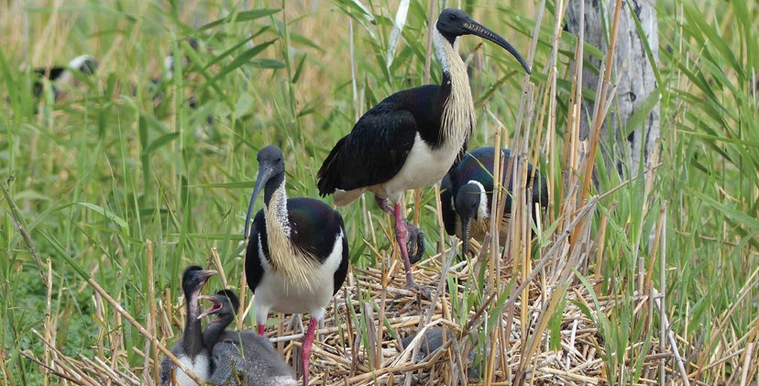For more information about Commonwealth environmental water, please contact us at:

 1800 803 772

@: [ewater@environment.gov.au](mailto:ewater@environment.gov.au)

[www.environment.gov.au/water/cewo](http://www.environment.gov.au/water/cewo)

@theCEWH



 GPO Box 787, Canberra, ACT, 2601