

**Commonwealth Environmental Water**

Portfolio Management Plan

Namoi River Valley

2017–18

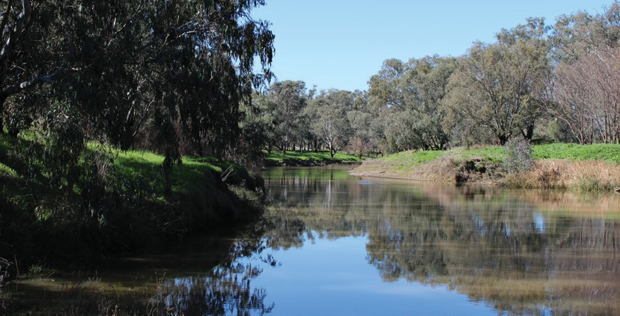

Front cover image credit: Namoi River. Photo by Commonwealth Environmental Water Office.

Back cover image credit: White-necked Heron, Walgett Town Weir. Photo by Commonwealth Environmental Water Office.

The Commonwealth Environmental Water Office respectfully acknowledges the traditional owners, their Elders past and present, their Nations of the Murray-Darling Basin, and their cultural, social, environmental, spiritual and economic connection to their lands and waters.

**© Copyright Commonwealth of Australia, 2017.**

*Commonwealth Environmental Water Portfolio Management Plan: Namoi River Valley 2017–18* is licensed by the Commonwealth of Australia for use under a Creative Commons Attribution 4.0 International licence with the exception of the Coat of Arms of the Commonwealth of Australia, the logo of the agency responsible for publishing the report, content supplied by third parties, and any images depicting people. For licence conditions see: https://creativecommons.org/licenses/by/4.0/

This report should be attributed as ‘*Commonwealth Environmental Water Portfolio Management Plan: Namoi River Valley 2017–18*, Commonwealth of Australia, 2017’.

The Commonwealth of Australia has made all reasonable efforts to identify content supplied by third parties using the following format ‘© Copyright’ noting the third party.

The views and opinions expressed in this publication are those of the authors and do not necessarily reflect those of the Australian Government or the Minister for the Environment and Energy.

While reasonable efforts have been made to ensure that the contents of this publication are factually correct, the Commonwealth does not accept responsibility for the accuracy or completeness of the contents, and shall not be liable for any loss or damage that may be occasioned directly or indirectly through the use of, or reliance on, the contents of this publication.

# Commonwealth environmental water portfolio management planning

## Commonwealth Environmental Water Holder

The Commonwealth Environmental Water Holder is a statutory position established under the *Water Act 2007* and is responsible for managing the Commonwealth’s environmental water holdings. This water must be managed to protect and restore the rivers, wetlands and floodplains (and the native animals and plants they support) of the Murray-Darling Basin. Mr David Papps is the current Commonwealth Environmental Water Holder. He is supported by staff of the Commonwealth Environmental Water Office. The Office employs six local engagement officers who live and work in regional centres across the Murray-Darling Basin.

## Commonwealth environmental water

Commonwealth environmental water holdings are water entitlements that have been acquired by the Australian Government through investments in water-saving infrastructure and purchases on the water market. The holdings are a mix of entitlement types held across 19 catchments. The rules governing the entitlements vary across states and across catchments. Commonwealth environmental water entitlements are subject to the same fees, allocations, carryover and other rules as equivalent entitlements held by other water users.

There are broadly three options for managing Commonwealth environmental water:

* delivering water to a river or wetland to meet an identified environmental demand
* leaving water in storage and carrying it over for use in the next water year (referred to as ‘carryover’)
* trading water, that is, selling water and using the proceeds to buy water in another catchment or in a future year, or investing in complementary ‘environmental activities’.

## Purpose of the document

This document sets out the plans for managing the Commonwealth environmental water portfolio in the Namoi River Valley for 2017–18. Efficient and effective management of Commonwealth environmental water requires the utilisation of all portfolio management options. By taking a multi-year approach to planning, portfolio management tools such as use, carryover and trade can be managed for maximising environmental outcomes.

The portfolio management plans support transparent, coordinated and adaptive management of Commonwealth environmental water, consistent with the Basin-wide environmental watering strategy and having regard to the Basin annual environmental watering priorities. To learn more about the planning approach see *Portfolio Management Planning: Approach to planning for the use, carryover and trade of Commonwealth environmental water, 2017–18* (available at: <http://www.environment.gov.au/water/cewo/publications>under ‘Planning approach’).

## Delivery partners

Commonwealth environmental water is managed in conjunction with and delivered by a range of partners. This portfolio management plan has been developed in consultation with our delivery partner WaterNSW. Commonwealth environmental water planning and delivery in the Namoi River Valley is supported by advice from New South Wales Office of Environment and Heritage, Department of Primary Industries – Water, Department of Primary Industries – Fisheries, and North West Local Land Services.

## Your input

The management of Commonwealth environmental water relies on considerable advice and assistance from local organisations, state governments and others. Individuals and groups within the Murray-Darling Basin community are encouraged to submit suggestions for the management of Commonwealth environmental water. Please contact the Office via: [ewater@environment.gov.au.](mailto:ewater@environment.gov.au)

# Table of contents

## Commonwealth environmental water portfolio management planning 1

Commonwealth Environmental Water Holder 1

Commonwealth environmental water 1

Purpose of the document 1

Delivery partners 1

Your input 1

## Table of contents 2

1. **Environmental watering in the Namoi River Valley 3**
   1. The Namoi River Valley 3
   2. Environmental objectives in the in the Namoi River Valley 5
   3. Environmental flow requirements 6
   4. Monitoring and adaptive management 6

## Portfolio management in 2017–18 7

* 1. Antecedent and current catchment conditions and the demand for environmental

water in 2017–18 7

* 1. Water availability in 2017–18 8
  2. Overall purpose of managing environmental water based on supply and demand 9
  3. Water Delivery in 2017–18 10
  4. Trading water in 2017–18 10
  5. Carrying over water for use in 2018–19 11
  6. Identifying Investment Opportunities 11

## Next steps 18

* 1. From planning to decision making 18
  2. Further information 18

## Bibliography 19

**Attachment A – Expected outcomes from the Basin-wide environmental**

**watering strategy 21**

**Attachment B – Library of watering actions 23**

Operational considerations in the Namoi River Valley 23

Potential watering actions under different levels of water resource availability 24

Potential watering actions – standard operating arrangements 26

## Attachment C – Long-term water availability 30

Commonwealth environmental water holdings 30

Other sources of environmental water 30

Planned environmental water 30

# Environmental watering in the Namoi River Valley

## The Namoi River Valley

The Namoi River Valley is located in north-eastern New South Wales (NSW), extending westwards of Nundle to Walgett. Rainfall in the upper catchment drives river flows and can be highly variable between years.

Water for regulated delivery throughout the valley is stored in Split Rock and Keepit dams (Figure 1). There are also a number of smaller regulating weirs downstream of Keepit Dam.

The Namoi River is the primary riverine asset and is a major tributary of the Barwon River. Major tributaries of the Namoi include Cox’s Creek and the Mooki, Manilla and the Peel rivers, which join the Namoi River upstream of Boggabri. Flows are confined in-channel until the floodplain begins to broaden at Gunnedah. The Pian (an anabranch of the Namoi River), Narrabri, Baradine and Bohena creeks contribute flows to the Namoi River downstream of Boggabri.

The Peel River contributes an average annual volume of approximately 280 000 megalitres (ML) into the Namoi system (Green et al. 2011). Flows are regulated out of Chaffey Dam and flow into the Namoi River slightly downstream of Keepit Dam. Major tributaries into the Peel River are Goonoo Goonoo Creek, the Cockburn River and Dungowan Creek.

Environmental watering in the Namoi River Valley is most likely to be delivered as baseflows or freshes, undertaken in conjunction with other flows in the system (e.g. a naturally occurring fresh flow, or consumptive water or block releases), or during prolonged low flow conditions.

Held environmental water in the Peel River can be made available from Chaffey Dam in combination with downstream unregulated tributary inflows, consumptive water or planned environmental water. For example, Commonwealth environmental water may be delivered in conjunction with the Peel environmental contingency allowance managed by the NSW Government.

In order to meet the Lower Namoi River in-channel fresh requirements regulated releases from Keepit Dam may need to be timed to coincide with unregulated inflows from the Peel and Mooki rivers and Cox’s Creek. The environmental benefits from these flows may also extend downstream to the Barwon-Darling River.

Where possible, environmental water will be managed to provide environmental benefit to multiple sites in order to maximise the efficiency and effectiveness of water delivery.

There is a growing awareness of the importance of connecting flows across the northern basin. These connecting flows support populations of native fish and aquatic fauna in the Barwon-Darling and the northern tributaries. These flows provide hydrological connections that link a diversity of aquatic environments for feeding, breeding, dispersal, migration and re-colonisation, which is essential for the survival of native fish populations and other aquatic fauna. The importance of these connecting flows will be taken into consideration when using Commonwealth environmental water to connect the Namoi and Barwon rivers.

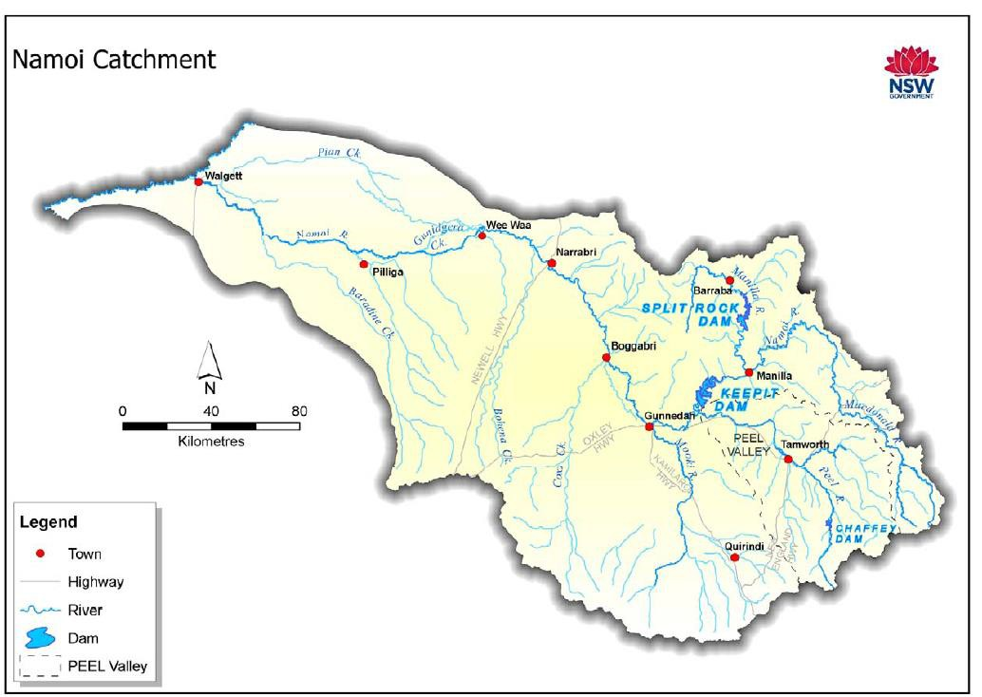

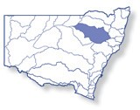

**Figure 1:** Map of the Namoi River Valley (Green et al. 2011).

4

## Environmental objectives in the in the Namoi River Valley

The long-term environmental objectives for the Murray-Darling Basin are described in the Basin Plan’s environmental watering plan and the Basin-wide environmental watering strategy, which includes ‘quantified environmental expected outcomes’ at both a Basin-scale and for each catchment. The expected outcomes relevant for the Namoi River Valley are described in Attachment A.

Basin state governments are also developing long-term watering plans for each catchment. These plans will identify the priority environmental assets and ecosystem functions in the catchment, the objectives and targets for these assets and functions, and their watering requirements. Once developed, these plans will provide the key information on the long-term environmental water demands in the catchment. Prior to the development of these long-term watering plans, the Office will continue to draw on existing documentation on environmental water demands developed by state governments, local natural resource management agencies, and the Murray-Darling Basin Authority.

Based on these strategies and plans, and in response to best available knowledge drawing on the results of environmental watering monitoring programmes, the objectives for environmental watering in the Namoi River Valley are summarised in Table 1 below. The objectives for water-dependent ecosystems will continue to be revised as part of the Office’s commitment to adaptive management.

**Table 1:** Summary of objectives being targeted by environmental watering in the Namoi River Valley

|  |  |  |  |
| --- | --- | --- | --- |
| **BASIN-WIDE OUTCOMES**  **(Outcomes in red link to the Basin-wide Environmental Watering Strategy)** | **ENVIRONMENTAL OBJECTIVES FOR NAMOI RIVER VALLEY ASSETS** | | |
| **IN-CHANNEL ASSETS** | | **OFF-CHANNEL ASSETS** |
| **Lower Namoi River channel** | **Peel River channel** | **Lower Namoi anabranch & floodplain wetland system** |
| **VEGETATION** | Maintain riparian and in-channel vegetation condition, growth and survival (extent) | | Maintain the condition, growth and survival (extent) of native vegetation of the anabranch communities and wetland vegetation |
| **WATERBIRDS** | Provide drought refuge for waterbirds and support waterbird habitat | | |
| **FISH** | Support reproduction and recruitment opportunities for native fish  Support connectivity and movement, and maintain in-channel refuge and aquatic habitat for native fish | | |
| **MACROINVERTEBRATES** | Support recruitment and maintain macroinvertebrate diversity | | |
| **OTHER VERTEBRATES** | Support opportunities for the reproduction and recruitment of other native aquatic species, including frogs and turtles | | |
| **CONNECTIVITY** | Support longitudinal connectivity, including with the Lower Namoi floodplain and Barwon-Darling system | Support longitudinal connectivity along the river channel | Support connectivity, particularly lateral between the river and floodplain |
| **PROCESSES** | Support key ecosystem functions within channel and on the floodplain, including the cycling of nutrients and wetting banks and benches | | |
| **WATER QUALITY** | Maintain water quality within channels and pools | | |
| **RESILIENCE** | Provide drought refuge habitat (particularly for fish) | | |

Information sourced from: MDBA (2012), MDBA (2014), Barma Water Resources et al. (2012), Department of the Environment (2014).

## Environmental flow requirements

Not all environmental demands can and will be met through the use of held environmental water. Some demands are met by regulated water deliveries for consumptive purposes while others are met by planned environmental water such as large unregulated/natural flows events and end of system flow requirements. Some demands are beyond what can be delivered within operational constraints.

Figure 2 below shows the broad environmental demands that are in scope for Commonwealth environmental water. Importantly, these are broad, indicative demands and individual watering events may contribute to particular opportunities, such as using infrastructure to deliver water to individual wetlands that would otherwise not be possible due to constraints. Also, there may be opportunities for Basin State governments to remove or modify constraints, which will improve the efficiency and/or effectiveness of environmental watering. Further information on delivery constraints are described in Attachment B.

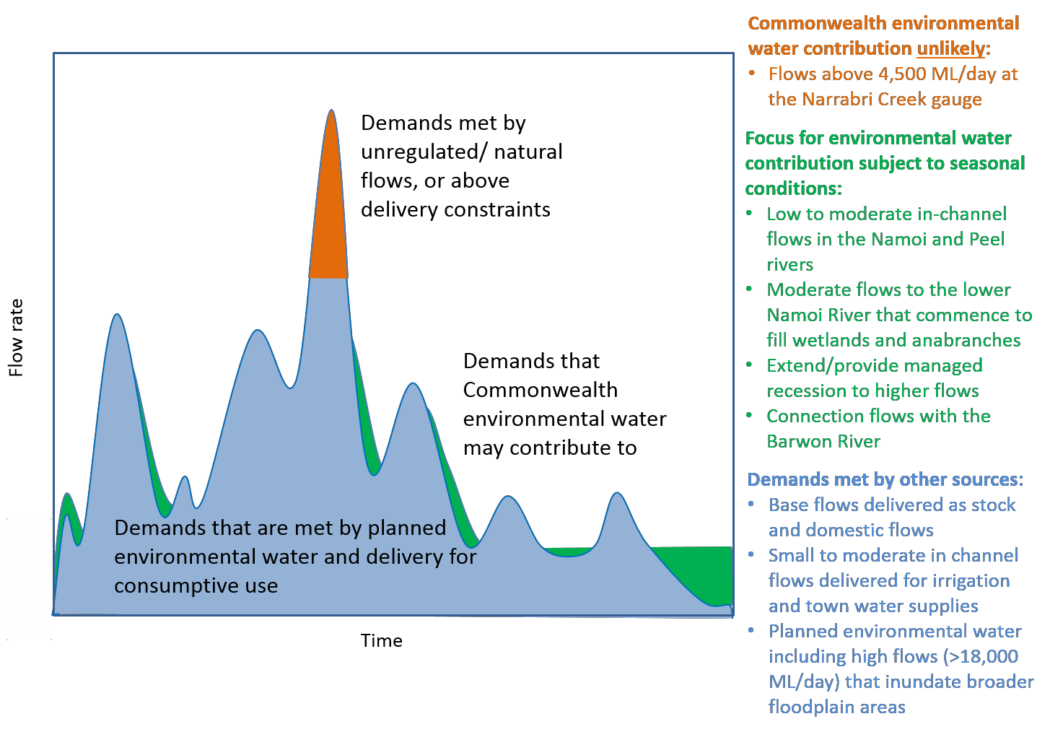

**Figure 2:** Scope of demands that Commonwealth environmental water may contribute to in the Namoi River Valley

Based on the above objectives and delivery constraints, specific watering requirements (flow magnitude, duration, timing and frequency) have been identified as being in scope for Commonwealth environmental water. These water requirements are described in Table 3. The priority for the use of Commonwealth environmental water is maintaining low flows in the catchment as these are required to maintain ecosystem health. As with the objectives and targeted outcomes, the environmental water requirements will continue to be reviewed and revised in response to new knowledge.

## Monitoring and adaptive management

Operational monitoring is undertaken for Commonwealth environmental watering actions and involves collecting on-ground data with regard to environmental water delivery such as volumes delivered, impact on the river systems hydrograph, area of inundation and river levels. It can also include observations of environmental outcomes. Short term intervention monitoring will be considered for Commonwealth environmental watering events in the Namoi River Valley in 2017–18. The outcomes from these monitoring activities are used to inform portfolio management planning and adaptive management decision-making as outlined in the following Section 2.

# Portfolio management in 2017–18

In planning for the management of Commonwealth environmental water, the Office aims to maximise the outcomes achieved from the available water. This includes consideration of the urgency of environmental demands (based on targeted objectives and watering requirements, watering history and asset condition) and the available supply under different resource scenarios. Plans for water delivery, trade and carryover are then made in a multi-year context, with an assessment also undertaken of the need for water in future years.

This planning process is outlined in full in Table 3 and summarised in the sections below.

## Antecedent and current catchment conditions and the demand for environmental water in 2017–18

Dry conditions prevailed in the Namoi River Valley from 2013 to 2016 with below average rainfall and above average temperatures. The minimum flows required to maintain refuge pools did not occur for several years. This is likely to have contributed to the decline of environmental assets in the Namoi River Valley. Water availability improved in 2016 with increased rainfall, tributary and consumptive flows starting the recovery of the environmental assets. Commonwealth environmental water releases in 2017 along with natural flows from the Namoi River tributaries and the Peel River supported further asset recovery. Some environmental assets experienced ecological damage in the dry conditions from 2013 to 2016 and are taking a while to recover and are still in a poor condition. Water dependent species will require support in 2017–18 to ensure their survival, and the river system will need water to maintain and build resilience over the coming years.

Environmental water demands for environmental assets in the Namoi River Valley in 2017–18 are represented in Table 3 and summarised below:

*Lower Namoi River channel:* Low to High demand. The majority of the higher flow water frequencies were met in 2016–17. However, the dry conditions from 2013–16 contributed to ecological damage resulting in a high environmental demand for low to medium flows in 2017–18 to support recovery even where required watering frequencies have been met. Minimum flows are required each year and there is a high environmental demand for these flows.

*Wetlands/anabranches*: Low to moderate environmental demand. Wetter conditions provided the minimum duration requirements of flows for 7 days in 2016 but not the maximum duration requirements of flows for 45 days.

*Peel River channel:* High demand. There is a high demand for baseflows in the Peel River every year. The higher flow requirements were met in 2016.

Commonwealth environmental water holdings in the Namoi River Valley are just over 11 GL and so are insufficient to meet all of the environmental water demands in the Valley.

### Murray-Darling Basin-wide environmental watering strategy and 2017–18 annual priorities

In contributing to these demands, the Commonwealth Environmental Water Office will also be aiming to contribute to the expected outcomes in the Basin-wide environmental watering strategy (see Attachment A) and the following 2017–18 Basin annual environmental watering priorities relevant to the Namoi River Valley.

* Improve flow regimes and connectivity to maximise the ecological function of the Barwon-Darling river system for native fish
* Support viable populations of threatened native fish and maximise opportunities for range expansion and the establishment of new populations

## Water availability in 2017–18

### Forecasts of Commonwealth water allocations

The volume of Commonwealth environmental water likely to be carried over in the Namoi River Valley for use in 2017–18 is estimated to be around 9 GL.

Allocations against Commonwealth water entitlements in the Namoi River Valley will vary depending on inflows and are determined by NSW. The following forecasts in Table 2 are based on the best available information including State forecasts and historical inflow scenarios.

**Table 2**: Forecasts of Commonwealth water allocations (including carryover) in 2017–18 in the Namoi River Valley as at 31 May 2017.

|  |  |  |  |  |  |  |
| --- | --- | --- | --- | --- | --- | --- |
| **Entitlement type** | **Forecasts of Commonwealth water allocations (including carryover) in 2017–18 (GL)** | | | | | |
| **Very dry** |  |  |  | **Very wet** | |
| **95**  **percentile** | **90**  **percentile** | **75**  **percentile** | **50**  **percentile** | **25**  **percentile** | **10**  **percentile** |
| Upper Namoi general security | 0.1 | 0.1 | 0.1 | 0.1 | 0.1 | 0.1 |
| Lower Namoi general security | 9.0 | 9.0 | 9.6 | 11.9 | 15.2 | 19.5 |
| Peel River general security | 1.2 | 1.2 | 1.2 | 1.2 | 1.2 | 1.2 |
| **Total – Namoi** | **10.3** | **10.3** | **10.9** | **13.2** | **16.5** | **20.8** |

Notes:

1. Forecasts for regulated catchments are given to the nearest whole GL except where the entitlement held by the Commonwealth is below 1 GL.
2. Allocation rate scenarios are based on long term average allocation rates.
3. Figures include a carryover account balance of 9 GL

Information on allocations to Commonwealth environmental water holdings can be found at <http://www.environment.gov.au/water/cewo/about/water-holdings>and is updated monthly.

### Water resource availability scenarios

Commonwealth environmental water is not managed in isolation. When considering the available resource to meet environmental demands, it is necessary to also factor in the resources managed by other entities and available to contribute to environmental objectives. While there are currently no other sources of held environmental water in the Namoi River Valley, relevant water resources include planned environmental water (e.g. end of system flows and environmental contingency allowance), unregulated flows, conveyance water and consumptive water. Further detail on the sources of water in the Namoi River Valley is provided in Attachment C.

By combining the forecasts of water held by the Commonwealth with streamflow forecasts, as well as taking into account operational considerations, water resource availability scenarios can be developed ranging from very low to very high. Based on available information, low to very high resource availability scenarios are in scope for 2017–18.

## Overall purpose of managing environmental water based on supply and demand

Environmental water needs (demand) and water availability (supply) both influence the overall purpose of Commonwealth environmental water management. Under different combinations, the management purpose can range from ‘avoiding damage’ to the environment to ‘improving’ ecological health. This in turn informs the mix of portfolio management options that are suitable for maximising outcomes.

Figure 3 shows how current demands and forecasted supply are considered together.

The overall purpose for managing the Commonwealth’s water portfolio in the Namoi River Valley for 2017– 18 is to maintain ecological health and resilience in the Lower Namoi River channel, wetlands and anabranches, and the Peel River. Depending on resource availability there may be scope to improve the health and resilience of aquatic ecosystems in the Namoi River Valley.

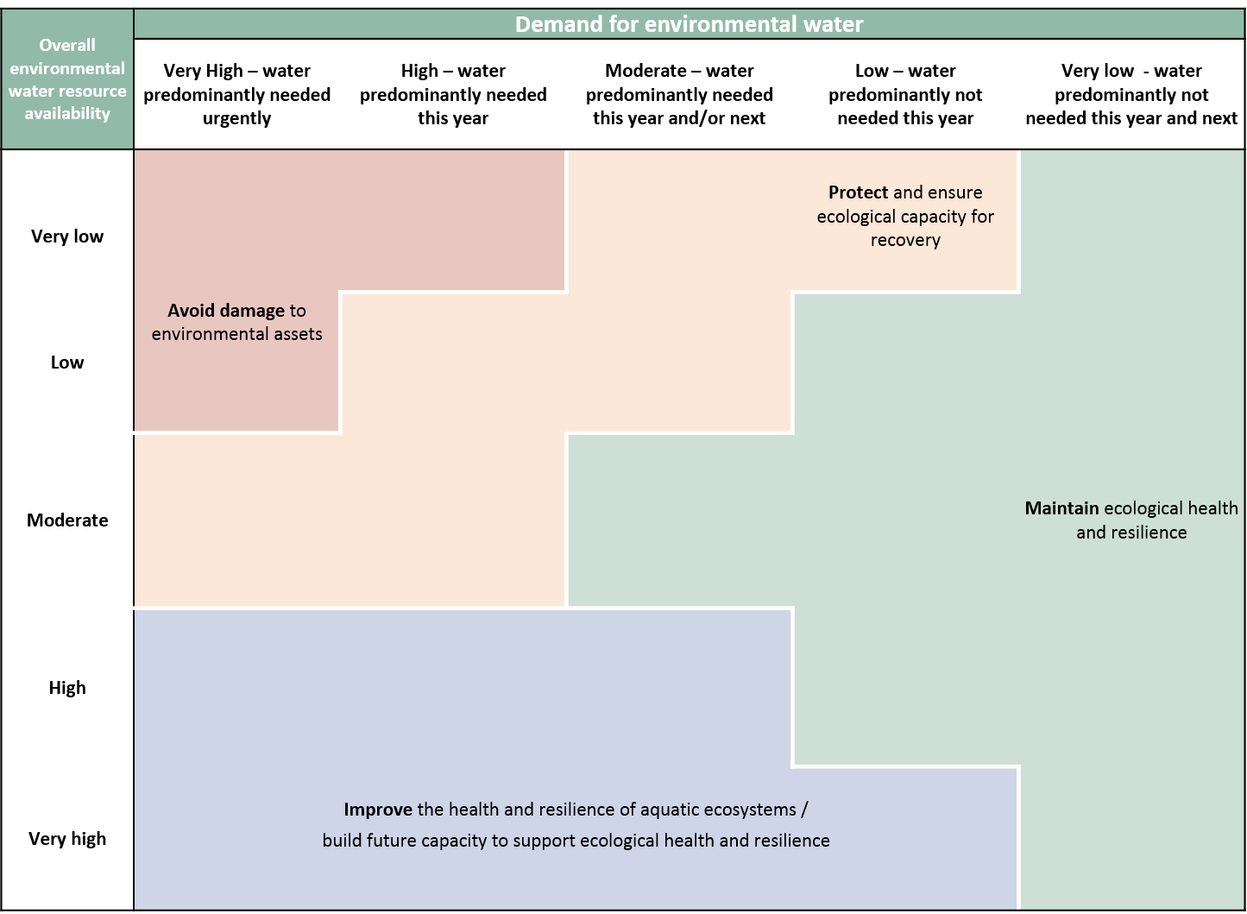

**Figure 3:** Determining a broad purpose for portfolio management in the Namoi River Valley for 2017–18. Note: grey lines represent potential range in demand and resource availability.

Further detail on how the overall purpose for portfolio management changes under different supply and demand scenarios is provided in *Portfolio Management Planning: Approach to planning for the use, carryover and trade of Commonwealth environmental water, 2017–18* (available at: [http://www.environment.gov.au/water/cewo/publication](http://www.environment.gov.au/water/cewo/publications)).

## Water Delivery in 2017–18

Consistent with the demands and purpose described above, the Office is considering supplying environmental water to the following watering actions for 2017–18 (see also Table 3 for supporting information regarding the basis for determining these watering intentions).

The priorities for the use of Commonwealth environmental water in the Namoi catchment are to improve connectivity, support aquatic ecology and refresh pools in the Lower Namoi.

Options for the delivery of Commonwealth environmental water are:

* Lower Namoi River minimum flows. In a moderate resource availability scenario, the purpose of the action is to protect and ensure ecological capacity for recovery, with the environmental demand high. Providing environmental water to maintain baseflows and provide connectivity between pools is a priority for supporting the survival of native fish including silver perch.
* Lower Namoi habitat maintenance, fish dispersal and resilience. Environmental water could be used to maintain the ecological health and resilience of aquatic ecosystems. This option is dependent on additional flows and may be delivered in conjunction with other releases.
* Lower Namoi river connectivity, fish spawning and movement. In a high resource availability scenario, the purpose of the action is to improve the ecological health and resilience of aquatic ecosystems with the environmental demand low to moderate. Environmental water could be delivered in conjunction with a natural flow event and the appropriate conditions (water temperature and flow rates).
* Peel River baseflows. Environmental water could be used to provide access to habitat, maintain water quality, support fish resilience and provide movement, spawning and/or recruitment opportunities, provide connectivity and wet low level-benches and point bars. In moderate resource availability the purpose of the action is to maintain the ecological health and resilience of aquatic ecosystems with the environmental demand low for a fresh flow and high for baseflows.

### Stakeholder Feedback

Feedback on the proposed actions was sought from the New South Wales Office of Environment and Heritage, Department of Primary Industries – Water, Fisheries, WaterNSW and North West Local Land Services. Feedback included a request to include a watering action to provide connection between the Namoi and Barwon rivers subject to conditions in the Barwon and Namoi catchments and operational feasibility. For example, this action could be considered when predicted flows in the Barwon River are greater than

4 000 ML/day as measured at the Danger Bridge gauge, subject to water availability and travel times. This action has been added to the possible watering actions in Table 3 and the library of watering actions at Attachment B.

## Trading water in 2017–18

The *Water Act 2007* provides for the trade of Commonwealth environmental water (allocations and entitlements) and specifies the conditions under which sales may occur. To improve environmental outcomes must be the primary reason for trade of Commonwealth Environmental water. The Commonwealth Environmental Water Holder has no plans to trade entitlements in 2017–18.

Planning on water trade considers supply and demand within the catchment and across the Basin. In the Namoi River Valley, inflows and allocations are highly variable. Where possible, retaining an account balance that will provide for environmental watering in future years under a range of climate scenarios is particularly important given the possibility of low to very low annual water allocation.

The Commonwealth Environmental Water Holder regularly assesses the environmental demand and supply position throughout the year, considering factors such as environmental condition and demand, current and forecast climate conditions, water availability, carryover capacity and market conditions. Any potential allocation trade would be subject to an assessment of the level of supply or demand for consumptive use within the Namoi River Valley water market.

Should a decision be made to seek a trade, then further information will be made widely available at [http://www.environment.gov.au/water/cewo/trade/current-trading-actions.](http://www.environment.gov.au/water/cewo/trade/current-trading-actions)

For more information on the rules and procedures governing the trade of Commonwealth environmental water, refer to the *Commonwealth environmental water Trading Framework* at: [http://www.environment.gov.au/water/cewo/publications/water-trading-framework-dec2014.](http://www.environment.gov.au/water/cewo/publications/water-trading-framework-dec2014)

## Carrying over water for use in 2018–19

The volume of water carried over for use in 2018–19 will depend upon resource availability and demand throughout the year.

Carryover provisions vary across the Namoi River Valley.

* In the Lower Namoi unused water may be carried over, but the account limit is set at 150 per cent of the entitlement volume.
* In the Upper Namoi up to 50 per cent of the entitlement volume can be carried over, but the account limit is 100 percent of the entitlement volume.
* In the Peel Valley there is no provision for carryover.

As documented in Table 3 below, potential demands in 2018–19 include:

* Lower Namoi River channel: Demand for water to provide baseflows, refresh pools and to maintain habitat, support native fish dispersal and resilience, and maintain connectivity within the river channel and with the Barwon River.
* Wetlands/anabranches: Demand for water to provide off channel habitat, and to support native fish and riparian vegetation in low commence to flow anabranches.
* Peel River channel: Demand for baseflows and freshes in the Peel River.

Carryover volumes will be adjusted throughout the year as the season unfolds in response to both current and future demands and the water available to meet these demands. These decisions will based upon best information available at the time.

More information on how the Commonwealth makes decisions on carryover is available at: <http://www.environment.gov.au/water/cewo/portfolio-mgt/carryover>

## Identifying Investment Opportunities

Changes to the *Water Act 2007* in 2016 have increased the flexibility for the Commonwealth Environmental Water Holder (CEWH) to use the proceeds of water allocation sales to invest in environmental activities. Under these amendments environmental activities must improve environmental outcomes and be undertaken for the purpose of protecting and restoring environmental assets in the Basin.

The CEWH will publically release a discussion paper seeking feedback on what type of activities stakeholders would like the CEWH to consider when developing a framework for future investment in environmental activities.

It should be noted that proceeds of past water sales must be managed based on the legislation in place at that time and are not available to be used for such activities.

### Table 3a: Environmental demands, potential watering in 2017–18 and outlook for coming years in the Namoi River Valley – VERY LOW / LOW WATER RESOURCE AVAILABILITY IN 2017–18 (Low volumes of environmental water and dry climate)

|  |  |  |  |  |  |  |  |  |  |  |  |  |
| --- | --- | --- | --- | --- | --- | --- | --- | --- | --- | --- | --- | --- |
| **Environmental assets** | **Indicative demand**  **(for all sources of water in the system)** | | | **Watering history (from all sources of water)** | | | **2017–18** | | | **Implications for future demands** | | |
| **Physical and process assets** | **Flow/Volume** | **Required frequency (maximum dry interval)** | **2014–15** | **2015–16** | **2016–17** | **Predominant urgency of environmental demand for water.** | **Purpose of environmental watering under very low / low resource availability** | **Potential Commonwealth environmental water contribution?** | **Likely urgency of demand in 2018–19 if**  **watering occurred as planned in 2017–18** | **2019–20**  **Range of likely demand** | Met in 2018–  19 |
| (dry) | (dry) | **(Wet)** | Not met in 2018–  19 |
| **Lower Namoi River channel 1** | Drought refuge habitat  Habitat maintenance  Fish dispersal and resilience | Small flows (minimum flows and baseflows):   * 8 ML/day at Boggabri and 13 ML/day at Wee Waa * 72 ML/day at Boggabri and 105 ML/day at Wee Waa (Dec–June) * 215 ML/day at Boggabri and 260 ML/day at Wee Waa (July–Nov) | 1 in 1–2 years | Minimum flows not met  Baseflows below targets | Minimum flows not met  Cease to flow periods at Boggabri  Baseflows below targets (block releases used to deliver water) | Minimum flows met  Baseflows not met in August 2016 and  March 2017 | High  Minimum flows are required each year  The dry conditions from 2013–16 contributed to environmental damage resulting in a high environmental demand for low to medium flows in 2017–18 to support recovery even where required watering frequencies have been met | **Avoid damage**  **/ Protect** | A high potential for watering in 2017–18 to provide minimum flows and contribute to baseflows | High | High | |
| Critical | |
| Longitudinal connectivity  Low level bank and bar wetting:  Pool maintenance  Fish movement, habitat access, spawning and recruitment | Medium flows:   * 500 ML/day at Bugilbone for 75 days (min. 25 consecutive days) preferably in late spring/summer and late winter | 1 in 2–3 years | Not met | Not met  Height above  500 ML for 2 days at Bugilbone | Medium flows met | Moderate  The dry conditions from 2013–16 contributed to environmental damage resulting in a moderate environmental demand for low to medium flows in 2017–18 to support recovery even where required watering frequencies have been met | **Protect** | Environmental water could contribute to meeting this demand for the minimum of 25 days if delivered in conjunction with other water. | Low | Low | |
| Moderate | |
| Fish spawning, recruitment, dispersal and condition  Increase ecosystem function  Bench and bank wetting:  Access to habitat  Nutrient cycling | Large flows:   * 1 800 ML/day at Bugilbone for 60 days (min. 6 consecutive days) preferably in late spring/summer and late winter   •   1 400–2 870 ML/day at  Boggabri and 1 500–  3 150 ML/day at Wee Waa in Sept–Dec for min. 7 days | 1 in 3–5 years | Not met | Not met | Large flows met 1 800 ML/day  Bugilbone 5  Sept to 12 Oct Over 5 00ML  Boggabri 15-25  Sept Over  3 150 ML/day  at Wee Waa 14-30 Sept | Low to Moderate Minimum duration requirements  met but not for maximum  duration in 2016–17 | **Not Applicable** | Insufficient water under a low water availability scenario to contribute to this demand. | Moderate | Low | |
| High | |
| **Namoi and Barwon rivers connection flow** | Longitudinal connectivity  Fish dispersal, genetic diversity and recruitment | Small flow of 100-  150 ML/day at Wee Waa to provide connection between the Namoi and Barwon rivers. Ideally when Barwon River flows are over 4 000 ML/day at Dangar Bridge | Opportunistic watering (whenever flow trigger at Dangar Bridge is met) | Not Met | Not Met | Met from Sept to Nov | Moderate  Met in 2016–17 and fish recruitment is expected to continue in the Barwon River until it dries down | **Improve** | Environmental water could contribute to this demand subject to suitable conditions and operational feasibility | Moderate | Moderate | |
| Moderate | |

|  |  |  |  |  |  |  |  |  |  |  |  |  |
| --- | --- | --- | --- | --- | --- | --- | --- | --- | --- | --- | --- | --- |
| **Environmental assets** | **Indicative demand**  **(for all sources of water in the system)** | | | **Watering history (from all sources of water)** | | | **2017–18** | | | **Implications for future demands** | | |
| **Physical and process assets** | **Flow/Volume** | **Required frequency (maximum dry interval)** | **2014–15** | **2015–16** | **2016–17** | **Predominant urgency of environmental demand for water.** | **Purpose of environmental watering under very low / low resource availability** | **Potential Commonwealth environmental water contribution?** | **Likely urgency of demand in 2018–19 if**  **watering occurred as planned in 2017–18** | **2019–20**  **Range of likely demand** | Met in 2018–  19 |
| (dry) | (dry) | **(Wet)** | Not met in 2018–  19 |
| **Wetlands / Anabranches 2** | Riparian vegetation in low commence to flow anabranch channels  Fish movement and off channel habitat  Fish breeding and recruitment | Commence to fill wetlands preferably in late spring/summer and winter over 45 days (min. 7 consecutive days):  •   4 000–4 500 ML/day at Bugilbone   * Greater than   4 600 ML/day at Boggabri (for Barbers Lagoon)   * Greater than   3 300 ML/day at Duncan’s Junction | 1 in 2–5 years  (varies between native fish species) | Not met | Not met | Minimum requirements met  Over  4 500 ML/day at Bugilbone 16 Sept-2 Oct  Over  4 600 ML/day  Boggabri 15-25 Sept  Over  3 300 ML/day at Duncan’s Junction 18-27 Sept | Low to moderate  Minimum duration requirements met but maximum duration was not met in 2016–17 | **Not Applicable** | Insufficient water under a low water availability scenario to contribute to this demand. | Moderate | Low | |
| High | |
| **Peel River channel 3** | Habitat Water quality  Fish resilience, movement, spawning and recruitment  Connectivity  Wet low level- benches and point bars | Baseflows:   * Minimum variable low baseflow greater than 3 ML/day) from Chaffey Dam * Pulsed baseflows (~500 ML/day) from Chaffey Dam | Annually | Min. baseflows met | Min. Baseflows not met | Met | High  Baseflow requirements need to be met every year. | **Avoid damage**  **/ Protect** | Environmental water could contribute to providing minimum baseflow variability | High | High | |
| Critical | |
| Pulsed baseflows not met | Pulsed baseflows not met | Met | Environmental water could contribute to providing pulsed baseflows | High | High | |
| Critical | |
| Connectivity Water quality  Fish spawning, recruitment, movement and condition | Fresh flow (1 000–  4 000 ML/day) to provide connectivity and wet medium-level benches, point bars and riparian zone | 2–3 years Average return interval | Not met | Not met | Met Above  1100 ML/day in  Nov | Low  Demand met in 2016–17 | **Not Applicable** | Insufficient water under a very low water availability scenario to contribute to this demand. | Moderate | Low | |
| High | |
| See references and key at Table 3c | | | | | | | | **Carryover potential** | The level of carryover will depend on environmental demands and resource availability.  *NOTE: No carryover provisions in the Peel Valley.* | | | |
| **Trade potential** | There may be a need to adjust the availability of allocations through trade. Any potential allocation trade would be subject to an assessment of supply and demand within the water market in the Namoi | | | |

### Table 3b: Environmental demands, potential watering in 2017–18 and outlook for coming years in the Namoi River Valley - MODERATE WATER RESOURCE AVAILABILITY IN 2017–18 (Low volumes of environmental water and moderate climate)

|  |  |  |  |  |  |  |  |  |  |  |  |  |
| --- | --- | --- | --- | --- | --- | --- | --- | --- | --- | --- | --- | --- |
| **Environmental assets** | **Indicative demand**  **(for all sources of water in the system)** | | | **Watering history (from all sources of water)** | | | **2017–18** | | | **Implications for future demands** | | |
| **Physical and process assets** | **Flow/Volume** | **Required frequency (maximum dry interval)** | **2014–15** | **2015–16** | **2016–17** | **Predominant urgency of environmental demand for water.** | **Purpose of environmental watering under Moderate resource availability** | **Potential Commonwealth environmental water contribution?** | **Likely urgency of demand in 2018–19 if**  **watering occurred as planned in 2017–18** | **2019–20**  **Range of likely demand** | Met in 2018–  19 |
| (dry) | (dry) | **(Wet)** | Not met in 2018–  19 |
| **Lower Namoi River channel 1** | Drought refuge habitat  Habitat maintenance  Fish dispersal and resilience | Small flows (minimum flows and baseflows):   * 8 ML/day at Boggabri and 13 ML/day at Wee Waa * 72 ML/day at Boggabri and 105 ML/day at Wee Waa (Dec–June) * 215 ML/day at Boggabri and 260 ML/day at Wee Waa (July–Nov) | 1 in 1–2 years | Minimum flows not met  Baseflows below targets | Minimum flows not met Cease to flow periods at Boggabri  Baseflows below targets (block releases used to deliver water) | Minimum flows met  Baseflows not met in August 2016 and  March 2017 | High  Minimum flows are required each year  The dry conditions from 2013–16 contributed to environmental damage resulting in a high environmental demand for low to medium flows in 2017–18 to support recovery even where required watering frequencies have been met | **Protect** | Under moderate resource scenario, natural flows and consumptive deliveries will meet this demand for almost all the year.  Baseflows in autumn may need to be supplemented with environmental water.  Contributing to medium sized flows would also meet this demand | High | High | |
| Critical | |
| Longitudinal connectivity  Low level bank and bar wetting:  Pool maintenance  Fish movement, habitat access, spawning and recruitment | Medium flows:   * 500 ML/day at Bugilbone for 75 days (min. 25 consecutive days) preferably in late spring/summer and late winter | 1 in 2–3 years | Not met | Not met  Height above  500 ML for 2 days at Bugilbone | Medium flows met | Moderate  The dry conditions from 2013–16 contributed to environmental damage resulting in a moderate environmental demand for low to medium flows in 2017–18 to support recovery even where required watering frequencies have been met | **Maintain** | Environmental water may be able to contribute to meeting this demand in 2017–18, depending on available water and if delivered in conjunction with other flows | Low | Low | |
| Moderate | |
| Fish spawning, recruitment, dispersal and condition  Increase ecosystem function  Bench and bank wetting:  Access to habitat  Nutrient cycling | Large flows:   * 1 800 ML/day at Bugilbone for 60 days (min. 6 consecutive days) preferably in late spring/summer and late winter   •   1 400–2 870 ML/day at  Boggabri and 1 500–  3 150 ML/day at Wee Waa in Sept–Dec for min. 7 days | 1 in 3–5 years | Not met | Not met | Large flows met 1 800 ML/day  Bugilbone 5  Sept to 12 Oct Over 5 00ML  Boggabri 15-25  Sept Over  3 150 ML/day  at Wee Waa 14-30 Sept | Low to Moderate Minimum duration requirements  met but not all maximum  duration in 2016–17 | **Not Applicable** | Insufficient water under a moderate water availability scenario to contribute to this demand. | Moderate | Low | |
| High | |
| **Namoi and Barwon rivers connection flow** | Longitudinal connectivity  Fish dispersal, genetic diversity and recruitment | Small flow of 100-  150 ML/day at Wee Waa to provide connection between the Namoi and Barwon rivers. Ideally when Barwon River flows are over 4 000 ML/day at Dangar Bridge | Opportunistic watering (whenever flow trigger at Dangar Bridge is met) | Not Met | Not Met | Met from Sept to Nov | Moderate  Met in 2016–17 and fish recruitment is expected to continue in the Barwon River until it dries down | **Improve** | Environmental water could contribute to this demand subject to suitable conditions and operational feasibility | Moderate | Moderate | |
| Moderate | |

|  |  |  |  |  |  |  |  |  |  |  |  |  |
| --- | --- | --- | --- | --- | --- | --- | --- | --- | --- | --- | --- | --- |
| **Environmental assets** | **Indicative demand**  **(for all sources of water in the system)** | | | **Watering history (from all sources of water)** | | | **2017–18** | | | **Implications for future demands** | | |
| **Physical and process assets** | **Flow/Volume** | **Required frequency (maximum dry interval)** | **2014–15** | **2015–16** | **2016–17** | **Predominant urgency of environmental demand for water.** | **Purpose of environmental watering under Moderate resource availability** | **Potential Commonwealth environmental water contribution?** | **Likely urgency of demand in 2018–19 if**  **watering occurred as planned in 2017–18** | **2019–20**  **Range of likely demand** | Met in 2018–  19 |
| (dry) | (dry) | **(Wet)** | Not met in 2018–  19 |
| **Wetlands / Anabranches 2** | Riparian vegetation in low commence to flow anabranch channels  Fish movement and off channel habitat  Fish breeding and recruitment | Commence to fill wetlands preferably in late spring/summer and winter over 45 days (min. 7 consecutive days):  •   4 000–4 500 ML/day at Bugilbone   * Greater than   4 600 ML/day at Boggabri (for Barbers Lagoon)   * Greater than   3 300 ML/day at Duncan’s Junction | 1 in 2–5 years  (varies between native fish species) | Not met | Not met | Minimum requirements met  Over  4 500 ML/day at Bugilbone 16 Sept-2 Oct  Over  4 600 ML/day  Boggabri 15-25 Sept  Over  3 300 ML/day at Duncan’s Junction 18-27 Sept | Low to moderate  Minimum duration requirements met but maximum duration was not met in 2016–17 | **Not Applicable** | Insufficient water under a moderate water availability scenario to contribute to this demand. | Moderate | Low | |
| High | |
| **Peel River channel 3** | Habitat Water quality  Fish resilience, movement, spawning and recruitment  Connectivity  Wet low level- benches and point bars | Baseflows:   * Minimum variable low baseflow greater than 3 ML/day) from Chaffey Dam * Pulsed baseflows (~500 ML/day) from Chaffey Dam | Annually | Min. baseflows met | Min. Baseflows not met | Met | High  Baseflow requirements need to be met every year | **Not Applicable** | Minimum baseflows would be met by other water under a moderate scenario. | High | High | |
| Critical | |
| Pulsed baseflows not met | Pulsed baseflows not met | Met | **Maintain** | Environmental water could contribute to providing pulsed baseflows | High | High | |
| Critical | |
| Connectivity Water quality  Fish spawning, recruitment, movement and condition | Fresh flow (1 000–4 000 ML/day) to provide connectivity and wet medium-level benches, point bars and riparian zone | 2–3 years Average return interval | Not met | Not met | Met Above  1100 ML/day in  Nov | Low  Demand met in 2016–17 | **Maintain** | If required environmental water may be able to contribute to meeting this demand if delivered in conjunction with other flows | Low | Low | |
| Moderate | |
| See references and key at Table 3c | | | | | | | | **Carryover potential** | The level of carryover will depend on environmental demands and resource availability.  *NOTE: No carryover provisions in the Peel Valley.* | | | |
| **Trade potential** | There may be a need to adjust the availability of allocations through trade. Any potential allocation trade would be subject to an assessment of supply and demand within the water market in the Namoi. | | | |

### Table 3c: Environmental demands, potential watering in 2017–18 and outlook for coming years in the Namoi River Valley –HIGH/VERY HIGH WATER RESOURCE AVAILABILITY IN 2017–18 (Low volumes of environmental water and wet climate)

|  |  |  |  |  |  |  |  |  |  |  |  |  |
| --- | --- | --- | --- | --- | --- | --- | --- | --- | --- | --- | --- | --- |
| **Environmental assets** | **Indicative demand**  **(for all sources of water in the system)** | | | **Watering history (from all sources of water)** | | | **2017–18** | | | **Implications for future demands** | | |
| **Physical and process assets** | **Flow/Volume** | **Required frequency (maximum dry interval)** | **2014–15** | **2015–16** | **2016–17** | **Predominant urgency of environmental demand for water.** | **Purpose of environmental watering under High / Very High resource availability** | **Potential Commonwealth environmental water contribution?** | **Likely urgency of demand in 2018–19 if**  **watering occurred as planned in 2017–18** | **2019–20**  **Range of likely demand** | Met in 2018–  19 |
| (dry) | (dry) | **(Wet)** | Not met in 2018–  19 |
| **Lower Namoi River channel 1** | Drought refuge habitat  Habitat maintenance  Fish dispersal and resilience | Small flows (minimum flows and baseflows):   * 8 ML/day at Boggabri and 13 ML/day at Wee Waa * 72 ML/day at Boggabri and 105 ML/day at Wee Waa (Dec–June) * 215 ML/day at Boggabri and 260 ML/day at Wee Waa (July–Nov) | 1 in 1–2 years | Minimum flows not met  Baseflows below targets | Minimum flows not met Cease to flow periods at Boggabri  Baseflows below targets (block releases used to deliver water) | Minimum flows met  Baseflows not met in August 2016 and  March 2017 | High  Minimum flows are required each year  The dry conditions from  2013–16 contributed to environmental damage resulting in a high environmental demand for low to medium flows in 2017–18 to support recovery even where required watering frequencies have been met | **Maintain** | Under a high resource scenario natural flow conditions will meet this demand for almost all the year. Baseflows in autumn may need to be supplemented with environmental water.  Contributing to medium sized flows would also meet this demand | High | High | |
| Critical | |
| Longitudinal connectivity  Low level bank and bar wetting:  Pool maintenance  Fish movement, habitat access, spawning and recruitment | Medium flows:   * 500 ML/day at Bugilbone for 75 days (min. 25 consecutive days) preferably in late spring/summer and late winter | 1 in 2–3 years | Not met | Not met  Height above  500 ML for 2 days at Bugilbone | Medium flows met | Moderate  The dry conditions from  2013–16 contributed to environmental damage resulting in a moderate environmental demand for low to medium flows in 2017–18 to support recovery even where required watering frequencies have been met | **Improve** | Under a high resource scenario natural flow conditions will meet this demand. If required Environmental water may be able to contribute to meeting this demand if delivered in conjunction with other flows | Low | Low | |
| Moderate | |
| Fish spawning, recruitment, dispersal and condition  Increase ecosystem function  Bench and bank wetting:  Access to habitat  Nutrient cycling | Large flows:   * 1 800 ML/day at Bugilbone for 60 days (min. 6 consecutive days) preferably in late spring/summer and late winter   •   1 400–2 870 ML/day at  Boggabri and 1 500–  3 150 ML/day at Wee Waa in Sept–Dec for min. 7 days | 1 in 3–5 years | Not met | Not met | Large flows met 1 800 ML/day  Bugilbone 5  Sept to 12 Oct Over 5 00ML  Boggabri 15-25  Sept Over  3 150 ML/day  at Wee Waa 14-30 Sept | Low to moderate Minimum duration  requirements met but not all  maximum duration in 2016–17 | **Improve** | Under a high resource scenario natural flow conditions will likely meet this demand. If required Environmental water may be able to contribute to meeting this demand if delivered in conjunction with other flows | Low | Low | |
| Low | |
| **Namoi and Barwon rivers connection flow** | Longitudinal connectivity  Fish dispersal, genetic diversity and recruitment | Small flow of 100-150 ML/day at Wee Waa to provide connection between the Namoi and Barwon rivers. Ideally when Barwon River flows are over 4 000 ML/day at Dangar Bridge | Opportunistic watering (whenever flow trigger at Dangar Bridge is met) | Not Met | Not Met | Met from Sept to Nov | Moderate  Met in 2016–17 and fish recruitment is expected to continue in the Barwon River until it dries down | **Improve** | Environmental water could contribute to this demand subject to suitable conditions and operational feasibility | Moderate | Moderate | |
| Moderate | |

|  |  |  |  |  |  |  |  |  |  |  |  |  |
| --- | --- | --- | --- | --- | --- | --- | --- | --- | --- | --- | --- | --- |
| **Environmental assets** | **Indicative demand**  **(for all sources of water in the system)** | | | **Watering history (from all sources of water)** | | | **2017–18** | | | **Implications for future demands** | | |
| **Physical and process assets** | **Flow/Volume** | **Required frequency (maximum dry interval)** | **2014–15** | **2015–16** | **2016–17** | **Predominant urgency of environmental demand for water.** | **Purpose of environment al watering under High / Very High resource availability** | **Potential Commonwealth environmental water contribution?** | **Likely urgency of demand in 2018–19 if**  **watering occurred as planned in 2017–18** | **2019–20**  **Range of likely demand** | Met in 2018–  19 |
| (dry) | (dry) | **(Wet)** | Not met in 2018–  19 |
| **Wetlands / Anabranches 2** | Riparian vegetation in low commence to flow anabranch channels  Fish movement and off channel habitat  Fish breeding and recruitment | Commence to fill wetlands preferably in late spring/summer and winter over 45 days (min. 7 consecutive days):  •   4 000–4 500 ML/day at Bugilbone   * Greater than 4 600 ML/day at Boggabri (for Barbers Lagoon) * Greater than 3 300 ML/day at Duncan’s Junction | 1 in 2–5 years  (varies between native fish species) | Not met | Not met | Minimum requirements met  Over  4 500 ML/day at Bugilbone 16 Sept-2 Oct  Over  4 600 ML/day  Boggabri 15-25 Sept  Over  3 300 ML/day at Duncan’s Junction 18-27 Sept | Low to moderate  Minimum duration requirements met but maximum duration was not met in 2016–17 | **Improve** | Under a high resource scenario natural flow conditions will meet this demand. If required environmental water may be able to contribute to meeting this demand if delivered in conjunction with other flows | Low | Low | |
| Moderate | |
| **Peel River channel 3** | Habitat Water quality  Fish resilience, movement, spawning and recruitment  Connectivity  Wet low level- benches and point bars | Baseflows:   * Minimum variable low baseflow greater than 3 ML/day) from Chaffey Dam * Pulsed baseflows (~500 ML/day) from Chaffey Dam | Annually | Min. baseflows met | Min. Baseflows not met | Met | High  Baseflow requirements need to be met every year | **Not Applicable** | Minimum baseflows would be met by other water under a wet scenario. | High | High | |
| Critical | |
| Pulsed baseflows not met | Pulsed baseflows not met | Met | Pulsed baseflows would be met by other water under a wet scenario. | High | High | |
| Critical | |
| Connectivity Water quality  Fish spawning, recruitment, movement and condition | Fresh flow (1 000–4 000 ML/day) to provide connectivity and wet medium-level benches, point bars and riparian zone | 2–3 years Average return interval | Not met | Not met | Met Above  1100 ML/day in  Nov | Low  Demand met in 2016–17 | **Improve** | Under a high resource scenario natural flow conditions will meet this demand. If required environmental water may be able to contribute to meeting this demand if delivered in conjunction with other flows | Low | Low | |
| Moderate | |
| **References**   1. Sourced from information provided by Green et al (2011), MDBA (2012), and previous environmental watering, with advice from NSW DPI Fisheries (Anthony Townsend, pers. comm.) 2. Sourced from information provided by Green et al (2011), MDBA (2012) and Foster (1999), with advice from NSW DPI Fisheries (Anthony Townsend, pers. comm.) 3. Sourced from Barma Water Resources et al. (2012), with advice from NSW DPI Fisheries (Anthony Townsend, pers. comm.) 4. All watering history sourced from data from the following gauges (WaterNSW 2017c):    * 419021: Namoi River at Bugilbone    * 419012: Namoi River at Boggabri    * 419059: Namoi River d/s Gunidgera Weir (Wee Waa)    * 419094: Namoi River d/s Duncan’s Junction    * 419091: Upstream Walgett    * 422001: Dangar Bridge    * 419045: Peel River d/s Chaffey Dam | | | | | **Key - events in previous years**  means demand was met by Commonwealth environmental water or any other source  means demand was partially met by Commonwealth environmental water or any other source (may be used to indicate infrastructure assisted delivery) means water not provided (or not required)  Note that not all demands require water every year; drying phases are important for floodplains and temporary wetlands or streams  **Key - potential watering in 2017-18**  means a high priority for Commonwealth environmental watering (full or partial contribution, and subject to seasonal and operational considerations) means a secondary priority for Commonwealth environmental watering, likely to be met via other means (other water holders, or natural flows) means a low priority for Commonwealth environmental watering  **Key - urgency of environmental demands**  means critical demand i.e. urgent need for water in that particular year to manage risk of irretrievable loss or damage means high demand for water i.e. needed in that particular year  means moderate demand for water i.e. water needed that particular year and/or next means low demand for water i.e. water generally not needed that particular year  means very low demand for water i.e. water generally not needed that particular year or the following year  Note that demand is considered at a generalised scale; there may be specific requirements that are more or less urgent within the flow regime | | | | | **Carryover potential** | The level of carryover will depend on environmental demands and resource availability.  *NOTE: No carryover provisions in the Peel Valley.* | |
| **Trade potential** | Market activity may be thin and opportunities to trade allocation would be subject to an assessment of supply and demand within the water market in the Namoi. | |

# Next steps

## From planning to decision making

It is important to distinguish between planning and operational decision making. As shown in Figure 4, planning allows the Office to manage the environmental water portfolio in a holistic manner and is an exercise in developing a broad approach or intention, based on the key drivers (demand and supply).

Decision making throughout each year builds on the intention by considering in more detail the specific prevailing factors and additional factors such as costs, risks, and constraints to water delivery and market conditions.

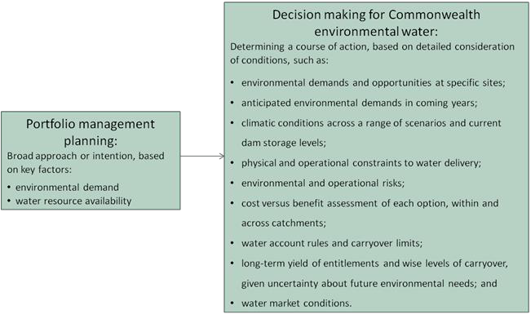

**Figure 4:** Planning and decision making for Commonwealth environmental water use

## Further information

For further information on how the Office plans for water use, carryover and trade, please visit our web site: <http://www.environment.gov.au/water/cewo>

or the sites below:

* Water use: [www.environment.gov.au/topics/water/commonwealth-environmental-water-](http://www.environment.gov.au/topics/water/commonwealth-environmental-water-office/assessment-framework) [office/assessment-framework](http://www.environment.gov.au/topics/water/commonwealth-environmental-water-office/assessment-framework)
* Carryover: [http://www.environment.gov.au/topics/water/commonwealth-environmental-water-](http://www.environment.gov.au/topics/water/commonwealth-environmental-water-office/portfolio-management/carryover) [office/portfolio-management/carryover](http://www.environment.gov.au/topics/water/commonwealth-environmental-water-office/portfolio-management/carryover)
* Trade: *Discussion Paper – Trade of Commonwealth Environmental Water* and *Commonwealth Environmental Water Trading Framework:*  <http://www.environment.gov.au/water/cewo/trade/trading-framework>

18

# Bibliography

Barma Water Resources, Thurtell, L. And Wettin, P. (2012). *Environmental water delivery: Namoi River*. Prepared for Commonwealth Environmental Water, Department of Sustainability, Environment, Water, Population and Communities, Canberra.

Bureau of Meteorology (2017). *Thirty-six-monthly rainfall deciles for New South Wales / ACT*. [http://www.bom.gov.au/jsp/awap/rain/index.jsp?colour=colour&time=latest&step=0&map=decile&per](http://www.bom.gov.au/jsp/awap/rain/index.jsp?colour=colour&amp;time=latest&amp;step=0&amp;map=decile&amp;period=36month&amp;area=ns) [iod=36month&area=ns](http://www.bom.gov.au/jsp/awap/rain/index.jsp?colour=colour&amp;time=latest&amp;step=0&amp;map=decile&amp;period=36month&amp;area=ns)

Bureau of Meteorology (2017). *Twelve-monthly maximum temperature decile for New South Wales/ACT.*  [http://www.bom.gov.au/jsp/awap/temp/index.jsp?colour=colour&time=latest&step=0&map=maxdecil](http://www.bom.gov.au/jsp/awap/temp/index.jsp?colour=colour&amp;time=latest&amp;step=0&amp;map=maxdecile&amp;period=12month&amp;area=ns) [e&period=12month&area=ns](http://www.bom.gov.au/jsp/awap/temp/index.jsp?colour=colour&amp;time=latest&amp;step=0&amp;map=maxdecile&amp;period=12month&amp;area=ns)

Department of the Environment (2011). *Water use strategy 2011–12: Namoi River Catchment*. Unpublished.

Department of the Environment (2014). *Commonwealth environmental water use options 2014–15: Namoi River Valley*, Commonwealth of Australia 2014. [http://www.environment.gov.au/resource/commonwealth-environmental-water-annual-use-options-](http://www.environment.gov.au/resource/commonwealth-environmental-water-annual-use-options-namoi-river-valley) [namoi-river-valley](http://www.environment.gov.au/resource/commonwealth-environmental-water-annual-use-options-namoi-river-valley)

Department of the Environment (2015). *Integrated planning for the use, carryover and trade of Commonwealth environmental water: Namoi River Valley 2015–16.* Commonwealth of Australia 2015. <http://www.environment.gov.au/water/cewo/publications/integrated-planning-cew-namoi-2015-16>

Department of the Environment (2016). *Portfolio Management Plan: Namoi River Valley 2016–17.* Commonwealth of Australia 2016. [http://www.environment.gov.au/water/cewo/publications/portfolio-](http://www.environment.gov.au/water/cewo/publications/portfolio-mgt-plan-namoi-2016-17) [mgt-plan-namoi-2016-17](http://www.environment.gov.au/water/cewo/publications/portfolio-mgt-plan-namoi-2016-17)

Foster N. (1999). *An Assessment of the Commence-to-flow levels of Wetlands of the Lower Namoi Valley*,

Department of Land and Water Conservation.

Green D., Petrovic J., Moss P., Burrell M. (2011). *Water resources and management overview: Namoi catchment*, NSW Office of Water.

[http://www.water.nsw.gov.au/](http://www.water.nsw.gov.au/__data/assets/pdf_file/0003/549300/catchment_overview_namoi.pdf)

[data/assets/pdf_file/0003/549300/catchment_overview_namoi.pdf](http://www.water.nsw.gov.au/__data/assets/pdf_file/0003/549300/catchment_overview_namoi.pdf)

Murray-Darling Basin Authority (MDBA) (2012). *Assessment of environmental water requirements for the proposed Basin Plan: Lower Namoi River (in-channel flows),* Commonwealth of Australia 2012 [http://www.mdba.gov.au/sites/default/files/archived/proposed/EWR-Lower-Namoi-River-in-](http://www.mdba.gov.au/sites/default/files/archived/proposed/EWR-Lower-Namoi-River-in-channelflows.pdf) [channelflows.pdf](http://www.mdba.gov.au/sites/default/files/archived/proposed/EWR-Lower-Namoi-River-in-channelflows.pdf)

Murray-Darling Basin Authority (MDBA) (2014). *Basin-wide environmental watering strategy*, Commonwealth of Australia 2014 [http://www.mdba.gov.au/sites/default/files/pubs/Final-BWS-](http://www.mdba.gov.au/sites/default/files/pubs/Final-BWS-Nov14.pdf) [Nov14.pdf](http://www.mdba.gov.au/sites/default/files/pubs/Final-BWS-Nov14.pdf)

NSW Government (2010). *Water Sharing Plan for the Peel Valley Regulated, Unregulated, Alluvium and Fractured Rock Water Sources 2010*. [http://www.water.nsw.gov.au/Water-management/Water-sharing-](http://www.water.nsw.gov.au/Water-management/Water-sharing-plans/Plans-commenced/Water-source/Peel-Valley-Regulated--Unregulated--Alluvium-and-Fractured-Rock/default.aspx) [plans/Plans-commenced/Water-source/Peel-Valley-Regulated--Unregulated--Alluvium-and-Fractured-](http://www.water.nsw.gov.au/Water-management/Water-sharing-plans/Plans-commenced/Water-source/Peel-Valley-Regulated--Unregulated--Alluvium-and-Fractured-Rock/default.aspx) [Rock/default.aspx](http://www.water.nsw.gov.au/Water-management/Water-sharing-plans/Plans-commenced/Water-source/Peel-Valley-Regulated--Unregulated--Alluvium-and-Fractured-Rock/default.aspx)

NSW Government (2016). *Water Sharing Plan for the Upper Namoi and Lower Namoi Regulated Water Sources* [http://www.water.nsw.gov.au/water-management/water-sharing/plans-commenced/water-](http://www.water.nsw.gov.au/water-management/water-sharing/plans-commenced/water-source/upper-namoi-and-lower-namoi-regulated-river) [source/upper-namoi-and-lower-namoi-regulated-river](http://www.water.nsw.gov.au/water-management/water-sharing/plans-commenced/water-source/upper-namoi-and-lower-namoi-regulated-river)

NSW Government (2017). *Available Water Determinations Register*, Department of Primary Industry - Office of Water 2017 <http://registers.water.nsw.gov.au/wma/DeterminationSearch.jsp?selectedRegister=Determination>

Tony Townsend (2015). Personal communication 13 April 2015, NSW Department of Primary Industry - Fisheries

WaterNSW (2016). *Chaffey Dam upgrade and augmentation*

<http://www.waternsw.com.au/projects/dam-safety/chaffey>

WaterNSW (2017a). *Keepit Dam*. <http://www.waternsw.com.au/supply/visit/keepit-dam>

WaterNSW (2017b). *Split Rock Dam* <http://www.waternsw.com.au/supply/visit/split-rock-dam>

WaterNSW (2017c). *NSW Water Gauges*

[http://realtimedata.water.nsw.gov.au/water.stm?ppbm=STORAGE_SITE&da&3&dakm_org](http://realtimedata.water.nsw.gov.au/water.stm?ppbm=STORAGE_SITE&amp;da&amp;3&amp;dakm_org)

# Attachment A – Expected outcomes from the Basin-wide environmental watering strategy

Expected outcomes from the Basin-wide environmental watering strategy (MDBA 2014) that are relevant to the Namoi River catchment are described below.

### RIVER FLOWS AND CONNECTIVITY

* Baseflows are at least 60 per cent of the natural level.
* Contributing to a 10 per cent overall increase in flows in the Barwon-Darling.
* A 10–20 per cent increase in the frequency of freshes and bankfull flows.

### VEGETATION

* Maintain the current extent of forest and woodland vegetation and non woody vegetation.
* No decline in the condition of black box, river red gum and coolibah.
* Improved recruitment of trees within black box and river red gum communities

### Vegetation extent

|  |  |  |  |  |
| --- | --- | --- | --- | --- |
| **Area of river red gum (ha)** | **Area of black box (ha)** | **Area of coolibah (ha)** | **Shrublands** | **Non–woody water dependent vegetation** |
| 6 100 | 800 | 4 200 |  | Closely fringing or occurring within the Namoi River |

**WATERBIRDS**

* Maintain current species diversity
* Increase Basin-wide abundance of waterbirds by 20–25 per cent by 2024
* A 30–40 per cent increase in nests and broods (Basin-wide) for other waterbirds
* Up to 50 per cent more breeding events (Basin-wide) for colonial nesting waterbird species

### FISH

* No loss of native species
* Improved population structure of key species through regular recruitment, including:
  + Short-lived species with distribution and abundance at pre-2007 levels and breeding success every 1–2 years
  + Moderate to long-lived with a spread of age classes and annual recruitment in at least 80 per cent of years
* Increased movements of key species
* Expanded distribution of key species and populations

### Key fish species for the Namoi River Valley include:

|  |  |  |
| --- | --- | --- |
| Species | Specific outcomes | In-scope for C’th water in the Namoi River Valley? |
| Freshwater catfish (*Tandanus tandanus*) | Expand the core range of at least 3–5 existing populations (Candidate sites include Namoi and Peel River) | Yes |
| Golden perch (*Macquaria ambigua*) | A 10–15 per cent increase of mature fish (of legal take size) in key populations | Yes |
| Murray cod (*Maccullochella peelii peelii*) | A 10–15 per cent increase of mature fish (of legal take size) in key populations | Yes |
| Olive perchlet (*Ambassis agassizii*) | Establish or improve the core range of 2–5 additional populations (Candidate sites include Namoi River) | Possibly (Once widespread. Current extent unknown in Namoi) |
| River blackfish (*Gadopsis marmoratus*) | Establish or improve the core range of 2–4 additional populations (candidate sites include Namoi River) | Yes |
| Silver perch (*Bidyanus bidyanus)* | Expand the core range of at least 2 existing populations (Candidate sites include Namoi River) | Yes (Current extent unknown in Namoi. Stocking of 50 000 fingerlings each year in 2016 and 2017. Anecdotal evidence of silver perch between Narrabri and Gunnedah, near Keepit Dam and in the Peel River) |
| Southern purple-spotted gudgeon (*Mogurnda adspersa*) | Establish or improve the core range of 2–5 additional populations – (priority catchments include Namoi) | Possibly (Once widespread. Current extent in Namoi unknown. Some stocking has occurred) |

**Important Basin environmental assets for native fish in the Namoi River Valley**

|  |  |  |  |  |  |  |  |
| --- | --- | --- | --- | --- | --- | --- | --- |
| Environmental asset | Key movement corridors | High Biodiversity | Site of other Significance | Key site of hydrodynamic diversity | Threatened species | Dry period / drought refuge | In-scope for C’th e-water |
| Lower Namoi River (Keepit Dam to Walgett) | Yes | Yes | Yes | Yes | Yes | Yes | Yes |
| Peel River downstream of Chaffey Dam |  | Yes |  | Yes | Yes | Yes | Yes |
| Upper Namoi River upstream of Keepit Dam |  | Yes |  | Yes | Yes |  | Yes |

**Attachment B – Library of watering actions**

**Operational considerations in the Namoi River Valley**

The delivery of environmental water in the Namoi River Valley is currently constrained by the release capacities from storages, channel capacities, and system constraints.

Watering actions will be developed in consideration of the following constraints:

* Keepit Dam storage capacity of 425 510 ML and outlet capacity of 4 000 ML/day (WaterNSW 2017a)
* Chaffey Dam storage capacity of 102 868 ML and outlet capacity of 1 100 ML/day (WaterNSW 2016)
* Minor flood level of 39 900 ML/day at Narrabri
* Minor flood level of 13 400 ML/day at Bugilbone (downstream of Duncan’s Junction)
* The need to notify the community if deliveries from Chaffey Dam will exceed 500ML/day.

In the Namoi River, Commonwealth environmental water could be coordinated with unregulated flow events to deliver freshes and appropriate flow recessions. In the instance of a low inflow scenario, Commonwealth environmental water may be used in conjunction with other flows to provide low flow variability and maintain water quality and drought refuge. The Lower Namoi entitlement has a maximum use in a single year of 125 per cent of entitlement (subject to the account balance) and 300 per cent of entitlement over three consecutive years.

In the Peel River, Commonwealth environmental water deliveries could be coordinated with a NSW environmental contingency allowance flow or other flows to deliver a fresh flow. Under a low flow scenario, Commonwealth environmental water could provide low flow variability for baseflows delivered from Chaffey Dam or translucency flows in response to dam inflows. The Peel allocation cannot be carried over and unused water is forfeited.

Operational considerations such as delivery methods, opportunities, constraints and risks will differ depending on the inflow scenario and are summarised in Table 4 on the following page. These considerations will be assessed throughout the year as decisions to make water available for use are made and implemented. This includes refining the ecological objectives, assessing operational feasibility and potential risks and the ongoing monitoring of the seasonal outlook and river conditions.

**Potential watering actions under different levels of water resource availability**

Under certain levels of water resource availability, watering actions may not be pursued for a variety of reasons, including that environmental demand may be met by unregulated flows and that constraints and/or risks may limit the ability to deliver environmental water. Table 4 identifies the range of potential watering actions in the Namoi River Valley and the levels of water resource availability that relate to these actions.

**Table 4:** Summary of potential watering actions for the Namoi River valley

|  |  |  |  |  |  |  |
| --- | --- | --- | --- | --- | --- | --- |
| **Broad Asset** | **Indicative demand** | **Applicable level(s) of resource availability** | | | | |
| **Very Low** | **Low** | **Moderate** | **High** | **Very High** |
| **Lower Namoi River channel** | Small flows (minimum flows and baseflows):   * 8 ML/day at Boggabri and 13 ML/day at Wee Waa * 72 ML/day at Boggabri and 105 ML/day at Wee Waa (Dec–June) * 215 ML/day at Boggabri and 260 ML/day at Wee Waa (July–Nov) | *1. Minimum flows:* contribute to minimum flows during dry periods to provide refuge habitat and maintain resilience. | |  | | |
| *2. High and low season baseflows:* contribute to baseflows to refresh pools, manage water quality, and provide hydrological connectivity, allowing fish movement and building population resilience. | | | | |
| Medium flows:   * 500 ML/day at Bugilbone for 75 days (min. 25 consecutive days) preferably in late spring/summer and late winter |  | *3. Providing hydrological connectivity:* contribute flows (freshes) to supplement river flows to inundate low level structures and provide longitudinal connectivity and access to habitat for native fish, which would also achieve movement, spawning and possible recruitment in some species. | | |  |
| Large flows:   * 1 800 ML/day at Bugilbone for 60 days (min. 6 consecutive days) preferably in late spring/summer and late winter   •  1 400–2 870 ML/day at  Boggabri and 1 500–  3 150 ML/day at Wee Waa in Sept–Dec for min. 7 days |  | | *4. Managed flow recessions:* contribute flows (freshes) to extend the duration and recession of unregulated flows to provide instream habitat, support native fish (movement, spawning, recruitment and condition), and maintain ecosystem function and longitudinal connectivity. | | |
| Small flow of 100-150 ML/day at Wee Waa to provide connection between the Namoi and Barwon rivers. Ideally when Barwon River flows are over 4 000 ML/day at Dangar Bridge | *5. Connection between the Namoi and Barwon rivers:* provide a small flow at Wee Waa which will flow down the Namoi River to Walgett and connect the Namoi and Barwon rivers. This will provide longitudinal connectivity, fish dispersal, genetic diversity and recruitment. | | | | |

|  |  |  |  |  |  |  |  |  |  |
| --- | --- | --- | --- | --- | --- | --- | --- | --- | --- |
| **Broad Asset** | **Indicative demand** | **Applicable level(s) of resource availability** | | | | | | | |
| **Very Low** | **Low** | | **Moderate** | | | **High** | **Very High** |
| **Wetlands / Anabranches** | Commence to fill wetlands preferably in late spring/summer and late winter over 45 days (min. 7 consecutive days):  •  4 000–4 500 ML/day at Bugilbone   * Greater than 4 600 ML/day at Boggabri (for Barbers Lagoon) * Greater than 3 300 ML/day at Duncan’s gauge |  | | *6. Connectivity with anabranches:* contribute flows to supplement other flows to connect the river with low commence to flow anabranches, there is also a possibility to pump water into anabranches. This action is to provide off channel habitat, support riparian vegetation, and support fish movement, spawning, recruitment and condition. | | | | | |
| **Peel River channel** | Baseflows:   * Minimum variable low baseflow (greater than 3 ML/day) from Chaffey Dam * Pulsed baseflow (~500 ML/day) from Chaffey Dam | *7. Variable baseflows:* Contribute to a variable baseflow, likely during or after a period of low flows, to provide habitat, maintain resilience, provide hydrological connectivity, and maintain water quality, as well as fish movement and population resilience. | | | |  | | | |
| Fresh flow (1 000–4 000 ML/day) |  | | *8. In-channel freshes:* Contribute to freshes in conjunction with other flows to provide habitat, support ecological processes, maintain riparian vegetation, and support fish movement, spawning, recruitment and condition | | |  | | |

## Potential watering actions – standard operating arrangements

Table 4 identifies the range of potential watering actions in the Namoi River Valley in the Murray-Darling Basin that give effect to the long-term demands and flow regime identified as being in scope for the contribution of Commonwealth environmental water in any given year. The standard considerations associated with these actions are set out below.

### Action 1. Lower Namoi River minimum flows

*Watering action:* Contribute to minimum flows (including low flow variability) in the Lower Namoi River during dry periods to provide refuge habitat and maintain resilience. This action would contribute to maintaining flows and preventing a no flow situation.

*Standard operational considerations:*

* Environmental water could be delivered from Keepit Dam, or Gunidgera weir, as in-channel flows, and managed within standard water delivery arrangements.
* The flow limit for this action is 4 500 ML/day at Narrabri Creek (noting that the minor flood level at Bugilbone is 13 400 ML/day).
* The delivery rate will depend on antecedent conditions and available water, and may be delivered by supplementing other water sources.
* Water orders will be developed in conjunction with WaterNSW to ensure operational feasiblity and the achievement of environmental objectives.

*Typical extent:* This action could contribute flows to the Lower Namoi River downstream of Keepit Dam to Walgett. The actual extent achieved will depend on antecedent conditions and availabile water. Consideration could also be given to delivering low baseflows in the Manilla River downstream of Split Rock Dam to maintain critical refuge during extreme dry conditions (using General Security entitlements held in the Upper Namoi River).

*Approvals:* Consult with NSW agencies (WaterNSW, OEH and DPI Fisheries) before implementing this action. Approval would need to be sought to link Commonwealth entitlements to a Works Approval for Split Rock Dam if delivery of water to the Manilla River was to proceed.

### Action 2. Lower Namoi River baseflows

*Watering action:* Contribute to baseflows in the Lower Namoi River to refresh pools, manage water quality, provide hydrological connectivity, allowing fish movement and building population resilience.

*Standard operational considerations:*

* Environmental water could be delivered from Keepit Dam, or Gunidgera weir, as in-channel flows, or sourced from tributary flows as appropriate, and managed within standard water delivery arrangements.
* The flow limit for this action is generally 4 500 ML/day at Narrabri Creek (noting that the minor flood level at Bugilbone is 13 400 ML/day).
* The delivery rate will depend on antecedent conditions and available water, and may be delivered by supplementing other water sources.
* Water orders will be developed in conjunction with WaterNSW to ensure operational feasiblity and the achievement of environmental objectives.

*Typical extent:* This action could contribute flows to the Lower Namoi River downstream of Keepit Dam to Wagett. The actual extent achieved will depend on antecedent conditions and water availability.

*Approvals:* Consult with NSW agencies (WaterNSW, OEH and DPI Fisheries) before implementing this action.

### Action 3. Providing hydrological connectivity

*Watering action:* Contribute flows (freshes) to supplement river flows to inundate low level river structures and provide longitudinal connectivity and access to habitat for native fish, which would also achieve movement, spawning and possible recruitment in some species.

The timing and duration of this action is important for achieving outcomes for target native fish species.

*Standard operational considerations:*

* Environmental water could be delivered from Keepit Dam, or Gunidgera weir, as in-channel flows, or sourced from tributary flows as appropriate, and managed within standard water delivery arrangements.
* The flow limit for this action is generally 4 500 ML/day at Narrabri Creek (noting that the minor flood level at Bugilbone is 13 400 ML/day).
* This action could be delivered by supplementing other river flows, with preference given to supplementing natural flows rather than regulated releases.
* Water orders will be developed in conjunction with WaterNSW to ensure operational feasiblity and the achievement of environmental objectives.

*Typical extent:* This action could contribute flows to the Lower Namoi River downstream of Keepit Dam to Walgett, with the potential to increase connection with the Barwon River.

*Approvals:* Consult with NSW agencies (WaterNSW, OEH, DPI Water and DPI Fisheries) before implementing this action.

### Action 4. Managed flow recessions in the Lower Namoi River

*Watering action:* Contribute flows (freshes) to extend the duration and recession of unregulated flows or water deliveries to provide instream habitat, support native fish support native fish (movement, spawning, recruitment and condition), and maintain ecosystem function and longitudinal connectivity.

The timing and duration of this action is important for achieving outcomes for target native fish species.

*Standard operational considerations:*

* Environmental water could be delivered from Keepit Dam, or Gunidgera weir, as in-channel flows, or sourced from tributary flows as appropriate, and managed within standard water delivery arrangements.
* The flow limit for this action is generally 4 500 ML/day at Narrabri Creek (noting that the minor flood level at Bugilbone is 13 400 ML/day).
* This action would be delivered by supplementing other river flows, with preference given to supplementing natural flows rather than regulated releases. Consideration may be given to augmenting regulated releases to increase peak flows, or to provide a secondary flow peak, and to provide a more natural recession.
* Water orders will be developed in conjunction with WaterNSW to ensure operational feasiblity and the achievement of environmental objectives.

*Typical extent:* This action could contribute flows to the Lower Namoi River downstream of Keepit Dam posibly all the way to Walgett depending on volume of flows.

*Approvals:* Consult with NSW agencies (WaterNSW, OEH and DPI Fisheries) before implementing this action.

### Action 5. Connection between the Namoi and Barwon rivers

*Watering action:* Contribute flows to connect the Namoi River with the Barwon River. This would provide longitudinal connectivity, fish dispersal, genetic diversity and recruitment.

*Standard operational considerations:*

* Environmental water could be delivered from Keepit Dam, or Gunidgera weir, as in-channel flows or sourced from tributary flows as appropriate.
* This action is to provide a small flow of 100-150 ML/day at Wee Waa which will flow down the Namoi River to Walgett and connect the Namoi and Barwon rivers. This action is dependent on the Barwon River flowing high enough to back up from Walgett weir (11A) and drownout the Walgett town weir on the Namoi River.
* Flows pulses in the Barwon River predicted to be greater than 4 000 ML/day at Dangar Bridge and flows in the Namoi predicted to be below 200 ML/day at Wee Waa.
* Catchment conditions and water availability.
* Operational feasibility including the lag time from the release of the environmental water to when the water reaches the Barwon River will need to be accounted for so the water arrives in sufficent time to connect with the Barwon flows.
* Water orders will be developed in conjunction with WaterNSW to ensure operational feasiblity and the achievement of environmental objectives.

*Typical extent:* This watering action would contribute flows to connect the Namoi and Barwon rivers. Providing connection flow is important for native fish outcomes.

*Approvals:* Consult with NSW agencies (WaterNSW, OEH and DPI Fisheries) before implementing this action.

### Action 6. Connectivity with wetlands/anabranches in the Lower Namoi

*Watering action:* Contribute flows to supplement natural unregulated freshes or other water to connect the Namoi River with low commence to flow anabranches, provide off channel habitat, support riparian vegetation, and support fish movement, spawning, recruitment and condition.

*Standard operational considerations:*

* Environmental water could be delivered from Keepit Dam, or Gunidgera weir, as in-channel flows or sourced from tributary flows as appropriate, there is a possibility of providing water via pumps or instream as part of standard water delivery arrangements.
* This action will be delivered in conjunction with a natural unregulated flow event (likely in the order of 2 000–4 000 ML/day.
* Environmental water may be used to slow and extend the flow recession following an unregulated flow event of an appropriate size to maintain inundation in anabranch habitats.
* Environmental water delivery may also be considered to add to an unregulated event to deliver a secondary flow peak that allows reconnection of anabranch habitat for native fish outcomes.
* Water orders will be developed in conjunction with WaterNSW to ensure operational feasiblity and the achievement of environmental objectives.

*Typical extent:* This watering action would contribute flows to low commence to flow anabranch channels in the Lower Namoi River system. Providing a reconnection flow is important for native fish outcomes.

*Approvals:* Consult with NSW agencies (WaterNSW, OEH and DPI Fisheries), Local Land Services, and relevant landholders before implementing this action.

### Action 7. Variable baseflows in the Peel River

*Watering action:* Contribute to a variable baseflow in the Peel River, likely during or after a period of low flows. This will provide habitat, maintain resilience, provide hydrological connectivity, and maintain water quality, as well as fish movement and population resilience.

*Standard operational considerations:*

* Water could be delivered to the Peel River from Chaffey Dam as in-channel flows, and managed within standard water delivery arrangements.
* Water orders will be developed in conjunction with WaterNSW to ensure operational feasiblity and the achievement of environmental objectives.
* The actual flow rate will be determined based on antecedent conditions and flows through the season.

*Typical extent:* This action will contribute flows to the Peel River between Chaffey Dam and the Namoi River.

*Approvals:* Consult with NSW agencies (WaterNSW, OEH, and DPI Fisheries) before implementing this action.

### Action 8. In-channel freshes in the Peel River

*Watering action:* Contribute to freshes to the Peel River, in conjunction with other flows to provide habitat, support ecological proceses, maintain riparian vegetation, and support fish movement, spawning, recruitment and condition.

*Standard operational considerations:*

* Water could be delivered in conjunction with other in-stream freshes or water sources, such as tributary flows or the environmental contingency allowance.
* Water will be delivered to the Peel River from Chaffey Dam as in-channel flows, and will be managed within standard water delivery arrangements.
* Water orders will be developed in conjunction with WaterNSW to ensure operational feasiblity and the achievement of environmental objectives.
* The actual flow rate will be determined based on antecedent conditions and flows through the season.

*Typical extent:* This action will contribute flows to the Peel River between Chaffey Dam and the Namoi River.

*Approvals:* Consult with NSW agencies (WaterNSW, OEH and DPI Fisheries), Local Land Services, peak irrigation bodies and landholders before implementing this action.

# Attachment C – Long-term water availability

## Commonwealth environmental water holdings

The Commonwealth holds the following entitlements in the Namoi River Valley:

* General Security – Upper Namoi
* General Security – Lower Namoi
* General Security – Peel

The full list of Commonwealth environmental water holdings can be found at [www.environment.gov.au/topics/water/commonwealth-environmental-water-office/about-](http://www.environment.gov.au/topics/water/commonwealth-environmental-water-office/about-commonwealth-environmental-water/how-much) [commonwealth-environmental-water/how-much](http://www.environment.gov.au/topics/water/commonwealth-environmental-water-office/about-commonwealth-environmental-water/how-much) and is updated monthly.

## Other sources of environmental water

There are currently no other sources of held environmental water in the Namoi River Valley.

## Planned environmental water

In addition to water entitlements held by environmental water holders, environmental demands may also be met via natural or unregulated flows and water provided for the environment under rules in state water plans (referred to as ‘planned environmental water’).

The Water Sharing Plan for the Upper Namoi and Lower Namoi Regulated Water Sources (NSW Government 2016) provides for planned environmental water and stock and domestic (replenishment flows) releases. Water deliveries to meet irrigation orders may provide baseflows in some sections of the Namoi River. Planned environmental water includes limiting the long term average extraction levels to a percentage of average flow, limiting supplementary access to a percentage of flow at certain times of the year and providing minimum end of system flows. Supplementing other water releases with Commonwealth environmental water may increase the potential for environmental objectives to be achieved and assist with delivery efficiency.

The Peel Water Sharing Plan (Water Sharing Plan for the Peel Valley Regulated, Unregulated, Alluvium and Fractured Rock Water Sources, NSW Government 2010) includes a 5 000 ML environmental contingency allowance. The Office is working with the NSW Government to coordinate environmental water releases in the Peel River.

For more information about Commonwealth environmental water, please contact us at:

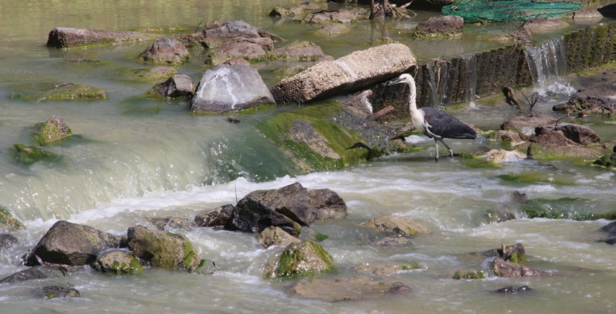

 1800 803 772

@: [ewater@environment.gov.au](mailto:ewater@environment.gov.au)

[www.environment.gov.au/water/cewo](http://www.environment.gov.au/water/cewo)

@theCEWH



 GPO Box 787, Canberra, ACT, 2601