NATIONAL RECOVERY PLAN
FOR THE JERVIS BAY LEEK ORCHID
Prasophyllum affine

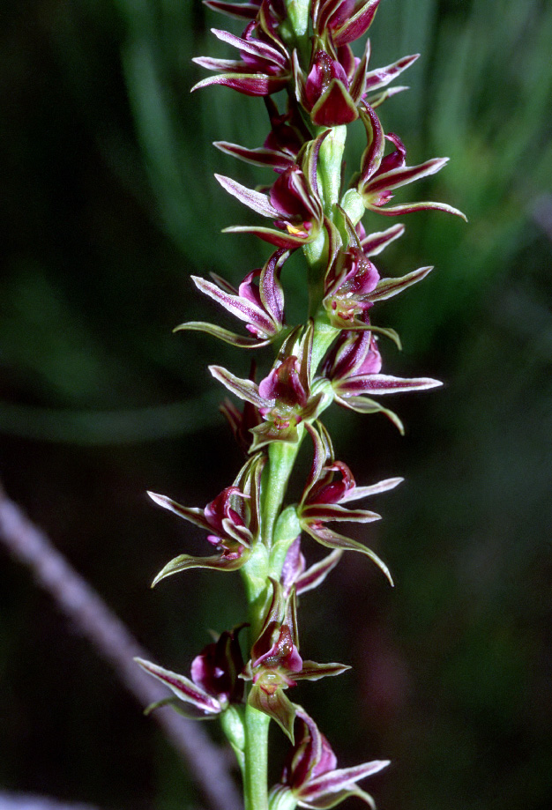



© NSW Office of Environment and Heritage, 2011.
This work is copyright. However, material presented in this Plan may be copied for personal use or published for educational purposes, providing that any extracts are fully acknowledged. Apart from this and any other use as permitted under the Copyright Act 1968, no part may be reproduced without prior written permission from the NSW Office of Environment and Heritage.

Prepared by:
Biodiversity Conservation Section
Environment Protection and Regulation Group
NSW Office of Environment and Heritage
PO Box 733
Queanbeyan NSW 2620
Tel: 02 6299 7121
This recovery plan was prepared with financial support from the Australian Government for adoption as a national recovery plan under the provisions of the Commonwealth Environment Protection and Biodiversity Conservation Act 1999.
This plan should be cited as follows:
NSW Office of Environment and Heritage (2011). National Recovery Plan for the Jervis Bay Leek Orchid (Prasophyllum affine), NSW Office of Environment and Heritage, Hurstville.

ISBN 978 1 74232 841 6 OEH 2010/570

Cover Photo: © John Briggs

DISCLAIMER
The attainment of objectives and the provision of funds may be subject to budgetary and other constraints affecting the parties involved, and may also be constrained by the need to address other conservation priorities. Approved recovery actions may be subject to modifications due to changes in knowledge and changes in conservation status.

Summary
This document constitutes the formal National Recovery Plan for the Jervis Bay Leek Orchid (Prasophyllum affine). It considers the conservation requirements of the species across its known range, identifies the future actions to be taken to ensure the long-term viability of the Jervis Bay Leek Orchid in nature and the parties who are likely to carry these out.
The Jervis Bay Leek Orchid is listed as Endangered under the Commonwealth Environment Protection and Biodiversity Conservation Act 1999 and as Endangered (Schedule 1, Part 1) on the NSW Threatened Species Conservation Act 1995. It is a ground orchid that grows to between 30 and 50 cm in height and flowers in early November. The species occurs only in NSW, where it is confined to three areas, Kinghorne Point, Wowly Gully near the town of Calalla Bay, and near the township of Vincentia. These three areas are in the vicinity of Jervis Bay, south-east of Nowra on the NSW South Coast.
The future Recovery Actions detailed in this Recovery Plan include
- Surveillance monitoring of all known populations
- Annual measurement of permanent monitoring plots located at Vincentia and Kinghorne Point
- Ensure that management activities in Jervis Bay National Park do not adversely affect reserved populations
- Maintenance of the Kinghorne Point track and the protective fencing and the erection of signage advising of the significant vegetation there
- Negotiate with private landowners for the long-term formal protection of sites
- Potential purchase of privately owned land with Jervis Bay Leek Orchid populations
- Monitor development consent conditions applied to protect Jervis Bay Leek Orchid populations

Abbreviations used in this Plan
DSEWPaC – Department of Sustainability, Environment, Water, Population and Communities
EPA Act – NSW Environmental Planning and Assessment Act 1979
EPBC Act – Commonwealth Environment Protection and Biodiversity Conservation Act 1999
ESD – Ecologically Sustainable Development
NPW Act – NSW National Parks and Wildlife Act 1974
OEH- NSW Office of Environment and Heritage
SCC – Shoalhaven City Council
SR CMA – Southern Rivers Catchment Management Authority

Species information and general requirements

Description
The Jervis Bay Leek Orchid is a slender herb usually growing to between 30 cm and 50 cm tall. Each plant produces a single, hollow, cylindrical leaf resembling the young leaf of an onion or leek. The upper part of the leaf usually withers at flowering. The flowering spike usually grows to 40 cm tall with up to 35 flowers in a long, crowded spike. The flower spike emerges from the leaf at approximately three quarters of the height of the leaf above the ground. The flowers are 7-9 mm wide, pale green, pink, brownish or purplish, and lightly scented. The flowers are borne reversed on the spike compared with most other orchids (i.e. with the tongue (labellum) uppermost). Shiny green, obovoid capsules to 4 mm long are produced after flowering. These mature and dry about six weeks later, at which time they turn brown and split to release fine, dust-like seeds.
Flower colour is variable, both within and between sites, with plants in some populations having predominantly pale green to yellowish flowers, whilst in other populations they are predominantly brownish green to purple (as seen in the cover photograph).

Distribution
The Type Locality for the Jervis Bay Leek Orchid was at Port Jackson, NSW (between South Head and Botany Bay) in 1803, but there have not been any further collections of the species from that area.
The species is currently known from three locations: Kinghorne Point, Wowly Gully near the town of Callala Bay, and at Vincentia. The three locations are situated around the western and northern parts of Jervis Bay, south-east of Nowra on the NSW South Coast (see Figure 1), and have a total geographic range of approximately 15 km.
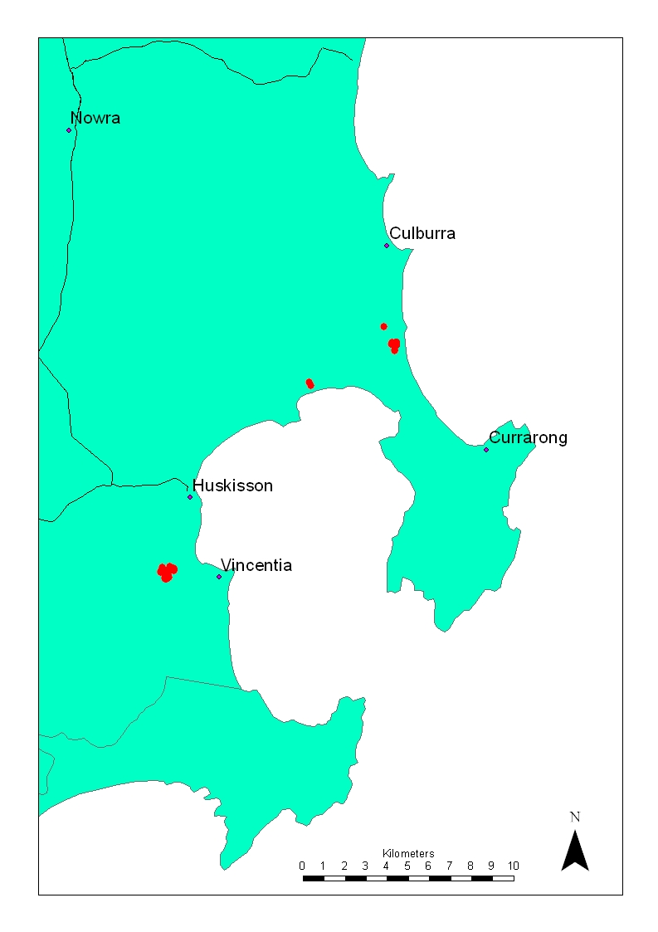
Figure 1. Map showing the three locations of the Jervis Bay Leek Orchid
Habitat
The Jervis Bay Leek Orchid occurs on poorly drained grey-brown clay soils that support low grassy heathland and sedgeland communities, often in a mosaic with clumps of a mallee form of Red Bloodwood (Corymbia gummifera). Associated species which occur at most sites include Black Sheoak (Allocasuarina paludosa), Mountain Devil (Lambertia formosa), Drumsticks (Isopogon anemonifolius), Broad-leaved Hakea (Hakea dactyloides), Dagger Hakea (Hakea teretifolia), Thyme Honey-myrtle (Melaleuca thymifolia), Fish Bones (Lomandra obliqua), Silky Purple Flag (Patersonia sericea), Hairpin Banksia (Banksia ericifolia), Coast Banksia (B. paludosa), Matchheads (Comesperma ericinum), Rice flower (Pimelea linifolia), Eyebright (Euphrasia collina), Broad leaved Geebung (Persoonia levis), Milk Maids (Burchardia umbellata), Guinea Flower (Hibbertia riparia), Devils Twine (Cassytha glabella) and Kangaroo Grass (Themeda triandra - syn T. australis). The heaths are diverse, and contain a number of other shrubs, forbs, grasses, orchids and sedges.
Surveys for additional populations of the Jervis Bay Leek Orchid which were organised and undertaken by several members of the Recovery Team in November 2001 and December 2003 found that the low drier heath/sedge habitat suitable for the Jervis Bay Leek Orchid is extremely restricted in distribution and extent. The surveys extended from Cudmirrah in the south to Maddens Plains in the north and included the Beecroft and Bhewerre Peninsulas. The type of heath suitable for the Jervis Bay Leek Orchid is currently mapped as part of a complex that includes taller, denser and wetter heaths that are more common in the Jervis Bay area. Thus current vegetation mapping of heath on the NSW south coast does not accurately reflect the rarity of the Jervis Bay Leek Orchid habitat.
Biology and ecology
The Jervis Bay Leek Orchid is dormant over summer and plants have usually commenced producing a leaf by mid-winter (plants have been observed with leaves up to 15 cm long by the beginning of June). Mature leaves can be up to 50 cm long and remain until after the flower spike emerges from near the leaf apex in late October/early November. At or soon after flowering the leaf tip usually withers, but the base remains green until the seed capsules mature in late December. The dust-like seed is wind dispersed.
Annual monitoring conducted by OEH since 2001 has confirmed the flowering period to be consistently from early to mid-November, and has also identified that the Kinghorne Point population often begins flowering a week earlier than the Vincentia population.
Bower (2002) found that the pollinators of Prasophyllum affine are a variety of wasps and ants (Hymenoptera) from five families/subfamilies. The most important group were the Flower Wasps (Thynninae), which dominated at both the Vincentia District Centre (Neozeleboria sp.) and Kinghorne Point (Lophocheilus anilitatus) sites (Bower 2002). The wasps feed mainly on Eucalyptus and Leptospermum flowers, and move up to 200 m in search of food, or mates.
Population Size and Structure
In November 2001 1146 flowering individuals were found. There were 302 plants at Vincentia, 763 plants at Kinghorne Point, 12 plants in Jervis Bay National Park near Kinghorne Point, and 69 in Jervis Bay National Park at Wowly Gully near the town of Calalla Bay. A complete population count has not been undertaken since then.
Seven permanent monitoring plots were established at Vincentia and Kinghorne Point by OEH in 2001. All flowering individuals were marked in these plots at the time of their establishment and any new flowering plants found since then have also been marked. The history of all flowering plants on these plots is thus being monitored in detail. Table 1 below shows the number of flowering plants observed across all plots each year since the plots were established:
Table 1. Total number of flowering Jervis Bay Leek Orchid plants in all monitoring plots
Location | 2001 | 2002 | 2003 | 2004 | 2005 | 2006 | 2007 | 2008 | 2009 | 2010
Kinghorne Point | 71 | 0 | 30 | 24 | 6 | 10 | 2 | 9 | 14 | 18
Vincentia | 67 | 0 | 125 | 49 | 31 | 42 | 16 | 25 | 4 | 13
Total | 138 | 0 | 155 | 73 | 37 | 52 | 18 | 34 | 18 | 31
The data show large fluctuations in the number of flowering plants observed each year, and a significant decline in numbers since 2003. The decline is most likely due to the prolonged below average rainfall between 2003 and 2010. Despite above average rainfall in 2010 the species had not displayed a significant recovery when monitored in November 2010.
Impact of Disturbance
An informal and non-replicated trial burn and trial slashing management treatment was applied by OEH at Kinghorne Point in autumn 2001 when the Jervis Bay Leek Orchid plants were dormant (Briggs, pers. com.). Both treatments appeared to have a neutral impact on the number of flowering plants of the Jervis Bay Leek Orchid (the density of flowering plants was similar in 2000 (before treatment) and in 2001 (post treatment) on both the control and treatment areas).
Fire and slashing are more likely to have an adverse impact on the Jervis Bay Leek Orchid, as with other Prasophyllum species, if the habitat is burnt or slashed whilst the species is in leaf, flower or fruit. Such events would potentially destroy a season’s reproductive effort and perhaps weaken the tubers by reducing the photosynthetic period of the growing season, possibly resulting in reduced flowering the following season.
Legal Status
The Jervis Bay Leek Orchid is listed as Endangered under the New South Wales Threatened Species Conservation Act 1995 (TSC Act) and the Commonwealth Environment Protection and Biodiversity Conservation Act 1999 (EPBC Act).
International obligations
The species is not listed under international agreements. However, this Plan is consistent with the aims and recommendations of the Convention on Biological Diversity, which has been ratified by Australia, and the Plan will assist in meeting Australia’s responsibilities under that convention.
Role and interests of indigenous people
Local indigenous groups were consulted in the preparation of this Plan. At the time of publication no role or interest of indigenous people had been identified for this species. Indigenous communities also had opportunity to comment on the Plan during the public exhibition stage, but no submissions were received. The interests of these communities will nevertheless be considered in the implementation of recovery actions where a role is identified.
Habitat critical to the survival of the species
Given the small number of extant populations, limited area of occupancy and the low population size at all sites, all populations and the habitat they occupy are critical to the survival of the Jervis Bay Leek Orchid. The exact area of habitat critical to the survival of the species has not been mapped.
Biodiversity Benefits
The preparation and long term implementation of Recovery Plans for threatened species, populations and ecological communities, contributes to, and highlights the importance of, conserving biodiversity. The conservation of biodiversity has a number of wider community benefits. These include providing and maintaining a range of ecosystem functions and contributing to increased ecological knowledge of species, habitats and broader ecosystems.
In protecting the Jervis Bay Leek Orchid, the plant community in which it is found will also be conserved. Protecting the populations of the Jervis Bay Leek Orchid and its pollinators at Vincentia will also protect some of the co-occurring populations of one threatened plant species and five fauna species that are regarded as threatened in NSW. These are listed in Table 2.
Table 2. Threatened species that co-occur with Jervis Bay Leek Orchid.
Species | Common Name | Commonwealth | NSW
Flora
Cryptostylis hunteriana | Leafless Tongue Orchid | Vulnerable | Vulnerable
Fauna
Dasyornis brachypterus | Eastern Bristlebird | Endangered | Endangered
Pezoporus wallicus wallicus | Eastern Ground Parrot | Not listed | Vulnerable
Cercartetus nanus | Eastern Pygmy Possum | Not listed | Endangered
Sminthopsis leucopus | White-footed Dunnart | Not listed | Vulnerable
Calyptorhynchus lathami | Glossy Black Cockatoo | Not listed | Vulnerable

Affected Interests
Stakeholders and those involved in implementing the plan include:
- OEH (Landowner and implementation of Recovery Actions).
- Shoalhaven City Council (landholder and implementation of Recovery Actions).
- Stocklands (landowner who is already required as a condition of development consent to implement Vegetation and Weed Management Plans for a designated Environmental Zone on their land that supports Jervis Bay Leek Orchid).
- Woolworths (landowner who is already required as a condition of development consent to implement Vegetation and Weed Management Plans for a designated Environmental Zone on their land that supports Jervis Bay Leek Orchid).
- Jervis Bay Baptist Church (landowner who is already required as a condition of development consent to protect and manage areas on their property that support the Jervis Bay Leek Orchid).
- Realty Realizations Pty Ltd (owner of the land supporting the majority of the Kinghorne Point population)
Social and economic impacts
The main social benefit of conserving the habitat in which the Jervis Bay Leek Orchid survives is in meeting the desire of many in the community that further loss of species and the ecological communities in which they occur should be prevented.
There are some social and economic costs associated with conserving the Jervis Bay Leek Orchid habitat. These include:
- A reduction in the area available for the expansion of the community and recreational facilities at the Vincentia Leisure Centre.
- A reduction in the area available for residential and commercial development at Vincentia.
- A restriction on the footprint of a proposed private school development at Vincentia.
Plan review and evaluation
OEH will evaluate the performance of the recovery plan against the criteria identified below. The Plan will be formally reviewed within five years from the date of its adoption under the EPBC Act and be revised if necessary.
Threats
Urban development
Urban development has been the major threat to the populations at Vincentia. One population is almost surrounded by development, or by land on which development is proposed. Development approval for the proposed District Centre and adjoining residential development by both the NSW Department of Planning and the Australian Government has included a requirement to protect the Jervis Bay Leek Orchid populations and areas of pollinator habitat. In addition to restricting the development footprints to avoid direct impacts on the orchid and its pollinator habitat, the Conditions of Consent issued by the Australian Government for the Vincentia District and adjoining residential development require the erection of a person-proof fence around the perimeter of the designated Environment Zone containing the Jervis Bay Leek Orchid. This is to minimize increased public use of the areas supporting the Jervis Bay Leek Orchid. The Australian Government’s Conditions of Consent for these developments also require the preparation of management plans for the vegetation and for weed control within the Environment Zone.
The other population at Vincentia (Wirrilliko Road site) is on private land that was the subject of a development application for the establishment of a school. Development consent was granted by both SCC and the Southern Rivers Catchment Management Authority, but the approval required the protection of habitat supporting the currently known population of the Jervis Bay Leek Orchid. The development approval also required careful ongoing management and monitoring to ensure the habitat would be protected from trampling damage by children and other individuals using the facility and to detect any unforeseen threats. In 2010 OEH received advice from the landowners that they have decided not to proceed with this development (Briggs, pers. com). The future of this site is currently uncertain, but the situation may present an opportunity for the site to be purchased by government or non-government parties to achieve more secure long term protection of the orchid and surrounding habitat.

Damage by vehicles
At Kinghorne Point, part of the population occurs along a road easement which is used by vehicles to access the beach at Kinghorne Point. Until 2001 this track was in very poor condition and the vegetated verges where the Jervis Bay Leek Orchid occurs were being rapidly destroyed by vehicle traffic driving off the main track in an effort to avoid deep potholes. In response to a request by the Jervis Bay Leek Orchid Recovery Team, in 2002 SCC upgraded the track and erected fences parallel to the track to restrict traffic to the designated pavement. The fence is currently in disrepair and the track is deteriorating and there is a risk that traffic could again damage the track verge habitat if maintenance work is not undertaken.
Previously at the Vincentia District Centre site there has been a loss of about 1 ha of Jervis Bay Leek Orchid habitat due to the creation of an unauthorised skid pan area which was regularly used by vehicles doing burn outs, doughnuts and other manoeuvres. This area has now been fenced off to prevent this activity continuing and the area is now subject to rehabilitation works as part of the Australian Government’s conditions of consent for the construction of the Vincentia District Centre.

Dumping of waste
There have also been a number of instances of soil and rubble and garden waste being dumped along the Kinghorne Point track verge which has lead to minor habitat damage and the introduction of the invasive exotic grass, Kikuyu (Pennisetum clandestinum).
Potential threats
Most of the population at Kinghorne Point is on freehold land zoned for environmental protection (although existing-use rights operate). In the past this area was subject to low levels of stock grazing, but in recent years stock grazing has been removed by the landowner to assist in the protection of the Jervis Bay Leek Orchid. Provided grazing is not resumed and the area is not fertilised or pasture improved then the population of the Jervis Bay Leek Orchid on this land can be expected to persist. Until 1998 parts of the habitat at Kinghorne Point where the orchid occurs had also been periodically slashed, but in recent years the landowner has also ceased slashing to avoid any potential negative impact on the species.
Guidance for Environmental Management
Although this recovery plan cannot prescribe decision-making under Commonwealth or State environmental legislation, given the low overall numbers all populations are critical to the long-term survival of the species. Development assessments should consider the habitat requirements of the pollinators in additional to the habitat requirements of the orchids. To avoid significant impacts on the species, any of the following management practices or on ground works in the vicinity of P. affine require assessment.
- Clearing
- Herbicide and pesticide spraying
- Grazing
- Burning
- Removal of vegetation in and around the populations
- Removal or destruction of P. affine plants; and
- Damage to P. affine plants.

Previous Recovery Actions
- Detailed population counts were undertaken by Shoalhaven City Council (SCC) and private consultants in 2000 at the proposed Vincentia District Centre site and the Kinghorne Point site.
- A Recovery Team was established by OEH in February 2001.
- A trial unreplicated burn and a slashing treatment were applied in April 2001 by OEH on the private land site at Kinghorne Point to ascertain the effect these management actions have on the Jervis Bay Leek Orchid.
- Much of the Vincentia District Centre site was burnt by OEH in collaboration with the landowner in April 2001 in an effort to maximise the likelihood of detecting any Jervis Bay Leek Orchid plants within the area the following flowering season (November). This was to enable a development footprint to be finalised that would be likely to avoid all known and potential occurrences of the plants.
- The Vincentia Leisure Centre access road was fenced by SCC in September 2001 to prevent vehicle damage to Jervis Bay Leek Orchid habitat adjacent to the road.
- Studies were conducted from late October to early December in both 2001 and 2003 to identify the pollinator/s of the Jervis Bay Leek Orchid at the proposed Vincentia District Centre and at Kinghorne Point. This study was initiated on the recommendation of the Recovery Team to assist in determining the amount and types of habitat required to conserve the pollinator/s and was funded by Realty Realizations Pty Ltd, the landowner at the time.
- Targeted surveys for the species were carried out in 2000 and more extensively in 2001 and 2003, covering a large proportion of the potential habitat within Jervis Bay, including both the Beecfroft Peninsula and Booderee National Park. Potential habitat as far north as Maddens Plains and as far south as Cadmirrah National Park, south of Sussex Inlet, was also surveyed. These surveys included mapping of habitat occupied and conducting detailed counts of the number of plants.
- A total of seven permanent monitoring plots were established at the proposed Vincentia District Centre site and on the private land site at Kinghorne Point in November 2001. These were established to monitor individuals of the Jervis Bay Leek Orchid over time. The plots at Kinghorne Point were also used to monitor any effects of burning and slashing treatments. All plots have been monitored in detail by OEH each November since 2001.
- A 300 m section of the track to Kinghorne Point was repaired, plain wire fencing erected and large boulders strategically placed along both sides of the track edge by SCC to prevent vehicles driving off the original track alignment and thus prevent further loss of Jervis Bay Leek Orchid plants and habitat. The track requires periodic maintenance to fill potholes and several broken wires in the fence currently require repair.
- OEH and the Recovery Team have provided advice to proponents and consent authorities regarding the design of three major development proposals at Vincentia (residential and District Centre sites and private school site off Wirrilliko Road) that would provide adequate protection to the Jervis Bay Leek Orchid and other affected threatened species. Proponents have also been required to consult with OEH during the preparation of Vegetation and Weed Management Plans for the ongoing protection and management of the nearby areas supporting the Jervis Bay Leek Orchid sites once the developments are complete. As a result, the conditions of consent from both State and Australian Government approval authorities for these developments include measures to assist these orchid populations to persist, including the exclusion of public access, monitoring and additional research on impacts on the orchid pollinators. One of the conditions of consent for the residential and District Centre development also includes a requirement to rehabilitate with suitable native vegetation an extensive bare area adjacent to the largest population of the orchid and the current access road easement.

Recovery Objectives and criteria

Objectives
Over the life of this Recovery Plan:
- ensure that all natural populations of Jervis Bay Leek Orchid are stable or increasing in size
- eliminate or control all threats where feasible

Performance Criteria
Over the life of this Recovery Plan:
- all populations have remained stable or have increased in size over a five year period in relation to the population count made in 2001
- all controllable threats either eliminated or reduced before they lead to any reduction in population size or loss of habitat

The estimated cost of implementation of recovery actions over five years is $30 000.

recovery actions

1. Surveillance Monitoring of all known populations.
Those populations not subject to detailed annual monitoring outlined under Action 2 should be inspected annually to detect obvious new threats or increased levels of threat. Appropriate action should be undertaken to eliminate or control any new or increased level of threat before there is any further impact on the orchids or their habitat. Counts of all flowering individuals should be undertaken at these sites at the appropriate time of year every three or four years to provide data on population size trends across all sites. These counts can be compared with the annual counts obtained from the monitoring plots to determine to what extent any changes in population size are likely to be due to seasonal conditions rather than to specific threats.
Responsibility: OEH
Cost: $2000 (total)

2. Annual measurement of permanent monitoring plots
Seven permanent monitoring plots were established by OEH in November 2001 at the proposed Vincentia District Centre site at Vincentia and on the private land site at Kinghorne Point. These plots were established to monitor the life history of all individuals of the Jervis Bay Leek Orchid found on the plots over time. Every year since 2001 OEH has recorded the state of all marked individuals and marked any new flowering plants during the flowering season in November. This annual monitoring program should be continued to assist in the understanding of the population dynamics of the species, including the extent of year to year variation in the size of the flowering population. During the annual monitoring inspections of the general area should be undertaken to detect obvious new threats or increased levels of threat. Appropriate action should be undertaken to eliminate or control any new or increased level of threat before there is any further impact on the orchids or their habitat.
Responsibility: OEH
Cost: $10 000 in kind (total)

3. Ensure that management activities in Jervis Bay National Park do not adversely affect populations
The location, habitat and protection requirements for the Jervis Bay Leek Orchid will be incorporated into the relevant OEH park management documents. These will be included to ensure that track construction, fire suppression activities or any other management actions do not impact on the individuals present.
Responsibility: OEH.
Cost: In kind

4. Maintenance of track, fences and erection of signage at Kinghorne Point
The access track to Kinghorne Point should be maintained to a sufficient standard that leaves no reason for traffic to deviate from the designated pavement. The internal fences adjacent to the road pavement that were erected to keep traffic to the designated alignment should be maintained in good repair. The road is owned by SCC and OEH will liaise with SCC in regard to its maintenance.
Appropriate signage should be erected by SCC along the Kinghorne Point access track alerting the public to the conservation importance of the roadside vegetation and prohibiting the dumping of waste in the area.
Responsibility: OEH, SCC
Cost: $5000 (total)
5. Negotiate with landowners for the long-term formal protection of sites
The long-term security of the Jervis Bay Leek Orchid sites is an important goal in the protection of this species. Two privately owned sites at Vincentia (District Centre and adjoining residential area) have now been formally protected in offset areas as part of the conditions of consent by the relevant approval authorities for proposed developments on adjoining land. Effort should be made to negotiate with the owners of the Kinghorne Point and Wirrilliko Road private land sites to develop a formal protection mechanism for these sites. Options for formal protection of privately owned sites include Voluntary Conservation Agreements (OEH) and Property Management Plans (SR CMA).
Responsibility: OEH.
Cost: In kind

6. Potential purchase of privately owned land with Jervis Bay Leek Orchid populations
The Australian and/or State Government should consider the purchase of privately owned land supporting Jervis Bay Leek Orchid populations if any of these sites become available for purchase.. Once purchased, the land could then be added to the formal reserve system. The Wirrilliko Road and Kinghorne Point sites would be priority properties. As an alternative to direct purchase, these two properties may also be suitable for use as formal offset or Biobank sites for other developments impacting on similar vegetation in the region.
Responsibility: DSEWPaC, OEH.
Cost: $1000 per year in kind, plus purchase cost

7. Monitor development consent conditions applied to protect Jervis Bay Leek Orchid populations
The Australian and NSW Governments have applied a number of conditions to the approval for the development of the Vincentia District Centre and the adjoining residential development. Some of these conditions relate to the protection of the Jervis Bay Leek Orchid habitat and its pollinator habitat. The conditions include the preparation of threatened species and vegetation Management Plans, including rehabilitation of the old skid-pan area, which required approval by OEH and the Australian Government prior to the commencement of construction. Adherence to the conditions of consent should be monitored regularly during the construction phase and annually post construction. The consent authorities should enforce compliance with the conditions and negotiate with the developer modifications to the conditions if they are not proving effective.
Conditions of consent were also applied by the Australian and NSW Governments to the Wirrilliko Road school development site but the landowner has now advised OEH that this development is now unlikely to proceed.
Responsibility: DSEWPaC, OEH.
Cost: $2000 per year for years 1 - 3, $1000 per year for years 4 & 5 (in kind)

Table 3 provides a summary of desirable actions identified in this Plan and an estimate of the costs to implement these actions. Implementation of many of these actions will be dependant on the availability of adequate resources to those parties identified as primarily responsible for the various actions.
Table 3. Summary of actions and costs identified in the Recovery Plan
Action No. | Action Title | Cost Estimate ($1000s/year) |  |  |  |  | Total Cost ($) | Responsible Party | Priority
Action No. | Action Title | Year 1 | Year 2 | Year 3 | Year 4 | Year 5 | Total Cost ($) | Responsible Party | Priority
1 | Surveillance monitoring of all populations | 0 | 1 | 0 | 0 | 1 | 2 | OEH | 1
2 | Annual measurement of permanent monitoring plots | 2 | 2 | 2 | 2 | 2 | 10 | OEH | 1
3 | *Ensure that management activities in Jervis Bay NP do not adversely affect populations |  |  |  |  |  |  | OEH | 2
4 | Maintenance of track, fences and erection of signage at Kinghorne Point | 1 | 1 | 1 | 1 | 1 | 5 | OEH, SCC | 2
5 | *Negotiate with landowners for the long-term formal protection of sites |  |  |  |  |  |  | OEH | 2
6 | *Potential purchase of privately owned land with Jervis Bay Leek Orchid populations | 1 | 1 | 1 | 1 | 1 | 5 | OEH, DSEWPaC | 2
7 | *Monitor development consent conditions applied to protect Jervis Bay Leek Orchid populations | 2 | 2 | 2 | 1 | 1 | 8 | OEH, DSEWPaC | 1
Total |  | 6 | 7 | 6 | 5 | 6 | 30
- *Costs will be borne by agencies as tasks to be undertaken by existing staff

References
Bernhardt, P. & Rowe, R.R. (1993). In Flora of NSW, Volume 4, Ed. Harden, G. J., New South Wales University Press, NSW.

Bower, C. C. (2002). Pollination of the Jervis Bay Leek Orchid Prasophyllum affine Lindley (Orchidaceae). Final Report to the Jervis Bay Leek Orchid Recovery Team, pp. 65. Orchid Research, Orange.

Bower, C. C. (2004). Pollinators of the Jervis Bay Leek Orchid, Prasophyllum affine, at Vinventia, NSW – Distribution and movements, pp. 24. (unpublished report for Environmental Resources Management Australia).

Briggs, J.D. (Personal communication). OEH, Queanbeyan.

Briggs, J.D. & Leigh, J.H. (1996). Rare or Threatened Australian Plants: 1995 Revised Edition, pp. 466. CSIRO Publishing: Melbourne.

Howell, P. (Personal communication). Sydney.

Jones, D.L. (1988). Native Orchids of Australia. Reed Books, Sydney.

Jones, D. L. (2000). Ten new species of Prasophyllum R. BR. (Orchidaceae) from south-eastern Australia. Orchadian 13(4):149-173.

Acknowledgments
OEH would like to thank the following people and their respective agencies/organisations for their assistance with the preparation of the draft NSW Recovery Plan on which this Plan is based, and with the implementation of recovery actions to date for this species.
John Briggs (OEH)
John Creelman (Realty Realizations)
Elizabeth Dickson (SCC)
Phil Howell (ex Realty Realizations)
David Jones (Bermagui)
Sandie Jones (OEH)
Les Mitchell (Kangaroo Valley)
Ken Murray (ex. Shoalhaven City Council (deceased))
Geoff Robertson (OEH)
Murray Schofield (Gunninah Environmental Consultants)
Michael Smith (SCC)
Alan Stephenson (Nowra)
Genevieve Wright (OEH)

