# Carbon + Biodiversity Pilot

Price Guide: South West NRM Region (Western Australia)

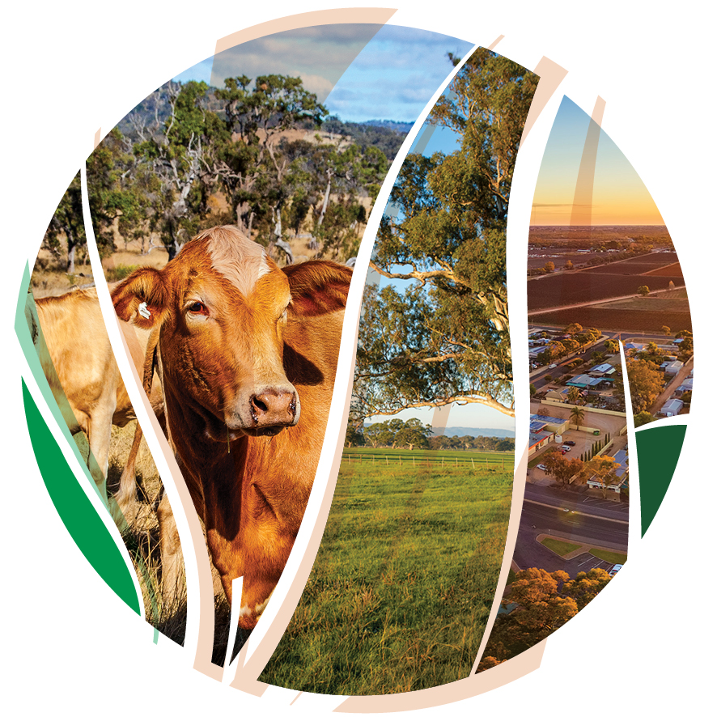

© Commonwealth of Australia 2021

**Ownership of intellectual property rights**

Unless otherwise noted, copyright (and any other intellectual property rights) in this publication is owned by the Commonwealth of Australia (referred to as the Commonwealth).

**Creative Commons licence**

All material in this publication is licensed under a [Creative Commons Attribution 4.0 International Licence](https://creativecommons.org/licenses/by/4.0/legalcode) except content supplied by third parties, logos and the Commonwealth Coat of Arms.

Inquiries about the licence and any use of this document should be emailed to [copyright@awe.gov.au](mailto:copyright@awe.gov.au).



**Cataloguing data**

This publication (and any material sourced from it) should be attributed as: DAWE 2021, *Carbon + Biodiversity Pilot. Price Guide:* *South West NRM Region (Western Australia)*, Department of Agriculture, Water and the Environment, Canberra, March. CC BY 4.0.

This publication is available at <https://www.agriculture.gov.au/ag-farm-food/natural-resources/landcare/sustaining-future-australian-farming/carbon-biodiversity-pilot>

Inquiries can be made by email at agstewardship@awe.gov.au.

Department of Agriculture, Water and the Environment

GPO Box 858 Canberra ACT 2601

Telephone 1800 900 090

Web [awe.gov.au](https://www.awe.gov.au/)

**Disclaimer**

The Australian Government acting through the Department of Agriculture, Water and the Environment has exercised due care and skill in preparing and compiling the information and data in this publication. Notwithstanding, the Department of Agriculture, Water and the Environment, its employees and advisers disclaim all liability, including liability for negligence and for any loss, damage, injury, expense or cost incurred by any person as a result of accessing, using or relying on any of the information or data in this publication to the maximum extent permitted by law.

**Acknowledgements**

We thank the South West Catchments Council and Professor Andrew Macintosh, Dr Don Butler, Dr Dean Ansell and Dr Tyrone Lavery from the Australian National University (ANU) for their assistance in preparing this document.

## Acknowledgement of Country

We acknowledge the Traditional Owners of Country throughout Australia and their continuing connection to land, sea and community. We pay our respects to them and their cultures and to their elders past, present and emerging.

Contents

Acknowledgement of Country 3

1. Role of the Price Guide 5

1.1 Importance of project planning 5

1.2 Role of Natural Resource Management Groups 5

2. Making an application 6

3. Indicative average costs 1

4. Questions and feedback 3

## Role of the Price Guide

The *Carbon + Biodiversity Pilot: Price Guide* (Price Guide) has been developed to help farmers who are considering applying to participate in the Agriculture Stewardship – Carbon + Biodiversity Pilot (C+B Pilot). The [C +B pilot documentation](https://www.agriculture.gov.au/ag-farm-food/natural-resources/landcare/sustaining-future-australian-farming/carbon-biodiversity-pilot) explains how the pilot will operate and should be read prior to reading the Price Guide and commencing an application.

The Price Guide:

1. outlines the information required for each planting area to complete a C+B Pilot application (Section 2 of Price Guide); and
2. provides indicative estimates of the average costs associated with establishing environmental planting projects (Section 3 of Price Guide).

### 1.1 Importance of project planning

Before applying to participate in the C+B Pilot, you will need to plan your project and consider how it fits into your existing agricultural business. Amongst other things, when planning the project, you should consider:

* alternative areas for, and designs and types of, environmental plantings;
* the most cost-effective ways of establishing environmental plantings on your property; and
* the likely costs of both establishing the plantings and managing them over the life of the ERF permanence period (i.e. either 25 or 100 years).

Where necessary, you should seek expert advice from agronomists, financial advisers, service providers and others when planning the project.

The information contained in Section 3 of the Price Guide can be used as a starting point for project planning to give you a point of reference in considering whether you want to participate in the C+B Pilot. However, it **should not** be relied on as the sole or primary source of information on the costs associated with establishing biodiverse environmental planting projects. Project costs are highly variable and depend on a range of factors, including the size, remoteness and accessibility of the site, the types of species that are planted, soil type, slope and the type of tree protection that is used (if any). Applicants are responsible for collecting their own information on project costs and conducting their own analysis of the costs and benefits of participating in the C+B Pilot.

### 1.2 Role of Natural Resource Management Groups

Your regional Natural Resource Management (NRM) group can provide general assistance with project planning and help identify relevant local service providers, including nurseries, and weed, planting and fencing contractors.

## Making an application

After completing the project planning, you should be in a position to apply to participate in the C+B Pilot through the web portal at the [C+B Pilot website](https://www.agriculture.gov.au/ag-farm-food/natural-resources/landcare/sustaining-future-australian-farming/carbon-biodiversity-pilot). The web portal requires applicants to:

* map the areas where the plantings will be established on their property (known as ‘planting areas’);
* provide details of how the plantings will be established and managed in each of the planting areas; and
* estimate the cost of establishing the plantings in each of the planting areas.

Table 1 summarises the information required for each planting area.

It is important that the information you submit for each planting area is as accurate as possible. The submission of inaccurate information could distort the outcomes from the pilot and threaten the ability of the C+B Pilot to achieve its objectives. The cost estimates are of particular importance as they will be used to generate biodiversity payment offers, test the competitiveness of bids and rank projects in the selection process. Due to this, all applicants are asked to:

1. undertake proper project planning before submitting an application through the web portal;
2. give appropriate thought and consideration to the information they submit; and
3. to the extent possible, ensure the cost estimates that are submitted accurately reflect the likely costs associated with undertaking the proposed environmental planting project.

**Duty to ensure submitted information is accurate**

Applicants are required to act with the utmost good faith in their engagements with the C+B Pilot, including in applying to participate through the web portal. This duty requires proponents to act reasonably, honestly and with propriety, and with due regard to what the Australian Government is trying to achieve with the C+B Pilot.

Knowingly providing inaccurate information in an application is likely to constitute a breach of this duty and could result in your exclusion from the C+B Pilot. It could also result in the termination of any agreement you may be offered under the C+B Pilot.

Applicants should note that making false or misleading statements, or providing false or misleading information, in an application is an offence under Chapter 7 of the Commonwealth *Criminal Code*, carrying maximum penalties of up to 12 months imprisonment.

**Table 1. Information required for each planting area to complete C + B Pilot application**

|  |  |
| --- | --- |
| **Planting step** | **Required information** |
| Site preparation (weed control) | An estimate of the number of weed treatments (spot spray, boom spray or other) that will be carried out prior to planting.  An estimate of the total cost of the weed treatments, including labour, equipment and chemicals. |
| Soil preparation | Details of how the soil will be prepared for the plantings (manual digging, deep ripping, discing or other).  An estimate of the total cost of the soil preparation works, including labour, equipment and chemicals. |
| Planting | Details of the method that will be used to establish the plantings (manual tubestock, mechanical tubestock or direct seeding (with or without supplemental tubestock plantings)).  If tubestock planting is used, an estimate of the number of seedlings that will be planted in each planting area and an estimate of the total cost of the seedlings.  If direct seeding is used, an estimate of the amount (kilograms) of seed that will be used in each planting area and an estimate of the total cost of the seed.  An estimate of the other planting costs, including the labour and machine hire costs associated with planting the seedlings or sowing the seed. |
| Tree protection | If fencing is used:   * an estimate of the length of fencing and an estimate of the total cost of the fencing wire, intermediate posts/pickets and droppers (where required); * an estimate of the number of strainer assemblies and an estimate of their cost; * an estimate of the number of gates and an estimate of their cost; * an estimate of the cost of other fencing materials; and * an estimate of the cost of installing the fencing.   If tree guards are used:   * an estimate of the number of tree guards and an estimate of their cost, including the cost of support stakes; and * an estimate of the cost of installing the guards. |
| Recurrent management* | Details of the recurrent management actions that will be undertaken in the planting area (e.g. weeding and pest control).  An estimate of the average annual cost (in 2021 dollars) of the proposed recurrent management actions (e.g. pest control, weed control, fence maintenance). This estimate should not include:   * the cost of management actions that are already legally required to be carried out or that are already funded under another government environment program; or * any foregone returns that may be associated with the exclusion of livestock or cessation of cropping. |

## Indicative average costs

Table 2 contains indicative estimates of the average costs associated with establishing environmental planting projects in the South West NRM Region in Western Australia. The estimates are provided in five generalised cost categories relating to the establishment of plantings:

* site preparation – weed control;
* soil preparation;
* cost of seedlings and seed;
* planting costs; and
* tree protection costs.

The indicate costs are provided as a range and they **do not** include GST.

As noted in Section 1.1 above, the information contained in Table 2 is intended to provide potential applicants with an initial point of reference when considering whether to participate in the C+B Pilot. It is not intended to be, and should not be used as, a definitive costing guide.

Table 2 **should not** be relied on as the sole or primary source of information when undertaking project planning or submitting an application to participate in the C+B Pilot.

**Should GST be included in the cost estimates submitted through the web portal?**

The cost estimates that are submitted through the web portal are required to include GST *where it is payable*. Do not include GST if it is not payable on the relevant good or service.

For example, if you intend to use tubestock from a local nursery but plant the seedlings yourself, GST is likely to be payable on the tubestock but not on the amount you cost for your time and labour. Consequently, the cost estimates submitted through the web portal should: (a) include the GST payable on the tubestock; and (b) not include GST in the cost of the labour associated with planting the seedlings.

Note that, if you are registered for GST, GST will be included in any biodiversity payment offer that you receive.

**Table 2. Indicative average cost ranges, by planting cost component**

|  |  |  |
| --- | --- | --- |
|  | **Cost estimate** | **Comment** |
| **Site preparation - weed control** | | |
| Spot spray | $80-$200 per ha per treatment | Non-woody weeds only. Plantings generally require between 0-3 treatments. |
| Boom spray | $40-$300 per ha per treatment | Non-woody weeds only. Plantings generally require between 0-3 treatments. |
| **Soil preparation** | | |
| Manual digging - for seedlings | $0.80-$1.50 per seedling | Depends on size of planting, stocking densities and location. |
| Deep ripping/discing | $60-$300 per ha | Size, remoteness and accessibility important. |
| **Plants** | | |
| Tubestock (seedlings) | $0.50-$3.00 per seedling | High variability. Local provenance can increase costs. Specialist/rare species can increase costs significantly. |
| Seed | $300-$900 per kg | High variability. Local provenance can increase costs. Specialist/rare species can increase costs significantly. |
| Amount of seed per ha | 0.3-0.7 kg per ha | Depends on stocking density, species and site characteristics |
| **Planting** | | |
| Manual tubestock planting | $0.40-$1.00 per seedling | Depends on size of planting, stocking densities, site characteristics and location. |
| Mechanical tubestock planting | $0.50-$1.30 per seedling | Depends on size of planting, stocking densities, site characteristics and location. |
| Direct seeding | $200-$450 per ha | Depends on size of planting, site characteristics and location. |
| **Tree protection** | | |
| Fencing - wire and posts | $6.00-$8.00 per metre, supplied and installed | Includes materials, supply and installation |
| Fencing - strainer assemblies | $100-$200 per assembly, supplied and installed | Includes materials, supply and installation |
| Fencing - gates | $200-$240 per gate, supplied and installed | Includes materials, supply and installation |
| Guards | $0.30-$2.00 per guard | Depends on type of guard (cardboard milk carton, plastic sleeve, corflute plastic etc.) and quantity purchased. |
| Guard stakes | <$0.01-$0.50 per stake | Depends on type of stake (bamboo, hardwood etc.) and quantity purchased. |
| Guard installation | $0.20-$0.25 per guard | Depends on site characteristics and number and type of stake. |

## Questions and feedback

Any questions or feedback about this document should be sent to [agstewardship@awe.gov.au](mailto:agstewardship@awe.gov.au) or you can contact the Department of Agriculture, Water and the Environment on 1800 329 055.