Completing a Project MERI Plan

The project MERI plan (the plan) is a living document that should be updated at least annually through consultation between the funding recipient and the Australian Government. The plan has been streamlined to reduce red-tape while still delivering key information about funded projects to the Department. New projects will now complete their plan in the Department’s online reporting tool, MERIT. Transferring a plan into MERIT is optional for old projects.

The purpose of the plan is to:

* clearly set out the intended outcomes and outputs of NLP funded project/s and the project activities intended to achieve them; and
* monitor progress and achievements through six monthly reporting against the plan which supports accountability and adaptive management.

The plan links to reporting requirements and summaries of achievement within MERIT. An example plan has been set up in the MERIT Demonstrator project. This project has been set up in the test environment so that users can experience and explore the range of activity forms currently available. Users will need to log in with the credentials noted on the overview page in order to view the project. Search for ‘MERIT’ in the search tool, or use the following link: <https://fieldcapture-test.ala.org.au/project/index/8b87b9d5-fc24-4d6f-b526-bf8aef4a8754>)

**Completing the plan in MERIT**

|  |  |  |
| --- | --- | --- |
| **Component** | **Location** | **Comment** |
| MERI Plan | Template: Admin tab, then ‘MERI Plan’ from list of options on the left of the screen  Displayed: ‘MERI Plan’ tab |  |
| Planned Activities | ‘Activities’ tab |  |
| Output Targets | ‘Activities’ tab | Required for Dashboard to work correctly |
| Risks & Threats | Template: ‘Activities’ tab  Displayed: ‘MERI Plan’ tab | Can be edited at any time (without the need to modify (unlock) an approved plan). |

The plan template contains descriptions of the information required in each field. The descriptions can be viewed by hovering your mouse cursor over the 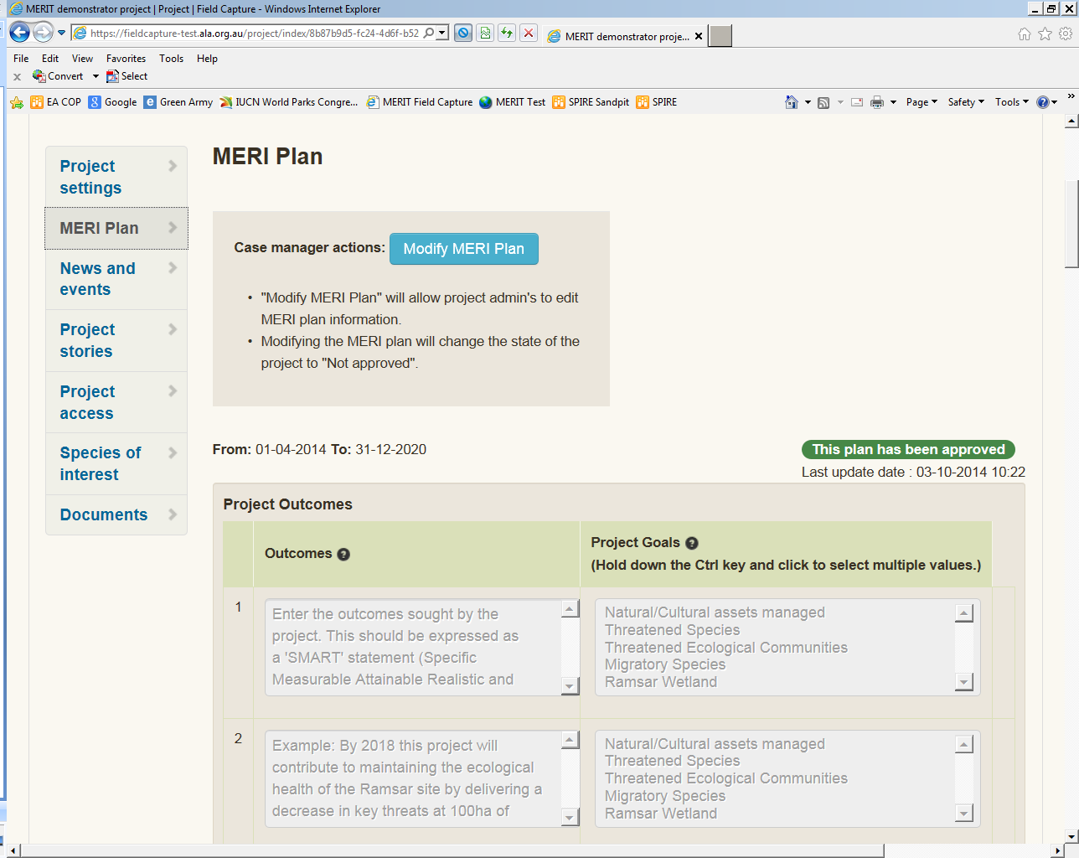 icon. They are also listed below:

|  |  |  |
| --- | --- | --- |
| **Section** | **Information required** | **Suggested length** |
| **Project Outcomes** | Enter the outcomes sought by the project. This should be expressed as a 'SMART' statement (Specific Measurable Attainable Realistic and Time-bound) and deliver against the programme. A project may have more than 1 outcome. | The outcome should be no more than 2 sentences. |
| **Asset(s) addressed** | The high level assets being addressed by the project outcome. An outcome may be delivering against more than one of these. | Select the relevant asset(s) addressed by the Project Outcome is addressing from the list available. Selecting the goals allows the Department to more efficiently evaluate programme performance. Please review the list and select the most appropriate asset being addressed, ‘other’ should be used as a last resort. |
| **Monitoring indicator** | List the indicators of project success to be monitored. These may be things such as increased community participation, increased abundance of a threatened species, maintenance of vegetation condition etc. | The indicator should be approximately 1 to 2 sentences. The indicator being monitored should be easily identifiable on review of the text. |
| **Monitoring approach** | How will this indicator be monitored? Briefly describe the method to be used to monitor the indicator. | The section should provide sufficient detail so that a grants manager can easily understand the methods being used and when the monitoring will take place. Broad definitions are sufficient, e.g. vegetation condition monitoring using Bushland Condition Monitoring method. There is no requirement to outline that this involves transects, plots etc. |
| **National and regional priorities** | List the name of the National or Regional plan the project is addressing, what section (target/outcomes/objective etc) of the plan is being addressed, and in what way will the project deliver against this section? | 1 to 2 sentences on the strategic alignment of the project to the document is sufficient as long as it clearly outlines how the project aligns. |
| **Project implementation / delivery mechanism** | How is the project to be delivered? Briefly describe the high-level method/s to be used, e.g. the types and rates of herbicide to use are not required. The delivery mechanism/s should provide sufficient detail to understand how the project's outcomes will be achieved . | Length will vary from project to project because of the variation in projects complexity and the range of outcomes being delivered. Succinctly describe the delivery mechanisms. |
| **Project partnerships** | Provide the name of project partners, project partners needs to be actively involved in planning or delivering the project, very briefly indicate how the partner is contributing to the project and select the most appropriate partner type from the list provided. | Nature of partnership should be able to be described in 2 to 3 sentences. Please list all partners actively involved in the planning and delivery of the project. The type of organisation allows the Department to more efficiently evaluate programme performance. |
| **Key evaluation question** | Please list the Key Evaluation Questions for your project. Evaluation questions should cover the effectiveness of the project and whether it delivered what was intended; the impact of the project; the efficiency of the delivery mechanism/s, and the appropriateness of the methodology. These need to be answerable within the resources and time available to the project. | Provide as many KEQs as necessary to ensure your grants manager has sufficient evidence that appropriate project evaluation processes are in place to ensure project outcomes are met. |
| **Project Events and Announcements** | This section provides grantee's a place to provide key forward (planned) announcables and invite the Australian Government to participate in launches, communication and media opportunities related to this requirement. This includes opportunities to announce recipients of small projects and related activities. Dates provided can be indicative only, grant managers can clarify actual dates closer to the timing of the events or as required. | Provide a full list of key events and their indicative dates. The list does not need to include field days, workshops, training sessions etc. |
| **Project Budget** | Include the planned budget expenditure against each programme objective. For NLP regional delivery projects please provide 2 rows per objective. One to indicate the amount directed toward engaging the community, the second indicating all other expenditure against the objective. |  |
| **Activities** | The activities are found under the ‘Activities’ tab of MERIT, not the MERI Plan tab. These are the activities that you will report against each 6 months. Provide a full list of activities associated with the delivery of your project outcome. Several documents are available to help in the selection of the correct activities. These are outlined below. | To enter/modify activities your project needs to be unlocked by your grants manager. |
| **Output targets** | Output targets are the total outputs that a project has committed to achieve. The list of Output targets is generated automatically according to the Planned Activities selected, e.g. selecting ‘Revegetation’ as an activity creates the Output targets of “Area of revegetation works (Ha)’, ‘Number of plants planted’ and ‘Kilograms of seed sown’. | To enter Output target figures your project needs to be unlocked by your grants manager. |
| **Project risks & threats** | Ensure key risks and threats are addressed with appropriate descriptions and how the controls/contingencies will manage them. Key risks such as, but not limited to, seasonal conditions and Workplace Healthy and Safety must be considered. | Select the appropriate likelihood and consequence of the risk, describe the controls in place to manage the risk and apply a residual risk rating based on the control. Overall project risk profile is to be assigned, this is not an auto calculate field based on the risk table. Apply a level of risk appropriate to the project and risks identified and the strength of controls to manage these risks. |

Several resources are available to help in the selection of the correct activities and are available on the ‘Overview’ tab of the MERIT Demonstrator Project (<https://fieldcapture-test.ala.org.au/project/index/8b87b9d5-fc24-4d6f-b526-bf8aef4a8754>)

**MERIT Schema** – Word document that contains every field description, data use and type for each activity form. It also lists the outputs that are currently used for reporting.

**MERIT Ready Reckoner** – a three page summary table of each activity, minimum data requirement (mandatory fields), target measures (outputs) plus more.

**Activity family tree** - a one-page table demonstrating the temporal relationship between activities. Commence reading the table from the centre ‘Primary Activity’ column. Activities to the left are those you may choose in preparation for the primary activity, including baseline data collection. Activities to the right are those you may choose for monitoring/maintenance of the activity, including comparison to baseline data.

Once the MERI Plan (including the list of planned activities and output targets for new projects) is completed, funding recipients click the ‘submit for approval’ button at the bottom of the template page to commence the plan approval process.