Providing Friendly Feedback on Recycling Contamination
How we tested a new method to reduce residential recycling contamination in multi-unit dwellings

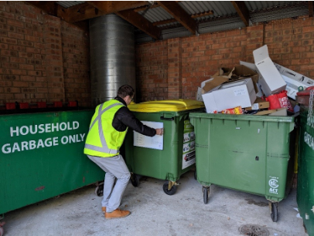

© Commonwealth of Australia 2020

Ownership of intellectual property rights
Unless otherwise noted, copyright (and any other intellectual property rights) in this publication is owned by the Commonwealth of Australia (referred to as the Commonwealth).
Creative Commons licence
All material in this publication is licensed under a Creative Commons Attribution 4.0 International Licence except content supplied by third parties, logos and the Commonwealth Coat of Arms.
Inquiries about the licence and any use of this document should be emailed to copyright@awe.gov.au.

Cataloguing data
This publication (and any material sourced from it) should be attributed as: Providing Friendly Feedback on Recycling Contamination, Department of Agriculture, Water and the Environment, Canberra, February. CC BY 4.0.
This publication is available at http://www.environment.gov.au/protection/waste-resource-recovery/publications
Department of Agriculture, Water and the Environment
GPO Box 858 Canberra ACT 2601
Telephone 1800 900 090
Web awe.gov.au
The Australian Government acting through the Department of Agriculture, Water and the Environment has exercised due care and skill in preparing and compiling the information and data in this publication. Notwithstanding, the Department of Agriculture, Water and the Environment, its employees and advisers disclaim all liability, including liability for negligence and for any loss, damage, injury, expense or cost incurred by any person as a result of accessing, using or relying on any of the information or data in this publication to the maximum extent permitted by law.
Project Team
This trial was a collaborative effort between the Behavioural Analysis Team of the Department of Agriculture, Water and the Environment and ACT NoWaste from the ACT Government.

Acknowledgements

Participating residents of ACT multi-unit dwellings
The building and strata managers who participated in this research
Jenni Downes of BehaviourWorks Australia, whose evaluation guidance shaped this report’s conclusions
The National Waste and Recycling Taskforce

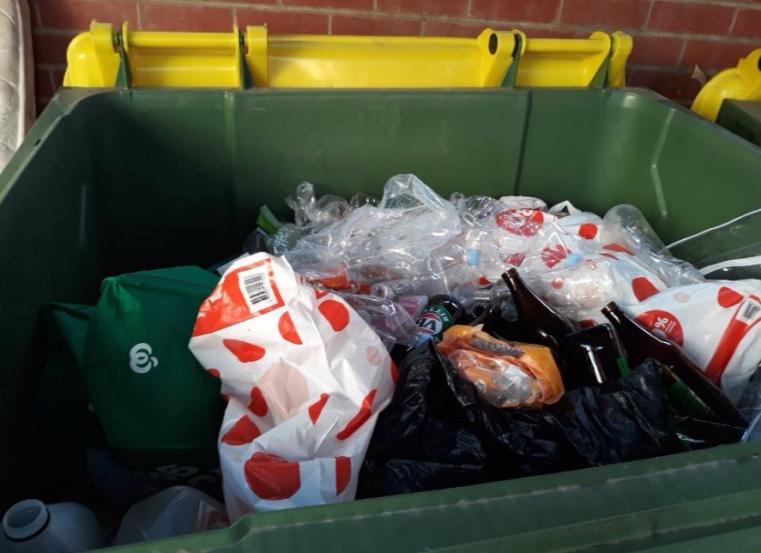
One-page summary

One-page summary

1. Problem: Existing policy and research showed there is a need to know more about techniques to improve Australians’ recycling behaviours. The Department of the Environment and Energy’s Behavioural Analysis Team and ACT Government NoWaste partnered to research reducing contamination of recycling by plastic bags in ‘multi-unit dwellings’ (apartment buildings and townhouse complexes) , because this is a common contamination issue.
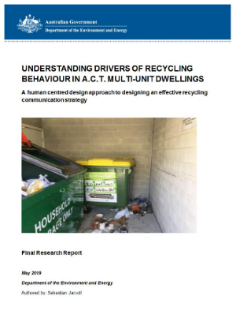
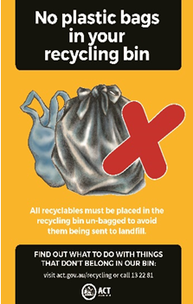
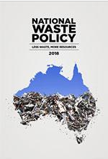

2. Solution Design: Previous research by the Behavioural Analysis Team showed residents often don’t notice professional educational signs, were confident that they were doing the right thing even when they weren’t, and incorrectly believed that plastic bags could be recycled. We designed an informal-looking whiteboard that aimed to leverage those findings to stop residents using plastic bags in their recycling. We deployed a prototype in multi-unit dwellings throughout the ACT and tested its impact on the behaviour of residents.

Design features:
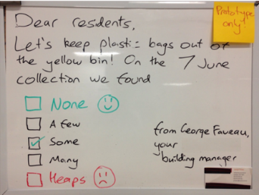
-Personalised
feedback
-Attention-grabbing
-Trusted messenger
-Social identity
3. Results: Our tests showed the whiteboard could work, so we think it’s ready to be trialled more fully and adopted by local councils and strata managers. In particular, residents were very positive about receiving messages from their strata management and were glad to see attention paid to their property’s recycling performance.
Residents said…
“I thought they [plastic bags] could be recycled, but apparently not.”

“I’m going to pay attention to what’s on that whiteboard.”

“I was very happy when [the amount of plastic bags in recycling] changed to ‘None’.”

Background

Background: what led us here?

This research falls under Strategy 3 of the 2018 National Waste Policy. The Department of Agriculture, Water and the Environment (the Department) is leading cross-jurisdictional knowledge-sharing to improve waste management Australia-wide.
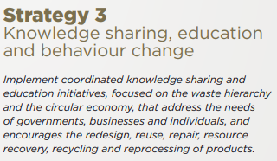
Previous research has found several common ‘problem areas’ regarding residential recycling. These include recycling behaviour of multi-unit dwelling (MUD) residents, and incorrect disposal of plastic bags into recycling streams.
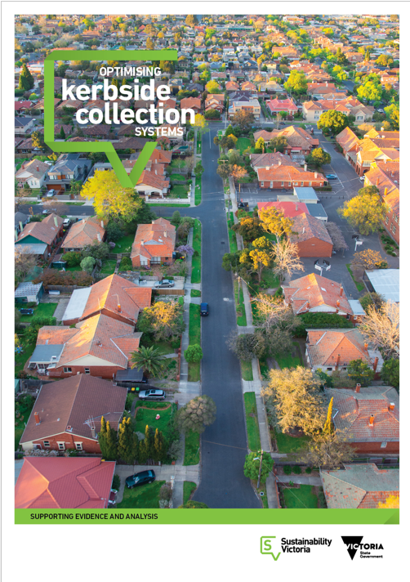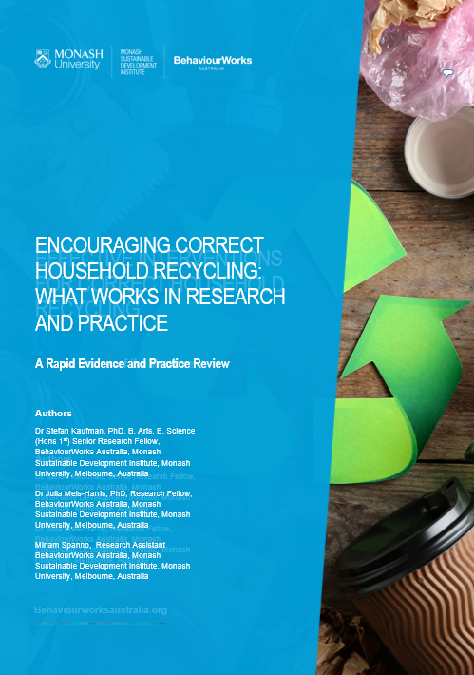
The Department’s partnership with ACT NoWaste produced research findings that suggested several opportunities to improve recycling behaviour. Bin audits, surveys and interviews provided rich information on which to base behavioural interventions.

Background: How did we start?

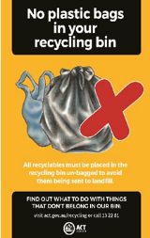
Plastic bag contamination is a problem across Australia, and our previous research confirmed that this problem does occur in Canberra MUDs.

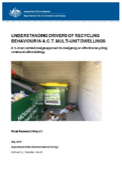
+
Our previous research also gave us a lot of insight into what was driving that behaviour.
=
Research aim: Design and test a new technique to reduce plastic-bagging behaviour among recyclers in MUDs.
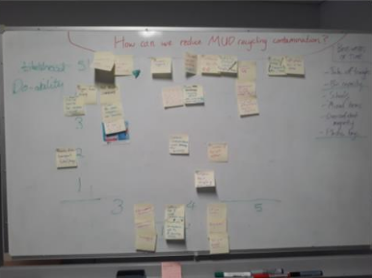
Once we had a research aim, we started by brainstorming possible solutions, which we then narrowed down to pick a winning idea. We considered factors like cost, practical feasibility, ability to scale across councils nation-wide, and likely impact on the problem.

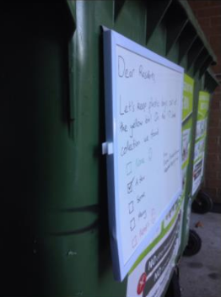
Background: How did we design a prototype?

The prototype was based on four main behavioural principles, each targeted in several ways:
Personalised feedback
- Handwritten text
- ‘Performance’ rating (based on real bin audit data)
- Updated based on actual behaviour, with concrete dates
Attention-grabbing (to overcome ‘sign blindness’)
- Unusual ‘object’ rather than a sign or sticker
- Located close to eye level ‘between’ resident and bin
Trusted messenger
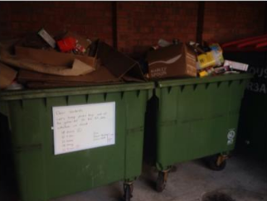
- Building/strata manager
- ‘Signed’ with business card to add authority
Social identity
- Activating a positive, inclusive identity: ‘Dear residents’
- Including messenger in the in-group: ‘Let’s…’
- Feedback including faces
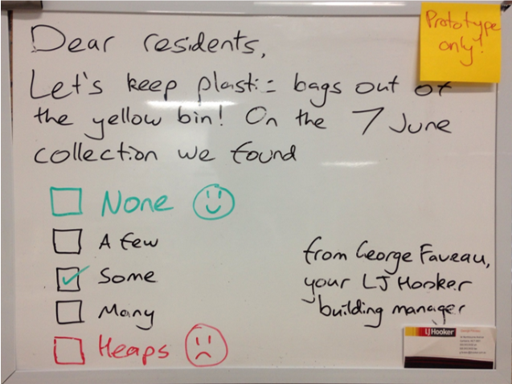

Background: What did we do, and when?

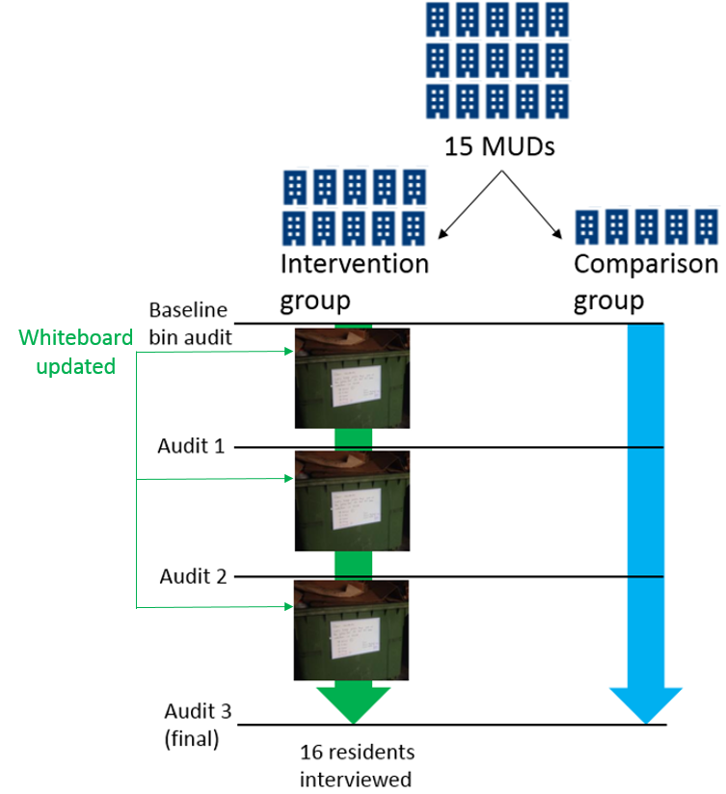
- We recruited strata managers of 15 multi-unit dwellings (MUDs) in Canberra, and divided those into ten ‘intervention’ MUDs where we deployed the whiteboard, and five ‘comparison’ MUDs where we did not.
- Every two weeks, we used bin audits to measure contamination rates at all 15 MUDs, then deployed and updated whiteboards at the intervention MUDs based on their latest audit results.
- At the end of this period, we conducted 16 in-depth interviews with residents of the intervention MUDs, to ask them about how they had interacted with the whiteboard.
- Note: To ensure that bin audits measured resident behaviour accurately, managers were asked not to ‘clean’ hopper contents before kerbside collection during the research period. Hopper cleaning by managers is common practice to ensure cleanliness for residents and to manage capacity issues. This practice can make it difficult to determine the true behaviours and recycling mistakes of residents.

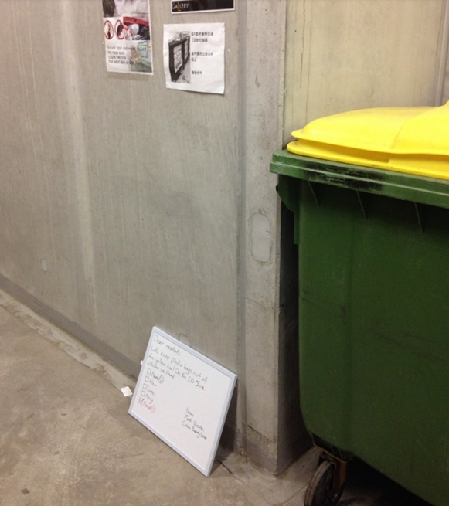
Over 20 whiteboards were deployed, none were vandalised and only 2 went missing over the 6 weeks.

Some were moved during bin collection (pictured).
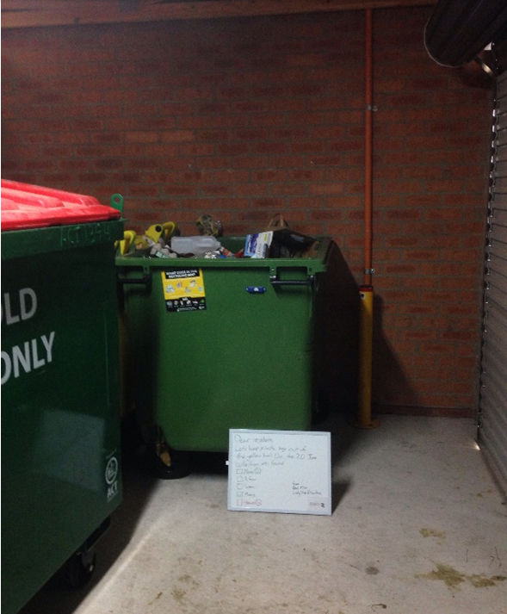

Results

Results: Interviews overview

- Almost everyone interviewed had seen the whiteboard. Of the two who hadn’t, one never recycled, and the other had just moved in from overseas.

- Some interviewees had noticed that the ‘messenger’ responsible for the whiteboard was their property’s strata management. Others assumed it was either a fellow resident or their body corporate.

- Similarly, some interviewees noticed that the tick in the rating scale measured their property’s recent plastic-bag performance.
- Of the two plastic-baggers we spoke to, one had stopped that behaviour because of the whiteboard. The other believed the plastic bags they used were actually cotton, and so dismissed the whiteboard as not relevant to them.
Results for each research question:
 |  | Yes | No
Did they notice the whiteboard at all? |  | 14 | 2
Did they notice that the whiteboard was from their strata manager? |  | 8 | 8
Did they notice the tick showing their recent performance? |  | 6 | 10
Did they usually plastic-bag their recycling? |  | 2 | 14
Of the plastic baggers: Did they stop plastic bagging because of the whiteboard? |  | 1 | 1
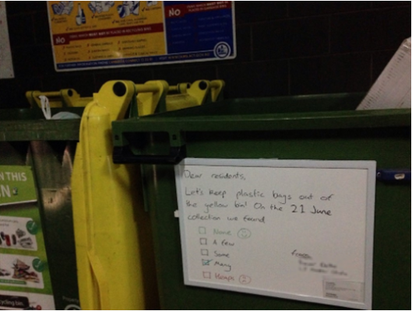

Results: Interview themes

Everyone was positive about the messenger they thought was responsible.
“Good to see someone actually doing something about it.”
“[Interviewer: How do you feel about getting a message from him? Resident:] Wonderful.”
“Fine, fine, no dramas with [manager’s name].”
“I’ve lived in other apartments and they don’t tell you nothing […] good to know that someone is keeping an eye on it.”

There was some confusion about which kinds of bags are recyclable, and which the whiteboard was referring to.
“I thought they [plastic bags] could be recycled, but apparently not.”
“[Describing a thick plastic bag:] It’s a cotton bag from Liquorland. It’s a fabric bag so it is recyclable.”
“[It said] “don’t put rubbish bags in there, in the recycling.””
“There was even a note not to put trash bags in the yellow bin.”

Residents treated the whiteboard as a welcome reminder.
“I reckon nothing wrong with getting a reminder notice.”
“I think it’s very accurate what he says. I hope that the people take notice.”
“I thought it was pretty good. It just makes it easier for everyone I suppose, especially for tenants.”

Feedback was welcomed, both in general and specifically on this issue.
“They put on how many plastic bags were in the recycling, whether it was not many, many, too many. Yeah, so that’s a good thing.”
“On the last couple of times it’s said ‘None’ and ‘keep it up’. Even adults can be encouraged to change their behaviour.”
“It’s been a nice little tick so it looks like that’s been effective.”

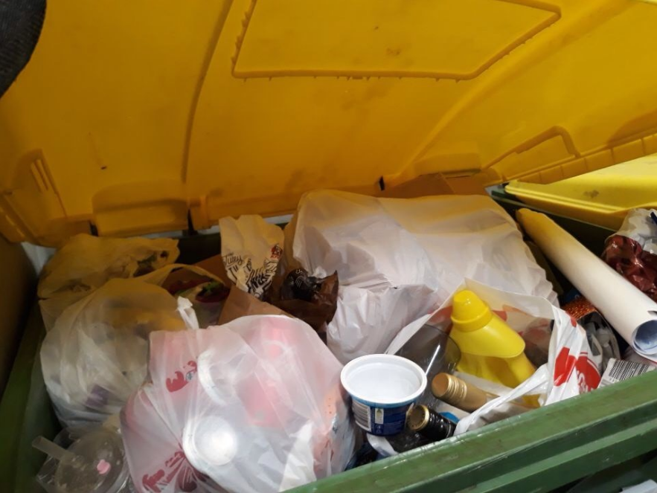
“I thought they [plastic bags] could be recycled, but apparently not.”

Results: Bin audits
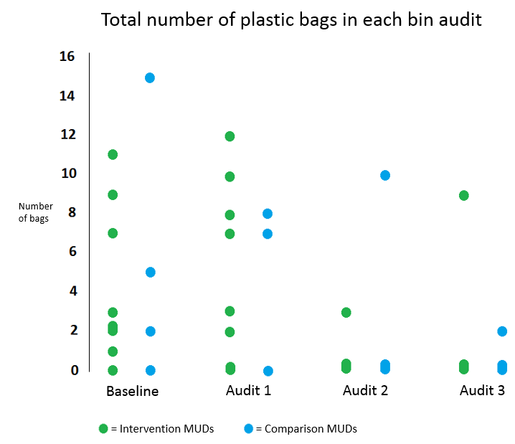
- Bin audits were successfully used to provide feedback on each whiteboard about the previous fortnight’s performance. If adopted at scale, this step could be replaced with visual inspection of bin contents before collection to reduce costs.
- We also checked bin audit data for any evidence of differences between MUDs with the whiteboard, and those without. Overall, we observed no meaningful difference in rates of plastic bag contamination between intervention and comparison groups.
- The last two audits showed more MUDs with less plastic bag contamination compared to the first two audits. However, as this change occurred in both the intervention and comparison groups, we did not attribute it to the whiteboard. We interpret this change as due to overall seasonality in recycling, for example due to school holidays, sports events, or other local communications activities.
- Interpreting the audit data was made difficult in part because there was an overall low level of plastic bag contamination in all MUDs during the study period, compared to previous research.

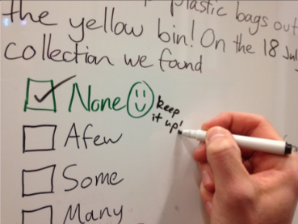
Results: Our main conclusions

- Interview data suggests that the whiteboard could work, and in the ways that we expect it to. We believe novelty could have played a substantial role, such that intermittent rather than permanent deployment of the whiteboard would be most effective.
- We found no substantial problems with deploying this kind of intervention. Notably, before deployment we expected to encounter a moderate amount of graffiti and theft, but recorded only a few instances of loss/theft and no instances of graffiti.
- Our intention was to design an intervention that could easily be adopted by individual strata managers or local councils. As a result of testing, we now believe this should be possible, assuming substitution of visual inspection of bin loads for formal bin audits to reduce costs.
- The ways in which the whiteboard worked are not specific to plastic bags: salient, personalised feedback of this kind could be used to address a range of multi-unit dwelling waste management concerns. For this reason, a similar system could be trialled by strata managers or local councils to manage excessive unflattened cardboard boxes, organics contamination, and other waste management issues.

Results: Directions for future trials

- We suspect novelty was a significant factor in how many interviewees had noticed the whiteboard. Future trials could test the extent to which the whiteboard can be deployed long-term, perhaps by removing it for long stretches in between intervention periods.

- The whiteboard could be trialled in locations other than the waste areas of MUDs. For example, they might be effective in the lifts or lift atriums of apartment towers.

- Residents also interpreted descriptions of contamination differently – in this case, there was clear variance in what ‘plastic bag’ meant to different residents. Future trials could attempt more precise definitions while still keeping the whiteboard text short and engaging.

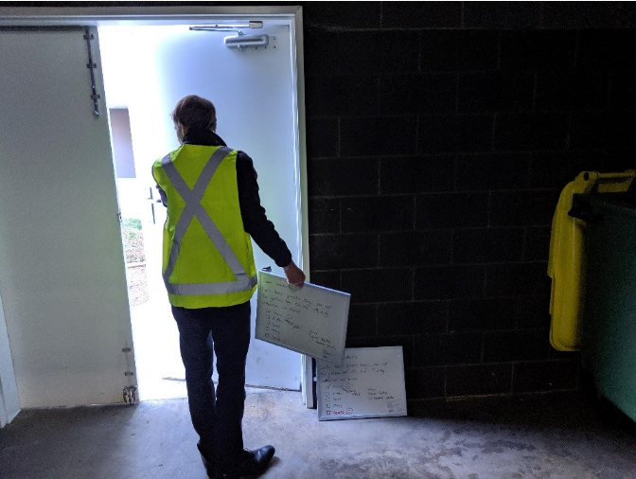

Lessons learnt

- We initially intended this research to follow a randomised controlled trial design. However, early power analysis showed the number of MUDs required to detect a small effect would be over 200, which was not practical in the ACT. We therefore redesigned the research to focus on qualitative methods. We are satisfied with this decision and our results, and will continue to look for opportunities to conduct quantitative research on similar interventions.
- We received a complaint from one resident about our identity and the purpose of our research, but were able to resolve this to their satisfaction over the phone later. This was in part because we had anticipated similar questions and set up clear processes for residents to confirm our identity through the Department’s switchboard. In future we will consider carrying more authoritative identification with us during field research activities.

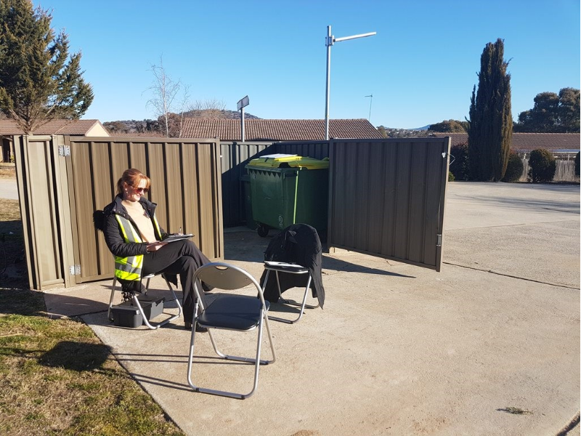

Lessons learnt (continued)

- Conducting resident interviews in winter may have reduced the number of residents willing to stay outside long enough to share their perspectives. Future trials involving outdoor research should avoid mid-summer and mid-winter activities. In addition, more consideration could be given to avoiding seasonal events like sports matches and school holidays that could disproportionately affect bin audit data.

- Due in part to our contracting requirements not being specific enough, the bin audit data was sometimes difficult to interpret. Future trials could take more time collaborating with contractors on precise definitions of what items to count – for example is an open bag with half-spilled contents counted as ‘bagged recycling’ or not? The high inherent seasonality of recycling and our low MUD numbers also contributed to this interpretational difficulty.

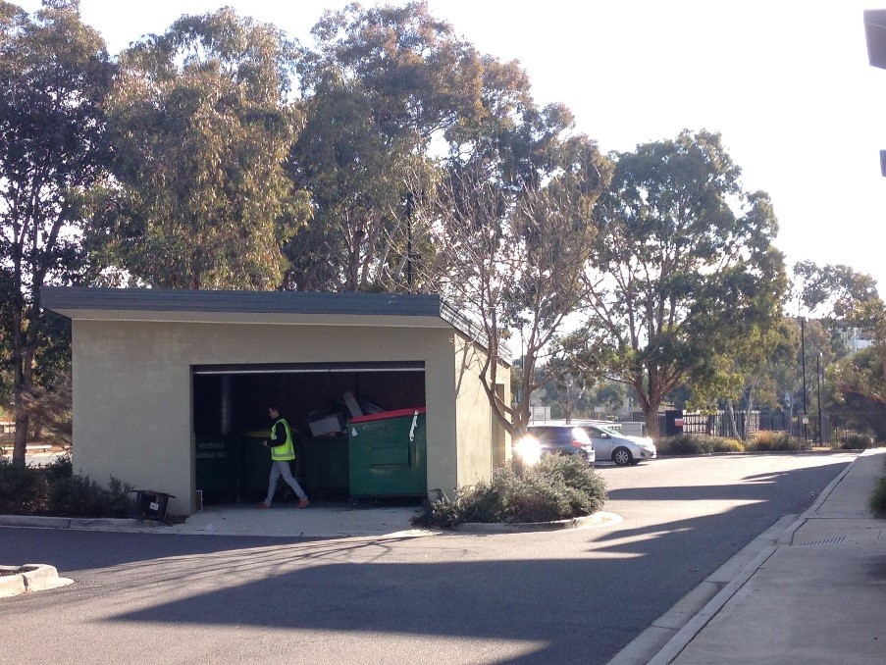

Thanks for reading

