September 2023

# Outcomes of the pilot Soil Monitoring Incentives Program

The pilot Soil Monitoring Incentives Program opened in March 2022 and closed to new applicants in December 2022. It supported the implementation of the [National Soil Strategy](https://www.agriculture.gov.au/agriculture-land/farm-food-drought/natural-resources/soils) and contributed to the strategy’s goals of increasing soil data availability and supporting the understanding of soil condition and trends across Australia.

The program trialled providing a financial incentive as a method of collecting soil information and sharing aggregated and de-identified soil test data on the [Australian National Soil Information System](https://ansis.net/). This information will be available later in 2023.

Land managers received a contribution of $275 per sampled site towards the costs of soil sampling and testing, up to a maximum of $10,000 per business (ABN). The program required participants to enter into data-sharing agreements and complete a qualitative survey about their land management practices, soil testing regime and soil knowledge.

The department engaged Southern Cross University to deliver the program nationally through its network of 66 approved sampling providers following an open competitive tender process in late 2021.

## Results

The key program outcomes include:

* Sampling and testing provided to 101 land managers who can now use that soil information to improve their land management practices. This includes 18 participants who followed the 2021 Carbon methodology for the Australian Carbon Credit Unit Scheme and 83 participants who tested for soil physical (texture, bulk density) and chemical properties (pH, electrical conductivity, soil organic carbon, nitrate nitrogen, ammonium and available phosphorous) at 3 depths (0 to 10 cm, 10 to 20 cm, 20 to 30 cm).
* The data collected will improve researcher and policymakers’ understanding of the condition of Australia’s soil and support policy, programs and decision-making of the future.
* 69 land managers voluntarily shared their additional soil chemical and biological test data that they undertook to meet their own farm management needs.
* 398 qualitative surveys were completed, indicating land managers across a range of land use types see the value in soil monitoring and use soil testing to inform fertiliser application, sowing strategies and to identify problem areas.

**Map: Geographical spread of soil data submitted through the program**

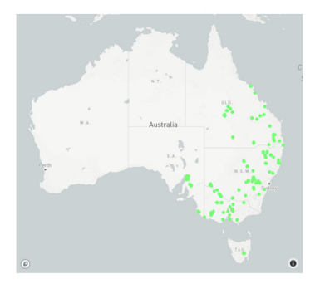

## Learnings

The key learnings from the program include:

* The soil information needed for policy and research purposes is different to the soil information needed by farmers. Adding these ‘public good’ measures in sampling regimes for farmers and land managers adds cost.
* Farmers are not accustomed to large out-of-pocket costs for more complex soil sampling relating to soil health measures.
* Land managers prefer to use their soil adviser and laboratory of choice to continue their existing sampling regime and trusted relationships.
* Some land managers are reluctant to share their soil data with the government due to concerns it could be used for regulatory purposes.
* There is not widespread capacity in the soil sampling sector to sample at 30 cm depth with gaps particularly in regional and remote areas.
* Asking soil sampling providers to deliver services outside of their usual business practice adds time and cost.

## More information

Web [www.agriculture.gov.au/soils](http://www.agriculture.gov.au/soils)

[www.ansis.net](http://www.ansis.net)

**Acknowledgement of Country**

We acknowledge the Traditional Custodians of Australia and their continuing connection to land and sea, waters, environment and community. We pay our respects to the Traditional Custodians of the lands we live and work on, their culture, and their Elders past and present.

© Commonwealth of Australia 2023

Unless otherwise noted, copyright (and any other intellectual property rights) in this publication is owned by the Commonwealth of Australia (referred to as the Commonwealth).

All material in this publication is licensed under a [Creative Commons Attribution 4.0 International Licence](https://creativecommons.org/licenses/by/4.0/legalcode) except content supplied by third parties, logos and the Commonwealth Coat of Arms.

The Australian Government acting through the Department of Agriculture, Fisheries and Forestry has exercised due care and skill in preparing and compiling the information and data in this publication. Notwithstanding, the Department of Agriculture, Fisheries and Forestry, its employees and advisers disclaim all liability, including liability for negligence and for any loss, damage, injury, expense or cost incurred by any person as a result of accessing, using or relying on any of the information or data in this publication to the maximum extent permitted by law.