

Third independent review of the *Product Stewardship (Oil) Act 2000*

Final report

A report prepared for the Department of the Environment September 2013



Disclaimer

This report has been prepared by Aither, led by Senior Associate, Professor Neil Byron at the request of the Australian Government Department of the Environment (the Department). The report is prepared in accordance with the scope set out in our engagement contract. This report does not purport to contain any financial or legal advice and should not be relied upon as such. Aither are not certified providers of financial advice.

The information contained in this report has been prepared by Aither from publicly available data and information supplied by the Department, the Australian Taxation Office (ATO) and industry stakeholders. Aither and its respective agents, directors, officers and employees make no express or implied representation or warranty as to the accuracy, reliability or completeness of the data and information.

Aither advises that the report should be read in its entirety. Individual sections of this report could be misleading if considered in isolation from each other.

Acknowledgements

Throughout the review, Aither benefited from extensive stakeholder consultation and engagement. Information received as part of this process, including feedback on a consultation discussion paper, as well as stakeholder submissions, is drawn on and referenced throughout the report.

We would like to thank the Department of the Environment and the ATO for their assistance with data and information for the review, and thank all stakeholders who attended consultation meetings or provided written submissions (see Appendix B).

We would also like to thank Mary Gimondo from the ATO in Perth, and those who hosted field visits for the review team: Tim Rose (Southern Oil); Blake Senior (Transpacific); Harry Kay (RRR), and; Philippe Reboul (Hydrodec).

© Commonwealth of Australia 2013

This work is copyright. Apart from any use as permitted under the Copyright Act 1968, no part may be reproduced by any process without prior written permission from the Commonwealth. Requests and enquiries concerning reproduction and rights should be addressed to Department of the Environment, Public Affairs, GPO Box 787 Canberra ACT 2601 or email public.affairs@environment.gov.au.

ISBN 978-1-921733-86-4 (print) 978-1-921733-87-1 (electronic)

The views and opinions expressed in this publication are those of the authors and do not necessarily reflect those of the Australian Government or the Minister for the Environment.

While reasonable efforts have been made to ensure that the contents of this publication are factually correct, the Commonwealth does not accept responsibility for the accuracy or completeness of the contents, and shall not be liable for any loss or damage that may be occasioned directly or indirectly through the use of, or reliance on, the contents of this publication.

This brochure has been printed on Monza Satin paper which is FSC® Mixed Sources Certified and ensures that all virgin pulp is derived from well-managed forests and controlled sources. It is manufactured by an ISO 14001 certified mill.

Table of Contents

Abbreviations 6

Executive summary 7

Part A – Background 14

1. Introduction and review scope 15

1.1 Review background 15

1.2 Scope and requirements 15

1.3 Review process and methodology 16

1.4 Structure of the report 16

2. Background, rationale and objectives 17

2.1 The problem of used oil 17

2.2 Product stewardship 21

2.3 Objectives and scope of the PSO Scheme 21

3. Operation of the PSO Scheme 22

3.1 Structure and administration 22

3.2 The levy-benefit arrangements 25

3.3 Transitional assistance and municipal infrastructure 26

Part B – Assessment 27

4 Achievements 28

4.1 Avoidance of improper disposal by households 28

4.2 Collection of used oil 31

4.3 Re-use and recycling of used oil 33

4.4 Establishment of the used oil industry 35

4.5 The role of the PSO Scheme and other factors 36

4.6 Summary 41

5 Challenges 43

5.1 Design 43

5.2 Implementation 55

5.3 Financial 64

5.4 Summary 67

6 Assessment 68

6.1 Appropriateness 68

6.2 Effectiveness and efficiency 69

6.3 Sustainability 70

6.4 Summary 71

Part C – Options and recommendations 72

7 Options 73

7.1 Continue the PSO Scheme without modification 73

7.2 Cease the PSO Scheme altogether 76

7.3 Transition the PSO Scheme to the *Product Stewardship Act 2011* 77

7.4 Continue the PSO Scheme with modifications 78

7.5 The role of supporting or complementary activities 88

7.6 Summary 89

8 Conclusion and recommendations 90

8.1 Defining success and redefining objectives 90

8.2 Levy and benefit modifications 91

8.3 Definitions and compliance 92

8.4 Imports and exports 93

8.5 Policy and coordination 93

8.6 Information and reporting 94

8.7 Investment in collection infrastructure and incentivising collection 94

8.8 *Product Stewardship Act 2011* 95

8.9 Sequencing 95

Part D – Appendices and references 97

Appendix A – Terms of Reference 98

Appropriateness 98

Effectiveness and efficiency 98

Sustainability 99

Appendix B – Stakeholder consultation 100

Consultation meetings 100

Appendix C – International comparison 102

Introduction 102

Country case studies 110

Conclusions 111

Appendix D – Environmental benefits of re-refining 118

Introduction 118

Information from recent studies 118

Discussion 122

Conclusions 123

Appendix E – Extended producer responsibility under the   
*Product Stewardship Act 2011* 124

References 128

Document history 130

Figures

Figure ES1. Volume of used oil input by use and value of PSO Scheme benefits paid 8

Figure ES2. Observed and modelled collection and recycling trends: Scenario 1 9

Figure ES3. Observed and modelled financial trends: Scenario 1 11

Figure ES4. Observed and modelled financial trends: Scenario 4 12

Figure 1. Volume of lubricating oils sold in Australia 17

Figure 2. Lubricating oil consumption in Australia 18

Figure 3. Lubricating oil consumption in Australia by jurisdiction 18

Figure 4. Estimate of used oil generated in Australia 19

Figure 5. Life-cycle of lubricating and used oils in Australia 20

Figure 6. Operational overview of the PSO Scheme 23

Figure 7. Australian households that disposed of motor oil 29

Figure 8. Australian household methods of recycling or re-using motor oil 29

Figure 9. Reasons for Australian households not recycling or re-using motor oil 30

Figure 10. Reasons for Australian households not recycling or reusing motor oil by state 30

Figure 11. Ways Australian households disposed of motor oil 31

Figure 12. Collection of used oil under the PSO Scheme 32

Figure 13. End uses of recovered oils and total volume recovered 34

Figure 14. Volume of finished product 34

Figure 15. PSO Scheme benefit claimants 35

Figure 16. Public awareness of hazardous waste disposal services and facilities 39

Figure 17. Collection of used oil at landfill sites in Australia 40

Figure 18. Quantity of used oil collected at landfill sites 40

Figure 19. Global crude oil prices 46

Figure 20. Used oil industry and PSO Scheme incentives 48

Figure 21. Used oil imports 58

Figure 22. Annual levy, benefits and surplus/deficit 65

Figure 23. Annual and notional cumulative surplus, and transitional assistance 65

Figure 24. Volume of used oil input by use and value of PSO Scheme benefits paid 66

Figure 25. Simple model of current PSO scheme levy-benefit arrangement 74

Figure 26. Observed and modelled financial trends: Scenario 1 75

Figure 28. Observed and modelled collection and recycling trends: Scenario 1 80

Figure 29. Observed and modelled financial trends: Scenario 2 81

Figure 30. Difference in annual PSO Scheme deficit due to removing certain Category 1 claims 83

Figure 31. Observed and modelled financial trends: Scenario 3 85

Figure 32. Observed and modelled financial trends: Scenario 3 86

Figure 33. Observed and modelled financial trends: Scenario 4 87

Figure 34. International used oil collection and re-refinement rates: 2008 103

Figure 35. Saskatchewan return incentive region map 107

Figure 36. Overview of impact assessment results where all figures relate to the particular result   
of re-refining 120

Figure 37. Overview of impact-related and normalised differences between average re-refining   
and combustion 121

Tables

Table 1. Legislation and regulation enabling the PSO Scheme 25

Table 2. Relevant regulation, functions and administration 25

Table 3. PSO Scheme benefit categories and rates 26

Table 4. Industry estimates of used oil collected under the PSO Scheme 34

Table 5. EPA legislation and regulations by state and territory 38

Table 6. PSO Scheme benefit categories and fuel excise rates 51

Table 7. Overview and rationale for scenarios modelled 80

Table 8. EPR scheme responsibilities by country 105

Table 9. Non-EPR scheme responsibilities by country 106

Table 10. Saskatchewan return incentive region and incentive rate chart: January 2010 109

Table 11. Policies on re-refining by country 110

Table 12. Summary and comparison of international used oil schemes 114

Table 13. Energy savings for re-refining vs burning of used oils 119

Table 14. Ratios of impact characteristics for used oil combustion compared to re-refining and distillation 120

# Abbreviations

AAT Administrative Appeals Tribunal

ATO Australian Taxation Office

ABS Australian Bureau of Statistics

BREE Bureau of Resources and Energy Economics

COAG Council of Australian Governments

DIY Do-it-Yourself

ELVs End of Life Vehicles

EPA Environmental Protection Authority

OECD Organisation for Economic Co-operation and Development

OEMs Original Equipment Manufacturers

PSO Product Stewardship for Oil Scheme

ML Megalitres (1 million litres)

OSAC Oil Stewardship Advisory Council

WTOG Waste Thematic Oversight Group

EPR Extended Producer Responsibility

SME Small to Medium Enterprise

# Executive summary

## The *Product Stewardship (Oil) Act 2000* Review

This report presents the findings and recommendations of the Third Independent Review of the *Product Stewardship (Oil) Act 2000* (the Act), undertaken by Aither for the Australian Government Department of the Environment (the Department).

The Act was introduced by the Australian Government in 2000 to establish a legislative framework and levy-benefit arrangement to increase recycling of petroleum-based and synthetic used oil in Australia. The Act has three objects:

• develop a product stewardship arrangement for waste oils

• ensure environmentally sustainable management, re-refining and re-use of waste oil

• support economic recycling options for waste oil.

Section 36 of the Act requires an independent review of the operation of the Act every four years. Two previous reviews have been undertaken; the first in 2004 and the second in 2009.[1] It stipulates that the review must include an assessment of the extent to which the objects of the Act have been met, along with the relevant provisions of customs and excise legislation. The Terms of Reference for the 2013 review are contained in Appendix A.

## Product Stewardship for Oil Scheme

The Product Stewardship for Oil Scheme (PSO Scheme) operates under the Act. The PSO Scheme aims to encourage the environmentally sustainable management and re-refining of used oil and its re-use. The Department has policy responsibility for the Scheme, while the Australian Taxation Office (ATO) is responsible for implementation and administration in accordance with the relevant legislation and regulations. Scheme arrangements comprise of a levy-benefit system, whereby:

• a mandatory 5.449 cents per litre (cpl) levy is applied to sales of all targeted oils, whether new or recycled, that generates revenue to fund benefit payments, and

• benefit payments are made to oil recyclers as volume-based incentives.

The Explanatory Memorandum for the Act suggests that the full cost of benefits paid should be offset by revenue collected by the levy (i.e. that the Scheme should be self-financing).[2]

The benefit payment rate varies across different categories of oil recycling and re-use – in line with the degree of processing undertaken, the use for the recovered oil and relative associated environmental benefits. These payments provide an incentive to increase collection of used oil for either re-refining or re-use as fuel.

Noting that these arrangements have been operating relatively unchanged since 2001, this review examines whether the existing product stewardship model is still the most appropriate, effective and sustainable way to manage used oil in Australia.

In assessing the arrangements, this third review finds that a range of positive outcomes have been achieved, but that some major challenges also exist with current Scheme arrangements.

## Achievements

Over the twelve years that the PSO Scheme has been in operation, much has been achieved to minimise improper disposal, and encourage the collection and re-use or recycling of used oil. The common view held by a broad range of stakeholders, and which we support, is that the Scheme has played an important role in these achievements, in concert with the efforts of state and territory governments, the impact of transitional assistance, and other factors like changes in community awareness and behaviour.

To a large degree the objects of the Act are being met: a stewardship arrangement for used oils is in place; used oil is managed in more environmentally sustainable ways; a vigorous industry for the collection and sale of used oils has emerged, particularly in eastern Australia; and economic recycling options for waste oil have been and continue to be supported (see Figure ES1).

### Figure ES1. Volume of used oil input by use and value of PSO Scheme benefits paid

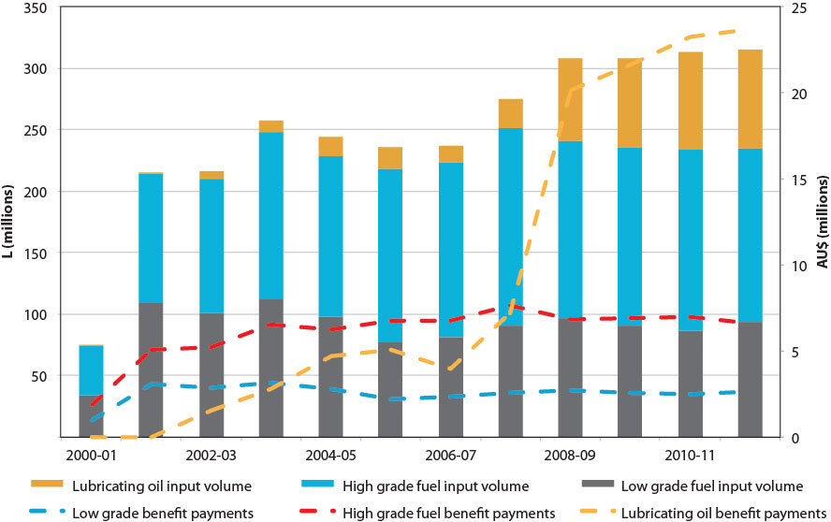

Source: Aither, based on the Department of the Environment (2013). Note: 2000-01 only includes six months data.

The volume of used oil being input into recycling processes to produce re-refined oil has grown from nil in 2000 to approximately 80 megalitres (ML) in 2011-12. This is approximately 25 per cent of the estimated total volume of oil collected under the Scheme (around 315 ML in 2011-12) and approximately thirteen per cent of the total volume of oil sold that year (613 ML). It was recycled to become approximately 48 ML of output – base oil for blending and subsequent re-use as a lubricant. This represented only about eight per cent of the total oil sales that year.

Payment of Category 1 benefits (for re-refined base oil) increased substantially between 2006-07 and 2008-09 with the opening of a second larger re-refiner. Further increases are expected from 2013-14 to 2015-16 due to another re-refiner coming on-line.

The remaining seventy-five per cent of used oil collected under the Scheme in 2011-12 was burnt as fuel after various levels of treatment, either domestically or as exports to other countries in the Asia Pacific region. The uses of collected oil have been changing and are projected to continue to change with reduction in sales of low grade fuels, and increased production of re-refined base oils. Figure ES2 below shows the overall change in composition of the used oil market under the Scheme from 2000-01 to 2011-12, and modelled out to 2023-24 under *status quo* assumptions.

### Figure ES2. Observed and modelled collection and recycling trends: Scenario 1

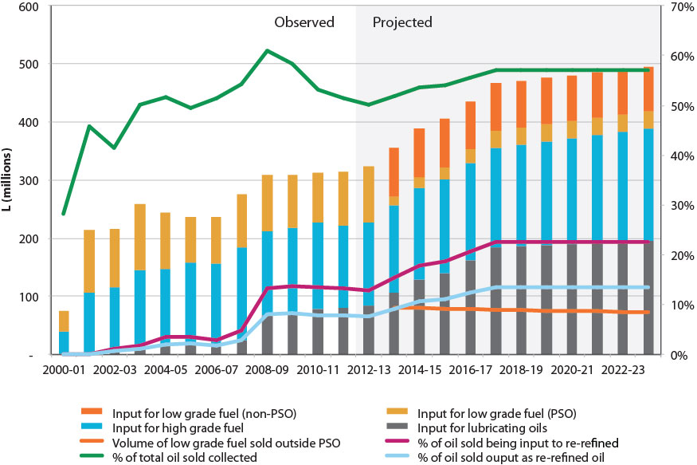

Source: Aither, based on the Department of the Environment (2013).

Notes: (a) 2000-01 only includes six months data. (b) Percentage of total oil sold that is collected (green line) rises slightly after 2012-13 due to expected increase in demand for feedstock of existing and new re-refiners.

Two main features stand out:

• Between 50 and 60 per cent of the volume of oil sold each year is being collected – most authorities agree that approximately sixty per cent is the maximum feasible due to losses in use. This is likely to continue.

• The use of recovered oil with minimal treatment (filtering and de-watering) as low grade fuel oil has declined from half of all collections to one-third and is projected to decline further. Because of recent decisions by the Administrative Appeals Tribunal which will affect the payment of benefits for collected oils used as low grade fuels, much of this material and activity will no longer be part of the Scheme.

The Scheme incentivises the recovery and re-use of used oil, at low overall cost to the Australian community, and with low implementation and compliance costs. In large parts of the country, used oil is no longer regarded as a waste but instead as a resource. More broadly, environmental and public health costs due to improper disposal of used oils and lubricants have been reduced or eliminated.

## Challenges

Despite these achievements, the review highlighted a range of challenges related to the design, implementation and financial sustainability of current arrangements:

• A major structural imbalance in the levy-benefit arrangement that is resulting in current annual deficits, which will be compounded by known increases in re-refining capacity, and is financially unsustainable in the long term.

• An absence of defined time, scale or outcome objectives to guide the PSO Scheme; it is largely open ended with no specific criteria for success nor guidance as to when or how the Scheme should be phased out.

• The Scheme is premised on the existence of end use markets for recycled oils, which are heavily exposed to exogenous factors outside the control of government or industry. The sale of re-refined oil products, which is a key aspect of the Scheme, currently suffers marketing and acceptance issues.

• Complications regarding interactions with Commonwealth, state and local policies, and other arrangements.

• The Act is silent on the topic of trading used oils. It provides no guidance in relation to imports of used oils for processing in Australia, or for exports from Australia to other nations.

• Benefit rates struggle to achieve uniform outcomes across the country – neither is the differentiation in rates based on a robust assessment of environmental benefits nor are they aligned with the main environmental objects of the Act.

• Too little investment and effort is being directed towards auditing and spot checks, combined with the use of vague descriptions and prescriptions of technologies or processes rather than robust output standards that facilitate efficiency and innovation.

The Scheme is under-funded to achieve even modest levels of recycling (lube-to-lube) without requiring large, and ever-increasing financial input from government. The fundamentals of the Scheme are such that a levy of 5.449 cpl could only fund a Category 1 benefit payment for about eleven per cent of the oil sold each year in Australia – even if there were no other benefits – before the Scheme runs into deficit. This fundamental problem, compounded by the other major challenges identified above, has the capacity to undermine the effectiveness and sustainability of the Scheme, and threatens the achievements of the past twelve years.

## Options for securing the benefits of the PSO Scheme

The central challenge facing government and industry is determining how to maintain the achievements of PSO Scheme while addressing the major challenges it now faces. The approach of the last twelve years is no longer viable. We believe that there are two basic approaches in response:

• modify the existing Scheme, or

• replace the existing Scheme with one based on the *Product Stewardship Act 2011*

Our strong preference is to modify the existing Scheme, correct its major problems and set out a long term pathway to greater efficiency and effectiveness in achieving environmental benefits at low cost to consumers and producers of oil, and at no or minimal costs to taxpayers. We believe this is both feasible and desirable given the principles of product stewardship.

Figure ES3 below models the financial implications of a business as usual situation of the Scheme to 2023-24. It demonstrates that if the current fundamentals of the Scheme are not modified, the Scheme will remain in annual deficit and trend to an ever increasing cumulative deficit as a result.

### Figure ES3. Observed and modelled financial trends: Scenario 1

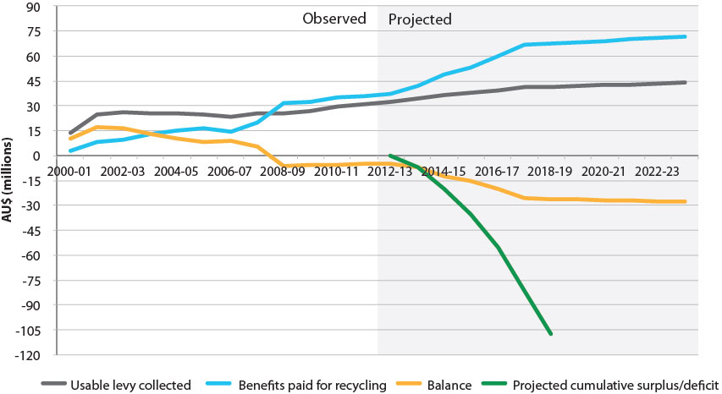

Source: Aither, based on the Department of the Environment (2013).

Notes: (a) 2000-01 only includes six months data. (b) Cumulative deficit projection is based on a notional $0 starting balance in 2012-13. (c) Cumulative surplus/deficit beyond 2018-19 has been cropped for scaling purposes; cumulative deficit is projected to be over $240 million in 2023-24.

In order to maximise environmental benefits it is important to collect as much used oil as is feasible; with a secondary emphasis on stimulating re-refining to the extent it is practical and affordable. It is important to note that it will be difficult to exceed thirty-six per cent of all oil sold being re-refined to base oil suitable for eventual resale as a lubricant – simply due to the generally technologically fixed used oil generation and re-refining recovery factors. As a result, there is merit in broadening the distribution of incentives to include directly encouraging collection (where the bulk of the environmental benefits are achieved) in some areas.

In contrast to the above figure, Figure ES4 below models the projected financial implications of a modified Scheme where major problems are corrected. Under this scenario a surplus is generated in the near term and maintained. The figure also demonstrates how surpluses generated by changes to levy-benefit arrangements could be redistributed towards investment in new or renewed collections infrastructure and more directly incentivising collections activity.

### Figure ES4. Observed and modelled financial trends: Scenario 4

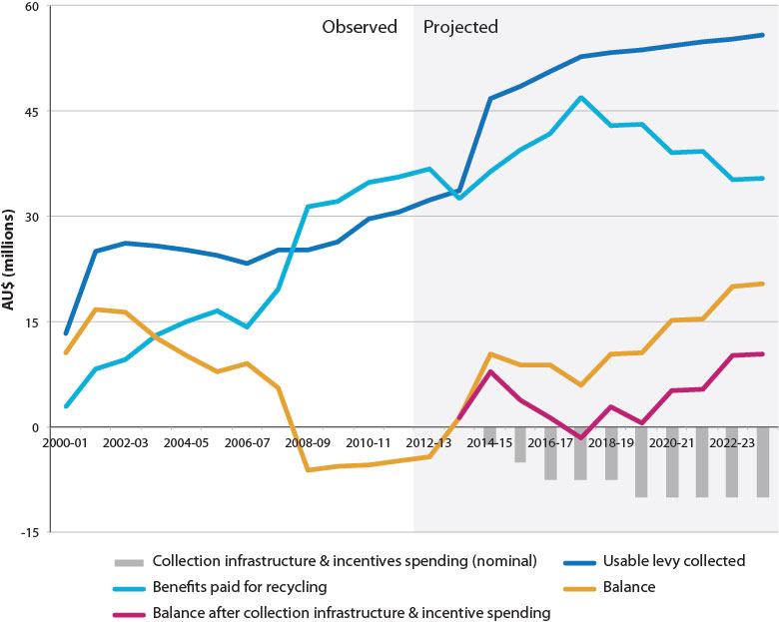

Source: Aither, based on the Department of the Environment (2013).

Note: 2000-01 only includes six months data.

Failing a decision to modify the Scheme there is an alternative pathway for achieving similar environmental objectives; namely replacing the existing Scheme with a new mandatory scheme for ‘extended producer responsibility’ under the *Product Stewardship Act 2011*. The possible arrangements for an industry run scheme and its likely effectiveness are discussed later in this report. In short, we are not yet convinced a new scheme under the *Product Stewardship Act 2011* would be as effective as a modified PSO Scheme in achieving public policy objectives, or that it could do so at lower costs. However, if modifications to the existing Scheme are not effective over the next four years, then the move to implement a new scheme under the *Product Stewardship Act 2011* should be considered.

## Recommendations

Our recommendations reflect our preferred approach; to modify the existing PSO Scheme. Recommendations are provided in full in Section 8, but in summary, we recommend:

1. the Commonwealth articulate a vision of success for used oils in Australia, and supports this by clarifying the objects of the Act

2. the levy on oil sold is increased immediately – we propose an increase to 7 cpl

3. the Category 1 benefit payment be gradually phased down at 5 cpl increments every two years, beginning in 2014-15 until such a point that it reaches 25 cpl

4. benefit payments for low grade fuel oils (Category 6) be discontinued immediately regardless of whether they are produced from a re-refinery or from a simple filtering and de-watering process

5. Scheme benefit categories be rationalised, with remaining categories modified such that they are based on objective output standards or physical specifications, with audits, spot checks and independent testing applied to all Scheme benefit claimants

6. the way in which Scheme levy-benefit arrangements apply to imported and exported used oil be clarified to ensure exports of used oil are not unduly restricted and imports of used oil are either excluded from benefits or levied appropriately

7. improved coordination with and involvement of industry through a tasked Oil Stewardship Advisory Council

8. policy coordination with other levels of government be improved through an intergovernmental committee under the Council of Australian Governments structure

9. information and data collected on used oils be improved, especially in relation to used oil collections – under and outside of the Scheme

10. further investigation of mechanisms to deal with high collection costs and poor access to end use markets in some regional and remote areas

11. surpluses generated by changes to the levy-benefit arrangements be invested into existing or new collection infrastructure, as well as directly incentivising collection activities – where required

12. further investigation into the feasibility and specific design options for used oil arrangements under the *Product Stewardship Act 2011*; prior to the next Scheme review.

The rationale for our approach and recommendations is that it provides for major, but appropriate, changes to the existing Scheme, which is currently well accepted by most stakeholders and achieves many positive outcomes. We have endeavoured to give the used oil collection and recycling industry a clear picture of the extent of support that can sustainably be provided through the current Scheme. However, it will be necessary for government to continue to review progress periodically. The next review in four years should assess the extent to which the changes recommended here have been effective in:

• achieving increased and more efficient collection of used oils

• bringing the Scheme into financial neutrality, such that the stewardship levy is sufficient to cover the costs of environmentally sound re-use or recycling

• maintaining the integrity of, and public support for, the Scheme.

Our recommendations help prepare government and industry for further change, including if the modifications adopted do not prove effective. This includes by ensuring that there is an improved information base and understanding on which to make further decisions in four years. By this time there should be considerably more evidence to indicate whether or not the current Scheme can be made more effective and financially sustainable, and what a possible replacement might look like. A future review should have the option of declaring the Scheme to be no longer appropriate and in need of replacement with a well-designed extended producer responsibility scheme if the latter can be demonstrated to deliver better environmental outcomes at the same or lower costs to the Australian public.

# Part A – Background

# 1. Introduction and review scope

This section provides an overview and background to the review, including its scope and requirements, the review process and methodology applied, and the structure of this report.

## 1.1 Review background

The Product Stewardship for Oil Scheme (PSO Scheme) was introduced by the Australian Government to provide incentives to increase recycling and re-use of used oil, and became effective at the beginning of 2001. The Scheme is overseen by the Department of the Environment (the Department) and aims to encourage the environmentally sustainable management and re-refining of used oil and its re-use.[3]

The *Product Stewardship (Oil) Act 2000* (the Act) establishes the general framework for the Scheme. The Scheme is based on a levy-benefit arrangement that collects funds from the sale of oil to provide for benefits payments to activities in the re-use and recycling of used oil. The arrangement is designed to provide incentives to encourage collection (indirectly) by directly encouraging both re-use and recycling of used oil.

There are two main components of the Scheme’s operation:

• A levy of 5.449 cents per litre (cpl) on the sale of all lubricating oils; collected through Australian Government excise and customs arrangements.

• Scaled benefits paid for different forms of recycling, re-refining or re-use of used oil; administered by the Australian Taxation Office (ATO).

In addition, ‘transitional assistance’ funding was provided between 2000 and 2007 to support implementation and establishment of the Scheme, such as infrastructure and education and awareness programs.

Two previous reviews of the Scheme have been undertaken; one in 2004 and the other in 2009. The transitional assistance funding program has also been reviewed previously.

Aither was engaged by the Department to undertake the third independent review of the Act and this report represents the final results of the review.

## 1.2 Scope and requirements

Section 36 of the Act requires an independent review of the operation of the Act and relevant provisions of customs and excise legislation, and the extent to which the objects of the Act have been met. The review must produce a written report which is to be tabled in both houses of Commonwealth Parliament.

The terms of reference for the review require an examination of the appropriateness, effectiveness and sustainability of the operation of the PSO Scheme to date; a consideration of opportunities for improvement for the Scheme; and recommendations where considered appropriate. Further requiring:

• Examination of whether the existing product stewardship model is still the most appropriate way to manage used oil.

• Examination of the operation of the Act and relevant provisions of customs and excise legislation, and the extent to which objects of the Act have been achieved.

• Assessment of the financial and environmental sustainability of the current Scheme.

A detailed analysis of the social, economic and environmental benefits presented by the Scheme was not a requirement of this review due to this being sufficiently detailed in the two previous reviews of the Scheme.

Further detail of the review requirements is provided in the full version of the terms of reference included at Attachment A.

## 1.3 Review process and methodology

The review began in early 2013 and was completed in June 2013. The review comprised of:

• development and distribution of a consultation paper to stakeholders

• stakeholder meetings in Brisbane, Sydney, Canberra and Perth

• consultation with the Oil Stewardship Advisory Council

• field visits to re-refiners and collectors of used oil

• written submissions from stakeholders – a total of twelve submission were received

• an international comparison of the PSO Scheme with similar arrangements in comparable international jurisdictions (see Appendix C)

• a summary of existing recent literature on the environmental benefits of re-refining compared with other end uses of used oil (see Appendix D)

• identification and analysis of achievements and emerging issues associated with the Scheme

• identification and analysis of options for the future of the Scheme

• scenario modelling and further analysis of specific aspects of different options.

Further information regarding consultations, including submissions and meeting attendees, is contained in Appendix B.

## 1.4 Structure of the report

The remainder of the report is structured as follows:

• **Section 2** provides the background and rationale for the introduction of the PSO Scheme, and outlines its objectives.

• **Section 3** describes the operation of the Scheme; including enabling and supporting legislation and regulations.

• **Section 4** documents achievements made in relation to the government’s stated policy objectives for used oil over the period that the Scheme has been operating.

• **Section 5** outlines and discusses a range of challenges arising from the current operation of the Scheme.

• **Section 6** provides an explicit overall assessment of the Scheme based on the achievements and challenges identified, and using the criteria of appropriateness, effectiveness, efficiency and sustainability.

• **Section 7** outlines and assesses different options for the future of the Scheme.

• **Section 8** provides recommendations on the preferred option for the Scheme and other supporting actions.

# 2. Background, rationale and objectives

## 2.1 The problem of used oil

Used oil is the single largest environmentally hazardous recyclable material (Nixon & Saphores 2002). Used oil is insoluble, persistent and slow to degrade and evaporate. As used oil is rarely pure and often contains contaminants such as toxic chemicals and heavy metals, it poses a greater risk to the environment than new oil.

The improper disposal of used oil can have catastrophic effects on the environment and public health. A one litre spill of used oil can potentially result in the contamination of one million litres of freshwater. In addition, oil concentrations as small as one part per million can contaminate drinking water supplies.

Therefore, the PSO Scheme stands to make an important contribution to the environmentally sustainable management, re-refining and re-use of used oil. Prior to the commencement of the Scheme, a significant amount of used oil was not disposed of properly. But since the introduction of the Scheme, the volume of oil collected and recycled has increased considerably and there have been very few reports of improper disposal of used oil.

2.1.1 Oil demand and use

Oil is used in a wide range of industries and processes in Australia. The major users of lubricating oil are industrial and mining companies, primary producers, transport companies and the automotive industry. These users account for approximately 85 per cent of total sales in Australia. The remainder is primarily sold to light commercial industry and motorists.

Total sales of lubricating oils in Australia have trended upwards over the last decade. Sales have risen to over 613 megalitres (ML) in 2011-12 (see Figure 1 below). A proportion of this growth can be attributed to oil demand associated with mining activities.

### Figure 1. Volume of lubricating oils sold in Australia

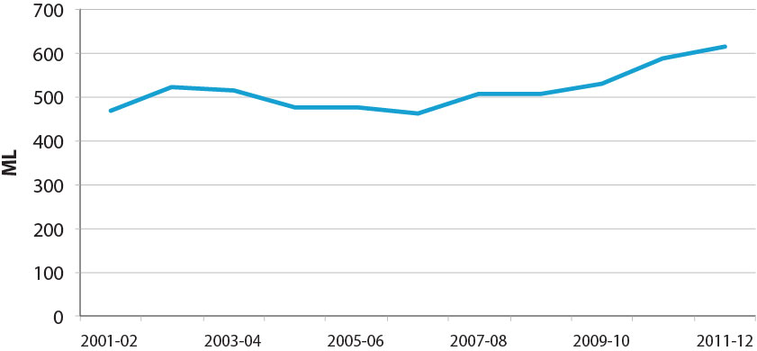

Source: Aither, based on the Department of the Environment (2013).

Based on data from the Bureau of Resources and Energy Economics (BREE), as can be seen in Figure 2 below, consumption (as opposed to sales above) of lubricating oil in Australia totalled 430 ML in 2010-11. Consumption is suggested to have declined from a peak of 613 ML in 2003-04, notwithstanding a slight increase in the latter part of the last decade.

This trend decline is likely to be at least partly attributable to longer intervals between car and machine servicing due to technological improvements.[4]

### Figure 2. Lubricating oil consumption in Australia

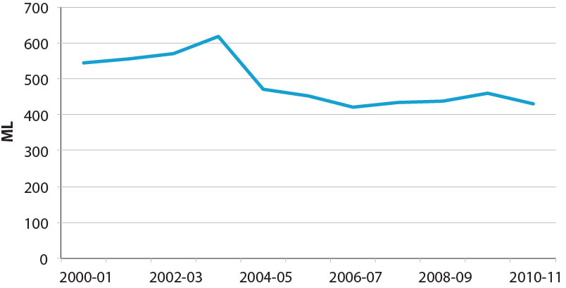

Source: BREE (2013).

### Figure 3. Lubricating oil consumption in Australia by jurisdiction

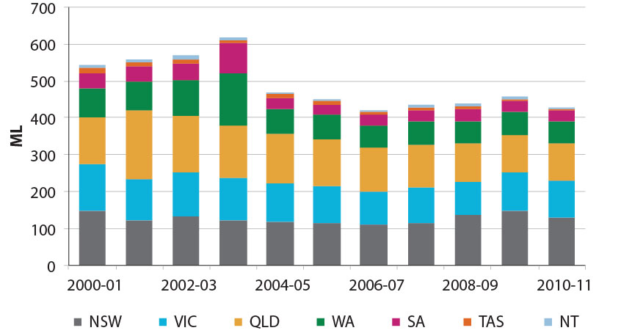

Source: BREE (2013).

Based on the BREE data, New South Wales and Victoria are suggested to be the largest consumers of lubricating oil by jurisdiction (see Figure 3 above), reflecting population and industry size.

2.1.2 Generation of used oil

Oil is consumed through direct consumption during use and from minor leaks and spills at the point of use. Major sources of used oil are vehicle lubricating oil and used oil generated in the manufacturing industry (MMA 2005). The volume of oil consumed during use determines the amount of used oil generated, but many factors affect the degree to which oil is consumed; including the nature of use and the age and condition of vehicles or machinery involved. In addition, some volumes of oil may be ‘consumed’ through the disposal of End of Life Vehicles (ELVs), or if ELVs are depolluted and recycled appropriately, the used oil may become available for recycling and re-use.

There is a lack of reliable data on the generation of used oil in Australia. It is difficult to source accurate information on the amount of used oil generated because different machines consume oil in different proportions. As a result, the amount of used oil generated is often estimated by a generation factor applied to data on sales of new oil.

There is considerable debate regarding the amount of used oil in circulation that could potentially be collected. Most previous studies have assumed an average generation factor (across all types of oils) of between 50 and 60 per cent across the economy with a range for specific types of oils from zero to 99 per cent.

As shown in Figure 4 below, the generation of used oil is estimated to have increased sharply in recent years – consistent with the increase in total sales of new oil. These estimates assume a generation factor of 0.6, and estimates from other recent studies are also shown.[5] Figure 5 provides an overview of the life-cycle of lubricating and used oils in Australia.

### Figure 4. Estimate of used oil generated in Australia

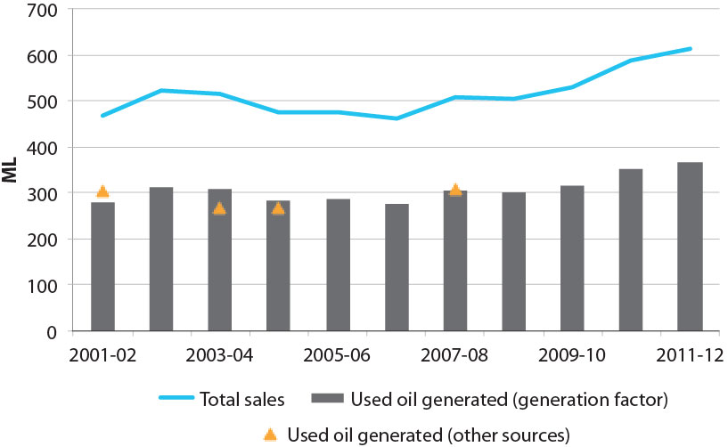

Source: Aither, based on the Department of the Environment (2013).

Notes: (a) Used oil generated is based on a generation factor of 0.6. (b) Additional reported point source data: Meinhardt Infrastructure & Environment Group (2002), Australian Academy of Technological Sciences and Engineering (2004), MMA (2005) and MMA (2008).

### Figure 5. Life-cycle of lubricating and used oils in Australia

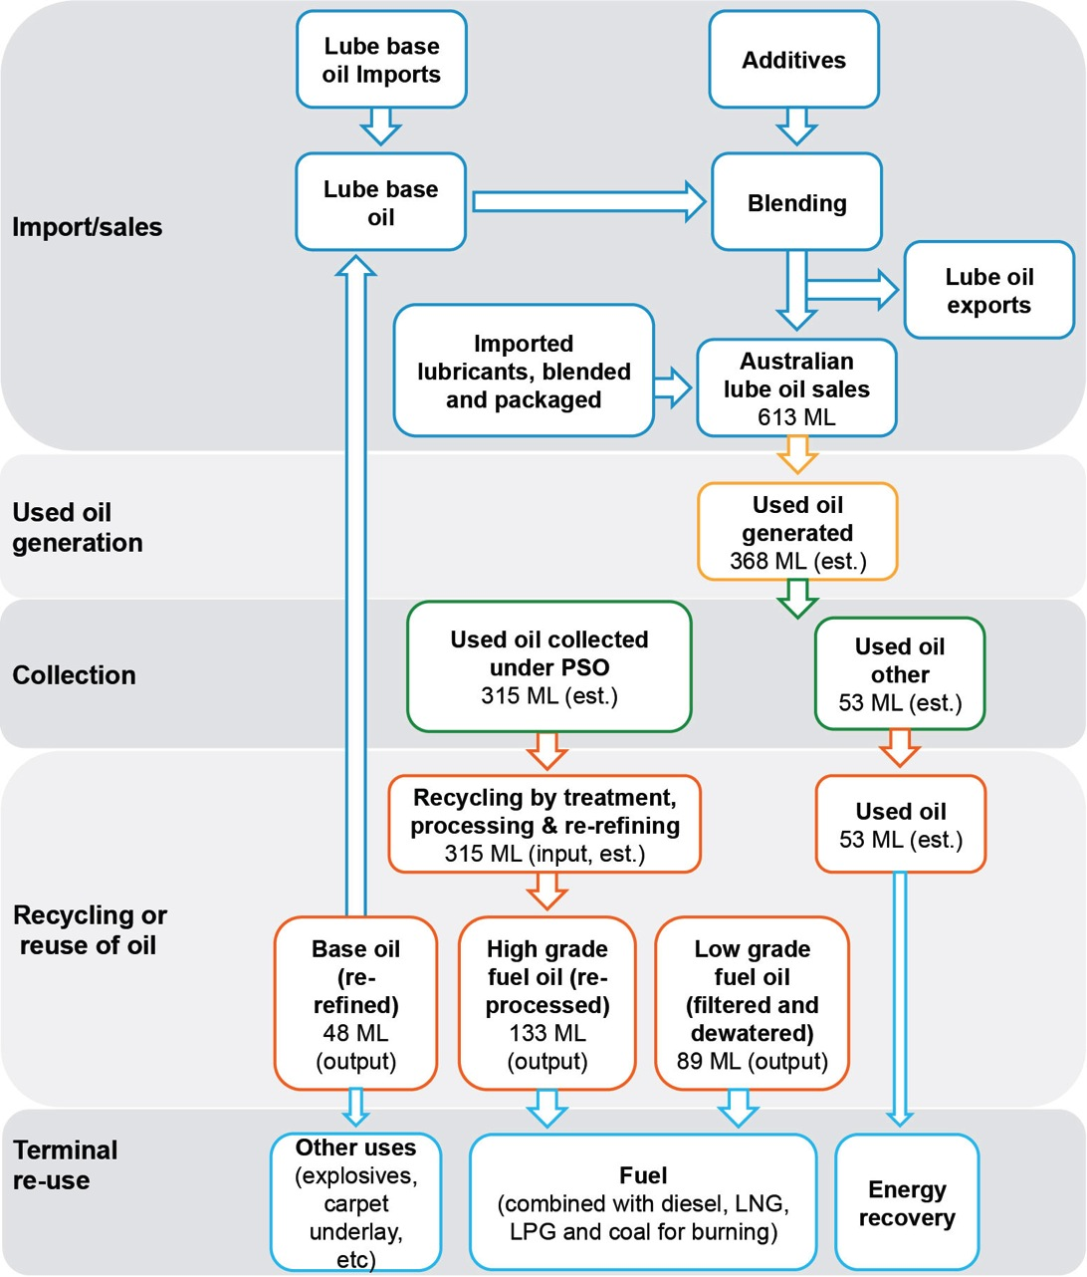

Source: Aither.

Note: Volumes based on the Department of the Environment (2013).

## 2.2 Product stewardship

The Organisation for Economic Co-operation and Development defines product stewardship as ‘a system of managing products through all stages of their life cycle, including customer use and disposal (with the objective of continuously improving safety for health and the environment)’. Manufacturers may or may not be directly responsible for program funding or operation (Environment Canada 2013).

This differs from the concept of extended producer responsibility practiced by some European Countries, which maintains the principle of life-cycle management, but attempts to place the financial burden on the producer and shift costs away from the public sector – however, in reality this is often not achieved (PPI 2013) (see also Appendix C).[6] Under a product stewardship program, both legislated environmental fees and public funds are commonly used as a funding base (Environment Canada 2013).

In Australia, the government’s response has been to develop a ‘product stewardship partnership which links oil companies, recyclers, the states and the Commonwealth’ (Australia Parliament 2000). In practice, the underlying principle is that the costs of appropriately managing oil over its life-cycle should largely be borne by producers and users of oil. This was seen to be the ‘most effective long term solution’ to the risks of poor waste oil management by addressing problems of waste disposal, and ‘to encourage recycling of finite resources’ (Australia Parliament 2000).

Australia’s PSO Scheme, administered by the ATO and the Department, is based on a legislated environmental fee and is more consistent with a product stewardship program than an extended producer responsibility program. According to international experiences, both approaches can be successful in the management of used oil (see Appendix C).

Given the large volumes of virgin oil sold into the economy each year, and the inadequacy of existing recycling and disposal routes, environmental concerns over the hazardous potential of used oil were a key driver for the development of the Scheme. Another driver was the lack of awareness and understanding of the potential commercial value of recycled oil as a high quality product and substitute fuel, which at the same time had the potential to meet increasing oil demand while decreasing environmental impacts. The approach was designed to share the costs of managing a product throughout its life between manufacturers and users, rather than solely on manufacturers - a comparison drawn at the time with segments of the chemical industry.

## 2.3 Objectives and scope of the PSO Scheme

The rationale for the PSO Scheme includes addressing a waste disposal problem, encouraging re-use and recycling of finite resources, and having oil users meet the costs of managing used oil. Given these drivers, the Act has three specific objects:

• develop a product stewardship arrangement for waste oils

• ensure the environmentally sustainable management, re-refining and re-use of waste oil

• support economic recycling options for waste oil.

The Scheme was not designed to directly fund collection, transport and storage of used oils, or to simply reward current good practice in environmental management. Rather it was intended to reduce the improper disposal of used oil, encourage higher value re-use, and foster a market for these activities through transitional assistance and targeted benefit payments funded by a levy imposed on sales of oil. This was intended to provide a positive environmental outcome by complementing existing state and territory legislation prohibiting improper disposal (dumping) of used oil. As improper disposal of used oil is policed by the relevant Environmental Protection Authorities, the Scheme is intended to provide an attractive alternative.

# 3. Operation of the PSO Scheme

The PSO Scheme operates on the basis of a levy collected on the sale of new (and some recycled) oils, which funds benefits paid towards different levels of re-use or recycling of used oil. This is made possible through enabling and supporting legislation, regulation, and other administrative arrangements. These elements are outlined in this section.

## 3.1 Structure and administration

The following figure outlines how the administrative and levy-benefit arrangements relate to the consumption, use and recycling of oil in the economy. The levy is collected on the sale of all new oils and some recycled oils (such as, re-refined Category 1), the proceeds of which are used to fund benefit payments to those treating and re-refining used oils. Some recycled oil products are used in terminal uses (such as fuel, explosives and carpet underlay), while others are re-refined to base lube oil standards and sold back into the system.

### Figure 6. Operational overview of the PSO Scheme

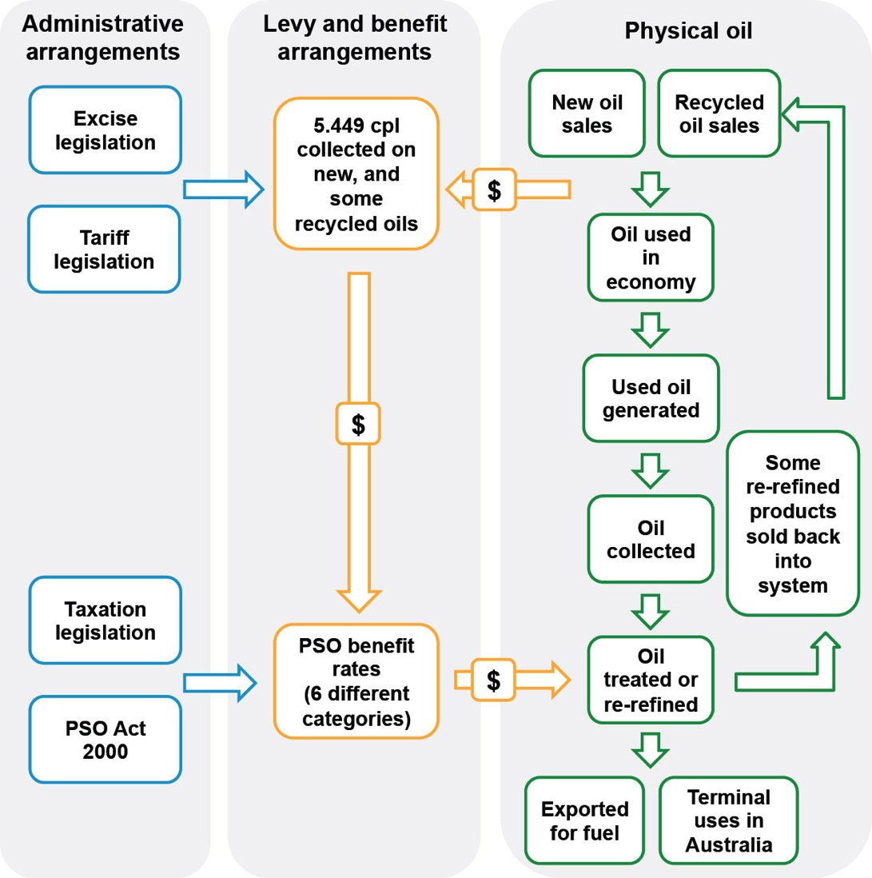

Source: Aither.

3.1.1 Enabling legislation and regulation

Multiple pieces of legislation are involved in the operation and administration of the PSO Scheme. These range from creating the institutional arrangements and reporting requirements, to establishing the rates of entitlements and defining exempt oils.

Multiple government agencies are also responsible for the administration of the relevant Acts, including the Department of the Environment, the ATO, Treasury, and the Office of the Attorney-General.

The Department has particular responsibilities with the carriage of the two main pieces of legislation pertaining to the Scheme, as well as the main source of Scheme regulation.

Details of the enabling legislation, regulation, their functions and administrative bodies are detailed below in Table 1.

#### Table 1. Legislation and regulation enabling the PSO Scheme

|  |  |  |
| --- | --- | --- |
| **Legislation and regulation** | **Function** | **Administered by** |
| ***Product Stewardship (Oil) Act 2000*** | Establishes the general framework, benefit entitlements and the operation of the Oil Stewardship Advisory Council. | The Australian Taxation Office (the Department of the Environment has policy responsibility). |
| ***Product Grants and Benefits Administration Act 2000*** | Establishes eligibility criteria and the administrative mechanisms used by the Australian Taxation Office pays benefits to recyclers and re-users. | The Australian Taxation Office (Treasury has policy responsibility). |
| ***Product Stewardship (Oil) (Consequential Amendments) Act 2000*** | Contributes to establishing the Product Stewardship Levy and general administrative arrangements. | The Australian Taxation Office (the Department of the Environment has policy responsibility). |
| **Product Stewardship (Oil) Regulations 2000** | Describes the categories of recycled oil product that will be eligible for PSO Scheme benefits and the benefit rate for each category, as well as health, safety and environment (HSE) standards for oils eligible for the highest level of benefits. | The Australian Taxation Office (the Department of the Environment has policy responsibility). |
| **Product Grants and Benefits Administration Regulations 2000** | Enumerates specific criteria that must be met by a recycler wishing to claim benefits; including the need to comply with relevant state and territory legislation and regulations | The Australian Taxation Office (Treasury has policy responsibility). |

3.1.2 Supporting legislation and regulation

The enabling legislation that creates the PSO Scheme is supported by amendments to two Acts; the *Excise Tariff Act 1921* and the *Customs Tariff Act 1995* (see Table 2 below).

These amendments establish the levy arrangements for the production and import of oil products.

#### Table 2. Relevant regulation, functions and administration

|  |  |  |
| --- | --- | --- |
| **Legislation** | **Function** | **Administered by** |
| ***Excise Tariff Act 1921*** | Collectively contribute to establishing the Product Stewardship Levy, list exempt oils and abolish the automatic indexation on the levy | The Australian Taxation Office (Treasury has policy responsibility). |
| ***Customs Tariff Act 1995*** | Administered by Customs (Office of the Attorney-General has policy responsibility). |

The *Excise Tariff Act 1921* and the *Customs Tariff Act 1995* imposes a duty on petroleum based oils, greases, and their synthetic equivalents that are manufactured or produced in Australia of $0.05449 per litre or $0.05449 per kilogram depending on the product type.

## 3.2 The levy-benefit arrangements

A levy system was established under the PSO Scheme that requires producers and importers of certain oil products to pay 5.449 cpl on sales of virgin oil. The revenue that is generated from this levy funds benefit rates paid to those who re-use and recycle used oil in certain ways under the Scheme.

The levy-benefit system operates as follows (see also Figure 6 above):

• A mandatory 5.449 cpl levy on sales of all virgin oils generates revenue.

• Benefit payments are paid to used oil recyclers as volume-based incentives. The payment rate varies across different categories of recycled and re-used oil.

• Oil that is re-refined back into lubricant or, hydraulic or transformer oil and sold again in Australia as equal to virgin oil is subject to the levy of 5.449 cpl at point of sale.

Under the Scheme, a system of benefit payment rates exists, ranging from 3 to 50 cpl (depending on the degree or manner of processing undertaken), that is paid to used oil recyclers upon sale of an end product. The intention was that the hierarchy (differing benefit rates) would reflect the recycling effort and investment required to produce products of better quality with improved environmental outcomes. Benefit rates were suggested to only be paid where they might serve as an incentive for increased recycling activity.

Therefore, following this rationale, certain forms of used oil recycling that are the most input intensive, for example re-refining, and those that produce the greatest environmental benefits (such as, achieving lube-to-lube product life-cycle), are paid the largest benefit rate under the Scheme. On the other hand, those forms of used oil recycling that have minimal inputs and that do not produce the greatest environmental benefits ( for example, terminal uses such as burning), receive the smallest benefit rates under the Scheme. The benefit rates that are paid are shown in Table 3 below.

#### Table 3. PSO Scheme benefit categories and rates

|  |  |  |
| --- | --- | --- |
| **Category Number** | **Category Description** | **Benefit Rate (Cents/Litre)** |
| 1 | Re-refined base oil (for use as a lubricant or a hydraulic or transformer oil) that meets the criteria mentioned in Schedule 1 of the *Product Stewardship (Oil) Regulations 2000* | 50 |
| 2 | Other re-refined base oils (for example, chain bar oil) | 10 |
| 3 | Diesel fuels that comply with the *Fuel Standard (Automotive Diesel) Determination 2001* | 7 |
| 4 | Diesel extenders that:  a) are filtered, de-watered and de-mineralised, and  b) if combined with diesel fuels, would produce a combine fuel that complies with the *Fuel Standard (Automotive Diesel) Determination 2001* | 5 |
| 5 | High grade industrial burner oils (filtered, de-watered and de-mineralised) | 5 |
| 6 | Low grade industrial burner oils (filtered and de-watered) | 3 |
| 7 | Industrial process oils and lubricants, including hydraulic and transformer oils (re-processed or filtered, but not re-refined) | 0 |
| 8 | Gazetted oil consumed in Australia for a gazetted use | 5.449 |

Source: ATO (2013a).

Note: Category 8 benefits provide a mechanism to refund levies paid on oils that are being put to particular uses. As exemptions are generally few, the levy is collected on all oils with refunds provided for the exempted uses.

## 3.3 Transitional assistance and municipal infrastructure

Prior to the introduction of the Act, collection facilities for used oil across Australia were inadequate; particularly in regional areas (ATSE 2004). In recognition of this major barrier to the collection and recycling of greater quantities of used oil, transitional assistance funding of $34.5 million was provided by the Australian Government for strategic initiatives to increase the recycling of used oil in order to complement the stewardship levy-benefit arrangement (the Department) and also facilitate compliance with state Environmental Protection Authority regulations against improper disposal. The assistance was an interim mechanism to drive change and intended to underpin the long term viability of the PSO Scheme and used oil industry more generally.

The transitional assistance funding had four key objectives:

• ensure a sustainable oil recycling industry

• accelerate the uptake of used oil from urban and rural areas

• facilitate industry and community involvement to achieve the Act’s objects

• to the extent possible, address special difficulties for remote Australia in the recovery and management of used oil for recycling (the Department).

The grants awarded under the transitional assistance program included funding for public awareness campaigns, oil recycling technologies and the construction of more than 950 used oil collection and storage facilities across Australia (the Department). The grants resulted in a significant rise in the number of local government collection facilities for used oil, including in regional and remote communities, and assisted in the establishment of the first plant producing quality recycled base oil (ATSE 2004). The increased awareness and infrastructure created as a result of the transitional assistance funding continues to assist in the functioning of the Scheme. However, the transitional assistance could not ensure a sustainable oil recycling industry – but it certainly did increase the prospects of success. Whether something similar would be useful or necessary again, will be canvassed later in this report.

# Part B – Assessment

Part B – Assessment

# 4 Achievements

Over the twelve years that the Product Stewardship for Oil Scheme (PSO Scheme) has been in operation, much has been achieved with respect to minimising improper disposal and encouraging the collection and re-use or recycling of used oil. There is a commonly held view amongst a range of stakeholders that the Scheme, in combination with the efforts of state and territory governments, the impact of transitional assistance, and other factors such as community awareness, has played an important role in these achievements.

To a large degree the objects of the *Product Stewardship (Oil) Act 2000* (the Act) are being met: a stewardship arrangement for used oils is in place; used oil is managed in more environmentally sustainable ways; and economic recycling options for waste oil have been, and continue to be, supported. More broadly, environmental and public health costs due to improper disposal of used oils and lubricants have been reduced or eliminated over this period of time.

This section outlines some of the achievements that can be observed in relation to used oil in Australia and discusses how much of this achievement can be specifically attributed to the Scheme itself.

## 4.1 Avoidance of improper disposal by households

The Australian Bureau of Statistics (ABS) has collected data on household used oil disposal every three calendar years between 2000 and 2012. This data is presented in two publications titled *Environmental Issues: Waste Management, Transport and Motor Vehicle Usage March 2009* and *March 2012*. These publications present survey results on three areas; one is of relevance to this report, namely the way households recycle and re-use household items and the manner in which they dispose of potentially hazardous waste. Importantly, methodological changes in data collection between the surveys in 2006 and 2009 on household motor oil re-use, recycling and disposal, means that data from the years of 2000, 2003 and 2006 cannot be accurately compared to data collected in 2009 and 2012.

Most Australian households do not dispose of motor oil (see Figure 7 below). In 2012, only four per cent of Australian households personally disposed of motor oil, which suggests for those that consume motor oil in vehicles, most are likely to have the used oil disposed of through vehicle servicing arrangements. Since 2009, data has shown a trend that households are decreasingly likely to be disposing of motor oil themselves across all states and territories (except the Australian Capital Territory, which rose marginally from 6.8 to 6.9 per cent).

### Figure 7. Australian households that disposed of motor oil

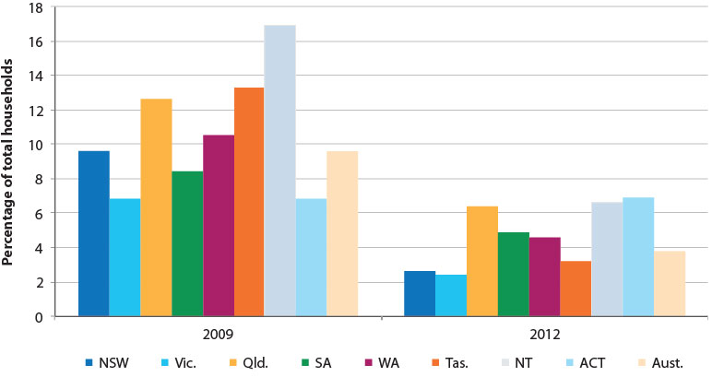

Source: ABS (2009 and 2012).

Of those households that recycled or re-used motor oil in 2009 or 2012, the majority took the oil to a special area or collection point, and this increased substantially between 2009 and 2012 (see Figure 8 below). While this is the case, around 30 per cent of households re-use oil at home or in other ways and there may be questions about the appropriateness of some of the alternative re-uses in this context.

### Figure 8. Australian household methods of recycling or re-using motor oil

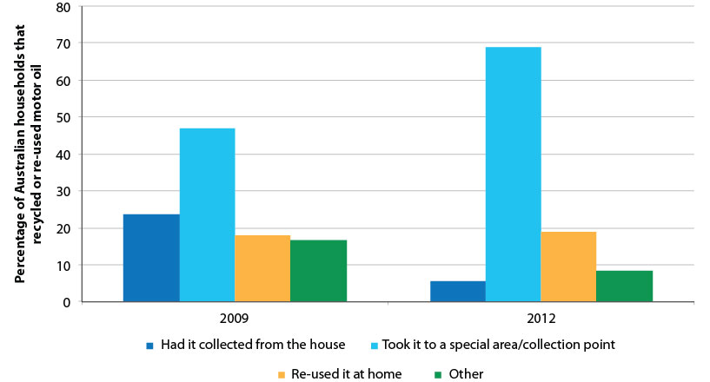

Source: ABS (2009 and 2012).

Of those households not recycling or reusing motor oil, the most common reason for not doing so was either not needing to, not using the item, or it not being considered appropriate. In both 2009 and 2012 very few respondents cited a lack of services or facilities as a reason for not recycling or reusing motor oil, and this has declined (4.5 per cent in 2009 and 3.8 per cent in 2012).

### Figure 9. Reasons for Australian households not recycling or re-using motor oil

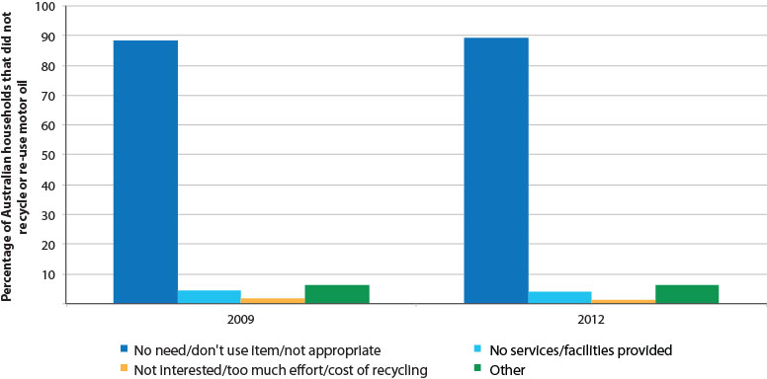

Source: ABS (2009 and 2012).

Interestingly, in the Northern Territory 25 per cent of respondents to the 2012 survey gave the reason for not recycling or reusing motor oil as due to a lack of services (see Figure 10 below).

### Figure 10. Reasons for Australian households not recycling or reusing motor oil by state

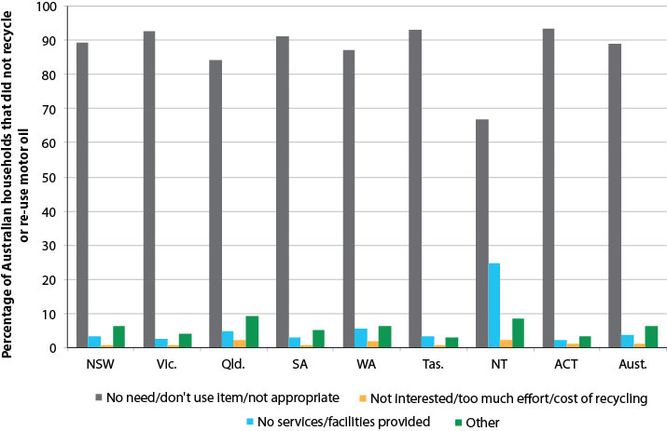

Source: ABS (2009 and 2012).

Of those households that disposed of motor oil in 2009 or 2012, meaning they did not re-use or recycle it personally, the majority took it to a business, shop or central point (see Figure 11 below). This increased between 2009 and 2012, with other potential disposal routes declining; including burial, giving it away or selling it, or pouring it down the drain (which declined from 0.4 per cent to nearly zero per cent). While there were declines in the percentage of households taking used oil to a municipal transfer station or similar facility, this continues to constitute the second most popular method for disposal of used motor oil amongst Australian households. However, there are still some potentially questionable disposal methods, including some oil being collected with usual garbage (suggesting inappropriate disposal to landfill), although this has also almost halved since 2009.

### Figure 11. Ways Australian households disposed of motor oil



Source: ABS (2009 and 2012).

|  |
| --- |
| Finding 1  There have been substantial changes in the patterns and amounts of disposal of used oils by households in recent years; most is now disposed of to an appropriate collection point and virtually none is poured down drains, however there is still room for improvement in some areas. |

## 4.2 Collection of used oil

The data presented above generally reflects changes in household behaviour, and to some extent reflects trends in commercial behaviour, given that an increasing proportion of households dispose of used oil through a commercial arrangement with a business or shop (in this case most likely service stations and mechanics).

Primary data on the extent of commercial collections of used oil is generally poor, but can be estimated for collections undertaken under the PSO Scheme – but not outside of it. Submissions to this review have suggested that commercial used oil collection in Australia is strong and that there is little waste oil generated that is not collected (except in Western Australia). While this may be the case, it is difficult to estimate the true volume of total used oil generated and collected – there is no authoritative or accurate source of data for used oil generated, and generation factors are often used to derive estimates. As the Scheme is involved in incentivising the sale of recycled or treated used oil products, it collects production rather than collections data. However, it is possible to estimate used oil generated from generation factors on total oil sales, and by using input production factors, estimates of used oil collected by Scheme participants can be made. This is illustrated in the following figure which estimates the volume of used oil generated in the Australian economy and the volume of used oil collected.

### Figure 12. Collection of used oil under the PSO Scheme

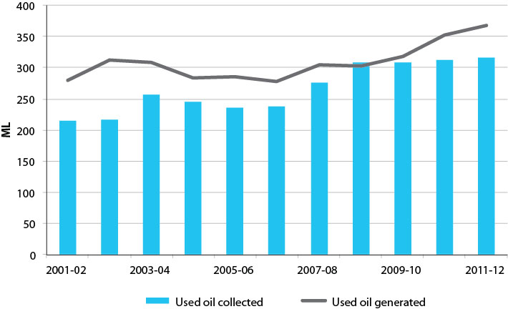

Source: Aither, based on the Department of the Environment (2013).

Notes: (a) Collection volumes derived using industry wide average production factors for PSO Scheme benefit-attracting used oil products. (b) The collection volume does not include any volumes of used oil that is collected, sold or re-used outside the Scheme; such as where collected used oil is provided directly to an energy recovery end user without collecting Scheme benefits. (c) Used oil generated is based on a generation factor on oil sales of 0.6. (d) Used oil collected may exceed that generated in some years due to collection of used oil generated in previous years, or due to use of the average generation factor, which is an imperfect proxy for the true volume of used oil available in the economy. (e) Data for 2000-01 has been excluded as the Scheme was only operational for six months in that year.

The figure above highlights that in 2011-12 there was a shortfall of approximately 50 megalitres (ML) between used oil estimated to have been generated and used oil that was collected under the Scheme. This difference could be accounted for by used oil collections and sales that exist outside of the Scheme – in some cases there is sufficient enough demand for used oil as a fuel that some collectors are collecting and on-selling used oil without participating in the Scheme.

It is clear that a substantial amount of used oil is being collected, and that this amount is increasing year-to-year with growth in used oil generated. Over time, the gap between estimates of used oil generated and that collected under the Scheme has varied, with diminishing gaps in early years likely to be explained by stockpiles being collected, and increases in later years potentially due to growth in oil sales outpacing the capacity of the used oil collection and recycling industry.[7]

There is a noticeable increase in the volume of used oil collected between the years 2001-02 and 2003-04, and again between 2006-07 and 2008-09. These increases may coincide with increases in re-refining capacity, or in the latter case, coincide with the period of time that transitional assistance funding was provided. Whether the latter increase in used oil collection can be solely attributed to transitional assistance is unclear from this data. However, the outcomes of the transitional assistance have arguably made the collection of used oil easier and more economically viable and thus an increase in the amount of used oil collected would reasonably be expected. Some submissions to the review also provided estimates of the volumes of collected used oil in Australia. Table 4 below, is adapted from submissions to protect confidentiality. It estimates the total volume of oil collected in Australia during 2012-13 to be between 311 and 321 ML; this number is very similar to that derived from the Department of the Environment’s annual report data above.

#### Table 4. Industry estimates of used oil collected under the PSO Scheme

| **Collector** | **Estimated collection volume (ML)** | **End use markets** |
| --- | --- | --- |
| **1.** | 160 | Re-refining, burning and export |
| **2.** | 25 | High grade fuel |
| **3.** | 22 | Burning and export |
| **4.** | 20 | Burning and export |
| **5.** | 15 | High grade fuel |
| **6.** | 12 | Burning |
| **7.** | 10 | N/A |
| **8.** | 7 | N/A |
| **9.** | 5 | N/A |
| **Other** | 35-45 | Burning and export |
| **Total** | **311-321 ML** |  |

Source: Industry estimates.

## 4.3 Re-use and recycling of used oil

It has been established that a large proportion of generated used oil is collected and that the proportion has varied, while generally increasing, over the life of the PSO Scheme. Once used oil has been collected it is then either treated or re-refined to produce a variety of different oil grades to be used for a variety of different purposes.

Figure 13 below shows the volume of used oil collected under the Scheme and used as input to produce the three major categories of output products.[8] As highlighted in the figure below, later and gradual growth in lubricating oil production is a result of time taken to establish re-refining plants.

### Figure 13. End uses of recovered oils and total volume recovered

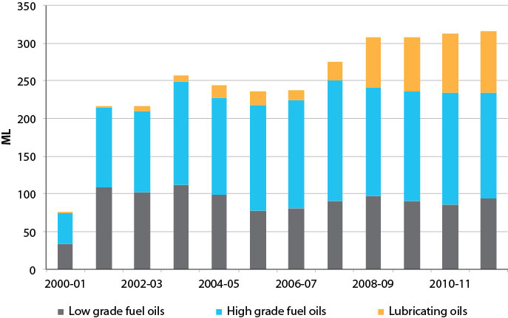

Source: Aither, using average industry wide production factors, based on the Department of the Environment (2013).

Note: 2000-01 only includes six months data.

Figure 14 below shows the volume of finished product recorded under the Scheme; grouped in the same product categories as the preceding figure. It is clear from this figure that the amount of low grade fuel oils being produced has declined slightly, while production of high grade fuel oils and lubricating oils has generally increased. This is likely to reflect increases in re-refining capacity and substitution of volumes previously going into low grade fuel oils now being treated to a higher standard and produced as higher grade fuel oils and lubricating oils. The higher benefit payments for these types of products under the Scheme are likely to have incentivised this outcome.

### Figure 14. Volume of finished product

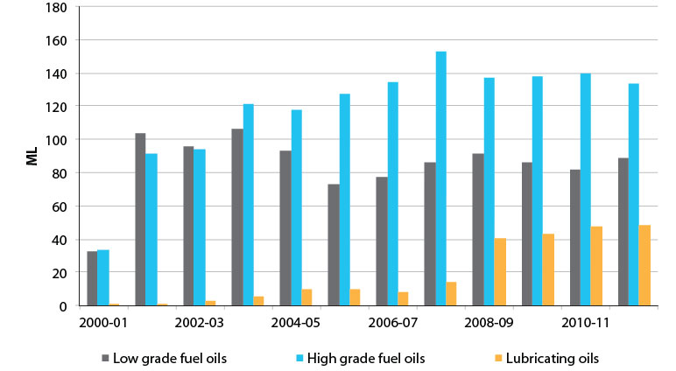

Source: Aither, based on the Department of the Environment (2013).

Note: 2000-01 only includes six months data.

By volume, both high and low grade fuel oils combined constitute the major share of used oil derived products, which in part reflects the technical efficiency limitations of re-refining processes and the quality of used oils collected and used as inputs to production processes. There is strong anecdotal evidence of shrinking market demand for low grade oil as customers switch to cheaper, better quality or more reliable energy sources such as mains gas.

|  |
| --- |
| Finding 2  The amount of re-refined lubricating oils produced under the PSO Scheme has increased substantially since the year 2007-08. However, despite receiving the highest benefit rate under the Scheme, the volume of used oil converted into lubricating oil only equates to around twenty-five per cent of the total volume of oil collected. |

## 4.4 Establishment of the used oil industry

The figure below charts broad trends in claimants of PSO Scheme benefits. It is presented here as a representative measure of the establishment and consolidation of the used oil industry, which under the Scheme may constitute aggregation, collection, treatment or re-refining businesses.

### Figure 15. PSO Scheme benefit claimants

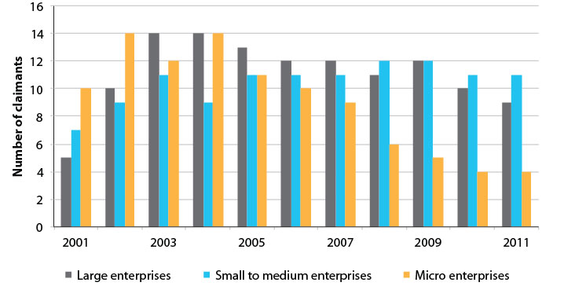

Source: Aither, based on unpublished ATO data supplied by the Department of the Environment.

It is clear from this data that under the Scheme, collecting used oil or producing and selling used oil derived products is commercially viable for a number of enterprises (claimants) – twenty-four claimants were registered for and claimed Scheme benefits in 2011.[9] The total number of claimants has reduced from a high of thirty-seven in the years of 2003 and 2004. However, over this same time period, there has been a substantial decrease in the number of microclaimants registering for and claiming Scheme benefits – down from fourteen in the years 2002 and 2004, to four in 2011. This is likely to be explained by industry consolidation over time, including larger claimants having bought out microclaimants; the re-use or recycling of used oil not being commercially viable for some microenterprises despite Scheme benefit rates; or microenterprises not needing to claim

Scheme benefits to be commercially viable – such as may be the case for low grade treatment and sale to energy recovery markets. Such consolidation is a normal part of the ongoing operation of any successful industry.

|  |
| --- |
| Finding 3  A used oil collection, treatment and re-refining industry has been successfully established in Australia – enterprises are increasingly collecting, reusing and recycling used oil and in doing so claiming PSO Scheme benefits. |

## 4.5 The role of the PSO Scheme and other factors

Four major points have been established from the above discussion:

• While Australian households are unlikely to dispose of used oil, if they do, they are more than likely to drop it to some sort of collection, aggregation point or depot for re-use or recycling; or at least dispose of it in an environmentally sustainable manner.

• Collection of used oil Australia wide has increased since 2001-02 by approximately 100 ML.

• The amount of used oil recycled into lubricating oils (lube-to-lube) has increased substantially since the year 2007-08.

• Reusing or recycling used oil is commercially viable for a number of enterprises who register for, and claim, PSO Scheme benefit rates.

It is clear that the increased amount of used oil that is being recycled into lubricating oils, and the general growth of the used oil industry itself, is a direct result of Scheme benefit rates. However, it is difficult to disaggregate how much of the broader environmental achievements – such as changes in household behaviour regarding the disposal of used oil – is due to the Scheme itself, as distinct from associated transitional assistance, the respective activities and regulations of state and territory governments and their Environmental Protection Authorities (EPAs), or enhanced environmental awareness and responsibility amongst the Australian public. There are also strong market drivers outside of Australia (world oil supply and demand, freight rates, currency exchange rates, and costs of producing lubricants offshore) that have substantially affected the viability and competitiveness of oil collection and recycling in Australia. In this sense, it is inevitably difficult to attribute how much of the changes over the past ten to twelve years are due to the Scheme alone.

While state policies and programs (especially the EPAs – which are discussed in greater detail in Section 4.5) prohibit the improper disposal of used oil as a hazardous toxic waste substance, apart from the Scheme, there have been few incentives to create an industry that sees used oil as a valuable commercial resource. In fact, controls on the movement and management of used oil as a waste product appear to have unintentionally inhibited the emergence of the oil recovery industry in some circumstances (see Section 5).

Fundamentally the Scheme gives no incentive to the general public to re-use or recycle used oil outside of a commercial setting. Therefore, it would be unwise to attribute changes in household waste disposal behaviour to the Scheme. Rather, the fact that households are increasingly more than likely to drop used oil to aggregation points or depots might better be attributed to improved infrastructure built under transitional assistance, state and territory regulations and policies or increased awareness at a local level.

Despite being able to attribute an increase in re-refining of used oil and the general growth of the used oil industry on the whole to the Scheme and its benefit rates, as stated above, other factors, including transitional assistance, relevant state and territory policy and regulation, and community awareness and behaviour must be explored in order to develop an understanding of their contribution to the increase in used oil re-use and recycling in Australia.

4.5.1 Transitional assistance

Transitional assistance, as explained previously in Section 3.3, was intended to provide strategic funding for projects that addressed fundamental barriers to the recycling of waste oil. The major barrier that the transitional assistance sought to address was the lack of adequate infrastructure or technology for oil recycling in Australia. The major focus was on the lack of infrastructure in rural and remote areas of Australia, and thus, the *Used Oil Collection Infrastructure Small Grants Program* was established to develop collection facilities in order to increase the collection and recycling of greater amounts of used oil.

There were three main outcomes of transitional assistance funding:

• It is now easier for Do-it-yourself (DIY) users and households to dispose of used oil in a legal manner – as can be seen through increases between 2009 and 2012 in households reusing and recycling used oil by taking it to special collection points.

• Aggregation of used oil in centralised collection points and depots has made it more viable and efficient for used oil collectors to collect oil – potentially shown through highlighted increases in collected used oil.

• Collection points and depots have meant that previously uncollected smaller quantities of used oil can now be more efficiently aggregated and recycled.

4.5.2 State policy and regulation

State and territory policies and regulations, including their EPAs, regulate various environmental matters, and of particular relevance to the PSO Scheme, they regulate the handling, generation, transport, recycling and disposal of used oil (as a waste). The fundamental aim of these policies and regulations is to prevent potentially hazardous wastes, such as used oil, from creating environmental harm – for example, through incorrect transport or inappropriate disposal.

These policies and regulations have likely encouraged businesses and generators of used oil at commercial premises, as distinct from households, to dispose of used oil in an environmentally sustainable manner – such as arranging collections from site or transporting it appropriately to collection sites.

These policies and regulations vary significantly in legislative detail across state jurisdictions, but are generally consistent in their overall aims and objectives. These are summarised in Table 5 below.

#### Table 5. EPA legislation and regulations by state and territory

| **State** | **Relevant legislation, regulations and policies** | **Example objectives and outcomes** |
| --- | --- | --- |
| **NSW** | *Protection of the Environment Administration Act 1991*  Waste Less, Recycle More: Waste and Resource Recovery Initiative | • To provide clear and consistent waste management regulations that minimise environmental harm and encourage resource recovery of waste  • $70 million over five years to establish community drop-off points to assist in improved household waste disposal |
| **Vic.** | *Environment Protection Act 1970*  *Pollution of Waters by Oils and Noxious Substances Act 1986*  Environment Protection (Industrial Waste Resource) Regulations 2009 | • The disposal of used oil in waterways is prohibited  • The Victorian Government is working with communities to see used oil diverted from landfill to alternative pathways |
| **Qld.** | *Environment Protection Act 1994*  *Waste Reduction and Recycling Act 2011*  Waste Reduction and Recycling Regulation 2011 | • The disposal of used oil in non-coastal waterways is prohibited  • Restrictions on storage of oil  • Waste oil is a regulated waste |
| WA | *Environmental Protection Act 1986*  Environmental Protection Regulations 1987  Environmental Protection (Unauthorised Discharges) Regulations 2004 | • Restrictions on the disposal of used oil onto land or into waterways  • Curbing generation of waste at commercial sites, and if waste is generated, assisting in the promotion of re-use, recycling, energy recovery and appropriate disposal of it |
| **SA** | *Environment Protection Act 1993*  Environmental Protection (Waste to Resources) Policy 2010 | • Ban on disposing of oil in landfill  • Organisations such as Zero Waste SA are implementing policies relevant to the re-use and recycling of used oil |
| **Tas.** | *Environmental Management and Pollution Control Act 1994*  Environmental Management and Pollution Control (Waste Management) Regulations 2010  Environmental Management and Pollution Control (Controlled Waste Tracking) Regulations 2010 | • Regulations regarding the removal, storage, re-use, recycling, reprocessing, salvaging, incinerating, treating and disposal of, or use for energy recovery of used oil  • The Tasmanian Government continues to support and facilitate the PSO Scheme |
| **ACT** | *Environment Protection Act 1997*  Environment Protection Regulation 2005  Hazardous Materials Environment Protection Policy 2010 | • The disposal of used oil in waterways is prohibited  • Used oil could be dropped at the Energy Services Environmental treatment facility located in Mitchell until it was destroyed by fire |
| **NT** | *Northern Territory Environment Protection Act 2012*  *Waste Management and Pollution Control Act 2013*  Waste Management and Pollution Control (Administration) Regulations 2013 | • Working with industry to minimise waste generation  • Working with communities to increase awareness of issues associated with waste  • Providing assistance and advice on oil spill contingency plans |

Source: State government websites, legislation and regulations.

4.5.3 Community awareness and behaviour

The ABS, as a part of their *Environmental Issues: Waste Management, Transport and Motor Vehicle Usage March 2009* survey, collated data on Australian households’ awareness of hazardous waste disposal services and facilities in their local area (Figure 16 below) – data of this nature was not collected or published in the 2012 survey by the ABS. It shows that in 2009, approximately sixty per cent of Australian households were not aware of their local hazardous waste disposal services or facilities.

### Figure 16. Public awareness of hazardous waste disposal services and facilities

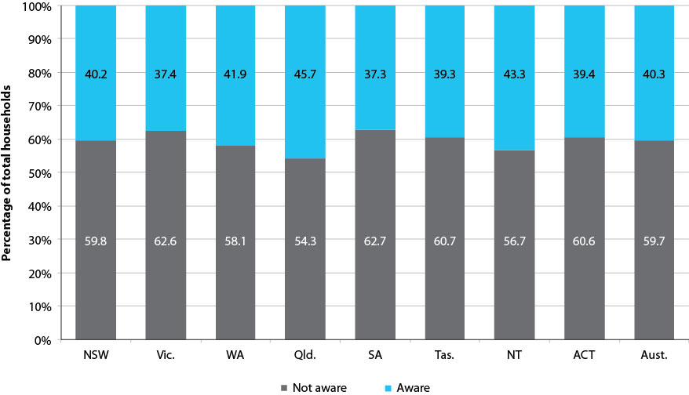

Source: ABS (2009 and 2012).

Regarding the disposal of household waste oil, it is possible that the majority of households, at least in 2009, wanting to re-use, recycle or dispose of waste oil, may not be aware of the relevant local services and facilities that exist as a means to do so. However, referring back to Figure 8 in Section 4.1, it is clear that of those households wanting to re-use or recycle waste oil, over 45 per cent in 2009 and almost seventy per cent in 2012, took it to a special area or collection point. Furthermore, of those households wanting to dispose of waste oil, 73 per cent in 2009 and seventy-nine per cent in 2012, brought their waste oil to either a waste or dump transfer station; or to a business, shop or central point. These figures highlight that at least among those households wanting to re-use, recycle or dispose of waste oil, there seems to be more awareness of hazardous waste disposal services and facilities in the local area than Figure 16 above would convey. Despite this, it is hard to attribute this increase in public awareness to the PSO Scheme itself. A better explanation might be associated with an increase in hazardous waste disposal services and facilities in local areas due to transitional assistance funding or associated with respective activities and regulations of state and territory governments and their EPAs.

In addition to this, the Waste Management Association of Australia conducted landfill surveys in 2008 and 2010 that collected data regarding used oil collection at landfill sites. Figure 17 below shows a breakdown of the total amount of landfill sites in Australia (517 sites) and those that collect oil compared to those that don’t. The majority of landfill sites that responded to the survey collect used oil in some capacity.

### Figure 17. Collection of used oil at landfill sites in Australia

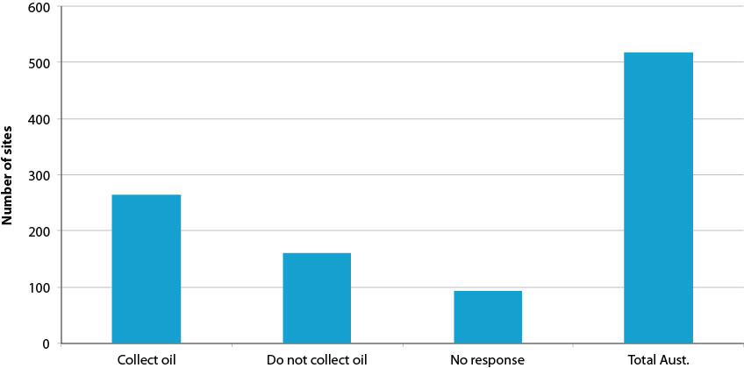

Source: Aither, derived from combined data provided by the Department of the Environment from the Waste Management Association of Australia’s 2008 and 2010 Landfill Survey.

Note: Figure shows data from a combined 2008 and 2010 dataset.

Of those landfill sites that collect used oil, only approximately half provided details as to what quantity was collected. The figure below highlights that in the years 2008 and 2010 combined, around 1.8 ML of used oil was collected by landfill sites that; a) responded to the survey; b) collected oil; and c) provided details as to what quantity. It is obvious from the data that New South Wales, Queensland and Western Australia represent the majority of used oil collected by landfill sites.

### Figure 18. Quantity of used oil collected at landfill sites

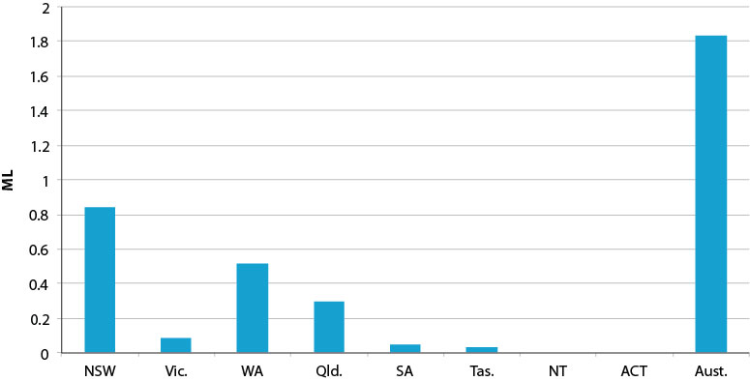

Source: Aither, derived from combined data provided by the Department of the Environment from the Waste Management Association of Australia’s 2008 and 2010 Landfill Survey.

Note: Figure shows data from a combined 2008 and 2010 dataset.

While the collection of oil at landfill sites is minimal relative to the overall size of the used oil industry, there are three important points to note:

The small amount of used oil being brought to landfill sites by the general public corroborates findings in Section 4.1 that only a small number of Australian households dispose of used oil themselves.

The fact that used oil is being collected at landfill sites means that there is at least some public awareness of local collection points for used oil.

Despite the quantity being small in relative terms to the Australian wide used oil industry, at a local level, it is important that these quantities of stored used oil are managed in an environmentally sustainable manner.

|  |
| --- |
| Finding 4  It is clear that three key achievements can be primarily attributed to the PSO Scheme:  • The Scheme provides collectors of used oil with a commercial incentive to undertake collections that may be unviable without the Scheme benefit rate.  • The increasing proportion of used oil that is re-refined into lube oil can be directly attributed to the Scheme benefit rates.  • The Scheme, by providing a financial incentive to re-users and recyclers of used oil at the end of the system, creates a pull through effect throughout the entire system – however, the magnitude of this pull through is also unclear from the data and information available. |

The extent to which the environmental achievements seen in the used oil industry can be attributed solely to the Scheme is uncertain. What is certain, however, is that the Scheme has worked effectively in concert with a combination of other factors as mentioned above to bring about these achievements. The Scheme has provided the market-pull to encourage and facilitate compliance with state regulations and has helped change used oil from being seen as a disposal problem to being seen as a commercially viable and valuable resource in many areas of Australia. The creation through the Scheme of a number of competitive markets for used oil – for example, re-refining, energy-recovery, and export – has helped to reduce environmental and public health risks and supported the emergence of collection and re-refining industries.

## 4.6 Summary

The PSO Scheme is suggested to have achieved much in incentivising the recovery and re-use of used oil, at low overall cost to the Australian community, and with low implementation and compliance costs. This section has five major conclusions:

• Australian households are unlikely to dispose of used oil, but if they do they are more than likely to drop it to some sort of collection, aggregation point or depot for re-use or recycling – or at least dispose of it in an environmentally sustainable manner.

• Collection of used oil Australia wide has increased since 2001-02.

• The production of high and low grade fuel oils from collected used oil constitutes the vast majority of the used oil market while only receiving modest benefits under the Scheme.

• The amount of used oil re-refined lube-to-lube has increased substantially since the year 2007-08.

• Reusing or recycling used oil is commercially viable for a number of enterprises who register for and claim the Scheme benefit rates.

The extent to which all of these achievements can be attributed solely to the Scheme is to some extent uncertain – except that it is very unlikely that Australia would have any re-refining industry without the Category 1 benefit under the Scheme. The broader environmental achievements, such as changes in household behaviour regarding the disposal of used oil, should be attributed more to other relevant factors distinct from the levy-benefit arrangement under the Scheme. Thus an exploration of these factors was warranted; from which three points were found:

• Transitional assistance funded much of the infrastructure that supports the collection of used oil, and thus the used oil industry.

• State and territory policies, regulations and EPAs have likely encouraged businesses and generators of used oil at commercial premises to dispose of used oil in an environmentally sustainable manner, such as arranging collections from site or transporting it to collection sites. This, combined with increased collections of used oil has meant that more re-refining is taking place.

• Potential awareness issues exist regarding the disposal of used oil by the general public.

What is clear, and is most likely of more importance, is that the Scheme has worked effectively with a combination of other factors to bring about the achievements discussed here. The Scheme has most importantly provided the market-pull to encourage the creation of a competitive used oil market in Australia and has thus helped to reduce environmental and public health risks associated with uncollected used oil in the community, and further supported the emergence of collection and re-refining industries. However, and more fundamentally, the increased proportion of used oil that is re-refined into lube oil and the general growth of the used oil industry can be directly attributed to the Scheme.

# 5 Challenges

The stated policy objectives of the PSO Scheme have been largely achieved either directly or indirectly in combination with other efforts and investments such as transitional assistance and the policy and regulatory efforts of state and territory governments. While the outcomes are significant and generally positive, this review has revealed a range of challenges arising from the current operation of the Scheme. These have the capacity to substantially erode its future effectiveness, efficiency and sustainability. This section outlines and discusses these matters and their implications for the Scheme.

## 5.1 Design

Some challenges facing the PSO Scheme, now and increasingly into the future, can be traced back to the original design of the Scheme. These are explored below.

5.1.1 The net environmental benefit of re-refining

Currently, the PSO Scheme favours re-refining of used oil over other processing methods or end uses at a ratio of as much as 50:3. All stakeholders’ perspectives differ regarding why this is the case; some anecdotal information suggests the 50 cents per litre (cpl) benefit rate for re-refining was somehow aligned to costs of capital investment for re-refining, while others have suggested the benefit is based on environmental grounds, that re-refining is significantly superior to other end uses.

The second reading speech for the Act suggests that at that time, the basis for the scaled benefits was largely on environmental grounds:

A system of differentiation will mean some uses and products of waste oil will attract a different level of benefit to other uses and products. The government recognises that there are a variety of end uses for waste oil. As the focus of this legislation is environmental, product stewardship benefits will reflect the environmental merits of the products and processes. In making a decision to differentiate, the Minister for the Environment must consider any relevant environmental matters related to the recycling. The information needed to differentiate benefits will be based in part on a comparison of the environmental footprint for the production of each product (Australia Parliament 2000).

Further, the speech goes on to state:

In the initial stages of the product stewardship Scheme, a simple differentiation system, based largely on sustainability criteria, is proposed. Lower levels of benefit will be paid for uses where the waste oil is consumed as a fuel, where essentially only the thermal energy of the oil is recovered. Where the waste oil molecules are not consumed, such as when they are turned into lubricant rather than fuel, a substantially higher benefit should apply. With oil being a limited natural resource, this approach is both highly desirable and consistent with the objects of this bill (Australia Parliament 2000).

Based on this information, it appears the grounds for differentiation were environmental – however, we are unaware of any specific studies or assessments undertaken that assisted in determining the precise ratios of benefit rates used under the Scheme. As part of this review, an evaluation of the environmental benefits of re-refining was undertaken based on existing literature (see Appendix D). This suggested that re-refining is likely to be less harmful to the environment than energy recovery (burning) in two key ways:

• avoidance of environmental and human health risks associated with harmful emissions from burning

• conservation of oil resources, and potentially lower carbon footprint

Given these two areas of environmental concern are not explicit objectives of the Act, and the fact that the literature generally does not quantify the degree of environmental superiority, it is difficult to determine whether or not the current ratios of benefit rates under the Scheme are justified. Given the possibility that state environmental protection regulations may control the improper burning of certain fuels or the emissions they create, the first area may not be an important objective for the Scheme to address. And given the existence of carbon policy in Australia, and the more efficient approach of signalling resource scarcity through pricing (such as world oil prices), it would seem questionable whether the second area of benefit should be a focus for the Scheme.

The key environmental benefit associated with product stewardship arrangements is the prevention of improper disposal and the associated negative environmental impacts that result. Evidence presented earlier in this report suggests much has been achieved in this regard. While further benefits are possible beyond this, we would suggest that these benefits are, or should be, a secondary focus for the Scheme.

Despite this, there remains uncertainty as to exactly how much better re-refining is than other processes or end uses, and under what circumstances (it may not be more beneficial in all circumstances – such as when collecting used oil from very remote locations for re-refining rather than reusing it on-site for energy recovery). Providing higher benefits for re-refining is also problematic because of the inability to control end use after re-refining has occurred

|  |
| --- |
| Consultations  During the consultation process, stakeholders highlighted a lack of clarity regarding the Scheme’s objectives. This included the primacy of encouraging re-refining versus encouraging collection and re-use; even if it leads to energy recovery in other industries. There appears to be some tensions between the most economically rational approach and the ‘ideological purity’ of the waste hierarchy and the attractiveness of ‘completing the cycle’ by re-refining, regardless of other factors affecting the viability of the industry.  Respondents from the used oil refining industry cited that re-refining is overall the most sustainable outcome for the treatment of waste oil, particularly as new lubricating oil is imported and produces the most reliable health outcomes for the treatment of used oil. These respondents argued that the carbon emissions created during re-refining are substantially less than those created during burning.  Aside from the environmental benefit of re-refining, some stakeholders highlighted the higher value of re-refining relative to the burning of used oil and the creation of more, and higher-skilled, jobs in the economy. |

|  |
| --- |
| Finding 5  While re-refining is likely to be environmentally superior to energy recovery from the perspective of harmful (toxic or carbon) emissions and oil resource conservation, the specific ratios of benefit rates under the PSO Scheme cannot be substantiated based on existing environmental literature, and arguably should not be based on such grounds, or at such ratios. |

|  |
| --- |
| Finding 6  The PSO Scheme’s major environmental contribution lies in avoiding improper disposal of used oil rather than in attempting to determine the most appropriate treatment processes or end uses for recycled oil products. Alternative policy mechanisms – such as carbon pricing or state based regulations – are better placed to manage externalities associated with carbon or harmful emissions. In addition, existing markets – for example the global oil market – are more efficient in signalling the need to conserve oil resources. |

5.1.2 Defining success

One key weakness in the original design of the PSO Scheme is the lack of a clear definition of what success would look like; either in quantitative or qualitative terms. This impedes effective assessment of its performance, and answering questions such as if, or when, the Scheme should be scaled back or wound down altogether.

This issue is particularly problematic for determining when the used oil industry is large enough, or determining what level of oil collection or recycling the Scheme should achieve. There is no clear indication of how much recycling is enough (in percentage terms), how big or small the industry should be, how much the industry should (or shouldn’t) be publically subsidised, when it should cease being subsidised, or otherwise. Existing documentation of the Scheme does not discuss how long it was supposed to last, or by which criteria a decision to stop could be made. This is a key weakness that needs to be addressed in order to provide greater certainty to industry participants, but also to government administrators and future reviewers in assessing performance.

It is necessary to either define or redefine what ‘success’ looks like for the Scheme, as this will ultimately determine how it is structured into the future. This is particularly important given that (as will be argued later) the initial objects of the Act have largely been met – so the question remains, where to from here? Is success defined in terms of the volume or per cent of oil collected each year or the proportion of that which is re-refined and sold back into the lubricant market? Or could success be defined by the number of operational re-refineries, and if so, what would be a feasible and desirable target?

It is quite understandable that in 2000, the obvious answer was ‘more of all of those’. However, now that the Scheme has been operation for twelve years, and has delivered results, greater clarity is required.

|  |
| --- |
| Consultations  While most respondents agreed that there are real successes associated with the PSO Scheme, such as a national network of used oil collectors and at least three re-refineries operational, there was a general consensus that there is no clearly defined or accepted vision of success for the Scheme – for instance, the target number of re-refining plants needed to ensure used oil is not stockpiled.  Many suggestions were made during the consultation process to fine-tune the Scheme regarding definitions, eligibility, classifications and loopholes. Respondents from the used oil refining industry called for greater certainty about the future of the Scheme and the rate of benefit to be received. |

|  |
| --- |
| Finding 7  A clear definition of long term success for the PSO Scheme needs to be determined, agreed upon and articulated effectively to provide certainty and clarity to industry participants, government administrators and future reviewers. Guidance on such a vision is provided in Section 8. |

5.1.3 Exposure of the PSO Scheme to exogenous drivers

The PSO Scheme appears to have been designed in a way that is largely ambivalent towards national and international drivers that are exogenous to the Scheme. Such drivers can, and do, have a significant bearing on the viability and performance of the Scheme – yet the Scheme’s design appears to not take account of them.

The current markets for used oil based products in Australia – for example energy recovery, re-refining and export – are heavily exposed to exogenous factors outside the control of the Australian government and industry, including the exchange rate of the Australian dollar, global crude oil prices, international refinery capacity, capacity-utilisation rates and production costs, global trade in used oils, freight costs, alternative fuels, acceptability of substitute products, carbon policy, and others. The dependence of the Australian re-refining industry on these factors in particular is such that significant shifts in any of them could make the industry unviable, regardless of the level of benefit paid to re-refining. Neither the Scheme nor the transitional assistance can ensure a sustainable oil recycling industry in the face of powerful external drivers.

For example, if the global price of oil falls from $100 to $70 per barrel, a Scheme payment of 50 cpl or even $1 might not keep the Australian re-refiners viable. In contrast, if the global oil price went from $100 to $150 per barrel, it is probable that no Scheme payment would be required for them to be viable and internationally competitive, vis a vis virgin oil. Over the course of the Scheme, there has been considerable variation in global oil prices, as shown in Figure 19 below.

### Figure 19. Global crude oil prices

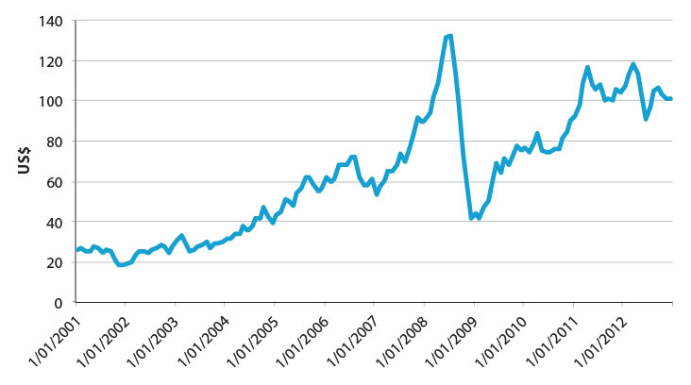

Source: Indexmundi (2013).

Note: Accessed 28 June 2013 and does not reflect changing in price since.

Note: Simple average of three spot prices; Dated Brent, West Texas Intermediate, and the Dubai Fateh.

If re-refining was to become completely unviable, the consequences could be serious for the whole of the used oil industry, and hence for environmental protection due to collection rates being compromised, oil accumulating and some of it inevitably leaking or being dumped into the environment.

The following figure illustrates how the Scheme effectively targets processes and end use markets for used oil, rather than collection, aggregation or other aspects of the use or collection of oil – the Scheme has no direct bearing on the collection of used oil. Collection demand is derived from those treating or re-refining used oil for particular end use markets, or the end use markets themselves. As a result, the Scheme is heavily exposed to the conditions in those three markets, which as noted above, could have serious implications. There are many places where the current system can and might break down:

• The cost of imported oil reduces to a level that recycled oil is unable to be sold at a profit, even with increased Scheme benefit rates. As a consequence used oil would become unpopular as a fuel with burning customers no matter how cheap it is.

• Technical standards demanded by Original Equipment Manufacturers (OEMs) increase beyond what Australian re-refiners can produce, thus they become technically unable to satisfy market demands (see box below). This means that re-refined Australian oil will no longer be recirculated in the Australian economy in the way that environmental advocates had assumed.

• Collection costs increase so that costs of recovery become prohibitive, even if demand holds up at current levels.

|  |
| --- |
| Group oils and Original Equipment Manufacturers (OEMs)  The standards and specifications of virgin oils have been increasing in recent years, in part due to more stringent requirements of vehicle and machinery manufacturers. This includes improvements to the quality of base oils, but also in relation to additives that are blended into final products. Such improvements are designed to decrease service intervals and improve the working life of the vehicle or machinery. The standards are reflected in ‘groups’ of oils (Group 1, Group 2, Group 3, and so on), which provide the specifications. Most OEMs now require at least Group 1, with many already requiring Group 2 or 3. At this stage, we understand that no re-refiners in Australia can produce a re-refined oil certified as equivalent to a Group 1 virgin oil, so are thus faced with a major difficulty in selling their product. Some major fleet owners are suggested to have been ignoring their OEM requirements and potentially voiding warranties by buying and using re-refined products, but these seem to be rare exceptions. The major risk to the PSO Scheme is that if the re-refiners cannot sell their product profitably, the Scheme will suffer from a glut, which would reduce collections, and could potentially lead to major environmental problems if there are accidental discharges because collections cease (altogether, or in particular areas or markets). |

### Figure 20. Used oil industry and PSO Scheme incentives

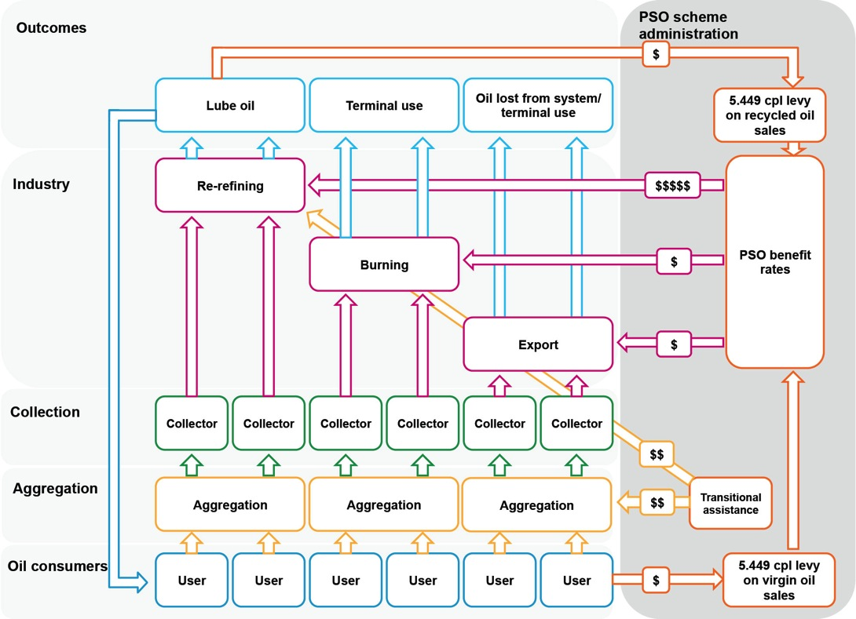

Source: Aither.

Note: The PSO Scheme levy is actually collected from producers or manufacturers of virgin and recycled oil products, but the cost is passed onto consumers.

|  |
| --- |
| Consultations  There was a general consensus that the demand for re-refining, energy recovery and exports is highly susceptible to exogenous factors that may influence the degree of difference that the PSO Scheme can make. Respondents from the re-refining sector stated that factors such as global oil prices, exchange rates, alternative fuel sources and shipping costs drive the profitability of the sector. There is large volatility in recovered prices due to the relationships between gas, coal and oil prices, and the substitution between each resource, which affects price stability for exporters.  Stakeholders also cited the exposure of oil re-refiners to the high Australian dollar as a concern as it affects the ability of re-refiners to recover the costs of recycling. Some respondents noted that factors contributing to the current high demand for fuel oil in Asia may change, reducing the premium received on Australian exports. Pressure on the domestic recycled fuel oil market due to the rise in the use of natural gas was also cited as a concern.  Some stakeholders suggested that the re-refining industry in Australia could fail due to global competitiveness factors; even if the Scheme continued to exist in its current form. |

|  |
| --- |
| Finding 8  The success of the PSO Scheme is heavily dependent on exogenous factors outside the control of government or industry. Major changes in such factors could potentially compromise used oil collections and the environmental achievements of the Scheme to date. Focusing incentives on collection and being more agnostic about treatment or recycling processes and end uses could be a more efficient and appropriate approach to mitigating these risks. |

5.1.4 Market issues with re-refined products

The current design of the PSO Scheme implicitly assumes that re-refiners will find end use markets for re-refined products. The Scheme provides benefits upon the sale of recycled oil products, but the Scheme itself cannot incentivise demand for such products, nor can it control the needs and requirements of potential end users of recycled oil products.

For example, there are challenges in ensuring acceptance of re-refined oil products. Increasingly stringent requirements of OEMs are such that re-refined products cannot be used in many vehicles and machines without invalidating warranties. This is contributing to an unintended consequence whereby Category 1 benefit products are not being used as lubricants, but rather being used in terminal uses such as explosives and carpet underlay. Testing and verification of re-refined products is also proving to be prohibitively expensive for the Australian re-refining industry, further complicating the acceptance of re-refined products, and resulting in such products being sold at a discount relative to virgin oil.

Industry participants appear to have been active in attempting to promote greater use of re-refined lubricating oils, but ultimately they cannot control the needs and requirements of OEMs or other potential end users. Some progress has been achieved, and this may improve over time, but it nevertheless seems likely to persist.

While it could be argued that the Scheme incentive is in the right place because it provides incentives to re-refiners to develop and find new markets for used oil derived products, it does fail to acknowledge that no matter how hard re-refiners work, there may be real or perceived barriers to use of recycled oil products that are very difficult to overcome.

|  |
| --- |
| Consultations  There were concerns from companies in the used oil refining industry that there are no incentives for industry to purchase recycled oil. They highlighted the need for diverse and flexible markets for the sale of used oil, as the current markets for re-refined oil are restricted given manufacturer specifications.  Industry participants argued that re-refiners are at a disadvantage relative to virgin oil competitors due to challenges meeting specifications, including the cost of product testing. If the product cannot be sold, the re-refiner cannot claim the PSO Scheme benefits and therefore some products are being sold for explosives and carpet underlay rather than lubricants.  Many respondents proposed a minimum mandatory re-refined oil content in all new lubricant sold in Australia, in order to promote the industry and reduce negative stigmas surrounding the use of recycled oil. There were examples cited of other jurisdictions that were implementing similar measures.  The respondents from the re-refining industry agreed that the negative connotations associated with recycled oil were related to the definition of used oil. For example, some stakeholders suggested that the New South Wales EPA still defines used oil, and any subsequent products even if re-refined, as a waste (however, we were unable to verify the accuracy of this suggestion). |

|  |
| --- |
| Finding 9  More could possibly be done to develop end use markets for re-refined lubricating oil. However, in any normally functioning industry this would, and should, be the responsibility of industry. If governments wish to achieve greater levels of re-refining they will have to either acknowledge and work within the limitations of existing end use markets, or work in different ways to attempt to increase acceptance of re-refined products in the market place. |

5.1.5 Interaction with other areas of Commonwealth policy and programs

Other areas of Commonwealth policy or programs have the potential to support or work in opposition to the PSO Scheme; raising the potential for perverse or unintended consequences. Some key and interrelated areas that have been brought to our attention in this regard are explored below.

Fuel excise and the PSO

Excise duty is a tax paid by all entities producing or manufacturing fuel or petroleum based oil and grease products in Australia. To manufacture an excisable product, entities are required to be a licenced manufacturer and produce the product at a licenced premise within Australia. The excise is liable to be paid by the producer of the fuel on sale of the product – but producers normally pass this cost onto customers. Under previous arrangements, PSO Scheme Category 3, 4, 5 and 6 used oil products attracted fuel excise. As a result of *Cooper Bros Holdings Pty Ltd trading as Triple R Waste Management v. Commissioner of Taxation (2013) (RRR v. ATO (2013))*, most Category 6 products no longer attract fuel excise. The implications of this are discussed in more detail below. The table below summarises previous fuel excise rates.

#### Table 6. PSO Scheme benefit categories and fuel excise rates

|  |  |  |
| --- | --- | --- |
| **PSO Scheme category** | **ATO Excise Tariff category** | **Excise rate** |
| 3 | 10.10 – Diesel (other than biodiesel) | $0.38143 per litre |
| 4 | 10.10 – Diesel (other than biodiesel) | $0.38143 per litre |
| 5 | 10.28 | $0.38143 per litre |
| 6 | 10.28 | $0.38143 per litre |

Source: ATO (2013b).

Prior to the introduction of a carbon price, most fuel oil customers under the PSO were able to claim a fuel tax credit equal to the full amount of the excise cost passed on by the producer. Neither producers nor their customers were at a financial disadvantage – in fact the producer may have been at a financial advantage if they claimed for a benefit under the PSO Scheme. However, with the introduction of a carbon price, the fuel tax credit was reduced by the amount of the carbon price (this mechanism was used to give effect to intended carbon policy outcomes). Further carbon policy matters are discussed below.

Carbon policy

The main implications of a carbon policy for the PSO Scheme include increased cost of business for re-refiners, and changes in costs and switching of fuel sources for burners. The first issue is an economy wide impact and is an intended consequence of a carbon policy to incentivise switching to alternative energy sources – in this sense it is not suggested to be unique to the Scheme, nor a specific threat to its achievements. Switching of burner fuels may or may not be specifically due to a carbon price; recent increases in the availability of cheaper fuel sources, including gas, are likely to be playing a role also. Contraction in burner markets could present challenges for the Scheme if this impacts on collections – but this is a broader issue that is not necessarily directly a result of a carbon policy.

More specifically, as a result of the carbon policy, which is implemented through a reduction in the fuel tax credit of approximately 6 cpl, some burners of used oil have become more financially exposed due to having to bear greater costs of fuel excise that is passed onto them by the producers. Recent decisions stemming from *RRR v. ATO (2013)* regarding Category 6 used oil products, has reduced this financial exposure for some burners and in doing so no longer left them exposed to increased costs under the new carbon policy.

|  |
| --- |
| Cooper Bros Holdings Pty Ltd trading as Triple R Waste Management v. Commissioner of Taxation (2013)  Prior to the Administrative Appeals Tribunal’s decision on RRR’s liability for fuel excise, companies in Australia, such as RRR, collected used oil, subjected it to a process of filtering and de-watering and then on-sold this oil for use as burner fuel, earning the 3 cpl benefit under the PSO Scheme in the process. The sale of this used oil as low grade fuel was liable to pay $0.38143 per litre in fuel excise. Under the previous arrangements, companies in Australia such as RRR paid excise on the sale of the product and passed the cost onto their customers. The customers were able to claim this cost back in the form of fuel tax credit.  Under new carbon policy arrangements, the fuel tax credit was reduced by the amount of the carbon price, therefore putting them at around a $0.06 per litre disadvantage. RRR thus appealed an earlier ATO Ruling requiring them to pay fuel excise on Category 6 products being produced at their Melbourne plant. |
| In appealing this, RRR risked their right to claim the 3 cpl benefit rate under the Scheme, but the liability to their customers of them having to pass on the cost of fuel excise without full compensation was greater.  In the *RRR v. ATO (2013)* case, the tribunal found that the collected oil, subjected to a filtering and de-watering process only, could not be deemed a manufactured or produced product within the ordinary meaning of the words (ATO 2013c), and thus:  • The end product is no longer subject to fuel excise.  • Any customer that acquires the end product for its own use is not entitled to a fuel tax credit because the end product that was acquired was not a ‘taxable fuel’.  Subsequent to the Administrative Appeals Tribunal (AAT) decision, the ATO issued a Decision Impact Statement which stated that since used oil subjected to simple filtering and de-watering was no longer considered a manufactured or produced product – the Tribunal found they were not processing or changing the nature of oil – it would no longer be entitled to any benefit under the Scheme on the basis that the end product would not have been ‘produced from used oil’ as is required by section 6 of the Product Steward (Oil) Act 2000.  An unintended consequence appears to be that their customers are no longer exposed to the impacts of carbon policy due to the product not being considered an excisable fuel. This may affect any incentive the carbon policy intended to provide to such fuel users. |

While there are domestic implications regarding *RRR v. ATO (2013)* and fuel excise, different circumstances may apply for exports. Exported fuels are not liable for the carbon price, and some Category 6 products that are exported may no longer be eligible for benefit payments. In this situation, the producer is likely to be 3 cpl worse off. However, this is assuming that it would not be possible to renegotiate export prices. In practice, export prices change frequently, and recent changes in the currency exchange rates would affect the overall profitability of used oil exports much more than changes in the Scheme.

|  |
| --- |
| Consultations  The consultations identified issues arising from the PSO Scheme’s interactions with other Commonwealth legislation and programs – for example fuel excise, carbon pricing and the Basel Convention on hazardous wastes (discussed further below).  Some respondents stated that certain policies and legislation may reflect the issue of hazardous waste disposal rather than ensuring that valuable used oil is accessible to those who need it most as a valuable feedstock. This discrepancy may be presenting barriers to the active or developing markets for used oils as feedstock.  Respondents from the re-refining industry expressed concerns over the role of the carbon policy in pushing up production costs and making it difficult for domestic re-refiners to compete with imported virgin oil. They cited the carbon policy as a driving factor behind the recent development to export oil. |

|  |
| --- |
| Finding 10  The *RRR v. ATO (2013)* decision is likely to have modest impacts on the financial performance of the PSO Scheme – but the decision in itself should not compromise the Scheme’s environmental performance. In this sense factors other than Category 6 Scheme benefits will continue to be the main drivers of low grade fuel oil markets and associated collections. Increased re-refining capacity may take up some previous Category 6 volumes. |

|  |
| --- |
| Finding 11  The *RRR v. ATO (2013)* decision may have had the unintended consequence of removing the carbon policy liability for some users of low grade fuel oils. |

5.1.6 Interaction with state and territory policies or programs

State and territory policies or programs also have the capacity to impact on the PSO Scheme’s operation or performance. Key areas noted in the course of the review include occupational health and safety, hazardous waste transport, waste policy, fuel reservation policy, and state landfill bans and conditional disposal restrictions. As is the case for Commonwealth policy, there is the potential for perverse and unintended consequences if state policies are working independent of, or in opposition to, the Scheme.

Licensing and tracking arrangements regarding the transport, storage and disposal of used oil within jurisdictional boundaries could impact on the efficiency and sustainability of the Scheme. It seems obvious from an environmental perspective that large-scale transport of used oil should be subject to strict regulations, whether it is being transported intra-state or inter-state. It can be reasonably assumed that costs associated with complying with these regulations are an expected and absorbable cost to large-scale operators and it is unlikely to have a major impact on business viability. However, these costs may be of concern to smaller operators who might be unable to absorb the costs associated with complying with the regulations as well as the larger operators can.

This may have particular implications in regional areas, such as for farmers or small scale entities producing used oil, who may be unwilling or unable to transport their used oil to collection or aggregation points because of the potential licensing costs they face in doing so. This is not necessarily an issue if licensed used oil collectors are willing to collect from the producer’s premises. However, if it is not economically viable for these collections to take place, and the users of oil do not find it economically viable to transport it themselves, then the used oil remains uncollected. In addition, occupational health and safety requirements in relation to the transport of dangerous or hazardous goods could be playing a role in preventing small scale users of oil from transporting their used oil to collection points.

As has been noted above, gas reservation policies – specifically in Western Australia – have the potential to impact on the Scheme due to reduction in burner markets. Such reduction may be beneficial from an environmental point of view, or from Western Australia’s perspective due to lowering the costs for businesses due to reservation, but they could potentially put collections at risk if other markets (such as exports and re-refining) do not take up the surplus volumes of collected oil.

Further to this, policies such as those regarding waste in New South Wales, have the potential to propagate the stigma associated with used oil due to it being defined as a waste. While clearly transport and similar policies need to acknowledge the hazardous nature of used oil, it is clear from the Scheme that used oil can be a commercially valuable resource, rather than a waste, and redefining certain aspects of waste policy may assist in removing ongoing stigmas in the marketplace for used oil derived products.

|  |
| --- |
| Movement of hazardous waste between states  In 1998 (updated in 2010), the *National Environmental Protection Measure for the Movement of Controlled Waste between States and Territories* was established. This measure regulates the movement of controlled waste between Australian jurisdictions; requiring consistency between jurisdictions regarding transportation, tracking and licensing of controlled wastes. Wastes containing used oil/water mixtures and emulsions are subject to these requirements.  Under all state and territory government regulation, wastes such as used oil, must be tracked when being transported inter-state.  Prior approval from the relevant inter-state environmental authority must be obtained by the producer of the waste before any transport is undertaken.  While there is little difference between state and territory regulations regarding inter-state transport of controlled waste, some regulatory differences exist when controlled waste is transported within states or territories. For example, in Western Australia, and possibly in other jurisdictions as pointed to in stakeholder submissions, approximately 200 l or kg (one 44 gallon drum) is the maximum amount of used oil that can be transported on public roads by a member of the public to a used oil aggregation point before needing to comply with state based licensing and tracking regulations (WADE 2004). Similarly, in Queensland, the transport of used oil for non-commercial purposes is limited to 250 kg before tracking and licensing regulations apply. In addition, New South Wales exempts waste oil destined for recovery from their tracking arrangements, which contributes to some data problems. |

|  |
| --- |
| Consultations  There was a general consensus on the need to improve clarity in the way the PSO Scheme interacts with state regulations. Respondents stated that in some instances state regulation supports the Scheme (such as South Australia) and in other instances state regulations conflict with the Scheme (for example Western Australia).  In particular, the consultation meetings identified issues with the way the Scheme interacts with state controls on the movement and transport of hazardous wastes within and across states. Some respondents highlighted the need for improved clarity in the way the Scheme interacts with state environmental regulations by tightening the definitions of a de-watered and de-mineralised product as opposed to a waste. State gas reservation policies can also limit the market for used oil as domestic energy users take advantage of the larger availability of cheap natural gas.  Some respondents stated that certain policies and legislation may reflect the issue of hazardous waste disposal itself rather than ensuring valuable used oil is accessible to those who need it most as a valuable feedstock. This discrepancy may present barriers to the active or developing markets for used oils as feedstock. |

|  |
| --- |
| Finding 12  There is room for improvement in alignment and coordination of state government policy and the operation of the PSO Scheme. In some areas, improvement may be required to ensure the Scheme can operate as intended. |

5.1.7 Regional and remote areas

Ensuring complete collection of used oils from regional and remote areas continues to be a challenge in some areas. Western Australia, parts of South Australia, Tasmania and the Northern Territory are still facing costs, rather than benefits (i.e. nil cost or receiving payment, as is the case in much of the Eastern Seaboard) associated with the collection of used oil. This is due to challenges in local markets – such as a lack of re-refining and energy recovery markets in Western Australia –, aggregation issues, and transport costs. In some situations remote collection facilities are receiving oil but this oil is not being collected, creating environmental risks as a result.

These challenges reflect the issues inherent in a national Scheme, and the cost challenges associated with distance and population density that are often faced in regional and remote areas. It is questionable whether the PSO Scheme can, or should, deal with these issues directly, or if alternative strategies should be pursued. For example, increasing benefit rates may create sufficient incentive to push collectors into more regional and remote areas; but this is also likely to increase demand for used oil in populated areas of the Eastern Seaboard where markets for used oil are arguably already over inflated. This is likely to lead to increased re-refining capacity, which will push the Scheme into financial difficulties.

As a result, alternative strategies outside the Scheme itself may need to be considered to ensure sufficient collection in regional areas. This might be achieved through transport cost equalisation or similar assistance, or encouraging on-site treatment and re-use in regional areas. The latter may be worthy of further investigation given that carbon emissions associated with collecting used oil and transporting diesel fuel to remote areas could be higher than from burning used oil as a fuel on-site. For example, it does seem strange that used lubricants from the APY lands in northern South Australia have to be collected and returned to metropolitan areas so they can be used as diesel fuel extenders, rather than being used as diesel fuel extenders in situ (which would also have the beneficial effect of reducing the amount of diesel that has to be transported to fuel generators to those remote outstations). In Tasmania, investment in greater local aggregation capacity and freight equalisation to the mainland may be sufficient to ensure connectivity to the Eastern Seaboard market and drive collections more effectively in that state.

Further specific ways in which the Scheme might be able to increase its effectiveness in Western Australia and other remote and regional areas might include:

• higher Scheme rates specific to rural and remote areas, to stimulate collection without overextending the already vigorous eastern markets

• specific freight subsidies for the collection of used oils in remote areas

• special arrangements to assist a new re-refinery, provided that it was built in a location that is not being adequately serviced, such as north-Western Australia – whether by offering differentiated Scheme benefit payments per litre of product for some specific time period, a capital grant towards the construction of a facility, or assistance with related transport infrastructure.

Choosing *whether* to promote greater collection and recycling, re-use or export in Western Australia or other states, and if so how best to do so, would necessitate consultations between the Commonwealth, the particular state government and the interested industry stakeholders to decide on which measure, if any, would be most effective and cost-effective.

|  |
| --- |
| Consultations  Some government respondents were of the view that the PSO Scheme is inequitable, as it does not provide sufficient support for regional and remote local governments. In particular, the markets of Western Australia, Tasmania and the Northern Territory are separated from the east coast by high freight costs and so there is little demand pull for collection to re-refining or burning. While the incentives of the Scheme may be suitable for the east coast market, they may not be appropriate everywhere. Anecdotal evidence was provided of some stockpiling in regional and remote areas, but no evidence was provided of inappropriate disposal.  Despite this, the general consensus from the re-refining industry was that the Scheme was equitable and collection was occurring from remote areas. Respondents from the re-refining industry commented that the Scheme does provide incentives to collect oil that would otherwise not be profitable – although noted collections would always be driven by commercial considerations and very remote regions would continue to incur a charge for the service.  Consultations raised questions about the possibility of a once-only transitional assistance package for regional infrastructure to deal with the collection of unsold oil accumulating in those states, and the viability of commercial solutions as an alternative. Some respondents stated that solutions for remote areas could not depend on intermittent funding from transitional assistance alone and may require recurrent funding. Other respondents suggested that consideration could be given to Scheme zones, with the most remote regions being subject to differential rates. |

|  |
| --- |
| Finding 13  In some regional or remote areas, further effort is likely to be required to ensure sustainable and ongoing collection or appropriate re-use of used oil. |

## 5.2 Implementation

There are further challenges facing the PSO Scheme that arise from the implementation of the Scheme and its evolution over time. These are explored below.

5.2.1 Exports and PSO Scheme benefit payments

Stakeholders have raised a number of issues in relation to the export of products which attract PSO Scheme benefits (mainly low grade fuel oil), including issues associated with hazardous waste conventions, the potential for the Scheme to be paying for the export of water, and the principle of whether or not the Scheme should be paying for exports in any way.

We do not believe the export of water is likely to be a material issue, as we think it probable that any customer would require any export to be de-watered first as it would have significant implications for shipping costs. We think that this issue is equally immaterial in the domestic setting as it is highly unlikely that domestic customers would wish to pay the transport charges involved for a mixture or emulsion that included between ten and fifteen per cent water.

The principle of whether or not benefits should be paid on exports is somewhat more complicated. On one hand, despite being exported, the oil is being collected, thus the major environmental benefit, and object, of the Act and Scheme is being achieved. Some have suggested this is not optimal as the oil cannot be re-used in Australia – but this is not entirely correct, as the oil could have been used in a terminal use in Australia, or it could potentially be re-refined internationally and blended back into oils sold back into the Australian market (and this may be commercially viable due to return freight costs to Asia being very low). In any case, the existence of the benefit payments for exported products contributes to the drive for collections, and the availability of an export market provides the diversity required to ensure the used oil industry can survive in the face of challenges other end use markets may face in the future.

|  |
| --- |
| Finding 14  The capacity to export Australian used oils or products derived from them is important in driving the overall level of collection, and making Australian oil collections more stable and viable than would be the case in the absence of exports. |

|  |
| --- |
| The Basel Convention  Australia is a Party to the Basel Convention on the Control of Transboundary Movement of Hazardous Wastes and their Disposal. The overall goal of the Convention is to protect human health and the environment against the adverse effects resulting from the generation, transboundary movements and management of hazardous wastes. The Convention is based on a control system for the transboundary movement of hazardous wastes, with the aim of reducing such movements, ensuring environmentally sound management, and minimising the generation of hazardous wastes.  Australia implements its obligations under the Convention through the *Hazardous Waste (Regulation of Exports and Imports) Act 1989* (the Act) which is administered by the Department of the Environment. The Act establishes a permitting system for the import and export of hazardous wastes into and out of Australia; as well as transits through Australia. The Act sets out the criteria for granting or refusing such permits, the requirements for notifying countries involved in any transboundary movement of hazardous waste, and the reports that permit holders are required to submit.  The Act references the Annexes to the Basel Convention which define categories of hazardous waste and the types of processing permitted. The following categories of used oil are classified as hazardous waste (Annex VIII List A wastes):  • A3020: Waste mineral oils unfit for their originally intended use.  • A4060: Waste oils/water, hydrocarbons/water mixtures, emulsions.  • Waste oils contaminated with other hazardous substances, such as polychlorinated biphenyls or leaded anti-knock compounds, are also classified as hazardous waste.  Provided a Basel export permit is granted, used oil could be exported for: resource recovery through use as a fuel, other than in direct incineration; recycling/reclamation of organic substances which are not used as solvents; or re-refining or other re-uses. The Basel Convention includes incineration on land as one of the operations for final disposal. However, this would not be considered environmentally sound management of the used oil and it is likely that an export permit would not be granted for this purpose.  If used oil has been treated in such a way that it meets accepted industry standards, then the oil may no longer be classified as a waste, but as a product, and not be regulated under the Act. |

Due to *RRR v. ATO (2013)*, Scheme benefit payments are at present unlikely to apply to the majority of Category 6 used oil – including exported volumes. In light of this, the majority of used oil that has been exported from Australia in the past will no longer fall under the Scheme unless it is processed to meet Category 5 requirements. Due to this, and the existing regulatory framework for the movement of hazardous wastes noted above, the export of used oil should not be of concern to the Scheme.

|  |
| --- |
| Consultations  There was a general consensus amongst stakeholders that the export of unmanufactured used oils may be in breach of Australia’s obligations under the Basel Convention.  Some respondents proposed the abolition of Category 5 and 6 benefits to ensure they were not paid to the export of unrefined used oil, which is likely to be burned in an uncontrollable manner once exported. Non-manufactured fuel oils also contain high water content and benefits should not be provided for the sale of water. However, others from the used oil refining industry argued that domestic demand is shifting away from fuel oil towards natural gas and therefore exports are a necessary output for collectors and re-refiners. If there was no export avenue, some of the current used oil collection would become unviable. These respondents suggested tighter scrutiny for Category 5 and 6 claimants, rather than the abolition of the necessary benefits.  Respondents from the used oil refining industry also commented that if the Australian Government were to provide an incentive for recycled products to be purchased by domestic industry, there would be no need for the export of surplus used oil. Some suggestions included adjusting the excise or fuel tax credit legislation and carbon policy components on recycled fuel oil. |

|  |
| --- |
| Finding 15  PSO Scheme benefit payments are likely to no longer apply to exports of unmanufactured fuel oils due to the implications of *RRR v. ATO (2013)* – which removes benefits for most production of unmanufactured fuel oils in Australia, regardless of whether they are consumed internationally or domestically. |

The main environmental benefit of the PSO Scheme is achieved through oil collections. As a result, export of used oil derived products is not working in opposition to the Scheme, but is rather supporting it by assisting in the drive for used oil collections. The availability of export markets ensures pull through demand for collections.

|  |
| --- |
| Finding 16  Anything that reduces the ability of processors to sell their products (whether internally or for export) is likely to reduce the demand for recovered oils in Australia, thereby increasing the probability of improper disposal of oils and serious environmental and public health consequences. |

|  |
| --- |
| Finding 17  Suggestions in stakeholder submissions of potential breaches of the Basel Convention and potential issues with the PSO Scheme paying benefits towards the export of water (due to water content in low grade fuel oils) do not appear to be material issues. An export permit system is in place, and as a result of *RRR v. ATO (2013)*, low grade fuel oil exports will generally no longer be eligible for benefits under the Scheme.[10] |

5.2.2 Imports of used oil from overseas

Recently there has been an increase in the importation of used oil from overseas for treatment, recycling or re-use in Australia (see Figure 21 below). Imports have come from Antarctica, Papua New Guinea and New Zealand, and permits were issued for imports from as far away as Mexico.

### Figure 21. Used oil imports

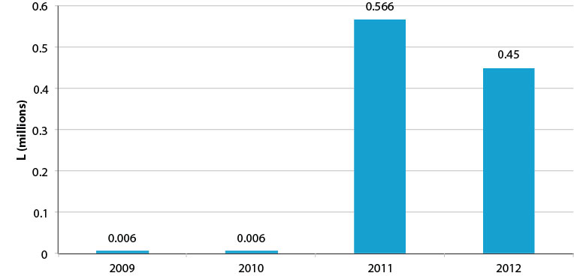

Source: Aither, based on unpublished data provided by the Department of the Environment.

Note: Derived from hazardous waste transport permit data, and may not include all volumes of used oil imports.

The main concern with importation and processing of used oil in Australia is the financial implication for the PSO Scheme. Other considerations include international aid, commercial matters (imports can be useful for re-refiners to secure marginal feedstock), and environmental (as imports could potentially oversupply and result in gluts in the local used oil markets, thereby impacting on domestic collections). There is also the issue that Australia could end up with more output product to sell in what may already be difficult end use market conditions and a net increase in used oil despite not having used the original oil from which it was derived. Australia is also effectively providing an environmental service or benefit to other countries.

Because the used oil imports do not pay the levy of 5.449 cpl, they do not contribute to the pool of funds available for benefit payouts. But should the oil be processed in Australia then Scheme claims will be made when the output is sold. If the oil is processed into Category 1 products, then the financial liability to the Scheme is potentially high. If the Scheme is running in deficit, Australian taxpayers will effectively subsidise environmental improvements in foreign countries. This may be an entirely justifiable goal on an international aid basis, but is likely to be better achieved through other arrangements – such as formal aid commitments and agreements– that don’t push the Scheme into or towards deficit.

Given the low volumes involved, imports may not be a material risk in the immediate term – but any further increase is likely to negatively impact on the financial situation of the Scheme. In principle, there is no reason to prevent re-refiners or other Australian operators from obtaining and treating used oil from foreign countries; but this should probably occur entirely outside of the Scheme given that Australia does not derive environmental benefits from the processing of the oil (and to the extent imports substitute for domestic inputs into re-refining, could actually harm environmental outcomes for Australia). This last risk is likely to be mitigated by ensuring no Scheme benefit payments can be made for the processing of any imported used oil – if it is still commercially attractive for re-refiners to import and process imported oil outside of the Scheme, then they should be allowed to do so, but the existence of benefits for domestic volumes should mean they will be prioritised by re-refiners. International aid issues could be dealt with through the appropriate government agencies who may wish to contribute to the costs foreign countries face in exporting their used oil (but this should not be subsidised to such a level that it puts imported oil at a competitive advantage over domestic volumes of used oil).

An alternative approach to imports that may be relatively administratively straightforward might involve imposing a levy on imports of used oils equivalent to the maximum Scheme benefit on the product. For example, if 1000 l of used oil was imported and processed as a Category 1 output (approximately 600 l at 50 cpl) then the customs tariff could be set at 30 cpl. The re-refiner may still choose to import and process the used oils for commercial reasons, but the financial impact on the Scheme should be neutral.

|  |
| --- |
| The Waigani Convention  While primarily focused on banning both the importation into Forum Island Countries of hazardous wastes and controlling the movement of hazardous wastes within the South Pacific Region, the Waigani convention also enables Australia to receive hazardous wastes (such as used oil) from nations in the South Pacific Region that are not Party to the Basel Convention. This imported used oil can then be re-refined or re-used and be sold domestically or exported – provided it complies with the *Hazardous Waste (Regulation of Exports and Imports) Act 1989* and Australia’s obligations under the Basel Convention. There are questions associated with the financial and environmental sustainability of the PSO Scheme regarding the practice of importation under the Waigani Convention of used oils into Australia from nations in the Forum Island Countries |

|  |
| --- |
| Consultations  The payment of benefits for the sale of Category 1 used oil manufactured from imported waste oil was an area of disagreement for respondents. Some respondents believed the PSO Scheme benefits should not be paid for sales of oil manufactured from imported used oil in order to ensure that benefit payments are delivered to Australian-based facilities.  These respondents noted that although the importation of used oil represents a very small fraction of total oil currently recycled in Australia, anecdotal evidence suggests that such oil imports may increase significantly in coming years (particularly from the Pacific Islands). The rationale for excluding the Scheme benefits from sales of product derived from imported waste oil was that no levy is collected on the imported oil to contribute to the Scheme and that it provides no environmental benefit to Australia.  However, other respondents were of the position that the Scheme benefits assist poorer nations in achieving environmental outcomes and therefore should continue to apply to imported waste oil. In this sense, the importation of waste oil could be viewed as an environmental service or a type of overseas aid. |

|  |
| --- |
| Finding 18 Australia may compromise the financial and environmental sustainability of the PSO Scheme if it continues to make benefit payments available for the processing of used oil imported from foreign countries – especially if the volume increases significantly. |

|  |
| --- |
| Finding 19 Assistance to less affluent foreign countries in managing their used oil should be dealt with deliberately through the proper international aid channels rather than inadvertently through the PSO Scheme. |

|  |
| --- |
| Finding 20 Commercial arrangements for imported used oil processing should not be prevented from occurring, provided PSO Scheme benefits are not claimed as part of such transactions. Alternatively, a levy could be imposed on used oils equivalent to the maximum Scheme benefit on the product. |

5.2.3 Collection infrastructure

In some areas, collection infrastructure maintenance and renewal has been suggested to be a problem. Collection infrastructure is important to the ongoing success of the PSO Scheme, especially in areas where commercial collections do not occur, or occur less intensely or frequently, such as in regional and remote areas. For the same reason, the costs of maintaining such infrastructure may be a problem where the rate payer base revenue is not sufficient to maintain collection infrastructure effectively. In urban and densely populated areas, municipal collections infrastructure can be readily financed due to the ratepayer base. Furthermore, it is often less necessary, as there is little DIY or Small-to-medium Enterprise (SME) need for used oil disposal at municipal sites – most oil collections are undertaken commercially from service stations and mechanics or directly from SMEs. Despite this, in regional areas, collections are less frequent or not occurring at all; this comes at a significant cost to councils and users due to distance to collection sites. As a result, infrastructure is apparently in poor condition.

This issue is likely to warrant further consideration as to its extent and materiality. In the event that collections infrastructure is in decline and underfunded, it should be addressed, as it forms a key component in the Scheme, and may be particularly critical in regional areas to avoid improper disposal. It is important to note in regard to Figure 20, that there is an absence of any mechanisms under the Scheme to support collection directly – all the Scheme payments are on a cpl basis to particular end uses, in the expectation that some of this might trickle down to collection facilities, which appears to not always be the case.

Consideration of these issues might investigate how maintenance and renewals of oil collection infrastructure can be provided for in the long term, either by the Scheme itself (where such infrastructure is important to the overall operation of the Scheme) or through other means (such as targeted or one-off assistance where there is pressing need).

|  |
| --- |
| Consultations  Some government respondents were of the view that the PSO Scheme is inequitable, particularly for local governments that are required to cover the costs of used oil collection and receive no benefit for doing so. This issue appears to be particularly prevalent in Western Australia where used oil recycling companies introduced a collection fee on local governments in 2007.  Stakeholders in Western Australia noted that local council depots or tanks are requiring renewals and that some depots are being used to dump commercial quantities of used oil. They also note that local councils are asking for a handling charge to be paid to them.  Some stakeholders noted that the transitional assistance provided to local councils to establish collection depots had been very effective, whilst others claimed that local councils had been ‘abandoned’ and called for ongoing funding to assist in the maintenance and renewal of the depots established. The Western Australia Local Government Association and Zero Waste South Australia suggested greater shared responsibility amongst stakeholders across the whole oil product life-cycle. |

|  |
| --- |
| Finding 21  Public collections infrastructure is important to the proper functioning of the PSO Scheme and is likely to be especially critical in regional and remote areas. Infrastructure requires maintenance and renewal and these needs to be more effectively accounted for under the Scheme or via other means to ensure environmental benefits continue to be achieved. |

5.2.4 PSO Scheme benefits for fuel oil

Research and consultation for the review suggests some small scale collectors are, or have been, delivering used oil to energy customers (burners) without claiming Category 6 PSO Scheme benefits, largely due to sharply lower costs of used oil compared to virgin fuel oils, in addition to strong demand. This suggests incentives may not be required to drive oil collection for these end uses – noting some state policies may be working in opposition to this, such as the Western Australian gas policy.

In addition, energy uses for used oil are terminal, and the environmental merits of this end use may not be sufficient to warrant benefits; especially as they were arguably put in place to drive higher collection rates and finance collection systems. Furthermore, paying benefits on low grade fuel oils is arguably working at odds to the carbon policy which is seeking to incentivise shifts to renewable and other alternative sources of energy.

Due to the ATO Decision Impact Statement (in light of the AAT’s decision on the *RRR v. ATO (2013)* case), a large volume of Category 6 claims are likely to cease from April 2013. This effectively means that benefits will no longer be paid for Category 6 products which are not manufactured or produced.[11]

|  |
| --- |
| Consultations  Consultation meetings identified the movement of non-trivial quantities of used oil from collectors straight to energy users without registering for the PSO Scheme. Therefore, many stakeholders believed that fuel oil is such a valuable commodity in some places that it does not require the Category 6 benefits.  In addition, some respondents supported the removal of benefits for low grade fuel oil as it typically contains relatively high water content and therefore the Scheme is effectively funding the sale of water. However, some argued that the removal of benefits for low grade fuel oil would reduce the viability of used oil collections for recycling. |

|  |
| --- |
| Finding 22  Reducing or eliminating benefit payments for low grade fuel oil has the potential to marginally improve the budget position of the PSO Scheme without directly impacting on collections. Changes in energy recovery and other used oil end use markets are likely to have a greater influence in this regard. Payment of benefits to fuels is also potentially working in opposition to the carbon policy. |

5.2.5 Nature and specification of benefit categories

The current benefit categories for the PSO Scheme are in part process defined and in part output defined. In some cases where they are output defined, definitions are not sufficiently precise, or are out of date or no longer relevant. For some categories the definitions have been suggested to be inadequate, create confusion and uncertainty, and contribute to suspicion regarding the veracity of some claims being made under the Scheme. Numerous industry participants suggested that in the event that greater auditing or compliance was undertaken, the current definitions would prove problematic. While the ATO has made efforts to clarify category definitions (including through its Product Benefits Grant Ruling 2012/1[12]) it is limited by the underlying nature of the categories.

Process based specifications are generally less efficient because they encourage use of particular processes rather than allowing for technological improvement and innovation which is more likely to occur when specifying minimum output characteristics. This is also evidenced by the fact that some operators under the Scheme have had to seek special consideration for the processes they undertake, some of which are new and innovative and may not have been previously anticipated under the Scheme. Process based specifications have the capacity to stifle industry and prevent further improvement.

The current categories are also suggested to be not sufficiently based on robust technical standards to ensure or incentivise more widely marketable products. This is an important issue for the development of new markets or wider acceptance of re-refined products; the oil industry generally works off internationally accepted standards, which are not currently reflected in the benefit categories.

There is also room for rationalisation of benefit categories. Categories 3 and 4 are almost never claimed (in part due to specification), and due to *RRR v. ATO (2013)*, very low volumes of Category 6 claims might be expected in the future. Elimination of benefits for all Category 6 claims would enable some rationalisation.

Governments are unlikely to be best positioned to decide on technical specifications or definitions of categories, so it would be wise to seek industry advice on how to specify benefit categories at important technical thresholds, but also do so in such a way that doesn’t stifle innovation (such as output specifications for viscosity or sulphur content). This should obviously be undertaken in the context of clear objectives about what different benefit levels are trying to incentivise and achieve in terms of outcomes. For example, Category 1 benefits should arguably be about ensuring the availability of recycled lubricating base oils of the same (or better) standard than virgin base oils, rather than the creation or support of a re-refining industry.

|  |
| --- |
| Consultations  Most respondents raised concerns that the current categories are too broadly grouped and subjective and therefore difficult to audit against. Companies from the used oil re-refining industry were of the position that more robust specifications should be tied to each category to enable a clearer definition of the products claimed in each category. These respondents proposed the establishment of a minimum quality level to reach the Category 1 benefits.  Some respondents also recommended the tightening of the definition of waste oil to ensure that non-specification lubricant is not being included. They noted that there is a fine line between the definitions of what a waste is as opposed to what constitutes a product.  Respondents also noted the lack of specifications for Category 5 and 6 and that it is necessary to have a basic specification for these categories as some more sophisticated burning systems require a certain standard of burning fuel. They also noted that the category for diesel fuel is no longer used as the recent Australian standard for diesel fuel has rendered it irrelevant. |

|  |
| --- |
| Finding 23  There is an obvious need to rationalise benefit categories and improve the way they are specified. Benefit categories should not inhibit technological improvement and innovation and should be minimum technical specifications for each output rather than the process. Industry should play a role in advising on any changes to categories. |

5.2.6 Data and information

This review, as was the case for previous reviews, has faced data and information limitations. Such limitations make it difficult to form robust conclusions about the operation of the PSO Scheme and the ways in which it should be improved in the future. While some of these relate to confidentiality issues, others may be more material, such as the absence of more robust data about the true extent of collections of used oil in Australia. In addition, it may be better to have a system that makes continuous fine-tuning adjustments, rather than one which relies on imperfect information and four yearly external reviews which seem to have generated the expectation of a ‘yes/no’ answer.

There is a particular challenge in relation to knowledge about collection, processing and use of used oils outside of the Scheme, which may be an increasing problem as a result of fewer Category 6 benefits claims in the future. There is also an absence of data about the true extent of stockpiles or other used oil in regional and remote areas that is not being collected, and regarding exports of used oil. We also understand that there are volume reconciliation issues between datasets, including against National Environment Protection Measures (NEPMs) and Basel Convention derived data.

|  |
| --- |
| Consultations  There was a general consensus that the level of data availability and accuracy was of concern. While the datasets collected by the Department of the Environment and the ATO were generally believed to be accurate by stakeholders (such as data on volume of lubricants sold), there were concerns about the collection volumes being approximated from this data.  Many respondents from the used oil refining industry expressed concerns that significant volumes of used oil were not being captured in the current data sets.  While the consultation meetings provided interesting anecdotal evidence, systematic rigorous analysis of the PSO Scheme will continue to be challenged by issues with data and information. |

|  |
| --- |
| Finding 24  The absence of robust data and information complicates analysis of the PSO Scheme’s performance over time. The true volume of used oil collected, both within and external to the Scheme, and the existence of stockpiles or uncollected volumes of used oil in regional and remote areas remain unknown and are imprecisely estimated. |

5.2.7 Monitoring, compliance and enforcement

Given the level of expenditure paid out to PSO Scheme claimants in most years, and suggestions of potentially false claims by stakeholders, it may be useful to consider what additional monitoring, auditing, compliance, or enforcement activities could be undertaken. Submissions to the review suggested that some stakeholders believe too little effort and funding has been applied to monitoring and enforcement, and that this may have contributed to financial challenges due to false claims.

It should be noted that the ATO has a risk management and compliance regime in place to provide assurance around scheme payments. For Category 1, claimants must provide the ATO with test results that demonstrate production meets required standards. The PSO legislation and regulations capture this requirement, including independent collection and custody control of samples. The ATO has previously reviewed the claims and processes of Category 1 claimants to provide assurance and has suspended or adjusted Category 1 benefits in some cases. In addition, the ATO targets higher risk claims based on risk profiling and acts on industry intelligence. Even though the scheme has a small number of claimants, over the last four years the ATO has advised that it has undertaken reviews or audits of nine claimants, which in some cases have resulted in adjustments due to:

• claims of category 5 benefits instead of category 6 benefits

• failure to provide test results to support a Category 1 claim or failure to provide test results in the required time period

• failure to provide proof that the entity was undertaking any process of manufacture of recycled oil

• claims for benefits based on the used oil received at the premises instead of the volume of recycled oil sold or consumed.

However, anecdotal information provided as part of the review suggests there may be areas where enhanced compliance and enforcement activities could close potential loopholes or prevent behaviour that may be having negative financial consequences for the Scheme.

Some have suggested there have been false claims for processing of Category 6 products when they are being on sold for a subsequent higher category claim. Others have suggested that product is being claimed as Category 1 when the output allegedly does not meet the specification. There have been suggestions that some Category 1 products are being sold for terminal uses, contrary to the intent (but not the letter) of the regulations. In aggregate these claims could have serious financial implications for the Scheme.

It would be low cost, and likely high return, to implement spot checks, independent testing, auditing, or similar measures, to ensure that participants in the Scheme are operating within the Scheme’s regulations and policy intent. The nature and specification of benefit categories discussed above would need to be undertaken in concert with this.

|  |
| --- |
| Consultations  Most respondents agreed that the PSO Scheme could be more actively policed through the auditing of claimants, particularly claims for Category 1. Respondents suggested substantial claiming of Category 1 benefits illegitimately existed and that some benefits are being claimed twice (Category 5 or 6 benefits are being claimed before on-selling for a subsequent Category 1 claim).  Some respondents stated that additional scrutiny is required to ensure that Category 1 claimants have the technical capability to manufacture oil to the category standard, Category 6 claims do not include water content and that exported products have been manufactured. They suggested some basic criteria for guarding against misuse such as ‘does the product meet the specification, where has it come from and has a PSO benefit already been claimed?’  Some respondents from the oil re-refining industry proposed the establishment of an organisation to provide regular advice to the Minister and oversight of the Scheme. |

|  |
| --- |
| Finding 25  Monitoring, compliance and enforcement activities need to be strengthened to ensure the integrity of the PSO Scheme. There are likely to be high returns for low levels of investment from doing so. |

## 5.3 Financial

The current financial position of the PSO Scheme is likely a function of many aspects of the above challenges. However, it is mostly a result of the high incentives (benefit payments) paid to re-refining combined with the subsequent growth in re-refining capacity due to the financially attractive incentives. As is discussed further below, the current situation is not financially sustainable, nor is it compatible with the principles underpinning product stewardship and the Scheme.

5.3.1 Financial sustainability of the PSO Scheme

The PSO Scheme is currently operating at a deficit of approximately $5 million per annum. In some senses this is reflective of the Scheme being ‘too successful’ in that the volume of products being sold that attract Scheme benefits is higher than can be sustained by revenue generated by the current levy. Growth in re-refining capacity that is soon to come on-line is likely to substantially increase the deficit in the future, and it is neither sustainable nor desirable for the Australian public to subsidise the Scheme in this way. An outcome such as this is against the principles of product stewardship – in that that those transacting do not bear the full costs of the transaction. The following figure highlights the annual budget position of the Scheme over the period it has been operating. The Scheme has been running in annual deficit since 2008-09, which coincides with an increase in re-refining capacity. In cumulative terms, the Scheme is still notionally in surplus – but the Scheme operates on the basis of consolidated revenue rather than a special hypothecated account.

### Figure 22. Annual levy, benefits and surplus/deficit

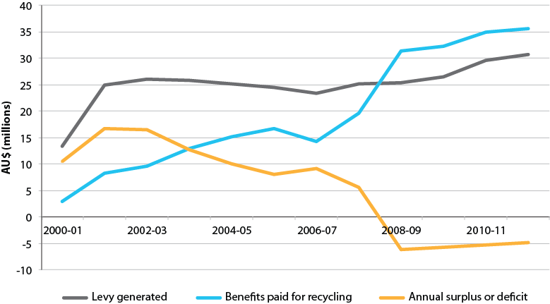

Source: Aither, based on the Department of the Environment (2013).

Note: 2000-01 only includes six months data.

Because there was no re-refining for the first years of the PSO Scheme, and most claims were for Category 6 low grade fuel, the levy was substantially in excess of benefit payments for the first five to six years.

### Figure 23. Annual and notional cumulative surplus, and transitional assistance

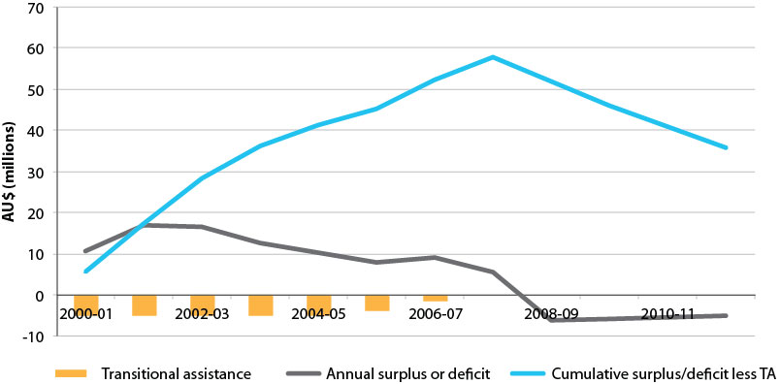

Source: Aither, based on the Department of the Environment (2013).

Note: 2000-01 only includes six months data.

The PSO Scheme levy

Consultations suggested many industry participants believe the best way to address the financial situation of the PSO Scheme is to raise the levy rate. Many have cited the price elasticity of demand for oil and the very small levy cost as a proportion relative to the total cost of oil.

In principle, we do not believe increasing the levy is the first best approach despite the fact that the price elasticity of demand for oil, and the absolute amount of the levy, is such that marginal increases would likely go unnoticed. In general terms, the industry should be moving towards lesser, not greater, dependence on the levy, consistent with used oil needing to be viewed as a commercially valuable resource. It appears unlikely that the original intent of the Scheme was to indefinitely incentivise re-refining capacity. Raising the levy might institutionalise entitlement and reduce pressure for efficiency gains and innovation, as well as leading to potential future structural adjustment risks. While raising the levy should be a last rather than first resort, there may be circumstances in which it is the only viable option.

Benefit amounts

As was discussed in relation to environmental benefits associated with re-refining, it is not particularly clear what the basis is, or was, for the current benefit payment amounts. Nor is it clear that they accurately reflect the achievement of environmental benefits or potential achievements in relation to other objectives.

The current Category 1 benefit rate has been effective in stimulating significant growth in re-refining capacity – arguably too effectively given that the current, and soon to increase, re-refining capacity is financially unsustainable at the current rate. Despite this, Category 1 represents the vast majority of expenditure while representing a small volume-share either by input collection demand, or finished product (as shown below in Figure 24 below).

### Figure 24. Volume of used oil input by use and value of PSO Scheme benefits paid

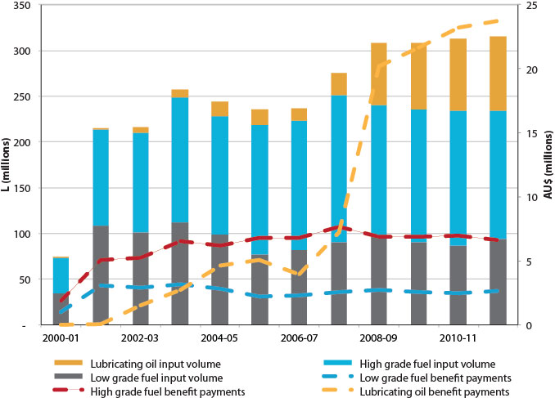

Source: Aither, based on the Department of the Environment (2013).

Note: 2000-01 only includes six months data.

The benefit amounts also relate to the problem that the PSO Scheme lacks a definition of what success looks like. Given re-refiners desire for levy increases, and in some cases benefit increases, a legitimate question to ask might be at what level such increases should stop? When the levy is sufficiently high to support five re-refineries? Or 10 re-refineries? And of what relevance is this number to the total volume of oil sold in the Australian economy, and hence the amount of used oil that actually needs to be collected and processed or re-used?

A scenario of increasing levy amounts or benefit payments is likely to result in large private benefits, but it is not clear this is either appropriate or necessary to achieve the environmental objects sought by the Act.

|  |
| --- |
| Consultations  There was a general consensus amongst re-refiners that either, or both, the levy should be increased or indexation of the levy re-introduced. It was suggested that an increase to the levy would generally pass through the industry without being noticed by consumers. The suggested levies ranged between 8 cpl and 11 cpl.  There was also a general consensus amongst re-refining stakeholders that the Category 1 benefits should be retained to secure continued investment in re-refining. Respondents from the used oil re-refining industry suggested that the commercial viability of their re-refineries is dependent on the continuation of Category 1 benefits from the PSO Scheme.  However, there was some disagreement amongst respondents regarding whether the Scheme should be allowed to run at a deficit. Some stakeholders were of the position that the Scheme should not be able to operate at a deficit while others stated that the societal (for example employment gains) and environmental benefits (such as reduced dumping of used oil) of the Scheme should be recognised as deserving of public funding. |

|  |
| --- |
| Finding 26  Changes to the levy or the benefit rates are required if the PSO Scheme is to return to and maintain a budget neutral position. Even though some public benefits are provided by the Scheme, a budget neutral position is necessary and desirable given the principles upon which the Scheme was founded. |

|  |
| --- |
| Finding 27  Increasing the levy rate is unlikely to represent either a sustainable or a desirable approach to ensuring the financial viability of the PSO Scheme. Efficiency gains within the Scheme are likely to be possible without jeopardising the environmental performance of the Scheme, and are therefore more desirable. |

## 5.4 Summary

Numerous challenges associated with the design and implementation of the PSO Scheme has led to a financial challenge for the Scheme that is only set to increase with the addition of new re-refining capacity. Because the ultimate end goals of the Scheme have not been clearly articulated, if more re-refineries are brought into operation or existing capacity is expanded, the financial deficit will become ever greater unless benefits are reduced or the levy is increased. Some other challenges may not be as material to the future effectiveness of the Scheme, but what is clear is that the Scheme is not viable in the long term unless a number of material challenges are addressed now and dealt with effectively into the future.

# 6 Assessment

This section presents an explicit assessment of the PSO Scheme based on the achievements and challenges noted in the preceding two sections. The assessment criteria of appropriateness, effectiveness, efficiency and sustainability, are set by the terms of reference for this independent review.

## 6.1 Appropriateness

Noting that the PSO Scheme has been operating relatively unchanged since 2001, the review is to examine whether the existing product stewardship model is still the most appropriate way to manage used oil in Australia. In particular, the review was asked to;

*Consider the applicability to Australia of used oil management practices in comparable jurisdictions.*

Many other member nations of the Organisation for Economic Co-operation and Development have oil stewardship Schemes very similar to Australia’s. However, unlike Australia, some have Extended Producer Responsibility (EPR) arrangements for oil (akin to Australia’s *Product Stewardship Act 2011*) which seem to give very comparable results – albeit with different strengths and weaknesses (see Appendix C). Further discussion of the feasibility of Australia adopting an EPR type Scheme is provided in Section 7 and Appendix E.

*Consider the relative environmental merits of alternative end uses of used oil, including those supported by the PSO Scheme as well as other potential options (for example export for processing overseas).*[13]

The relative environmental merits of alternative end uses of used oil have been the subject of much research and debate. While conclusions are not uniform, the general proposition is that most of the environmental benefit of oil stewardship is in the prevention of improper disposal with the differences between subsequent uses being minor in comparison.

In the European Union, recycling is explicitly preferred over once-off (terminal) single uses such as burning, provided that it is feasible and cost-effective, or requires only modest amounts of additional support. A specific statutory preference for recycling over terminal uses is unwarranted where it is very expensive to achieve, or where re-refining is likely to be rendered unviable by external factors.

*Examine the desirability and feasibility of developing new product stewardship arrangements for used oil, including a Scheme under the provisions of the Product Stewardship Act 2011. If significant changes to current arrangements are proposed then the transition to any new product stewardship arrangements is to be considered.*

We have considered changes to the existing PSO Scheme that could overcome the challenges and flaws identified. As explored further in Section 7 and Appendix E, there is at present little evidence that an EPR *Product Stewardship Act 2011* type Scheme would give better outcomes or at lower costs when compared to a revised PSO Scheme. Despite this lack of evidence, further investigation into the design and feasibility of possible oil arrangements under the *Product Stewardship Act 2011* would be prudent (see Section 7 and Appendix E).

## 6.2 Effectiveness and efficiency

The review was required to examine the operation of the Act and relevant provisions of customs and excise legislation and the extent to which the objects of the Act have been achieved. This examination was to include an assessment of:

*The effectiveness and efficiency of current administrative arrangements for the Scheme.*

Enhanced enforcement and auditing activities are necessary to ensure there are no unwarranted claims for PSO Scheme benefits. Changes to category definitions, including moving to output specifications and technical standards rather than process definitions would help considerably in this respect. Furthermore, there is room for improvement regarding alignment between state and Commonwealth policies as well as the need for a clearer definition of what the Scheme is aiming for in terms of long term success.

*The effectiveness and efficiency of existing benefit categories and rates; including whether these are providing incentives for industry to respond appropriately in the promotion of sustainable environmental outcomes.*

It is clear from data that the amount of lubricating oils produced from used oil has increased substantially since the year 2007-08 as a result of generous benefit payments. However, the specific ratios of benefit rates under the PSO Scheme could not be substantiated based on existing environmental literature. Questions have also been raised as to whether making benefit payments available for imported used oil, compromises the sustainability of the Scheme.

The magnitude of current Category 1 benefit payments is likely to be unwarranted and Category 6 benefit payments are likely to be unnecessary. In addition, tighter technical specifications on the eligibility of products under each category of benefit need to be established, and redistribution of some benefit payments towards investment in collection infrastructure and direct incentives for collection is likely to be required.

*Any unintended consequences of existing benefit categories and rates.*

As discussed above, the existing benefit categories need improved definitions for a number of reasons. Given the design of the PSO Scheme and the levy-benefit arrangements, and the addition of new re-refining capacity, the Scheme is unsustainable – this may not have been the intention of the original designers of the Scheme or been anticipated but it is clearly now a problem. In addition, the recent *RRR v. ATO (2013)* decision regarding Category 6 is unlikely to have been anticipated or intended, however, the interaction with fuel excise and the carbon price may not represent a material problem for the Scheme in the future. Furthermore, the financial and environmental sustainability of the Scheme may be compromised by unintended impacts associated with the importation of used oil or any changes that restrict the export of used oil or restrict sales for particular end uses.

*The effectiveness and efficiency of the existing levy-benefit arrangements in meeting the objects of the Act.*

The PSO Scheme has stimulated more collection and more re-refining to base oil, and in doing so stimulated a new industry that relies on used oil as a raw material, thereby changing used oil from a waste disposal problem to a commercial feedstock – except in Western Australia and Tasmania. The Scheme has driven high levels of collection – with the primary aim having been to keep used oil out of the environment. It has done this at very low cost to consumers, industry or government. Despite these achievements, fundamental changes regarding benefit and levy amounts and definitions are required and the redistribution of some benefit payments towards investment in collection infrastructure and incentivising collection directly needs to be considered.

*The relative effectiveness and efficiency of the Scheme in different parts of the country, with particular reference to regions, such as Western Australia and rural and remote areas.*

Western Australia, parts of South Australia, Tasmania and the Northern Territory are not experiencing the same level of collections as other parts of the country, or simply face higher costs for collections. Further effort to improve collection infrastructure and incentives is likely to be required to improve this situation, and as noted above, consideration needs to be given to redistributing benefits towards collection infrastructure. We do not believe increasing benefit payment incentives will effectively address remote area issues as they are likely to add ‘heat’ to already overstimulated markets – at least in the Eastern Seaboard – and may not sufficiently incentivise re-refining or the conditions required for other end use markets (such as export facilities in north-western Australia).

*Any mechanisms that would increase the effectiveness and efficiency of the Scheme in the above-mentioned areas.*

As noted above, more could be done to investigate options for increasing the PSO Scheme’s effectiveness and efficiency in these remote areas. Greater industry involvement in the ongoing management of the Scheme, as well as close involvement of state and local governments, may assist in this regard – other options have been outlined in Section 5. In general, improved access to end use markets is likely to assist regional and remote area collections. Improvements in data on used oil collections would also be beneficial, as would further investigation into the extent of uncollected oil and the nature and extent of economic barriers to greater collections in remote areas.

*The effectiveness and efficiency of the used oil collection and recycling infrastructure and systems which have developed in response to the incentives provided by the PSO Scheme, noting any regional issues.*

There appears to be more than sufficient private infrastructure in place that has resulted from the incentives provided by the PSO Scheme. Observed data on household behaviour appears to suggest public infrastructure is being utilised and playing an important role, but collection infrastructure is failing in some remote and regional areas due to insufficient investment in asset maintenance and renewal. We have also found that the capacity to export used oil under the Scheme is important in driving pull through of collections.

*The interaction of the Act, including activities encouraged by the incentives it provides, with other Commonwealth policies and legislation such as the Hazardous Waste (Regulation of Exports and Imports) Act 1989, and State and Territory policies and legislation.*

As discussed in Section 5, there are a number of areas of interaction with Commonwealth and state and territory policies, legislation and regulation. Some of these are material to the successful functioning of the PSO Scheme and there is room to improve alignment and coordination between state and local government policies or activities and the Scheme. In addition, the *Hazardous Waste (Regulation of Exports and Imports) Act 1989* has the potential to restrict access to international markets for used oil. Other national policies (such as carbon policies) do interact with the functioning of the Scheme but their impacts on Scheme outcomes are unlikely to be as material as other exogenous factors.

*Current levels of imports of used oil for recycling in Australia and exports of recycled oil and their impact on the long term viability of the PSO Scheme.*

The legislation that gave effect to the PSO Scheme was silent on the matter of trade in used oils. However, as discussed in Section 5, we are of the view that imports and exports are now a material issue for the Scheme and need to be dealt with.

Ensuring imports are processed completely outside the Scheme, or are levied at a rate equal to the maximum benefit they might receive, are possible ways of dealing with this issue. Exports are important to ensuring the availability of end use markets and driving pull through demand for used oil, which ensures that collections continue and expand. We would suggest that benefit payments should be payable against used oil derived products regardless of whether they are destined for domestic or foreign consumption – subject to appropriate regulations regarding their safe transport (rather than the domestic environmental or other policies of foreign countries).

*The availability of data to evaluate the Scheme’s effectiveness.*

As has been noted in Section 5, the availability of robust data regarding collections of used oil is still a problem and is likely to continue to be in the future, especially as a result of *RRR v. ATO (2013)*, that will effectively result in less data being collected about collections for the low grade fuel market. Improvements are required to the way in which data about the used oil industry is collected to ensure the ability to effectively fine-tune the PSO Scheme over time. Suggestions on how to deal with this are provided in Section 8.

## 6.3 Sustainability

The review was required to assess the financial and environmental sustainability of the current PSO Scheme. In particular the review was to:

*Estimate the likely future costs of the current Scheme and the impacts of expected increases in total benefit outlays and suggest ways to ensure the financial sustainability of the Scheme.*

These matters are dealt with explicitly and in detail in Section 7 and Section 8. Increased re-refining capacity is expected to have significant negative financial implications for the PSO Scheme. The main policy levers available to the Scheme in rectifying this are increasing the levy or reducing benefit rates for some or all benefit categories.

*Assess current and future markets for recycled oil and how these may evolve in response to factors such as changes in market demand and the introduction of carbon pricing.*

Carbon policy has the potential to incentivise fuel switching away from fuels such as those produced under the PSO Scheme. There is expected to be general reductions in the market for low grade fuel oils in the future, regardless of carbon policy. It is also the case that re-refined lubricating markets are limited by factors outside the control of the re-refiners and government, such as acceptability of re-refined oils by OEMs, which places the Scheme’s achievements at risk. Furthermore, questions regarding the future of the import and export markets under the Scheme may be creating a level of uncertainty about future access to markets.

*Assess risks to the continued delivery of the Scheme’s environmental outcomes of high rates of used oil collection, recycling and re-use.*

The PSO Scheme focuses its efforts primarily on the re-refining end use market – the conditions for which are dictated by global and exogenous factors. This potentially places the Scheme outcomes at risk. The availability of export markets for used oil is also important to Scheme outcomes, as if collectors or processors cannot sell collected used oil, collections may diminish or cease altogether. Such issues are a function of the Scheme focusing entirely on end use markets (rather than collection directly, or a more balanced approach between the two), which potentially creates unnecessary risks to the main environmental benefits of the Scheme. This is especially the case in rural and remote areas, where environmental benefits are achieved through the effective collection of used oils and avoidance of improper disposal, rather than in determining the subsequent end use of the used oil.

## 6.4 Summary

The PSO Scheme has been appropriate and effective in achieving its stated objectives, including those stated in the Act. However, owing to elements of its design, the Scheme is not financially sustainable, and unless revised, the Scheme may place at risk the significant environmental benefits it has achieved to date. Given the fact that the Scheme has no clear definition of success, it is important to now consider what success for Scheme should look like, and consider the Scheme’s objectives in light of the fact that much of what was set out to be achieved, now has been.

# Part C – Options and recommendations

# 7 Options

The review considered and analysed the feasibility of four main options for the future of the Product Stewardship for Oil Scheme (PSO Scheme), in addition to considering the role that supporting or complementary policies, programs or other activities might play. These options were considered in the context of ensuring the achievements made by the Scheme are not lost but that the future approach is financially sustainable and achieves the intended environmental and product stewardship outcomes.

The four main options considered were:

a) continue the Scheme as it currently stands, without modification

b) cease the Scheme altogether

c) transition the Scheme to an alternative stewardship arrangement under the *Product Stewardship 2011 Act*

d) continue the Scheme with modifications, with detailed and extensive modelling used to explore four scenarios for different modifications.

The relative merits of these options are further explored below.

## 7.1 Continue the PSO Scheme without modification

The review has revealed a sufficiently broad and material range of issues that retaining the PSO Scheme as it currently stands is not a viable option – it is wholly financial unsustainable and is likely to result in significant efficiency losses while not improving environmental or other outcomes in proportion with the increase in costs. The *status quo* will also see the Australian public increasingly subsidise the Scheme’s operation.

Product stewardship arrangements are intended to internalise externalities and ensure those involved in a transaction meet any costs imposed on others. As it currently stands, the Scheme does not achieve this due to an annual operating deficit (setting aside consideration of its cumulative position), which means that the Australian public are subsidising the Scheme. While the current annual deficit of approximately $5 million may be justified on the basis of the environmental benefits the Scheme provides to society, the deficit will increase significantly and progressively with increased re-refining capacity that will be introduced from 2013-14. In the absence of any modification, the 50 cents per litre (cpl) benefit payment is such that it may attract further re-refining capacity in the future, which would push the Scheme further into deficit again.

This challenge associated with the *status quo* option is supported by a simplified model of the current levy-benefit arrangements. In this model, only Category 1 re-refining exists (all other categories are ignored), 5.449 cpl is levied on new and recycled oil sales, and 50 cpl is paid to Category 1, as is currently the case. In this situation, with gradual increases in the proportion of total oil re-refined, the Scheme will go into deficit once nearly eleven per cent of the total volume of oil sold is produced and sold as a Category 1 product (i.e. re-refined lubricating oil output). This is illustrated in the figure below, where 10 megalitres (ML) of oil is sold in the first year, and eight per cent of that volume is sold as re-refined product. The Scheme falls into deficit once more than approximately 10.8 per cent of the total volume of oil sold is subsequently sold as Category 1 re-refined product (or approximately eighteen per cent in terms of used oil input requirements).

### Figure 25. Simple model of current PSO scheme levy-benefit arrangement

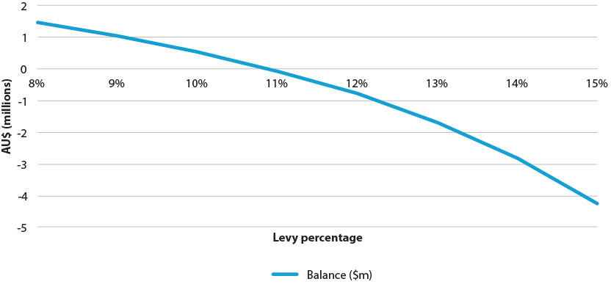

Source: Aither.

|  |
| --- |
| Maximum potential re-refining under budget neutrality  As noted in Section 7.1 and Figure 25, the maximum amount of Category 1 output that is financially sustainable under the current levy-benefit arrangement of a 5.449 cpl levy and 50 cpl benefit rate is approximately eleven per cent of total oil sold. Or in terms of collections (input to production) about eighteen per cent of the total volume sold.  This raises the question of how low the Category 1 benefit would need to be in order to be financially sustainable. If we consider a simplified model where 1 Million litres of oil is sold in any given year and the PSO Scheme levy is paid on it, where all used oil collected is for re-refining and that potentially recoverable oil is sixty per cent (the generation factor), and where there is a technologically-fixed recovery factor of 60 per cent base lube oil for every litre of raw sump oil going into a re-refinery, then the maximum benefit rate payable that will ensure budget neutrality is 15.15 cpl.  If we consider possible combinations, using the same assumptions described above, if the levy was raised to 7.2 cpl, and Category 1 benefits reduced to 20 cpl, the Scheme would be budget neutral. Assuming full collection of all used oil and maximum re-refining capacity utilisation, under this scenario approximately thirty-six per cent of total oil sold would be the maximum volume of finished Category 1 output that could be financially sustained. |

Further modelling has been undertaken that incorporates the full spectrum of categories and benefit payments, and accounts for a range of other factors such as known growth in re-refining capacity, expected demand for virgin and recycled products, and other factors. Such modelling also demonstrates the financial unsustainability of the current arrangements.

The following figure is based on observed historical data and future projections for oil sales, collections, and production of recycled oil products. Due to cessation of an expected large volume of Category 6 claims after 2012-13, the annual deficit may have been expected to improve slightly, but this is offset by increased re-refining capacity and associated increases in Category 1 claims. As discussed in Section 5, due to low volumes of recycling and amounts of Category 1 claims in the Scheme’s early years, the Scheme currently would have a notional cumulative surplus – but as the Scheme does not operate under a special account, and any such surplus is not available for use. If we ‘reset’ any notional surplus or deficit to zero in the year 2012-13, under the *status quo* scenario (Scenario 1) the Scheme will not achieve an annual zero balance or a surplus in any year, and will be in cumulative deficit in all years as a result.[14] If no more re-refining capacity is added to the system other than the Gladstone plant (as is the assumption here), the Scheme is projected to have a cumulative deficit of over $240 million in 2023-24.

### Figure 26. Observed and modelled financial trends: Scenario 1



Source: Aither, based on the Department of the Environment (2013).

Notes: (a) 2000-01 only includes six months data. (b) Cumulative deficit projection is based on a notional $0 starting balance in 2012-13. (c) Cumulative surplus/deficit beyond 2018-19 has been cropped for scaling purposes; cumulative deficit is projected to be over $240 million in 2023-24.

|  |
| --- |
| Consultations  Continuing the PSO Scheme without modification was only advocated by some oil recyclers. There was significant discussion on the desirability of the current Scheme particularly in its applicability for current conditions. There was general consensus between waste industry actors that the Scheme is highly effective in preventing inadequate and irresponsible disposal of oil. All submissions from actors in the re-refining industry stated their belief in the equity of the current Scheme. Some industry groups maintained that the current program of public funding is desirable, particularly in its promotion of environmental outcomes. However, most industry groups noted certain parts of the Scheme that required at least some modification, including the levy amount, the role of international markets, and the operation of Categories 5 and 6.  Industry bodies were wholly against the continuation of the Scheme without modification. They explicitly recognised the lack of sustainability of the Scheme and argued that operating the current Scheme at a deficit should not be allowed.  Government groups were mostly against the Scheme continuing without modification. Government groups highlighted the inequity of the current Scheme, particularly for regional and rural actors in Western Australia, where market failure had not been adequately mitigated. There was evidence of disillusionment from local governments, which claimed high cost and little benefit. |

|  |
| --- |
| Finding 28  The current levy-benefit arrangement is financially unsustainable; it is likely to lead to increasing annual deficits due to increased re-refining capacity and the PSO Scheme will trend into very high cumulative deficits in the near future. |

|  |
| --- |
| Finding 29  The current levy-benefit arrangements are insufficient to fund more than approximately eleven per cent of total oil sales to be recycled (as re-refined product) even if there were no payments for other forms of re-use. |

## 7.2 Cease the PSO Scheme altogether

Given the achievements of the PSO Scheme to date and the potentially severe impacts that sudden removal of the Scheme might have on the re-refining and collection industries, we do not view cessation of the Scheme to be a viable option that would be in the best interests of the Australian community. Doing so may present significant risks to achievements already made and could seriously compromise the re-refining industry, including recent major capital investments.

Furthermore, given the time frame that the Scheme has been in operation and its initial objectives, it is unrealistic to expect after twelve years of operation, that the re-refining industry would be entirely self-sustaining and viable in the absence of the Scheme. However, as has been noted earlier, it is imperative that a clear definition of success for the Scheme is determined and agreed upon, to provide guidance for future consideration regarding if, when and how the Scheme should be removed.

|  |
| --- |
| Consultations  No respondents promoted ceasing the PSO Scheme altogether. Oil recyclers were strictly against ceasing the Scheme, noting the importance of environmental outcomes. It was suggested by most recyclers that the benefits of the Scheme so far would be lost if the Scheme was halted or phased out. It was also stressed that disbanding the Scheme would not allow the industry to mature. Several noted that ceasing the Scheme would result in significantly negative financial outcomes for recycling businesses, with some claiming potential insolvency.  Industry bodies were similarly against cessation of the Scheme, particularly focussing on the inability of the oil recycling industry to develop without the levy program, and the importance of industry development for environmentally sustainable use of oil in the future.  While submissions from government agencies highlighted significant pitfalls of the Scheme, they suggested modification and improvement rather than cessation. Submissions highlighted the importance of retaining some form of the Scheme in order to promote environmental outcomes, noting that the viability of recycling will be compromised if the Scheme was completely disbanded. |

|  |
| --- |
| Finding 30  Ceasing the PSO Scheme altogether at this stage is unlikely to be a viable or sensible option. Doing so could put at risk the significant environmental and other achievements of the Scheme to date. |

## 7.3 Transition the PSO Scheme to the *Product Stewardship Act 2011*

The Australian Government recently implemented product stewardship arrangements for electronic waste (‘e-waste’) through the *Product Stewardship Act 2011*. A requirement of the terms of reference was to consider the desirability and feasibility of moving current used oil arrangements under this new Act.

The review, rather than revealing any major advantages of moving to an arrangement under the *Product Stewardship Act 2011*, has in fact revealed some disadvantages in doing so at this stage. Australia’s current PSO Scheme arrangements have fared relatively well and are comparable to those in many other international jurisdictions; while the stewardship arrangement for e-waste is still to prove itself and has not been tried in a similar way for used oil elsewhere.

At this stage it would seem unwise to replace a tried and proven system (shortcomings and challenges aside) with a relatively new one; especially given that such a change would require significant and expensive institutional, legislative, administrative and commercial changes. In addition, it is not clear that these costs would be outweighed by improved environmental benefits, despite possible lower ongoing administrative costs under a *Product Stewardship Act 2011* arrangement.

Further investigation is required to determine how the *Product Stewardship Act 2011* could apply to used oil; as it has very different characteristics to e-waste – once oil is out of the bottle it is homogenous and its producer cannot readily be identified unlike e-waste (although there are potential mechanisms available to address this problem). In addition, further investigation would need to be undertaken to assess if the same or better environmental benefits could be achieved than is currently the case, at the same or lower cost. A *Product Stewardship Act 2011* arrangement may have the advantage of being kept budget neutral, but producers would likely target the cheapest (and potential not the most desirable) recycling or re-use methods.

Such investigation is likely to be warranted and beneficial before the next scheduled review of the Scheme. The next review should be able to benefit from knowledge and experience gained through further operation of the *Product Stewardship Act 2011* over time, including determining its strengths, weaknesses, achievements, or otherwise. By the time of the next Scheme review, a formal independent review of the *Product Stewardship Act 2011* (due in 2016-17) will have been undertaken.

In support of this further work and more detailed consideration, an outline is provided at Appendix E regarding how extended producer responsibility might be provided for used oils under the *Product Stewardship Act 2011*.

|  |
| --- |
| Consultations  The option of replacing the existing PSO Scheme with an alternative under the *Product Stewardship Act 2011* was addressed by a minority of groups. One government body expressed a preference for regulation of the Scheme under the Product Stewardship Act. Conversely, a number of industry groups considered the role of the *Product Stewardship (Oil) Act 2000* and concluded that regulation under a separate scheme was more desirable. While some other actors advocated for amendments to the Scheme regarding legislation and regulation, none of these suggestions referred to the *Product Stewardship Act 2011*. |

|  |
| --- |
| Finding 31  Further work is required to determine the feasibility of managing used oil under the *Product Stewardship Act 2011*. Such work should determine if the same or greater environmental benefits could be achieved at the same or lower cost than under the current PSO Scheme, and should also account for costs to government and industry of transition. |

## 7.4 Continue the PSO Scheme with modifications

Given the significant achievements, challenges associated with current PSO Scheme arrangements, and a lack of explicit understanding of how well collection and recycling or re-use would continue to perform under the *Product Stewardship Act 2011*, the remaining and only currently viable option is to continue with the current Scheme subject to modifications designed to address material challenges.

Potential modifications to the current arrangements fall into two main areas:

1. changes to the operation of the Scheme itself (levy, benefit categories and rates), and

2. changes associated with supporting or complementary policies, programs or activities.

These are further explored below.

|  |
| --- |
| Consultations  A majority of stakeholders supported continuation of the PSO Scheme with modification. Many respondents supported increasing the levy.  Oil recyclers, although supportive of the Scheme generally, were supportive of modifying it. There was general consensus on the need for increased clarity and rigour in regulation of the Scheme. A number of recyclers suggested that an independent advisory council should advise and assist the government with the Scheme. Another common consideration was the need for incentives for industry to purchase re-refined oil from the recyclers. While most recyclers wanted the benefits paid on exported fuels to be disbanded, some agreed with benefit payments to exported fuels. There was division concerning the dropping of Categories 5 and 6, with some recyclers arguing that the categories are relevant for reporting purposes, but that benefits should (or could) be removed, while others argued that they could be disbanded completely.  Industry bodies also emphasised the need for Scheme modification on the basis of oil exportation. They stressed the importance of supporting Australian industry and upholding obligations under the Basel Convention. This group also advocated longer intervals between reviews of the Scheme, noting that four year reviews were inappropriate. They also suggested improving oil collection in remote areas, particularly in Western Australia.  Government agency input highlighted the need for the Scheme to include incentives for industry actors to buy re-refined oil. It also advocated improvements in remote oil collection, shared responsibility for environmental impacts from all actors, and enhanced stakeholder engagement. Government groups particularly highlighted the need for equitable outcomes to be better addressed by the Scheme, especially in Western Australia. |

7.4.1 Modifications internal to the PSO Scheme

The major future challenge for the PSO Scheme is ensuring maximum levels of collection and efficient levels of recycling and re-use activities occur while ensuring the Scheme is at, or as close as possible to, budget neutrality. If the Scheme is to continue based on the principal of producers and consumers meeting externality costs, then oil producers and oil consumers need to meet the costs of the Scheme’s operation rather than it being publically subsidised. The current budget imbalance reflects that there could be greater than necessary private benefits provided by the Scheme through the high benefits available to re-refining, and that a fundamental principle of product stewardship is not being achieved.

The key ‘policy levers’ available to the Scheme are:

• the levy amount, and what it applies to – for example, which oils, virgin and recycled or just one

• the benefit arrangements – the nature of the categories, the absolute and relative amounts, definitions and eligibility

• compliance and enforcement

• treatment of imports of used oils and export of treated oils.

Options within the broader modification option might include:

• the Scheme stopping altogether at a defined point in the future, with a signalled phase out period starting beforehand

• time limits for the availability of benefits for Category 1 producing re-refineries, potentially tied to the time required to pay off initial capital investments

• Reducing benefit amounts to different benefit categories over a defined period of time

• increasing the levy

• combinations of the above.

While a range of different scenarios could be explored, based on the principles of budget neutrality (and hence oil producers and consumers bearing costs) and ensuring the used oil industry is moving towards greater self-reliance in the long term, the scenarios described in the following table were modelled and assessed.

#### Table 7. Overview and rationale for scenarios modelled

| **Scenario** | **Description** | **Rationale for inclusion and assessment** |
| --- | --- | --- |
| **1** | *Status quo* or base case includes known and expected growth in capacity and demand, and changes to Category 6 resulting from *RRR v. ATO (2013)*, but no other changes. | Establishes what is likely to occur if no change to the PSO Scheme, in terms of financial balance and environmental outcomes. |
| **2** | As above, but tightens loopholes associated with suspect claims for Category 1 production and sales of Category 1 products to non-preferred (terminal) end uses. No change to benefits, but increases the PSO Scheme levy to 7 cpl | Demonstrates the nature and extent of financial and other impacts of tightening loopholes in current system, and the impact of raising the levy to an amount equivalent to that if it had continued to be indexed to the Consumer Price Index. |
| **3** | As for Scenario 1, but removes Category 6 benefits altogether, downscales Category 1 benefits over time. Levy unchanged at 5.449 cpl. | Addresses the main structural imbalance in the PSO Scheme and ensures that industry receives appropriate signals regarding the need to be less dependent on benefit payments. Potential for some trade-off in collections may exist. |
| **4** | As for scenario 3, but increases the PSO Scheme levy to 7 cpl. | Provides short term budget benefit while still signalling the need for less dependence on benefit payments. Facilitates payments for system-wide benefits such as better collection facilities and incentives, as well as direct cpl payments. |

Note: See Appendix F for full description of scenario assumptions

Scenario 1 – Base case/*status quo*

Under this scenario there is no change other than by taking account of the impact of *RRR v. ATO (2013)* on Category 6 claims, which reduces benefit claims, but is not expected to impact on collection volumes. This scenario accounts for known and expected growth in re-refining capacity.

*Oil sales under Scenario 1*

Under Scenario 1, total oil sales and recycled oil sales are projected to grow annually, but slightly more from 2012-13 to 2017-18 than beyond due to new mining projects coming on-line, and increased re-refining capacity. A small degree of substitution of virgin oil by re-refined oil is expected. Figure 27 below shows these trends, which are expected to be very similar under further scenarios modelled below.

Figure 27. Observed and modelled total and recycled oil sales: Scenario 1

Source: Aither, based on the Department of the Environment (2013).

*Financial implications of Scenario 1*

Figure 26 above (Observed and modelled financial trends: Scenario 1), provides the model output for the financial implications of Scenario 1. The consequences of *RRR v. ATO (2013)* are expected to improve the financial position of the PSO Scheme by approximately $2.5 million in 2013-14, but this is expected to be compensated for by increases in Category 1 claims due to increased re-refining capacity coming on-line. As new re-refining capacity is more fully utilised over time, the Scheme will fall further into annual and cumulative deficit; reaching a cumulative deficit of nearly $360 million in 2027-28.

*Collection and recycling implications of Scenario 1*

The consequences of *RRR v. ATO (2013)* are not expected to substantially reduce the amount of collections previously associated with Category 6 benefit claims – some of this volume may be taken up in re-refinery production, with the remainder likely to be collected and consumed outside of the PSO Scheme, such as through burning or export, even in the absence of the 3 cpl benefit. Collections of used oil are expected to grow initially due to increased re-refining capacity. Low grade fuel sales are suggested to decline over time due to fuel switching. The peak in ’percentage of total oil sold that is collected’ in 2008-09 probably reflected the collection of any pre-existing stockpiles of used oil. The sales of re-refined oil, as a proportion of total oil sold peaks at approximately 12.5 per cent and stabilises thereafter.

Under this scenario, the most likely case is for re-refinery investment to increase due to ongoing high benefit payments – but such investment cannot be financially sustained. Such investment could increase pull through in the system (assuming end use markets remain strong), may increase pull through in remote areas, and may also result in payments rather than fees for collections in remote areas. However, it provides ongoing stimulus in already overheated collection markets (such as the Eastern Seaboard), doesn’t encourage industry to move to greater self-reliance, and directs public money into private profit (to an extreme degree).

### Figure 28. Observed and modelled collection and recycling trends: Scenario 1

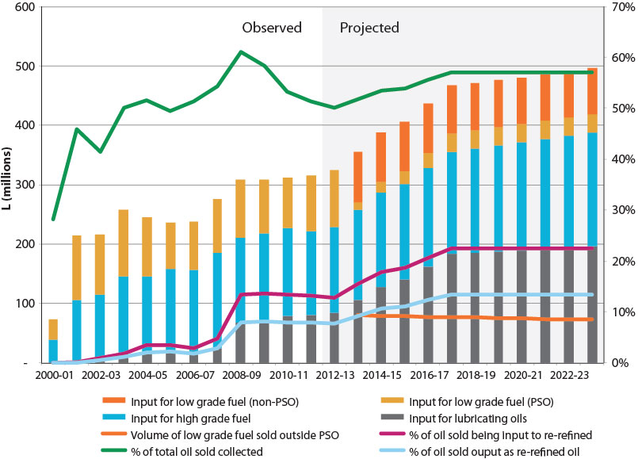

Source: Aither, based on the Department of the Environment (2013).

Notes: (a) 2000-01 only includes six months data. (b) Lubricating and fuel oil volumes are based on the expected volume of collection and input to production, not output. (c) Non-PSO Scheme input to production of low grade fuel oil is not shown historically as data is not available; expected future volumes estimated based on expected impact of *RRR v. ATO (2013)* and declines in the fuel oil burner market. (d) The percentage of total oil sold collected (green line) rises slightly after 2012-13 due to expected increases in demand for feedstock of existing and new re-refiners.

|  |
| --- |
| Finding 32  Modelling of the financial and environmental implications of continuing with the current PSO Scheme arrangements provides further evidence for the unsustainability of this option. |

Scenario 2 – Tighten loopholes and increase the PSO Scheme levy

Under Scenario 2, potential loopholes are closed in relation to (a) claims for Category 1 benefits on output not meeting the Category 1 requirements, and (b) Category 1 benefits paid for products being sold into ‘terminal’ end uses (see discussion on both these topics in Section 5 and in the following two text boxes below). It assumes claims for products not meeting the Category 1 specifications will be claimed as Category 5 products, and no claims will be made for an estimated volume (10 ML) of Category 1 products currently going to terminal uses, with no future claims against any category for this volume (i.e. no substitution into other PSO Scheme claimable products). This scenario also takes account of Category 6 changes noted above (resulting from the AAT decision in *RRR v. ATO (2013)*). It leaves benefit payments at existing rates, but increases the Scheme levy to 7 cpl.

*Financial implications of Scenario 2*

In this scenario, an annual surplus is achieved in 2013-14 due to the combination of removing potentially false claims for products not meeting Category 1 specifications, and Category 1 products being sold into terminal uses. Under this scenario the PSO Scheme will return to an annual deficit in 2016-17 due to increased re-refining capacity and associated Category 1 claims. Cumulative deficit begins in 2019-20 and continues thereafter. The levy increase to 7 cpl (which begins in 2014-15) is not sufficient to ensure a budget neutral position in the long term. The levy increases, in addition to the lack of any change to benefit categories under this scenario, further entrenches industry reliance on the Scheme without sending appropriate signals about the need for greater self-reliance over time. If no changes to benefit amounts are made (such as is the case here), further additional re-refining capacity may come on-line, which would push the Scheme further into deficit (however, this potential additional capacity is not modelled here).

### Figure 29. Observed and modelled financial trends: Scenario 2

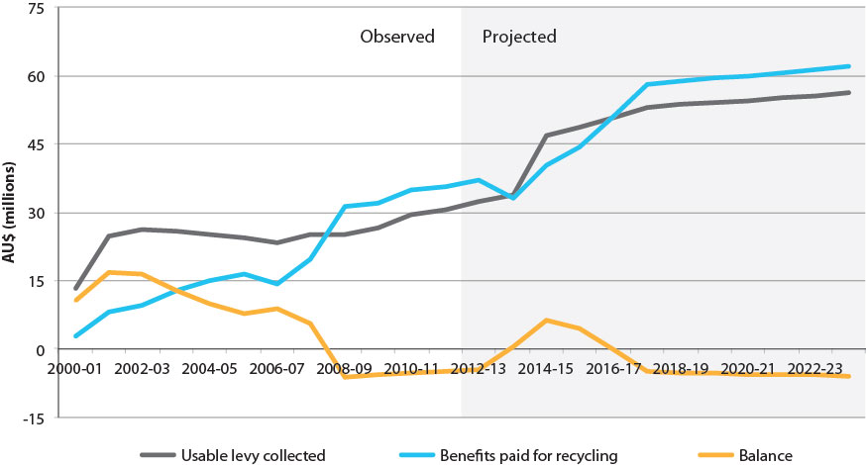

Source: Aither, based on the Department of the Environment (2013).

Notes: (a) 2000-01 only includes six months data. (b) Cumulative deficit projection is based on notional $0 balance in 2012-13.

*Collection and recycling implications of Scenario 2*

Under Scenario 2 there may only be very minor changes to collections as compared with that under Scenario 1, and these mainly relate to assumptions regarding how a few producers might respond to not being able to claim Category 1 benefits. Greater enforcement against claims for Category 1 product not meeting specifications may not impact on collections if such producers make Category 5 claims instead (as has been assumed here) because the re-refinery has the same feedstock contracts in place and produces the same output volume, but just receives a lower benefit rate for that volume instead (see following text box for alternative scenarios regarding such producer responses).

Because we have assumed some producers will still sell Category 1 standard products into terminal uses (but just not receive the benefit) under this model, producers do not place any downward pressure on collections. However, if these producers cannot make these sales in the absence of the benefit payment, they could easily demand less feedstock and hence negatively impact on collections (see further discussion of this in the second of two following text boxes). There is significant uncertainty associated with such producer decisions due to the wide range of variables influencing behaviour, but under Scenario 2 we have assumed the producer will continue to manufacture and sell a Category 1 standard product due to sufficient demand for the product, the need to maintain throughput through the re-refinery, the absence of more profitable alternatives, and upward trends in global oil prices.

|  |
| --- |
| Potential impact of tightening Category 1 specifications and improved auditing  A number of industry participants provided anecdotal information suggesting that up to 10 ML of Category 1 claims are currently being made for output or processes that do not meet requirements. Should this prove to be the case, and the matter is resolved through modified regulations or improved compliance and enforcement, it is possible that the relevant producers may either:  • claim Category 2 benefits, should an end use market be found  • claim Category 5 benefits, again assuming an end use market  or  • sell their feedstock supply (for example, collections contracts) to other producers, who can legitimately claim Category 1 benefits – again, assuming their end use markets will sustain this.  In the event that such producer(s) sell their feedstock to other Category 1 producers who subsequently claim benefits, there is unlikely to be any net change in the financial position of the PSO Scheme. In the event that legitimate Category 2 or 5 claims are made instead, the Scheme’s financial balance will improve by the difference in benefits between Category 1 and the category claimed, multiplied by the volume in question. This is illustrated in the following figure which compares the outcomes of the potential Category 1 false claim volume continuing (baseline) with it being claimed as Category 2, or as Category 5. If feedstock is bought by other producers and claimed legitimately then the result would be the same as the baseline. |

### Figure 30. Difference in annual PSO Scheme deficit due to removing certain Category 1 claims

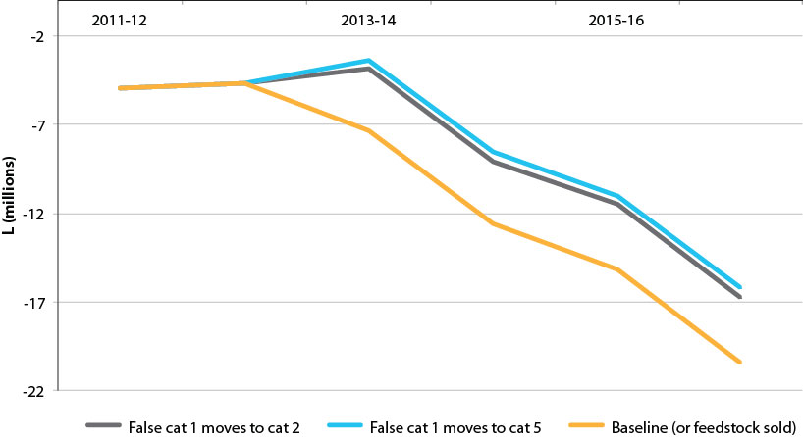

Source: Aither.

Notes: (a) The budget situation improves in 2013-14 due to the bulk of previous Category 6 claims being disallowed due to the AAT decision in *RRR v. ATO (2013)* in late 2012-13. (b) Subsequent decline is due to increased re-refining capacity and Category 1 claims. (c) The above figure does not account for any possible impacts due to preventing sales of Category 1 products into terminal end uses.

|  |
| --- |
| Potential impact of disallowing terminal end uses of Category 1 products  Anecdotal information provided industry stakeholders suggests that there could also be up to 10 ML per annum of Category 1 products being sold into terminal end uses (such as explosives and carpet underlay). This is not the intention of the PSO Scheme which assumes Category 1 products will be sold into lube-to-lube uses because this closes the product life-cycle loop and allows the re-refined oil to be subsequently re-refined again after multiple uses. Terminal uses of oil do not allow this to occur. This distinction has both environmental and financial dimensions.  In the case of lube-to-lube, an argument can be made for environmental superiority due to the potential for ongoing re-refining, but the promotion of re-refining does not achieve anything in relation to terminal uses – the demands for which will be met by either imported virgin oil, or re-refined oil, with re-refined oil arguably having a lower carbon footprint due to transport of virgin oil from overseas and conservation of virgin oil. The financial dimension to this might involve questioning why high benefit payments are available for a terminal end use when these payments were originally premised on lube-to-lube re-refining being achieved.  Should greater enforcement of end use (a) be decided upon and (b) actually be achieved, it is possible that this could have either positive or negative consequences for the pull through of used oil through the re-refining system, and ultimately on collections.[15] The loss of benefits for terminal use sales may mean producers continue to sell to those markets in the absence of the benefit (should it remain profitable), or the absence of the benefit may render those markets completely unviable (due to inability to compete with a virgin product), which could negatively impact on collections. In the event that it results in small but feasible margins, it may incentivise greater production and hence increase demand pull, as producers attempt to extract more return through increased production volume – assuming output can be sold. |

Assuming that any revisions to the regulatory approach towards terminal end uses was consistent across all lubricating oil benefit categories (i.e. Category 1 and 2), the impact on the PSO Scheme’s bottom line would be expected to be the volume of terminal use claims multiplied by the 50 cpl benefit rate. If this is not the case, the impact would likely see producers claiming Category 2 benefits instead, with less improvement in the bottom line. Substitution to Category 5 claims in relation to terminal uses is unlikely, as the terminal end uses have primarily been those that require a high quality lubricating oil (rather than a fuel oil). So to the extent that it is still more profitable for producers to sell lubricating oils to terminal uses (in the absence of the benefit payment) than to switch to producing a fuel oil and selling it to different customers (and claiming the benefit), then we would expect the benefit to the Scheme’s bottom line to simply be the volume in question multiplied by the foregone benefit rate – $5 million in the case of a hypothetical 10 ML. Should Category 5 product be produced and claimed instead, the improvement would be the same as that demonstrated in Figure 30 above (or additional to it if both sets of false claims were addressed simultaneously).

|  |
| --- |
| Finding 33  Closing loopholes associated with suspect claims under the PSO Scheme is a sensible approach based on the principle of ensuring the integrity of the Scheme. However, while the financial implications are likely to be positive, the environmental implications are less certain (and could be negative in the case of terminal uses), and both will depend on producer responses, as well as the efficacy of monitoring, compliance and enforcement. |

Scenario 3 – Tighten loop holes, remove Category 6 benefits, and scale down Category 1 benefits

In Scenario 3 the loopholes are tightened as for Scenario 2, Category 6 changes arising from *RRR v. ATO (2013)* are accounted for, but the scenario goes further by removing Category 6 benefit payments altogether from 2014-15 (some residual and legitimate claims continue to exist in previous scenarios), and models a reduction of Category 1 benefits starting at 45 cpl in 2014-15 and declining by 5 cpl every subsequent two years until it reaches 25 cpl. The levy is left at 5.449 cpl rather than being increased.

*Financial implications of Scenario 3*

Under Scenario 3, we see an immediate response in the annual budget position due to assumptions about how producers will respond to the closing of loopholes, and impacts associated with *RRR v. ATO (2013)*, which outweigh increased claims due to new re-refining capacity. However, the increased re-refining capacity means that the budget goes back into deficit until the more aggressive reductions in Category 1 benefits come into effect later in the scenario (from around 2021) and the complete removal of Category 6 benefits is at the margins and cannot overcome the increased re-refining capacity. While this scenario is beneficial in that it sends the right signals to industry to stand alone and rebalances PSO Scheme payments to environmental and public benefits to some extent, the medium term deficit still exists and remains inconsistent with the principles of product stewardship, and collecting enough revenue to meet costs.

### Figure 31. Observed and modelled financial trends: Scenario 3

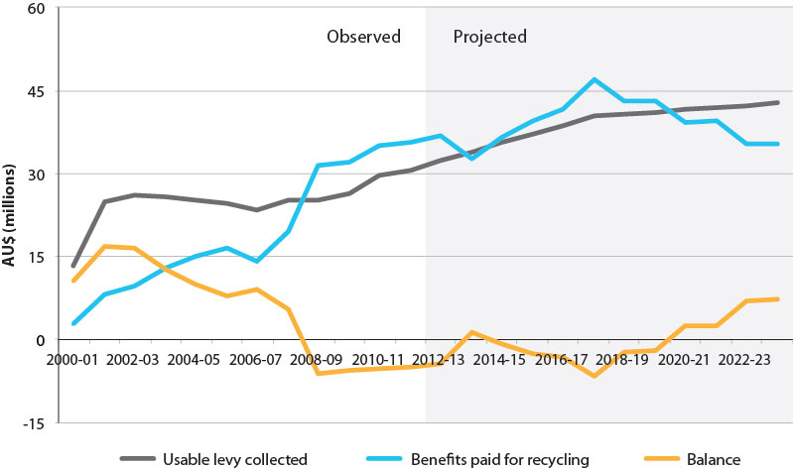

Source: Aither, based on the Department of the Environment (2013).

Note: (a) 2000-01 only includes six months data. (b) Cumulative deficit projection is based on notional $0 balance in 2012-13.

*Collection and recycling implications of Scenario 3*

In general terms, we may expect to see some response from recycled oil producers to the reduced incentive associated with the reduction in Category 1 benefits. This is difficult to model, especially in the absence of detailed and commercially sensitive information from producers about margins, costs and other factors, and the uncertainty associated with exogenous drivers.

The main concern with such a reduction is that the producers’ responses may impact negatively on collections, which is the key environmental consideration for the PSO Scheme. The extent of any response is likely to be driven by profit margins of different producers, conditions in end use markets, and a range of other exogenous factors (such as world oil prices and changes in the degree of acceptance of re-refined oil products by manufacturers). It is possible that reductions in benefit payments may actually incentivise greater collection effort as producers attempt to maximise production and throughput due to re-refining being a highly capital intensive activity – depending on the extent of capacity utilisation.

For this scenario we have assumed that the decline in Category 1 benefits will lead to no further growth in production of recycled oil (which is projected to grow in earlier scenarios). Known future increases in capacity are modelled to utilise capacity at the same rate as earlier scenarios due to the need for such businesses to recoup fixed costs and therefore maximise throughput regardless of margin. Under the scenario we assume no plant closures and no decline in capacity utilisation for existing plants. The result of this assumption is a slightly lower total volume of input into recycled oil production under the Scheme, and a slight decline in the percentage of total oil sold collected under the Scheme after 2017-18 (due to virgin oil sales increasing at a greater rate than recycled oil production). Given the range of possible producer responses, this outcome is somewhat speculative.

Regardless of the assumptions made and modelled, the benefit of a long term, signalled, and staged decline in benefits is that producers have time to plan and respond accordingly to small adjustments over time, thereby reducing the risk that the change in benefits will negatively impact on collections or the viability of the industry. In addition, options to mitigate potential downward pressure on collections, due to reduced benefit payments, is explored under Scenario 4 and in Section 8.

### Figure 32. Observed and modelled financial trends: Scenario 3

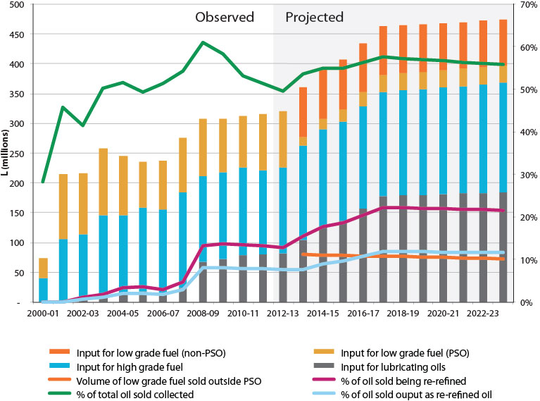

Source: Aither, based on the Department of the Environment (2013).

Note: As per Figure 28, however, the percentage of total oil sold that is collected peaks and then declines slightly before stabilising due to the assumption of a lower rate of growth in re-refining feedstock demand due to reduced benefit payments for Category 1.

|  |
| --- |
| Finding 34  The combination of closing loopholes, removing Category 6 benefits, and scaling down Category 1 benefits may deliver an immediate short term surplus and deal with the deficit in the long term, but increased re-refining capacity means these measures are unlikely to be enough to keep the PSO Scheme out of deficit in the medium term. In addition, some environmental risks may become present if nothing further is done to incentivise collections. |

Scenario 4 – Tighten loopholes, remove Category 6 benefits, scale down Category 1 benefits, increase the PSO Scheme levy and redistribute benefits to collections

Scenario 4 is the same as Scenario 3, except that the levy is increased with the objective of ensuring budget neutrality and enabling redistribution of benefits towards collection infrastructure and incentives. The levy is increase to 7 cpl in 2014-15 and held at that level thereafter.

*Financial implications of Scenario 4*

Under Scenario 4, there is a modest budget surplus in 2013-14 (due to ending allegedly false claims, and the implications of *RRR v. ATO (2013)*) with a more significant surplus in 2014-15 (due to the aforementioned factors in addition to the cessation of Category 6 benefits and the higher levy rate). Surpluses vary but are maintained in the medium term due to the higher levy, which generally compensates adequately for the increased re-refining capacity. Annual surpluses continue and increase towards 2023-24 as the Category 1 benefit rate continues to decline.

The figure below demonstrates the financial impact of redistributing the surpluses generated towards collection infrastructure and incentives. Doing so in a gradually increasing and sustained manner from 2014-15 is likely to keep the PSO Scheme operating at around a zero balance, while having the benefit of being able to invest in new or renewed public collection infrastructure, and provide direct incentives for collection of used oil in areas that have not been attractive under the existing levy-benefit arrangement. It can also address problems arising from the fact that the only current incentives are provided on a cpl output basis which is unlikely to assist with matters such as siting collection or processing infrastructure where it is most required. The benefit of this approach is that it is consistent with covering the costs of product stewardship including that oil producers and consumers fully meet the costs of the Scheme’s operation. It provides the mechanism to rebalance Scheme benefits, and mitigate risks of lower levels of collection due to declining output based benefits. In addition, reductions to the levy could be considered in the future if surpluses in excess of collection infrastructure or incentive needs continue to be generated.

### Figure 33. Observed and modelled financial trends: Scenario 4

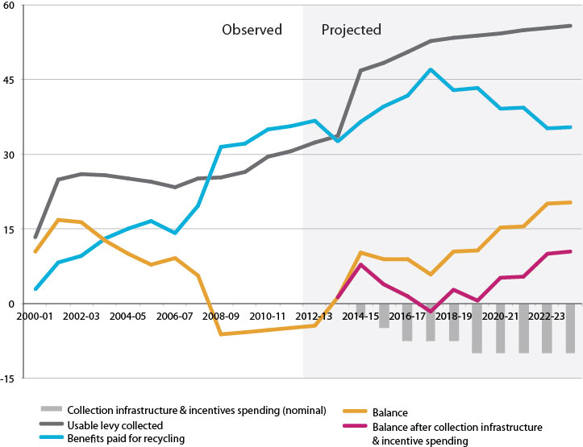

Source: Aither, based on the Department of the Environment (2013).

Notes: (a) 2000-01 only includes six months data. (b) Collection and infrastructure spending amount is nominal and not based on any explicit assessment of infrastructure needs, or appropriate amounts or methods of collection incentives.

*Collection and recycling implications of Scenario 4*

While we might expect to see similar responses from producers to Scenario 3 regarding collections and recycling due to the same reduction in Category 1 benefits applying in this scenario, collections risks may be mitigated by using the surpluses generated to focus on incentivising collections, and investing in infrastructure that supports greater collections and lowers collection costs. If implemented correctly, such changes are likely to have far greater marginal environmental benefit as focusing on collections directly prevents improper disposal and is likely to come at much lower cost than current benefits to re-refining.

Modelling undertaken for the review does not specifically account for how the surpluses generated might be redistributed towards collection infrastructure or incentives, such as the balance between investment in infrastructure versus in collection incentives, and the methods by which this might occur (such as competitive grants, transport subsidies, or zone based rebates). Nor does it account for the potential or likely responses of oil collectors and recyclers to such investments or changes.

However, should the investment appropriately target needs and be implemented effectively, then we would expect to see marginal total increases in the levels of collection due to costs of collection decreasing and infrastructure being made available – or maintained to a safe and serviceable standard. Such increases would be expected to compensate for any declines in the level of growth in recycling activity that may result from reduced benefit payments. If implemented effectively, such changes may also result in greater collection and recycling activity than may occur under the base case scenario (see Figure 28).

While it was outside the scope of this review to consider specific infrastructure needs or provide advice on the design of collection based incentives, some consideration of these matters has been provided in Section 5.1.7 and Section 8.

|  |
| --- |
| Finding 35  In combination with other measures, increasing the PSO Scheme levy a small amount represents an effective way of generating a reliable surplus for the Scheme in the short and long term. If such surpluses were invested into collections infrastructure and incentives then potential risks to ongoing collections (due to a range of reasons) could be mitigated. |

## 7.5 The role of supporting or complementary activities

A number of challenges identified in Section 6 of this report may best be addressed through activities that complement or support the PSO Scheme, rather than through specific changes internal to the Scheme:

• defining success for the Scheme

• understanding and more effectively mitigating against exogenous factors and improving acceptability of re-refined oil products in the market place

• interaction with other policies, programs or activities

• specific needs associated with regional and remote area infrastructure and collections.

We believe some or all of these issues could be addressed through:

• The Oil Stewardship Advisory Council (OSAC) (or a similar body with potentially modified terms of reference) playing a more active role in providing advice and guidance to government regarding how the Scheme is operating and could be improved.

• Greater coordination between local, state, and the Australian Government on policies and programs that have the ability to influence how effectively or efficiently the Scheme operates. This could be achieved through the Waste and Chemicals Thematic Oversight Group (WCTOG) under the Council of Australian Governments inter-governmental committee structure, or through a similar body that brings together the right policy professionals across all levels of government (such as from waste, transport, environment protection and similar portfolios).

• Targeted investment in collections infrastructure through competitive grants programs or similar activities, with OSAC and the WCTOG (or similar body) providing advice in relation to these matters.

We do not believe government’s mandating the use of re-refined oil (by government agencies or government owned businesses for example) is an appropriate approach to stimulating sales of re-refined products and thereby supporting the re-refining industry. This would impose additional costs and has the potential to create unintended consequences. Re-refined products should be encouraged to compete on their own merits, and government or any other users free to choose whichever lubricants most suit their needs.

The key areas where improved outcomes could be achieved as a result include:

• ensuring there are no perverse outcomes associated with policies of programs that are working in opposition either at the same or different levels of government

• ensuring industry has greater and more frequent participation in how the Scheme is run and ownership of outcomes, and to some extent mitigating industry concerns about the risk of four yearly reviews

• maximising potential collections and hence environmental benefits of the Scheme.

OSAC would be well positioned to provide advice on issues emerging that might best be dealt with by either the Australian Government as operator of the Scheme, or by the WCTOG or similar body where issues are state based or of a cross jurisdictional nature. Improving dialogue, coordination and engagement between all levels of government, as well as between government and industry, would be beneficial, and could help identify ways in which to improve recycled oil product marketing and development.

The successful future operation of the Scheme will require that collection infrastructure be effectively maintained and renewed, especially in regional areas. The costs of this could be financed through redistribution of benefits within the Scheme over time, as Scenario 4 above demonstrates.

Mechanisms to deal with regional and remote area issues such as very high collection costs are also likely to be required and could be financed through similar redistribution of benefits. This could include transport equalisation strategies, co-investment between Commonwealth and state governments in particular infrastructure, or incentivising local treatment and re-use of oil for energy recovery.

## 7.6 Summary

The review has considered a wide range of options and specific measures to address the challenges faced by the PSO Scheme. The scenarios tested have sought to identify specific ways in which the effectiveness and efficiency of the Scheme could be improved while ensuring it returns to budget neutrality and long term financial sustainability. Some measures are obvious and within the existing Scheme, such as:

• the benefit category rates, including their relative and absolute levels

• more vigorous auditing to ensure compliance with the categories of benefits

• the rate for the Scheme levy.

While other measures look towards the external environment within which the Scheme operates:

• greater consideration of external and market pressures, and refocusing on incentivising collection

• better coordination with state and local governments, stronger cooperation with the private sector entities involved, and clearer understanding of interactions with other policies

• the need for measures to address rural and remote issues and other differences between states.

The recommendations in the following section are intended to give practical effect to these measures.

# 8 Conclusion and recommendations

The recommended approach is to retain the PSO Scheme with modifications designed to address its current material shortcomings, and ensure that future operation of the Scheme is financially viable and achieves its important environmental objectives in the most efficient way.

This is to be supported by complementary activities, including targeted investment to address collection infrastructure and remote and regional issues and improved policy coordination, monitoring and industry involvement in Scheme operation. Recommendations to this effect are provided below.

## 8.1 Defining success and redefining objectives

Legislation or other documentation for the PSO Scheme does not provide a clear definition of success. This hinders overall assessment of the Scheme, and makes it difficult to determine when an acceptable level of collection, recycling or re-use of oil is occurring, and hence, when and how the Scheme may need to be phased down or cease completely.

The objects set out in *Product Stewardship (Oil) Act 2000* (the Act) have been appropriate in stimulating used oil collection and recycling in Australia, and many positive environmental achievements can be attributed to these object. However, given that for the most part the objects of the Act have now been achieved, it is necessary to consider redefining objectives for the Scheme in the context of a defined vision of success.

Regardless of whether the Australian Government decides to continue with the Scheme under existing legislation (as we recommend), or place it under the *Product Stewardship Act 2011*, clarification of objectives for used oil collection and recycling will be required. This is arguably more fundamental if a move is made to a Scheme under the *Product Stewardship Act 2011* given that specific targets for levels of collection, recycling and re-use would need to be set.

|  |
| --- |
| Recommendation 1  A definition of success for used oil in Australia should be determined and articulated, and objectives for the PSO Scheme redefined in light of that. Such vision and objectives should guide future operation of the Scheme, and provide guidance in consideration of any possible future transition to the *Product Stewardship Act 2011*. |

We believe the primary objective of any Scheme for used oil should be to maximise used oil collection for re-use, in order to prevent improper disposal and keep used oil out of the environment. The secondary objective should be to encourage re-refining up to an efficient level (given its costs, international competitiveness, and ability to effectively market and sell re-refined products).

In developing and articulating a vision for the Scheme, the following parameters should be considered:

• the amount of used oil collected, given the quantities and proportions of various oils sold and how much of each is potentially collectable

• the completeness and cost of collection from regional and remote areas

• the existence or extent of inappropriate disposal or environmental harm associated with used oil

• the balance between different forms of treatment and re-refining of used oil, and end uses

• the scale, capacity, nature and distribution of the re-refining industry

• the quality and coverage of public and private collection infrastructure

• the extent of acceptance of use of re-refined products in the marketplace.

However, further work is required to quantify these parameters. OSAC and WCTOG may also be able to play a role in assisting with developing the vision.

While we have provided a view on a vision and objectives for any used oil Scheme above, we do not believe legislative amendments to the Act would be required for the Scheme to continue operating effectively given these slightly revised objectives. In addition, we believe that for the most part, suggested changes below could be given effect through amendments to existing regulations and supported by a policy or ministerial statement.

## 8.2 Levy and benefit modifications

Immediate modifications to the levy-benefit arrangements are required to improve the financial sustainability of the PSO Scheme.

This includes increasing the levy on oil sold. While we believe that this is a last rather than first resort, and that in principle the industry should be moving towards lesser not greater dependence on the levy, raising the levy is currently necessary to ensure sufficient revenue is collected to fund benefit payments, and is the most feasible short term solution to the budget deficit.

|  |
| --- |
| Recommendation 2  The PSO Scheme levy on oil sold should be increased to 7 cpl immediately. |

Raising the levy to 7 cpl is unlikely to have a noticeable impact on oil producers or consumers yet will contribute to securing the environmental benefits of the Scheme and in combination with reductions to benefit payments will help secure a budget neutral position over time. Setting the rate at 7 cpl provides some margin for error given uncertainty about the future level of oil sales and is approximately the rate at which the levy would currently be set if indexation of the levy had not ceased. It also assists in buffering the Scheme from exogenous shocks to some degree. In addition, this levy rate is still well within the ‘normal’ range for comparable Organisation for Economic Co-operation and Development (OECD) countries (see Appendix C).

The Category 1 benefit for re-refined oils is overly generous, and is not reflective of where the true environmental benefits of the Scheme actually lie, or the actual degree of its environmental superiority relative to other end uses. Although only taking in around seventeen per cent of the used oils collected, re-refining is absorbing almost two-thirds of the benefit payments and this is likely to substantially increase when a new re-refinery comes on stream in the 2013-14 financial year. The high rate of benefit for Category 1 oils was never intended to be permanent (although this may have been assumed) so it is now time to signal the phasing down of this incentive payment. A lower benefit payment is also required to reduce the risk of over investment in re-refining capacity.

|  |
| --- |
| Recommendation 3  The Category 1 benefit for base oils must be reduced to 45 cpl immediately and incrementally phased down at 5 cpl increments every two years thereafter, until it reaches 25 cpl. |

Decreasing the levy immediately is required to ensure the principles of the product stewardship are maintained, including that the PSO Scheme is not subsidised by those not selling or consuming oil. This re-refining benefit is not out of line for those comparable OECD countries that offer a re-refining benefit. Some, such as the United Kingdom, do not provide any additional incentive for re-refining compared to energy recovery (see Appendix C).

A staged reduction provides time for industry to plan and adjust. The reduction to 25 cpl should be complete before the sixth independent review, at which time the feasibility of, or need for any further reductions could be considered.

In addition to reducing the Category 1 benefits, there is also a case for modifying Category 6 benefits. This is partly in response to the recent AAT decision in *RRR v. ATO (2013)*, but also because of evidence that this product stewardship benefit is unwarranted and unnecessary, both of which suggest there is a strong case for eliminating benefit payments to Category 6 (low grade fuels) altogether.

|  |
| --- |
| Recommendation 4  Category 6 benefit payments for low grade fuel oils should be discontinued immediately, regardless of whether they are produced from a re-refinery or from a simple filtering and de-watering process. |

As a result of the AAT decision in *RRR v. ATO (2013)*, the majority of recent Category 6 claims would be expected to cease regardless. Notwithstanding, benefit payments for the residual volume of Category 6 claims are unwarranted and unnecessary and represent an opportunity to further improve the PSO Scheme’s financial position with minimal or no impact on collections.

However, the result of *RRR v. ATO (2013)* and discontinuation of Category 6 payments altogether will create implications for the collection of data and information. These matters are discussed further below.

## 8.3 Definitions and compliance

There have been numerous reports of anomalies and potentially false claiming of benefits that need to be addressed, as these have implications for the financial position, credibility and integrity of the PSO Scheme. Some loopholes arise from a failure to stipulate objective and independently verifiable technical standards for each benefit category, which have instead relied on general or subjective terms and descriptions. This is an area in which the Scheme can and should be improved, and has been called for by a range of stakeholders. Some submissions to the review called for more auditing, and suggested that operational and administrative costs of the Scheme had been insufficient to maintain its integrity and equity.

As has been observed by previous reviews, it appears some benefit categories are redundant and are no longer claimed, with some no longer being relevant due to changes in industry requirements or end uses. Furthermore, current category definitions are technology or process focused, rather than output focused, which prevents improvements in efficiency and stifles innovation.

In addition, improved category definitions may present an opportunity to address marketing and acceptance challenges associated with end use of re-refined products by improving alignment of benefit categories with specifications or standards required in the marketplace.

|  |
| --- |
| Recommendation 5  PSO Scheme benefit categories should be rationalised where they are redundant, all categories should be modified such that they are based on objective output standards or specifications, and audits, independent spot checks and testing should be applied to all benefit claimants. |

Industry should play a role in advising government on the appropriate technical standards or specifications for benefit categories, including thresholds to differentiate between them (see also Section 8.4 below).

While we acknowledge that monitoring and spot checks may be costly, increasing the integrity of the PSO Scheme has the potential to deliver financial benefits to the Scheme that far outweigh any monitoring costs.

As a caution, we would also note that restrictions against claiming Scheme benefits based on end use may limit the markets available to re-refiners, which could compromise the key environmental benefits of the Scheme by reducing collections.

## 8.4 Imports and exports

Imports of used oil from foreign countries should be allowed to occur subject to existing transport and hazardous waste controls; but these volumes of oil should not attract any form of (net) PSO Scheme benefit payment. If Australian re-refiners wish to process this oil it should be allowed to occur outside of Scheme arrangements (in other words on a purely commercial basis). Re-refined oil from this process which enters the Australian market should attract the Scheme levy. If Australia wishes to assist foreign nations in removing and processing used oils, it should do so through foreign aid arrangements.

|  |
| --- |
| Recommendation 6  The Department of the Environment should clarify how the PSO Scheme levy-benefit arrangements apply to imported used oil, based on the principle that there should be no benefit payable if there is no environmental benefit to Australia. |

When re-refined or other oils derived from oils used in Australia are exported, the relevant PSO Scheme benefit should be applicable. The payment is not intended to subsidise exports of oil from Australia, but rather ensure that used oil was treated safely and prevented from causing environmental damage in Australia.

|  |
| --- |
| Recommendation 7  PSO Scheme benefit payments should be payable against used oil derived products regardless of whether they are destined for domestic or foreign consumption, and regardless of what the end use is. |

As was noted above, because of the way the PSO Scheme is designed (it primarily rewards sales of re-refined oil products), any restrictions on end use markets for re-refined products (such as limiting end uses), is likely to compromise collections and hence jeopardise environmental outcomes.

## 8.5 Policy and coordination

To better reflect proposed data and information roles, and to remove existing or the potential for unintended or perverse outcomes, greater coordination and alignment of Australian, state and local government policy measures is required. In addition, closer involvement of industry in PSO Scheme maintenance and operations is required. Both will ensure the Scheme can operate as effectively and efficiently as possible.

|  |
| --- |
| Recommendation 8  An intergovernmental committee under the Council of Australian Governments structure (e.g. the current Waste Thematic Oversight Group or similar) should be formed, or if it exists, tasked with oversight of the PSO Scheme. It should be responsible for ensuring other policies or programs do not unduly impact on the Scheme’s performance and should coordinate collection of data and information relevant to Scheme performance. |

A modified OSAC or similar body that acts as an interface between the used oil collection and recycling sector and government (including local government) is likely to benefit the successful operation of the PSO Scheme and further development of the industry. Such a body could facilitate greater industry coordination in market and product development and play an important role in advising government.

|  |
| --- |
| Recommendation 9  The Oil Stewardship Advisory Council should be tasked with playing a more active role in advising government on the PSO Scheme’s operation and issues relating to used oil aggregation and collection, including collecting and providing relevant data and information. |

## 8.6 Information and reporting

It is important for the ongoing effectiveness and sustainability of the PSO Scheme to continue to improve information and data collection and reporting. A key past deficiency has been the lack of robust data and information on the true extent of used oil collections, including volumes that are collected and used outside of the Scheme. Such ‘off-radar’ collections are set to increase due to *RRR v. ATO (2013)*, which reinforces the need to implement better approaches to data and reporting on used oil collections.

Possible methods to improve information on collections include specific additional questions in the existing data collections undertaken by the Australian Bureau of Statistics (ABS) of the recycling industry and in the census of manufacturing. In addition, state governments are likely to already have data and information on used oil through regulation of hazardous wastes (such as permits and transportation information, as well as municipal waste sites) which could be modified to consistently collect information on used oil volumes. Greater policy coordination through an appropriate committee could help make these modifications where necessary or coordinate and consolidate data where it already exists. In addition, a reformed OSAC could be required to provide total collections data (regardless of whether benefits are claimed or not) to government for monitoring purposes.

|  |
| --- |
| Recommendation 10  Monitoring and data availability must be improved to enable more effective fine-tuning of the PSO Scheme over time. Effort should be focused on ensuring comprehensive and consistent collection of data and information on used oil collections both under and external to the Scheme. Both the Waste Thematic Oversight Group and Oil Stewardship Advisory Council (or similar bodies) have an important role to play in this regard. |

## 8.7 Investment in collection infrastructure and incentivising collection

Given that most of the environmental benefits come from preventing improper disposal rather than how the collected oil is subsequently used, it is important to ensure effective, incentivised collection of used oil across the economy as a whole. Specific mechanisms to deal with very high collection costs in regional and remote areas require further investigation. These could include transport equalisation strategies, co-investment between Commonwealth and state governments in particular infrastructure, zone based rebates, or incentivising local treatment and re-use of oil for energy recovery.

|  |
| --- |
| Recommendation 11  Mechanisms to deal with very high collection costs and poor access to end use markets are required in some regional and remote areas. Additional investigations should be undertaken into the most appropriate mechanisms as soon as possible. The Oil Stewardship Advisory Council and Waste Thematic Oversight Group should be consulted and provide advice on these matters. |

Further study of the approaches used in other jurisdictions with high collection costs due to very low population density and hence oil-density (such as Alberta and Saskatchewan in Canada, and Finland) might provide some useful insights. However, it would also be important to bear in mind that these might differ greatly from regional parts of Australia (such as Western Australia) in important respects (such as those countries having very strong demand for commercial and industrial heating fuels in winter).

The successful future operation of the PSO Scheme will require existing collection infrastructure to be effectively maintained and renewed, especially in regional areas, and may require new infrastructure in certain areas to incentivise collections. We suggest that this should be financed by surpluses generated through redistribution of benefits within the Scheme over time. It is unlikely that the existing system of payments on a cpl basis at the time of sale to the final user will be able to drive or facilitate such investments, particularly for multi-user facilities.

|  |
| --- |
| Recommendation 12  Surpluses generated by changes to the levy-benefit arrangements should be directed towards investment in existing or new public or shared collection infrastructure, through a competitive grants Scheme, and towards direct incentives for collection in areas where collection is currently insufficient. Further analysis should be undertaken to identify areas of need and priority infrastructure. |

## 8.8 *Product Stewardship Act 2011*

Our preference is to modify the existing PSO Scheme using available policy levers, correct its major problems and set out a long term pathway to greater environmental effectiveness, efficiency and sustainability at low costs to consumers and taxpayers.

However, should it become evident over the next four years that this strategy is not delivering the desired results, there is an alternative pathway for potentially achieving similar environmental outcomes, namely replacing the existing Scheme with a new mandatory Scheme for extended producer responsibility under the *Product Stewardship Act 2011*.

It would be prudent to spend time over the next four years further investigating how such a Scheme could be implemented, what target levels of recycling and re-use to mandate, and any restrictions, constraints and supplementary targets that need to be imposed on an industry run Scheme.

|  |
| --- |
| Recommendation 13  The Department of the Environment should undertake further investigations into the feasibility and possible design options for used oil arrangements under the *Product Stewardship Act 2011*, prior to the next PSO Scheme review. |

## 8.9 Sequencing

Our modelling was based on implementing key changes (levy and benefits) from the beginning of the 2014-15 financial year. We would suggest that the recommended changes to the levy-benefit arrangements be announced immediately and implemented in regulatory changes as soon as possible to ensure the signal reaches producers quickly, and to ensure surpluses are achieved as soon as possible. If delays occur beyond 2014-15 the budget position will be worse than our modelling indicates due to new re-refining capacity coming on-line.

Further suggestions on sequencing are provided below:

• A reformed OSAC and new or modified WTOG, or similar body, should be implemented as soon as possible. These measures should be in place before changes to the levy-benefit arrangements occur (i.e in the 2014 calendar year, if not sooner).

• Investigative work into the feasibility and design of the *Product Stewardship Act 2011* arrangements for used oil could occur at any time, but must be completed before the next four yearly PSO Scheme review (2014 or 2015 may be appropriate).

• Any redistribution of benefits towards collection infrastructure and incentives should occur once it is confirmed that surpluses have been (or will be) achieved.

• Redistribution of such benefits will require that any infrastructure needs analysis and investigation into methods for redistribution and incentives must be completed well in advance of surpluses being generated (ideally this should be completed in late 2013 or early 2014).

# Part D – Appendices and references

# Appendix A – Terms of Reference

The review is to examine the appropriateness, effectiveness and sustainability of the operation of the Product Stewardship for Oil Scheme (PSO Scheme) to date; consider opportunities for improvement; and make recommendations where considered appropriate.

## Appropriateness

Noting that the PSO Scheme has been operating relatively unchanged since 2001, the review is to examine whether the existing product stewardship model is still the most appropriate way to manage used oil in Australia. In particular, the review is to:

• consider the applicability to Australia of used oil management practices in comparable jurisdictions

• consider the relative environmental merits of alternative end uses of used oil, including those supported by the PSO Scheme as well as other potential options (e.g. export for processing overseas) [Noting a full life-cycle analysis is not required]

• examine the desirability and feasibility of developing new product stewardship arrangements for used oil, including a Scheme under the provisions of the *Product Stewardship Act 2011*. If significant changes to current arrangements are proposed then the transition to any new product stewardship arrangements is be considered.

## Effectiveness and efficiency

The review is to examine the operation of *Product Stewardship (Oil) Act 2000* (the Act) and relevant provisions of customs and excise legislation and the extent to which the objects of the Act have been achieved. This examination is to include an assessment of:

• the effectiveness and efficiency of current administrative arrangements for the PSO Scheme

• the effectiveness and efficiency of existing benefit categories and rates; including whether these are providing incentives for industry to respond appropriately in the promotion of sustainable environmental outcomes

• any unintended consequences of existing benefit categories and rates

• the effectiveness and efficiency of the existing levy-benefit arrangements in meeting the objects of the Act

• the relative effectiveness and efficiency of the PSO Scheme in different parts of the country, with particular reference to regions, such as Western Australia and rural and remote areas

• any mechanisms that would increase the effectiveness and efficiency of the PSO Scheme in the above-mentioned areas

• the effectiveness and efficiency of the used oil collection and recycling infrastructure and systems which have developed in response to the incentives provided by the PSO Scheme, noting any regional issues

• the interaction of the Act, including activities encouraged by the incentives it provides, with other Commonwealth policies and legislation such as the *Hazardous Waste (Regulation of Exports and Imports) Act 1989*, and state and territory policies and legislation

• current levels of imports of used oil for recycling in Australia and exports of recycled oil and their impact on the long term viability of the PSO Scheme

• the availability of data to evaluate the PSO Scheme’s effectiveness.

## Sustainability

Assess the financial and environmental sustainability of the current PSO Scheme. In particular the review is to:

• estimate the likely future costs of the current PSO Scheme and the impacts of expected increases in total benefit outlays and suggest ways to ensure the financial sustainability of the Scheme

• assess current and future markets for recycled oil and how these may evolve in response to factors such as changes in market demand and the introduction of carbon pricing

• assess risks to the continued delivery of the PSO Scheme’s environmental outcomes of high rates of used oil collection, recycling and re-use.

# Appendix B – Stakeholder consultation

## Consultation meetings

Brisbane - 8 April 2013

• Grant Musgrove (Australian Council of Recycling)

• Cristal Lau (Australian Council of Recycling)

• Kylie Hughes (Department of Environment and Heritage Protection (QLD))

• Declan O’Connor-Cox (Department of the Environment)

• Richard Taylor (J.J. Richards & Sons)

• Kyle Bender (Transpacific Industries)

• Barbara Aston (Transpacific Industries)

• Andrew Lowe (Transpacific Industries)

• Georgia Davis (Waste Recycling Industry Association (QLD))

Sydney – 9 April 2013

• Paul Lucas (Australian Waste Oil Refineries)

• Bob Pullinger (AWOR)

• Felicity Armstrong (Department of the Environment)

• Doug Hagen (Hagen Oil)

• Gordon Chung (Hydrodec)

• Mark McNamara (Hydrodec)

• Paul Manchester (Hydrodec)

• Robb Wallace (Southern Oil Collection)

• Blake Senior (Transpacific Industries)

• Steve Matthews (Worth Recycling)

• Bob Cooper (Worth Recycling)

Canberra – 10 April 2013

• Debra Rowe (ATO)

• Pauline Zdjelar (ATO)

• James Voortman (Australian Automobile Association)

• Paul Barrett (Australian Institute of Petroleum)

• Denis McRae (Australian Waste Oil Refineries)

• Michael Ison (Cement Industry Federation)

• Bruce Edwards (Department of the Environment)

• Peter Walsh (Department of the Environment)

• Philippe Reboul (Hydrodec)

• William Hand (Hydrodec)

• Fritz Retief (Hydrodec)

• Tim Rose (Southern Oil)

Perth 11 April 2013

• Ashley McKinnon (Nationwide Oil)

• Mary Gimondo (ATO)

• Michael Hughes (ATO)

• Judy Scott (City of Stirling)

• Scott McKenzie (Department of Environment and Conservation (WA))

• Peter Walsh (Department of the Environment)

• Anthony Muir (Nationwide Oil)

• Chris Scollen (Remondis)

• Ged Styles (Toxfree)

• Aaron Griffiths (Toxfree)

• Vanessa Fernandez (WA Local Government Association)

• Heather Squire (WA Local Government Association)

• Doug Hall (Waste Management Association of Australia)

• Alex Wren (Wren Oil)

Written submissions received

• Australian Automobile Association

• Australian Council of Recycling

• Australian Oil Recyclers Association

• Hydrodec

• J.J. Richards and Sons

• Southern Oil Refining

• Transpacific Industries Group

• Waste Recycling Industry Association of Queensland

• Western Australian Department of Environment and Conservation

• Western Australian Local Government Association

• Wren Oil

• Zero Waste South Australia

# Appendix C – International comparison

## Introduction

Purpose and scope

This international review is designed to provide an overview of existing practices for the legislated management of used oil in a range of countries. Much of the literature available focuses on European countries and this is where much of the content is derived. Canada and the United States also have active used oil stewardship programs and those are also covered in this review. Although the list of countries studied here is not considered exhaustive, it should not be assumed that all developed countries have used oil schemes in place. Japan, for example, does not, even though it has a comprehensive product stewardship scheme for other used materials (such as packaging and electronics) (Chong et al. 2009).

This report will provide a range of management options that are in place in other parts of the world, and the rationale behind why they have been designed in these ways. This will inform the review of the PSO Scheme by comparing it as much as possible to relevant cases and provide an insight into what improvements might be made to increase Australia’s scheme’s efficiency, effectiveness and equity. A summary table of overseas schemes is also provided at the end of this appendix. It provides a comparison of eighteen management schemes for used oil across fifteen countries. It provides headline data on the nature, duration, and volumes involved in various schemes, as well as notes on their strengths and weaknesses.

Evaluating effectiveness

One difficulty with comparing international schemes that are developed independently from one another is the ability to create a level playing field with which to draw a comparison. Differences in objectives, values, targets, and reporting between schemes are vast. These differences, in addition to geographic and demographic factors, create a degree of variation which makes comparison difficult. Even metrics for which data are reported differ. For example, when Spain reports it has achieved one hundred per cent collection, it does not mean that all oils, or all potentially collectable oils, have been collected; rather that the percentage of used oil collected in a given year is greater than forty per cent of the amount of oil sold in that year (ADEME 2010). This type of difference in reporting structures makes international performance comparisons difficult. Nonetheless, the data that is available does paint a useful picture in terms of international performance and benchmarking, despite its limitations.

Also, it should be noted that European Union Council Directive 75/469 EEC on the disposal of used oils, as amended by Council Directive 87/101/EEC, establishes priority for re-refining of used oil for recovery of base oil provided there are no technical, economic or organisational obstacles (IFEU 2005). This is seen to be a success criterion among all the European examples, and is used below as such. The extent to which re-refining offers additional environmental benefit is addressed in a separate appendix and will not be explored in this report.

Data from 2008 shows the following performance in terms of used oil collected and re-refined for 11 countries with used oil stewardship schemes (ADEME 2010). The data shows the variable rates of collection and re-refining among the countries considered, and appears to suggest an inverse relationship between the volume of oil collected and that re-refined.

### Figure 34. International used oil collection and re-refinement rates: 2008

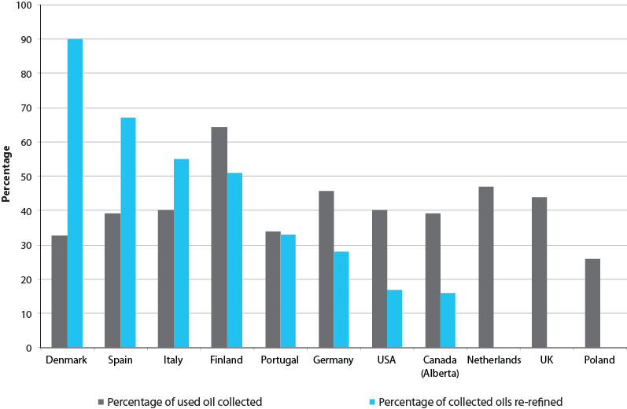

Source: ADEME (2010).

Note: The percentage of used oil collected is based on the market volume of new oils sold and the quantity recovered in 2008 (in tons). See Table 12.

The four countries with the highest re-refining rates (Denmark, Spain, Italy and Finland) mostly use different schemes for used oil management and vary substantially in the percentage of used oil collected. Other countries, for example Germany and the Netherlands, use systems that are different again, with varying outcomes (some re-refining in Germany but none in the Netherlands). As data constraints do not allow a conclusive comparison of the effectiveness of the systems in detail, a comparison of the different management models forms the basis of the following discussion.

**International systems in use**

Extended producer responsibility schemes

One of the common management approaches in the literature is that of Extended Producer Responsibility (EPR). This concept is defined by the Organisation for Economic Co-operation and Development (OECD) as ‘an environmental policy approach in which a producer’s responsibility for a product is extended to the post-consumer stage of a product’s life cycle’ (OECD 2013).

In a 2010 comparative international report for the French Agency for Environment and Energy Management (ADEME 2010), this approach was so prevalent that the eight countries investigated in depth were divided into two camps: those that use an EPR model, and those that do not.

Both EPR and product stewardship programs can be used to manage products at their end of life. The main difference between the two approaches is that funding for EPR programs is provided by producers and that costs can be internalized as a factor of production or may be passed on to consumers. By contrast, under a product stewardship program, legislated environmental fees or public funds are commonly used as a funding base (Environment Canada 2013).

EPR schemes have been implemented for various substances in many other countries and regions, including Europe, the United Kingdom, the United States, Canada, Taiwan, Japan and Korea (EPA New South Wales 2012). A 2003 study conducted by EPA New South Wales on EPR for wastes of concern (including waste oil) showed overwhelming support for the EPR approach, particularly from the twenty-three local municipalities, on the basis that EPR has the potential to reduce the burden on municipal waste collection systems and contributes to waste avoidance (EPA New South Wales 2004).

Four countries which use EPR schemes for used oil are Belgium, Spain, Italy and Portugal, and their used oil collection and recycling industries share many structural similarities.

Domestic producers and importers are responsible for the financing of collection and treatment of used oils. Operational responsibilities, in terms of selecting collectors or treatment facilities, falls to private not-for-profit enterprises that are established as part of the industry. These organisations are also charged with information and communication on the importance of recycling and collection of used oils. Enforcement and compliance responsibilities vary between countries, with some falling to regional authorities (Belgium), municipal authorities (Spain), or federal departments (Italy, Portugal). Table 8 below summarises the different approaches taken.

#### Table 8. EPR scheme responsibilities by country

| **Country** | **Belgium** | **Spain** | **Italy** | **Portugal** |
| --- | --- | --- | --- | --- |
| **Economic responsibility** | Producers and importers | | | |
| **Operational responsibility** | Not-for-profit enterprise  (collection) | Not-for-profit enterprise  (collection) | Not-for-profit enterprise  (collection and treatment) | |
| **Information dissemination responsibility** | Not-for-profit enterprise  (voluntary) | Not-for-profit enterprise  (required) | | |
| **Compliance responsibility** | Regional authorities | Autonomous communities | Ministers for Health; Economic Development; Finance and the Economy; Environment and Stewardship of the Territory and the Sea | Portuguese Environment Agency |
| **Reporting responsibility** | Producers and importers, not-for-profit enterprise | | | |

Source: Translated from ADEME (2010).

The EPR scheme is generally seen to be effective in these countries, with much of the success of these schemes attributed to the presence of established collection points; particularly where existing waste collection infrastructure for other materials has been leveraged.

The exception is Portugal where collection and recycling objectives have not yet been met. The lack of separate collection of different types of oils has limited re-refinement opportunities. Also, ‘free riding’ – where businesses put their oil to market without contributing to the management system – is a significant issue; occurring at a rate of approximately five per cent of oils collected (ADEME 2010).

Italy enjoys the oldest scheme studied, with re-refining in place since after World War II and a collection system in place for over twenty-five years.

Non-EPR schemes

Four countries that have chosen a different approach from EPR to managing used oil are Germany, Denmark, Finland and the Netherlands. Each country has its own approach to collection and treatment, particularly on how these activities are financed.

In Germany and Denmark, financing responsibilities for collection and treatment are split on the basis of oil type. In Germany, distributors bear costs for engine oil and transmission oil, while users bear costs for other oil types. In Denmark, the division is based on the ability to recycle the oil that is collected. Producers and importers bear the cost of collection for oils that are re-refinable, and users bear the costs for other oils. For example, both individual and industrial oils are collected at no charge to the user as long as they meet the definition of oils considered re-refinable under the scheme. Users of other types of oils (such as oils for marine use and certain industrial oils) must organise and bear the cost of collection.

In Finland, costs are borne by producers, importers and the Ministry for the Environment. In the Netherlands, financial responsibilities lie entirely with users, who are charged a direct collection fee for commercial collection. Domestic collection is funded through municipal rates for waste collection and disposal.

Table 9 below summarises the different approaches, there is significantly more variation between countries and approaches than seen in the EPR examples.

#### Table 9. Non-EPR scheme responsibilities by country

| **Country** | **Germany** | **Denmark** | **Finland** | **Netherlands** |
| --- | --- | --- | --- | --- |
| **Economic responsibility** | Distributors (for motor oil and transmission oil)  Users (other oils) | Producers and importers (re-refinable oils)  Users (other oils) | Producers and importers, Ministry for the Environment | Users |
| **Operational responsibility** | Distributors and users | Producers and importers through the Danish Lubricants Association (recyclable oils) | Private enterprise | N/A |
| **Information dissemination responsibility** | State government | N/A | Ministry for the Environment | N/A |
| **Compliance responsibility** | State government | Ministry for the Environment | Ministry for the Environment | N/A |
| **Reporting responsibility** | Users, collectors and recyclers | Recyclers | Private enterprise | Collectors and recyclers |

Source: Translated from ADEME (2010).

As with the EPR countries, the reported data shows that these schemes can also be effective in encouraging the collection and recycling of used oil. From the information available, the systems appear to meet the needs of the individual countries. Finland, for example, appears satisfied that its system of subsidised collection only effectively overcomes the barrier of low population density while maintaining competition within the petroleum industry (ADEME 2010). Germany and Denmark both observed that there was broad industry and community support for their measures as they were seen to come about organically and involved a high level of industry ownership.

Decentralised systems

In larger, non-European countries, management of used oils can be largely state-based rather than nationally managed. This occurs in Canada and the United States. This may be due to several factors, including the nature of responsibilities normally assumed by states under their federal structures.

Belgium is the only European country with its oversight broken up among three regions (Wallonia, Flanders and Brussels). However a not-for-profit enterprise is the sole national operator, making it more akin to the other European examples.

In Canada, provinces are responsible for the collection and management of used oil. The British Columbia, Saskatchewan, Alberta and Manitoba provinces operate an EPR scheme operated by not-for-profit organisations similar to European models. These provinces have a levy, named the Environmental Handling Charge (EHC), on wholesale suppliers of new collectable oil. A Return Incentive (RI) is paid to registered collectors for picking up materials from collection facilities and major generators and delivered to approved recycling facilities. The RI is freight-adjusted by regional remoteness, with the least populated and most remote regions receiving the largest RIs. The RI rate varies by province but in no province does it vary by oil type. An example is provided below.

### Figure 35. Saskatchewan return incentive region map

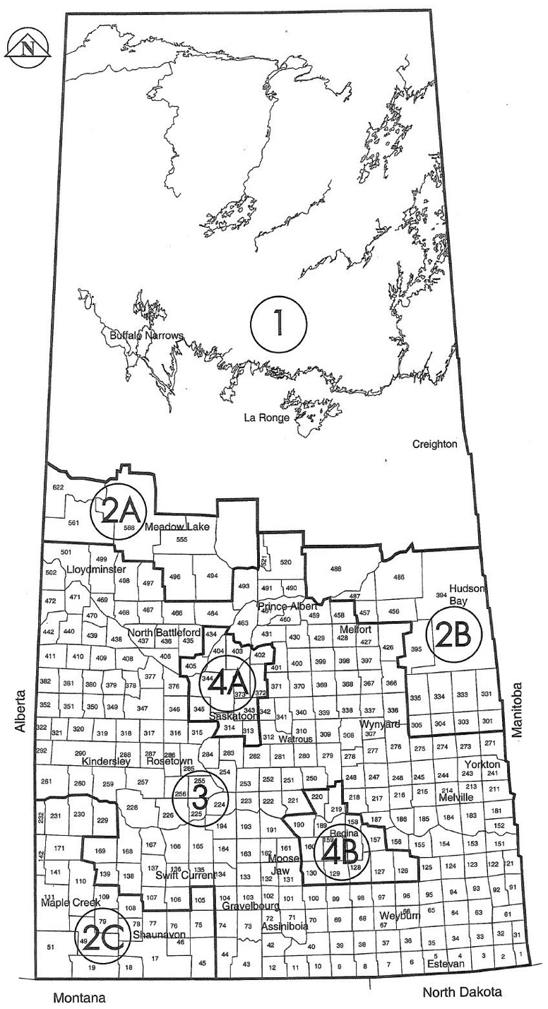

Source: Saskatchewan Association for Resource Recovery Corporation (2013).

#### Table 10. Saskatchewan return incentive region and incentive rate chart: January 2010

| **Province** | **Used oil ($/L)** |
| --- | --- |
| **1** | 0.16 |
| **2A, 2B, 2C** | 0.11 |
| **3** | 0.09 |
| **4A, 4B** | 0.08 |

Source: Saskatchewan Association for Resource Recovery Corporation (2013).

In the Prince Edward Island, New Brunswick, Nova Scotia, and Newfoundland and Labrador provinces, all users (including non-commercial) are required to transport used oil back to their retailer (or a retailer-nominated collection point) who is then charged with the disposal of the oil. No funding is provided - compliance relies on environmental protection legislation. Ontario, Canada’s most populated province, has no used oil scheme in place and relies solely on environmental protection legislation for proper disposal.

In the United States, a national directive, *40 CFR 279 Standards for the management of used oil*, stipulates standards for the collection, transport, storage and treatment of used oil. These standards must be observed in every state, although the way they are implemented can vary and additional measures in individual states are permitted. Some differences include:

• Nine states collect taxes on the sale of lubricants to subsidise collection.

• Twelve states have specific laws pertaining to the management of used oil, such as collection and specific containers.

• Twenty-four states have put in place preferential purchasing arrangements for re-refined oil products in order to stimulate demand.

• Nineteen states produce periodic reports on the amount of used oil collected and its destination.

Due to the number of individual systems between Canadian provinces and the United States (over 63 in total), each reporting differently on their performance at varying times, it was not possible in the scope of this report to conduct a detailed comparison of the performance of their systems for managing used oil. The description of their range of systems is valuable, however, in observing how non-European countries which may more closely resemble Australia in geographic expanse, political organisation, and demographics (particularly Canada) approach this issue.

Environmental objectives

One important difference between countries is the nature of the approach to the material and the environmental objectives to be achieved in their management of used oil. Although both help the environment, re-refining and collection can have competing interests. Since the quality of oil necessary for re-refining is high, emphasis or incentives promoting re-refining can hinder collection as the lowest quality (and most toxic) waste oils are not collected as they are unfit for the re-refining process, and the more remote sources of used oil are not collected because of transport costs. Although more of the used oil collected is re-refined, overall collection rates may be lower (Oakdene Hollins 2005).

Conversely, if collection is prioritised then re-refining rates may be lower as a smaller portion of the oil collected is suitable for this process. The United Kingdom for example, has a collection rate of nearly ninety per cent (see Figure 34), however it has no re-refining capability whatsoever. The country also has favourable financial arrangements for burning oil as a fuel, which makes it very attractive for combustion processes. This results in the United Kingdom importing large amounts of waste oil from other European Union countries, to the extent of 100,000 tons in 2001 (Oakdene Hollins 2005 and US Department of Energy 2006).

The European Union Directive mandates re-refining as a priority for signatories. However the extent to which this is achieved is variable (see Table 11). Some countries use re-refining targets and set a rate of collected oil for re-refining, either domestically or abroad. Denmark, for example, has limited re-refining capabilities and has most of its used oil re-refined in Germany.

#### Table 11. Policies on re-refining by country

| **Country** | **Priority given to re-refining** | **Re-refining target** | **Incentives, support, or other mechanisms to achieve target** |
| --- | --- | --- | --- |
| **Germany** | Yes | No | No |
| **Belgium** | Yes, in Wallonia. Unclear in other regions | Wallonia and Brussels sixty per cent recycling; Brussels eighty-five per cent* | Yes, in terms of payments. €1/t for recycled, €0.25/t for incineration |
| **Denmark** | Yes | No | Separate system for recyclable oils versus non-recyclable oils which is funded by oil producers and managed by an industry association |
| **Spain** | Yes | 65 per cent re-refined | Up to €66.12/t for re-refining, up to €18.04/t for other forms of treatment |
| **Finland** | Yes | No | No |
| **Italy** | Yes | No | Yes |
| **Netherlands** | Yes | No | No |
| **Portugal** | Yes | Twenty-five per cent re-refined | No |
| **Canada** | No | No | No |
| **UK** | No | No | No |
| **USA** | Theoretical | No | Procurement policies in governments that favour purchasing of re-refined oil products |

Source: ADEME (2010).

Note: In Belgium, ‘recycling’ refers to re-refinement or other re-use.

In the United States, re-refining is not so much supported by a supply-side subsidy as a demand-side policy. Since 1998, the Federal Government and some states have adopted policies that prioritise procurement of re-refined oil products in order to generate market demand and increase levels of supply, increasing market viability of the industry. Executive Order 13101 mandates all Federal agencies to take immediate steps to procure re-refined oil (US Federal Register 1998). As a result, the United States Armed Forces, Postal Service and National Park Service used re-refined oil in their respective fleets (CalRecycle 2003).This is potentially in response to the very low rates of re-refining seen in Figure 34 (seventeen per cent), higher only than Alberta, Canada, which also has no re-refining policy.

## Country case studies

Phasing out assistance: Germany

Germany began regulating the management of used oils in 1987. In 2002 it moved to prioritise re-refining which was not part of its initial legislation and contravened a 1975 European Union Directive (75/439/CEE) requiring prioritisation of re-refining and requiring governments to put in place measures to ensure collection and re-refining of used oil. A government support program for the industry was subsequently launched to meet this requirement.

From 2001 to 2007, the government put in place temporary transitional assistance arrangements to support the re-refining industry. The scheme was designed to run for seven years, and supported plants producing base oils from used oil produced in Germany and treated it to a suitable lubricant standard.

The subsidy, paid by the state, was calculated in such a way to compensate for losses incurred as a result of production of base oils from recycled oils. For 2001, the maximum subsidy was €25/t of oil, which was reduced by €2.60 every subsequent year. About €10 million in subsidies was paid out in this fashion from 2001, resulting in new treatment plants and upgrades of existing plants. As a result, the capacity for re-refining was increased from approximately 60,000 tons in 2001 to 150,000 tons in 2010.

Since the end of the financing program from 2001 to 2007, the industry has received no further financial support.

There exists roughly one hundred collectors of used oil in Germany, and tariffs for collection vary widely. These tariffs depend on the quantity, quality, transport distance and the existence of regional agreements. As of 2008, Germany reported one hundred per cent collection but only twenty-eight per cent re-refining.

Government assistance: Finland

Similarly to Germany, Finland began the legislated management of used oils in 1987 after spending most of the 1980s incinerating their used oil in burners with few emissions quality requirements. The system introduced a tax on lubricants sold in order to subsidise the collection and treatment of used oils. Oils that are consumed during their use and do not produce used oil are exempt. The tax was first put in place for a period of 10 years before being adopted permanently (ADEME 2010). The tax covers the collection, transport, storage, and pre-treatment of used oils by a not-for-profit government entity, Ekovoima, but can also be used for costs of decontaminating land that has been contaminated by used oil.

Collections are undertaken free of charge for individuals, and for businesses with more than 400 L of good quality oil. Where contamination is over ten per cent, collectors can impose fees. For businesses with less than 400 L, collection fees are imposed at a rate of €0.015/L to €0.068/L, depending on the distance travelled and the quality of the oil collected (ADEME 2010).

Finland is one of the few examples (withstanding France and Australia) where used oil management is subsidised using public funds. In the case that Ekovoima’s costs are not covered by the revenues from taxation of new oils, the government provides a subsidy (€0.09/L in 2007). For the year 2009, the Minister for the Environment budgeted €2.3 million for this subsidy. Ekovoima is also subsidised by the sale of used oils for regeneration, and a contribution from municipalities of €0.02/L for local used oil collections (ADEME 2010). The rationale behind this arrangement may stem from the low population density in Finland – only 17 persons/km2- which may make collection economically unviable without adequate support, as opposed to Germany which may have economies of scale in collection with a population density of 236 persons/km2.

Like other European countries, Finland prioritises re-refining over other uses for used oil, however, it has no set targets and does not provide financial support to re-refining industry. It has one re-refinery with a capacity of 60 ML/year. Waste oils from Russia are recycled in Finland as part of the European Neighbourhood Partnership Instrument (ENPI).

Focusing on collections: United Kingdom

The United Kingdom’s position is on one extreme of the re-refining versus collection prioritisation debate. Since 1985, it has taken the position that ‘the Government favours the regeneration of waste oil as lubricant whenever practicable, but sees no reason, environmental or otherwise, to discriminate against the use of base oil as supplementary fuel’ as expressed by William Waldegrave, Parliamentary Under Secretary of State, 1985. As a result, the United Kingdom has no priority given to re-refining, and early attempts to operate a commercially viable re-refining industry have failed (ADEME 2010 and Oakdene Hollins 2005). This lack of priority to re-refining has been the source of some consternation in the European Union, and the United Kingdom has received much negative attention for this approach.

In 2004, the European Court of Justice (ECJ) condemned the country for having failed to prioritise regeneration, and was likewise found guilty of having an inadequate regime in place and of failing to have correctly defined the notion of dangerous substances pertaining to used oil (ADEME 2010).

As a result, the United Kingdom put in place the *2007 Environmental Permitting Regulations* to act as the primary legislation for the treatment of wastes, which requires appropriate handling and disposal that is consistent with environmental and human health. Section 34 of this legislation introduces the principle of ‘duty of care’ which requires appropriate ‘cradle to grave’ management of the product throughout its life-cycle. This is regulated through a licensing system for any party that handles, stores, recycles or transports used oil, and the use of transport logs.

This emphasis on minimising waste and the lack of support for regeneration has resulted in a used oil industry entirely composed of burning. Waste oil as a substitute for fuel is supported by derogation in excise duty on the waste derived fuel product of approximately fifteen per cent of the delivered product price (Oakdene Hollins 2005). This favours demand for recovered fuel, and as the quality of fuel for burning is low – nearly all fuels collected can be used for this purpose.

The United Kingdom has clearly prioritised collection over re-refining, and as such has a high level of collection and burning but no re-refining industry.

Focusing on re-refining: Italy

At the other end of the spectrum is Italy, an EPR scheme prioritises re-refining at the expense of collections. Italy’s system of used oil management has been in place since 1982 and is one of the oldest systems examined in this review. It is managed by a central agency, the Mandatory Consortium for Used Oils (MCUO), which was formed the same year to oversee used oil management. The agency is funded by contributions from producers and importers of new oil of €155/ton (as of 2010) to compensate for the withdrawal of state funding for regeneration and a requirement that all funding for regeneration come from MCUO (ADEME 2010).

The amount of contributions is evaluated each year as a function of anticipated revenue for used oil sales at treatment centres. Being a not-for-profit agency, the sum of industry contributions and the revenue from used oil sales is designed to cover operating costs of the MCUO. In 2008, the MCUO was financed sixty-seven per cent by used oil revenue and thirty-three per cent by industry contribution.

The MCUO determines at its storage facilities what method of disposal is appropriate for used oils. As the country has a political commitment to prioritise re-refining, the majority of used oil collected is re-refined, and the rest incinerated for energy recovery or simply burned. In 2008, 0.3 per cent of oil collected was burned without energy recovery (ADEME 2010).

Waste oil collection occurs free of charge regardless of location and amount. However emulsions and oils contaminated by fuel are excluded and not considered under the collectable calculations set by the government (Oakdene Hollins 2005). This results in a free collection service for only some oils. Others, potentially those that are the most impure and environmentally hazardous, fall outside the system and do not necessarily get captured or collected.

This emphasis on re-refining has impacts on the amount and quality of used oil collected in Italy. Despite their reporting of high rates of collection (93 per cent), their definition of collectable oils excludes those that are unsuitable for re-refining and may result in high levels of used oil uncollected and unaccounted for.

## Conclusions

Although the nature of data collection and availability makes comparison difficult, the research shows that many different forms of used oil management exist in Europe and North America. EPR schemes largely based on a levy arrangement and not-for-profit operator appear to be popular and reasonably successful. Other approaches vary widely from pure markets to fully subsidised collection. In geographically expansive countries, regional approaches are favoured which tailor schemes to local conditions but can lack consistency without a federal mandate.

Countries further differ in their approaches to environmental benefits and approaches to promoting collection or re-refining of used oil. The literature appears to suggest that high levels of both are not easily achieved, and that some trade-offs between the two are inevitable without drastic intervention. Signatories to the European Union Directive are compelled to prioritise re-refining where possible, but the degree to which this is achieved varies widely.

Overall, it appears that many different approaches can be reasonably successful in achieving an acceptable level of used oil management and that there are valuable lessons from many countries. Many have strong similarities with the PSO Scheme, and others (the EPR type) are comparable to Australia’s *Product Stewardship Act 2011*. However, no particular country or system stands out as a clear exemplar to emulate, which must certainly reflect the different circumstances and drivers of the countries studied.

#### Table 12. Summary and comparison of international used oil schemes

| **Country** | **System type** | **In place since** | **Market volume of new oils 2008 (tons)** | **Quantity recovered 2008 (tons)** | **Economic data** | **Strengths** | **Weaknesses** |
| --- | --- | --- | --- | --- | --- | --- | --- |
| **Belgium - Wallonia** | EPR16 - with a reclamation obligation of used oils on importers and producers | 2002 | 110,742 | 44,711 | Producer contributions of €0.30/litre | • Based their system on existing models for disposal of industrial packaging and management of cooking oils, already practiced and accepted in Belgium.  • Largely uses existing infrastructure and did not require the creation of additional collection points by distributors. | • Implementation difficulties in Brussels as it did not have the same existing infrastructure as the other two regions.  • Costs of collection and treatment of used mineral oil in recycling depots is high. Almost half the budget of the main agency for recycling is spent on these depots; however they account for only about five per cent of the total quantity collected.  • Producers initially challenged the EPR model and spent six years in negotiations with government on the issue.  • Collectors are supportive of the measures as they now receive compensation from the main agency for submitting their collection data whereas before they did not. |
| **Belgium - Flanders** | 2004 |
| **Belgium- Brussels** | 2003 |
| **Bulgaria** | EPR | 2006 | 156,000 | 5,455 | N/A | N/A | N/A |
| **Canada- Alberta** | EPR | 1997 | 205,000 | 80,500 | • Producer contribution of €33/ton.  • Subsidy to collectors of €56-120/ton | • Seen as a successful and transparent model. The main agency establishes a three-yearly business plan and produces an audited annual report. | None listed |
| **Canada- New Brunswick** | System of return to the distributor, collection and treatment financed by distributors | 2002 | N/A | Used oils available 2,300 | N/A | None listed | • The program does not have stated targets, and the lack of information (particularly around the volume of oil on the market) does not allow for accurate performance management of the program.  • New Brunswick is looking to reform the system to more closely resemble that of Alberta. |
| **Denmark** | Dual system, depending on oil type. Voluntary system financed by oil producers and managed by the Danish association for lubricants for re-refinable oils. All other oils subject to market system financed by users. | 2000 | 61,182 | 20,000 | Producer contributions of 0.5 DKK/litre (approx. €0.07/litre) | • Presence of a system devoted to re-refinable oils permits selective collection for oils with that purpose.  • Voluntary nature of the system means producers and importers are given responsibility. | • Some supermarket chains import lubricant oils however they do not form part of the current system. Therefore they do not pay any contribution to the system and enjoy a competitive advantage. However their used oils are still collected by the system, creating further inequality. |
| **Finland** | State-managed system, financed by tax on new oils | 1987 | 70,074 | 45,000 | • Tax to producers and importers of €57.5/ton  • Subsidy to collectors of €100/ton | • Seen by the Finnish Oil and Gas Federation as flexible enough to adapt to the Finnish regional context.  • Low population density and a small population overall means that distances travelled to collect the product are long, and the volumes to be collected are small.  • This model is not deemed to encumber competition in the petroleum industry as the only collection regime is subsidised. | • This system may be reviewed as a result of the changed status of the main collection agency and new Finnish legislation on waste to respond to the requirements of the new Directive on waste. |
| **France** | Industry financed by the Agency for the Environment and Energy Management. Aid provided to collectors and to re-refinement. | 2007 | TBD | TBD | TBD | Not listed | Not listed |
| **Germany** | Dual system, depending on oil type. Mandatory free reclamation by the distributor of motor oils and oils from gearboxes, then financing of collection and treatment by distributors. Market system for all other oils. Users pay for collection and treatment. | 1988 | 1,079,576 | 493,000 | N/A | • Longevity of the system, one of the oldest in Europe.  • Good information dissemination among ‘holders’ of used oils.  • Sense that the system came about naturally, without imposing on industry actors or citizens.  • Objective to have a certain security around waste oils and avoid a lack of treatment centres.  • Generally seen as successful and no changes to the system are foreseen at the time of writing. | • Collectors express a desire for more state influence to limit the impacts of competition. For example, smaller collectors cannot always afford to collect used oils for free, whereas larger entities can. |
| **Greece** | EPR | 2004 | 81,100 | 39,000 | N/A | N/A | N/A |
| **Italy** | EPR | 1982 | 529,870 | 212,497 | Producer contributions of €155/ton (2009)  Cost of collections €133.9/ton | • Longevity of the system, with re-refinement existing since the end of WWII and the collection system in place for over twenty-five years. The objective was to conform to the requirements of European Union Directive #75/439, Waste Oils Directive.  • Seen to be effective.  • Good communication with the general public. | • The main agency responsible has succeeded in collecting more than ninety per cent of eligible oils, and seeks to increase this to one hundred per cent.  • No changes to the existing agency are foreseen, however they are looking to work with other actors (including municipalities) to increase the number of drop-off points and facilitate collection. |
| **Netherlands** | Market system financed by users. | 1998 | 115,412 | 54,000 | N/A | • Collection separated into different categories of oils allows for optimal treatment.  • Collection of used oils is less expensive for users than for other dangerous wastes. Automatic collection makes reaching 100 per cent collection targets easily attained. | • The waste processing centre to be built under the National Waste Plan of 2002-2012 has yet to be built, due to financial constraints. |
| **Poland** | EPR | 2002 | 311,000 | 80,000 | N/A | N/A | N/A |
| **Portugal** | EPR | 2003 | 93,576 | 31,695 | Producer contributions of €70/ton | • The integrated nature of the management system assures coordination among all the actors in the industry, including users. | • Collection and re-use and recycling objectives have not been met.  • No separate collection of different types or grades of used oils.  • Problem of ‘free-riding’ at a rate of approximately five per cent of oils collected. Some businesses put their oil into the market without contribution or management system.  • Desire to develop a network of collection points for particular types of used oils. |
| **Spain** | EPR | 2007 | 485,200 | 190,000 | Producer contributions of €0.06/kg | • Quantitative objectives in collection, re-use, recycling, and re-refinement are met. | • Better communication with companies and garages is needed to inform them of appropriate used oil management. |
| **United Kingdom** | Market system, underpinned by duty of care and cradle-to-grave management | 1990 | 800,000 | 350,000 | Collection carried out by private entities; therefore prices vary by a function of tax rates and the price of virgin oil. | • In each step of the product’s life-cycle, many actors are charged with assurance of appropriate management during the various phases.  • The system of a ‘waste transfer note’ ensures traceability and auditing of their path from production through to treatment.  • The communication campaign *Oil Care Campaign* informed the broader public about good management practices and promoted waste disposal centres. | • Re-refinement is not widely supported by the United Kingdom government.  • Statistics on the volumes of used oil generated, collected, and re-used are not available to the general public.  • No collection objective or management requirement is foreseen at the time of writing. |
| **United States of America** | National level framework implemented in each state (case studies California, Virginia, Michigan) | 1992 | 8,050,000 | 3,219,000 | N/A | N/A | N/A |

# Appendix D – Environmental benefits of re-refining

## Introduction

A common element in used oil management schemes existing today is the degree of prescription or guidance on how the used oil should be employed. The importance of collection and re-use of oil is generally accepted, which is undoubtedly why used oil collection schemes exist in so many countries. The schemes that have been examined as part of this review (see table at Appendix C) all have the objective of reducing environmental harm through the proper collection of used oils, and reusing the substance through either burning or re-refining. In Europe, a European Directive requires signatories to favour re-refining over burning where possible and practicable, as this is seen as the environmentally superior option. However the evidence to support this claim is not so conclusive. Based on the available studies, the benefits of re-refining versus burning vary depending on various factors, including the processes being compared, and the desired outcome.

This appendix provides a short description of recent literature on the relative benefits of re-refining in comparison to burning, based on four studies carried out between 2004 and 2013.

## Information from recent studies

In 2006, the US Department of Energy prepared a report to address its *Energy Policy Act 2005*, which specifically called for a study of the energy and environmental benefits of re-refining (US Department of Energy 2006). The outcomes of most interest in this study pertained to resource conservation and the need to reduce the United States’ (US) strategic reliance on crude oil.

This study conducted its evaluation as a two-step process: 1) calculate the energy required to prepare the used oil for combustion in a utility boiler or cement kiln, and take into account the amount of energy resources displaced in doing so; then, 2) calculate the level of energy consumption required to process the used oil into re-refined oil and the energy saved in not producing that equivalent volume of fresh virgin based oil in a crude oil refinery.

The study found that by comparing the energy required in Step 1 compared to Step 2, re-refining presents greater benefits from a total energy resource conservation point of view. Although burning had advantages in energy consumption in terms of transportation and processing, the avoided processing by re-refining instead of processing virgin oil made this process significantly more advantageous. The results are depicted in the table below.

#### Table 13. Energy savings for re-refining vs burning of used oils

|  |  |  |  |  |
| --- | --- | --- | --- | --- |
| **Energy Balance (Thousand Btu/Bbl of Waste Oil)** | **Process to Fuel and Burning** | **Re-refine** | **Variance** | **%[4]** |
| Transportation [1] | -144 | -198 | -54 | -0.9 |
| Processing consumed [2] | -294 | -742 | -448 | -7.6 |
| Processing saved [3] | 745 | 1,722 | 977 | 16.6 |
| Energy recovered | 5,564 | 5,564 | 0 | 0 |
| Net Energy/Recovered | 5,871 | 6,346 | 474 | 8.1 |

Source: Graziano & Daniels (1995) p. 50.

Notes: (a) Fuel Burning: transportation to burning facility from collection facility and re-refining transportation to re-refining facility; also takes into account indirect crude oil transportation. (b) Fuel Burning: reduce water and sediment content; re-refining: energy consumption in re-refining process including distillation and hydrotreating. (c) Fuel Burning: saved energy to produce alternative fuel for combustion; re-refining: energy saved in virgin base oil refining. (d) Percentage of 5,871 Btu/Bbl (Net Energy Recovered for process to fuel and burning).

As an estimated 780 million gallons per year of oil was recovered and burned in the US that year, the analysis above would conclude that in total the net theoretical energy savings for re-refining compared to burning is 8.1 per cent of 780 million gallons. This equates to an annual energy saving of up to 63 million gallons. The report went on to point out that the above analysis is conservative based on an independent study conducted by the Environmental Protection Agency (EPA) in 2004, which concluded that the energy consumed in re-refining is fifty to eighty-five per cent less when compared to virgin base oil refining. From a resource conservation point of view, the energy savings from re-refining were greater than burning, mainly because the energy use in refining virgin oil could be avoided.

Other studies have been less interested in resource conservation as they have with environmental pollution and human health impacts. In 2004, the Californian EPA and the University of California, Berkeley, conducted an environmental assessment of used oil management methods, which compared re-refining, distillation for marine fuel, and untreated fuel oil (Boughton and Horvath 2004).

#### Table 14. Ratios of impact characteristics for used oil combustion compared to re-refining and distillation

| **Environmental impact category** | **Ratio of used oil fuel to refining** | **Ratio of used oil fuel to distillation** |
| --- | --- | --- |
| **Terrestrial ecotoxicity potential [kg DCB equiv]** | 150 | 150 |
| **Human toxicity potential [kg DCB equiv]** | 5.7 | 5.7 |
| **Eutrophication potential [kg [phosphate equiv]** | 3.2 | 3.1 |
| **Aquatic ecotoxicity potential [kg DCB equiv]** | 2 | 2 |
| **Ozone depletion potential [kg R11 equiv]** | 1.1 | 1.1 |
| **Photochemical oxidant potential [kg ethane equiv]** | 1.1 | 1.1 |
| **Global warming potential (100yr) [kg CO2 equiv]** | 0.9 | 0.9 |
| **Acidification potential [kh SO2 equiv]** | 0.5 | 0.5 |

Source: Boughton and Horvath (2004).

Note: Based on equivalent functional units of product and energy recovery assuming no air pollution control.

The study found that consuming used oil as fuel results in terrestrial ecotoxicity impact potential of 150 times and human toxicity over five times that of re-refining or distillation due to heavy metals. Eutrophication impact potential was also three times higher due to high phosphorus content.

On the basis of potential human health and environmental impacts, the study concluded that used oil re-refining and distillation are significantly better management practices than combustion of used oil as fuel. However, this also assumed no air pollution control measures were in place, which is not necessarily representative of current practice where environmental protection legislation (rather than used oil legislation) is in place to ensure the quality of emissions from burning activities.

The study did comment on energy savings, similar to the US 2006 study, although this was not the focus. It made the important distinction between energy recovery and resource recovery, in that the combustion of used oil as fuel recovers only the energy content whereas distillation and re-refining recovers the valuable materials (at the expense of some energy and chemical inputs). To burn the product means that only the energy is recovered, whereas the product itself is lost and must eventually be replaced at a significant environmental cost. This is supported by the US 2006 study, where the preference for re-refining was based on avoided energy rather than other factors.

In 2005, German company IFEU prepared a report for the GEIR to investigate the basis of the European Union (EU) Directive 75/469 EEC on the disposal of used oils, as amended by Council Directive 87/101/EEC, which establishes priority for re-refining of used oil for recovery of base oil as long as there are no technical, economic or organisational obstacles (IFEU 2005).

The priority given to re-refining was based on the goal of resource preservation.

Previous studies from the 1990s did not show a significant benefit to the re-refinement of base oils over burning, even though a benefit over refining virgin oil could be demonstrated. The IFEU study argued the previous studies were no longer valid on the basis of important changes in the operating environment, such as:

• New regeneration technologies with improved performance have been developed and implemented.

• Regulatory requirements concerning motor vehicle emissions have enhanced the quality of lubricants.

• In today’s markets, the amounts of synthetic and semi-synthetic compounds used have increased significantly and keep on increasing. These more sophisticated and stable oils require far more energy to manufacture and allow re-refiners to manufacture high quality base oils more easily because the inherent quality of collected used oils is substantially improving (IFEU 2005).

This final point is supported by the findings of the 2006 US Department of Energy study described earlier. Their report refers to the IFEU findings on synthetics, and goes on to state, ‘as the quality of the pool of used oil increases with growing synthetic content, then the quality of the re-refined oil also increases thus displacing the higher quality virgin base oil’(US Department of Energy 2006).

A direct comparison of re-refining versus combustion yielded the following data (see figure below). The results show that the benefits of re-refining compared to burning were strongly influenced by the question of which primary fuels are substituted by waste oil combustion – however re-refining is shown to be more beneficial than direct burning for the majority of impact categories.

### Figure 36. Overview of impact assessment results where all figures relate to the particular result of re-refining

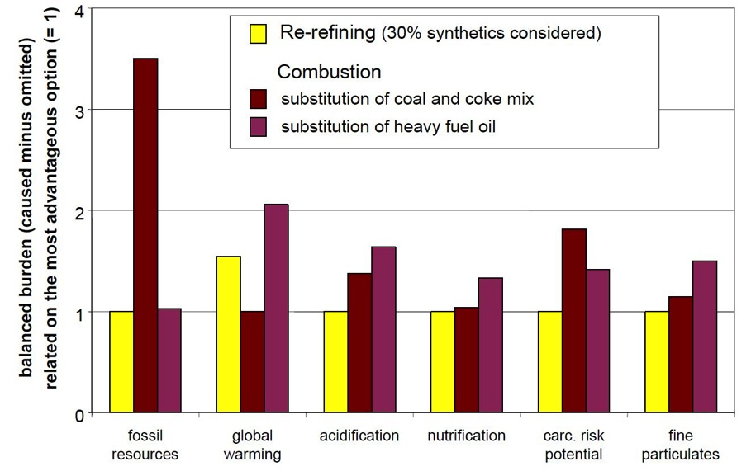

Source: IFEU (2005) p. 6.

Similar to the Californian and US energy studies, the avoided impacts on requiring further fossil fuel resources made re-refining most attractive, as well as small advantages in the other categories of human health. It was less favourable in terms of global warming, which is described in the next figure as of ‘high ecological importance’ (see figure below).

The information available on this study does not say whether or not air pollution mitigation measures were considered for the combustion scenarios, which may reduce the benefits to re-refining of fine particulates, carcinogenic risk potential, and acidification. However, these measures would do nothing to improve the case for combustion in terms of fossil resources, which is where re-refining shows the greatest benefits as an alternative.

### Figure 37. Overview of impact-related and normalised differences between average re-refining and combustion

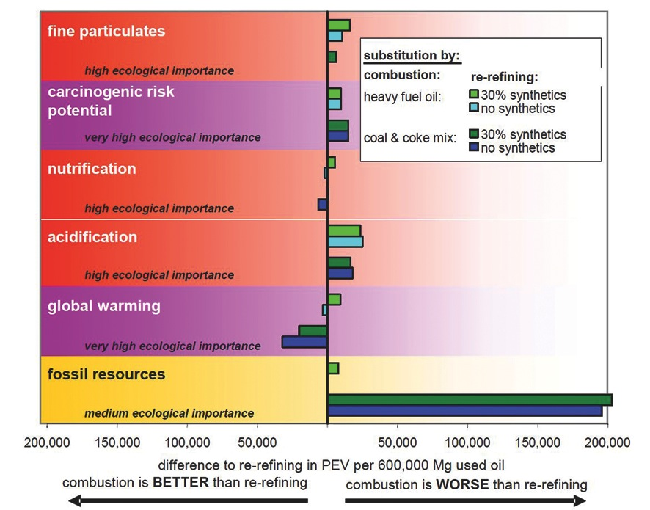

Source: IFEU (2005) p. 7.

As different substitution scenarios are present in the EU, those main scenarios are described in the study; substitution of heavy fuel, or of a coal and coke mix. The benefits of re-refining were particularly obvious when the fuel to be replaced is fuel oil or gas. Where coal and petroleum coke are substituted, combustion is more beneficial in relation to global warming.

As the proportion of synthetic compounds in used oil increases, the benefit with respect to global warming when burning used oil directly is significantly reduced. On the other hand the apparent advantages of re-refining remain stable or increase.

This study can be seen to show that the relative ecological impact of re-refining or burning favours re-refining in all aspects except its contribution to global warming, which is of very high ecological significance.

The most recent report at our disposal was an advanced draft of a Life-cycle Assessment Report of used oil processes, prepared by University of California, Santa Barbara for CalRecycle, currently in progress (CalRecycle 2013). The study discusses the impact assessment results of different models of used oil management in California using three hypothetical scenarios, as well as the 2010 base year. The hypothetical scenarios suppose that all used oil collected and reprocessed in 2010 is sent to just one of three disposition routes: re-refining (Extreme Re-refining), marine diesel oil (Extreme MDO), or fuel oil for combustion (Extreme RFO). These assumed that all available collected oil was used in the nominated fashion, such that the Extreme Re-Refining example assumes that all used oil is re-refined. The other scenarios are established likewise with combustion, and use for marine diesel oil.

The life-cycle assessment was conducted in line with ISO 14040:2006 and ISO14044:2006, and used eight impact assessment categories, listed below:

• TRACI 2.0, Global Warming Potential in kg CO2 eq

• TRACI 2.0, Acidification Potential in hydrogen ion mole equivalents (H+ moles eq)

• TRACI 2.0, Eutrophication Potential in kg N eq

• TRACI 2.0, Ecotoxicity Potential in PAF m3 day/kg

• TRACI 2.0, Human Health (Cancer) Potential in cases

• TRACI 2.0, Human Health (Non Cancer) Potential in cases

• TRACI 2.0, Human Health (Criteria Air) Potential in kg PM10 eq

• TRACI 2.0, Smog Creation Potential in kg of ground-level ozone equivalent (kg O3 eq).

For the eight metrics used, the Extreme RFO (fuel oil for combustion) scenario performed better in terms of net impacts than Extreme Re-refining in all but one case. Mostly the difference was marginal, and for four of the eight impact categories, the main impacts were entirely due to improper disposal. If improper disposal was eliminated and no longer needed to be factored into the analysis, the impacts would have been zero or negative for four of the eight categories. This is consistent with a 2005 report for the Organisation for Economic Co-operation and Development (OECD) (Oakdene Hollins 2005), which emphasises collection over any type of end use as the impacts of improper disposal are the biggest environmental risk.

The only metrics with an observed order of magnitude difference were Acidification and Human Health (air). The Extreme RFO scenario offered more than three times more avoided impacts to acidification than the re-refining scenario, although this also had net avoided (or negative impacts (RFO: -7.02E+07, ReRe: -2.19E+07). For Human Health (air), the high particulate matter in combustion showed huge impacts compared to all other scenarios, particularly re-refining which showed the greatest avoided impacts (RFO: 3.84E+06, ReRe: -9.27E+4).

For proper analysis, these metrics should be weighted and considered as to their relative importance rather than considered on par with each other.

An important note on processes comes from a life-cycle study by Kanokkantapong et al. (2009), which explains that not all re-refining or burning processes are created equal in terms of environmental impacts; several methodologies for both are available. For recycling, these include acid clay and solvent extraction. For burning, options include small boiler, vaporising burner boiler, atomizing burning boiler, and cement kiln (Kanokkantapong et al.2009). The acid clay process, which has been believed to severely undermine the environmental benefit of re-refining, actually compares well to other processes in all aspects except acidification. For burning, cement kiln burning compares favourably to other options in terms of global warming and heavy metals due to the high temperature combustion of organic compounds and heavy metals captured in mortar during the cement reaction (Kanokkantapong et al.2009). Although a complete chemical analysis of competing approaches hasn’t been reviewed, it is important mainly to note that different processes for both burning and re-refining will have varying impacts.

## Discussion

Two main outcomes were considered in the studies comparing re-refining and burning. The first is pollution mitigation, where emissions or wastes emitted into the environment could harm humans or the environment, and the other is resource conservation.

The focus of some studies has been the reduction of harmful impacts of emissions associated with both re-refining and burning. From this point of view, the body of evidence leans toward support for re-refining with results of high rates of ecotoxicity, carcinogenic risk potential and presence of particulates in burning processes that make it more hazardous – although it rates better for contribution to global warming. These studies also may or may not have assumed any pollution mitigation measures (such as smoke stack scrubbers), which could have a significant impact on these findings. A recent study underway in California contradicts this, with data suggesting that acidification impacts are three times greater in re-refining than burning, and ecotoxicity impacts are on par. The study goes on to corroborate the human health aspects of earlier studies, with human health impacts significantly greater under burning scenarios than re-refining scenarios.

The second outcome that is often considered is a related, but different, objective of resource conservation. Given the resource intensity of all the processes involved and in extracting crude oil, energy conservation is undoubtedly also an important environmental issue. If the objective is energy resource conservation, studies in the US from 2004 and 2006 and from Europe in 2005 demonstrate that re-refining is a superior option to burning. The US study pointed specifically to a conservative eight per cent in energy savings when using re-refining over burning.

Improper disposal is seen to be an important factor in terms of ecological benefits and avoided impacts. A 2005 OECD study found that impacts of improper disposal were more hazardous than the outcomes of either re-refining or burning. The recent Californian life-cycle analysis also found impacts were neutralized or negative in both re-refining and burning scenarios in some aspects when improper disposal was removed from the analysis. This demonstrates that improper disposal may completely negate the benefits of either re-refining or burning, and thus should be prioritised.

## Conclusions

Of the four reports that are summarised above, three conclude that re-refining is a superior option to burning fuel oil from an environmental point of view mainly due to the avoidance of new fossil resources being extracted to service fuel needs. However, as noted above, a number of studies suggest the largest environmental gains are achieved through the avoidance of improper disposal of used oil. This could suggest that strategies that favour re-refining at the expense of collection could be less environmentally beneficial than strategies that balance collection and burning with re-refining.

Current information about the magnitude of benefit of re-refining versus burning suggests that it is important to consider the relative priority of environmental objectives being sought by any regulatory regime before attempting to determine which end use should be favoured over another. At this stage, it also appears that there is insufficient information or evidence to provide conclusive guidance on the extent to which one end use should be favoured over another by regulatory regimes such as the PSO Scheme.

# Appendix E – Extended producer responsibility under the *Product Stewardship Act 2011*

As described in Appendix D, European countries have been operating EPR schemes for collection and recycling of used oils for about twenty years, with varying results. Based on that overseas experience and discussions during this review with the importers and distributors of new oils, and participants in the oil collection and recycling industry, we have attempted to articulate how such a scheme might work in Australia as a replacement for the existing PSO Scheme, and its relative strengths and weaknesses.

Firstly a syndicate of some kind is formed, involving the producers, importers, distributors and representatives of (or the major companies in) the oil collection and recycling industry – perhaps also with representatives from government or environmental non-governmental organisations. The syndicate has the responsibility and authority for collecting a levy from all importers and distributors – or they make financial contributions regularly on a pro-rata basis related to their volume of relevant products distributed. This aspect is handled under the scheme by the Customs service and the Australian Taxation Office (ATO), which have data and revenue collection powers, so the syndicate would need both the means of ascertaining who has to contribute how much, and the power to demand such contributions and levies.

The government, in determining whether the proposed scheme is acceptable under the *Product Stewardship Act 2011*, would consider:

• the level of collection that must be achieved each year – as an absolute amount or as a percentage of each importer and distributor’s sales

• whether maximum limits are imposed on how much can be exported annually or how much can be burnt as fuel within Australia

• whether minimum limits on how much lube-to-lube recycling must be achieved in Australia each year; if any

• whether spatial targets are imposed (such as for rural and remote area collection so that the entire target cannot be achieved just through intensive collection in urban areas or other concentrations of used oil such as major mining operation) or whether the targets are to apply on a state-by-state basis.

The syndicate’s (termed an arrangement in the *Product Stewardship Act 2011*) role is to try to achieve the required level of collection and proper disposal. It would seek to do so at the lowest possible cost. It has strong commercial incentives to minimise the impost on the retail prices of the oils being sold to consumers, but has to be self-financing so it seeks out the lowest cost ways of meeting the mandatory targets.

The cheapest option to the syndicate might be to simply collect as much oil as possible, starting from the easiest, cheapest sources, continuing until the minimum requirement has been reached, and export all or most of this collection to Asia. Each additional constraint imposed by government will increase the cost of meeting the minimum obligations – for example if some very expensive collections for remote areas are compulsory; if increasing amounts of re-refined base oils must be generated within Australia.

Potential advantages

The syndicate would have flexibility and implement measures that are not possible under the current scheme. For example:

• it might offer different incentive payments in Western Australia than on the east coast, to reflect the much higher collection costs – it is not constrained to have a uniform national set of incentive payments for specific grades of oil, or types of re-use . Similarly it could offer higher incentives for oils collected in remote areas if it has to achieve some target there

• it is not constrained to make payments only on the basis for cents per litre (cpl) of product sold – it might make capital grants to new collectors or processors; or it could invest in collection infrastructure to be shared by many collectors (akin to transitional assistance funding under the Scheme between 2003 and 2007)

• it can offer incentives in other ways, like off-take arrangements with the existing re-refiners to take their products back to market at higher prices than currently (eliminating the ten to fifteen per cent discount that re-refiners often have to accept to be able to sell their base oils to blenders who prefer, for various reasons, not to accept it).

Perhaps the most obvious advantage from the Australian Government’s viewpoint is that such an arrangement is by definition is self-financing and fully funded by the industry supplying the products and the products’ users – the question of the government having to manage a surplus or deficit in the Scheme does not arise.

The syndicate would have much greater flexibility in what it does and how, than the existing Scheme based on uniform national schedules of benefits for prescribed categories.

But given the syndicate’s strong incentive to only just meet the required targets at the lowest possible costs, the government has to give considerable thought to how and where the limits are set, and then must remain vigilant that the required goals are in fact being achieved. There are consequences of setting the targets too high or too low, or having too many different targets that could potentially conflict.

Whereas the Scheme is independently reviewed every four years to ensure that the goals are being met and that the scheme is still effective, efficient and appropriate, the syndicate could continuously monitor changes in market conditions or new technologies. This may give the collection and recycling industry more confidence than the periodic Yes/No decisions every four years.

There would be a range of information required to ensure that the EPR arrangement continued to meet national objectives effectively and efficiently, particularly from those engaged in the oil supply and the oil collection industry, from state and local government officials and from environmental NGOs. Suggestions for raising the minimum collection percentages, or the re-refining targets, could come from any such interest, or from universities, or scientific organisations (such as the CSIRO or the Academy of Technological Sciences and Engineering). It may not be expensive to collect information, and it may not be necessary to commission special technical studies (such as used oil generation surveys) if the coordination mechanism is operating well. Regardless of the nature of the proposed change in threshold (up or down), or the source of the proposal, the challenge for the Commonwealth is to be sufficiently well-informed to make periodic changes that will actually improve the outcomes that the arrangements achieve, without disrupting or destabilising the scheme.

There are possible mutual benefits in the implementation and administration of such a scheme. For the industry there is greater autonomy over how the scheme is implemented as well as the greater flexibility already mentioned. Governments may be relieved to not have to directly administer the scheme through the ATO, Customs and the Department of the Environment. However, government involvement is still necessary in ensuring the public good and environmental objectives are met, and that the financial impost on consumers is minimised. Perhaps the most difficult and contentious role of government in an industry run scheme is ensuring that the targets set (and periodically revised) are not too high or too low.

Appendix F – Modelling assumptions

## Assumptions for all scenarios

• Ninety per cent of pre-existing Category 6 claim volumes will not be claimed due to *RRR v. ATO (2013)*

• Sales of volumes associated with pre-existing category claims (the ninety per cent referred to above) decline over time due to decline in burner market and some uptake by re-refiners

• Increasing growth rate for virgin oil sales equal to four per cent 2012-13 to 2014-15, three per cent 2015-16 to 2017-18 and one per cent 2018-19 to 2027-28

• Recycled oil sales is equal to the volume of Category 1 production and sales

• Growth in new re-refining capacity (see below for specific assumptions)

• Assumed growth in drawbacks and refunds equal to growth in virgin oil sales

• No Category 3 or 4 production volume or benefit claims

• Growth in projected recycled oil sales is equal to projected growth in Category 1 volumes in addition to increasing re-refining capacity due to Gladstone

**Scenario 1 – Base case/** *status quo*

• Recycled oil production grows at three per cent for first three years, and two per cent thereafter, with the exception of Category 3 and 4 which are assumed to have no volumes produced or claimed

• False claims are not removed (i.e. any false claims continue)

**Scenario 2 – Tighten loop holes and raise the PSO Scheme levy**

• Same assumptions as Scenario 1 for recycled oil production and sales growth

• False claims of 10 ML of Category 1 due to not meeting specifications are claimed as Category 5 instead

• 10 ML of claims associated with terminal uses of Category 1 no longer receive benefit, but volume is still produced and sold

• Levy is raised to 7 cpl from 2014-15 and stays at that level thereafter

**Scenario 3 – Tighten loopholes, remove Category 6 benefits, and scale down Category 1 benefits**

• All false claims are removed as above

• Levy is held at 5.449 cpl

• Category 1 benefits are reduced to 45 cpl in 2014-15 and decline by 5 cents every two years until they reach 25 cpl

• Category 6 benefits are removed completely from 2014-15 onwards

• In response to decline in benefits, recycled oil production and sales grow at a slower rate; two per cent per annum for first three years, and one per cent per annum thereafter

**Scenario 4 – Tighten loopholes, remove Category 6 benefits, scale down Category 1 benefits, increase the PSO Scheme levy and redistribute benefits to collections**

Same assumptions as for Scenario 3, but:

• Levy increased to 7 cpl from 2014-15

Note that under Scenario 4, annual surpluses are expected to be generated due to changes in the levy-benefit arrangements. A line item for collections infrastructure and incentives is generated and includes notional spending amounts, but the model does not account for what the impacts of such spending might be due to the fact that the specific amounts are notional, and the design of such measures would have a significant bearing on the nature and extent of outcomes.

**Gladstone assumptions**

• New re-refinery has an input capacity of 100 ML

• Of that input, output production is assumed to be sixty per cent for Category 1, ten per cent for Category 5, and twenty per cent for Category 6

• Capacity growth is assumed to be:

2012-13 equal to zero per cent capacity.

2013-14 equal to twenty per cent capacity.

2014-15 equal to forty per cent capacity.

2015-16 equal to fifty per cent capacity.

2016-17 equal to seventy per cent capacity.

2017-28 equal to ninety per cent capacity.

# References

Agence de l’Environnement et de la Maîtrise de l’Energie (ADEME) 2010, *Étude de la gestion de la filière de collecte et de valorisation des huiles usagés dans certains pays de l’UE,* France.

Australian Academy of Technological Sciences and Engineering 2004, *Independent Review of the Transitional Assistance Element of the Product Stewardship for Oil (PSO) Program*, viewed June 2013, <http://www.environment.gov.au/settlements/waste/oilrecycling/publications/pubs/ta-review.pdf>.

Australia, Parliament 2000, *Second Reading Speech,* viewed June 2013, <http://parlinfo.aph.gov.au/parlInfo/genpdf/chamber/hansardr/2003-03-27/0024/hansard_frag.pdf;fileType=application%2Fpdf>.

ABS – See Australian Bureau of Statistics.

Australian Bureau of Statistics 2009, *Environmental Issues: Waste Management, Transport and Motor Vehicle Usage Survey March 2009*, viewed June 2013, <http://www.abs.gov.au/AUSSTATS/abs@.nsf/Lookup/4602.0.55.002Main+Features1Mar%202009>.

Australian Bureau of Statistics 2012, *Environmental Issues: Waste Management, Transport and Motor Vehicle Usage Survey March 2012*, viewed June 2013, <http://www.abs.gov.au/AUSSTATS/abs@.nsf/allprimarymainfeatures/E0168CED3B9E9884CA2576730012E8E5?opendocument>.

ATO – See Australian Taxation Office

Australian Taxation Office 2013a, *PSO benefit rates*, viewed June 2013, <http://ato.gov.au/Business/Fuel-Schemes/In-detail/Product-stewardship-for-oil-program/About/Product-Stewardship-for-Oil-program/?default=&page=4>.

Australian Taxation Office 2013b, *Excise Tariff Working Pages*, viewed June 2013, <http://law.ato.gov.au/atolaw/view.htm?Docid=PAC/BL030002/1&PiT=99991231235958>.

Australian Taxation Office 2013c, *Cooper Bros Holdings Pty Ltd trading as Triple R Waste Management vs Commissioner of Taxation Decision Impact Statement*, viewed June 2013, <http://law.ato.gov.au/atolaw/view.htm?DocID=LIT/ICD/2011/3815/00001>.

Boughton, B & Horvath, A 2004, ‘Environmental Assessment of Used Oil Management’, *Environmental Science and Technology*, vol. 38, no. 2, pp. 353-58.

Bureau of Resources and Energy Economics (BREE) 2013, *2013 Australian Energy Statistics Data*, viewed July 2013, <http://www.bree.gov.au/publications/aes-2013.html>.

California Department of Resources Recycling and Recovery (CalRecycle) 2003, *Oil Does Not Wear Out...It Just Gets Dirty*, CIWMB Publication no. 611-01-002, California, USA.

Chong, J, Mason, L, Pillora, S & Giurco, D 2009, *Briefing Paper – Product stewardship Schemes in Asia: China and Taiwan, Japan and South Korea*, paper prepared for the Department for the Environment, Water, Heritage and the Arts, by the Institute for Sustainable Futures, UTS, Sydney.

Australian Government Department of the Environment 2013, *Annual Reports from 2000-01 to 2011-12*, viewed June 2013, <http://www.environment.gov.au/about/publications/annual-report/index.html>.

Environment Canada 2013, *Extended Producer Responsibility*, viewed June 2013, <http://www.ec.gc.ca/gddmw/default.asp?lang=En&n=FB8E9973-1>.

Environmental Protection Authority (EPA) New South Wales 2004, *Report on the Extended Producer Responsibility Preliminary Consultation Program*, Department of Environment and Conservation, Sydney, viewed June 2013, <http://www.environment.nsw.gov.au/resources/waste/epr/reportepr.pdf>.

Environmental Protection Authority (EPA) New South Wales 2012, *Extended Producer Responsibility: overview*, viewed June 2013, <http://www.environment.nsw.gov.au/warr/EPR.htm>.

Graziano, D & Daniels, E 1995, *Assessment of Opportunities to Increase the Recovery and Recycling of Waste Oil*, Department of Energy, Argonne National Laboratory.

Indexmundi 2013, *Crude Oil (petroleum), Price Index Monthly Price*, viewed June 2013, <http://www.indexmundi.com/commodities/?commodity=petroleum-price-index&months=120>.

*Institut für Energie- und* Umweltforschung (IFEU) 2005, *Ecological and Energetic Assessment of Re-refining Used Oils to Base Oils*, report commissioned for Groupement Européen de l’Industrie de la Régénération (GEIR), Heidelberg.

MMA – See McLennan Magasanik and Associates.

McLennan Magasanik and Associates 2005, *Markets for Recycled Oils in Australia*, prepared for the Department of the Environment and Heritage, Canberra.

McLennan Magasanik & Associates 2008, Market Snapshot of Australia’s Used Oil Recycling Industry, prepared for the Department of Environment, Water, Heritage and the Arts, Canberra.

Meinhardt Infrastructure & Environment Group 2002, *Used Oil in Australia*, Environment Australia.

Nixon, H & Saphores, J 2002, *Used Oil Policies to Protect the Environment: An Overview of Canadian Experiences*, viewed June 2013, <www.uctc.net/papers/666.pdf>.

Oakdene Hollins 2005, *Improving Markets for Waste Oils*, paper prepared for Organisation for Economic Co-operation and Development, United Kingdom.

Organisation for Economic Co-operation and Development (OECD) 2013, *Environmental policy tools and evaluation: Extended Producer Responsibility*, viewed June 2013, <http://www.oecd.org/env/tools-evaluation/extendedproducerresponsibility.htm>.

PriceWaterhouseCoopers 2009, S*econd Independent Review of the Product Stewardship (Oil) Act 2000*, viewed June 2013, <http://www.environment.gov.au/settlements/waste/oilrecycling/publications/pubs/final-report.pdf>.

Product Policy Institute (PPI), *Product Stewardship and Extended Producer Responsibility: Definitions and Principles*, viewed June 2013, <http://www.productpolicy.org/content/epr-principles>.

Saskatchewan Association for Resource Recovery Corporation 2013, *Our Components – Return Incentives*, viewed June 2013, <http://usedoilrecyclingsk.com/webcura/files/253585_sarrc_return_incentive_rates_and_regions.pdf>.

United States (US) Department of Energy 2006, *Used Oil Re-refining Study to Address Energy Policy Act of 2005 Section 1838*, Washington DC, USA.

United States (US) Federal Register 1998, *U.S. Executive Order 13101: Greening the Government Through Waste Prevention, Recycling, and Federal Acquisition*, Washington DC, USA, viewed June 2013, <http://www.epa.gov/epp/pubs/13101.pdf>.

Vorapot Kanokkantapong et al. 2009, ‘Used lubricating oil management options based on life cycle thinking’, *Resources, Conservation and Recycling*, vol. 53, pp. 294-99.

Western Australian Department of Environment (WADE) 2004, *Guideline for Controlled Waste Generators*, viewed June 2013, <http://www.dec.wa.gov.au/component/docman/doc_download/2820-guideline-for-controlled-waste-generators.html?Itemid=1>.

# Document history

## Revision:

|  |  |
| --- | --- |
| **Revision no.** | **04** |
| Author/s | Ryan Gormly, Neil Byron, Will Fargher |
| Checked | Neil Byron |
| Approved | Will Fargher |

## Distribution:

|  |  |
| --- | --- |
| **Issue date** | **27 September 2013** |
| Issued to | Department of the Environment |
| Description: | Final report |

## Citation:

Aither (2013), Third independent review of the *Product Stewardship (Oil) Act 2000*, Canberra.

## For information on this report:

Please contact: Will Fargher, Director

Mobile: 0402 336 614

Email: will.fargher@aither.com.au

1. See the Independent Review of the Product Stewardship (Oil) Act 2000 by the Allen Consulting Group (available at <http://www.environment.gov.au/settlements/waste/oilrecycling/publications/pubs/pso-review.pdf>) and the Second Independent Review of the Product Stewardship (Oil) Act 2000 by PriceWaterhouseCoopers (available at <http://www.environment.gov.au/settlements/waste/oilrecycling/publications/pubs/final-report.pdf>).
2. See the Product Stewardship (Oil) Bill 2000 Explanatory Memorandum (available at <http://www.austlii.edu.au/au/legis/cth/bill_em/psb2000285/memo1.html>).
3. See Department of the Environment ‘Product Stewardship for Oil Program (PSO)’ website for more detail on Departmental responsibilities (available at <http://www.environment.gov.au/settlements/waste/oilrecycling/program/index.html>).
4. Department of the Environment data on oil sales (as reflected in Figure 1) has been used for all analysis in this report. As the PSO Scheme levy applies to all lubricating oils, it provides the most authoritative data on total oil sold, and hence the total amount of oil in the economy. In addition, the BREE dataset does not provide a definition of consumption (including how its data is derived) nor inclusions or exclusions in its definition of lubricating oil.
5. Note: a generation factor of 0.6 has been used in this case because it is widely applied in the literature and previous studies.
6. Companies often pay levies but simply pass the cost on through pricing. Users and taxpayers inevitably end up bearing the cost regardless of where in the process the levy is applied by the government.
7. In addition, used oil collection outside of the PSO Scheme, and changes in generation factors because of changing patterns of what oils are used for and where they are used, may be playing a role in creating this discrepancy between estimates of used oil generated and what is collected under the Scheme.
8. Note: volumes of used oil collected outside of the PSO Scheme are not represented in this figure.
9. Note: because PSO Scheme benefits are paid upon sale of treated or re-refined products, claimants must treat or re-refine used oil and sell it to an end user. As a result, collection companies are often owned by, or operate under contract to supply, producers of treated or re-refined used oil products.
10. In addition, Department of the Environment is undertaking a review of the Hazardous Waste (Regulation of Exports and Imports) Act 1989 and associated regulations to ensure that Australia effectively and efficiently meets its international obligations and national policy objectives for managing hazardous substances, hazardous wastes and other wastes.
11. See the Triple R Waste Management v. Commissioner of Taxation (2013) Decision Impact Statement (available at <http://law.ato.gov.au/atolaw/view.htm?DocID=LIT/ICD/2011/3815/00001>).
12. PGBR 2012/1 clarified the meaning of ‘goods produced from used oil’ and the terms ‘filtered’, ‘de-watered’, and ‘de-mineralised’. However, the ruling was partially withdrawn due to RRR v. ATO. See: http://law.ato.gov.au/.
13. Note: a full life-cycle analysis was not required to be undertaken.
14. See Appendix F for a full description of modelling scenarios and their collective and respective assumptions.
15. Aither was advised by multiple stakeholders (government and industry) that end use controls are notoriously hard to enforce due to inability to effectively monitor and the potential for intermediaries to mask or hide the end use either intentionally or unintentionally. For example, re-refined lubricating oil could be sold to an oil blending company and legitimately attract a benefit payment, but that oil company could subsequently and legitimately sell the oil into a terminal use. Or specific intermediary companies could be set up to hide the ultimate end user, which is an entirely plausible scenario if sufficient profit margins remain and there are no other market outlets for re-refined product.