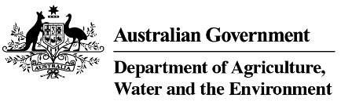

Product stewardship for Oil scheme statistics, 2017-18

Table 1: Product stewardship for Oil benefit payments, by category, 2017-18

Product  category | Product description | Volume  (litres)  2017-18 | Benefits paid  2017-18
1 | Re-refined base oil (For use as a lubricant or a hydraulic or transformer oil) | 135,157,175 | $67,578,588
Other | Other categories of oil | 131,523,461 | $7,309,385
Total |  | 266,680,636 | $74,887,973

Table 2: Product stewardship for Oil Scheme levies (excise and customs duty) collected, 2017-18

Excise tariff item | Product | Excise  2017-18 | Approved volume litres 2017-18
15.1 | Petroleum based oils (not greases) | $25,632,016 | 301,553,125
15.2 | Petroleum based oils – recycled (not greases) | $6,916,535 | 81,370,993
15.3 | Petroleum based greases | $1,069,781 | 12,585,659
Total domestic levy, collected by ATO |  | $33,618,331 | 395,509,778
Total import levy, collected by Department of Home Affairs |  | $19,769,399 | 245,785,866
Total of all levies |  | $53,387,730 | 641.295,644

Table 3: Drawbacks and refund claims 2017-18

Excise tariff item | Excise claim type | Amount  2017-18 | No of claims  2017-18
15.1 | Drawback | $3,922,820 | 73
15.1 | Refund | $91,529 | 14
15.2 | Drawback | $694,750 | 5
15.3 | Drawback | $252 | 3
Total |  | $4,709,351 | 95

Source: Australian Taxation Office

