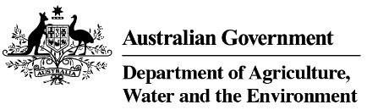

Product stewardship Oil Scheme statistics, 2018-19

Table 1: Product stewardship (oil) benefit payments, by category, 2018-19

Product  category | Product description | Volume  (litres)  2018-19 | Benefits paid  2018-19
1 | Re-refined base oil (For use as a lubricant or a hydraulic or transformer oil) | 129,957,406 | $64,978,703
Other | Other categories of oil | 136,161,800 | $7,681,604
Total |  | 266,119,206 | $72,660,307

Table 2: Product stewardship Oil Scheme levies (excise and customs duty) collected, 2018-19

Excise tariff item | Product | Excise  2018-19 | Approved volume litres 2018-19
15.1 | Petroleum based oils (not greases) | $25,371,721 | 298,490,838
15.2 | Petroleum based oils – recycled (not greases) | $4,724,572 | 55,583,194
15.3 | Petroleum based greases | $853,173 | 10,037,326
Total domestic levy, collected by ATO |  | $30,949,466 | 364,111,358
Total import levy, collected by Department of Home Affairs |  | $19,024,202 | 232,630,669
Total of all levies |  | $49,973,668 | 596,742,027

Table 3: Drawbacks and refund claims 2018-19

Tariff item no | Excise claim type | Amount  2018-19 | No of claims  2018-19
15.1 | Drawback | $1,391,081 | 51
15.1 | Refund | $365,016 | 12
15.2 | Drawback | $5,169 | 2
15.3 | Drawback | $17,053 | 12
Total |  | $1,778,319 | 77

Source: Australian Taxation Office

