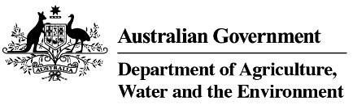

Product stewardship Oil Scheme statistics, 2019-20

Table 1: Product stewardship (oil) benefit payments, by category, 2019-20

Product  category | Product description | Volume  (litres)  2019-20 | Benefits paid  2019-20
1 | Re-refined base oil (For use as a lubricant or a hydraulic or transformer oil) | 132,571,374 | $66,544,686
Other | Other categories of oil | 364,455,893 | $23,894,389
Total |  | 497,027,267 | $90,439,075

Table 2: Product stewardship Oil Scheme levies (excise and customs duty) collected, 2019-20

Excise tariff Item | Product | Excise  2019-20 | Approved volume  litres 2019-20
15.1 | Petroleum based oils (not greases) | $26,147,084 | 307,612,751
15.2 | Petroleum based oils – recycled (not greases) | $4,525,571 | 53,226,010
15.3 | Petroleum based greases | $716,861 | 8,433,663
Total domestic levy, collected by ATO |  | $31,389,516 | 369,272,423
Total import levy, collected by Department of Home Affairs |  | $20,060,352 | 241,455,130
Total of all levies |  | $51,449,868 | 610,727,553

Table 3: Drawbacks and refund claims 2019-20

Tariff item | Excise claim type | Amount  2019-20 | No of claims  2019-20
15.1 | Drawback | $1,146,380 | 51
15.1 | Refund | $416.338 | 21
15.2 | Drawback | 0 | 0
15.3 | Drawback | $46,076 | 10
Total |  | $1,608,794 | 82

Source: Australian Taxation Office

