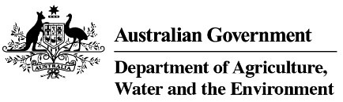

Product Stewardship Oil Scheme statistics, 2020-21

Table 1: Product stewardship (oil) benefit payments, by category, 2020-21

Product  category | Product description | Volume  (litres)  2020-21 | Benefits paid  2020-21
1 | Re-refined base oil (for use as a lubricant or a hydraulic or transformer oil) | 155,286,623 | $87,408,555
Other | Other categories of oil | 130,450,886 | $7,619,043
Total |  | 285,737,509 | $95,027,598

Table 2: Product Stewardship Oil Scheme levies (excise and customs duty) collected, 2020-21

Excise tariff Item | Product | Excise  2020-21 | Approved volume  litres 2020-21
15.1 | Petroleum based oils (not greases) | $25,027,976 | 294,446,780
15.2 | Petroleum based oils – recycled (not greases) | $5,170,894 | 60,834,051
15.3 | Petroleum based greases | $611,267 | 7,191,379
Total domestic levy, collected by ATO |  | $30,810,138 | 362,472,210
Total import levy, collected by Department of Home Affairs |  | $21,066,166 | 252,458,362
Total of all levies |  | $51,876,303 | 614,930,572

Table 3: Drawbacks and refund claims 2020-21

Tariff item | Excise claim type | Amount  2020-21 | No of claims  2020-21
15.1 | Drawback | $388,063 | 26
15.1 | Refund | $489,710 | 21
15.2 | Drawback | $504 | 1
15.3 | Drawback | $32,737 | 10
Total |  | $911,013 | 58

Source: Australian Taxation Office

