Australian Government - Commonwealth Environment Water Office Logo

Restoring our Rivers

Monitoring in Reedy Lagoon, Gunbower Forest Victoria 
Aquatic vegetation in the Murrumbidgee catchment
Fish monitoring for the Lower Murray LTIM project (South Australian Research and Development Institute)


The Pulse

2015–16

# Water used to improve the health of our rivers, floodplains and wetlands is known as environmental water

## Water is the lifeblood of regional Australia. Everything depends on it—life, livelihoods, communities, local and national economies and the environment.

A healthy river system is able to maintain productive water and soil quality to enable native plants, animals, and communities to survive and thrive.

The Murray-Darling Basin river system is home to diverse and rich natural environments, animals, plants, birds and fish that are unique to their region, including many native species listed under the *Environment Protection and Biodiversity Conservation Act 1999* (EPBC Act) as well as migratory birds and wetlands of international importance.

The river system is often placed under pressure because the natural movement, distribution, and quality of water is altered due to river regulation, water storages and other infrastructure built to support burgeoning communities and agricultural production.

*The Pulse* is an annual summary of scientific monitoring and evaluation activity commissioned by the Commonwealth Environmental Water Holder. This work assesses the impacts of water for the environment. Specifically, what is working and what is not.

Detailed long-term intervention monitoring project reports are available on the Commonwealth Environmental Water Office website at [www.environment.gov.au/water/cewo](http://www.environment.gov.au/water/cewo)

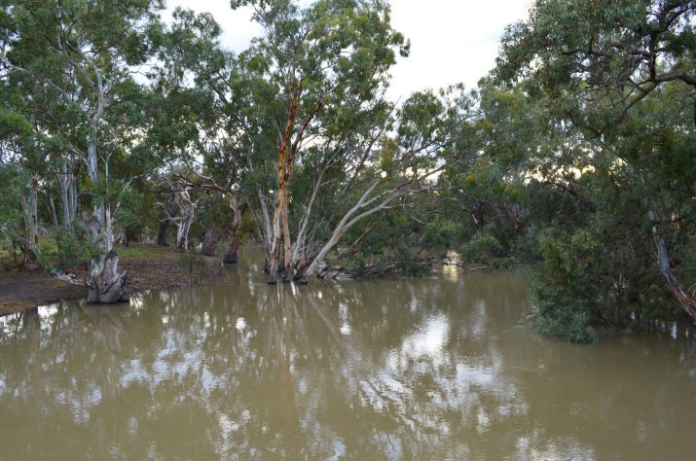  
Lachlan Booligal Wetlands, New South Wales

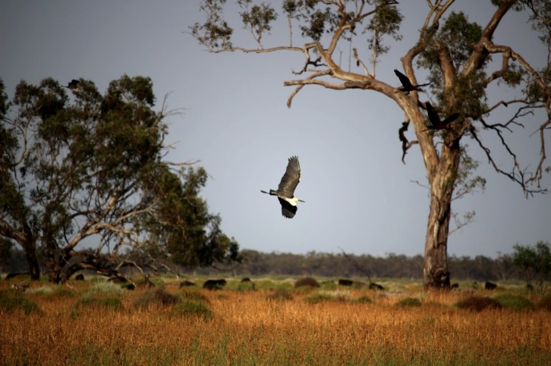  
White necked heron at U Block, New South Wales

# The bigger picture — Basin-wide strategy

## The Commonwealth Environmental Water Holder makes decisions about the most effective use of water, consistent with the longer-term outcomes outlined in the Basin-wide Environmental Watering Strategy (part of the implementation of the Murray-Darling Basin Plan).

**Basin-wide environmental watering targets**

Water Icon Improve connections along rivers and between rivers, floodplains and wetlands.

Vegetation Icon Maintain the extent and improve the condition of native vegetation.

Bird Icon Maintain current species diversity and improve waterbird breeding success and numbers.

Fish Icon Maintain native fish diversity, assist distribution throughout the system and improve spawning success and numbers.

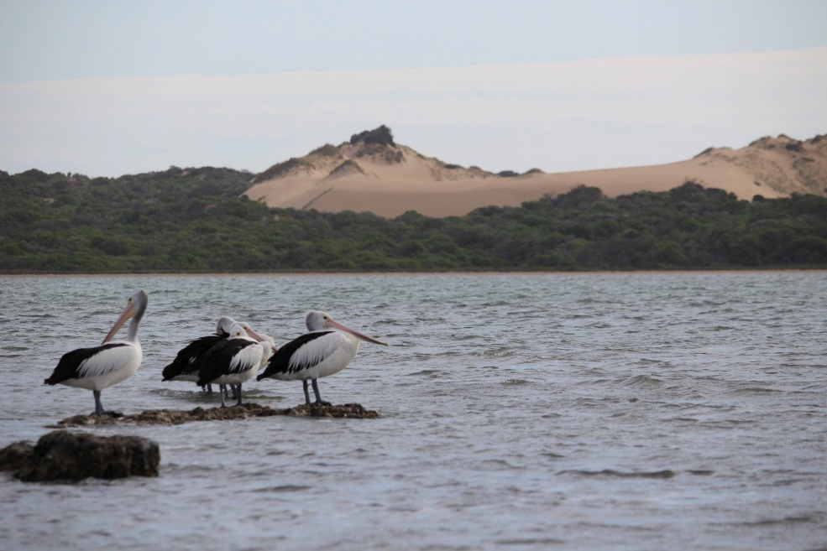   
Pelicans with the Coorong in the background

# Working in partnership to protect and restore our rivers

## Managed environmental water is a practical rehabilitation measure introduced by governments to improve some natural variability in Basin river flows and to bring back some of the flows needed to sustain the natural waterways and the environment.

Commonwealth environmental water often supplements water delivered locally by State water holders and managers and their local delivery partners.

By delivering the right amount of water at the right time and in the right place, this water is helping to connect rivers with many of the floodplains and wetlands that no longer receive the flows they need naturally.

Commonwealth and State environmental water holders and managers, their local delivery partners, non-government organisations and river operators work together to share, plan and manage the water that is available to protect and restore our rivers.

The Commonwealth Environmental Water Holder seeks advice from environmental water advisory groups and scientists working on the ground.

Six local engagement officers also work alongside State and local land and water management officers, providing outreach to communities throughout the Basin.

The Commonwealth Environmental Water Holder is particularly focused on supporting the Basin’s vast estate of wetlands listed under the Ramsar Convention on Wetlands of International Importance, and the many native animals, plants, birds and fish unique to the region, including threatened species and communities under the *Environment Protection and Biodiversity Conservation Act 1999* (EPBC Act).

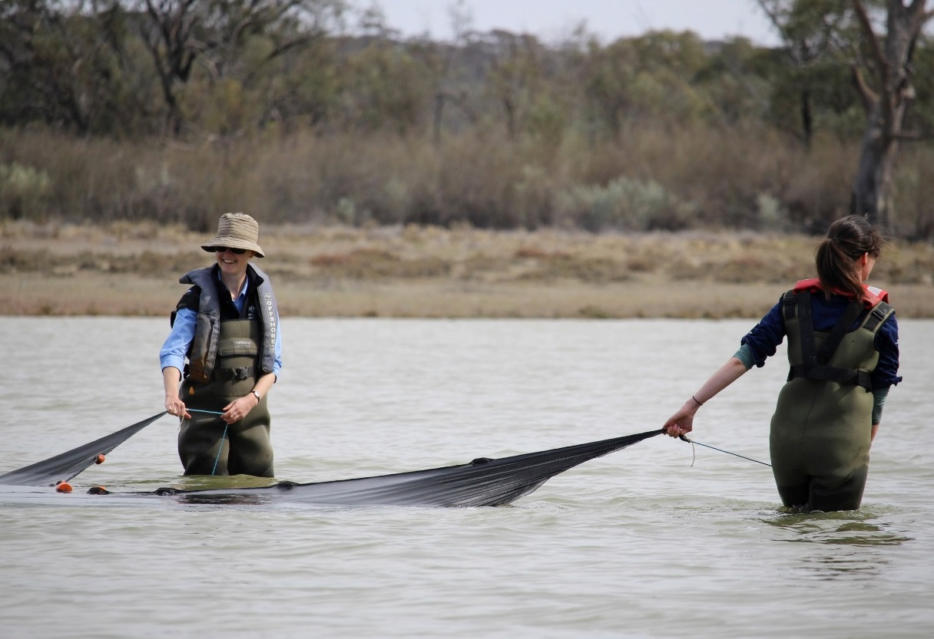

Netting sea-monkeys in the Lower Murray-Darling

# Environmental water is part of government efforts to sustainably share water resources

**National Water Account 2014–15**

**The image shows how water is shared between urban use, irrigation and the environment. 
Rainfall: 421mm, 6% more than last year, 88% of long-term average
Surface water diverted 18% less than last year.
Groundwater extracted 13% more than last year.
Uban use 374 GL supplied, 12% more than last year.
Irrigation 8176 GL supplied, 15% less than last year.
Environment 1445 GL supplied, 6% less than last year.
**

Bureau of Meteorology National Water Account for 1 July 2014 to 30 June 2015. The image shows how water is shared between urban use, irrigation and the environment. Information relevant to 2015–16 will be available later in 2017. Visit www.bom.gov.au/ water/nwa/2016

# Targeted use of water for the environment is helping to re-establish the variability in river flows that once occurred naturally.

## Environmental demands are assessed according to water availability each year and across multiple years. Water availability is influenced by conditions including the environment, climate, hydrology and river operations.

The year of 2015–16 was a year of contrast. In the hot and dry 2015, the Menindee Lakes recorded their lowest inflows, with the South Australian River Murray system at its driest in three years. However, from January to June 2016, much of the Basin started to see good rainfall and more average temperatures.

In locations where there was greater water availability, the delivery of environmental water achieved hydrological connectivity (river connections) at multiple scales, while contributing to improved vegetation condition and diversity and stable habitat for frogs, fish and birds.

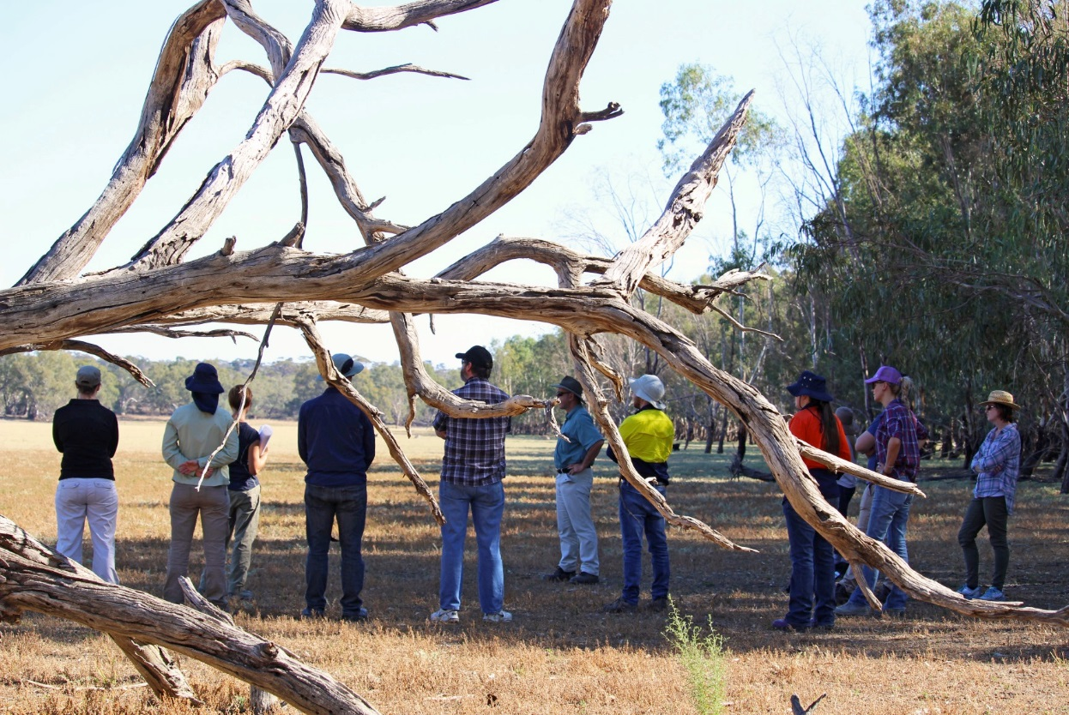

Lower Murray-Darling, Welia Victoria

## The year of 2015–16 was a year of contrast:

Heat map of basin shows the areas where rainfall was:
- Lowest on record
- Very much above average
- Below average
- Above average
- Very much above average
- Highest on record

Australian Bureau of Meteorology

# Water availability in 2015–16

## Over the past eight years, more than 5,552 gigalitres (GL) of Commonwealth environmental water has been delivered to sites throughout the Basin.

The Commonwealth Environmental Water Holder manages a large portfolio of water (made up of entitlements with annual allocations) which is acquired through the Australian Government’s investment in water-saving infrastructure and strategic water purchasing throughout the irrigation districts of the Murray-Darling Basin, as part of national water reforms (the *Water Act* *2007* and the Murray-Darling Basin Plan).

The benefits generated by environmental water are in addition to what can be achieved through natural floods, overflowing dams and other planned water releases from storages (dams, weirs, reservoirs etc.) throughout the year.

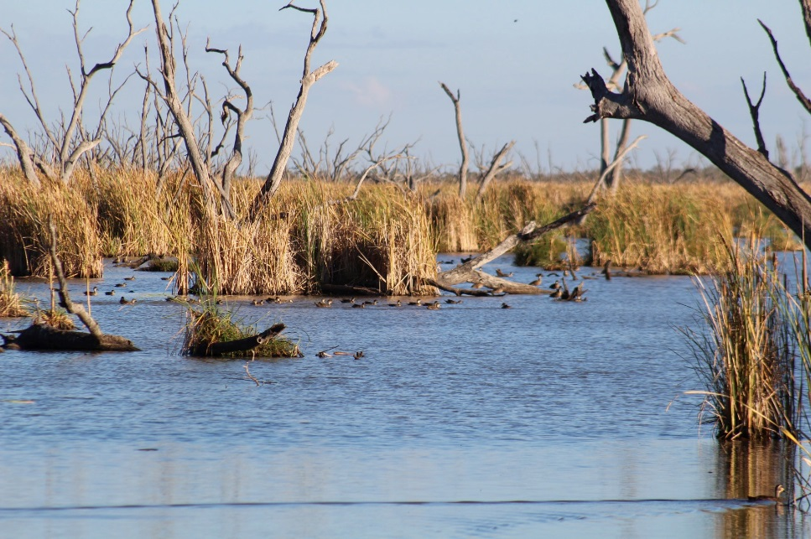  
Gwydir Wetlands, New South Wales

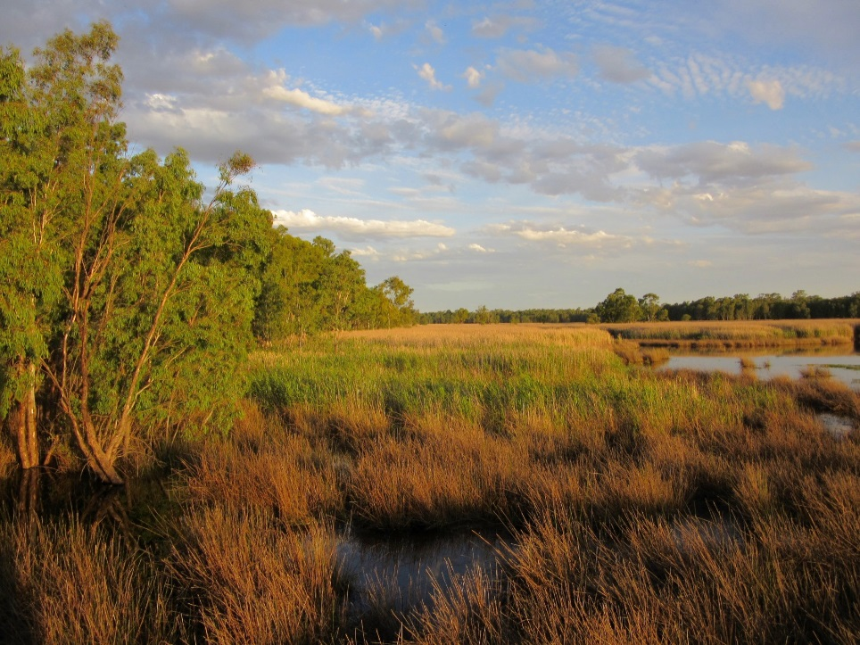  
Mid-Murray Reed Beds Swamp

## In 2015–16, the Commonwealth Environmental Water Holder had access to:

Graphic of rain gauge shows:
- 2,432 GL total water holdings
- 1,451 GL Total water available for use in 2015-16
- 361 GL unused and carried over to 2016-17
- 23 GL traded
- 1,007 GL allocation
- 444 GL carryover from previous year

# Building knowledge by delivering environmental water

## Adaptive management is a cycle that starts with water managers using the best available information to make predictions about the outcomes of different watering options and deciding which will give the best outcome, while taking into account the water availability, operational and community issues.

Graphic shows the cycle of delivering environmental water to improve and restore river health, including: long-term indicators of a healthy river system; short-term influencers on water management and delivery; environmental water decisions and steps, and government and community involvement.


# Environmental flows and their impacts on system health, what we know…

## By interrogating the effects of environmental water, we can adapt the volume, timing and location of water delivered to maximise environmental outcomes.

Outcomes from environmental water are highly dependent on the condition of the ecosystem prior to water delivery. The better the health of a site, the greater its ability to bounce back to life.

Broadscale wetland reconnections are needed to deliver water to where it is required. This provides food and habitat to support the lifecycles of our native plants and animals.

Overbank flows and wide-scale floodplain and wetland inundation are critical to deliver nutrients and organic carbon back into the stream channel—a function imperative for the process of stream metabolism to occur. However, volumes of environmental water delivered to date have been constrained by:

1. water availability (not enough water to actually achieve overbank inundation)
2. circumstances where the risk of third-party impacts (such as flooding private property) are too great, and
3. infrastructure constraints (not being able to get environmental water from A to B) due to operational issues.

## **What is stream metabolism and why is it important?**

Stream metabolism comprises two ecological processes: primary production (use of light and carbon dioxide to produce organic material through photosynthesis) and decomposition (recycling of organic matter). Measuring stream metabolism helps us to understand the processes which support and sustain aquatic foodwebs.

A lack of primary productivity could impact the food chain – e.g. less organic material for invertebrates may mean fewer fish due to a reduction in their food supply. Fewer fish could mean limited food for waterbirds and could affect breeding sites.

# River height, or flow variability, is key to healthy rivers

## A river will not thrive without a combination of different environmental flows. Each type of flow achieves different purposes at different times to support the lifecycles of our native plants and animals.

Diagram shows types of flows: overbank, bankfull, freshes, base flows and cease to flow.
.  
Victorian Environmental Water Holder

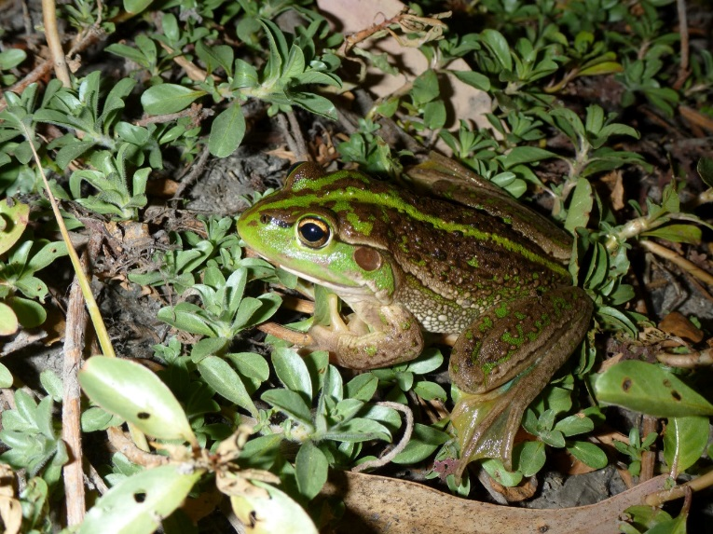  
Southern bell frog, Murrumbidgee

# The science behind environmental watering

## Building knowledge based on what is working and what is not, is key to achieving Basin-scale environmental outcomes over the longer-term.

Allocating, planning and managing environmental water is undertaken in a comprehensive and collaborative manner, drawing on best available science and local knowledge. However, it must be recognised that while there have been major advances in our knowledge, our understanding of how to allocate water to best achieve environmental outcomes is in its infancy.

By continually building and updating knowledge over time, water managers and Basin communities can better understand the needs of the environment in the context of the impacts of flow-regulating structures (dams, weirs and levees etc.) and other impediments to river flows and connectivity.

Scientific monitoring and evaluation of environmental water use helps all water users to better understand flow regimes and their various components. This work is helping to improve understanding about how flows relate to the health and diversity of fish and bird populations, vegetation and ecosystems as well as water quality and river hydrology (water flow and water connectivity to wetlands and floodplains).

Redressing environmental decline that has occurred over decades is going to take some time. It will be years before we can show lasting change and improvements to the health of the rivers, floodplains and wetlands, consistent with the long-term targets of the Murray-Darling Basin Authority’s basin-wide environmental watering strategy.

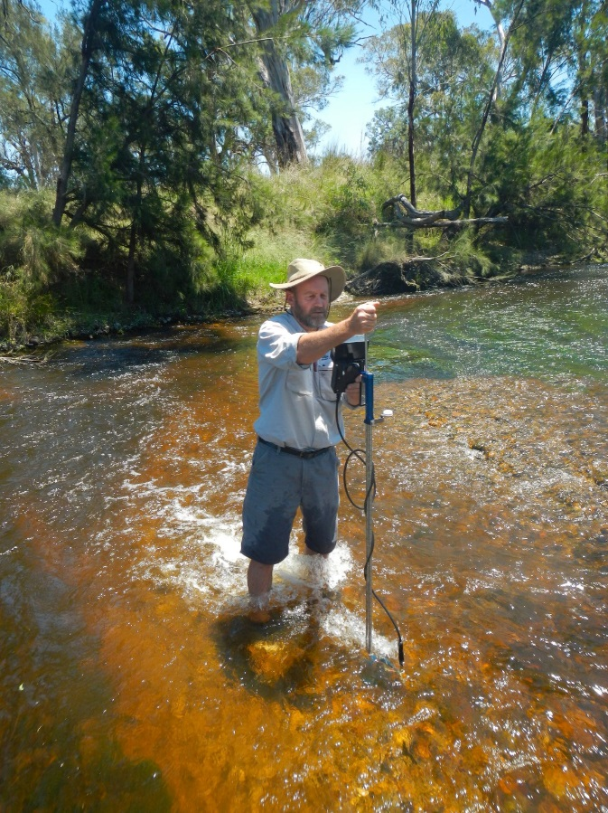  
Measuring stream flow in the Border Rivers

# Long Term Intervention Monitoring

## 2015–16 Selected Area Evaluation Projects

|  |  |
| --- | --- |
| Junction of Warrego and Darling Rivers | |
| **Lead Agency** | **Consortium Partners** |
| Eco Logical Australia  Paul Frazier  E: paulf@ecoaus.com.au  T: +61 2 8081 2681 | University of New England, NSW Office of Environment and Heritage, NSW DPI Fishing and Aquaculture, NSW Office of Water, NSW National Parks and Wildlife Services, Western Local Land Services, and Australian Floodplain Association |
| Gwydir river system | |
| **Lead Agency** | **Consortium Partners** |
| Eco Logical Australia  Paul Frazier  E: paulf@ecoaus.com.au  T: +61 2 8081 2681 | University of New England, Future North Western Local Land Services, State Water, NSW Office of Environment and Heritage, NSW Office of Water, NSW National Parks and Wildlife Services, NSW DPI Fishing and Aquaculture, Cotton Research and Development Corp., and Gwydir Valley Irrigator representatives |
| Lachlan river system | |
| **Lead Agency** | **Consortium Partners** |
| University of Canberra  Fiona Dyer  E: fiona.dyer@canberra.edu.au  T: +61 2 6201 2452 | Charles Sturt University, Central Tablelands Local Land Services, NSW Office of Environment and Heritage, NSW Office of Water, NSW DPI Fishing and Aquaculture, and University of New South Wales |
| Murrumbidgee river system | |
| **Lead Agency** | **Consortium Partners** |
| Charles Sturt University  Skye Wassens  E: swassens@csu.edu.au  T: +61 2 6051 9153 | Riverina Local Land Services, CSIRO, NSW Office of Environment and Heritage, NSW DPI Fishing and Aquaculture, and University of New South Wales |

|  |  |
| --- | --- |
| Edward-Wakool river system | |
| **Lead Agency** | **Consortium Partners** |
| Charles Sturt University  Robyn Watts  E: rwatts@csu.edu.au  T: +61 2 6051 9807 | Murray Local Land Services, NSW Office of Environment and Heritage, NSW DPI Fishing and Aquaculture, Griffith University, Monash University, Wakool River Association, Edward-Wakool Angling Association, and Western Murray Land Improvement Group |
| Goulburn river system | |
| **Lead Agency** | **Consortium Partners** |
| University of Melbourne  Angus Webb  E:angus.webb@unimelb.edu.au  T: +61 3 8344 9347 | Goulburn Broken Catchment Management Authority, Victorian Environmental Water Holder, Department of Environment, Land, Water and Planning, Goulburn Murray Water, Arthur Rylah Institute, Centre for Aquatic Pollution Identification and Management, Monash University, and SKM |
| Lower Murray River | |
| **Lead Agency** | **Consortium Partners** |
| South Australian Research and Development Institute  Qifeng Ye  E: qifeng.ye@sa.gov.au  T: +61 8 8207 5447 | University of Adelaide, South Australian Department of Environment, Water and Natural Resources, CSIRO, Primary Industries and Regions South Australia, South Australian Environment Protection Authority, South Australia Water, and Murray Darling Basin Authority |
| Basin-scale evaluation | |
| **Lead Agency** | |
| Murray-Darling Freshwater Research Centre | |
| Wodonga  E: mdfrc@latrobe.edu.au  T: +61 2 6024 9650 | Mildura  E: mdfrc@latrobe.edu.au  T: +61 3 5051 4050 |

The Commonwealth Environmental Water Holder acknowledges Australia’s Traditional Owners and respects their continued connection to water, land and community. We pay our respects to them and their cultures and to their elders both past and present.

The best approaches to environmental water management involve local knowledge. The Commonwealth Environmental Water Office regularly attends community forums, events and committees within the catchments. We continue to forge local partnerships so that community groups, including Aboriginal Traditional Owners, can help shape the regional planning and management of environmental water delivery over the long term.

**Commonwealth Environmental Water Holder**

T: 1800 803 772

E: ewater@environment.gov.au

W: www.environment.gov.au/water/cewo

Twitter Icon@theCEWH

Postal address: GPO Box 787, Canberra ACT 2601

Please contact your local engagement officer to learn more about our work or offer suggestions for the use of environmental water locally at: [www.environment.gov.au/water/cewo/local-engagement](http://www.environment.gov.au/water/cewo/local-engagement)

Creative Comms Logo

© Commonwealth of Australia

*All images are by the Commonwealth Environmental Water Office unless noted otherwise.*

**Cover images**

Monitoring in Reedy Lagoon, Gunbower Forest, Victoria

Aquatic vegetation in the Murrumbidgee catchment

Fish monitoring for the Lower Murray LTIM project (South Australian Research and Development Institute)