# Agriculture, fisheries and forestry exports increase Q1 2021

First quarter statistics for 2021 indicate that Australian agriculture, fisheries and forestry exporters are accessing more diverse markets and the value of exports is up $606m (+5%) compared with the first quarter 2018 to 2020 average.

## Exports rise after a challenging 2020

* Australian agricultural, fisheries and forestry (AFF) exporters faced a number of challenges in 2020, including the lingering effects of drought and the 2019-20 bushfires, COVID-19 lockdown measures and disruptions to the China market.
* Recovery in the first quarter (Q1) 2021 has been led by the agriculture sector, with Australian fisheries and forestry exports remaining at relatively low levels

## Grain exports up, beef exports down

* Favourable seasonal conditions will see grain exports increase in 2021, while meat and livestock exports will likely decrease as farmers rebuild their herds.
* In Q1 2021, the value of wheat exports were more than double the 2018-2020 Q1 average, while the value of beef and veal exports was down by 15% compared to the 2018-20 Q1 average.

Figure 1 Selected Australian AFF exports, Q1 2018-2020 average and Q1 2021

Source: ABS Catalogue 9920.0 and ABARES Agricultural commodities, vol. 10, no. 4

## AFF exports have been more diverse in Q1 2021

* In Q1 2021, Australia’s top-5 most valuable export markets for AFF products accounted for 43% of the total value of AFF trade, 17% lower than the 2018-2020 Q1 average of 60%.
* This has not come at the expense of the total value of AFF exports, which were $606 million higher (+5%) than the Q1 2018-2020 average.
* Export diversification in Q1 2021 is the result of a range of factors including:
  + larger than average grain crops flowing to Saudi Arabia and South East Asia
  + increased canola exports to the EU27 and chickpea exports to Bangladesh
  + reduced supply of Australian meat, leading to falling export values to major meat markets including Japan, the USA and the Republic of Korea
  + a 37% fall in the value of AFF exports to China in Q1 2021 compared with the 2018-2020 Q1 average.

Figure 2 Share of the value of Australian AFF exports by destination, Q1 2018-2020 average and Q1 2021

China (CHN)

Japan (JPN)

United States of America (USA)

European Union 27 (EU)

Republic of Korea (KOR)

Indonesia (IDN)

Rest of World (ROW)

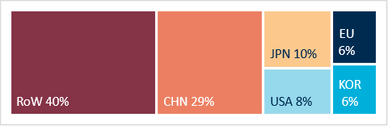

Q1 2018-2020 average

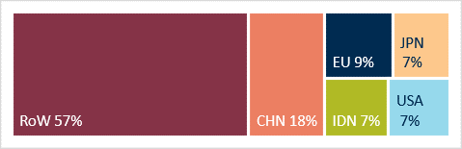

Q1 2021

Source: ABS Catalogue 9920.0 and ABARES Agricultural commodities, vol. 10, no. 4

## **Salmon exports (almost) double in 2020Q1 2021**

## Australian salmon exports almost doubled in value in 2020 and look set for another strong year in 2021. Increased exports to ASEAN nations and the United States have driven this increase.

## Salmon exports double in 2020 despite COVID-19

## Despite the challenges posed by COVID-19, the value of Australian salmon exports increased by 97% in 2020 to $247m, up from $125m in 2019.

## Increased export values have occurred in an environment of declining seafood prices. The average price of Australian salmon exports has fallen from $11.99/kg in 2018 to $10.33/kg in the first quarter of 2021. Reduced unit price is the result of several factors, including COVID-19-related restrictions on restaurant dining.

## ABARES forecasts that higher production volumes, rising global demand and greater market diversification will strengthen demand for Australian salmon over the medium-term.

## The majority of Australian salmon exports originate from the Tasmanian salmon industry and are exported from either Tasmania or Victoria.

Figure 1 Australian salmon exports by state, 2020

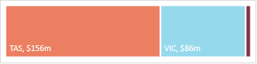

Tasmania

Victoria

Other

Source: ABS Catalogue 9920.0 and ABARES Australian fisheries and aquaculture outlook 2021.

* Favourable seasonal conditions will see grain exports increase in 2021, while meat and livestock exports will likely decrease as farmers rebuild their herds.
* In Q1 2021, the value of wheat exports were more than double the 2018-2020 Q1 average, while the value of beef and veal exports was down by 15% compared to the 2018-20 Q1 average.

Figure 2 Australian salmon exports by value and price, 2018 to Q1 2021

$/kg (left axis)

Total export value $m (right axis)

Source: ABS Catalogue 9920.0 and ABARES Australian fisheries and aquaculture outlook 2021.

## Exports and market diversification a focus for salmon industry

* The Australian salmon industry is shifting from a domestically focussed sector to one with diverse and growing export markets.
* In 2020, the value of Australian salmon exports increased to established markets, such as Taiwan, Vietnam and Japan, and relatively new markets, such as the United States, Singapore and Thailand.
* China is Australia’s most valuable salmon export market, however represented a small proportion of total export value in 2020 and the first quarter (Q1) of 2021 than in 2017-2019.
* Since its establishment in April 2020, the International Freight Assistance Mechanism (IFAM) has facilitated the export of seafood exports, including salmon. Geography and perishability make adjusting to disrupted to air-freight networks a challenge for Australian salmon exporters.

Figure 3 Australian salmon exports by destination 2017, 2020 and Q1 2021

China

Taiwan

Vietnam

United States of America

Japan

Singapore

Thailand

Indonesia

Other

Source: ABS Catalogue 9920.0 and ABARES Australian fisheries and aquaculture outlook 2021.

1 Disruptions to domestic and international market conditions and ongoing COVID-19 containment measures mean that medium term projections are subject to considerable uncertainty.

**Positive signs for exports to Vietnam**

**Q1 2021**

## Vietnam's strong economic growth and growing demand for high-quality products saw Australian agriculture, fisheries and forestry exports to Vietnam reach record highs the first quarter of 2021.

## Growth of the Vietnam market in 2021

* Vietnam was one of the few countries to record positive GDP growth in 2020 (+2.9%). The World Bank expects Vietnam’s economy to grow a further 6.6% in 2021.
* Australia exported $681m of agricultural, fisheries and forestry (AFF) products to Vietnam in quarter one (Q1) 2021, a 44% increase on Q1 2020.
* Exports were up across most commodities, including wheat, barley, cotton, beef, table grapes, logs and dairy. This reflects both improved seasonal conditions in Australia and the relatively strong position of the Vietnamese economy.
* Up until 2018, seafood products were a major Australian export to Vietnam. More recently, it has been Australian grain exports that have led to increased AFF exports.

Figure 1 Australian exports to Vietnam by sector, Q1 2015-2021

Agriculture

Fisheries

Forestry

Source: ABS Catalogue 9920.0, UN Statistics Division (UNComtrade) and World Bank. UNComtrade data for Vietnam is not available for 2020.

## Growth opportunities for both countries

* Vietnam exported US$30b of AFF products in 2019 (approx. A$42b), led by exports of nuts, fish, coffee, prawns and rice.
* Australia was Vietnam’s 12th most valuable AFF market in 2019, accounting for 2% of total AFF export value.
* Vietnam and Australia established a Strategic Partnership in March 2018 and the Australia-Vietnam Enhanced Economic Engagement Strategy is due for completion in late 2021.
* Vietnam’s growing middle-class is increasingly seeking premium grains and protein from Australia, while Vietnam’s export oriented manufacturing sector is seeking high-quality inputs for value-added products

Figure 2 Vietnam agriculture, fisheries and forestry exports by commodity 2019

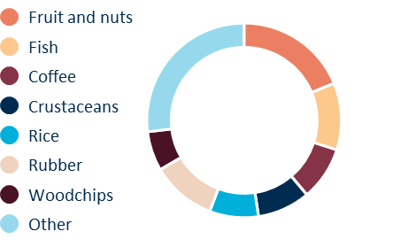

Source: ABS Catalogue 9920.0, UN Statistics Division (UNComtrade) and World Bank. UNComtrade data for Vietnam is not available for 2020.

Figure 3 Vietnam agriculture, fisheries and forestry exports by country 2019

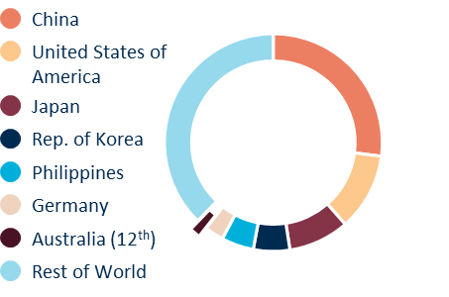

Source: ABS Catalogue 9920.0, UN Statistics Division (UNComtrade) and World Bank. UNComtrade data for Vietnam is not available for 2020.

**Australian wheat exports gathering pace**

**Q1 2021**

## Improved seasonal conditions have seen the value of wheat exports in the first quarter (Q1) of 2021 rise to $2.5b, more than double the 2018-2020 Q1 average.

## Improved seasonal conditions see increased wheat production

## With favourable seasonal conditions in many production regions, Australian wheat production is projected to reach a record high of 33.3 million tonnes in 2020-21.

## As a staple food product, COVID-19 lockdown measures have had a limited impact on demand for wheat based products.

## Market access enables export growth

## Australian wheat has favourable market access across the world and has already been exported to 53 individual countries in quarter one (Q1) 2021.

## Compared to the Q1 2018-2020 average, Australian wheat exports to Asia, the Middle East and African markets were up in Q1 2021, including Indonesia (+$320m), Vietnam (+$231m), Saudi Arabia (+$92m) and South Africa (+$70m).

## The Australian Government is working with counterparts in Brazil, a major wheat importer, to explore opportunities for Australian wheat, which currently cannot be exported to Brazil.

Figure 1 Australian wheat exports by destination, Q1 2018-2020 average and Q1 2021

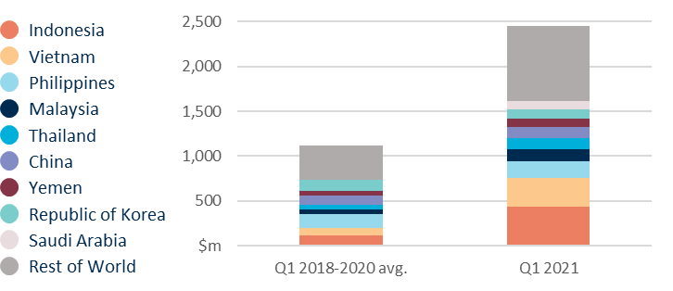

Source: International Trade Centre (TradeMap), ABS Catalogue 9920.0, ABARES Agricultural commodities, vol. 10, no. 4 and General Administration of Customs China.

## Australian wheat exports to China remain at record high levels

## Surging Chinese demand and reduced exports from some other wheat producing countries has seen Australian wheat exports to China increase.

## According to the General Administration of China Customs, imports of Australian wheat have risen from 492kt in 2018 to 1,223kt in 2020 (approx. AUD$180m to AUD $520m.

## China’s total wheat imports have also increased, growing from 3,097kt in 2018 to 8,373kt in 2020 (approx. AUD$1b to AUD $3.3b).

## In Q1 2021, 33% of China’s wheat imports were from Australia (by volume). This reflects a general increase in Australian wheat exports to China and the timing of Australia’s wheat crop, which is counter-cyclical to China’s suppliers in the Northern Hemisphere.

Figure 2 China wheat imports by country, 2018 to 2020

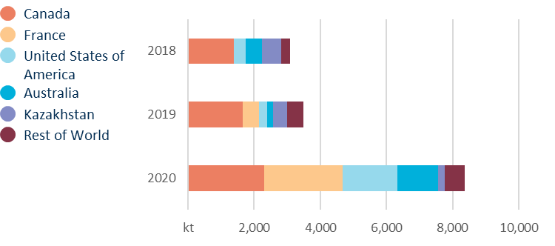

Source: International Trade Centre (TradeMap), ABS Catalogue 9920.0, ABARES Agricultural commodities, vol. 10, no. 4 and General Administration of Customs China.

**Wine exports adjusting to China tariffs**

**Q1 2021**

## Australian wine producers and exporters are diversifying their export markets but the loss of the China market saw the value of wine exports fall in the first quarter of 2021.

## Wine exports diversify, but China leaves a big hole

## In the first quarter (Q1) of 2021, Australian wine exports were substantially lower than the 2018-2020 Q1 average by both volume (-26%) and value (-29%), led by a 95% fall in the value (-$173m) of wine exported to China.

## Compared with the Q1 2018-20 average, exports of Australian wine in Q1 2021 increased to Hong Kong (+45%), Republic of Korea (+153%), EU27(+14%), and UK (+5%), while exports of wine to Indonesia rose 610% from a low base of $0.6m to $3.2m. These increases did not fully offset lost export value from disruptions to wine exports to China.

## Growth in exports to the UK, USA, EU27 and Canada in Q1 2021 resembles Australian wine export patterns of a decade ago, prior to the rapid growth of the China market.

Figure 1 Share of the value of Australian wine exports by destination, 2010 (whole year) and Q1 2021

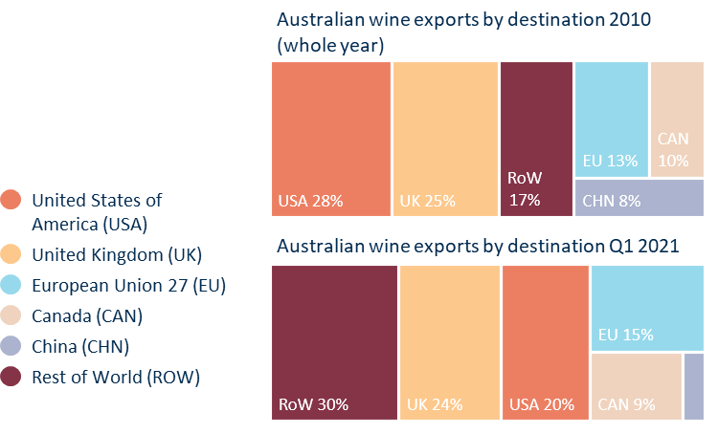

Source: ABS Catalogue 9920.0, ABARES Agricultural commodities, vol. 10, no. 4 and General Administration of Customs China.

## No increase for bulk wine exports

## The imposition of tariffs on bottled wine has not resulted in a substantial shift to bulk wine exports. Exports of Australian wine in containers greater than 2L fell from an average of $140m in Q1 2018-2020 (25% of total wine export value) to $118m in Q1 2021 (28% of total wine export value).

## Total China wine imports continue to fall, France and Chile take market share

## According to data from the General Administration of Customs China, the total value of China’s wine imports from all countries has been falling since 2017. Q1 2021 continued the general downward trend.

## The imposition of tariffs on Australian wine has seen France and Chile take an increasing share of the China market.

Figure 2 Value of China wine imports by source, Q1 2018 to Q1 2021

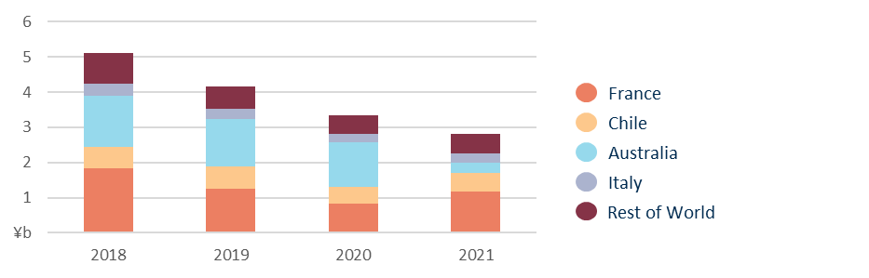

Source: ABS Catalogue 9920.0, ABARES Agricultural commodities, vol. 10, no. 4 and General Administration of Customs China.