Commercially Harvested Macropods  
2018–22

Prepared by: Industry and Development Assessment, Department of Environment and Heritage Protection

© The State of Queensland (Department of Environment and Heritage Protection) 2017

**Disclaimer**

This document has been prepared with all due diligence and care, based on the best available information at the time of publication. The department holds no responsibility for any errors or omissions within this document. Any decisions made by other parties based on this document are solely the responsibility of those parties. Information contained in this document is from a number of sources and, as such, does not necessarily represent government or departmental policy.

If you need to access this document in a language other than English, please call the Translating and Interpreting Service (TIS National) on 131 450 and ask them to telephone Library Services on +61 7 3224 8412.

This publication can be made available in an alternative format (e.g. large print or audiotape) on request for people with vision impairment; phone +61 7 3224 8412 or email <library@ehp.qld.gov.au>.

March 2017

# Definitions

Carcase—the body of an animal slaughtered for meat, after removal of the offal.

Note: from the Macquarie Dictionary.

**Dealer site**—licensed site that enables the purchase of harvested macropods from a licensed harvester but does not allow the processing of the harvested macropod.

Ecologically sustainable development—this plan employs the definition contained in the Environment Protection and Biodiversity Conservation Act 1999. In general this definition includes the precautionary principle, inter-generational equity, conservation of biological diversity and ecological integrity, and improved valuation of environmental factors.

Harvest macropod—the kangaroo or wallaroo species that can be utilised in accordance with this management plan: the red kangaroo Macropus rufus, eastern grey kangaroo M. giganteus, and the common wallaroo M. robustus erubescens and M. robustus robustus.

Note: As set out in the Nature Conservation (Administration) Regulation 2006.

Landholder includes:

(a) for a reserve under the Land Act 1994—the trustees of the reserve; and

(b) for land leased under the Land Act 1994—the lessee of the land; and

(c) for a conservation agreement under section 45 in relation to transferred land as defined under the Aboriginal Land Act 1991—the indigenous landholder for the transferred land under that Act.

Note: As set out in the Schedule Dictionary of the Nature Conservation Act 1992.

National Code of Practice for the Humane Shooting of Kangaroos and Wallabies for Commercial Purposes (the code of practice)—the current nationally endorsed code, endorsed by the Natural Resource Management Ministerial Council in 2008. A reference to this code will also apply to any future nationally-endorsed subsequent codes.

Contents

Definitions iii

1 Introduction 1

2 Legislative and regulatory framework 2

2.1 Commonwealth 2

2.2 Queensland legislation 2

3 Goal and aims 4

3.1 Goal 4

3.2 Aims 4

Aim 1 Manage and administer commercial operations via licensing 4

Aim 2—Monitor macropod populations and set quotas 5

Aim 3—— Ensure humane treatment of commercially-harvested macropods 7

Aim 4—Monitor macropod industry compliance 8

Aim 5—Undertake program reporting and review 8

Aim 6—Facilitate adaptive management and research 9

Aim 7—Promote community awareness and participation 10

4 Administration of the commercial macropod harvest 11

4.1 Animal welfare 13

4.2 Commercial Wildlife Harvesting Licence (Macropod) 13

4.3 Commercial wildlife licence for dead macropods 14

4.4 Tags 15

4.5 Movement of dead macropods 15

5 Biology and ecology of commercially-harvested macropods 16

5.1 Introduction 16

5.2 Red kangaroo *Macropus rufus* 16

5.3 Eastern grey kangaroo *Macropus giganteus* 19

5.4 Common wallaroo *Macropus robustus* 21

6 Conservation of commercially-harvested macropods 23

6.1 Conservation status 23

6.2 Predation and disease 23

6.3 Climatic variables 24

6.4 Habitat change 24

6.5 Protected areas 25

6.6 Genetic diversity 25

6.7 Long-term monitoring of commercially harvested macropod populations in Queensland 26

6.8 Proportional threshold harvesting 29

References 31

1. Introduction

The commercial macropod harvest industry in Queensland is centred on three species:

* red kangaroo Macropus rufus
* eastern grey kangaroo M. giganteus
* common wallaroo M. robustus.

The harvesting of these macropods is regulated through the following Queensland legislation:

* Nature Conservation Act 1992
  + Nature Conservation (Administration) Regulation 2006
  + Nature Conservation (Wildlife Management) Regulation 2006
  + Nature Conservation (Wildlife) Regulation 2006
  + Nature Conservation (Macropod) Conservation Plan 2005
  + Nature Conservation (Macropod Harvest Period) Notice
* Animal Care and Protection Act 2001
* Food Production (Safety) Act 2000.

In Queensland legislation, all native mammals are protected but species can be declared ‘of least concern’ wildlife and harvested, providing there is a conservation plan developed for the species. All species covered in this plan are declared of ‘least concern wildlife’ under the Nature Conservation (Wildlife) Regulations 2006 and the harvesting is provided for under the Nature Conservation (Macropod) Conservation Plan 2005.

The Department of Environment and Heritage Protection (the department) administers the harvest of macropods in Queensland in accordance with the International Union for Conservation of Nature (IUCN) Recommendation 18.24, ‘the ethical, wise and sustainable use of some wildlife can provide an alternative or supplementary means of productive land-use, and can be consistent with and encourage conservation, where such use is in accordance with appropriate safeguards’ (IUCN 1990).

The Commonwealth regulates the export of macropod products in Australia under the Environment Protection and Biodiversity Conservation Act 1999. This management plan has been developed to satisfy the requirements of this Act and to meet the legislative requirements of the Queensland Government.

This management plan is current for a maximum five-year period from 1 January 2018 to 31 December 2022.

This management plan does not provide for the harvesting of macropods within protected areas as defined under the Nature Conservation Act 1992 or State forests, timber reserves, or forest reserves as defined under the Forestry Act 1959. The combined area of these tenures within the commercial harvest zones is approximately 79,981 square kilometres.

This plan relates only to the commercial harvest of macropods in Queensland. It does not relate to the non-commercial harvest of macropods or to damage mitigation permits for macropods causing demonstrable damage to primary production.

1. Legislative and regulatory framework
   1. Commonwealth

The relevant provisions under the Environment Protection and Biodiversity Conservation Act 1999 (EPBC Act) came into force on 11 January 2002, following the incorporation of the former Wildlife Protection (Regulation of Exports and Imports) Act 1982. The EPBC Act provides legislative provisions requiring the development and approval of wildlife trade management plans in order for permits to be issued for the commercial export of wildlife products. The EPBC Act states that the Commonwealth Minister responsible for the environment may approve a wildlife trade management plan for a maximum of five years. The EPBC Act specifies that such approval must only be given if the Minister is satisfied that:

* the plan is consistent with the objects of Part 13A of the EPBC Act
* an assessment of the environmental impacts of the activities of the plan has been undertaken
* the plan includes management controls directed towards ensuring that the impacts of the activities covered by the plan are ecologically sustainable
* the activities in the plan are not detrimental to the species to which the plan relates or any relevant ecosystem
* the plan includes measures to mitigate, monitor and respond to the environmental impacts of the activity covered by the plan.

In deciding whether to declare a plan, the Minister must also consider whether:

* legislation relating to the protection, conservation or management of the specimens to which the plan relates is in force in the state or territory connected
* the legislation applies throughout the state or territory concerned
* in the opinion of the Minister, the legislation is effective.

Finally, in resolving whether to declare a plan the Minister must also be satisfied that if an animal is killed, it is done in a way that is generally accepted to minimise pain and suffering. Animal welfare standards for the commercial harvesting of macropods are detailed in the Code of Practice for the Humane Shooting of Kangaroos and Wallabies for Commercial Purposes (the code of practice), which is available on the Australian Government's website <www.environment.gov.au>. All macropods must be taken in accordance with this code or any subsequent relevant nationally-endorsed codes that replace that document.

* 1. Queensland legislation

Throughout this wildlife trade management plan, reference is made to a number of legislative documents that relate to the commercial harvesting of macropods in Queensland. While documents cited are applicable at the time of this plan’s approval, legislation is subject to amendment. A brief description of the legislation relating to harvesting macropods is as follows:

* Nature Conservation Act 1992—the principal Act in Queensland by which the conservation of nature is addressed. Section 8 of the Act states, 'nature' includes ecosystems and constituent parts, natural and physical resources, natural dynamic processes, and the characteristics of places that contribute to biological diversity and integrity or their intrinsic or scientific value.
* Nature Conservation (Administration) Regulation 2006—subordinate legislation. Section 175 of the Act allows the Governor-in-Council to make regulation for the purposes of the Act. This regulation deals with licenses, authorities and permits used in taking and keeping wildlife.
* Nature Conservation (Wildlife Management) Regulation 2006—subordinate legislation, which applies to wildlife not in a protected area and must be read in conjunction with the Nature Conservation (Administration) Regulation 2006, the Nature Conservation Act 1992, and the Nature Conservation (Wildlife) Regulation 2006.
* Nature Conservation (Wildlife) Regulation 2006—subordinate legislation. This regulation prescribes species of wildlife by class, that is, those taxa that are prescribed to be protected wildlife (presumed extinct, endangered, vulnerable, rare or least concern), international wildlife, or prohibited wildlife. The regulation also specifies the declared management intent for each class of wildlife. Under this Act, the red kangaroo, the eastern grey kangaroo and the common wallaroo are species of ‘least concern’ wildlife that may be subject to a declared harvest period (section 73 of the Act).
* Nature Conservation (Macropod) Conservation Plan 2005—subordinate legislation relating to macropod harvesting in Queensland approved under section 119 of the Act. The Act specifies the use of a harvest period and other conditions for the taking of macropods. A harvest period may be declared in the whole or any part of Queensland, and for the whole or any part of a year, as long as the harvest meets the provisions of section 73 of the Act. The provisions of this section establish management principles that relate to protected wildlife. The Act requires the harvest to be ecologically sustainable.
* Animal Care and Protection Act 2001—The purpose of this Act is to promote the responsible care and use of animals, promote standards for the care and use of animals and protect animals from unjustifiable, unnecessary or unreasonable pain. This Act has direct relationship with the code of practice with regard to breaches of the code and instances of animal cruelty.
* Food Production (Safety) Act 2000—the principle Act in Queensland that ensures the production of primary produce is carried out in a way that makes the primary produce fit for human and animal consumption. Part 5 of the Act, 'Accreditation' gives effect to this purpose by ensuring that persons producing primary produce for human and animal consumption are required to be accredited by Safe Food Queensland to conduct these activities.
* Food Production (Safety) Regulation 2014—subordinate legislation. This regulation provides the Meat Food Safety Scheme specific provisions and deals, amongst other matters, with traceability, acceptability of an animal, health and hygiene of a person, place or vehicle and transportation of an animal at any stage from a place where the animal is killed to the premises where the animal is processed.

1. Goal and aims
   1. Goal

The overriding goal of this plan is to provide for the sustainable use of macropod species covered by the plan, in accordance with the principles of ecologically sustainable development.

The principles of ecologically sustainable development are defined in the Environment Protection and Biodiversity Conservation Act 1999.

In order to achieve the overriding goal, this management plan has seven specific aims each addressing a particular aspect of the macropod management program. The management actions detail how the aims will be achieved with each action linked to a number of performance indicators. Annually the macropod management program in Queensland will be audited against the performance indicators via an annual report (Aim 5).

* 1. Aims

The aims of this management plan are:

1. Manage and administer commercial operations via licensing in accordance with the provisions of the Nature Conservation Act 1992 and Regulations and the Nature Conservation (Macropod) Conservation Plan 2005.
2. Monitor macropod populations and set commercial quotas to ensure macropods are utilised in accordance with the overriding goal of this management plan. Direct and indirect monitoring will be undertaken annually in all zones where macropods are commercially harvested.
3. Ensure humane treatment of commercially-harvested macropods in accordance with the code of practice.
4. Monitor macropod industry compliance with the Nature Conservation Act 1992 and Regulations, the Nature Conservation (Macropod) Conservation Plan 2005, and the code of practice.
5. Undertake program reporting and review via an annual reporting process to ensure outcomes remain consistent with the goal of this management plan.
6. Facilitate adaptive management and research via adaptive and flexible management practices. The department may facilitate research on commercially harvested macropods either directly where required or by assisting external institutions to improve our understanding of macropod population dynamics and management.
7. Promote community awareness and participation via a regularly updated website, annual stakeholder forums, and regular interaction with macropod industry participants and other key stakeholders.

### **Aim 1 Manage and administer commercial operations via licensing**

In order to ensure that viable populations of macropods are maintained throughout their ranges, the commercial macropod industry in Queensland is regulated via a range of licensing and tag procedures provided for under the Nature Conservation Act 1992, Nature Conservation (Administration) Regulation 2006, Nature Conservation (Wildlife Management) Regulation 2006 and the Nature Conservation (Macropod) Conservation Plan 2005. This includes licensing of harvesters, processors and dealers, design and issuing of tags and setting conditions of take.

The legislative basis for licensing and licensing procedures, are described in section 2.2.

Action 1.1—All relevant activities are licensed in accordance with the applicable Queensland legislation and departmental policy.

All applications for licenses relating to Queensland commercial macropod industry operations are to be assessed, processed and issued in accordance with the provisions of the Nature Conservation Act 1992 and subordinate legislation.

Performance indicator 1.1.1—Annual audits of licences will be conducted to ensure licences are being assessed and issued appropriately in accordance with Queensland legislation.

Performance indicator 1.1.2—Databases are maintained to ensure licensee information is current and accurate.

Action 1.2—Licence conditions are applied where required.

Performance indicator 1.2.1—Licence conditions are imposed on licences where required and in accordance with Queensland legislation.

Performance indicator 1.2.2—Information notices explaining conditions and rights of review are provided with all licences with licence conditions.

### Aim 2—**Monitor macropod populations** and set quotas

Action 2.1—Populations within the commercial harvest zones will be estimated annually based on aerial surveys. There are three commercial harvest zones: Western, Central and Eastern. Populations are estimated for the whole of the Western and Eastern harvest zones. The Central harvest zone is further divided into three separate areas (i.e., Central North, Central South and Central East) for the purposes of estimating the populations, thus giving five population estimate regions. The three population estimate regions within the Central harvest zone are combined for the purposes of setting and administering a quota for the Central harvest zone as a whole. Details of the methodologies used to conduct aerial surveys are available on the department’s website. Should there be any significant change to the survey methodology during the life of the plan the Commonwealth will be notified prior to their taking effect.

Performance indicator 2.1.1—Macropod population estimates are obtained annually via aerial surveys throughout the life of this plan.

Action 2.2—Commercial macropod harvest quotas will be set in accordance with the provisions of the Queensland Wildlife Trade Management Plan 2018–22.

The harvest quota for a species is the maximum number that can be utilised commercially in a calendar year. Macropod population estimates derived from aerial surveys (direct monitoring) will be used as the basis of setting harvest quotas following the procedures set out in this management plan. The Commonwealth Government will be advised of the harvest quotas prior to implementation via a quota submission.

Sustainable harvest quotas are calculated using a fixed proportion of the estimated macropod populations within the three Queensland harvest zones. Quotas cannot be transferred between commercial harvest zones. The proportions used vary between species and are adjusted across the state in relation to the margins of error present in population estimates for each harvest zone. The maximum proportions used for each species are 15 per cent of populations for eastern grey kangaroos and common wallaroos, and 20 per cent of the population for red kangaroos. These maximum proportions are applied only to populations within the Central Harvest Zone where survey effort is greatest and hence confidence limits for population estimates are within acceptable limits. In both the Eastern and Western harvest zones more conservative harvest proportions of 10 per cent are used for species for which a quota is set. These sustainable-use harvest proportions are based on research and modelling undertaken by Caughley et al. (1987) and Hacker et al. (2004) and are currently accepted by the scientific community as being sustainable. Should there be any significant change to the harvest zone boundaries or the sustainable harvest quotas during the life of this plan the Commonwealth will be notified prior to their taking effect.

Performance indicator 2.2.1—All commercial macropod harvest quotas are set in accordance with the provisions of the Queensland Wildlife Trade Management Plan 2018–22 throughout the life of the plan.

Performance indicator 2.2.2—The Commonwealth Government is advised of commercial harvest quotas for the following calendar year by 30 November.

The quota submission will contain the following information:

* population estimates for each species in each population estimate region
* quotas calculated as proportion of population estimate
* any proposed changes to quotas
* any changes to the commercial harvest zones
* data outlining trends in population estimates, quotas and harvest.

Performance Indicator 2.2.3—If Commonwealth approval is required for quotas set above the rates specified in this plan as part of an adaptive management experiment, such approval is obtained before the additional quota is implemented.

Performance Indicator 2.2.4—The quota report is made available to the public via the department's website.

Action 2.3—Special macropod harvest quotas will be set in accordance with the provisions of the Queensland Wildlife Trade Management Plan 2018–22.

A special quota will be set annually at a maximum of one and a half per cent (1.5 per cent) of the population estimate of each commercially harvested macropod species. The special quota for a specific harvest zone can be up to five per cent for that zone but the total special quota for that species cannot be greater than 1.5 per cent of the total population estimate for the three zones combined.

The sole purpose of special quota allocations is to provide for commercial utilisation of macropods that would be shot and left in the field under the normal non-commercial licensing system. The use of this quota will depend on one or more of the following:

* climatic trends and local conditions
* exceptional circumstance declarations
* macropod population trends.

Special quota allocations and the use of the special quota will be reported to the Commonwealth in the quota report and annual report.

Performance Indicator 2.3.1—Special macropod harvest quotas are set and utilised in accordance with the provisions of the Queensland Wildlife Trade Management Plan 2018–22.

Action 2.4—Macropod populations will be monitored indirectly throughout the life of this plan.

Indirect data on macropod populations will be obtained continuously throughout the life of this plan from commercial macropod industry returns. Dealer returns detail the number of each species taken and date, average carcase weights, sex and location of harvest.

Ongoing monitoring of dealer returns by the department will identify significant changes in the average weights of harvested macropods, which, for example, can provide an indication of population health. Dealer return data also provide an accurate record of the sex ratio of the macropod harvest. If the percentage of females harvested is greater than 40 per cent in any calendar quarter, possible contributing factors will be examined. If necessary, management action will be taken to ensure the sustainability of the macropod population. Actions may include reducing or suspending the commercial harvest for that species in that zone or increasing survey intensity during the next survey period.

Performance indicator 2.4.1—Where a harvest zone showed greater than 40 per cent female harvest, then appropriate management action would be taken.

Action 2.5—Annual population estimates for commercially harvested macropod species will be assessed against predetermined trigger points in each population estimate region. Should an estimated population go below the predetermined trigger point, harvest quotas will be adjusted accordingly. Notification of a change in quota will be communicated to the industry via a revised Harvest Period Notice. A special quota could not be set when an estimated population has gone below the predetermined trigger point.

Macropod harvest quotas in Queensland have been based on a fixed proportion of the estimated population since 1984. Known as constant proportional offtake, this strategy is considered of low risk for species where the estimation of population size is regular and accurate (Engen et al 1997, McLeod & Pople 1998, Pople 2004). Precision in the estimate of population size is important for monitoring trends in the population. Increasing the precision of the population estimate reduces the risk of over harvesting the population when using the constant proportional harvesting strategy. The aerial surveys conducted by helicopter and using the line transect methodology used to estimate macropod populations in Queensland are considered the most precise currently available.

One way of reducing the risk of overharvesting a species further without increasing the precision of the population estimate is to adopt an even more conservative harvesting strategy. Proportional threshold harvesting, also known as constant escapement harvesting, is considered the optimal strategy for maintaining a viable yield and minimising any adverse risks to the sustainability of the harvested species (Engen et al 1997, Pople 2004). Using this strategy, thresholds are set under which the proportion of the population to be harvested (i.e. the quota) is reduced and finally ceased to avoid any risk of over harvesting.

Thresholds for macropod population abundance will be set for all species of macropod covered by this management plan. The threshold levels will be set using an analysis of the long-term population estimates of macropods in each of the five regions used to estimate population densities (Figure 2).

For the three population estimate regions comprising the Central harvest zone the method will update the threshold level with every additional year of population data collected.

In the Eastern and Western harvest zones, macropod population size has only been estimated since 2004 and survey intensity in these zones is less than the Central zone. Consequently the population estimates and associated standard deviations are less precise both spatially and temporally in the Eastern and Western Zones. Due to the lower survey intensity, a reduction of the harvest quota may require further information collected from additional surveys to validate the population estimates.

Performance indicator 2.5.1—Where an estimated population for a population estimate region within the Central harvest zone falls below a trigger point of 1.5 standard deviations below the long term average for that region then the harvest quota will be halved for that region in the next calendar year.

Performance indicator 2.5.2—Where an estimated population for a population estimate region within the Central harvest zone falls below a trigger point of two standard deviations below the long-term average for that region then the harvest quota will be suspended for that region in the next calendar year.

Performance indicator 2.5.3—Where an estimated population in the Western or Eastern harvest zones falls below a set trigger point of 1.5 standard deviations below the long term average then the harvest quota will be halved for that zone in the next calendar year. When the estimated population exceeds a trigger point of two standard deviations below the long-term average for that zone then the harvest quota will be suspended for that zone in the next calendar year.

### Aim 3—**— Ensure humane treatment of commercially-harvested macropods**

The National Code of Practice for the Humane Shooting of Kangaroos and Wallabies for Commercial Purposes is the current nationally-endorsed animal welfare standard for the commercial harvest of macropods. Accordingly, compliance with this code is required of the commercial macropod industry. Any approved subsequent code(s) will similarly be adopted as the animal welfare standard for the commercial harvest of macropods in Queensland.

Action 3.1—The department will work with the TAFE Queensland South West or other accredited provider to ensure that all potential harvesters are competent to achieve the standards set out in the code of practice before being issued a license.

Under the Nature Conservation (Macropod) Conservation Plan 2005, applicants for licences must have completed an approved course of training and an approved shooting course within the preceding 12 months. (The 12-month requirement is applicable only if the applicant has not held a licence within the preceding 12 months.) The approved course of training is currently conducted by the TAFE Queensland South West. It covers the requirements under the Environment Protection and Biodiversity Conservation Act and requirements of the code of practice. The approved TAFE course need only be completed once. The approved shooting course is conducted by a firearms instructor licensed under the Weapons Act 1990, or an Instructor belonging to an organisation that is a Vocational Education Training and Employment Commission–approved provider of firearms training. It is designed to ensure that all commercial macropod harvesters are capable of shooting humanely, in accordance with the code of practice. The certification provides a minimum industry standard for shooting accuracy. Where a harvester has not been licensed in the preceding 12-month period they must complete the approved shooting course again.

Performance indicator 3.1.1—All successful applicants for harvester’s licences have completed the approved training course and the approved shooting course.

Performance indicator 3.1.2—Approved course of training is reviewed and revised if necessary during the life of this plan.

Performance indicator 3.1.3—The code of practice is provided to all new applicants when they receive their licence and is available on the department website.

Action 3.2—The department will monitor compliance with the code of practice by commercial macropod industry operators.

The department’s authorised officers undertake regular and opportunistic inspections of macropods taken by licensed harvesters. Departmental officers also respond to reports of non-compliance with the code of practice and take action wherever necessary. The department does not tolerate breaches of the code of practice, and where macropods have been found to be taken other than in accordance with the code, warning notices or penalty infringement notices (PINs) are issued or licensees are prosecuted as appropriate.

Performance indicator 3.2.1—All licensees who are found to have breached licence conditions in relation to animal welfare are issued with warning notices, PINs or are prosecuted as appropriate.

Action 3.3—The department will contribute to nationally-focused research in improving animal welfare outcomes, if requested.

The department will work with external research organisations to identify and investigate animal welfare issues relevant to the commercial harvest of macropods. Such research may include aspects of the biology and ecology of macropods as they relate to the commercial harvest, or harvest techniques. Contributions by the department may include funding and/or in-kind support such as the provision of harvest data.

Performance indicator 3.3.1—Research proposals from universities and other research institutions concerned with the welfare aspects of the commercial harvest of macropods are considered during the life of this plan. Assistance to such research will be provided where appropriate

### Aim 4—Monitor macropod industry compliance

Monitoring commercial macropod industry compliance with the provisions of Queensland legislation and departmental policy forms an integral part of effectively maintaining sustainable populations of macropods throughout their range, and ensuring public confidence in the management of macropods in Queensland.

Action 4.1—The department will undertake both regular and opportunistic monitoring of compliance by commercial macropod industry operators.

In order to assess industry compliance, authorised officers will, on both a regular and opportunistic basis, inspect macropods taken by licensed harvesters and all premises registered by licensed dealers. The inspecting officers will check to ensure that the macropods have been taken in accordance with the Nature Conservation Act 1992 and subordinate legislation as well as the code of practice.

Performance indicator 4.1.1—A minimum of one per cent of harvested macropods are inspected by departmental staff to ensure compliance with Queensland legislation and licence conditions. Any food safety issues are reported to Safe Food Production Queensland.

Performance indicator 4.1.2—During the life of this plan all macropod processing works in Queensland are inspected by department staff annually and dealer sites are inspected opportunistically to ensure compliance with Queensland legislation and licence conditions.

Performance indicator 4.1.3—During the life of this plan, harvester's vehicles loaded with macropod carcases are inspected opportunistically to ensure compliance with Queensland legislation and licence conditions and the results of these inspections are documented.

Action 4.2—Activities not in accordance with Queensland legislation and Queensland Wildlife Trade Management Plan 2018–22 will be investigated and where an offence has been committed, and it is appropriate, prosecute.

Investigation and prosecution of activities not in accordance with the Queensland Wildlife Trade Management Plan 2018–22 and Queensland legislation is essential for the delivery of the plan and for maintaining public, industry and stakeholder confidence in the effectiveness of the plan as a mechanism for maintaining the sustainability of macropod populations, and the commercial macropod industry.

Performance indicator 4.2.1—Reports of unlicensed activities and activities in breach of legislation are investigated to the fullest extent possible, and where sufficient evidence is available offenders are issued with, warning notices, PINs or prosecuted as appropriate.

Action 4.3—The accuracy of industry returns will be continually monitored during the life of this plan.

It is a legislative requirement that commercial macropod industry operators submit regular returns to the department. The data obtained from these returns are essential for reporting to the Commonwealth Government, industry and the public. In addition, the data from industry returns is utilised in indirect monitoring of macropod populations.

Performance indicator 4.3.1—During the life of this plan, incoming industry returns are scrutinised and discrepancies are investigated and resolved.

Action 4.4—A compliance database will be maintained to support investigations, inspections and audits.

A compliance database for use in macropod management investigations, inspections and audits will be maintained for use by staff involved with macropod management. The database facilitates compliance reporting to the Commonwealth Government and other stakeholders and also easy access to information for relevant authorised officers. Relevant compliance information stored in the database includes reports of alleged breaches of the Nature Conservation Act 1992 and/or licence conditions, investigation activities undertaken and outcomes of investigations.

Performance indicator 4.4.1—A compliance database of investigations, inspections and audits is maintained.

### Aim 5—**Undertake program reporting and review**

Regular program review and reporting is essential for the delivery of the plan and for maintaining public, industry and stakeholder confidence in the effectiveness of the plan as a mechanism for ensuring the sustainability of macropod populations, and the commercial macropod industry.

Action 5.1—An annual report on the Queensland Wildlife Trade Management Plan 2018–22 will be prepared and submitted to the Commonwealth.

A report detailing the management of the commercial harvest of macropods in Queensland will be prepared annually. The annual report will audit plan aims against performance indicators so that progress towards achieving the goal of this management plan can be measured.

The annual report will include the following information:

* actual harvest, by zone and species, compared to quota
* any special quota utilised
* harvest sex ratio, average carcase weights and size of skin only harvest for each species in each zone
* non-commercial cull statistics within the commercial harvest zone
* compliance statistics:
  + number of premises inspected
  + number of PINs issued and reason for issue
  + number of alleged offences investigated and outcomes
  + number of prosecutions undertaken (offence and outcome)
  + any surveillance/enforcement activities completed
* any unusual situations that arose (e.g. flood/disease outbreak; market factors)
* any experiments or research where the department assisted or were sponsored by the department.

Performance indicator 5.1.1—An annual report on the operation of the Queensland Wildlife Trade Management Plan 2018–22 for each calendar year is submitted to the Commonwealth Government by the end of March of the following year.

Performance indicator 5.1.2—All annual reports prepared during the life of this plan are available on the department's website.

Action 5.2—The review of this Queensland Wildlife Trade Management Plan 2018–22 will commence no later than 12 months prior to the expiry of this plan in order to assess the success of the plan in achieving its goal. The review will be conducted with the aim of improving on the current plan in the development of subsequent plans.

Performance indicator 5.2.1—The Queensland Wildlife Trade Management Plan 2018–22 will be reviewed no later than 12 months prior to the expiry of this plan.

Performance indicator 5.2.2—The success of the current plan in achieving its goal is assessed by measuring the aims against the performance indicators.

Performance indicator 5.2.3—The results of the plan review are presented to the Commonwealth no later than six months prior to the expiry of this plan.

### Aim 6—**Facilitate adaptive management and research**

The department responds to changes as they arise. This ability to adapt the management program is essential for the delivery of the plan and for maintaining public, industry and stakeholder confidence in the effectiveness of the plan and as a mechanism for maintaining the sustainability of macropod populations, as well as the commercial macropod industry.

Research into particular aspects of macropod ecology or harvest management can assist in ensuring that the commercial harvest is sustainable in the long term. While there has been a large body of research on the ecology and management of macropods, there are information gaps which, when filled, may lead to more effective management of the commercial harvest.

Action 6.1—The department will respond to changes as they arise. Changes made to the management program will be communicated to all relevant stakeholders.

Performance indicator 6.1.1—Changes to the macropod management program will be communicated to relevant stakeholders via the department’s website and directly to stakeholders where appropriate.

Action 6.2—The department will facilitate research into the ecology and harvest management of macropods.

The department will work with external research organisations to identify and investigate issues relevant to the commercial harvest of macropods. Such research may include aspects of the biology and ecology of macropods as they relate to the commercial harvest, or harvest techniques. Contributions by the department may include funding and/or in-kind support such as the provision of harvest data.

Performance indicator 6.2.1—Research proposals from universities and other research institutions concerned with the ecological aspects of the commercial harvest of macropods are considered during the life of this plan. Assistance to such research will be provided where appropriate.

### Aim 7—**Promote community awareness and participation**

There are many stakeholders with an interest in macropod management in Queensland representing a diverse range of viewpoints. This ideological polarity among stakeholders requires that the management of the commercial harvest of macropods be transparent. The department maintains a regularly updated website pertaining to the commercial harvest of macropods. Annual reports, quota submissions, relevant legislation and policy are available along with all relevant material required by harvesters and dealers. Each year the department hosts a stakeholder forum for the sharing of information between interested parties. The department also responds to all stakeholders providing feedback or seeking information about macropod management throughout the year.

Action 7.1—Relevant public documents will be made available on the department's website.

Performance indicator 7.1.1—Throughout the life of this plan, the department's website contains the following information as a minimum standard:

* current and previous wildlife trade management plans
* monthly tag issue and commercial harvest statistics
* historical harvest statistics
* population survey reports
* current population estimates
* current commercial quotas
* contact information for the Macropod Management Unit
* current forms for commercial macropod licences.

Additional relevant information will be available on the department's website as available and appropriate.

Action 7.2—Publicly available information will be provided to interested parties on request.

The provision of information to members of the public promotes understanding of the Queensland Wildlife Trade Management Plan 2018–22 and allows members of the community to form better-educated opinions regarding macropod management issues.

Performance indicator 7.2.1—Publicly available macropod management information is distributed to interested parties as soon as practicable after such a request.

Action 7.3—Where appropriate, relevant macropod management program staff will participate in media interviews and prepare media releases

Participation in media interviews and preparation of media releases can be an effective mechanism for communicating information regarding macropod management to a broad audience and moreover improves program transparency and accountability and therefore public confidence.

Performance indicator 7.3.1—Departmental staff participate in interviews with the media where appropriate.

Performance indicator 7.3.2—Media releases are prepared when appropriate for issues of interest to the community such as population surveys and the release of the quota for the next calendar year.

Action 7.4—Relevant information regarding licensing arrangements will be developed as required and made available to all licensees.

Licensees and operators will be provided with information relevant to their licensing arrangements to assist in achieving a high level of compliance with the licensing framework.

Performance indicator 7.4.1—A copy of the current Harvest Period Notice and code of practice is made available to harvesters and dealers throughout the life of this plan to ensure that licensees are aware of relevant licensing requirements and responsibilities.

1. Administration of the commercial macropod harvest

All macropod species are ‘protected fauna’ in Queensland under the Nature Conservation (Wildlife) Regulations 2006. However, the Nature Conservation (Administration) Regulations 2006 make provisions for the licensing of a range of activities in relation to the commercial harvesting of macropods in Queensland.

Macropods can only be taken in accordance with this management plan under a licence issued by the department. The commercial harvesting of macropods in Queensland is restricted to the commercial macropod harvest zones, illustrated in Figure 1.

The licensing process commences with a harvester applying for a Commercial Wildlife Harvesting Licence. Other activities associated with the commercial use of macropods require licences specific to those activities (such as a Commercial Wildlife Licence for purchasing dead macropods).

The Commercial Wildlife Harvesting Licence is issued under section 10 the Nature Conservation (Wildlife Management) Regulations 2006; and the Commercial Wildlife Licence for dead macropods is issued under section 17 of the Nature Conservation (Macropod) Conservation Plan 2005.

Figure 1 Queensland macropod harvest zones

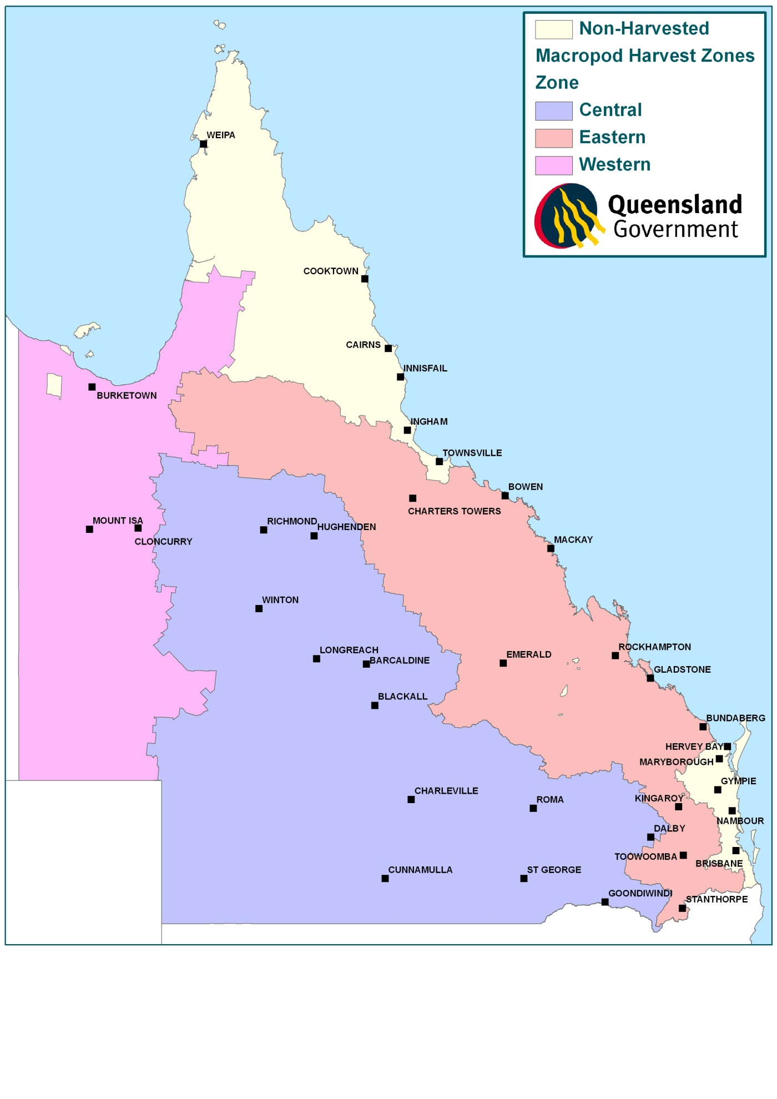

* 1. Animal welfare

The Australian Senate Select Committee on Animal Welfare (1988) examined macropods and had as its terms of reference to inquire and report on:

'the question of animal welfare in Australia with particular reference to:  
 (a) interstate and overseas commerce in animals;  
 (b) wildlife protection and harvesting;  
 (c) animal experimentation;  
 (d) codes of practice of animal husbandry for all species; and  
 (e) use of animals in sport.'

The committee’s conclusions were:

'…that a balance must be struck between the need to preserve kangaroos in abundant numbers and the need to use Australia’s resources for the wellbeing of all.'

and:

'…that a proper balance involves the development of a strictly controlled management programme.'

The committee went on to make 27 separate recommendations relating to the macropod industry. Many of these were already in place or under examination at the time of the committee’s report. Of the remainder, most are now either completely or partly implemented. Some are no longer relevant or practical. Strict adherence to and enforcement of the code of practice was emphasised by the committee.

Under the Nature Conservation (Macropod) Conservation Plan 2005, commercial harvesters are required to abide by a code of practice. This code was revised in 2008. The code sets an achievable standard of humane conduct and is the minimum required of people shooting macropods, defined as all members of the family Macropodidae. It ensures that all people intending to shoot a free-living macropod are aware of the welfare aspects of the activity. The code is available on the Australian Government website <www.environment.gov.au>.

Copies of the code are available on the department website. All commercial harvesters in Queensland are provided with a copy of the code as part of the approved TAFE course and when licensed for the first time.

Since the revised code took effect in 2008 new research into the welfare aspects of macropod harvesting has occurred (Sharp et al. 2014). If the code of practice is amended during the life of this plan, then the new code will apply.

* 1. Commercial Wildlife Harvesting Licence (Macropod)

A Commercial Wildlife Harvesting Licence can be issued under the Nature Conservation (Administration) Regulation 2006. Before a harvester can obtain a Commercial Wildlife Harvesting Licence (Macropod) they need to have:

* a current firearms licence
* completed a firearms competency certification for harvesters by a licensed firearms instructor under the Weapons Act 1990, or a range instructor belonging to an organisation that is an approved provider
* successfully completed the 'Commercial Wildlife Harvesting Course (DEHP)' through TAFE Queensland South West.

Before approving an application for a harvesters licence, an authorised officer will consider relevant information, including confirming that:

* the applicant holds a current firearms licence
* the applicant has successfully completed the firearms competency certification in the previous 12 months if they did not hold a harvesting licence within the previous harvest period
* the application has the applicant’s original handwritten signature or submitted via electronic system with secure login
* the applicant is a suitable person to hold the licence. A person may be deemed unsuitable if they have been convicted of an animal welfare offence under the Animal Care and Protection Act 2001 or an offence relating to wildlife against another Act; or the person has had an unacceptable number of demerit points accrued relating to the licence.

A Commercial Wildlife Harvesting Licence (Macropod) does not authorise the taking of macropods in lands dedicated or declared as protected areas as defined under the Nature Conservation Act 1992 or tenure as defined under the Forestry Act 1959.

Harvesters’ licences are subject to requirements under the Act and licence conditions that include, but are not limited to:

* All macropods must be shot in accordance with the code of practice.
* Tags must be attached to all macropods taken under the licence.
* The licensee must obtain written consent from the landholder (or person authorised by the landholder) before entering any land for the purpose of taking wildlife under the licence. Written consent must be obtained for each place and must be renewed for each licence period.
* Written consent from the landholder (or person authorised by the landholder) must be carried while conducting activities under this licence and must be presented to authorised officers when asked.
* The licensee may only take a macropod in a harvest period if they possess a valid tag for that species and harvest zone.
* Macropod carcases or skins taken under a commercial wildlife harvesting licence must not be sold or given away if the macropod’s body has a bullet wound.
* A person should not be in possession of tags that have not been issued to them.
* Identifying sex remnants must remain attached to the macropods.
* All macropods must be sold, before the end of the harvest period, directly to a person who holds a commercial wildlife licence in Queensland.
* Harvesters are responsible for ensuring they have arranged with a licensed dealer for the purchasing of skins/carcases prior to taking any macropods.
* Harvesters are responsible for completing a return of operations that records all details of macropod species they have harvested, where they were shot, tag numbers, and who they were sold to, for each month of operation during the harvest period.
* The return must be provided to the department on a monthly basis and must be submitted within 14 days from close of the reporting period.
  1. Commercial wildlife licence for dead macropods

Issued under the Nature Conservation (Administration) Regulation 2006.

This licence allows a person to buy, keep and use dead macropod carcases and skins until they become processed products under the legislation.

A licence may be approved for an individual or a company

Applicants for a commercial wildlife licence must provide the following details:

* standard personal details, name, address and date of birth of the licensee
* location in Queensland where the activities authorised by the licence will be carried out
* location where the record books will be kept in a secure manner
* if a company, proof that the licensee is a member of the board of the company
* the person who will be operating the site and their personal details.

Failure to supply any of the information will render the application invalid and a licence will not be issued.

Commercial wildlife licences are subject to requirements under the Act and licence conditions that include, but are not limited to:

* Only purchase macropods that have been taken under a commercial wildlife harvesting licence and meet the standards of the harvest period notice for that year.
* Skin grading sizes are set in the Nature Conservation (Macropod) Conservation Plan 2005, however it should be noted that the grading are for record-keeping purposes only. They in no way restrict the market value of the skins or the arrangements made regarding price made between harvesters and dealers.
* A return of operations must be provided for each month of the sites operation, but may be required weekly. The return must be provided to the department within 14 days from the close of the reporting period.
* Tags can only be removed in Queensland at a licensed tannery.
* The license can be issued to one place only.
  1. Tags

The harvest is controlled by self-locking numbered plastic tags with a unique colour code for each species and updated each year.

* The department's macropod program issues plastic tags to harvesters each year throughout the harvest period.
* A fee (fixed by the chief executive) must be paid to the department macropod program for the tags.
* The tags must be individually numbered and identified for a specific harvest period.
* Tags are issued for a specific harvester and are not transferable to another harvester.
* Tags must be applied to all macropods (either skins or carcases) taken under a wildlife harvesting licence.
* The tags must be self-locking and once applied, shall not be removable without destroying it or leaving substantial obvious tamper evidence.
* A tag can only be removed from the macropod skin during the skin tanning process at a licensed tannery.

Some of the details above may change during the life of this plan with adoption of new technology, etc. The overall function of the tag will remain to ensure traceability and to enable the aims of the plan to be achieved. Any significant changes to the tag system will be reported to the Commonwealth Government.

* 1. Movement of dead macropods

Licensed commercial macropod harvesters are required to complete a movement advice before moving the carcase or any part of a macropod and forward that advice to the chief executive no more than seven days after moving the carcase or part.

This does not apply if the harvester is moving it to his residential address or the premises of a licensed dealer.

A licensed commercial wildlife holder or dealer must fill out a movement advice before moving macropods within, into or out of Queensland.

The macropods must be accompanied by a copy of the movement advice.

1. Biology and ecology of commercially-harvested macropods
   1. Introduction

Macropods are among the most widely studied group of species in Australia, largely as a consequence of the commercial harvest. The biology, ecology, conservation status, threats and issues relating to the conservation and harvesting of macropod species have been comprehensively documented in a large number of widely available publications. Accordingly, the following sections provide only a summary of the specific aspects of macropod biology, ecology, conservation, management and harvesting. The information in this section has largely been adapted from the background information for macropod management in Commercial Harvesting of Kangaroos in Australia (Pople and Grigg 1999).

The three macropod species that are the subject of this plan are abundant over a broad area of the continent and Queensland (figures 2 to 4). They are particularly common over the sheep and cattle grazing pastures of Queensland. Within the sheep rangelands, the provision of permanent watering points has meant that macropods are now more likely to be limited by food than water (Oliver 1986). This has had a profound effect on their distribution as well as their abundance (Newsome 1965a). It has been suggested that sheep and cattle also improved the habitat of macropods through facilitative grazing; creating a sub-climax pasture (Newsome 1975). These changes to the environment would have been most pronounced in the late 1800s when average sheep numbers in the rangelands of New South Wales were nearly twice what they are today (Caughley 1976). There were other significant changes to Australia’s rangelands following European settlement—numerous species of eutherian herbivores and predators were introduced and became established in the wild; at the same time numerous small native mammal species disappeared and many are now extinct. As Caughley (1987b) explained, not only was the habitat modified, but the ecological system was ‘changed beyond recognition’. The current distribution and abundance of macropods may therefore bear only a vague resemblance to what it was prior to European settlement.

* 1. Red kangaroo Macropus rufus

The red kangaroo is an abundant species distributed over much of continent’s rangelands and is the only species exclusively restricted to the arid zone (Tyndale-Biscoe 2005) (Figure 2). This distribution reflects the interaction between mean annual precipitation and mean annual temperature (Caughley et al. 1987). Red kangaroos occupy a wide range of habitats including mulga and mallee scrub, shrubland, woodland, grassland and even desert (Caughley 1964; Russell 1974; Johnson and Bayliss 1981; Low et al. 1981; Short et al. 1983; Strahan 1995). This species has a preference for open plains habitat where individuals rest in the same areas as they feed (Russell 1974; Priddel et al. 1988a; Strahan 1995; McAlpine et al. 1999; Coulson 2009)

Many scientists consider that vegetation clearing, provision of artificial watering points and control of dingo Canis lupus dingo populations to facilitate the grazing of domestic stock in the pastoral zone have 'improved' the habitat for the red kangaroo and thus resulted in a general population increase from pre-European times (Russell 1974; Newsome 1975; Caughley et al. 1980; Squires 1982; Grigg 1982; Dawson 1995; Dawson et al. 2006; Letnic and Crowther 2012). Intensive agriculture is not regarded as beneficial to the species (Grigg 1982; Short & Grigg 1982) and, most red kangaroo habitat hasn’t been altered by cropping.

Recent initiatives such as the Great Artesian Basin Initiative are leading to some Artificial Watering Points (AWP) becoming unavailable to macropods. The consequences of the changes to available water have not been examined. Few studies have investigated the relationship between density of AWPs and kangaroo abundance. Letnic and Crowther (2012) indicated that density of AWPs was a poor indicator of kangaroo abundance. Fukuda et al. (2009) compared the density of kangaroos around fenced and non-fenced AWPs and concluded that fencing of AWPs did not influence distribution of kangaroos. However, other factors such as access and distance to other water sources should be considered and future research could improve our knowledge in this area.

Red kangaroos are herbivores foraging mostly at night (Caughley 1964; Dawson et al. 2004); accordingly their role in the ecosystem can be defined as primary consumers. Several detailed dietary studies have been undertaken on this species (Griffiths & Barker 1966; Chippendale 1968; Storr 1968; Bailey et al. 1971; Ellis 1976; Dawson et al. 2004), with all indicating a preference for green herbage including grasses and dicotyledonous plants. Although they prefer to eat grasses and forbs, when these become scarce, red kangaroos will switch to chenopods and black bluebush, and in some areas will even browse shrubs (Tyndale-Biscoe 2005). Recent research (Munn et al. 2008, 2013) has estimated the grazing pressure of red kangaroos as approximately 44 per cent that of sheep or the equivalent of 0.7 sheep and a lower rate of water requirement, being only 13 per cent of sheep. This may suggest the capability of resources to support co-existence of agricultural fauna and macropods.

The reproductive biology of red kangaroo has been thoroughly studied (Frith & Sharman 1964; Newsome 1964; Sharman 1964; Sharman & Pilton 1964; Newsome 1965b). Females come into oestrus at approximately 35-day intervals and are therefore potentially fertile throughout the year. Periods of extreme drought, however, may lead to suppression of the oestrus cycle. Females can come into breeding condition almost immediately after drought-breaking rains. Reproduction success among age groups of female red kangaroos was investigated by Pople et al. (2010a). Findings indicated that while older females had 7-20 per cent greater success, most of the variance in reproduction success was attributed to body condition (30 per cent) and environmental conditions (60 per cent). Pregnancy does not interrupt recurrence of oestrus. The female may give birth 33 days after mating and the result from this post-partum mating remains a quiescent blastocyst until the previous young is about to leave the pouch or is lost prematurely (embryonic diapause).

Studies of behaviour and social organisation have been conducted by Caughley (1964) and Croft (1980). The red kangaroo is a gregarious species (Kirkpatrick 1967) and appear to become more aggregated during dry seasons (Pople et al.2017). Although relatively large groups may sometimes form, these groups are unstable in composition (Croft 1980). Some authors have indicated that the grouping behaviour evolved as response to predation (Watson and Dawson 1993; Coulson 2009). Blumstein and Daniel (2003) demonstrated correlations with vigilance and group size in red kangaroos. The only enduring red kangaroo relationship is between the mother and her young. The mating system of the red kangaroo appears to be based on polygamy (Croft 1980).

Several studies have examined the movement patterns of red kangaroo (Frith 1964; Bailey 1971; Denny 1980; Croft 1980; Priddel 1987). These studies indicate that the majority of the population is relatively sedentary, moving distances of no more than 10 kilometres; although a small proportion of animals may move tens or hundreds of kilometres. Individual home ranges have been found to overlap (Croft 1982; Priddel 1987).

The population dynamics of red kangaroos have been studied in detail with much of the information being derived from regular aerial surveys. These surveys provide a means of assessing the response of macropod populations to environmental conditions, particularly rainfall. Caughley et al. (1984), working in New South Wales, found that the rate of increase in numbers was related to rainfall. Populations decreased when rainfall was approximately 90 millimetres below average and, except when rainfall was extremely high, increased when rainfall exceeded the 90 millimetres below average level. The maximum annual rate of increase was approximately 45 per cent per annum, but under average rainfall, populations increased at 30–35 per cent per annum. In poor conditions, populations declined at a maximum rate of 55 per cent per annum. Robertson (1986) observed a 30 per cent per annum decline in the red kangaroo population at Kinchega National Park in western New South Wales during the 1982–83 drought. Similar population changes have been observed in South Australia by Grigg (1982). Population dynamics models have been investigated by Pople (2006), Jonzen et al. (2005), and Pople et al. (2010b) using rainfall as a factor in a bottom-up (primary production) regulated environments. These models utilising other factors such as the effect of harvesting, and competition, displayed variation from state to state and within states in predicting population dynamics. Letnic and Crowther (2012) showed that there was only a weak positive relationship between red kangaroos and primary production in the presence of predators.

Red kangaroo populations are subject to predation by wild dogs/dingos. Shepherd (1981) and Letnic and Crowther (2012) have made direct observations of dingo predation of red kangaroo, concluding that they prefer juveniles and females as prey and that the dingo might be able to limit the rate of increase of red kangaroo populations as a top-down regulator. Caughley et al. (1980) were more definite in their conclusions concerning dingo predation, and attribute the high densities of red kangaroo in the sheep country of South Australia, Queensland and New South Wales to the elimination of the dingo from these areas. This relationship was further supported by Letnic and Koch (2010) who demonstrated a clear relationship between dingo predation and red kangaroo numbers in the Strzelecki Desert.

Figure 2 Red kangaroo Macropus rufus distribution

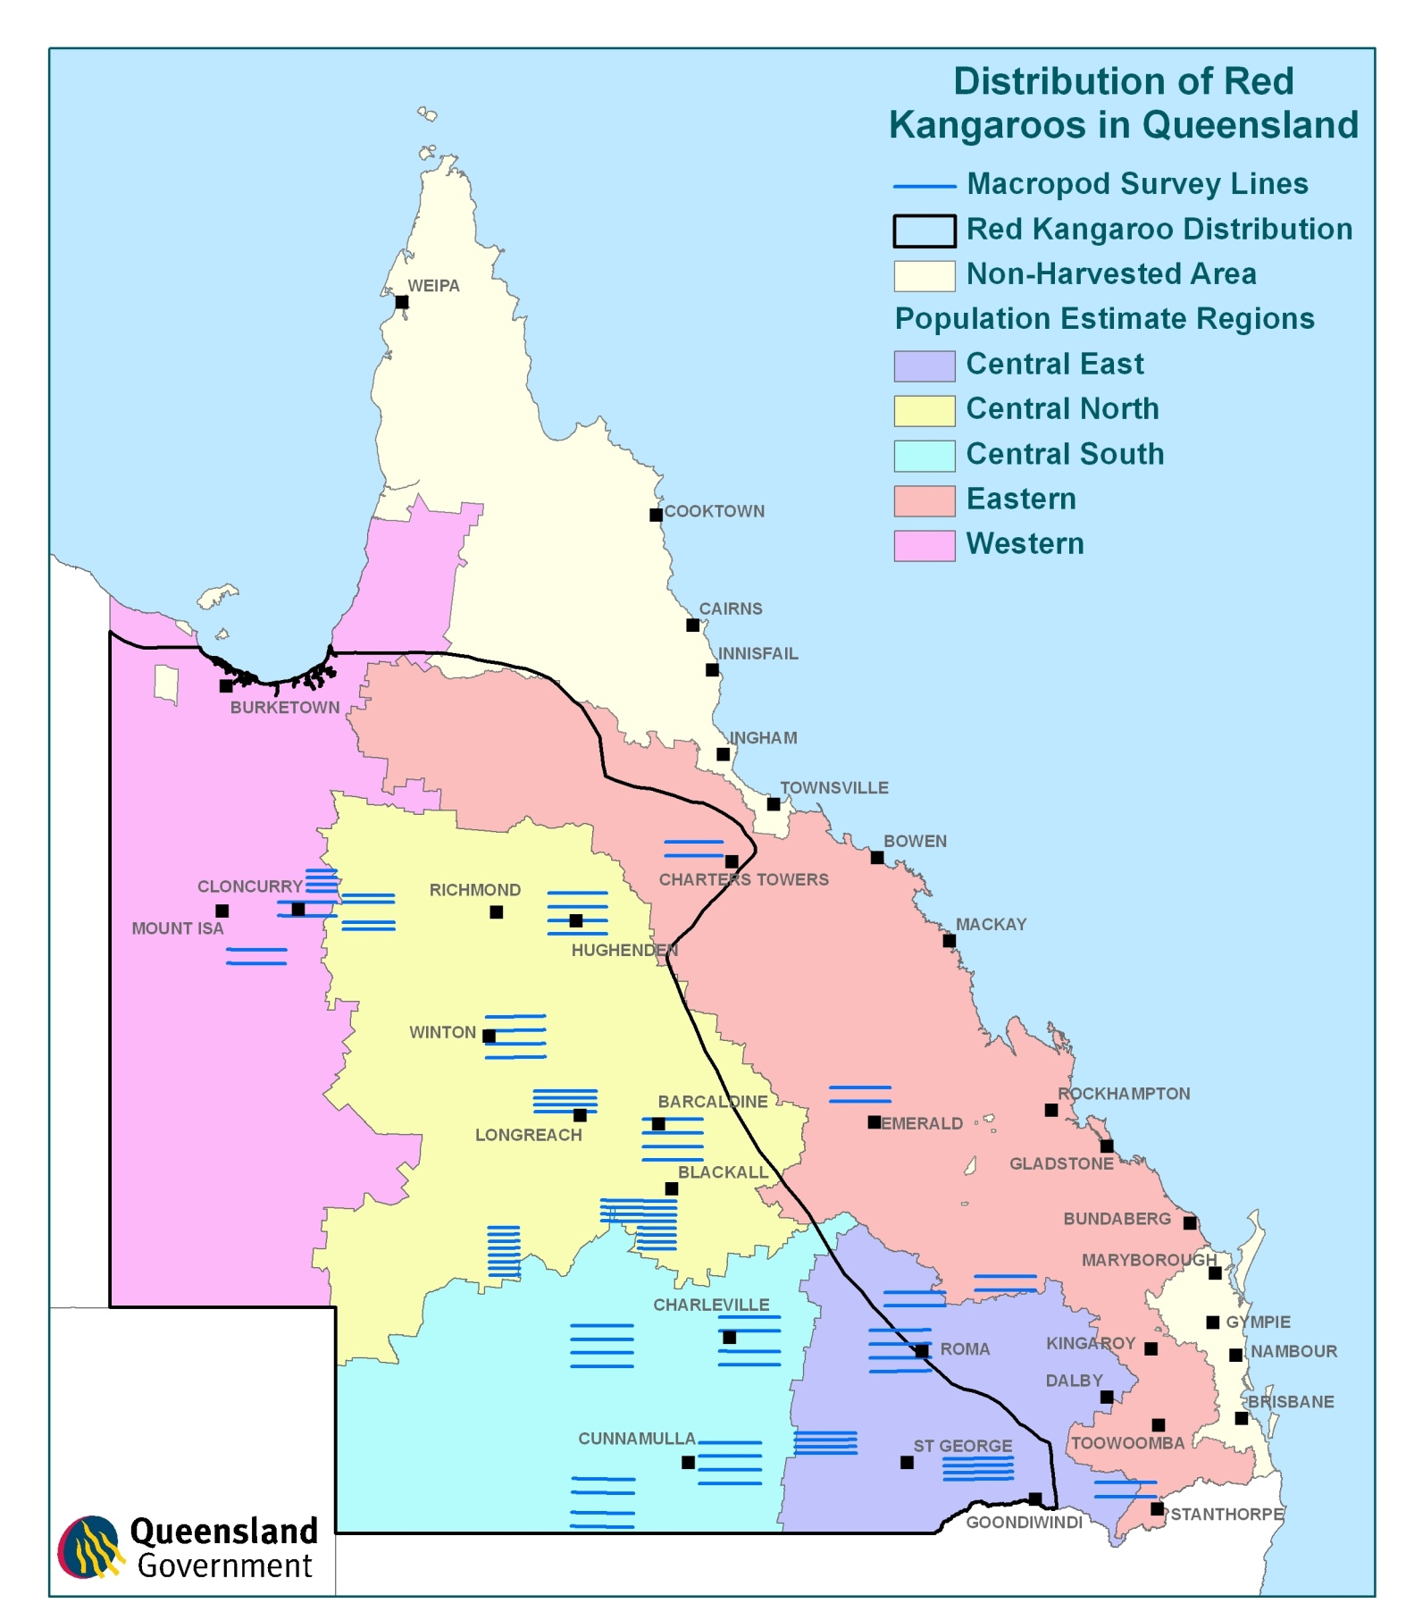



* 1. Eastern grey kangaroo Macropus giganteus

The eastern grey kangaroo is distributed across eastern Australia from northern Queensland to Tasmania between the inland plains and the coast (Russell 1974; Strahan 1995) (Figure 3). The distribution corresponds with areas where rainfall either has little seasonal trend or where rainfall in summer exceeds rainfall in winter (Caughley et al. 1987). The eastern grey kangaroo is abundant and occupies a range of habitats including woodland, shrubland, open forest, and semi-arid mallee and mulga scrubs (Caughley 1964; Calaby 1966; Bell 1973; Russell 1974; McCann 1975; Taylor 1980; Hill 1981; Strahan 1995; Southwell 1987).

Poole (in Strahan 1995) considers it most likely that the development of the pastoral industry has led to a marked increase in the abundance of this species. Furthermore, the eastern grey kangaroo has been moving westward for the past 70 years due partly to the increase in watering points for sheep and cattle (Tyndale-Biscoe 2005, Dawson et al. 2006). Conversely, intensive agriculture with its associated widespread tree clearance has not been beneficial to the species (Short & Grigg 1982) which prefers heterogeneous landscapes containing horizontal cover (Moore et al. 2002; Schmidt et al. 2010) as a means of predatory avoidance (Caughley 1964; Nave 2002). However, vegetation management through mechanical clearing has shown to increase abundance and food resources (Davis et al. 2016). The western boundary of the eastern grey kangaroo range is probably influenced by competition with red kangaroos and wallaroos because the latter species have a better tolerance of high temperatures and uncertain rainfall (Tyndale-Biscoe 2005). Research has shown a correlation between group size and individual time spent vigilant in this species (Blumstein and Daniel 2003, Dannock et al. 2013). .

The eastern grey kangaroo is a herbivore and therefore a primary consumer. Foraging behaviour occurs mostly at night (Caughley 1964; Dawson et al. 2004). Detailed dietary studies indicate that the species is a grazer with a preference for a range of grasses depending on location (Kirkpatrick 1965; Griffiths & Barker 1966; Southwell 1981; Taylor 1983b; Dawson et al. 2004).

Reproductive biology of eastern grey kangaroo has been well studied (Kirkpatrick 1965, 1967; Poole 1975; Kirsch & Poole 1972). Breeding occurs throughout the year but there is a peak of births in summer. The oestrus cycle is 46 days and the gestation period 36 days. Post-partum ovulation does not occur in eastern grey kangaroo and quiescent blastocysts are rarely found in this species. Male testosterone concentrations have been observed to peak during the peak breeding activity of October to April (Nave 2002).

The social behaviour of eastern grey kangaroo reflects their seasonal breeding and preference for woodland habitat. Eastern grey kangaroos are gregarious (Southwell 1984a), forming groups that are unstable in their composition (Southwell 1984b) exhibiting fission-fusion dynamics (Best et al. 2013) Best et al. (2013) has demonstrated that females are generally philopatric with overlapping ranges and form social communities. Though it is not clear whether these communities are formed because they share the same space or they prefer to interact. There are three common associations related to essential life functions: male–male agonistic behaviour to establish hierarchical rank; males courting oestrus females—this species has a polygamous mating system; and the mother–young association (Jarman & Southwell 1986; Miller et al. 2010).

Eastern grey kangaroos are less mobile than red kangaroos. Studies of eastern grey kangaroo movement by Jarman and Taylor (1983),Jarman and Southwell (1986) and Best et al. (2013) indicate that the species occupies well-defined, overlapping home ranges. Few individuals have been shown to disperse; those that do are young males.

The population dynamics of eastern grey kangaroo were examined during the aerial surveys of Caughley et al. (1984) which were undertaken at two sites on the inland plains of New South Wales, one to the east of, and one to the west of, the plains. The eastern site contained both eastern grey kangaroo and western grey kangaroo, which cannot be reliably distinguished from the air. Eastern grey kangaroos were far more abundant than western grey kangaroos (Caughley et al. 1984) so the changes observed can be attributed almost entirely too eastern grey kangaroos. Caughley et al. (1984) found that populations had a maximum rate of increase of 35 per cent per annum where rainfall was above average, and a rate of increase of 25 per cent per annum at average rainfall level. Populations declined only when rainfall was well below average.

Aerial survey has been the main means by which broad scale estimates of eastern grey kangaroo populations has been obtained. Eastern grey kangaroo populations are subject to predation by wild dogs/dingos (Robertshaw & Harden 1985, Letnic and Koch 2010, Letnic and Crowther 2012). Removal of dingoes from areas of eastern grey kangaroo habitat has reduced the effects on populations of this natural predation (Letnic and Crowther 2012).

Figure 3 Eastern grey kangaroo Macropus giganteus distribution

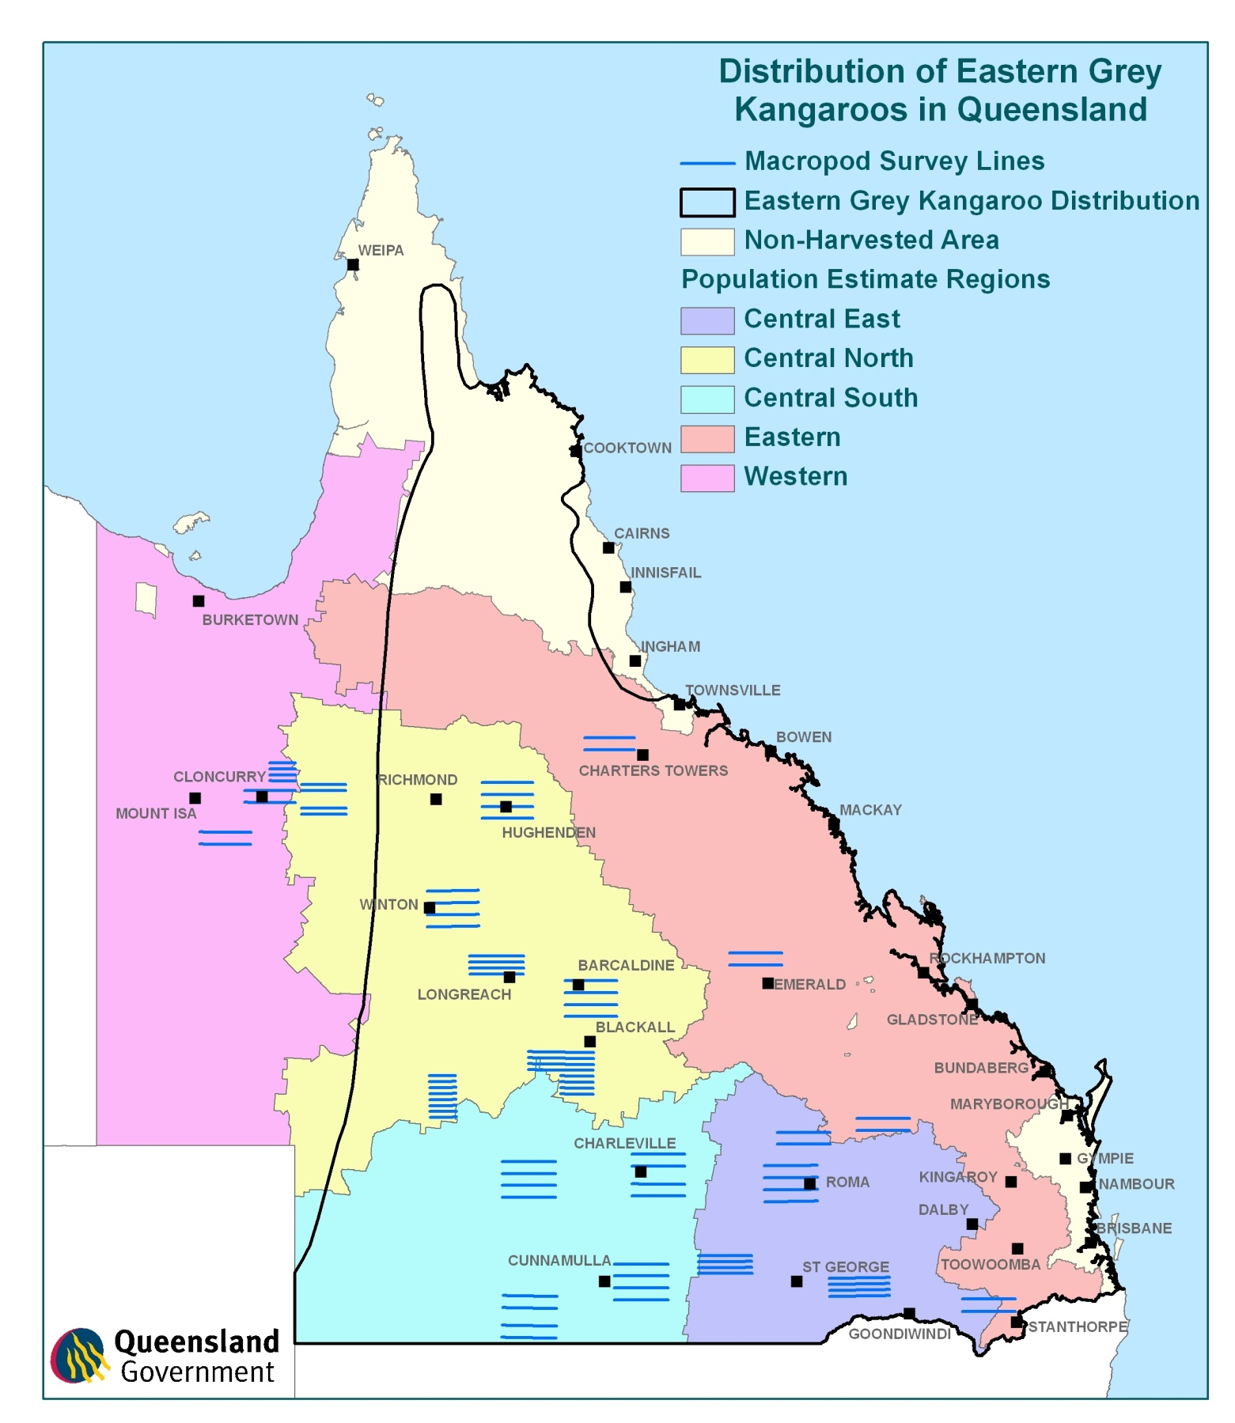

* 1. Common wallaroo Macropus robustus

The common wallaroo has the widest distribution of the larger macropod species. It occurs across the entire mainland continent and is absent only from the extreme northern and southern portions of the continent (Russell 1974; Strahan 1995) (Figure 4). Despite their relative abundance, members of this group are infrequently seen because of their association with mountains and rocky hill country (Dawson 1995). A consequence of their close association with such habitats is that common wallaroo distribution is discontinuous. This discontinuity has resulted in the common wallaroo being a species which shows considerable variation in external characteristics such as coat colour, coat texture and ear length. Richardson and Sharman (1976) suggested that the number of subspecies recognised should be four, which they considered, reflected the extremes of the variability present. The work by Richardson and Sharman (1976) was based on both molecular genetics and traditional skull and teeth measurements. Hale 1999 validated this work further using molecular genetic analysis and variation in coat colour. One of these subspecies occurs in South Australia, two are found in Queensland, three occur in Western Australia and two occur in New South Wales.

The validity of these two subspecies (M. robustus robustus and M. robustus erubescens) is questionable as both intergrade into each other over a broad area of Queensland and consequently do not fulfil the criteria for recognition of variants as subspecies. Rather, the situation in Queensland is more consistent with clinal variation as indicated by the review document prepared by Tony Pople and Gordon Grigg (1999) on behalf of Environment Australia and which is available on the Australian Government’s website <www.environment.gov.au>.

Over most parts of their respective continental ranges Macropus r. robustus and Macropus r. erubescens are separated geographically by the wide plains for the Darling River and its tributaries (Dawson 1995). However at the northern end of this river basin, in Central Queensland, the two subspecies seem to merge and hybridisation was suspected. While no genetic analyses have been completed to confirm the existence of this situation in the field the two subspecies do interbreed in captivity and the offspring from such a mating are fertile.

The common wallaroo occupies a wide range of habitats but prefers areas with steep escarpments, rocky hills or stony rises (Calaby 1966; Kirkpatrick 1968; Russell 1974; McCann 1975; Strahan 1995; Taylor 1985). Newsome (1975) considers that the alteration of vegetation communities to sub-climax Spinifex by the grazing of sheep in north-west Western Australia has enabled the common wallaroo to colonise previously unoccupied valley areas.

The common wallaroo appears to occur at lower overall densities than the other large macropods, but high densities can occur in localised areas. Surveys over small-scale areas of favourable habitat have revealed densities of 16 to 44 per square kilometre at Fowlers Gap in western New South Wales (Croft 1981) and seven to 55 per square kilometre on grazing properties of the New England Tablelands (Taylor 1983a). Broadscale ground surveys across the eastern highlands in Queensland and New South Wales give a more representative picture of overall density. In South East Queensland, common wallaroos attained an average density of 1.5 per square kilometre across 65 000 square kilometres of suitable habitat (Southwell & Fletcher 1989). In the New England and western slopes region of New South Wales, preliminary results from a recent ground survey indicate an average density of six per square kilometre in 45 000 square kilometres of suitable habitat (Southwell et al. 1995).

Detailed dietary studies have been undertaken by Ealey and Main (1967), Storr (1968), Ellis (1976), Squires (1982), and Taylor (1983b). Taylor (1983b) found that in the tablelands of New South Wales common wallaroos had a broadly similar diet to eastern grey kangaroos, consisting primarily of grasses. In the arid Pilbara region of Western Australia, common wallaroo diet was found to concentrate on Spinifex (Ealey & Main 1967).

The reproductive biology of wallaroo has been studied by Sadlier (1965), Ealey (1963), Kirkpatrick (1968) and Poole and Merchant (1987). Like red kangaroos, wallaroos are opportunistic breeders. Under normal conditions, females breed continuously, giving birth to a single young every eight to nine months. However, if drought persists for more than six months, female wallaroos enter a state of anoestrus until they either die or the drought breaks (Tyndale-Biscoe 2005).

Common wallaroos are less gregarious than the other large macropod species (Kirkpatrick 1968; Croft 1981; Taylor 1982). Croft (1981) studied their social behaviour, which is broadly similar to that of other large macropod species. Social groups are highly unstable, the only enduring relationship being between a female and its progeny.

Studies of movement by Ealey (1967), Croft (1981), and Jarman and Taylor (1983) indicate that the species is relatively sedentary, occupying small home ranges that overlap broadly with those of other individuals. Clancy and Croft (1989) found that males of M. r. erubescens in the Fowlers Gap area progressively shifted their centres of activity within their home ranges on a short term basis, a trait shown by some of the females as well. Movements are, however, quite small-scale (within a couple of kilometres) and home ranges remained stable from year to year.

Figure 4 Common wallaroo (Macropus robustus) distribution

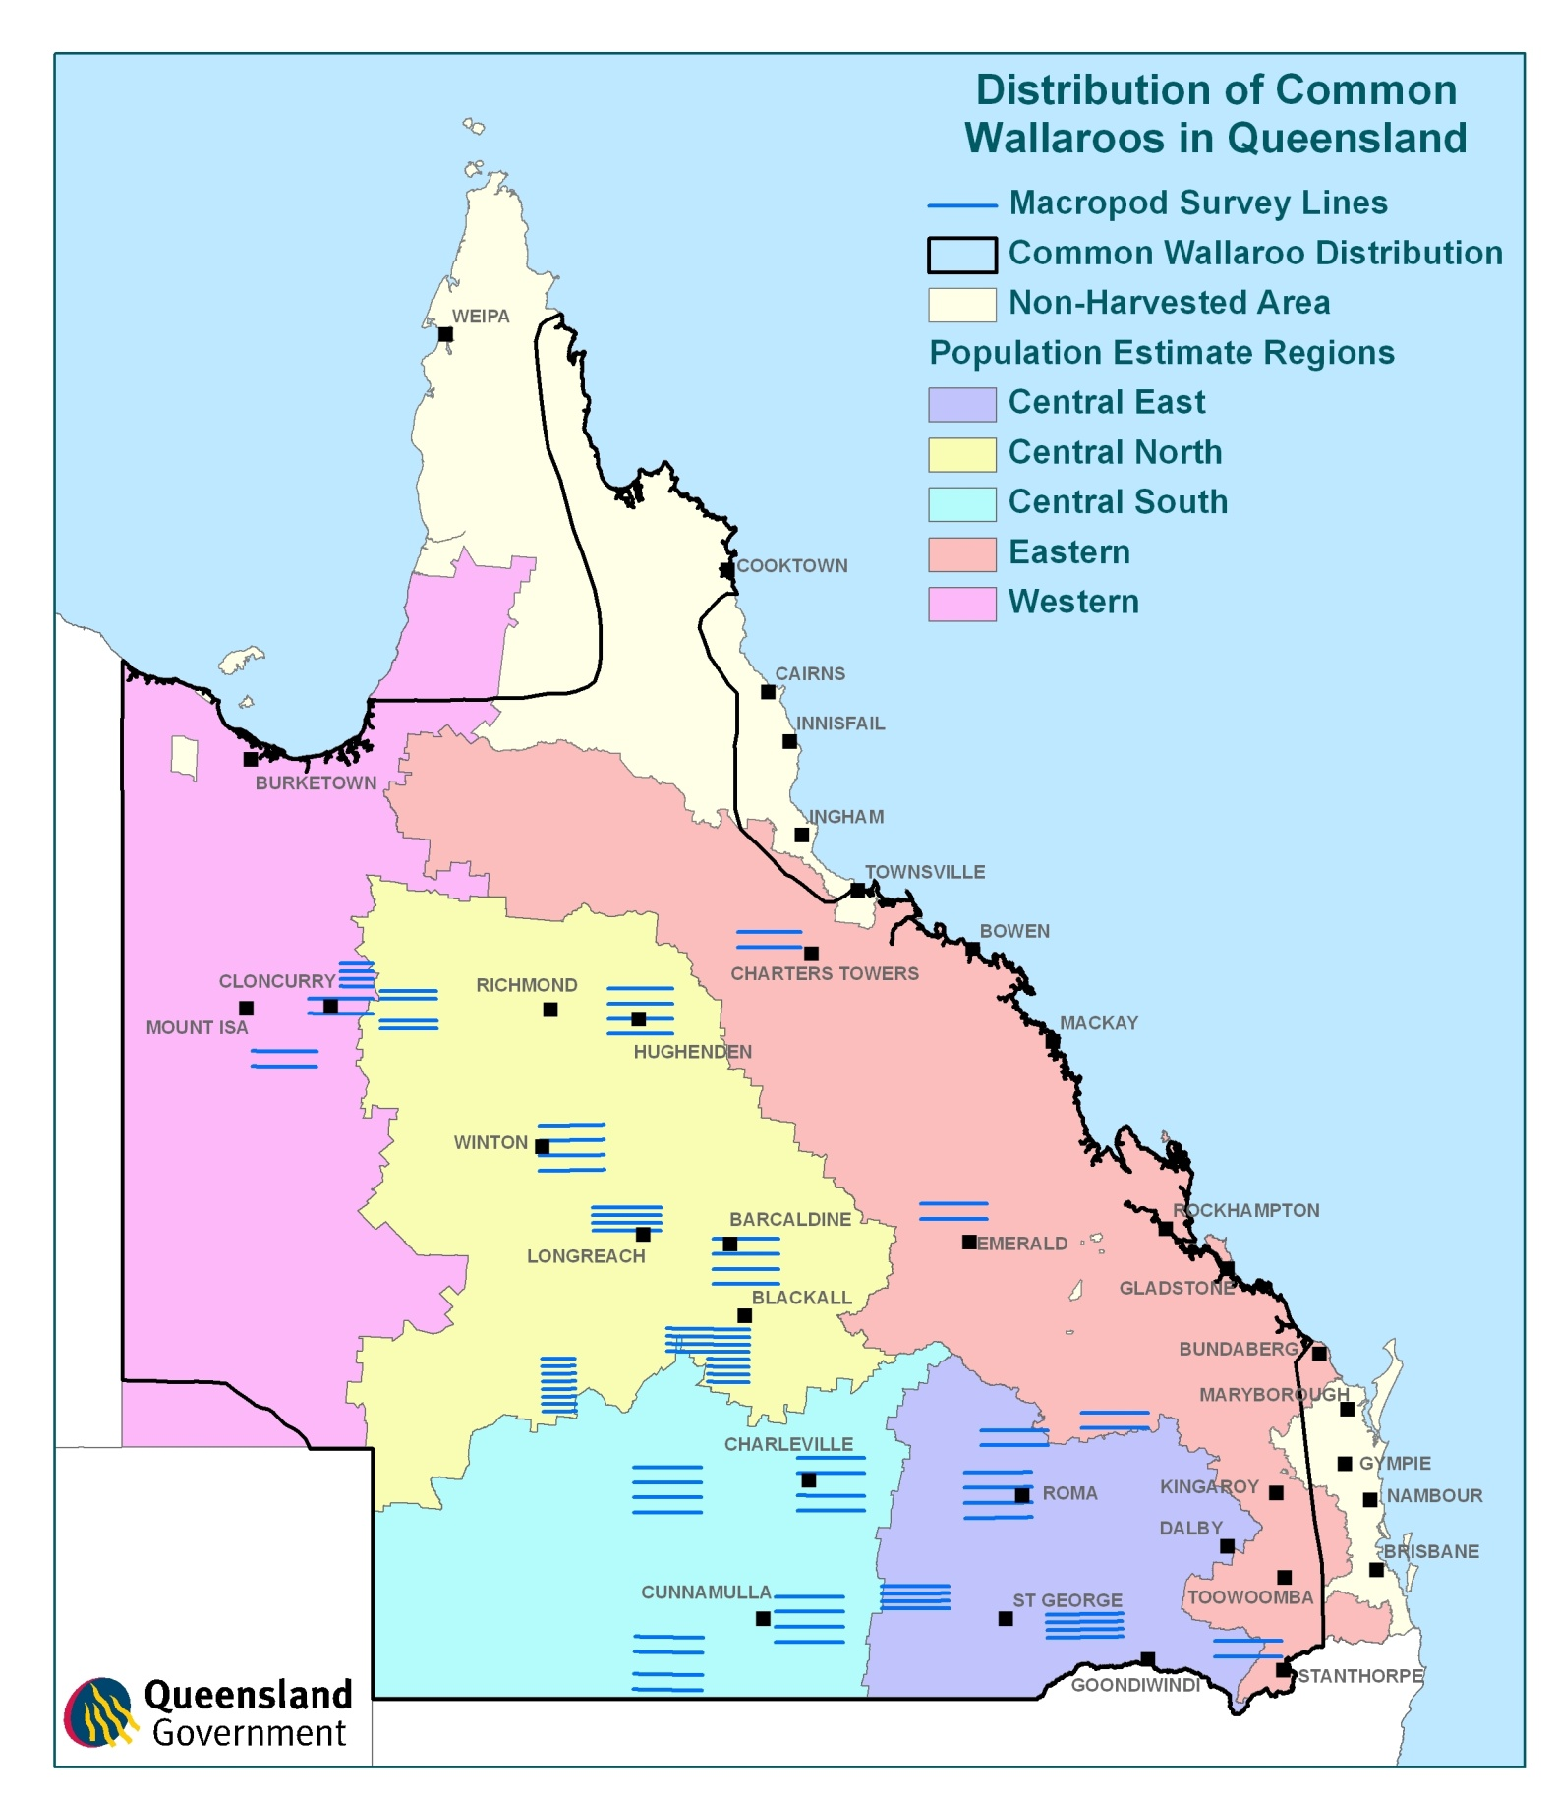

1. Conservation of commercially-harvested macropods

Free ranging macropod populations across Australia are affected by a number of factors common to most wildlife populations including predation, disease, climatic variables and habitat availability. The commercially harvested species are further influenced by both the intensity and nature of the harvest. While some of these influences are beyond the control of the department the effects of all are monitored. Any impacts on the population size of the commercially harvested macropod species from ecological or harvest induced factors are accounted for through regular monitoring. The commercial harvest of macropods also potentially impacts other species, habitats and ecosystems. These potential impacts are addressed in Table 3.

* 1. Conservation status

The conservation status of the commercially harvested macropod species in Queensland reflects their abundance and thus their utilisation. No commercially harvested macropod species in Queensland is listed as a threatened or endangered species under either state or Commonwealth legislation (Table 1).

The Convention on International Trade in Endangered Species of Wild Fauna and Flora (CITES) is an international agreement between governments—including the Australian Government—the aim of which is to ensure that international trade in specimens of wild animals and plants does not threaten their survival. CITES accords varying degrees of protection to more than 30 000 species of animal and plant, which are listed in the three CITES appendices. None of the macropod species commercially harvested in Queensland are listed in the CITES appendices (Table 1).

Table 1 The Queensland, Commonwealth and CITES conservation status of the macropod species to which this plan relates

|  |  |  |  |  |
| --- | --- | --- | --- | --- |
| **Species** | **Queensland** | **Commonwealth** | **IUCN** | **CITES** |
| Red kangaroo | Least concern | Not listed | Least concern | Not listed |
| Eastern grey kangaroo | Least concern | Not listed | Least concern | Not listed |
| Wallaroo | Least concern | Not listed | Least concern | Not listed |

* 1. Predation and disease

The commercially-harvested macropod species in Queensland have a number of predators including wild dogs/dingoes, wedge-tailed eagles and to a lesser extent foxes. Many authors believe dingo predation has a significant impact on macropod populations and attribute the control of dingoes for the pastoral industry as a major contributing factor in the abundance of macropod species throughout the rangelands (Jarman & Denny 1976; Caughley et al. 1980; Corbert & Newsome 1987; Thompson 1992; Banks et al. 2000 Pople & Page 2001;Letnic and Crowther 2012;). Letnic and Crowther (2012) compared the population dynamics of kangaroos on either side of the dog fence to observe the effect of predators on kangaroo population. The results indicated that kangaroo are less abundant where dingoes are present due to predator regulation.

Macropods are susceptible to a number of naturally occurring diseases and parasites. Long-term monitoring of macropod populations indicates that none of the commercially harvested species are significantly affected by these agents. Periodically mass deaths occur which are associated with high rainfall events and flooding (Kirkpatrick 1985; Caughley 1987a; Speare et al. 1989; Clancy et al. 1990; Choquenot 1991; Gilroy et al. 1999; People & Grigg 1999). Conversely, Boland et al. (2012) observed an occurrence of oral necrobacillosis (‘lumpy jaw’) in Victoria during a period of drought suggesting that limited pasture availability and heavy faecal contamination were contributing factors to the disease occurring. The last recorded event in Queensland was in March 2010 in the far west of the state from the border with New South Wales, extending north of Quilpie including the Paroo and Bulloo river systems. A combined investigation was undertaken by field veterinarians and veterinary diagnostic laboratories in both New South Wales and Queensland. The investigation and surveillance established that the deaths were very limited and restricted to small areas only.

* 1. Climatic variables

The rangeland environments where most of the commercial macropod harvesting occurs are dominated by periods of drought followed by flooding rains. Rainfall and its effect on plant growth is a significant factor effecting macropod population size. Macropod species have evolved in this dynamic environment and although droughts significantly reduce population size they recover quickly when droughts end (Bayliss 1987; Cairns & Grigg 1993; Cairns et al. 2000; Caughley et al. 1985; McCarthy 1996; Pople 2003; Robertson 1986). Figure 5 shows the response of commercially harvested macropod populations to rainfall as recorded across Queensland on an annual basis. The possible effects of climate change on Australian rangeland environments are uncertain but likely to increase variability (Garnaut 2011). An increase in variability could impact on macropod populations. The annual surveys of population abundance conducted by the Queensland Government provides valuable data to monitor any effects that may result from changed climatic conditions.

Figure 5 Estimated population size of commercially harvested macropod populations and annual rainfall recorded across Queensland



* 1. Habitat change

There have been significant changes to the landscape across the commercial macropod harvest zones since European settlement. Land clearing, vegetation changes due to grazing from domestic stock and the provision of permanent water for the pastoral industry has occurred throughout the harvest zones whilst in the eastern parts of the state habitats have been altered to facilitate cropping activities. These changes are widely recognised as benefiting the commercially harvested macropod species. Not only have populations increased in response to these changes but the distribution of eastern grey and red kangaroos has increased (Short & Grigg 1982; Calaby & Grigg 1989; Dawson et al. 2004; Davis et al 2016).

In recent years pastoralists throughout the harvest zones have established predator proof fences. Whilst the principal reason for these fences is the control of wild dogs they also prevent the free movement of other large wildlife like emus and macropods. The current aerial survey program covers large areas of the harvest zone regardless of land tenure including properties with and without predator proof fencing. Whilst localised changes in macropod densities might occur unnoticed by the survey program broad scale differences in densities at a landscape scale would certainly be detected. To date no significant change in macropod abundance can be attributed to property fencing.

* 1. Protected areas

Commercial harvesting of macropods can only occur in three harvest zones in Queensland. Cape York Peninsula and the south east corner of Queensland are designated Non-harvest zones (figure 22). Within the three commercial harvest zones macropods cannot be harvested within National Parks, States Forests, Regional Parks, Timber Reserves and Forest Reserves. The total area of parks, reserves and forest where harvesting cannot occur within the commercial harvest zones is 79,981km2. In addition, the commercial macropod harvest effort is uneven across the harvest zones with many individual properties not participating in the commercial harvest. At a property level the harvest effort is not evenly applied due to the logistics of access, leaving many areas of unharvested or refuge habitat (Tenhumberg et al. 2004).

* 1. Genetic diversity

The commercial macropod industry desires larger animals to maximise the profitability of the production process. This results in a selective harvesting process where larger animals are sought by harvesters. These larger animals are usually male, hence the commercial harvest of macropods in Queensland is heavily biased towards the large males within the population.

Queensland harvest data shows that females traditionally accounted for around 30 per cent of the total harvest until recently. Since 2012 the proportion of females harvested represents 5 per cent or less of the total harvest due to a commercial decision made by members of the Kangaroo Industry Association of Australia (Figure 6).

A selective harvest such as this has the potential to impact upon the genetic diversity of a population without sufficient safeguards. The safeguards in place to protect the genetic diversity of harvested macropods in Queensland include: conservative harvest quotas; non-harvest zones and protected areas where harvesting is prohibited through legislation; a mosaic of properties and areas within properties where harvesting is legal but does not occur due to landowner wishes or logistic difficulties. Several studies have examined the genetic diversity of harvested macropod populations and there is no evidence to suggest that current harvesting practices have any impact (Clegg et al. 1998; Hacker et al. 2003, 2004; Hacker & McLeod 2003; Hale 2001, 2004; Tenhumberg et al. 2002, 2004). Indeed the current harvesting occurring in Queensland is consistent with models of unharvested macropod populations due to male biased mortality during drought (Hacker et al 2003, McLeod et al. 2004).

**Figure 6.** Total commercial macropod harvest in Queensland since 1997 showing male and female take.



* 1. Long-term monitoring of commercially harvested macropod populations in Queensland

The commercial harvest of macropods has been monitored indirectly in Queensland since 1952 when they were protected by state legislation (Fauna Conservation Act 1954–1979). The use of quotas to regulate the harvest was introduced in 1975, along with self-locking non-reusable tags. Each year, the average weight of harvested carcases and the sex ratio of harvested species are monitored.

Aerial surveys of commercially-harvested macropod species began in 1980 and have continued annually since 1984. Data collected from aerial surveys is used to estimate the population size of the commercially harvested species within the commercial harvest zones. Annual aerial surveys are conducted over 22 monitoring blocks positioned within five population estimate regions (Figure 7).

A full description of the history and methodology of aerial macropod surveys in Queensland is available on the department’s website ([www.qld.gov.au/environment/plants-animals/wildlife-permits/macropods/index.html](http://www.qld.gov.au/environment/plants-animals/wildlife-permits/macropods/index.html)). Based on the population estimates of all three commercially harvested macropod species in Queensland populations fluctuate significantly (Figure 6). These fluctuations are largely in response to rainfall at a landscape scale (Figure 5).

Figure 6 Estimated macropod populations 1992–2011 (population estimates for common wallaroo is based on 1.2 correction factor except for 2011 where a correction factor of 1.85 is used)



Figure 7 Regions used to calculate population estimates of commercially harvested macropods

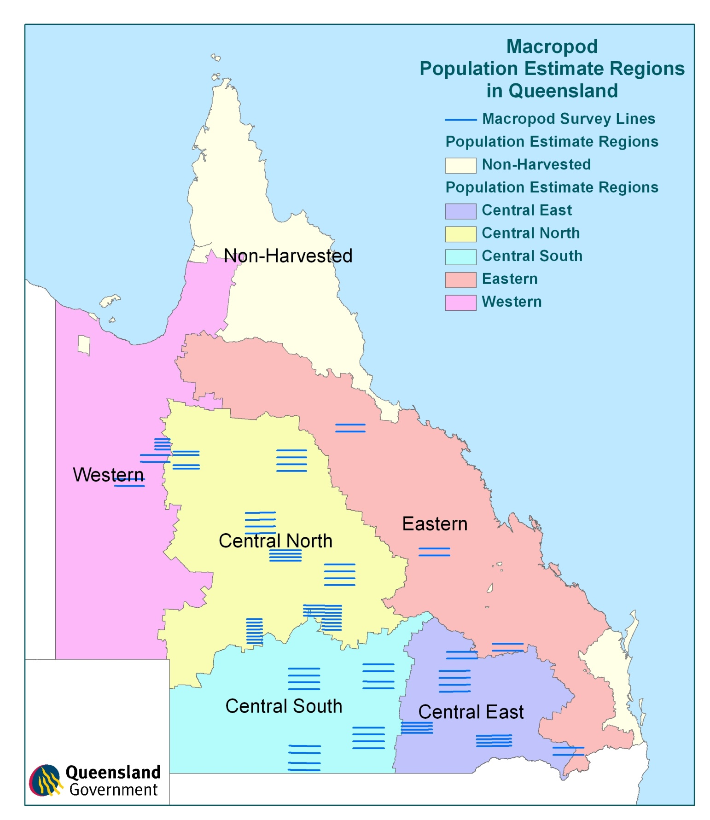

* 1. Proportional threshold harvesting

Proportional harvesting strategies have been well studied and are considered safe and efficient for fluctuating populations (Caughley 1987a; Engen et al. 1997). Moreover, a program of regularly monitoring and estimating abundance allows for any other mortality agents acting on macropod populations to be accounted for in the setting of annual commercial harvest quotas (e.g. animals lost through drought, disease or road kill). Proportional threshold harvesting—also known as constant escapement harvesting—is considered the optimal strategy for maintaining a viable yield and minimising any adverse risks to the sustainability of the harvested species (Engen et al 1997, Pople 2004). Using this strategy thresholds are set under which the proportion of the population to be harvested, (i.e. the quota) is reduced and finally ceased to avoid any risk of over harvesting. The Queensland Government adopts a proportional threshold harvesting strategy for the commercial harvest of macropods.

The department sets sustainable harvest quotas as a fixed proportion of the estimated macropod populations within the harvest zones. The proportions used vary between species and are also adjusted across the harvest zone in relation to the margins of error present in the population estimates. The maximum proportions used for each species are 15 per cent of populations for eastern grey kangaroos and common wallaroos and 20 per cent of the population for red kangaroos. These maximum proportions are only applied to populations within the Central harvest zone where survey effort is greatest and hence confidence limits for population estimates are within acceptable limits.

Due to the significantly lower macropod densities and associated lower harvest densities recorded historically from the Eastern and Western harvest zones, these two zones are not surveyed with the same intensity as the Central zone. Accordingly in both the Eastern and Western harvest zone regions, more conservative harvest proportions of 10 per cent for eastern grey kangaroos and common wallaroo and 15 per cent for red kangaroos were applied. These sustainable-use harvest proportions are based on research and modelling undertaken by Caughley (1987a) and Hacker et al. (2003, 2004) and are currently accepted by the scientific community for determining the harvest quota. Table 2 shows the percentage of quota on a regional basis per species. These percentages may vary throughout the life of this plan in response to changing conditions.

Threshold levels are set using an analysis of the long-term population estimates in each of the five population estimate regions. This method updates the threshold level with every additional year of population data collected. Where an estimated population for a population estimate region reaches a trigger point of 1.5 standard deviations below the long-term average for that region, then the harvest quota will be reduced for that region in the next calendar year. Where an estimated population for a population estimate region reaches a trigger point of two standard deviations below the long-term average for that region, then the harvest quota will be further reduced or suspended for that region in the next calendar year.

Table 2 Harvest quotas used in each of the Queensland commercial macropod harvest zones

|  |  |  |  |
| --- | --- | --- | --- |
| **Species** | **Central zone** | **Eastern zone** | **Western zone** |
| Red kangaroo | 20% | 10% | 10% |
| Eastern grey kangaroo | 15% | 10% | NA |
| Common wallaroo | 15% | 10% | 10% |

Table 3 Impacts of the commercial macropod harvest on other species, habitat and ecosystems

| **Potential impacts** | **Comments** | **Selected references\*** |
| --- | --- | --- |
| Reduction in soil quality and land stability | There is unlikely to be a reduction in soil quality or land stability as a consequence of the commercial kangaroo harvest as harvesters generally operate on already-formed tracks. Moreover, kangaroo harvest offcuts have been shown to contribute to soil nutrient retention and cycling, thereby improving soil quality. | Wilson & Read 2003 |
| Detrimental effects on water bodies, watercourses, wetlands and natural drainage systems | There is no evidence that suggests the commercial kangaroo harvest will have detrimental effects on water bodies, watercourses, wetlands and natural drainage systems. |  |
| Vegetation clearing or modification | No vegetation is likely to be cleared or modified as a consequence of the commercial kangaroo harvest. The commercial harvest may however provide indirect benefits to vegetation by potentially contributing to an integrated approach to reducing total grazing pressure or facilitating the retention of vegetation that provides habitat for kangaroos by private landholders. | Fisher et al. 2004;  Grigg 1988, 1995 |
| Detrimental effects on threatened flora species, populations, or their habitats | There is no evidence that the commercial macropod harvest has a detrimental effect on threatened flora species, populations, or their habitats. |  |
| Endangering, displacing or disturbing native fauna, or creating a barrier to their movement | Native fauna is unlikely to be endangered, displaced or disturbed as a consequence of the commercial kangaroo harvest. The commercial harvest is, moreover, unlikely to create a barrier to the movement of native fauna. Kangaroo harvest offcuts are however utilised by birds of prey thereby benefiting these species. | Read & Wilson2004 |
| Detrimental effects on threatened fauna species, populations, or their habitats | There is no evidence that the commercial kangaroo harvest has a detrimental effect on threatened fauna species, populations, or their habitats. There may be indirect effects on threatened fauna species and/or populations as a consequence of the commercial kangaroo harvest, however such effects are not likely to be significant (see section on introduced predators below). |  |
| Detrimental impacts on ecological communities of conservation significance | Ecological communities of conservation significance are unlikely to be impacted by the commercial kangaroo harvest. |  |
| Increase in populations of introduced predators | Kangaroo harvest offcuts are utilised by introduced predator’s, particularly foxes (*Vulpes vulpes*) and may sustain populations of these predators during periods of low prey availability. Maintenance of artificially high predator populations may in turn threaten prey populations, including endangered taxa. However, given that many harvesters presently bury harvest offcuts and that harvest offcuts are widely and randomly dispersed across the landscape, it is unlikely that the commercial kangaroo harvest will have a significant positive effect on populations of introduced predators. | Key et al. 2000;  Read & Wilson 2004;  Saunders et al. 1995 |
| Increase in populations of introduced herbivores | The commercial kangaroo harvest, by reducing kangaroo populations and thus competition, may allow populations of introduced herbivores such as goat (Capra hircus) and rabbit (Oryctolagus cuniculus) to increase. However, the limited magnitude of the reduction in kangaroo numbers coupled with the ongoing and extensive pest animal control programs undertaken in Queensland ensure that the commercial kangaroo harvest is unlikely to have a significant positive effect on populations of introduced herbivores. |  |

* where applicable and/or available

# References

Anderson, DR & Southwell, C 1995, 'Estimates of macropod density from line transect surveys relative to analyst expertise', Journal of Wildlife Management, vol. 59, no. 4, pp. 852–857.

Bailey, PT 1971, 'The red kangaroo, Megaleia rufa (Desmarest), in north-western New South Wales. I. Movements', CSIRO Wildlife Research, vol. 16, pp. 11–28.

Bailey, PT, Martensz, PN & Barker, R 1971, 'The red kangaroo, Megaleia rufa (Desmarest), in north-western New South Wales. II. Food', CSIRO Wildlife Research, vol. 16, pp. 29–39.

Banks, PB, Newsome, AE & Dickman, CR 2000, 'Predation by red foxes limits recruitment in populations of eastern grey kangaroos', Austral Ecology, vol. 25, pp. 283–291.

Barker, RD 1987, 'The diet of herbivores in the sheep rangelands' in G Caughley, N Shepherd & J Short (eds), Kangaroos: their ecology and management in the sheep rangelands of Australia, Cambridge University Press, Cambridge, pp. 69–83.

Best, EC, Seddon, JM, Dwyer, RG & Goldizen, AW 2013. ‘Social preference influences female community structure in a population of wild eastern grey kangaroos’, Animal Behaviour, vol. 86, pp. 1031–1040.

Borland, D, Couslon, G, & Beveridge, I 2012. ‘Oral necrobacillosis (‘lumpy jaw’) in a free-ranging population of eastern grey kangaroos (Macropus giganteus) in Victoria’, Australian Mammalogy, vol. 34, pp. 29–35.

Blumstein, DT & Daniel, JC 2003. ‘Red kangaroos (Macropus rufus) receive an antipredator benefit from aggregation’, Acta Ethologica, vol. 5, pp.95–99.

Bayliss, P 1987, 'Kangaroo dynamics'. In G Caughley, N Shepherd and J Short (eds), Kangaroos: their ecology and management in the sheep rangelands of Australia, Cambridge University Press, Cambridge, pp. 119–134.

Bell, HM 1973, 'The ecology of three macropod marsupial species in an area of open forest and savannah woodland in north Queensland, Australia', Mammalia, vol. 37, pp. 527–544.

Cairns, SC, Pople, AR & Grigg, GC 1991. ‘Density distributions and habitat associations of red kangaroos, Macropus rufus, and western grey kangaroos, M. fuliginosus, in the South Australian pastoral zone’, Wildlife Research, vol. 18, pp. 377–402.

Cairns, SC & Coombs, MT 1992, The monitoring of the distributions of commercially harvested species of macropod in New South Wales, unpublished report to the Australian National Parks and Wildlife Service.

Cairns, SC & Grigg, GC 1993, 'Population dynamics of red kangaroos (Macropus rufus) in relation to rainfall in the South Australian pastoral zone', Journal of Applied Ecology, vol. 30, pp. 444–458.

Cairns, SC, Grigg, GC, Beard, LA, Pople, AR & Alexander, P 2000, 'Western grey kangaroos (Macropus fuliginosus) in the South Australian pastoral zone: populations at the edge of their range', Wildlife Research, vol. 27, pp. 309–318.

Calaby, JH 1966, Mammals of the upper Richmond and Clarence Rivers, NSW, CSIRO Division of Wildlife Research Technical Paper, no. 10, pp. 1–55.

Calaby, JH & Grigg, GC 1989, 'Changes in macropodoid communities and populations in the past 200 years, and the future', in G Grigg, P Jarman & I Hume (eds), Kangaroos, wallabies and rat-kangaroos, Surrey Beatty & Sons, Sydney, pp. 813–820.

Caughley, G 1964, 'Density and dispersion of two species of kangaroo in relation to habitat', Australian Journal of Zoology, vol. 12, pp. 238–249.

Caughley, G 1976, 'Wildlife management and the dynamics of ungulate populations', in TH Coaker (ed), Applied biology, vol. 1, Academic Press, London, pp. 183–246.

Caughley, G 1987a, 'Ecological relationships', in G Caughley, N Shepherd & J Short (eds), Kangaroos: their ecology and management in the sheep rangelands of Australia, Cambridge University Press, Cambridge, pp. 159–187.

Caughley, G 1987b, 'Introduction to the sheep rangelands', in G Caughley, N Shepherd & J Short (eds), Kangaroos: their ecology and management in the sheep rangelands of Australia, Cambridge University Press, Cambridge, pp. 1–13.

Caughley, G & Grigg, GC 1981, 'Surveys of the distribution and density of kangaroos in the pastoral zone of South Australia, and their bearing on the feasibility of aerial survey in large and remote areas', Australian Wildlife Research, vol. 8, pp. 1–11.

Caughley, G, Grigg, GC & Short, J 1983, 'How many kangaroos?', Search, vol. 14, pp. 151–2.

Caughley, G, Grigg, GC & Smith, L 1985, 'The effect of drought on kangaroo populations', Journal of Wildlife Management, vol. 49, pp. 679–685.

Caughley, G, Grigg, GC, Caughley, J & Hill, GJE 1980, 'Does dingo predation control the densities of kangaroos and emus?', Australian Wildlife Research, vol. 7, pp. 1–12.

Caughley, G, Short, J, Grigg, GC & Nix, H 1987, 'Kangaroos and climate: an analysis of distribution', Journal of Animal Ecology, vol. 56, pp. 751–761.

Caughley, G, Sinclair, R & Scott-Kemmis, D 1976, 'Experiments in aerial survey', Journal of Wildlife Management, vol. 40, no. 2, pp. 290–300.

Caughley, J, Bayliss, P & Giles, J 1984, 'Trends in kangaroo numbers in western New South Wales and their relation to rainfall', Australian Wildlife Research, vol. 11, pp. 415–422.

Chippendale, GM 1968, 'The plants grazed by red kangaroos, Megaleia rufa (Desmarest), in central Australia', Proceedings of the Linnaean Society of New South Wales, vol. 93, pp. 98–110.

Choquenot, D 1991, Short and medium-term effects of flooding on kangaroo density on an inland river system, unpublished report to the Australian National Parks and Wildlife Service, Canberra.

Clancy, TF & Croft, DB 1989, 'Space-use patterns of the common wallaroo Macropus robustus erubescens in the arid zone', in G Grigg, P Jarman & I Hume (eds) Kangaroos, wallabies and rat-kangaroos, Surrey Beatty & Sons, Sydney, pp. 603–609.

Clancy, TF, Southwell, C, Weaver, K, McRae, PD & McDonnell, JM 1990, Post-flood die-off of kangaroos in southwestern Queensland, unpublished report to the Queensland Department of Environment.

Clegg, S, Hale, P & Moritz, C 1998, 'Molecular population genetics of the red kangaroo (Macropus rufus): mt DNA variation', Molecular Ecology, vol. 7, pp. 679–686.

Corbert, LK & Newsome, AE 1987, 'The feeding ecology of the dingo. III. Dietary relationships with widely fluctuating prey populations in arid Australia: an hypothesis of alternation of predation', Oecologia, vol. 74, pp. 215–227.

Coulson, G & Norbury, G 1988, Ecology and management of western grey kangaroos (Macropus fuliginosus) at Hattah-Kulkyne National Park, Arthur Rylah Institute for Environmental Research Technical Report, series no. 72.

Couslon, G 2009. ‘Behavioural ecology of red and grey kangaroos: Caughley’s insights into individuals, associations and dispersion’, Wildlife Research, vol. 36, pp. 57–69.

Croft, DB 1980, 'Behaviour of red kangaroos, Macropus rufus (Desmarest 1822), in north-western NSW, Australia', Australian Mammalogy, vol. 4, pp. 5–58.

Croft, DB 1981, 'Social behaviour of the euro, Macropus robustus, in the Australian arid zone', Australian Wildlife Research, vol. 8, pp. 13–49.

Croft, DB 1991, 'Home range of the red kangaroo Macropus rufus', Journal of Arid Environments, vol. 20, pp. 83–98.

Dannock, RJ, Blomberg, SP & Goldizen, AE 2013. ‘Individual variation in vigilance in female eastern grey kangaroos’, Australian Journal of Zoology, vol. 61, pp. 312–319.

Davis, NE, Di Stefano, J, Couslon, G, Whelan, J & Wright, J 2016. ‘Vegetation management influences habitat use by mammalian herbivores in shrub-encroached grassy woodland’, Wildlife Research vol. 43, pp. 438–447.

Dawson, TJ 1995, Kangaroos: biology of the largest marsupials, University of New South Wales Press, Sydney.

Dawson, TJ, McTavish, KJ & Ellis, BA 2004, 'Diets and foraging behaviour of red and eastern grey kangaroos in arid shrub land: is feeding behaviour involved in the range expansion of the eastern grey kangaroo into the arid zone?', Australian Mammalogy, vol. 26, pp. 169–178.

Dawson TJ, McTavish KJ, Munn AJ, Holloway J. 2006. Water use and the thermoregulatory behaviour of kangaroos in arid regions: insights into the colonisation of arid rangelands in Australia by the Eastern Grey Kangaroo (Macropus giganteus) Journal Of Comparative Physiology B, Biochemical, Systemic, And Environmental Physiology.176:45–53.

Denny, MJS 1980, Red kangaroo arid zone studies, unpublished report to the Australian National Parks and Wildlife Service, Canberra.

Ealey, EH 1967, 'Ecology of the euro, Macropus robustus (Gould), in north-western Australia. II. Behaviour, movements and drinking patterns, CSIRO Wildlife Research, vol. 12, pp. 27–51.

Ealey, EHM 1963, 'The ecological significance of delayed implantation in a population of the hill kangaroo', in AC Enders (ed), Delayed Implantation, Rice University Semi-centennial Press, Houston.

Ealey, EHM & Main, AR 1967, 'Ecology of the euro, Macropus robustus (Gould), in north-western Australia. III. Seasonal changes in nutrition', CSIRO Wildlife Research, vol. 12, pp. 53–65.

Ellis, BA 1976, 'Diet selection in two native and introduced herbivores in an Australian rangeland region', Australian Rangeland Journal, vol. 1, p. 78.

Engen, S, Lande, R & Saether, B-E 1997, 'Harvesting strategies for fluctuating populations based on uncertain population estimates', Journal of Theoretical Biology, vol. 186, pp. 201–212.

Fisher, A, Hunt, L, James, C, Landsberg, J, Phelps, D, Smyth, A, & Watson, I 2004, Review of total grazing pressure management issues and priorities for biodiversity conservation in rangelands: a resource to aid NRM planning, Desert Knowledge CRC and Tropical Savannas Management CRC, Alice Springs. Frith, HJ 1964, 'Mobility of the red kangaroo, Megaleia rufa', CSIRO Wildlife Research, vol. 9, pp. 1–19.

Frith, HJ & Sharman, G 1964, 'Breeding in wild populations of the red kangaroo, Megaleia rufa', CSIRO Wildlife Research, vol. 9, pp. 86–114.

Fukuda, Y, McCallum, HI, Grigg, GC & Pople, AR 2009. ‘Fencing artificial waterpoints failed to influence density and distribution of red kangaroos (Macropus rufus)’, Wildlife Research, vol. 36, pp. 457–465.

Garnaut, R 2011, The Garnaut Review 2011: Australia in the Global Response to Climate Change Cambridge University Press, New York.

Gilroy, J, Curran, G & Gay, E 1999, 'Dealing with an epidemic in macropods', Australian Rangeland Society centenary symposium proceedings, Australian Rangeland Society, Sydney.

Griffiths, M & Barker, R 1966, 'The plants eaten by sheep and by kangaroos grazing together in a paddock in south-western Queensland', CSIRO Wildlife Research, vol. 11, pp. 145–167.

Grigg, G 1982, 'Roo harvesting. Are kangaroos really under threat?', Australian Natural History, vol. 21, pp. 123–127.

Grigg, G 1995, 'Kangaroo harvesting for conservation of rangelands, kangaroos and graziers', in GC Grigg, PT Hale & D Lunney (eds), Conservation through sustainable use of wildlife, Centre for Conservation Biology, The University of Queensland, Brisbane, pp. 161–165.

Grigg, GC & Pople, AR 2001, 'Sustainable use and pest control: kangaroos, a case study', in JD Renyolds, G Mace & KH Redford (eds), Conservation of exploited species, Cambridge University Press, Melbourne.

Hacker, R & McLeod, S 2003, Living with kangaroos: a guide to kangaroos and their management in the Murray-Darling Basin, New South Wales Department of Agriculture, Orange.

Hacker, R, McLeod, S, Druhan, J, Tenhumberg, B & Pradhan, U 2004, Kangaroo management options in the Murray-Darling Basin, report to Murray-Darling Basin Commission, Canberra.

Hacker, RB, McLeod, SR & Druhan, J 2003, Evaluating alternative management strategies for kangaroos in the Murray-Darling Basin, final report to the Murray-Darling Basin Commission, Canberra.

Hale, PT 1999. Genetic variation in common wallaroo populations: regional differences and the effects of harvesting. Report to Queensland Parks and Wildlife Service.

Hale, PT 2001, Kangaroo genetics: impacts of harvesting, New South Wales National Parks and Wildlife Service, Dubbo. (http://www.nationalparks.nsw.gov.au/PDFs/genetics.pdf)

Hale, PT 2004, 'Genetic effects of kangaroo harvesting', Australian Mammalogy, vol. 26, pp. 75–86.

Hill, GJE 1981, 'A study of the habitat preferences in the grey kangaroo', Australian Wildlife Research, vol. 8, pp. 245–254.

Jarman, PJ & Denny, MJS 1976, 'Red kangaroos and land use along the New South Wales, Queensland and South Australian borders', in PJ Jarman (ed), Agriculture, forestry and wildlife: conflict or coexistence?, University of New England, Armidale, pp. 56–67.

Jarman, PJ & Southwell, CJ 1986, 'Grouping, associations, and reproductive strategies in eastern grey kangaroos', in DI Rubenstein & RW Wrangham (eds), Ecological aspects of social evolution, Princeton University Press, Princeton, NJ, pp. 399–428.

Jarman, PJ & Taylor, RJ 1983, 'Ranging of eastern grey kangaroos and wallaroos on a New England pastoral property', Australian Wildlife Research, vol. 10, pp. 33–38.

Johnson, CN & Bayliss, PG 1981, 'Habitat selection by sex, age and reproductive class in the red kangaroo, Macropus rufus, in western New South Wales', Australian Wildlife Research, vol. 8, pp. 465–474.

Jonzen, N, Pople, AR, Grigg, GC & Possingham, HP 2005. ‘Of sheep and rain: large‐scale dynamics of the red kangaroo’, Ecology, vol. 74, pp. 22‐30.

Kay, B, Gifford, E, Perry, R & van der Ven, R 2000, 'Trapping efficiency for foxes (Vulpes vulpes) in central New South Wales: age and sex biases and the effects of reduced fox abundance', Wildlife Research, vol. 27, pp. 547–552.

Kirkpatrick, TH 1965, 'Studies of Macropodidae in Queensland. I. Food preferences of the grey kangaroo (Macropus major Shaw)', Queensland Journal of Agricultural and Animal Science, vol. 22, pp. 89–93

Kirkpatrick, TH 1967, 'The red kangaroo in Queensland', Queensland Agricultural Journal, vol. 93, pp. 484–486.

Kirkpatrick, TH 1968, 'Studies of the wallaroo', Queensland Agricultural Journal, vol. 94, pp. 362–365.

Kirkpatrick, TH 1985, 'Biology for management', in HJ Lavery (ed), The kangaroo keepers, University of Queensland Press, St Lucia, pp. 135–160.

Kirsch, JAW & Poole, WE 1967, 'Serological evidence for speciation in the grey kangaroo, Macropus giganteus Shaw 1790 (Marsupialia: Macropodidae)', Nature, vol. 215, pp. 1097–1098.

Kirsch, JAW & Poole, WE 1972, 'Taxonomy and distribution of the grey kangaroos, Macropus giganteus (Shaw) and Macropus fuliginosus (Desmarest), and their subspecies (Marsupalia: Macropodidae)', Australian Journal of Zoology, vol. 20, pp. 315–339.

Letnic M and Koch F 2010, Are dingoes a trophic regulator in arid Australia? A comparison of mammal communities on either side of the dingo fence. Austral Ecology 35, pp. 167–175.

Letnic, M, & Crowther, MS 2012 ‘Patterns in the abundance of kangaroo populations in arid Australia are consistent with the exploitation ecosystems hypothesis’, Oikos, vol. 122, pp. 761–769.

Low, WA, Müller, WJ, Dudzinski, ML & Low, BS 1981, 'Population fluctuations and range community preference of red kangaroos in central Australia', Journal of Applied Ecology, vol. 18, pp. 27–36.

Maguire, G, Ramp, D & Coulson, G 2006. ‘Foraging behaviour and dispersion of eastern grey kangaroos (Macropus giganteus) in an ideal free framework’, Journal of Zoology, vol. 268, pp. 261–269.

McAlpine, CA, Grigg, GC, Mott, JJ & Sharma, P 1999. ‘Influence of landscape structure on kangaroo abundance in a disturbed semi-arid woodland of Queensland’ The Rangeland Journal, vol. 21, pp. 104–134.

McCann, JC 1975, 'Agriculture, forestry and wildlife in the upper Clarence region of New South Wales with particular reference to macropods and the edge effect', in Proceedings of a workshop on agriculture, forestry and wildlife: conflict or coexistence?, University of New England, Armidale, NSW, pp. 33–38.

McCarthy, MA 1996, 'Red kangaroo (Macropus rufus) dynamics: effects of rainfall, density dependence, harvesting and environmental stochasticity', Journal of Applied Ecology, vol. 33, pp. 45–53.

McLeod, S, Hacker, R, & Druhan, J 2004. Managing the commercial harvest of kangaroos in the Murray-Darling Basin. Australian Mammalogy 26, 9-22.

Miller, EJ, Eldridge, MDB, Cooper, DW, Herbert, CA. 2010. ‘Dominance, body size and internal relatedness influence male reproductive success in eastern grey kangaroos (Macropus giganteus)’, Reproduction Fertility and Development, vol. 22, pp. 539–549.

Moore, B, Coulson, G & Way, S 2002. ‘Habitat selection by adult female eastern grey kangaroos’, Wildlife Research, vol. 29, pp. 439–445.

Munn, AJ, Dawson, TJ, McLeod, SR, Croft, DB, Thompson, MB & Dickman, CR 2008. ‘Field metabolic rate and water turnover of red kangaroos and sheep in an arid rangeland: an empirically derived dry-sheep-equivalent for kangaroos’, Australian Journal of Zoology, vol. 57, pp. 23–28.

Munn, AJ, Dawson, TJ, McLeod, SR, Dennis, T & Maloney, SK 2013, ‘Energy, water and space use by free-living red kangaroos Macropous rufus and domestic sheep Ovis aries in an Australian rangeland’, Journal of Comparative Physiology B. 183:843-858.

Nave, CD 2002 ‘Fertility control in the eastern grey kangaroo, Macropus giganteus’, Ph.D. thesis. Department of Zoology, The University of Melbourne.Newsome, AE 1964a, 'Anoestrus in the red kangaroo, Megaleia rufa (Desmarest)', Australian Journal of Zoology, vol. 12, pp. 9–17.

Newsome, AE 1964b, 'Oestrus in the lactating red kangaroo, Megaleia rufa (Desmarest)', Australian Journal of Zoology, vol. 12, pp. 315–321.

Newsome, AE 1965a, 'The distribution of red kangaroos, Megaleia rufa (Desmarest), about sources of persistent food and water in central Australia', Australian Journal of Zoology, vol. 13, pp. 289–299.

Newsome, AE 1965b, 'Reproduction in natural populations of the red kangaroo, Megaleia rufa (Desmarest), in central Australia', Australian Journal of Zoology, vol. 13, pp. 735–759.

Newsome, AE 1975, 'An ecological comparison of the two arid-zone kangaroos of Australia and their anomalous prosperity since the introduction of ruminant stock to their environment', The Quarterly Review of Biology, vol. 50, pp. 389–424.

Norbury, GL 1987, 'Diet selection by western grey kangaroos in relation to declining food availability', in M Rose (ed), Herbivore nutrition research, Australian Society for Animal Production, Brisbane, pp. 75–76.

Oliver, A 1986, 'Social organisation and dispersal in the red kangaroo', PhD thesis, Murdoch University, Perth.

Pays, O & Jarman, PJ 2008. ‘Does sex affect both individual and collective vigilance in social mammalian herbivores; the case of the eastern grey kangaroo?’, Behavioral Ecology and Sociobiology, vol. 62, pp. 757–767.

Poole, WE 1975, 'Reproduction in the two species of grey kangaroos, Macropus giganteus and Macropus fuliginosus. II. Gestation, parturition and pouch life', Australian Journal of Zoology, vol. 23, pp. 333–354.

Poole, WE & Merchant, JC 1987, 'Reproduction in captive wallaroos: the eastern wallaroo, Macropus robustus robustus, the euro, M. r. erubescens, and the antilopine wallaroo, M. antilopinus', Australian Wildlife Research, vol. 14, pp. 225–242.

Pople, A 2004, 'Population monitoring for kangaroo management', Australian Mammalogy, vol. 26, pp. 37–44.

Pople, AR 2006. ‘Modelling the spatial and temporal dynamics of kangaroo populations for harvest management’, Final Report to the Department of Environment and Heritage.

Pople, AR & Page, M 2001, Management of artificial watering points on National Parks in western Queensland, report for the Queensland National Parks and Wildlife Service.

Pople, AR, Cairns, SC, & Menke, N 2003, Monitoring kangaroo populations in southeastern New South Wales, unpublished report to New South Wales National Parks and Wildlife Service, Dubbo. <www.nationalparks.nsw.gov.au/PDFs/kmp_se_nsw_survey.pdf>.

Pople, AR, Cairns, SC, Menke, N & Payne, N 2006, 'Estimating the abundance of eastern grey kangaroos (Macropus giganteus) in south-eastern New South Wales, Australia', Wildlife Research, vol. 33, pp. 93–102.

Pople, T 2003, Harvest management of kangaroos during drought, report to the New South Wales National Parks and Wildlife Service. <www.nationalparks.nsw.gov.au/npws.nsf/Content/PDFs/NSWNPWS_drought_harvestmanagement_colour.pdf>

Pople, T & Grigg, G 1999, Commercial harvesting of kangaroos in Australia, Department of the Environment and Heritage. <www.deh.gov.au/biodiversity/trade-use/wild-harvest/kangaroo/harvesting/index.html>.

Pople, AR, Cairns, SC & McLeod, SR 2010a. ‘Increased reproductive success in older female red kangaroos and the impact of harvesting’, Australian Zoologist, vol. 35, pp. 160–165.

Pople, AR, Grigg, GC, Phinn, SR, Menke, N, McAlpine, C & Possingham, HP 2010b. 'Reassessing the spatial and temporal dynamics of kangaroo populations.' In ‘Macropods: The Biology of Kangaroos, Wallabies and and Rat‐kangaroos.’ (Eds G Coulson and MDB Eldridge) pp 197‐210. (CSIRO Publishing: Melbourne).

Priddel, D 1987, 'The mobility and habitat utilisation of kangaroos', in G Caughley, N Shepherd & J Short (eds), Kangaroos: their ecology and management in the sheep rangelands of Australia, Cambridge University Press, Cambridge, pp. 100–118.

Priddel, D, Shepherd, N & Wellard, G 1988a, 'Home ranges of sympatric red kangaroos, Macropus rufus, and western grey kangaroos, M. fuliginosus, in western New South Wales', Australian Wildlife Research, vol. 15, pp. 405–411.

Priddel, D, Wellard, G & Shepherd, N 1988b, 'Movements of sympatric red kangaroos, Macropus rufus, and western grey kangaroos, M. fuliginosus, in western New South Wales', Australian Wildlife Research, vol. 15, pp. 339–346.

Read, JL, and Wilson, D 2004, 'Scavengers and detritivores of kangaroo harvest offcuts in arid Australia', Wildlife Research, vol. 31, pp. 51–56.

Richardson, BJ & Sharman, GB 1976, 'Biochemical and morphological observations on the wallaroos (Macropodidae: Marsupialia) with a suggested new taxonomy', Journal of Zoology (London), vol. 179, pp. 499–513.

Robertshaw, JD & Harden, RH 1985, 'The ecology of the dingo in north-eastern New South Wales. II Diet', Australian Wildlife Research, vol. 12, pp. 39–50.

Robertson, GG 1986, 'The mortality of kangaroos in drought', Australian Wildlife Research, vol. 13, pp. 349–354.

Russell, EM 1974, 'The biology of kangaroos (Marsupalia - Macropodidae)', Mammal Review, vol. 4, pp. 1–59.

Sadlier, RM 1965, 'Reproduction in two species of kangaroo (Macropus robustus and Megaleia rufa) in the arid Pilbara region of Western Australia', Proceedings of the Zoological Society of London, vol. 145, pp. 239–261.

Saunders, G, Coman, B, Kinnear, J & Braysher, M 1995, Managing vertebrate pests: foxes, Bureau of Resource Sciences, Canberra.

Schmidt, B, Coulson, G & Di Stefano, J 2010. ‘Habitat partitioning among sympatric grey kangaroos and swamp wallabies in box-ironbark remnants.’ In ‘Macropods: the Biology of Kangaroos, Wallabies and Rat-kangaroos’. (Eds G. Coulson and M. Eldridge.) pp. 219–230. (CSIRO Publishing: Melbourne.)

Sharman, GB 1964, 'The female reproductive system of the red kangaroo, Megaleia rufa', CSIRO Wildlife Research, vol. 9, pp. 50–57.

Sharman, GB & Pilton, PE 1964, 'The life history and reproduction of the red kangaroo (Megaleia rufa)', Proceedings of the Zoological Society of London, vol. 142, pp. 29–48.

Sharp, TM, McLeod, SR, Leggett, KEA, & Gibson TJ 2014. ‘Evaluation of a spring-powered captive bolt gun for killing kangaroo pouch young’, Wildlife Research vol. 41, pp. 623–632.

Shepherd, NC 1981, 'Predation of red kangaroos, Macropus rufus, by the dingo, Canis familiaris dingo (Blumenbach), in north-western New South Wales', Australian Wildlife Research, vol.8, pp. 255–262.

Short, J & Grigg, GC 1982, 'The abundance of kangaroos in suboptimal habitats: wheat, intensive pastoral and mallee', Australian Wildlife Research, vol. 9, pp. 221–228.

Short, J, Caughley, G, Grice, D & Brown, B 1983, 'The distribution and abundance of kangaroos in relation to environment in Western Australia', Australian Wildlife Research, vol. 10, pp. 435–451.

Southwell, C 1981, 'Sociobiology of the eastern grey kangaroo, Macropus giganteus', PhD thesis, University of New England, Armidale, NSW.

Southwell, C 1987, 'Macropod studies at Wallaby Creek. II. Density and distribution of macropod species in relation to environmental variables', Australian Wildlife Research, vol. 14, pp. 15–33.

Southwell, C & Fletcher, MS 1989, Whiptail wallaby survey in south-east Queensland. I. Abundance and harvesting of whiptail wallabies, unpublished report to Queensland National Parks and Wildlife Service.

Southwell, CJ 1984a, 'Variability in grouping in the eastern grey kangaroo, Macropus giganteus. I. Group density and group size', Australian Wildlife Research, vol. 11, pp. 423–435.

Southwell, CJ 1984b, 'Variability in grouping in the eastern grey kangaroo, Macropus giganteus. II. Dynamics of group formation', Australian Wildlife Research, vol. 11, pp. 437–449.

Southwell, CJ, Weaver, KE, Cairns, SC, Pople, AR, Gordon, AN, Sheppard, NW & Broers, R 1995, 'Abundance of macropods in north-eastern New South Wales, and the logistics of broad-scale ground surveys', Wildlife Research, vol. 22, pp. 757–766.

Speare, R, Donovan, JA, Thomas, AD & Speare PJ 1989, 'Disease of free-ranging Macropodoidea', in G Grigg, P Jarman & I Hume (eds), Kangaroos, wallabies and rat-kangaroos, Surrey Beatty & Sons, Sydney, pp. 705–734.

Squires, VR 1982, 'Competitive interactions in the dietary preference of kangaroos, sheep, cattle and goats in inland Australia', Journal of Arid Environments, vol. 5, pp. 337–345.

Storr, GM 1968, 'Diet of kangaroos (Megaleia rufa and Macropus robustus) and merino sheep near Port Headland, Western Australia', Journal of the Royal Society of Western Australia, vol. 51, pp. 25–32.

Strahan, R 1995, The mammals of Australia, Reed Books, Sydney.

Taylor, RJ 1980, 'Distribution and feeding activity of the eastern grey kangaroo, Macropus giganteus, in coastal lowland of south-east Queensland', Australian Wildlife Research, vol. 7, pp. 317–325.

Taylor, RJ 1982, 'Group size in the eastern grey kangaroo, Macropus giganteus, and the wallaroo, Macropus robustus', Australian Wildlife Research, vol. 9, pp.229–238.

Taylor, RJ 1983a, 'Association of social classes of the wallaroo', Australian Wildlife Research, vol. 10, pp. 39–46.

Taylor, RJ 1983b, 'The diet of the eastern grey kangaroo and wallaroo in areas of improved and native pasture in the New England Tablelands', Australian Wildlife Research, vol. 10, pp. 203–211.

Taylor, RJ 1985, 'Habitat use by the eastern grey kangaroo and wallaroo in an area of sympatry', Mammalia, vol. 49, pp. 173–186.

Tenhumberg, B, Tyre, AJ, Pople, AP & Possingham, HP 2002, Evolutionary responses to selective harvesting in a stochastic environment, report to Murray-Darling Basin Commission, Canberra.

Tenhumberg, B, Tyre, AJ, Pople, AP & Possingham, HP 2004, 'Do harvest refuges buffer kangaroos against evolutionary responses to selective harvesting?', Ecology, vol. 85, pp. 2003–2017.

Thompson, PC 1992, 'The behavioural ecology of dingoes in north-western Australia. III. Hunting and feeding behaviour, and diet', Wildlife Research, vol. 19. pp. 531–541.

Tyndale-Biscoe, H 2005, Life of marsupials, CSIRO Publishing, Collingwood.

Watson, DM and Dawson, TJ 1993. ‘The effects of age, sex, reproductive status and temporal factors on the time-use of free-ranging red kangaroos (Macropus rufus) in western New South Wales’, Wildlife Research, vol. 20, pp. 785–801.

Wilson, D & Read, JL 2003, 'Kangaroo harvesters: fertilising the rangelands', The Rangeland Journal, vol. 25, no. 1, pp. 47–55.