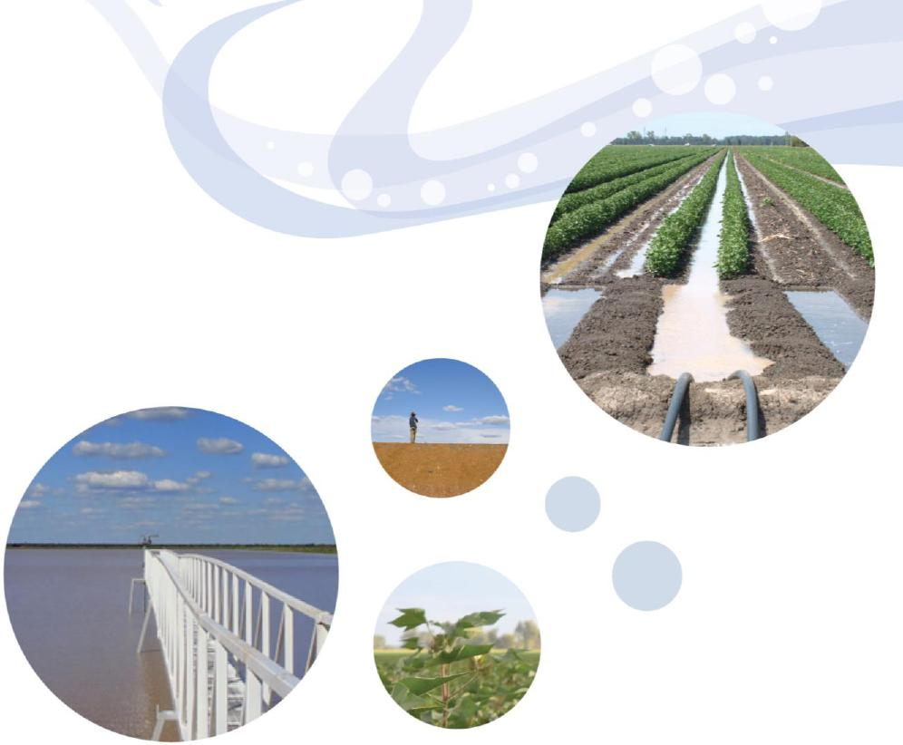
Healthy HeadWaters Water Use Efficiency
Phase 2 Final Report
 | 
Australian Government

Department of Agriculture Queensland Government

© State of Queensland (Department of Natural Resources, Mines and Energy) 2020
This document has been prepared with all due diligence and care, based on the best available information at the time of publication. The department holds no responsibility for any errors or omissions within this document. Any decisions made by other parties based on this document are solely the responsibility of those parties. Information contained in this document is from a number of sources and, as such, does not necessarily represent government or departmental policy.
March 2020
2

Executive summary
Introduction
The Queensland Government is working to manage Murray–Darling Basin water resources to meet social, economic and environmental needs.
The Queensland and Australian governments and other Basin states (New South Wales, Victoria, South Australia and the Australian Capital Territory) entered into agreements for “priority projects” to deliver water saving infrastructure, return of water to the environment and adaptation to climate change.
The Healthy HeadWaters Water Use Efficiency (HHWUE) program was one of Queensland’s priority projects. The HHWUE program helped Queensland meet its water reform commitments with the following objectives:
- assist in securing a long-term sustainable future for irrigation communities as a result of realising water savings through targeted investment in on-farm water use efficiency
- deliver water to the environment by transferring a portion of the water savings achieved through HHWUE funding in on-farm water use efficiency to the Australian Government for management by the Commonwealth Environmental Water Office
- assist faster adoption of more efficient water use technologies across the irrigation sector, leading to greater value returns per megalitre to producers.
The Australian Government allocated up to $154 million¹ for two phases of the HHWUE program. This report discusses the outcomes of Phase 2 which ran from 2012 to 2019.
The program was delivered under a Water Management Partnership Agreement Schedule 2 between the Queensland and Australian governments.
Program conduct
Phase 2 of the HHWUE program contained two components:
- an infrastructure funding program
- complementary measures to support the funding program.
Infrastructure funding program
The Queensland Government delivered ten HHWUE program funding rounds between August 2012 and
June 2017. Funding was available for upgrades to on-farm infrastructure to improve the efficiency and productivity
of on-farm water use and management.
Application guidelines
The HHWUE program provided up to 90 per cent of the total cost of works. Up to 50 per cent of the water saved by the works was retained by the irrigator, with the remainder transferred to the Australian Government for environmental use.
Eligible irrigators were required to:
- be registered for GST with a valid ABN or ACN
- have access to land and a tradable water entitlement in an eligible area of the Queensland Murray–Darling Basin (eligible areas changed depending on water recovery priorities)
- be able to enter into a contract with the Queensland Government
- be able to oversee the project in accordance with Queensland and Australian laws and standards. Eligible projects had to:
- relate to storage, distribution or in-field use of water for primary production
- construct, upgrade or commission on-farm water saving irrigation infrastructure
1 All financial information in this document is GST exclusive unless otherwise stated
3

- offer between 50 and 100 per cent (and at least 10 ML) of water savings as a tradable entitlement to the Australian Government
- include an irrigator contribution of at least 10 per cent to the total project cost.
Assessment
Funding rounds were generally open for six months. The Queensland Government assessed applications received under compliance, environmental, technical feasibility, governance and value for money criteria. The Australian Government provided final approval of applications.
Contracts
Approved irrigators entered into two contracts: a contract with the Queensland Government for the project and funding, and a water entitlement transfer deed with the Australian Government for the transfer of the water. Contracts detailed obligations such as compliance with legislation, reporting, timely delivery, record keeping and claiming payments. The Queensland Government monitored project contracts by obtaining regular reports, conducting site inspections and monitoring projects for any variations.
Payment claims
The Queensland Government made three types of milestone payments for each project according to a milestone table that formed part of the contract:
- first payment – paid upon transfer of the water entitlement and usually prior to works starting. The amount was equal to the agreed “price” of the water entitlement to be transferred
- intermediate milestones – paid upon irrigators demonstrating a specified level of progress and expenditure
- final payment – paid upon irrigators demonstrating commissioning of works. The amount was equal to 20 per cent of the total Australian Government funding.
Complementary measures
The Queensland Government also delivered complementary measures projects under the HHWUE program. These complementary measures engaged stakeholders with the HHWUE program and develop industry knowledge of water use efficiency measures:
- Technical advice grants – the Queensland Government approved 61 small grants for irrigators to consider suitable water use efficiency options with the assistance of a qualified irrigation professional
- Eligibility check and pre-lodgement information – the Queensland Government conducted 43 eligibility checks to help irrigators ensure they were fully informed before committing to an application
- Engagement – the program was represented at 79 meetings, including 17 HHWUE-led events, to develop and maintain connections with industry during Phase 2
- Benchmarking – the Queensland Government engaged an irrigation consultant to assess and report on performance, water use and energy consumption of 41 irrigation systems across the Condamine and Balonne and Border Rivers catchments
- Industry Advisory Committee – an industry advisory committee chaired by the Queensland Government enhanced program outcomes by recommending the project deliver relevant events and complementary measures projects
- Industry development – the program delivered projects to increase industry knowledge of water use efficiency technologies and develop decision making tools.
Promotional activities
Phase 2 included a tiered communication strategy to maximise participation from eligible irrigators. The strategy promoted the program to key irrigator groups through local activities such as small field days, one-on-one contact, direct mail and email. Wider groups were captured through general activities such as advertising, online content and attendance at conferences or trade shows.
In addition to engagement events, the HHWUE program was promoted through 153 activities during Phase 2, including program updates, articles in industry publications, media releases, public notices, letters and a video. The Queensland Government had 740 direct formal contacts with 374 irrigators, consultants and other industry representatives.
4

Program governance
The Queensland and Australian governments employed a number of measures to ensure sound governance of the HHWUE program in accordance with the Water Management Partnership Agreement. The Queensland Government established and evolved internal procedures and practices by drawing on knowledge from the project management discipline:
- integration – the program was part of the Queensland Government’s approach to implementing the Basin Plan. The program was governed under the Intergovernmental Agreement on Implementing Water Reform in the Murray–Darling Basin, Water Management Partnership Agreement and internal policies and procedures
- scope – the scope, including the funding program, complementary measures and promotional activities, was established in the agreed Water Management Partnership Agreement Schedule 2
- time – the Schedule 2 established the start and end dates of the program. An annual project plan agreed between the Queensland and Australian governments identified the activities for each financial year. The program team established and monitored timelines around implementation and funding cycles
- cost – the program was fully funded by the Australian Government. The budget including infrastructure funding, complementary measures and program management costs was identified in the Schedule 2. The Queensland Government monitored income and expenditure using its existing financial systems
- quality – the project office maintained and implemented quality measures in contract administration. Internal quality controls were integral to procedures and program documentation. The Queensland and Australian governments undertook the reviews to ensure the program met its agreed quality standards
- human resources – the HHWUE program was delivered by a team based primarily in the Toowoomba office of the Department of Natural Resources, Mines and Energy. The team operated under the Queensland Government and department’s human resources policies and procedures
- communications and stakeholders – the Queensland Government developed a strategy to identify and meet the program’s promotional and stakeholder management objectives
- risk – consistent with the Enterprise Risk Management Framework and standard AS/NZS ISO 30111:2009, the HHWUE program developed a subsidiary risk management plan which outlined how program and project risks were identified, assessed, mitigated and monitored
- procurement – the Queensland Government engaged contractors in accordance with its procurement and
finance policies and procedures including the department’s Financial management practice manual.
Outcomes and evaluation
The Queensland Government used a number of sources (e.g. project data, surveys, third-party studies) to monitor and evaluate the Phase 2 HHWUE program against its three overarching aims.
Long-term sustainable future
The HHWUE program helped irrigation communities become more sustainable at an industry, priority catchment and project scale by establishing efficient infrastructure and building knowledge of water use efficiency practices.
Irrigation industry
An industry benefit of the HHWUE funding program was investment in infrastructure which required less water to operate, which in turn increased industry efficiency and productivity. In contrast to a direct water purchase, the program contributed significantly to water recovery while reinvesting funds into the agriculture industry. Additionally, the complementary measures projects developed industry knowledge of sustainability practices.
Priority catchments
The program focussed on participation in priority catchments and communities such as St George, Dirranbandi and Goondiwindi. The majority of funded projects aligned with priority catchments for water recovery, particularly the Lower Balonne (32 projects) and Border Rivers (20 projects) regions. During the construction phase, projects generated a socioeconomic stimulus in these communities and the region. Irrigators directly engaged an estimated 260 contractors and suppliers during construction of Phase 2 HHWUE projects.
Irrigation enterprises
Australian Government contributed $73,916,531.44 to 64 Phase 2 funded projects representing infrastructure works of approximately $90 million. Forty-three enterprises participated in this phase, some with multiple projects
5

for a range of works. In addition to water efficiencies, irrigators cited ongoing benefits from projects including improved productivity per hectare, increased management flexibility, reduced operating costs, ability to use less labour-intensive systems, reduced energy requirement and increased options for risk management.
Water for the environment
Funded Phase 2 projects achieved an estimated 28.8 gigalitres (GL) water savings across four Queensland Murray–Darling Basin catchments, of which 18.6 GL were permanently transferred to the Australian Government for environmental use.
Phase 2 projects offered between 50 and 100 per cent of the total water savings to the Australian Government. On average, projects transferred 69.2 per cent of the water savings to the Australian Government.
Over the two phases, the HHWUE program achieved an estimated 40.9 GL water savings and contributed 25 GL water to the environment, which is equal to 19.1 GL long term average annual yield.
Faster adoption of efficient water use technologies
The HHWUE program assisted faster adoption of more efficient water use technologies by raising awareness of efficient technologies and providing funding to assist and enable uptake.
Awareness-raising activities
Phase 2 complementary measures projects raised awareness of water use efficiency technologies and their benefits. The projects also developed tools and knowledge to provide irrigators greater certainty when assessing existing practice or choosing new technologies. The Queensland Government identified these opportunities through Phase 1 studies and ongoing engagement with the irrigation industry.
Funding for efficient technologies
The HHWUE program encouraged uptake of technologies by providing funding for irrigators to convert or upgrade their systems to more water use efficient infrastructure. Through funding of $73,916,531.44, the program contributed to in-field, storages and distribution upgrades on 43 enterprises including:
- 48 storages with a combined volume of 106 GL modified to reduce losses from seepage and evaporation
- 3082 hectares converted or upgraded to 25 centre pivot and lateral move machines
- 5616 hectares of other irrigation systems converted or upgraded.
Twenty-two out of 23 agreed the HHWUE project enabled them to complete projects sooner than they would have on their own.
Financial summary
The Australian Government funded the HHWUE program under the Sustainable Rural Water Use and
Infrastructure Program, as part of the implementation of the Murray–Darling Basin Plan in Queensland. The Water Management Partnership Agreement Schedule 2, under which the program was delivered, identified the funding for infrastructure projects and program management for each round and financial year. The total actual Australian Government funding for Phase 2 was $78,994,354.76. The Queensland Government obtained other Phase 2 contributions to the program totalling $16,061,037.77.
Over the program life, the Australian Government provided funding of $103,878,770.95, and the Queensland Government obtained other contributions of $21,795,099.75, approximately 21 per cent.
Conclusion
Through Phase 2, the HHWUE program has helped secure a long-term sustainable future for irrigation communities, delivered water to the environment and assisted adoption of efficient water use technologies.
The Queensland and Australian governments have continuously improved the program to be responsive to emerging stakeholder needs while operating within its agreed framework. Additionally, HHWUE produced insights and learnings valuable to similar future programs, particularly regarding program delivery to meet objectives while balancing participation and ensuring a control environment for appropriate use of government funding.
The program has secured water savings in priority catchments, and funded measures to improve the resilience of vulnerable communities and the irrigation industry. Funded projects invested in regional economies during construction and continue to achieve profitability gains for enterprises across the QMDB. The reports, tools and information developed through studies inform and support the industry now and into the future.
6

Contents
1 Introduction 8
2 Program conduct 10
2.1 Infrastructure funding program 10
2.1.1 Application guidelines 10
2.1.2 Assessment 12
2.1.3 Contract negotiation 15
2.1.4 Water transfer 16
2.1.5 Payment claims 17
2.1.6 Contract monitoring 20
2.2 Complementary measures 21
2.2.1 Technical advice grants 21
2.2.2 Eligibility check and pre-lodgement information 22
2.2.3 Engagement 22
2.2.4 Benchmarking 24
2.2.5 Industry Advisory Committee 24
2.2.6 Industry development 25
2.3 Promotional activities 25
2.4 Program governance 27
2.4.1 Integration 27
2.4.2 Scope 27
2.4.3 Time 27
2.4.4 Cost 28
2.4.5 Quality 28
2.4.6 Human resource 30
2.4.7 Communications and stakeholders 30
2.4.8 Risk 31
2.4.9 Procurement 31
3 Outcomes and evaluation 33
3.1 Long-term sustainable future 33
3.1.1 Irrigation industry 33
3.1.2 Priority catchments 33
3.1.3 Irrigation enterprises 36
3.2 Water to the environment 37
3.3 Faster adoption of efficient water use technologies 39
3.3.1 Awareness-raising activities 39
3.3.2 Funding for efficient technologies 40
4 Financial summary 42
5 Conclusion 43
6 Learnings 45
7

1 Introduction
This report describes Phase 2 of the Healthy HeadWaters Water Use Efficiency program which ran from 2012 to 2019. It documents the program’s delivery, success and learnings in meeting the outcomes identified in the Water Management Partnership Agreement Schedule 2 and meets the Final Project Report requirement at Schedule 2 Item 1.3.
The Queensland Government is working to manage Murray–Darling Basin water resources to meet social, economic and environmental needs.
In 2008, the Queensland and Australian governments and other Basin states (New South Wales, Victoria, South Australia and the Australian Capital Territory) entered into an agreement on sustainability in the Murray–Darling Basin. The Intergovernmental Agreement on Implementing Water Reform in the Murray–Darling Basin was a precursor to, and now supports, the Basin Plan 2012. This overarching agreement allowed for the Australian Government to enter into agreements with individual states for “priority projects” to deliver water saving infrastructure, return of water to the environment and adaptation to climate change.
The Healthy HeadWaters Water Use Efficiency (HHWUE) program was one of Queensland’s priority projects. The HHWUE program helped Queensland meet its water reform commitments with the following aims.
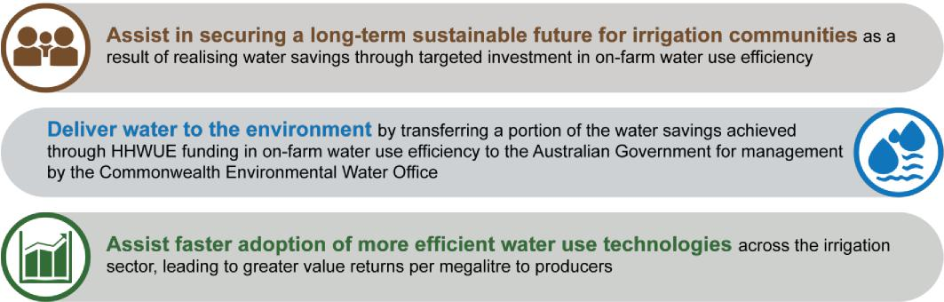
The Australian Government allocated up to $154 million² for the HHWUE program to fund water use efficiency improvements for irrigation infrastructure in the Queensland Murray–Darling Basin (QMDB). In return for funding, irrigators transferred a proportion of water savings to the environment. The allocation also included funding for complementary measures projects and studies.
In 2009, the Australian Government provided the Queensland Government initial advance funding of $898,149.36 in 2009 for program planning and research. From this research, the Queensland Government developed a business case for the HHWUE program. The Australian Government approved the business case, including delivery of the program in two phases. Phase 1 was a pilot with two funding rounds. Further rounds under Phase 2 were dependent on the outcomes of the pilot.
In 2010, the Queensland and Australian governments entered into a Water Management Partnership Agreement for priority projects including the HHWUE program. The agreement included a Schedule 2 for Phase 1 of the program which outlined the milestones, budget and other requirements. Phase 1 ran from 1 May 2010 to 30 October 2013 with a total budget of $23 million. The two pilot funding rounds yielded 10 approved projects representing $19 million of Australian Government funding. The 10 projects proposed 10 gigalitres (GL)³ of water savings of which 6 GL were returned to the environment. Phase 1 included a number of complementary measures to benchmark the overall health of the QMDB irrigation industry and existing efficiency technologies.
2 All financial information in this document is GST exclusive unless otherwise stated
3 All water volumes in this document are in nominal volume unless otherwise stated
8

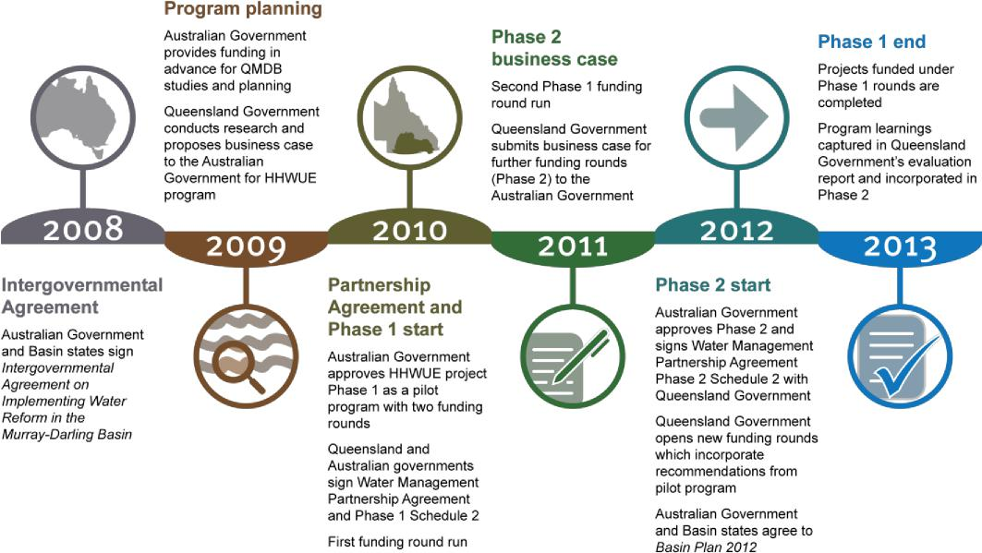
Figure 1: Phase 1 and Phase 2 commencement timeline
Following a preliminary evaluation of Phase 1, the Queensland Government proposed a business case for further funding rounds. The format of the program was to be similar to the pilot, with some changes based on the results and recommendations from the first two rounds completed under Phase 1. The Australian Government approved the business case for Phase 2, and the Queensland and Australian governments entered into a new Schedule 2 to the Water Management Partnership Agreement for Phase 2. A final evaluation of Phase 1 in 2013 further informed the program’s continuous improvement.
9

Delivering the Basin Plan in Queensland
The QMDB covers 260 011 km² (15 per cent) of Queensland and is approximately 25 per cent of the area of the total Murray–Darling Basin. The catchments within the QMDB include the Condamine and Balonne, Border Rivers, Moonie, Warrego, Nebine and Paroo.
The QMDB is a major producer of both dryland and irrigated cotton, broadacre crops, livestock and horticulture. Irrigation infrastructure includes on-farm water storages, delivery and in-field application systems.
In 2012, the Basin states agreed to the Murray–Darling Basin Plan. The Basin Plan recognises the impact of drought and water use on the Murray–Darling Basin and aims both to restore it to a sustainable level and support the water-dependent communities. The Basin Plan aims to improve
water management through measures including:
• delivering water for the environment to improve the health of rivers, wetlands and floodplains
• decreasing water consumption in catchments and across the Basin to meet sustainable reduction targets.
The HHWUE program was developed as part of the implementation of the Basin Plan in Queensland.
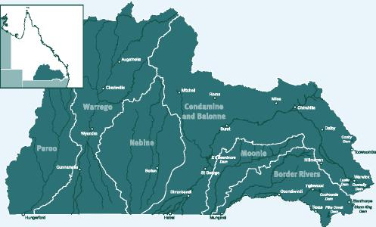


2 Program conduct
Phase 2 of the HHWUE program started on 1 August 2012 and contained two components:
- an infrastructure funding program
- complementary measures to support the funding program.
2.1 Infrastructure funding program
Under Phase 2, the Queensland Government delivered ten HHWUE program funding rounds between August 2012 and June 2017. Funding was available for upgrades to on-farm infrastructure. These upgrades were intended to improve the efficiency and productivity of on-farm water use and management.
The HHWUE program provided up to 90 per cent of the total cost of works. Up to 50 per cent of the water saved by the works was retained by the irrigator, with the remainder transferred to the Australian Government for environmental use.
2.1.1 Application guidelines
At the start of each round, the Queensland Government released application guidelines outlining eligibility criteria, closing dates, assessment criteria and general contract information. Early application packs also included case studies of water use efficiency projects, sample applications and other guidance material, however as irrigators became more familiar with the process these were discontinued. Irrigators could access the application pack by visiting the HHWUE program webpage or contacting the Queensland Government.
2.1.1.1 Eligibility
In general, eligible irrigators were required to:
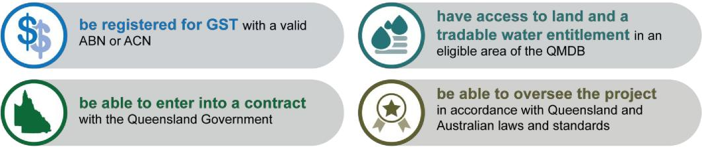
Below is a list of all water products eligible during Phase 2 of the HHWUE program. Not all products were eligible for each round as areas changed depending on water recovery priorities at the time.
Catchment | Water Type | Zones
Condamine and | Supplemented | • | Chinchilla Weir Water Supply Scheme
Balonne |  | • | St George Water Supply Scheme (zones 1-4)
 |  | • | Upper Condamine Water Supply Scheme (zones 2-4)
 | Unsupplemented | • | Condamine and Balonne Water Management Area (zones 1-9)
 |  | • | Lower Balonne Water Management Area (zones 1-10)
 |  | • | Upper Condamine Water Management Area (zones 5-16)
 | Overland flow | • | Lower Balonne Water Management Area
Border | Supplemented | • | Border Rivers Water Supply Scheme (zones A-B)
Rivers
 | Unsupplemented | • | Border Rivers Water Management Area (Dumaresq, Macintyre and Barwon zones)
 |  | • | Upper Weir Water Management Area (classes UW2A, UW2B and UW2C)
 |  | • | Lower Weir Water Management Area

10

Moonie Unsupplemented • Moonie Water Management Area (zones A-D)
Warrego Unsupplemented • Lower Warrego Water Management Area (zones A-D)
Irrigators participating in the HHWUE program were required to own the land or water related to the project, or have documented consent of the owners. Irrigators could offer water from a different location within the same water management zone to the land on which works were proposed. In round 12, irrigators were also able to offer “dislocated” water (i.e. water from a different zone within the same catchment to the land on which works were proposed). This flexibility enabled irrigators with multiple properties in the same catchment to align their projects better to their farm-level business priorities.
From round four, “cross border” projects became eligible, offering flexibility for irrigators who owned property on the Macintyre and Dumaresq Rivers on either side of the Queensland and New South Wales border to participate. Cross border projects were required to offer Queensland water allocations, however works could occur on adjacent land in the Border Rivers region of New South Wales.
Eligible projects were to:

Water management in Queensland
In Queensland, water is managed in catchments (e.g. Condamine and Balonne, Border Rivers), each of which is defined under a statutory Water Plan. The Water Plan establishes overarching measures, outcomes and performance indicators, in addition to amounts of water available for use and criteria for making licencing decisions.
The Water Plan breaks each catchment into “water management areas” each of which has its own specifications. Each water management area is further broken down into local zones.
Water is generally classified as:
- Supplemented – surface (i.e. river) water supplied by releasing water from centrally managed dams or weirs
- Unsupplemented – surface water supplied by natural river flows
- Overland flow – water that runs across land after rainfall
- Groundwater – water from underground aquifers such as the Great Artesian Basin.

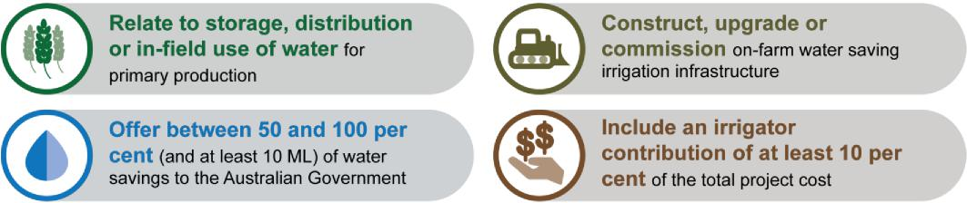
While the minimum irrigator contribution was 50 per cent of the water savings and 10 per cent of the total project cost, many irrigators chose to offer a higher contribution to improve the “value for money” of their applications. From round five, irrigators were able to offer additional water in lieu of a “cash” irrigator contribution. The Queensland and Australian governments developed this option in response to feedback from irrigators who had a limited cash flow and could not easily make a cash contribution to their projects.
2.1.1.2 Applications
Irrigators applying for HHWUE funding were required to submit complete applications. Complete applications included the application form and attachments describing the location, works, technical feasibility, methodology of calculating water savings, management plan, budget and timeframe. Applications were required to include approval of all landholders and water owners. The irrigator’s qualified irrigation professional signed a certification confirming the project and water savings were feasible and based on sound methodology. Recognised qualifications were Registered Professional Engineer of Queensland, Irrigation Australia Certified Irrigation Designer or Irrigation Australia Certified Irrigation Agronomist.
11

2.1.1.3 Closing dates
Rounds were generally open for six months. Prior to applying, irrigators were encouraged to request technical, eligibility or pre-lodgement information (see sections 2.2.1 and 2.2.2).
During rounds three to six, the Queensland Government used a “two step” application process to make applications simpler and more flexible:
- Firstly, irrigators submitted expressions of interest outlining their proposed projects and included maps, plans, costings and supporting information. At the end of the application period the Queensland Government assessed expressions of interest received. If required, the Queensland Government sought additional information from irrigators during this assessment period
- Secondly, eligible irrigators were invited to complete their application by submitting a proposal. The proposal identified the amount of funding requested and water offered, and included the signatures of all land and water owners and a certification by the irrigator’s qualified professional.
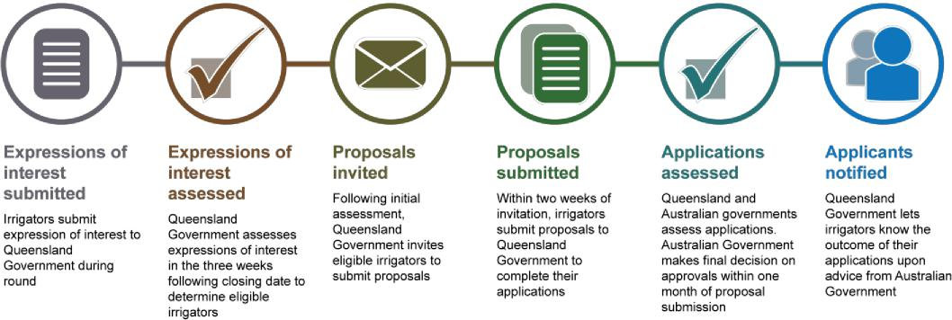
Figure 3: Two step application process
Later industry feedback indicated irrigators preferred shorter application periods with a faster turnaround time on approvals. As a result, from round seven onwards, applications reverted to a single step process. The rounds were still open for six months, however applications were assessed in monthly intakes (i.e. six intakes per round). Closing dates were usually the last business day of each month. Irrigators whose applications were declined in one intake were able to reapply with revised projects later in the round.
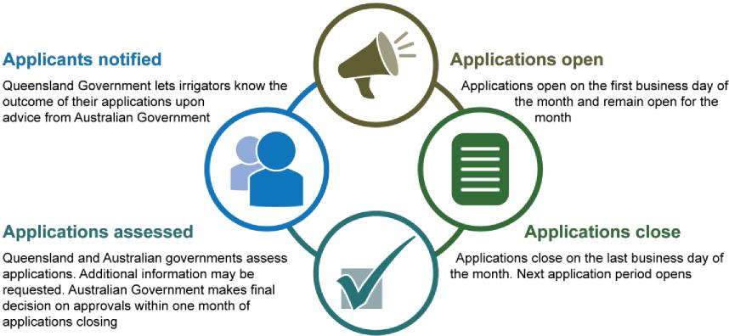
Figure 4: Single step application process
2.1.2 Assessment
Applications received during funding rounds were assessed according to five criteria: compliance, environmental,
12

technical feasibility, governance and value for money. The assessment panel comprised of the immediate Queensland Government program team, with input from expert sources.
The first four criteria were assessed to confirm the irrigator had provided the required information and the
application met the eligibility criteria for the round. If information was incomplete the Queensland Government could request additional information. All irrigators were required to provide this information within a set timeframe (usually one week for applications under the two-step process, or two business days for applications under the single-step process).
The Queensland Government assessed the value for money criterion against an assumed threshold, and the Australian Government verified the assessment during its decision making process. The value for money proposal was final at the time of application, and the irrigator could not adjust the amount of funding requested or water offered unless they withdrew and resubmitted the application in a subsequent intake.
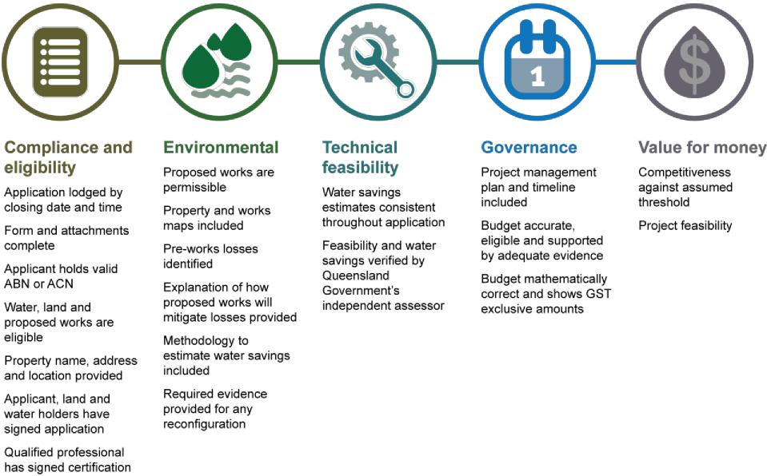
Figure 5: Assessment criteria
2.1.2.1 Compliance and eligibility criterion
The first step of assessment included receipting the application and checking for completeness. The assessment panel conducted searches of land and water title data and business/company registers to determine the application’s compliance with the eligibility criteria for the round.
2.1.2.2 Environmental criterion
The panel reviewed the application to determine whether the proposed works were sufficiently described and the associated estimated water savings reasonable. This check included input from the Queensland Government’s water licencing unit who advised whether the offered water entitlements were possible to trade in an unencumbered state, the steps to transfer and likely approvals required for the works and transfer.
For some entitlements (particularly those in the Lower Balonne region), the Australian Government also required information regarding environmental benefits. To meet this requirement, the Queensland Government obtained a hydrological modelling report from Queensland Hydrology identifying the expected characteristics and benefits of these water entitlements following transfer.
The Queensland Government also engaged an independent Registered Professional Engineer of Queensland to assess each project. This assessor reported on whether the methodology, pre-works losses and proposed water savings were reasonable. Where the assessor considered the application information incomplete or unclear, the Queensland Government could seek additional information from the irrigator.
13

2.1.2.3 Technical feasibility criterion
Each application required certification from the irrigator’s qualified irrigation professional that the project was technically feasible (see section 2.1.1.2). Applications had to include sufficient information for the Queensland Government’s independent assessor to review and confirm feasibility of the proposed projects. The panel also considered the nature of proposed projects against previous applications and studies regarding types of upgrades likely to achieve water savings.
2.1.2.4 Governance criterion

Water use efficiency measures
Applications proposed measures to improve the water use efficiency of storages, distribution and in-field systems. Types of projects commonly seen included:
- storage modification – storage modification refers to a number of measures to mitigate seepage and evaporation losses. These measures are usually based on reducing the surface or floor area to improve storage efficiency. For instance, replacing a shallow storage with a deep storage of the same volume results in less area exposed to evaporation losses
- bankless channel – bankless channel is a form of surface irrigation. Fields are divided into “bays” along a head ditch, usually separated by gates or similar control measures in the head ditch and tail drain. Water is released along the head ditch to the gate and runs down the bay. Once the bay is sufficiently irrigated, the gate is opened and water flows into the next bay. This system allows greater control over water flow. This increased control means less water is lost to run-off, evaporation or deep drainage, which reduces the amount of water required to irrigate the area
- centre pivot and lateral move – these automated low-pressure overhead watering systems enable better
watering precision than systems such as siphons which traditionally flood large areas. Centre pivot
machines are generally fixed at one end and travel in a circle. Lateral move machines are
not fixed at either end and can travel in a linear pattern. The increased precision means
less water is lost to run-off, evaporation or deep drainage, which reduces the amount of
water required to irrigate the area.

Irrigators were required to identify the timeframe for works and describe how they would manage projects to ensure works were completed on time. This requirement became more important towards the end of the HHWUE program. Project implementation could only occur within short timeframes, and irrigators were required to demonstrate their capacity to complete the works on time.
Irrigators were required to propose a project budget with allowance for application preparation, project management, capital, earthmoving and commissioning. The Queensland Government assessed the proposed budgets to ensure the costs were eligible and supported by either a quotation, calculations (with workings shown and quotations for unit rates applied) or estimates for minor items.
2.1.2.5 Value for money criterion
The value for money of the application was expressed as the cost per megalitre (ML) of water that a project represented for investment by the Australian Government. The value for money figure for each application was calculated by dividing the funding requested by the ML of water offered. A margin was added to the funding requested to account for program management overheads. The cost per megalitre was then compared to a regional benchmark price for the water to achieve a “market multiple”.
The Australian Government set the regional benchmark price depending on the water entitlement location and characteristics. The price was determined based on historical trade data and valuations. In areas where trade data was limited, the Queensland Government sought additional valuations through its State Valuation Service to inform its initial assessment. The Australian Government also sought valuations as required.
The market multiple reflected how many times above the market price the Australian Government would pay per ML of water offered should the application be funded. Approved projects were generally within a market multiple range of 2.0 to 2.51. Applications with a lower market multiple were considered of greater value for money to the Australian Government and more likely to be approved for funding.
14

Calculating value for money

The value for money market multiple was calculated based on the funding requested, water offered to the Australian Government and regional benchmark. For instance:
- Funding sought: $900,000
- Water offered to the Australian Government: 225 ML

- Cost per ML: $4000/ML ($900,000/225 ML)
- Regional benchmark: $1770/ML
- Market multiple: 2.25 ($4000/$1770) not including program management margin.

2.1.2.6 Recommendation of applications
Following application assessment, the Queensland Government recommended projects to the Australian Government for approval in a “works package”. The works package included both recommended and not recommended projects.
The Australian Government responded with its approval by letter, listing applications approved and applications declined with the reasons. From rounds three to six, the Queensland and Australian governments entered into a variation to the Water Management Partnership Agreement Schedule 2 listing the approved projects in the agreement. Following this variation, the Queensland Government was able to enter into contracts with approved irrigators. From round seven onwards, the process was amended to suit the shorter assessment periods. The approval letter, signed by both governments, was sufficient authority for the Queensland Government to enter into contracts with irrigators.
2.1.2.7 Application outcomes
The Queensland Government notified irrigators by phone immediately upon receiving the Australian Government’s approval letter. Following the phone call, the Queensland Government sent written notifications to irrigators. Irrigators with approved projects also received an information sheet on the next steps, a draft contract and a sample water entitlement transfer deed.
Irrigators with declined projects were provided the reasons their applications were declined and offered the opportunity to discuss the matter with the Queensland or Australian governments. In most cases, applications were declined on the basis of value for money (i.e. the price per ML of water was higher than the Australian Government was willing to fund). Often, irrigators chose to reapply in a subsequent round with a revised value for money proposal.
2.1.3 Contract negotiation
Approved irrigators entered into two contracts: a contract with the Queensland Government for the project and funding, and a water entitlement transfer deed with the Australian Government for the transfer of the water.
2.1.3.1 Contracts
For each project, the irrigator, landholder, water owner and Queensland Government entered into a contract. Contracts detailed obligations such as compliance with legislation, reporting, timely delivery, record keeping and claiming payments.
Contracts were developed from a standard Queensland Government contract template with modifications for the HHWUE program. The contracts were contingent on irrigators’ subsequently entering into water entitlement transfer deeds with the Australian Government.
Irrigators could negotiate milestone dates within the overall timeframe of the HHWUE program, the number of intermediate milestones and special conditions (from round eight onwards) in the Schedule 1.
The contract template was updated from time to time, for instance in response to legislation or for consistency with HHWUE process improvements. An additional version of the template was developed for cross border projects.
2.1.3.2 Pre-contractual meetings
The Queensland Government held a pre-contractual meeting with each approved irrigator. Irrigators were invited to
15

include their consultants, landholders, water owners and any other interested parties at these meetings. The meetings introduced irrigators to the contract and processes such as the water transfer, payments and reporting. If a draft contract had not previously been provided to the irrigator, the Queensland Government presented it at this time. The Queensland Government recommended all irrigators seek independent legal advice before entering into contracts.
Following the pre-contractual meeting, the Queensland Government requested the irrigator confirm their acceptance of the contract and provide any documentation necessary for establishment.
2.1.3.3 Signing
Once the irrigator confirmed acceptance of the draft contract, the Queensland Government prepared a final contract for signing. In most cases, the Queensland Government signed the final contract first. Where this timing was unsuitable however, contracts were signed in counterpart (i.e. by the parties concurrently on duplicate copies of the contract).
Once the contract was signed, changes could only be made through a deed of variation. For projects prior to round eight, all original parties were required to sign variations. For projects from round eight onwards, the water owner had no further obligation to sign variations once the water transfer had taken place.
Upon signing contracts, irrigators were required to provide the Queensland Government various evidence of their meeting agreed obligations including insurances. From round five, irrigators were required to provide additional information on how they would meet their compliance obligations, in the form of a compliance plan identifying any approvals or permits required for their works, how they would be obtained and the evidence which would be provided to the Queensland Government.
2.1.4 Water transfer
Irrigators returned water to the environment by transferring a water entitlement to the Australian Government. Water transfer was a pre-requisite for any funding payments. While irrigators could start work on their projects upon approval, any work undertaken prior to the contract being signed and water transferred was at their risk.
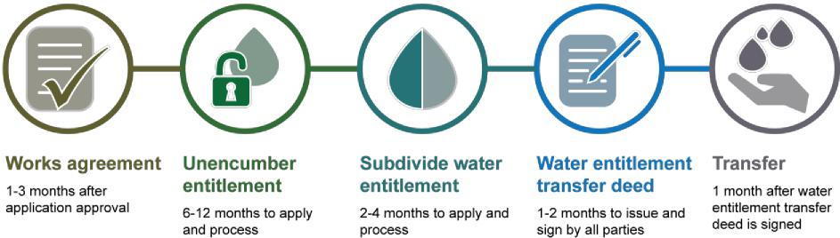
Figure 6: Common steps and timeframe to water transfer
2.1.4.1 Preparing entitlements for transfer
The water entitlements transferred under the HHWUE program had to be free from any encumbrances and transferred permanently. Because preparing an entitlement for transfer could be costly and time consuming, the Queensland Government did not require entitlements to be ready to transfer at the time of application. If the application was approved however, the water owner was required to prepare the entitlement. Typically, the steps involved removing encumbrances and subdividing an entitlement into two portions (the volume of water to be transferred to the Australian Government, and the volume retained by the water owner).
16

Owning water in Queensland

In Queensland, water entitlements can be owned, subdivided, leased and traded. Entitlements may also have encumbrances such as mortgages, ties to parcels of land, or particular interactions with the holder’s other entitlements.
A common encumbrance is an “overland flow hook”. This hook occurs where both surface and overland flow water are captured, stored and managed under the same entitlement. In order to transfer the surface water component, the water owner must “unhook” the entitlement, creating separate surface and overland flow entitlements with independent conditions.
The water owner applies to the Queensland Government to unhook the entitlement. This application is accompanied by an
overland flow certification from a Registered Professional Engineer of Queensland. The certification provides details
of storage capacity, rate of take and other information which helps determine the new entitlement conditions.

Where these details differ from the Queensland Government’s modelling of the entitlement, significant
negotiation may be required to agree on the final conditions.
Due to this complexity, the Queensland Government often advised HHWUE water owners to expect unhooking would incur a considerable time and cost commitment.

The Queensland Government’s water licencing and titles business units processed unencumbering and subdivisions upon application by the water owner. These units were separate to the HHWUE program team, however frequently worked together throughout the program. From 2016 onwards, the HHWUE program team had a dedicated officer coordinating the workflow between the water owner, Australian Government, licencing and titles units. This role was developed in response to the sometimes lengthy unencumbering process and the approaching end of the HHWUE program. This officer established and managed expectations and championed processes. The officer attended pre-contractual meetings to explain the steps and timeframe for each entitlement. The officer then monitored progress of the transfer and contacted each party to ensure critical timeframes were met.
2.1.4.2 Water entitlement transfer deed
The Australian Government entered into a deed with the owner of the water entitlement to be transferred. The irrigator was not a party to this “water entitlement transfer deed” unless they were a water owner also. Similarly, the Queensland Government was not a party to the deed, however monitored progress for information. The Australian Government notified Queensland when “due diligence” commenced, the deed was issued, the deed was executed and transfer had occurred.
Before issuing the deed, the Australian Government undertook a “due diligence” process, performing final checks that the offered entitlement met the requirements for water recovery. The transfer was not considered fully approved until the entitlement passed due diligence, however the program had no instances where an approved entitlement subsequently did not pass this check.
Usually, the Australian Government started due diligence once the Queensland Government advised the contract was executed and the water entitlement was ready for transfer. During round 10, the Queensland and Australian governments trialled an early due diligence process. Under this process the Australian Government commenced due diligence upon application approval, however waited until the contract was signed and water entitlement ready before issuing the deed. Early due diligence intended to help expedite water transfer, however results showed only a minimal benefit and the Australian Government reverted to the previous process.
The Australian Government issued the deed to the water owner to sign first. Once both parties had signed the deed, settlement of the water transfer could occur.
2.1.5 Payments
The Queensland Government made three types of milestone payments for each project: first, intermediate and final. The payments were set out in a milestone table that formed part of the contract. The first and final milestones were for fixed activity and amounts of funding. The number and amount of intermediate milestones could be negotiated with each irrigator to best suit their project and financial situation.
Early versions of the milestone table listed the activities required to be demonstrated for intermediate and final milestones (e.g. pipes purchased, storage 50 per cent constructed).This process became cumbersome however as, in practice, not all activities were undertaken in the anticipated order. From round six, the Queensland Government changed the format of the milestone table to require simply a percentage of project completion. During 2016, the completion percentage was further revised to correspond to the cumulative amount of funding (see Figure 7).
17

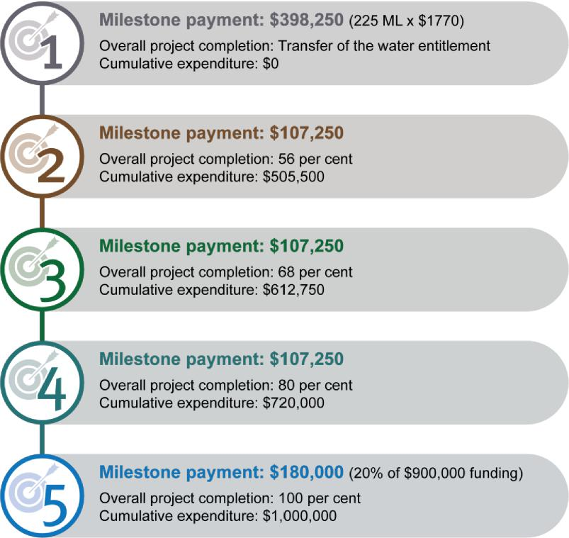
Figure 7: Typical milestone format under the final version of the milestone table
2.1.5.1 First payment
The first milestone was paid upon transfer of the water entitlement and usually prior to works starting. The first milestone was contingent upon:
- signing of the contract by all parties
- completion of the water transfer.
Where irrigators intended to start works before receiving the first payment, the first milestone could include other conditions such as a pre-works site inspection by the Queensland Government or provision of information. If not in the first milestone, these conditions were usually part of the second milestone and prerequisites to work starting.
The amount of the first payment equalled the volume of water (ML) transferred to the Australian Government multiplied by the Australian Government’s “agreed market price” ($/ML) of the water entitlement. This payment was considered an advance payment, whereas all other payments were in arrears.
Once the Australian Government advised the water entitlement transfer deed was signed, the Queensland Government requested the irrigator provide a tax invoice for the amount of the first milestone. Payment occurred by cheque or electronic transfer immediately after the Australian Government advised settlement had occurred.
2.1.5.2 Intermediate milestones
Intermediate payments were made in accordance with individual milestone tables. Intermediate payment claims were contingent upon the irrigators demonstrating:
- the specified level of project progress
- cumulative actual expenditure equal to the previous milestones plus the milestone claimed. Irrigators could claim more than one milestone payment at a time if they could demonstrate sufficient progress and
18

expenditure. Many irrigators chose to claim all intermediate milestones and the final together as one bulk payment at the end of their projects.
To claim an intermediate payment, irrigators provided to the Queensland Government:
- a tax invoice for the amount of the milestone claimed
- invoices and proof of payment for contracted work
- indirect evidence for in-kind work and fuel use (e.g. logbooks, bowser records).
The Queensland Government undertook a site inspection to verify the claimed level of completion. For some simple projects, the HHWUE program team or a Queensland Government engineer performed this check. For most projects however, the Queensland Government engaged an independent qualified professional to verify progress.
Irrigators evidenced contracted work by presenting invoices and proof of payment, which could be receipts, bank statements or supplier statements. Irrigators could also claim a dollar value for logged in-kind work. Irrigators presented a summary of logbooks and rates applied for in-kind. From 2016 onwards, irrigators were required also to present copies of logbooks to support the summary of hours claimed. Similarly, irrigators initially demonstrated fuel through invoices for bulk supply and a summary of litres claimed towards the HHWUE program. From 2016 onwards, irrigators were required to provide bowser records or fuel consumption calculations in addition to this evidence.
With the exception of application preparation, work claimed could not be retrospective (i.e. before the date of application approval). Irrigators could however claim stock-on-hand if they could demonstrate the cost. Irrigators were responsible for ensuring stock-on-hand was of a suitable quality and specification for the project.
2.1.5.3 Final payment

Definitions
Contracted work: goods or services supplied by or undertaken by another party, such as irrigation supplies, earthworks or professional consulting
In-kind: goods and or services provided by the proponent, such as the use of own earthmoving equipment or project
management time
Irrigator contribution: the irrigator’s required minimum 10 per cent contribution towards the total project cost
Stock-on-hand: second-hand or new capital items purchased by the irrigator prior to application approval

The final milestone was equivalent to 20 per cent of the total funding and made upon commissioning of works. This payment was contingent upon the irrigator demonstrating:
- the project was commissioned
- the total project cost had been spent.
To claim a final payment, irrigators provided to the Queensland Government:
- the same evidence as required for an intermediate milestone
- a commissioning report from the irrigator’s qualified professional demonstrating project completion
- a statutory declaration confirming the project and funds had been managed in accordance with the contract.
The commissioning report was provided by a Registered Professional Engineer of Queensland, Irrigation Australia Certified Irrigation Designer or Irrigation Australia Certified Irrigation Agronomist. In exceptional circumstances, the commissioning report could also be from another person, for instance an experienced supplier, if first approved by the Queensland Government.
Where projects achieved cost savings, these savings were shared between the Queensland Government and irrigators in proportion to the funding/irrigator contribution ratio. In practice, this adjustment meant the proponent and Queensland Government still provided their agreed percentages of the actual project costs. Most projects expended more than originally budgeted due to unexpected project costs or inflation in the time between application preparation and project delivery. Only 10 completed projects received an adjustment to the funding payment.
19

2.1.6 Contract administration
The Queensland Government introduced a “case management” approach to contract administration during Phase 2 of the HHWUE program. Each project was assigned a case manager within the HHWUE program team. The case manager provided a single contact point between the irrigator and the team for their HHWUE project. The case manager conducted the pre-contractual meeting, received confirmation of the contract, attended and conducted site inspections as required, obtained reports from the irrigator, assessed payment claims and maintained correspondence. A second HHWUE program team member accompanied the case manager and cross checked payment claims, contracts and correspondence.
2.1.6.1 Reporting
Under the contract, irrigators provided quarterly reports to the HHWUE program team. The reports included an estimate of expenditure against the approved budget and commentary on progress, emerging issues and promotional activities. These reports in turn informed the Queensland Government’s reporting to the Australian Government.
The case manager provided the irrigator a reporting template to be completed in the first two weeks immediately following the quarter. The Queensland Government did not usually seek quarterly reports where the project was on hold as there was no expenditure or progress to report. The case manager however monitored the project to ensure critical dates could still be met. Similarly, the Queensland Government did not seek a report if a payment had recently been made as the information required for the payment claim was sufficient to determine expenditure and progress.
2.1.6.2 Site inspections
In addition to pre-works and milestone payment site inspections, the Queensland Government undertook selected inspections to check progress during project delivery. These inspections occurred where some time had elapsed between milestone payments or inspections. Additionally, some projects received a pre-works inspection and progressed directly to a final payment claim. In these instances, the Queensland Government may not have had the opportunity to conduct an intermediate or second independent inspection of the works. During 2018, the Queensland Government conducted further independent inspections for these projects before making the final milestone payments.
2.1.6.3 Contract variations

Quality assurance checks
The Queensland Government required checks throughout application assessment and project delivery:
Application certification: undertaken by a qualified irrigation professional; obtained by the irrigator; confirmed the project and water savings were feasible and based on sound methodology
Application assessment: undertaken by a qualified irrigation professional; obtained by the Queensland Government; confirmed whether the methodology, pre-works losses and proposed water savings were reasonable
Pre-works: undertaken by a qualified irrigation professional or HHWUE project team (depending on complexity); obtained by the Queensland Government; confirmed pre-works condition of the project site
Milestone payments: undertaken by a qualified irrigation professional or HHWUE project team (depending on complexity); obtained by the Queensland Government; verified the claimed level of completion
Commissioning: undertaken by a qualified irrigation professional or (in exceptional circumstances) experienced supplier; obtained by the irrigator; demonstrated project completion.

Irrigators were required to seek approval for changes to the project specification and timeframe. The Queensland Government assessed these changes against the original project eligibility, intent and outcomes. The Queensland Government was able to approve simple changes such as the relocation of a capital item or a minor extension to the project timeframe. More complex changes such as exchanging the proposed works or moving milestone payments between financial years required consultation with the Australian Government prior to approval.
Approved changes, if significant, were formalised through a deed of variation to the contract. If declined, irrigators could submit a revised variation request based on feedback from the Queensland Government. Often, the changes were identified in collaboration with irrigators so non-approval was unlikely.
20

2.1.6.4 Withdrawn projects
In some cases, irrigators chose not to proceed with approved projects for business reasons. Twenty-one approved projects identified in Phase 2 did not proceed.
Irrigators advised the Queensland Government in writing if they did not wish to proceed with the project. If a contract had not yet been executed, the Queensland Government withdrew the offer of funding. If a contract had been executed, the contract was finalised either through an exchange of letters or execution of a deed of termination. If a water transfer had occurred, the water remained the property of the Australian Government and the irrigator retained the first payment.
Withdrawal did not preclude the irrigator from applying again for funding.
2.2 Complementary measures
The Queensland Government also delivered complementary measures projects under the HHWUE program. These projects, which were funded under the complementary measures component of the HHWUE program, achieved the following outcomes⁴.
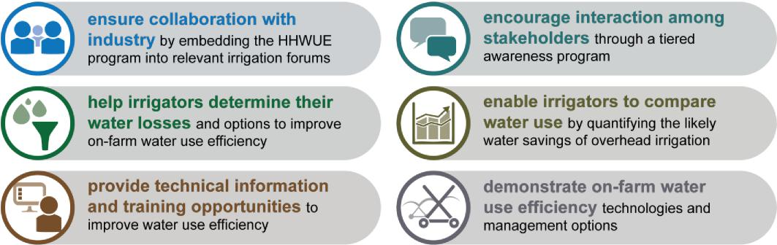
Complementary measures funding also included the Queensland Government’s program management costs. These costs were to promote the infrastructure funding program, run rounds, assess applications, undertake contractual processes, oversee funded projects and engage contractors.
2.2.1 Technical advice grants
Aim |  | To help irrigators obtain advice on on-farm water use efficiency options and consider the viability of an HHWUE infrastructure project without extensive early expenditure
Project |  | This project provided small grants for irrigators to consider suitable water use efficiency options with the assistance of a qualified irrigation professional. Irrigator eligibility criteria were the same as for the infrastructure funding program.  Irrigators could engage a qualified professional for services including:  - on-farm water accounting and removing overland flow hooks  - measurement of on-farm storages  - measurement of evaporation and seepage losses from on-farm storages  - farm level irrigation design  - water auditing (including system performance evaluation and whole farm water balances).  The HHWUE program paid irrigators up to 80 per cent of the cost (to a maximum of $4000) of services. Irrigators applied for the grant before obtaining professional advice. Approved irrigators received advice, then claimed reimbursement from the Queensland Government. Irrigators had a fixed period after approval, usually until the end of the financial year, in which to claim the reimbursement. Irrigators shared some of the information generated which helped the Queensland Government identify potential projects and areas of interest.  If irrigators proceeded to apply and be approved for HHWUE infrastructure funding, part of the remaining

4 Water Management Partnership Agreement, Schedule 2, C.2.2
21

2.2.2 Eligibility check and pre-lodgement information
Aim
Project
Timing Outputs
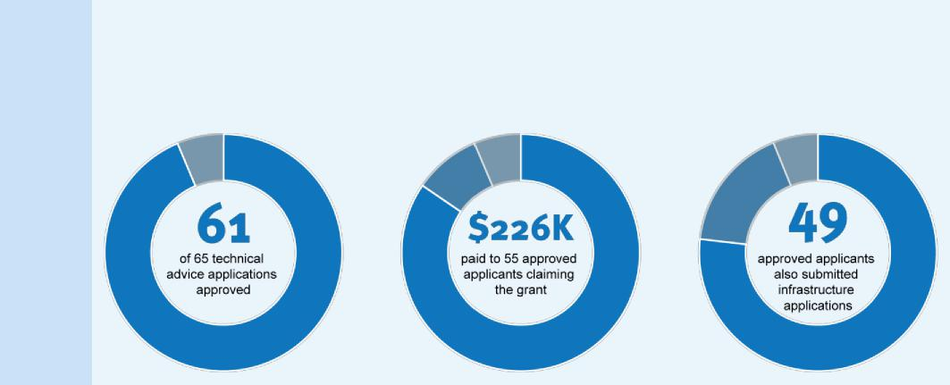
Timing
Outputs
Approved applications were spread across irrigation design, storage measurement, water auditing and losses measurement.
2012 to 2017
professional costs could be claimed under the infrastructure project budget.
2.2.3 Engagement

To inform irrigators considering infrastructure funding applications whether their proposed projects and water entitlements were eligible and the steps required for transfers
This project also intended to reduce initial outlay for potential applicants and to ensure they were fully informed before committing to an application. In round three, the HHWUE program ran an eligibility request process. Potential applicants completed a short form identifying their water entitlements, property lots and proposed works. The Queensland Government provided initial feedback on eligibility and considerations, and a free copy of the water entitlement titles (if eligible).
In rounds four to 12, the Queensland Government expanded the information available and replaced the eligibility check with a pre-lodgement information request process. In addition to eligibility and titles, potential applicants could receive:
- free hydrological modelling data (Condamine and Balonne entitlements)
- water management and trading advice
- project plan and development assistance.
Condamine and Balonne water owners had reported difficulty obtaining modelling which often delayed the unencumbering process. Starting this process prior to the application intended to reduce the time to transfer the entitlement after approval. It also allowed irrigators to consider whether the post-transfer conditions of their remaining entitlement were suitable, a deciding factor in whether to progress with an application.
2012 to 2017
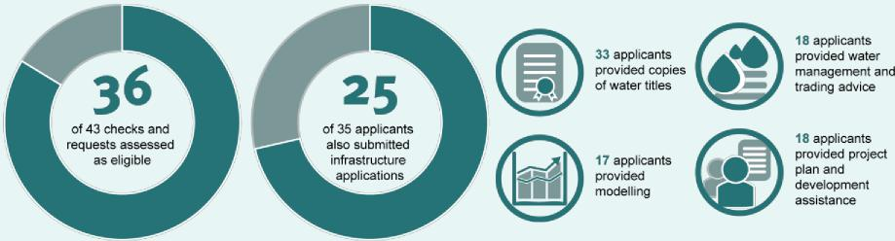
Aim |  | To encourage participation in the HHWUE infrastructure funding program, gather industry feedback to help improve the program and raise awareness of water use efficiency practices
Project |  | The HHWUE program team employed an engagement officer to develop and maintain connections between industry and the program. The engagement officer was based at St George within the Lower Balonne region. The role included running HHWUE-led events to showcase water use efficiency options, completed projects and

22

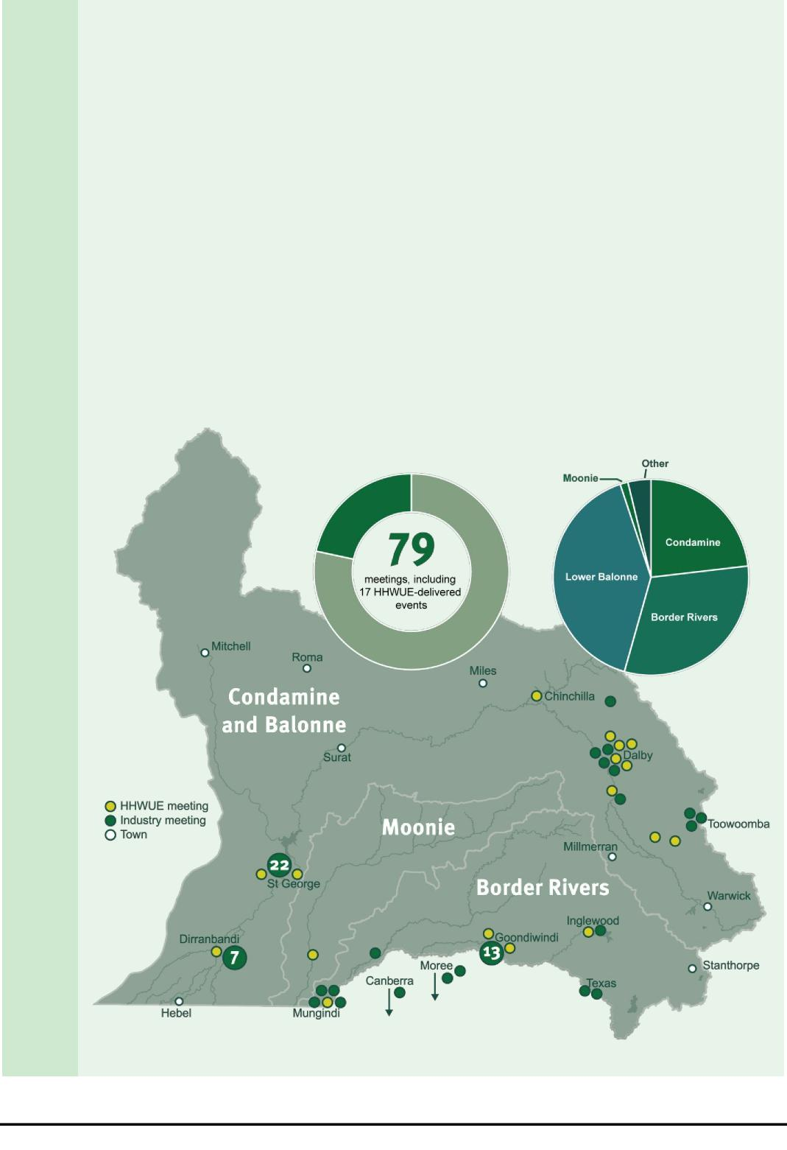
other topics as requested by industry, while participating in industry meetings and events.
The role also involved one-on-one meetings with irrigators to discuss potential applications and the format of the funding program. This extensive collaboration provided the irrigation community a mechanism to shape program improvements such as the shorter application assessment periods and eligible areas.
Timing
2013 to 2017
Outputs
- The HHWUE program was represented at 79 meetings during Phase 2. Of these meetings, 62 were industry meetings and events attended by HHWUE engagement representatives. A further 17 meetings and events were delivered by the HHWUE program (sometimes in conjunction with other departments or industry bodies). Highlights included:
- Financial institutions field days in St George and Goondiwindi in March 2013 and February 2014. These field days gave agribusiness and local banking representatives an opportunity to see completed projects and help develop mutual understanding of HHWUE processes, particularly regarding transfer of water entitlements and funding payments
- Water use efficiency options field days in St George and Goondiwindi in August and September 2014. Two field days showcased completed HHWUE projects and promoted the funding program
- Storage options field day in St George in March 2015. This field day toured six completed storage projects in the St George region. Irrigation specialists and funded irrigators shared their experiences with completed projects, outcomes and effectiveness, with a focus on storage benchmarking and pump efficiency.
- The HHWUE program was also represented at two industry-led training events and three trade shows.
Figure 8: Phase 2 engagement activities
23

2.2.4 Benchmarking
Aim |  | To provide irrigators metrics against which to measure existing centre pivot and lateral move efficiency, and to decide whether new machines would be beneficial for their businesses
Project  Timing |  | This project commenced in Phase 1 with measurement of centre pivot and lateral move machines during the 2010–11 and 2011–12 seasons. The Queensland Government engaged irrigation consultant WaterBiz Pty Ltd to conduct the research. The findings helped build industry knowledge of these systems. The Queensland Government identified continued research would help improve the accuracy and scope of the study.  WaterBiz continued to deliver the benchmarking project in Phase 2 for three summer irrigation seasons. The scope of the study was broadened to include additional machines, benchmark energy consumption and consider various crops including cotton, mung beans, corn, sorghum, soy beans, lucerne, sunflowers, cowpeas and fodder. From interviews and logging, the studies collected data regarding crops, seasonal water use, rainfall, crop yield, soil moisture, flow rates, irrigations and energy activities.  2012 to 2015
Outputs |  | 
- Three seasonal benchmarking reports demonstrate the water efficiencies gained using centre pivot and lateral move systems, and the range of energy use possible (http://tinyurl.com/yxbllb5k)
- End-of-season workshops provided feedback to irrigators on the challenges and successes of the season and compared trends in water and energy consumption.
- WaterBiz’s YouTube video can be viewed at www.youtube.com/watch?v=nn-uFmaQKNM.

2.2.5 Industry Advisory Committee
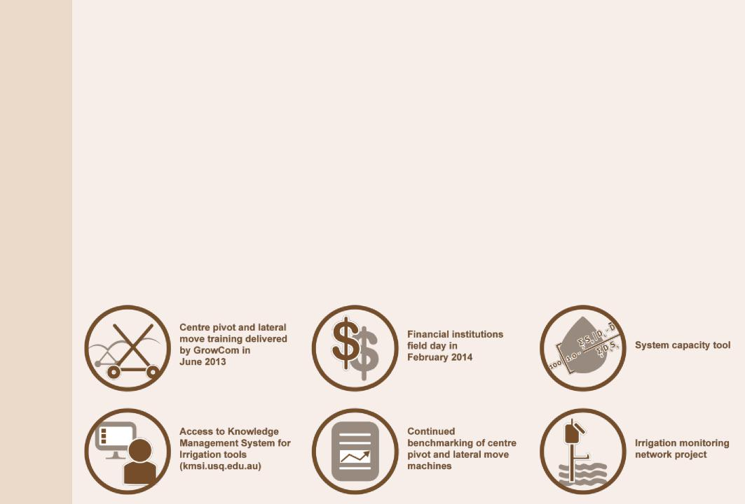
Aim
Timing
Outputs
Project
To provide connection between the HHWUE program and irrigation community, and to ensure the program was responsive to community needs when delivering outcomes
The Queensland Government chaired the committee which included a maximum 19 members and three representatives from the HHWUE program team. Members were irrigation consultants, technical specialists and agronomists drawn from across the QMDB. The industry advisory committee met at least twice each year, helping develop an annual project plan for the HHWUE program, monitor progress and identify opportunities for complementary measures projects and program changes.
Coordinating meetings with members spread across the QMDB however was often difficult, and some meetings were held progressively across local centres such as St George, Goondiwindi and Toowoomba. Members attended when available and were not paid sitting fees. The committee was disbanded in 2014, however the Queensland Government continued to implement projects recommended by the committee and liaise with irrigation community members about program direction.
2012 to 2014
On recommendations from the committee, the Queensland Government delivered the following events and industry development projects.

24

2.2.6 Industry development
Aim
Project
Timing Outputs
2.3 Promotional activities

To increase industry knowledge of water use efficiency technologies and develop decision making tools to help irrigators upgrade to efficient systems
In response to recommendations from the industry advisory committee and other research, the Queensland Government engaged contractors to deliver the following industry development projects:
- System capacity tool: This web-based interactive calculator helps irrigators and consultants estimate the system capacity required for their centre pivot and lateral move machines based on operating hours, efficiency, hectares and geographic location. Capacity was identified as a key deciding factor in system choice and design. The HHWUE program provided some of the funding for the National Centre for Engineering in Agriculture (NCEA) to develop the tool and make it publicly available on the Knowledge Management System for Irrigation (KMSI) website
- Access to KMSI tools: The National Centre for Engineering in Agriculture (NCEA) had previously developed 13 online tools to help irrigators measure irrigation efficiency, model scenarios and make informed decisions. Some of these tools were free to the public while others, typically those that stored the data, required paid access. The HHWUE program funded up to eight users to access the paid tools, including training and ongoing support from NCEA from 2013 to 2014
- Irrigation monitoring network project: This project tested and demonstrated automatic sensors as a monitoring technology for head ditches. The Queensland Government engaged WaterBiz to install eight water level sensors on two Lower Balonne properties which had completed HHWUE projects. WaterBiz calibrated the sensors and provided irrigators access to the supplier website to view monitoring information online. Irrigators used the sensors over the 2013–14 season and experiences were captured in a case study. Irrigators reported the sensors gave them greater water delivery precision, avoided issues such as breached banks and reduced time required to monitor flow
- Greenacre case study: Until round five, projects which developed unirrigated area were not eligible for HHWUE program funding. As irrigator demand for these types of projects increased, the Queensland Government commissioned a study into the impact of developments to determine the benefits of funding such projects. In 2013, the Queensland Government engaged WaterBiz to model three development scenarios, analyse the results and report on the likely impacts. The report concluded development could be beneficial for the enterprise while maintaining a similar water consumption particularly if used for reconfiguration or rotational cropping. This study influenced the change in HHWUE eligibility to allow certain types of unirrigated area development.
2013 to 2014
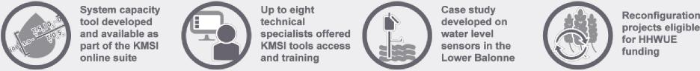
Phase 2 included a tiered communication strategy to maximise participation from eligible irrigators. The strategy emphasised promoting the program to key irrigator groups through local activities such as small field days, one-on-one contact, direct mail and email. Wider groups were captured through a few general activities such as advertising, online content and attendance at conferences or trade shows.
The strategy was regularly updated to reflect the stages of the program life. Early promotional activities focused on raising awareness of the project. As irrigators became more familiar with the program, activities focussed on encouraging participation, showcasing successful projects and announcing format changes.
In addition to engagement events, the HHWUE program was promoted through 153 activities during Phase 2, including:
- 38 updates to a mailing list of approximately 200 stakeholders through the program’s Hughie update
- 42 articles in industry newsletters, magazines and journals resulting from direct submissions or Hughie updates
- 33 newspaper articles resulting from media releases, Hughie updates or irrigator promotion
- 15 public notices in local newspapers
- 7 media releases
25

- 3 mail outs totalling 682 letters to water entitlement holders to promote rounds three, four and 10
- a Queensland Government produced video showcasing completed HHWUE projects (www.youtube.com/watch?v=wW2dkeeJFEY&feature=youtu.be).
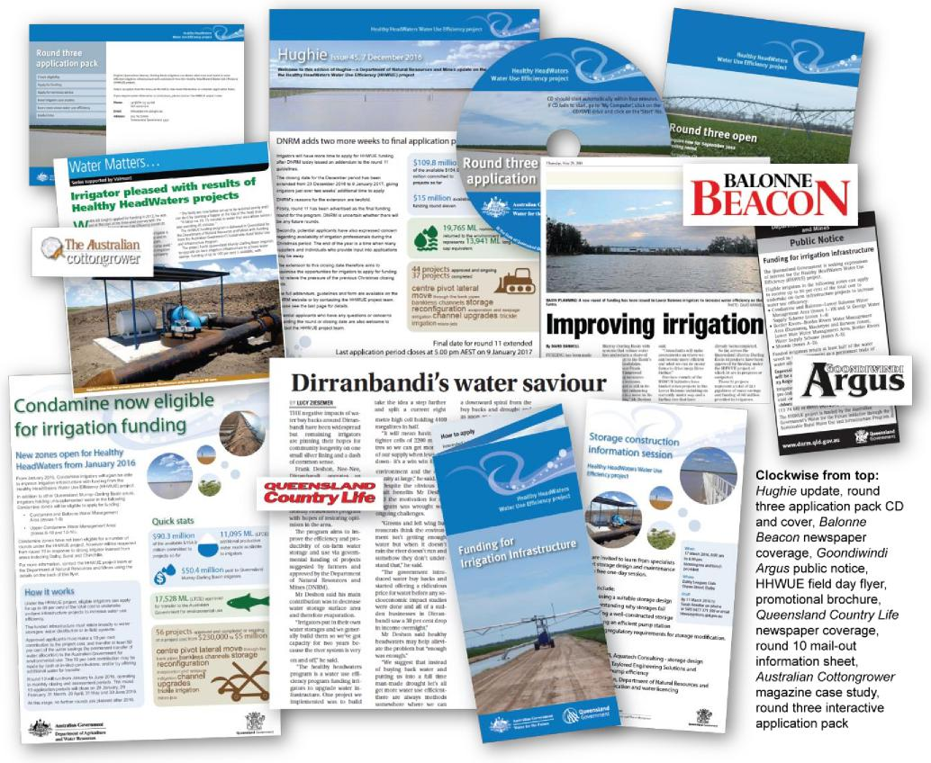
Figure 9: Sample of promotional materials
During Phase 2, the Queensland Government had 740 direct formal contacts with 374 irrigators, consultants and other industry representatives. More than 80 per cent of these contacts related to eligibility for the current round and the application process. Other enquiries related to the technical advice project, events and other complementary measures projects.
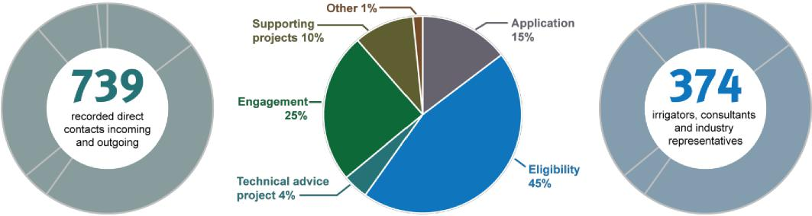
26

2.4 Program governance
The Queensland and Australian governments employed a number of measures to ensure sound governance of the HHWUE program in accordance with the Water Management Partnership Agreement, internal procedures and best practice. The Queensland Government established and evolved internal procedures and practices by drawing on knowledge from the project management discipline⁵.
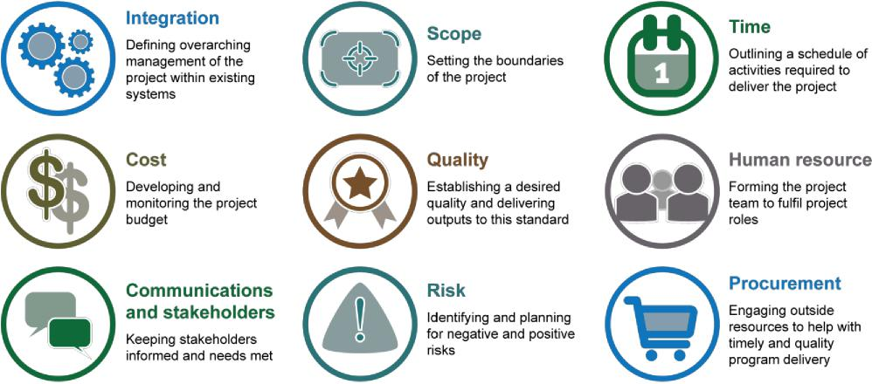
2.4.1 Integration
The HHWUE program was part of the Queensland Government’s approach to implementing the Basin Plan. The program came under the Intergovernmental Agreement on Implementing Water Reform in the Murray–Darling Basin and Water Management Partnership Agreement, documents agreed and signed between the relevant Queensland and Australian Government Ministers. At a Basin-scale, the program was part of water recovery measures including other States’ priority programs (e.g. New South Wales Irrigated Farm Modernisation project, Victorian Farm Modernisation project) and the Australian Restoring the Balance in the Murray–Darling Basin Program (sometimes referred to as the ‘buyback program’).
Internally, the Queensland Government managed the program in accordance with project plans for each component (funding program, complementary measures projects), program procedures (e.g. application assessment, contract management) and departmental policies and procedures. Early project planning and monitoring was based on PRINCE2 methodology, while later contract management adopted Agile and PMBOK concepts.
2.4.2 Scope
The Queensland Government’s 2011 business case for the HHWUE program outlined the scope, including the funding program, complementary measures and promotional activities. This scope was formalised in the agreed Water Management Partnership Agreement Schedule 2 Item B.
The Schedule 2 outlined the program, recorded the approved projects and effected any changes to individual projects or program conduct. After each funding round, the Queensland and Australian governments usually varied the Schedule 2 identifying the newly approved projects in the scope. The Schedule 2 and any variations were signed by the Australian Government and relevant Queensland Government financial delegate.
2.4.3 Time
2.4.3.1 Project duration
The Schedule 2 Items B and C.2.4 identified the key dates and broad quarterly milestones. The Queensland and Australian governments reviewed this timeframe when negotiating variations. For instance, as program uptake
5 Project Management Institute 2004, A guide to the project management body of knowledge (PMBOK guide), Newtown Square, Pa: Project Management Institute
27

increased, the Queensland and Australian governments extended the original program end date of November 2017 up to June 2020. As projects reached completion however, the final milestone date was brought back to September 2019.
2.4.3.2 Annual project plan
In addition to the broad Schedule 2 milestones, the Queensland Government delivered the HHWUE program according to an annual project plan. The Queensland and Australian governments agreed to an annual project plan for each financial year. The plan identified when the Queensland Government would run funding rounds, how contracts would be managed, and what outcomes were expected from complementary measures. The agreed plan was usually incorporated as an attachment to the Schedule 2 at the next variation.
2.4.3.3 Internal tracking
The Queensland Government established internal milestones and timelines to break down tasks and measure progress. The program team reported progress against milestones in the departmental annual report, water projects monthly status report and National Partnership Agreements six-monthly report.
Within these broader milestones, the program team also used detailed work breakdown structures to track discrete activities such as opening funding rounds, assessing applications and managing each contract.
2.4.4 Cost
2.4.4.1 Program budget
The Schedule 2 Items B.1.8 and D identified the Phase 2 budget including infrastructure funding, complementary measures and program management costs. The Queensland and Australian governments reviewed costs regularly and renegotiated amounts within the maximum possible funding as needed. While the maximum was approximately $130 million, both parties understood the total actual costs would be determined progressively as projects were approved for funding.
2.4.4.2 Australian Government reimbursement
The program was funded by the Australian Government, and the Queensland Government was generally paid in arrears for expenditure. The Queensland Government claimed reimbursement for infrastructure funding payments as these were made to irrigators. All other costs were claimed quarterly and were contingent on the Queensland Government satisfactorily demonstrating progress against milestones.
2.4.4.3 Income and expenditure monitoring
The Queensland Government tracked income and expenditure through its existing SAP system. The Queensland Government provided an audited financial statement to the Australian Government following the end of each financial year. The statement was audited by an independent Certified Practising Accountant for confirmation of funds received, paid and any interest accrued.
2.4.5 Quality
The Schedule 2 Item C outlined the requirements of the HHWUE program including the desired outputs of complementary measures, the conduct of contract management and the approved project details. The Queensland and Australian governments oversaw the program using the following mechanisms:
- program overview group – this group consisted of the Queensland Government’s HHWUE program Director and team, and the Australian Government Department of Agriculture’s Purchase and Northern Infrastructure Director and relevant team members. The group met quarterly to discuss program progress, issues and opportunities. This meeting provided a forum for joint decision making and information sharing between levels of government. Members of the group also maintained regular contact out of session
- quarterly reporting – the Queensland Government provided the Australian Government a written quarterly report on progress against the annual project plan and Schedule 2 milestones. Quarterly reports provided by irrigators to the Queensland Government and regular monitoring activities informed the report.
The Queensland and Australian governments also undertook the following reviews to ensure the program met these agreed quality standards and was delivered in line with continuous business improvement.
28

2.4.5.1 Strategic review
Under the Schedule 2 Item 1.5, the Queensland Government was required to review HHWUE Phase 2 progress in 2014 and report on options to improve the program. The Queensland Government conducted an assessment of the program which identified maintaining irrigator participation as a key focus for the program. The report recommended improvements to the program, of which the following were adopted in subsequent rounds:
- providing irrigators more information regarding the regional benchmark and market multiple used to calculate value for money
- expanding eligible areas to include the mid and upper Condamine, and Lower Balonne overland flow water
- expanding eligible projects to include dislocated water.
2.4.5.2 Social sciences survey
As part of the program’s strategic review, the Queensland Government engaged its Department of Science, Information Technology and Innovation’s Social Sciences unit to gauge irrigator interest and attitudes towards the HHWUE program. The review, which was concluded in April 2015, gathered information on the biophysical, financial, philosophical, technical and personal factors which influenced irrigator’s participation in HHWUE and other water recovery measures. Researchers conducted 41 interviews with Border Rivers and Lower Balonne irrigators, including some HHWUE and buyback participants. The findings informed subsequent changes to promotional and engagement activities.
2.4.5.3 Procedural reviews
The Queensland Government engaged accountants from Barr Group BCM to provide issues-based advice on matters of financial accountability. Barr Group BCM also conducted two procedural reviews on the HHWUE program in 2017 with a focus on the appropriateness and rigor of payment claim assessment procedures. The reviews concluded the Queensland Government had implemented and continuously improved a series of processes for robust assessment of payment claims. The review recommended some additional measures in relation to in-kind expenditure and verification of goods which were adopted into the HHWUE program’s continuous improvement.
2.4.5.4 Internal expenditure review
The Queensland Government undertook an internal expenditure review for the HHWUE program in 2018. This review aimed to determine whether the use of funds by irrigators under the HHWUE program had been appropriate. The Department of Natural Resources, Mines and Energy’s Regional Investigation Unit reviewed a sample of 15 HHWUE projects and their expenditure. The unit undertook a desktop assessment of project records and satellite imagery, and sought additional evidence from irrigators and third parties.
The review identified procedural improvements for the HHWUE program many of which were incorporated into contract management processes if not already included. For instance, the review recommended additional site inspections to check projects before making final payments. The Queensland Government undertook a number of these inspections in 2018. Other recommendations were considered suitable for future similar programs and are captured in the learnings in this report. Overall however, the review found no direct evidence to indicate inappropriate use of HHWUE funding and concluded the program had been delivered with sound levels of rigor, knowledge and accountability.
2.4.5.5 Assurance review
The Australian Government conducted reviews of HHWUE processes to ensure compliance with the Water Management Partnership Agreement and Schedule 2.
The Australian Government also commissioned an independent assurance review by KPMG of the HHWUE program in 2018. The review aimed to examine the governance, risk and control processes of the program to ensure the effective use of Australian Government funds. KPMG selected a sample of 20 HHWUE projects for a desktop review, and within this sample selected nine projects for on-farm verification. The sample covered a range of total project costs, funding rounds, project types and catchments.
Similar to the internal expenditure review, some recommendations had already been incorporated into the HHWUE program while others are captured as learnings for future programs. Overall, KPMG’s assessment found:
- the Queensland Government had developed and implemented a number of controls, processes and structures to assist in the effective administration of the HHWUE program
29

- the projects reviewed through desktop and site visits corresponded with scope and progress reported and maintained by the Queensland Government
- no instances of non-compliance with key provisions of the Water Management Partnership Agreement.
2.4.6 Human resource
The HHWUE program was delivered by a team employed by the Department of Natural Resources, Mines and Energy and based in the department’s Toowoomba office. The team operated under the Queensland Government and department’s human resources policies and procedures. The team functioned within the Basin Implementation business unit and consisted of a Director, Program Manager and up to six Project Officers with collective skills in contract management, engagement, agriculture, finance and communication. Early in the program, the team also included a part time Legal Officer who handled contract and Schedule 2 matters, and a GIS Officer who provided data and mapping services.
The program team was responsible for receiving and assessing applications, facilitating contract execution, monitoring project progress, assessing payment claims, delivering engagement and promotional activities and overseeing contracts for complementary measures projects. Decisions such as recommendations for funding or approval of payments were referred to the relevant departmental financial delegate.
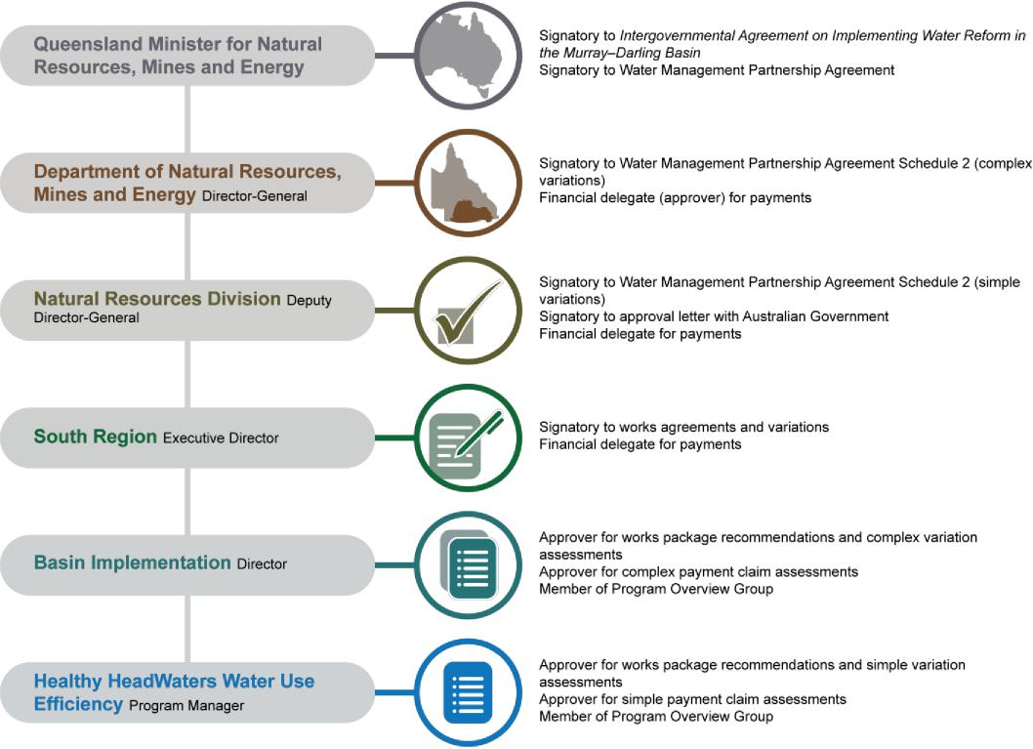
Figure 10: Indicative decision making structure at the time of writing
2.4.7 Communications and stakeholders
The Queensland Government developed a communication strategy for the HHWUE program. This strategy covered both the promotional activities discussed above and broader stakeholder management. The Queensland Government identified key stakeholder groups and their needs, interest and influence in relation to the program. The strategy was updated regularly to reflect changes in the program targeting.
30

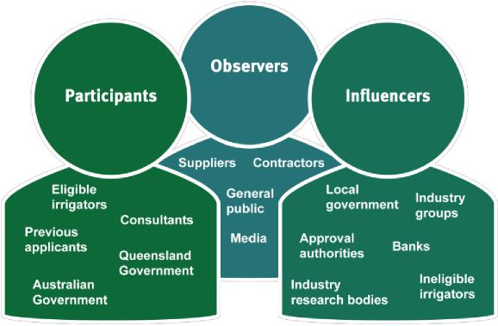
Figure 11: Key stakeholders who shaped Phase 2
Core stakeholders such as eligible irrigators, consultants and the Australian Government participated in developing and delivering the program since Phase 1, and have been the focus of consistent communication over the program life. During the program life, the Queensland Government also consulted a wide group of industry representatives and related bodies who influenced program changes. The Queensland Government kept these stakeholders informed of program progress and changes. Many communications activities are discussed in the promotional and engagement sections above.
2.4.8 Risk
The Queensland Government managed the program in accordance with its Enterprise Risk Management Framework and standard AS/NZS ISO 30111:2009. The HHWUE program also developed a subsidiary risk management plan which outlined how program and project risks were identified, assessed, mitigated and monitored. This plan aimed to ensure program objectives were met through maximising participation opportunities while ensuring a robust control environment.
The Queensland Government maintained a risk register for the HHWUE program which recorded continuous improvements in response to risks, emerging issues or recommendations from reviews. Most risks related to:
- stakeholders – irrigators having the knowledge, support and time required to submit quality applications and administer approved projects. The Queensland Government worked extensively with irrigators and consultants to clarify program requirements and timeframes. Complementary measures projects helped build industry knowledge, while direct contact with irrigators ensured the Queensland Government clearly communicated obligations and expectations
- allowed case managers to gauge the level of support each irrigator required
- business delivery – the program meeting irrigator’s needs regarding timeliness, eligibility and flexibility. The suitability and responsiveness of the program was important to maintaining irrigator participation. This issue was managed through program changes to improve the turnaround time on application assessment, increase the flexibility of project types and funding options, and broaden the eligible areas in response to industry feedback
- compliance – funded projects meeting the program guidelines, contractual obligations and legal requirements. The Queensland Government worked closely with irrigators and approving bodies to identify compliance responsibilities and ensure projects met these requirements. Pre-contractual meetings and compliance tracking mechanisms helped clarify the Queensland Government’s expectations and monitor progress. In 2016, the Queensland Government received an allegation of fraudulent activity regarding an irrigator funded under the HHWUE program. The Queensland Government referred the allegation to the Queensland Police Service for investigation and the matter is before the courts at the time of this report.
2.4.9 Procurement
The Queensland Government engaged contractors in accordance with its procurement and finance policies and procedures including the department’s Financial management practice manual. Contractors provided external expertise to support some key aspects of program delivery. Most suppliers were engaged to deliver complementary measures activities. The following procurements supported the funding program delivery:
- probity advice – an external probity advisor reviewed the application process during round three. Based on
31

advice, the Queensland Government revised application guidelines and assessment procedures to ensure better record keeping regarding the transparency and fairness of the assessment process. The advisor oversaw the remaining rounds and provided ad hoc advice on issues such as changes to the guidelines or assessment of contract variations
- technical expertise – the Queensland Government engaged independent Registered Professional Engineers of Queensland to provide technical assessments. Engineers assessed applications and relevant variations against the technical feasibility criterion and conducted site inspections for approved projects
- socioeconomic assessment – as part of the Phase 2 business case, the Queensland Government commissioned a socioeconomic assessment of the HHWUE program based on the outcomes of Phase 1. The Queensland Government also obtained an assessment of round three applications. This assessment supported the findings of the Phase 2 business case.

32

3 Outcomes and evaluation
The Queensland Government used a number of sources to monitor and evaluate the HHWUE program:
- aggregated project data collected during application assessment, contract management and commissioning
- feedback from 23 voluntary irrigator post-completion surveys
- information from third-party industry studies
- observations and recommendations from third-party program reviews
- program running logs and records.
The Queensland Government has evaluated the Phase 2 program against its three overarching aims.
3.1 Long-term sustainable future

The HHWUE program helped irrigation communities become more sustainable at an industry, priority catchment and project scale by establishing efficient infrastructure and building knowledge of water use efficiency practices.
3.1.1 Irrigation industry
3.1.1.1 Investing in efficient and productive infrastructure
A broad benefit of the HHWUE funding program was investment in infrastructure which required less water to operate, in turn increasing industry efficiency and productivity.
The Queensland Government commissioned a socioeconomic analysis of the HHWUE program as part of the Phase 2 business case⁶. The analysis concluded the program’s impact on an industry scale while not large, was positive. Ongoing production gains from improved infrastructure were anticipated to be between 1–2 per cent of gross regional product.
3.1.1.2 Growing knowledge of sustainable practices
The complementary measures projects developed industry knowledge of sustainable practices. For instance, the benchmarking and industry development projects developed decision making tools and information resources which were made available to the irrigation industry both within and outside the QMDB. Technical advice grants were provided to eligible irrigators to help improve decision making processes and raise awareness of different water use efficiency options on farm. These grants were provided with no obligation on the irrigator to apply for infrastructure funding. Therefore irrigators who did not apply could still have access to the technical resources to make water use efficiency decisions and could implement projects later on their own. This outcome supports longterm sustainability for irrigation communities beyond the HHWUE program life.
3.1.2 Priority catchments
3.1.2.1 Prioritising irrigation communities
The Queensland Government regularly consulted with the Australian Government to ensure the program’s target areas aligned with their current priorities such as water recovery areas and vulnerable communities — those most likely to be negatively impacted by water reductions⁷. Murray–Darling Basin communities were assessed on a combination of factors such as water and agricultural dependence, economic diversity, adaptive capacity and
6 Binney, J & Tunny, G 2012, Healthy HeadWaters: Phase 2 issues and analysis, Marsden Jacob Associates, Brisbane
7 Stenekes, N, Kancans, R, Randall, L, Lawson K, Reeve, I & Stayner R 2012, Revised indicators of community vulnerability and adaptive capacity across the Murray–Darling Basin: A focus on irrigation in agriculture, Murray–Darling Basin Authority, Canberra
33

sensitivity. Typically, the more vulnerable communities in the QMDB were the Lower Balonne and Border Rivers regions.
Accordingly, HHWUE eligibility, program promotion and engagement focussed on the communities of St George, Dirranbandi and Goondiwindi. The following map demonstrates the concentration of Phase 2 projects in these centres as a result of this prioritisation.
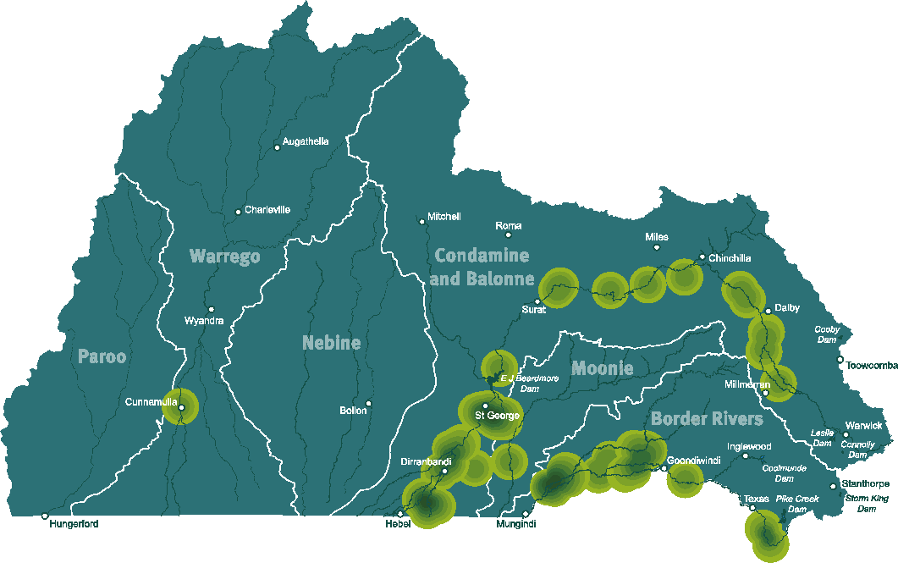
Figure 12: Phase 2 project localities
3.1.2.2 Targeting water recovery areas
Eligibility aligned with priority catchments for water recovery, particularly the Lower Balonne and Border Rivers regions, and irrigator demand.
Unsupplemented water was generally considered a higher priority than supplemented. This focus was reflected in eligible areas. Towards the end of the program, the only eligible supplemented entitlements were in the Lower Balonne. In the final rounds, the Queensland and Australian governments opened eligibility to remaining water recovery areas and products, including Lower Balonne overland flow and mid to upper Condamine unsupplemented entitlements.
The following table shows the number of Phase 2 funded projects by priority catchment and type.
Catchment and type Projects
Border Rivers 20
Supplemented 10
Unsupplemented 10
Condamine 9
Unsupplemented 9
Lower Balonne 32
34

Supplemented | 1
Unsupplemented | 26
Overland flow | 5
Other | 3
Unsupplemented | 3
Total | 64

3.1.2.3 Socioeconomic benefits
The Queensland Government conducted assessments of the HHWUE program to determine the socioeconomic benefits to QMDB irrigation communities. The assessments projected modest impact on the whole agriculture sector, and a more significant impact on a regional and irrigator level⁸.
Projects could be highly profitable for individual irrigators and would collectively make a contribution to sustaining regional irrigation communities (for instance, maintaining regional employment). A stimulus was expected during project construction, including a modest increase in employment. Some economic benefit would spread outside the region. For example, centre pivot and lateral move machines, while purchased locally, were usually manufactured and imported from the United States of America.
Based on expenditure reported by irrigators, the Queensland Government estimated Phase 2 HHWUE projects directly engaged more than 260 contractors and suppliers, excluding irrigators’ employees and other related but unclaimed expenditure. Approximately one third of these contractors and suppliers worked across more than one HHWUE project, on average supplying to 2.5 projects. In areas such as St George and Dirranbandi, suppliers often serviced a large number of projects due to high project concentration and limited local market.
The following chart shows a breakdown of reported project expenditure by ten broad categories.
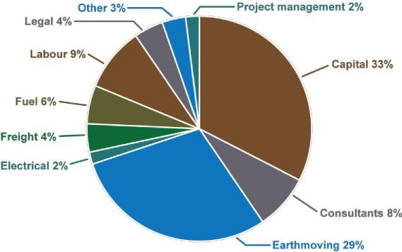
Figure 13: Contractors and suppliers engaged on HHWUE projects
- Capital – large capital, building materials, pipe, fittings, telemetry systems and other physical items
- Consultants – qualified irrigation professionals, surveying, soil sampling and other specialist services
- Earthmoving – equipment hire and operators
- Electrical – installation for some capital items, where not included in cost
- Freight – transport for capital items, where not included in cost
- Fuel – diesel for earthmoving equipment
8 Tunny, G & Fitzgibbons A 2012, Healthy HeadWaters round three: Socioeconomic assessment of tenders, Marsden Jacob Associates, Brisbane
35

- Labour – general labour, site work, welding, construction and other activities
- Legal – reviewing HHWUE contracts and conveyancing water transfers
- Project management – site supervision and administration, where not undertaken by the irrigator
- Other – financial services, valuers and other related goods and services.
As anticipated, benefits of any given project extended outside the local catchment and QMDB. Some specialised goods and services such as consultants, capital items or legal services were sourced from larger centres such as Toowoomba or Brisbane. In Dirranbandi and throughout the Border Rivers, goods and services were frequently obtained from close-by New South Wales centres such as Moree. However, the figure below demonstrates more than 65 per cent of the contractors and suppliers were based in QMDB catchments with the remainder in other Queensland regions, New South Wales and Victoria.
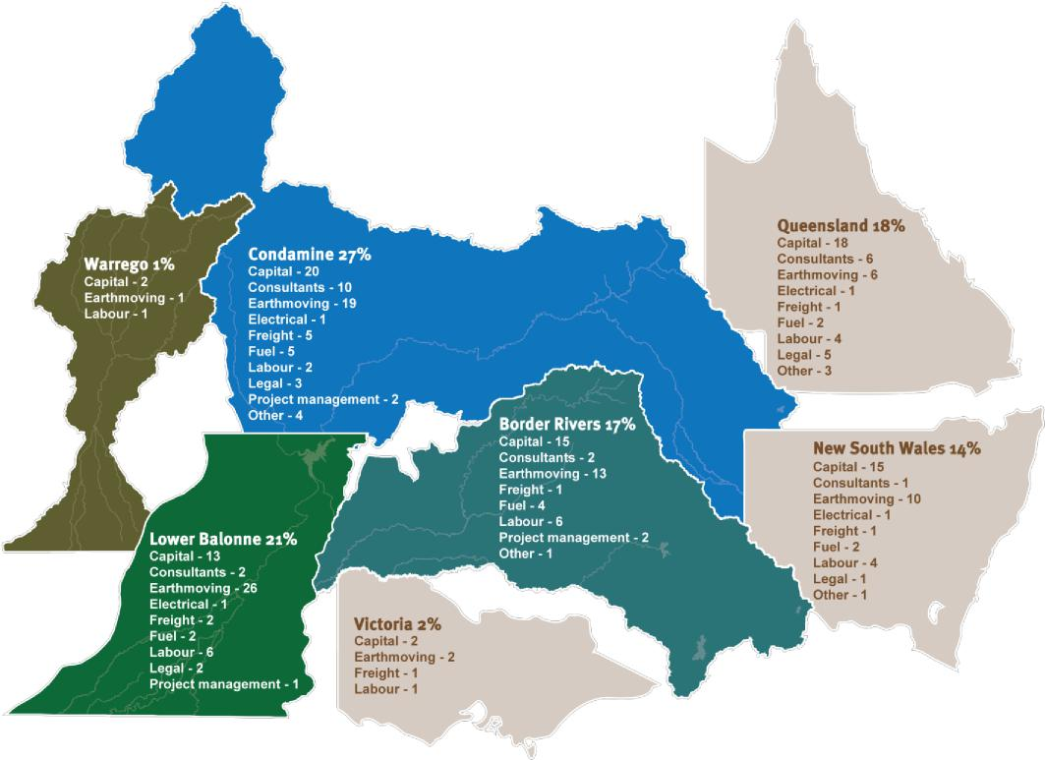
Figure 14: Contractors and suppliers by region
3.1.3 Irrigation enterprises
Phase 2 yielded 64 funded projects representing infrastructure works of approximately $90 million, to which the Australian Government contributed $73,916,531.44. Forty-three enterprises in the QMDB participated in this phase, some with multiple projects for a range of works.
The table below shows the project expenditure and Australian Government investment in water use efficiency projects by priority catchment.
Catchment Reported total project cost Funding paid
Border Rivers $49,710,335.91 $40,039,388.27
Condamine $6,530,928.42 $5,200,507.86
36

Lower Balonne | $27,974,550.03 | $23,493,365.92
Moonie | $4,454,181.69 | $4,007,269.39
Warrego | $1,307,573.16 | $1,176,000.00
Total | $89,977,569.21 | $73,916,531.44

While the focus of the HHWUE program was on water savings, irrigators identified a number of other benefits, some of which were key drivers for program participation. Financial benefits, for instance, were a significant driver for participation⁹. The HHWUE program offered irrigators a cost-effective opportunity to improve the productivity or profitability of existing irrigation business. Nearly all respondents to the post-completion surveys identified the funding enabled them to achieve business benefits and complete projects quicker than they would have on their own. Additionally, some irrigators held water entitlements which were not regularly in use. The program offered them the opportunity to “exchange” these licences for a productive asset (i.e. improved infrastructure)⁹.
Other irrigators cited ongoing productivity benefits from the upgraded infrastructure including:
- improved productivity per hectare
- increased flexibility in cropping and water management
- reduced operating costs
- ability to use less labour-intensive systems
- reduced energy requirement
- increased options for risk management.
These benefits, particularly the improvements in yield and productivity, are supported by the socioeconomic assessments from the program¹⁰. These assessments similarly concluded ongoing operating benefits would be improved profitability and resilience of participating enterprises, and greater reliability in regional production and income.
3.2 Water to the environment
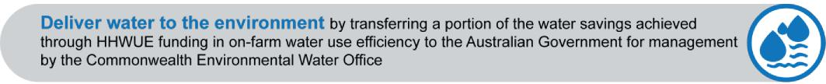
Funded Phase 2 projects achieved an estimated 28.8 GL water savings across four QMDB catchments, of which 18.6 GL were permanently transferred to the Australian Government (Commonwealth Environmental Water Holder) for environmental use. This volume includes additional water offered by two projects in lieu of a “cash” irrigator contribution. The table below outlines the Phase 2 savings and transfers by catchment and water type.
Total water Water transferred to Australian
Catchment and type savings (ML) Government (ML)
Border Rivers 15,199.42 9880
Supplemented 6595.90 3856
Unsupplemented 8603,52 6024
Condamine and Balonne 10,964.50 6946
9 McCartney, F & Durante, J 2015, Factors that influence Queensland Murray–Darling Basin irrigators’ participation in water use efficiency and water recovery programs, Department of Science, Information Technology and Innovation, Brisbane
10 Tunny, G & Fitzgibbons A 2012, Healthy HeadWaters round three: Socioeconomic assessment of tenders, Marsden Jacob Associates, Brisbane
37

Supplemented | 48.00 | 45
Unsupplemented | 9006.50 | 5717
Overland flow | 1910.00 | 1184
Moonie | 2312.00 | 1509
Unsupplemented | 2312.00 | 1509
Warrego | 350.00 | 350
Unsupplemented | 350.00 | 350
Total | 28,825.92 | 18,685

Projects offered a minimum 50 and maximum 100 per cent of the total water savings to the Australian Government. On average, projects transferred 69.2 per cent of the water savings to the Australian Government.
The average transfer size was 296 ML. The largest transfers (e.g. more than 500 ML) occurred in the Lower Balonne and Border Rivers catchments, while a number of smaller transfers (less than 200 ML) occurred in the Condamine region.
The charts below shows the rounded megalitres transferred by catchment and zone.
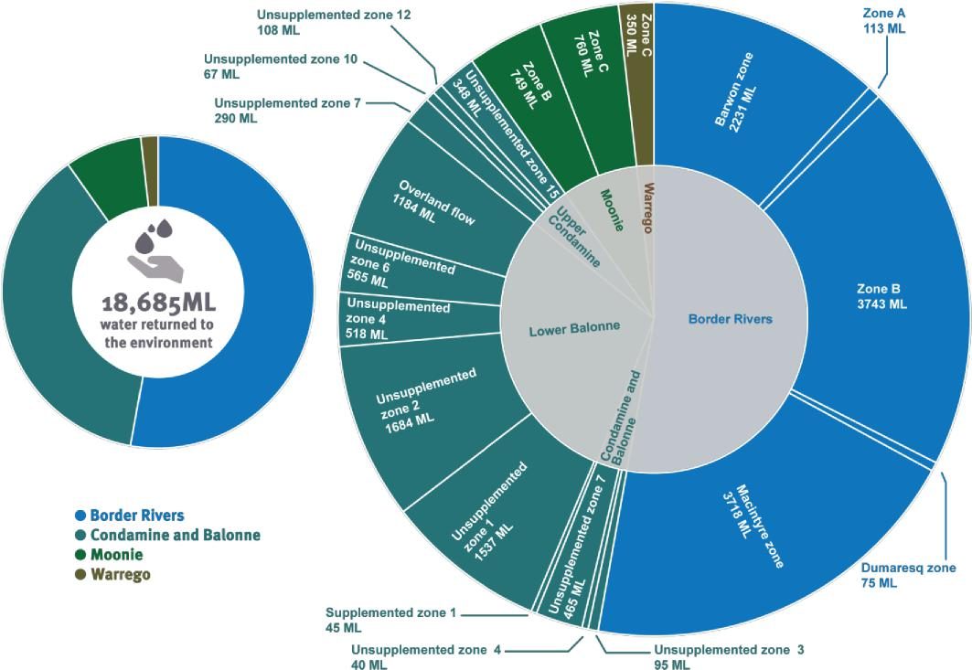
Figure 15: Water transferred by catchment and zone
Over Phases 1 and 2, the HHWUE program achieved an estimated 40.9 GL water savings and contributed 25 GL water to the environment, which is equal to 19.1 GL long term average annual yield (LTAAY).
The Australian Government reports water recovered in LTAAY rather than nominal volume to enable comparability between different catchments and water conditions. The following table shows how this contribution fits within
38

overall reduction targets and surface water recovery under the Basin Plan. These figures are reported in LTAAY and were current at 31 March 2019¹¹.
Catchment | Total reduction target (GL, LTAAY) | Water recovery (GL, LTAAY) |  |  |  | HHWUE  Percentage of  contribution  total reduction  to total  achieved  reduction
 |  | BuyBack HHWUE Gifted |  |  | Total
Border Rivers | 14 | 3.9378 | 8.9876 | 0.443 | 13.3684 | 95% | 64%
Condamine  and Balonne | 100 | 79.1061 | 8.2928 | 0 | 87.3989 | 87% | 8%
Moonie | 2.1 | 0 | 1.423 | 1.1 | 2.523 | 120% | 68%
Nebine | 3.8 | 0 | 0 | 3.842 | 3.842 | 101% | 0%
Paroo | 0 | 0 | 0 | 0 | 0 |  | 0%
Warrego | 20.1 | 10.1291 | 0.4428 | 9.524 | 20.0959 | 100% | 2%
Total | 140 | 93.173 19.1462 14.909 |  |  | 127.2282 | 91% 14%

3.3 Faster adoption of efficient water use technologies
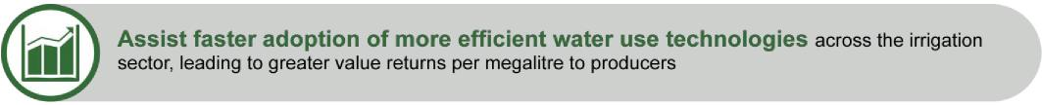
The HHWUE program assisted faster adoption of more efficient water use technologies by raising awareness of efficient technologies and providing funding to assist and enable uptake.
3.3.1 Awareness-raising activities
Phase 2 complementary measures projects aimed to raise awareness of water use efficiency technologies and their benefits. The projects also developed tools and knowledge to provide irrigators greater certainty when assessing existing practice or choosing new technologies. The Queensland Government identified these opportunities through Phase 1 studies and ongoing engagement with the irrigation industry.
For instance, the benchmarking project originated from a knowledge gap identified in Phase 1. Studies noted these overhead irrigation machines were increasingly popular, however limited information was available on real savings and management practices to ensure optimum performance in Australia. The benchmarking project captured real data on water use, yield and irrigation activity from machines operating across a range of crops in the Condamine and Balonne and Border Rivers catchments. During the study, the Queensland Government identified energy costs as further area of uncertainty for irrigators. The Phase 2 benchmarking project captured energy consumption data in addition to water use, and shared findings with irrigators through reports, workshops and a short information video.
Similarly, the industry development project built a suite of tools and knowledge to help irrigators and consultants make informed decisions about centre pivot and lateral move machines, water requirements, automatic sensors and other key areas. Complementary measures studies, the Industry Advisory Committee and other engagement highlighted the demand for this information, which is now available to the irrigation industry within and outside the QMDB (https://kmsi.usq.edu.au/).
These projects were supported by targeted engagement and promotional activities. The program delivered 17
11 Australian Government Department of Agriculture 2019, Surface water recovery required under the Basin Plan including the Sustainable Diversion Limit Adjustment Mechanism, www.agriculture.gov.au/water/mdb/progress-recovery/progress-of-water-recovery, accessed 26 September 2019
39

meetings and events to highlight successful technologies, management practices and funding opportunities through the HHWUE program. Presenters at these events included irrigators, researchers, irrigation professionals and other specialists who discussed findings, developing trends and outcomes of completed projects. Key outputs such as the seasonal benchmarking reports were made available online and in limited hard copies. The Queensland Government distributed case studies and other information at industry events and through the program’s Hughie update.
3.3.2 Funding for efficient technologies
The HHWUE program encouraged uptake of technologies by providing funding for irrigators to convert or upgrade their systems to more water use efficient infrastructure.
Through funding of $73,916,531.44, the program contributed to in-field, storages and distribution upgrades on 43 enterprises across the QMDB.
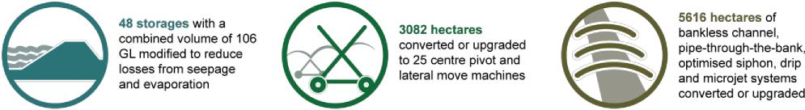
Some projects included multiple technologies, such as storage modification and conversion to lateral move systems in one project. Eight in-field projects reconfigured new irrigation area for rotational or opportunity crops.
3.3.2.1 Storage modification
Storage modification encompassed a broad range of methods to mitigate seepage and evaporation losses. Thirty-seven projects conducted modifications on 48 storages with a combined volume of 106 GL. Geographically, storages were the widest spread project type with projects across all four catchments. Completed storages ranged in size from 200 ML to 6.8 GL. Mitigation strategies included:
- clay lining seepage-prone areas on the storage floor
- lining storage crests to reduce erosion and subsequent height decrease
- constructing internal walls to create smaller storage cells
- replacing shallow storages with deeper storages.
Storage projects usually required extensive earthworks. In some projects, delivery system reconfigurations were required to allow movement of water between storages and fields. Projects such as deep cell construction for instance required efficient management between all on-farm storages (e.g. ensuring water was held the longest in deeper cells to reduce the overall potential for evaporation and seepage).
Storages represented some of the more time consuming projects, often requiring a complex development approval process and constrained by water availability. While in-field projects could occur between regular cropping seasons, storage projects could often only be undertaken when the storage was dry. If a river flow occurred for instance, it was rarely practical for irrigators to miss this opportunity to take water in favour of undertaking the storage works.
3.3.2.2 Centre pivot and lateral move
Centre pivot and lateral move projects represented 17 projects, the largest proportion of in-field works by project. Most centre pivot and lateral move projects were located in the mid and upper Condamine regions with the remainder in the Border Rivers.
These projects generally involved converting irrigated area from siphon or other more water-intensive irrigation methods to low pressure overhead systems. Some projects upgraded existing overhead systems to a more efficient design. Projects often included reshaping and reconfiguring fields and drains to suit the circle or linear area of the machines. Individual field size ranged from around 20 ha to 300 ha, with lateral moves spanning most of the larger areas.
3.3.2.3 Bankless channel
Bankless channel represented 4275 hectares of field upgrades, the largest proportion of in-field works on a hectare scale. The 10 projects were located in the Lower Balonne region and Border Rivers catchment. Typically, these projects converted siphon irrigated area to bankless channel. Fields often required significant reshaping and
40

grading to suit the bankless channel bays and changes to flow direction.
3.3.2.4 Other in-field systems
A further eight projects undertook in-field upgrades including pipe-through-the-bank, optimised siphon, drip and microjet systems. These projects represented 1341 ha of upgrades in the Lower Balonne region. These projects converted fields to low-pressure, precision technologies, some of which occurred in conjunction with other works.
3.3.3 Irrigator responses
The program investment enabled irrigators to secure the benefits of new technologies faster than they would have own their own. These benefits included both water use efficiencies and other gains such as reduced operating costs, increased flexibility and improved productivity¹².
The 23 irrigators who returned post-completion surveys provided positive feedback on the outcomes of their projects and the impact of the funding program.
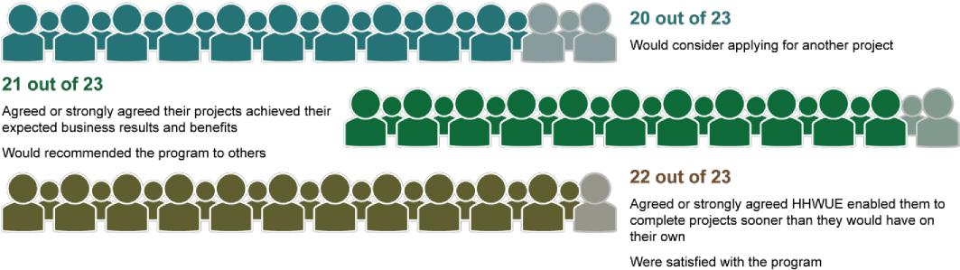
Figure 16: Irrigator feedback from post-completion surveys
Irrigators’ comments were also positive regarding the level of support from the HHWUE program team, in particular the case management and localised approach to each project. Three out of the 23 irrigators noted the time and complexity of the water transfer process created a barrier when participating in the program. Three out of 23 irrigators also expressed frustration with the record keeping requirements of the program. One irrigator suggested productivity gains and carbon emissions could be assessment criteria in future programs. Overall however, irrigators expressed satisfaction with the program and its ability to help them meet their business outcomes.
12 Tunny, G & Fitzgibbons A 2012, Healthy HeadWaters round three: Socioeconomic assessment of tenders, Marsden Jacob Associates, Brisbane

Irrigator feedback from post-completion surveys
“We found working with the HHWUE program to be an extremely positive process. HHWUE is a fabulous opportunity for both the government and the property owners especially during these times of negativity surrounding irrigators.”
“Well laid out program.”
“All staff have been good to work with. Thank you for your assistance.”
“Too much detail required in filling form and accountability.”
"I really appreciated having the continuity of having a local reliable person to work with.”
“We are quite happy with the project overall and would endorse further efficiency funding.”
“A clearer step by step guide to the water transfer process... would be helpful. There were times when the steps [in] this process were unclear.”
“Consideration of productivity gain and carbon emission reduction should be items considered
alongside or even separately to water use efficiency in these water reform programs.”
“We would be very interested in completing another HHWUE project.”

41

4 Financial summary
The Australian Government funded the HHWUE program under the Sustainable Rural Water Use and Infrastructure Program, as part of the implementation of the Murray–Darling Basin Plan in Queensland.
The Schedule 2 identified the funding for infrastructure projects and program management for each round and financial year. The following table provides a summary of the total actual amount of funding by financial year.
Expenditure item FY12/13 FY13/14 FY14/15 |  | FY15/16 | FY16/17 | FY17/18 | FY18/19 | FY19/20 | Total
Complementary
measures (Schedule | $430,436.00 $907,799.62 $901,515.54 | $699,174.42 | $751,799.02 | $556,773.95 | $613,109.86 | $217,214.91 | $5,077,823.32
2, Item C.2 )
Infrastructure funding
(Schedule 2, Item | $0 $7,444,353.40 $16,055,307.80 | $17,376,318.79 | $15,097,267.48 | $10,378,447.04 | $7,564,836.93 | $0.00 | $73,916,531.44
C.3)
Financial year total $430,436.00 $8,352,153.02 $16,956,823.34 |  | $18,075,493.21 | $15,849,066.50 | $10,935,220.99 | $8,177,946.79 | $217,214.91 | $78,994,354.76
Australian Government funding (Phase 2) |  |  |  |  |  |  | $78,994,354.76
Australian Government funding (advance funding and Phase 1) |  |  |  |  |  |  | $24,884,416.19
Total Australian Government funding |  |  |  |  |  |  | $103,878,770.95
Other contributions (Phase 2) |  |  |  |  |  |  | $16,061,037.77
Other contributions (Phase 1) |  |  |  |  |  |  | $5,734,061.98
Total other contributions |  |  |  |  |  |  | $21,795,099.75

Under Item D.4 of the Schedule 2, the Queensland Government was required to obtain other contributions to the program which, when added to the Phase 1 other contributions, totalled at least 10 per cent of the Australian Government contribution. Other contributions are derived from irrigators’ minimum 10 per cent contribution to project costs. These other contributions totalled $21,795,099.75, approximately 21 per cent of the Australian Government contribution.
Actual expenditure differs slightly when compared to the Schedule 2 budget. Some projects did not receive the full amount of funding budgeted, usually due to cost savings which were shared proportionally between the HHWUE program and irrigator. Ten projects received a reduction in funding, resulting in a total saving of $1,552,911.92 to the HHWUE program. Additionally, the Queensland Government achieved cost savings of $222,176.68 in the Phase 2 complementary measures expenditure when compared to the budget in the Schedule 2 (variation 10).
42

5 Conclusion


Eligible irrigators Application data, post-completion surveys, third-party industry studies
Engagement of more than 260 contractors and suppliers in and beyond the QMDB
Almost $74 million of Australian Government funding invested in improved profitability and resilience for 43 enterprises
Application and commissioning data, program running logs and records
Australian Government, eligible irrigators
28.8 GL water savings in priority catchments, with 18.6 GL delivered to the environment in Phase 2
Benefit Stakeholders Measurement
Water recovery
Irrigation industry
Priority catchments
Irrigation enterprises
Deliver water to the environment by transferring a portion of the water savings achieved through HHWUE funding in on-farm water use efficiency to the Australian Government for management by the Commonwealth Environmental Water Office
Contribution to Basin Plan water recovery targets while reinvesting in efficient and productive infrastructure
Increased industry knowledge of sustainable practices through a range of awareness-raising measures
Funding for 64 projects in the priority catchments of the Condamine and Balonne, Border Rivers, Moonie and Warrego, with a focus on the vulnerable communities in the Lower Balonne and Border Rivers
Eligible irrigators, previous applicants, consultants, ineligible irrigators, industry groups, industry research bodies, banks, suppliers, contractors
Eligible irrigators, previous applicants, consultants, banks, suppliers, contractors
Program running logs and records, third-party industry studies
Application data, program running logs and records, third-party industry studies
Awareness-raising activities
Funding for efficient technologies
The following tables summarise how the Queensland Government has achieved the water reform aims under Phase 2 of the HHWUE program with a range of benefits for stakeholders in irrigation-dependent communities.
Assist in securing a long-term sustainable future for irrigation communities as a result of realising water savings through targeted investment in on-farm water use efficiency
Benefit Stakeholders Measurement
Assist faster adoption of more efficient water use technologies across the irrigation sector, leading to greater value returns per megalitre to producers

Benefit Stakeholders Measurement

Suite of new decision-making tools and resources available to irrigators and consultants through the benchmarking and industry development projects  Delivery of 17 meetings and events to promote efficient technologies, management practices and funding opportunities  Range of irrigation water use efficiency upgrades undertaken on 43 enterprises across the QMDB  Participating irrigators able to achieve business outcomes and benefits from upgrades faster with HHWUE funding than on their own | Eligible irrigators, previous applicants, consultants, ineligible irrigators, industry groups, industry research bodies  Eligible irrigators,  previous applicants | Program running logs and records, third-party industry studies  Application and commissioning data, program running logs and records, post-completion surveys

43

Through both phases of the HHWUE program, the Queensland Government has delivered a positive contribution to sustainability in the QMDB.
The Queensland and Australian governments have continuously improved and adapted the program over nearly a decade. This approach developed a program which was responsive to emerging stakeholder needs while operating within the program management framework agreed between the governments. Additionally, HHWUE produced insights and learnings valuable to similar future programs, particularly regarding program delivery to meet objectives while balancing participation and ensuring a control environment for appropriate use of government funding.
The program has secured water savings in priority catchments. Savings have been returned to the environment by the permanent transfer of water to the Australian Government. The program has invested in projects and knowledge which help improve the water use efficiency and resilience of vulnerable communities and the irrigation industry. Funded projects invested in regional economies during construction and continue to achieve profitability gains for enterprises across the QMDB. The reports, tools and information developed through studies inform and support the industry now and into the future.

44

6 Learnings
The following learnings have been identified through the Queensland Government’s risk and issues registers maintained over the life of the HHWUE program. They are informed by third party reports, industry engagement and program reviews. Where possible, the Queensland Government adapted its procedures to incorporate these learnings. The Queensland Government also received some review recommendations late in the program. As the program was reaching its conclusion, these recommendations were no longer relevant, however they are captured below to inform future similar programs.
Program governance
- State service delivery risk analysis. At times, Queensland and Australian government roles and risk responsibilities were unclear in delivering the program. In most cases, the governments were able to negotiate the division of responsibilities as needed. However, a detailed service delivery risk analysis at the start of the program could help define the scope of roles and responsibilities before accepting future state-delivered Australian Government programs.

- Synergy between other water recovery programs. The HHWUE program was run quite separately to the Australian Government’s Buyback program, despite both being water recovery initiatives. This distinction created some misunderstanding among stakeholders and limited opportunities for cross-promotion.
- Thorough documentation of decision making processes. Program documentation, particularly application and payment claim assessments, were continuously improved to ensure documents were stand-alone, easily locatable records. This format was important for demonstrating the decision making process with transparency.
Program team
- Case management approach. The team clearly designated a case manager and a back-up case manager for each project. This approach established a single point of contact between the irrigator and the program team, and helped develop detailed knowledge of each project and manage expectations for each irrigator. The approach was resource intensive and ten active projects was considered an optimal load per case manager.
- Capacity to deliver program. Maintaining the capacity to deliver the program could be challenging, particularly in a small team. The team’s case management and back-up approach helped share knowledge within the team and ensure continuity. The team also sourced external specialist input where additional expertise was required.
- Compliance and auditing capability. Later program work required a level of compliance and auditing capacity which was not a main focus earlier in the program. As the program was originally staffed with a focus on engagement and promotion, the program team sought external input to build this capability. Future programs may consider including compliance and auditing skills in the initial project planning, activities and staffing mix.
- Program team funding requirement. The Queensland Government aimed to keep program overheads at a minimum including regularly reviewing and reducing the complementary measures funding requirement. This streamlining was particularly important as the Queensland Government’s program management costs were added to irrigators’ funding requests when calculating the value for money criterion. For instance, Phase 2 overheads represented approximately 6 per cent of total program expenditure. A larger percentage may have made supporting activities such as additional complementary measures projects or more frequent audits possible. Future programs may benefit from identifying the resources required to administer the program proportionate to the funds being distributed during program development and maintaining these throughout program delivery.

Eligibility
- Responsive eligibility criteria. Adapting eligibility criteria to meet irrigator demand helped maintain participation in the program. Changes to eligibility criteria included new catchments and water products, reconfiguration projects and dislocated water. These changes helped keep the program relevant and responsive to irrigators’ needs.
- Engagement with irrigators and consultants. Early applications were frequently missing supporting information. The program also occasionally received applications for ineligible works or water products. Engagement with irrigators and consultants gave the program team the opportunity to explain guidelines and reduce the perceived complexity of the application process. Pre-lodgement information was also an important mechanism for clarifying eligibility and saving irrigators time and cost preparing ineligible applications.

45

Project delivery
- Verification of water savings. One challenge was how to check the achievability of proposed water savings. This issue was particularly relevant for new technologies for which data on water savings was limited. The program sought to develop this data by conducting research into lesser known efficiency measures. Technical assessments of applications also helped determine whether savings were feasible, and gave the Queensland Government the ability to seek further information from irrigators if required.
- Industry expertise. Projects savings often depended on the level of expertise in installing, commissioning and operating the new technology. Applying appropriate expertise was therefore essential to achieving the estimated water savings. The program provided training and information sharing activities to help build industry knowledge and promote best practice. Later commissioning reports were required to include a statement on the achievability of the original estimated savings under the completed project.
- Project flexibility. Projects were dependent on a number of variables such as seasonal and economic conditions. Projects often encountered long lead times from application development to implementation. As a result, it was not feasible for the budget apportionment, timeframe or individual milestone activities to be overly prescriptive. Variations of around +/-10 per cent between budgeted items were reasonable and in most cases expected. Milestones were originally made up of various items at set levels of completion. This approach however was unsuitable as items were not always completed in the prescribed order. Later milestone tables were amended to reflect a percentage of overall project completion, giving irrigators the flexibility to implement projects in the most appropriate order at the time.
- Project variations. In another flexibility measure, the Queensland Government enabled irrigators to apply for variations to change project timing or components after receiving funding approval. Variation requests were assessed against the original application criteria to ensure irrigators were still able to meet the original water savings and program outcomes. Variations however ensured projects could be adapted to meet irrigators’ needs, particularly in instances where further planning determined another project to be more suitable than the original application.
- Cash flow. A number of irrigators obtained loans to cover their project overlay. Early in the program, irrigators expressed concerns about their ability to secure loans. This issue was not however recurring, possibly due to the first milestone payment reducing some of this cash flow pressure or because irrigators only chose to participate where they could finance their projects.

Expenditure assessment
- Expenditure outside project scope. The Queensland Government monitored budgeted costs and expenditure claimed to ensure items were within the project scope and eligibility criteria. For instance, capital items with a value and purpose outside the HHWUE project (e.g. earthmoving equipment) were considered ineligible and the application guidelines were updated early in the program to make this distinction clear. Additionally, the Queensland Government checked expenditure items for relationship to the project. A further mechanism could be requiring irrigators to inform the Queensland Government of any non-project works occurring on their enterprises in the same timeframe as the funded project.
- Invoice format. Later program reviews identified improvements to the accepted invoice format including requiring line items to be fully described, presenting invoices on Australian standard templates, and eliminating most handmade notations. The Queensland Government partially implemented these recommendations. Where the nature of work was unclear from invoice descriptions, the Queensland Government sought clarification in writing from suppliers. Any notations made by the program team were initialled and dated. In most cases, invoices presented met Australian standards.
- Stock-on-hand. Demonstrating the value of stock-on-hand presented challenges, particularly as this stock often did not have accompanying evidence of expenditure. Acceptable secondary evidence of value was usually a quote or valuation for a comparable product.
- Supplier and contractor cross checking. The Queensland Government considered a number of measures for cross checking evidence of expenditure provided by irrigators with suppliers and contractors. Measures included random cross checking of invoices, receiving evidence directly from suppliers (rather than via irrigators) and requiring use of earthmoving contractors able to provide GPS tracking data or logbooks, particularly for levelling. Ultimately, the Queensland Government determined most of these measures would require a separate contract with each supplier. Information requested from third parties under existing irrigator contracts was provided on a goodwill basis. The Queensland Government was however able to obtain additional information including written explanatory statements from suppliers on this basis.

46

Compliance
- Queensland and Australian Government legislation. Under contracts, irrigators were required to comply with Queensland and Australian Government legislation including obtaining necessary development permits and complying with the Australian Government Work Health and Safety Accreditation Scheme where applicable. Irrigators submitted compliance plans to the Queensland Government, which identified particular approvals or permits required to undertake their projects. Later in the program, irrigators were required to submit copies of approvals or permits to support their compliance plan.
- Contractual requirements. Some irrigators seemed unaware of their obligations in relation to reporting, payment claims and other matters after entering into contracts with the Queensland Government. Following adoption of the case management approach however, this issue seemed less prevalent as the program team was frequently engaging with irrigators and reinforcing their responsibilities. Additionally, the program team held pre-contractual meetings with irrigators upon application approval to discuss contractual requirements and the Queensland Government’s compliance expectations.
- Developing suitable controls. The Queensland Government developed broad controls under contracts including the completion of compliance plans, asset registers and reports. These controls however may have placed an unnecessary obligation on low-risk projects. Future programs may consider a discretionary approach to applying controls based on the level of individual project risk.
- Site inspections. The Queensland Government continuously improved the regularity and outputs of project site inspections. Site inspections focused on ground proofing works completion and location to determine project progress in accordance with the contracts. Inspection reports were presented on a standardised template which included photographs, maps and commentary on observed progress. In addition to gauging works completion, one review recommended similar programs could inspect projects to check compliance.

Timing
- Administrative process. The Queensland and Australian governments originally spent significant time negotiating administrative processes including rounds, application assessment, approvals and contracts. These delays were frequent at the start of the program as processes were still being developed and streamlined between governments. The time taken in administrative processes impacted on irrigators’ project delivery windows, creating demand for shorter turnaround times. As the program settled into the monthly application process however, the timeframe from close of applications to notification of outcomes reduced significantly from three months to one.

- Water transfers. Until the water transfer occurred, works were at the irrigator’s risk and the irrigator may not have had sufficient cash flow to commence their project. A number of projects experienced significant delays due to the time required for unencumbering and transferring water entitlements. Irrigators did not always expect such extended timeframes, which caused frustration with the program. The Queensland Government case managed each transfer and built effective working relationship with key stakeholders (e.g. water licencing, titles, solicitors) to help simplify this process. This approach helped improve turnaround and set realistic expectations regarding the often lengthy lead times.
- Water Management Partnership Agreement. While contracts were relatively flexible, the Water Management Partnership Agreement was at times more prescriptive particularly regarding the program end date and funding payments in each financial year. Through variations to the Schedule 2, the Queensland and Australian governments negotiated extensions to the program end date and revised budgets for financial years. As the program usually spent less than budgeted, the prescribed budget each financial year did not present an issue in reality.

47

7 Bibliography
Binney J and Tunny G 2011, Socio-economic impact assessment of the first round of the Healthy HeadWaters Program, Marsden Jacob Associates, Brisbane.
Binney J and Tunny G 2011, Socio-economic impact assessment of Healthy HeadWaters round 2, Marsden Jacob Associates, Brisbane.
Binney J and Tunny G 2012, Healthy HeadWaters: Phase 2 issues and analysis, Marsden Jacob Associates, Brisbane.
C Baillie, J Baillie, R Davis, M Scobie, D Wigginton, E Schmidt, B Muller and P Watts 2010, An appraisal to identify and detail technology for improving water use efficiency in irrigation in the Queensland Murray–Darling Basin, USQ, Toowoomba.
Cape J 2012, Healthy Headwaters final report: Irrigation industry development – training, River Murray Training, Berri.
Cotton Catchment Communities CRC 2011, Modifying storages to save water: The cost of water saved through storage structural modifications, accessed 23 March 2020 http://mppd.com.au/wp-content/uploads/2017/12/modifyingstorages.pdf.
Culpitt, R 2010, Healthy HeadWaters farm level economic and financial modelling of alternative irrigation practices: A representative farm approach in the Lower Balonne and Border Rivers areas, Synergies Economic Consulting Pty Ltd, Brisbane.
Culpitt, R 2011, Healthy HeadWaters farm level economic and financial modelling of alternative irrigation practices: A representative farm approach in the Condamine River area, Synergies Economic Consulting Pty Ltd, Brisbane.
Department of Environment and Resource Management 2009, Healthy HeadWaters business case for on-farm water use efficiency in the Queensland Murray Darling Basin, DERM, Toowoomba.
Department of Environment and Resource Management 2010, Basin Appraisal Project, Component No. 1, A description of QMDB water management characteristics, priorities and opportunities for acquisition under the Healthy HeadWaters Water Use Efficiency Program, DERM, Toowoomba.
Department of Environment and Resource Management 2011, Healthy HeadWaters Water Use Efficiency Phase 2 business case, DERM, Toowoomba.
Department of Environment and Resource Management 2011, Healthy HeadWaters Water Use Efficiency: evaluation report – Phase 1, DERM, Toowoomba.
Department of Natural Resources and Mines 2014, Healthy HeadWaters Water Use Efficiency Program Phase 1 final report, DNRM, Toowoomba.
Department of Natural Resources and Mines 2014, Healthy HeadWaters Water Use Efficiency Phase 2 strategic review 2014, DNRM, Toowoomba.
Department of Natural Resources, Mines and Energy 2018, Completion report 23 August 2018: Compliance audit: Queensland Healthy Headwater Use Efficiency project 16 March 2018 to 23 August 2018, DNRME, Nambour.
Jacob P and Tunny G 2010, Cost-benefit analysis of the Healthy HeadWaters on-farm water use efficiency program, Marsden Jacob Associates, Brisbane.
KPMG 2018, Review of State Priority Projects – Healthy HeadWaters Water Use Efficiency Project, KPMG, Canberra.
Leaver W 2017a, Healthy HeadWaters Water Use Efficiency project procedure audit, Barr Group Consulting, Brisbane.
Leaver W 2017b, Healthy HeadWaters Water Use Efficiency project procedure audit, Barr Group Consulting, Brisbane.
McCartney, F and Durante, J 2015, Factors that influence Queensland Murray Darling Basin irrigators’ participation in water use efficiency and water recovery programs, Department of Science, Information Technology and Innovation, Brisbane.
Queensland Rural Adjustment Authority 2012, Healthy HeadWaters Water Use Efficiency Project procedural governance review, QRAA, Brisbane.
Smith P, Foley J, Priest S, Bray S, Montgomery J, Wigginton D, Schultz J and Van Niekerk R 2014, A review of centre pivot and lateral move irrigation installations in the Australian cotton industry, Department of Primary
48

Industries, New South Wales.
Tunny G 2012, Healthy HeadWaters cost file for benchmarking of project cost items, Marsden Jacob Associates, Brisbane.
WaterBiz Pty Ltd 2011, Healthy HeadWaters centre pivot-lateral move benchmarking: 2010-2011 seasonal benchmarking report, WaterBiz Pty Ltd, Toowoomba.
WaterBiz Pty Ltd 2012, Healthy HeadWaters centre pivot-lateral move benchmarking: 2011-2012 seasonal benchmarking report, WaterBiz Pty Ltd, Toowoomba.
WaterBiz Pty Ltd 2013, Healthy HeadWaters centre pivot-lateral move benchmarking: 2012-2013 seasonal benchmarking report, WaterBiz Pty Ltd, Toowoomba.
WaterBiz Pty Ltd 2015, Healthy HeadWaters centre pivot-lateral move benchmarking: 2013/14 seasonal benchmarking report, WaterBiz Pty Ltd, Toowoomba.
WaterBiz Pty Ltd 2015, Healthy HeadWaters centre pivot-lateral move benchmarking: 2014/15 seasonal benchmarking report, WaterBiz Pty Ltd, Toowoomba.

49

