# DAWE Profiling



**current capability and future uplift**

May 2022

Jon Webber

a/g Director, Profiling and Targeting Section



About

# PaTS

The Profiling and Targeting Section (PaTS):

* Profile governance owners across cargo, traveller and mail pathways
* Deploy control testing to validate regulatory control effectiveness
* Support tactical targeting to discover and disrupt high-harm threat
* Administer the Cargo Compliance Verification program

What is mail and traveller profiling **capability?**

* Mail
  + restricted capability based on the restricted article level detail
  + based on limited data parameters
  + Intervention based on postal system controls
  + limited ability to go beyond country of origin
* Traveller
  + statistical methodology based on various factors and deployed against ‘cohorts’ of travellers
  + Specific schemes managed for non-compliant travellers, frequent travellers and crew
  + COVID impacts yet to be told

What is Cargo Profiling **capability?**

* 5800 Cargo Profiles – biosecurity, illegal logging, imported foods
* Types of profiles – compliantly reported commodity profiles (98%) and response/entity profiling (2%)
* Cargo profiling is the essential link between import conditions and getting consignments in front of officers for assessment
* Support for control tests and targeting and ad-hoc support across environment, fisheries and export domains

Cargo Profiling,

# what it looks like

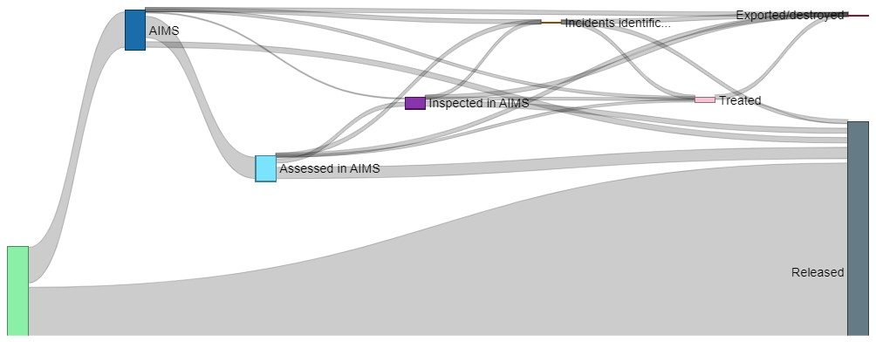

577,685

(13.26%)

4

,358,153 FIDs approached the border

DAWE Profiling

# capability uplift

* Why?
  + increasing trade
  + Increasing complexity of supply chains
  + efficient and effective resource utilisation
  + government commitments
* What?
  + improved data holdings and analytical tools
  + IT infrastructure development
  + systems ownership

# machine learning – SAC (live)

* currently deployed machine learning capability for non-commercial cargo
* provides recommendation of required ‘at-border’ action for non-commercial cargo
* requires manual (human) validation
* currently deployed to a subset of our profile (approx. 60 profiles that account for about 40% of match volume)
* evolving process of maturing and refining the capability, both technically and to ensure appropriate human interaction
* Expected iterative release phases to realise full potential

# machine learning – FID (emerging)

* Proof of concept ran in 2019 to test ability for machine learning algorithms performance in accurately predicting risk
* Trained on historical data and tested against live inspections.
* 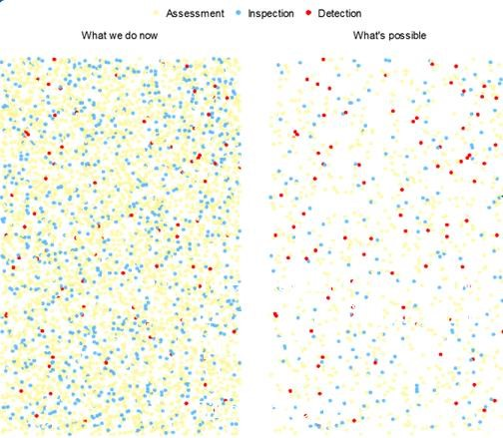Phase 2 validation nearing completion and design and architecture discussions underway.
* Options for implementation/deployment
* Strong governance and management
* Significant shift in risk management approach

# mail Electronic Advance Data

* EAD is the info from the customs declarations that people fill out when posting internationally. We now receive this data in near real-time.
* 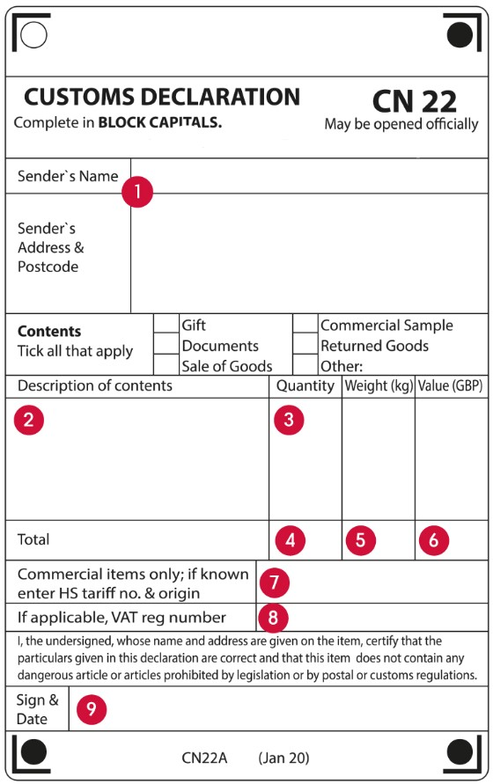The data tells us more about mail than ever before, and it may allow us to predict non-compliance in the future.
* Successful small-scale trials mimicking cargo profiling
* Second stage trial to look at entities
* Future use case and capacity

Cargo Profiling **Questions**