

REFERENCE

# Plant Exports Management System (PEMS) Authorised officer user guide – Quality System Recognition Inspections

**In this document**

This document contains the following topics.

Purpose of this document 2

Initiating the Quality System Recognition (QSR) inspection 2

Quality System Recognition Inspection record 4

Opening the Request for Permit (RFP) details 5

Returning to the inspection record from the RFP page 6

Recording additional declarations 7

Verifying import permit details 9

Edit Exporter name (*if applicable*) 11

Recording reinspection of a consignment (if required) 11

Changing outcome details 11

Splitting lines on the inspection record 13

Recording results for Quality System Recognition 13

Navigating between line inspection windows 17

Checking container approvals in PEMS 17

Revoking container approval status 18

Completing and submitting the inspection record 21

Expiration date for Quality System Recognition inspection 23

Related material 24

Contact information 24

Document information 25

Version history 25

## Purpose of this document

This reference outlines how to use PEMS to record a Quality System Recognition Inspection.

**Note:** An overview of PEMS and general functions can be found in the Reference: *Plant Exports Management System (PEMS) Authorised Officer User Guide – Overview and general functions*.

### Initiating the Quality System Recognition (QSR) inspection

To initiate a QSR inspection, click on the **Home1** PEMS menu tab and then click the **Quality System Recognition2** button.

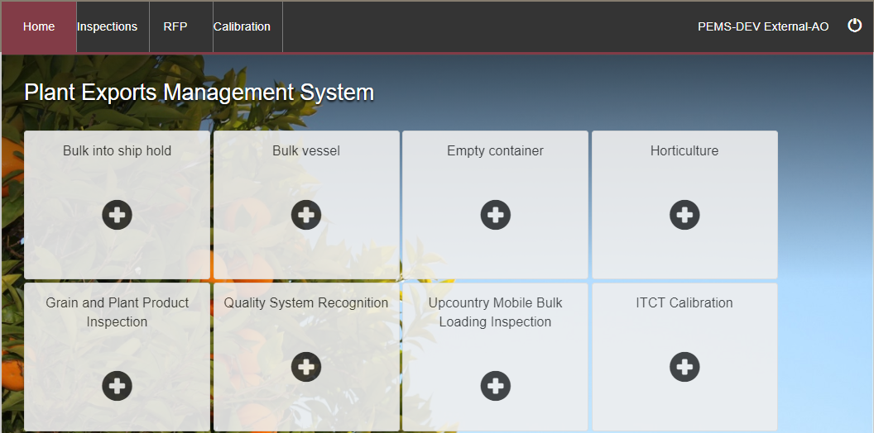

The *Create Quality System Recognition Inspection* window will display (below).

Enter the **RFP number1**. The RFP number should be 7 digits long.

Enter the **Establishment number2.** The establishment number should be 3 to 4 digits long.

Enter the **QSR number3** for the establishment.

Enter the prefix **QSR** and the 3 or 4 digit number.

****Click **Create4**.

Where a change is made to the RFP in EXDOC, you can select the **Reload RFP from EXDOC5** check box to update the relevant inspection record in PEMS.

For more information see Section 4.1: Reload RFP from EXDOC of Reference: *PEMS AO user guide – Overview and General Functions*.

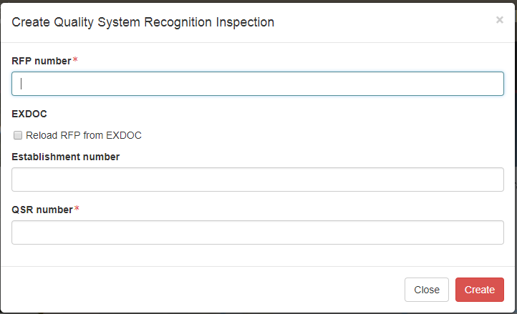

The Quality System Recognition Inspection record will open.

****PEMS extracts RFP information from EXDOC to populate the inspection record automatically.

While the inspection record is active, the date provided on the inspection record is the date the inspection record was initiated.

The inspection record will remain **Active1** until the record is withdrawn, submitted or cancelled.

### Quality System Recognition Inspection record

The inspection record (below) displays the following sections:

* **RFP details1** –populated based on RFP information extracted from EXDOC.
* **Outcome details2** – allows you to confirm the trade description and track the inspection outcomes, including total quantity.
* **Results3** –prepopulated with the consignment information based on the RFP. The inspection results are recorded here.
* **Comments4** – general comments regarding the inspection can be recorded here   
  (see Section 3.6: Adding comments to an inspection record of Reference: *PEMS AO user guide – Overview and General Functions*).

Step-by-step instructions on how to record or change data within the record is provided throughout this document.

### Opening the Request for Permit (RFP) details

To open the RFP record, click the **Inspection1** tab and then click **Open2** under the RFP details section.

The *Request For Permit* *(RFP)* page will display (below).

The *RFP* page will display a **Summary1** of the RFP, as well as the **Request for Permit lines2**. For more information on the RFP **tabs3** see Section 4: RFP functions in PEMS of Reference: *PEMS AO user guide – Overview and General Functions*.

Click **Open4** beside any RFP line to view the details of that line.

Where relevant, the **Import Permits5** are shown, click **open6** to add comments regarding the import permit.

For departmental AOs only: you can click Change beside **Comments7** to record comments at the RFP level.

When you click **Open4** (above) beside any RFP line, the *RFP Line* window will open (below) and display the details of the line as they were provided on the RFP in EXDOC.

If more than one line, click **Previous** and **Next1** to navigate between the RFP line details window.

Click **Close2** to exit the RFP line window at any time and return to the RFP page.

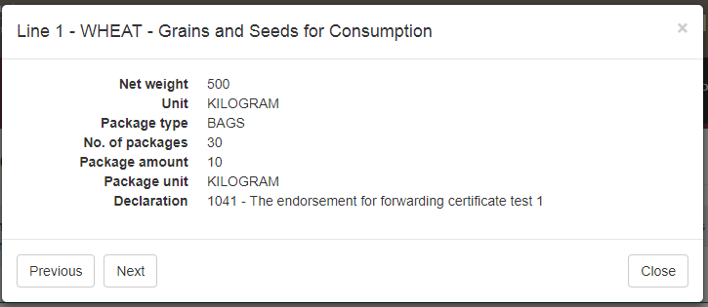

### Returning to the inspection record from the RFP page

To return to the inspection record, click the **Inspections1** tab.

The full list of inspections relating to the RFP will display. For more information see Section 4.3: Inspections of Reference: *PEMS AO user guide – Overview and General Functions*. Click **Open2** beside the Active inspection to view the record.

### Recording additional declarations

If there is additional declaration information for the consignment, it must be verified and recorded in PEMS.

To record additional declaration information, click the **Inspection1** tab and then click **Change2** under the RFP details section.

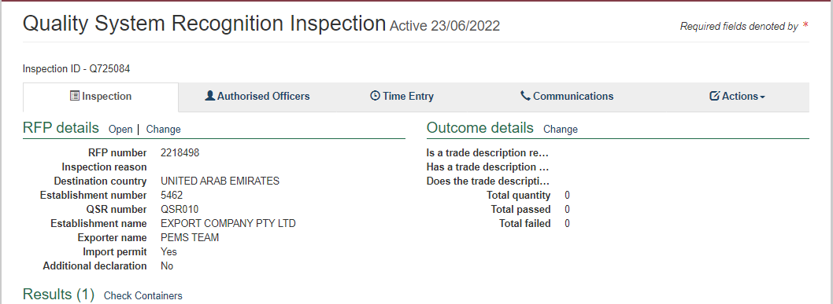

The *Change Details* window will display (below).

Where applicable, you must **View1** the *Link to Micor.* This will open another window and link you to the Micor case for the commodity and country. Select the **Additional declaration Verified2** checkbox in the *Change Details* window. You will not be able to click the checkbox if you have not verified the Micor case.

Click **Save3.**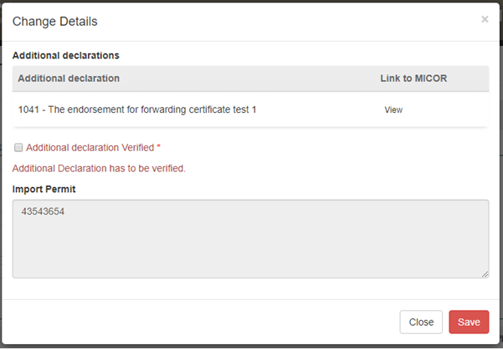

The inspection record will display the updated **Additional declaration1** information.

****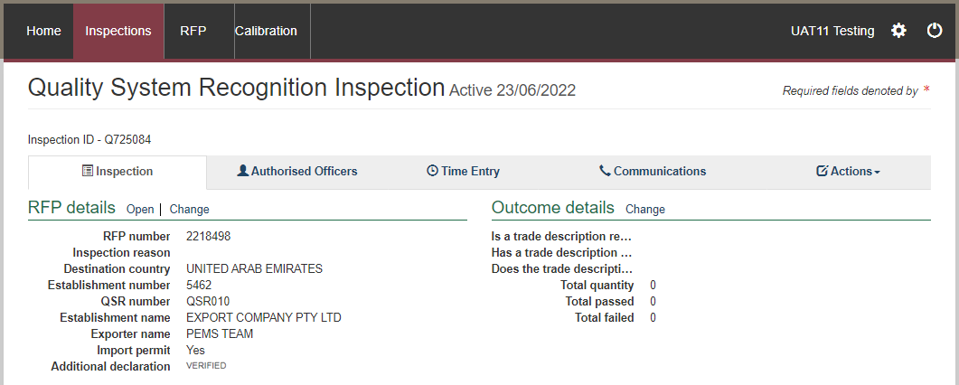

Inspection results grid will be enabled only when the additional declaration is set either to *No* or *Verified*.

### Verifying import permit details

Import permit details must be verified for the consignment.

To verify import permit details, click the **Inspection1** tab.

Click **Change2** under the RFP details section.

The *Change Details* window will display.

You must verify that the **import permit1** details relevant to the consignment in PEMS, match the details on the import permit provided by the client.

Click **Save2.**

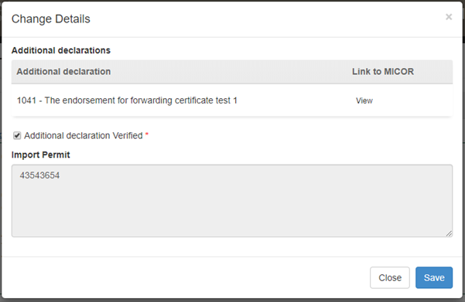

### Edit Exporter name (*if applicable*)

There is a field length limitation of 35 characters when the exporter name is extracted into PEMS from EXDOC (system constraint). This means that in some instances the entire exporter name will not appear in PEMS. This change can no longer be made by the AO.

You must check that the exporter name that appears in the inspection record in PEMS matches the exporter name on the RFP.

If the exporter nameis not correct, you need to contact PEMS@agriculture.gov.au to have the name corrected in the PEMS reference table. Once this is corrected you will not need to request the change again for future inspections/calibrations, as PEMS will save the corrected version of the exporter name for all future records.

If the exporter name is different due to another reason (for example, legal change of entity name) then these changes must be made in EXDOC through the appropriate process.

### Recording reinspection of a consignment (if required)

For more information see Section 4.4 Creating inspection records where a record already exists for an RFPofReference: *PEMS AO user guide – Overview and General Functions*.

### Changing outcome details

To change the Outcome details, click the **Inspection1** tab and then click **Change2** under the Outcome details section.

The *Outcome Details* window will display.

Some **Trade description1** declarations need to be made. Where 'Yes' is selected, this will prompt the system to generate further declarations until all required declarations are complete.

The **Total Quantity2** is extracted from EXDOC and can be amended in PEMS if required.

Click **Save3**.

The Outcome details section will display the updated **Trade description1** and will reflect the **Total quantity and unit (type)2** selected.

### Splitting lines on the inspection record

For Quality System Recognition Inspection records, you can split lines of the inspection record where key information regarding the inspected consignment is not provided on the RFP in EXDOC, or does not transfer from the RFP into PEMS, but is important for traceability of the goods.

RFP lines should be split on inspection records to identify, where applicable:

* each container that is being loaded (including any additional containers that must be added to the inspection record)
* each individual commodity source, such as by the silo, bin, stack or lot number associated with the packages.

To split lines on the inspection record, click **Split line1** beside the appropriate commodity line. Any line presented for inspection can be split any number of times.

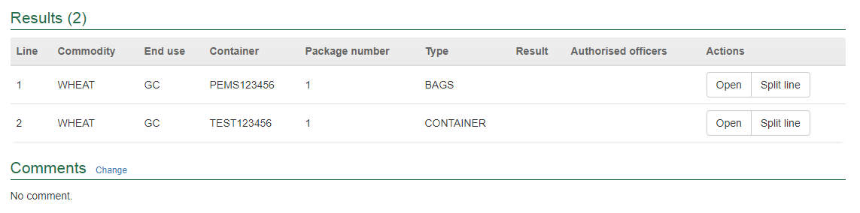

The inspection Results window for the new line will display (see the second screenshot in the **‘Recording results for Quality System Recognition’** section below and continue to record the results for each line).

### Recording results for Quality System Recognition

To enter or change inspection results, click **Open1** beside the appropriate line presented for inspection.



The *Inspection Result* window for the specific line will display.

For each inspection result window:

* Enter the **Container number1** (must be 4 letters followed by 6 or 7 digits, for example, ABCD1234567).
* Check the container number you have entered is correct by clicking on **Check2**.
* Enter the **Source3** of the commodity being inspected (for example, silo, bin, stack, or lot number) and brand or commercial names of products.

****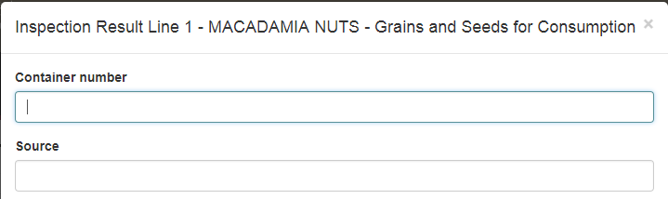

**Check2** performs a two-step validation process via a check digit algorithm and by checking if the container number recorded is available in the *BIC Global Container Database*. This database captures approximately 70% of all containers globally. If the container you have inspected is not captured in the database a warning message is generated encouraging, you to double check the details on the container. You will still be able to submit the inspection.

* enter the **Number4** of packages presented if the information is not prepopulated (where lines have been split, you may need to amend the number of units specified in the parent RFP line)
* the packaging **Type5** of the goods will be prepopulated from EXDOC (for example, container, bales, bags, bulk etc.)
* enter the package **Weight6** of the unit(s)
* select appropriate package **Unit7** of measurement, provided on RFP (the unit of measurement must be the same for all lines).
* Select appropriate **Sub Package Type**8, as per inspection.

PEMS will populate sub-total **Line weight8** from the information provided on the RFP in EXDOC. If the package weight is provided in EXDOC, PEMS will calculate the sub-totalline weight as the product of ****the package number and package weight (Number of packages x package weight).

Sub-total **line weight unit9** and the package weight unit must be the same. Package weight unit can be amended and PEMS will default the subtotal line weight unit to the package weight unit.

For each inspection result window, you should also:

* Select the check box if the **packaging is secure intact and has not been damaged10**
* Select a **Result11** of pass or fail for the line
* Select one or more **Remarks12** check boxes, if applicable (mandatory if the line fails the inspection)
* When a remark is selected the **Tolerance Level13** drop down will appear, select the appropriate tolerance ‘above’ or ‘below’
* **Comment14** becomes mandatory about the tolerance level
* Select the check box of all **Authorised officers15** who performed the inspection (see Section 3.1: Assigning Authorised Officers of Reference: *PEMS AO user guide – Overview and General Functions)*.

Click **Save16** to save the inspection result and exit the window.

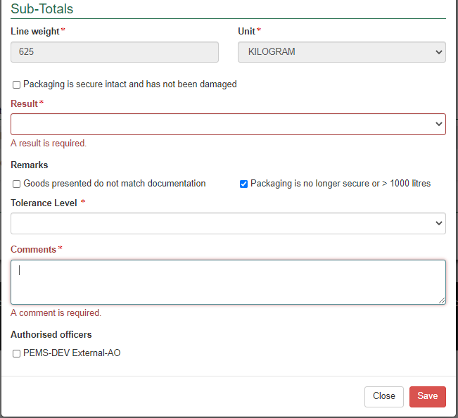

The inspection record will display the **inspection result1**.

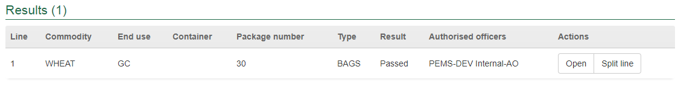

****Once the inspection result is saved, the Result page will display. Any **new split line(s)1** will appear in the Results table. You can **Remove2** the split line(s) up until the inspection is submitted, withdrawn, or cancelled.

Where split lines are entered on the inspection record you must manually amend the number of units or line weight specified in the parent RFP line to ensure the inspection record is consistent with the RFP in EXDOC.

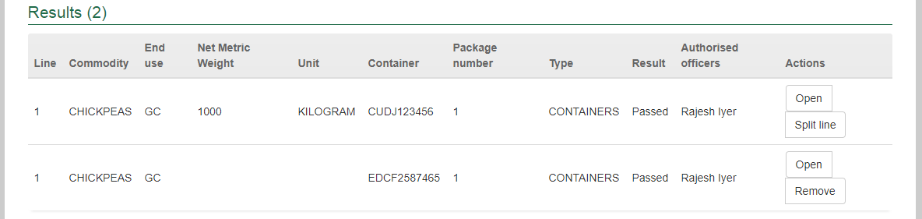

### Navigating between line inspection windows

You can navigate between line inspection result windows by clicking **Previous** or **Next1** at the bottom of the inspection result window. Each line inspection result will automatically save when you navigate between the windows in this manner.

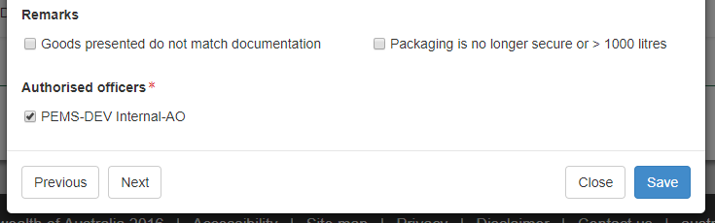

### Checking container approvals in PEMS

****You can use the PEMS database to confirm whether containers selected for loading on the inspection record have the appropriate approvals recorded in PEMS. PEMS may not include records of all current container approvals.

PEMS will not prevent you from submitting the grain and plant product inspection record where current inspection validity is not recorded for all containers on the inspection record. However, AOs must operate consistent with the approved work instructions for their appointed job functions when undertaking and submitting grain and plant product inspection records.

To check PEMS for a record of a container approval, click the **Actions1** tab and then click **Check containers2**. Alternatively, you can select **Check Containers3**.

The *Containers* window will display the list of containers provided on the inspection record.

To search for a specific container, you can **Filter containers1** by entering all or part of a container number into the field. Select **Clear2** to display the full list of containers on the inspection record.

If there is an issue with a particular listed container it will be highlighted in bold and red. This will be viewable under the **Errors3** heading.

If a container has been allocated as used on a different RFP with a completed inspection in PEMS, the **Used4** flag status would display as *Yes*. If the container is available, then it should be reinspected again to allow the status of the **Used4** flag to be reset to *No*.

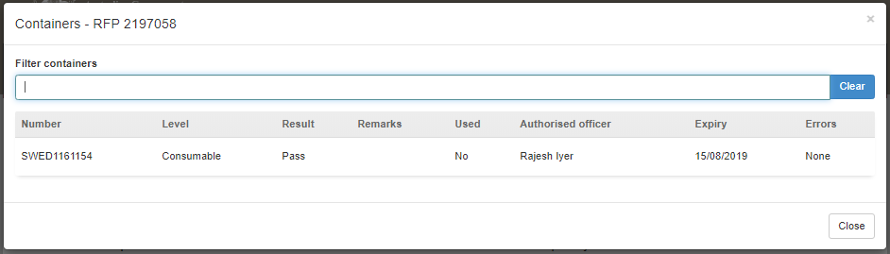

### Revoking container approval status

If the condition of an empty container has changed from when it was originally passed, and it no longer complies with the department’s requirements, the approval status of the container can be changed from Pass to Revoked. This action can be performed by any authorised officer that has the quality system recognition inspection job function.

Select the container/s that need to be to have the approval status revoked and click **Revoke1**.

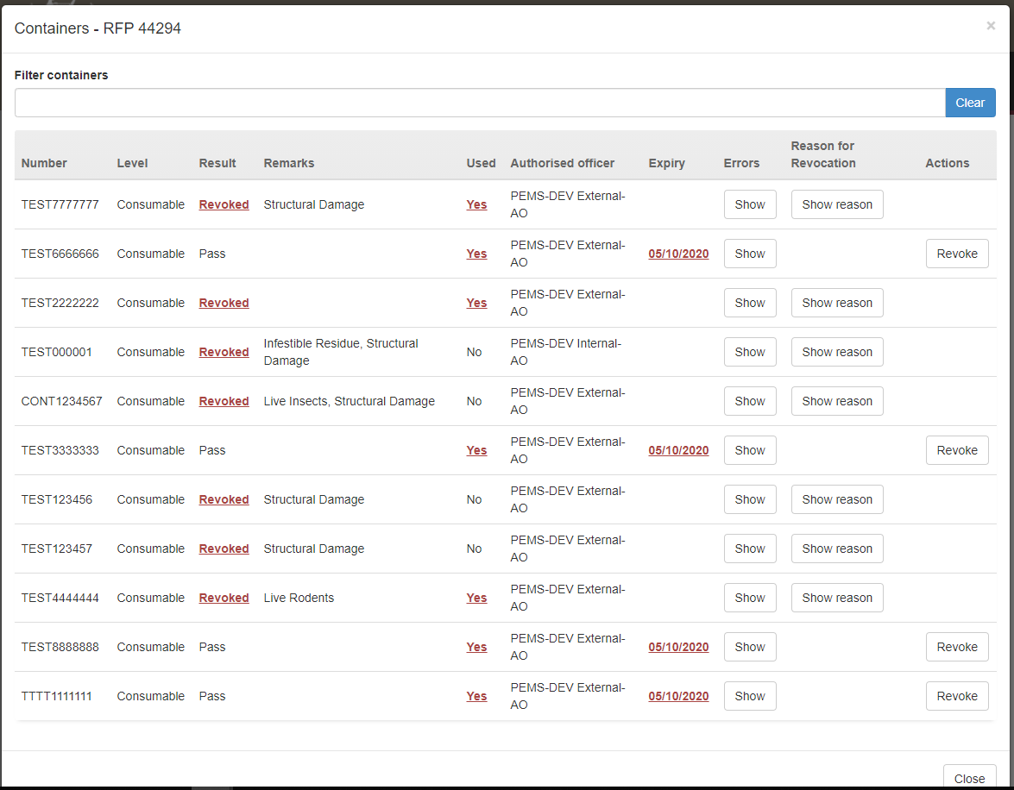

The *Revoke Details will appear at the top of the* window.

Select the appropriate **Remarks1**.

Enter the **Reason for Revocation2**. This reason will appear in the body of the email and can be up to 500 characters.

Enter the **Email Address3** of the client to notify them that the container approval has been revoked. Multiple email addresses can be added to the email address field and each address should be separated by a comma and a space.

Click **Save4**.

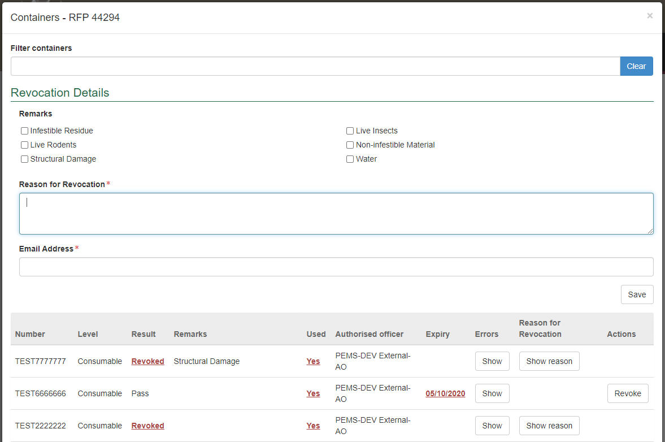

The containers that have been revoked will have the Result changed to **Revoked1**.

This revocation cannot be removed until a new empty container inspection is completed.

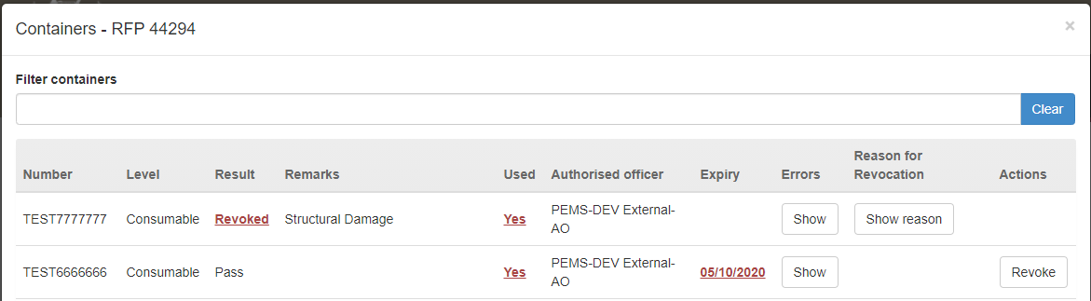

### Completing and submitting the inspection record

The inspection can only be submitted after:

* all inspection results and data are recorded appropriately

**Notes:**

* Please ensure that the consolidated net metric weight is recorded in the *comments* section as the system does not capture this information. The system only captures the number of containers that have passed/failed
* If the number of packages presented during inspection are different to the number of packages provided on the RFP, you would need to mention the original RFP extracted quantity in the comments section
* a **Time Entry1** is provided for all AOs who recorded inspection results
* attachments and correspondence relating to the inspection are recorded under the **Communications2** tab (if applicable)

Details on the Time Entry and Communications tabs can be found in Section 3: General PEMS inspection functions of Reference: *PEMS AO user guide – Overview and General Functions*.

When you are ready to submit the inspection record, click the **Actions3**tab and then click **Submit4**.

A message will appear requiring confirmation, select the **appropriate box1**.

You will need to confirm that you want to **submit this inspection2**.

It will ask if you want to **email the exporter/EDI user on the submission of the inspection3**. When selecting this option, the Inspection submit confirmation box will expand.

Enter the **email address4**, this can be multiple email addresses each separated by a comma.

Enter in any **Comments5** that are to be included in the email.

Click **Save6**.

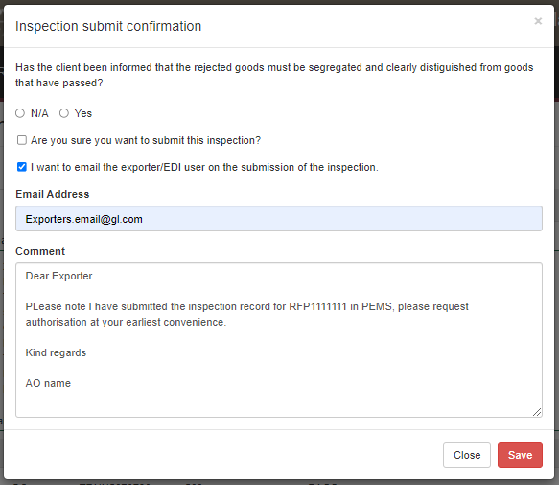

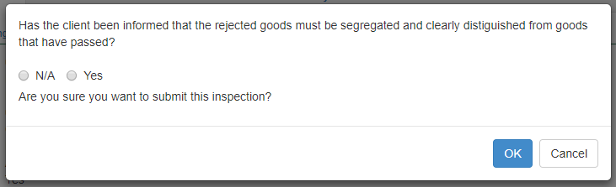

****The inspection record will display as **Completed1.**

The date(s) specified on the completed inspection record will be the start date and end date for the inspection. The inspection record date corresponds with the earliest and latest time entry across all AOs for the inspection.

### Expiration date for Quality System Recognition inspection

Following the submission of the Quality System Recognition inspection record, an expiry date will be allocated to all goods which have passed assessment. The expiry date is automatically calculated from the first date of the first-time entry, and the length varies depending on the QSR parameters set for the commodity/packaging combination.

To view the expiration date, click **Expiry date1** under the inspection validity section.

If the expiry date is extended, you can view the reason for the expiry date extension by clicking **History2** under the inspection validity section.

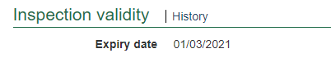

If you click history, the *Expiry History* window will display.

Click **Close1** to exit the window.

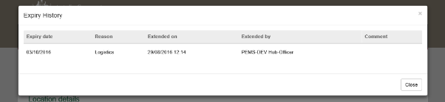

## Related material

The following related material is available on the website:

* Manual of Importing Country Requirements (Micor)
* Protocols and Work Plans
* Plant Export Operations Manual
* Reference: *PEMS AO user guide – Overview and General Functions*

The following related material is available on Learnhub:

* Plant Export Management System (PEMS) video tutorials.

## Contact information

* Authorised Officer Hotline: 1800 851 305
* Authorised Officer Program: PlantExportTraining@aff.gov.au
* PEMS Administration: PEMS@aff.gov.au

## Document information

The following table contains administrative metadata.

| **Instructional Material Library document ID** | **Instructional material owner** |
| --- | --- |
| IMLS-9-7596 | Director, Change Management, Digital Clearance Service, Digital Trade Initiative |

## Version history

The following table details the published date and amendment details for this document.

| **Version** | **Date** | **Amendment details** |
| --- | --- | --- |
| 1.0 | 08/07/2016 | New user guide. |
| 1.1 | 12/07/2016 | Minor variations for accuracy and clarity. |
| 2.0 | 30/09/2016 | * Complete document restructure. * Addition of sections on: * Logging into PEMS * Calibration records * Calibration search. |
| 2.1 | 16/12/2016 | * Minor variations for accuracy and clarity * Removal of Appendix F – Calibrations and loading * Removal of Section 2.3 – Calibration search |
| 3.0 | 09/10/2018 | AO user guide updated with PEMS v2.1 enhancements. |
| 4.0 | 23/05/2019 | AO user guide updated with PEMS v3.1 and v3.2 enhancements. |
| 5.0 | 4/11/2019 | Updated with PEMS v.3.3 and 3.4 enhancements. |
| 6.0 | 3/06/2020 | Updated with PEMS 3.5 enhancements. |
| 7.0 | 28/08/2020 | Removal of appendices from *Plant Exports Management System (PEMS) Authorised Officer user guide* to make each its own user guide. |
| 8.0 | 30/10/2020 | Updated with PEMS v3.8b enhancements |
| 9.0 | 28/03/2021 | Updated for commencement of the *Export Control Act 2020* and associated Plant Rules. |
| 10 | 7/06/2021 | Updated with PEMS May 2021 release. |
| 11 & 12 | 5/07/2021 | * Updated with PEMS July 2021 release * Removal of edit exporter function. |
| 13 | 13/09/2021 | Updated email notification on submission in line with September 2021 release. |
| 14 | 17/12/2021 | Updated in line with PEMS December 2021 release. |
| 15 | 07/04/2022 | Updated with PEMS release April 2022. |
| 16 | 25/07/2023 | Updated with PEMS release June 2022. |
| 17 | 22/08/2023 | Updated department’s email address and PEMS team name. |