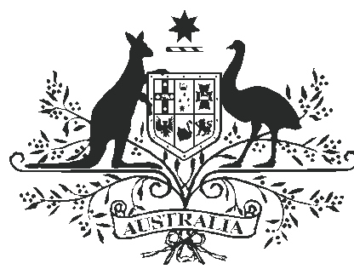

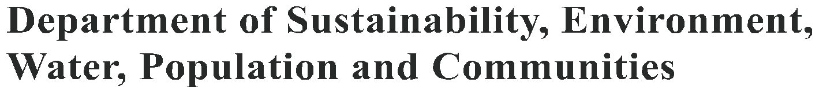

FERAL EUROPEAN RABBIT (ORYCTOLAGUS CUNICULUS)

The feral European rabbit is one of the most widely distributed and abundant mammals in Australia. It causes severe damage to the natural environment and to agriculture. Feral rabbit control is complicated because of welfare and harvesting issues, and because both native and introduced predators feed on feral rabbits in many parts of Australia. A combination of traditional control techniques and biological control
holds the best promise for reducing feral rabbit populations and minimising the damage they cause.

History

Domesticated rabbits arrived in Australia with the First Fleet. The first feral rabbit population was reported in Tasmania as early as 1827. On the mainland, Thomas Austin freed about a dozen on his property near Geelong, Victoria, in 1859. They
reached the Queensland – New South Wales border by 1886 and covered most of their present range
by 1910. This was despite the Western Australian Government’s 1700 kilometre rabbit-proof fence, built between 1901 and 1907.

Today, feral rabbits occur throughout Australia, except in the northernmost areas.
Ecology

Feral rabbits can be found in many different habitats across Australia, ranging from deserts to coastal plains — wherever there is suitable soil for digging warrens. They are scarce in areas with clay soils and abundant where soils are deep and sandy,
such as in the north-east of South Australia. In arid areas, feral rabbits need access to water, but elsewhere they can often obtain enough moisture from their food.

Feral rabbits are night-time grazers, preferring green grass and herbs. They also dig below grasses to reach roots and seeds. During the breeding season, feral rabbits form territorial groups made up of one to three males with up to seven females, led by a dominant pair. After breeding, the
groups break up again, except for the dominant pair.

Feral rabbits can breed from the age of four months, and can do so at any time of the year, particularly when food is in good supply. In favourable conditions, they can produce five or more litters in
a year, with four or five young in each litter. Even in unfavourable conditions, they can produce one or
two litters a year.

environment.gov.au

Distribution of feral european rabbits in Australia
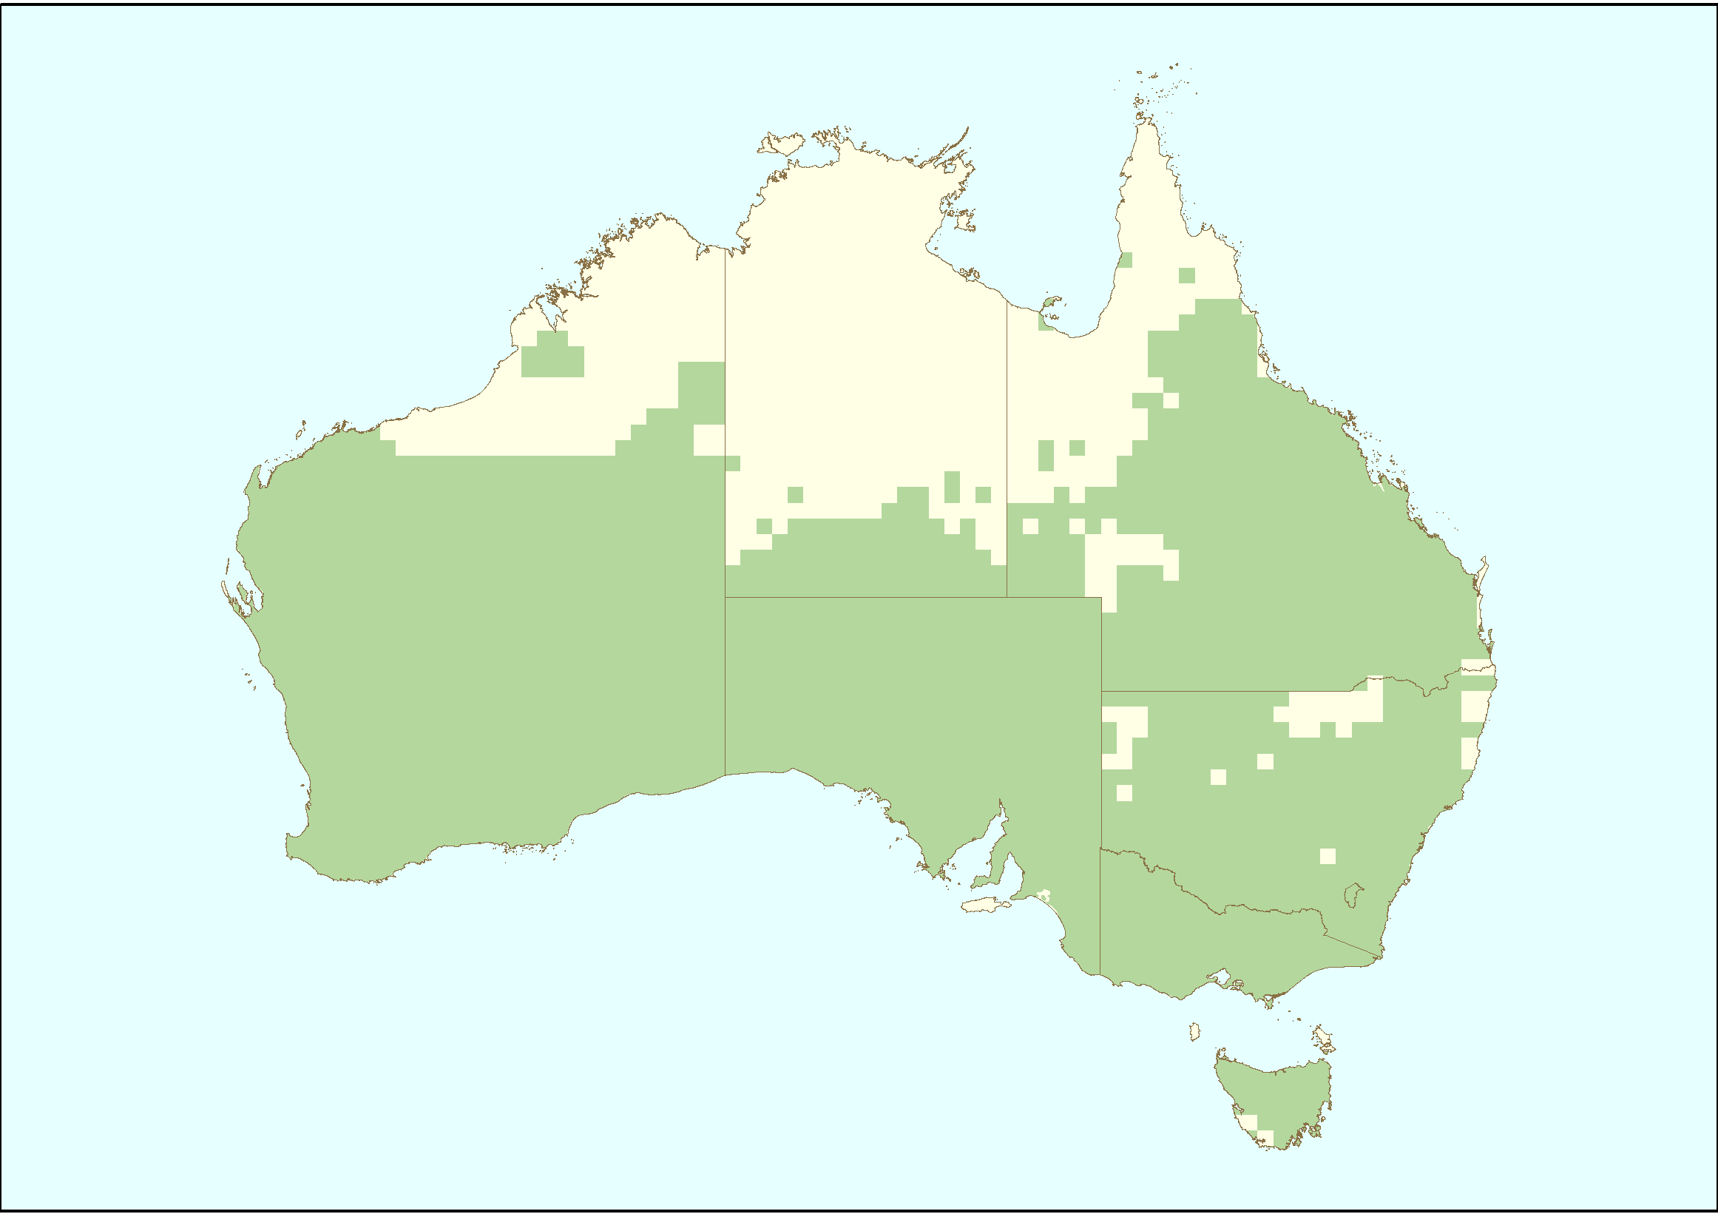

Sources: National Land & Water Resources Audit (2008) Assessing invasive animals in Australia 2008, NLWRA, Canberra./SEWPaC (2010) Feral animals on offshore islands database located at http://www.environment.gov.au/biodiversity/invasive/ferals/islands/

Impact

Feral rabbits compete with native wildlife, damage vegetation and degrade the land. They ringbark trees and shrubs, and prevent regeneration by eating seeds and seedlings. Their impact often increases during drought and immediately after a fire, when food is scarce and they eat whatever they can.
Feral rabbits may have caused the extinction of several small (up to 5.5 kilograms) ground-dwelling mammals of Australia’s arid lands, and have contributed to the decline in numbers of many native plants and animals.

In the Norfolk Island group, feral rabbits and goats reduced Philip Island to bedrock, leaving at least two plants locally extinct. Feral rabbits even threaten colonies of seabirds such as Gould’s petrel.

Control

Effective rabbit control requires integration of different methods; any single technique used in isolation is less effective than two or more

techniques carefully combined. When reliance is placed on only one technique and follow-up control is not implemented, initial gains are lost as rabbits will readily recolonise in the absence of further control.

Current techniques available for controlling rabbits can be categorised broadly as biological, chemical and mechanical. Biological control for rabbits has been particularly effective.

Biological controls include the myxoma virus causing the disease myxomatosis, which only affects rabbits. Released in 1950, the virus initially killed over 90 per cent of feral rabbits that caught the disease, but some developed resistance, making the pathogen less effective. However, the myxomatosis disease still keeps populations to an average of five per cent of former population sizes in wetter areas, and 25 per cent in arid areas.

The other important biological control is the rabbit calicivirus disease (rabbit haemorrhagic disease virus) which has proved more effective in wetter parts of the country than in drier regions. Australia currently has only one strain of calicivirus which
is relatively stable and rabbits are developing genetic resistance to infection. Research is being undertaken to identify new field strains to release in Australia.

The main chemical control used for rabbits is the poison; sodium flouroacetate (1080) an effective toxin providing a high mortality rate of up to 90 per cent. Pressure fumigation or diffusion fumigation using toxins like chloropicrin and carbon monoxide are used to kill rabbits while they are in their warrens.



Rabbits reduced Phillip Island, NSW, to a wasteland
(top) but recovery was spectacular after the rabbits were eradicated (bottom photo) (SEWPaC).

Destruction of warrens and above-ground harbours is the most widely used mechanical method for rabbit control. Warren ripping can be a cost- effective and efficient method for suppressing rabbit numbers and inhibiting reinvasion of the treated area, because it deprives rabbits of a safe place
for breeding. Other methods used less widely are fencing, shooting, trapping and explosives to destroy warrens.

Researchers are also looking at ways to improve traditional feral rabbit control techniques, and to ensure that control is applied in a strategic way that achieves targeted, sustained results.

There is a community expectation that all animals, including pests are to be treated humanely. Therefore, animal welfare issues must be an important consideration when planning rabbit control operations.

How the Australian Government is dealing with a national problem

‘Competition and land degradation by feral rabbits’ is listed as a key threatening process under the Commonwealth Environment Protection and Biodiversity Conservation Act 1999 (EPBC Act). Under the EPBC Act, the Australian Government, in consultation with the states and territories,
has developed the Threat Abatement Plan for
Competition and Land Degradation by Rabbits.

The threat abatement plan aims to reduce the impact of feral rabbits on biodiversity by:
• preventing rabbits from occupying new areas in Australia and eradicate rabbits from high- conservation-value ‘islands’

• promoting the maintenance and recovery of native species and ecological communities
that are affected by rabbit competition and land degradation

• improving knowledge and understanding of rabbit impacts and interactions with other species and other ecological processes

• improving the effectiveness, target specificity, integration and humaneness of control options for rabbits, and

• increasing awareness of all stakeholders of the objectives and actions of the threat abatement plan, and of the need to control and manage rabbits.

Feral rabbit control programs need to be coordinated with other activities taking place, including the on-ground protection of threatened plants and animals and control of other invasive species, such as feral cats and foxes. The threat abatement plan provides a national framework that
enables the best use of the resources available for feral rabbit management. The Australian Government works with the states and territories to deal with this national problem.

More information about the threat abatement plan can be found at: http://www.environment.gov.au/ biodiversity/threatened/publications/tap/rabbits08. html

Caring for our Country

The Australian Government’s Caring for our Country Business Plan 2009-10 identified reducing the impact of rabbits as one of the priority areas for investment.

Invasive species are eligible for funding as an integrated component of a number of the key targets under the Caring for our Country initiative. The Australian Government, through Caring for our Country, is providing a strong framework in which invasive species management will be addressed
as an important component of landscape-scale management, and consistent with existing national arrangements for dealing with invasive species.

For further information, contact:

Department of Sustainability, Environment, Water, Population and Communities

GPO Box 787
Canberra ACT 2601
Phone: 1800 803 772
Web site: http://www.environment.gov.au/
biodiversity/invasive/index.html

InvasiveSpecies@environment.gov.au

BIO53.0610

Photo credits in order: Illustration of rabbit (Karina Hansen McInnes), Pair of rabbits (Invasive Animals Cooperative Research Centre), Rabbit in burrow (Brian Cooke, Invasive Animals Cooperative Research Centre), Single rabbit (Brian Cooke, Invasive Animals Cooperative Research Centre), Rabbit (Brian Cooke, Invasive Animals Cooperative Research Centre), Rabbit (Invasive Animals Cooperative Research Centre).

© Commonwealth of Australia 2011

This work is copyright. You may download, display, print and reproduce this material in unaltered form only (retaining this notice) for your personal, non-commercial use or use within your organisation. Apart from any use as permitted under the Copyright Act 1968, all other rights are reserved. Requests and inquiries concerning reproduction and rights should be addressed to Commonwealth Copyright Administration, Attorney General’s Department, Robert Garran Offices, National Circuit, Barton ACT 2600 or posted at www.ag.gov.au/cca.

Disclaimer

The views and opinions expressed in this publication are those of the authors and do not necessarily reflect those of the Australian Government or the
Minister for Sustainability, Environment, Water, Population and Communities.

