 **

**Recovery plan for the boggomoss snail *Adclarkia dawsonensis***

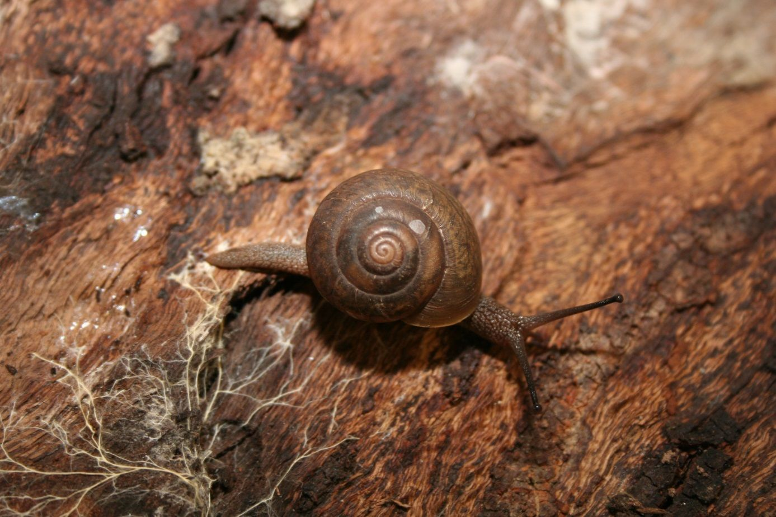

June 2017

Prepared by: Conservation Operations, Department of Environment and Heritage Protection.

© State of Queensland, 2017.

The Queensland Government supports and encourages the dissemination and exchange of its information. The copyright in this publication is licensed under a Creative Commons Attribution 3.0 Australia (CC BY) licence.



Under this licence you are free, without having to seek our permission, to use this publication in accordance with the licence terms.

You must keep intact the copyright notice and attribute the State of Queensland as the source of the publication.

For more information on this licence, visit <http://creativecommons.org/licenses/by/3.0/au/deed.en>

ISBN 978-0-9942384-1-2

**Disclaimer**

The Australian Government, in partnership with the Queensland Department of Environment and Heritage Protection, facilitates the publication of recovery plans relevant to Queensland to detail the actions needed for the conservation of threatened native wildlife.

The attainment of objectives and the provision of funds may be subject to budgetary and other constraints affecting the parties involved and may also be constrained by the need to address other conservation priorities. Approved recovery actions may be subject to modification due to changes in knowledge and changes in conservation status.

**Citation**

Queensland Department of Environment and Heritage Protection 2017. Recovery plan for the boggomoss snail Adclarkia dawsonensis. Queensland Department of Environment and Heritage Protection, Brisbane.

**Image credits**

Front Cover:

Boggomoss snail (© Copyright, John Stanisic).

June 2017

Contents

Summary 3

1. General information 4

Conservation status 4

Evaluation of achievement of the first recovery plan 4

Affected interests 6

Consultation with Indigenous stakeholders 7

Benefits and impacts of this recovery plan to other species or ecological communities 7

Social and economic benefits and impacts 7

2. Biological information 8

Taxonomy and description 8

Life history and ecology 8

Distribution 8

Habitat needs 13

Population 16

Habitat critical to the survival of the species 16

3. Threatening processes 17

Threats 18

Flooding 18

Inappropriate fire regimes 18

Clearing of vegetation 18

Firewood collection 18

Changes to hydrology 19

Weeds 19

Inappropriate grazing regimes 19

Feral pigs 19

Predation by feral house mice and cane toads 19

Climate change 19

Areas under threat 19

Populations under threat 20

4 Securing and recovering the Boggomoss Snail 21

Recovery goal 21

5 Management practices 27

Habitat protection 27

Guide for decision makers 27

6. Estimated cost of recovery 28

7. Monitoring 30

8. Evaluation of the recovery plan 31

Acknowledgements 32

References 33

# Summary

The boggomoss snail Adclarkia dawsonensis, also known as the Dawson River snail, is an endemic species found only in the Dawson River catchment, in the Brigalow Belt Bioregion of Queensland.

This is the second recovery plan for the species. Modest progress was made in achieving the objectives of the first plan. The most significant work undertaken since the approval of the previous recovery plan has been a series of surveys, which have resulted in new knowledge about the snail’s distribution and habitat. The snail is now known to occur across a broader range and in more locations. However, the number of locations is small and the current extent of occurrence (3080.0 km2) and area of occupancy (112.0 km2) are relatively small, still placing the species at risk of extinction.

Conservation status

The boggomoss snail Adclarkia dawsonensis is listed as Critically Endangered under the Commonwealth Environment Protection and Biodiversity Conservation Act 1999 and as Endangered under Queensland’s Nature Conservation Act 1992. It is ranked as a critical priority for conservation under Queensland’s threatened species prioritisation process.

Species taxonomy and description

The boggomoss snail is one of three species in the genus. It is a medium-sized snail characterised by a relatively thin, semi-transparent shell. It survives dry periods by sealing to the underside of logs and leaf litter (Stanisic 1996).

Distribution and habitat

The boggomoss snail is found in a very restricted distribution along a distance of 90km of the Dawson River at sites found between Mt Rose near Taroom and south of Theodore and within 2km of the river. Broad habitat types in which the species has been found include: riparian woodlands and forest; monospecific stands of Carnarvon fan palm *Livistona nitida;* open forest fringing ephemeral wetlands on the Dawson River floodplain; and mound springs.

The microhabitat preferences of the boggomoss snail include partially buried logs in moist conditions and accumulated leaf litter (including palm fronds) under trees.

Threats

Flooding has a negative impact on the quality of the snail’s habitat and is also likely to have caused a significant reduction in the number of snails in some areas. Inappropriate fire regimes are a major threat affecting the snail directly by incineration and dehydration, and indirectly through the destruction of microhabitat. Historically, clearing of vegetation has been a significant threat resulting in most of the snail’s habitat being cleared for farming, and little original vegetation remains. Clearing is still a threat, particularly relating to new infrastructure traversing riparian vegetation. Other threats include: inappropriate grazing regimes resulting in trampling and loss of habitat; weeds; feral animals (pigs, mice, cane toads); changes to hydrology; firewood collection; and climate change.

The long-term recovery goal

The boggomoss snail is a self-sustaining population that is stable or increasing in at least eight sites protected from threats by 2037.

Recovery objectives:

1. Secure habitat critical to the survival of the boggomoss snail and enhance suitability of sites for the snail within and surrounding this habitat;
2. Implement threat abatement in areas where the boggomoss snail exists;
3. Increase population through captive breeding and translocation to at least two sites;
4. Improve understanding of key aspects of the biology and ecology of the species; and
5. Consolidate support for the recovery effects with academic institutions, NGOs, NRM groups, and others.

# General information

### Conservation status

The boggomoss snail *Adclarkia dawsonensis* (Stanisic 1996) is listed as Critically Endangered under the *Commonwealth Environment Protection and Biodiversity Conservation Act 1999* (*EPBC Act*) and as Endangered under the *Queensland Nature Conservation Act 1992*. Queensland’s threatened species prioritisation process (Back on Track), which prioritises Queensland's native species to guide conservation management and recovery, identifies the boggomoss snail as a highest (critical) priority species for conservation action.

The boggomoss snail is currently not listed on any international agreements. This recovery plan is consistent with Australia’s international obligations.

### Evaluation of achievement of the first recovery plan

The Queensland Department of Environment and Heritage Protection (DEHP) carried out an evaluation of the first recovery plan (refer to Stanisic 2008). The plan identified one overall objective, five specific objectives and 17 recovery actions. As part of the performance evaluation, each recovery action was assessed according to the performance indicators and scored between 0-3 using the following criteria:

0 no progress/cannot be assessed

1 insufficient action to meet criteria

2 action underway – most elements of action met, or it is anticipated that they will be

3 criteria met – further action may or may not be required.

Each of the recovery plan’s actions and their progress against their performance criteria are provided in Table 1.

**Table 1: Progress of actions against performance criteria.**

| Action | Performance criteria | Comment | Score |
| --- | --- | --- | --- |
| Objective 1: Protect the boggomoss snail habitat to ensure survival of the species | | | |
| 1.1 Undertake field surveys to assess weed problems in the two known habitats of the boggomoss snail and develop and implement control programmes, if necessary. Use of chemicals to be avoided. | Weed assessment report written and, if required, weed management plan written and implementation reported on. | No surveys done. | 0 |
| 1.2 Develop and implement fire risk management plans for the two known habitats of the boggomoss snail. | There is an appropriate fire regime that maximises the survival of the snails. Fire management plans for the two sites are written and implementation is reported on. | No fire management regime developed and no fire management plans produced. | 0 |
| 1.3 Undertake field surveys to identify and map all essential habitat and habitat critical to the survival of the boggomoss snail. | Map produced detailing essential habitat and habitat critical to the survival of the species. | Surveys have been done and maps produced based on knowledge of macro and microhabitats. | 2 |
| 1.4 Fence the habitat critical to the survival of the boggomoss snail to exclude cattle. | Fencing erected around the snail’s habitat that will eliminate the threat of animals being trampled and compression of leaf litter. | Done at one site—Mt Rose. | 2 |
| 1.5 Develop and implement a post-fencing fire and weed management plan. | Fire and weed management plans for areas post-fencing written and implementation reported on. | No plans produced. | 0 |

| Action | Performance criteria | Comment | Score |
| --- | --- | --- | --- |
| Objective 2. Protect populations of the boggomoss snail | | | |
| 2.1 Review the conservation status of the boggomoss snail under the Queensland *Nature Conservation Act, 1992.* | Nomination produced and status changed. | Status of snail has been changed to ‘endangered’ under Queensland *Nature Conservation Act, 1992.* | 3 |
| 2.2 Enter into negotiations with owners of the Mt Rose Station to protect the population of snails through a conservation covenant such as a Nature Refuge agreement or another voluntary conservation agreement. | A voluntary conservation agreement is signed. | No agreement signed. | 0 |
| 2.3 Conduct field investigations to investigate significance of other threats (e.g. predators); develop a management plan; and implement actions identified in the management plan. | A report (and management plan, if required) is produced on the significance of other threats. | No report or plan done. | 0 |
| Objective 3: Identify additional living populations of the boggomoss snail in the wild | | | |
| 3.1 Conduct scientific surveys of the Taroom-Theodore area. | Knowledge of distribution of the snail has increased and results of survey have been documented in a report. | Surveys undertaken and reports produced. | 3 |
| 3.2 If new population/s are discovered, undertake actions to protect them. | New populations (if discovered) are protected. | New populations have been discovered but no actions to protect them. | 0 |
| Objective 4: Increase understanding of the distribution and ecology of the boggomoss snail | | | |
| 4.1 Develop specific guidelines for the conduct of research and survey on the boggomoss snail. | Research and survey guidelines have been produced. | No guidelines produced. | 0 |
| 4.2 Conduct research into the ecology and life cycle of the boggomoss snail. | Based on the research reports/papers are produced. | No research done. | 0 |
| 4.3 Monitor the presence or absence of the boggomoss snail twice yearly. | Reports are produced on population monitoring results every six months. | Monitoring not done. | 0 |
| 4.4 Undertake genetic research into the living populations of the boggomoss snail in order to determine degree of genetic diversity among populations. | Results of genetic research written up as a report or paper. | No research done. | 0 |
| Objective 5: Increase public awareness of the boggomoss snail | | | |
| 5.1 Prepare and distribute a community awareness brochure. | The production of an informative brochure leading to an increased awareness. | No brochure produced. | 0 |
| 5.2 Conduct a high profile media campaign about the boggomoss snail. | Two media articles are produced each year. | No media articles produced. | 0 |
| Action | Performance criteria | Comment | Score |
| 5.3 Collaborate with landowners with habitat suitable for the boggomoss snail to maintain those areas for the purpose of the conservation of the snail. | Habitat suitable for the boggomoss snail is protected and maintained. | Habitat not protected. | 0 |

The evaluation determined that little progress was made in achieving the objectives of the first plan as there was no single point of responsibility and no specific funding allocated to implement the recovery plan. Four actions were implemented but performance criteria were all met for only two of these actions—action 2.1 and 3.1 (both medium priorities). The most significant work undertaken was a series of surveys (action 3.1) that resulted in new knowledge about the boggomoss snail’s distribution and habitat. These surveys were carried out as part of the Environmental Impact Statement for proposed Nathan Dam.

A summary of the actions taken for each specific objective and supporting action in the recovery plan are provided in Table 2.

Table 2: Evaluation of the action taken for each specific objective and supporting actions in the recovery plan for the boggomoss snail.

|  |  |
| --- | --- |
| Specific Objective | No. of actions (priority), score and percentage completed. |
| 1. Protect the boggomoss snail habitat to ensure survival of the species. | 5 actions (all high):  4/15 - 27% |
| 1. Protect populations of the boggomoss snail. | 3 actions (2 high and 1 medium):  3/9 - 33% |
| 1. Identify additional living populations of the boggomoss snail in the wild. | 2 actions (1 high and 1 medium):  3/6 - 50% |
| 1. Increase understanding of the distribution and ecology of the boggomoss snail. | 4 actions (1 high, 2 medium and 1 low):  0/12 - 0% |
| 1. Increase public awareness of the boggomoss snail. | 3 actions (2 medium and 1 low):  0/9 - 0% |

### Affected interests

Implementation of this recovery plan may affect, or require involvement of, these stakeholders:

* SunWater;
* private landholders—most sites where the snail occurs are on private land;
* Queensland Department of Environment and Heritage Protection;
* Queensland Department of Natural Resources and Mines;
* Queensland Department of Agriculture and Fisheries;
* Queensland Department of State Development, Infrastructure and Planning;
* lessees of State land;
* Fitzroy Basin Association Natural Resource Management Regional Body;
* Banana Shire Council;
* Indigenous groups;
* community groups;
* mining companies; and
* conservation groups.

These people/organisations are potentially responsible for and/or involved in the protection, rehabilitation and management of boggomoss snail habitat, education of the public and land managers, raising awareness of boggomoss snails, habitat assessment, surveys and monitoring.

### Consultation with Indigenous stakeholders

Consultation with Indigenous stakeholders was undertaken through the Fitzroy Basin Elders Committee, a leading Indigenous organisation that engages with Indigenous parties regarding natural resource and cultural issues in Central Queensland. The Fitzroy Basin Elders Committee was provided with the draft recovery plan for comment and for dissemination to representatives of local Indigenous groups and Traditional Owners. No comments were received on the draft revised plan. Implementation of the plan will take into account the Indigenous values, rights and interests concerning the boggomoss snail.

### Benefits and impacts of this recovery plan to other species or ecological communities

The Dawson River Valley landscape is generally land cleared for pasture, crops and cattle grazing. This is particularly the case with the alluvial flats and riparian environments along the Dawson River—in many areas between Mt Rose and Theodore vegetation is cleared to the edge of the river levee. Protection and management of remaining boggomoss snail habitat is likely to benefit all biota.

One of the preferred habitats of the boggomoss snail is riparian vegetation. Riparian vegetation is important for providing shade, nutrients, debris and protection for animals that live within the habitat and in adjacent waterways, as well as reducing downstream flooding and improving water quality (DEHP 2016). Another of the snail’s preferred habitat, the boggomosses, are perennial mound springs of the Dawson River valley, which form part of the Springsure Group of the [Great Artesian Basin](http://en.wikipedia.org/wiki/Great_Artesian_Basin) springs. They are up to 150m across and are scattered among dry woodland communities. Boggomosses range in form from small muddy swamps to elevated peat bogs or swamps and support a range of unusual flora and fauna (Stanisic 1996). They are rich in invertebrates and are significant for the dispersal of wet-adapted species in the region (Stanisic 1996).

Riparian vegetation, boggomosses, and the other places where the boggomoss snail is found represent important oases of moist habitats in a dry and largely cleared landscape. Continued preservation of any of these environments will have conservation benefit for a range of local biota, especially those requiring moist habitat and sheltered understoreys. The boggomoss snail’s range overlaps numerous ‘of concern’ Regional Ecosystems (Sattler and Williams 1999) and the Boggomoss Springs which is listed in the national Directory of Important Wetlands. The boggomoss snail is associated with ‘the community of native species dependent on natural discharge of groundwater from the Great Artesian Basin’ which is listed as an endangered ecological community under the *EPBC Act*.

Recovery actions such as fire management, feral animal control and weed control are likely to benefit some non-target species but may also negatively impact other non-target species. Consideration needs to be given to the species found in the boggomoss snail’s habitat to ensure that they are not negatively impacted by implementation of the recovery actions.

### Social and economic benefits and impacts

Implementation of the recovery plan will have minimal social and economic impacts on the local or broader community. Although most known sites are on freehold land, the total distribution of the snail is relatively confined and so the number of properties where the snail is found is limited and the sites have not been deemed as suitable for agriculture. The protection of the snail’s riparian habitat may impact on landholder’s ability to graze stock and there is likely to be an associated cost of managing pest animals, weeds, grazing and fire. However, implementation of recovery actions by landholders is primarily voluntary although the control of some weeds and management of certain habitat types is required under Queensland legislation (refer to the *Biosecurity Act 2014*).

The management of most sites will need to consider the interests of all parties involved in the ownership or use of sites including landholders, trustees, lessees and the Queensland Department of Natural Resources and Mines as the party responsible for unallocated state land.

# Biological information

### Taxonomy and description

The boggomoss snail *Adclarkia dawsonensis* is one of three species in the genus (Stanisic *et al*. 2010), within the family Camaenidae (camaenids). The snail was named by [John Stanisic](https://en.wikipedia.org/w/index.php?title=John_Stanisic&action=edit&redlink=1), a scientist at the [Queensland Museum](https://en.wikipedia.org/wiki/Queensland_Museum). The genus is named after local grazier and conservationist [Adam Clark](https://en.wikipedia.org/wiki/Adam_Clark), while the species name refers to the Dawson River.

The boggomoss snail is a medium-sized snail characterised by a relatively thin, semi‑transparent shell. The shell is almost flat with a slightly elevated spire and very small central depression. Shell diameter is between 21 and 26mm, shell height is between 14 and 16mm. Shell colour is light-brown to horn with a slight yellowish-green tinge.

The animal is grey with a mustard coloured mantle and distinct irregular black blotches on the lung roof that are visible through the shell. The shell surface appears smooth but microscopically shows a series of covering ridglets that bear a fine elongate scale in fresh specimens.

In central and western parts of Australia camaenids inhabit many parts of the arid zone whereas in eastern Australia most live in the moister coastal forests. The boggomoss snail is one of a small number of camaenids that inhabit semi-arid country in Queensland. Solem (1992) postulated that colonisation of eastern South Australia by camaenids was from the north through what is now central inland Queensland and then through western New South Wales. The boggomoss snail has a number of anatomical and shell features that relate it to the South Australia camaenids grouped under the genus *Cupedora*. As such, the species is an important evolutionary link in the history of this family in eastern Australia’s drier habitats (Stanisic 1996).

### Life history and ecology

Little is known of the life history of the boggomoss snail. However, there are estimates of life spans of 10–20 years for camaenids (land snails) in arid parts of northern Australia (Solem 1992). It is reasonable to suggest that the boggomoss snail has similar longevity.

The boggomoss snail is a terrestrial, nocturnal species and lives among deep, moist, accumulated leaf litter and under fallen logs (Stanisic 2008; J. Stanisic pers. comm. 2015; C. Eddie pers. comm. 2015). It is thought to feed on fungi and other biofilm growing among decomposing leaf litter and on fallen timber. The species aestivates (enters a dormant condition) during dry periods by loosely sealing to the underside of logs or to leaves in the litter (Stanisic 1996). This enables it to withstand periods of desiccation. Boggomoss snails reach maturity in their second year (JKR 2010). They are hermaphrodites so each individual would have the potential to contribute to the survival of the species (J. Stanisic pers. comm. 2015).

Snails in general are an important food source for birds, rodents, frogs, reptiles, beetles, ants, calliphorid flies and other snails. These taxa are present in the boggomoss snail’s habitat (Clarke and Spier-Ashcroft 2003).

The area that the snail is found in is subject to periodic natural flooding when the Dawson River overflows due to heavy rainfall (KBR 2016). Flooding can have positive effects (allows dispersal and gene flow as snails are carried by the flood downstream to suitable habitat patches (J. Stanisic pers. comm. 2015)) and negative effects (mortality from drowning or crushing, transport to unsuitable habitat, and the removal of leaf litter, logs and ground cover essential for survival in existing suitable habitat patches).

### Distribution

The snail appears to be restricted to alluvial flats and riparian environments between Mt Rose and south of Theodore. Before 1995, only two specimens were known from shells in the collection of the Queensland Museum. These had been collected in the mid-1970’s ‘near Theodore’ by a non-snail specialist. The snail was then found in two locations (Mt Rose and Isla Delusion) in surveys by the Queensland Museum and was described in 1996.

In spite of intensive field surveys conducted by staff of the Queensland Museum during 1993-1998, the snail was not found in either the surrounding brigalow communities or the scattered vine thickets that still exist in the area.

Surveys undertaken between 2009 and 2013 extended the known distribution of the boggomoss snail from the two known locations to six locations made up of 19 individual recording sites, within 11 discrete habitat patches. The six locations are identified at Kia Ora, Nardoo, Southend, Isla Delusion, Gyranda and Mt Rose (refer to Figure 1 and Table 3). The area of occupancy (AOO) at the time of the original recovery plan was 36.0 km2 and the extent of occurrence (EOO) was 838.0 km2. As a result of the surveys, the AOO has increased to 112.0 km2 and EOO to 3080.0 km2 (DotEE 2016). Refer to Figure 2 for the AOO and EOO at the time of the original recovery plan (2008) and presently.

**Figure 1: Boggomoss snail distribution.** 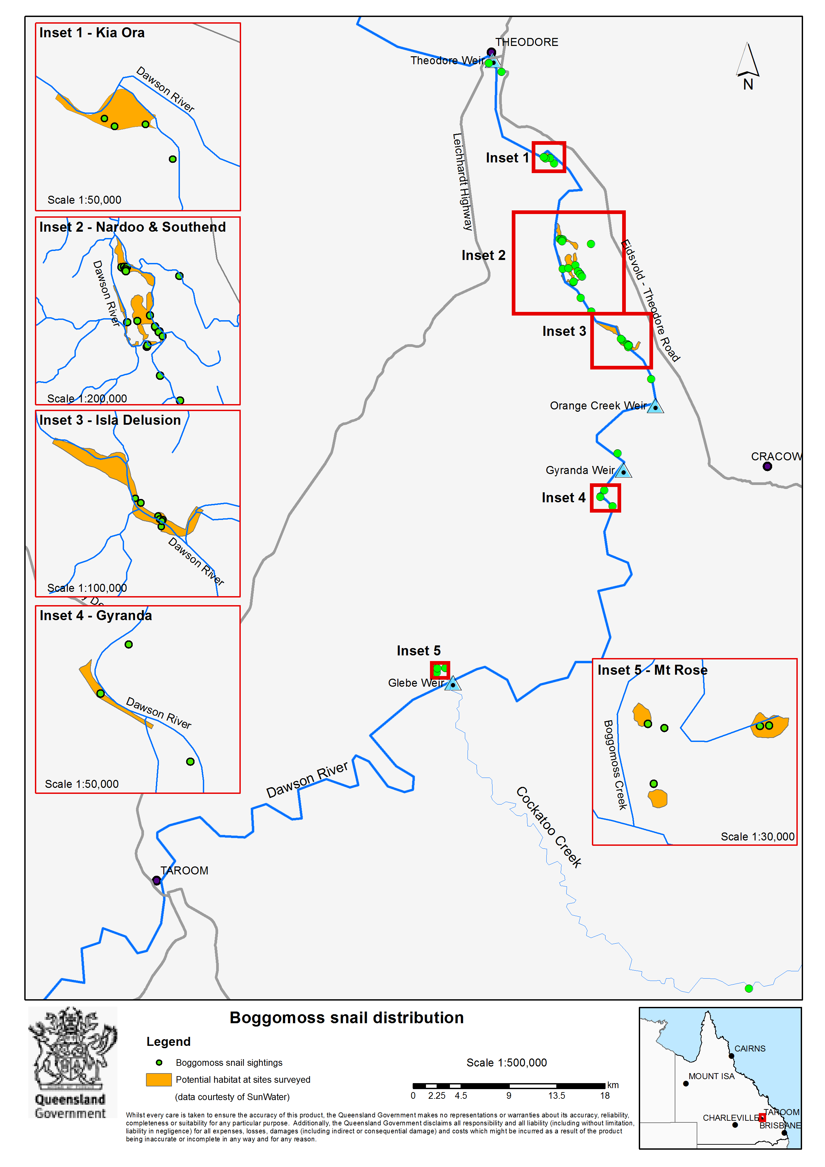

Table 3: Summary of the condition of the known snail locations (from AMEC, [2014] unless specifically referenced).

| Snail Location | Area | REs | 2013 Vegetation Condition | Proximity to Dawson River (m) | Observed Threats | Estimated area of suitable habitat (ha) | Live snails found during last survey (2013) | Tenure | Current management |
| --- | --- | --- | --- | --- | --- | --- | --- | --- | --- |
| Mt Rose | On the Glebe Weir Road, approximately 31km northeast of Taroom. | 11.3.3,  11.3.4*,  11.3.25,  11.3.27  (*only occurrence on this RE) | Good. No evidence of canopy dieback or attrition due to fire or pests. Some areas of extensive pig damage and introduced grass species prevalent. | Boggomoss No. 14 site –1400m  Boggomoss No. 15 site –1700m  Boggomoss No. 16 site –1100m | * Flood related scouring and litter reduction. * Prolonged inundation * Rooting by feral pigs. * Trampling by cattle. * Rodent predation (BAAM 2009) | 2.4 | 3 (3 adults) | Freehold | Boggomoss habitat fenced to exclude cattle. |
| Gyranda | Off the Eidsvold Theodore Road, 14km west of Cracow. | 11.3.25 | Poor. Extensive dieback due to prolonged inundation, heavily weed infested and extensive pig damage. | 0–100 | * Flood related scouring and litter reduction. * Prolonged inundation. * Rooting by feral pigs. * Trampling by cattle. | 13.0 (SunWater pers. comm. 2015) | none | Lands Lease | None |
| Isla Delusion | On the Isla Delusion Crossing Road, 18km north-west of Cracow. | 11.3.3, 11.3.25 | Excellent. No evidence of dieback or attrition due to fire or pests. | 0–200 | * Flood related scouring and litter reduction. * Rooting by feral pigs. | 142.7 (SunWater pers. comm. 2015) | 8  (4 adults  3 sub-adults  1 hatchling) | Reserve (camping and stock reserve), Lands Lease | None |
| Southend | Off the Isla Delusion Crossing Road, 20km south south-east of Theodore. | 11.3.25  11.3.36  (JKR Ecological 2010)  11.3.27 (JKR Ecological 2010) | Good. No evidence of canopy dieback or attrition due to fire or pests. Some areas of extensive pig damage and introduced grass species prevalent. | 0-1300 | * Flood related scouring and litter reduction. * Rooting by feral pigs. | 167.1 (SunWater pers. comm. 2015) | 14  (5 adults  6 sub-adults  3 juveniles) | Reserve, Lands Lease, Freehold | None |
| Nardoo | Off the Leichardt Hwy, 15km south south-east of Theodore. | 11.3.3, 11.3.25 | Good. No evidence of Canopy dieback or attrition due to fire or pests. Some areas of extensive pig damage and introduced grass species prevalent. | 0–300 | * Flood related scouring and litter reduction. * Rooting by feral pigs. | 91.0 (SunWater pers. comm. 2015) | 125  (25 adults  76 sub-adults  24 juveniles) | Lands Lease | None |
| Kia Ora | Off the Leichardt Highway, 9km south south-east of Theodore. | 11.3.3, 11.3.25 | Good. No evidence of Canopy dieback or attrition due to fire or pests. Some areas of extensive pig damage and introduced grass species. | 0-400 | * Prolonged inundation * Rooting by feral pigs prevalent. * Flood related scouring and litter reduction. | 32.9 (SunWater pers. comm. 2015) | 2 (2 adults) | Freehold | None |

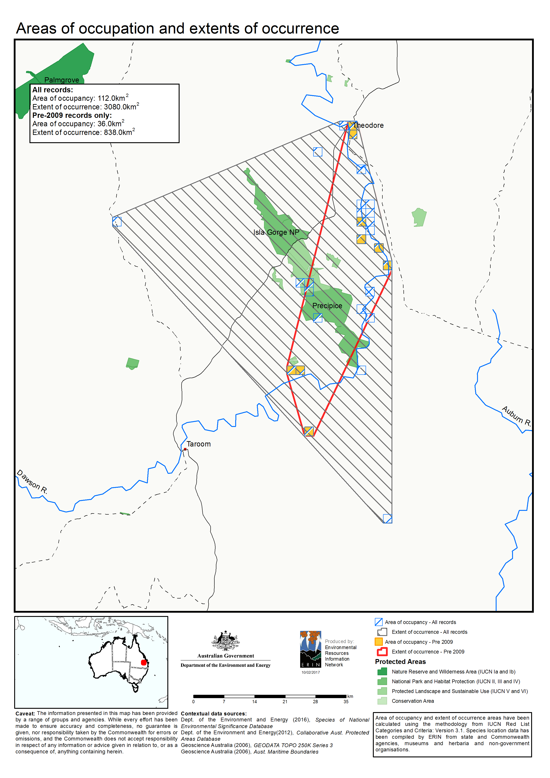**Figure 2: Boggomoss snail areas of occupancy and extents of occurrence.**

Numerous other sites in the area have been surveyed for the snails with some snails found at sites outside the six main locations (refer to Figure 3). Robinson (2013) indicated that it is likely that snails exist in suitable habitat that has been identified but not yet surveyed. For more details of the snails found in all surveys, including age classes, years and detailed locations refer to AMEC (2014).

It is noteworthy that all occupied sites are downstream of Mt Rose. The occupied sites may all be opportunistic colonisations representing refugia remaining from former critical habitat upstream from Mt Rose and to the north that was lost to land clearing for agricultural purposes (J. Stanisic pers. comm. 2016). Stanisic (1996) considered the periodic ‘break out’ flooding that happens in the upper Dawson River as probably an important dispersal agent for the snail, which will opportunistically colonise any preferred habitat. AMEC (2014) considers it likely that a proportion of the boggomoss snail population within flood-affected habitat survives flooding impacts.

### Habitat needs

The boggomoss snail appears to have a narrow preference for both macrohabitat and microhabitat. The snail needs a moist environment and cannot live in open country. The preferred habitat is the floodplain of the Dawson River in places where there is good canopy cover, a moist environment, fallen logs and deep leaf litter. This habitat once formed as an extensive archipelago of suitable patches connected by riparian vegetation, but most of the snail’s habitat has been cleared for farming and little original vegetation remains (Clarke and Spier-Ashcroft 2003).

Broad habitat types in which the species has been found (refer to Figure 4) are:

* Riparian woodlands dominated by Queensland blue gum *Eucalyptus tereticornis*, Carnarvon fan palm *Livistona nitida* and Coolibah *Eucalyptus coolabah*
* Riparian forest associations within regional ecosystem 11.3.25 on the Dawson River which support Queensland blue gum or river red gum *Eucalyptus camaldulensis* with Carnarvon fan palm *Livistona nitida* as a co-dominant species in the canopy or a dominant sub-canopy species
* Monospecific stands of Carnarvon fan palm on the Dawson River, including minor anabranch systems
* Open forest of Queensland blue gum fringing ephemeral wetlands on the Dawson River floodplain
* Artesian springs (mound springs or boggomoss springs) with a canopy of Queensland blue gum *Eucalyptus tereticornis* and a mid-storey of sandpaper figs *Ficus opposita* at Mt. Rose Station. Most of the artesian springs within the Dawson River valley are not suitable for the boggomoss snail, which has been recorded from only three boggomoss springs on alluvial flats on Mt Rose Station.

Within the broad habitat types the species has been found in five regional ecosystems (REs) as described under the Queensland Vegetation Management Framework:

* RE 11.3.3—*Eucalyptus coolabah* woodland on alluvial plains
* RE 11.3.4—*Eucalyptus tereticornis* and/or *Eucalyptus* spp. tall woodland on alluvial plains (snails have been found in this RE type at Mt Rose only)
* RE 11.3.25—*Eucalyptus tereticornis* or *E. camaldulensis* woodland fringing drainage lines
* RE 11.3.27—freshwater wetlands
* Re 11.3.36—*Eucalyptus crebra* and/or *E. populnea* and/or *E. melanophloia* on alluvial plains (only recorded at Southend by JKR Ecological 2010).

(AMEC 2014; BAAM 2009; JKR Ecological 2010; SKM 2009; Stanisic 2008).

All of these REs have a biodiversity status ‘of concern’. An RE is listed as ‘of concern’ under the Queensland Vegetation Management Act *1999* if remnant vegetation is 10–30% of its pre-clearing extent across the bioregion or more than 30% of its pre-clearing extent remains and the remnant extent is less than 10,000ha (Queensland Government 2017).

The Boggomoss Springs are included as a wetland system listed in the Directory of Important Wetlands.

The boggomoss snail microhabitat has a critical requirement for deep, moist litter and fallen timber which provide food, shelter and egg-laying sites. The microhabitat preferences are considered as follows:

* Partially buried logs in moist situations at all known sites
* Accumulated leaf litter under Queensland blue gum at all known sites
* Accumulated litter (including fronds) at the base of Carnarvon palm in the riparian forests of the Dawson River
* Deep accumulated leaf litter among the canes of sandpaper figs on the boggomosses of Mt Rose Station. Boggomosses are a series of small, raised peat bogs that form when water from aquifers of the Great Artesian Basin is pushed to the surface through mound springs (Fensham 1998).

(AMEC 2014; BAAM 2009; JKR Ecological 2010; SKM 2009; Stanisic 2008).

Figure 3: Sites surveyed for boggomoss snails between 2009 and 2013.

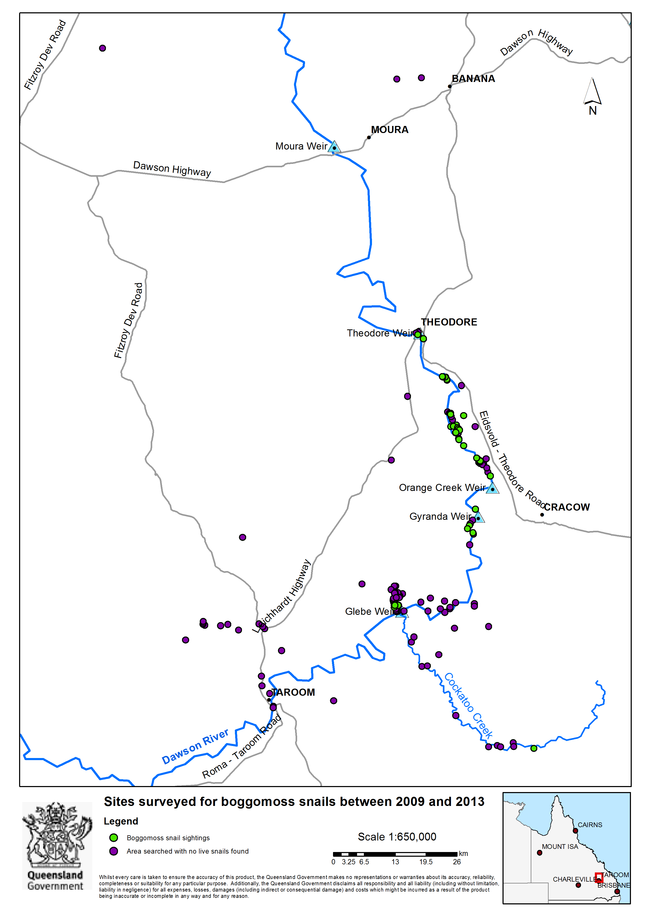

Figure 4: Example of known habitat for the boggomoss snail (green forested areas close to the river) at Isla Delusion

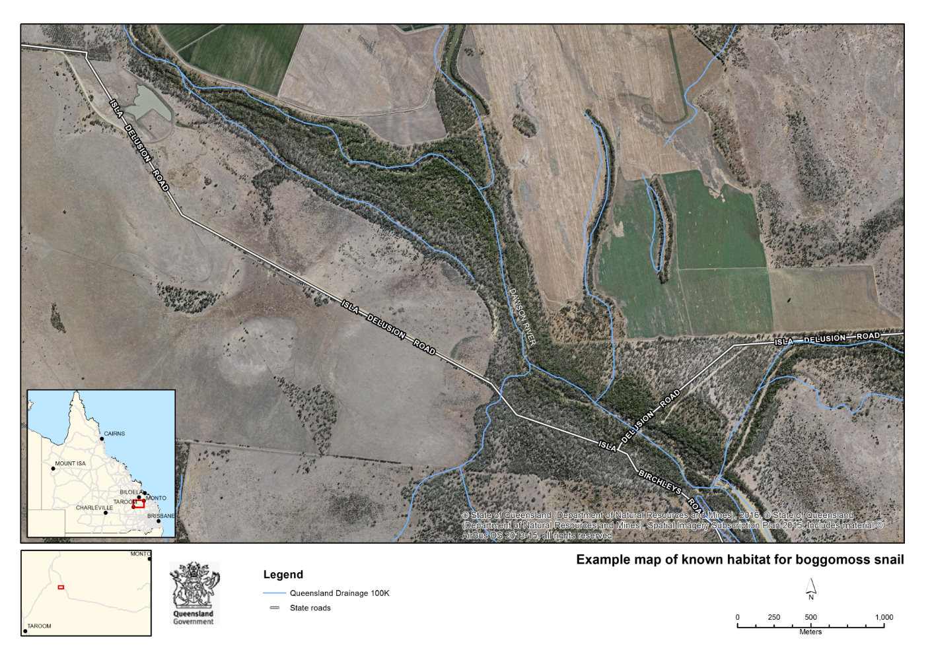

### Population

The species is considered to occur as a single population connected by the Dawson River. Taking into consideration that all of the existing known locations for the snail occur within the flood-zone of the Dawson River and riparian zones are an acknowledged corridor for species dispersal, it is likely that snails are moved between the discrete habitat patches during flooding events. During these events the snails are likely to be moved to downstream habitat, thus facilitating gene flow (J. Stanisic pers. comm. 2015).

In 2008, the Mt Rose Station boggomoss covering an area of 0.75ha was then deemed to be the stronghold for the species after surveys found two adults and 10 sub-adults (Ingram and Stanisic 1997) and then 2 sub-adults and 20 juveniles (BAAM 2009). Subsequently, three surveys have been undertaken resulting in two surveys finding no live snails and the third finding three live snails. There are conflicting views on what this means. John Stanisic (pers. comm. 2015) stated that this implies high fluctuations in numbers of snails. AMEC (2014) determined that given the search intensity undertaken across the entire area of available habitat at the Mt Rose location, the population at that time was extremely small. Robinson (2013) concluded that Mt Rose numbers were considered moderate in 2009 but in 2013 were low and that this couldn’t be completely explained by differences in detectability. In contrast to the low numbers found at Mt Rose over the last several surveys, at another location (Nardoo) during the 2013 surveys, 125 snails were recorded in a single sampling event, more than in all other survey events combined (AMEC 2014).

Surveys undertaken from 2009 to 2013 identified several new sites with significantly larger numbers of snails (including adult, sub-adult and juvenile snails) in more extensive areas of vegetation than had been found at the two original sites where the snails were first discovered (AMEC 2014; EcoSM 2012; JKR Ecological 2010; SKM 2009). The surveys undertaken between 2009 and 2013 to get population estimates of the boggomoss snail produced variable results. There was no consistency in the time of year, which is likely to result in different population structure, and the major flood events of 2010 and 2011 had a significant effect on the snail’s distribution. In addition, results were not comparable due to different survey aims, sampling techniques and different populations being surveyed. An independent peer review of the population estimates from the surveys concluded that on statistical grounds none of the estimates are valid (Robinson 2013). For this reason, no population estimates have been provided, and a recommended action is to produce and apply a consistent methodology in future. The total number of live snails counted in the most recent survey, carried out in 2013, was 152 (39 adults, 85 sub-adults, 27 juveniles and one hatchling) (AMEC 2014).

### Habitat critical to the survival of the species

Most of the native vegetation in the Dawson Valley has been cleared for farming (Clarke and Spier-Ashcroft 2003) and within the little remaining native vegetation the boggomoss snail is dependent on oases refugia of moist habitat (Bishop 1981; Stanisic 2008). The continued existence of the snail in very small suitable areas of remnant vegetation appears to indicate that its viability can be maintained in small allotments (1-3ha) (Stanisic 2008).

Habitat critical to the survival of the boggomoss snail includes:

* the current area of occupancy
* potential suitable habitat to which the species could be dispersed to or be translocated
* newly discovered locations that extend the current area of occupancy.

The surveys undertaken between 2009 and 2013 provided valuable data on the species’ distribution and areas of habitat. However, the surveys did not use a consistent methodology to assess each habitat. The snail’s habitat should be formally assessed using a consistent methodology to clearly define habitat critical to the survival of the species. Defining and mapping habitat critical to the survival of the snail and potential habitat are included as recovery actions.

# Threatening processes

A conceptual diagram of the threatening processes and underlying causes of population decline is shown in Figure 5. The current critically endangered status of the species can be attributed to the fact that most of the suitable habitat in the area has been cleared, and remaining patches are isolated from each other. Thus the snail has suffered, and continues to suffer from both direct mortality and from decreased resilience—the ability for the population to withstand or recover from threats.

**Figure 5: Threats to the boggomoss snail.**

Loss of microhabitat

Small population, small range, isolation of subpopulations

Loss of macrohabitat, microhabitat and connectivity

Past and present clearing, habitat modification

Additional potential clearing/ modification of habitat through dams, mining, roads, firebreaks, firewood collection

Feral house mice, cane toads

Trampling, disturbance of microhabitat

Pigs

Inadequate habitat and food

Direct mortality

Fire

Climate change and climatic events

Prolonged drought

Increased vulnerability, decreased resilience to all threats

Flood

Lack of resilience (e.g. ability to recolonize after floods or other impacts)

Invasive plants (e.g. buffel grass, Guinea grass)

Predation

Cattle

**Note:** Causes of direct mortality are in pink; underlying causes are in light brown. The impacts of the threats on the survival of the species – direct mortality and lack of resilience – are in red boxes. Arrows represent the direction of influence. This may be direct (fire kills snails) or indirect (a small isolated sub-population has less resilience to survive or recover from an event such as a fire or severe flood). Please note that the diagram does not necessarily represent the complexities of the inter-relationships of the ‘underlying causes’ and ‘causes’.

## Threats

### Flooding

While flooding can positively affect snails through dispersal of snails to suitable downstream habitat, it can also negatively affect the snails in three ways: through direct mortality; through transportation in flood waters to unsuitable habitat; and through the removal from its habitat of the leaf litter, logs and other ground cover essential to its survival. The threat of flooding is considered to have increased due to the human-related impacts of land clearing that have occurred in the region. This is due to the fact that removal of vegetation increases runoff which can increase flooding (The State of Queensland 2011). In 2010 and 2011 two major flood events occurred (EcoSM 2012; JKR Ecological 2010). These floods are significant in a historical context, with only two larger events on record, both from pre-1900 (1870 and 1890) (EcoSM 2012). Surveys undertaken following these major flooding events determined the flooding had a negative impact on the quality of habitat; at many sites microhabitats were limited or had been stripped due to flooding impacts. In addition, flooding resulted in inundation of sites for several weeks. The significant reduction in the number of snails found at some sites compared to previous surveys is thought to have been a consequence of the flooding (EcoSM 2012).

There was, however, some evidence that the snail can survive in the riparian and floodplain zones of the Dawson River. For example, the snail was found in an area that had recently been inundated by four metres of flood water, where there was abundant flood debris (JKR Ecological 2010). Reporting on a later survey, AMEC (2014) noted that in spite of the flooding in 2010 and 2011 there was evidence of successful breeding or recruitment at some sites. As such the impact of flooding may not be the same for each of the snail’s habitats. Furthermore, little is known about the ability of the snail to withstand inundation at different ages. The threat of flooding should be investigated for each snail location to determine the location’s susceptibility to flooding impacts. Genetic studies of the boggomoss snail population would also clarify the role of flooding in the dispersal of snails. While flooding cannot be managed directly, actions that reduce snail mortality and increase the distribution and resilience of the boggomoss snail population should reduce the negative effects of flooding.

### Inappropriate fire regimes

Inappropriate fire regimes are a major threat to the viability of land snail populations (Stanisic and Ponder 2004). Fire can incinerate and dehydrate snails, and can indirectly affect them through the destruction of microhabitat (e.g. litter and logs).

The snail’s preferred habitat can support high fuel loads (e.g. accumulated palm leaves and introduced grasses), resulting in intense fires that can destroy habitat. Introduced grasses, specifically buffel grass, *Cenchrus ciliaris* and Guinea grass, *Megathyrsus maximus*, are known to be fuel for hot and frequent fires. The boggomoss remnants are small which makes them vulnerable to fire, particularly hot fires (Clarke and Spier-Ashcroft 2003). Nothing is known about current fire management practices within the habitat of the snail. Although evidence of fires has been present during surveys it is not known if these were planned burns or naturally occurring fires. Snails have been found at sites that showed evidence of fire in the past (e.g. BAAM 2009; SKM 2009). This could mean that snails are able to tolerate some fire in their habitat or that they can quickly recolonise sites after fire but there is currently no evidence to support either scenario conclusively. As such the snail’s level of fire tolerance has not been established. Avoidance of fire in the snail’s habitat is recommended until the snail’s level of fire tolerance has been established (which has been included as part of a recovery action).

All snails found to date have been in habitats with dead logs on the ground. The Isla Delusion reserves are open to the public for the purpose of camping, which includes lighting fires, and could pose an increased risk of fire affecting habitat.

### Clearing of vegetation

Past clearing of vegetation for agriculture and pastoralism has had a significant impact on the snail. Clearing remains a threat, particularly for new infrastructure traversing riparian vegetation such as access tracks, power lines or linear infrastructure associated with coal seam gas production–pipeline crossings. Clearing may also occur associated with the maintenance of existing infrastructure such as roads, easements, tracks, firebreaks or fence lines. Most of the snail’s known habitat area is covered by granted mining leases. While mining is not currently being undertaken, mining and exploration activities could pose a serious threat to the snail through vegetation clearing and disturbance, habitat alteration, and hydrological modification.

### Firewood collection

The collection of fallen timber at Isa Delusion reserve by campers to use for lighting fires is a threat to the snail as it degrades its habitat and can lead to the direct mortality of snails through burning if present on the timber.

### Changes to hydrology

Changes to hydrology from a structure such as a dam or weir could have significant consequences for the boggomoss snail. Impoundment of water from the building of a dam or weir could cause inundation of the snail’s habitat if the habitat is upstream of the structure (J. Stanisic pers. comm. 2015). In addition, the change in river flows downstream is likely to dry the riparian vegetation community on which the boggomoss snail relies.

### Weeds

Weeds have the potential to alter both the lower shrub layer and consequent litter as well as contributing to an increased fuel load. Significant weeds include buffel grass, *Cenchrus ciliaris* and Guinea grass, *Megathyrus maximus*. Other weed threats within the species’ habitat need to be identified.

### Inappropriate grazing regimes

Habitat degradation can result from inappropriate grazing regimes which cause soil compaction and loss of snails from trampling. All sites except Mt Rose are at threat from grazing. Through a local agreement between Queensland Parks and Wildlife Service and the landowner in 2009, the boggomoss on Mt Rose Station was fenced to exclude cattle. However, this has resulted in higher fuel loads through the growth of grasses and a greater risk of wildfire. Currently there is insufficient knowledge about the relative impacts of cattle and fire. For example, low stocking rates would reduce fuel loads (weeds and pasture grasses) and might not be detrimental to snail habitat. It is also likely that there will be site-specific issues. For example, sites with multiple large logs may be less accessible to cattle, and therefore light grazing may not pose a threat, and some of the dense fan palm forest sites, particularly the wetter ones, develop little grass and are less likely to suffer from grazing pressure (J. Stanisic pers. comm. 2014).

### Feral pigs

Using their muscular, mobile snout and forefeet, feral pigs effectively root up the ground searching for food, including snails (Choquenot *et al*. 1996). Rooting by feral pigs has been observed in boggomoss snail habitat (AMEC 2014) resulting in habitat degradation and likely direct mortality by predation.

### Predation by feral house mice and cane toads

Large numbers of damaged shells have been found during surveys at Mt Rose suggesting that predation by mammals—most likely house mice and native rats which were trapped at the same time—may be significant at this site. However it was not known if the predation was pre or post mortality (AMEC 2014). There is little information on the threat of feral house mice at other sites. Land snails are eaten by cane toads, *Bufo marinus*, including camaenid snails in laboratory experiments (Pearson *et al*. 2009). Cane toads occur in the Dawson River catchment and may prey on boggomoss snails. Due to the boggomoss snail’s restricted geographic distribution, low vagility (ability to move) and ‘slow’ life-history (slow growth, late maturation and low reproductive rates) cane toads may threaten populations (Pearson *et al*. 2009).

### Climate change

It is acknowledged that climate change may influence long-term sustainability of the snail. A report on climate change for the East Coast NRM regions of Australia, which includes the area where the boggomoss snail is found, predicts with high confidence that there will be higher temperatures, hotter and more frequent hot days, increased intensity of heavy rainfall, increased evaporation rates, and harsher fire-weather climate in the region (Dowdy *et al.* 2015). While there is no information specifically identifying impacts of climate change on the boggomoss snail, these climate change predictions for the region are likely to mean that the threats of fire, flooding, and changes to hydrology will increase.

No actions have been developed that directly address climate change. Recovery actions that address other threats to the snail should increase its resilience to climate change.

## Areas under threat

All areas where the species occurs are considered under threat from flooding, inappropriate fire regimes, changes to hydrology (either from inundation or altered flow regimes), inappropriate grazing regimes, feral pigs, weeds, cane toads and clearing of vegetation. Further to that, Isla Delusion has camping reserves where lighting fires is allowed, increasing the risk of fire impacting negatively on the snail and its habitat as well as the collection of wood for lighting fires. It is also the only site where there is a public road through snail habitat. The Mt Rose site has been fenced to exclude cattle. However, this has resulted in higher fuel loads through the growth of grasses and has potentially increased the risk at the site from fire. Mt Rose is the only site where damaged shells have been found showing signs of predation by rodents.

## Populations under threat

The species is considered to occur as a single population. Therefore the whole population is considered under threat given the small total habitat area, and lack of formal habitat protection. Further scientific study will assist in determining if the population is recoverable to sustainable levels.

1. Securing and recovering the Boggomoss Snail

## Recovery goal

The long-term recovery goal for the boggomoss snail is a self-sustaining population that is stable or increasing in at least eight sites protected from threats by 2037.

Recovery objectives and actions for the next ten years

**Objective 1: Secure habitat critical to the survival of the boggomoss snail and enhance suitability of sites for the snail within and surrounding this habitat.**

**Performance criteria:**

* An increase in connectivity of habitats with snail populations, compared to baseline to be established in year two.
* An increase in suitable microhabitat and quality of canopy cover compared to baseline to be established in year two.
* Conservation agreements (formal or informal) have been developed with landholders over areas identified as critical to the survival of the boggomoss snail and Habitat Management Guidelines have been produced and communicated to landholders.
* A code of practice for works within boggomoss snail habitat has been produced and disseminated to Banana Shire Council.

**Action 1.1:** Work with landholders/managers to protect and enhance habitat critical to the survival of the boggomoss snail, increase connectivity between known habitat areas and foster or restore potential additional habitat:

* Restore areas of known or potential habitat that are currently in poor condition or lacking in suitable microhabitat. For example, exclusion of cattle to encourage build-up of leaf litter, preventing the collection of firewood, and physical restoration of logs may restore a suitable environment for snails to colonise.
* Restore riverine vegetation along the Dawson River and its tributaries in the habitat area to enable natural dispersal of boggomoss snails and allow natural revegetation of suitable habitat to occur.
* Initiate negotiation of conservation agreements or stewardship arrangements where possible.
* Investigate financial incentives and other support for landholders to amend land use practices, control invasive species and exclude fire from known habitat.
* Work with landholders, through NRM groups or other field agents, to protect the snail’s habitat and subpopulations on the ground.
* Produce and communicate simple habitat management guidelines for the conservation of the boggomoss snail and its habitat (including agreed approaches to undertaking farming or infrastructure management activities within boggomoss snail habitat).
* Develop a code of practice for council planning schemes for works undertaken in boggomoss snail habitat.

**Action 1.2:** Work with the Queensland Department of Natural Resources and Mines in regard to future leases with suitable snail habitat to include conditions in relation to the management of grazing and fire that maintain snail habitat.

**Rationale:** Improved connectivity, microhabitat and canopy cover, and protection of snail habitat will enhance the quality of snail habitat, allow for natural dispersal of snails to suitable habitat and mitigate the threat of clearing of vegetation. Incentive or reward schemes if available, may encourage landholders to protect snail habitat. The use of the guidelines and code of practice should make sure that the snail is not further impacted by clearing of vegetation or degradation of habitat from agriculture or other infrastructure development/maintenance. Restoration of vegetation will assist in mitigating the impacts of major floods. Future lease conditions can better protect the snail and its habitat.

Objective 2: Implement threat abatement in areas where the boggomoss snail exists.

Performance criteria:

* A 50% decrease in proportion of known habitat impacted by cattle and pigs compared to baseline to be established in year two.
* A report has been prepared investigating suitable methods of controlling cane toads and feral mice.
* A decrease in the proportion of habitat under threat from fire compared to baseline to be established in year two.
* A 50% decrease in proportion of habitat with invasive grasses compared to baseline to be established in year two.
* No logs from boggomoss snail habitat within Isla Delusion taken as firewood.

Action 2.1: Minimise impacts from cattle, pigs and other disturbance to habitat:

* Manage grazing intensity at a level to reduce fuel loads while minimising disturbance and retaining native vegetation cover.
* Control pigs where their activity is evident.
* Investigate suitable methods of controlling cane toads and feral mice within the snail’s habitat critical to the survival of the species.

Action 2.2: Reduce the impact of fire on habitat or snails:

* Exclude fire from known habitat patches.
* Reduce fuel loads from invasive grasses.
* Manage recreational use of fire at camp grounds to reduce risk of wildfire at Isla Delusion.

**Action 2.3**: Control weeds and prevent establishment of new weeds:

* Control existing invasive plants (e.g. buffel grass and Guinea grass) through controlled grazing, mechanical or chemical methods but ensure control methods pose no risk of harm to snails or their food sources.
* Prevent further establishment of these or other pest plants, including climbing species.

**Action 2.4:** Prevent firewood collection at Isla Delusion camping reserve through appropriate signage, fencing off of important snail habitat to protect logs, and by providing firewood for campers.

**Rationale:** Fire, weeds, cane toads, feral mice, pigs and cattle grazing, and removal of logs for firewood all threaten the snail either indirectly through habitat degradation or directly through mortality. The snail’s tolerance to fire has not been established as yet so the recommended fire regime is fire avoidance until an assessment of the snail’s tolerance to fire has been completed and an appropriate fire management regime has been identified.

**Objective 3: Increase population through captive breeding and conservation translocation to at least two sites.**

Performance criteria:

* Snails are held in captivity and are successfully breeding for the period of a captive breeding agreement.
* Up to 200 snails from the captive bred population have been successfully reintroduced to at least two suitable areas.

**Action 3.1:** Undertake a captive breeding program to enable conservation translocations into the natural environment and to enable research into the snail’s biology and ecology.

**Action 3.2:** Translocate snails into habitat to mimic the natural dispersal of the snail and support existing subpopulations.

**Rationale:** Maintenance of a captive bred population will quickly increase snail numbers for translocation to establish new subpopulations at new sites or support existing subpopulations. Care must be taken to establish the captive breeding population without reducing the survival of the snail in the wild. Expansion of snail distribution to areas where it may have formally existed will increase its resilience. Captive bred populations can also be used to enable research into the biology and ecology of the snail. For example, the use of artificial habitat structures to replace lost microhabitat (fallen leaves and logs) could be studied using captive bred snails.

Conservation translocation is the intentional movement and release of organisms for conservation purposes. Conservation translocation includes the movement of organisms for reinforcement of existing subpopulations and reintroduction to establish new subpopulations inside its indigenous range (IUCN/SCC 2013). Translocation of snails should only occur once known threats at the site/s have been mitigated. Monitoring the effectiveness of any reinforcement or reintroductions of boggomoss snails is essential. A site has been identified in an area higher up the Dawson River catchment than Mt Rose that may be suitable for reintroduction of snails. Sites below Nathan Gorge may also be suitable for reintroductions and reinforcements. A Captive Breeding Agreement would need to be negotiated with the Queensland Government under the *Nature Conservation Act 1992* to develop a captive bred population of snails and release those snails into the wild. Part of this Agreement would include identification of minimum numbers of founder snails required to achieve the goals of the program and a detailed translocation or release plan consistent with policy and IUCN guidelines (IUCN/SCC 2013).

**Objective 4: Improve understanding of key aspects of the biology and ecology of the species.**

Performance criteria:

* A peer-reviewed report has been developed documenting method.
* Baseline data established on habitat, population, threats and current land management.
* Reports and papers have been produced documenting estimated population, successes and failures in translocations and reintroductions, conclusions about habitat critical to the survival of the snail, any subpopulations, and extent of suitable habitat.
* Peer-reviewed report has been developed on genetics of boggomoss snail population.
* Report has been developed on the boggomoss snail’s tolerance to fire and identification of an appropriate fire management regime for the snail.

**Action 4.1:** Develop a consistent documented field method to collect important information on the snail’s population, habitat requirements and threatening processes, including:

* a population monitoring method that is repeatable, representative and not deleterious to the snail and its habitat.
* a consistent recording form for macro-habitat characteristics (e.g. dominant trees, substrate, susceptibility to flooding, fire etc.) and microhabitat characteristics (e.g. leaf litter, woody debris, etc.), threats, ecological integrity and land use.
* method for assessing connectivity between patches of known and potential habitat.

**Action 4.2:** Assess habitat, the population and threats in all areas where the snail is known to occur, using the method developed in Action 4.1:

* Record habitat details, current condition, and threats as baseline for future monitoring, and repeat study every two to five years or after flooding events as appropriate.
* Record numbers of live and dead snails including age classes and signs of predation every 6 months during the life of this recovery plan.
* Estimate the size of any subpopulation using the consistent methodology produced in action 4.1.
* Document current land management and history of management (e.g. is the land grazed, fenced, managed for fire).
* Assess the snail’s level of tolerance to fire and establish a suitable fire management regime for the boggomoss snail.
* Draw conclusions about the habitat critical for the survival of the snail, threats at each location, priority sites for management, and the importance of any subpopulations.

**Action 4.3:** Conduct genetic analyses to determine genetic variation within the snail population.

**Rationale**: A consistent survey and research method will enable a better understanding of the boggomoss snail’s biology, ecology, life cycle and habitat requirement to enable successful management. The survey method should not be destructive to the snail’s microhabitat and should outline optimal times for surveys when the snail is active (e.g. at night after rain). The data collected from assessments of sites will provide the information required to implement site-specific management actions. Regular monitoring of snail numbers in accordance with the methodology will identify changes in the status of the snail and determine the success or failure of management. Genetic analyses will assist when developing a captive bred population, translocating snails and in understanding dispersal mechanisms along the Dawson River.

**Objective 5: Consolidate support for the recovery efforts with academic institutions, NGOs, NRM groups, and others.**

Performance criteria:

* Research has been undertaken by at least one research organisation on research actions identified in this recovery plan.
* A recovery team has been established, terms of reference have been produced, the team is meeting bi-annually and recovery outcomes and resultant changes to recovery program are reported at least annually.
* Webpage/s have recorded progress of recovery of snail.

**Action 5.1:** Partner with academic and research organisations and seek private sponsorship to establish and maintain research and monitoring capacity to support this recovery plan.

* Encourage and facilitate the establishment of research partnerships, in conjunction with the recovery group.
* Develop research priorities and seek funding to support research and monitoring.

**Action 5.2**: Develop and maintain a recovery team that effectively organises, implements, reviews and reports on the recovery outcomes.

* Establish and maintain an effective recovery group.
* Produce terms of reference, conduct bi-annual meeting, and communicate as necessary to support recovery efforts.

**Action 5.3:** Create public awareness about the boggomoss snail as a flagship species for threatened invertebrate species.

* Maintain webpages about the boggomoss snail and record progress on its recovery.
* Promote the recovery program and specific actions as appropriate, including raising awareness at camping areas.

**Rationale**: Involvement of research institutes should make sure that the required research is carried out on the boggomoss snail. So that the recovery plan is implemented it requires ownership and co-ordination. Where there are multiple stakeholders, as is the case with the boggomoss snail, communication, decision-making and can provide momentum for continued implementation, monitoring and reporting is important. Maintenance of a webpage will create public awareness and may encourage community participation in the recovery of the species. The boggomoss snail can be used as a flagship species to highlight conservation needs of, and generate support for, other invertebrates, a group of animals which have traditionally not received very much attention.

**Potential contributors to the actions:**

SunWater; landholders; Queensland Department of Environment and Heritage Protection; Queensland Department of Natural Resources and Mines; Queensland Museum; Fitzroy Basin Association Natural Resource Management Regional Body; Wildlife Preservation Society of Queensland—Upper Dawson Branch; Banana Shire Council; conservation groups, universities and educational institutions; individual land snail enthusiasts; project proponents; campers.

Figure 6: Actions to address threats to the boggomoss snail.

Figure 6 depicts how the actions listed above are intended to reduce threats to the boggomoss snail and increase habitat, population size etc. Actions aim to reduce the direct mortality and to increase the population size and resilience, enabling the snail population as a whole to become more resilient to existing and potential future threats.

Small population, small range, isolation of subpopulations

Loss of macrohabitat, microhabitat and connectivity

Past and present clearing, habitat modification

Additional potential clearing/ modification through dams, mining, roads, firebreaks

Trampling, disturbance of microhabitat

Pigs

Inadequate habitat and food

Direct mortality

Fire

Climate change and climatic events

Prolonged drought

Flood

Increased vulnerability, decreased resilience to all threats

Lack of resilience (e.g. ability to recolonize after floods or other impacts)

Invasive plants (e.g. buffel grass, Guinea grass)

Cattle

Predation

Loss of microhabitat

**Note:** Actions are shown in yellow ovals shapes. Green arrows depict the chain of results, where an action should alter the causal factor and thus reduce threat and hence the impacts. The diagram does not necessarily represent the complexities of the inter-relationships of the ‘underlying causes’ and ‘causes’.

1. Management practices

## Habitat protection

In addition to the recovery actions, habitat protection may be achieved by management practices (activities, policies and/or guidelines) that are not specifically designed for recovery of the boggomoss snail, but may still make valuable contributions, including:

* Queensland Water Plan (Fitzroy Basin) 2011 through the management of the flow regime for the Dawson River
* Queensland Vegetation Management Act 1999 through the management of clearing of native vegetation;
* State and Local Government land use planning for biodiversity conservation
* Management of Precipice National Park through the maintenance of biodiversity and control of threats such as weeds, pigs and fire
* Fitzroy Basin Association plans through planning for biodiversity conservation
* Great Artesian Basin Strategic Management Plan through the recognition and provision of water for environmental flows and for groundwater-dependent ecosystems.

## Guide for decision makers

Under the CommonwealthEPBC Act any person proposing to undertake actions that may have a significant impact on listed threatened species (including the Boggomoss snail) should refer the action to the relevant Minister in accordance with the EPBC Act requirements. The Minister will determine whether the action requires EPBC Act assessment and approval. As these provisions relate to proposed future actions, they can include actions which may result in increased impact from existing threats or potential threats, and actions which may result in a new threat.

Whether or not an action is likely to have a significant impact depends upon the sensitivity, value and quality of the environment which is impacted, and upon the intensity, duration, magnitude and geographic extent of the impacts. The potential for an action to have a significant impact will therefore vary from case to case (DoE 2013).

Actions occurring within habitat critical to survival that result in any of the following may have a significant impact on the boggomoss snail:

* clearing/loss of boggomoss snail habitat, including suitable microhabitat
* decrease in canopy continuity and canopy condition in boggomoss snail habitat
* decrease in food availability
* decrease in refuge site availability
* increased likelihood of predation on the boggomoss snail
* increased likelihood of competition of the boggomoss snail with other fauna
* reduced ability of the boggomoss snail to disperse.

# Estimated cost of recovery

Table 4. Estimated costs ($) of the boggomoss snail recovery plan (these are generalised costs and will need to be fully costed prior to implementation).

*Costed actions are subject to funding availability and do not include GST.

| **Recovery Actions** | **Year 1** | **Year 2** | **Year 3** | **Year 4** | **Year 5** | **Total** | **Priority of action** |
| --- | --- | --- | --- | --- | --- | --- | --- |
| **Objective 1: Secure habitat critical to the survival of the boggomoss snail and enhance suitability of sites for the snail within and surrounding this habitat** | | | | | | | |
| **Action 1.1** Work with landholders/managers to protect and enhance habitat critical to the survival of the boggomoss snail, increase connectivity between known habitat areas and foster or restore potential additional habitat | **$**20,000 | **$**52,000 | $42,000 | **$**26,000 | **$**10,000 | **$150,000** | High |
| **Action 1.2** Work with Department of Natural Resources and Mines in regard to future leases with suitable snail habitat to include conditions in relation to the management of grazing and fire that maintain snail habitat | N/A | N/A | N/A | N/A | N/A | N/A | Medium |
| **Objective 2:** Implement threat abatement in areas where the boggomoss snail exists. | | | | | | | |
| **Action 2.1** Minimise impacts from cattle, pigs and other disturbance to habitat | **$**61,000 | **$**51,000 | **$**51,000 | **$**51,000 | **$**51,000 | **$265,000** | Medium |
| **Action 2.2** Reduce the impact of fire on habitat and snails | **$**14,880 | **$**7,440 | **$**7,440 | **$**7,440 | **$**7,440 | **$44,640** | High |
| **Action 2.3** Control weeds and prevent establishment of new weeds | **$**18,000 | **$**18,000 | **$**18,000 | **$**18,000 | **$**18,000 | **$90,000** | Medium |
| **Action 2.4** Prevent firewood collection at Isla Delusion camping reserve through appropriate signage and fencing to protect microhabitat | **$1**3,000 | N/A | N/A | N/A | N/A | **$3,000** | High |
| **Objective 3: Increase population through captive breeding and conservation translocation to at least two sites.** | | | | | | | |
| **Action 3.1** Undertake a captive breeding program to enable conservation translocations into the natural environment and to enable research into the snail’s biology and ecology | **$**9,000 | **$**5,000 | **$**5,000 | **$**5,000 | **$**5,000 | **$29,000** | Medium |
| **Action 3.2** Translocate snails into habitat to mimic the natural dispersal of the snail and support existing subpopulations | N/A | N/A | **$**22,200 | **$**19,200 | **$**19,200 | **$60,600** | Medium |
| **Objective 4: Improve understanding of key aspects of the biology and ecology of the species.** | | | | | | | |
| **Action 4.1** Develop a consistent documented field method to collect important information on the snail’s population, habitat requirements and threatening processes | **$**40,000 | N/A | N/A | N/A | N/A | **$40,000** | High |
| **Action 4.2** Assess habitat, the population and threats in all areas where the snail is known to occur, using the method developed in Action 4.1. | N/A | **$**200,000 | **$**9,600 | **$**100,000 | **$**9,600 | **$319,200** | High |
| **Action 4.3** Conduct genetic analyses to determine genetic variation within the snail population | N/A | **$**10,000 | N/A | N/A | N/A | **$10,000** | High |
| **Objective 5: Consolidate support for the recovery efforts with academic institutions, NGOs, NRM groups, and others.** | | | | | | | |
| **Action 5.1** Partner with academic and research organisations and seek private sponsorship to establish and maintain research and monitoring capacity to support this recovery plan | **$**4,000 | **$**4,000 | **$**4,000 | **$**4,000 | **$**4,000 | **$20,000** | Medium |
| **Action 5.2** Develop and maintain a recovery team that effectively organises, implements, reviews and reports on the recovery outcomes | **$**5,000 | **$**5,000 | **$**5,000 | **$**5,000 | **$**5,000 | **$25,000** | Low |
| **Action 5.3** Create public awareness about the boggomoss snail as a flagship species for threatened invertebrate species. | **$**1,000 | **$**1,000 | **$**200 | **$**200 | **$**200 | **$2,600** | Low |
| **\*Annual costs of implementing Recovery Plan** | **$185,880** | **$353,440** | **$164,440** | **$235,840** | **$129,440** |  |  |
| **\*Total cost of Recovery Plan** |  |  |  |  |  | **$1,069,040** |  |

# Monitoring

Monitoring the recovery of the boggomoss snail and the implementation of this recovery plan should be undertaken by measurement of the key indicators shown in Table 5. The most critical indicator is the estimated species population.

Table 5: Summary of indicators and targets.

| Objective | Indicator type | Performance criteria | Target |
| --- | --- | --- | --- |
| Recovery goal | Outcome | Estimated total population size | Population levels of the boggomoss snail are increased over baseline estimated in year 2 to a point where population is considered self-sustaining. |
| Objective 1 | Outcome | Extent of connectivity between suitable habitat patches | By 2025, demonstrated increase in connectivity of habitats with snail populations, compared to extent known in 2016 with monitoring of progress done every two years. |
| Objective 1 | Outcome | Extent of suitable habitat (including microhabitat and quality of canopy cover) | By 2025, 20% increase in appropriate habitat in suitable condition for boggomoss snails with monitoring of progress done every two years. |
| Objective 2 | Threat | Proportion of known habitat patches where trampling impacts and signs of pigs are obvious | By 2027, 50% decrease in proportion of impacted habitat compared to baseline to be established in year two. |
| Objective 2 | Threat | Mapped incidence of fires in known habitat patches | By 2027, decrease in proportion of habitat under threat from fire compared to baseline to be established in year two. |
| Objective 2 | Threat | Mapped extent of invasive species | By 2027, decrease in proportion of habitat with invasive grasses compared to baseline to be established in year two. |
| Objective 3 | Process | Captive snail population | By 2018, a captive population of snails is held and successful breeding recorded. |
| Objective 3 | Outcome | Number of snails successfully translocated into suitable habitat in the wild | By 2025, up to 200 snails successfully re-introduced to appropriate habitats. |
| Objective 3  Objective 4 | Management Information | Reports and papers documenting estimated population, successes and failures in translocations and reintroductions, conclusions about habitat critical to the survival of the snail, any subpopulations, and extent of suitable habitat. | Reports published every two years after assessments have been carried out. |
| Objective 4 | Management Information | Map of existing and potential suitable habitat for the boggomoss snail | Map produced by 2020 and updated every three years as required. |
| Objective 1  Objective 5 | Outcome | Landholders willing and capable to implement recovery actions and habitat protection. | 80% of landholders by 2025. |

# Evaluation of the recovery plan

The recovery plan will be reviewed within five years of the date of adoption, as required under the EPBC Act. However, new information obtained during this period should be incorporated into actions as soon as possible.

# Acknowledgements

SunWater facilitated the production of the plan by providing resources and information. The development of this plan was greatly assisted by Dr Tim Holmes, Dr John Stanisic, Craig Eddie, Phil Rowland, Dr Rod Fensham and SunWater. Other useful comments were provided by the Wildlife Preservation Society of Queensland, Cassandra Bouna, Joanna Andrews, Fiona Leverington, Sarah Parker-Webb and Rebecca Richardson.

# References

AMEC 2014. [*Nathan Dam and Pipelines—targeted surveys for the boggomoss snail*](http://www.sunwater.com.au/__data/assets/pdf_file/0003/17742/Targeted-Surveys-for-the-Boggomoss-Snail-AMEC,-2014.pdf) (*Adclarkia dawsonensis*), report prepared for SKM, Brisbane, < <http://www.sunwater.com.au/__data/assets/pdf_file/0003/17742/Targeted-Surveys-for-the-Boggomoss-Snail-AMEC,-2014.pdf> >, viewed 14 February 2017.

Biodiversity Assessment and Management Pty Ltd (BAAM) 2009. *Nathan dam, Taroom—results of boggomoss snail survey*, report prepared for SunWater Pty Ltd.

Biodiversity Assessment and Management Pty Ltd (BAAM) 2011. *Nathan Dam and associated infrastructure - the critically endangered boggomoss snail relocation of Mt Rose populations*, report prepared for SunWater Pty Ltd.

Bishop MJ 1981. *The biogeography and evolution of Australian land snails* in Ecological Biogeography of Australia, (Keast A ed.). W. Junk, The Hague.

Choquenot D, McIlroy J, Korn T 1996. [*Managing vertebrate pests: feral pigs*](http://www.feral.org.au/wp-content/uploads/2010/03/Managing-vertebrate-pests-feral-pigs.pdf), Bureau of Rural Sciences, Canberra, < <http://www.feral.org.au/wp-content/uploads/2010/03/Managing-vertebrate-pests-feral-pigs.pdf> >, viewed 14 February 2017.

Clarke G, Spier-Ashcroft F 2003. [*A review of the conservation status of selected Australian non-marine invertebrates*](http://www.environment.gov.au/system/files/resources/ce834791-26aa-47d0-9470-7c63dcdeff8f/files/non-marine-invertebrates.pdf)*,* Natural Heritage Trust, Canberra, < <http://www.environment.gov.au/system/files/resources/ce834791-26aa-47d0-9470-7c63dcdeff8f/files/non-marine-invertebrates.pdf> >, viewed 14 February 2017.

Department of Environment and Heritage Protection (DEHP) 2016. *Riparian vegetation, Wetland*Info, Queensland, < <http://wetlandinfo.ehp.qld.gov.au/wetlands/ecology/components/flora/riparian-vegetation.html> >, viewed 14 February 2017.

Department of the Environment and Energy (DotEE) (2016). *Area of Occupancy and Extent of Occurrence for* Adclarkia dawsonensis. Unpublished report, Australian Government Department of the Environment, Canberra.

Department of the Environment (DoE) 2013. ‘Matters of National Environmental Significance: Significance Impact guidelines 1.1’, p. 2, < <http://www.environment.gov.au/system/files/resources/42f84df4-720b-4dcf-b262-48679a3aba58/files/nes-guidelines_1.pdf> >, viewed 14 February 2017.

Dowdy A, Abbs D, Bhend J, Chiew F, Kirono D, Lucas C, McInnes K, Moise A, Mpelasoka F, Webb L, Whetton P 2015. *East Coast Cluster Report*, Climate Change in Australia Projections for Australia’s Natural Resource Management Regions: Cluster Reports, eds. Ekström M, Whetton P, Gerbing C, Grose M, Webb L, Risbey J, CSIRO and Bureau of Meteorology, Australia.

Ecological Survey and Management (EcoSM) 2012. *Nathan Dam and Pipelines Project—results of surveys for boggomoss snails*, report prepared for SKM Pty Ltd.

Eddie C 2015. Personal communication by email, 5 February 2015. Consultant, Boobook, Roma.

Fensham RJ 1998. Mound springs in the Dawson valley, Queensland. Vegetation-environment relations and consequences of a proposed impoundment on botanical values. *Pacific Conservation Biology* **4**: 42–54.

Ingram GJ, Stanisic J 1997. *Dawson River Project – Impact assessment study: Boggomosses (mound springs) and other spring-fed areas*, Queensland Museum, Brisbane.

IUCN/SSC 2013. *Guidelines for Reintroductions and Other Conservation Translocations*. *Version 1.0*' Gland, Switzerland.

JKR Ecological 2010. *Nathan dam project—survey for the boggomoss snail*, report prepared for SKM Pty Ltd.

Pearson DJ, Greenlees M, Ward-Fear G, Shine R 2009. Predicting the ecological impact of cane toads (Bufo marinus) on threatened camaenid land snails in north-western Australia. *Wildlife Research* **36**:533–540.

Queensland Government 2017. *Biodiversity status and vegetation management class, Regional Ecosystem descriptions*, Queensland, < <https://www.qld.gov.au/environment/plants-animals/plants/ecosystems/biodiversity-status/> >, viewed 14 February 2017.

Robinson WA 2013. *Review of Boggomoss snail populations,* technical report to the Queensland Coordinator-General’s Office.

Sattler PS, Williams RD (eds.) 1999. *The Conservation status of Queensland’s Bioregional Ecosystems*, Environmental Protection Agency, Brisbane.

Sinclair Knight Merz Pty Ltd (SKM) 2009. *Nathan Dam project—survey for the boggomoss snail*, SKM, Brisbane.

Solem A 1992. Camaenid land snails from southern and eastern South Australia, excluding Kangaroo Island. Part 2. Biogeography and covariation. *Records of the South Australian Museum, Monograph Series* **2**: 339–424.

Stanisic J 1996. New land snails from boggomoss environments in the Dawson Valley, south-eastern Queensland (Eupulmonata: Charopidae and Camaenidae). *Memoirs of the Queensland Museum* **39(2):** 343–354.

Stanisic J 2008. *Recovery plan for the boggomoss snail* Adclarkia dawsonensis*.* Report to Australia Department of the Environment, Water, Heritage and the Arts, Environmental Protection Agency, Brisbane.

Stanisic J 2014. Personal communication by email, 6 November 2014, Queensland Museum, Brisbane.

Stanisic J 2015. Personal communication by email, 22 January 2015, Queensland Museum, Brisbane.

Stanisic J 2016. Personal communication, 9 February 2016, Queensland Museum, Brisbane.

Stanisic J, Ponder WP 2004. *Forest snails in eastern Australia-one aspect of the other 99%,* in D. Lunney (ed.) Conservation of Australia’s Forest Fauna. Royal Zoological Society of New South Wales, Mosman.

Stanisic J, Shea M, Potter D, Griffiths O 2010. *Australian land snails volume 1—a field guide to eastern Australian species*, Bioculture Press, Mauritius.

SunWater 2015. Personal communications by letter, 17 December 2015, SunWater, Brisbane.

The State of Queensland 2011. *Understanding floods: questions and answers*, Queensland Government, Brisbane, < <http://www.chiefscientist.qld.gov.au/images/documents/chiefscientist/pubs/floods/understanding-floods_full_colour.pdf> >, viewed 14 February 2017.