# National Recovery Plan for the Grey-headed Flying-fox Pteropus poliocephalus

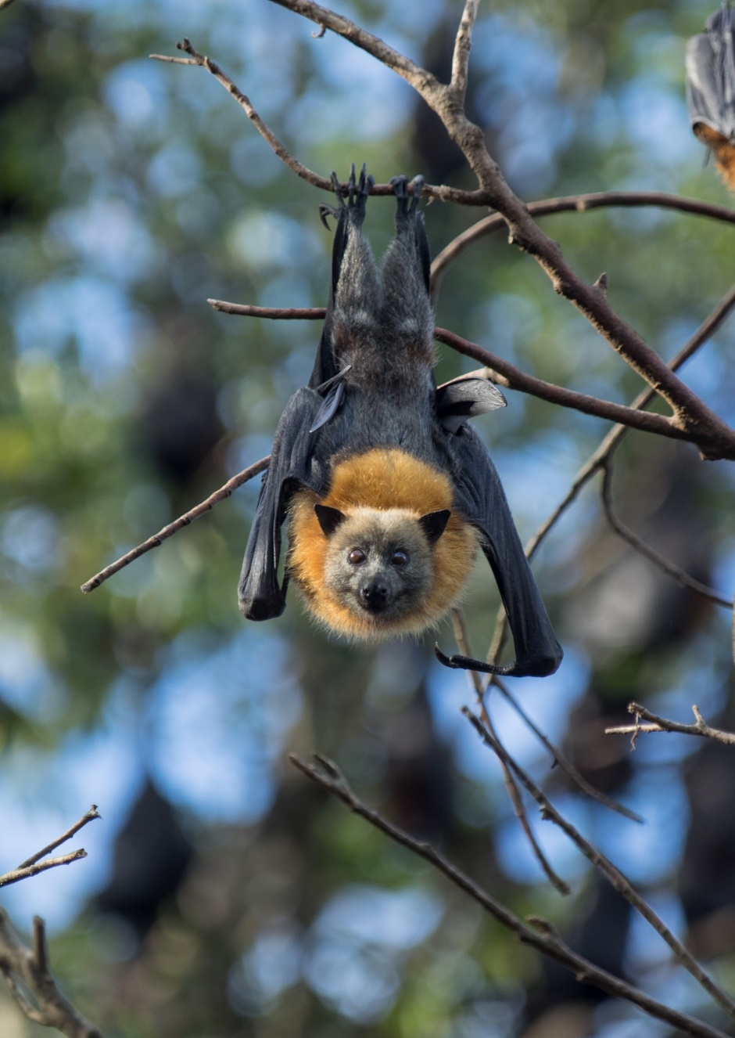

**March 2021**

© Commonwealth of Australia 2021

**Ownership of intellectual property rights**

Unless otherwise noted, copyright (and any other intellectual property rights) in this publication is owned by the Commonwealth of Australia (referred to as the Commonwealth).

**Creative Commons licence**

All material in this publication is licensed under a [Creative Commons Attribution 4.0 International Licence](https://creativecommons.org/licenses/by/4.0/legalcode) except content supplied by third parties, logos and the Commonwealth Coat of Arms.

Inquiries about the licence and any use of this document should be emailed to [copyright@awe.gov.au](mailto:copyright@awe.gov.au).

Logo for Creative Commons Attribution 4.0 licence

**Cataloguing data**

This publication (and any material sourced from it) should be attributed as: DAWE 2021, *National Recovery Plan for the Grey-headed Flying-fox ‘Pteropus poliocephalus’*, Department of Agriculure, Water and the Environment, Canberra, March. CC BY 4.0.

ISBN 978-1-76003-368-2

This publication is available at <https://www.environment.gov.au/biodiversity/threatened/recovery-plans>

Department of Agriculture, Water and the Environment

GPO Box 858 Canberra ACT 2601

Telephone 1800 900 090

Web [awe.gov.au](https://www.awe.gov.au/)

**Disclaimer**

The Australian Government acting through the Department of Agriculture, Water and the Environment has exercised due care and skill in preparing and compiling the information and data in this publication. Notwithstanding, the Department of Agriculture, Water and the Environment, its employees and advisers disclaim all liability, including liability for negligence and for any loss, damage, injury, expense or cost incurred by any person as a result of accessing, using or relying on any of the information or data in this publication to the maximum extent permitted by law.

**Acknowledgements**

This recovery plan has been developed with the involvement and cooperation of a broad range of stakeholders, but individual stakeholders have not necessarily committed to undertaking specific actions.

This recovery plan is based on the extensive work of many flying-fox experts. It has benefited from the diligence of Commonwealth and state government officers, the Commonwealth Threatened Species Scientific Committee, the NSW Flying-fox Consultative Committee, Department of Agriculture Water and Environment facilitated Grey-headed Flying-fox policy workshops and the CSIRO coordinated National Flying-fox Monitoring Program.

The preparation of this plan was funded by an initial grant from the Australian Government and continued support from the NSW State Government. The NSW government coordinated the initial drafting of this plan before it was finalised by the Australian Government in consultation with state and territory governments.

**Image credit**

The Grey-headed Flying-fox (Pteropus poliocephalus) © David Westcott.

Contents

Summary v

Purpose v

Current status of taxon v

Habitat and distribution v

Threats to species survival v

Recovery objectives, actions and performance criteria v

General information 1

Conservation status 1

Purpose of this plan 1

International obligations 1

Affected interests 1

Interests of indigenous people 2

Ecological function 3

Social and economic impacts 3

Biological information 4

Taxonomy 4

Description 4

Distribution 4

Life history 5

Competition and predation 7

Diet 7

Foraging behaviour and habitat 8

Roosting behaviour and habitat 9

Habitat critical to the survival of the species 10

Population size and trends 12

Seasonal patterns 13

Historical change 14

Overview of threats and issues 15

Vulnerability to threats 15

Key threat 15

Other threats 16

Recovery objectives, performance criteria and actions 23

Recovery objective 1 23

Recovery objective 2 24

Recovery objective 3 24

Recovery objective 4 25

Recovery objective 5 26

Recovery objective 6 27

Recovery objective 7 27

Recovery objective 8 28

Recovery objective 9 29

Priority actions 30

Plan evaluation and duration 32

References 33

**Photographs**

Photograph 1 Grey-headed Flying-foxes feed on flowering and fleshy-fruited trees 8

Photograph 2 Grey-headed Flying-foxes play a role in pollination and seed dispersal in World Heritage Areas and rainforests 9

Photograph 3 Grey-headed Flying-foxes roost in large aggregations known as camps 10

Photograph 4 Coastal banksia is an important food tree for the Grey-headed Flying-fox 11

Photograph 5 Winter and spring flowering vegetation critical to the survival of the Grey-headed Flying-fox 12

Photograph 6 Bushfires affect Grey-headed Flying-foxes 20

Photograph 7 Rainforest provides important habitat for the Grey-headed Flying-fox 31

**Maps**

Map 1 Grey-headed Flying-fox distribution and camp locations 6

**Boxes**

Box 1 Camp management guidance 17

## Summary

### Purpose

The purpose of this plan is to set out the management and research actions necessary to stop the decline of, and support the recovery of the Grey-headed Flying-fox over the next 10 years.

### Current status of taxon

The Grey-headed Flying-fox is listed as ‘Vulnerable’ under both the Commonwealth Environment Protection and Biodiversity Conservation Act 1999 and the New South Wales Biodiversity Conservation Act 2016. It is listed as 'Threatened’ under the Victorian Flora and Fauna Guarantee Act 1988 and ‘Rare’ under the South Australian National Parks and Wildlife Act 1972. It is also listed Vulnerable in the Australian Capital Territory under the Nature Conservation Act 2014.

### Habitat and distribution

The Grey-headed Flying-fox has historically occupied forests and woodlands in the coastal lowlands, tablelands and slopes of eastern Australia, from Bundaberg in Queensland to Geelong in Victoria, with some isolated camps and rare sightings outside this range. More recently, camps have established in South Australia, the Australian Capital Territory and inland areas of central and southern New South Wales and Victoria and sightings have increased in Tasmania.

### Threats to species survival

The primary known threat to the survival of the Grey-headed Flying-fox is loss and degradation of foraging and roosting habitat. Conflict with people, including disturbance in camps and mortality from actions to manage commercial fruit crops, is considered to be a moderate threat, but is increasing in urban areas. The level of threat caused by electrocution on power lines and entanglement in netting and barbed-wire fences is unknown. The impact of climate change on Grey-headed Flying-foxes is also unknown but increasing temperatures, storms, bushfires and floods and drought conditions are likely to degrade foraging and roosting habitat, influence the frequency of foraging in commercial orchards, cause heat stress and increase heat related mortality.

### Recovery objectives, actions and performance criteria

Actions under this plan aim to improve the national population trend; identify, protect and increase key foraging and roosting habitat; improve the community’s capacity to coexist with flying-foxes; and increase awareness about flying-foxes, the threats they face and the important ecosystem services they provide as seed dispersers and pollinators. Success of this recovery plan will be evaluated against:

* a robust estimate of an increasing population trend
* an improved understanding of habitat critical to the survival of the species
* an increase in protection of habitat critical to the survival of the species and nationally important camp sites
* implementation of effective habitat restoration projects
* a reduction of conflict between people and flying-foxes in residential areas through investment in household mitigation measures
* greater uptake of crop netting under subsidy schemes
* decrease in the number of licences issued to harm the species
* an improved understanding of threats with as yet unquantified impacts on flying-foxes, such as electrocution, entanglements and climate change.

## General information

### Conservation status

The Grey-headed Flying-fox is listed as ‘Vulnerable’ under the Environment Protection and Biodiversity Conservation Act 1999 (EPBC Act). For more information see the [species listing advice](http://www.environment.gov.au/biodiversity/threatened/conservation-advices/pteropus-poliocephalus).

The Grey-headed Flying-fox is also listed as ‘Vulnerable’ in New South Wales under the Biodiversity Conservation Act 2016, as ‘Threatened’ under the Victorian Flora and Fauna Guarantee Act 1988, as ‘Rare’ under the South Australian National Parks and Wildlife Act 1972 and Vulnerable under the Australian Capital Territory Nature Conservation Act 2014. It is not listed in Queensland or Tasmania.

### Purpose of this plan

The purpose of this plan is to set out the management and research actions necessary to stop the decline of, and support the recovery of the Grey-headed Flying-fox over the next ten years.

### International obligations

The Grey-headed Flying-fox is listed in Appendix II of the Convention on International Trade in Endangered Species of Wild Fauna and Flora (CITES). A CITES listing subjects international trade in that species to certain controls, and all import and export of the species covered by the Convention must be authorised through a licensing system.

### Affected interests

A wide range of public authorities, organisations and private individuals may be affected by actions to prevent further decline and promote the recovery of the Grey-headed Flying-fox. Managing foraging and roosting habitat falls under the jurisdiction of a range of authorities and is regulated by Commonwealth and State/Territory legislation in the range of the species (Queensland, NSW, ACT, Victoria, Tasmania and South Australia), as well as by the policies of local government areas throughout the range of the species. Affected interests include but are not limited to:

* Commonwealth
  + Department of Agriculture Water and Environment
  + Department of Health
  + Commonwealth Scientific and Industrial Research Organisation
* State/territory/local government
  + Queensland Department of Environment and Heritage Protection
  + Queensland Department of Agriculture and Fisheries
  + Queensland Department of State Development
  + New South Wales Department of Planning, Industry and Environment
  + New South Wales Department of Primary Industries
  + New South Wales Health
  + Victorian Department of Environment, Land, Water and Planning
  + Parks Victoria
  + Tasmanian Department of Primary Industries, Parks, Water and Environment
  + South Australian Department of Environment, Water and Natural Resources
  + South Australian Department of Primary Industries and Regions
  + Australian Capital Territory Government
  + Local government areas throughout the range of the species
  + Government affiliated natural resource management groups
* Non-government organisations and individuals
  + Private landholders and organisations responsible for foraging or roosting habitat
  + Residents and businesses affected and potentially affected by Grey-Headed Flying-Foxes
  + Aboriginal land managers
  + Conservation and advocacy organisations, e.g. Ku-ring-gai Bat Conservation Society
  + Licensed animal rehabilitators and their representative organisations e.g. Wildlife Information, Rescue and Education Service
  + Zoological facilities, e.g. Taronga Conservation Society Australia, Zoos South Australia
  + Individuals and groups involved in tree-planting and habitat restoration programs and threatened species conservation
  + Individual researchers and their representative organisations
  + Community-based natural resource management groups
  + Wildlife Health Australia
* Industry groups and agricultural interests
  + NSW Farmers’ Association
  + Growcom (formerly Queensland Fruit and Vegetable Growers) (Queensland)
  + Eastern Metropolitan Fruit Growers Association (Victoria)
  + Fruit Growers Victoria
  + Victorian Farmers Federation Horticulture Branch
  + Horticulture Coalition of SA
  + The Apple and Pear Growers Association of South Australia
  + Orchardists and growers in all range States impacted by flying-foxes (e.g. Bananas NSW, coffee growers)
  + State horse racing organisations
  + Airports and airport authorities
  + Horse owners and their representative organisations
  + Veterinarians

### Interests of indigenous people

The Grey-headed Flying-fox has significance to Aboriginal people as a food source, as a clan totem, as an art subject and as an indicator of particular habitat associations and seasonal and climatic changes, both annually and in the dreaming cycle (Ecobiological 2009). The literature indicates that Aboriginal people traditionally had an intimate understanding of many aspects of Grey-headed Flying-fox ecology, such as breeding and movement patterns, and that they carefully managed flying-fox habitat to protect the species (Ecobiological 2009).

Traditional owners will be encouraged throughout the life of this plan to be involved in further consultation and implementation of recovery actions. All activities should be undertaken in a manner that respects the cultural traditions of Indigenous groups throughout the species range.

### Ecological function

Grey-headed Flying-foxes feed on over 100 species of flowering trees and fleshy-fruited trees and lianas (Eby and Law 2008). In doing so they interact with numerous plant communities and assist seed and pollen dispersal of its food plants that occur within these communities (Eby 1996, Southerton et al. 2004, Birt 2005b).

Due to this role as a pollen and seed disperser, protection of the Grey-headed Flying-fox will contribute to sustaining ecological processes within vegetation communities along the east coast of Australia, including three of Australia’s World Heritage Areas: Fraser Island, the Gondwana Rainforests and the Greater Blue Mountains.

Actions to manage and improve foraging and roosting habitat will benefit several hundred vegetation communities in Queensland, New South Wales and Victoria (Eby and Law 2008, Eby 2016). Nectar and fruit feeding bats, birds and mammals will also benefit, as will a range of other fauna that occupy the forest and woodland communities used by the Grey-headed Flying-fox.

### Social and economic impacts

Despite its significant ecological role, the Grey-headed Flying-fox is capable of causing significant damage to commercial fruit crops, public gardens and native vegetation. Flying-fox foraging in cultivated fruit crops and associated crop damage has been known to occur since the time of European settlement (Tidemann et al. 1997).In recent years Grey-headed Flying-foxes have been reported in areas where they were previously only rarely seen. This can result in significant crop damage when the orchardists in these areas do not have measures in place to protect their crops from flying-foxes. Subsidies to install netting to protect crops in NSW have increased the area of crops protected by netting and substantially reduced the number of licences issued to shoot flying-foxes. Changes to food availability as a result of native habitat loss and climate change may increase flying-fox impacts on crops.

Camps in urban areas can have localised negative impacts on amenity when they are located near centres of human activity such as schools, or in areas of special cultural significance, such as botanic gardens. Some people living adjacent to camps complain about the noise and smell associated with flying-fox camps as well as the perceived disease risk despite it being rare and preventable. Management of conflict associated with flying-fox camps are discussed in more detail in section 3 of the plan.

In November 2016 the House of Representatives Standing Committee on the Environment and Energy conducted an inquiry into the impact of flying-foxes, including the Grey-headed Flying-fox, on communities in the eastern states of Australia. The Committee tabled its report in Parliament on 27 February 2017 which included four recommendations aimed to complement existing efforts to protect, conserve and recover flying-fox populations and provide support for the local councils and affected residents. The findings of the Committee’s report have been considered in the development of this recovery plan and the Committee’s recommendations align with the objectives and actions outlined in this plan.

## Biological information

### Taxonomy

The taxonomy of Australian flying-foxes is stable (Hall 1987), and the taxonomy of the Grey-headed Flying-fox Pteropus poliocephalus (Temminck 1825) is considered unambiguous (Hall 1987, Tidemann 1995, Webb and Tidemann 1996). No intraspecific taxa are recognised.

### Description

The Grey-headed Flying-fox is one of the largest bats in the world. Adult males generally weigh between 750g and 1,000g, although weights up to 1133g have been recorded (Ratcliffe 1932, Tidemann 1995). Adult females generally weigh between 650g and 800g. Although males and females exhibit bimaturation (a difference in developmental timing between males and females) (Welbergen 2010) and seasonal differences in body mass (Welbergen 2011), the forearms of adult individuals of both sexes are of similar length (155mm to 175mm).

Body fur is typically medium to dark grey, with many light-tipped hairs (Hall and Richards 2000). Fur on the head is also grey but varies in shade from near black to silver. An orange or russet-coloured mantle or collar encircles the neck, which is unique to this species (Hall 1987). Leg fur extends to the ankle, and this characteristic distinguishes the Grey-headed Flying-fox from the similarly sized Black Flying-fox, which has bare legs below the knee (Hall 1987). The wing membranes of the Grey-headed Flying-fox are black.

### Distribution

The Grey-headed Flying-fox is endemic to Australia, with a distribution ranging from Ingham in Queensland, to Adelaide in South Australia. They are usually found on the coastal lowlands and slopes of eastern Australia below altitudes of 200 m (Map 1).

Grey-headed Flying-foxes are regularly found from the coast, inland to the tablelands and western slopes of northern New South Wales and the tablelands of southern Queensland. Breeding camps have been recorded as far north as Ingham in far north Queensland and more recently, the species has become established in South Australia, the Australian Capital Territory and Victoria and inland areas of New South Wales (DoEE 2017). There are also records of individuals on Bass Strait islands (Tidemann 1998) and mainland Tasmania (Driessen 2010).

Patterns of occupancy and relative abundance within its distribution vary widely seasonally and temporally. When assessed at a local scale, the species is generally present intermittently and irregularly (Eby and Lunney 2002). However, a small number of local areas do support a continuous presence while others are associated with regular, annual patterns of use (Map 1).

Broad trends in the distribution of plants with similar flowering and fruiting phenology support regular annual cycles of migration that are apparent at regional scales (Eby and Lunney 2002).

An [interactive web viewer](http://www.environment.gov.au/webgis-framework/apps/ffc-wide/ffc-wide.jsf) created to support the National Flying-Fox Monitoring Program shows the location of all known and historic camps of Grey-Headed Flying-Fox across their entire distribution. This viewer is updated regularly as information is collected from the National Flying-Fox Monitoring Program.

### Life history

Grey-headed flying-foxes are seasonal breeders, with a single breeding event each year. Females give birth to a single pup and the majority of births occur from October to December (Martin and Mcllwee 2002; Divljan 2008). Females generally reach sexual maturity in their second year; however it is thought that few females younger than three years successfully raise young to independence (Mcllwee and Martin 2002).

Flying-foxes are prone to abort foetuses and mass abortions and premature births are known to occur in response to environmental stress (Martin and Mcllwee 2002). Anthropogenic stresses such as disturbance to camps and habitat clearing is likely to invoke a similar response.

Flying-foxes are thought to have a maximum natural longevity of 15-20 years, an inference that is supported for Grey-headed Flying-foxes by age data from the wild (Divljan et al. 2006). This, combined with slow sexual maturation and a low reproductive rate, is indicative of a species with a low natural mortality rate (Martin and Mcllwee 2002). Since European settlement, flying-foxes have faced a greatly increased mortality due to habitat loss, persecution and culling (Martin and Mcllwee 2002).

Due to their low reproductive rate, Grey-headed Flying-foxes also have a low population growth rate, even under optimal conditions. This, combined with increased mortality, means the species has limited capacity for recovery from frequent or persistent threats.

Map 1 Grey-headed Flying-fox distribution and camp locations

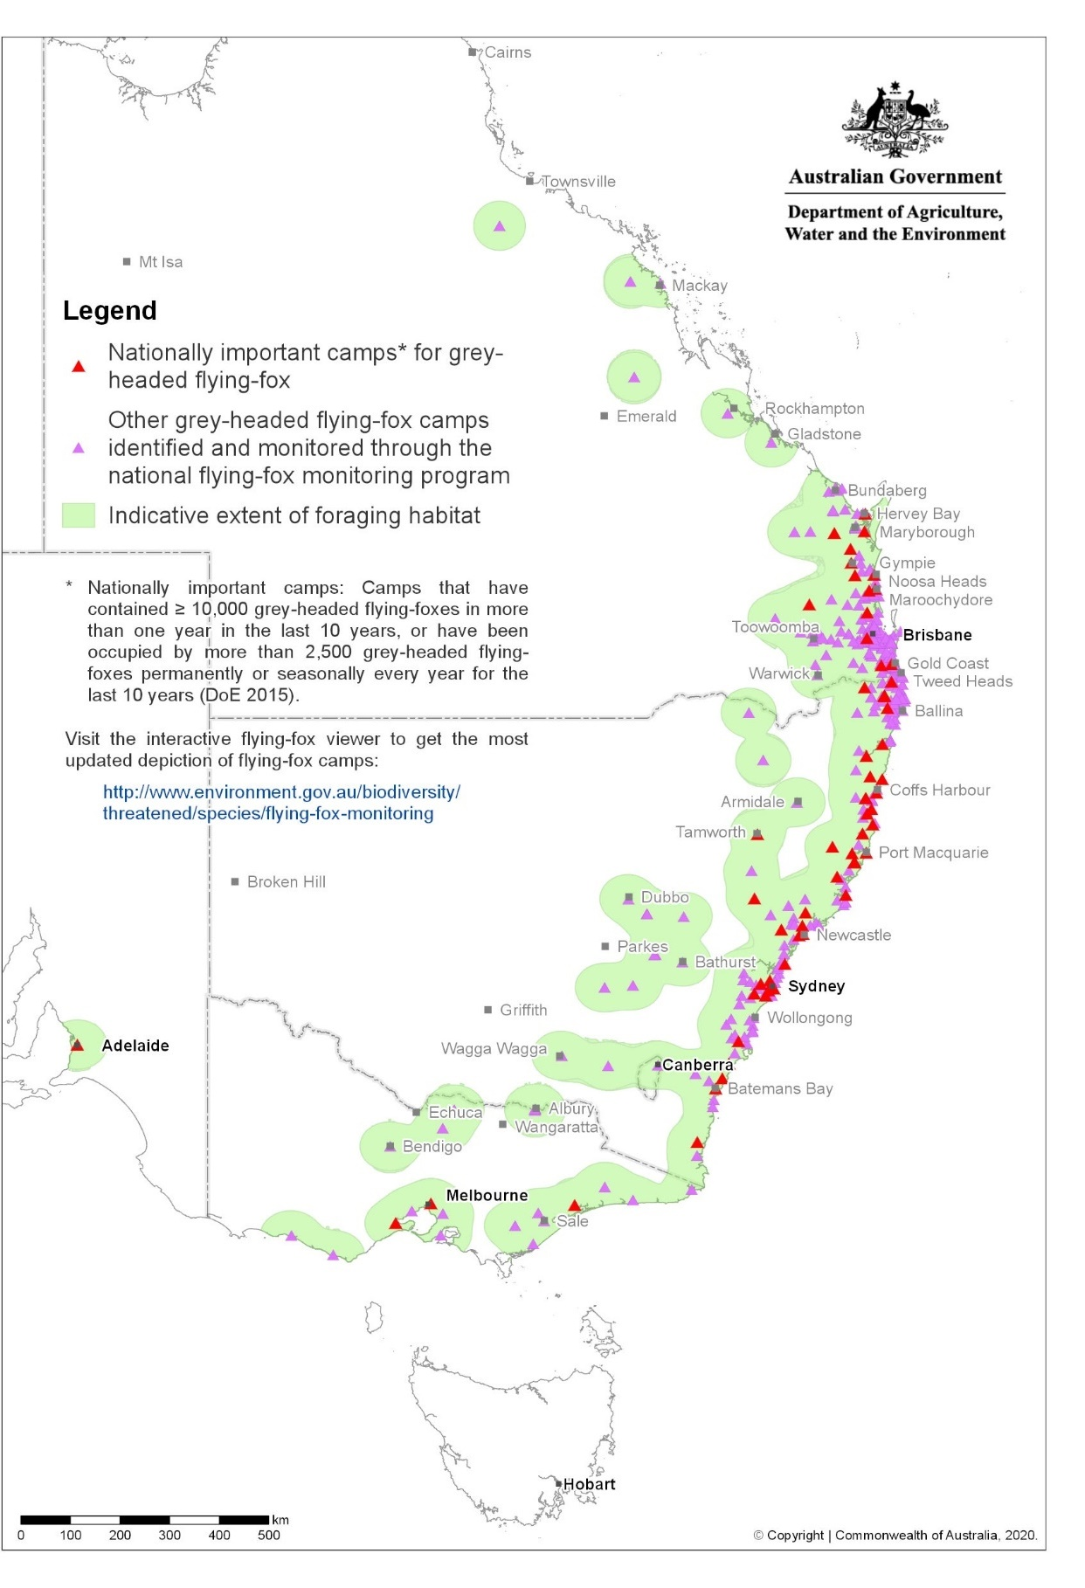

### Competition and predation

The range of the Grey-headed Flying-fox overlaps extensively with that of two other non-nationally-listed flying-fox species, the Black Flying-fox (Pteropus alecto) and the Little Red Flying-fox (Pteropus scapulatus). A single Grey-headed Flying-fox camp occurs within the range of the Spectacled Flying-fox at Ingham well outside the main range of the former species (Westcott et al. 2015)

Grey-headed Flying-foxes and Black Flying-foxes are ecologically similar species that share many behavioural and ecological characteristics. In regions where their ranges overlap, their diets are equivalent (Hall and Richards 2000, Birt 2005b), although it is unclear whether there are differences in their foraging behaviour.

Both species are highly colonial and share camp sites, within which they generally segregate spatially (Ratcliffe 1932, Nelson 1965a, McWilliam 1986, Birt and Markus 1999, Eby 2004). In addition, both species are synchronous, seasonal breeders and their annual reproductive cycles are closely aligned at subtropical latitudes (Nelson 1965b, O’Brien 1993, Webb and Tidemann 1995, Martin et al. 1996). The Little Red Flying-fox reproductive cycle is approximately six months out of phase with those of the other two species.

During the past 20 years numbers of Grey-headed Flying-foxes have declined markedly, relative to those of Black Flying-foxes, in coastal areas north from the Clarence Valley and in the tablelands of south-east Queensland (Birt 2000, Hall 2002, Eby 2004).

Expansion of the southern range limit of the Black Flying-fox has increased the area of overlap with the Grey-headed Flying-fox (Roberts et al. 2012). This has occurred in floristically diverse regions east of the escarpment that provide continuous food and suitable camps for both species. The reasons for this range shift of Black Flying-foxes are unclear, and cannot be readily explained by climate or habitat change (Roberts et al. 2012). There is currently relatively little information available about both long-term shifts in the distributions of Spectacled and Little Red Flying-foxes, and changes in overlap between the ranges of Grey-headed and Little Red Flying-foxes.

There is no evidence that Black Flying-foxes and Grey-headed Flying-foxes use antagonistic behaviours to compete directly for resources (N. Markus pers. obs., P. Eby pers. obs.). However, the increasing displacement of Grey-headed Flying-foxes suggests that indirect competition favours Black Flying-foxes. The level of threat posed by Black Flying-foxes requires further research.

There is anecdotal evidence that flying-foxes may be preyed upon by a range of animals including carpet pythons, goannas, raptors and Powerful Owls. Currawongs and ravens are known to attack flying-foxes found on their own in the daytime. The impact on the flying-fox population from these threats is thought to be insignificant (WPSA 2010).

### Diet

The Grey-headed Flying-fox feeds primarily on blossoms and fruit in canopy vegetation, and supplements this diet with leaves (Parry-Jones and Augee 1991, Eby 1995, Eby 1998, Tidemann 1999, Hall and Richards 2000). Major food plants include the fruit and blossom of rainforest species, especially Ficus spp., and blossoms of myrtaceous species such as Eucalyptus, Corymbia and Angophora, melaleucas, banksias (Eby and Law 2008) and the fruit and flowers of Syzygium spp. (Roberts 2006, Eby 1991).

Photograph 1 Grey-headed Flying-foxes feed on flowering and fleshy-fruited trees

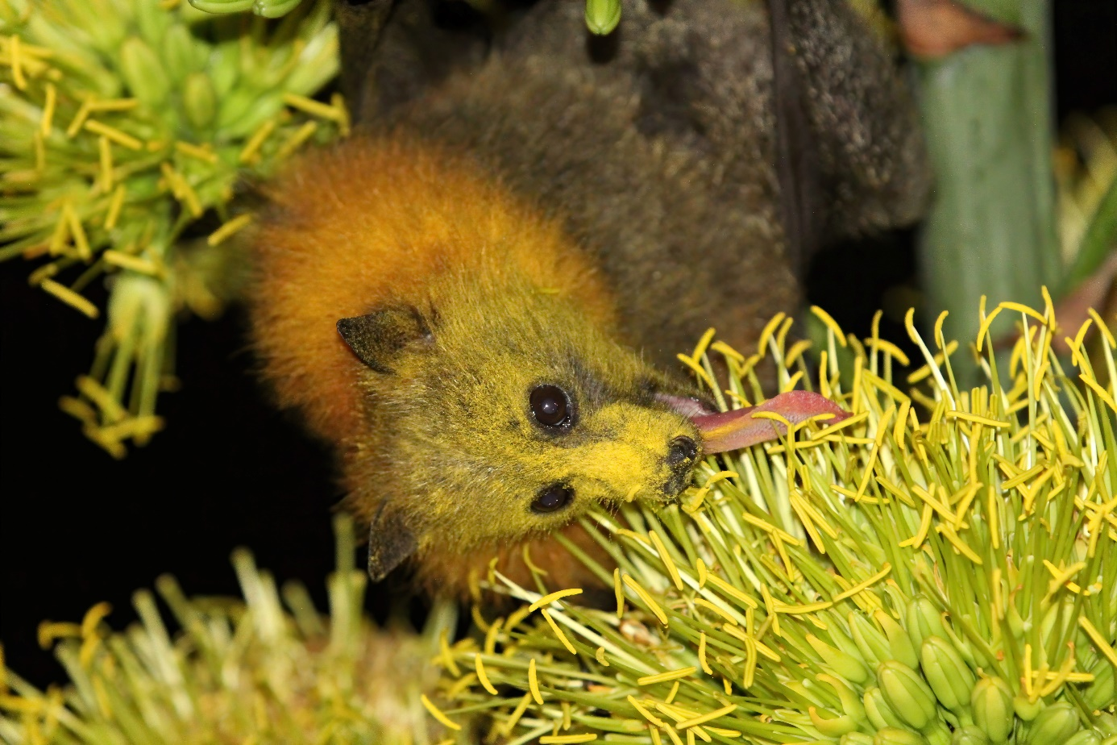

Credit: © Department of Agriculture, Water and the Environment.

The majority of myrtaceous plants in the diet of the Grey-headed Flying-fox flower within a defined season but are not annually reliable and the locations of productive foraging habitat provided by these plants vary (Law et al. 2000, Eby and Lunney 2002, Birt 2005b, Eby and Law 2008). In most months it is not possible to predict which localities will be productive, and therefore which localities will provide food for the species. Some roosting and foraging habitat may consist of introduced plants, including environmental weeds that are food sources for example, camphor laurel, Celtis spp., Ligustrum spp., Cocos palm and Psidium spp. (Roberts 2006).

### Foraging behaviour and habitat

The foraging behaviour of the Grey-headed Flying-fox alters when native food sources are scarce. They have no biological adaptations to withstand food shortages (e.g. torpor) and migrate in response to changes in the quantity and location of food (Hall and Richards 2000). The majority of eucalypts have regular seasonal flowering events, but do not flower every year and there are few areas within the Grey-headed Flying-fox’s range where nectar is available continuously (House 1997, Wilson and Bennett 1999, Law et al. 2000).

Grey-headed Flying-foxes forage over extensive areas and have been known to fly as far as 40 km to feed, before returning to their roost the same night (Eby 1991). Based on telemetry data, Westcott et al (2015) reported the mean distance of a Grey-headed Flying-fox foraging site from the camp in which the animal had roosted and to which it returned was 10.9 km (quartile range from 6.2 - 27.9 km), with the maximum distance recorded during these observations being 148.3 km.

Flying-foxes disperse pollen and seeds during their foraging and in doing so contribute to the ecological and evolutionary processes of forest communities. The ability of flying-foxes to move freely among habitat types makes them effective dispersers of pollen and seeds between habitat types and across fragmented, degraded and urban landscapes. Telemetry indicates that Grey-headed Flying-foxes forage in all habitat types and do so roughly in proportion to their representation in the landscape (Westcott et al. 2015).

Photograph 2 Grey-headed Flying-foxes play a role in pollination and seed dispersal in World Heritage Areas and rainforests

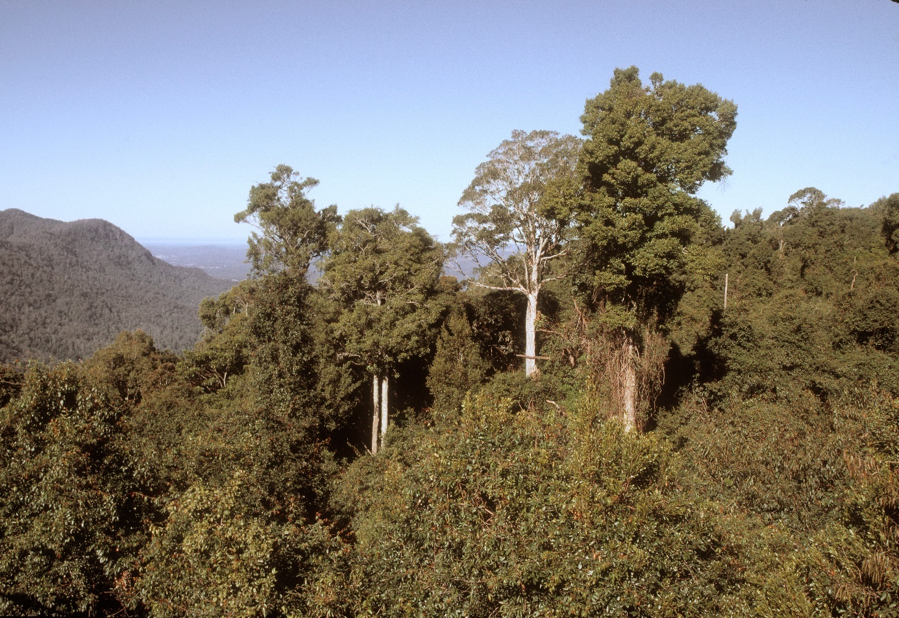

Credit: © Colin Totterdell.

### Roosting behaviour and habitat

Grey-headed Flying-foxes roost in large aggregations, known as camps, in the exposed branches of trees (Nelson 1965a, Parry-Jones and Augee 1992). The locations of camps have in the past generally been stable through time, and several sites have documented histories that exceed 100 years (Lunney and Moon 1997).

Camps provide resting habitat, sites of social interactions and refuge for animals during significant phases of their annual cycle, such as birth, lactation and conception (Parry-Jones and Augee 1992, Parry-Jones and Augee 2001). Camps are used as day refuges by animals that forage in surrounding areas over several weeks, as maternity camps, and as short-term stopover sites by migrating animals (Eby 1991, Eby 1995, Tidemann and Nelson 2004).

Patterns of camp occupation vary, ranging from sites that are inhabited continuously to those that are inhabited only rarely (Parry-Jones 1993, Eby 1995). Although many camps have distinguishable seasonal patterns of occupation, annual variations can be extreme and peak population size can exceed 50 000 (Parry-Jones and Augee 1992, Parry-Jones 1993, Eby et al. 1999, Birt 2000).

Grey-headed Flying-foxes display a degree of flexibility in their choice of camp vegetation (Tidemann 1999, Peacock 2004, Roberts 2005). Camps occur in vegetation ranging from continuous forest to patches as small as 1 hectare (Eby 2002b, West 2002). During periods of food shortages such as those in 2010, 2016–2017 and 2019-2020, flying-foxes have been recorded roosting in unusual locations and some camps have been smaller in size (DoEE 2017; M. Mo pers. comm).

In Australia, flying-foxes appear to be becoming more urbanised and are coming into increased contact with humans. Identifying whether urbanisation of flying-fox populations is in fact occurring and the nature of its drivers is a fundamental step in developing effective management solutions (Tait et al. 2014). Research currently underway and proposed in this plan aims to improve our understanding of this roosting behaviour.

Photograph 3 Grey-headed Flying-foxes roost in large aggregations known as camps

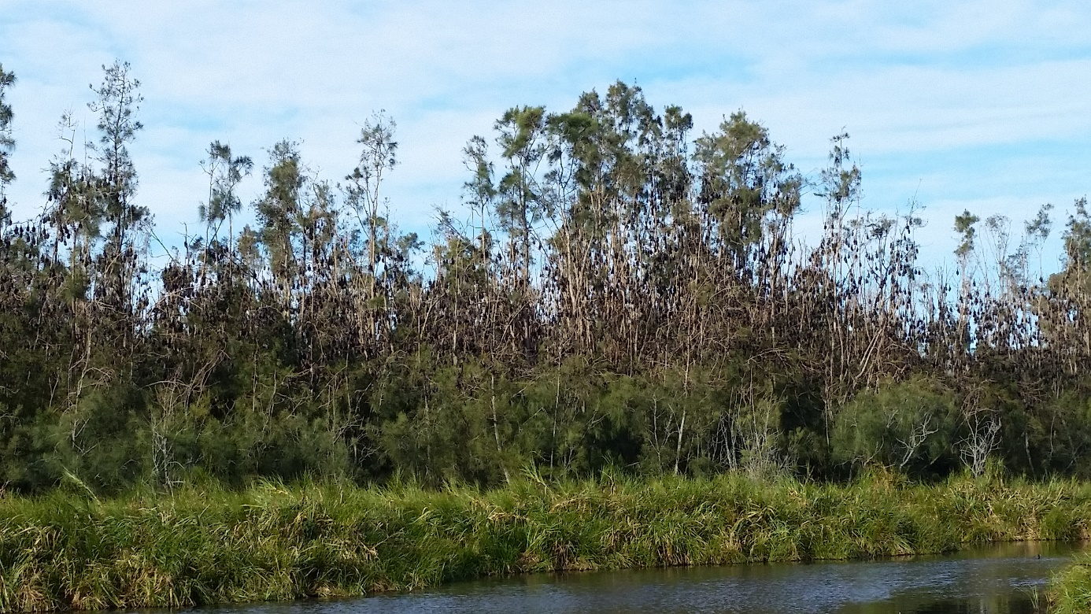

Credit: © Department of Agriculture Water and Environment.

### Habitat critical to the survival of the species

The majority of myrtaceous plants in the diet of Grey-headed Flying-foxes flower within a defined season, but are not annually reliable and the location of productive foraging habitat from these plants varies (Law et al. 2000, Eby and Lunney 2002, Birt 2005b). In most months it is difficult to predict which locations will be productive as foraging habitat for the species.

Few diet plants flower in winter, and those that flower reliably in winter occur on coastal lowlands in northern New South Wales and southern Queensland (Eby et al. 1999, Eby and Lunney 2002). There is also evidence that spring forage is currently inadequate to provide reliable resources during critical periods in the reproductive cycle of Grey-headed Flying-foxes (Eby and Law 2008).

Important winter and spring vegetation communities are those that contain Eucalyptus tereticornis, E. albens, E. crebra, E. fibrosa, E. melliodora, E. paniculata, E. pilularis, E. robusta, E. seeana, E. sideroxylon, E. siderophloia, Banksia integrifolia, Castanospermum australe, Corymbia citriodora citriodora, C. eximia, C. maculata, Grevillea robusta, Melaleuca quinquenervia or Syncarpia glomulifera (Eby and Law 2008; Eby 2016; Eby et al., 2019).

Photograph 4 Coastal banksia is an important food tree for the Grey-headed Flying-fox

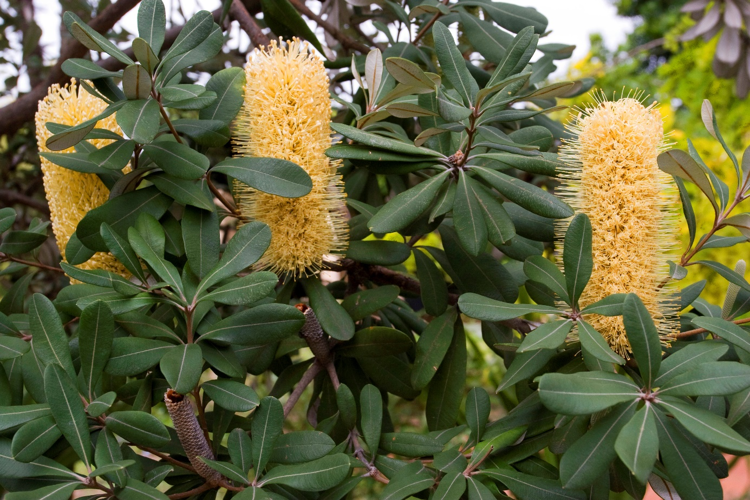

Credit: © John Baker.

Where the existence of these important winter and spring flowering vegetation communities is verified in the field, they are considered habitat critical to the survival of the Grey-headed Flying-fox. Back yard fruit trees, orchards or non-native trees that may be used for foraging are not considered to be habitat critical to the survival of the Grey-Headed Flying-Fox.

Habitat critical to the survival of the Grey-headed Flying-fox may also be vegetation communities not containing the above tree species but which:

* contain native species that are known to be productive as foraging habitat during the final weeks of gestation, and during the weeks of birth, lactation and conception (August to May)
* contain native species used for foraging and occur within 20 km of a nationally important camp as identified on the Department’s [interactive flying-fox web viewer](http://www.environment.gov.au/webgis-framework/apps/ffc-wide/ffc-wide.jsf), or
* contain native and or exotic species used for roosting at the site of a nationally important Grey-Headed Flying-Fox camp1 as identified on the Department’s [interactive flying-fox web viewer](http://www.environment.gov.au/webgis-framework/apps/ffc-wide/ffc-wide.jsf).

Habitat critical to the survival of the Grey-headed Flying-fox should be the focus for protection and any revegetation initiatives aimed to support the species. Habitat and associated seasonal resources critical to the survival of the Grey-headed Flying-fox have been mapped across large parts of the species range, but have yet to be ground-truthed (Eby and Law 2008). Actions under this recovery plan seek to build on this.

Nationally important camps are those that have contained ≥ 10,000 Grey-headed Flying-foxes in more than one year in the last 10 years, or have been occupied by more than 2,500 Grey-headed Flying-foxes permanently or seasonally every year for the last 10 years (DoE 2015). As at August 2020, 75 of the 418 Grey-headed Flying-Fox camps known to have been occupied since the commencement of the National Flying-fox Monitoring Program are recognised as nationally important camps.

Photograph 5 Winter and spring flowering vegetation critical to the survival of the Grey-headed Flying-fox

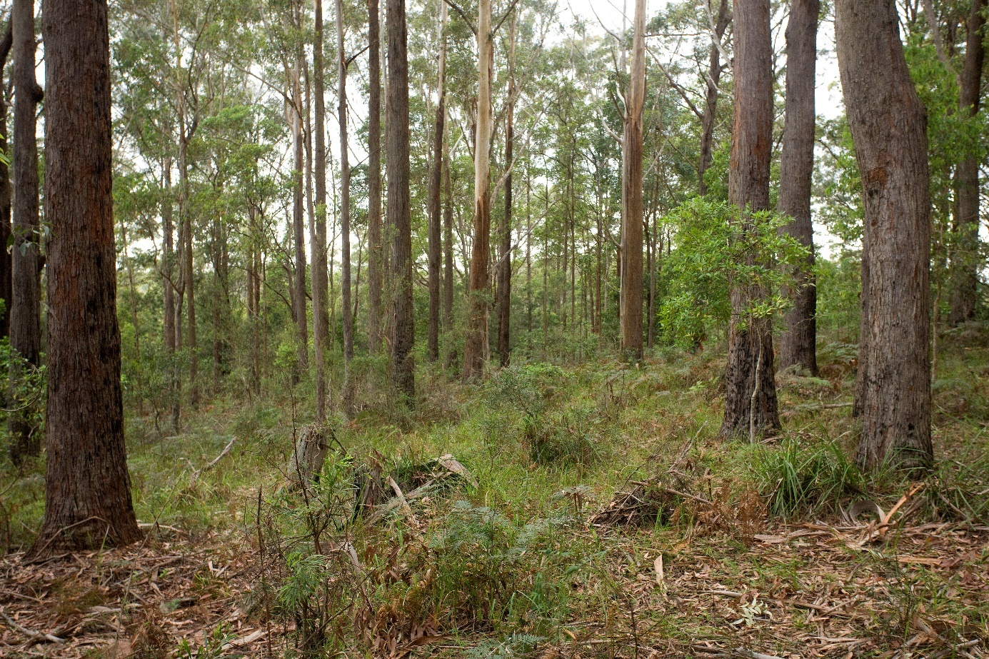

Credit: © John Baker.

### Population size and trends

The Grey-headed Flying-fox is considered to be a single, mobile population with individuals distributed across Queensland, New South Wales, Victoria, South Australia, Tasmania and the ACT.

Between 1998 and 2005, there were a number of attempts to establish a reliable estimate of national population size. Based on eleven national counts during this time (Eby 2002a, Eby 2003, Eby 2004, Birt 2005a) the accepted estimate was somewhere between 320,000 to 435,000 individuals with variations likely to be the result of a combination of counting error and actual fluctuations in the abundance of the species (Eby 2004).

These national counts illustrated some of the practical difficulties encountered when surveying this highly mobile and widely distributed species. Given this, the then Department of the Environment and Energy commissioned the Commonwealth Scientific and Industrial Research Organisation (CSIRO) to develop a peer-reviewed field and analytical approach for monitoring the national Grey-headed Flying-fox population and interpreting the results (Westcott et al. 2011). The National Flying-fox Monitoring Program is a collaboration between the Australian Government, the South Australian, Victorian, New South Wales, Australian Capital Territory and Queensland governments, CSIRO, local governments and volunteers in New South Wales and Queensland. The project is funded by the Commonwealth of Australia, the State of New South Wales and the State of Queensland. The monitoring methodology involves on-ground static counting of all Grey-headed Flying-foxes in known camps across the entire species’ distribution. All camps are surveyed simultaneously over a three-day period, four times per year (November, February, May and August). The monitoring program also includes a tracking study to reduce and understand the error associated with counting flying-foxes consequently reducing the time required to detect trends in the population.

The monitoring program commenced in 2012 and is ongoing. Quarterly reports from the CSIRO are published on the Department of Agriculture Water and Environment website. The program is working to provide essential data on trends in population size, structure and dynamics and will eventually enable identification of key drivers of population processes. The data may also be used subsequently to predict risk factors associated with flying-foxes, such as disease transmission, or damage to orchards.

Westcott et al. (2015) analysed the results of the monitoring program and estimated that in November 2014 the Grey-headed Flying-fox population size, taking counting error into account, was 495,852 (+/- 168, 590) individuals. If additional corrections for uncounted camps are made the estimated population would have been 680,000 (+/- 158,500; 95% CI). Westcott et al. (2015) recommended against comparisons with previous estimates (1998-2005) because of the differences in the methods used, geographic scope and uncertainty regarding the survey coverage of the population in those previous estimates. Given the confidence intervals associated with population estimates in the program, a much longer period of monitoring is required before any trends can be confirmed (Westcott et al. 2015). For more information see the report on the [status and trends of Australia's EPBC-listed flying foxes](http://www.environment.gov.au/biodiversity/threatened/publications/status-and-trends-australias-epbc-listed-flying-foxes).

### Seasonal patterns

During spring, Grey-headed Flying-foxes are uncommon south of Nowra in New South Wales, but widespread in other areas of their range. In summer they are widespread throughout their range and in autumn they occupy coastal lowlands and are uncommon inland. In winter they congregate in coastal lowlands north of the Hunter Valley and are occasionally found on the south coast of New South Wales (associated with flowering Spotted Gum Corymbia maculata) and the northwest slopes (generally associated with flowering White Box Eucalyptus albens or Mugga Ironbark E. sideroxylon) (Eby and Law 2008, DoEE 2017).

The metropolitan areas of Brisbane, Newcastle, Sydney and Melbourne are occupied continuously, as are various coastal areas in the north of the species’ range (Pallin 2000, Hall 2002, van der Ree et al. 2006). Patterns of occupancy and abundance have altered over time. During the past 20 years, the numbers of animals occupying camps in metropolitan Newcastle, inner Sydney and Melbourne/Geelong have increased and several camps in these large urban areas have changed their patterns of occupation from seasonal use to continuous use (Richards 2002, van der Ree et al. 2006). The number of camps in metropolitan areas of Sydney and Brisbane has also increased in that time (P. Eby pers. obs).

### Historical change

It has been suggested that the latitudinal distribution of the Grey-headed Flying-fox has changed during the past 100 years, possibly in response to climate change in eastern Australia. However, recent work suggests there has been no significant change in either the northern or southern range limits of this species (Roberts et al. 2012, McDonald-Madden et al. 2005). Insufficient information exists to enable the assessment of change to inland boundaries.

Grey-headed Flying-foxes have recently become more abundant near their southern range limit in urban Melbourne, accompanied by a change in their temporal pattern of occurrence from inconsistent to continuous (Roberts et al. 2012). This increased abundance is possibly due to a combination of increased food in urban Melbourne and habitat reduction elsewhere (Roberts et al. 2012). The increasing occurrence in Melbourne has resulted in a general increase in sightings in Gippsland and on the south coast of New South Wales, as animals migrate to and from Melbourne (Tidemann and Nelson 2004).

In recent years Grey-headed Flying-foxes have consistently occupied camps in areas where they have rarely been seen previously such as Adelaide, Canberra and Orange in central western New South Wales. There is also a maternity camp of Grey-headed Flying-foxes in Ingham, far north Queensland. The factors driving these occurrences are poorly understood.

## Overview of threats and issues

### Vulnerability to threats

The processes that threaten Grey-headed Flying-foxes are most prevalent in coastal areas north from the Sydney Basin. These areas support the greatest natural diversity of food plants and the most consistent presence of the species outside metropolitan areas. These areas also support numerous large and varied commercial fruit growing operations, have rapidly expanding human populations and increasing numbers of Black Flying-foxes. These operations and population increases reduce available habitat, increase competition for resources and expose animals to human-induced mortality.

The Grey-headed Flying-fox also has a very low capacity for increase, even under the most ideal conditions (McIllwee and Martin 2002) which limits their ability to recover from threatening processes such as culling at orchards (Martin 2011) and die-offs during extreme heat events (Welbergen et al. 2008).

### Key threat

#### Habitat loss

The Grey-headed Flying-fox requires a continuous temporal sequence of productive foraging habitats and suitable roosting habitat. Loss of foraging habitat is considered the primary threat to the Grey-headed Flying-fox (Tidemann et al. 1999, Dickman and Fleming 2002, Eby and Lunney 2002). The species has complex habitat requirements and requires multiple populations of food trees dispersed over a large area. This makes it difficult to protect foraging habitats solely within conservation reserves, such as national parks, and leaves the species vulnerable to land-uses that may clear native vegetation or degrade habitat (Parry-Jones 1993, Pressey 1994, Eby 1996, Tidemann and Vardon 1997).

For example, in New South Wales, less than 15 % of potentially suitable habitat for the Grey-headed Flying-fox occurs in conservation reserves (Murphy et al. 2008) and only 5 % of roost sites are protected by some form of conservation status (Murphy et al. 2008).

Clearing of winter forage is a particular threat for the species. Few diet plants flower in winter and those that do flower reliably occur on coastal lowlands in northern New South Wales and southern Queensland (Eby et al. 1999, Eby and Lunney 2002, Eby and Law 2008). There is evidence that spring forage in remaining habitat is inadequate to provide reliable resources during critical periods in the reproductive cycle of Grey-headed Flying-foxes. The species is subject to recurring food shortages during late gestation, birth and early lactation. These shortages are associated with rapid weight loss in adults, poor reproductive success and death (Collins 2000, Eby 2000, Parry-Jones and Augee 2001).

Evidence of repeated food shortages during winter and spring indicates that inadequate productive foraging habitat exists in these seasons to sustain the current Grey-headed Flying-fox population. Actions under this recovery plan seek to build on the work undertaken by Eby and Law (2008) by further identifying, verifying, mapping and protecting habitat that is critical to the survival of the Grey-headed Flying-fox.

Degrading or removing foraging habitats may also result in increased impacts on commercial orchards when critical native food resources are further reduced, increasing conflict and exposing individual flying-foxes to increased threat from persecution by orchardists.

Loss of roosting habitat has also been identified as a threat to Grey-headed Flying-foxes (Tidemann et al. 1999, NSW Scientific Committee 2001). Camp vegetation has been exposed to the same historical patterns of clearing and degradation as foraging habitat (Lunney and Moon 1997, Hall 2002). The roosting requirements of Grey-headed Flying-foxes are however not well understood, nor are the impacts to the species from the loss of long-term sites or loss and fragmentation of urban camps. Actions and other information in this plan seek to improve our understanding and protect roosting habitats.

### Other threats

#### Camp disturbance

Conflict between people and Grey-headed Flying-foxes is an ongoing problem that particularly affects camps in coastal areas (Smith 2002, Tidemann 2002, West 2002). A rapid increase in the human population of coastal Queensland and New South Wales has meant that camps that were once isolated from human activities are now increasingly surrounded by urban and rural residential development (Smith 2002, West 2002, Coffs Harbour City Council 2004).The number of camps in urban areas has increased in recent years, particularly in urban areas of Qld and NSW where some are now continuously occupied (Birt et al. 1998, Hall 2002, Richards 2002, van der Ree et al. 2006, Mo et al. 2020).

This trend has been associated with an increase in the density and diversity of food trees in the gardens and streetscapes of cities like Brisbane, Sydney and Melbourne, together with increasing pressures on Grey-headed Flying-foxes in non-urban landscapes from reductions in the availability of native forage and increasing competition from Black Flying-foxes (Birt et al. 1998, Hall and Richards 2000, Parry-Jones and Augee 2001, Hall 2002, McDonald-Madden et al. 2005).

Negative perceptions of Grey-headed Flying-foxes can lead to conflict, impacting the population directly through harassment, deliberate destruction and attempts at dispersal, or indirectly by inhibiting community support for conservation initiatives.

People living near camps can find them annoying and unpleasant. Flying-fox camps are often noisy during the day and just before dawn when individuals return from foraging, and can generate a strong smell caused by the dense concentration of animals. People in close proximity can also be concerned about mess from faecal droppings and the potential for transmission of diseases from flying-foxes to people (Eby 1995, Tidemann 1999, Smith 2002). The risk of disease transmission is extremely low and occurrences are rare however community concern is often high (Halpin et al. 2011). The likelihood of bats being responsible for any large-scale zoonotic disease threat to humans is very low (FAO 2011). Further investment in community education is required in this area to change public perception.

Active disturbances have been used in attempts to remove animals from camps (Lunney and Moon 1997, Tidemann 1999, Hall 2002, Tidemann 2002, Roberts et al. 2011, Roberts and Eby 2013). Efforts to break the fidelity of individual Grey-headed Flying-foxes to specific camps have generally been unsuccessful (Roberts et al. 2011; Roberts and Eby 2013, Mo et al . 2020). In the few situations where the animals have moved, ongoing programs of disturbance and monitoring have been required to keep them away.

Requests for the relocation of camps in urban areas have increased in recent years. It is not possible to determine prior to a disturbance where flying-foxes will relocate to (Mo et al. 2020). As a result individuals may set up new camps in unsuitable locations, effectively shifting the problem from one area to another (Hall 2002, Roberts et al. 2011). Similarly, attempts to relocate camps may cause stress to flying-foxes, increasing the noise and activity within existing camps, and potentially leading to injury, abortions by pregnant females or death and camp abandonment.

Box 1 Camp management guidance

|  |
| --- |
| Attempts to remove Grey-headed flying-foxes from camps should only be considered as a last resort management action. Comprehensive attempts improving co-existence between people and flying-foxes and mitigating flying-fox impacts should be conducted prior to any consideration to move on individuals is made or any reduction of their roosting habitat is considered. While there may be some situations where comprehensive mitigation measures don’t work and proposals to relocate the flying-foxes are made, these actions need to be carefully managed. The risks associated with such actions need to be fully understood and disclosed and community expectations need to be realistic and managed.  Every attempt should be made to resolve conflict through mediation and public education. Camp management plans should be developed in conjunction with the community and plans should include both long-term and short-term strategies for ameliorating conflict. Land management authorities should identify camps that are potential sites of conflict and initiate programs of community engagement and public education to reduce the potential for future disputes. Where concerns have been raised, authorities should respond rapidly by providing advice and information to those involved.  The NSW government provides a [template for camp management plans](https://www.environment.nsw.gov.au/topics/animals-and-plants/wildlife-management/management-flying-foxes) among other resources to support community engagement and camp management. The Commonwealth’s guidance on flying-fox camp management and the legislative obligations under the EPBC Act of those proposing impacts to Grey-headed Flying-fox camps are outlined in the Department of Agriculture Water and Environment’s [referral guideline for management actions in Grey-headed and Spectacled Flying-fox camps](http://www.environment.gov.au/biodiversity/threatened/species/flying-fox-policy-statement). |

#### Mortality in commercial fruit crops

Grey-headed Flying-foxes have caused damage to cultivated fruit crops since European settlement (Ratcliffe 1931, Tidemann et al. 1997). Crops grown in coastal areas north from the Illawarra in New South Wales are most commonly affected, with damage reported from as far south as Batlow. Many commercial orchards in these areas have invested in full exclusion or throwover netting with the assistance of funding under the NSW government netting subsidy scheme (NSW Flying-fox Licensing Review Panel 2009).

The increase in occurrence of Grey-headed Flying-foxes in eastern Victoria over the past 20 years has been associated with locally significant and sporadic crop damage in that region (I. Temby pers. comm). Levels of damage vary considerably between localities and years, and there is consistent evidence that the animals increase their use of commercial crops when native food is scarce (Ratcliffe 1931, McWilliam 1986, Teagle 2002). In these circumstances, greater numbers of animals are killed from crop management practices including shooting by orchardists. Conserving habitat that is productive during periods of fruit maturation will reduce the damage to commercial fruit crops and reduce the mortality of flying-foxes (Eby and Law 2008).

Prior to the listing of the species as vulnerable, shooting was the most commonly used method to protect crops against Grey-headed Flying-fox damage (Teagle 2002). A nationally agreed limit for damage mitigation licences of 1.5 % of the population size was put in place in 2002, after Grey-headed Flying-foxes were listed as vulnerable under the EPBC Act (Department of the Environment and Heritage 2003).

In May 2009, an independent review panel was commissioned by the NSW Government to determine whether the current New South Wales licensing policy for the legal harm of flying-foxes, particularly the Grey-headed Flying-fox, remained valid on environmental, economic and social grounds. The review panel concluded the animal welfare issues resulting from shooting as a method of mitigating crop damage caused by flying-foxes were unacceptable ethically and legally; that any shooting would hasten the decline of the species; that shooting is ineffective as a crop protection measure; and that the industry could rely solely on exclusion netting as a means of flying-fox crop damage mitigation (NSW Flying-fox Licensing Review Panel 2009). On 1 July 2011, the NSW Government introduced a $5-million scheme to subsidise the cost of installing flying-fox exclusion netting for Sydney Basin and Central Coast orchardists - where impacts occur every year - to eliminate the need to issue shooting licences for flying-foxes. This subsidy was extended to cover the whole of NSW with total funding of $7.1 million.

The states of Queensland and New South Wales do still permit, in certain circumstances, the use of lethal measures (shooting) for controlling flying-fox damage to crops. In 2013, the Queensland Government published an Operational Policy: Ecologically sustainable lethal take of flying-foxes for crop protection. This policy allows the public to apply for Damage Mitigation Permits which allow an annual quota of 1,280 Grey-headed Flying-foxes to be culled.

The NSW government announced that from 1 July 2015 until 1 July 2020, it only issues licences to shoot flying-foxes as a crop protection measure where it considers that flying-fox damage to orchards is the result of special circumstances. Licences will be issued to shoot flying-foxes for the duration of the incursion, subject to strict limits.

The Commonwealth Government does not promote the lethal take of Grey-headed Flying-foxes and significant lethal take actions have the potential to breach the EPBC Act and be subject to civil and or criminal penalties. Unlicensed harm to any native species is illegal under state and territory legislation and penalties apply. Actions in this plan seek to minimise the impact of mortality in commercial fruit crops by working with orchardists to implement non-lethal crop protection methods and reduce the incidence of illegal shooting.

#### Heat stress

Exposure to high temperatures results in mortality in Grey-headed Flying-foxes and is known to occur when the surrounding air temperature exceeds 40°C (Parry-Jones 2000, Welbergen et al. 2008). This is especially true when the high temperatures are accompanied by low humidity and hot drying winds (DSE 2006). Rates of mortality are lower at ambient temperatures of 41-43.5°C and increase rapidly at temperatures above 43.5°C. Currently, between 0-5 flying-fox die-offs occur per year, but these events are expected to increase in frequency under climate change (Welbergen et al. 2008). During 2019-2020, 85 flying-fox die-offs were recorded in New South Wales, Australian Capital Territory, Victoria and South Australia, resulting in at least 54,000 Grey-headed and Black Flying-fox deaths (M. Mo, pers. comm).

To aid the important roles of wildlife carers, land managers, and other stakeholders in coping with such events, a team from Western Sydney University, the University of Melbourne, and the Bureau of Meteorology developed a flying-fox [heat stress forecaster](https://www.animalecologylab.org/ff-heat-stress-forecaster.html). The forecaster predicts the camps where flying-foxes are likely to be exposed to extreme heat up to 72 hours into the future. The NSW government has developed a [fact sheet](https://www.environment.nsw.gov.au/topics/animals-and-plants/wildlife-management/management-flying-foxes/heat-stress-in-flying-fox-camps/responding-to-heat-stress) on heat stress events and appropriate responses to the events.

Key to this threat is maintaining the vegetation integrity of camps which allows individuals to naturally move within the camp to cooler areas, reducing heat-related mortality. An action under this plan aims to improve ways to minimise heat stress on Grey-headed Flying-foxes.

#### Entanglement in netting and barbed wire fencing

Animals can become entangled in netting that is draped loosely over fruit trees. In Victoria a retrospective analysis was performed on 532 records from two wildlife hospitals. Anthropogenic factors (63.7%) were a major cause of flying-fox admissions with entanglement in fruit netting the most significant risk for bats (36.8%) (Scheelings and Frith 2015). Landholders are encouraged to use wildlife-friendly netting that is well secured and has an aperture size of less than five millimetres.

Barbed wire is a major hazard for flying-foxes with thousands of animals each year facing death or permanent injury from entanglement on barbs, usually on the top strand. The wildlife friendly fencing project is raising awareness of the impact of fencing on Australian wildlife, and developing [guidelines](http://www.wildlifefriendlyfencing.com/WFF/Home.html) for good practice. Members of the public using drape netting on fruit trees should be encouraged to use [techniques](https://www.environment.nsw.gov.au/topics/animals-and-plants/wildlife-management/management-flying-foxes/heat-stress-in-flying-fox-camps/responding-to-heat-stress) which minimise entanglements.

Actions under this plan include promoting methods of fencing and netting to avoid entanglement of flying-foxes and working towards banning non-wildlife friendly netting.

#### Climate change

Climate change has the potential to affect food availability and heat-related mortality in Grey-headed Flying-foxes. Climate change may put further pressure on alternative food sources, commercial fruit crops and urban and botanical gardens.

Current models of climate change predict that mean maximum temperatures in south-eastern Australia will rise (Pittock and Wratt 2001). Many eucalypts have a narrow range of tolerance to temperature and rainfall, and the predicted levels of change are expected to impact distribution and reproduction (Hughes et al. 1996, Hughes 2003).

Hudson et al (2010 and 2011) found that temperature and rainfall significantly influence the timing and intensity of eucalypt flowering in complex ways and concluded that climate change will impact flowering regimes. Butt et al (2015) concluded that climate-change impacts on temperature and rainfall extremes in the subtropics alter the timing of flowering and fruiting events and reduce the continuity of resources for dependent wildlife.

The occurrence of extreme temperatures is also predicted to rise. Fire and drought are potential causes of habitat loss.

#### Bushfires

The 2019/20 bushfires across southern and eastern Australia affected large areas of foraging habitat for the Grey-headed Flying-fox. On 20 March 2020, the Department of Agriculture, Water and Environment included the Grey-headed Flying-fox in its provisional list of 119 animal species requiring urgent management intervention as a result of the bushfires (Wildlife and Threatened Species Bushfire Recovery Expert Panel, 2020).

The fire impacts on important winter foraging resources have not yet been quantified. Preliminary analysis by the NSW Government has indicated minor impacts on flying-fox camps in NSW, with a small number of fire-affected camps abandoned or recently vacated (M. Mo pers. comm).

It is expected that the impacts of the bushfires on this species will be significant, placing further pressure on the species through loss of foraging habitat and reduction in foraging resources. The impacts may take several years to detect. The fires may also result in the movement of flying-foxes into new areas increasing potential conflict with the public and foraging in commercial orchards. Improving our understanding of the impacts of recent and future bushfire events on this species is an action in this plan under Objective 1.

During 2019-20, mass pup mortality was recorded in 15 camps in NSW. Although the exact causes were not clear, these events coincided with bushfires and food shortages.

Photograph 6 Bushfires affect Grey-headed Flying-foxes

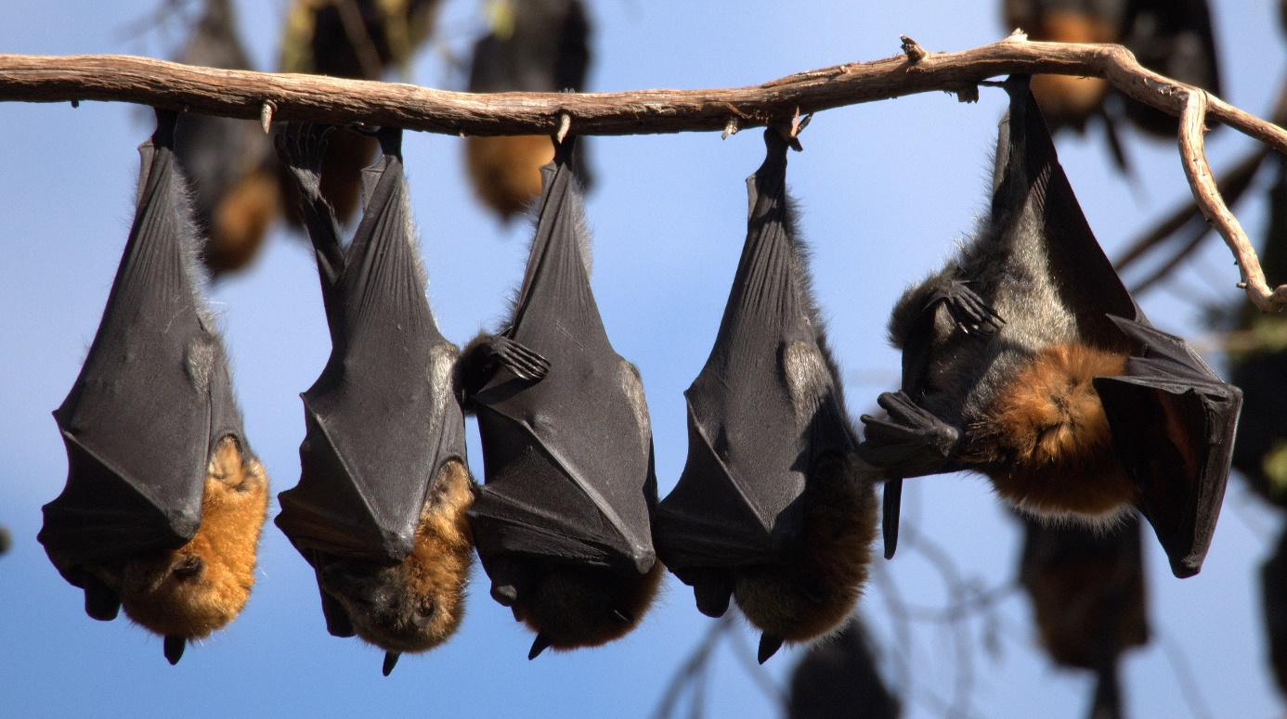

Credit: © Adam McKeown.

#### Electrocution on power lines

Grey-headed Flying-foxes are vulnerable to accidental injury and death from various artificial obstacles. They are prone to electrocution on power lines, particularly in urban areas, and increasing urbanisation exposes larger numbers of animals to electrocution (Tidemann 1999, Tidemann and Nelson 2011).

#### Public misunderstanding of disease risk

Diseases of Australian flying-foxes have been reviewed (Olsson and Woods, 2008). There is very little information available on the impact of disease on Australian flying-fox populations, including Grey-headed Flying-foxes. The main area of impact of disease appears to be associated with the public perception of bats as a source of some diseases that can affect humans.

Australian flying-foxes, including the Grey-headed Flying-fox, are natural reservoirs for at least three zoonotic diseases, meaning that they carry a disease agent that can affect humans: Australian Bat Lyssavirus, a rabies-like disease, and two paramyxoviruses – Hendra virus and Menangle virus (Philbey et al. 1998, Halpin et al. 2000, Hanna et al. 2000; Clayton et al. 2013). Research suggests that Australian flying-foxes may also be carriers for pathogenic Leptospira species, although they are not considered to pose a significant risk to humans of leptospirosis (Smythe et al. 2001; Cox et al. 2005; Tulsiani et al.2011).

Coronaviruses appear to be widespread and endemic in global bat populations with recent work suggesting a similar situation exists in Australian bats (Wildlife Health Australia, 2020). Several recently emerging coronavirus diseases, such as Severe Acute Respiratory Syndrome (SARS), Middle East Respiratory Syndrome (MERS) and severe acute respiratory syndrome coronavirus 2 (SARS-CoV-2), appear to have bats in general as their natural hosts. The potential for cross-species transmission of these viruses and their ability to evolve relatively rapidly makes them a source of concern to the public, particularly those living near flying-foxes. There is however no evidence of SARS or SARS-like, MERS or MERS-like, or SARS-CoV-2-like viruses in Australian flying-foxes (Wildlife Health Australia, 2020). While SARS, MERS and SARS-CoV-2have caused serious disease in humans, the coronaviruses isolated from Australian bats are not closely related to the causative agents of these diseases. No human health implications have been identified to date (Wildlife Health Australia, 2020).

The incidence of Lyssavirus in the Grey-headed Flying-fox is low (<1 %). The virus appears to have evolved with the flying-foxes and is generally in equilibrium with the population. However, when flying-foxes are subject to significant ecological stress the incidence of Lyssavirus can increase to the point where the disease can impact upon the population (H. Field pers. comm.). The incidence of Lyssavirus infection is also higher (5-10%) in sick, injured and orphaned flying-foxes (DAFF 2013).

Australian health authorities suggest that Lyssavirus poses a low public health risk. Evidence suggests the virus can only be transmitted to humans in saliva from an infected flying-fox via a penetrating bite or scratch, or by contamination of mucous membranes or broken skin. Coming into contact with flying-fox urine or faeces reportedly poses no risk of Lyssavirus infection. Effective pre-exposure and post-exposure (prior to clinical signs) protection from Lyssavirus is available through a vaccine that can be administered by medical practitioners or, in some cases, post exposure administration of human rabies immunoglobulin (DHA 2012).

There is no evidence that Hendra or Menangle viruses can be transmitted directly from flying-foxes to humans, although each has been transmitted to humans by domestic animals (horses and pigs respectively) (Chant et al. 1998; Philbey et al. 1998, Selvey et al. 1996; Field et al. 2001; Clayton et al. 2013). Menangle virus has occurred as a single outbreak in a piggery in NSW in 1997, causing reproductive failure in pigs and significant illness in two piggery workers who subsequently recovered (Clayton et al. 2013). Flying-foxes were considered to be the likely reservoir of Menangle virus (Clayton et al. 2013).

Hendra virus has received extensive media attention, with sporadic cases occurring in horses since the first recorded case in 1994. Outbreaks have involved the death of a number of horses. Although spill-over infection from horses to humans is a very rare event, it can be fatal. The human cases have all been attributed to close exposure of people to infected horses. There is no evidence that Hendra virus can spread directly from flying-foxes to people (Breed et al. 2006, NSW Department of Health 2011, and Department of Health 2017). Land-use change, urban habituation and decreased flying-fox migratory behaviour have however been implicated as factors that may influence the prevalence of Hendra virus in flying-fox populations (Plowright et al. 2011; Plowright et al. 2015).

Animal disease outbreaks are generally managed by the relevant State agency for primary industry, in conjunction with their health department counterparts. Following an outbreak of Hendra virus in 2011, an Intergovernmental Hendra Virus Taskforce was established with representatives from respective heads of biosecurity agencies in Queensland, New South Wales, Victoria and the Australian Government; chief veterinary officers, chief health officers, chief scientists, and senior environmental representatives from Queensland and New South Wales; and the Australian Chief Veterinary Officer and head of the Australian Animal Health Laboratory CSIRO.

The taskforce was responsible for ensuring a consistent and coordinated approach in responding to the disease, identifying areas for further collaboration and undertaking longer-term planning for managing the disease and its impacts. The National Hendra Virus Research Program was established to fund research leading to strategies that minimise the impact of Hendra virus.

Outcomes of the Taskforce included:

* A Hendra virus vaccine for horses released on Thursday 1 November 2012. Vaccination is the single most effective way of reducing the risk of Hendra virus infection in horses. Vaccinating horses is also an important measure to prevent human infection occurring and provides a public health and workplace health and safety benefit (NSW DPI 2015).
* Research identifying that roost disturbance is not likely to precipitate increased Hendra virus infection and excretion in dispersing flying-foxes (Edson et al. 2015a)
* Black Flying-foxes are more likely a vector for Hendra than Grey-headed or Little Red Flying-foxes (Edson et al. 2015b).

The Australian Government Department of Health (2017) in consultation with the Communicable Diseases Network Australia and endorsed by the Australian Health Protection Committee developed a [National Hendra Virus Guideline](https://www1.health.gov.au/internet/main/publishing.nsf/Content/cdna-song-hendra.htm'). It provides nationally consistent advice and guidance to public health units in responding to a notifiable disease event and is a good source of information on the disease, prevention activities, case management and education.

White-nosed syndrome, a fungal disease causing widespread concern due to its impact upon bat populations in North America, has only been identified in small insectivorous bats. The disease has not been identified in Australia. Angiostrongylosis and a number of other diseases have been identified in Grey-headed Flying-foxes (Barrett, 2004; Olssen and Woods, 2008; Reddacliff et al. 1999); however, the impact of these diseases at a population level is unknown. The lack of information available suggests that further work is required to assess and quantify any potential threats that may be posed by disease on Grey-headed Flying-fox populations.

## Recovery objectives, performance criteria and actions

The overall objectives of this Grey-headed Flying-fox recovery plan are:

* to improve the Grey-headed Flying-foxes national population trend by reducing the impact of the threats outlined in this plan on Grey-headed Flying-foxes through habitat identification, protection, restoration and monitoring, and
* to assist communities and Grey-headed Flying-foxes to coexist through better education, stakeholder engagement, research, policy and continued support to fruit growers.

Following are specific objectives intended to be achieved over ten years, actions to achieve them and performance criteria against which achievement can be assessed.

### Recovery objective 1

Identify, protect and increase native foraging habitat that is critical to the survival of the Grey-headed Flying-fox.

**Background:** Foraging habitat loss and degradation pose the most significant threat to Grey-headed Flying-foxes. There is evidence that winter and spring are periods of limited food availability (Eby and Law 2008) and are therefore likely to be population limiting periods for the species. Increasing resources during these months through tree-planting and habitat restoration and rehabilitation programs will decrease pressure on the species and aid its recovery. Summer and autumn flowering trees will also be beneficial to the species and should be maintained and enhanced. Range-wide, integrated strategies of habitat protection are needed to conserve the species. Priority habitats need to be identified and direct actions taken to incorporate the requirements of the species into pre-existing mechanisms for protecting, enhancing and rehabilitating native vegetation, on both public and private lands.

**Action 1.1:** Building on the work of Eby and Law (2008), through field surveys and spatial analysis further identify habitat critical to the survival of the Grey-headed Flying-fox. Make this information available on the Department of the Agriculture Water and the Environments interactive web viewer for the National Flying-Fox Monitoring Program.

**Action 1.2:** Building on the outcomes of Action 1.1, identify and implement protection of important foraging resources in native vegetation communities that are poorly represented within current reserves.

**Action 1.3:** Building on the outcomes of Action 1.1, identify opportunities to protect priority foraging habitats on private land through permanent covenants and local land use planning schemes.

**Action 1.4:** Increase the extent and viability of foraging habitat for the Grey-headed Flying-fox that is productive during winter and spring by planting appropriate tree species in the appropriate soil and landscape position (Eby 2016).

**Action 1.5:** Quantify the impacts of the 2019/20 bushfires on habitat critical to the survival of the species and incorporate into planning for the above actions.

**Performance criterion:** Foraging habitat critical to the survival of Grey-headed Flying-foxes, including winter and spring foraging habitat, is spatially identified, the extent of this habitat that is protected under conservation management programs is increased by at least 500 km2, and the condition of this habitat is improved. At least 1000 km2 of foraging habitat is created or restored with vegetation communities and species optimised for nectivorous species including the Grey-headed Flying-fox. More precise performance measures will be developed once a baseline has been established.

### Recovery objective 2

Identify, protect and increase roosting habitat of Grey-headed Flying-fox camps.

**Background:** The loss and modification of roosting habitat is an increasing threat to the Grey-headed Flying-fox as local governments and other land managers clear roosting vegetation to minimise impacts on residents affected by camps and to address community concerns.

**Action 2.1:** Continue to maintain a database of Grey-headed Flying-fox camps through the National Flying-fox Monitoring Program and display on the interactive flying-fox web viewer.

**Action 2.2:** Undertake work on the database to include tenure and zoning of the land and land adjoining all camps (where approval is given) to facilitate their protection.

**Action 2.3:** Protect and increase roosting habitat for Grey-headed Flying-foxes, particularly in low conflict locations.

**Action 2.4:** Develop and implement plans of management focusing on mitigation for all problematic Grey-headed Flying-fox camps which are considered to be nationally important.

**Action 2.5:** Identify scientifically robust criteria for identifying roosting habitat which is critical to the survival of the species and develop actions to improve protection of that habitat.

**Action 2.6:** Increase the number of camps protected under conservation agreements with land managers and associated communities.

**Performance criterion:** Camps of Grey-headed Flying-foxes are identified and mapped, the number of camps protected is increased and the condition of roosting habitat is improved with camp management plans, covenants or other forms of permanent legal protection in place for at least 50% of nationally important camps.

### Recovery objective 3

Determine trends in the Grey-headed Flying-fox population so as to monitor the species’ national distribution, habitat use and conservation status.

**Background:** A 30 % decline in the national population of Grey-headed Flying-foxes was the key criterion for listing the species as vulnerable to extinction. There has been an ongoing public debate suggesting Grey-headed Flying-fox numbers have increased and that the species is not in decline, questioning the need for legislative protection. An estimation of the national Grey-headed Flying-fox population and trend is an appropriate response to the ongoing public debate and will enable more informed management decisions. CSIRO has developed a field and analysis methodology and is monitoring the Grey-headed Flying-fox’s national population.

**Action 3.1:** Continue conducting range-wide assessments of the Grey-headed Flying-fox population as part of the monitoring program being coordinated by the CSIRO.

**Action 3.2:** [Monitor](https://www.animalecologylab.org/ff-heat-stress-forecaster.html) and report on the impact of heat stress events, including their location and frequency, in order to understand the impact of heat stress on recovery. Consideration should be given to implementing a systematic heat stress monitoring protocol to better understand the impact of heat stress events in warmer months.

**Action 3.3:** Develop robust models of Grey-headed Flying-fox life history and population dynamics, to enable predictions of the likely impacts of threats on population viability.

**Action 3.4:** Once robust and accurate population size and trend estimates are available, undertake a review of the species conservation status, using the [Common Assessment Method](http://www.environment.gov.au/biodiversity/threatened/cam) for assessing and listing threatened species, to ensure alignment of its threatened species listing status across its range.

**Performance criterion:** By 2029, the abundance of Grey-headed Flying-foxes is assessed, the error in abundance measures is estimated, the population trend is identified as stable or improving and its threatened species listing status is consistent across jurisdictions within its range.

### Recovery objective 4

Build community capacity to coexist with flying-foxes and minimise the impacts on urban settlements from new and existing camps while avoiding interventions to move on or relocate entire camps.

**Background:** Habitats throughout the range of the Grey-headed Flying-fox continue to be substantially modified by human activities (Eby and Law 2008). Coastal development which has overtaken long-standing camps, loss of vegetation away from urban areas and increased food supply in urban areas from extensive planting of native species in cities, have all led to an increased interaction between humans and flying-foxes in urban areas.

In general, where flying-fox camps exist it is important to build the capacity of the community to live near the animals. This approach recognises that dispersal of flying-fox camps comes with other impacts such as potentially moving a problem camp onto another community, creating further conflict. Dispersals also come with significant financial costs and have little likelihood of long-term success. Efforts to disperse flying-foxes from established camps also affect the wellbeing of the animals concerned and may lead to injury or death.

A range of management strategies can be employed in situ to minimise the impact of flying-foxes on urban settlements without dispersing their camps. For example vegetation can be planted to create a buffer around homes, or preferred roosting and foraging trees can be removed from sensitive locations close to human settlements. Building improvements such as installing double glazed windows and air conditioning have been effective in enabling residents to live near flying-foxes. Financial incentives and subsidies to assist landholders with cleaning and covers for cars, solar panels, pools and clotheslines have also been successful.

Landscape habitat mapping which identifies existing and potential flying-fox habitat can assist future land use planning so that the location of roosting habitat is considered when deciding the placement of new homes, schools and hospitals.

**Action 4.1:** Undertake community surveys to elicit community values and attitudes towards wildlife, specifically flying-foxes, and also to assess the effectiveness of public awareness-raising actions.

**Action 4.2:** Develop and publish information for, and actively engage with, the community, media and decision makers to build their capacity to coexist with Grey-headed Flying-foxes, including current information on population status and trend and the ecological role of flying-foxes.

**Action 4.3:** Publish case studies demonstrating how effective in situ management of flying-foxes can mitigate impacts on the local community, as well as the difficulties and costs associated with attempting dispersals.

**Action 4.4:** Work with local governments and private landholders to identify existing flying-fox roosting habitat, implement mitigation measures in areas of conflict and investigate opportunities for creating or rehabilitating roosting habitat away from people, and areas unsuitable for development due to potential conflict.

**Action 4.5:** Investigate options to encourage private landholders to co-exist with flying-foxes e.g. funding support / incentives for mitigation measures.

**Action 4.6:** Work with fauna rehabilitation groups and individuals across the species distribution to support rehabilitation measures including rescue and triage practice, data collection and interjurisdictional coordination for key events such as heat stress.

**Performance criterion 1:** Improvement in public attitudes towards Grey-headed Flying-foxes, as measured by community surveys before and after the implementation of public awareness-raising actions, resulting in fewer applications to intervene at camps.

**Performance criterion 2:** Improvement in rate of return of rehabilitated flying-foxes to the wild.

### Recovery objective 5

Increase public awareness and understanding of Grey-headed Flying-foxes and the recovery program, and involve the community in the recovery program where appropriate.

**Background:** Recovery of the Grey-headed Flying-fox cannot occur without wide community participation. In several areas, negative public attitudes toward the species act as an impediment to the recovery process. The continued clearing of Grey-headed Flying-fox habitat for urban and rural development both reduces the habitat available for animals to occupy and increases the conflict between flying-foxes and people. As well as protecting flying-fox habitat, strategic programs of public education are needed to improve co-existence between people and flying-foxes and reduce this conflict.

**Action 5.1:** Develop a comprehensive strategy of public education (Recovery objective 4).

**Action 5.2:** Create a website to promote the Grey-headed Flying-fox Recovery Plan to inform the public of the recovery plan, its progress and opportunities for participation in actions.

**Action 5.3:** Promote public participation in surveys and reporting of camp and foraging locations as part of the national monitoring program.

**Action 5.4:** Support the flying-fox rehabilitation sector, to attract, train and retain flying-fox carers and to install and maintain rehabilitation and soft release facilities.

**Performance criterion:** Improvement in public attitudes towards Grey-headed Flying-foxes and reduction in conflict between people and flying-foxes reduced as measured by periodic random surveys, the number of disruptive management actions and an increase in the number of positive off site management actions.

### Recovery objective 6

Improve the management of Grey-headed Flying-fox camps in areas where interaction with humans is likely.

**Background:** Management problems can arise when flying-fox camps establish or unexpectedly increase in size in urban environments. In September 2015, the Australian government released a referral guideline for management actions in Grey-headed and Spectacled flying-fox camps. This guideline was developed in cooperation with state, territory and local governments, species experts and the general public to ensure high protection standards for the Grey-headed Flying-fox whilst seeking streamlined assessment outcomes. It provides guidance to proponents on when and how they can act to manage problematic camps whilst ensuring there are no significant impacts on the Grey-headed Flying-fox.

**Action 6.1:** Ensure the public is aware of the referral guideline and that it is widely available for proponents who are proposing to manage a flying-fox camp that is considered problematic.

**Action 6.2:** Collaborate with state, territory and local governments and non-government organisations to ensure that the referral guideline remains current as significant new information on management techniques, their impact on the species, population size and trends or climate related impacts becomes available.

**Action 6.3:** Establish a formal process for collecting data on management interventions of Grey-headed Flying-fox camps and maintain a database of camp interventions, their drivers, context and outcomes to support and communicate improved methods for camp management.

**Action 6.4:** Undertake research to improve the understanding of the impacts of camp management actions on the Grey-headed Flying-fox.

**Performance criterion:** Problematic camps are managed in accordance with the Department’s referral guideline.

### Recovery objective 7

Significantly reduce levels of licenced harm to Grey-headed Flying-foxes associated with commercial horticulture.

**Background:** Flying-foxes cause damage to commercial fruit crops across Queensland, New South Wales and Victoria. The extent and severity of the damage varies from place to place and year to year. Permits/licences to lethally control Grey-headed Flying-foxes in commercial crops are not issued in Victoria or South Australia, and are only issued in special circumstances in New South Wales. There is anecdotal evidence that Grey-headed Flying-foxes are illegally killed in the vicinity of commercial crops in all range States. There are significant animal welfare concerns with the licenced and illegal harm of flying-foxes to mitigate commercial crop damage.

Population control by deliberate destruction is not considered to be an effective method of reducing crop damage in the long-term and poses a threat to the recovery of the Grey-headed Flying-fox.

**Action 7.1:** Promote practical and cost-effective non-lethal measures to protect commercial crops from flying-fox damage (e.g. netting), particularly in newly occupied areas.

**Action 7.2:** Undertake an education and compliance program targeting illegal shooting of flying-foxes, particularly in newly occupied areas.

**Action 7.3:** Review licensing to harm flying-foxes for mitigation of commercial crop damage in New South Wales and Queensland with a view to having it phased out.

**Performance criterion:** Increased use of non-lethal methods are used by horticulturalists to protect their crops as measured by a 90 % reduction in the licenced harm of Grey-headed Flying-foxes in commercial crops by 2029 (as measured against 2017 levels).

### Recovery objective 8

Support research activities that will improve the conservation status and management of Grey-headed Flying-foxes.

**Background:** A better understanding of flying-foxes will help to assess the impacts of the threats to Grey-headed Flying-foxes identified in this recovery plan and develop efficient and effective management strategies.

**Action 8.1:** Continue to monitor and review the current knowledge of the range, distribution and habitat usage of all flying-fox species (Black, Little Red, Spectacled, Grey-headed Flying-foxes; following Roberts et al. 2012) to assess whether there have been long-term changes and, if so, to identify the probable causes of those changes.

**Action 8.2:** Continue research into the ways Grey-headed Flying-foxes use permanent and temporary camps, and methods for recreating/rehabilitating suitable foraging habitats. Make the products of this research widely available to land managers.

**Action 8.3:** Improve understanding of population dynamics of flying-foxes, including the movement, distribution and behaviour of populations. This encompasses broader research issues such as investigating the determinants of sedentary or transient status of flying-foxes; patterns of juvenile dispersal; and the behaviour of populations under stress from food shortages and heat events and response to camp management actions.

**Action 8.4:** Engage experts to conduct research into the changing human dimension of interactions with flying-foxes, in order to develop targeted and cost-effective strategies to improve co-existence and minimise conflict.

**Action 8.5:** Conduct research and examine existing information to reveal ways of best mitigating the effect of heat stress on juvenile flying-foxes during heat stress events.

**Performance criterion:** Knowledge of the Grey-headed Flying-fox biology and ecology is improved.

### Recovery objective 9

Reduce the impact on Grey-headed Flying-foxes of electrocution on power lines, and entanglement in netting and on barbed-wire.

**Background:** Grey-headed Flying-foxes are prone to accidental injury and death from various artificial obstacles. Animals can be electrocuted on powerlines and become entangled in barbed-wire and netting that does not comply with wildlife-friendly netting guidelines. Electrical utilities should be encouraged to increase spacing between electrical cables when replacing crosspieces as part of their maintenance and upgrade programs and to install underground powerlines where possible.

**Action 9.1:** Work with the electrical utilities to ensure a move towards increasing minimum spacing on new powerlines and converting old systems during maintenance or upgrades through installing underground powerlines or aerial bundling of lines.

**Action 9.2:** Promote methods of erecting backyard netting to avoid entangling flying-foxes and implement community education campaigns annually just prior to major fruiting times of backyard crops.

**Action 9.3:** Actively promote the use of plain top wires on fencing instead of barbed-wire.

**Performance criterion 1:** The awareness of the injuries and death to Grey-headed Flying-foxes from man-made obstacles is increased. This is best measured through publication of case studies and website information from industry companies and bodies on their corporate social responsibility in mitigating impacts to flying-foxes and demonstrating impact reduction.

**Performance criterion 2:** Reduced rates of injury as measured by the number of individuals cared for by fauna rehabilitation groups and individuals.

## Priority actions

The cost of implementation of this plan should be incorporated into the core business expenditure of the affected organisations and through additional funds obtained for the explicit purpose of implementing this recovery plan. It is expected that the Commonwealth, state and local government agencies will use this plan to prioritise actions to protect the species and enhance its recovery, and that projects will be undertaken according to agency priorities and available resources. Whilst an attempt has been made to prioritise actions in this recovery plan, this shouldn’t deflect from any proposal to undertake any other actions outlined in section 4 of this plan. All actions in section 4 are considered important steps towards ensuring the long-term survival of the species and in certain areas or unique circumstances, some actions not identified may be the highest priority.

The high priority actions are considered those that are necessary in order to quantify long-term population trends and reverse decline, contribute significantly to improving co-existence and resolving conflict, inform decision making about development impacts and urban planning and provide a more informed basis for the long-term management and recovery of the species. These actions would be best done collaboratively between the government stakeholders (outlined on page 6) in conjunction with the CSIRO and various private research organisations or individuals. Commonwealth and State strategic funding programs are the best avenues to implement the priority actions e.g. the National Landcare Programme or NSW Environment Trust. Where approvals are given for actions with residual impacts to the Grey-headed Flying-fox, environmental offsets may provide opportunities to increase habitat critical to the species survival and or undertake research.

Given the complexity of stakeholders involved with this species, its large range across multiple jurisdictions and the spatial or social nature of many of the recovery actions, no attempt has been made to cost the actions in this plan. Suitably qualified people should be engaged to undertake costings when funding opportunities arise and proposals are being submitted. Where possible consultation across jurisdictions and organisations is highly recommended.

Actions considered to be priority actions are:

* **Action 1.1:** Building on the work of Eby and Law (2008) field verify and spatially identify key foraging areas and vegetation communities used by the Grey-headed Flying-fox through an annual cycle.
* **Action 1.4:** Increase the extent and viability of foraging habitat for the Grey-headed Flying-fox that is productive during winter and spring (refer to Eby 2016).
* **Action 2.3:** Protect and increase native roosting habitat critical to the survival of the Grey-headed Flying-fox.
* **Action 3.1:** Continue to conduct periodic range-wide assessments of the Grey-headed Flying-fox as part of the National Flying-Fox Monitoring Programme.
* **Action 3.3:** Develop robust models of Grey-headed Flying-fox life history and population dynamics, to enable predictions of the likely impacts of threats on population viability.
* **Action 4.2:** Develop and publish information for the community to build their capacity to coexist with Grey-headed Flying-foxes .
* **Action 4.4:** Identify existing flying-fox roosting habitat, opportunities for creating or rehabilitating habitat away from people and areas unsuitable for development due to potential conflict.
* **Action 6.3:** Establish a formal process for collecting data on management interventions at Grey-headed Flying-fox camps and maintain a database of camp interventions, their drivers, context and outcomes to support the development of improved methods for camp management.
* **Action 7.1:** Promote practical and cost-effective non-lethal measures to protect commercial crops from flying-fox damage (e.g. netting), particularly in newly occupied areas.

Photograph 7 Grey-headed Flying-foxes forage and roost in rainforests

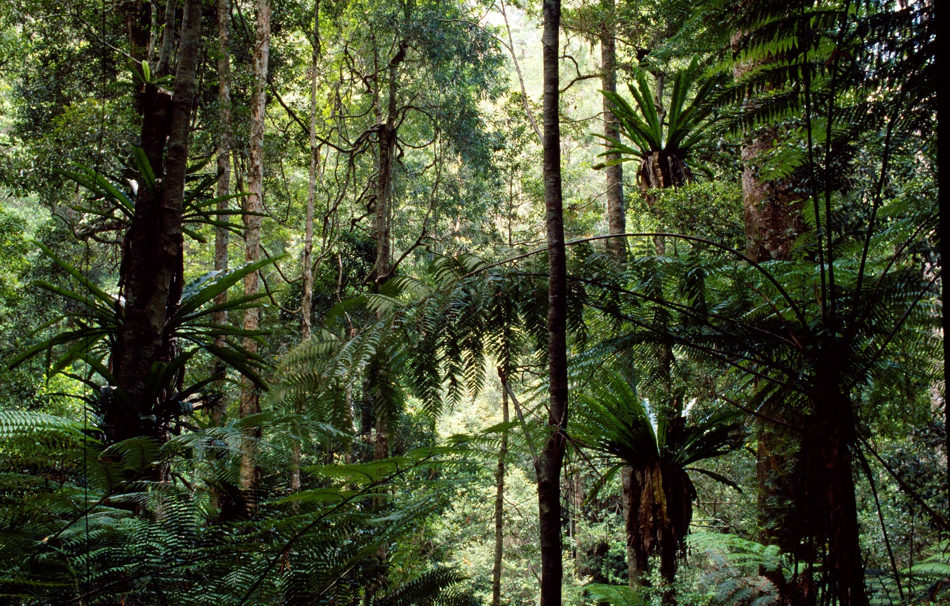

Credit: © Allan Fox.

## Plan evaluation and duration

This recovery plan’s performance is to be reviewed after five years. Potential contributors to review the plan include the Australian Government Department of Agriculture Water and Environment in conjunction with all relevant State and Territory agencies.

Successful management to ensure the long-term survival of the Grey-headed Flying-fox will require an ongoing commitment from all governments across the species’ range.

Success of this recovery plan will be evaluated against:

* a robust estimate of an increasing population trend
* an improved understanding of habitat critical to the survival of the species
* an increase in protection of habitat critical to the survival of the species and management of nationally important camp sites
* implementation of effective habitat restoration projects
* a reduction of conflict between people and flying-foxes in residential areas through investment in household mitigation measures
* greater uptake of crop netting
* a decrease in the number of licences issued to harm the species, and
* an improved understanding of threats of unknown status; climate change and electrocution/ entanglements.

## References

Barrett, J. L. 2004. Australian bat lyssavirus. PhD thesis. School of Veterinary Science, University of Queensland. <http://eprint.uq.edu.au/archive/00002417/>. Accessed 26 September 2006.

Birt, P. 2000. Summary information on the status of the Grey-headed (Pteropus poliocephalus) and Black (P. alecto) Flying-fox in New South Wales. pp. 78–86. in Proceedings of a Workshop to Assess the Status of the Grey-headed Flying-fox in New South Wales, edited by G. Richards, Australasian Bat Society, Canberra.

Birt, P. 2005a. National Population Assessment Grey-headed flying-foxes Pteropus poliocephalus 21 and 22 May 2005. A report to: Department of Environment and Heritage, Queensland Parks and Wildlife Service, New South Wales Department of Environment and Conservation, Victorian Department of Sustainability and Environment. Unpublished.

Birt, P. 2005b. Mutualistic interactions between the nectar-feeding Little Red Flying-fox Pteropus scapulatus (Chiroptera: Pteropodidae) and Eucalypts: habitat utilisation and pollination. PhD thesis. University of Queensland, Brisbane.

Birt, P. and Markus, N. 1999. Notes on the temporary displacement of Pteropus alecto and P. poliocephalus by P. scapulatus within a day-time campsite. Australian Mammalogy 21: 107-110.

Birt, P., Markus, N., Collins, L. and Hall, L.S. 1998. Urban flying-foxes. Nature Australia 26: 54-59.

Breed, A.C, Field, H.E., Epstein, J.H. and Daszak, P. 2006. Emerging henipaviruses and flying-foxes – Conservation and management perspectives. Biological Conservation 131: 211-220.

Butt, N., Seabrook, L., Maron, M., Law, B., Dawson, T., Syktus, J., McAlpine, C. 2015. Cascading effects of climate extremes on vertebrate fauna through changes to low-latitude tree flowering and fruiting phenology. Global Change Biology. d.o.i:10.1111/gcb.12869.

Chant, K., Chan, R., Smith, M., Dwyer, D. E., Kirkland, P. and the NSW Expert Group 1998. Probable human infection with a newly described virus in the family Paramyxoviridae. Emerging Infectious Diseases 4: 273-275.

Clayton, B. A., Wang, L. F and Marshm G. A. 2013. Henipaviruses: an updated review focusing on the pteropid reservoir and features of transmission. Zoonoses and public health 60.1: 69-83.

Coffs Harbour City Council. 2004. Draft Site Management Plan for the Coffs Creek Flying-fox Camp. CHCC, Coffs Harbour, NSW.

Collins, L. 2000. Impact of periods of food shortage on the body weight of Grey-headed Flying-foxes. Pp. 99-101. In Proceedings of a Workshop to Assess the Status of the Grey-headed Flying-fox in New South Wales, edited by G. Richards, Australasian Bat Society, Canberra.

Cox, T. E., Smythe, L. D. and Leung, L. K. P. 2005. Flying-foxes as carriers of pathogenic Leptospira species. Journal of Wildlife Diseases 41: 753–757.

Department of Agriculture, Fisheries and Forestry (DAFF) 2013. [Australian bat lyssavirus guidelines for veterinarians](http://era.daf.qld.gov.au/id/eprint/7446/1/australian-bat-lyssavirus-veterinarian-information.pdf).

Department of the Environment and Heritage. 2003. EPBC Act Administrative Guidelines on Significance – supplement for the Grey-headed Flying-fox 2003–2004. Department of the Environment and Heritage, Canberra.

Department of the Environment, Water, Heritage and the Arts (DEWHA) 2013. Matters of National Environmental Significance, Significant impact guidelines 1.1. EPBC Act Policy Statement.

Department of the Environment (DoE) 2015. Referral guideline for management actions in Grey-headed and Spectacled flying-fox camps. EPBC Act Policy Statement.

Department of the Environment and Energy (DoEE) 2017. Monitoring flying-foxes website. CSIRO quarterly reports of the National Flying-fox Monitoring Programme. Webpage www.environment.gov.au/biodiversity/threatened/species/flying-fox-monitoring.

Department of Health and Ageing. 2012. [Rabies and Australian bat lyssavirus national guidelines for public health units](https://www1.health.gov.au/internet/main/publishing.nsf/Content/cdnasongs.htm).

Department of Health 2017. Hendra virus – [Series of National Guidelines](https://www1.health.gov.au/internet/main/publishing.nsf/Content/cdna-song-hendra.htm').

Department of Sustainability and Environment 2006. Protocols for management of Grey-headed Flying-foxes at Yarra Bend Park during severe adverse weather events, Australasian Inter-service Incident Management System.

Dickman, C. and Fleming, M. 2002. Pest, or Passenger Pigeon? The New South Wales Scientific Committee’s assessment of the status of the Grey-headed Flying-fox. Pp. 20-28 in Managing the Grey-headed Flying-fox as a Threatened Species in NSW, edited by P. Eby and D. Lunney. Royal Zoological Society of NSW, Mosman, NSW.

Divljan, A., Parry-Jones, K. and Wardle, G.M., 2006. Age determination in the grey-headed flying fox. Journal of Wildlife Management, 70(2), pp.607-611.

Divljan, A. 2008. Population ecology of the Grey-headed Flying-fox, Pteropus poliocephalus: A study on the age-structure and the effects of mortality on a vulnerable species. PhD thesis. University of Sydney, Sydney, NSW.

Driessen, M. 2010. Recent sightings of flying-foxes in Tasmania. The Tasmanian Naturalist 132.

Duncan, A., Baker, G.B. and Montgomery, N., 1999. The Action Plan for Australian Bats. Biodiversity Group Environment Australia, Canberra.

Eby, P. 1991. Seasonal movements of Grey-headed Flying-foxes, Pteropus poliocephalus (Chiroptera: Pteropodidae), from two maternity camps in northern New South Wales. Wildlife Research 18: 547-559.

Eby, P. 1995. Biology and Management of Pteropus in New South Wales.Species Report. NSW National Parks and Wildlife Service, Hurstville, NSW.

Eby, P. 1996. Interactions between the Grey-headed Flying-fox Pteropus poliocephalus (Chiroptera: Pteropodidae) and its diet plants – seasonal movements and seed dispersal. Ph.D. Thesis, University of New England, Armidale, NSW.

Eby, P. 1998. An analysis of diet specialization in frugivorous Pteropus poliocephalus in Australian subtropical rainforest. Australian Journal of Ecology 23: 443-456.

Eby, P. 2000. Low reproductive output in Grey-headed Flying-foxes associated with a short period of food scarcity. Australasian Bat Society Newsletter 14: 17-20.

Eby, P. 2002a. National Count of the Grey-headed Flying-foxes July 27 & 28, 2002. Unpublished Report to Environment Australia, Queensland Parks and Wildlife Service, NSW National Parks and Wildlife Service and Victoria Dept Natural Resources and Environment.

Eby, P. 2002b. Using New South Wales planning instruments to improve conservation and management of Grey-headed Flying-fox camps. pp. 240-250 in Managing the Grey-headed Flying-fox as a Threatened Species in NSW, edited by P. Eby and D. Lunney. Royal Zoological Society of NSW, Mosman, NSW.

Eby, P. 2003. National Count of Grey-headed Flying-foxes April 12 & 13, 2003. Unpublished report to: Department of Environment and Heritage Australia, Queensland Parks and Wildlife Service, Department of Environment and Conservation (NSW), Department of Sustainability and Environment (Victoria).

Eby, P. 2004. National Count of Grey-headed Flying-foxes – April 3 & 4, 2004. Unpublished report to the Department of Environment and Heritage, Canberra.

Eby, P. and Lunney, D. 2002. Managing the Grey-headed Flying-fox Pteropus poliocephalus as a threatened species in NSW: adjusting to a long-term vision. pp. 273-284 in Managing the Grey-headed Flying-fox as a Threatened Species in NSW, edited by P. Eby and D. Lunney. Royal Zoological Society of NSW, Mosman, NSW.

Eby, P., Collins, L., Richards, G. and Parry-Jones, K. 1999. The distribution, abundance and vulnerability to population reduction of a nomadic nectarivore, Pteropus poliocephalus, during a period of resource concentration. Australian Zoologist 31: 240-253.

Eby, P. and Law, B. 2008. [Ranking the feeding habitats of Grey-headed Flying-foxes for conservation management.](https://www.environment.nsw.gov.au/resources/threatenedspecies/GHFFmainreport.pdf) A report for a report for The Department of Environment and Climate Change and Water (NSW) & The Department of Environment, Water, Heritage and the Arts.

Eby, P. 2016. Using restoration and revegetation plantings to aid conservation of threatened nomadic pollinators and long-distance pollination services in NSW. A report to the NSW Office of Environment and Heritage.

Eby, P., Sims, R. and Bracks, J. 2019. Flying fox Foraging Habitat Mapping NSW: a seamless map for assessing temporal and spatial patterns of habitat quality for flying foxes. Report to Local Government Association New South Wales.

Ecobiological 2009. Report on Aboriginal Consultation around the Draft National Recovery Plan for the Grey-headed Flying-fox: Coastal CMA regions, NSW. Unpublished report prepared for the Department of Environment, Climate Change and Water NSW.

Edson D, Field H, McMichael L, Jordan D, Kung N, Mayer D, et al. (2015a) Flying-Fox Roost Disturbance and Hendra Virus Spillover Risk. PLoS ONE 10(5): e0125881. doi:10.1371/journal.pone.0125881.

Edson, D., Field, H., McMichael, L., Vidgen, M., Goldspink, L., Broos, A., Melville, D., Kristoffersen, J., de Jong, C., McLaughlin, A. and Davis, R. (2015b). Routes of Hendra virus excretion in naturally-infected flying-foxes: implications for viral transmission and spillover risk. PloS one, 10(10), p.e0140670.

Field, H., Young, P., Yob, J. M., Mills, J., Hall, L. and Mackenzie, J. S. 2001. The natural history of Hendra and Nipah viruses. Microbes and Infection 3:307-314.

Fleming, T.H. and Eby, P. 2003. Ecology of bat migration. Pp.156-208 in Ecology of Bats. edited by T.H. Kunz and M.B. Fenton. University of Chicago Press, Chicago USA.

Food and Agriculture Organisation of the United Nations 2011. Investigating the role of bats in emerging zoonoses; Balancing ecology, conservation and public health interests. Edited by S. H. Newman, H. E. Field, C. E. de Jong and J. H. Epstein. FAO Animal Production and Health Manual no.12. Rome.

Hall, L. S. 1987. Identification, distribution and taxonomy of Australian Flying-foxes (Chiroptera: Pteropodidae). Australian Mammalogy 10: 75-79.

Hall, L.S. 2002. Management of flying fox camps: what have we learnt in the last twenty five years? Pp 215–224 in Managing the Grey-headed Flying-fox as a Threatened Species in NSW, edited by P. Eby and D. Lunney. Royal Zoological Society of NSW, Mosman, NSW.

Hall, L.S. and Richards, G. 2000. Flying Foxes: Fruit and Blossom Bats of Australia. UNSW Press: Sydney.

Halpin, K., Young, P., Field, H. and Mackenzie, J. 2000. Isolation of Hendra virus from pteropid bats: a natural reservoir of Hendra virus. Journal of General Virology 81: 1927-1932.

Halpin, K., Hyatt, A.D., Fogarty, R., Middleton, D., Bingham, J., Epstein, J.H., Rahman, S.A., Hughes, T., Smith, C., Field, H.E. and Daszak, P., 2011. Pteropid bats are confirmed as the reservoir hosts of henipaviruses: a comprehensive experimental study of virus transmission. The American journal of tropical medicine and hygiene, 85(5), pp.946-951.

Hanna, J., Carney, I., Smith, G., Tannenberg, A., Deverill, J., Botha, J., Serafin, I., Harrower, B., Fitzpatrick, P. and Searle, J. 2000. Australian bat lyssavirus infection: a second human case, with a long incubation period. Medical Journal of Australia 172: 597-599.

House, S. 1997. Reproductive biology of eucalypts. Pp. 30-54 In Eucalypt ecology: individuals to ecosystems, edited by J. E. Williams and J. C. Z. Woinarski. Cambridge University Press, Cambridge.

Hudson, I.L., Keatley, M. R., Kang, I. 2010. Wavelet characterization of eucalypt flowering and the influence of climate. Environmental and Ecological Statistics. Published first online 27 June, 2010. DOI: 10.1007/s10651-010-0149-5.

Hudson IL, Keatley, M.R., Kang I. 2011. Wavelet Signatures of Climate and Flowering: Identification of Species Groupings In: Olkkonen H (ed) Discrete Wavelet Transforms / Book 2. InTech, Vienna (38pp).

Hughes, L., 2003. Climate change and Australia: trends, projections and impacts. Austral Ecology 28: 423-443.

Hughes, L., Cawsey, E.M. and Westoby. M. 1996. Climatic range sizes of species in relation to future climate change. Global Ecology and Biogeography Letters 5: 23-29.

Law, B.S., Mackowski, C., Schoer, L., and Tweedie, T. 2000.The flowering phenology of myrtaceous trees and their relation to environmental and disturbance variables in northern New South Wales. Austral Ecology 25: 160-78.

Lunney, D. and Moon, C. 1997. Flying-foxes and their camps in the rainforest remnants of north-east NSW. pp. 247-277 In Australia’s Ever-Changing Forests III, edited by J. Dargavel. Centre for Resource and Environmental Studies, Australian National University, Canberra.

Martin, L. and McIlwee, A.P. 2002. The reproductive biology and intrinsic capacity for increase of the Grey-headed Flying-fox Pteropus poliocephalus, and the implications of culling. Pp. 91-108 in Managing the Grey-headed Flying-fox as a Threatened Species in NSW, edited by P. Eby and D. Lunney. Royal Zoological Society of NSW, Mosman, NSW.

Martin, L., Kennedy, J.H., Little, L., Luckhoff, H.C., O’Brien, G.M., Pow, C.S.T., Towers, P.A., Waldon, A.K. and Wang, D.Y. 1996. The reproductive biology of Australian flying-foxes (genus Pteropus). Symposium of the Zoological Society of London 67: 167-184.

McDonald-Madden, E., Schreiber, E.S.G., Forsyth, D.M., Choquenot, D. and Clancy, T.F. 2005. Factors affecting Grey‐headed Flying‐fox (Pteropus poliocephalus: Pteropodidae) foraging in the Melbourne metropolitan area, Australia. Austral Ecology, 30(5), pp. 600-608.

McIlwee, A.P. and Martin, L. 2002. On the intrinsic capacity for increase of Australian flying-foxes. (Pteropus spp., Megachiroptera).Australian Zoologist 32: 76-100.

McWilliam, A.N. 1986. The feeding ecology of Pteropus in north-eastern New South Wales, Australia. Myotis 23-24: 201-208.

Mo, M., Roache, M., Williams, R., Drinnan, I.N. and Noël, B. 2020. From cleared buffers to camp dispersal: mitigating impacts of the Kareela flying-fox camp on adjacent residents and schools. Australian Zoologist. Published first online 10 January, 2020. DOI: 10.7882/AZ.2020.002.

Murphy, H., Westcott, D., Fletcher, C., and McKeown A. 2008. Determining an effective, scientifically robust census method for the Grey-headed Flying-fox. CSIRO report to the Department of the Environment, Heritage and the Arts.

Nelson, J.E., 1965a. Movements of Australian flying-foxes (Pteropodidae: Megachiroptera). Australian Journal of Zoology 13: 53–73.

Nelson, J. E. W. 1965b. Behaviour of Australian Pteropodidae (Megachiroptera). Animal Behaviour 13: 544–557.

NSW Department of Primary Industries, 2015. Web page – [Hendra Virus Vaccine Information for Horse owners](https://www.dpi.nsw.gov.au/animals-and-livestock/horses/health-and-disease/hendra-virus/vaccine-info-owners). Accessed 13 October 2015.

NSW Department of Health 2011. Fact sheet – Hendra virus. www.health.nsw.gov.au/factsheets/infectious/hendra.html. Accessed 6 July 2012.

NSW Flying-fox Licensing Review Panel. 2009. [Report to Landscapes and Ecosystems Conservation Branch](https://www.environment.nsw.gov.au/resources/threatenedspecies/NSWflyingfoxreview.pdf), NSW Department of Environment and Climate Change.

NSW Scientific Committee 2001 (last amended 12 February 2008, accessed 11 July 2008). [Grey-headed Flying-fox vulnerable species listing, final determination](https://www.environment.nsw.gov.au/topics/animals-and-plants/threatened-species/nsw-threatened-species-scientific-committee/determinations/final-determinations/2000-2003/grey-headed-flying-fox-pteropus-poliocephalus-vulnerable-species-listing).

O’Brien, G.M. 1993. Seasonal reproduction in flying-foxes, reviewed in the context of other tropical mammals. Reproduction, Fertility and Development 5: 499-521.

Olsson, A. and Woods. R. 2008. Bats, pp. 465 – 502 In L. Vogelnest and R. Woods (Eds). Medicine of Australian Native Mammals. 2008. CSIRO Publishing, Collingwood, Victoria, Australia.

Pallin, N. 2000. Ku-ring-gai Flying-fox Reserve: habitat restoration project, 15 years on. Ecological Management and Restoration 1: 10-20.

Parry-Jones, K.A. 1993. The movements of Pteropus poliocephalus in New South Wales. Ph.D. Thesis, University of New South Wales, Sydney.

Parry-Jones, K.A. 2000. Historical declines since the early 1900s, and current mortality factors and abundance of the Grey-headed Flying-fox.pp. 57-66 in Proceedings of a Workshop to Assess the Status of the Grey-headed Flying-fox in New South Wales edited by G. Richards, Australasian Bat Society, Canberra.

Parry-Jones, K. A. and Augee, M. 1991.Food selection by Grey-headed Flying-foxes (Pteropus poliocephalus) occupying a summer colony site near Gosford, N.S.W. Wildlife Research 18: 111-124.

Parry-Jones, K.A. and Augee, M. 1992. Movements of Grey-headed Flying-foxes (Pteropus poliocephalus) to and from a colony site on the central coast of New South Wales. Wildlife Research 19: 331-340.

Parry-Jones, K.A. and Augee. M.L. 2001. Factors affecting the occupation of a colony site in Sydney, New South Wales by the Grey-headed Flying-fox, Pteropus poliocephalus (Pteropodidae).Austral Ecology 26: 47-55.

Peacock, L. 2004. The Roost Preference of the Grey-headed Flying-fox, Pteropus poliocephalus, in New South Wales. Thesis, Faculty of Veterinary Science, University of Sydney, NSW.

Philbey, A., Kirkland, P., Ross, A., Davis, R., Gleeson, A., Love, R., Daniels, P., Gould, A. and Hyatt, A. 1998. An apparently new virus (family Paramyxoviridae) infectious for pigs, humans and fruit bats. Emerging Infectious Diseases 4: 269-271.

Pittock, A.B. and Wratt, D. 2001. Australia and New Zealand. pp. 591-639 in Climate Change 2001: Impacts, Adaptation, and Vulnerability. The IPCC Third Assessment Report, Working Group II Report, edited by J.J. McCarthy, O.F. Canziani, N.A. Leary, D.J. Dokken and K.S. White KS, Cambridge University Press, Cambridge.

Plowright, R. K., Field, H. E., Smith, C., Divljan, A., Palmer, C., Tabor, G. M., Daszak, P. & Foley, J. E. 2008. Reproduction and nutritional stress are risk factors for Hendra virus infection in little red flying-foxes (Pteropus scapulatus). Proceedings of the Royal Society B. 275, 861–869. (doi:10.1098/rspb.2007.1260).

Plowright, R. K., Foley, P., Field, H. E., Dobson, A. P., Foley, J. E., Eby, P. & Daszak, P. 2011. Urban habituation, ecological connectivity and epidemic dampening: the emergence of Hendra virus from flying-foxes (Pteropus spp.). Proceedings of the Royal Society B. doi:10.1098/rspb.2011.0522).

Plowright R.K., Eby P., Hudson P.J., Smith I.L., Westcott D., Bryden WL., et al. 2015. Ecological dynamics of emerging bat virus spillover. Proceedings of the Royal Society B: Biological Sciences 282:9.

Pressey, R.L. 1994. Land classifications are necessary for conservation planning but what do they tell us about fauna? pp.31-41 in Future of the Fauna of Western New South Wales, edited by D. Lunney, S. Hand, P. Reid and D. Butcher. Surrey Beatty & Sons, Chipping Norton, NSW.

Queensland Department of Agriculture, Fisheries and Forestry 2012. [National Hendra Virus Research Program commissioned projects.](https://www.agriculture.gov.au/biosecurity/emergency/wedpp/hendra-mapping)

Ratcliffe, F.N. 1931. The flying-fox (Pteropus) in Australia. Bulletin of the Council for Scientific and Industrial Research 53: 1-80.

Ratcliffe, F.N. 1932. Notes on the fruit bats (Pteropus spp.) of Australia. Journal of Animal Ecology 1: 32–57.

Reddacliff, L. A., Bellamy, T. A. & Hartley, W. J. 1999. Angiostrongylus cantonensis infection in grey-headed fruit bats (Pteropus poliocephalus). Australian Veterinary Journal 77(7), 466–468.

Richards, G. 2002.The development of strategies for management of the flying fox colony at the Royal Botanic Gardens, Sydney.pp. 196-201 in Managing the Grey-headed Flying-fox as a Threatened Species in NSW, edited by P. Eby and D. Lunney. Royal Zoological Society of NSW, Mosman, NSW.

Roberts, B. 2005. Habitat characteristics of flying fox camps in south-east Queensland. BSc(Hons) Thesis, Griffith University, Brisbane.

Roberts, B.J. 2006. Management of Urban Flying-fox Camps: Issues of relevance to camps in the Lower Clarence Valley, NSW. Valley Watch Inc., Maclean.

Roberts, B. J., Catterall, C.P., Kanowski, J., and Eby, P. 2008. A re-evaluation of the northern distribution alimit of the Grey-headed Flying-fox, Pteropus poliocephalus. The Australasian Bat Society Newsletter 31: 16-19.

Roberts, B. J., Catterall, C. P., Eby, P. and Kanowski J. 2012. Latitudinal range shifts in Australian flying-foxes: A re-evaluation. Austral Ecology 37: 12-22.

Roberts, B., Eby, P., Catterall, C., Kanowski, J. and Bennett, G. 2011. The outcomes and costs of relocating flying-fox camps: insights from the case of Maclean, Australia. In Biology and Conservation of Australasian Bats (Eds B Law, P Eby, D Lunney and L Lumsden). Royal Zoological Society of NSW, Mosman, NSW Australia.

Roberts, B, Eby, P. 2013. Review of past flying-fox dispersal actions between 1990-2013. Unpublished report.

Scheelings TF, Frith SE, 2015. Anthropogenic Factors Are the Major Cause of Hospital Admission of a Threatened Species, the Grey-Headed Flying Fox (Pteropus poliocephalus), in Victoria, Australia. PLoS ONE 10(7): e0133638. doi:10.1371/journal.pone.0133638.

Selvey, L. A., Taylor, R., Arklay, A. and Gerrard, J. 1996. Screening of bat carers for antibodies to equine morbillivirus. Comm. Dis. Intell. 20:477-478.

Smith, M. 2002. Management of roost sites of the Grey-headed Flying-fox Pteropus poliocephalus on the north coast of NSW: a National Parks & Wildlife Service perspective. Pp. 202-214 in Managing the Grey-headed Flying-fox as a Threatened Species in NSW, edited by P. Eby and D. Lunney. Royal Zoological Society of NSW, Mosman, NSW.

Smythe, L. D., Field, H. E., Barnett, L. J. et al. (2002). Leptospiral antibodies in flying-foxes in Australia. Journal of Wildlife Diseases 38, 182–186.

Southerton, S.G., Birt, P., Porter, J. and Ford, H.A. 2004. Review of gene movement by bats and birds and its potential significance for eucalypt plantation forestry. Australian Forestry 67: 44-53.

Tait J, Perotto-Baldivieso HL, McKeown A, Westcott DA 2014. Are Flying-Foxes Coming to Town? Urbanisation of the Spectacled Flying-Fox (Pteropus conspicillatus) in Australia. PLoS ONE 9(10): e109810. https://doi.org/10.1371/journal.pone.0109810.

Teagle, S. 2002. Flying-fox Consultative Committee – formation, outcomes and future strategies. pp. 109-116 in Managing the Grey-headed Flying-fox as a Threatened Species in NSW, edited by P. Eby and D. Lunney. Royal Zoological Society of NSW, Mosman, NSW.

Threatened Species Scientific Committee 2001. Advice to the Minister for the Environment and Heritage on Amendments to the list of Threatened Species under the EPBC Act. Department of the Environment and Heritage, Canberra.

Tidemann, C.R. 1995. Grey-headed flying fox Pteropus poliocephalus.pp 439-441 in The Mammals of Australia, edited by R. Strahan. Reed Books, Chatswood, NSW.

Tidemann, C.R. 1998. Grey-headed Flying-fox, Pteropus poliocephalus, Temminck, 1824. In: Strahan, R., ed. The Mammals of Australia. Frenchs Forest: New Holland Publishers Pty Ltd.

Tidemann, C.R. 1999. Biology and management of the Grey-headed Flying-fox, Pteropus poliocephalus. Acta Chiropterologica 1: 151-164.

Tidemann, C.R. 2002. Sustainable management of the Grey-headed Flying-fox, Pteropus poliocephalus.pp. 122-127 in Managing the Grey-headed Flying-fox as a Threatened Species in NSW, edited by P. Eby and D. Lunney. Royal Zoological Society of NSW, Mosman, NSW.

Tidemann, C.R. and Nelson, J. 2004. Long-distance movements of the grey-headed flying fox (Pteropus poliocephalus).Journal of Zoology London 263: 141-146.

Tidemann, C.R. and Vardon, M.J. 1997. Pests, pestilence, pollen and protein: the need for community-based management of flying-foxes in Australia. Australian Biologist 10: 77-83.

Tidemann, C. R., Kelson, S.L. and Jamieson, G. 1997. Flying-fox damage to orchard fruit in Australia – incidence, extent and economic impact. Australian Biologist 10: 179-186.

Tidemann, C., Eby, P., Parry-Jones, K. and Vardon, M. 1999. Grey-headed Flying-fox. Pp 31-35 in The Action Plan for Australian Bats, edited by A. Duncan, G.B. Baker and N. Montgomery. Environment Australia, Canberra.

Tidemann, C.R. and Nelson, J.E., 2011. Life expectancy, causes of death and movements of the grey-headed flying-fox (Pteropus poliocephalus) inferred from banding. Acta Chiropterologica, 13(2), pp.419-429.

Tulsiani, S. M., Cobbold, R. N., Graham, G. C., Dohnt, M. F., Burns, M-A, Leung, L. K-P, Field, H. E., Smythe, L. D. & Craig, S. B. 2011. The role of fruit bats in the transmission of pathogenic leptospires in Australia. Annals of Tropical Medicine & Parasitology, 105(1), 71-84.

Van der Ree, R., McDonnell, M.J., Temby, I., Nelson, J. and Whittingham, E. 2006. The establishment and dynamics of a recently established urban camp of Pteropus poliocephalus outside their geographic range. Journal of Zoology London 268: 177-185.

Webb, N. and Tidemann, C. 1995. Hybridisation between black (Pteropus alecto) and grey-headed (Grey-headed Flying-fox) flying-foxes (Megachiroptera: Pteropodidae). Australian Mammalogy 18: 19-26.

Webb, N. J. and C. R. Tidemann. 1996. Mobility of Australian flying-foxes. Pteropus spp (Megachiroptera): evidence from genetic variation. Proceedings of the Royal Society of London B 263: 497-502.

Welbergen, J., Klose, S., Markus, N. and Eby, P. 2008. Climate change and the effects of temperature extremes on Australian flying-foxes. Proceedings of the Royal Society of London B 275: 419-425.

West, C. 2002.Contemporary issues in managing flying fox camps.pp. 176-195 in Managing the Grey-headed Flying-fox as a Threatened Species in NSW, edited by P. Eby and D. Lunney. Royal Zoological Society of NSW, Mosman, NSW.

Westcott, D., McKeown, A., Murphy, H.T. and Fletcher, C.S. 2011. A monitoring method for the grey-headed flying-fox, Pteropus poliocephalus. Unpublished report to the Commonwealth Department of Sustainability, Environment, Water, Population and Communities. CSIRO.

Westcott, DA, Heersink, DK, McKeown, A, Caley P. 2015. The status and trends of Australia’s EPBC-Listed flying-foxes. CSIRO, Australia.

Wildlife and Threatened Species Bushfire Recovery Expert Panel. 2020. [Provisional list of animals requiring urgent management intervention](http://www.environment.gov.au/biodiversity/bushfire-recovery/priority-animals). Released on 20 March 2020.

Wildlife Preservation Society of Australia (WPSA) 2010. [Flying-foxes](https://wildlife.org.au/flying-foxes/). WPSA webpage accessed 31/7/2012.

Wildlife Health Australia. 2020. Fact Sheet –Coronaviruses in Australian Bats (COVID-19). Accessed 30 April 2020.

Wilson, J. and Bennett, A.F. 1999. Patchiness of a floral resource: flowering of red ironbark Eucalyptus tricarpa in a Box and Ironbark forest. Victorian Naturalist 116: 48-53.