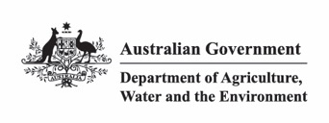
National Recovery Plan for the Koala
Phascolarctos cinereus
(combined populations of Queensland,
New South Wales and the Australian Capital Territory)
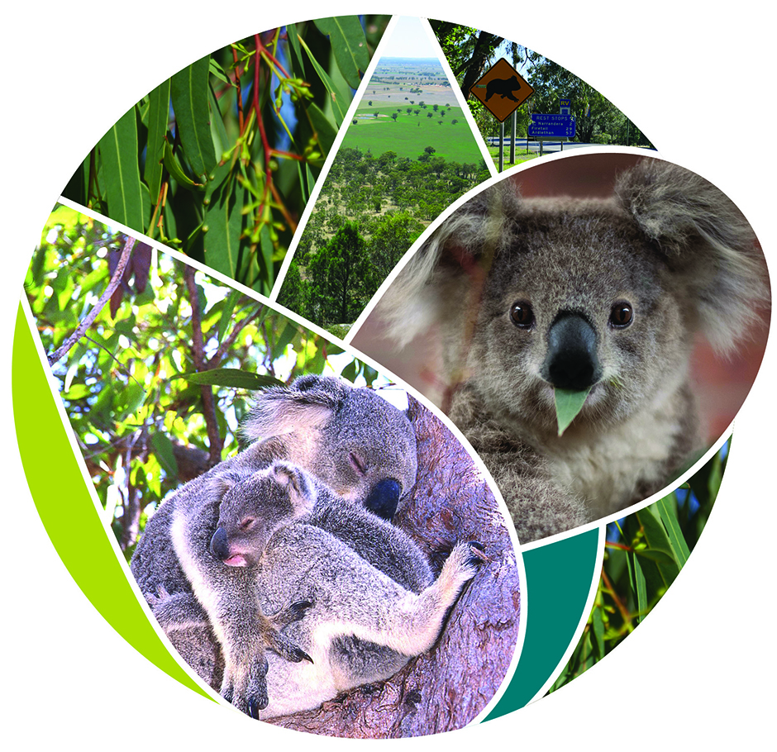

March 2022
The Species Profile and Threats Database page linked to this recovery plan can be found at:
http://www.environment.gov.au/cgi-bin/sprat/public/sprat.pl
Prepared by the Department of Agriculture, Water and the Environment.
Made under the Environment Protection and Biodiversity Conservation Act 1999
© Commonwealth of Australia 2022
Ownership of intellectual property rights
Unless otherwise noted, copyright (and any other intellectual property rights) in this publication is owned by the Commonwealth of Australia (referred to as the Commonwealth).
Creative Commons licence
All material in this publication is licensed under a Creative Commons Attribution 4.0 International Licence except content supplied by third parties, logos and the Commonwealth Coat of Arms.
Inquiries about the licence and any use of this document should be emailed to copyright@awe.gov.au.
Cataloguing data
This publication (and any material sourced from it) should be cited as: DAWE 2022, National Recovery plan for the Koala: Phascolarctos cinereus (combined populations of Queensland, New South Wales and the Australian Capital Territory). Department of Agriculture, Water and the Environment, Canberra. March 2022. CC BY 4.0.
ISBN 978-1-76003-386-6
Department of Agriculture, Water and the Environment
GPO Box 858 Canberra ACT 2601
Telephone 1800 900 090
Disclaimer
The Australian Government acting through the Department of Agriculture, Water and the Environment has exercised due care and skill in preparing and compiling the information and data in this publication. Notwithstanding, the Department of Agriculture, Water and the Environment, its employees and advisers disclaim all liability, including liability for negligence and for any loss, damage, injury, expense or cost incurred by any person as a result of accessing, using or relying on any of the information or data in this publication to the maximum extent permitted by law.
Images credits
Cover page: (from left to right) Mother and joey, Magnetic Island, Qld. Image: © E. Vanderduys, CSIRO; Leaves of the river red gum E. camaldulensis which occurs across Australia and a favourite food of the Koala. Image: © S. Brown; Open grey-box woodlands (E. microcarpa) cleared for cropping resulting in habitat loss, scattered paddock trees, narrow corridors and small patches, central NSW. Image: © S. Brown; A young Koala in care rescued in the 2019–2020 summer bushfires. Image: © Marta Yebra; An iconic road-side sign warning drivers to be aware of Koalas. Image: © S. Brown.
Back page: Child’s drawing of a Koala. Image: © Tom Mallela-Leavesley.

Contents
Glossary 7
Acronyms 10
Overview 11
PART I Background and policy context 16
1. Cultural significance 16
1.1 Significance of the Koala to Indigenous Australians 16
1.2 Non-Indigenous significance 17
2. Conservation status 18
3. Purpose of the recovery plan 19
4. Planning and policy context 21
4.1 Australian Government 21
4.2 State and territory governments 23
PART II Goal, objectives and strategies 26
5. Overview of threats 26
6. Goal 27
7. Objectives 28
8. Strategies and actions 29
9. National Koala Monitoring Program 49
9.1 Governance structure 51
PART III Implementation 52
10. Introduction 52
11. Governance, Recovery Team and structure 53
12. National coordination, regional implementation 54
12.1 National implementation pathway 54
12.2 Regional implementation plans 54
12.3 Conservation and other translocations 55
13. Schedule and costs 55
14. Current recovery actions 56
14.1 Australian Government 57
14.2 NSW Government 58
14.3 ACT Government 58
14.4 Queensland Government 59
15. Community interests and roles 59
15.1 Indigenous communities 59
15.2 Community conservation for the listed Koala 59
16. Potential benefits and impacts 60
16.1 Affected interests 60
16.2 Social and economic considerations 61
16.3 Broader biodiversity benefits 62
17. Monitoring, evaluation and adaptation of the recovery plan 62
PART IV Threats and impacts 64
18. Introduction 64
19. Direct threats 66
19.1 Climate change 66
19.2 Land use change 67
19.3 Natural systems modification 69
19.4 Other 72
20. Ecological threatening processes 75
20.1 Habitat loss and fragmentation 75
20.2 Habitat degradation 77
20.3 Genetic effects 77
20.4 Genetic effects and disease 78
PART V Distribution trends, genetic structure and diversity, and habitat 79
21. Distribution 79
21.1 National 79
21.2 The listed Koala 81
21.3 Predicted 2070 distribution under climate change 81
21.4 Queensland 84
21.5 New South Wales 85
21.6 Australian Capital Territory 86
21.7 Victoria 86
21.8 South Australia 86
22. Genetic structure and diversity 87
23. Valued populations 89
24. Habitat 90
25. Habitat critical to survival 94
PART VI Biology and ecology 96
26. Species description 96
27. Behavioural ecology and demography 96
27.1 Reproduction 97
27.2 Demography 98
27.3 Movement patterns 98
28. Foraging ecology 99
29. Physiology 101
References 102
Appendices 120
Appendix 1 Costings 120
Appendix 2 EPBC Act-listed fauna 125
Appendix 3 Predicted habitat loss under climate change 127
Appendix 4 2019–2020 fire extent 132
List of figures
Figure 1. Modelled distribution (geographic range) of the listed Koala and unlisted Koala 12
Figure 2. Summary of the structural overview of the relationship between the
supporting strategies and the on-ground strategies to meet the recovery plan’s goal 14
Figure 3. Policies, programs, strategies and regulations at all levels of local, state,
territory and Australian governments that relate to the listed Koala recovery 23
Figure 4. Stylistic representation of the relationships between land use change affecting the landscape and Koala habitat, and Koala populations, exacerbated by climate change and natural systems change 27
Figure 5. Proposed governance structure of the National Koala Monitoring Program and
relationship with the National Koala Recovery Plan, and the state and territory strategies and
plans, and committees 51
Figure 6. Predicted listed Koala distribution in 2070 under a high global emissions scenario (RCP8.5) considering the impacts of climate-change driven changes to droughts and heatwaves on Koalas 83
List of tables
Table 1: International, national, state and territory conservation status of the Koala 18
Table 2. Proportion of forest or woodland by land tenure across the listed Koala’s
modelled habitat and states 61
Table 3. Estimated losses of Koala distribution due to climate change under a high
global-emissions scenario (A1FI or RCP8.5) 67
Table 4. The area and percentage of land burned in the 2019–2020 summer bushfires
by Natural Resource Management (NRM) areas within the area where the listed Koala
and its habitat for known or likely to occur 80
Table 5. Methods used to describe genetic diversity in the Koala, their benefits and limitations 87

Acknowledgement of Country
We acknowledge the traditional custodians of Australia. We recognise their continuing connection to the land and waters, and thank them for protecting this country and its ecosystems since time immemorial. We pay our respects to Elders past and present, and extend that respect to all Indigenous Australians.
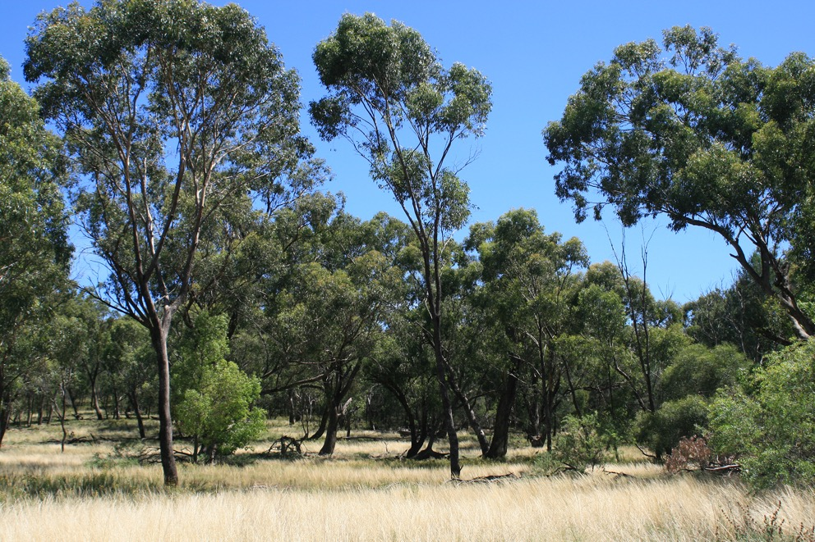
Open grey box (Eucalyptus macrocarpa) woodlands, central NSW. Image: © S. Brown.

Acknowledgements
This plan represents the combined efforts of many people, including those who have directly contributed to the content of the plan, those whose site and management action information has been captured, and those who have built the knowledge and understanding on which this plan relies.
Due to the vast number of contributors who have provided inputs to this plan representing the interests of a diverse range of stakeholder groups including traditional owners, land managers, landowners, conservation organisations, researchers, Koala friends’ groups and government agencies, attempting to list them all would be impractical and risk missing someone unintentionally.
We extend our sincerest thanks to every individual and organisation that has contributed and invested effort to support the recovery of this iconic and culturally significant species to remain in the Australian landscape for future generations.

Glossary
Area of Occupancy. The area within the extent of occurrence (distribution) that is occupied by the species using 2 x 2 km grid cells (IUCN 2019).
Barrier/s. Impediments to the genetic dispersal of Koalas such that fewer than one individual capable of breeding can naturally move between populations over three generations. Barriers include geographic features such as escarpments or inhospitable landscapes but do not include structures such as roads where movement is possible even if irregular or results in an increased rate of mortality.
Direct threats (anthropogenic). The proximate human activities or processes that directly cause changes to Koalas’ survival or breeding, or that reduce the quality of extent of their habitat. Direct threat classification is adapted from the IUCN Threat Classification Scheme (Version 3.2)(IUCN 2016). Examples include housing developments, road building, and harvesting using silvicultural systems that directly remove habitat trees and patches. The occurrence of dogs and vehicles may cause direct mortality of Koalas.
Drivers. Drivers are the demands from the society or human systems from which threats arise. Drivers can be direct or indirect. Indirect drivers are factors that influence the level of production and consumption of ecosystem services and the sustainable use of resources (sensu MA 2003), and can include biophysical, economic, social, cultural, or other factors.
Ecological threatening processes. The biophysical processes that may affect the survival, abundance or evolutionary potential of a native species or ecological community. Examples include habitat fragmentation, increased mortality and changes in habitat quality. Processes need not be outside the natural bounds of variability to be ecologically threatening. These can be grouped into landscape processes – those processes acting on Koala habitat and landscapes, and metapopulation processes – those processes acting on Koala populations and structure.
Indices (singular, index). Parameters or numerical metrics used to characterise a system of interest. An index is a single number compiled from one or more metrics and may be a direct or indirect metric. Direct metrics may be measures of abundance, density, and presence/absence (population parameters), or; homozygosity and allelic richness (genetic parameters). Indirect metrics may include measures of population change of the Koala inferred from changes in habitat area or a categorical measure such as an overall condition score for Koala health.
Landscape effects. The consequences of ecologically threatening processes acting on Koala habitat and landscapes. Examples include habitat loss and fragmentation, changes in habitat quality.
Listed Koala. The legal entity covered by this recovery plan, being Phascolarctos cinereus (combined populations of Queensland, New South Wales and the Australian Capital Territory) which is listed as Endangered under the EPBC Act. This entity is considered to be a ‘species’ for the purposes of the EPBC Act. See also see Species (legal definition), in this glossary.
Metapopulation (synonyms: composite population, assemblage of populations). The set of biological populations within a larger area, where movement or gene flow from one biological population to at least some other patches is possible and is important for maintaining abundance and distribution at regional scale, even if such movement is infrequent.
Metapopulation processes. The processes acting on populations that influence spatial structure of populations. Processes that cause extinction and recolonisation and affect metapopulation structure may be caused by disruption to dispersal patterns and exchange of genes between populations, changes in the carrying capacity of habitat and therefore the size of populations and their viability, changes to sex ratios, and mortality rates.
Model. A physical or mathematical or conceptual representation of ideas, events or processes.
Patch. Location or area of habitat with all the necessary resources for the persistence of a population and that is separated from other patches by inhospitable habitat that does not contain all the resources necessary for long-term survival and reproduction (though the inhospitable habitat may allow movement). At any given time, a patch may be occupied or empty. Isolated patches are those patches separated from other patches by habitat or a distance that is unlikely to be traversed by Koalas.
Population (biological definition). A biological population as defined in this recovery plan is a set of individuals that live in the same habitat patch and interact with one another, commonly forming a breeding unit within which the exchange of genetic material is more or less unrestricted (synonyms: local population, subpopulation, deme).
Population effects. The consequences of ecologically threatening processes acting on Koala populations and individuals that influence the demographic structure and status of populations. Examples include stress, changes to mortality rates and recruitment.
Species (legal definition). Following the EPBC Act (s528) a species is a group of biological entities that (a) interbreed to produce fertile offspring; or (b) possess common characteristics derived from a common gene pool; and includes (c) a sub-species.
Under section 517 of the EPBC Act, the Minister for the Environment may determine that a distinct population of biological entities is a species for the purposes of the Act. On 27 April 2012, the Phascolarctos cinereus (combined populations of Queensland, New South Wales and the Australian Capital Territory) was determination under this provision to be a species (Commonwealth of Australia 2012). In this recovery plan, the legal entity is referred to as the ‘listed Koala’.
Threats. Activities, events and processes, whether anthropogenic or natural, that directly or indirectly influence the biophysical environment or natural demographic or ecological processes and may interfere with the conservation of the Koala. Examples of indirect threats include habitat loss, fragmentation and degradation, and population isolation.
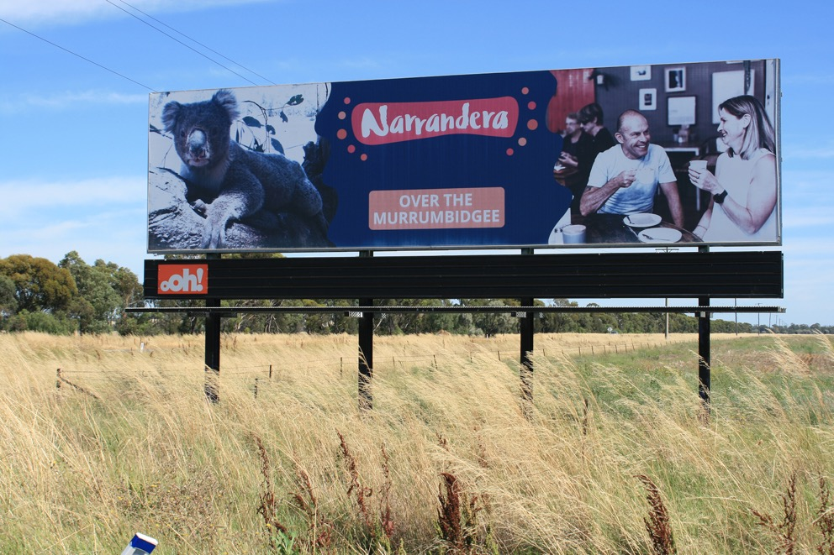
Signage advertising the local Koala attraction, welcoming visitors. Narrandera, central NSW.
Image: © S. Brown.

Acronyms
Term | Definition
ABARES | Australian Bureau of Agricultural and Resource Economics and Sciences
ACT | Australian Capital Territory
BC Act | Biodiversity Conservation Act 2016 (NSW)
CSIRO | Commonwealth Scientific and Industrial Research Organisation (Commonwealth)
DAWE | Department of Agriculture, Water and the Environment (Commonwealth) (formerly DoEE and DotE)
DotE | Department of the Environment (Commonwealth) (former)
DoEE | Department of Energy and the Environment (Commonwealth) (former)
DECC | Department of Environment and Climate Change (NSW) (former)
DES | Department of Environment and Science (Queensland) (formerly DERM)
DERM | Department of Environment and Resource Management (Queensland) (former)
DELWP | Department of Environment, Land, Water and Planning (Victoria) (formerly DSE)
DPIE | Department of Planning, Industry and Environment (NSW) (formerly OEH)
DSE | Department of Sustainability and Environment (Victoria) (former)
EPBC Act | Environment Protection and Biodiversity Conservation Act 1999 (Commonwealth)
IBRA/IBRA7 | Interim Biogeographic Regionalisation for Australia. Version 7
IUCN | International Union for Conservation of Nature
KoRV | Koala retrovirus
Minister | The Australian Government Minister for Agriculture, Water and the Environment
NAILSMA | North Australian Indigenous Land and Sea Management Alliance Ltd.
NRM | Natural Resource Management
OEH | NSW Office of Environment and Heritage (OEH) (former)
SPRAT | Species Profile and Threats Database
TSSC | Threatened Species Scientific Committee
UNESCO | United Nations Educational, Scientific and Cultural Organization

Overview
The Koala Phascolarctos cinereus (Goldfuss 1817), is recognised globally as an iconic Australian marsupial and is of cultural and emotional significance to both Indigenous and non-Indigenous Australians. To see a Koala is a highlight for most international and Australian tourists and, as a drawcard, it provides a significant contribution to Australia’s tourism economy (Hundloe and Hamilton 1997). The Koala is also of global biodiversity significance because it is the only surviving member of the ancient line of the marsupial family Phascolarctidae (Black 1999).
The Koala is associated with trees of the genera Eucalyptus, Corymbia, and Angophora, on which it predominantly feeds (Moore and Foley 2000), and is widely, but patchily, distributed across eastern and southern mainland Australia (Figure 1; section 21, DAWE 2021a).
In 2012, the Koala (combined populations of Queensland, New South Wales and the Australian Capital Territory) was determined to be a species under s517 of the Environment Protection and Biodiversity Conservation Act 1999 (EPBC Act), and was included in the Vulnerable category on the list of threatened species under the Act (TSSC 2012a). In 2021, a reassessment by the Threatened Species Scientific Committee up-listed these populations to Endangered (TSSC 2021).
Hereafter, the Koala will be referred to as either ‘Koala’ or ‘Koalas’ when referring to individuals or populations, ‘the Koala’ or ‘the species’ when referring to the species as a whole, or the ‘listed Koala’ when referring explicitly to the EPBC Act-listed Koala (combined populations of Queensland, New South Wales and the Australian Capital Territory). The populations of Victoria and South Australia may be referred to by their state origin or collectively as either the ‘unlisted Koala’ or ‘southern populations’; the latter is consistent with the term used in research publications.
The overarching threats to the listed Koala are land use change and climate change. Other direct threats include disease, dogs and vehicles (Part IV) (TSSC 2021). These threats interact to impact population size of the listed Koala and distribution through associated ecologically threatening processes of habitat loss, fragmentation and degradation, exacerbation of disease impacts, disruption of population processes, impediments to safe movement and loss of genetic diversity (Figure 4, Part VI). Because of the listed Koala’s large distribution, the relative importance of these threats varies at local scales.
This National Recovery Plan for the listed Koala (the recovery plan) is made under the EPBC Act. The purpose of this plan is to provide for the research and management actions necessary to stop the decline of, and support the recovery of, the listed Koala so that the chances of its long-term survival in nature are maximised. It is the road map to recovery.
This recovery plan is informed by the 2021 EPBC Act listing assessment and Conservation Advice (TSSC 2021), new research, state and territory Koala plans and strategies, and consultation with partners, interest groups and individuals. Although the recovery plan focuses on the ten years to 2032, it is also a plan for the conservation of the listed Koala beyond this time, when climate change impacts are predicted to increase.
This recovery plan is a nationally led, landscape-scale conservation framework for recovery therefore requiring cross-jurisdictional and multi-tenure considerations. It will provide for a national approach to listed Koala conservation, coordinate fragmented actions across many national policies, disciplines and multiple jurisdictions, and prioritise investment to maximise the potential for recovery. The approach to the implementation of actions is guided by a set of principles in community engagement, investment prioritisation and decision making, and landscape ecology (Part III). Although the recovery plan aims as a priority to complement and augment jurisdiction-level strategies and actions, it does not preclude locally driven activities.
Figure 1. Modelled distribution (geographic range) of the listed Koala and unlisted Koala*
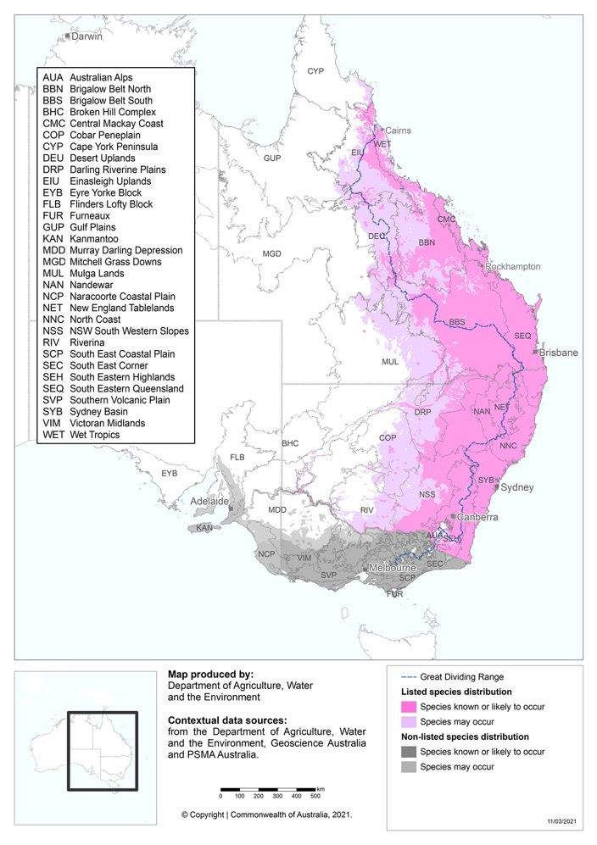
Caveat: The information presented in this map has been provided by a range of groups and agencies. While every effort has been made to ensure accuracy and completeness, no guarantee is given, nor responsibility taken by the Commonwealth for errors or omissions, and the Commonwealth does not accept responsibility in respect of any information or advice given in relation to, or as a consequence of, anything containing herein.
Species distribution mapping: The species distribution mapping categories are indicative only and aim to capture a) the specific habitat type or geographic feature that represents the recent observed locations of the species (known to occur), b) the suitable or preferred habitat occurring in close proximity to these locations (likely to occur), and c) the broad environmental envelope or geographic region that encompasses all areas that could provide habitat for the species (may occur). These presence categories are created using an extensive database of species observation records, national and regional-scale environmental data, environmental modelling techniques and documented scientific research.
* Note: modelled distribution does not equate to Koala habitat (see section 21.2 for further explanation on distribution modelling) Source DAWE 2021a.
The Australian Government acknowledges that, to appropriately manage the listed Koala, a national approach is required that considers the listed Koala in the context of its relationship with unlisted Koala populations in Victoria and South Australia. The implementation of the recovery plan will consider the management and populations status of Koalas across Victoria and South Australia through cooperation and collaboration, national governance and monitoring. The vision is that all respective Koala plans and strategies will mutually inform the conservation effort at a national scale.
The recovery plan has been split into the following parts:
- Part I provides background and policy context for the listed Koala
- Part II presents the national goal, objectives and six strategies, comprised of 37 actions to recover the listed Koala, and the newly established National Koala Monitoring Program
- Part III outlines the nationally led implementation approach
- Part IV details the relationships between drivers, direct threats and ecological threatening processes impacting the listed Koala
- Part V presents background information on the distribution, population trends, habitat and habitat critical to the survival of the listed Koala
- Part VI presents an overview of biology and ecology of the Koala important for recovery planning and actions
- Appendices 1–4 provide further technical information and resource material.
The goal of the recovery plan is to stop the trend of decline in population size of the listed Koala, by having resilient, connected, and genetically healthy metapopulations across its range, and to increase the extent, quality and connectivity of habitat occupied.
To meet this goal, the recovery plan encompasses objectives and actions (Part II) that are multi-faceted and linked at the population level, while recognising the need to manage populations locally because of the heterogeneity of threats across landscapes (Part IV).
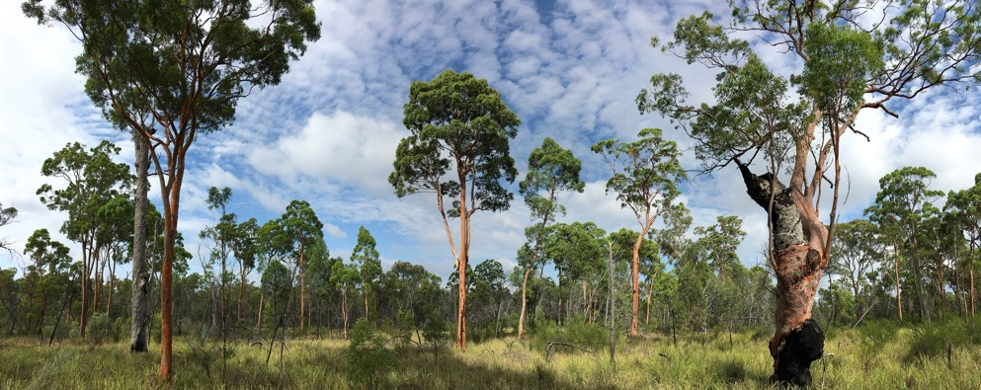
Angophora leiocarpa woodland, Western Creek, south-east Qld. Image: © E. Vanderduys, CSIRO.
Objectives are that by 2032:
- The area of occupancy and estimated size of populations that are declining, suspected to be declining, or predicted to decline are instead stabilised then increased (Objective 1A).
- The area of occupancy and estimated size of populations that are suspected and predicted to be stable are maintained or increased (Objective 1B).
- Metapopulation processes are maintained or improved (Objective 2).
- Partners, communities and individuals have a greater role and capability in listed Koala monitoring, conservation and management (Objective 3).
Addressing any individual driver, direct threat and associated ecological threatening process alone is unlikely to recover listed Koala populations. Recovery will require a holistic and integrated approach to action (Figure 2; Figure 4, section 8). The three objectives of this recovery plan are underpinned by four supporting strategies and two on-ground (direct) strategies, or action areas, as a way of organising and implementing coordinated action:
- Build and share knowledge (Strategy 1)
- Engage and partner with the community in listed Koala conservation (Strategy 2)
- Increase the area of protected habitat for the listed Koala (Strategy 3)
- Integrate listed Koala conservation into policy, statutory and land use plans (Strategy 4)
- Strategically restore listed Koala habitat (Strategy 5)
- Actively manage listed Koala metapopulations (Strategy 6).
The supporting strategies (Strategies 1–4) provide for governance to coordinate actions. They include: research to improve effectiveness of actions, mapping, monitoring and survey methods; data collation, curation and analysis; dissemination of information; community support and capacity building; and provision of principles for state-level conservation planning for the listed Koala. They also intend to increase the area of protected priority Koala habitat to prevent further habitat loss and fragmentation, and to maintain population viability.
The on-ground (direct) strategies (Strategies 5–6) relate to improving habitat quality and restoration, and the collective actions required to ensure metapopulation processes are maintained.
Figure 2. Summary of the structural overview of the relationship between the supporting strategies and the on-ground strategies to meet the recovery plan’s goal
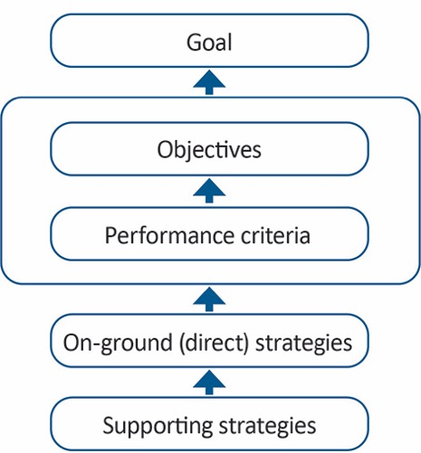
Implementation of this plan will require commitment and collaboration between partners, with the Australian Government leading national coordination. A detailed National Implementation Pathway is to be developed within twelve months of the making of the recovery plan, subject to negotiation with major partners (section 12.1). Regional plans will provide the basis for planning and implementation prioritisation to reflect local land use patterns, risks and threats, and social and economic influences (section 12.2).
A national Recovery Team, representative of the diversity of those engaged with conservation for the listed Koala, will be the nucleus of recovery efforts. It will monitor progress in implementation, share and review information, and identify funding opportunities. The Recovery Team will be supported by an Expert Technical Advisory Committee and Community Advisory Committee, and Commonwealth and state and territory governments (section 11).
Indigenous and non-Indigenous groups will play a central role in the recovery of the listed Koala through co-designing, direct land management, habitat restoration, citizen science, welfare and rehabilitation of injured Koalas, and in many other ways.
Substantial gaps exist in our knowledge of the distribution, population size and trends of the listed Koala in northern and inland Queensland, parts of inland New South Wales, and for the Australian Capital Territory. A National Koala Monitoring Program will be established in partnership with states and territories, and other interest groups to establish baselines, monitor population trends, increase predictive capacity, and understand the drivers and local threats affecting decline or recovery over the entire species distribution, including Victoria and South Australia. The National Koala Monitoring Program will work with other initiatives on Koala health, disease and habitat restoration. It will also allow the evaluation of the effectiveness of management actions through an adaptive management framework (section 9).
Habitat across the geographic distribution of the listed Koala supports more than 50 other threatened species and ecological communities listed under the EPBC Act. Consequently, actions in this recovery plan to manage and protect the habitat of the listed Koala may provide direct benefits to many other threatened species and communities.
The implementation of this recovery plan is expected to have social and economic benefits and costs. Measures to assist recovery of this species that involve restrictions in the use or management of land may result in economic impacts to some affected industries. Conversely, engaging positively with these sectors may provide benefits in terms of achieving sustainability certification or other indirect benefits, such as increasing the amenity of urban landscapes (section 16).
The Koala is an iconic and much-loved Australian animal. Supporting recovery of the listed Koala is likely to provide a positive image of Australia to the world and to Australians, and encourage tourism to regions where Koalas exist. The recovery of the listed Koala will be an exemplary representation of broader efforts to manage Australia’s environmental sustainably into the future.

PART I
Background and policy context

1. Cultural significance

1.1 Significance of the Koala to Indigenous Australians
The Koala is a deeply significant animal in the spiritual and cultural lives of many Indigenous Australians. It is embedded into numerous Dreaming stories and Songlines, and demonstrates Indigenous Australians’ deep understanding of Koala ecology (State of New South Wales 2020; Phillips 1990).
For many Indigenous Australians, the Koala is also an important totem. This status carries weighty responsibilities to protect Koalas and their habitat and to pass on specific Traditional Knowledge from generation to generation (State of New South Wales 2020). The many values, names and stories relating to the Koala reflect the diversity of Indigenous cultures across eastern Australia (Costello 2019; Schlagloth et al. 2018).
Indigenous Australians have developed sophisticated ecological knowledge frameworks over thousands of years that guide their management of the plants and animals of their lands. They also weave Traditional Knowledge with scientific best practice to maximise outcomes for biodiversity (Woodward et al. 2020). In some regions, these frameworks inform the management of the Koala and its habitat. For example, the Gumbaynggirr People from the Northern Rivers of New South Wales use fire to protect Koala habitat as well as the ground between trees and patches to enable Koalas to move freely.
Koalas are just one of many culturally significant species that we burn for. We need to make sure the canopy is healthy and safe. The pathways are also important. At home there are stories about the koalas and their song line pathways. They are pathways that we share as well. We burn to keep the pathways open. (Costello 2019, p. 23)
Indigenous Australians have long advocated for greater acknowledgement of their diverse ecological expertise and responsibilities. They also call for greater rights to manage land and waters their way and to be included in government land management planning and threatened species recovery (Costello 2019; Robinson et al. 2021; Woodward et al. 2020). The empowerment of Indigenous Australians to care for Country benefits Australia’s biodiversity. It also facilitates the flow of Indigenous Knowledge between land managers and improves the physical, psychological, cultural and economic wellbeing of Indigenous Australians (Costello 2019; Woodward et al. 2020).
The National Recovery Plan for the listed Koala recognises the extensive experience and wisdom of Indigenous Australians that informs complex ecological knowledge frameworks. The implementation of this recovery plan will support them to play an active role in recovery, maintain strong connections to Koalas and their habitat and share Traditional Knowledge where they see fit.
Engagement with Indigenous Australians as part of this recovery plan will be based on the five pillars critical to successful Indigenous partnerships (below) as identified by the National Environmental Science Programme (DotE 2014):
- Building trust
- Respectful interactions
- Upholding rights
- Mutual understanding
- Enduring partnerships.

1.2 Non-Indigenous significance
Australians have an emotional connection to the Koala. This is reflected in the attention it receives in media stories, in the number of community groups dedicated to Koala conservation and is exemplified by its use as a symbol of the impacts of the disastrous bushfires during the 2019–2020 summer. The Koala is also an icon of Australian wildlife and is important in shaping Australia’s global image. As one of the major attractions for tourists, its appeal is widely used in campaigns to attract overseas travellers to the country, and local and international visitors to zoos and sanctuaries (Markwell 2020). The value of the Koala to the tourism industry for 2000 was estimated to be greater than $2.5 billion annually (extrapolated from 1996 figures) (Hundloe and Hamilton 1997). Today, this figure would be expected to be significantly greater.
Australians, especially children, have a special place in their heart for Koalas. Adults of today were raised as children on the adventures of Blinky Bill, the Magic Pudding, and Snugglepot and Cuddlepie (Phillips 1990), while modern stories familiar to today’s children that include Koala characters include Wombat Stew and Koala Lou.
Many Australians are also deeply passionate about the conservation of their local Koala populations as exemplified by the many Friends’ groups, dedicated Koala hospitals, wildlife rehabilitation groups, carers and research organisations that work on Koala conservation and the welfare and rehabilitation of individual animals.
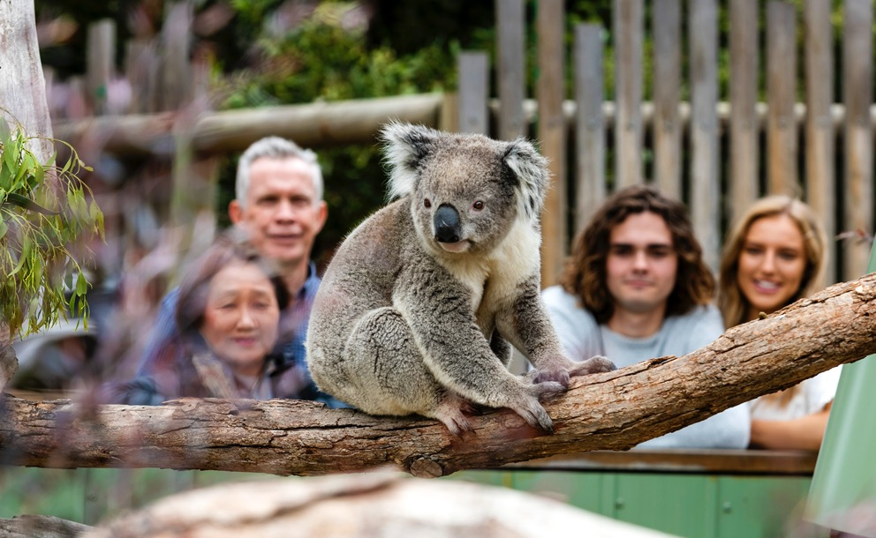
Overseas visitors admiring a Koala. Image: © Moonlit Sanctuary, Victoria

2. Conservation status
The Koala (combined populations in Queensland, New South Wales and the Australian Capital Territory) was uplisted from Vulnerable to Endangered in December 2021 under the EPBC Act (TSSC 2021).
The national Koala population was split due to contrasting conservation status across its range. Most of the populations in New South Wales and Queensland were found to be declining rapidly, whereas most of the populations in Victoria and South Australia were considered relatively stable, or in some cases, over-abundant. This required divergent management responses between the two clusters of states. Following advice from the Threatened Species Scientific Committee (TSSC) the northern population (Queensland, New South Wales and the Australian Capital Territory) of the Koala was determined to be a species for the purposes of the EPBC Act under s 517 (TSSC 2012c).
The listed Koala is considered Vulnerable under state and territory legislation in Queensland, New South Wales and the Australian Capital Territory. The Koala also occurs in Victoria and South Australia, where it is not considered threatened. In contrast to other states, overall the populations of the Koala in Victoria and South Australia are largely stable, although in places such as the Otway Ranges (Victoria) and Kangaroo Island (South Australia) the Koala is intensively managed due to over-abundance (at least prior to the 2019–2020 summer bushfires). The (International Union for Conservation of Nature) IUCN Red List of Threatened species lists the whole population of the Koala (that is, including Victoria and South Australia) as Vulnerable. Table 1 provides a summary of the conservation status of the Koala.
Table 1: International, national, state and territory conservation status of the Koala
Legislation | Conservation status
Environment Protection and Biodiversity Conservation Act 1999  Phascolarctos cinereus (combined populations in Queensland, New South Wales and the Australian Capital Territory) | Endangered
Nature Conservation Act 1992 (Qld)  Koala (Phascolarctos cinereus) | Vulnerable
Biodiversity Conservation ACT 2016 (NSW)  Koala (Phascolarctos cinereus) | Vulnerable
Nature Conservation Act 2014 (ACT)  Koala (Phascolarctos cinereus) | Vulnerable
Flora and Fauna Guarantee Act 1988 (VIC)  Koala (Phascolarctos cinereus) | Not listed
National Parks and Wildlife Act 1972 (SA)  Koala (Phascolarctos cinereus) | Not listed
IUCN Red List of Threatened Species Koala (Phascolarctos cinereus) | Vulnerable

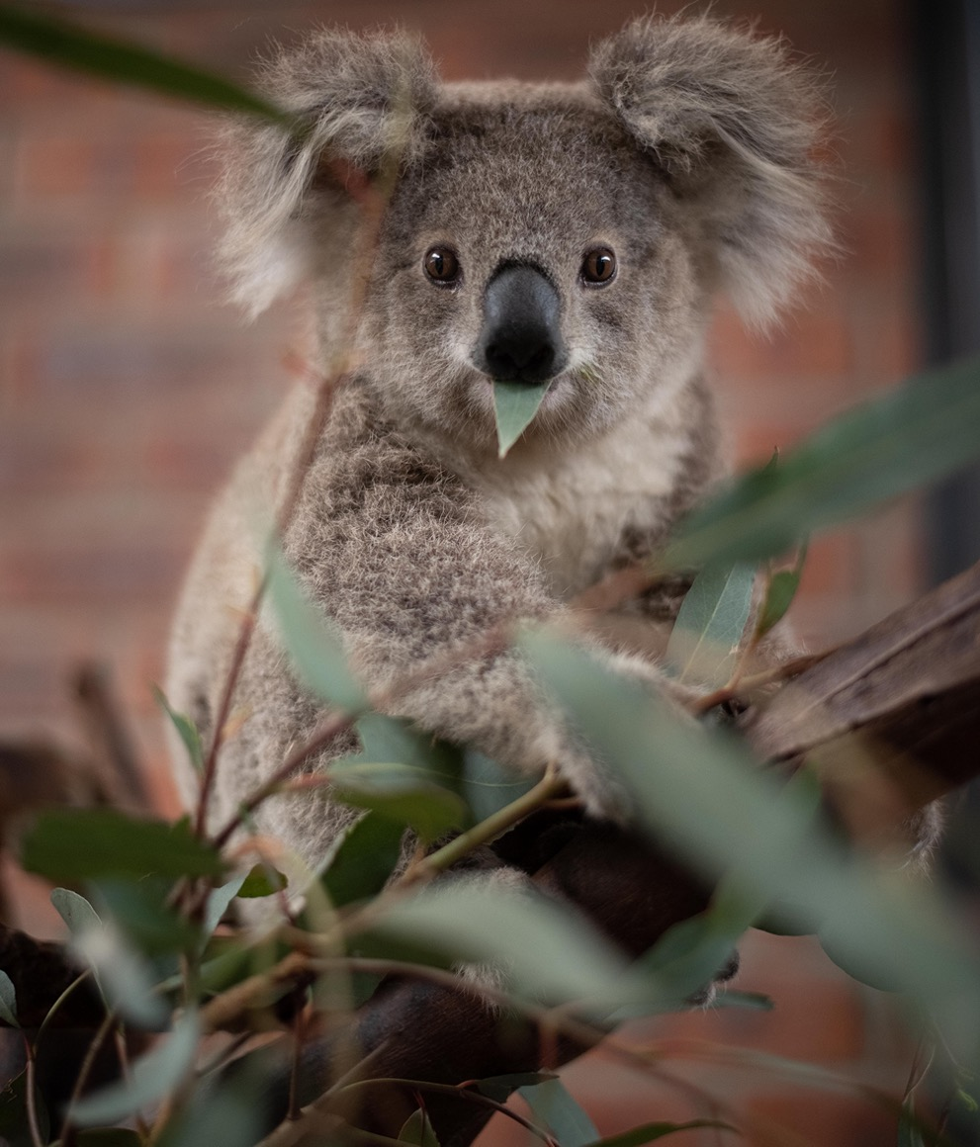
A young Koala in care rescued in the 2019–2020 summer bushfires. Image: © Marta Yebra.

3. Purpose of the recovery plan
Across the distribution of the listed Koala many policies and plans exist. Individuals, networks of community groups, Indigenous Australians, research institutions, and all levels of government, are working to protect and recover the listed Koala. Research in ecology, biology, genetics, health and disease is taking place, community groups are monitoring their local Koala populations, and revegetation projects are occurring.
Some of these activities are fragmented, uncoordinated, occur in isolation and lack a national-level focus.
This recovery plan sets out the road map for a national integrated recovery effort.
A recovery plan under the EPBC Act must provide for the research and management actions to stop the decline of, and support the recovery of, a listed threatened species so that its chances of long-term survival in nature are maximised.
This recovery plan for the listed Koala replaces the National Koala Conservation and Management Strategy (2009–2014) (NRM Ministerial Council 2009). It has been developed with relevant state and territory governments to provide an overarching national conservation framework for the listed Koala that aligns with local, state and territory government plans, programs and strategies. It does not replace these pre-existing plans, programs and strategies but aims to complement them. It is the first recovery plan for the nationally listed Koala.
The Australian Government acknowledges that to appropriately manage the listed Koala a national approach is required that considers the listed Koala in the context of its relationship with unlisted Koala populations in Victoria and South Australia. The implementation of the recovery plan will consider the management and populations status of Koalas across Victoria and South Australia through cooperation and collaboration, national governance, and monitoring. It is envisioned that all respective Koala plans and strategies will mutually inform conservation effort at a national scale.
Prior to the 2019–2020 summer bushfires, Victorian and South Australian populations were considered overall to be stable or increasing, although in some places there are local declines (Menkhorst 2008). Nevertheless, these populations are susceptible to the direct threats and threatening ecological processes outlined in this recovery plan. For example, some of the unlisted Koala populations have low genetic diversity and display evidence of inbreeding (section 22), while the Kangaroo Island population (introduced) was significantly impacted by the bushfires in 2019–2020.
The Victorian and South Australian populations may also become of greater significance as a stronghold in the future as climate change impacts progress, or if some unpredicted widescale catastrophe befalls the listed Koala populations. Thus, although this recovery plan does not legally inform management of the populations of the Koala in Victoria and South Australia, the principles and actions outlined here are also largely applicable to those populations, and engagement of Victoria and South Australian Koala management agencies will be sought as part of a broader national, coordinated Koala conservation effort.
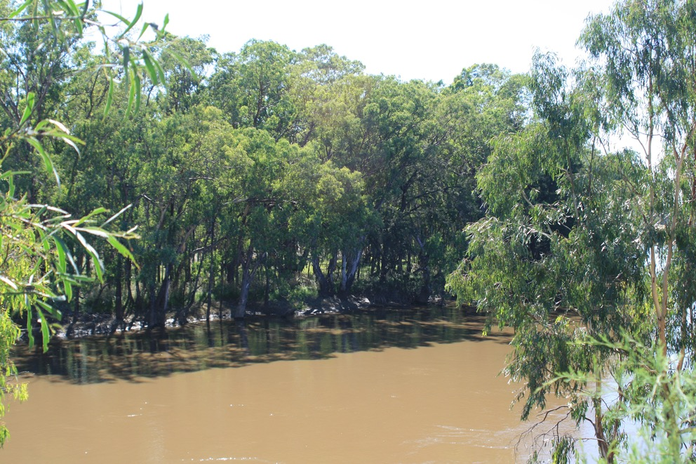
Locally known as Koala Reserve (Narrandera Nature Reserve) is home to over 200 Koalas. Murrumbidgee Valley National Park, central NSW. Image: © S. Brown.

4. Planning and policy context
Across Australia, biodiversity conservation and protection are delivered through the combined efforts of the Australian Government, local, state, and territory governments, along with the actions of landholders, communities, traditional owners, the private sector, and non-government organisations. Conservation of the listed Koala is therefore influenced by a variety of cross-jurisdictional, Australian Government, and state, territory and local government policies, legislation, regulations and programs. This recovery plan is informed by, and interacts with, these policies and frameworks at multiple levels (Figure 3). It is the key national planning document guiding national and collaborative recovery efforts for the listed Koala. The Australian Government will take a lead role in coordination of recovery effort across national policies and will respond to new initiatives.

4.1 Australian Government
Australia is a Party to the international Convention on Biological Diversity, which aims to conserve biological diversity and promote sustainable development. The listed Koala occurs in areas where development is occurring. A sustainable development approach is required to meet the international obligations of this treaty. Australia’s Strategy for Nature 2019–2030 (Commonwealth of Australia 2019) is a national plan to implement the Convention’s Strategic Plan and meet the Aichi Targets. Together with Australia’s Native Vegetation Framework (COAG Standing Council on Environment and Water 2012). These polices provide broad frameworks for conservation planning. They recognise the essential role that vegetation plays in conserving and promoting a biodiverse and thriving natural landscape and the shared responsibility at all levels of government to manage and protect Australia’s environment for all Australians.
The listed Koala also occurs in five World Heritage Areas in Australia (UNESCO 2021): the Gondwana Rainforests of Australia, the Greater Blue Mountains Area, K’gari (Fraser Island), the Wet Tropics of Queensland and the Great Barrier Reef. It also intersects with a variety of National Heritage places such as the Australian Alps National Parks and Reserves, Warrumbungle National Park and the Royal National Park and Garawarra State Conservation Area.
The listed Koala is not listed in the Appendices of the Convention on International Trade in Endangered Species of Wild Fauna and Flora (CITES). It is not traded, there is no suspected or demonstrable potential demand for trade, and future commercial trade is unlikely (CITES 2019).
The EPBC Act is the Australian Government’s key piece of environmental legislation that provides a legal framework to protect and manage nationally and internationally important flora, fauna, ecological communities and heritage places. These entities (including the listed Koala) are defined in the EPBC Act as Matters of National Environmental Significance (MNES). Consequently, the listed Koala is subject to regulatory decision making under the EPBC Act, which is triggered when an action has, will have, or is likely to have, a significant impact. These actions require referral to the Australian Government for assessment and approval under the EPBC Act to be carried out lawfully.
The EPBC Act also provides a framework to plan for the long-term recovery of listed threatened species and ecological communities through assessment to determine eligibility for listing, conservation advices and the development of recovery plans. This recovery plan is informed by the 2021 listing assessment and associated conservation advice (TSSC 2021). As national plans, these statutory documents guide collaborative investment and participation in recovery efforts by all levels of government and the broader community. The EPBC Act provides a significant foundation upon which long-term conservation planning and action is directed, and is a major step in reporting on Australia’s international responsibilities in protecting biodiversity.
The EPBC Act is part of a broader framework that aligns legal protection with Australian Government program investment with biodiversity policy in order to direct focus on priority national-level matters. The Australian Government directly invests in the protection and recovery of Australia’s biodiversity through the Natural Heritage Trust funding package. Environmental programs are delivered through the national Regional Land Partnerships Program with benefits for listed threatened species and ecological communities (Figure 3).
Figure 3. Policies, programs, strategies and regulations at all levels of local, state, territory and Australian governments that relate to the listed Koala recovery. The Conservation Advice (TSSC 2021) is the foundation document used in the development of the recovery plan
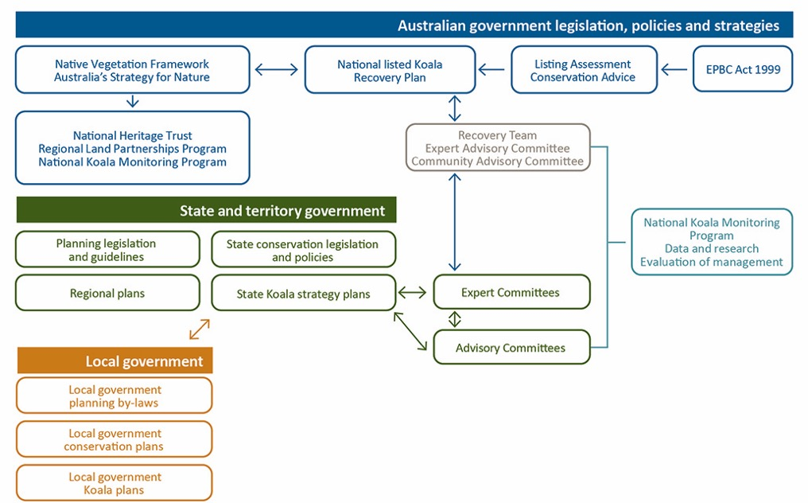

4.2 State and territory governments
States and territories are responsible for regulating environmental matters in their respective jurisdictions and are the primary regulators for Australia’s native plants and animals. All state and territory governments have legislation to conserve biodiversity and to retain and manage habitats, including through a conservation reserve system. State and territory governments operate native vegetation conservation programs, while also providing for sustainable development of lands and waters within their jurisdictions.

NSW Government
The NSW Government has in place several laws and policies to help secure the future of the listed Koala in the wild.
In May 2018, the first New South Wales Koala Strategy was released. The strategy delivered actions under four pillars: Koala habitat conservation; conservation through community action; safety and health of Koala populations; and building our knowledge and education. In 2020, the NSW Government committed to doubling the New South Wales koala population by 2050 with more than $193 million in funding announced in 2021 to meet this goal (section 14.2).
The Biodiversity Conservation Act 2016 (BC Act) contains provisions for identifying and protecting threatened species. The Koala is listed as a Vulnerable species under Schedule 1 of the BC Act. The BC Act also establishes a framework for assessing and offsetting biodiversity impacts from proposed development. The listing of Koalas as Vulnerable means they must be considered under the Environmental Planning and Assessment Act 1979 when preparing environmental planning instruments and when undertaking development assessments. The BC Act also requires a Biodiversity Conservation Program be established to maximise the long-term security of threatened species and threatened ecological communities in nature. The NSW Koala Strategy fulfils this requirement.
In addition, on 17 March 2021 the NSW State Environmental Planning Policy (Koala Habitat Protection) 2021 (Koala SEPP) was made and commenced. The principles of the Koala SEPP 2021 are to:
- help reverse the decline of Koala populations by ensuring Koala habitat is properly considered during the development assessment process
- provide a process for councils to strategically manage Koala habitat through the development of Koala plans of management.
The primary legislation for native forestry on State forests and Crown-timber lands in New South Wales is the Forestry Act 2012, which provides for the Integrated Forestry Operations Approvals (IFOAs). IFOAs integrate the regulatory regimes for environmental planning and assessment, protection of the environment and threatened species conservation and include specific provisions for the identification and protection of Koala habitat.
The BC Act, Local Land Services Act 2013 and State Environmental Planning Policy (Vegetation in Non-Rural Areas) 2017 establish the regulatory framework for managing impacts to native vegetation in New South Wales.

ACT Government
The Australian Capital Territory lies within more marginal habitat for the listed Koala, and although currently there are no known extant populations, populations existed in the past (section 21.6). In 2019, the Koala was listed as Vulnerable under the ACT Government’s Nature Conservation Act 2014, and a Conservation Advice notified (ACT Scientific Committee 2019). The ACT Government continues to liaise with the NSW Government in relation to populations and potential habitat along the New South Wales and Australian Capital Territory borders.

Queensland Government
Despite protection measures to date in Queensland, an independent review determined that the decline in peri-urban Koala populations in the Koala Coast and Pine Rivers areas of South East Queensland showed no evidence of slowing, and may even be increasing (Rhodes et al. 2015). These declines were linked to ongoing habitat loss in South East Queensland resulting from increasing urbanisation as well as other threats, such as dog attacks, disease and road mortality associated with development. These causes for decline have been the driver for an increase in the extent and level of protection of Koala habitat and other management actions for Koala conservation in South East Queensland.
The introduction of amendments to the Koala conservation planning framework in 2020 has resulted in the strongest Koala habitat protections Queensland has ever seen. This framework provides increased protection for Koala habitat in South East Queensland by increasing both the size and level of protections for Koala habitat areas compared with the state’s previous regulatory framework. Koala habitat areas (including both core Koala habitat areas (KHA) and locally refined Koala habitat areas (LRKHA)) now cover 714,040 ha of land across South East Queensland. Of this, 332,278 ha, including 10,012 ha within the South East Queensland Urban Footprint, falls within Koala priority areas in which the clearing of Koala habitat areas is prohibited by the Queensland Government, subject to certain exemptions. These exemptions balance protecting Koala habitat with the need to allow clearing for limited development such as essential services.
The new planning protections introduced by the Queensland Government are supported by state-of-the-art Koala habitat mapping using advanced modelling techniques. The new methodology was endorsed by the Koala Expert Panel and independently reviewed by the CSIRO. The mapped Koala habitat represents the best habitat for Koalas, based on the combination of biophysical measures (including climate), suitable vegetation and Koala occurrence records. This approach will allow the new Koala habitat modelling and mapping to be updated and refined periodically, and enable the government to continue to accurately identify the best quality Koala habitat and track changes over time.
Outside South East Queensland, Koala populations are protected by a range of measures under the Nature Conservation Act 1992 and subordinate Nature Conservation (Koala) Conservation Plan, including requirements in relation to clearing habitat in areas containing Koalas. Koala habitat outside South East Queensland is also regulated through the Vegetation Management Act 1999 as Essential Habitat.

PART II
Goal, objectives and strategies

5. Overview of threats
The human-induced threats of land use change and climate change, and their social, economic, and cultural drivers, underpin the impacts on listed Koala populations that this recovery plan aims to address. With a wide distribution, Koalas are impacted by a broad range of interacting direct threats that vary at local scales: land use threats such as urbanisation, grazing, agriculture, transport infrastructure, mining and energy extraction; modification of natural systems that includes vegetation change through forest harvesting and altered fire regimes; droughts and heatwaves, exacerbated by climate change; and other direct threats such as disease and dog and vehicles (Figure 4).
These threats interact to impact populations of the listed Koala via the ecologically threatening processes such as habitat loss, fragmentation and degradation, changes to population processes that alter demographics, impact from disease, and genetic effects (Figure 4, see Part IV for further details on threats).
Addressing individual drivers, threats, and resultant ecological threatening processes in isolation from each other is unlikely to recover listed Koala populations (Beyer et al. 2018; Rhodes et al. 2011). Therefore, an integrated strategy that simultaneously manages multiple threats, is appropriate to local conditions and undertaken at an appropriate scale, is the most effective and efficient response to address declines.
Figure 4. Stylistic representation of the relationships between land use change affecting the landscape and Koala habitat, and Koala populations, exacerbated by climate change and natural systems change. Changes in landscape configuration and habitat quality mediate the disruption of population processes of both Koala trees and Koala populations through many interrelated and synergistic processes culminating with changes to population sizes, dominated by declines for the listed Koala. Disease is both a direct threat and ecologically threatening process due to increased stress from anthropogenic threats, resulting in increased mortality and reduced fecundity. Red = direct threats; Green = landscape processes and effects; Brown = population processes; and Black is the impact on Koala populations. Direct threat classification is adapted from the IUCN Threats Classification Scheme (Version 3.2) (IUCN 2016) and the Conservation Advice (TSSC 2021)
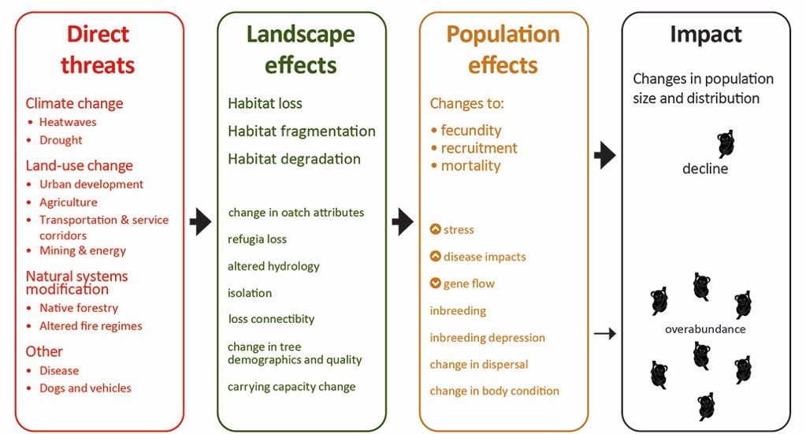

Each recovering population will require an integrated package of coordinated actions that recognises high profile but complex conservation context for this species. This includes the integration and harmonisation of recovery actions for the listed Koala into existing and future planning, policy and land use plans; improved governance structures; increasing the area of protected habitat; building and maintaining strong community engagement and partnerships; building knowledge to inform priority settings, strategies and planning; and adaptive metapopulation management (section 8).

6. Goal
To stop the trend of decline in population size of the listed Koala, by having resilient, connected, and genetically healthy metapopulations across its range, and to increase the extent, quality and connectivity of habitat occupied.

7. Objectives
To progress the long-term recovery goal, three objectives are set for the 10-year life of this plan that complement and build upon state and territory plans and strategies for the listed Koala, and the 2021 Conservation Advice (TSSC 2021).
Attainment of the first two objectives (1A, 1B and 2) will ensure that national and regional trends of populations improve in terms of distribution, abundance, the quality of habitat, and the health of populations. The third objective is an enabling objective to determine the effectiveness of national coordination and engagement in listed Koala conservation. Effective engagement, whereby on-ground efforts are realised, will result in positive outcomes for the first two objectives. For example, strategic habitat restoration, supported by research, planning and engagement by community groups to plant trees or improve habitat quality, will likely improve the status of the listed Koala; however, it may take several years before trends can be detected with certainty.
1A. The area of occupancy and estimated size of populations that are declining, suspected to be declining, or predicted to decline are instead stabilised then increased
Performance Criteria: By 2032,
- Indices of population size (abundance) of a representative sample of populations show that population size has increased.
- The area of occupancy of a representative sample of populations has increased.
- The area and quality of refugial habitat of populations whose primary threat is climate change, and indirectly drought and heatwaves, has increased. Importantly, it is increasingly apparent that parts of the listed Koala’s range will become climatically unsuitable for the species’ persistence in the future (sections 19.1, 21.3). Evaluation against this objective will necessarily involve some allowance for strong effects that are unable to be mitigated thus requiring a ‘shifting baseline’. Where such losses are unavoidable, conservation translocations may be considered to maintain adaptability of surviving populations to a changing climate (section 12.3, Action 6b).
1B. The area of occupancy and estimated size of populations that are suspected and predicted to be stable are maintained or increased
Performance Criteria: By 2032,
- Indices of population size (abundance) of a representative sample of populations show that population size are maintained or increased.
- The area of occupancy of a representative sample of populations is maintained or increased.
Performance Criteria (1A and 1B): By 2032,
- Across all representative populations, there is a total net increase of habitat (excluding offset areas) five-yearly.
2. Metapopulation processes are maintained or improved
Performance Criteria: By 2032,
- Indicators of population health (genetic and disease) are maintained or improved.
- Indicators of ecosystem health are maintained or improved.
3. Partners, communities and individuals have a greater role and capability in listed Koala monitoring, conservation and management
Performance Criteria: By 2032,
- There is an increase in the number, locations and activities of Indigenous Australians participating in recovery for the listed Koala, including leadership, agenda setting, citizen science, training and capacity building and on-ground works across the range of the listed Koala.
- There is an increase in the number, locations and activities of the general community participating in recovery for the listed Koala, including leadership, agenda setting, citizen science, training and capacity building and on-ground works.
- There is an increase in the number, locations and activities of the partners participating in recovery for the listed Koala, including leadership, agenda setting, citizen science, training and capacity building and on-ground works across the range of the listed Koala.

Indices and metrics for the performance criteria
The indices and metrics used to monitor progress for these objectives will be overseen by the Recovery Team, the Technical Advisory Committee and workshopped with experts and key partners. They will consider natural stochastic variability. These will be collectively informed by the National Koala Monitoring Program (section 9), the Koala Health Research Initiative and the Koala genomics projects initiated with key partners in 2021, as well as monitoring programs run by the jurisdictions.
It will not be practicable to frequently measure every population, thus a sample of populations which are representative across the listed Koala’s range will be monitored and baselines of population size and abundance informed by robust modelling.

8. Strategies and actions
To meet these objectives, actions are grouped under strategies, or action areas, as a way of organising and implementing coordinated action. Actions from any of the six strategies are cross-cutting to meet one or more objectives. Furthermore, many actions are predicated on other actions; for example, strategic habitat restoration is predicated on having up-to-date habitat mapping information and understanding of the nutritional quality of habitat within the landscape of interest. Also, many actions are iterative within an adaptive management framework. This means that the performance of a single action, or subset of actions, cannot be directly evaluated against a single objective. Therefore, each performance criterion applies only to the objectives, and no performance criterion or prioritisation is placed against individual actions.
Four supporting strategies and two on-ground (direct) strategies are identified.
Supporting strategies:
1) Build and share knowledge
2) Engage and partner with the community in listed Koala conservation
3) Increase the area of protected habitat for the listed Koala
4) Integrate listed Koala conservation into policy, statutory and land use plans
On-ground strategies:
5) Strategically restore listed Koala habitat
6) Actively manage listed Koala metapopulations
Supporting strategies provide for governance to coordinate actions, led by the Australian Government in partnership with the states and territory. They provide for research and capacity building to improve effectiveness of actions, such as: enhanced mapping, monitoring and survey methods; improved data collation, curation and analysis; to better sharing and communication of information; and building on community capacity, support and engagement. They also provide for improved planning frameworks and principles for state-level conservation planning for the listed Koala.
Increasing the area of priority listed Koala habitat that is protected is a key strategy to prevent further habitat loss and fragmentation and prevent further loss of listed Koala populations (see section 19). Once identified (Actions 1a–c), areas of priority listed Koala habitat should include areas of large intact landscapes that have the greatest potential to retain viable populations and have the potential to also act as source populations to adjacent areas.
On-ground (direct) strategies relate to improving habitat quality and restoration of habitat, and the suite of collective actions required to ensure metapopulation processes are maintained. The former will generally be implemented at the site-level, while the latter is a holistic landscape-scale approach to metapopulation management.
Many state-level actions have been ongoing, or recently commenced, under various state and territory environment-related, or specific strategies for the listed Koala (for detail, see section 14).
Conservation of the listed Koala is complex, and there is local-scale variation in the nature and intensity of threats, land use patterns and land management activities. Recognising this complexity and variation, it is essential that regional-level implementation plans are developed (Action 1c; Part III Implementation), prioritising areas where gaps exist. These plans will include fine-scale mapping, spatial prioritisation, and more prescriptive details on land management actions (e.g. fire and weed management, revegetation) of appropriate scale to each region.
NB. Prioritisation seeks to complement, not replace or duplicate, that undertaken by state and territory jurisdictions.
Actions that may potentially have the greatest impact on recovery include Actions 3b and 4b. These will reduce the cumulative loss of habitat and improve the likelihood of retaining habitat on private lands.
Priorities assigned to actions under each of the six strategies are interpreted as follows:
Priority 1: | Urgent. Prompt action is needed in advance of implementation of other management actions, to ensure effective coordination or to provide crucial information for planning and management. Early action might also be necessary to avoid or mitigate the most significant threats.
Priority 2: | Essential. Action is necessary to avoid or mitigate direct threats, implement planning and management, undertake research, and develop tools towards the long-term recovery
Priority 3: | Highly beneficial. Action is desirable, and while not critical, will provide for longer term maintenance of recovery.  NB. Threats are outlined in Part IV and level of risk categorised in TSSC 2021.
Indicative costs for actions by priority and year are in Appendix 1.
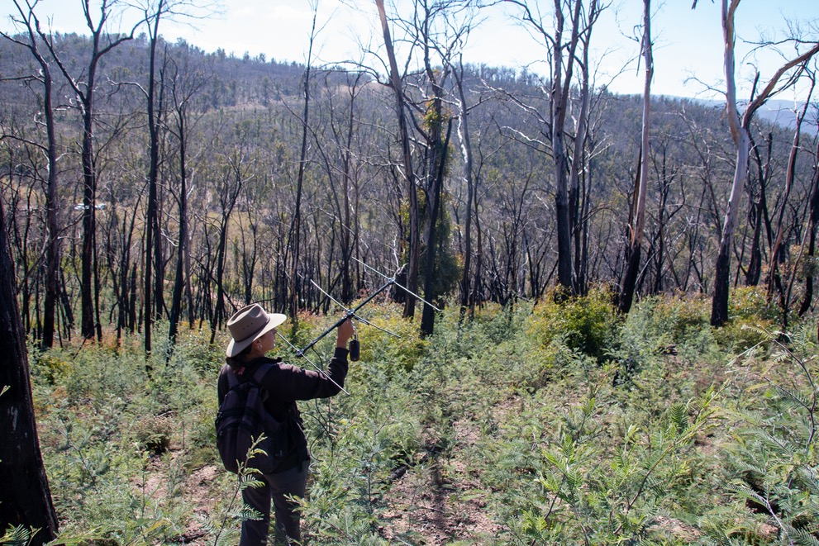
Radio-tracking Koalas to understand movement patterns following the 2019/2020 bushfires. Image: © James Skewes.

Strategy 1: Build and share knowledge
The actions here comprise knowledge-based inputs or activities that support direct actions in the recovery plan. These inputs will provide information for a strategic and coordinated approach to conservation for the listed Koala, now and into the near future.
Action no. | Description | Potential partners/responsibility | Priority | Timeframe | Indicative  cost
1 a | Identify nationally important populations and habitat for recovery across the listed Koala range under current and future conditions. This includes considering impacts of projected climate change such as drought, heatwave and fire. This is assessed by undertaking modelling and analysis of Koala habitat, distribution and abundance, and genetic and genomic analysis (sections 14.1 and 20.3), allowing for iterative updates using a robust scenario-based approach. Prioritise areas for gathering information that are poorly understood or potentially of greatest risk, including, but not limited to, areas of inland and northern Queensland and inland New South Wales; prioritise populations at greatest risk from climate change and land clearing (Table 2, section 16.1 ). NB. This prioritisation seeks to complement, not replace or duplicate, that undertaken by state or territory jurisdictions which may, for example, focus on securing currently robust populations into the future. | Coordinated by the Australian Government with: state and territory government agencies using internal or external mapping and modelling experts; or Expert Technical Advisory Panel and the National Koala Recovery Team; or researchers. | 1 | Year 1 | $100,000 to $200,000 for a desk-top project
1 b | Identify spatially and temporally strategic areas of high priority for: (i) restoration and revegetation based on Koala and eucalypt population viability; (ii) climate and fire refugia; and (iii) corridors facilitating movement and metapopulation processes of Koalas, allowing for iterative updates using the latest models available in a robust scenario-based approach. Prioritise areas for information gathering that are poorly understood or potentially of greatest risk, including, but not limited to, areas of inland and northern Queensland and inland New South Wales; prioritise populations at greatest risk from climate change and land clearing (Table 2; section 16.1).  NB. This prioritisation seeks to complement, not replace or duplicate, that undertaken by state or territory jurisdictions which may, for example, focus on securing currently robust populations into the future. | Coordinated by the Australian Government with: state and territory government agencies; local government and natural resource management organisations; or non-government conservation organisations; or researchers. | 1 | Year 1 and ongoing | $30,000 to $60,000 per regional-scale document for a desk-top project
1 c | Develop prioritisation at regional or other appropriate scales for the long-term implementation of actions. These include threat risk assessment, prioritisation of habitat attributes for the recovery of the listed Koala, local actions and land management planning (see Part III Implementation). Prioritise regions that are poorly understood or potentially of greatest risk, including, but not limited to, areas of inland and northern Queensland and inland New South Wales, and climate refugia.  NB. This prioritisation seeks to complement, not replace or duplicate, that undertaken by state or territory jurisdictions which may, for example, focus on securing currently robust populations into the future. | Governments appropriate to scale, with: natural resource management organisations; mapping and modelling experts; Expert Technical Advisory Panel and the National Koala Recovery Team; and researchers. | 1 | Year 2 | Highly variable depending on size and location of area and socio-economic complexity.  $50,000 to $1m per regional-scale document, plus in-kind contribution through normal government business
1 d | In consultation with each range state and territory, including Victoria and South Australia, scope out and establish a fit-for-purpose long-term National Koala Monitoring Program (NKMP) to improve understanding of trends in populations, distribution and population health across the Koala’s range, and efficacy of management interventions. | Coordinated by the Australian Government with: CSIRO, state and territory government agencies; local governments, natural resource management organisations; community groups; non-government conservation organisations; Koala research community; Koala rehabilitation organisations and groups; and the Expert Technical Advisory Panel and the National Recovery Team. | 1 | Year 1 to 2 | $ 2.25m
1 e | Implement National Koala Monitoring Program; review design to ensure it remains fit-for-purpose and adaptive (see section 9). | Coordinated by the Australian Government with: state and territory government agencies; local governments and natural resources management organisations; community groups; non-government conservation organisations; Koala research community; Koala welfare and rehabilitation organisations and the Expert Technical Advisory Panel and the National Recovery Team. | 1 | Year 2 and ongoing | $2–3m per year (depending on number of monitoring sites)

1 f | Mapping of key metrics (distribution, habitat restoration, habitat condition and habitat loss) is reviewed at appropriate timeframes to detect changes, is coordinated across jurisdictions, and provides for landscape management now and at least 20 years into the future. | Coordinated by the Australian Government with: state and territory government agencies; internal or external mapping and modelling experts; or Expert Technical Advisory Panel and the National Koala Recovery Team; or researchers. | 1 | Year 1 and 5 yearly | $200,000 to $300,000 coordinated by Australian Government; plus absorbed by normal government business
1 g | Coordinate pre-existing relevant Koala databases; coordinate and develop data standards (including metadata standards) (section 9, National Koala Monitoring Program); survey and sampling design standards to improve the quality of Koala monitoring (e.g. Community of Practice for Survey and Monitoring).  Collate and synthesise existing data (e.g. from past research projects) that may improve understanding of Koala population dynamics and threat profiles across habitats and scales. | Coordinated by the Australian Government with: state and territory government agencies; internal or external mapping and modelling experts; local governments, natural resource management agencies; Koala research community; Koala welfare and rehabilitation organisations and the Expert Technical Advisory Panel and the National Recovery Team. | 2 | Years 1 to 5 | $30,000 to $500,000 coordinated by Australian Government; plus absorbed by normal government business
1 h | Establish national research priorities targeted at applied outcomes, that inform and improve Koala management. This action will identify national research needs in:  - effective partnerships and structures for Koala conservation  - social, economic and institutional barriers and constraints, and solutions to improve effective implementation of Koala strategies  - cost-benefit analysis and effectiveness of incentive mechanisms on private lands  - climate change refugia, and climate-resilient re-vegetation and restoration practices (Actions 1b, 5b) drivers of broad-scale population dynamics and processes  - translocation decision support tools (Action 6b).  This action builds on research priorities identified by the states and territory including the NSW Koala Research Plan and priority research identified by Expert Technical Advisory Panel and the outputs of the first Koala expert elicitation workshop for New South Wales (Hemming et al. 2018). | Coordinated by the Australian Government with: state and territory government agencies; with local governments, natural resource management organisations; Koala research community; Koala welfare and rehabilitation organisations; the Expert Technical Advisory Panel and the National Recovery Team. | 1 | Year 1 and ongoing | $60,000 to $80,000 per workshop
1 i | Establish national-level recurring forums to complement gaps in existing forums and enhance existing collaboration and knowledge sharing among researchers, managers, Koala rehabilitation workers and carers, and other interested parties to make the most effective use of research outcomes, techniques in Koala rehabilitation and habitat restoration, and identify and address any further key knowledge gaps. | Coordinated by the Australian Government with state and territory government agencies and the Expert Technical Advisory Panel. | 2 | Annually | $60,000 to $80,000 per workshop, plus sponsorship
1 j | Initiate and facilitate a network to establish and support an active National Koala Recovery Team, Expert Technical Advisory Panel, Community Advisory Committee with strong governance in place (Figure 3, Part III Implementation). | Coordinated by the Australian Government with state and territory governments. | 1 | Year 1 | Absorbed by normal government business
1 k | Share knowledge across experts, government organisations, conservation groups, rescue and rehabilitation groups, Indigenous groups and the general public through regular Koala workshops and conferences. This includes a national Koala conference every three to five years that brings together researchers, policy makers, planners and interested conservation groups and citizens; Exceptional circumstance workshops, such as following responses after major crises (e.g. fire and drought). | Coordinated by the Australian Government with state and territory governments, and the Expert Technical Advisory Panel and the National Recovery Team. | 3 | 5 yearly | $300,000 to $550,000 per conference, plus sponsorship
1 l | Facilitate the ongoing capture, storage and sharing where appropriate, including by intergenerational transfer, of traditional knowledge on the Koala. Build and demonstrate the strong connection to Koalas and their habitat maintained by Indigenous Australians (e.g. https://koala.nsw.gov.au/culture/). | Coordinated by Indigenous people in partnership with: the Australian Government, state and territory governments; local governments, natural resource management organisations non-government organisations and philanthropists. | 1 | Year 1 and ongoing | $400,000 to $500,000 per year, plus absorbed by normal government business and sponsorship

Strategy 2: Engage and partner with the community in listed Koala conservation
Successful conservation for the listed Koala relies on a collaborative approach across all sectors and levels of government. Communities have a key role to play in protecting local Koalas. The high level of community support for the conservation of the listed Koala provides an opportunity for a range of actions that contribute to shared goals, from formal partnerships for habitat protection to raising awareness. Actions include engaging citizens in conservation science for the listed Koala and supporting and training professionals and Koala rehabilitation carers in the community. This includes intangible extension activities.
Action no. | Description | Potential partners/responsibility | Priority | Timeframe | Indicative cost
2 a | Grow partnerships with Indigenous and community groups and local government organisations to co-design opportunities for citizens to be involved in long-term Koala monitoring programs and research. | Australian Government, state and territory governments in coordination with local governments, natural resource management organisations; the National Koala Recovery Team and the Community Advisory Committee; Indigenous Australians; non-government organisations and the Zoo and Aquarium Association. | 1 | Year 1 and ongoing | $1m to $2m per year for one to five staff per jurisdiction, plus in-kind contributions through existing and new projects
2 b | Promote existing programs and grow new partnerships with Indigenous and community groups, non-government organisations and all level of governments to restore priority areas using best-knowledge revegetation guidelines for the listed Koala. | Australian Government, state and territory governments in coordination with local governments, natural resource management organisations; the National Koala Recovery Team and the Community Advisory Committee; Indigenous Australians and non-government organisations. | 1 | Year 1 and ongoing | Under 2a costing, plus in-kind contributions through existing and new projects

2 c | Develop active communication, education and extension or outreach strategies for businesses (developers, industries and rural land-owners’ enterprises) aimed at Koala habitat protection, incentives, partnership and compliance. | Australian Government, state and territory governments in coordination with local governments and natural resource management organisations; and the Community Advisory Committee; and behavioural scientists. | 2 | Year 1 and ongoing | $400,000 to $600,000 per year for one staff per jurisdiction
2 d | Integrate traditional ecological knowledge and vision, monitoring and land management practices with Koala conservation, citizen science and research activities, recognising and including the cultural and spiritual importance of the Koala to Indigenous Australians.  Reinvigorate Indigenous Australian support and integrate knowledge in Koala conservation, citizen science and field activities.  Strengthen cross-cultural knowledge exchange and develop partnerships for the management and conservation of Koalas by holding a national Indigenous Koala Knowledge Festival, to collate and share cultural and spiritual stories of the Koala. | Australian Government, state and territory governments in coordination with local governments, traditional owners and joint management partners, natural resource management organisations; the National Koala Recovery Team and the Community Advisory Committee; non-government organisations, and the Zoo and Aquarium Association. | 1 | Year 1 and ongoing | $470,000 to $770,000, plus sponsorship and in-kind contributions through normal business for a national conference; including employment of Indigenous Australian coordinator.  Under costing of 2a, plus in-kind contributions through existing and new projects
2 e | Implement a comprehensive communication strategy for the plan’s realisation. | Australian Government, state and territory governments, natural resource management organisations and the National Koala Recovery Team; Community Advisory Committee; and behavioural scientists. | 1 | Year 1 and ongoing | $60,000 to $100,000 coordinate and contract by Australian Government; absorbed by normal government business

2 f | Collaborate with existing database infrastructure to develop a user-friendly single-site portal for the general public to report Koala sightings, together with awareness raising and encouragement; embed processes for regular updates and regular communication of information generated from the data. | Coordinated by the Australian Government with state and territory governments; local governments and natural resource management organisations; non-government organisations and the Zoo and Aquarium Association. | 1 | Years 2 to 5 | $80,000 per year for coordination and building network links, plus in-kind contributions through existing infrastructure
2 g | Facilitate coordination and national consistency in codes of practice for Koala care, ethics, monitoring and compliance.  This will be achieved by incorporating consistent Koala-specific requirements into existing guidance information with experts to develop national guidelines for veterinary standards in care, sampling, diagnosis, treatment, prevention and control of disease, fertility control and investigation, assessment for release, release and post-release protocols for veterinary staff, carers and Koala rehabilitation centres. The process will include updates and reviews to incorporate new understanding and knowledge. (NB. This should complement, not duplicate, Action 6b). | Coordinated by the Australian Government with state and territory governments, with input from research and veterinary experts; Expert Technical Advisory Panel; National Recovery Team; the RSPCA and Koala welfare and rehabilitation organisations; Wildlife Health Australia and the Zoo and Aquarium Association. | 2 | Years 2 to 5 | Absorbed by normal government business as new instruments and policies are reviewed, and compliance practices are applied
2 h | Expand and build on existing community education and engagement programs in urban and peri-urban areas where impacts on Koalas are high, incorporating best-practise understanding on values and attitudes towards Koalas, responsible dog ownership, vehicle collisions and other urban issues resulting in Koala deaths. These include, but are not limited to, rolling out innovative programs for dog owners in reducing Koala aversion by their dogs; population and disease awareness; and reporting Koala sightings. | State and territory governments in coordination with local government, traffic authorities and natural management organisations, welfare and rehabilitation organisations and groups; the Zoo and Aquarium Association, behavioural scientists; dog training organisations; and the RSPCA. | 1 | Year 1 and ongoing | $2,000 to $5,000 per engagement or education event

Strategy 3: Increase the area of protected habitat for the listed Koala
Land use change is one of the most significant threats to the listed Koala through habitat loss, fragmentation and degradation. Increasing the total area of protected, connected quality Koala habitat in priority areas will be important to protect and recover listed Koala populations. As Koalas occur across different land tenures, including private land, this will require a range of incentive mechanisms, including direct land purchases. Improvements in land management practices can also increase habitat protection without changing land use.
Action no. | Description | Potential partners/responsibility | Priority | Timeframe | Indicative cost
3 a | Increase the overall area of protected Koala habitat by dedication of Crown land, and purchasing of private land identified as priority Koala habitat and considered to be at risk of loss, for incorporation into state protected areas. Priority areas include those that support source populations, those that have the greatest potential for population-level recovery (including occupied and unoccupied habitat) and climate refugia. | Australian Government, state and territory governments; and philanthropic investment. | 2 | Year 1 and ongoing | Purchases: going land value rate per ha  Change of land tenure: absorbed by normal state government business
3 b | Establish or expand existing targeted private or leasehold land incentive mechanisms and programs to increase the area for long-term protection and conservation of areas identified as Koala habitats. These will include Australian Government and state and territory government carbon reduction programs, stewardship and conservation agreements, as well as local government schemes. Primary target groups include, but are not limited to, graziers, agricultural landholders, rural landholders, private forestry and Indigenous Australian land owners. | Australian Government, state and territory governments; philanthropic investment; non-government organisations; traditional owners and managers. | 1 | Year 1 and ongoing | Highly variable, depending on existing and future government initiatives and scope: absorbed by normal government business
3 c | Investigate the potential to increase the protection of priority Koala habitat, including climate refugia, through identification and registration of Critical Habitat where appropriate (i.e. Commonwealth-owned lands). | Australian Government agencies; with input from state and territory governments. | 2 | Years 2 to 5 | $120,000 to $200,000 coordinated by the Australian Government; plus absorbed by normal government business
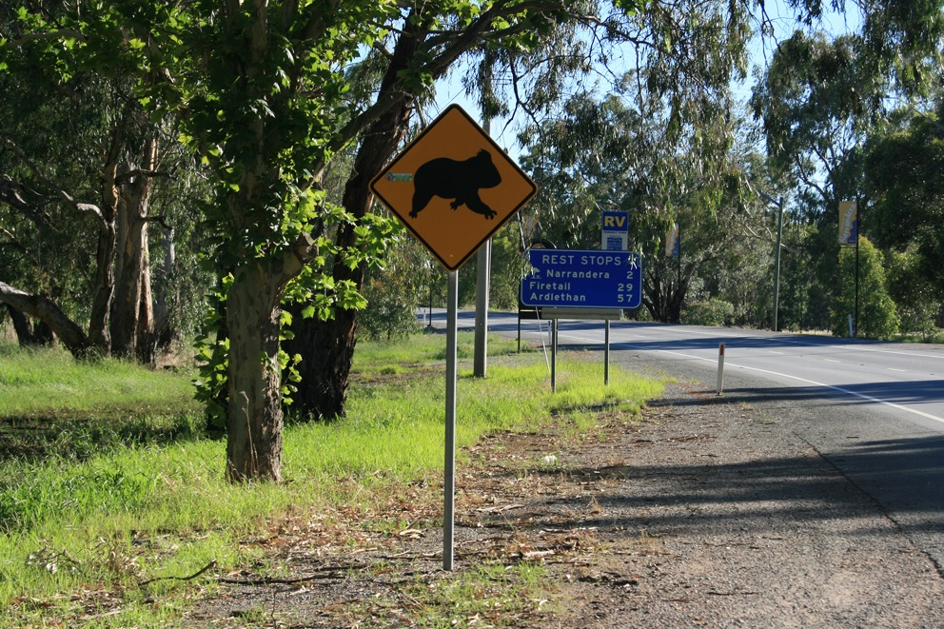
An iconic road-side sign warning drivers to be aware of Koalas. Image: © S. Brown.

Strategy 4: Integrate listed Koala conservation into policy, statutory and land use plans
Management actions alone will not be sufficient to recover the listed Koala. Actions are needed to ensure harmonisation of existing and future planning and policy settings such that they collectively contribute to maximising the chances of long-term survival of Koalas in the wild.
Action no. | Description | Potential partners/responsibility | Priority | Timeframe | Indicative cost
4 a | Review and update the Species Profile and Threats database (SPRAT) environmental impact guidance documents relevant to the listed Koala, guided by the recovery plan, to support regulatory decision making. | Australian Government in consultation with state and territory governments, experts, planners and industry groups. | 1 | Year 1 | $80,000 to $150,000 per document plus absorbed by normal government business
4 b | Review, revise, and, where appropriate, strengthen statutory planning instruments and policies. Embed principles of landscape-scale management for the listed Koala into statutory planning. Include climate refugia.  Improve regulation and compliance practices at all levels of government, including local government.  These are to avoid or minimise impacts of land use or land management on listed Koala conservation consistent with the recovery plan. | Governments appropriate to scale (see Part III Implementation for potential partners/stakeholder consultation). | 1 | Year 1 and ongoing | Absorbed by normal government business as new instruments and policies are reviewed, and compliance practices are applied
4 c | Ensure identification and implementation of any offset decisions are strategic at a landscape scale and informed by the recovery plan. These will draw on relevant planning and mapping documents such as natural resource management regional plans, regional implementation plans (Part III) Indigenous Healthy Country Plans or local government Koala strategies. | Governments appropriate to scale. | 1 | Year 1 and ongoing | Absorbed by normal government business

4 d | Incorporate the impacts of projected climate change such as drought, heatwave and fire, into all strategic Koala planning and actions, including restoration guidelines, offsets, translocation guidelines, forestry practices, corridor, reserve and protected area planning, allowing for iterative updates using a robust scenario-based approach. | Australian Government, state and territory governments in coordination with local governments and natural resource management organisations. | 2 | 5 yearly | Absorbed by normal government business
4 e | Build on existing information to develop national guidelines or standards for Koala-friendly urban design. | Australian Government to coordinate state and territory government agencies, in consultation with local governments; (including, but not limited to, road authorities); and urban planners. | 1 | Year 1 and ongoing | $80,000 to $200,000  Plus normal government business
Strategy 5: Strategically restore listed Koala habitat
Restoration increases the overall habitat available for Koalas and increases the connectivity between areas of habitat, which is important to the long-term survival of listed Koala populations. Many Landcare-type organisations are restoring lost and degraded habitat for many species or improve environmental functions. These activities are to ensure that resources are targeted to the most strategic areas.
Action no. | Description | Potential partners/responsibility | Priority | Timeframe | Indicative cost
5 a | Build on and implement landscape-scaled habitat restoration plans. To facilitate movement and re-occupation, consider landscape-scale processes such as climate change, fire and drought, and Koala movement patterns. Draw on natural resource management plans, regional implementation plans (Part III) based on up-to-date mapping and spatial analysis and climate change projections. | Coordinated approach between states and territory governments; local governments; natural resource management organisations; and non-government organisations. | 1 | Year 1 and ongoing | Highly variable depending on size and location of area:  $5,000 to $50,000 per document, plus in-kind contribution through normal government business

5 b | Build on guidelines where they exist (e.g. New South Wales Koala habitat revegetation guidelines [Wegner and Taws 2019]), to develop and implement best practice revegetation and restoration guidelines appropriate to local conditions. Guidelines are to include planning for drought, heatwave, fire, and eucalypt responses to climate change using a robust scenario-based approach, consistent with national standards for ecological restoration (SERA 2017). | Coordinated between state and territory governments with input from research experts; Expert Technical Advisory Panel; natural resource management organisations; and local community groups and non-government organisations. | 2 | Years 1 to 5 | $80,000 to $120,000 to coordinate and contract by the Australian Government; plus absorbed by normal government business
5 c | Implement on-ground revegetation or restoration programs in previously cleared areas of Koala habitat, following local-level restoration guidelines for the Koala where they exist (e.g. New South Wales Koala habitat revegetation guidelines [Wegner and Taws 2019]). Actions should be undertaken in consultation with experts in Koala ecology and plan genetics, and should include experimental trialling of the establishment of climate resilient and nutritious feeding trees outside traditional ranges of Koala habitat trees. | Coordinated approach between states and territory government agencies; local government; natural resource management organisations; local community groups and non-government organisations. | 2 | Years 1 to 5 | $500 to $5,000 per ha (revegetation)  $2,500 to $5,000 per ha (weed management)
5d | Improve the condition of existing Koala habitat on both private and public land through best-practice land management, including management of vegetation, fire, weeds, and introduced species. | State and territory government land-management agencies; local fire authorities; natural resource management organisations; non-government land-owners; local community groups, traditional owners and non-government organisations. | 2 | Year 1 and ongoing | Absorbed by land management business under normal review practices.  Highly variable depending on location and risk: $50 to $1,000 per ha (fire management)
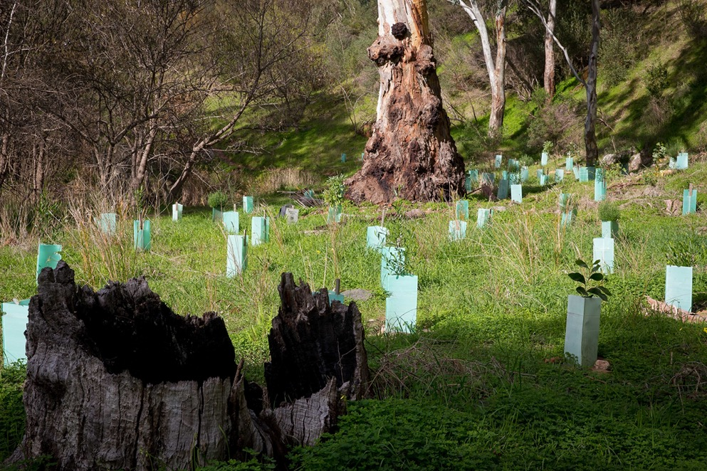
Revegetation projects provide food trees for future Koala populations. Image: © Shutterstock.
Strategy 6: Actively manage listed Koala metapopulations
Metapopulation management concerns the movement of individuals and their genes between populations to maintain and potentially improve genetic diversity. It is a complex and multi-faceted process.
This strategy relies heavily on relevant and up-to-date habitat and distribution mapping and modelling for spatial prioritisation, modelling impacts of climate change, principles of landscape processes, and research into Koala disease, population genetics habitat requirements, movement patterns, and biology. Management of fire, forest harvesting, and human activities and developments all influence Koala metapopulations processes and must be managed to mitigate adverse impacts.
Action No. | Description | Potential Partners/Responsibility | Priority | Timeframe | Indicative cost
6 a | Develop meaningful and measurable metrics of health, genetics, population and distribution, and climate at relevant planning scales, with threshold triggers for management response. Integrate these triggers into metapopulation management, decision making and programs. Implement response plans. | Australian Government, state and territory governments, with input from research experts; National Koala Monitoring Program; the Expert Technical Advisory Panel and National Recovery Team; Koala rehabilitation organisations and groups, Wildlife Health Australia and the Zoo and Aquarium Association. | 1 | Years 1 to 5 | Absorbed by normal government business
6 b | Develop national principles for conservation translocation decisions for the Koala (see section 12.3) consistent with IUCN guidelines (IUCN/SCC 2013) to capture and maintain genetic diversity of the species, strengthen resilience of populations, manage and ameliorate disease and other risks, and complement state and territory translocation policies. (NB. This should complement, not duplicate Action 2g). | Coordinated by the Australian Government with state and territory government agencies, with input from research experts; the Expert Technical Advisory Panel and the National Recovery Team; Koala rehabilitation organisations or groups, Wildlife Health Australia, the Zoo and Aquarium Association, and the RSPCA. | 2 | Year 2 and 5 yearly | $80,000 to $120,000 to coordinate and contract by the Australian Government; plus absorbed by normal government business
6 c | Regionally assess the feasibility, risks and cost-effectiveness of fire management options that seek to deliver long-term, strategic and landscape scale enhancement of the extent, and quality of current and future suitable habitat across tenures. | State and territory agencies with input from fire research experts; Expert Technical Advisory Panel and the National Recovery Team; local fire authorities; local governments and natural resource management organisations. | 1 | Years 1 to 5 | Absorbed by normal landholder and government business as plans are reviewed

6 d | Develop and implement fire management that effectively secures and promotes long-term, strategic and effective protection of known populations and suitable habitat. | State and territory agencies with input from fire research experts; Expert Technical Advisory Panel and the National Recovery Team; local fire authorities; local governments and natural resource management organisations; traditional owners and managers. | 1 | Years 1 to 5 | Absorbed by normal landholder and government business as plans are reviewed
6 e | Develop and implement response and decision-support tools for individual and population management in emergencies such as bushfire, drought and floods. These include support and coordination of carer networks. | Coordinated by the Australian Government with state and territory governments with local governments and agencies, natural resource management organisations; local fire authorities; and Koala rehabilitation organisations and groups, Wildlife Health Australia, the Zoo and Aquarium Association, and the RSPCA; with input from research experts; the Expert Technical Advisory Panel and the National Recovery Team. | 1 | Years 1 to 5 | $400,000 to $1 m  Absorbed by normal government business, plus in-kind contributions by organisations
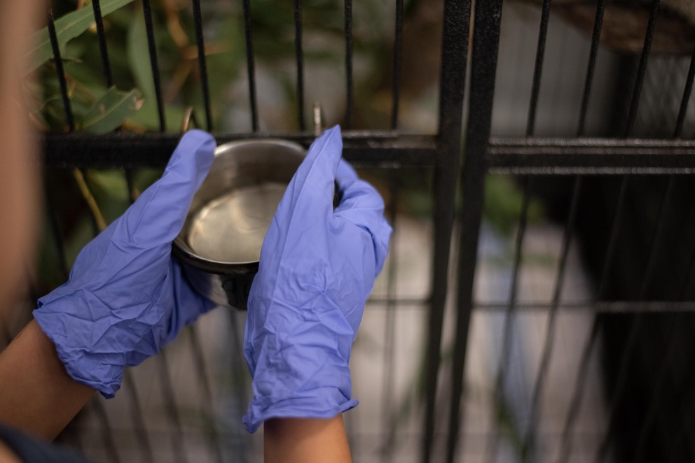
Carer refreshing water for a Koala in care. Image: © Marta Yebra.

9. National Koala Monitoring Program
Adaptive monitoring and subsequent management will underpin effective conservation of the listed Koala. Adaptive management is a structured, iterative approach to decision making that incorporates formal learning processes (both technical and social) into conservation actions to improve their effectiveness in the face of uncertainties (Williams and Brown 2014). An adaptive management framework for the listed Koala will be developed.
Measurement of performance against the three national objectives, and by implication the effectiveness of actions at local scales, requires monitoring of Koala populations in a statistically robust manner. Monitoring Koala populations is essential to document existing conditions, detect trends and increase predictive capacity and to understand the local threats and drivers of decline or recovery. To meet this end a National Koala Monitoring Program is being implemented and co-designed in partnership with CSIRO and in consultation with states and territory governments, local governments, natural resource management organisations, Indigenous Australians, community and industry groups, and researchers. Monitoring will be conducted across the entire species’ range (Action 1d and e).
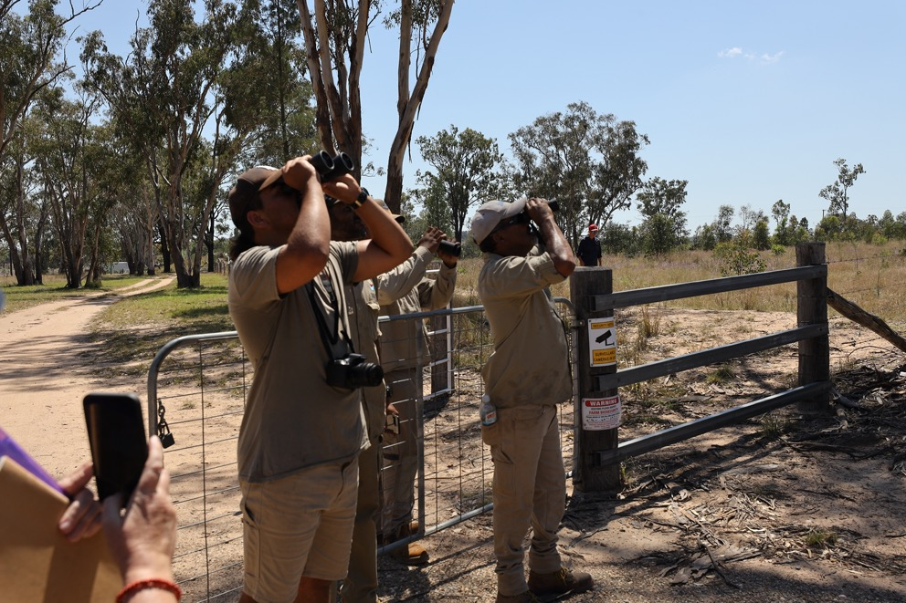
Queensland Murray-Darling Rangers undertaking surveys for the Koala as part of the National Koala Monitoring Program. Image: © CSIRO and QMD Catchment Limited.
The National Koala Monitoring Program is intended to complement and augment existing state and territory monitoring and reporting programs, targeting spatial and temporal information gaps. The key objective of the monitoring program is to connect with, and build on, existing Koala monitoring efforts and implement a long-lasting program to assess and respond to changes in Koala population size, health and condition across their distribution. It will:
- deliver a robust estimate of Australia’s Koala population
- provide a baseline on numbers, health and condition for Koalas from which the effectiveness of conservation actions and investments can be measured
- support future assessments of Koala threats and conservation status
- support strategic Koala conservation and monitoring
- collate existing data and identify knowledge and monitoring gaps for further assessment
- investigate how new tools and technologies can support Koala monitoring.
This program includes the Koala populations of Victoria and South Australia. The states and territory have established or ad-hoc Koala monitoring programs of varying size and effort (in space and time), based on a range of methods and tailored to reflect each jurisdiction’s needs and questions.
The design, analysis and synthesis of the National Koala Monitoring Program will account for strengths, weaknesses and biases of the many survey methods commonly used. A Community of Practice in Survey Methods (Action 1h) will be developed as a guide to assist stakeholders conducting field-based Koala assessment activities, e.g. consultants, researchers and citizen science groups in employing the most suitable method for given circumstances.
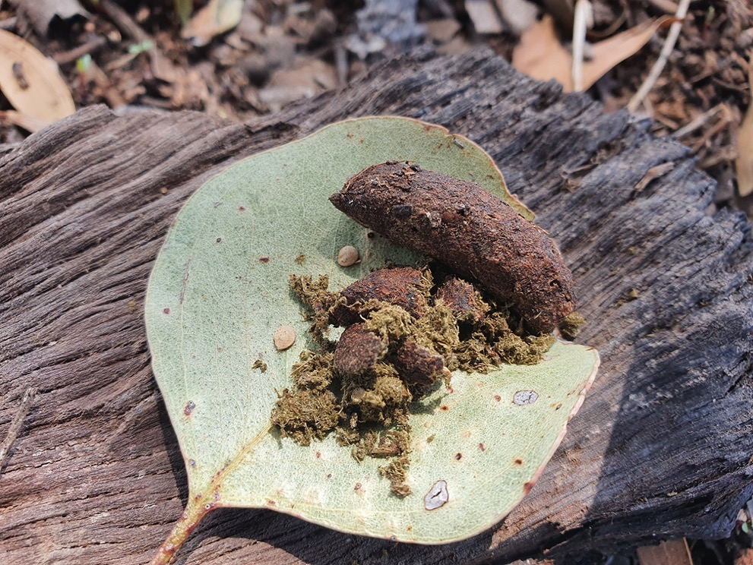
Koala scats are used in detecting Koala presence and for extracting DNA. Image: © C. Robinson, CSIRO.
Because of the large geographic range of the Koala, partners and citizen scientists will play a significant role in the National Koala Monitoring Program. This recovery plan aims to support and build capability of interest groups and individuals to establish a long-term monitoring program with the support of researchers and governments of all levels.
The program integrates with a national Koala Health Initiative (delivered by the University of Sydney Koala Health Hub) and habitat restoration program for the listed Koala (delivered by Regional Land Partnerships Service Providers, non-government organisations and NSW government agencies) (section 14.1).
The National Koala Health Initiative includes three streams of work, with the inclusion of Koala health and condition monitoring as part of the National Koala Monitoring Program. This work will develop a standardised Koala health monitoring protocol/s which can be implemented alongside activities being carried out as part of the monitoring program. The Koala health monitoring protocol will be designed, trialled, and implemented under the program.
Habitat restoration projects for the listed Koala in New South Wales and Queensland will be monitored under the program to measure effectiveness of management actions in recovery. Likewise, the monitoring program will also provide for integration with other Koala projects/programs such as the genomic sequencing of Koalas across their range (funded in part through the Australian and NSW governments) which may provide novel insights into the drivers of population dynamics.

9.1 Governance structure
A proposed model is a Technical Steering Committee to steer and coordinate the National Koala Monitoring Program across jurisdictions (Figure 5). Each jurisdiction and the Australian Government will support and promote collaboration and coordination in their respective jurisdictions across different agencies so that the National Koala Monitoring Program is complementary and coordinated at a national level. An Indigenous led Community of Practice will work with the state and territory agency representatives to help guide project team efforts to support Indigenous co-design and participation. At invitation, representatives from community groups and organisations may participate in meetings or be invited to participate in sub-groups.
Figure 5. Proposed governance structure of the National Koala Monitoring Program and relationship with the National Koala Recovery Plan, and the state and territory strategies and plans, and committees. CoP = Community of practice; NGOs = Non-government organisations
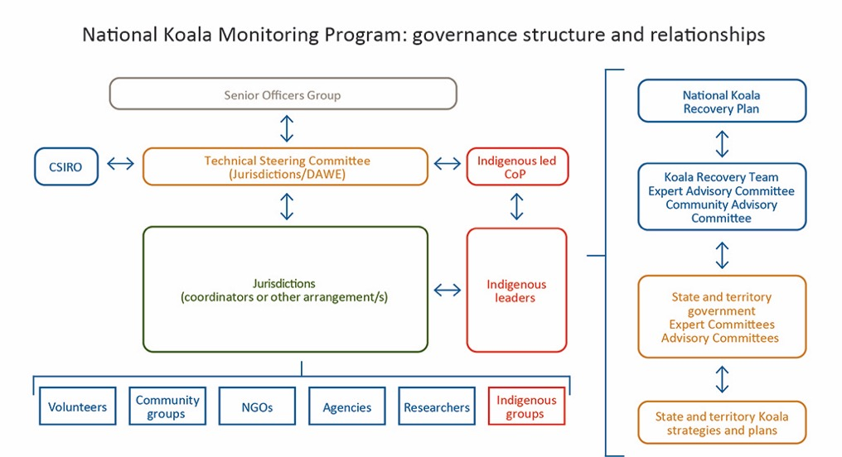

PART III
Implementation

10. Introduction
This recovery plan is a national framework to recover the listed Koala with the Australian Government taking a lead role in coordination.
Conservation planning and recovery is a long-term proposition. Implementation of this recovery plan will require on-going commitment and collective action by major partners and the wider community, through effective consultation and co-design, building on the many actions already underway (section 14). Implementation of actions is guided and underpinned by a set of principles.
Principles
Engagement with Indigenous Australians
Recognise the role of Indigenous Knowledge, custodianship and cultural connection in Koala management, and the importance of respectful scientific collaborations and engagement with Indigenous Australians. Culturally sensitive information and ecological knowledge is curated appropriately and respectfully.
Community engagement
Promote partnerships among governments, agencies, organisations, industries, Friends’ groups and individuals across Indigenous and non-Indigenous communities and individuals in the co-design and collaboration of actions to recover the listed Koala.
Knowledge sharing and building capability
Data, information and products for the recovery of the listed Koala are openly available in a timely manner, where possible, for policy makers, resource managers, the science community, welfare staff and carers and the Australian community. Knowledge is shared to build capability.
Functional ecology
Actions are underpinned by landscape-scale functional ecology, with actions directed at the unit of the population.
Relevant and quality science
Employing the latest knowledge, techniques and innovations, and robust monitoring designs, methods and assessments in management of the listed Koala.
Adaptive management
Science-based adaptive management underpins actions to recover the listed Koala. There are uncertainties about some conservation management actions, so implementation of actions in this recovery plan should address knowledge gaps, be flexible and adaptive.
Decision making
Decision making is founded on sustainable development principles, considering the functional needs of listed Koala populations at the landscape scale. The latest research and quality science underpins decision making and policies.
Investment
Investment for the listed Koala recovery is prioritised with respect to actions set out in the recovery plan, targeting areas that maximise recovery.

11. Governance, Recovery Team and structure
The Australian Government will coordinate the implementation of the recovery plan (section 4). A governance structure will be agreed between the Australian Government, and state and territory governments. A proposed option is to have a group comprised of the Australian and state and territory governments to liaise among jurisdictions and to act as an enabler to guide conservation actions for the listed Koala.
A Recovery Team will be established with supporting Expert Technical Advisory and Community Advisory Committees to provide advice to the Recovery Team as required (Figure 3, Action 1k). These groups will work with and complement but not duplicate existing groups established at the level of the states and territory.
The Recovery Team will be the nucleus to collaborate and coordinate recovery effort, and will be formed in accordance with best practice governance guidelines established by the Australian Government (http://www.environment.gov.au/biodiversity/threatened/recovery-teams).
The Recovery Team will be representative of the diversity of those engaged in Koala research, conservation management, community activities, social sciences and Indigenous Australians. It will monitor progress in implementation, share and review information, identify funding opportunities and report on progress.
Two committees will provide support to the Recovery Team:
- an Expert Technical Advisory Committee, which will provide technical support across various disciplines of conservation and social sciences
- a Community Advisory Committee, which will have representation of the wide range of groups with an interest in Koala conservation, welfare and rehabilitation, and interested industry groups to disseminate and share information (Figure 3).
The time required to commit to a Recovery Team and any supporting committees will likely be significant and therefore it is anticipated that most members will be supported by their parent organisation or affiliation. To share the anticipated workload fairly, the structure of these groups may need to be made up of multiple members representing various disciplines. These also can provide the opportunity for emerging early career researchers, and staff of partner organisations to gain valuable experience by sharing best-practice by senior personnel.

12. National coordination, regional implementation

12.1 National implementation pathway
Within twelve months of the making of the recovery plan, the development of a National Implementation Pathway will be led by the Australian Government and subject to negotiation with key partners through which agreement is reached on partner responsibilities, contributions, governance arrangements, risk management, commitment to agreed actions, data-sharing arrangements, and reporting structure, once the recovery plan is in place. This will be underpinned by principles on cooperation. This recovery plan will also be augmented by appropriate regional-scale plans (Action 1c, section 12.2).
Potential implementation partners will be identified for every action, while affected interest groups will be consulted as required (section 16.1), noting partners and affected interest groups may not necessarily be mutually exclusive.
Broadly, these will include, but are not limited to:
- Australian Government, state and territory government agencies and local governments with statutory responsibilities to protect and manage the listed Koala and its habitat
- Key Koala conservation stakeholders and organisations representing smaller groups such as: natural resource management organisations; non-government conservation organisations; professional veterinary and zoological organisations for Koala health and welfare; research institutions; scientists; consultancies; community organisations and Indigenous community groups
- Industry and land-management organisations and agencies such as: urban and property development organisations; infrastructure and building industry organisations; local fire authorities; landowners; farming-based organisations; forestry-based industry groups; tourism organisations, and energy and mining industry groups.

12.2 Regional implementation plans
This recovery plan will be implemented through regional-scale implementation plans (Action 1c) in consultation with the wider community and affected interest groups. These plans will provide for fine-scale Koala habitat mapping, prioritisation of spatial and resource attributes for the Koala, localised threat risk assessments, local-level land management actions and population management. While local-level strategies or plans have been developed by many local government councils and natural resource management organisations, gaps exist.
Regional-scale implementation plans will be prioritised for regions of poorly understood populations or populations potentially at greatest risk. This prioritisation seeks to complement that currently undertaken by state or territory jurisdictions.
Due to the heterogeneity of threats (section 19), social and economic interests, land use, and natural patterns of variation across the distribution of the Koala, this recovery plan will be implemented through regional scale implementation plans.
Bioregions represent one potential scale, where gaps exist, as a basis for intermediate level planning at a scale that can be informed by the recovery plan and state/territory-level strategies, while also having the capacity to incorporate fine-level habitat analysis, planning and an understanding of the nature and risk of local threats to listed Koala recovery. Such planning approaches already exist in many areas, for example, Queensland has a South East Queensland Strategy (DES 2020a) and New South Wales has Koala Management Plans under the NSW SEPP (section 4.2).
Implementation of the recovery plan will require the refinement of priorities of the strategies and actions outlined here. Additional mapping, ground truthing, monitoring and research may be required to develop these bioregional plans. The development of the plans themselves will require prioritisation, with highest priority given to bioregions where key populations are under most threat or of importance for functional recovery and not currently addressed in state or local level planning. These will be developed in partnership with state, territory and local governments, government authorities, in consultation with key interest groups and affected groups (section 16.1) relevant to the bioregion.

12.3 Conservation and other translocations
Translocation is a tool widely adopted in species conservation and is commonly used following the rehabilitation of displaced or injured Koalas. The International Union for Conservation of Nature (IUCN) sets out a framework for conservation translocation decisions (IUCN/SSC 2013) under which Australian governments operate. The goals or objectives of any given translocation depend on the circumstances and the intended outcomes. The IUCN classifies translocations based on their primary intent, and fall into one of the following two categories:
1) Conservation translocations (including conservation introductions): to improve the status of the species via population restoration (re-introduction or reinforcement) or introducing a species beyond its former range.
2) Other translocations: accidental, non-lethal control, rehabilitation, commercial/recreational (including salvage from land use change), religious, biological control, animal rights liberation or aesthetic reasons. These are not considered conservation activities.
While the states and territory have their own translocation policies and processes for plants and animals, this recovery plan recognises the need to foster consistent approaches to conservation translocation decision making by developing guidelines and principles for the listed Koala.
Action 6b of the recovery plan is intended to address decisions relating to conservation translocations. Although unintended, such guidelines or principles are likely to be relevant to other translocations that may have potential impact on the conservation of the species. A Koala translocation guideline document will assist in decision making on conservation translocations may be considered as a response to projected climate change and for the maintenance of a healthy, genetically connected metapopulation. It will outline a set of principles to enable a transparent, consistent, and coordinated approach to decisions on Koala conservation translocations. It will be based on up-to-date knowledge and will include considerations such as population structure and gene flow, genetic diversity, disease, and landscape context to guide decision making on conservation translocations for the listed Koala. This document will be developed under the guidance of the Expert Advisory Committee (or sub-group with relevant expertise) in consultation with stakeholders.
This guideline is not intended to address decisions relating to captive care and breeding of Koalas, or protocols for the welfare, treatment of disease and trauma, and care of transferring Koalas among facilities or to the wild. These are addressed by other relevant national and state policies and guidelines and, where required, through updated national documents (Action 2g).

13. Schedule and costs
The conservation of the listed Koala across a large geographic range will require considerable investment from partners, interest groups, volunteers, in-kind contributions (such as regular government business or volunteer revegetation contributions) and funds to undertake the actions.
Implementing this recovery plan is subject to budgetary and other resource opportunities and constraints affecting partners. The cost of implementing this recovery plan should, where possible, be incorporated into the core business expenditure of partner organisations and through additional funds obtained for the explicit purpose of implementation. A key action upon formation of a governance structure to steer implementation of the recovery plan will be to prioritise and assign relative budgets against these under the National Implementation Pathway (section 12.1).
The majority of actions have draft prioritisation against each (categories 1–2) to the extent practicable, while most costings are estimates for the following reasons:
- Actions cross-cut across multiple threat management actions and supporting actions.
- The risk presented by each threat varies across the distribution of the Koala, hence the priority for actions varies by location.
- Action priorities at specific locations are likely to change within the life of the plan, and the complexity of threat management actions preclude prescribing priorities.
- Threat management is adaptive, and therefore effort will need to change in space and time.
- Knowledge of the effectiveness of threat management actions is incomplete, and therefore new knowledge informed by research may alter management approaches.
- Many actions cannot be accurately costed, or are weather and bushfire dependent, or are part of existing core business and resourcing.
- Some actions are predicated on outcomes of other actions (e.g. mapping) or research.
- Planning legislation, regulations and policies, and how they influence local threat management actions, varies widely at the state and local government level.
- Many actions are underway by state and local governments and conservation groups.
Total costings for the actions of the recovery plan are presented by priority and year in Appendix 1.

14. Current recovery actions
Many actions, or parts of actions in this plan, are underway through Australian Government and state-led investment programs, plans or other conservation efforts for the listed Koala. In addition many non-government organisations, Friends’ groups, community groups and individuals are contributing outside government funded projects.
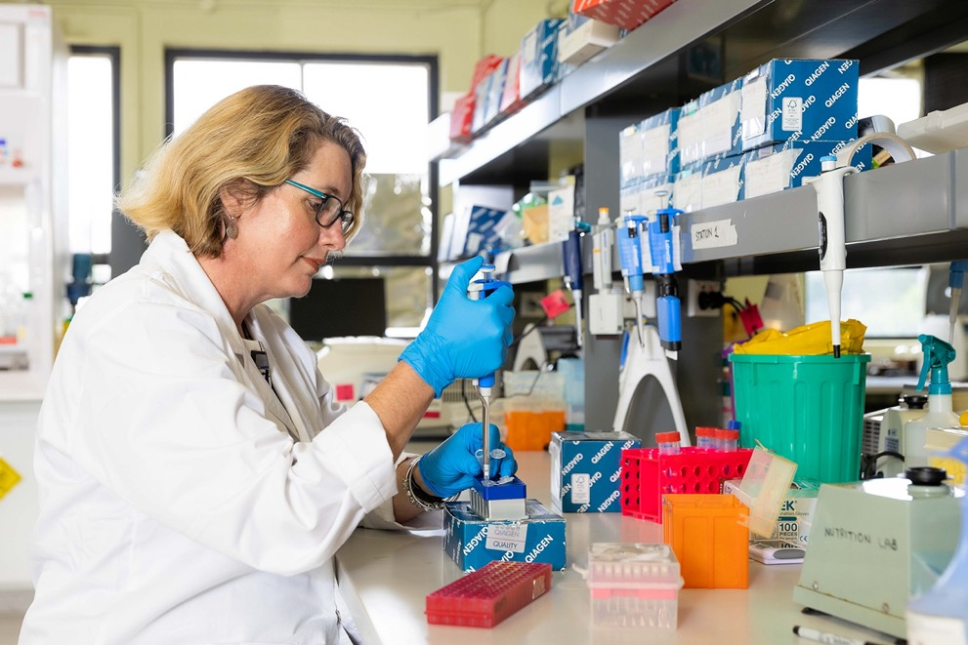
Sequencing the Koala genome. Image: © University of Sydney.

14.1 Australian Government
Since 2019, the Australian Government has committed $74.3 million over six years to the conservation of the listed Koala. This includes $12 million to establish and implement a National Koala Monitoring Program (including Victoria and South Australia) (section 9), which will build on and complement existing monitoring led by state and territory governments and other organisations. Another $8.3 million is to support the Koala Health Initiative, genetics research, care and treatment, and $47 million for habitat restoration projects.
The Koala Health Initiative includes wildlife treatment and care training for vets and vet nurses, a national-level Koala disease risk assessment and a suite of practical and applied Koala health research projects. In partnership with the NSW and Australian Governments, Taronga Conservation Society Australia is delivering training for vets and vet nurses in wildlife treatment and care, with a specific module focused on Koala care. The Koala disease risk assessment and research projects are being delivered by the Koala Health Hub at the University of Sydney.
The Koala disease risk assessment will identify diseases at a national level that require intervention, effective mitigation strategies and priority research gaps. Additional applied research projects include: investigating the significance of key pathogen and host traits; developing testing for key pathogen and host traits (including Chlamydia pecorum, Koala retrovirus (KoRV) and Koala herpesvirus); determining the spatial distribution of Koala diseases; investigating the distribution and treatment of sarcoptic mange (caused by the mite Sarcoptes scabiei); developing scat-based methods to support Koala health monitoring; and preventing captive transmission of C. pecorum.
In addition, in partnership with the NSW Government, the Australian Government is funding the genomic sequencing of Koalas from across its range, delivered by the University of Sydney. This project will analyse functional genes including those for heat shock, taste receptors and disease resilience. Information from this project will inform conservation management actions such as translocation to improve or augment population resilience from infectious diseases (section 19.4), physiological resilience from heatwaves and drought (section 29), maintain or improve gene flow and metapopulation processes (section 20.3) and improve our understanding of the variation in fine-scale habitat preferences by Koalas (section 28) and population structure (section 22).

14.2 NSW Government
The first NSW Koala Strategy (2018–21) aimed to address key threats to stabilise and then increase koala numbers in the wild. The NSW Government’s $44.7 million investment to deliver the strategy secured significant outcomes, including:
- adding more than 4,400 hectares of Koala habitat to the New South Wales national park estate, setting aside more than 8,900 hectares of state forest for Koalas and conserving 2,834 hectares of Koala habitat on private land through conservation agreements
- delivering more than 70 local Koala conservation actions in partnership with community groups, councils and universities, including habitat restoration, dog attack and vehicle strike mitigation
- working with seven Indigenous communities to support regenerating and protecting Koala habitat through cultural land management activities
- partnering with Taronga Conservation Society Australia to deliver a world-class professional development course in wildlife care (see section 14.1)
- developing and releasing the Koala Habitat Information Base, which delivers the best available state-wide spatial data on Koala habitat, likelihood, Koala preferred trees and Koala sightings for New South Wales
- developing and publishing the New South Wales Koala Monitoring Framework and commencing implementation with ten partners
- launching the ‘I Spy Koala’ app to allow members of the public to record Koala sightings, and running the Community Wildlife Survey, which received more than 7,000 public responses, including 2,199 sightings of Koalas
- support for the volunteer wildlife rehabilitation sector through grants and resources for the improvement of standards to enhance animal welfare and post rehabilitation release outcomes.
Building on this work, in 2020 the NSW Government committed to doubling the New South Wales Koala population by 2050. In May 2021, the NSW Government announced more than $193 million in funding to meet this goal.

14.3 ACT Government
The ACT Government protects suitable Koala habitat within Namadgi National Park. The ACT Government manages Namadgi National Park and its surrounds for fire, weeds and other threats. Habitat in the Australian Capital Territory may be suitable for the establishment of insurance populations to retain and conserve local genetic diversity, or as future translocation sites. These areas are also potential refugia in the future under climate change.
Although the ACT Government does not directly manage wild populations of Koalas, ad-hoc surveys are undertaken in areas that may potentially support them. Recent surveys did not detect any evidence of Koalas in the wild in the Australian Capital Territory (ACT Scientific Committee 2019). At Tidbinbilla Nature Reserve, the ACT Government breeds Koalas (originating from Victoria) in captivity for display and educational purposes.

14.4 Queensland Government
The Queensland government has commenced the implementation of the South East Queensland Koala Strategy with funds for $4.48 million (ex GST) to the Koala Habitat Restoration Program in cooperation with Queensland Trust for Nature. This includes $1.2 million (ex GST) of Land Restoration Fund funding to demonstrate carbon farming opportunities can facilitate Koala habitat restoration. Already 90,000 trees have been planted over 100 hectares across seven sites in South East Queensland. The Queensland government has also invested more than $7.5 million into the South East Queensland Wildlife Hospital Network since it was established in 2016. The 2021–22 budget commits a further $6 million over four years and $1.5 million per annum to ongoing support for the South East Queensland Wildlife Hospital Network.
The Queensland Government’s direction for the conservation and habitat protection of the listed Koala is detailed in the South East Queensland Koala Conservation Strategy 2020–2025. This strategy establishes a vision to halt the decline of Koala populations in the wild in South East Queensland. The strategy has been built around six action areas for habitat protection and restoration, threat management, improved mapping monitoring research and reporting, community engagement, and partnerships and strategic coordination. It was guided by the findings of the 2017 Koala Expert Panel report.
Key targets have been developed to track progress against the vision, including stabilising Koala populations in South East Queensland, securing a net gain in Koala habitat, restoring Koala habitat and introducing threat reduction programs. A number of the actions in the strategy have already commenced, including the development of state-of-the-art Koala habitat mapping for South East Queensland and amendments to the land use planning framework to deliver an increase in both the size and level of protections for Koala habitat in South East Queensland.
A detailed implementation plan and monitoring, evaluation, reporting and improvement framework is under development in partnership with a range of key delivery partners.

15. Community interests and roles

15.1 Indigenous communities
Indigenous Australians have a relationship with the Koala extending back many thousands of years (section 1.1) and are continuing to lead the management of healthy Koala habitat in many regions of Australia. Their involvement in the decision making and co-design of projects as well as the on-ground implementation of actions set out in this plan will be actively sought. Individuals and groups will be supported to contribute to citizen science, ecological restoration and Koala recovery projects on both traditional owner managed lands and other land tenures.

15.2 Community conservation for the listed Koala
This recovery plan recognises the many small groups and individuals who are committed to conservation of the Koala in their local areas through habitat restoration activities, caring for injured and sick animals in rehabilitation, or involvement in research (citizen science). It outlines actions to support and build capability of these groups. Likewise, representatives of these many groups will be actively sought to be involved in the actions set out in the plan and contribute to the recovery of the listed Koala.

16. Potential benefits and impacts

16.1 Affected interests
Government institutions likely to be both major partners and affected by the actions proposed in this plan include Australian Government and state government agencies, local government, particularly where there are environmental, transport and road, urban planning, resources or forestry responsibilities.
The private sectors likely to be affected include timber production, grazing and agriculture, mining, and commercial and residential development interests and tourism operators.
It is imperative that affected interest groups are effectively engaged and consulted with in the implementation of many actions directly affecting these groups. This is particularly for those actions related to dedicating state Crown lands (Action 3a) to protected areas, and statutory planning and policy (Action 4b and 4c). Groups notably potentially affected by these types of actions include the energy extraction and mining industries, and land developers and the grazing and agricultural industries respectively.
The South East Queensland Koala Conservation Strategy 2020–2025 (DES 2020a) represents a relatively successful planning approach, undertaken in consultation with interest groups, at a bioregional scale that is fit for purpose and is a bespoke response to the issues affecting the management of Koalas in South East Queensland. The alignment of the national recovery plan with regional implementation plans, regional partnerships as part of a statewide plan, or similar existing products (Section 12.2, Action 1c), potentially represents a model to implement across other priority regions. Such an approach may provide a benefit of long-term certainty to conservation planning as well as for investment by industry groups for residential and commercial development, with its associated service corridors and infrastructure.
Other potential partners or those groups and individuals with a strong interest in the recovery of the listed Koala include Koala advocacy and Koala welfare groups, scientists, natural resource management organisations, Indigenous communities, ecological consultants, land holders (farmers, rural residential and developers), non-government conservation organisations, wildlife interest groups, individuals and citizen scientists.
Habitat for the listed Koala spans most land tenures, with over half on private lands (Table 2) ranging from small residential housing to large tracts of rangelands, woodlands or forests. Consequently, successful consultation and engagement with all types of land-owners will play a major role in the success in meeting the recovery plan’s goal and objectives. To facilitate this, a comprehensive communication and engagement strategy is proposed for the implementation of this plan (Action 2i).
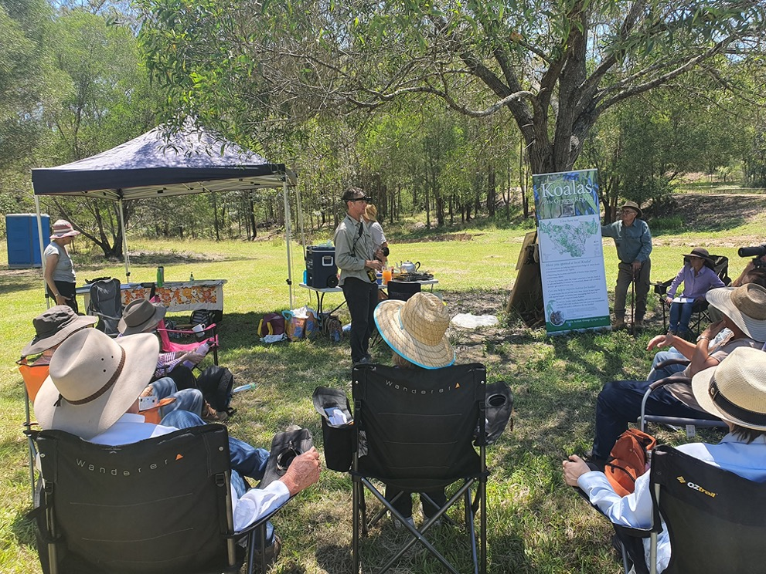
A community group receiving instructions on surveying Koalas, Gympie, Qld. Image: © CSIRO.
Table 2. Proportion of forest or woodland by land tenure across the listed Koala’s modelled habitat and states. Source: ABARES 2018; Runge et al. 2021a
Land tenure | Listed Koala | Queensland | NSW | ACT
Private | 57.2% | 55.4% | 61.4% | <0.1%
Leasehold | 13.9% | 20.5% | 0.7% | 18.3%
Multiple-use public | 12.0% | 12.5% | 11.0% | 11.0%
Nature conservation reserve | 13.4% | 8.6% | 22.5% | 60.8%
Other crown land | 3.5% | 3.0% | 4.4% | 9.8%

16.2 Social and economic considerations
The implementation of this recovery plan is expected to have social and economic benefits and costs. Proposed activities, including development, may need to be modified and adjusted to reduce the likelihood of a significant impact upon the listed Koala. Measures to assist recovery of this species that involve restrictions on the use or management of land may result in economic impacts to affected industries. Conversely, engaging positively with the sectors may provide benefits in terms of achieving sustainability certification, such as for forestry harvesting through forestry industry certification bodies, and ‘Koala-friendly’ suburbs may be attractive to residents and a way for developers and residents to demonstrate their commitment to sustainable communities and increase the amenity of landscapes.
As an iconic Australian species, enabling the recovery of the listed Koala is likely to assist the tourist industry by providing a positive image of Australia and encouraging visitors to regions where Koalas are recovering, in addition to areas where they currently exist. The recovery of the listed Koala will be an exemplary representation of broader efforts to manage Australia’s environment sustainably into the future.

16.3 Broader biodiversity benefits
The Koala is an archetypal umbrella species, whereby actions to manage and protect its habitat may likely provide benefits to many other species and enhance ecosystem functions. A recent study of how multiple species may benefit from actions taken to protect one species determined the Koala to be the second-most ‘umbrella-efficient’ species on the EPBC Act list (Ward et al. 2019a). A preliminary analysis conducted in 2021 (Kearney and Rumpff pers comm) estimated how many fauna species overlapped in their distribution with the listed Koala by at least 25% and would likely benefit also from habitat retention and restoration or fire management directed towards the listed Koala. There are approximately 33 fauna species that would benefit from habitat retention and restoration and 25 species that would benefit from fire management (43 unique species in total) (Appendix 2). An even greater number of plant species show similar overlaps and common threats.
Notably, the Greater Glider (Petauroides volans) (Vulnerable, and currently under re-assessment at the time of writing) and the Yellow-bellied Glider (Petaurus australis) (currently under assessment at time of writing), and other arboreal mammal species such as possums and bats, as well as forest owls, will benefit, and in turn provide ecosystem services such as pollination and pest control. Species that occupy the lower stratum of Koala habitat such as the Southern Brown Bandicoot (Isoodon obesulus) (Endangered) and small native rodents, especially those in urban fringes, might benefit not only from habitat protections and restoration, and fire management, but also from greater protection and reduction of threat from dog attack and vehicle strike. In the more arid landscapes of central Queensland and New South Wales, a different suite of species of open woodlands also occupies listed Koala habitat, notably nine listed Brigalow Belt reptiles, the Superb Parrot (Polytelis swainsoinii) (Vulnerable) and the Grey-headed Flying-flying (Pteropus poliocephalus) (Vulnerable).
The listed Koala is dependent on large tracts of forests and woodlands across eastern Australia. Revegetation of areas of previous koala habitat currently cleared across these landscapes will provide wider benefits to ecosystems and people by sequestering carbon dioxide from the atmosphere; reducing the extent and magnitude of drought (McAlpine et al. 2009); increasing connectivity between isolated habitat patches for other species; and enhancing thermal comfort and microclimate conditions for biota as well as humans.

17. Monitoring, evaluation and adaptation of the recovery plan
The recovery plan will establish an adaptive management framework that measures the progress of the plan’s actions. Monitoring of the plan will require ongoing assessment of the implementation and success of all actions, with regular reporting to the Recovery Team.
A statutory review of the recovery plan must be conducted within five years in accordance with the EPBC Act. This review will inform the need for any adaptation required within the plan, to identify and resolve any unexpected impediments, and to re-assess priorities for actions. The review will be coordinated by the Recovery Team. Due to the scale of this recovery plan, the Recovery Team will convene at an initial two-year period to review progress in implementing the plan and to inform a subsequent independent and identify any adaptations needed and changes in direction to inform the five-year review.
A comprehensive review of the implementation and success of the plan will be undertaken ten years after the making of this plan as a foundation for the development of a revised ten-year plan. This review will consider, among other things, trends in the status of the listed Koala and its habitat, effectiveness of actions described in this plan, new research findings and emerging issues, policy context, management capability and resourcing, and partner satisfaction with governance and other matters. The review will be conducted independently with input from the Recovery Team and other partners involved in the plan’s implementation.

PART IV
Threats and impacts

18. Introduction
The listed Koala is at most risk from climate change due to a shrinking climate envelope, along with wide-scale climate change effects that increase the frequency and intensity of drought and heatwaves, and increase the prevalence of weather conditions promoting bushfire (Adams-Hosking et al. 2011a; McAlpine et al. 2015; Runge et al. 2021b; TSSC 2021). Other major threats at a national scale are the clearing of habitat and the impact of disease (TSSC 2021).
The land use threats impacting the listed Koala include urbanisation; grazing and agricultural expansion; mining and energy extraction; and associated transport and service corridors infrastructure. The modification of natural processes that include vegetation change from native forestry and altered fire regimes (Figure 4).
These threats change ecological processes, impacting Koalas. These can be grouped into landscape processes including habitat loss, fragmentation and degradation and population effects (Figure 4). Disease can be thought of as both a naturally occurring direct threat in the case of epidemics, and an ecologically threatening process where land use change and climate change increase stress and disease in Koalas (Narayan and Williams 2016).
Changes in landscapes include changes in overall coverage of habitat, changes to patch size and number, changes to forest structure, loss of refugia, increased isolation and reduced connectivity, which collectively overall reduce habitat suitability and quality for Koala populations. These landscape effects in turn disrupt metapopulation processes at all scales via several pathways, such as:
- increased and sustained patch isolation may lead to inbreeding, reducing genetic health of isolated populations, ultimately reducing fecundity
- reduced habitat quality (e.g. loss of food and shelter trees, changes in hydrology, loss of suitable microhabitats, exposure to dogs and vehicles) can place increased physiological stress on individuals, increasing cortisol and other adverse inflammatory pathways in individuals which, in turn, increase susceptibility to disease and reduce fecundity
- habitat loss directly reduces carrying capacity of a given landscape, making populations more susceptible to extinction (the small population paradigm, Caughley 1994)
- loss of connectivity reduces natural movement such as the ability of individuals to disperse safely, therefore reducing gene flow and healthy levels of genetic exchange among adjacent populations
- fragmentation can increase mortality during movements made through the intervening matrix, for example, by dog attack and car strikes.
These landscape effects also disrupt natural processes which sustain Koala habitat, impacting the mortality, recruitment, nutrition, and climate adaptation of their food and shelter trees.

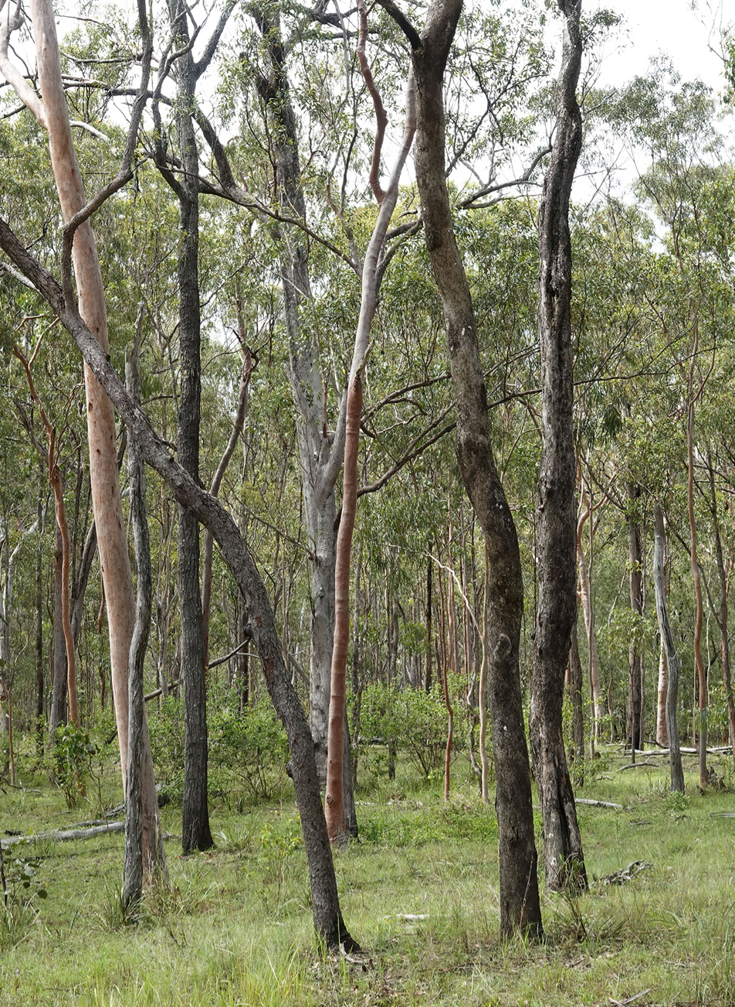
Eucalypt regrowth forest showing E. moluccana and C. citrioddora. The high elevation forest together with heavy summer rainfall makes such forest areas potential climate refugia for the listed Koala. Bluff Forest Reserve, far north Qld. Image: © Don Franklin.

19. Direct threats

19.1 Climate change
Climate change is a serious threat to Koala persistence across much of its distribution (see section 21.3). By 2030, more than 20% of listed Koala habitat is likely to be seriously impacted by climate change under high global emissions scenarios (Adams-Hosking et al. 2011a; Briscoe et al. 2016; Table 3). Under current climate trajectories, by 2100 near-normal and wet years will become much less frequent across much of the distribution of the Koala and the frequency of extreme drought and heatwaves is predicted to increase by 2100 (CSIRO and BOM 2015; Herold et al. 2018). The loss of climatically suitable habitat as a result of climate change may outpace losses from land use change within the next decade.
Drought and heatwaves leading to increased mortality are the predominant means by which climate change will impact Koalas (section 29). Recent rapid and substantial declines of Koalas in regions west of the Great Dividing Range from drought and heatwave are attributed to climate change (Seabrook et al. 2011; Lunney et al. 2017). These impacts are not confined to inland areas, in coastal New South Wales, climate change is adding to the cumulative impacts on already stressed populations (Lunney et al. 2014).
Most western populations are at greatest and most urgent risk from climate change and are likely to decline severely in the next decade and become extinct by 2070 unless climate change is halted (Appendix 3). Under high global emissions scenarios, there is a risk of widespread climate-driven extinction of Koalas by 2070 in most western populations including the Brigalow Belt, Mulga Lands, Mitchell Grass Downs, Darling Riverine Plains and Desert Uplands bioregions (Adams-Hosking et al. 2011a; Briscoe et al. 2016; McAlpine et al. 2015; Appendix 3). These populations may have traits and underlying genetics that mean they are better adapted to drought and heatwaves than are other Koala populations, and hence they are important to the survival of the Koala into the future (Kjeldsen et al. 2016; Lunney et al. 2017). Work is underway to determine which populations have traits that provide greater resilience to drought and heatwaves and to develop conservation actions for their persistence (Seddon and Schultz 2020). Isolated individuals may survive in local climate refugia, where microclimates, groundwater and habitat characteristics are favourable (Lunney et al. 2017; McLaughlin et al. 2017; Seabrook et al. 2014a).
Where ecosystems are already stressed from habitat modification and degradation, climate change is likely to exacerbate those stresses (Mac Nally et al. 2009; Steffen et al. 2009). Other processes interacting with climate change to impact the Koala include reduced fecundity brought about by stress (Lunney and Hutchings 2012; Davies et al. 2013); increased disease rates (Lunney et al. 2014); changes in the distribution and availability of their preferred tree species (Adams-Hosking et al. 2012; Drielsma et al. 2017; Hughes et al. 1996; Shabani et al. 2019); and altered fire regimes (section 19.3).
Furthermore, historic and ongoing habitat loss and degradation intensifies the effects of climate change on Koala populations by reducing the availability of climate-suitable habitat (Smith et al. 2013; Sullivan et al. 2004). Victoria, which holds unlisted populations of Koala, will become increasingly important as a habitat stronghold (Adams-Hosking et al. 2011a).
Table 3. Estimated losses of Koala distribution due to climate change under a high global-emissions scenario (A1FI or RCP8.5). Estimates are summarised across 13 projections of future Koala habitat (Adams-Hosking et al. 2011a, Briscoe et al. 2016)
These estimates consider the impacts of climate-change driven changes to droughts and heatwaves but not fire. Note that the magnitude of climate change by 2030 is relatively insensitive to future emissions. Estimates represent the change in area that was climatically suitable for the Koala based on conditions for the period 1961–1990 (Adams-Hosking) or 1991–2009 (Briscoe), and compared to the area that is expected to be climatically suitable for Koala in 2030, 2050 and 2070, within areas where Koalas or their habitat are known or likely to occur (DAWE 2021a). Negative values indicate a gain in climatically suitable area.
Population | Median % loss by 2030 (min, max) | Median % loss by 2050 (min, max) | Median % loss by 2070 (min, max)
Listed Koala | 20.9 (0, 48.7) | 35.2 (0, 67.4) | 45.2 (0, 83.3)
Queensland | 29.9 (0, 78.4) | 58.4 (0, 97.6) | 67.8 (0, 99.5)
New South Wales | 11 (0, 23.6) | 19 (0, 45.3) | 25.4 (0, 69.3)
ACT | 0 (-9.1, 5.1) | 0 (-9.5, 77) | 0 (0, 100)
Victoria | 2.6 (0, 20.4) | 10.5 (0, 33.8) | 16.3 (-0.2, 64.3)
South Australia | 2.5 (0, 25.5) | 6.6 (0, 53.3) | 12.8 (0, 91.3)
In addition to affecting Koalas directly, climate change also impacts the availability of preferred forage and shelter trees. Over the coming century, some eucalypt species preferred by Koalas may be lost from sites where they currently occur as conditions become climatically unsuitable for these trees (Booth 2017; González-Orozco et al. 2016). It is difficult to accurately predict how and where forests will change, as local genetics, disturbance history, soil, topography, and hydrology can all influence how native forests respond to climate change (Booth 2018; Booth et al. 2015).
Drought, heat, temperature increases and rising CO₂ will all influence eucalypt forests and may change the palatability of eucalypt leaves for Koalas (Adams-Hosking et al. 2012; Matusick et al. 2016; Matusick et al. 2018; Prober et al. 2016). These drivers all affect forests in different ways, and additional research is required to assess if and how these changes will affect Koala populations (DeGabriel et al. 2009). Bushfire effects on the nutritional value of eucalypt regrowth (e.g. epicormic growth) are unknown but research has been initiated.

19.2 Land use change
Land use policy and practices causing the loss, modification, and fragmentation of native vegetation cover is considered the most threatening of processes for decline in global biological diversity (Fahrig 2003; Maxwell et al. 2016) and is currently a significant threat to Koala populations in Australia (Cresswell and Murphy 2016; McAlpine et al. 2002, 2006a, 2015; TSSC 2012b).
The main cause of habitat loss is clearing for agriculture and resource extraction – steered in part by Australia’s role as a major exporter of food and energy resources – and habitat loss from clearing to accommodate a growing urban population and consequent urbanisation of Koala habitat (McAlpine et al. 2009). The pursuit of these economic goals and housing needs, with the associated development of infrastructure such as transportation (rail and roads) and service corridors (Figure 4), has impacted Koalas throughout most of their range.
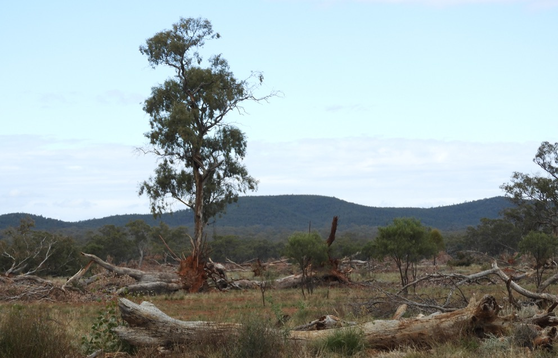
Clearing of woodland in western NSW. Image © Jennie Mallela.
Over one million hectares of forest and woodland within the Koala’s range was cleared between 2000 and 2017 (Ward et al. 2019b). The revised 2021 distribution for the Koala (this recovery plan, DAWE 2021a) is greater than the 2014 mapping used by Ward et al. (2019b), and consequently the area of cleared habitat is expected to be higher than the number reported in Ward et al. (2019b). Clearing associated with grazing during this period was the major driver of loss of Koala habitat, accounting for the majority of deforestation within the Koala’s distribution (Evans 2016; McAlpine et al. 2015). Large areas of woodland have been lost in western parts of the species’ range, including the Brigalow Belt, Mulga Lands, Darling Riverine Plains, Einasleigh Uplands and Desert uplands since 2000 (Ward et al. 2019b). These areas are home to large Koala populations (Adams-Hosking et al. 2016). Most clearing events occurred on freehold or leasehold land (Ward et al. 2019b).
Land-clearing continues to impact habitat across the listed Koala’s range (DES 2018; DPIE 2018). Clearing for mining and urbanisation has localised impacts on the Koala (Evans 2016; Ward et al.2019b). Urban expansion is concentrated along the eastern seaboard fringe of Queensland and New South Wales (Clarke and Johnston 2016), which is also a stronghold of the listed Koala. Low density and peri-urban development are expanding into forested and agricultural landscapes in these areas, while clearing for grazing and agriculture continues to occur across the Koala’s distribution. The expanding coal and coal seam gas developments of the past two decades and recent clearing for renewable energy projects represent additional but localised impacts to Koalas (McAlpine et al. 2015). Land use decisions affecting Koalas have been influenced, both positively and negatively, by the policy environment and social attitudes around land-clearing (Heagney et al. 2021; Simmons et al. 2021).
It is also important to note that land use change can increase Koala abundance. An example of this is the increased Koala abundance seen in plantation forests in Victoria, although this can have long-term impacts on local population viability through boom-and-bust cycles driven by over-browsing (Ashman et al. 2020).

19.3 Natural systems modification

Native forestry
The distribution of the listed Koala overlaps with areas managed under Regional Forest Agreements in New South Wales, as well as areas managed for timber production in Queensland. Koalas are known to use logged areas within a mosaic of logged and unlogged forest (Jurskis and Potter 1997) for foraging (Ashman et al. 2020; Kavanagh et al. 2007; Woodward et al. 2008) and movement (Kavanagh et al. 2007; Woodward et al. 2008). Koalas are also known to retain home ranges in selectively logged coupes (Kavanagh et al. 2007).
Long-term research on these aspects, the impacts of the bushfires in 2019–2020, nutritional quality of forests and demographics is ongoing in New South Wales forests (NRM Ministerial Council 2009). Between 2015 and 2017, the NSW Department of Primary Industries forest scientists undertook a large-scale study on Koala occupancy in the forests of north-east New South Wales, including the response of Koala to timber harvesting. Koala occupancy was not influenced by timber harvesting intensity, time since harvesting, land tenure, landscape harvesting extent or old-growth forest extent (Law et al. 2018).
The NSW Natural Resources Commission is undertaking independent research to better understand the response of Koalas to different types of harvesting in State forests on the North Coast of New South Wales. This work will also investigate how Koalas and their habitat are responding after the 2019–2020 bushfires. The report that synthesises the findings of this research was released in October 2021.
Under the Regional Forest Agreements, each state has a set of compliance rules and minimum standards for conducting native forestry operations on public land to deliver ecologically sustainable forest management.
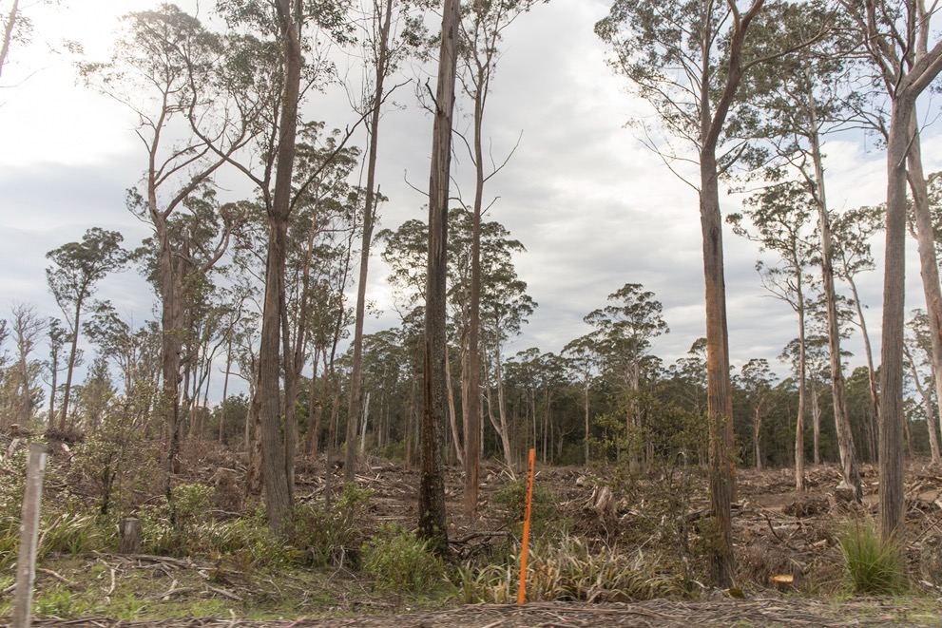
Recently harvested eucalypt forest, south-eastern NSW. Image: © DAWE.

Altered fire regimes
Fire regimes across the Koala’s range have been altered over the past two centuries by both changes in burning practices and the effects of climate change. Projected climate change, resulting in a warmer and drier environment over much of Australia will affect fire regimes (intensity, scale, frequency and seasonality) and increase the incidence of extreme fire-danger days (BOM and CSIRO 2020; Dowdy 2020; Sharples et al. 2016). The most significant changes are predicted for sclerophyll-dominated vegetation such as forests of south-eastern Australia (Williams et al. 2009), in which the Koala occurs. Climate change has complex effects on vegetation production through elevated CO2 (section 25, for discussion on potential impact on habitat quality), effects on fuel and fire weather, and ignitions, which collectively will influence future fire regimes (Williams et al. 2009).
Altered fire regimes, together with climate change, will have complex feedback interactions with biodiversity, both positive and negative (Williams et al. 2009). Understanding the impact of fire regimes on individual species’ responses is complex because of the individual nature and context in space and time of any one fire event and the complexity of associated environmental variables (Whelan 2002; Williams et al. 2009). This complex response, along with balancing the need of social and economic factors, makes managing fire risk for species conservation challenging, now and into the future (William et al. 2009; Clarke 2008).
Of major concern for biodiversity are large infrequent fires (>10,000 ha) in temperate eucalypt forests on the eastern seaboard (Bradstock 2008). Droughts, exacerbated by climate warming, are inextricably linked with large, infrequent fires (Bradstock 2008; Hughes 2003) and are responsible for the loss of significant numbers of animals and species survival (DELWP 2020; van Eeden et al. 2020). Fires which burn the forest crown pose a direct threat to arboreal species found in these forests, including the Koala (Jurskis and Potter 1997; Phillips 1990; Phillips et al. 2021; van Eeden et al. 2020).
In the summer of 2019–2020, Australia experienced bushfires of unprecedented scale, with estimates of three billion native animals killed – mammals, birds, reptiles and frogs, among many other orders of animals – including an estimated 61,000 Koalas killed, injured or affected in some way (van Eeden et al. 2020). Listed Koala populations were directly impacted (Phillips et al. 2021). Fires razed 3,659,625 ha (9%) of the area within which the listed Koala and its habitat are known or likely to occur, with the majority lost in New South Wales (3,466,578 ha or 94% of the total area of listed Koala habitat burned) (TSSC 2021) (Appendix 4). Despite the initially devastating impact of large fires, evidence indicates biota generally recover (Bradstock 2008) and that it is the frequency of fires (which incorporates both unplanned and prescribed burning) that has the strongest effect on biota (Bradstock 2008). Whether this concept holds up for the recovery of all species following the scale of the summer bushfires in 2019–2020 remains to be seen.
Fire threatens Koala populations through immediate mortality and injury, and via altered habitat that reduces food availability and increased exposure to predators (Lunney et al. 2007; Phillips et al. 2021; Zylstra 2019). It is also likely that changes in energy balances caused by increased exposure to temperature extremes (either heat or cold) increases physiological stress to individuals (Davies et al. 2013; Lunney et al. 2014; Narayan and Williams 2016) that survive fires, also reducing population recovery. The landscape configuration, proximity to source populations, and the intensity and extent of fire will influence how quickly Koalas repopulate habitat following fire (Lunney et al. 2002, 2004) as does the level of exposure to post-fire threats, such as dogs (Melzer et al. 2000; Lunney et al. 2007). However, at the landscape level, there is a paucity of research on the impacts of fire regimes and the influence of the resulting shifting habitat mosaic on recolonisation (e.g. attributes of in-situ refugia) and population-level recovery for the Koala.

Prescribed burning
Prescribed burning to reduce fire risk could affect biodiversity adversely undertaken without an adequate understanding or consideration for species’ responses to different fire regimes (Clarke 2008; Driscoll et al. 2010; Whelan 1995, 2002). Inappropriate burning practices can cause inadvertent and irreversible changes and may lead to the loss of local populations or extinction (Baker 2000).
Prescribed burning to reduce fire risk is widely used as a management tool to protect life, natural and built assets in Koala habitat across Queensland, New South Wales and the Australian Capital Territory. Multi-layered policies, strategies, planning procedures, tools and research guide fire management activities. Implementation varies markedly, depending on local vegetation type, land tenure, the organisation/s undertaking the fire management action and objectives.
Little data exist on the impact of prescribed burning on Koalas at the individual or population level; however, initial work in this area indicates that risks to Koalas is high regardless of fire suppression approaches. Modelling of fuel behaviour in dry sclerophyll forests of the Southern Tablelands, where low or moderate-intensity fires can cause significant canopy scorch (Cheney 1981), found that even low-intensity burns substantially increase the risk of injury and mortality to Koalas (Zylstra 2019). Fire behaviour simulation models of dense coastal forests near Bega, in south-eastern New South Wales, found that although substantial and expensive fuel reduction approaches to protect life and Koala habitat reduced bushfire size and probability, the residual risk remains high (Bentley and Penman 2017). While treatment of large areas can reduce the likelihood of a fire spreading, under severe fire weather conditions the amount of fuel becomes less important than weather as fire can still spread through areas with low fuel loads (Bradstock et al. 2010), as was evident in the 2019–2020 summer bushfires.
The alternative view, at least for south-eastern Australia, is that repeated low-intensity burning, similar to Indigenous cultural burning practices, can lead over time to healthy forests containing mature trees with relatively low nutritional status for Koala, yet are able to support stable, widespread, low-density populations (Jurskis 2017).
Since their arrival on the Australian land mass at least 65,000 years ago, Indigenous Australians have influenced fire regimes by purposeful use of landscape fire for a variety of reasons (Hisock 2008). This continues in parts of Australia. As Costello (2019, pg 23) notes ‘Budabe belong to waybar jagun. Koalas belong to fire Country’ and the Koala needs appropriate cultural and land management practices to flourish. The empowering of Indigenous leadership and participation in cultural burning and land management in eastern Australia (Robinson et al. 2021) will require supporting Indigenous land managers and respecting knowledge as part of Koala habitat recovery (Actions 1l, 1m, 2a, 2b, 2d; principles, section 10).
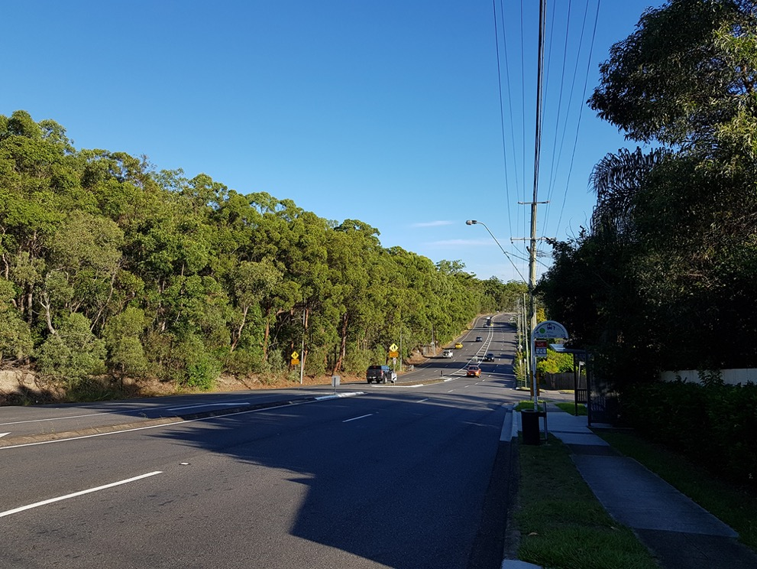
Koalas living in peri-urban environments face death and trauma from car strikes and dog attacks, Brisbane, Qld. Image: © C. Runge.

19.4 Other

Mortality from dogs and vehicles
Direct mortality and trauma caused from dog attack and vehicle strike is a major, though localised, effect of urbanisation, especially in the rapidly expanding urban and peri-urban areas where high-density Koala populations coexist with people (Beyer et al. 2018; Dique et al. 2003a; Lunney et al. 2002). Juvenile males in particular are susceptible to vehicle strike (Canfield 1991; Dexter et al. 2018; Dique et al. 2003a). Mortality from dogs and vehicles is not solely restricted to urban areas, as wild dogs and major highways also occur in relatively intact landscapes (Beyer et al. 2018). Trauma from vehicle strike and dogs account for a high proportion of veterinary clinic admissions (Beyer et al. 2018; Gonzalez-Astudillo et al. 2019).
Although mortality and trauma to Koalas from vehicles and dogs is widespread, the relative proportion of attribution to mortality and impact on local Koala populations (often along with disease) vary significantly depending on local landscape context (e.g. Beyer et al. 2018; Gonzalez-Astudillo et al. 2019; Lunney et al. 2002; Rhodes et al. 2006) and is influenced by road density and the volume of vehicle traffic (Dique et al. 2003a; McAlpine et al. 2006a and b; Rhodes et al. 2006; Ashman et al. 2020). Where populations are small and isolated, mortality from vehicles and dogs may result in population sinks (Dias 1996) where populations are essentially unviable and can only be retained through immigration from nearby source populations, rather than through intrinsic growth (e.g. Iluka population, New South Wales, Lunney et al. 2007). Dogs are implicated in exacerbating population declines in fire-affected fragmented landscapes (Lunney et al. 2007).
Actions addressing the impacts on Koalas from dogs and vehicles reside mainly with local government authorities (e.g. compliance and traffic control planning; McAlpine et al. 2007), and interventions have shown to be effective in local population recovery (Beyer et al. 2018). Further research into novel approaches to human social behaviour on dog-Koala interactions (Rundle-Thiel et al. 2019) and Koala aversion training for dogs (David et al. 2019) may also provide some new tools for reducing mortality and trauma from dog attacks.

Disease prevalence in the Koala
Koalas carry a range of pathogens and parasites. Of concern are infections by the bacterium Chlamydia pecorum that leads to chlamydial disease and the Koala retrovirus (KoRV) (Bachmann et al. 2014; Fabijan et al. 2019; Grogan et al. 2017, 2018; McCallum et al. 2018; Quigley and Timms 2020). Also for consideration are Phascolarctid herpesviruses, associated with predisposition to disease in Koalas in Victoria, but for which no information exists in New South Wales (Kasimov et al. 2020; Stalder et al. 2015); Trypanosomes, some of which appear to exacerbate disease but for which no information exists outside of Queensland, and Sarcoptes scabeii, which causes sporadic epidemics of mange, particularly in Victoria.
Chlamydia causes conjunctivitis (pink eye) leading to blindness, urinary tract disorders (wet bottom/dirty tail), pneumonia and infertility in females (Phillips 1990; Polkinghorne et al. 2013; Fabijan et al. 2019). This bacterium is one major reason for admissions of Koalas for clinical care in some regions, the other being dog and vehicle trauma (this section) (Beyer et al. 2018; Gonzalez-Astudillo et al. 2019). Chlamydial infection is almost ubiquitous among Koala populations (McCallum et al. 2018; Polkinghorne et al. 2013; Quigley and Timms 2020). A review into the status of research into disease of the Koala found that Kangaroo Island (n=170) was the only region with no evidence of chlamydial disease (Fabijan et al. 2019), though there is evidence indicating there are some increasing Clamydia-free populations in New South Wales (such as Campbelltown, some areas of the Blue Mountains and potentially Mumbulla State Forest). Elsewhere, where more than five Koalas were tested in an area, prevalence of Chlamydia infection ranged from 21% to 88% (Quigley and Timms 2020).
Given it commonly causes infertility, chlamydial disease is considered a major cause of decline in many contemporary populations (Rhodes et al. 2011; Robbins et al. 2019) and can be expected to exist with minimal impact (as it does in much of Victoria); cause declines on its own or when predisposed to by other pressures; or add to, amplify, or limit recovery from impacts of other pressures. Along with harvesting, it likely contributed to the decimation of past Koala populations during 1887–89, 1900–03 and throughout the 1920s and 1930s, and was thought to be a component of the Koala’s natural history (Phillips 1990), although recent genomic comparisons suggest that some Koala C. pecorum strains may originate from domestic livestock (Bachmann et al. 2014). This is an important question to resolve as, if like KoRV (see below) C. pecorum is an evolutionarily recent introduction, its likelihood for impact on populations is likely to significant.
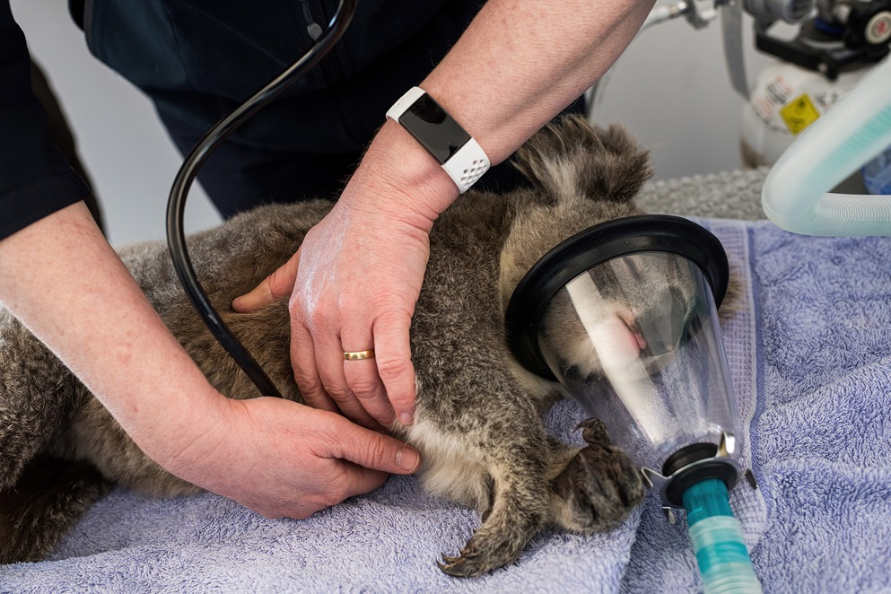
Koala undergoing a health check. Image: © Michael Weinhardt.
Multiple year studies and regional comparisons indicate that Chlamydia infection rates and disease severity of disease vary with time and population (range: 4% to 71%) (Quigley and Timms 2020), most likely influenced by a range of pathogen, host and environmental pressures including chlamydial strain (Fernandez et al. 2019; Robbins et al. 2020), aspects of coinfection with KoRV and other pathogens (Waugh et al. 2017; Quigley et al. 2018; Quigley et al. 2019; Robbins et al. 2020), host genetics such as MHC type (Cheng et al. 2018; Jobbins et al. 2012; Lau et al. 2014; Johnson et al. 2018; Robbins et al. 2020) and likely other environmental factors such as habitat and climatic stressors (Narayan and Williams 2016), and behavioural/ transmission dynamics. Chronic stress to individual Koalas from poor nutrition, reduced habitat quality (habitat loss, fragmentation, degradation and drought), exposure to unnatural situations (predation, dogs and traffic), heat-stress, bushfires or other factors, is likely to lead to the production of glucocorticoids (stress hormones), which can inhibit reproductive hormones and immune responses, reducing individual health (McAlpine et al. 2017; Narayan and Williams 2016). Where these factors become widespread and chronic, such as in areas of urban and peri-urban landscapes or in areas of marginal habitat quality (Davies et al. 2013), it is possible that loss of fertility due to disease and reduced recruitment due to habitat fragmentation will cause populations to decline and may inhibit recovery efforts.
KoRV is a gamma retrovirus that has been found to have integrated into the Koala germ line (endogenization – facilitating transmission from parent to offspring) of northern Koala populations (100% prevalence in Queensland and New South Wales), while it is believed to be exogenous (transmitted between Koalas through infection) in the southern populations (variable presence in Victoria and South Australia) (Ishida et al. 2015). There are also several other endogenous, exogenous functional and defective subtypes and retroviral elements involved to varying degrees within and between northern and southern populations. KoRV insertion sites have recently been shown to cause cancers such as lymphosarcoma, which are common in Koalas (McEwen et al. 2021) and it is likely that deleterious insertions interfere with a range of immune and metabolic genes, though evidence for this is preliminary. Given its evolutionarily recent introduction (<50,000 years) (Ishida et al. 2015), these heritable insertions are not stable in the genome and it is likely that deleterious insertions can become concentrated and more strongly expressed in fragmented or inbred populations, in a fashion similar to recessive genetic defects. Association with a range of KoRV aspects have been associated with chlamydial disease (Fabijan et al. 2017; Ishida et al. 2015; Quigley et al. 2019), although evidence is somewhat equivocal, likely due to the multifactorial nature of disease and the complex nature of retroviral infection.
Control of these diseases in wild populations centres on managing other additive or amplifying threats and pressures to improve the resilience of populations and prevent introduction of novel strains of pathogen to populations. At very local scales, removal or treatment of diseased animals, or vaccination to reduce transmission, may be feasible but the latter is still in the clinical and field evaluation phase. There is a deficiency of field-based population-level disease studies across the geographical range that have examined the prevalence of chlamydia and the underlying cause of disease in Koala populations and its relative importance on Koala demography and individual fitness, population and regional-level dynamics (Grogan et al. 2017, 2018; McCallum et al. 2018; Narayan and Williams 2016). Further studies on chlamydia, KoRV and other emerging Koala diseases in wild populations, particularly in relation to identifying pathogen, host and environmental drivers and associations, are needed to guide conservation management and prioritise investment. Furthermore, understanding the interactions between Koala genetic traits, pathogen strains and virulence traits is needed to inform risk management and design of future management actions.

Diseases of Koala habitat
An emerging disease that affects Koala habitat is Myrtle Rust, a plant disease caused by the introduced fungal pathogen Austropuccinia psidii. Myrtle rust was first detected in Australia in 2010 and affects plant species in the family Myrtaceae (eucalypts, lillypillies, paperbarks and tea-trees) which dominate many Australian ecosystems. The pathogen spreads easily via wind, animals and humans. The disease leads to defoliation, loss of reproductive capacity and death; and seedlings are particularly vulnerable (Makinson 2018). The disease is naturalised along the east coast of Australia, with the most serious infections in New South Wales and south-east Queensland (Makinson 2018). Although not yet identified as a threat to the Koala, emerging diseases like Myrtle Rust that impact the health of eucalypt ecosystems may indirectly affect the Koala via decline in habitat quality, although impacts are likely to be minor compared to other threatening processes (Fensham et al. 2020). The potential arrival of other strains of the pathogen in Australia poses an increased risk to susceptible species that are habitat for the Koala.

20. Ecological threatening processes

20.1 Habitat loss and fragmentation
Land use practices causing the loss and fragmentation of habitat are considered the primary ecological threatening process to Koalas, to which they are particularly sensitive (McAlpine 2006a and b; Reed and Lunney 1990; Rhodes et al. 2006, 2008). The Koala depends on trees, forests and woodlands for food and shelter (section 28), and has limited capability to traverse the intervening matrix safely, especially in built environments (section 27.3; Lunney et al. 2002; McAlpine et al. 2006a and b).
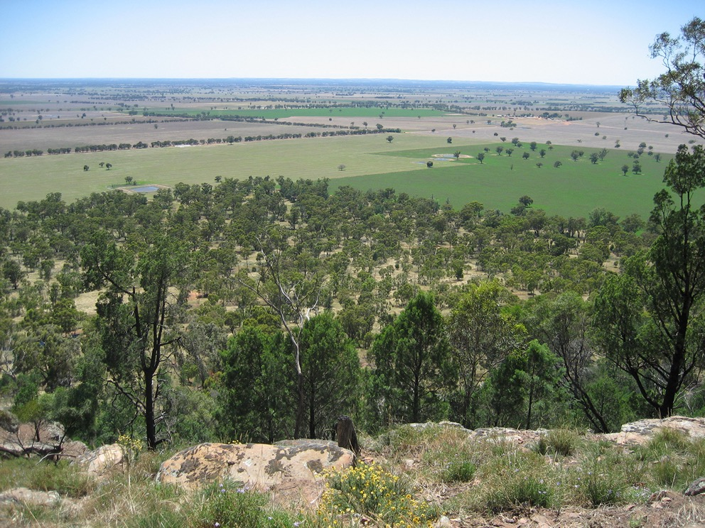
Open grey-box woodlands (E. microcarpa) cleared for cropping resulting in habitat loss, scattered paddock trees, narrow corridors and small patches, central NSW. Image: © S. Brown.
Since European settlement, Australia has lost nearly 40% of its forests, with the loss disproportionately occurring on productive fertile soils near the coast. This also coincides with preferred Koala habitat (Bradshaw 2012; Lindenmayer and Fischer 2006; McAlpine et al. 2002, 2006a and b). Since the 1970s, substantial forest loss has occurred in high-density Koala populations of south-eastern Queensland and northern New South Wales (Bradshaw 2012), although the majority of habitat loss within the Koala range occurred within the large but low-density Koala populations of the Brigalow Belt and Mulga Lands (Evans 2016). There appears to be a threshold of habitat coverage below which Koalas rapidly decline from landscapes, which ranges from 10–60% depending on the region (McAlpine et al. 2002, 2005; Rhodes et al. 2008).
Landscape configuration changes disrupt metapopulation processes for the Koala (McAlpine et al. 2006a and b) by directly decreasing population sizes or causing localised extinction through reduced carrying capacity within the landscape via reduced resource availability (Zanette et al. 2001; McAlpine et al. 2006a and b); increasing the isolation of populations (McAlpine et al. 2006b); reducing connectivity between populations (Lunney et al. 2002; McAlpine et al. 2006b; Thompson 2006; TSSC 2012a and b); increasing mortality risk from dogs and vehicles (Lunney et al. 2002; McAlpine et al. 2006b; Rus et al. 2021; see below); disrupting social systems (Thompson 2006); and influencing movement patterns (McAlpine et al. 2006b; Rus et al. 2021). Chronic stress to Koalas from these factors is thought to also increase their susceptibility to disease (Davies et al. 2013; Narayan and Williams 2016) (Figure 4).
Extinction debt (Tilman et al. 1994), whereby the local loss of Koala populations after habitat loss has tipped over the threshold for long-term persistence, can take up to 100 years to manifest itself (Seabrook et al. 2014b). Random fluctuations or perturbations in population growth rates due to chance events of individual mortality and reproduction (demographic stochasticity or drift) or environmental stochasticity (e.g. natural catastrophes) are exacerbated in isolated populations (Soulé et al. 1986). These processes have led to local losses of Koala populations (TSSC 2012a) such as reduction of Koala populations throughout its urbanised coastal range (Seabrook et al. 2014b).

20.2 Habitat degradation
The key threats driving habitat degradation for the Koala include timber harvesting using silvicultural systems that do not retain habitat trees; agriculture; altered hydrological regimes from land clearing, soil erosion and water extraction (Cowie et al. 2007); fire and fire management; and climate change (TSSC 2021). Direct threats such as climate change and land clearing can also interact with other threats such as invasion by weeds and pathogens, potentially increasing the impact. Habitat degradation reduces the availability or increases the mortality of food and shelter trees, reduces the nutrient value and water content of food trees, and changes the configuration and relative abundance of habitat trees. These changes impact Koalas by making it more difficult for them to find food and shelter resources, increasing stress levels and disease, and leading to reduced breeding success and increased mortality. Habitat degradation is common in landscapes that are also subject to progressive land use change. It can lead to habitat loss as native vegetation is slowly changed to a composition and structure that no longer resembles the original state (Lindenmayer and Fischer 2006). Habitat degradation also reduces availability and quality of resources for species and can drive population declines over the long term (extinction debt, Tilman et al. 1994).

20.3 Genetic effects
Land use change also adversely affects the genetic structure of populations by eroding genetic diversity and increasing genetic differentiation (Charlesworth and Charlesworth 1999; Thompson 2006). As populations become more isolated in smaller remnants that are disconnected, gene flow tends to decrease. The resultant smaller populations are more prone to the effects of genetic drift and inbreeding (Bouzat 2010; Hedrick and Fredrickson 2010). Indeed, Koalas do not appear to exhibit inbreeding avoidance behaviour, a characteristic thought to making them vulnerable to inbreeding (Schultz et al. 2020), although they do appear to exhibit mate choice based on genetic variation at the MHC region (Brandies et al. 2018). Inbreeding increases the probability of homozygosity and the likelihood of the accumulation of recessive deleterious alleles, inbreeding depression and the reduction of population viability (Bouzat 2010; Charlesworth and Charlesworth 1999; Hedrick and Fredrickson 2010; Schultz et al. 2020), although this is not always found to be the case in wild populations (Milot et al. 2007).
Studies into genetic structuring within and between populations of the Koala have provided insights into social structuring within a locality (Thompson 2006), inbreeding (Seymour et al. 2001; Johnson et al. 2018), immunity (Lau et al. 2014; Johnson et al. 2018), bottlenecks and patterns of movement (Thompson 2006; Norman et al. 2019) and therefore is a valuable tool for conservation of the listed Koala.
Levels of inbreeding vary across regions and is more prevalent in the southern unlisted populations (Houlden et al. 1996; Johnson et al. 2018) that have experienced sequential translocation events (Menkhorst 2008). Fortunately, although listed Koala populations are under threat from habitat loss and fragmentation (TSSC 2012a; 2012b; DERM 2009), high levels of contemporary genetic diversity exist within many of these populations (Houlden et al. 1996; Johnson et al. 2018; Kjedlen et al. 2016; Thompson 2006). Nevertheless, genetic evidence indicates that fragmentation of habitat is impacting heterozygosity within populations (Thompson 2006) and presenting an impediment to gene flow (Thompson 2006) noting; however, genetic studies have not been undertaken in large areas of the Koala’s range. Strategies to maintain linkages in populations threatened by habitat loss and fragmentation, such as revegetation or genetic augmentation, are required to mitigate potential adverse genetic affects in these landscapes.

20.4 Genetic effects and disease
Genetic diversity is one important factor linked to the ability of individuals to survive with, and/or recover, from disease events. Immune genes are some of the most genetically diverse gene families as they evolve under pathogen pressure. Marsupials, including Koala, have a complex immune system (Belov et al. 2013) and have high genetic diversity at the major histocompatibility complex (MHC), one of the most studied immune gene families, due to its direct role in disease resistance. Recent work has indicated a role for the MHC in resistance to Chlamydia (Cheng et al. 2018; Jobbins et al. 2012; Lau et al. 2014; Johnson et al. 2018; Robins et al. 2020) but evidence identifying particular resistance or susceptibility alleles is equivocal. Other immune gene families also contribute to disease resistance and new target capture methods which can characterise thousands of genes at once (Silver et al. under review), or whole genome sequencing, will greatly assist in our understanding of genetic effects and disease in Koala (section 19.4). Recent genomic analyses investigating 1,209 immune genes, found 17 genes associated with chlamydia disease progression in Koalas (Silver et al. under review). This highlights the utility of using whole genome analyses to inform our understanding of disease in different Koala populations (section 20.1).

PART V
Distribution trends, genetic structure and diversity, and habitat

21. Distribution

21.1 National
The Koala is endemic to Australia and has a wide but patchy distribution across coastal and inland areas of eastern and southern Australia (Martin and Handasyde 1999) (Figure 1; DAWE 2021a). Its natural range extends from far north-eastern Queensland to the south-east corner of South Australia, including some coastal islands, and is restricted by altitude (Melzer et al. 2000; Menkhorst 2008; Munks et al. 1996; TSSC 2012b). The exact extent of the Koala’s natural boundary at the margins of its distribution is poorly defined in some regions, especially the inland semi-arid and arid regions in western Queensland (Mitchell Grass Downs, Desert Uplands and Einasleigh Uplands bioregions) and western New South Wales (e.g. Mulga bioregion) where survey effort has been relatively low and cyclic droughts cause localised contraction and expansion of populations.
Several Koala populations are now established outside the species’ natural range due to historical translocations. In South Australia, the species was presumed extinct in the 1930s (TSSC 2012b) and subsequently Koalas, sourced mainly from Victoria, were introduced to Kangaroo Island, Eyre Peninsula, Riverland and Adelaide Hills (Phillips 1990; TSSC 2012b). In Victoria, to arrest population declines in the late 19th and early 20th centuries, Koalas were introduced to islands along the coast and in the Murray River in addition to reintroduction to many inland areas. Of these islands, populations persist to today on French Island and Phillip Island in Western Port Bay, and Snake Island and Raymond Island in east Gippsland (Menkhorst 2008). Koalas were also introduced to Yanchep National Park, near to Perth, in the 1930s (Phillips 1990; Menkhorst 2008).
Although the extent of the Koala’s range prior to European settlement is poorly understood (Phillips 1990), between the late 1800s until the 1930s the Koala suffered a precipitous decline in the central and southern areas of its distribution as a result of habitat loss, drought, bushfires, disease and intense exploitation for fur (Melzer et al. 2000). Due in part to protective legislation and cessation of hunting, Koalas have returned to parts of their former distribution (DECC 2008; Martin and Handysyde 1999; Menkhorst 2008).

2019–2020 summer bushfires
In the summer of 2019–2020, Australia experienced severe bushfires across the country. The coastal areas of southeast Queensland, New South Wales and eastern Victoria were particularly affected (van Eeden et al. 2020; Table 4). The majority of Kangaroo Island in South Australia was also burned. Together, these areas supported significant populations of Koalas: listed, unlisted and introduced.
For the listed Koala, 9% (3,659,625 ha) of the area within which the listed Koala and its habitat are known or likely to occur were burned and this was a significant contributor to the uplisting of the listed Koala to Endangered (TSSC 2021). The proportion burned ranges from <1% in the drier inland areas to 30% in the temperate coastal forests which support high-quality Koala habitat and areas of contiguous habitat. The coastal areas of northern and southern New South Wales areas were most impacted (Table 4, DAWE 2021b). Further analysis of the fire extent for the modelled distribution of the listed Koala by bioregions, state and territory is in Appendix 2.
Table 4. The area and percentage of land burned in the 2019–2020 summer bushfires by Natural Resource Management (NRM) areas within the area where the listed Koala and its habitat for known or likely to occur. Estimates for likely plus known only are provided, excluding may occur, using the previous version of Koala distribution mapping (2013). Note: modelled distribution does not equate to Koala habitat (see section 21.2 below for further explanation on distribution modelling). Source: DAWE 2021b
NRM region, State | Extent burned within likely  + known listed Koala distribution, ha (%)
South East NSW, NSW | 934,799 (30%)
North Coast, NSW | 899,006 (29%)
Northern Tablelands, NSW | 580,707 (20%)
Hunter, NSW | 397,701 (15%)
Greater Sydney, NSW | 331,974 (29%)
Central Tablelands, NSW | 250,520 (16%)
Murray, NSW | 19,295 (3%)
North West NSW, NSW | 43,282 (1%)
Western, NSW | none burned
Central West, NSW | 9,282 (<1%)
Riverina, NSW | 13 (<1%)
South East Queensland, QLD | 86,152 (4%)
Fitzroy, QLD | 55,544 (1%)
Desert Channels, QLD | none burned
Condamine, QLD | 30,061 (2%)
Burnett Mary, QLD | 15,331 (1%)
Wet Tropics, QLD | none burned
Southern Gulf, QLD | none burned
South West Queensland, QLD | none burned
Northern Gulf, QLD | none burned
Maranoa Balonne and Border Rivers, QLD | 3,024 (<1%)
Burdekin, QLD | 1,930 (<1%)
Mackay Whitsunday, QLD | 1,005 (<1%)
ACT | 21,140 (23%)
TOTAL | 3,659,625 (9%)

21.2 The listed Koala
The department’s modelled distribution for the listed Koala shows a widespread distribution extending from just north of Cairns in far north Queensland, down the east coast of Australia, to the Victorian border (Figure 1; DAWE 2021a). The majority of known habitat is concentrated along the coast of south-eastern Queensland and central to northern coast of New South Wales. Major riparian areas, including parts of the Murray River, the Darling River system (New South Wales) and the Carnarvon region (central Queensland) are likely to, or may, support Koalas in landscapes otherwise devoid of Koalas.
The listed Koala represents about 84% of the modelled distribution for the entire species. The total area of modelled distribution where Koalas and their habitat are known or likely to occur (Figure 1, shown in purple and dark pink) is the area of major focus for action under this recovery plan. This does not preclude actions in areas beyond these boundaries, where genetically unique populations may exist, or unmapped quality habitat may occur.
The categories likely to occur and may occur in the listed Koala distribution shown in Figure 1 were generated by combining information on the distribution of Koalas (DAWE 2021a) using MaxEnt software (maximum entropy modelling, Phillips et al. 2006), with, where available, expert-elicited and vegetation-based mapping of Koala habitat and models of Koala food trees (DES 2020b; DPIE 2019; Runge et al. 2021a). MaxEnt models predict species occurrence based on presence-only data and available biophysical data layers. The category known to occur was generated by spatial buffers around recorded observations of Koalas. It is important to note that modelled distribution is indicative only for recovery planning purposes, and that ground-truthing is required to examine site-level habitat suitability, quality and the presence of Koalas. The area within the modelled distribution may include areas that are not Koala habitat (e.g. grasslands or wetlands). Areas not relevant for the listed Koala, will be identified in fine-scale mapping such as regional plans (section 12.2), and will be excluded from recovery efforts.

21.3 Predicted 2070 distribution under climate change
Extreme heat events and extreme drought are becoming more frequent under climate change (CSIRO and BOM 2015; BOM and CSIRO 2020; Herold et al. 2018), and the long-term re-establishment of Koala populations in areas with more extreme climates will become increasingly unlikely. The Koala’s distribution appears to be contracting in a manner consistent with expected impacts of climate change on the species, with recent declines in previously healthy Koala populations at the species range limits attributed to drought and heatwaves (Gordon et al. 1988; Lunney et al. 2012, 2017; Seabrook et al. 2011).
The Koala’s distribution is predicted to dramatically contract southward and to the coast over the next 50 years under a high global emissions scenario, a consequence of further increases in the intensity and frequency of droughts and heatwaves brought about by climate change (Adams-Hosking et al. 2011a; Briscoe et al. 2016; (Figure 6). This will result in a reduction in the total area of distribution of the Koala, as the southern and eastern range limits are constrained by the Australian landmass.
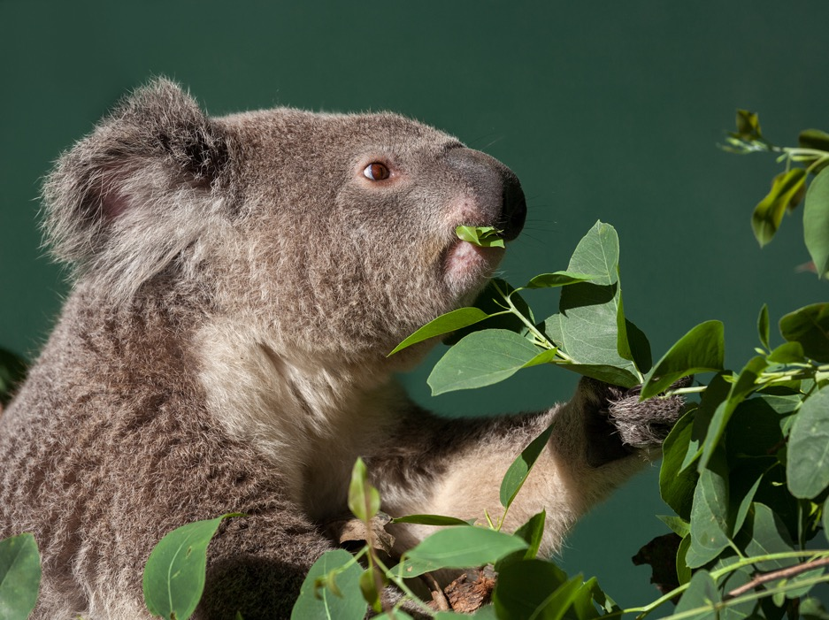
Koala feeding on nutritious eucalyptus leaves. Image © Shutterstock.
Figure 6. Predicted listed Koala distribution in 2070 under a high global emissions scenario (RCP8.5) considering the impacts of climate-change driven changes to droughts and heatwaves on Koalas. Colour indicates the degree of certainty that a given area will be climatically suitable for Koalas, indicated by the proportion of species distribution models that predict the area will be climatically suitable. Blue indicates high confidence that an area will be suitable for Koalas, and yellow indicates high confidence that an area will be unsuitable for Koalas. Data from Briscoe et al. (2016)
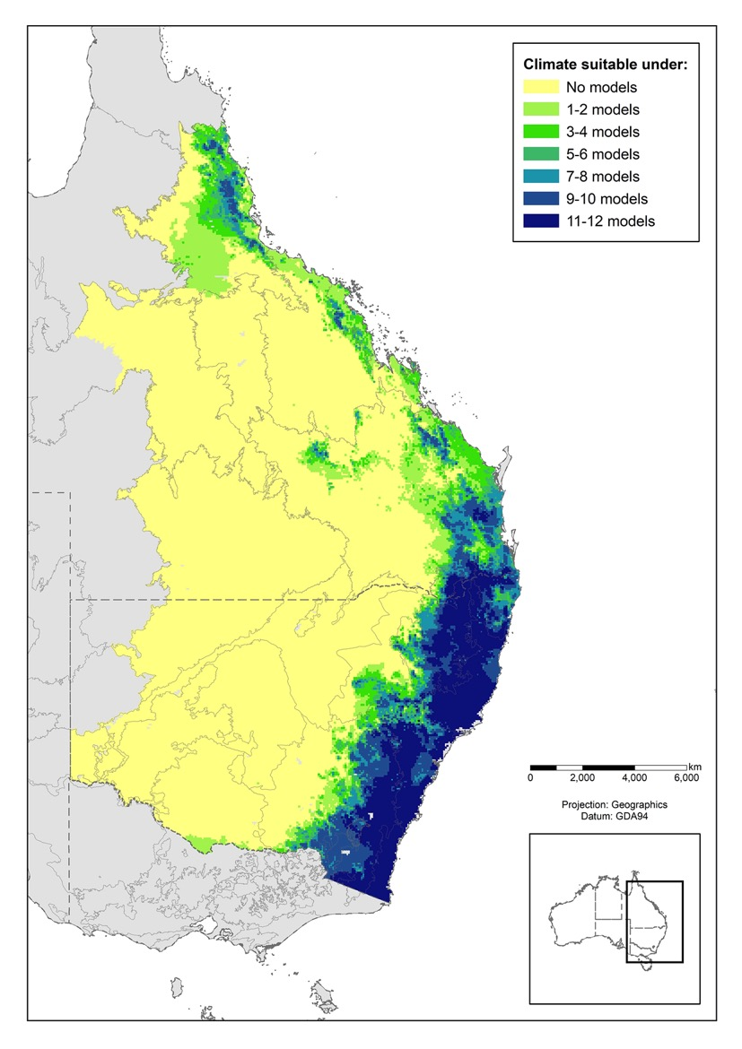
The northern and western edges of Koala distribution are limited by the physiological constraints of the Koala, and influenced by temperature, humidity, and water availability (Adams-Hosking et al. 2011a; Briscoe et al. 2016; Clifton et al. 2007; DPIE 2019; DES 2020b; Law et al. 2017; Seabrook et al. 2014a). Extreme climatic events such as drought and heatwave drive the distributional limits of Koalas (Briscoe et al. 2016; Seabrook et al. 2014a), mediated by Koalas’ vulnerability to water stress (section 29). Following favourable wetter years, Koalas may recolonise habitat at the edge of their distributional limits, only to become locally extinct during the next drought or heatwave.
Widespread extinction of Koalas due to climate change within the next 50 years is a risk in most western populations including the Brigalow Belt, Mulga Lands, Mitchell Grass Downs, Darling Riverine Plains and Desert Uplands bioregions (Adams-Hosking et al. 2011a; Briscoe et al. 2016; McAlpine et al. 2015). Isolated individuals may survive in local refugia, where microclimates, groundwater, and habitat characteristics are favourable (McLaughlin et al. 2017; Seabrook et al. 2014a).
There is some uncertainty surrounding where the northern and western edges of Koala distribution will fall under climate change (Adams-Hosking et al. 2011a; Briscoe et al. 2016). These differences are driven by differences in the types of species-distribution models (correlative versus mechanistic), the datasets used, and choices of model parameters. All models support climate-driven range contraction.

21.4 Queensland
In Queensland, the Koala has been recorded as far north as Cooktown, in the central west (Julia Creek region) and central southwest (Charleville region), with the main concentration of Koalas along the south-eastern coast (Gordon et al. 2006). Koalas also occur on islands off the Queensland coast. The population on North Stradbroke Island is probably natural, whereas those of Brampton, St. Bees, Newry, Rabbit and Magnetic Islands are introduced (Melzer et al. 2000).
Information on distribution of the Koala in Queensland prior to European arrival is scant and therefore the true extent of its natural range and subsequent contraction in distribution is uncertain. However, analysis of historical data indicates that between the late 1800s and the end of the 20th century the Koala has contracted in extent of occurrence by 27% and area of occupancy by 23%. This contraction has occurred mainly in the northern and western margins of distribution, with local losses in the areas of concentrated settlement along the coast (Gordon et al. 2006).
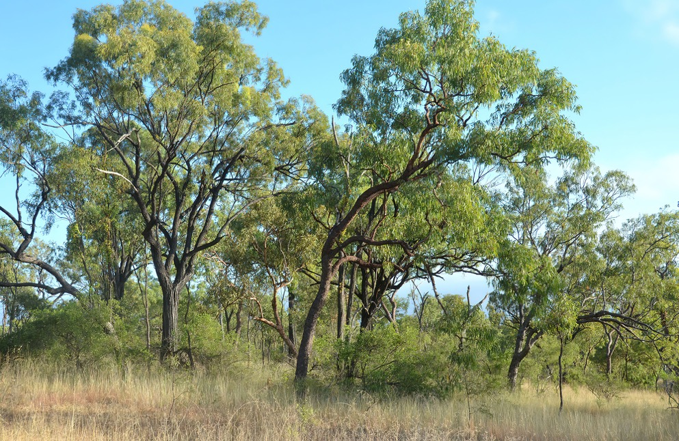
Tropical eucalypt savanna, showing E. crebra and C. intermedia. Einasleigh Uplands bioregion, The Oaks Station, Qld. Image: © Don Franklin.

21.5 New South Wales
In New South Wales, the Koala is found along much of the coast, with major populations in the northern coastal areas, bordering southern Queensland, and more scattered populations in the southern coast (Lunney et al. 1997, 2009, 2017; Phillips 1990; Reed et al. 1990). Towards central and western New South Wales, west of the Great Dividing Range, distribution is increasingly disjunct and scattered with a major population surrounding Gunnedah in north-western New South Wales (DECC 2008; Lunney et al. 2009; Phillips 1990; Reed et al. 1990). The most westerly sightings reported between 1985–2007 are around Bourke, Ivanhoe and Wilcannia in central and north-central New South Wales and Deniliquin near the Murray River. The Koala is absent in the far west (DECC 2008; Lunney et al. 2009).
A synthesis of surveys between 1949 and 1987 indicate that the distribution of the Koalas has contracted significantly in New South Wales, notably in the north-western and southern margins (Phillips 1990; Reed et al. 1990). These contractions have continued in recent years (McAlpine et al. 2015). Localised declines in the distribution of Koalas have been noted in coastal areas that are subject to high anthropogenic pressure (McAlpine et al. 2015). Some areas have seen localised, though possibly temporary, expansions (Ellis et al. 2017; Lunney et al. 2009, 2012).
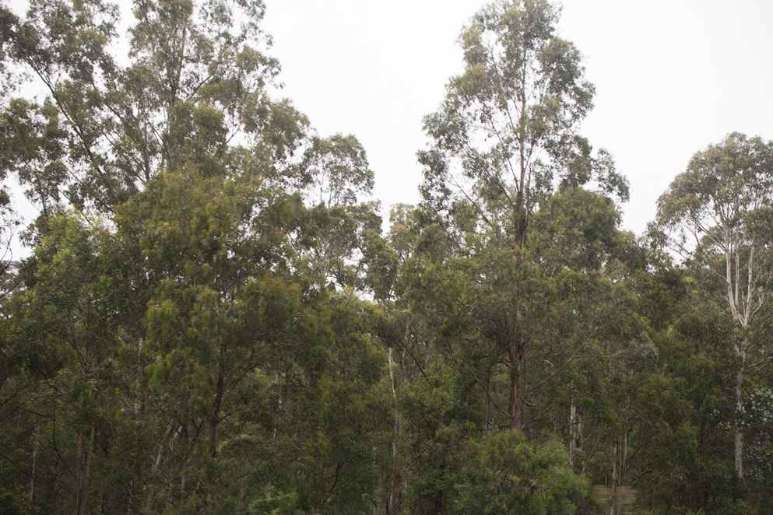
Dense eucalypt forest found along the east coast of Australia, Bemboka, south-east NSW. Image: © DAWE.

21.6 Australian Capital Territory
In the Australian Capital Territory, reports indicate that Koalas were common throughout the region when the territory was established (Phillips 1990). There have been several introductions of Koalas from Victoria and escapees from enclosures, and it is likely that surviving small populations in the Australian Capital Territory, should they exist, are derived in part from these introduced animals. Their likely descendants have been recorded in the Brindabella Ranges and Namadgi National Park (Phillips 1990; TSSC 2012b). However, few of these individuals would have survived the 2003 bushfires (TSSC 2012b), of which any recovering populations would have also been impacted by the 2019–2020 bushfires. Excepting an intensely managed and introduced small population at Tidbinbilla Nature Reserve, no wild Koalas are known to persist in the Australian Capital Territory (ACT Scientific Committee 2019).

21.7 Victoria
In Victoria, the Koala is widespread in lowland and foothill eucalypt forests and woodlands across much of those parts of the state where the annual rainfall exceeds about 500 mm. It is generally found in central, and southern Victoria, and largely absent from the semi-arid woodlands of the far north-west and high-altitude areas of the north-east of the state (DSE 2004). The distribution of the Koala in Victoria has fluctuated greatly over the past century and late 1800s because of Koala harvesting, localised overabundance and declines of populations and extensive translocation programs (Menkhorst 2008). Currently the Koala is considered broadly stable in the state (TSSC 2012b).

21.8 South Australia
The distribution of the Koala in South Australia prior to European settlement is also poorly documented, but Koalas were probably common in the south-east where clearing has since reduced available habitat (Melzer et al. 2000). A series of introductions has expanded its distribution in the state – initially to Kangaroo Island from Victoria, and then to mainland areas of the Adelaide Hills, Eyre Peninsular and sites along the Murray River. The Koala distribution in South Australia is probably constrained by the lack of availability of suitable habitat, and where they have been introduced, over-browsing by the localised expansion of populations is a significant management issue (Melzer et al. 2000; Phillips 1990).

22. Genetic structure and diversity
In all species there is a strong interplay between a species’ genetic diversity and their behaviour, ecology, reproductive biology, and other life history characteristics. Our knowledge of Koala genetics has increased in the past five years with the development of new genomic technologies. These genetic investigations are important for decision making in Koala management, such as translocations and disease management.
Genetic diversity is important for a species to maintain its adaptive potential, that is, the more diversity a species has at functionally important genes the better. The Koala genome is slightly larger than the human genome (3.5Gb v 3.2Gb) and contains approximately 20,000 genes (Johnson et al. 2018). Genes are located across the genome, and the areas between the genes are often called neutral regions. Neutral regions mutate faster than functional gene regions, and so conservation geneticists typically measure differences in these neutral regions to determine how different populations are to each other. Conserved functional genes tend to mutate at a slower rate, so the genetic differences within these conserved genes tends to be less than what we see in neutral regions. If functional genes are under selective pressure (due to some external factor) there can be differences within these genes, meaning different populations can have different diversity within these genes. Immune genes are an example of the types of genes that can have different diversity depending on the population they come from.
Measuring genetic diversity and understanding diversity within genes is a rapidly evolving field. A range of different genetic methods have been used over the past 20 years to describe genetic diversity in Koalas with benefits and limitations to the different methods (Table 5). Understanding the benefits and limitations of particular methods, allows us to better understand the current genetic status of Koala populations.
Table 5. Methods used to describe genetic diversity in the Koala, their benefits and limitations
Genetic marker type | Benefits | Limitations
Microsatellite markers – 6 consistent markers (Houlden et al. 1996); other markers developed but not consistent across studies | Cheap and reproducible  6 markers developed by Houlden et al. 1996 have been used by 14 of the 22 genetic studies published between 1996 and 2019 | Only represent small portions of the genome  Tend to only represent neutral regions  Markers need to be consistent across studies to be comparable
Reduced representation sequencing – 2 methods ddRAD (3,060 SNPs in Koalas; Kjeldsen et al. 2016) or DARTseq (4,606 SNPs; Kjeldsen et al. 2019)* | Produces thousands of single-nucleotide polymorphisms (SNPs) representing genome-wide diversity  Relatively cheap and reproducible (~$60 per sample; 2021) | ddRAD and DARTseq methods are not comparable; method needs to be consistent across studies to be comparable  SNPs must be called against the reference genome for the data to be comparable to future datasets  Digestion enzymes used are predisposed to neutral regions of the genome, so data is biased towards neutral data
Target capture – current analysis 1,209 genes (Silver et al. under review) | Developed from the reference genome for any specific gene family of interest  Provides detailed information about functional genes of interest  Can be aligned with other datasets to determine gene associations e.g. disease resistance | Labour intensive and expensive (~$500 per sample; 2021)  Only provides data on genes of interest
Exon capture – current analysis 1,163 genes (M. Lott, unpublished data) | Developed for phylogenetic analyses between different marsupial species  Can inform historical changes over time | Labour intensive and expensive  Only provides data on conserved gene regions
Whole genome sequencing | Provide both neutral and functional diversity information across the genome  Can be aligned with other datasets to determine gene associations e.g. disease resistance, heat tolerance, taste receptors | Expensive (~$1,200 per sample; 2021 for 30X depth)  Sequencing depth influences data quality, 7–10X depth is the same coverage as reduced representation sequencing; 30X depth provides ability to determine functional gene differences across the genome
* ddRAD = double digest restriction-site associated sequencing, digestion enzymes produce fragments approximately 120bp long; DARTseq = method developed by Diversity Arrays Technology (Canberra), digestion enzymes produce fragments approximately 75bp long
Note: scats yield low quality DNA, so scat analysis requires the use of microsatellite markers or reduced representation sequencing, although the number of SNPs obtained from scat is less than for tissue/blood samples. Target capture, exon capture and whole genome sequencing methods all require high quality DNA from either tissue or blood samples.
Using these different genetic methods, at the scale of the entire geographic population, the Koala is considered relatively genetically diverse, indicative of a healthy outbred species (Houlden et al. 1996; Johnson et al. 2018; Kjeldsen et al. 2016, 2019; Lee et al. 2010a), although genetic diversity varies at the population level (Lee et al. 2010a; Wedrowicz et al. 2018; Kjeldsen et al. 2019). Southern populations of Victoria and South Australia generally show lower genetic diversity, consistent with bottlenecks and founder events from translocations (Houlden et al. 1996; Johnson et al. 2018; Kjeldsen et al. 2019; Wedrowicz et al. 2018). South Gippsland may be an exception and is thought to be a remnant population (Wedrowicz et al. 2018). Analysis using whole genome data from this region and the more northern areas of Victoria will determine where the southern boundary of diversity delineates in Victoria.
As with many species that live across a large range, the Koala exhibits spatial structuring at multiple scales (Houlden et al. 1999; Johnson et al. 2018; Thompson 2006), with a large proportion of genetic variation among populations explained by geographic distance (Kjeldsen et al. 2019). At a continental scale, Neaves et al. (2016) found four shallowly divergent lineages within three geographic clusters corresponding to two known Pleistocene biogeographic barriers – the Brisbane River and Clarence River Valley, consistent with three linages described by Houlden et al. (1999). An additional barrier associated with the Hunter Valley has also been described (Johnson et al. 2018). Pleistocene barriers may have historically influenced mtDNA structure of the Koala, but evidence of contemporary gene flow indicates biogeographic features are no longer barriers to movement (Johnson et al. 2018; Neaves et al. 2016). An understanding of functional gene diversity is required to understand the long-term adaptive implications of this spatial structure differences.
At finer scales, populations show significant levels of neutral genetic differentiation attributed to contemporary habitat fragmentation (Lee et al. 2010b; Thompson 2006) or relative isolation such as those of islands (Lee et al. 2010a; Wedrowicz et al. 2018) and the Sydney Basin (Kjeldsen et al. 2019).

23. Valued populations
No population is more important than another – for a threatened species, all populations are of value in contributing to the total population size and recovery. Some populations are also valued for social, cultural or economic reasons, while some have functionally important roles for recovery.
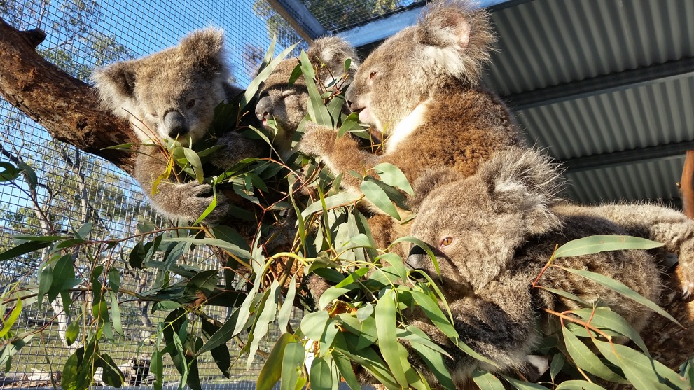
Koalas are valued by the community with efforts made to care for displaced Koalas. Image: © Karen Ford.
Spatially defining a biological population is challenging where data are deficient, boundaries are fuzzy, and can be influenced by the scale considered (regional versus local, temporal) and landscape context. There also are many reasons a population may be considered important (see below).
Populations of the Koala are valued for cultural, social, and economic reasons (section 1) as well as for the species’ conservation.
1) For the listed Koala conservation, among other reasons, it will be imperative to maintain populations:
a) that have the potential to act as source populations to adjacent areas of suitable, or potentially suitable, habitat
b) that exist in areas of climatically suitable refugia during periods of environmental stress including droughts, heatwaves, and long-term climate change
c) that are genetically diverse
d) or contain adaptive genes to current and future environmental stressors
e) are geographical or environmental outliers within the species range.
2) Populations are also valued for social, cultural or economic reasons, and may or may not, overlap with populations listed above. Reasons may include, but not limited to:
a) cultural and spiritual importance to Indigenous Australians
b) the social value and enjoyment of having Koalas in your home neighbourhood
c) the economic value brought to local business and tourism.

24. Habitat
Within the geographic range of the Koala (Figure 1), Koala habitat is defined by the availability and nutritional quality of food trees, presence of suitable resting trees and microclimates, age structure of vegetation, history, and impediments to dispersal. These differ regionally because they are strongly influenced by local climatic and landform attributes.
While precise requirements vary regionally and locally, Koala habitat can be considered in terms of the following multi-scale resource requirements in space and time:
- the selection by Koalas of individual trees for food and shelter and other resources within their home range (sections 28 and 29)
- patch size, form and context of home ranges within the landscape, including patches of forest, riparian, linear and roadside vegetation associations, open ground, corridors and scattered paddock trees used for breeding or dispersal (sections 27.3 and 28)
- at larger scales, the regional landscape in which a metapopulation exists
- the geographic range of the Koala (section 21).
The Koala is a specialist folivore that browses predominantly on the leaves of Eucalyptus, Corymbia and Lophostemon species (section 28) and resides in forests and woodlands ranging from tropical forests of far north coastal Queensland to the semi-arid woodlands of central Queensland and New South Wales, to coastal forests of eastern and southern Victoria (Martin and Handasyde 1999; Melzer et al. 2014; Moore and Foley 2000; Phillips 1990; Van Dyck and Strahan 2008). Across New South Wales and Queensland alone, it is associated with over 600 species of food and shelter tree (DES 2020b; DPIE 2019; Melzer et al. 2014; OEH 2018b; Sullivan et al. 2003), though in a given region or site only a few species might be used.
Non-food tree species are an essential resource to Koalas. Koalas use these shelter trees to thermoregulate, especially during hot days (Briscoe et al. 2015; Crowther et al. 2014; Ellis et al. 2009; Ellis et al. 2010a; Pfeiffer et al. 2005) and to avoid predators (Melzer et al. 2003). Koalas appear to prefer larger and more shady trees and use a wide range of tree species for shelter, including rainforest trees (Queensland, Pfeiffer et al. 2005), white cypress pine Callitris glaucophylla (Pilliga, New South Wales, Kavanagh et al. 2007), Callitris columellaris (North Stradbroke Island, Queensland, Cristescu et al. 2011; Woodward et al. 2008), brigalow Acacia harpophylla and black tea-tree Melaleuca bracteata (Queensland Brigalow, Ellis et al. 2002).
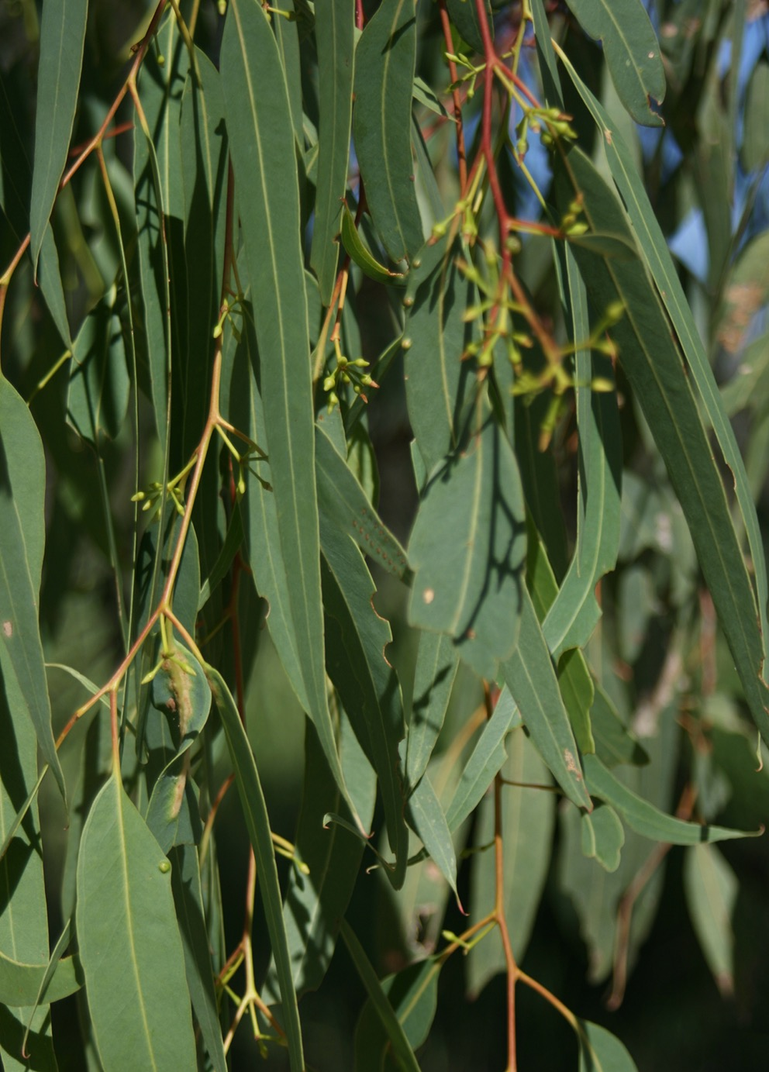
Leaves of the river red gum E. camaldulensis which occurs across Australia and a favourite food of the Koala. Image: © S. Brown.
Koalas shift between locations for habitat resources in space and time and, therefore, areas can constitute Koala habitat even if a Koala is not present at a given time. Individual Koalas move daily between food and shelter trees (Pfeiffer et al. 2005; Tucker et al. 2007). Over a longer timescale, individuals’ use of habitat is influenced by seasonal changes in food quality (Dargan et al. 2019; Woodward et al. 2008; Wu 2018), changes in habitat caused by drought (Seabrook et al. 2011), disturbance history (Kavanagh et al. 2007; Lunney et al. 2007; Matthews et al. 2016), the long-term results of a changing climate (Santika et al. 2014; Shabani et al. 2019) and competition with other species (e.g. Bell Miner Manorina melanophrys, Wardell-Johnson 2006).
Key factors that influence the quality of habitat for Koalas are the presence and density of preferred food tree species (Melzer et al. 2014; Moore and Foley 2000; Stalenberg et al. 2014; Whisson et al. 2016; Woodward et al. 2008); food trees’ nutritional foliar chemistry (Ellis et al. 2009; Moore and Foley 2005; More et al. 2004; Wallis et al. 2010) (section 28), and shelter trees and vegetation structure (Ellis et al. 2002; Ellis et al. 2009; Ellis et al. 2013; Pfeiffer et al. 2005; Smith et al. 2013; Woodward et al. 2008). Koalas also use open ground (whether natural or part of the built environment) to travel between trees and patches, and the safety or hostility of this matrix also contributes to the overall quality of habitat (section 27.3). At a broad scale, these factors are determined by climate variables (Hughes et al. 1996); disturbance history from fire and timber harvesting (Kavanagh et al. 2007; Lunney et al. 2007; Matthews et al. 2016); and landforms of the natural and built environment (Barth et al. 2019; McAlpine et al. 2006a; Rus et al. 2021; Santika et al. 2014; Sullivan et al. 2003; Wu et al. 2019).
At the landscape scale, the total amount of available habitat and habitat quality are the primary environmental factors that influence Koala presence (Barth et al. 2019; Dargan et al. 2019; Januchowski et al. 2008; McAlpine et al. 2006a and b). Also important to Koalas is the relative importance of landscape patch size, form and spatial configuration within context of the wider landscape, which can vary among landscapes and varies regionally. For example, riparian habitats and surface water bodies are essential for the survival of Koalas at the western margins of Koala distribution (Wu 2018), but persistence in these areas is supported by the presence of intact non-riparian habitat (Smith et al. 2013). The use of isolated trees (large trees also used by stock) within grazing paddocks is commonly recorded (Dargan et al. 2019; White 1999). In agricultural and fragmented landscapes of south-east Queensland scattered paddock trees have been found, along with roadside vegetation, to be disproportionately important to the local Koala population (Barth et al. 2019). Furthermore, riparian vegetation facilitates local movement (Davies et al. 2013) and is important in long-distance dispersal (McAlpine et al. 2006a and b; Norman et al. 2019) (section 27.3).
Over long timescales, and under climate change, habitat areas that provide refuge, or safe havens, during droughts are particularly important in sustaining Koala populations (Adams-Hosking et al. 2011b, Lunney et al. 2017). In drier parts of their range, habitat areas with perennial water and geological features that provide cooler microclimates may support the highest densities of Koalas and provide refuge for Koalas during times of heat and water stress (Lunney et al. 2017; Seabrook et al. 2011; Sullivan et al. 2004). Intact habitat outside watercourses but with higher quality food trees may also support refugial populations, albeit at lower densities (Davies et al. 2013; Ellis et al. 2010a; Smith et al. 2013).
As described above, Koalas need access to different types of habitat attributes at multiple spatial and temporal scales (Dargan et al. 2019). What constitutes Koala habitat is the result of interactions between an individual animal’s behaviour, which can be understood from studies of Koala’s behavioural ecology, biology and movement patterns (Part VI), and the requirement and selection of environmental resources of the particular landscape in which individual Koalas, and the populations they belong to, live (functional ecology). These in turn are influenced by processes at other scales (e.g. fire, hydrology, vegetation clearance and climate change).
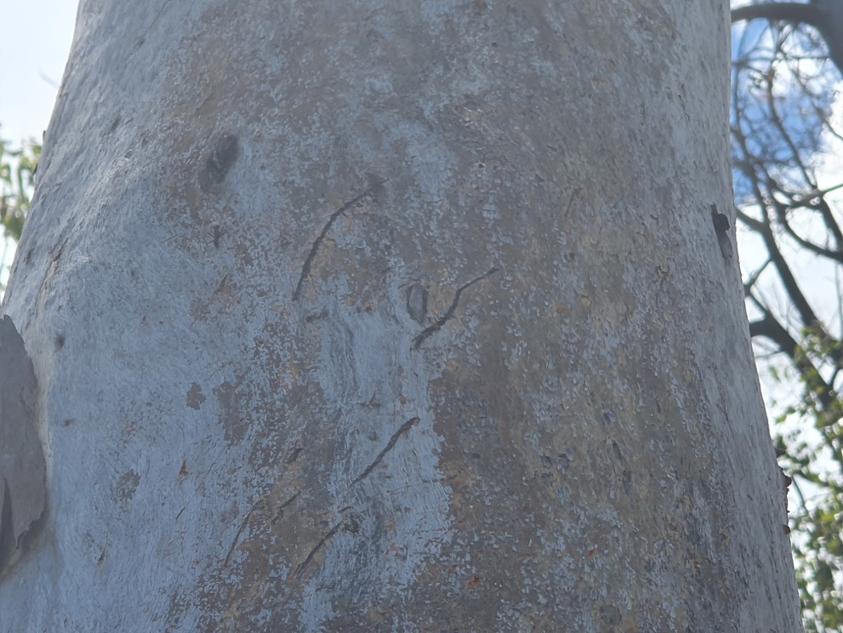
Tell-tale markings on bark made by the claws of a Koala. Image: © C. Robinson, CSIRO.
Koala habitat described in this recovery plan includes the total set of resources required by Koalas (above) to meet the needs of individual survival and reproduction, and the how those resources are arranged in the landscape to maintain viable metapopulation processes (i.e. it is landscape context dependent).
For an individual Koala, this includes access to sufficiently quality food and shelter trees to meet their daily energetic requirements and reproduction, and a safe place to avoid predators. Koala habitat includes forests or woodlands; roadside and railway vegetation and paddock trees; safe intervening ground matrix for travelling between trees and patches to forage and shelter and reproduce; and access to vegetated corridors or paddock trees to facilitate movement between patches. These resources fall within individual Koala’s home ranges and allow for interaction with adjacent individuals.
For a population of the listed Koala, this means sufficient total amount of habitat of adequate quality to support a viable biological population where mortality, survival, and recruitment are balanced or recruitment increasing to optimal carrying capacity and within the bounds of natural fluctuations. Crucial habitat elements include patches and corridors for gene flow. On longer-time frames this includes climate refugia such as drainage lines, riparian zones and patches that are resilient to drying conditions due to favourable hydrological systems. Additionally, this includes areas which may be temporarily unoccupied, because of seral (maturity or time) changes to habitat quality that arise through processes such as fire, drought, timber harvesting or disease (shifting habitat mosaic) or degradation, and are available for future recolonisation.

25. Habitat critical to survival
Habitat critical to the survival of a species is the area that the species relies on to halt decline and promote the recovery of the species. Ideally this would be identified spatially; however, given the variety of factors that determine whether habitat is suitable for Koalas or not, it is more appropriate to define habitat based on the characteristics required to meet their needs, than by spatial delineation. Additionally, despite the multitude of schemes for assessing and mapping koala habitat, there are difficulties with such maps even at relatively small scales (e.g. Mitchell et al. 2021). At the expansive scale of the distribution of the listed Koala across much of Queensland and New South Wales, this is confounded by the absence of data on Koala distribution and abundance and consequently their habitat requirements in those areas.
The preceding section provides an overview relating to the functional ecology of the Koala and its habitat that forms the basis for determining habitat critical to the survival of the listed Koala. The functional ecology of the Koala is described in terms of the combined assemblage of habitat qualities (extent, arrangement, attributes) theoretically required to stop decline and promote recovery. Key questions to ask in evaluating habitat for Koalas are:
a) whether the habitat is used during periods of stress (examples flood, drought or fire)
b) whether the habitat is used to meet essential life cycle requirements (e.g. foraging, breeding, social behaviour, dispersal)
c) the extent to which the habitat is used by important populations
d) whether the habitat is necessary to maintain genetic diversity and long-term evolutionary development
e) whether the habitat is necessary for use as corridors to allow the species to move freely between sites used to meet essential life cycle requirements
f) whether the habitat is necessary to ensure the long-term future of the species or ecological community through reintroduction or re-colonisation
g) any other way in which habitat may be critical to the survival of a listed threatened species or a listed threatened ecological community (EPBC Act).
Importantly, the understanding of the Koala’s habitat requirements is increasing (and changing) over time as we better understand the behaviour and physiology of Koalas, and the physiology and chemical composition of their food trees and how they respond to differing conditions. Consequently, in determining whether an area has the attributes constituting habitat critical to the survival of the listed Koala, or the potential to develop those attributes (e.g. via revegetation), it is important to examine the up to date literature, and to refer to local sources of information (especially with regard to preferred food and resting trees) and collect complementary data as close as practicable to the site. Potential proponents should also refer to such supporting documents as are available in the Species Profile and Threats database (SPRAT) which may include referral or significant impact guidelines if their production is deemed necessary.
While the complexity described above precludes detailed guidance here to cover all situations, it is clear that in order to halt decline and promote the recovery of the listed Koala, the following should be avoided:
- clearing of habitat used by Koalas for feeding and resting
- reducing connectivity between patches of habitat used by Koalas for feeding, resting, commuting and dispersing (either by clearing of vegetation or by the erection of barriers to passage)
- clearing of habitat used by Koalas during extreme events (heat waves, drought/fire refuge)
- avoiding activities that will expose Koalas to additional threats (e.g. dogs, cars) in places where Koalas must use the ground to move between resting and feeding trees.

PART VI
Biology and ecology
The wide-ranging distribution of the Koala and corresponding need to understand variability of habitat in terms of vegetation associations, landscape context and climate drivers has driven many regional studies. Predictably, substantial location-dependent variation is found in studies of Koala dietary preferences and resource use, patterns of movement, reproductive biology, genetic structure, disease and threats, which in turn affect local population dynamics and persistence (see supporting documents in SPRAT).
Information presented in Part VI is intended to only provide a general overview on Koala biology and ecology relevant to the conservation and management of the Koala through a selection of location-specific examples. Koala conservation managers and decision-makers are advised to draw on the extensive literature for studies relevant to location or undertake further research/surveys where crucial data are lacking to make informed decisions for location-appropriate management of Koalas.

26. Species description
The Koala Phascolarctos cinereus (Goldfuss 1817), is the only extant member of the endemic marsupial family Phascolarctidae (Van Dyck and Strahan 2008). It is semi-arboreal, with a stocky compact body, a residual tail, and muscular limbs, with sharp claws on the fore and hind paws for gripping bark when climbing trees. All digits are clawed, except the first (equivalent of a thumb) on the hind feet (Lee and Martin 1988). It has a rounded head, with a large flat, unfurred, black nose-pad, small eyes and large, oval-shaped ears covered in longer, white-tipped fur. Its chin, chest, belly and inside limbs are covered in sparse, short, white fur, while elsewhere its fur is ash-grey to brown, short and thick (or woolly). Some individuals may also have white fur patches on their rump (Martin and Handasyde 1999).
The Koala weighs between 4 to 15 kg and is sexually dimorphic with males up to 50% larger than females (Martin and Handasyde 1990; Martin, Handasyde and Krockenburger 2008). It exhibits clinal variation, with individuals from its southern range being about twice as heavy as those from northern Australia (average of 12 kg in Victoria cf. 6.5 kg in Queensland) (Martin and Handasyde 1999). Northern Koalas also tend to have shorter, silver-grey fur, whereas those in their southern range have longer, thicker, brown-grey fur (Martin and Handasyde 1999).
Previously, three subspecies (P. c. adustus, P. c. cinereus and P. c. victor) were described based on this clinal body size and colour variation (Troughton 1957); however, there is no genetic support for this (Houlden et al. 1999; Kjelsen et al. 2016; Neaves et al. 2016) and the Koala is now considered a single species.

27. Behavioural ecology and demography
The Koala is a semi-arboreal species spending most of its time in the tree branches of eucalypt forests; however, unlike other arboreal species such as gliders, it mainly uses the ground, rather than the canopy, to travel between trees (Marsh et al. 2014). It is largely sedentary, solitary and primarily nocturnal, with adults having limited social interactions (Martin and Handasyde 1999), although individuals have extensive overlap in home territories (Ellis et al. 2009; Mitchell 1990).

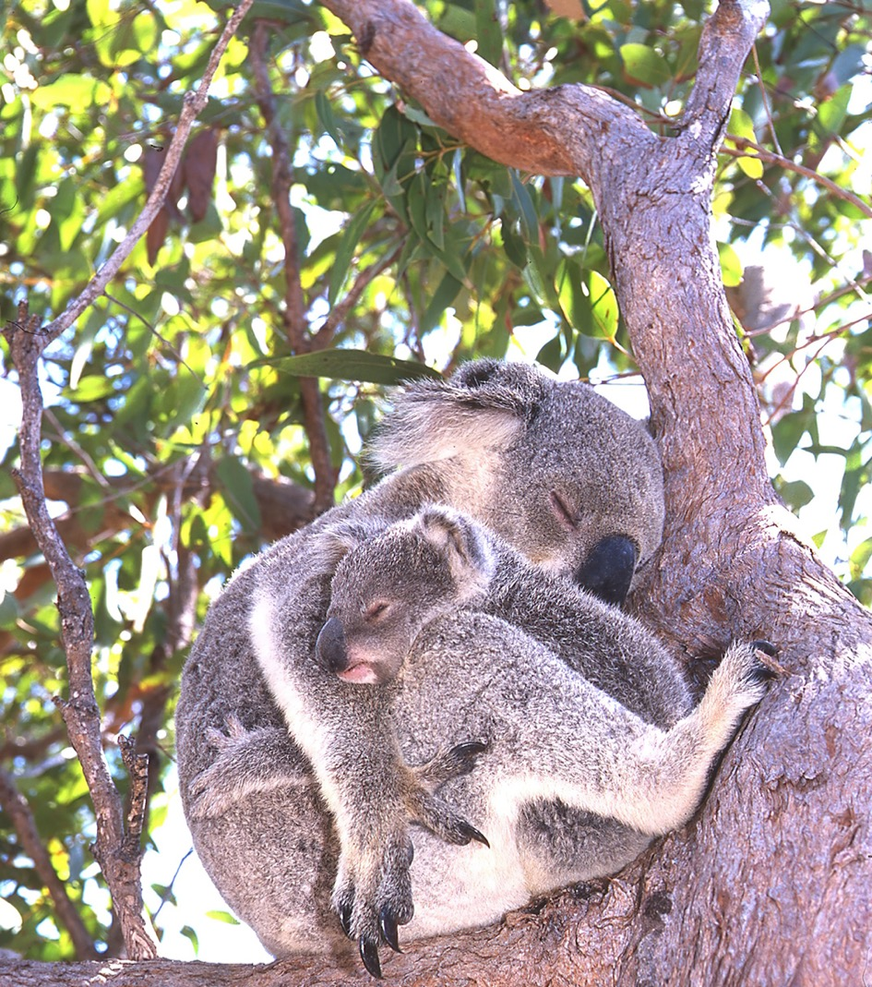
Mother and joey, Magnetic Island, Qld. Image: © E. Vanderduys, CSIRO.

27.1 Reproduction
Koala development follows a pattern of sexual bi-maturism with females obtaining reproductive age between two and three years of age, and males at four years (Martin and Handasyde 1999: McLean and Handasyde 2007). Mature females generally produce one offspring a year with births occurring between October and May (Close et al. 2017; McLean 2003; Thompson 2006) following a 35-day gestation period (Martin and Handasyde 1999; Tyndale-Biscoe and Renfree 1987). Koala reproduction is influenced by seasonality, and the timing of the breeding season can differ between northern and southern populations (Ellis et al. 2010b). Local factors, including population density, food quality and availability and climate influence the timing of breeding (McLean and Handasyde 2007; Ballantyne et al. 2015). Koalas may not breed every year if conditions are unfavourable, and breeding can be unsuccessful due to poor body condition or disease (e.g. Chlamydia) (McLean and Handasyde 2007).
Southern populations have shown seasonal sex biases in offspring (McLean and Handasyde 2007), although this has not been found in Queensland (Ellis et al. 2010b). The newborn joey suckles from inside the pouch for around nine months (240–270 days) and is then carried on the mother’s back for an estimated three months, until it is weaned at around 12 months (Ellis et al. 2010b; Martin and Lee 1984). Weaning coincides with periods of high food availability and favourable climatic conditions. This ensures the best survival conditions for offspring approaching independence (Ballantyne et al. 2015). The joey remains near the mother for another year before reaching sexual maturity at around two years of age, at which time it may disperse. Males provide no parental care (Mitchell and Martin 1990).

27.2 Demography
Records for wild Koalas report females commonly surviving to 13–14 years of age (Close et al. 2017) and up to at least 18 years (Martin and Handasyde 1990), and more than 12 years for males (Martin and Handasyde 1999), equating to a generation length of 6–8 years (TSSC 2012b). Mortality rates and causes vary between age cohorts and are location-dependent, and mainly threat-driven. In the ‘Koala Coast’ (south-east of Brisbane), disease is the largest single contribution to mortality, followed by natural causes and vehicle strikes, and then dogs (Rhodes et al. 2011). Mortality rates range from 8.5% (subadult males, Queensland) to 40% for adult males in Port Stephens, New South Wales (cited in TSSC 2012b; Thompson 2006) and >60% for 2–3 year old males in the Koala Coast, south-east Queensland (Rhodes et al. 2011). This last figure contrasts to other studies of the Koala Coast in peri-urban and remnant bushlands that found survival rates are high for both juveniles (89–96%) and adults (81%) (Thompson 2006), indicating that the potential for recovery of populations is very good where threats can be mitigated or removed.

27.3 Movement patterns
Koalas have a highly variable home range. Males typically have a larger home range than females with home range size increasing as trees become more widely spaced (Whisson et al. 2016). In general, home ranges are substantially larger inland in the semi-arid woodlands than in mesic coastal forests, reflecting variation in local patch context and quality. For example, some individuals in Central Mackay Coast bioregion have small home ranges of less than 2.0 ha (Ellis et al. 2015), whereas in the Mulga Lands bioregion home ranges are up to 169.5 ha (Davies et al. 2013). Home range size can also vary substantially within the same region (Ellis et al. 2002; Kavanagh et al. 2007) and may shift spatially across years (Ellis et al. 2009). High variability has been found on some islands (6.0–132.4 ha, North Stradbroke Island, Cristescu et al. 2011), while not on others (4.6–8.8 ha St. Bees Island, Ellis et al. 2009) and the latter study found individuals in overlapping home ranges rarely used the same trees, indicating resource partitioning on fine scales. Juveniles tend to have relatively smaller home ranges than adults (Thompson 2006). Koalas use both natural and built features as home ranges or boundaries (Close et al. 2017) and for dispersal (e.g. tracks, Lassau et al. 2008).
Both sexes disperse from their natal home-range between about 18 and 36 months of age (Dique et al. 2003b; Mitchell and Martin 1990) where daughters are reported to occupy home ranges embedded within their maternal home range (Ellis et al. 2009; Tucker et al. 2007) or adjacent areas (Close et al. 2017). Typical of mammal behaviour, the species exhibit male bias dispersal (Dique et al. 2003b; Mitchell and Martin 1990) although this is not perhaps such a dichotomous characteristic in the Koala (Thompson 2006). During natal dispersal, juveniles are susceptible to vehicle strike, especially males (Canfield 1991; Dexter et al. 2018; Dique et al. 2003a). Dispersing individuals are recorded to move up to 20 km from their natal areas (Close et al. 2017; Matthews et al. 2016; White 1999), with average distances reported at 3.5 km in south-east Queensland (Dique et al. 2003b). While studies indicate a predominance of short-range movements (e.g. Dique et al. 2003b), genetic modelling in slightly fragmented landscapes of north-eastern New South Wales suggests longer movements may be in fact relatively common (15–20 % of movements at 16.8–20.3 km) (Norman et al. 2019).
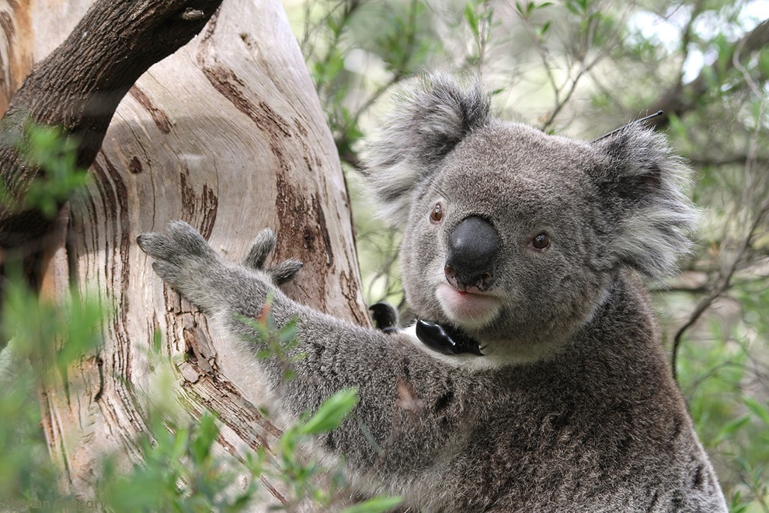
Collars carrying radio-transmitters are used to track movement patterns of individual Koalas. Image: © Desley Whisson.
The ability to disperse among habitat patches is critical for Koalas in maintaining metapopulation persistence (section 20), although this is not well understood. The amount of habitat required to support a population varies by location and will be influenced by factors such as habitat quality, spacing of trees in the landscape and the availability and use of climate refugia. A decrease in connectivity can precipitate the local population extinction of a dispersal-limited species (Bascompte and Sole 1996) like the Koala in fragmented landscapes. Furthermore, within intact landscapes, a mismatch between the scale of spatially and temporally shifting habitat suitability (shifting habitat mosaic) such as that caused by disturbance from timber harvesting or fire, and the ability of a species to disperse and recolonise, may also have adverse impact on long-term metapopulation persistence (Wimberley 2006).
Analysis of Koala densities before and during drought indicates that Koalas die out from habitat surrounding climate refuges, rather than migrating to refugial areas (Seabrook et al. 2011). Natural migration away from climate-affected areas cannot be relied upon as a rescue for at-risk Koala populations.

28. Foraging ecology
Koalas are recorded to feed on more than 120 species of Eucalyptus, Corymbia and Angophora (Moore and Foley 2000; OEH 2018a; Phillips 1990), primarily the subgenus Symphyomyrtus (Moore and Foley 2005), and a few other genera (Marsh et al. 2014; Moore and Foley 2000; Phillips 1990). As the tree species composition differs between location so does the diet. Knowledge of feeding species is growing as new habitat locations are studied. It is the nutritional quality of the available trees, not the diversity of trees per se, that primarily drives foraging decisions and subsequently population density (Brice et al. 2019; Moore and Foley 2000; Sluiter et al. 2002). Generally, their preferred tree species in the south of their distribution include Manna Gum (E. viminalis), Swamp Gum (E. ovata) and Blue Gum (E. globulus), while in the north Tallowwood (E. microcorys), Red Gums (E. camaldulensis and E. tereticornis) and Grey Gums (E. puncutata and E. propinqua) are important (Van Dyck and Strachan 2008). The browse species consumed, and the proportion of diet made up by each species, varies considerably among populations and individuals (Moore and Foley 2005), and seasons (Davies et al. 2014; Ellis et al. 2013), even within the same home range (Blyton et al. 2019; McAlpine et al. 2008).
In a given area, Koalas browse tree preference, and the palatability of leaves, is determined by plant secondary metabolites (PSMs) and nutrient content. PSMs act as a herbivore deterrent (Gleadow and Woodrow 2002; Moore et al. 2004). PSMs are chemical compounds produced by the plant via metabolic pathways that are not used for primary processes (i.e. growth and reproduction). Nutritional quality refers to the foliar concentrations of digestible nitrogen, which is a proxy for protein and a key limiting nutrient for the Koala, and plant secondary metabolites that are known to influence palatability, feeding tree choice and subsequently population densities of the Koala. Dietary selection is thought to be driven by trade-offs between palatability and the nutritional value of leaves of digestible proteins within and between browse species (measured by available nitrogen or digestible nitrogen) (DeGabriel et al. 2008; Wallis et al. 2012) and concentrations of less desirable secondary plant metabolites including formylated phloroglucinol compounds (FPCs) and tannins (Au et al. 2013; Marsh et al. 2007; Stalenberg et al. 2014; Wallis et al. 2010). For example, FPCs are toxic and protect the plant from predators. FPC levels differ within a species, on an individual tree basis. Leaf moisture may play a role during times of low rainfall or heat stress (Ellis et al. 2010a). Choice of browse trees is also influenced by physical characteristics including tree size, number of palatable trees nearby, and presence of shelter trees (Crowther et al. 2014; Moore et al. 2010).
The nutritional composition and amount of plant secondary metabolites of Eucalyptus species can vary within and between species (Moore et al. 2010; Wallis et al. 2010) at fine scales. This is also influenced by disturbance history, climate conditions (Au et al. 2019; Moore et al. 2004; Stalenberg et al. 2014; Youngentob 2015) and seasonality (More and Foley 2000), creating a patchy and dynamic distribution of food quality in space and time across landscapes and with corresponding spatio-temporal shifts in tree use by Koalas (Moore et al. 2010). Koalas living in different eucalypt communities therefore contend with different nutritional and toxicological challenges (DeGabriel et al. 2009).
The Koala has a specialised digestive tract with an extremely enlarged caecum to retain food for long periods to break down food to extract nutrients and degrade toxic plant metabolites by gastrointestinal microorganisms (Cork et al. 1983; Shiffman et al. 2017). Gut microbiomes of Koalas vary (Alfano et al. 2015) and appear to be influenced by diet (Brice et al. 2019) suggesting that gut microbiomes of Koalas are finely optimised to digest particular species of Eucalyptus, Corymbia, and Angophora, and dietary selection by individuals may be therefore limited by their microbiome (Blyton et al. 2019).
This relationship between diet and microbiome has ramifications for Koala translocations, the treatment of sick or injured Koalas, habitat restoration, population management and habitat requirements. If Koalas are introduced to new locations, a higher diversity of potential food trees may enable Koalas to find a suitable diet. Sick and injured Koalas treated with antibiotics that deplete gut microbiomes could be inoculated with probiotics to restore functional gut microbiomes, enhance recovery and successful return to the wild. Inoculations of microbiomes optimised for certain species of Eucalyptus, Corymbia, and Angophora could potentially be used to assist in translocations, disease prevention, or shift diets in-situ, preventing the need for translocations when managing population numbers (Blyton et al. 2019). Understanding population-level gut microbiomes could also be used to optimise the selection of tree species in habitat restoration targeted at Koalas, or via inoculations, to assist the plasticity of populations to adapt to changing forest tree composition in the future as the local climate changes.
Species distribution models indicate that the range of Koala browse trees will be impacted in the future by climate change (Adams-Hosking et al. 2011a) (section 21.3). Due to the Koala’s specialised diet and digestive biology, they have limited physiological ability to cope with drought or heat stress by increasing their leaf intake and subsequent dietary water intake (Lunney and Hutchings 2012). Koalas are thus particularly vulnerable to the increased temperatures and water stress encountered across much of their range due to climate change.

29. Physiology
Koalas are highly susceptible to extreme temperatures, both hot and cold, and drought, particularly where these occur simultaneously and for extended periods of time (Briscoe et al. 2016; Lunney et al. 2014; Seabrook et al. 2014a). The influence of extreme weather events on Koala is mediated by a combination of their physiology, morphology and behaviour.
The acute consequences of extreme heat events on Koalas arise from their physiological and dietary constraints. During periods of heat stress, animals decrease their food intake to reduce the additional burden of heat produced during foraging and digestion processes (Youngentob et al. 2021). This is increasingly hazardous for the Koala which survives on a low energy diet with the majority of their water needs provided by the leaves they eat. If an animal cannot dissipate heat, it can die from extreme heat stress in hot environments (Gordon et al. 1988; Seabrook et al. 2011). In longer drought and extreme heat events, tree death and subsequent starvation and stress on Koalas also reduce, breeding success and survival of young (Davies et al. 2013). Recent work indicates that some Koalas readily use free-standing water when provided, particularly when conditions are hot and dry (Mella et al. 2019, 2020), though this behaviour is thought to be rare (Lunney et al. 2012) and may be indicative of a stressed and/or unwell animal. The use of artificial watering stations may also be associated with the increased spread of disease in Koalas and further research is required.
Koalas have several behavioural responses that can mitigate heat stress. Koalas move daily between food trees and ancillary trees (for example shelter vegetation species and resting trees), and on hot days feed at night when temperatures are cooler (Crowther et al. 2014; Ellis et al. 2010a). Shelter vegetation can be critical for thermoregulation, providing shaded, cooler, climate refugia on heat stress days. The Koala’s diet consists of a broad range of tree species but show seasonal and regional preferences for browse species and seek out trees with higher leaf water during drought (Clifton et al. 2007; Davies et al. 2014). Certain tree species and other vegetation types not commonly recognised as important food trees may still be essential for Koala survival due to the shelter or other resources they provide (Cristescu et al. 2011; Kavanagh et al. 2007). During hot days, Koalas seek cool microclimates and take up heat-dispersing postures, such as hugging the cooler trunks of large trees, or splaying limbs (Briscoe et al. 2014). These strategies reduce or eliminate their need for respiratory evaporative cooling and the resulting loss of water. The ability of vegetation to mitigate impacts of climate change may be reduced during drought, as trees reduce the transport of cooler underground water through trunks and water-stressed leaves provide less shade and dietary water.

References
ABARES 2016, Australian Land Use and Management (ALUM) Classification Version 8 (October 2016), Australian Bureau of Agricultural and Resource Economics and Sciences, Canberra.
―― 2018, Tenure of Australia’s forests (2018), Australian Bureau of Agricultural and Resource Economics and Sciences, Canberra, DOI: 10.25814/5c592792c780e, accessed 9 November 2021.
ACT Scientific Committee 2019, Conservation Advice. Koala (Phascolarctos cinereus), Australian Capital Territory Scientific Committee, ACT Government, Canberra.
Adams-Hosking, C, Grantham, HS, Rhodes, JR, McAlpine, C & Moss, PT 2011a, Modelling climate-change-induced shifts in the distribution of the Koala, Wildlife Research, vol. 38, no. 2, pp. 122–130, DOI: 0.1071/WR10156, accessed 9 November 2021.
Adams-Hosking, C, Moss, P, Rhodes, J, Grantham, H & McAlpine, C 2011b, Modelling the potential range of the Koala at the Last Glacial Maximum: Future conservation implications, Australian Zoologist, vol. 35, pp. 983–990, DOI: 10.7882/AZ.2011.052, accessed 9 November 2021.
Adams-Hosking, C, McAlpine, C, Rhodes, JR, Grantham, HS & Moss, PT 2012, Modelling changes in the distribution of the critical food resources of a specialist folivore in response to climate change, Diversity and Distributions, vol. 18, no. 9, pp. 847–860, DOI: 10.1111/j.1472-4642.2012.00881.x, accessed 9 November 2021.
Adams-Hosking, C, McBride, MF, Baxter, G, Burgman, M, Villiers, D de, Kavanagh, R, Lawler, IR, Lunney, D. Melzer, A, Menkhorst, P, Molsher. R, Moore, BD, Phalen, D, Rhodes, JR, Todd, C, Whisson, D & McAlpine, CA 2016, Use of expert knowledge to elicit population trends for the koala (Phascolarctos cinereus), Diversity and Distributions, vol. 22, no. 3, pp. 249–262, DOI: 10.1111/ddi.12400, accessed 9 November 2021.
Alfano, N, Courtiol, A, Vielgrader, H, Timms, P, Roca, AL & Greenwood, AD 2015, Variation in Koala microbiomes within and between individuals: effect of body region and captivity status, Scientific Reports, vol. 5, p. 10189, DOI: 10.1038/srep10189, accessed 9 November 2021.
Ashman, KR, Rendall, AR, Symonds, MRE & Whisson, D 2020, Understanding the role of plantations in the abundance of an arboreal folivore, Landscape and Urban Planning, vol. 193, p. 103684, DOI: 10.1016/j.landurbplan.2019.103684, accessed 9 November 2021.
Au, J, Marsh, KJ, Wallis, IR & Foley, WJ 2013, Whole-body protein turnover reveals the cost of detoxification of secondary metabolites in a vertebrate browser, Journal of Comparative Physiology B, vol. 183, no. 7, pp. 993–1003, DOI: 10.1007/s00360-013-0754-3, accessed 9 November 2021.
Au, J, Clark, RG, Allen, C, Marsh, KJ, Foley, WJ & Youngentob, KN 2019, A nutritional mechanism underpinning folivore occurrence in disturbed forests, Forest Ecology and Management, vol. 453, p. 117585, DOI: 10.1016/j.foreco.2019.117585, accessed 9 November 2021.
Bachmann, NL, Fraser, TA, Bertelli, C, Jelocnik, M, Gillett, A, Funnell, O, Flanagan, C, Myers, GSA, Timms, P & Polkinghorne, A 2014, ‘Comparative genomics of koala, cattle and sheep strains of Chlamydia pecorum’. BMC Genomics, vol. 15, pp. 667, DOI: 10.1186/1471-2164-15-667, accessed 9 November 2021.
Baker, J 2000, The Eastern Bristlebird: Cover-dependent and fire-sensitive, Emu, vol. 100, pp. 286–298, DOI: 10.1071/MU9845, accessed 9 November 2021.
Ballantyne, K, Lisle A, Mucci, A & Johnston, SD 2015, Seasonal oestrous cycle activity of captive female koalas in south-east Queensland, Australian Mammalogy vol. 37, pp. 245–252, DOI: 10.1071/AM14018, accessed 9 November 2021.
Barth, BJ, FitzGibbon, SI, Gillett, A, Wilson, RS, Moffitt, B, Pye, GW, Dalene, A, Preece, H & Ellis, WA 2019, Scattered paddock trees and roadside vegetation can provide important habitat for Koalas (Phascolarctos cinereus) in an agricultural landscape, Australian Mammalogy, vol. 42, no. 2, pp. 194–203, DOI: 10.1071/AM18031, accessed 9 November 2021.
Bascompte, J & Sole, RV 1996, Habitat Fragmentation and Extinction Thresholds in Spatially Explicit Models, Journal of Animal Ecology, vol. 65, no. 4, pp. 465–473, DOI: 10.2307/3060946, accessed 9 November 2021.
Bentley, PD & Penman, TD 2017, Is there an inherent conflict in managing fire for people and conservation?, International Journal of Wildland Fire, vol. 26, no. 6, pp. 455–468, DOI: 10.1071/WF16150, accessed 9 November 2021.
Belov, K, Miller, RD, Old, JM & Young, LJ 2013 Marsupial immunology bounding ahead, Australian Journal of Zoology, no. 61, pp. 24–40, DOI: 10.1071/ZO12111, accessed 9 November 2021.
Beyer, HL, de Villiers, D, Loader, J, Robbins, A, Stigner, M, Forbes, N & Hanger, J 2018, Management of multiple threats achieves meaningful Koala conservation outcomes, Journal of Applied Ecology, vol. 55, no. 4, pp. 1966–1975, DOI: 10.1111/1365-2664.13127, accessed 9 November 2021.
Black, KH 1999, Diversity and relationships of living and extinct Koalas (Phascolarctidae, Marsupialia), Australian Mammalogy, vol. 21, no. 16–17, pp. 34–45.
Blyton, MD, Soo, RM, Whisson, D, Marsh, KJ, Pascoe, J, Le Pla, M & Moore, BD 2019, Faecal inoculations alter the gastrointestinal microbiome and allow dietary expansion in a wild specialist herbivore, the koala. Animal Microbiome, vol. 1, no. 6, pp.1–18, DOI: 10.1186/s42523-019-0008-0, accessed 9 November 2021.
BOM & CSIRO 2020, State of the Climate 2020 report, Australian Government Bureau of Meteorology & Commonwealth Scientific and Industrial Research Organisation, Commonwealth of Australia, Canberra, accessed 9 November 2021.
Booth, TH, Broadhurst, LM, Pinkard, E, Prober, SM, Dillon, SK, Bush, D, Pinyopusarerk, K, Doran, JC, Ivkovich, M & Young, AG 2015, Native forests and climate change: lessons from eucalypts, Forest Ecology and Management, vol. 347, pp. 18–29, DOI: 10.1016/j.foreco.2015.03.002, accessed 9 November 2021.
Booth, TH 2017, ‘Impacts of climate change on eucalypt distributions in Australia: an examination of a recent study’, Australian Forestry, vol. 80, no. 4, pp. 208–15.
Booth, TH 2018, Species distribution modelling tools and databases to assist managing forests under climate change, Forest Ecology and Management, vol. 430, pp. 196–203, DOI: 10.1016/j.foreco.2018.08.019, accessed 9 November 2021.
Bouzat, JL 2010, Conservation genetics of population bottlenecks: the role of chance, selection, and history, Conservation Genetics, vol. 11, no. 2, pp. 463–478, DOI: 10.1007/s10592-010-0049-0, accessed 9 November 2021.
Bradshaw, CJA 2012, Little left to lose: deforestation and forest degradation in Australia since European colonization, Journal of Plant Ecology, vol. 5, no. 1, pp. 109–120, DOI: 10.1093/jpe/rtr038, accessed 9 November 2021.
Bradstock, RA 2008, Effects of large fires on biodiversity in south-eastern Australia: disaster or template for diversity?, International Journal of Wildland Fire, vol. 17, no. 6, pp. 809–822, DOI: 10.1071/WF07153, accessed 9 November 2021.
Bradstock, RA, Hammill, KA, Collins, L & Price, O 2010, Effects of weather, fuel and terrain on fire severity in topographically diverse landscapes of south-eastern Australia, Landscape Ecology, vol. 25, no. 4, pp. 607–619, DOI: 10.1007/s10980-009-9443-8, accessed 9 November 2021.
Brandies PA, Grueber CE, Ivy JA, Hogg CJ, Belov K 2018, Disentangling the mechanisms of mate choice in a captive koala population. PeerJ 6: e5438, DOI: 10.7717/peerj.5438, accessed 9 November 2021.
Brice, KL, Trivedi, P, Jeffries, TC, Blyton, MDJ, Mitchell, C, Singh, BK & Moore, BD 2019, The Koala (Phascolarctos cinereus) faecal microbiome differs with diet in a wild population, PeerJ, vol. 7, p. e6534, DOI: 10.7717/peerj.6534, accessed 9 November 2021.
Briscoe, NJ, Handasyde, KA, Griffiths, SR, Porter, WP, Krockenberger, A & Kearney, MR 2014, Tree-hugging Koalas demonstrate a novel thermoregulatory mechanism for arboreal mammals, Biology Letters, vol. 10, no. 6, p. 20140235, DOI: 10.1098/rsbl.2014.0235, accessed 9 November 2021.
Briscoe, NJ, Krockenberger, A, Handasyde, KA & Kearney, MR 2015, Bergmann meets Scholander: geographical variation in body size and insulation in the Koala is related to climate, Journal of Biogeography, vol. 42, no. 4, pp. 791–802, DOI: 10.1111/jbi.12445, accessed 9 November 2021.
Briscoe, NJ, Kearney, MR, Taylor, CA & Wintle, BA 2016, Unpacking the mechanisms captured by a correlative species distribution model to improve predictions of climate refugia, Global Change Biology, vol. 22, no. 7, pp. 2425–2439, DOI: 10.1111/gcb.13280, accessed 9 November 2021.
Canfield, PJ 1991, A survey of Koala road kills in New South Wales, Journal of Wildlife Diseases, vol. 27, no. 4, pp. 657–660, DOI: 10.7589/0090-3558-27.4.657, accessed 9 November 2021.
Caughley, G 1994, Directions in conservation biology, Journal of Animal Ecology, vol. 63, no. 2, pp. 215–244, DOI: 10.2307/5542, accessed 9 November 2021.
Charlesworth, B & Charlesworth, D 1999, The genetic basis of inbreeding depression, Genetics Research, vol. 74, no. 3, pp. 329–340, DOI: 10.1017/S0016672399004152, accessed 9 November 2021.
Cheney, NP 1981 ‘Fire behaviour’ in AM Gill, RH Groves & IR Noble (eds) Fire and the Australian biota, Australian Academy of Science, Canberra, pp 151–175.
Cheng, Y, Polkinghorne, A, Gillett, A, Jones, EA, O’Meally, D, Timms, P & Belov, K 2018, Characterisation of MHC class I genes in the koala, Immunogenetics, vol. 70, no. 2, pp.125–133, DOI: 10.1007/s00251-017-1018-2, accessed 9 November 2021.
CITES (2019) Consideration of Proposals for Amendment of Appendices I and II . Eighteenth meeting of the Conference of the Parties (CoP18), Convention on International Trade in Endangered Species, Colombo, Sri Lanka, accessed 9 November 2021.
Clarke, Gf & Johnston, El 2016, ‘Coasts: Coasts’, in Australia State of the Environment 2016, Australian Government Department of the Environment and Energy, Canberra, accessed 9 November 2021.
Clarke, MF 2008, ‘Catering for the needs of fauna in fire management: science or just wishful thinking?’, Wildlife Research, vol. 35, no. 5, pp. 385–394.
Clifton, ID, Ellis, W, Melzer, A & Tucker, G 2007, Water turnover and the northern range of the Koala (Phascolarctos cinereus), Australian Mammalogy, vol. 29, no. 1, pp. 85–88, DOI: 10.1071/AM07010, accessed 9 November 2021.
Close, R, Ward, S & Phalen, D 2017, A dangerous idea: that Koala densities can be low without the populations being in danger, Australian Zoologist, vol. 38, no. 3, pp. 272–280, DOI: 10.7882/AZ.2015.001.
COAG Standing Council on Environment and Water 2012, Australia’s Native Vegetation Framework, Australian Government, Department of Sustainability, Environment, Water, Population and Communities, Canberra, accessed 11 November 2021.
Commonwealth of Australia 2019, Australia’s Strategy for Nature 2019–2030, Commonwealth of Australia, accessed 11 November 2021.
Commonwealth of Australia 2012, Determination that a distinct population of biological entities is a species for the purposes of the Environment Protection and Biodiversity Conservation Act 1999 (Cth) (132). Instrument F2012L00960, Federal Register of Legislation, accessed 15 September 2021.
Cork, SJ, Hume, ID & Dawson, TJ 1983, Digestion and metabolism of a natural foliar diet (Eucalyptus punctata) by an arboreal marsupial, the Koala (Phascolarctos cinereus)’, Journal of Comparative Physiology, vol. 153, no. 2, pp. 181–190, DOI: 10.1007/BF00689622, Accessed 11 November 2021.
Costello, O 2019, Inquiry into Koala populations and habitat in New South Wales’, Portfolio Committee No. 7 – Planning and Environment, Parliament of NSW, Sydney, accessed 11 November 2021.
Cowie, BA, Thornton, CM & Radford, BJ 2007, The Brigalow Catchment Study: I*. Overview of a 40-year study of the effects of land clearing in the Brigalow bioregion of Australia, Soil Research, vol. 45, no. 7, pp. 479–495, DOI: 10.1071/SR07063, accessed 11 November 2021.
Cresswell, I & Murphy, H 2016, ‘Biodiversity: Terrestrial plant and animal species: Threatened species lists’, in Australia state of the environment 2016, Australian Department of the Environment and Energy, Canberra, DOI: DOI 10.4226/94/58b65510c633b, DOI 10.4226/94/58b65510c633b, accessed 11 November 2021
Cristescu, R, Ellis, W, De Villiers, D, Lee, K, Woosnam-Merchez, O, Frere, C, Banks, PB, Dique, D, Hodgkison, S & Carrick, H 2011, ‘North Stradbroke Island: an island ark for Queensland’s Koala population?’, Proceedings of the Royal Society of Queensland, vol. 117, p. 309.
Crowther, MS, Lunney, D, Lemon, J, Stalenberg, E, Wheeler, R, Madani, G, Ross, KA & Ellis, M 2014, Climate-mediated habitat selection in an arboreal folivore, Ecography, vol. 37, pp. 336–343, DOI: 10.1111/j.1600-0587.2013.00413.x, accessed 11 November 2021.
CSIRO & BOM 2015 ‘Chapter seven – Projections: Atmosphere and the land’ in Climate change in Australia Technical Report, CSIRO and Bureau of Meteorology, Australia.
Dargan, JR, Moriyama, M, Mella, VSA, Lunney, D & Crowther, MS 2019, The challenge for Koala conservation on private land: Koala habitat use varies with season on a fragmented rural landscape, Animal Conservation, vol. 22, no. 6, pp. 543–555, DOI: 10.1111/acv.12487, accessed 11 November 2021.
David, P, Rundle-Thiele, S, Pang, B, Knox, K, Parkinson, J & Hussenoeder, F 2019, ‘Engaging the dog owner community in the design of an effective Koala aversion program’, Social Marketing Quarterly, p. 14, DOI: 10.1177/1524500418821583, accessed 11 November 2021.
Davies, N, Gramotnev, G, Seabrook, L, Bradley, A, Baxter, G, Rhodes, J, Lunney D & McAlpine, C 2013, Movement patterns of an arboreal marsupial at the edge of its range: a case study of the Koala, Movement Ecology, vol. 1, no. 1, p. 8, DOI: 10.1186/2051-3933-1-8, accessed 11 November 2021.
Davies, N, Gramotnev, G, Seabrook, L, McAlpine, C, Baxter, G, Lunney, D & Bradley, A 2014, Climate-driven changes in diet composition and physiological stress in an arboreal folivore at the semi-arid edge of its distribution, Biological Conservation, vol. 172, pp. 80–88, DOI: 10.1016/j.biocon.2014.02.004, accessed 11 November 2021.
DAWE 2021a Species of National Environmental Significance (Public Grids), Koala distribution, Department of Agriculture Water and the Environment, Canberra, accessed 11 November 2021.
―― 2021b Bushfire Recovery Environmental Analysis Decision Support (BREADS) tool, version 21_21 09/02/2020, Department of Agriculture Water and the Environment, Canberra.
DeGabriel, JL, Wallis, IR, Moore, BD & Foley, WJ 2008, A simple, integrative assay to quantify nutritional quality of browses for herbivores, Oecologia, vol. 156, no. 1, pp. 107–116, DOI: 10.1007/s00442-008-0960-y, accessed 11 November, 2021.
DeGabriel, JL, Moore, BD, Foley, WJ & Johnson, CN 2009, ‘The effects of plant defensive chemistry on nutrient availability predict reproductive success in a mammal’, Ecology, vol. 90, no. 3, pp. 711–719, DOI: 10.1890/08-0940.1, accessed 11 November, 2021.
DECC 2008, Recovery plan for the Koala (Phascolarctos cinereus), State of NSW and the Department of Environment and Climate Change NSW, Department of Environment and Climate Change NSW, Sydney, accessed 12 November 2021.
DELWP 2020, Victoria’s bushfire emergency: biodiversity response and recovery, Victorian Department of Environment, Land, Water and Planning, Melbourne, accessed 12 November, 2021.
DERM 2009 Decline of the Koala Coast Koala population: population status in 2008, Queensland Department of Environment and Resource Management, Brisbane, accessed 12 November.
DES 2018, Land cover change in Queensland: a statewide landcover and trees study summary report: 2016–17 and 2017–18, Queensland Department of Environment and Science, Brisbane, accessed 25 February 2021.
―― 2020a, South East Queensland Koala Conservation Strategy 2020–2025, Queensland Department of Environment and Science, Brisbane, accessed 12 November, 2021.
―― 2020b, Spatial modelling for Koalas in South East Queensland: Report version 1.1. Koala Habitat Areas (KHA) v1.0, Locally Refined Koala Habitat Areas (LRKHA) v1.1, Koala Priority Areas (KPA) v1.0, Koala Habitat Restoration Areas (KHRA) v1.0, Queensland Department of Environment and Science, Brisbane accessed 22 August 2021.
Dexter, CE, Appleby, RG, Scott, J, Edgar, JP & Jones, DN 2018, Individuals matter: predicting Koala road crossing behaviour in south-east Queensland, Australian Mammalogy, vol. 40, no. 1, pp. 67–75, DOI: 10.1071/AM16043, accessed 12 November, 2021.
Dias, PC 1996, Sources and sinks in population biology, Trends in Ecology & Evolution, vol. 11, no. 8, pp. 326–330, DOI: 10.1016/0169-5347(96)10037-9, accessed 12 November, 2021.
Dique, DS., Thompson, J, Preece, HJ, Penfold, GC, de Villiers, DL & Leslie, RS 2003a, Koala mortality on roads in south-east Queensland: the Koala speed-zone trial, Wildlife Research, vol. 30, no. 4, pp. 419–426, DOI: 10.1071/WR02029, accessed 12 November, 2021.
Dique, David S, Thompson, J, Preece, HJ, de Villiers, DL & Carrick, FN 2003b, Dispersal patterns in a regional Koala population in south-east Queensland, Wildlife Research, vol. 30, no. 3, pp. 281–290, DOI: /10.1071/WR02043, accessed 12 November, 2021.
DotE 2012, Interim Biogeographic Regionalisation for Australia (IBRA) Version 7, Regions – States and Territories), Department of the Environment and Energy, Canberra, accessed 12 November, 2021.
DotE 2014, ‘National Environmental Science Programme Indigenous Engagement and Participation Strategy Guidelines v1.0’, Australian Government Department of the Environment, Canberra.
Dowdy 2020 Seamless climate change projections and seasonal predictions for bushfires in Australia, Journal of Southern Hemisphere Earth Systems Science, vol 70, pp. 120–138, DOI: 10.1071/ES20001, accessed 12 November, 2021.
DPIE 2018, Woody vegetation change, Statewide Landcover and Tree Study (SLATS) for 2018, NSW Department of Planning, Industry & Environment, accessed 12 November, 2021.
―― 2019, Koala Habitat Information Base Technical Guide, New South Wales Department of Planning, Industry and Environment, Sydney, accessed 12 November, 2021.
Drielsma, MJ, Love, J, Williams, KJ, Manion, G, Saremi, H, Harwood, T & Robb, J 2017, Bridging the gap between climate science and regional-scale biodiversity conservation in south-eastern Australia, Ecological Modelling, vol. 360, pp. 343–362, DOI: 10.1016/j.ecolmodel.2017.06.022 accessed 12 November, 2021.
Driscoll, DA, Lindenmayer, DB, Bennett, AF, Bode, M, Bradstock, RA, Cary, GJ, Clarke, MF, Dexter, N, Fensham, R, Friend, G, Gill, M, James, S, Kay, G, Keith, DA, MacGregor, C, Russell-Smith, J. Salt, D, James, EM, Watson, Richard J. Williams & York, A 2010, Fire management for biodiversity conservation: Key research questions and our capacity to answer them, Biological Conservation, vol. 143, no. 9, pp. 1928–1939, DOI: 10.1016/j.biocon.2010.05.026 accessed 12 November, 2021.
DSE 2004, Victoria’s Koala management strategy, Victorian Government Department of Sustainability and Environment, Melbourne, accessed 12 November, 2021.
Ellis, MV, Rhind, SG, Smith, M & Lunney, D 2017, Changes in the distribution of reports of the Koala (Phascolarctos cinereus) after 16 years of local conservation initiatives at Gunnedah, north-west New South Wales, Australia, Pacific Conservation Biology, vol. 23, no. 1, pp. 63–70DOI: 10.1071/PC16004, accessed 12 November, 2021.
Ellis, W, Hale, PT & Carrick, F 2002, Breeding dynamics of Koalas in open woodlands, Wildlife Research, vol. 29, no. 1, p. 19, DOI: 10.1071/WR01042, accessed 12 November, 2021.
Ellis, W, Melzer, A & Bercovitch, FB 2009, Spatiotemporal dynamics of habitat use by Koalas: the checkerboard model, Behavioral Ecology and Sociobiology, vol. 63, no. 8, pp. 1181–1188, DOI: 10.1007/s00265-009-0761-2, accessed 12 November, 2021.
Ellis, W, Melzer, A, Clifton, I & Carrick, F 2010a, Climate change and the Koala Phascolarctos cinereus: water and energy, Australian Zoologist, vol. 35, no. 2, pp. 369–377, DOI: 10.7882/AZ.2010.025 , accessed 12 November, 2021.
Ellis, W, Bercovitch, F, FitzGibbon, S, Melzer, A, de Villiers, D & Dique, D 2010b, Koala birth seasonality and sex ratios across multiple sites in Queensland, Australia, Journal of Mammalogy, vol. 91, no. 1, pp. 177–182, DOI: 10.1644/08-MAMM-A-358R.1 , accessed 12 November, 2021.
Ellis, W, FitzGibbon, S, Melzer, A, Wilson, R, Johnston, S, Bercovitch, F, Dique, D & Carrick, F 2013, Koala habitat use and population density: using field data to test the assumptions of ecological models, Australian Mammalogy, vol. 35, no. 2, pp. 160–165, DOI: 10.1071/AM12023 , accessed 12 November, 2021.
Ellis, W, FitzGibbon, S, Pye, G, Whipple, B, Barth, B, Johnston, S, Seddon, J, Melzer, A, Higgins, D & Bercovitch, F 2015, The role of bioacoustic signals in Koala sexual selection: insights from seasonal patterns of associations revealed with GPS-proximity units, PLOS ONE, vol. 10, no. 7, p. e0130657, DOI: 10.1371/journal.pone.0130657 , accessed 12 November, 2021.
Evans, MC 2016, Deforestation in Australia: drivers, trends and policy responses, Pacific Conservation Biology, vol. 22, no. 2, pp. 130–150, DOI: 10.1071/PC15052 , accessed 12 November, 2021.
Fabijan, J, Woolford, L, Lathe, S, Simmons, G, Hemmatzadeh, F, Trott, DJ & Speight, N 2017, Lymphoma, koala retrovirus infection and reproductive chlamydiosis in a Koala (Phascolarctos cinereus), Journal of Comparative Pathology, vol. 157, no. 2–3, pp. 188–192, DOI: doi.org/10.1016/j.jcpa.2017.07.011, accessed 12 November, 2021.
Fabijan, J, Caraguel, C, Jelocnik, M, Polkinghorne, A, Boardman, WS, Nishimoto, E, Johnsson, G, Molsher, R, Woolford, L & Timms, P 2019, Chlamydia pecorum prevalence in South Australian Koala (Phascolarctos cinereus) populations: Identification and modelling of a population free from infection, Scientific Reports, vol. 9, no. 1, pp. 1–11, DOI: 10.1038/s41598-019-42702-z , accessed 12 November, 2021.
Fahrig, L 2003, Effects of habitat fragmentation on biodiversity, Annual Review of Ecology, Evolution, and Systematics, vol. 34, no. 1, pp. 487–515, accessed 12 November, 2021.
Fensham, RJ, Laffineur, B, Collingwood, TD, Beech, E, Bell, S, Hopper, SD, Phillips, G, Rivers, MC, Walsh, N & White, M 2020, Rarity or decline: Key concepts for the Red List of Australian eucalypts, Biological Conservation, vol. 243, p. 108455, DOI: 10.1016/j.biocon.2020.108455 , accessed 12 November, 2021.
Fernandez, CM, Schmertmann, LJ, Higgins, DP, Casteriano, A, Irinyi, L, Mella, VS, Crowther, MS, Meyer, W & Krockenberger, MB, 2019, Genetic differences in Chlamydia pecorum between neighbouring sub-populations of koalas (Phascolarctos cinereus), Veterinary microbiology, 231, pp.264–270, DOI: 10.1016/j.vetmic.2019.02.020, accessed 16 November 2021.
Gleadow, RM & Woodrow IE 2002, Defense chemistry of cyanogenic Eucalyptus cladocalyx seedlings is affected by water supply, Tree Physiology, Volume 22, Issue 13, September 2002, Pages 939–945, DOI: 10.1093/treephys/22.13.939, accessed 12 November, 2021.
Goldfuß, A & Bischof, G 1817, Physikalisch-statistische Beschreibung des Fichtelgebirges, Stein, Nürnberg.
Gonzalez-Astudillo, V, Henning, J, Valenza, L, Knott, L, McKinnon, A, Larkin, R & Allavena, R 2019, A necropsy study of disease and comorbidity trends in morbidity and mortality in the Koala (Phascolarctos cinereus) in South-East Queensland, Australia, Scientific Reports, vol. 9, no. 1, p. 17494, DOI: 10.1038/s41598-019-53970-0 , accessed 12 November, 2021.
Gordon, G, Brown, AS & Pulsford, T 1988, A Koala (Phascolarctos cinereus Goldfuss) population crash during drought and heatwave conditions in south-western Queensland, Australian Journal of Ecology, vol. 13, no. 4, pp. 451–461, DOI: 10.1111/j.1442-9993.1988.tb00993.x , accessed 12 November, 2021.
Gordon, G, Hrdina, F & Patterson, R 2006, Decline in the distribution of the Koala Phascolarctos cinereus in Queensland, Australian Zoologist, vol. 33, no. 3, pp. 345–358 , DOI: 10.7882/AZ.2006.008, accessed 12 November, 2021.
Grogan, LF, Ellis, W, Jones, D, Hero, J-M, Kerlin, DH & McCallum, H 2017, Current trends and future directions in Koala chlamydial disease research, Biological Conservation, vol. 215, pp. 179–188, DOI: 10.1016/j.biocon.2017.09.001, accessed 12 November, 2021.
Grogan, LF, Peel, AJ, Kerlin, D, Ellis, W, Jones, D, Hero, J-M & McCallum, H 2018, Is disease a major causal factor in declines? An evidence framework and case study on Koala chlamydiosis, Biological Conservation, vol. 221, pp. 334–344, DOI: 10.1016/j.biocon.2018.03.030, accessed 12 November, 2021.
Heagney, EC, Falster, DS & Kovač, M 2021, Land clearing in south-eastern Australia: Drivers, policy effects and implications for the future, Land Use Policy, vol. 102, p. 105243, DOI: 10.1016/j.landusepol.2020.105243, accessed 12 November, 2021.
Hemming, V, Hoffman, M, Jarrad, F & Rumpff, L 2018, NSW Koala Research Plan: Expert elicitation of knowledge gaps, Report prepared by the Centre of Environmental and Economic Research, The University of Melbourne, Australia. Prepared for the Office of Environment and Heritage, Sydney, NSW.
Hedrick, PW & Fredrickson, R 2010, Genetic rescue guidelines with examples from Mexican wolves and Florida panthers, Conservation Genetics, vol. 11, no. 2, pp. 615–626, DOI: 10.1007/s10592-009-9999-5, accessed 12 November, 2021.
Herold, N, Ekstrom, M, Kala, J, Goldie, J & Evans, JP 2018 Australian climate extremes in the 21st century according to a regional climate model ensemble: Implications for health and agriculture, Weather and Climate Extremes, vol 20, pp. 54–68, DOI: 10.1016/j.wace.2018.01.001, accessed 12 November, 2021.
Hiscock, P, 2008, ‘Archaeology of Ancient Australia’. Routledge, New York.
Houlden, BA, England, PR, Taylor, AC, Greville, WD & Sherwin, WB 1996, Low genetic variability of the Koala Phascolarctos cinereus in south-eastern Australia following a severe population bottleneck, Molecular Ecology, vol. 5, no. 2, pp. 269–281.
Houlden, BA, Costello, BH, Sharkey, D, Fowler, EV, Melzer, A, Ellis, W, Carrick, F, Baverstock, PR & Elphinstone, MS 1999, Phylogeographic differentiation in the mitochondrial control region in the Koala, Phascolarctos cinereus (Goldfuss 1817), Molecular Ecology, vol. 8, no. 6, pp. 999–1011, DOI: 10.1046/j.1365-294x.1999.00656.x, accessed 12 November, 2021.
Hughes, L, Cawsey, EM & Westoby, M 1996, Climatic range sizes of eucalyptus species in relation to future climate change, Global Ecology and Biogeography Letters, vol. 5, no. 1, pp. 23–29, DOI: 10.2307/2997467, accessed 12 November, 2021.
Hughes, L 2003, Climate change and Australia: Trends, projections and impacts, Austral Ecology, vol. 28, no. 4, pp. 423–443, DOI: 10.1046/j.1442-9993.2003.01300.x, accessed 12 November, 2021.
Hundloe, T & Hamilton C 1997, ‘Koalas and Tourism: An Economic Evaluation’, Discussion Paper Number 13, July 1997, The Australia Institute.
Ishida, Y, Zhao, K, Greenwood, AD & Roca, AL 2015, Proliferation of endogenous retroviruses in the early stages of a host germ line invasion, Molecular Biology and Evolution, vol. 32, no. 1, pp. 109–120, DOI: 10.1093/molbev/msu275, accessed 12 November, 2021.
IUCN/SSC 2013, Guidelines for reintroductions and other conservation translocations, Version 1.0, IUCN Species Survival Commission, Gland, Switzerland, p. 57, viewed 4 March 2021,
―― 2016, Threats Classification Scheme (Version 3.2), IUCN SSC Steering Committee, Gland, Switzerland, accessed 12 November, 2021.
―― 2019, Guidelines for Using the IUCN Red List Categories and Criteria, Version 14, IUCN Species Survival Commission, Gland, Switzerland, accessed 12 November, 2021.
Januchowski, SR, McAlpine, CA, Callaghan, JG, Griffin, CB, Bowen, M, Mitchell, D & Lunney, D 2008, Identifying multiscale habitat factors influencing Koala (Phascolarctos cinereus) occurrence and management in Ballarat, Victoria, Australia, Ecological Management & Restoration, vol. 9, no. 2, pp. 134–142, DOI: 10.1111/j.1442-8903.2008.00405.x, accessed 12 November, 2021.
Jobbins, SE, Sanderson, CE, Griffith, JE, Krockenberger, MB, Belov, K & Higgins, DP 2012, Diversity of MHC class II DAB1 in the koala (Phascolarctos cinereus), Australian Journal of Zoology, vol. 60, no. 1, pp.1–9, DOI: 10.1071/ZO12013, accessed 12 November, 2021.
Johnson, RN, O’Meally D, Chen, Z, Etherington, GJ, Ho, SYW, Nash, WJ, Grueber, CE, Cheng, Y, Whittington, CM, Dennison, S, Peel, E, Haerty W, O’Neill, RJ, Colgan, D, Russell, TL, Alquezar-Planas, DE, Attenbrow, V, Bragg, JG, Brandies, PA, Chong, AY, Deakin, JE, Di Palma, F, Duda, Z, Eldridge, MDB, Ewart, KM, Hogg, CJ, Frankham, GJ, Georges, A, Gillett, AK, Govendir, M, Greenwood, AD, Hayakawa, T, Helgen, KM, Hobbs, M, Holleley CE, Heider, TN, Jones, EA, King, A, Madden, D, Graves, JAM, Morris, KM, Neaves, LE, Patel, HR, Polkinghorne, A, Renfree, MB, Robin, C, Salinas, R, Tsangaras, K, Waters, PD, Waters, SA, Wright, B, Wilkins, MR, Timms, P & Belov, K 2018, Adaptation and conservation insights from the Koala genome, Nature Genetics, vol. 50, no. 8, pp. 1102–1111, DOI: 10.1038/s41588-018-0153-5, accessed 12 November, 2021.
Jurskis, V & Potter, M 1997, Koala surveys, ecology and conservation at Eden. Research Paper 34, Forest Research and Development Division State Forests of NSW, West Pennant Hills, accessed 12 November, 2021.
Jurskis, V, 2017 Ecological history of the koala and implications for management, Wildlife Research, vol. 44, pp. 471–483, DOI: 10.1071/WR17032, accessed 12 November, 2021.
Kasimov, V, Stephenson, T, Speight, N, Chaber, AL, Boardman, W, Easther, R & Hemmatzadeh, F, 2020, Identification and Prevalence of Phascolarctid Gammaherpesvirus Types 1 and 2 in South Australian Koala Populations, Viruses, 12(9), p.948, DOI: 10.3390/v12090948, accessed 16 November 2021.
Kavanagh, RP, Stanton, MA & Brassil, TE 2007, Koalas continue to occupy their previous home-ranges after selective logging in Callitris–Eucalyptus forest, Wildlife Research, vol. 34, no. 2, pp. 94–107, DOI: 10.1071/WR06126, accessed 12 November, 2021.
Kjeldsen, SR, Zenger, KR, Leigh, K, Ellis, W, Tobey, J, Phalen, D, Melzer, A, FitzGibbon S & Raadsma, HW 2016, Genome-wide SNP loci reveal novel insights into Koala (Phascolarctos cinereus) population variability across its range, Conservation Genetics, vol. 17, no. 2, pp. 337–353, DOI: 10.1007/s10592-015-0784-3, accessed 12 November, 2021.
Kjeldsen, SR, Raadsma, HW, Leigh, KA, Tobey, JR, Phalen, D, Krockenberger, A, Ellis, WA, Hynes, E, Higgins, DP & Zenger, KR 2019, Genomic comparisons reveal biogeographic and anthropogenic impacts in the Koala (Phascolarctos cinereus): a dietary-specialist species distributed across heterogeneous environments, Heredity, vol. 122, no. 5, pp. 525–544, DOI: 10.1038/s41437-018-0144-4, accessed 12 November, 2021.
Lassau, S, Ryan, B, Close, R, Moon, C, Geraghty, P, Coyle, A & Pile, J 2008, Home ranges and mortality of a roadside Koala Phascolarctos cinereus population at Bonville, New South Wales, Australian Zoologist, vol. 34, pp. 127–136, DOI: 10.1071/AM16043, accessed 12 November, 2021.
Lau, Q, Griffith, JE & Higgins, DP 2014, Identification of MHCII variants associated with chlamydial disease in the Koala (Phascolarctos cinereus), PeerJ, vol. 2, p. e443, DOI: 10.7717/peerj.443, accessed 12 November, 2021.
Law, B, Caccamo, G, Roe, P, Truskinger, A, Brassil, T, Gonsalves, L, McConville, A & Stanton, M 2017, Development and field validation of a regional, management-scale habitat model: A Koala Phascolarctos cinereus case study, Ecology and Evolution, vol. 7, no. 18, pp. 7475–7489.
Law, BS, Brassil, T, Gonsalves, L, Roe, P, Truskinger, A & McConville, A 2018, Passive acoustics and sound recognition provide new insights on status and resilience of an iconic endangered marsupial (koala Phascolarctos cinereus) to timber harvesting, PLOS ONE, vol.13, no.10, e0205075, DOI: 10.1371/journal.pone.0205075, accessed 12 November, 2021.
Lee, A & Martin, R 1988, ‘The Koala: a natural history’, New South Wales University Press, Kensington, NSW.
Lee, KE, Seddon, JM, Corley, SW & Ellis, WAH, Johnston, SD, de Villiers, DL, Preece, HJ & Carrick, FN 2010a, Genetic variation and structuring in the threatened Koala populations of Southeast Queensland, Conservation Genetics, vol. 11, no. 6, pp. 2091–2103, DOI: 10.1007/s10592-009-9987-9, accessed 12 November, 2021.
Lee, T, Zenger, KR, Close, RL, Jones, M & Phalen, DN 2010b, Defining spatial genetic structure and management units for vulnerable Koala (Phascolarctos cinereus) populations in the Sydney region, Australia, Wildlife Research, vol. 37, no. 2, pp. 156–165, DOI: 10.1071/WR09134, accessed 12 November, 2021.
Lindenmayer, D & Fischer, J 2006, Habitat fragmentation and landscape change: an ecological and conservation synthesis, CSIRO Publishing, Collingwood, accessed 12 November, 2021.
Lunney, D, Eston, C, Moon, C, Ellis, M & Matthews, A 1997, A community-based survey of the Koala, Phascolarctos cinereus, in the Eden Region of South-eastern NSW, Wildlife Research, vol. 24, pp. 111–128, DOI: 10.1071/WR94034, accessed 12 November, 2021.
Lunney, D, O’Neill, L, Matthews, A & Sherwin, WB 2002, Modelling mammalian extinction and forecasting recovery: Koalas at Iluka (NSW, Australia), Biological Conservation, vol. 106, no. 1, pp. 101–113, DOI: 10.1016/S0006-3207(01)00233-6, accessed 12 November, 2021.
Lunney, D, Gresser, SM, Mahon, PS & Matthews, A 2004, Post-ﬁre survival and reproduction of rehabilitated and unburnt Koalas, Biological Conservation, vol, 120, no. 4, p. 567–575, DOI: 10.1016/j.biocon.2004.03.029, accessed 12 November, 2021.
Lunney, D, Gresser, S, O’Neill, LE, Matthews, A & Rhodes, J 2007, The impact of fire and dogs on Koalas at Port Stephens, New South Wales, using population viability analysis, Pacific Conservation Biology, vol. 13, no. 3, pp. 189–201, DOI: 10.1071/PC070189, accessed 12 November, 2021.
Lunney, D, Crowther, MS, Shannon, I & Bryant, JV 2009, Combining a map-based public survey with an estimation of site occupancy to determine the recent and changing distribution of the Koala in New South Wales, Wildlife Research, vol. 36, no. 3, pp. 262–273, DOI: 10.1071/WR08079, accessed 12 November, 2021.
Lunney, D, Crowther, MS, Wallis, I, Foley, WJ, Lemon, J, Wheeler, R, Madani, G, Orscheg, C, Griffith, JE, Krockenberger, M, Retamales, M & Stalenberg, E 2012, ‘Koalas and climate change: a case study on the Liverpool Plains, north-west New South Wales’, in: D Lunney & P Hutchings (eds), Wildlife and climate change: towards robust conservation strategies for Australian fauna, Royal Zoological Society of New South Wales, Mosman, NSW, Australia, pp. 150–168, DOI: 10.7882/9780980327250, accessed 12 November, 2021.
Lunney, D & Hutchings, P (eds) 2012, Wildlife and Climate Change: Towards robust conservation strategies for Australian fauna, Royal Zoological Society of New South Wales, P.O. Box 20, Mosman NSW 2088, Australia, DOI: 10.7882/9780980327250, accessed 12 November, 2021.
Lunney, D, Stalenberg, E, Santika, T & Rhodes, JR 2014, Extinction in Eden: identifying the role of climate change in the decline of the Koala in south-eastern NSW, Wildlife Research, vol. 41, no. 1, pp. 22–34, DOI: 10.1071/WR13054, accessed 12 November, 2021.
Lunney, D, Predavec, M, Sonawane, I, Kavanagh, R, Barrott-Brown, G, Phillips, S, Callaghan, J, Mitchell, D, Parnaby, H, Paull, DC, Shannon, I, Ellis, M, Price, O & Milledge, D 2017, The remaining Koalas (Phascolarctos cinereus) of the Pilliga forests, north-west New South Wales: refugial persistence or a population on the road to extinction?, Pacific Conservation Biology, vol. 23, no. 3, pp. 277–294, DOI: 10.1071/PC17008, accessed 12 November, 2021.
MA 2003, Ecosystems and human well-being: a framework for assessment, Millennium Ecosystem Assessment, accessed 12 November, 2021.
Mac Nally, R, Bennett, AF, Thomson, JR, Radford, JQ, Unmack, G, Horrocks, G & Vesk, PA 2009, Collapse of an avifauna: climate change appears to exacerbate habitat loss and degradation, Diversity and Distributions, vol. 15, no. 4, pp. 720–730, DOI: 10.1111/j.1472-4642.2009.00578.x, accessed 12 November, 2021.
Makinson, RO 2018, Myrtle Rust in Australia – a draft Action Plan, presented at the Plant Biosecurity Cooperative Research Centre’s National Science Exchange, Melbourne, 31 May 2018, accessed 12 November, 2021.
Markwell, K 2020, Getting close to a national icon: an examination of the involvement of the Koala (Phascolarctos cinereus) in Australian tourism, Tourism Recreation Research, pp. 1–14, DOI: 10.1080/02508281.2020.1815411, accessed 12 November, 2021.
Marsh, KJ, Wallis, IR & Foley, WJ 2007, Behavioural contributions to the regulated intake of plant secondary metabolites in Koalas’, Oecologia, vol. 154, no. 2, pp. 283–290, DOI: 10.1007/s00442-007-0828-6, accessed 12 November, 2021.
Marsh, KJ, Moore, BD, Wallis, IR & Foley, WJ 2014, Continuous monitoring of feeding by Koalas highlights diurnal differences in tree preferences, Wildlife Research, vol. 40, no. 8, pp. 639–646, DOI: 10.1071/WR13104, accessed 12 November, 2021.
Martin, R & Lee, AK 1984, ‘The koala, Phascolarctos cinereus, the largest marsupial folivore’, in AP Smith & ID Hume (eds), Possums and gliders, Chipping Norton Inc., Sydney, Australia, pp. 463–467.
Martin, R & Handasyde, KA 1990, ‘Population dynamics of the Koala (Phascolarctos cinereus) in southeastern Australia. Analysis’ in AK Lee, KA Handasyde & GD Sanson (eds), Biology of the Koala, Surrey Beatty & Sons, Sydney, pp. 75–95.
―― 1999, The Koala: natural history, conservation and management 2nd Edition, UNSW press, Sydney.
Martin, R, Handasyde, KA & Krockenburger, A 2008, ‘Family PHASCOLARCTIDAE: Koala’, in S Van Dyck & R Strahan (eds), The Mammals of Australia 3rd edition, Reed New Holland Publishers, Sydney.
Matthews, A, Lunney, D, Gresser, S & Maitz, W 2016, Movement patterns of Koalas in remnant forest after fire, Australian Mammalogy, vol. 38, no. 1, pp. 91–104, DOI: 10.1071/AM14010, accessed 12 November, 2021.
Matusick, G, Ruthrof, KX, Fontaine, JB & Hardy, GESJ 2016, Eucalyptus forest shows low structural resistance and resilience to climate change-type drought, Journal of Vegetation Science, vol. 27, no. 3, pp. 493–503, DOI: 10.1111/jvs.12378, accessed 15 November 2021.
Matusick, G, Ruthrof, KX, Kala, J, Brouwers, NC, Breshears, DD & Hardy, GESJ 2018, Chronic historical drought legacy exacerbates tree mortality and crown dieback during acute heatwave-compounded drought, Environmental Research Letters, vol. 13, no. 9, p. 095002, accessed 15 November 2021.
Maxwell, SL, Fuller, RA, Brooks, TM & Watson, JEM 2016, Biodiversity: The ravages of guns, nets and bulldozers, Nature, vol. 536, no. 7615, pp. 143–145, DOI: 10.1038/536143a, accessed 12 November, 2021.
McAlpine, CA, Fensham, RJ & Temple-Smith, DE 2002, Biodiversity conservation and vegetation clearing in Queensland: principles and thresholds, The Rangeland Journal, vol. 24, no. 1, pp. 36–55, DOI: 10.1071/RJ02002, accessed 12 November, 2021.
McAlpine, CA, Callaghan, JG, Lunney, D, Bowen, ME, Rhodes, JR, Mitchell, DL & Possingham, HP 2005, ‘Conserving South-East Queensland Koalas: How much habitat is enough?’, paper presented at South East Queensland Biodiversity Conference 2004, The University of Queensland, Gatton, Queensland.
McAlpine, CA, Bowen, ME, Callaghan, JG, Lunney, D, Rhodes, JR, Mitchell, DL, Pullar, DV & Possingham, HP 2006a, Testing alternative models for the conservation of Koalas in fragmented rural–urban landscapes, Austral Ecology, vol. 31, no. 4, pp. 529–544, DOI: 10.1111/j.1442-9993.2006.01603.x, accessed 12 November, 2021.
McAlpine, CA, Rhodes, JR, Callaghan, JG, Bowen, ME, Lunney, D, Mitchell, DL, Pullar, DV & Possingham, HP 2006b, The importance of forest area and configuration relative to local habitat factors for conserving forest mammals: A case study of Koalas in Queensland, Australia, Biological Conservation, vol. 132, no. 2, pp. 153–165, DOI: 10.1016/j.biocon.2006.03.021, accessed 12 November, 2021.
McAlpine, CA, Rhodes, JR, Peterson, A, Possingham, HP, Callaghan, JG, Curran, T, Mitchell, D & Lunney, D 2007, Planning guidelines for Koala conservation and recovery: A guide to best planning practice, Australian Koala Foundation and the University of Queensland, Brisbane, accessed 12 November, 2021.
McAlpine, CA, Rhodes, JR, Bowen, ME, Lunney, D, Callaghan, JG, Mitchell, DL & Possingham, HP 2008, Can multiscale models of species’ distribution be generalized from region to region? A case study of the Koala, Journal of Applied Ecology, vol. 45, no. 2, pp. 558–567, DOI: 10.1111/j.1365-2664.2007.01431.x, accessed 12 November, 2021.
McAlpine, CA, Etter, A, Fearnside, PM, Seabrook, L & Laurance, WF 2009, Increasing world consumption of beef as a driver of regional and global change: A call for policy action based on evidence from Queensland (Australia), Colombia and Brazil, Global Environmental Change, vol. 19, no. 1, pp. 21–33, DOI: 10.1016/j.gloenvcha.2008.10.008, accessed 12 November, 2021.
McAlpine, CA, Lunney, D, Melzer, A, Menkhorst, P, Phillips, S, Phalen, D, Ellis, W, Foley, W, Baxter, G, de Villiers, D. Kavanagh, R, Adams-Hosking, C, Todd, C, Whisson, D, Molsher, R, Walter, M, Lawler IR & Close, R 2015, Conserving Koalas: A review of the contrasting regional trends, outlooks and policy challenges, Biological Conservation, vol. 192, pp. 226–236, DOI: 10.1016/j.biocon.2015.09.020, accessed 12 November, 2021.
McAlpine, CA, Brearley, G, Rhodes, J, Bradley, A, Baxter, G, Seabrook, L, Lunney, D, Liu, Y, Cottin, M, Smith, AG & Timms, P 2017, Time-delayed influence of urban landscape change on the susceptibility of Koalas to chlamydiosis, Landscape Ecology, vol. 32, no. 3, pp. 663–679 DOI: 10.1007/s10980-016-0479-2, accessed 12 November, 2021.
McCallum, H, Kerlin, DH, Ellis, W & Carrick, F 2018, Assessing the significance of endemic disease in conservation – Koalas, chlamydia, and Koala retrovirus as a case study, Conservation Letters, vol. 11, no. 4, p. e12425, DOI: 10.1111/conl.12425, accessed 12 November, 2021.
McEwen, GK, Alquezar-Planas, DE, Dayaram, A, Gillett, A, Tarlinton, R, Mongan, N, Chappell, KJ, Henning, J, Tan, M, Timms, P & Young, PR 2021, Retroviral integrations contribute to elevated host cancer rates during germline invasion, Nature Communications, 12(1), pp.1–13, DOI: 10.1038/s41467-021-21612-7, accessed 16 November 2021.
McLaughlin, BC, Ackerly, DD, Klos, PZ, Natali, J, Dawson, TE & Thompson, SE 2017, Hydrologic refugia, plants, and climate change, Global Change Biology, vol. 23, no. 8, pp. 2941–2961, DOI: 10.1111/gcb.13629, accessed 12 November, 2021.
McLean, N 2003, Ecology and management of overabundant koala (Phascolarctos cinereus) populations, PhD Thesis, University of Melbourne, accessed 12 November, 2021.
McLean, N & Handasyde, KA, 2007, Sexual maturity, factors affecting the breeding season and breeding in consecutive seasons in populations of overabundant Victorian koalas (Phascolarctos cinereus), Australian Journal of Zoology, vol. 54, pp. 385–392, DOI: 10.1071/ZO06015, accessed 12 November, 2021.
Mella, VSA, McArthur, C, Krockenberger, MB, Frend, R & Crowther, MS 2019, Needing a drink: Rainfall and temperature drive the use of free water by a threatened arboreal folivore, PLOS ONE, vol. 14, no. 5, p. e0216964, DOI: 10.1371/journal.pone.0216964, accessed 12 November, 2021.
Mella, VSA, Orr, C, Hall, L, Velasco, S & Madani, G 2020, An insight into natural Koala drinking behaviour, Ethology, vol. 126, no. 8, pp. 858–863, DOI: 10.1111/eth.13032, accessed 12 November, 2021.
Melzer, A, Carrick, F, Menkhorst, P, Lunney, D & John, BS 2000, Overview, critical assessment, and conservation implications of Koala distribution and abundance, Conservation Biology, vol. 14, no. 3, pp. 619–628, accessed 12 November, 2021.
Melzer, A, Hodgon, J, Elliott, BC & Tucker, G 2003, ‘A note on predation on koalas Phascolarctos cinereus by raptors, including Wedge-tailed eagles Aquila audax, in Queensland’, Journal of the Queensland Naturalist, vol. 41, no. 13, pp. 38–41.
Melzer, A, Cristescu, R, Ellis, W, FitzGibbon, S & Manno, G 2014, The habitat and diet of Koalas (Phascolarctos cinereus) in Queensland, Australian Mammalogy, vol. 36, no. 2, pp. 189–199, DOI: 10.1071/AM13032, accessed 12 November, 2021.
Menkhorst, P 2008, ‘Hunted, marooned, re-introduced, and contracepted: A history of Koala management in Victoria’ in D Lunney, L Munn and W Meikle (eds), Too close for comfort: contentious issues in human-wildlife encounters, Royal Zoological Society of NSW, Mosman, NSW, pp. 73–92, DOI: 10.1111/j.1442-8903.2012.00644.x, accessed 12 November, 2021.
Milot, E, Weimerskirch, H, Duchesne, P & Bernatchez, L 2007, Surviving with low genetic diversity: the case of albatrosses, Proceedings of the Royal Society B-Biological Sciences, vol. 274, no. 1611, pp. 779–787, DOI: doi.org/10.1098/rspb.2006.0221, accessed 12 November, 2021.
Mitchell, P 1990, ‘The home ranges and social activity of Koalas – a quantitative analysis’ in AK Lee, KA Handasyde & GD Sanson (eds), Biology of the Koala, Surrey Beatty & Sons, Sydney, pp. 171–87
Mitchell, P & Martin, R 1990, ‘The structure and dynamics of Koala populations: French Island in perspective’ in AK Lee, KA Handasyde & GD Sanson (eds), Biology of the Koala, Surrey Beatty & Sons, Sydney, pp. 97–108.
Mitchell, DL, Soto-Berelov, M, Langford, WT & Jones, SD, 2021, Factors confounding koala habitat mapping at multiple decision-making scales. Ecological Management & Restoration, vol. 22, pp.171–182.
Moore, BD & Foley, WJ 2000, A review of feeding and diet selection in Koalas (Phascolarctos cinereus), Australian Journal of Zoology, vol. 48, no. 3, pp. 317–333, DOI: 10.1071/ZO99034, accessed 12 November, 2021.
Moore, BD & Foley, WJ 2005, Tree use by Koalas in a chemically complex landscape, Nature, vol. 435, no. 7041, pp. 488–490, DOI: 10.1038/nature03551, accessed 15 November 2021.
Moore, BD, Lawler, IR, Wallis, IR, Beale, CM & Foley, WJ 2010, Palatability mapping: a Koala’s eye view of spatial variation in habitat quality, Ecology, vol. 91, no. 11, pp. 3165–3176 , DOI: 10.1890/09-1714.1 , accessed 15 November 2021.
Moore, BD, Wallis, IR, Pala-Paul, J, Brophy, JJ, Willis, RH & Foley, WJ, 2004, Antiherbivore chemistry of Eucalyptus – Cues and deterrents for marsupial folivores, Journal of Chemical Ecology, vol. 30, 1743–1769 , DOI: 10.1023/B:JOEC.0000042399.06553.c6 , accessed 15 November 2021.
Munks, SA, Corkrey, R & Foley, WJ 1996, Characteristics of arboreal marsupial habitat in the semi-arid woodlands of northern Queensland, Wildlife Research, vol. 23, no. 2, pp. 185–195, Characteristics of arboreal marsupial habitat in the semi-arid woodlands of northern Queensland , DOI: 10.1071/WR9960185 , accessed 15 November 2021.
Narayan, EJ & Williams, M 2016, Understanding the dynamics of physiological impacts of environmental stressors on Australian marsupials, focus on the Koala (Phascolarctos cinereus), BMC Zoology, vol. 1, no. 1, p. 2, DOI: 10.1186/s40850-016-0004-8 , accessed 15 November 2021.
Neaves, LE, Frankham, GJ, Dennison, S, FitzGibbon, S, Flannagan, C, Gillett, A, Hynes E, Handasyde K, Helgen KM, Tsangaras K, Greenwood AD, Eldridge MD & Johnson, RN 2016, Phylogeography of the Koala, (Phascolarctos cinereus), and harmonising data to inform conservation, PLOS ONE, vol. 11, no. 9, p. e0162207 , DOI: 10.1371/journal.pone.0162207, accessed 15 November 2021.
Norman, JA, Phillips, SS, Blackmore, CJ, Goldingay, R & Christidis, L 2019, Integrating measures of long-distance dispersal into vertebrate conservation planning: scaling relationships and parentage-based dispersal analysis in the Koala, Conservation Genetics, vol. 20, no. 5, pp. 1163–1174 , DOI: 10.1007/s10592-019-01203-2, accessed 15 November 2021.
NRM Ministerial Council 2009, National Koala Conservation and Management Strategy 2009–2014. Natural Resource Management Ministerial Council, Department of the Environment, Water, Heritage and the Arts, Canberra, accessed 15 November 2021.
OEH 2018a, A review of Koala tree use across New South Wales, New South Wales Office of Environment and Heritage, Sydney, accessed 15 November 2021.
―― 2018b, NSW Koala Strategy, New South Wales Office of Environment and Heritage, Sydney, accessed 15 November 2021.
Pfeiffer, A, Melzer, A, Tucker, G, Clifton, D & Ellis, W 2005, ‘Tree use by Koalas (Phascolarctos cinereus) on St Bees Island, Queensland-report of a pilot study’, Proceedings of the Royal Society of Queensland, vol. 112, pp. 47–51.
Phillips, B 1990, Koalas. The little Australians we’d all hate to lose, Australian National Parks Wildlife Service, AGPS Press Publication, Australian Government Printing Service, Canberra.
Phillips, S, Anderson, R & Schapire, R 2006, Maximum entropy modelling of species geographic distributions, Ecological Modelling, vol. 190, no. 3–4, pp. 231–259, DOI: 10.1016/j.ecolmodel.2005.03.026, accessed 15 November 2021.
Phillips, S, Wallis, K & Lane, A 2021, Quantifying the impacts of bushfire on populations of wild Koalas (Phascolarctos cinereus): Insights from the 2019/20 fire season, Ecological Management & Restoration, vol. 22, no. 1, pp. 80–88 DOI: 10.1111/emr.12458, accessed 15 November 2021.
Polkinghorne, A, Hanger, J & Timms, P 2013, Recent advances in understanding the biology, epidemiology and control of chlamydial infections in Koalas, Veterinary Microbiology, vol. 165, no. 3–4, pp. 214–223 DOI: 10.1016/j.vetmic.2013.02.026, accessed 15 November 2021.
Prober, SM, Potts, BM, Bailey, T, Byrne, M, Dillon, S, Harrison, PA, Hoffmann, AA, Jordan, R, McLean, EH, Steane, DA, Stock, WD & Vaillancourt, RE 2016, Climate adaptation and ecological restoration in eucalypts, Proceedings of the Royal Society of Victoria, vol. 128, no. 1, pp. 40–53, DOI: 10.1071/RS16004, accessed 15 November 2021.
Quigley, BL, Carver, S, Hanger, J, Vidgen, ME & Timms, P, 2018, The relative contribution of causal factors in the transition from infection to clinical chlamydial disease, Scientific Reports, 8(1), pp.1–11, DOI: 10.1038/s41598-018-27253-z, accessed 16 November 2021.
Quigley, BL, Phillips, S, Olagoke, O, Robbins, A, Hanger, J & Timms, P 2019, Changes in endogenous and exogenous Koala retrovirus subtype expression over time reflect Koala health outcomes, Journal of Virology, vol. 93, no. 18, DOI: 10.1128/JVI.00849-19, accessed 15 November 2021.
Quigley BL & Timms P (2020). Helping koalas battle disease–Recent advances in Chlamydia and koala retrovirus (KoRV) disease understanding and treatment in koalas, FEMS Microbiology Reviews, 44, 583–605, DOI: 10.1093/femsre/fuaa024, accessed 15 November 2021.
Reed, P & Lunney, D 1990, ‘Habitat loss: the key problem for the long-term survival of Koalas in New South Wales’, in D Lunney, C Urquart & P Reed (eds), Koala Summit Managing Koalas in NSW, National Parks and Wildlife Service, Hurstville, NSW.
Reed, PC, Lunney, D & Walker, P 1990, ‘A 1986–1987 survey of the Koala Phascolarctos cinereus (Goldfuss) in New South Wales and an ecological interpretation of its distribution’, in AK Lee, KA Handasyde & GD Sanson (eds), Biology of the Koala, Surrey Beatty in association with World Koala Research Corporation, Chipping Norton, NSW, pp. 55–74.
Rhodes, JR, Wiegand, T, McAlpine, CA, Callaghan, J, Lunney, D, Bowen, M & Possingham, HP 2006, Modelling species’ distributions to improve conservation in semiurban landscapes: Koala case study, Conservation Biology, vol. 20, no. 2, pp. 449–459, DOI: 10.1111/j.1523-1739.2006.00330.x, accessed 15 November 2021.
Rhodes, JR, Callaghan, JG, McAlpine, CA, de Jong, C, Bowen, ME, Mitchell, DL, Lunney, D & Possingham, HP 2008, Regional variation in habitat–occupancy thresholds: a warning for conservation planning, Journal of Applied Ecology, vol. 45, no. 2, pp. 549–557, DOI: 10.1111/j.1365-2664.2007.01407.x, accessed 15 November 2021.
Rhodes, JR, Ng, CF, de Villiers, DL, Preece, HJ, McAlpine, CA & Possingham, HP 2011, Using integrated population modelling to quantify the implications of multiple threatening processes for a rapidly declining population, Biological Conservation, vol. 144, no. 3, pp. 1081–1088, DOI: 10.1016/j.biocon.2010.12.027, accessed 15 November 2021.
Rhodes, JR, Beyer, HL, Preece, HJ & McAlpine, CA 2015, South East Queensland koala population modelling study, UniQuest, Brisbane.
Robbins, A, Hanger, J, Jelocnik, M, Quigley, BL & Timms, P 2019, Longitudinal study of wild Koalas (Phascolarctos cinereus) reveals chlamydial disease progression in two thirds of infected animals, Scientific Reports, vol. 9, no. 1, pp. 1–9, DOI: 10.1038/s41598-019-49382-9 accessed 15 November 2021.
―― 2020, Koala immunogenetics and chlamydial strain type are more directly involved in chlamydial disease progression in koalas from two south east Queensland koala populations than koala retrovirus subtypes, Scientific Reports, 10(1), pp.1–13, DOI: 10.1038/s41598-020-72050-2, accessed 16 November 2021.
Robinson, CJ, Costello, O, Lockwood, M, Pert, PL & Garnett, ST 2021, Empowering Indigenous leadership in bushfire recovery, cultural burning and land management, NESP Threatened Species Recovery Hub Project 8.2.1 Technical report, NESP Threatened Species Recovery Hub, Brisbane, accessed 15 November 2021.
Rundle-Thiele, S, Pang, B, Knox, K, David, P, Parkinson, J & Hussenoeder, F 2019, Generating new directions for reducing dog and Koala interactions: a social marketing formative research study, Australasian Journal of Environmental Management, vol. 26, no. 2, pp. 173–187, DOI: 10.1080/14486563.2019.1599740 accessed 15 November 2021.
Runge, CA, Rhodes, JR & Cubillos-Lopez DS 2021a, Harmonised koala habitat mapping. Version 1.0, NESP Threatened Species Recovery Hub Project 4.4.12 report, The University of Queensland, Brisbane, accessed 15 November 2021.
Runge, CA, Rhodes, JR & Latch, P 2021b, A national approach to the integration of koala spatial data to inform conservation planning, NESP Threatened Species Recovery Hub Project 4.4.12 report, The University of Queensland, Brisbane, accessed 15 November 2021.
Rus, AI, McArthur, C, Mella, VS & Crowther, MS 2021, Habitat fragmentation affects movement and space use of a specialist folivore, the Koala, Animal Conservation, vol. 24, no. 1, pp. 26–37, DOI: 10.1111/acv.12596, accessed 15 November 2021.
Santika, T, McAlpine, CA, Lunney, D, Wilson, KA & Rhodes, JR 2014, Modelling species distributional shifts across broad spatial extents by linking dynamic occupancy models with public-based surveys, Diversity and Distributions, vol. 20, no. 7, pp. 786–796, DOI: 10.1111/ddi.12189, accessed 15 November 2021.
Schlagloth, R, Cahir, F & Clark, I 2018, The Importance of the Koala in Aboriginal Society in nineteenth-century Victoria (Australia): a reconsideration of the archival record, Anthrozoös, vol. 31, no. 4, pp. 433–441, DOI: 10.1080/08927936.2021.1963544, accessed 15 November 2021.
Schultz, AJ, Cristescu, RH, Hanger, J, Loader, J, Villiers, D de & Frère, CH 2020, Inbreeding and disease avoidance in a free-ranging Koala population, Molecular Ecology, vol. 29, no. 13, pp. 2416–2430, DOI: 10.1111/mec.15488, accessed 15 November 2021.
Seabrook, L, McAlpine, C, Baxter, G, Rhodes, J, Bradley, A & Lunney, D 2011, Drought-driven change in wildlife distribution and numbers: a case study of Koalas in south west Queensland, Wildlife Research, vol. 38, no. 6, p. 509, DOI: 10.1071/WR11064, accessed 15 November 2021.
Seabrook, L, McAlpine, C, Rhodes, J, Baxter, G, Bradley, A & Lunney, D 2014a, Determining range edges: habitat quality, climate or climate extremes?, Diversity and Distributions, vol. 20, no. 1, pp. 95–106, DOI: 10.1111/ddi.12152, accessed 15 November 2021.
Seabrook, LM, McAlpine, CA, Phinn, SR, Callaghan, J & Mitchell, D 2014b, Landscape legacies: Koala habitat change in Noosa Shire, south-east Queensland, Australian Zoologist, vol. 32, no. 3, pp. 446–461, DOI: 10.7882/AZ.2002.023, accessed 15 November 2021.
Seddon, JM & Schultz, B 2020, ‘Koala conservation in Queensland, Australia: a role for assisted gene flow for genetic rescue?’, in J Ortega & J Maldonado (eds) Conservation Genetics in Mammals, Springer, Cham, DOI: 10.1007/978-3-030-33334-8_15, accessed 15 November 2021.
SERA 2017 National standards for the practice of ecological restoration in Australia, second edition, Society for Ecological Restoration, accessed 11 January 2022.
Seymour, AM, Montgomery, ME, Costello, BH, Ihle, S, Johnsson, G, John, BS, Taggart, D & Houlden, BA 2001, High effective inbreeding coefficients correlate with morphological abnormalities in populations of South Australian Koalas (Phascolarctos cinereus), Animal Conservation, vol. 4, no. 3, pp. 211–219, DOI: 10.1017/S1367943001001251, accessed 15 November 2021.
Shabani, F, Ahmadi, M, Peters, KJ, Haberle, S, Champreux, A, Saltré, F & Bradshaw, CJA 2019, Climate-driven shifts in the distribution of Koala-browse species from the Last Interglacial to the near future, Ecography, vol. 42, no. 9, pp. 1587–1599, DOI: 10.1111/ecog.04530, accessed 15 November 2021.
Sharples, JJ, Gary, GJ, Fox-Hughes, P, Mooney, S, Evans, JP, Fletcher, MS, Fromm, M, Grierson, PF, McRae, R & Baker, P 2016, Natural hazards in Australia: extreme bushfire, Climatic Change, vol. 139, pp 85–99, DOI: 10.1007/s10584-016-1811-1, accessed 15 November 2021.
Shiffman, ME, Soo, RM, Dennis, PG, Morrison, M, Tyson, GW & Hugenholtz, P 2017, Gene and genome-centric analyses of Koala and wombat faecal microbiomes point to metabolic specialization for Eucalyptus digestion, PeerJ, vol. 5, p. e4075, DOI: 10.7717/peerj.4075, accessed 15 November 2021.
Silver, LW, Cheng, Y, Quigley, BL, Robbins, A, Timms, P, Hogg, CJ & Belov, K (in press) ‘A targeted approach to investigating immune genes of an iconic Australian marsupial’. Molecular Ecology
Simmons, BA, Wilson, KA & Dean, AJ 2021, Psychosocial drivers of land management behaviour: How threats, norms, and context influence deforestation intentions, Ambio, vol. 50, pp. 1364–1377, DOI: 10.1007/s13280-020-01491-w, accessed 15 November 2021.
Sluiter, AF, Close, RL, Ward, SJ, 2002, Koala feeding and roosting trees in the Campbelltown area of New South Wales, Australian Mammalogy, vol. 23, pp. 173–175, DOI: 10.1071/AM01173, accessed 15 November 2021.
Smith, AG, McAlpine, CA, Rhodes, JR, Lunney, D, Seabrook, L & Baxter, G 2013, Out on a limb: habitat use of a specialist folivore, the Koala, at the edge of its range in a modified semi-arid landscape, Landscape Ecology, vol. 28, no. 3, pp. 415–426, DOI: 10.1007/s10980-013-9846-4, accessed 15 November 2021.
Soulé, M, Gilpin, M, Conway, W & Foose, T 1986, The millennium ark: how long a voyage, how many staterooms, how many passengers?, Zoo Biology, vol. 5, no. 2, pp. 101–113, DOI: 10.1002/zoo.1430050205, accessed 15 November 2021.
Stalder, K, Vaz, PK, Gilkerson, JR, Baker, R, Whiteley, P, Ficorilli, N, Tatarczuch, L, Portas, T, Skogvold, K, Anderson, GA & Devlin, JM, 2015, Prevalence and clinical significance of herpesvirus infection in populations of Australian marsupials, PLOS ONE, 10(7), p.e0133807, DOI: 10.1371/journal.pone.0133807, accessed 16 November 2021.
Stalenberg, E, Wallis, IR, Cunningham, RB, Allen, C & Foley, WJ 2014, Nutritional correlates of Koala persistence in a low-density population, PLOS ONE, vol. 9, no. 12, p. e113930, DOI: 10.1371/journal.pone.0113930, accessed 15 November 2021.
State of New South Wales 2020, NSW Koala Country, State of New South Wales, Parramatta, accessed 15 November 2021.
Steffen, W, Burbidge, AA, Hughes, L, Kitching, R, Lindenmayer, D, Musgrave, W, Stafford Smith, M & Werner, PA 2009, Australia’s biodiversity and climate change; a strategic assessment of the vulnerability of Australia’s biodiversity to climate change. A report to the Natural Resource Management Ministerial Council commissioned by the Australian Government, CSIRO Publishing, Canberra, accessed 15 November 2021.
Sullivan, BJ, Norris, WM & Baxter, GS 2003, Low-density Koala (Phascolarctos cinereus) populations in the mulgalands of south-west Queensland. II. Distribution and diet, Wildlife Research, vol. 30, no. 4, pp. 331–338, DOI: 10.1071/WR00032, accessed 15 November 2021.
Sullivan, BJ, Baxter, GS, Lisle, AT, Pahl, L & Norris, WM 2004, Low-density Koala (Phascolarctos cinereus) populations in the mulgalands of south-west Queensland. IV. Abundance and conservation status, Wildlife Research, vol. 31, no. 1, pp. 19–29, DOI: 10.1071/WR02037, accessed 15 November 2021.
Thompson, J, 2006, The comparative ecology and population dynamics of Koalas in the Koala coast region of south-east Queensland, PhD Thesis, The University of Queensland, Brisbane, DOI: https://doi.org/10.14264/uql.2015.743, accessed 15 November 2021.
Tilman, D, May, RM, Lehman, CL & Nowak, MA 1994, Habitat destruction and the extinction debt, Nature, 6492, vol. 371, no. 6492, pp. 65–66, DOI: 10.1038/371065a0, accessed 15 November 2021.
Troughton, E & Cayley, NW 1957, Furred animals of Australia, 6th ed., Angus and Robertson, Sydney.
TSSC 2012a Commonwealth Conservation Advice on Phascolarctos cinereus (combined population in Queensland, New South Wales and the Australian Capital Territory), Threatened Species Scientific Committee, Canberra, accessed 15 November 2021.
TSSC 2012b, Commonwealth Listing Advice on Phascolarctos cinereus (combined population in Queensland, New South Wales and the Australian Capital Territory), Threatened Species Scientific Committee, Canberra, accessed 15 November 2021.
TSSC 2012c, Rationale for recommendation by the TSSC to determine that the combined koala population in Queensland, NSW and the ACT be considered a species for the purposes of the Environment Protection and Biodiversity Conservation Act 1999, Threatened Species Scientific Committee, Canberra, accessed 15 November 2021.
TSSC 2021, Conservation Advice for Phascolarctos cinereus (Koala) combined populations of Queensland, New South Wales and the Australian Capital Territory, Threatened Species Scientific Committee, Canberra, accessed 15 November 2021.
Tucker, G, Melzer, A & Ellis, W 2007, The development of habitat selection by subadult Koalas, Australian Journal of Zoology, vol. 55, no. 5, p. 285, DOI: 10.1071/ZO07035, accessed 15 November 2021.
Tyndale-Biscoe, CH & Renfree, M 1987, Reproductive Physiology of Marsupials, Cambridge University Press, Cambridge.
Van Dyck, S & Strahan, R 2008, The Mammals of Australia, New Holland Publishers, Sydney.
van Eeden, LM, Nimmo, DG, Mahony, M, Herman, K, Ehmke, G, Driessen, J, O’Connor, J, Bino, G, Taylor, M & Dickman, CR 2020, Impacts of the unprecedented 2019–2020 bushfires on Australian animals, World Wildlife Fund Australia, Ultimo, NSW.
Wallis, IR, Nicolle, D & Foley, WJ 2010, Available and not total nitrogen in leaves explains key chemical differences between the eucalypt subgenera, Forest Ecology and Management, vol. 260, no. 5, pp. 814–821, DOI: 10.1016/j.foreco.2010.05.040, accessed 15 November 2021.
Wallis, IR, Edwards, MJ, Windley, H, Krockenberger, AK, Felton, A, Quenzer, M, Ganzhorn JU & Foley, WJ 2012, Food for folivores: nutritional explanations linking diets to population density, Oecologia, vol. 169, no. 2, pp. 281–291, DOI: 10.1007/s00442-011-2212-9, accessed 15 November 2021.
Ward, MS, Rhodes, JR, Watson, JEM, Lefevre, J, Atkinson, S & Possingham, HP 2019a Use of surrogate species to cost-effectively prioritize conservation actions, Conservation Biology, vol. 34, no.3 , pp. 600–610, DOI: 10.1111/cobi.13430, accessed 24 November 2021.
Ward, MS, Simmonds, JS, Reside, AE, Watson, JEM, Rhodes, JR, Possingham, HP, Trezise, R, File, L & Taylor, M 2019b, Lots of loss with little scrutiny: The attrition of habitat critical for threatened species in Australia, Conservation Science and Practice, vol. 1, no. 11, p. e117, DOI: 10.1111/csp2.117, accessed 15 November 2021.
Wardell-Johnson, G 2006, Bell miner associated dieback (BMAD) independent scientific literature review: a review of eucalypt dieback associated with Bell miner habitat in north-eastern New South Wales, Australia, NSW Department of Environment and Conservation, Coffs Harbour, NSW.
Waugh, CA, Hanger, J, Loader, J, King, A, Hobbs, M, Johnson, R & Timms, P 2017, Infection with koala retrovirus subgroup B (KoRV-B), but not KoRV-A, is associated with chlamydial disease in free-ranging koalas (Phascolarctos cinereus), Scientific Reports, 7(1), pp.1–11, DOI: 10.1038/s41598-017-00137-4, accessed 16 November 2021.
Wedrowicz, F, Mosse, J, Wright, W, Hogan, FE 2018, Genetic structure and diversity of the koala population in South Gippsland, Victoria: a remnant population of high conservation significance, Conservation Genetics, vol. 19, pp. 713–728, DOI: 10.1007/s10592-018-1049-8, accessed 15 November 2021.
Wegner L & Taws N 2019, Koala habitat revegetation guidelines: A practical guide to identify, connect and revegetatino koala habitat in New South Wales, NSW Department of Planning Industry and Environment – Environment, Energy and Science, Sydney, NSW.
Whelan, RJ 1995, The ecology of fire, Cambridge University Press, Cambridge.
Whelan, RJ 2002, Managing fire regimes for conservation and property protection: an Australian response, Conservation Biology, vol. 16, no. 6, pp. 1659–1661, DOI: 10.1046/j.1523-1739.2002.02091.x, accessed 15 November 2021.
Whisson, DA, Dixon, V, Taylor, ML & Melzer, A 2016, Failure to respond to food resource decline has catastrophic consequences for Koalas in a high-density population in southern Australia, PLOS ONE, vol. 11, no. 1, p. e0144348, DOI: 10.1371/journal.pone.0144348, accessed 15 November 2021.
White, NA 1999, Ecology of the Koala (Phascolarctos cinereus) in rural south-east Queensland, Australia, Wildlife Research, vol. 26, no. 6, pp. 731–744, DOI: 10.1071/WR98002, accessed 15 November 2021.
Williams, R, Bradstock, R, Cary, G, Enright, N, Gill, AM, Leidloff, AC, Lucas, C, Whelan, RJ, Andersen, AN, Bowman, DJMS & Clarke, PJ 2009, Interactions between climate change, fire regimes and biodiversity in Australia – a preliminary assessment, Report to the Department of Climate Change and Department of the Environment, Water, Heritage and the Arts, CSIRO Publishing, Canberra.
Williams BK, Brown E D 2014, Adaptive Management: From more talk to real action, Environmental Management, vol. 53, pp. 465–479, DOI: 10.1007/s00267-013-0205-7, accessed 15 November 2021.
Wimberly, MC 2006, Species dynamics in disturbed landscapes: when does a shifting habitat mosaic enhance connectivity?, Landscape Ecology, vol. 21, no. 1, pp. 35–46, DOI: 10.1007/s10980-005-7757-8, accessed 15 November 2021.
Woodward, W, Ellis, WA, Carrick, FN, Tanizaki, M, Bowen, D & Smith, P 2008, Koalas on North Stradbroke Island: diet, tree use and reconstructed landscapes, Wildlife Research, vol. 35, no. 7, pp. 606–611. DOI: 10.1071/WR07172, accessed 15 November 2021.
Woodward, E, Hill, R, Harkness, P, Archer R (eds) 2020, Our Knowledge Our Way in caring for Country: Indigenous-led approaches to strengthening and sharing our knowledge for land and sea management, Best Practice Guidelines from Australian experiences, NAILSMA and CSIRO, Canberra.
Wu, H 2018, Influence of leaf chemistry on dietary choice and habitat quality of Koala (Phascolarctos cinereus) populations in southwest Queensland, PhD Thesis, The University of Queensland, accessed 15 November 2021.
Wu, H, Levin, N, Seabrook, L, Moore, BD & McAlpine, C 2019, Mapping Foliar Nutrition Using WorldView-3 and WorldView-2 to Assess Koala Habitat Suitability, Remote Sensing, 3, vol. 11, no. 3, p. 215, DOI: 10.3390/rs11030215, accessed 15 November 2021.
Youngentob, K 2015, Emerging priorities final report: Charting forage quality for Koala conservation, National Environmental Research Program, Department of the Environment and Energy, Canberra.
Youngentob, KN, Lindenmayer, DB, Marsh, KJ, Krockenberger, K, Foley, WJ 2021, Food intake: an overlooked driver of climate change casualties? Trends in Ecology & Evolution, vol. 36, no.8, DOI: 10.1016/j.tree.2021.04.003, accessed 15 November 2021.
Zanette, L 2001, Indicators of habitat quality and the reproductive output of a forest songbird in small and large fragments, Journal of Avian Biology, vol. 32, no. 1, pp. 38–46.
Zylstra, DP 2019, Fire regimes for risk management of koalas on the NSW Southern Tablelands, University of Wollongong, Report to the NSW Office of Environment and Heritage, Centre for Environmental Risk Management of Bushfires, University of Wollongong, Wollongong, NSW, accessed 15 November 2021.

Appendices

Appendix 1 Costings
Table 1. Summary of the indicative costs for priority 1 recovery actions over ten years.*
Action No. | Year 1 | Year 2 | Year 3 | Year 4 | Year 5 | Year 6 | Year 7 | Year 8 | Year 9 | Year 10 | Total | In-kind and government contribution
1a | $100,000 to $200,000 | NA | NA | NA | NA | NA | NA | NA | NA | NA | $100,000 to $200,000 for a desk-top project | NA
1b | NA | NA | NA | NA | NA | NA | NA | NA | NA | NA | $30,000 to $60,000 per regional-scale document for a desk-top project | NA
1c | NA | NA | NA | NA | NA | NA | NA | NA | NA | NA | $50,000 to $1m per regional-scale document | Plus in-kind contribution through normal government business
1d | $1m | $1.25m | NA | NA | NA | NA | NA | NA | NA | NA | $2.25m | NA
1e | NA | NA | $2–3m | $2–3m | $2–3m | $2–3m | $2–3m | $2–3m | $2–3m | $2–3m | $16m–$24m (depending on number of monitoring sites) | NA
1f | $200,000 to $300,000 | NA | NA | NA | $200,000 to $300,000 | NA | NA | NA | NA | $200,000 to $300,000 | $600,000 to $900,000 | Plus absorbed by normal government business
1h | $60,000 to $80,000 | $60,000 to $80,000 | $60,000 to $80,000 | $60,000 to $80,000 | $60,000 to $80,000 | $60,000 to $80,000 | $60,000 to $80,000 | $60,000 to $80,000 | $60,000 to $80,000 | $60,000 to $80,000 | $600,000 to $800,000 | NA
1j | NA | NA | NA | NA | NA | NA | NA | NA | NA | NA | NA | Absorbed by normal government business
1l | $400,000 to $500,000 | $400,000 to $500,000 | $400,000 to $500,000 | $400,000 to $500,000 | $400,000 to $500,000 | $400,000 to $500,000 | $400,000 to $500,000 | $400,000 to $500,000 | $400,000 to $500,000 | $400,000 to $500,000 | $4–5m | Plus absorbed by normal government business and sponsorship
2a & 2b & 2d in part | $1–2m | $1–2m | $1–2m | $1–2m | $1–2m | $1–2m | $1–2m | $1–2m | $1–2m | $1–2m | $10–$20m | Plus in-kind contributions through existing and new projects
2d | $470,000 to $770,000 | $470,000 to $770,000 | $470,000 to $770,000 | $470,000 to $770,000 | $470,000 to $770,000 | $470,000 to $770,000 | $470,000 to $770,000 | $470,000 to $770,000 | $470,000 to $770,000 | $470,000 to $770,000 | $4.7–$7.7m | Plus sponsorship and in‑kind contributions through normal business for a national conference
2e | $60,000 to $100,000 | NA | NA | NA | NA | NA | NA | NA | NA | NA | $60,000 to $100,000 | NA
2f | NA | $80,000 | $80,000 | $80,000 | $80,000 | $80,000 | NA | NA | NA | NA | $400,000 | Plus in-kind contributions through existing infrastructure
2h | NA | NA | NA | NA | NA | NA | NA | NA | NA | NA | $2,000 to $5,000 per engagement or education event | NA
3b | NA | NA | NA | NA | NA | NA | NA | NA | NA | NA | Highly variable, depending on existing and future government initiatives and scope | Absorbed by normal government business
4a | $80,000 to $150,000 | NA | NA | $80,000 to $150,000 | NA | NA | NA | $80,000 to $150,000 | NA | NA | $240,000 to $450,000 | Plus absorbed by normal government business
4b | NA | NA | NA | NA | NA | NA | NA | NA | NA | NA | NA | Absorbed by normal government business as new instruments and policies are reviewed, and compliance practices are applied.
4c | NA | NA | NA | NA | NA | NA | NA | NA | NA | NA | NA | Absorbed by normal government business
4e | NA | NA | $80,000 to $200,000 | NA | NA | NA | NA | NA | NA | NA | $80,000 to $200,000 | Plus normal government business
5a | NA | NA | NA | NA | NA | NA | NA | NA | NA | NA | Highly variable depending on size and location of area:  $5,000 to $50,000 per document | Plus in-kind contribution through normal government business
6a | NA | NA | NA | NA | NA | NA | NA | NA | NA | NA | NA | Absorbed by normal government business
6c | NA | NA | NA | NA | NA | NA | NA | NA | NA | NA | NA | Absorbed by normal landholder and government business as plans are reviewed
6d | NA | NA | NA | NA | NA | NA | NA | NA | NA | NA | NA | Absorbed by normal landholder and government business as plans are reviewed
6e | NA | NA | NA | NA | $400,000 to $1m | NA | NA | NA | NA | NA | $400,000 to $1m | Absorbed by normal government business, plus in-kind contributions by organisations
TOTAL | NA | NA | NA | NA | NA | NA | NA | NA | NA | NA | $39.7m to $64.3m  Excluding government incentives; engagement events | NA
*Costs do not take into account inflation. NA = not applicable

Table 2. Summary of the indicative costs for priority 2 recovery actions for the first five years.*
Action No. | Year 1 | Year 2 | Year 3 | Year 4 | Year 5 | Year 6 | Year 7 | Year 8 | Year 9 | Year 10 | Total | In-kind and government contribution
1g | $30,000 to $100,000 | $30,000 to $100,000 | $30,000 to $100,000 | $30,000 to $100,000 | $30,000 to $100,000 | NA | NA | NA | NA | NA | $150,000 to $500,000 | NA
1i | $60,000 to $80,000 | $60,000 to $80,000 | $60,000 to $80,000 | $60,000 to $80,000 | $60,000 to $80,000 | $60,000 to $80,000 | $60,000 to $80,000 | $60,000 to $80,000 | $60,000 to $80,000 | $60,000 to $80,000 | $600,000 to $800,000 | NA
2c | $400,000 to $600,000 | $400,000 to $600,000 | $400,000 to $600,000 | $400,000 to $600,000 | $400,000 to $600,000 | $400,000 to $600,000 | $400,000 to $600,000 | $400,000 to $600,000 | $400,000 to $600,000 | $400,000 to $600,000 | $4–6m | NA
2g | NA | NA | NA | NA | NA | NA | NA | NA | NA | NA | NA | Absorbed by normal government business as new instruments and policies are reviewed, and compliance practices are applied.
3a | NA | NA | NA | NA | NA | NA | NA | NA | NA | NA | Purchases: going land value rate per ha | Change of land-tenure: absorbed by normal state government business
3c | NA | $120,000 to $200,000 | NA | NA | NA | NA | NA | NA | NA | NA | $120,000 to $200,000 | Plus absorbed by normal government business
4d | NA | NA | NA | NA | NA | NA | NA | NA | NA | NA | NA | Plus normal government business
5b | NA | NA | NA | $80,000 to $120,000 | NA | NA | NA | NA | NA | NA | $80,000 to $120,000 | Plus absorbed by normal government business
5c | NA | NA | NA | NA | NA | NA | NA | NA | NA | NA | $500 to $5,000 per ha (revegetation)  $2,500 to $5,000 per ha (weed management) | NA
5d | NA | NA | NA | NA | NA | NA | NA | NA | NA | NA | Highly variable depending on location and risk: $50 to $1,000 per ha (fire management) | Absorbed by land management business under normal review practices
6b | NA | NA | NA | $80,000 to $120,000 | NA | NA | NA | NA | NA | NA | $80,000 to $120,000 | Plus absorbed by normal government business
TOTAL | NA | NA | NA | NA | NA | NA | NA | NA | NA | NA | $5.03m– $7.74m  Excluding land purchases and land management | NA
*Costs do not take into account inflation. NA = not applicable
Table 3. Summary of the indicative costs for priority 3 recovery actions for ten years.*
Action No. | Year 1 | Year 2 | Year 3 | Year 4 | Year 5 | Year 6 | Year 7 | Year 8 | Year 9 | Year 10 | Total | In-kind and government contribution
1k | NA | NA | NA | NA | $300,000 to $550,000 | NA | NA | NA | NA | NA | $300,000 to $550,000 | Plus sponsorship
TOTAL | NA | NA | NA | NA | $300,000 to $550,000 | NA | NA | NA | NA | NA | $300,000 to $550,000 | Plus sponsorship
*Costs do not take into account inflation. NA = not applicable
Table 4. Summary of the indicative costs ($million) for ten years.*
Total | In-kind and government contributions
$44.5m–$72.4m  Plus government incentives; land management costs and land purchases; engagement events | Plus sponsorship; plus absorbed by normal government business; Absorbed by land management business under normal review practices
*Costs do not take into account inflation. NA = not applicable

Appendix 2 EPBC Act-listed fauna
Table 1. The EPBC Act-listed threatened fauna that would potentially benefit from fire management directed towards the listed Koala
Included here are only those species that are Matters of National Environmental Significance and that have >25% overlap with listed Koala distribution.
EPBC Act species name | EPBC Act common name | Taxonomic group | EPBC Act status | Distribution (%) overlap with the listed Koala
Argynnis hyperbius inconstans | Australian Fritillary | Invertebrate | Critically Endangered | 100.0
Atrichornis rufescens | Rufous Scrub-bird | Bird | Endangered | 100.0
Litoria kroombitensis | Kroombit Tree Frog | Frog | Critically Endangered | 100.0
Litoria littlejohni | Littlejohn’s Tree Frog, Heath Frog | Frog | Vulnerable | 100.0
Pommerhelix duralensis | Dural Land Snail | Invertebrate | Endangered | 100.0
Taudactylus pleione | Kroombit Tinker Frog, Pleione’s Torrent Frog | Frog | Critically Endangered | 100.0
Mixophyes fleayi | Fleay’s Frog | Frog | Endangered | 100.0
Mixophyes balbus | Stuttering Frog, Southern Barred Frog (in Victoria) | Frog | Vulnerable | 100.0
Mixophyes iteratus | Giant Barred Frog, Southern Barred Frog | Frog | Endangered | 100.0
Turnix melanogaster | Black-breasted Button-quail | Bird | Vulnerable | 100.0
Petaurus australis Wet Tropics subspecies | Yellow-bellied Glider (Wet Tropics) | Mammal | Endangered | 99.9
Litoria olongburensis | Wallum Sedge Frog | Frog | Vulnerable | 99.2
Bettongia tropica | Northern Bettong | Mammal | Endangered | 99.0
Thersites mitchellae | Mitchell’s Rainforest Snail | Invertebrate | Critically Endangered | 98.6
Pseudomys novaehollandiae | New Holland Mouse, Pookila | Mammal | Vulnerable | 97.8
Lerista allanae | Allan’s Lerista, Retro Slider | Reptile | Endangered | 94.6
Heleioporus australiacus | Giant Burrowing Frog | Frog | Vulnerable | 93.3
Dasyornis brachypterus | Eastern Bristlebird | Bird | Endangered | 89.2
Pseudophryne pengilleyi | Northern Corroboree Frog | Frog | Critically Endangered | 86.2
Petauroides volans | Greater Glider | Mammal | Vulnerable | 81.3
Potorous tridactylus tridactylus | Long-nosed Potoroo (SE mainland) | Mammal | Vulnerable | 69.8
Geophaps scripta scripta | Squatter Pigeon (southern) | Bird | Vulnerable | 69.7
Nyctophilus corbeni | Corben’s Long-eared Bat, South-eastern Long-eared Bat | Mammal | Vulnerable | 50.4
Petaurus gracilis | Mahogany Glider | Mammal | Endangered | 42.5
Turnix olivii | Buff-breasted Button-quail | Bird | Endangered | 36.4

Note: There are many threatened plant species also overlapping the listed Koala in distribution, but they have not been included here because the potential variation in appropriate fire regimes requires a more complex analysis that has not yet been undertaken.
Table 2: The EPBC Act-listed threatened fauna that would potentially benefit from habitat retention and restoration directed towards the listed Koala
Included here are only those species that are Matters of National Environmental Significance and that have >25% overlap with listed Koala distribution.
EPBC Act species name | EPBC Act common name | Taxonomic group | EPBC Act status | Distribution (%) overlap with the listed Koala
Euastacus bindal | freshwater crayfish, spiny crayfish | Invertebrate | Critically Endangered | 100.0
Antechinus arktos | Black-tailed Antechinus | Mammal | Endangered | 100.0
Litoria kroombitensis | Kroombit Tree Frog | Frog | Critically Endangered | 100.0
Litoria littlejohni | Littlejohn’s Tree Frog, Heath Frog | Frog | Vulnerable | 100.0
Maccullochella ikei | Clarence River Cod | Fish | Endangered | 100.0
Pseudomys oralis | Hastings River Mouse, Koontoo | Mammal | Endangered | 100.0
Pseudophryne covacevichae | Magnificent Brood Frog | Frog | Vulnerable | 100.0
Taudactylus pleione | Kroombit Tinker Frog, Pleione’s Torrent Frog | Frog | Critically Endangered | 100.0
Mixophyes balbus | Stuttering Frog, Southern Barred Frog (in Victoria) | Frog | Vulnerable | 100.0
Mixophyes iteratus | Giant Barred Frog | Frog | Endangered | 100.0
Petaurus australis Wet Tropics subspecies | Yellow-bellied Glider (Wet Tropics) | Mammal | Endangered | 99.9
Litoria olongburensis | Wallum Sedge Frog | Frog | Vulnerable | 99.2
Litoria booroolongensis | Booroolong Frog | Frog | Endangered | 98.9
Thersites mitchellae | Mitchell’s Rainforest Snail | Invertebrate | Critically Endangered | 98.6
Litoria castanea | Yellow-spotted Tree Frog | Frog | Critically Endangered | 95.1
Lerista allanae | Allan’s Lerista, Retro Slider | Reptile | Endangered | 94.6
Petrogale persephone | Proserpine Rock-wallaby | Mammal | Endangered | 90.0
Pseudophryne pengilleyi | Northern Corroboree Frog | Frog | Critically Endangered | 86.2
Dasyurus maculatus maculatus (SE mainland population) | Spot-tailed Quoll | Mammal | Endangered | 85.1
Petauroides volans | Greater Glider | Mammal | Vulnerable | 81.3
Anthochaera phrygia | Regent Honeyeater | Bird | Critically Endangered | 79.5
Pteropus poliocephalus | Grey-headed Flying-fox | Mammal | Vulnerable | 79.2
Dasyurus maculatus gracilis | Spotted-tailed Quoll (North Queensland), Yarri | Mammal | Endangered | 72.7
Potorous tridactylus tridactylus | Long-nosed Potoroo (SE mainland) | Mammal | Vulnerable | 69.8
Geophaps scripta scripta | Squatter Pigeon (southern) | Bird | Vulnerable | 69.7
Lathamus discolor | Swift Parrot | Bird | Critically Endangered | 57.7
Maccullochella macquariensis | Trout Cod | Fish | Endangered | 54.8
Nyctophilus corbeni | Corben’s Long-eared Bat | Mammal | Vulnerable | 50.4
Pteropus conspicillatus | Spectacled Flying-fox | Mammal | Endangered | 49.0
Crinia sloanei | Sloane’s Froglet | Frog | Endangered | 48.3
Petaurus gracilis | Mahogany Glider | Mammal | Endangered | 42.5
Grantiella picta | Painted Honeyeater | Bird | Vulnerable | 42.0
Erythrotriorchis radiatus | Red Goshawk | Bird | Vulnerable | 30.8

Appendix 3 Predicted habitat loss under climate change
Estimated changes to Koala distribution due to climate change under high global-emissions scenarios (A1FI or RCP8.5) were made for the years 2030, 2050 and 2070 (Table 1). Estimates are summarised across 13 projections of future Koala habitat (Adams-Hosking et al. 2011a, Briscoe et al. 2016). Note that climate change in 2030 is relatively insensitive to future emissions. These estimates can be interpreted as representing areas that fall within the physiological tolerance of Koalas, accounting for weather conditions including drought and heatwave but not fire. These estimates were calculated from 13 projections of future Koala distribution, chosen to represent variation in future climate and emissions scenarios and in variables chosen to represent Koala physiological tolerance. All projections predict range contraction of the Koala, though there is uncertainty around where the western and northern edges of Koala distribution will fall at a given time. Several models predict that bioregions known to contain Koala populations, including Mulga Lands, Darling Riverine Plains, and Mitchell Grass Downs, are currently unsuitable for Koalas, based on 1961–1990 or 1990–2009 climate conditions (Table 1).
Estimates represent the change in area that was climatically suitable for Koala based on conditions for the period 1961–1990 (Hoskings) 1991–2009 (Briscoe), and compared to the area that is expected to be climatically suitable for Koala in 2030, 2050 and 2070, within areas where Koalas or their habitat are ‘known’ or ‘likely’ to occur (DAWE 2021a). Estimates are summarised for IBRA7 bioregions (DoTE 2012). Negative values indicate a gain in climatically suitable area. The variables used to construct each model are summarised in Table 2.
Table 1. Estimated changes to Koala distribution due to climate change under a high global-emissions scenario (A1FI or RCP8.5), summarised across 13 models of Koala distribution for the years 2030, 2050 and 2070.
Queensland Bioregions | Median % loss by 2030 (min, max) | Median % loss by 2050 (min, max) | Median % loss by 2070 (min, max) | Number of models predicting this bioregion to historically hold  <1000ha of climatically suitable for Koalas
Brigalow Belt North | 57.1 (0, 97.5) | 91.1 (0, 100) | 95.3 (0, 100) | 0
Brigalow Belt South | 36.8 (0, 85.3) | 80.3 (0, 99.6) | 91.3 (0, 100) | 0
Central Mackay Coast | 11.7 (0, 95.1) | 65.9 (0, 100) | 84.8 (0, 100) | 1 of 13
Darling Riverine Plains | 98.1 (0, 100) | 100 (0, 100) | 100 (0, 100) | 6 of 13
Desert Uplands | 100 (0, 100) | 100 (0, 100) | 100 (-100, 100) | 0
Einasleigh Uplands | 20.7 (-27.8, 0.9) | 29.6 (-29.7, 100) | 57.3 (-35.9, 100) | 7 of 13
Mitchell Grass Downs | 0 (0, 0) | 0 (0, 0) | 0 (0, 0) | 11 of 13
Mulga Lands | 0 (0, 100) | 0 (0, 100) | 0 (0, 100) | 9 of 13
Nandewar | 0 (0, 51) | 8.9 (0, 94.9) | 30.5 (0, 99.8) | 0
New England Tablelands | 0 (0, 0.1) | 0 (0, 15.2) | 0 (0, 75.6) | 0
South Eastern Queensland | 0.8 (0, 63.1) | 21.4 (0, 97.4) | 43.3 (0, 100) | 0
Wet Tropics | 9.7 (-23.2, 57.3) | 22.5 (-27.4, 100) | 35.9 (-29.8, 100) | 0
TOTAL | 29.9 (0, 78.4) | 58.4 (0, 97.6) | 67.8 (0, 99.5) | NA
New South Wales Bioregions | Median % loss by 2030 (min, max) | Median % loss by 2050 (min, max) | Median % loss by 2070 (min, max) | Number of models predicting this bioregion to historically hold <1000ha of climatically suitable for Koalas
Australian Alps | 0 (-1.8, 66.6) | 0 (-6.8, 96.3) | 0 (-12.7, 98.1) | 11 of 13
Brigalow Belt South | 33.8 (0, 67.6) | 61 (0, 97.1) | 81 (0, 100) | 0
Cobar Peneplain | 0 (0, 100) | 0 (0, 100) | 0 (0, 100) | 13 of 13
Darling Riverine Plains | 96.4 (0, 99) | 100 (0, 100) | 100 (0, 100) | 9 of 13
Mulga Lands | 0 (0, 0) | 0 (0, 0) | 0 (0, 0) | 0
Murray Darling Depression | 0 (0, 100) | 0 (0, 100) | 0 (0, 100) | 0
Nandewar | 8.6 (0, 55.3) | 20.1 (0, 89.5) | 39.8 (0, 96.6) | 0
New England Tablelands | 0 (0, 2.2) | 0.1 (0, 10.1) | 0.3 (0, 47.1) | 0
NSW North Coast | 0 (0, 9.1) | 0.1 (0, 26.3) | 0.6 (0, 70.7) | 0
NSW South Western Slopes | 20.3 (0, 57.8) | 43.6 (0, 90.7) | 57.6 (0, 98.7) | 0
Riverina | 84.7 (0, 100) | 99.3 (0, 100) | 100 (0, 100) | 0
South East Corner | 0 (0, 0.2) | 0 (0, 1.2) | 0 (0, 8.7) | 0
South Eastern Highlands | 0 (-1.1, 18.2) | 0.3 (-0.9, 48.9) | 2.8 (-1.3, 60.1) | 0
South Eastern Queensland | 0 (0, 33.1) | 0 (0, 71.4) | 4.3 (0, 97.7) | 0
Sydney Basin | 0 (0, 2.6) | 0.7 (0, 21.3) | 4.8 (0, 54.6) | 0
TOTAL | 11 (0, 23.6) | 19 (0, 45.3) | 25.4 (0, 69.3) | NA
ACT Bioregions | Median % loss by 2030 (min, max) | Median % loss by 2050 (min, max) | Median % loss by 2070 (min, max) | Number of models predicting this bioregion to historically hold <1000ha of climatically suitable for Koalas
Australian Alps | 0 (-26.3, 9.8) | 0 (-28, 94.8) | 0 (-28, 100) | 0
South Eastern Highlands | 0 (-5.6, 3.9) | 0 (-5.7, 72.5) | 0 (0, 100) | 0
TOTAL | 0 (-9.1, 5.1) | 0 (-9.5, 77) | 0 (0, 100) | NA

Methods
Thirteen projections of Koala distribution under climate change were generated from six mechanistic species distribution models and seven f correlative species distribution models. The variables used to construct each model are summarised in Table 2.
Table 2. Summary of 13 species distribution models used to estimate impacts of climate change on the Koala
Modelling platform (model type) | Model name (see reference for details) | Variables included in model | General circulation models (GCM), emissions scenario (RCP) used | Historical climate | Threshold | Source
NicheMapR (mechanistic) | Poor_high | Energy and water requirements of reproducing females with site-specific morphology and available microclimates – assuming high foliage water content | ACCESS 1.3; RCP8.5 | 1990–2009 | Thresholded to include 95% of Koala records since 2000 (equivalent to test omission of 0.05), spatially thinned to  1 km | Briscoe et al. 2016
NicheMapR (mechanistic) | Poor_high | As above | HadGEM2-CC, RCP8.5 | 1990–2009 | As above | Briscoe et al. 2016
NicheMapR (mechanistic) | Poor_med | Energy and water requirements of reproducing females with site-specific morphology and available microclimates – assuming medium foliage water content | ACCESS 1.3, RCP8.5 | 1990–2009 | As above | Briscoe et al. 2016
NicheMapR (mechanistic) | Poor_med | As above | HadGEM2-CC, RCP8.5 | 1990–2009 | As above | Briscoe et al. 2016
NicheMapR (mechanistic) | Poor_low | Energy and water requirements of reproducing females with site-specific morphology and available microclimates – assuming low foliage water content | ACCESS 1.3, RCP8.5 | 1990–2009 | As above | Briscoe et al. 2016
NicheMapR (mechanistic) | Poor_low | As above | HadGEM2-CC, RCP8.5 | 1990–2009 | As above | Briscoe et al. 2016
Maxent  (correlative) | Averages | Annual rainfall, Max temp in warmest month, Eucalypt woodland cover, road density | ACCESS 1.3, RCP8.5 | – | As above | Briscoe et al. 2016
Maxent  (correlative) | Averages | As above | HadGEM2-CC, RCP8.5 | 1990–2009 | As above | Briscoe et al. 2016
Maxent  (correlative) | Extremes A | Max run of dry days, 95th percentile temperature, Vapour pressure during hot weather, Eucalypt woodland cover, road density | ACCESS 1.3, RCP8.5 | 1990–2009 | As above | Briscoe et al. 2016
Maxent  (correlative) | Extremes A | As above | HadGEM2-CC, RCP8.5 | 1990–2009 | As above | Briscoe et al. 2016
Maxent  (correlative) | Extremes B | Max run of dry days, max run of hot days, vapour pressure during hot weather, Eucalypt woodland cover, road density | ACCESS 1.3, RCP8.5 | 1990–2009 | As above | Briscoe et al. 2016
Maxent  (correlative) | Extremes B | As above | HadGEM2-CC, RCP8.5 | 1990–2009 | As above | Briscoe et al. 2016
Maxent  (correlative) | NA | Mean summer maximum temperature, mean annual rainfall | CSIRO MK 3.5 OzClim, SRES  A1FI | 1961–1990 | Equal sensitivity and specificity (Test omission =0.224) | Adams-Hosking et al. 2011a
As climate projections in Briscoe are available for 2070 only, these published models were interpolated following IUCN/SSC (2019) to generate estimates of the area of land within the Koala’s physiological tolerances for 2030 and 2050, using the following formula applied to each cell in the projected Koala distribution rasters.
z = x + | ((yr2 - yr1)(y - x))
 | ((yr3 - yr1))
Where x is the value of raster at yr1 (e.g. 2009), y is the value of raster at yr3 (e.g. 2070), and yr2 is the year for which values z are to be estimated (e.g. 2042). This formula assumes a linear interpolation between projections of koala distribution in year 1 and year 3 (Table 3). Models were resampled to 10km resolution and GDA 94 Albers projection (EPSG:3577) was used throughout.
Table 3. Years used for interpolation of climate estimates
Estimates | Yr1 | Yr3
Estimate for 2030 (Briscoe) | 2009 | 2070
Estimate for 2050 (Briscoe) | 2009 | 2070
Each raster was thresholded (Table 4) and any cell falling within the threshold was designated as suitable for the Koala. Thresholds were chosen from the baseline projection of each model at 1) BRISCOE: the value of the ‘current’ model within which 95% of records since 2000 fall (i.e. test omission 0.05) and 2) ADAMS-HOSKING: the equal sensitivity and specificity value (test omission 0.224).
Table 4. Thresholds applied to climate suitability rasters
Model | Threshold value
Adams-Hosking – Maxent | 0.407
Briscoe – NicheMapR – poor_low | 0
Briscoe – NicheMapR – poor_med | 0.454
Briscoe – NicheMapR – poor_high | 0.772
Briscoe – Maxent – averages | 0.373
Briscoe – Maxent – extremesA | 0.387
Briscoe – Maxent – extremesB | 0.364
As the models in Briscoe et al. (2016) and Adams-Hoskings et al. (2011a) predict future distributions beyond the current distribution of the Koala, each of these rasters was then intersected with areas where Koalas or their habitat are ‘known’ or ‘likely’ to occur (DAWE 2021a) to exclude areas where Koalas are unlikely to occur.
These rasters were then intersected with bioregions (DotE 2012; IBRA7) and the area and loss in area of land predicted to be within the physiological tolerance of the Koala was calculated for each of the 13 models. The minimum, maximum and median % loss was summarised across each of the 13 models.

Appendix 4 2019–2020 fire extent
Table 1. The area and proportion of land burned in the 2019–2020 bushfires within the area where the listed Koala and its habitat is known or likely to occur, by IBRA7 bioregion and by state/territory.
Numbers for likely plus known Koala distribution only are provided, excluding areas where Koalas may occur.
Queensland IBRA Regions | Extent burned within known + likely Koala distribution, ha (%) | Extent of known + likely  Koala distribution in region, ha
Brigalow Belt South | 66,949 (1%) | 5,815,861
Brigalow Belt North | 175 (<1%) | 3,393,155
South Eastern Queensland | 112,310 (2%) | 4,513,639
Desert Uplands | (0%) | 1,747,897
Einasleigh Uplands | (0%) | 994,082
Mulga Lands | (0%) | 775,412
Central Mackay Coast | 12,244 (2%) | 653,062
Mitchell Grass Downs | (0%) | 496,464
Nandewar | (0%) | 405,811
Wet Tropics | (0%) | 278,034
Gulf Plains | (0%) | 101,562
Darling Riverine Plains | (0%) | 83,103
New England Tablelands | 1,373 (1%) | 144,020
TOTAL | 193,051 (1%) | 19,402,102

NSW IBRA Regions | Extent burned within known + likely  Koala distribution, ha (%) | Extent of known + likely  Koala distribution in region, ha
Sydney Basin | 901,265 (30%) | 2,963,881
NSW North Coast | 1,111,476 (30%) | 3,676,443
South East Corner | 503,976 (52%) | 969,498
South Eastern Highlands | 308,784 (13%) | 2,341,800
South Eastern Queensland | 316,774 (19%) | 1,635,043
New England Tablelands | 248,737 (13%) | 1,906,295
Darling Riverine Plains | 4,358 (<1%) | 2,594,995
Brigalow Belt South | 8,463 (<1%) | 3,368,917
NSW South Western Slopes | 24,643 (2%) | 1,024,530
Nandewar | 37,371 (4%) | 880,898
Cobar Peneplain | (0%) | 260,148
Mulga Lands | (0%) | 86,266
Murray Darling Depression | (0%) | 23,388
Australian Alps | 697 (4%) | 19,701
Riverina | 29 (<1%) | 770,506
TOTAL | 3,446,573 (15%) | 22,522,309

Listed Koala IBRA Regions (combined) | Extent burned within known + likely  Koala distribution, ha (%) | Extent of known + likely  Koala distribution in region, ha
Sydney Basin | 901,265 (30%) | 2,963,881
NSW North Coast | 1,111,476 (30%) | 3,676,443
South East Corner | 503,976 (52%) | 969,498
South Eastern Highlands | 319,676 (13%) | 2,415,575
South Eastern Queensland | 429,084 (7%) | 6,148,681
New England Tablelands | 250,110 (12%) | 2,050,315
Brigalow Belt South | 75,412 (1%) | 9,184,778
Brigalow Belt North | 175 (<1%) | 3,393,155
Darling Riverine Plains | 4,358 (<1%) | 2,678,097
Desert Uplands | (0%) | 1,747,897
Einasleigh Uplands | (0%) | 994,082
Nandewar | 37,371 (3%) | 1,286,708
Mulga Lands | (0%) | 861,679
NSW South Western Slopes | 24,643 (2%) | 1,024,530
Central Mackay Coast | 12,244 (2%) | 653,062
Mitchell Grass Downs | (0%) | 496,464
Australian Alps | 10,945 (29%) | 37,662
Wet Tropics | (0%) | 278,034
Cobar Peneplain | (0%) | 260,148
Gulf Plains | (0%) | 101,562
Murray Darling Depression | (0%) | 23,388
Riverina | 29 (<1%) | 770,506
TOTAL | 3,680,764 (9%) | 42,016,145

Note: Modelled distribution does not equate to Koala habitat (see section 21 for further explanation). Numbers were generated using previous koala distribution mapping (2013).
Source: DAWE 2021b.

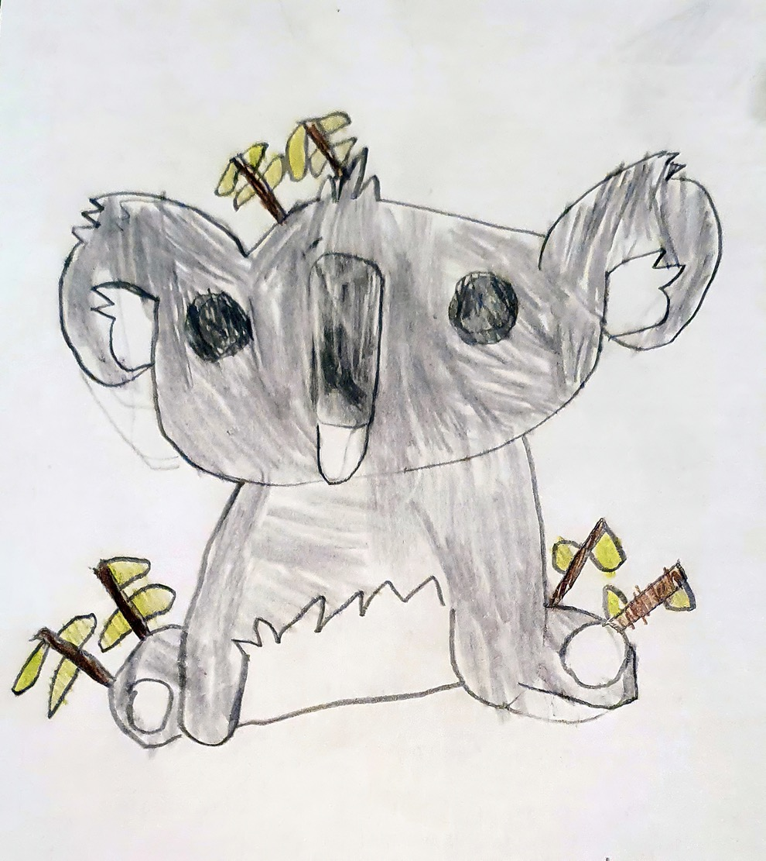
Child’s drawing of a Koala. Image: © Tom Mallela-Leavesley

