#### DSEWPaC-inline_stacked_blue.png

Recovery Plan for

Three Handfish Species

Spotted handfish *Brachionichthys hirsutus*

Red handfish *Thymichthys politus*

Ziebell’s handfish *Brachiopsilus ziebelli*

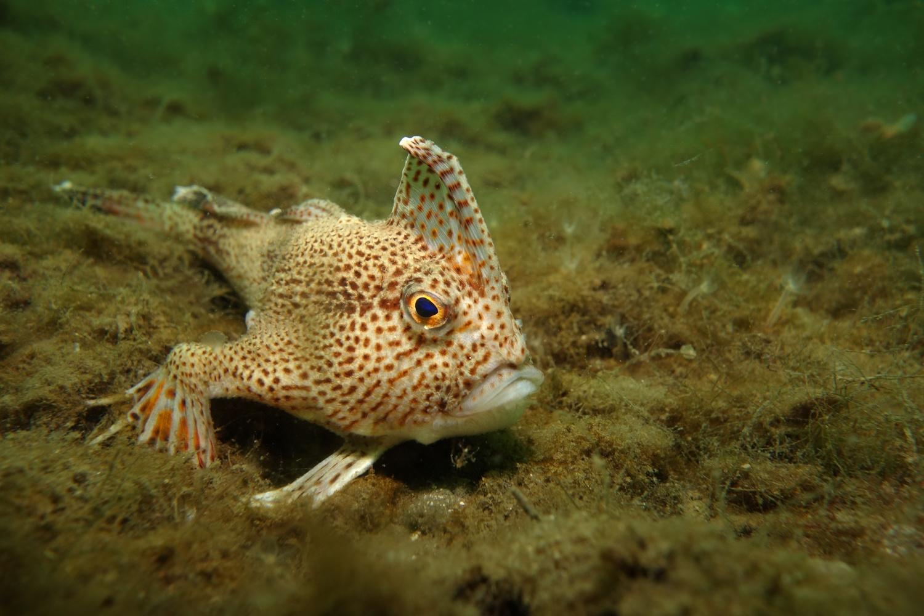

December 2015

The Species Profile and Threats Database pages linked to this recovery plan is obtainable from:   
<http://www.environment.gov.au/cgi-bin/sprat/public/sprat.pl>

© Copyright Commonwealth of Australia, 2015.

http://i.creativecommons.org/l/by/3.0/88x31.png

*Recovery Plan for Three Handfish Species* is licensed by the Commonwealth of Australia for use under a Creative Commons Attribution 4.0 International licence with the exception of the Coat of Arms of the Commonwealth of Australia, the logo of the agency responsible for publishing the report, content supplied by third parties, and any images depicting people. For licence conditions see: <https://creativecommons.org/licenses/by/4.0/>

This report should be attributed as ‘Recovery Plan for Three Handfish Species, Commonwealth of Australia 2015’.

The Commonwealth of Australia has made all reasonable efforts to identify content supplied by third parties using the following format ‘© Copyright, [*name of third party*] ’.

**Disclaimer**

While reasonable efforts have been made to ensure that the contents of this publication are factually correct, the Commonwealth does not accept responsibility for the accuracy or completeness of the contents, and shall not be liable for any loss or damage that may be occasioned directly or indirectly through the use of, or reliance on, the contents of this publication.

Images credits

Cover page: Spotted handfish *(Brachionichthys hirsutus) in the Derwent Estuary, Tasmania.*

Back page: Red handfish *(Thymichthys politus) at Primrose Sands, Tasmania.*

Page 22 (top image): Spotted handfish *(Brachionichthys hirsutus) in the Derwent Estuary, Tasmania.*

Page 22 (bottom image): Red handfish *(Thymichthys politus) at Primrose Sands, Tasmania.*

(All images © Emma Flukes)

Table of contents

[Acronyms 5](#_Toc417992941)

[1 Summary 6](#_Toc417992942)

[Spotted handfish *(Brachionichthys hirsutus)* 6](#_Toc417992943)

[Red handfish *(Thymichthys politus)* 6](#_Toc417992944)

[Ziebell’s handfish *(Brachiopsilus ziebelli)* 6](#_Toc417992945)

[Habitat critical for survival: 7](#_Toc417992946)

[Recovery plan objectives: 7](#_Toc417992947)

[Recovery team: 7](#_Toc417992948)

[Recovery strategies: 7](#_Toc417992949)

[Criteria for success: 8](#_Toc417992950)

[Criteria for failure: 8](#_Toc417992951)

[2 Introduction 9](#_Toc417992952)

[2.1 Conservation Status 10](#_Toc417992953)

[2.2 Handfish Recovery Group 10](#_Toc417992954)

[3 Background 11](#_Toc417992955)

[3.1 Spotted handfish *(Brachionichthys hirsutus)* 11](#_Toc417992956)

[3.1.1 Species description and distribution in Australian waters 11](#_Toc417992957)

[3.1.2 Population trends 11](#_Toc417992958)

[3.1.3 Biology and Ecology 11](#_Toc417992959)

[3.1.4 Habitat critical to the survival of the spotted handfish 11](#_Toc417992960)

[3.2 Red handfish *(Thymichthys politus)* 12](#_Toc417992961)

[3.2.1 Species description and distribution in Australian waters 12](#_Toc417992962)

[3.2.2 Population trends 12](#_Toc417992963)

[3.2.3 Biology and Ecology 12](#_Toc417992964)

[3.2.4 Habitat critical to the survival of the red handfish 12](#_Toc417992965)

[3.3 Ziebell’s / Waterfall Bay handfish *(Brachiopsilus ziebelli)* 13](#_Toc417992966)

[3.3.1 Species description and distribution in Australian waters 13](#_Toc417992967)

[3.3.2 Population trends 13](#_Toc417992968)

[3.3.3 Biology and Ecology 13](#_Toc417992969)

[3.3.4 Habitat critical to the survival of Ziebell’s handfish 13](#_Toc417992970)

[4 Threats 18](#_Toc417992971)

[4.1 Historical causes of decline 18](#_Toc417992972)

[4.2 Current threatening processes 18](#_Toc417992973)

[4.2.1 Habitat degradation and loss of spawning substrate 18](#_Toc417992974)

[4.2.2 Pollution and siltation of waterways 19](#_Toc417992975)

[4.2.3 Traditional boat moorings 20](#_Toc417992976)

[4.2.4 Northern Pacific seastar (Asterias amurensis) 20](#_Toc417992977)

[4.2.5 Other potential threatening processes 20](#_Toc417992978)

[5 Populations under particular pressure 21](#_Toc417992979)

[6 Objectives and strategies 21](#_Toc417992980)

[7 Actions to achieve the specific objectives 22](#_Toc417992981)

[Strategy 1 – Increase spawning success for spotted, red and Ziebell’s handfish 23](#_Toc417992982)

[Strategy 2 – Reduce impacts on spotted, red and Ziebell’s handfish, and their habitat 24](#_Toc417992983)

[Strategy 3 – Consider options for the active management of spotted, red and Ziebell’s handfish 25](#_Toc417992984)

[Strategy 4 - Improve knowledge of the distribution, abundance and population trends of spotted, red and Ziebell’s handfish 27](#_Toc417992985)

[Strategy 5 - Increase understanding of habitat preferences and threats to habitat for spotted, red and Ziebell’s handfish 29](#_Toc417992986)

[Strategy 6 - Encourage community participation in the conservation of spotted, red and Ziebell’s handfish 31](#_Toc417992987)

[8 Duration and cost of the recovery process 32](#_Toc417992988)

[9 Current management practices 33](#_Toc417992989)

[10 Effects on other native species and biodiversity benefits 33](#_Toc417992990)

[11 Social and economic considerations 33](#_Toc417992991)

[12 Affected interests 33](#_Toc417992992)

[13 Consultation 34](#_Toc417992993)

[14 Organisations/persons involved in evaluating the performance of the plan 34](#_Toc417992994)

[15 References 35](#_Toc417992995)

# Tables and figures

[**Table 1:** National and state conservation status of the three species of threatened handfish 10](#_Toc397349092)

[**Table 2:** Current distribution of threatened handfish species and key threats. 14](#_Toc397349093)

**Figure 1:** Modelled distribution of spotted handfish (Brachionicthys hirsutus)........................................15

**Figure 2:** Modelled distribution of red handfish (Thymichthys politus)....................................................16

**Figure 3:** Modelled distribution of Ziebell’s handfish *(Brachiopsilus ziebelli)*..........................................17

# Acronyms

|  |  |
| --- | --- |
| CSIRO | Commonwealth Scientific and Industrial Research Organisation (Commonwealth) |
| DEP | Derwent Estuary Program |
| DotE | Department of the Environment (Commonwealth) |
| DPIPWE | Department of Primary Industries, Parks, Water and Environment (Tasmania) |
| EPBC Act | *Environment Protection and Biodiversity Conservation Act 1999* (Commonwealth) |
| HRG | Handfish Recovery Group |
| IMAS | Institute for Marine and Antarctic Studies |
| IMCRA | Integrated Marine and Coastal Regionalisation of Australia |
| IUCN | International Union for Conservation of Nature |
| LMRM Act | *Living Marine Resources Management Act 1995* (Tasmania) |
| MAST | Marine and Safety Tasmania |
| MNES | Matter of National Environmental Significance |
| NGO | Non-government organisation |
| NVA | Natural Values Atlas (Tasmania) |
| REDMAP | Range Extension Database and Mapping Project |
| SPRAT | Species Profile and Threats |
| TSP Act | *Threatened Species Protection Act 1995* (Tasmania) |
| TSSC | Threatened Species Scientific Committee |
| UTAS | University of Tasmania |

# 1 Summary

## Spotted handfish *(Brachionichthys hirsutus)*

**Family:** Brachionichthyidae

**IMCRA Bioregion:** Known:Bruny

Possible: Freycinet and Davey

**Current status of taxon:** *Environment Protection and Biodiversity Conservation Act 1999*: Critically Endangered

*Threatened Species Protection Act 1995* (Tas): Endangered.

*IUCN Red List of Threatened Species:* Critically Endangered

**Distribution and habitat:** Spotted handfish occur in the lower Derwent Estuary and adjoining bays and channels. They inhabit benthic (seafloor) environments in association with coarse to fine sand and shell grit or silt, with a depth distribution ranging from 2 to 30 metres.

## Red handfish *(Thymichthys politus)*

**Family:** Brachionichthyidae

**IMCRA Bioregion:** Known:Bruny

Possible: Freycinet and Davey

**Current status of taxon:** *Environment Protection and Biodiversity Conservation Act 1999*: Critically Endangered

**Distribution and habitat:** Red handfish occur in Frederick Henry Bay and were historically recorded from sites off Port Arthur and the Forestier Peninsula. They inhabit a variety of locations, such as on top of rocks, amongst macro-algae, in sandy areas between rocks and the reef-sand interface and on sediments with weed clumps near reefs, with a depth distribution ranging from 1 to 20 metres.

## Ziebell’s handfish *(Brachiopsilus ziebelli)*

**Family:** Brachionichthyidae

**IMCRA Bioregion:** Possible:Bruny, Freycinet and Davey

**Current status of taxon:** *Environment Protection and Biodiversity Conservation Act 1999*: Vulnerable

**Distribution and habitat:** Ziebell’s handfish historically occurred in widely disjunct populations across eastern and southern Tasmania, though the species current distribution is unknown. They inhabit a variety of locations, such as soft bottomed habitat with patches of rock that support sponge and algae communities, rocky-bottomed seafloor, on rock ledges and in cracks on open walls and in caves and on the edge of giant kelp forests, with a depth distribution ranging from 3 to 20 metres.

## Habitat critical for survival:

Habitat critical to the survival of these taxa is defined as:

* the current area of occupancy of one or more taxa;
* any newly discovered locations that extend the area of occupancy for one or more taxa.

## Recovery plan objectives:

The objectives of this recovery plan are to:

* ensure an ecologically functional wild population of spotted handfish that, with limited site-specific management, has a high likelihood of persistence in nature; and
* increase the understanding of the biology and ecology of spotted handfish, red handfish and Ziebell’s handfish in order to conserve, and contribute to the future recovery, of each species.

## Recovery team:

Recovery teams provide advice and assist in coordinating actions described in recovery plans. They include representatives from organisations with a direct interest in the recovery of the species, including those involved in funding and those participating in actions that support the recovery of the species. The Handfish Recovery Group has the responsibility of providing advice, coordinating and directing the implementation of the recovery actions outlined in this recovery plan. The membership of the Handfish Recovery Group currently includes individuals with relevant expertise from DotE, DPIPWE, DEP, UTAS, independent researchers and community divers; however, membership may change over time.

## Recovery strategies:

The strategies to achieve the plans’ objectives are to:

* Increase spawning success for handfish;
* Reduce impacts on handfish, and their habitat;
* Consider options for the active management of handfish;
* Improve knowledge of the distribution, abundance and population trends of handfish;
* Increase understanding of habitat health and threats to handfish habitat; and,
* Encourage community participation in the conservation of handfish.

## 

## Criteria for success:

This recovery plan will be deemed successful if, within 10 years, all of the following have been achieved:

* Population densities of spotted handfish have increased at each known location.
* Known populations of spotted handfish, including any new populations discovered, have been regularly monitored.
* Surveys for red handfish and Ziebell’s handfish have been conducted in likely habitats.
* Understanding of the distribution and abundance of red handfish and Ziebell’s handfish has increased.
* The preferred habitat for each species of handfish covered by this plan has been identified and mapped.
* The factors limiting population growth for each species of handfish covered by this plan have been identified.
* Artificial spawning habitat, if found to be effective at increasing spawning success, has been provided at key locations to support spotted handfish spawning.
* Appropriate measures have been put in place to manage key threats to all handfish species covered by this plan.
* Habitat quality has been maintained or improved in key locations for all handfish species covered by this plan.
* Population response models, that include trigger points for captive breeding and/or translocation and reintroduction programs, have been developed for all species of handfish covered by this plan.

## 

## Criteria for failure:

This recovery plan will be deemed to have failed if; within 10 years any of the following have occurred:

* Any of the handfish species covered by this plan have become extinct in the wild, or their conservation status has declined, during the life of the plan.
* Surveys to improve understanding of the distribution and abundance of handfish species covered by this plan have not been conducted.
* Regular monitoring has not been conducted and population trends have not been assessed for known spotted handfish populations.
* Key factors limiting population growth for each species have not been identified and appropriate mitigation measures have not been implemented.
* Artificial spawning habitat, if found to be effective at increasing spawning success, has not been laid out at key spotted handfish locations.
* Habitat quality has declined in key locations for any handfish species.

# 2 Introduction

This document constitutes the ‘Australian National Recovery Plan for Three Handfish Species*:* spotted handfish(*Brachionichthys hirsutus*), red handfish(*Thymichthys politus*) and Ziebell’s handfish(*Brachiopsilus ziebelli*)’. The plan considers the conservation requirements of the species across their range and identifies the actions to be taken to ensure the species’ long-term viability in nature, and the parties that will undertake those actions.

This recovery plan is a revision of the 2005 National Recovery Plan for Four Species of Handfish (DEH, 2005). The 2005 recovery plan recognised Ziebell’s handfish *(Sympterichthys sp.)* and Waterfall Bay handfish *(Sympterichthys sp.)* as two distinct species. However, Ziebell’s handfish and Waterfall Bay handfish are now formally recognised as a single species *(Brachiopsilus ziebelli).* The 2005 recovery plan also recognised the red handfish under its previous taxonomic name of *Brachionichthys politus.* However, the red handfish is now formally recognised under the taxonomic name of *Thymichthys politus.* The EPBC Act list of threatened species was updated in October 2012 to recognise these taxonomic changes.

The 2005 recovery plan was reviewed in 2013 by an expert panel that included representatives from DotE, DPIPWE, CSIRO, UTAS and DEP. This review noted that, despite limited availability of resources, there had been a sustained effort to implement some recovery actions for the spotted handfish in the Derwent Estuary and recovery plan objectives had been partially met for this species. However, it was noted that limited progress had been made on implementation of the recovery plan actions for red handfish and Ziebell’s handfish, with progress limited to resolving taxonomic uncertainties. Furthermore, the review concluded that threats to handfish species remained largely unchanged and known handfish populations had not demonstrably increased in size. The review identified a number of relatively simple actions that could be implemented to boost the survival of the spotted handfish, and recommended that a new recovery plan be developed for the three handfish species. The 2005 recovery plan and the 2013 review of the recovery plan are available from: <http://www.environment.gov.au/biodiversity/threatened/recovery-plans/four-species-handfish>

Threats to handfish survival vary from species to species. However, principal threats to the three species covered by this plan may include loss of spawning substrate, habitat loss and degradation, water pollution and siltation, the spread of the invasive Northern Pacific seastar *(Asterias amurensis)* and the cumulative impacts of boating. Other potential threats to these species may include ongoing impacts from recreational and commercial fishing, and the illegal aquarium trade. Climate change is also likely to impact upon handfish as a result of rising water temperatures and increases in the frequency of severe weather events, together with potential increases in the abundance of native species that may degrade handfish habitat or compete for resources.

This recovery plan sets out the research and management actions necessary to stop the decline, and support the recovery, of handfish species in Australian waters. The overarching objectives of this recovery plan are to:

* ensure an ecologically functional wild population of spotted handfish that, with limited site-specific management, has a high likelihood of persistence in nature, and
* increase the understanding of the biology and ecology of spotted handfish, red handfish and Ziebell’s handfish in order to conserve, and contribute to the future recovery, of each species.

To achieve these objectives a range of strategies will be employed, including the development of a robust, targeted conservation breeding strategy for spotted handfish and the implementation of projects to facilitate the deployment of artificial spawning habitat and the replacement of traditional boat moorings with eco-friendly moorings to improve habitat quality.

Accompanying Species Profile and Threats Database (SPRAT) pages provide background information on the biology, population status and threats to the three listed species of handfish. SPRAT pages are available from: <http://www.environment.gov.au/cgi-bin/sprat/public/sprat.pl>.

## 2.1 Conservation Status

The three species of handfish considered in this recovery plan are listed as threatened under the *Environment Protection and Biodiversity Conservation Act 1999* (EPBC Act). The spotted handfish is also listed under the Tasmanian *Threatened Species Protection Act 1995* (refer to Table 1).

The spotted handfish *(Brachionichthys hirsutus)* and the red handfish *(Thymichthys politus)* were transferred to the critically endangered category of the EPBC Act in 2012 as the geographic distribution of each species was judged as very restricted and precarious to the survival of the species. The Ziebell’s handfish *(Brachiopsilus ziebelli)* was transferred from the *Endangered Species Protection Act 1992* to the vulnerable list of the EPBC Act when it came into force in July 2000.

**Table 1:** National and state conservation status of the three species of handfish covered in this recovery plan.

|  |  |  |
| --- | --- | --- |
| **Species** | **Conservation Status** | |
| National | Tasmania |
| Spotted handfish  *(Brachionichthys hirsutus)* | Critically Endangered1 | Endangered2  Protected3 |
| Red handfish  *(Thymichthys politus)* | Critically Endangered1 | Protected3 |
| Ziebell’s / Waterfall Bay handfish  *(Brachiopsilus ziebelli)* | Vulnerable1 | Protected3 |

Relevant legislation:

1 *Environment Protection and Biodiversity Conservation Act 1999*

2 *Threatened Species Protection Act 1995 (Tas)*

3 *Living Marine Resources Management Act 1995 (Tas)*

## 

## 2.2 Handfish Recovery Group

The recovery program for handfish is coordinated by the Handfish Recovery Group (HRG) which was formed in 2014. This recovery team replaced the Spotted Handfish Recovery Team. The membership of the HRG currently includes individuals with relevant expertise from DotE, DPIPWE, CSIRO, DEP and UTAS as well as independent researchers and community divers; however, membership may change over time. The HRG provides advice and assists in coordinating the recovery actions outlined in this recovery plan.

# 3 Background

## 3.1 Spotted handfish *(Brachionichthys hirsutus)*

### 3.1.1 Species description and distribution in Australian waters

Spotted handfish are small, colourful, slow moving benthic (sea-floor dwelling) fish. Adults are typically 70–90 mm total length (Last et al., 2007) and grow to a maximum of 143 mm (Last and Gledhill, 2009). The species has a relatively short, rounded body that tapers towards the tail and is covered with small spines (Last et al., 1983). The upper surface and sides of the head and body are white or pale pink, and covered with numerous orange, brown or black spots that have orange borders (Last et al., 1983). Spotted handfish have unique markings which allow for identification of individuals (Bruce et al., 1997).

Spotted handfish are endemic to south-east Tasmania (refer to Table 2 and Figure 1). They are currently known from the lower Derwent Estuary and D’Entrecasteaux Channel (Bruce et al., 1998). Historically their range extended along the east coast of Tasmania; however surveys indicate the majority of spotted handfish now persist as small fragmented populations within the historic range (Last and Gledhill, 2009). Within the Derwent Estuary their estimated extent of occurrence is approximately 70 km2, however their actual area of occupancy is likely to be considerably less (DPIPWE, 2014).

### 3.1.2 Population trends

Determining population trends for spotted handfish is difficult because the species is small, cryptic, extremely rare and not located in areas frequented by recreational divers, thus the likelihood of anecdotal observations is low. The species was common throughout the lower Derwent Estuary and adjoining bays prior to the mid 1980s (Pogonoski et al., 2002). Surveys conducted from the late 1980s to early 1990s reported only two handfish in areas previously renowned for sightings, providing the first indication that the population may have declined rapidly during the 1980s (Bruce and Green, 2000). Surveys of a restricted population at Primrose Sands identified 87 individuals in 1999 (Green and Bruce, 2000), however surveys conducted in 2005 failed to detect any handfish at this site (Green, 2005). Analysis of data in 2009 suggested a total abundance of 1500–2700 mature spotted handfish (Green, 2009), however total abundance may have decreased since this time (Green, pers comm., 2014).

### 3.1.3 Biology and Ecology

Spotted handfish move by using their hand-like fins to crawl across the seafloor (DEH, 2005) and use their illicium (modified dorsal fin ray) to attract food (Edgar et al., 1982) and probe egg masses (DEH, 2005). Their diet includes small crustaceans and polychaete worms (Bruce et al., 1998), small shells (Kuiter, 1996) and amphipods (Bruce et al., 1997). Spotted handfish migration rates are likely to be low (Green, 2005). Species longevity is yet to be determined (Bruce et al., 1999). However, female growth rates suggest maturity is reached at 2-3 years, at a size of 75-80 mm in length (Bruce et al., 1999).

Spotted handfish have a low breeding capacity and dispersal rate. Females lay 80-200 eggs held together by threads (Last and Bruce, 1996–97) and attached to small, vertical, semi-rigid structures on the seafloor, such as stalked ascidians (*Sycozoa*sp.), seagrasses, sponges, algae and polychaete worm tubes (DPIWE, 2002). Females guard eggs for 6–7 weeks (Bruce, 1998) until they hatch into fully formed juveniles (Pogonoski et al., 2002). Spawning is from September to October (Pogonoski et al., 2002) and hatchlings settle in the immediate area (Bruce et al., 1997).

### 3.1.4 Habitat critical to the survival of the spotted handfish

The spotted handfish is currently known from a limited number of sites in the lower Derwent Estuary and the D’Entrecasteaux Channel. The species occurs in benthic (seafloor) environments in association with coarse to fine sand and shell grit or silt (DPIWE, 2002) and is most common in depths of 5-15 meters on the continental shelf, but may have occurred at depths of 1-60 metres (Last and Gledhill, 2009). Given the low number of mature individuals and the extremely limited distribution of the species, all areas in which spotted handfish are found (including those currently known and any new areas identified in the future) represent habitat critical to the survival of the species.

## 3.2 Red handfish *(Thymichthys politus)*

### 3.2.1 Species description and distribution in Australian waters

Red handfish are small, slow moving benthic fish with a relatively elongate and moderately compressed body that tapers towards the tail (Last and Gledhill, 2009). The species grows to at least 136 mm total length and their skin is covered in small, close-set, flattened warts (Last and Gledhill, 2009). There are two primary colour morphs, both dominated by reddish tones. One morph is a uniform vivid red over the body and fin bases with the outer parts of the fins bluish and white; the second morph is a less strikingly mottled pink with extensive reddish patches and spots (Last and Gledhill, 2009).

Red handfish are endemic to south-east Tasmania (refer to Table 2 and Figure 2). They are currently known only from Primrose Sands in Frederick Henry Bay. However, historically the species range extended along the eastern coast of Tasmania.

### 3.2.2 Population trends

Determining trends in Red handfish populations is difficult because the species is small, cryptic and extremely rare. The largest known population, and the only population currently confirmed, is at Primrose Sands Reef in Frederick Henry Bay. During the 1990s the species was sighted regularly at Primrose Sands (Bruce et al., 1997) however no individuals were located during surveys in 2005 (Gledhill and Green, unpublished). Red handfish have subsequently been observed at Primrose Sands, albeit in low numbers (Gowlett-Holmes, pers comm., 2014; Jacques, unpublished). Historically the red handfish was also known from a number of locations off Port Arthur, the Acteaon Islands and the Forestier Peninsula, with the species being not uncommon in the Port Arthur area in the 1800s (Last and Gledhill, 2009). There have been suggestions that the species may have undergone a major population decline (Last and Gledhill, 2009) sometime during the 1900s. There have been no reported observations of the species from the Port Arthur area in recent decades and the last reliable sighting in Fortescue Bay was from the 1990s (Gowlett-Holmes, pers comm., 2014). However, survey effort for red handfish has been very limited and more information is needed to accurately assess population trends.

### 3.2.3 Biology and Ecology

Red handfish move by using their hand-like fins to crawl across the seafloor (DEH, 2005). The species' diet includes small crustaceans and polychaete worms (Edgar et al., 1982). The longevity of red handfish is yet to be determined. However, recorded specimens have ranged in size from 50-80 mm in length and observations suggest there may be sexual dimorphism in this species, with males being smaller than females (Bruce et al., 1997).

Red handfish have a low reproductive rate and a very low rate of dispersal. Females produce egg masses that vary in size, consisting of an estimated 30-60 eggs connected by tubules and bound together by associated threads (Bruce et al., 1997). Females have been observed to attach egg masses to green alga, *Caulerpa sp.,* (Bruce et al., 1997) as well as Sargassum species and thin red alga (Jacques, unpublished). Egg masses have been observed in the field in late October and early November and all egg masses were guarded by an adult red handfish (Bruce et al., 1997). Newly emerged hatchlings look similar to adults but are yellow/orange in colour and some have exhibited a pattern of black and white markings on their pectoral fins (Bruce et al., 1997). Once hatched, juveniles have been observed to settle immediately in the vicinity of the egg mass (DEH 2004).

### 3.2.4 Habitat critical to the survival of the red handfish

The red handfish is currently known from a single site at Primrose Sands Reef in Frederick Henry Bay. The species occurs in a variety of locations, such as on the top of rocks, amongst macro-algae and in sandy areas between rocks and the reef-sand interface (Bruce et al., 1997) and has a depth distribution of 1-20 metres (Last and Gledhill, 2009). Given the low number of mature individuals and the extremely limited distribution of the species, all areas in which red handfish are found (including those currently known and any new areas identified in the future) represent habitat critical to the survival of the species.

## 3.3 Ziebell’s / Waterfall Bay handfish *(Brachiopsilus ziebelli)*

### 3.3.1 Species description and distribution in Australian waters

Ziebell’s handfish is the largest known handfish species, reaching a maximum total length of approximately 150 mm (DEH, 2001). The species has a moderately short, rounded body that is usually humped near the head and tapers toward the tail (Last and Gledhill, 2009). It has thick, flabby, smooth skin. Typically, the body is pink to white, with the upper surface and sides having purple to brown randomly placed blotches. Fins are generally bright yellow and, in some specimens, the yellow extends onto the body adjacent to the fins (Last and Gledhill, 2009). The illicium (the modified first dorsal-fin spine) is pink to white (Last et al., 1983).

Ziebell’s handfish are restricted to eastern and southern Tasmania in widely disjunct populations (Last and Gledhill, 2009) (refer to Table 2 and Figure 3). The species has been recorded at Bicheno, Forestier Peninsula, Tasman Peninsula, Actaeon Islands and Cox Bight in depths of 10–20 m (Last and Gledhill, 2009). Ziebell’s handfish have not been observed, or systematically surveyed, for several years and the species’ current distribution is unknown.

### 3.3.2 Population trends

The Ziebell's handfish population has not been systematically surveyed (DEH, 2005). However, ad hoc surveys by Tasmanian dive groups suggest the population of Ziebell's handfish is small (DEH, 2001). In 2005, attempts by divers to locate specimens in locations where this species had previously been recorded, such as Waterfall Bay and the Actaeon Islands, failed to locate any individuals, suggesting localised declines (DEH, 2005). However, a lack of systematic surveying of the species makes it impossible to determine whether populations are increasing, decreasing or stable (DEH, 2005).

### 3.3.3 Biology and Ecology

Ziebell’s handfish move by using their hand-like fins to crawl across the seafloor (DEH, 2005). The species' diet probably consists of small invertebrates (Pogonoski et al., 2002) such as crustaceans and polychaete worms (Edgar et al., 1982). The longevity of Ziebell’s handfish is yet to be determined, though the species can obtain a total length of at least 151 mm (Last and Gledhill 2009).

Ziebell’s handfish have a similar breeding strategy to spotted handfish and red handfish, whereby they produce an egg mass structure connected by tubules and threads (Bruce et al.,, 1999), attach the egg masses to vertical structures and females guard the eggs until they hatch into fully formed young which settle in the immediate area (DEH, 2005). Egg masses have been found around sponges in depths of 20 m (Pogonoski et al., 2002).

### 3.3.4 Habitat critical to the survival of Ziebell’s handfish

The Ziebell’s handfish is most recently known from the Waterfall Bay area of the Tasman Peninsula. The species appears to prefer soft bottomed habitat, with patches of rock that support sponge and algae communities, though it has also been found at the edge of giant kelp forests, on rocky substrate, on rock ledges and in cracks on open walls and inside caves. The species has a depth distribution of 3-20 metres; most often found in depths of 10-20 metres (Last and Gledhill, 2009). Given the low number of mature individuals and the extremely limited distribution of the species, all areas in which Ziebell’s handfish are found (including those currently known and any new areas identified in the future) represent habitat critical to the survival of the species.

**Table 2:** Current distribution of handfish species and key threats.

|  |  |  |  |
| --- | --- | --- | --- |
| **Species** | **Distribution\*** | **Tenure** | **Threats** |
| Spotted handfish  *(Brachionichthys hirsutus)* | Known to occur: nine locations in the lower Derwent Estuary and two locations in the D’Entrecasteaux Channel.  Likely to occur: further locations in the lower Derwent Estuary and D’Entrecasteaux Channel.  May occur: multiple inshore locations along the continental shelf on the east coast of Tasmania, including Frederick Henry Bay, Great Oyster Bay, Huon Estuary, Cape Portland, St Helens and the wider D’Entrecasteaux Channel. | Marine Protected Area (IUCN category VI equivalent)  State Waters | Loss of spawning substrate  Habitat degradation (loss of refugia and foraging/feeding habitat) |
| Red handfish  *(Thymichthys politus)* | Known to occur: one location in Primrose Sands, Frederick Henry Bay.  Likely to occur: wider area surrounding Primrose Sands, Frederick Henry Bay.  May occur: multiple inshore locations along the eastern coast of Tasmania, including Port Arthur region, the Forestier Peninsula, the Actaeon Islands, D'Entrecasteaux Channel and possible areas in the Bass Strait, off northern Tasmania. | State Waters | Loss of spawning substrate  Climate change and habitat degradation |
| Ziebell’s / Waterfall Bay handfish  *(Brachiopsilus ziebelli)* | Known to occur: distribution of remaining extant populations currently unknown.  Likely to occur: Waterfall Bay area of Tasman Peninsula and Bicheno region.  May occur: multiple locations along the eastern and southern coasts of Tasmania, including the lower D’Entrecasteaux Channel, the Acteaon Islands, the Forestier and Tasman Peninsulas, Bicheno and Cox Bight in south-west Tasmania. | Marine Protected Area (IUCN category VI equivalent)  State Waters | Threats unknown |

\* *known to occur* consists of all locations where the species have been sighted within the past decade, this includes biologically important areas where the species are known to breed, feed or forage.

\* *likely to occur* consists of areas where the species or species’ habitat is likely to occur, such as locations adjacent to known distribution polygons or locations where the species have been previously sighted.

\* *may occur* consists of areas where the species or species’ habitat may occur, such as historic locations and larger stretches of the coastline within the depth distribution of the species.

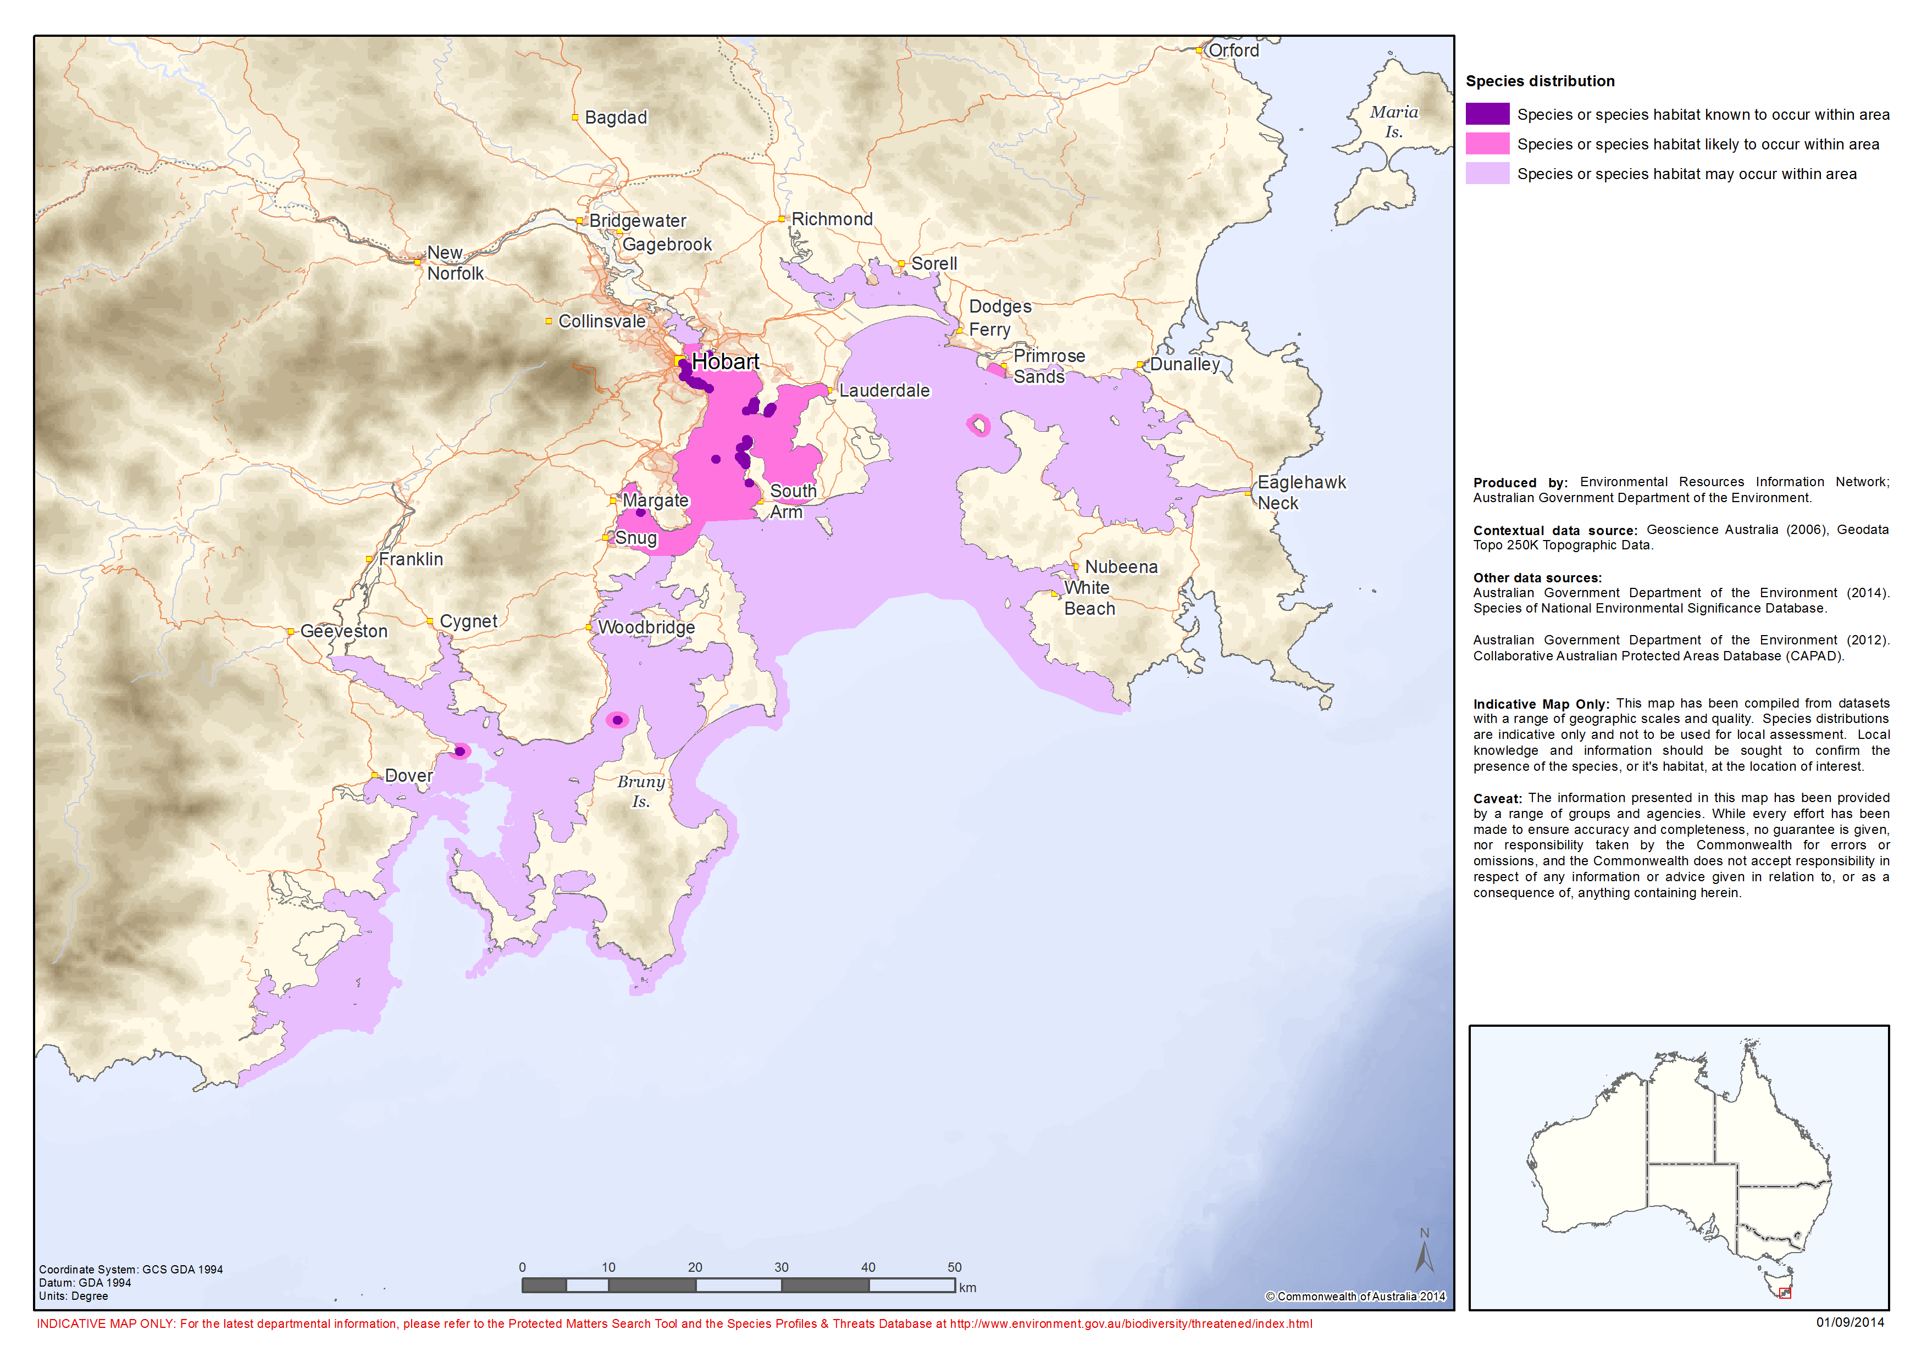

**Figure 1:** Modelled distribution of spotted handfish (Brachionichthys hirsutus).

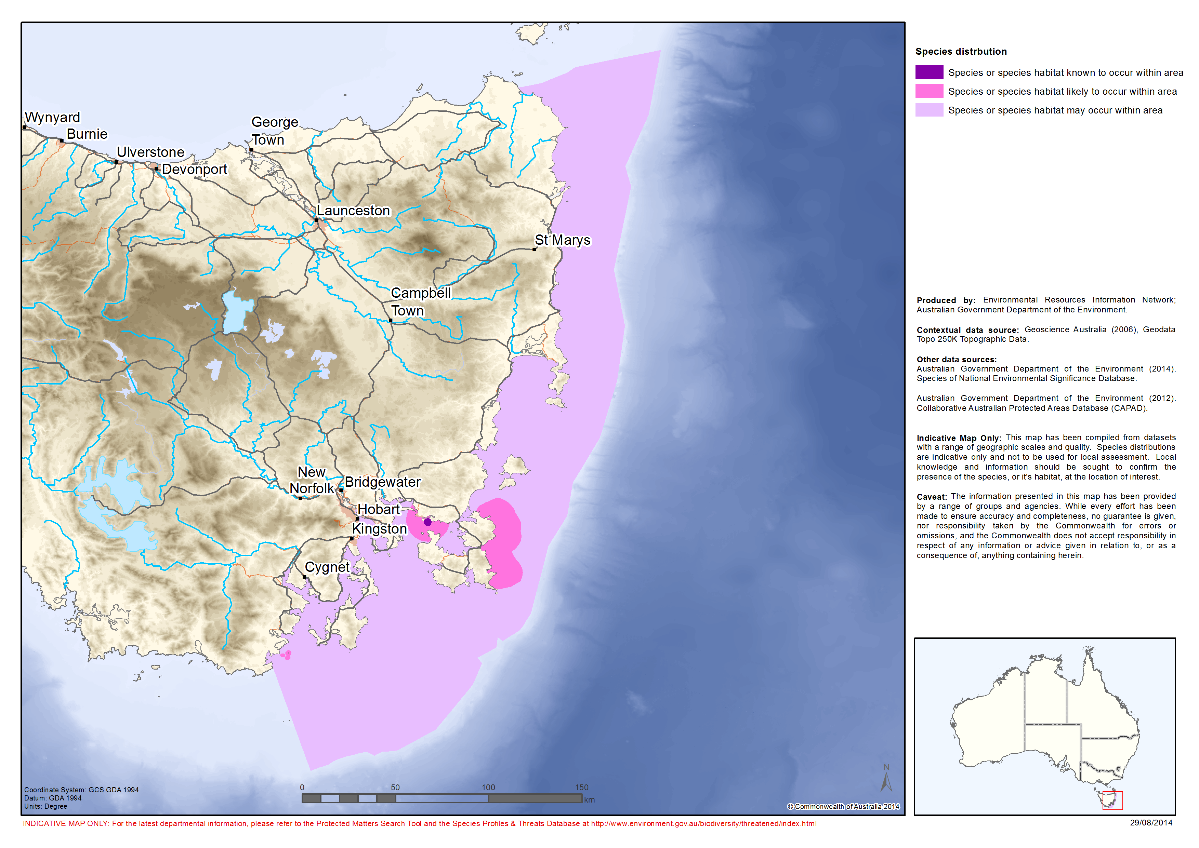

**Figure 2:** Modelled distribution of red handfish (Thymichthys politus).

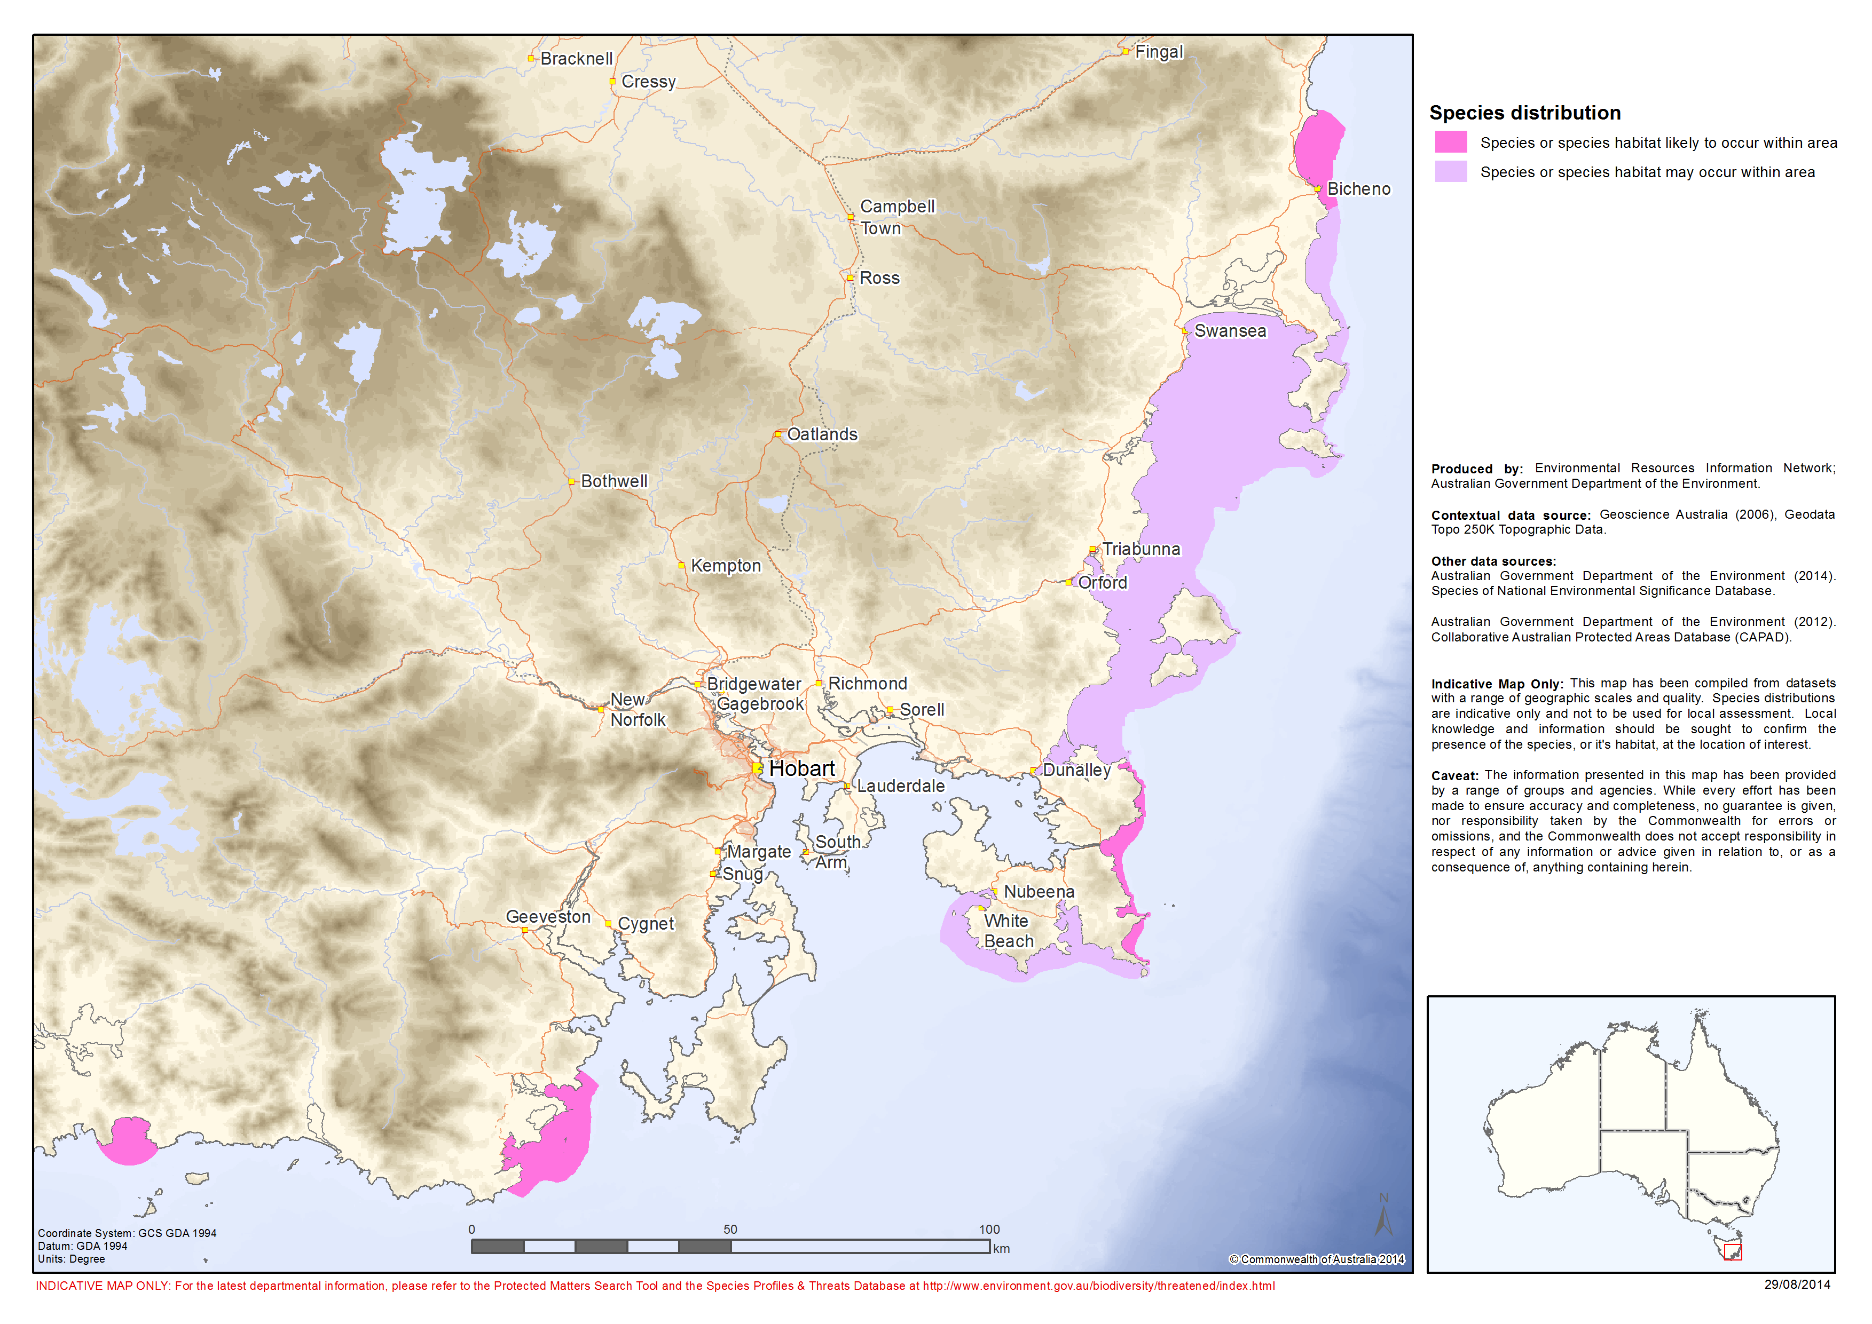

**Figure 3:** Modelled distribution of Ziebell’s handfish (Brachiopsilus ziebelli).

# 4 Threats

## 4.1 Historical causes of decline

Declines in the abundance of handfish during the 1900s may be a result of a number of factors, including commercial and recreational dredging and land management activities that caused shifts in turbidity, water and sediment quality. Scallop dredging previously occurred in the D’Entrecasteaux Channel and Great Oyster Bay, with these areas intensely harvested during the 1960s to the 1980s (Last and Gledhill, 2009). These fishing practices are known to have significant impacts on benthic habitat and are effective at catching small, slow-moving benthic fish (Bruce et al., 1999). Dredging may have significantly impacted spotted handfish reproduction and survival by decreasing the availability of important habitat, particularly critical spawning substrate (Bruce et al., 1999; DPIWE, 2002).

## 4.2 Current threatening processes

Key threats to handfish species covered by this plan include: loss/degradation of habitat, particularly spawning substrate; pollution and siltation of waterways from both diffuse and point-source activities; traditional boat moorings; and the spread of invasive Northern Pacific seastars *(Asterias amurensis)*. Other possible threats to handfish include: fishing; direct predation; illegal collection for the aquaria trade; bioaccumulation of heavy metals; and climate change.

Furthermore, the three species of handfish all exhibit the shared features of small population sizes, highly fragmented distributions and low dispersal abilities (DotE, 2014). Given these factors all three species face an increased risk of localised extinction as a result of stochastic events and are susceptible to a loss of genetic variation.

### 4.2.1 Habitat degradation and loss of spawning substrate

The principle threat to handfish appears to be reduced abundance and distribution of benthic organisms suitable for egg mass attachment (DPIWE, 2002). This reduction in the availability of suitable spawning substrate was found to limit the reproductive success of spotted handfish in the Derwent Estuary (DPIWE, 2002). All three species of handfish rely on semi-rigid vertical structures, such as stalked ascidians, sponges and fleshy alga, on which to attach their egg masses (DEH, 2005). When spawning substrate is absent handfish are unable to secure and guard their egg masses, which often results in any eggs laid being swept away in the current. Anecdotal reports suggest there has been a significant decline in abundance of the preferred spawning substrate for spotted handfish in recent years (Flukes, pers comm., 2014).

While reports indicate that handfish may use alternative forms of substrate, such as filamentous alga, this strategy may not be reproductively viable. Red handfish at Frederick Henry Bay were observed attaching egg masses to filamentous alga but all egg masses failed as the algae was washed away (Jacques, 2014). Furthermore, blooms of filamentous alga may smother the egg masses and possibly restrict the movement of handfish. Several species of unidentified red and brown filamentous algae have been recorded in the Derwent Estuary (Barrett et al., 2010) and Frederick Henry Bay (Jacques, unpublished). Filamentous algae cover varies in space and time and often appears in seasonal flushes. Anecdotal evidence indicates that warm summers and increasing water temperatures favour the growth of filamentous algae, which appears to outcompete other algae such as branching *Caulerpa* species (Flukes, pers comm., 2014). In spring and summer 2010 high covers of filamentous red and brown algae (unidentified species) were recorded at sites across the Derwent Estuary (Barrett et al., 2010). Divers have reported that they have not observed spotted handfish at sites in the Derwent Estuary where high covers of filamentous algae were present (Flukes, pers comm., 2014).

Other native species that have increased in abundance as a result of human activity may also impact on the availability of spawning substrate and interfere with the recruitment of juvenile handfish. The common butterfly-shell oyster *(Electroma georgiana)* is a rapidly growing species which experiences population explosions that result in the formation of large, smothering accumulations on the sea floor; these leave behind extensive swathes of decomposing matter when they die off (Green, pers comm., 2014). This speciestends to proliferate under high nutrient conditions (Aquenal Pty Ltd, 2008), such as those found in the Derwent Estuary where high sediment and nutrient loads are associated with urban and industrial development and changes in catchment use (Australian Government Land and Coasts, 2010). A high abundance of these oysters was observed at a site in the Derwent Estuary in the late 1990s. The proliferation of this oyster at this site, 'may have affected the recruitment of spotted handfish by smothering egg masses, hindering development and hatching of emerging fish or smothering sediments and restricting access of juvenile fish to benthic prey' (Green and Bruce 2000).

The native sea urchin *(Heliocidaris erythrogramma)* has also increased in abundance, possibly due to fishing activities that remove its predators, such as rock lobsters *(Jasus edwardsii)* (Brereton, pers comm., 2010) and wrasse species (Labridae family) (Flukes, pers comm., 2014; Gowlett-Holmes, pers comm., 2014). *H. erythrogramma* form into large aggregations, known as barrens, that remove larger macroalgae (potential handfish spawning substrate) from the reef resulting in overgrazed habitat (Edgar, 1997) with low productivity and biodiversity (Valentine and Johnson, 2005).

### 4.2.2 Pollution and siltation of waterways

Anthropogenic activities such as land clearing, land reclamation, dredging, port construction, damming and industrial and urban waste inputs often have significant impacts on estuarine ecosystems and can lead to increases in run-off and sediment loads and reductions in water quality, habitat quality and availability, and fish abundance (Edgar et al., 2000). The Derwent Estuary is no exception. After the city of Hobart was established on the western bank of the Derwent in the early 1800s extensive land clearing and agriculture development commenced, followed by the damming of the river (Butler, 2006). A rapidly expanding population led to increases in industrialisation and urbanisation around the shores of the Derwent Estuary during the 20th century (Butler, 2006). Discharges into the Derwent River increased considerably throughout the first two centuries of European settlement in the catchment (Butler, 2006).

The Derwent Estuary has been identified as one of the most heavily polluted waterways in the world with high concentrations of heavy metals in the estuary’s soft sediments (Whitehead et al., 2013). Historic sources of contamination include a zinc smelter and paper and pulp mill which operated along the estuary in the 1900s, while current sources include sewage, storm water, contaminated ground water from the zinc smelter, and aerial emissions (Whitehead et al., 2013). Toxicity effects to fish from exposure to metals are influenced by a range of biogeochemical, cellular, physiological and anatomical characteristics, and thus vary from species to species (Newman, 2003). Documented impacts to fish from exposure of the gills to dissolved or colloidal metals include disruptions and/or alterations to gas exchange, ammonia excretion, ion regulation and osmotic regulation (Newman, 2003) as well as structural lesions and other functional disturbances (Jezierska & Witeska, 2006).

Due to their distribution in shallow coastal habitats in close proximity to urban and industrial areas handfish, particularly spotted handfish, are exposed to numerous impacts from anthropogenic activities (DEP, 2013). Impacts to handfish populations from coastal developments can arise as a result of increased top soil runoff and sedimentation in surrounding waterways, while impacts from marine developments can occur due to the loss or modification of habitat (DEP, 2013).

In recent decades considerable effort has been put into improving water quality in the Derwent Estuary, including site works to reduce heavy metal discharge at the zinc smelter, expansion of the wastewater treatment plant at the paper mill, introduction of effluent reuse schemes for sewage from metropolitan Hobart and improvements to storm water management (Whitehead et al., 2013). Sediment samples taken in 2011 indicate that concentrations of heavy metals have decreased at some sites in the Derwent since 2000, however levels vary across the estuary and copper, arsenic, zinc and cadmium concentrations increased in some spotted handfish locations (Whitehead et al., 2013). Nevertheless, within the past decade overall discharges of heavy metal were reduced by more than 60 percent, discharges of organic matter were reduced by more than 90 percent, discharges of sewage-derived nutrients were reduced by 10-20 percent and considerable improvements were made in stormwater treatment (DEP, 2014).

At the time of writing this plan there continues to be substantial collaborative effort focussed on improving the condition of the Derwent. The best example of this is the Derwent Estuary Program (DEP), a regional partnership between Tasmanian State Government, local governments, commercial and industrial enterprises, and community-based groups focussed on progressively improving the health of the Derwent Estuary and protecting the important ecosystems and iconic species it supports, including spotted handfish (DEP, 2014). Key areas for action identified by DEP include managing and reducing heavy metal contamination, preventing eutrophication, promoting water sensitive urban design, conserving iconic habitats and species and education and interpretation (DEP, 2014).

### 4.2.3 Traditional boat moorings

Traditional block and chain swing moorings can have significant localised impacts on benthic habitat in sensitive areas (SEQ Catchments, 2014). In the Derwent Estuary a large number of traditional boat moorings are located in known, historic or potential spotted handfish habitats due to the deliberate positioning of moorings in shallow and sheltered estuarine embayments (Green, pers comm., 2014). Traditional moorings consist of a concrete block (or other dump weight) with a heavy chain attached and are designed to allow boats to move in response to winds and currents, often resulting in the slack chain dragging across the seabed and scouring the surrounding substrate (DPI, 2014). Scientists conducting spotted handfish surveys at Battery Point in the Derwent Estuary have observed damage to artificial spawning habitat caused by boat mooring chains dragging across the substrate and noted an absence of handfish in these disturbed areas (Green et al., 2014).

### 4.2.4 Northern Pacific seastar (Asterias amurensis)

Northern Pacific seastars are believed to have been present in the Derwent Estuary since at least the early 1980s when they were introduced via ballast water. The species subsequently spread to areas outside of the estuary (Whitehead, 2008). The Derwent Estuary is now believed to support some of the highest known concentrations of northern Pacific seastars in the world (Whitehead, 2008). Northern Pacific seastars are opportunistic, generalist feeders that are known to affect the abundance of a wide variety of benthic fauna within their native range, including molluscs, ascidians, bryozoans, sponges, crustaceans, polychaetes, fish and echinoderms, (Hatanaka and Kosaka, 1959; Fukuyama, 1994; Fukuyama and Oliver, 1985).Within the Derwent Estuary northern Pacific seastars have been observed feeding on stalked ascidians (*Sycozoa* sp.) and have been identified as a potential contributing factor in the decline of spotted handfish due to their reduction of available spawning substrate (Bruce and Green 1998). If northern Pacific seastars were to colonise, or increase in abundance, in areas that support red handfish or Ziebell’s handfish colonies they may also impact upon the availability of spawning substrate for these species.

### 4.2.5 Other potential threatening processes

* Any form of fishing that degrades the benthic habitat can be considered to pose a threat to handfish species (DPIWE, 2002).
* Reductions in prey abundance, possibly related to decreases in benthic cover of seagrasses and alga that provide habitat for invertebrates, may impact upon handfish survival and reproduction (DPIWE, 2002).
* Illegal collection for the aquaria trade may also pose a threat to handfish. While experts consider the likelihood of poaching to be low, the consequence of removing even a few individuals from the wild is considered to be severe given the small population size of each species.
* Climate change and warming ocean temperatures also pose a potential threat to all handfish species. Increased water temperature may impact upon handfish survival and reproductive capacity both directly, as handfish held in aquaria appeared distressed at temperatures above 18°C (Gledhill and Green, unpublished), and indirectly, through the creation of conditions favourable to the growth of filamentous alga and the spread of native urchins. Furthermore, climate change driven increases in severe weather events may dislodge spawning substrate and degrade habitat (Gowlett-Holmes, pers comm., 2014).

# 5 Populations under particular pressure

The actions described in this recovery plan are designed to provide ongoing protection for handfish species throughout their range.

The meta-population structure of each of the species covered by this plan is largely unknown. Red handfish and Ziebell’s handfish may each persist as isolated, single populations, while spotted handfish colonies may form one or more subpopulations. All species covered by this plan have restricted distributions and small population sizes, which present significant challenges for their recovery and exert strong pressures on their survival in the wild. Given these challenges all populations of handfish covered by this plan require protective measures.

# 6 Objectives and strategies

The objectives of this recovery plan are to:

* Ensure an ecologically functional wild population of spotted handfish that, with limited site-specific management, has a high likelihood of persistence in nature; and
* Increase the understanding of the biology and ecology of spotted handfish, red handfish and Ziebell’s handfish in order to conserve, and contribute to the future recovery, of each species.

The strategies to achieve the plans’ objectives are to:

* Increase spawning success for spotted, red and Ziebell’s handfish;
* Reduce impacts on spotted, red and Ziebell’s handfish, and their habitat;
* Consider options for the active management of spotted, red and Ziebell’s handfish;
* Improve knowledge of the distribution, abundance and population trends of spotted, red and Ziebell’s handfish;
* Increase understanding of habitat health and threats to handfish habitat for spotted, red and Ziebell’s handfish; and,
* Encourage community participation in the conservation of spotted, red and Ziebell’s handfish.

# 7 Actions to achieve the specific objectives

Actions identified for the recovery of spotted handfish, red handfish and Ziebell’s handfish are described below. It should be noted that some of the objectives are long-term and may not be achieved prior to the scheduled five-year review of the recovery plan. Priorities assigned to actions should be interpreted as follows:

|  |  |
| --- | --- |
| Priority 1: | Taking prompt action is necessary in order to mitigate the key threats to spotted handfish, red handfish or Ziebell’s handfish and also provide valuable information to help identify long-term population trends. |
| Priority 2: | Action would provide a more informed basis for the long-term management and recovery of spotted handfish, red handfish or Ziebell’s handfish. |
| Priority 3: | Action is desirable, but not critical to the recovery of spotted handfish, red handfish or Ziebell’s handfish or assessment of trends in that recovery. |

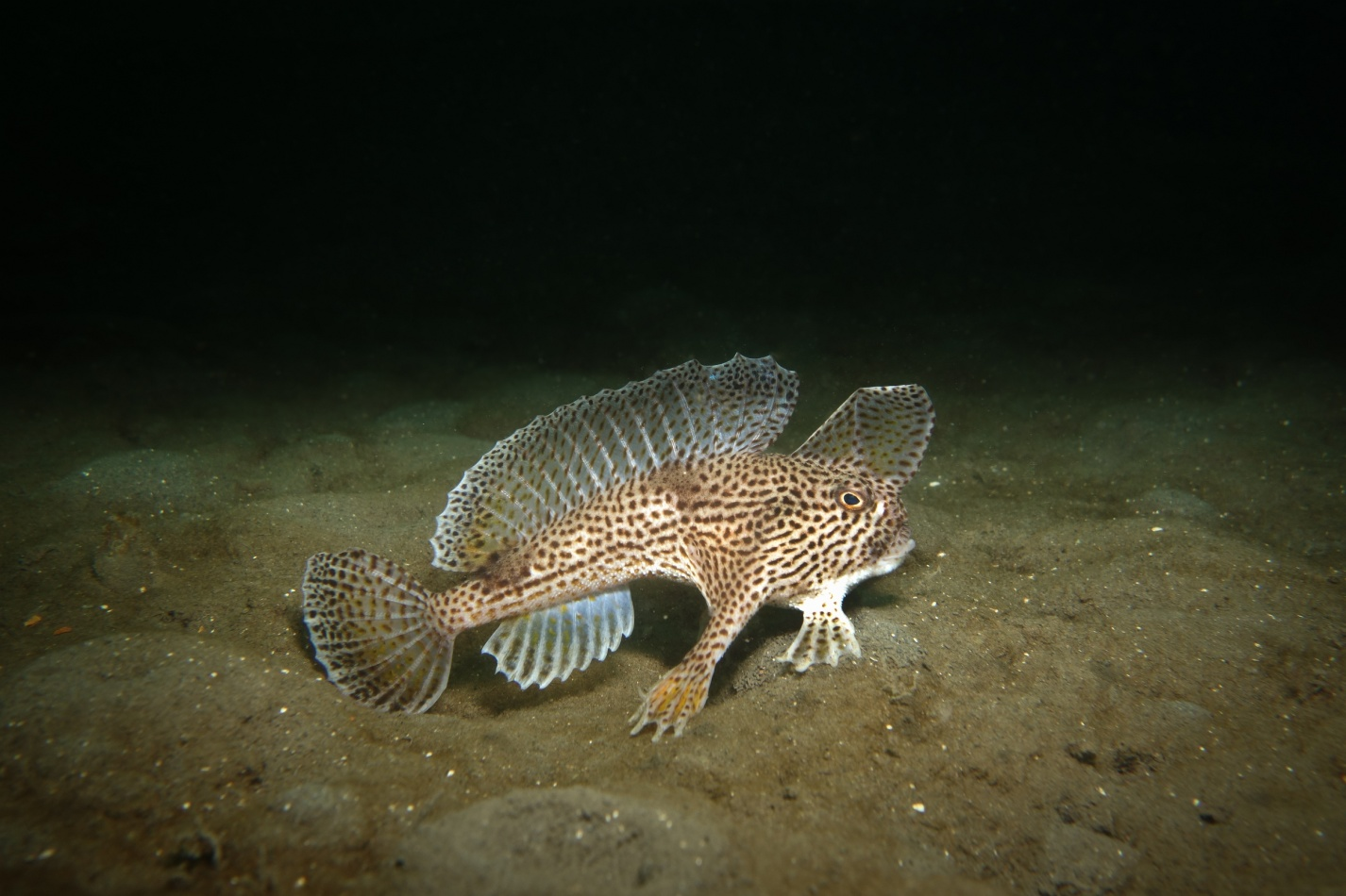 **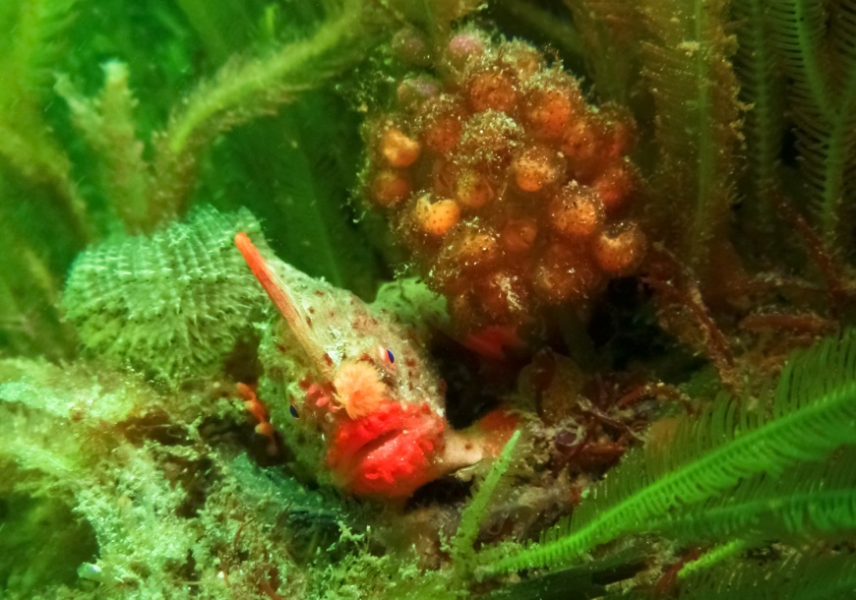**

Photo (left): Spotted handfish (Brachionichthys hirsutus) with unique markings

Photo (right): Female red handfish (Thymichthys politus) guarding eggs

## Strategy 1 – Increase spawning success for spotted, red and Ziebell’s handfish

**Research actions**

|  |  |  |  |  |  |
| --- | --- | --- | --- | --- | --- |
| Action | Description | Priority | Performance Criteria | Responsible Parties | Indicative Cost  \*priority 1 only |
| 1a | Improve knowledge of **spotted handfish** spawning triggers. | 2 | * Spawning triggers for spotted handfish are identified (e.g. water temperature triggers or seasonal triggers). | Research community  DPIPWE | - |
| 1b | Consider options for improving the spawning success of **red** and **Ziebell’s handfish.** | 2 | * If threats to spawning substrate are identified (under actions 5a and 5b), potential mitigation measures are investigated (e.g. removal of urchin barrens, oyster mats or filamentous alga proliferations that may be reducing the availability of spawning substrate). | Research community  DEP  DPIPWE | - |

**On-ground actions**

|  |  |  |  |  |  |
| --- | --- | --- | --- | --- | --- |
| Action | Description | Priority | Performance Criteria | Responsible Parties | Indicative Cost  \*priority 1 only |
| 1c | Assess the effects of artificial spawning habitat on **spotted handfish** reproductive output. | 1 | * Spotted handfish use of artificial spawning substrate is recorded, with eggs and subsequent number of juveniles counted after each breeding season. * Data is analysed to determine effectiveness of artificial spawning habitat for increasing handfish recruitment and results are reported to DotE and DPIPWE. | Research community  DPIPWE | $90 000 pa  (three year project) |
| 1d | Design and implement a long-term artificial spawning habitat program and deploy artificial spawning habitat at additional sites to increase the spawning success of **spotted handfish**. | 1 | * Key locations for the deployment of artificial spawning habitat are identified (e.g. sites in which availability of natural spawning substrate is a limiting factor). * The results of action 1c are used to inform the design of a long-term program for the deployment and maintenance of artificial spawning habitat. * Artificial spawning habitat is deployed at additional sites and handfish use of the additional artificial spawning habitat is assessed. * The condition of artificial substrate is assessed at yearly intervals after deployment and the average longevity of substrate is determined. | Research community Volunteer dive groups  DPIPWE | $50 000 pa  (three year project for two new sites) |

## Strategy 2 – Reduce impacts on spotted, red and Ziebell’s handfish, and their habitat

**Research actions**

|  |  |  |  |  |  |
| --- | --- | --- | --- | --- | --- |
| Action | Description | Priority | Performance Criteria | Responsible Parties | Indicative Cost  \*priority 1 only |
| 2a | Develop appropriate decision support tools and species-specific referral guidelines for coastal/marine developments. | 2 | * The effects of coastal and marine developments on handfish survival and reproduction are considered. * Clear guidance that incorporates a capacity for adaptive management, and includes mitigation measures for pollution/siltation, is developed to aid decision makers in their consideration of handfish under the assessment and approval process for marine/coastal developments. | DPIPWE  DotE  Research community | - |
| 2b | Assess red and Ziebell’s handfish for listing under the Tasmanian Threatened Species Protection Act. | 1 | * Red handfish and Ziebell’s handfish are both assessed for listing under the Threatened Species Protection Act 1995 (Tasmania). | DPIPWE | Core government business |

**On-ground actions**

|  |  |  |  |  |  |
| --- | --- | --- | --- | --- | --- |
| Action | Description | Priority | Performance Criteria | Responsible Parties | Indicative Cost  \*priority 1 only |
| 2c | Design and implement a program to reduce the impacts of traditional boat moorings on **spotted handfish** habitat. | 1 | * Identify locations in which traditional boat moorings are impacting upon spotted handfish habitat. * Investigate options for replacing public boat moorings with eco-friendly mooring designs. * Consider developing a zoning plan restricting the use of moorings within marine protected areas. * Develop best practice guidelines for the use of environmentally friendly moorings in sensitive habitats. | Research community  DPIPWE  MAST | $150 000  (Map moorings and review environmentally friendly alternatives)  $90 000 (replacement of 12 moorings at Battery Point, if impacts identified) |
| 2d | Conduct a public awareness campaign on environmental impacts of traditional boat moorings. | 2 | * Hold community fora to educate recreational boaters, and other water users, about environmental problems associated with traditional boat moorings and best practice guidelines for upgrading to environmentally friendly moorings. * Design and distribute educational pamphlets on the best practice guidelines for environmentally friendly moorings. | DEP | - |

## Strategy 3 – Consider options for the active management of spotted, red and Ziebell’s handfish

**Research actions**

|  |  |  |  |  |  |
| --- | --- | --- | --- | --- | --- |
| Action | Description | Priority | Performance Criteria | Responsible Parties | Indicative Cost  \*priority 1 only |
| 3a | Develop Population Response Models for **all handfish** species. | 1 | * Population response models are designed, for each species, to achieve the following objectives:   1. identification of a realistic recovery time frame and trajectory, informed by knowledge of species biology and threats,   2. identification of a habitat quality threshold, that will trigger translocation of handfish if habitat quality falls below this value,   3. identification of a population size threshold, that will trigger captive breeding if the species falls below this size,   4. development of a method to predict the outcomes of observed population fluctuations, and   5. development of a method to assess the effectiveness of recovery actions. | DPIPWE  Research community | Core government business in collaboration with research community  \*Up to $150 000 (if external expert required) |
| 3b | Design a conservation breeding strategy for **spotted handfish**. | 1 | * A workshop is held to bring together key experts on species biology and ecology, husbandry experts, geneticists, population modellers, managers etc. * A conservation breeding strategy, which incorporates a detailed captive management plan, is developed. * The strategy aims to achieve the following objectives:   1. clear goals/objectives, which support the overarching objective of the recovery plan, are defined,   2. the number of individual founders to be taken from the wild is determined,   3. the number of locations for re-introduction are identified,   4. a target for the percent of wild heterozygosity to be retained in the captive population is set,   5. the strategy is designed with a staged approach, starting with a precautionary trial breeding program and encompassing set triggers that prompt progression into the next stage,   6. a post release monitoring program is developed,   7. the strategy is designed in a manner that allows foradaptive management and can incorporate **red handfish** and **Ziebell’s handfish** in the futureif triggers are reached (under action 2a),   8. the strategy is designed to be consistent with IUCN ***Guidelines for Reintroductions and Other Conservation Translocations,* and**   9. the strategy is agreed by the HRG. | DPIPWE  HRG  Research community  ZAA | $15, 000 |

**On-ground actions**

|  |  |  |  |  |  |
| --- | --- | --- | --- | --- | --- |
| Action | Description | Priority | Performance Criteria | Responsible Parties | Indicative Cost  \*priority 1 only |
| 3c | Implement the conservation breeding strategy for **spotted handfish** (developed under action 3b). | 1 | * The conservation breeding strategy (developed under action 2b) is implemented. * Husbandry techniques are refined during the trial breeding program. * Disease risk management protocols for the movement and release of fish are developed and reviewed biennially, and strict bio-security/quarantine controls are maintained throughout the program. * Reintroduction sites are assessed, and managed where necessary, to ensure suitable conditions prior to wild releases of fish (e.g. threats are removed or threat abatement strategies are implemented). * Captive releases are managed to:   1. maximise the level of genetic diversity in individuals and groups,   2. include selection of individuals predicted to have the best opportunity to survive and reproduce in the wild, and   3. involve an optimum number of fish, as determined by the HRG, which is reviewed annually. | DPIPWE  HRG  Research community  ZAA | $45,000 Refining husbandry techniques  $25,000  Establishing a temporary Tasmanian holding facility  $225,000  Establishing a permanent holding and breeding facility  $5,000  Collection and transport of founder fish  $15,000  Disease risk management protocols  $65,000  Annual program running costs (years 2-5) |

## Strategy 4 - Improve knowledge of the distribution, abundance and population trends of spotted, red and Ziebell’s handfish

**Research actions**

|  |  |  |  |  |  |
| --- | --- | --- | --- | --- | --- |
| Action | Description | Priority | Performance Criteria | Responsible Parties | Indicative Cost  \*priority 1 only |
| 4a | Build a photographic database to identify individual fish observed for **all** **handfish** species. | 2 | * A photographic database, with a method of identifying and cataloguing individual handfish, is created. * A central repository for the database is established and a portal created to allow new photographic records to be verified and added. * The database is managed to ensure quality controls are maintained and recaptures are identified. | Research community  DotE  DPIPWE | - |
| 4b | Increase understanding of population dynamics (pop size, age/size classes, dispersal rate) for **all handfish** species. | 2 | * Knowledge of population dynamics is significantly increased for all handfish species. * Base measures of current population size and age/class structure are identified, and dispersal rates are assessed. | Research community  DPIPWE | - |

**On-ground actions**

|  |  |  |  |  |  |
| --- | --- | --- | --- | --- | --- |
| Action | Description | Priority | Performance Criteria | Responsible Parties | Indicative Cost  \*priority 1 only |
| 4c | Conduct surveys within the known, likely and historical ranges of **all handfish** species to improve knowledge of the current distribution of each species. | 1 | * All known locations for spotted handfish, as identified in this recovery plan, have been systematically surveyed to confirm current distribution. * All locations that are considered viable for supporting extant populations of red handfish or Ziebell’s handfish are identified. * All viable locations identified have been systematically surveyed, by experienced divers, to detect the presence/absence of red handfish and Ziebell’s handfish. * Estimates of total abundance are calculated for all identified populations of spotted handfish, red handfish and Ziebell’s handfish. | Research community  Volunteer dive groups DPIPWE | $105 000  (surveying to identify extant populations of spotted handfish)  $20 000-40 000 pa (two year surveying project to identify extant populations of red and Ziebell’s handfish) |

|  |  |  |  |  |  |
| --- | --- | --- | --- | --- | --- |
| 4d | Design an ongoing monitoring program for all handfish species. | 1 | * A scientifically robust surveying and reporting methodology is developed, and agreed upon by the HRG. * Alternative surveying methods (e.g. remote operated vehicles, acoustic tagging or water column DNA sampling) are considered and the most effective/viable monitoring method is identified. * Ongoing monitoring plans are developed for each species. | Research community  DotE  DPIPWE  HRG | Core government business |
| 4e | Conduct regular, ongoing monitoring to determine population trends, at all known and newly identified sites, for **all handfish** species. | 1 | * Spotted handfish colonies at known sites within Derwent Estuary and D’Entrecasteaux Channel are monitored at regular intervals:   1. annual monitoring at Battery Point and Sandy Bay, and   2. biannual monitoring of other identified extant populations. * All identified populations of red handfish and Ziebell’s handfish are monitored regularly (minimum biannually) and results are reported to DotE and DPIPWE. * Population trends for each species are assessed at each site and reported annually/biannually (depending on monitoring regime) to DotE and DPIPWE. * Decreases in the number of mature individuals at any site, for any species, are immediately reported to DotE, DPIPWE and the HRG. * A central repository for reporting all handfish observations, such as the NVA, is identified. | Research community  DotE  DPIPWE  HRG | $135 000 pa  (monitoring of spotted handfish at Battery Point and Sandy Bay)  $20 000 per site (monitoring of spotted handfish at other identified sites)  $800-1600 per site per day (for monitoring identified red and Ziebell’s sites) |

## Strategy 5 - Increase understanding of habitat preferences and threats to habitat for spotted, red and Ziebell’s handfish

**Research actions**

|  |  |  |  |  |  |
| --- | --- | --- | --- | --- | --- |
| Action | Description | Priority | Performance Criteria | Responsible Parties | Indicative Cost  \*priority 1 only |
| 5a | Develop methods for assessing habitat integrity for **all handfish** species | 2 | * Habitat characteristics are mapped at all locations surveyed for spotted handfish, red handfish and Ziebell’s handfish, and all habitat currently used by each species is mapped * Habitat data is analysed for each species to identify characteristics shared between occupied sites. * Characteristics that represent optimal and suboptimal habitat are understood for each species. * Habitat characteristics that may prohibit colonisation by handfish are identified for all species. |  |  |
| 5b | Map available habitat and identify threats to habitat for **all handfish** species. | 2 | * Existing areas of optimal and suboptimal habitat are mapped for all species. * The presence/absence of any habitat-related limitations to breeding is documented for all locations where handfish are observed. * Impacts on areas of optimal habitat are identified. * Sites with poor habitat conditions are reported to the HRG. | DPIPWE  Research community  Volunteer dive groups |  |
| 5c | Improve understanding of potential threats impacting upon survival of **all handfish** species. | 2 | * The tolerance limits of spotted handfish in relation to key water quality parameters are identified. * The effects of reduced water quality on spotted handfish survival and reproduction are assessed. * Potential threats are recorded for all sites surveyed for red handfish and Ziebell’s handfish. * Statistical analysis is conducted, where possible, to identify any correlations between the abundance of red handfish and Ziebell’s handfish and potential threats to survival. * Key threats are identified for each species, and presence/absence of these threats is identified for all known populations and reported to DotE and DPIPWE. | DPIPWE Research community  Volunteer dive groups | - |

**On-ground actions**

|  |  |  |  |  |  |
| --- | --- | --- | --- | --- | --- |
| Action | Description | Priority | Performance Criteria | Responsible Parties | Indicative Cost  \*priority 1 only |
| 5d | Consider options for improving habitat quality, mitigating key threats, or increasing protection within known habitat for **all handfish** species. | 2 | * Identify potential methods for improving the quality of known habitat for all handfish species. * Consider potential mitigation measures for all sites where threats to handfish are identified. * Consider enhancing protection within known handfish habitat, including consideration of the establishment of new marine reserves or fishing exclusion zones. | DPIPWE  Research community | - |
| 5e | Support current work to improve water quality in the Derwent Estuary. | 2 | * Options for improving the condition of habitat identified as in poor health are considered by the HRG, in collaboration with local councils and community groups. * Projects designed to improve water quality in the Derwent Estuary, and reduce future anthropogenic impacts, continue. | DEP  Local councils  DPIPWE | - |
| 5f | Encourage future investigation into potential control options for invasive northern Pacific seastars *(A. amurensis).* | 3 | * Any observations of interactions between invasive seastars and handfish, that may occur during the course of population surveys or habitat health assessment, are reported to the HRG who in turn share the information with researchers investigating potential control methods for invasive species. | Research community  HRG  DotE | - |

## Strategy 6 - Encourage community participation in the conservation of spotted, red and Ziebell’s handfish

**On-ground actions**

|  |  |  |  |  |  |
| --- | --- | --- | --- | --- | --- |
| Action | Description | Priority | Performance Criteria | Responsible Parties | Indicative Cost  \*priority 1 only |
| 6a | Develop and implement a broad strategy to raise awareness and educate the general public about conservation for **all handfish** species. | 2 | * Articles about handfish conservation, including threats and recovery actions, are published in community newsletters, local bulletins and newspapers. * Informative displays are developed to educate the broader community about handfish conservation. * Local initiatives to clean up the Derwent are well publicised, and actions that benefit handfish are identified, so as to encourage public participation. | DPIPWE  DotE  DEP  Community groups  Aquaria | - |
| 6b | Develop and implement a targeted strategy to promote the use of citizen science in relation to conservation for **all handfish** species. | 2 | * Articles are published in dive community newsletters and magazines to advertise the central repository for handfish observations and encourage citizen scientist involvement in handfish conservation. | DPIPWE  DotE  Dive groups | - |

# 8 Duration and cost of the recovery process

It is anticipated that the recovery process will not be achieved prior to the scheduled five year review of the recovery plan. The *Recovery Plan for Three Handfish Species* (2015) will therefore remain in place until such time as the Australian populations of handfish have improved to the point at which the populations no longer meet threatened species status under the EPBC Act.

The cost of implementation of this plan should be incorporated into the core business expenditure of the affected organisations and through additional funds obtained for the explicit purpose of implementing this recovery plan. It is expected that state and Commonwealth agencies will use this plan to prioritise actions to protect the species’ and enhance their recovery, and that projects will be undertaken according to agency priorities and available resources. In order to maximise the conservation outcomes and cost effectiveness of this plan, it is intended that the recovery actions proposed complement, where possible, those of other protected matters.

**Table 3:** Summary of high priority recovery actions and estimated costs in ($000’s) for the first five years of implementation (these estimated costs do not take into account inflation over time).

|  |  |  |  |  |  |  |
| --- | --- | --- | --- | --- | --- | --- |
| **Action** | **Cost** | | | | | |
| **Year 1** | **Year 2** | **Year 3** | **Year 4** | **Year 5** | **Total** |
| Increase spawning success for handfish:  - assess the effects of artificial spawning habitat on spotted handfish  - implement a long-term artificial spawning habitat program | 90  50 | 90  50 | 90  50 | -  - | -  - | 270  150 |
| Reduce adverse impacts on handfish habitat:  - program to reduce the impacts of traditional boat moorings | 75 | 75 | 45 | 45 | - | 240 |
| Consider options for the active management of handfish:  - design a conservation breeding strategy for spotted handfish  - implement the conservation breeding strategy for spotted handfish | 15  315 | -  65 | -  65 | -  65 | -  65 | 15  575 |
| Improve knowledge of the distribution, abundance and population trends of handfish:  - surveying to identify extant populations of spotted handfish  - surveying to identify extant populations of red and Ziebell’s handfish  - annual monitoring of spotted handfish at Battery Point and Sandy Bay  - biannual monitoring of spotted handfish at other identified sites  - biannual monitoring of red and Ziebell’s handfish at identified sites | 105  40  135  -  - | -  40  135  -  - | -  -  135  20-180\*  2-16\*\* | -  -  135  -  - | -  -  135  20-180\*  2-16\*\* | 105  80  675  40-360  4-32 |
| **TOTAL** | 825 | 455 | 407-581 | 245 | 222-396 | 2154-2502 |

\* cost may vary as action may not be implemented, or may be implemented at a reduced number of sites, as it is dependent on the outcomes of surveying to locate extant populations of spotted handfish

\*\* cost may vary as action may not be implemented, or may be implemented at a reduced number of sites, as it is dependent on the outcomes of surveying to locate extant populations of red handfish and Ziebell’s handfish

# 9 Current management practices

As the three species of handfish are protected under the EPBC Act, it is an offence to kill, injure, take, trade, keep, or move any individual without a permit in Commonwealth waters. In addition, all listed threatened species are considered matters of national environmental significance (MNES), and any action that may have an impact on MNES must be referred to the Minister of the Environment for approval. The Department of the Environment, as the Australian Government department responsible for administering the EPBC Act, maintains a suite of interactive tools that allow users to search, find and generate reports on information and data describing MNES, including handfish. The conservation values atlas shows the location and spatial extent of conservation values (where sufficient information exists) and is available at: [www.environment.gov.au/coasts/marineplans/cva/index.html](http://www.environment.gov.au/coasts/marineplans/cva/index.html).

The three handfish species are also protected across their range in state waters in Tasmania. Details of protection measures in Tasmania, including state marine parks that afford protection, can be obtained from the relevant state agency; classifications under state legislation are summarised in Table 1.

# 10 Effects on other native species and biodiversity benefits

Reducing anthropogenic impacts from coastal and marine developments and recreational boating activities, and supporting work to improve water quality in the Derwent Estuary, will likely benefit other listed threatened species, such as the Derwent River seastar *(Marginaster littoralis)* and the Tasmanian live-bearing seastar (*Parvulastra vivipara).* Implementation of the recovery plan will also have positive outcomes for other marine species through improving habitat quality.

# 11 Social and economic considerations

Habitat degradation (marine and coastal developments and pollution) threaten handfish species and may largely exclude them from areas, perhaps traditionally utilised for feeding or spawning, where they were historically much more abundant. Due to their distribution in shallow coastal habitats in close proximity to urban and industrial areas handfish, particularly spotted handfish, populations could be adversely affected by coastal habitat degradation and anthropogenic activities in these regions (DEP, 2013). As habitats critical to the survival of the species’ are identified, there is potential for developments to be restricted under the EPBC Act development assessment and approval process.

Recreational boating has the potential to impact upon handfish species, particularly spotted handfish, due to the use of traditional block and chain swing moorings which can have significant localised impacts on benthic habitat in sensitive areas (SEQ Catchments, 2014). In the Derwent Estuary a large number of traditional boat moorings are located in known, historic or potential spotted handfish habitats (Green, pers comm., 2014). The actions outlined in this recovery plan in relation to recreational boating focus on designing and implementing a plan to reduce the impacts of traditional moorings on handfish.

# 12 Affected interests

Organisations likely to be affected by the actions proposed in this plan include Australian and state governments agencies, particularly those with environmental and fisheries concerns; commercial and recreational fishers; local Indigenous communities; researchers; tourism operators and scuba diving operators/clubs; conservation groups; wildlife interest groups; aquarium managers and proponents of coastal development in the vicinity of important handfish habitat. This list, however, should not be considered exhaustive, as there may be other interest groups that would like to be included in the future or need to be considered when specialised tasks are required in the recovery process.

# 13 Consultation

The *Recovery Plan for Three Handfish* *Species* (2015) has been developed through extensive consultation with a broad range of stakeholders. The consultation process included a workshop in Tasmania that brought together key species experts and conservation managers, from a range of different organizations, to categorize ongoing threats to the three species covered by this plan, and identify knowledge gaps and potential management options. Workshop participants included representatives from DotE, DPIPWE, CSIRO, researchers from UTAS and local community groups. During the drafting processing the Department of the Environment (Cwlth) continued to work closely with key stakeholders.

# 14 Organisations/persons involved in evaluating the performance of the plan

This plan should be reviewed no later than five years from when it was endorsed and made publically available. The review will determine the performance of the plan and assess:

* whether the plan continues unchanged, is varied to remove completed actions, or varied to include new conservation priorities
* whether a recovery plan is no longer necessary for the species’ as either conservation   
  advice will suffice, or the species’ are removed from the threatened species list.

As part of this review, the listing status of the species’ will be assessed against the EPBC Act species listing criteria.

The review will be coordinated by DotE in association with relevant Australian and state government agencies and key stakeholder groups such as non-governmental organisations, local community groups and scientific research organisations.

Key stakeholders who may be involved in the review of the performance of the *Recovery Plan for Three Handfish Species*, include organisations likely to be affected by the actions proposed in this plan and are expected to include:

**Australian Government**

Department of the Environment

Commonwealth Scientific and Industrial Research Organisation

**Non-government organisations**

Conservation groups

Local communities

Universities and other research organisations

Recreational fishers and associations

Recreational boaters

**State/territory governments**

Department of Primary Industries, Parks, Water and Environment (Tas)

Natural resource management bodies in coastal regions

Local government in coastal regions

# 15 References

Aquenal Pty Ltd (2008). Marine and Estuarine Ecology Literature Review and Field Survey Program - Lauderdale Quay Proposal. Hobart, Australia.

Australian Government Land and Coasts (2010). Protecting Critical Aquatic Ecosystems: Site Investment Guide: Derwent Estuary. Caring for our Country, Australian Government Land and Coasts, Canberra, Australia. Available on the Internet at:

<http://www.nrm.gov.au/business-plan/10-11/priorities/coastal/aquatic/site-8.html>.

Barrett N, Edgar G, Zagal CJ, Oh E and Jones D (2010). Surveys of the intertidal and subtidal biota of the Derwent Estuary – 2010. Report to the Institute of Marine and Antarctic Studies, Hobart, Australia.

Brereton R (2010). Personal communication by email, 29 November 2010, Threatened Species Scientific Advisory Committee, Tasmania, Australia.

Bruce B (1998). 'Progress on Spotted Handfish Recovery', On the brink!. *Threatened Species and Communities*. 11:9.

Bruce BD, Green MA and Last PR (1997). *Developing captive husbandry techniques for spotted handfish, Brachionichthys hirsutus, and monitoring the 1996 spawning season*. Report to Endangered Species Unit, Environment Australia CSIRO Division of Marine Research, Hobart, Australia.

Bruce BD, Green MA and Last PR (1998). Threatened Fishes of the World: *Brachionichthys hirsutus* (Lacepede, 1804) (Brachionichthyidae). *Environmental Biology of Fishes*. 52:418.

Bruce BD, Green MA and Last PR (1999). Aspects of the biology of the endangered Spotted Handfish *Brachionichthys hirsutus* (Lophiiformes: Brachionichthyidae) off southern Australia. In ‘*Proceedings of the 5th Indo Pacific Fish Conference, Noumea 1997’* (eds B Seret and JY Sire). Societe Francaise d'Ichthyologie, Paris, France.

Butler ECV (2006). The Tail of Two Rivers in Tasmania: The Derwent and Huon Estuaries.In ‘[*Estuaries*](http://griffith.summon.serialssolutions.com/2.0.0/link/0/eLvHCXMwY2AwNtIz0EUrE0xSzFKNUxItzFJSUoxTUpJTkpONjS2TQafkpqUYpaWgjGQgFfBuQgxMqXmiDIpuriHOHrqwgYx46NhGfBJoi5iRhUGFoRgDC7C_nCrBoABMwUmpKabGZkDHmaSapFmYm5glm5iZWZqkJCUCqzcAFoEpug)’ - ***Series:*** *The Handbook of Environmental Chemistry’* (eds PJ Wangersky)**.** Springer-Verlag, Heidelberg, Germany.

Department of the Environment (DotE) (2014). *Brachionichthys hirsutus* in Species Profile and Threats Database, Department of the Environment, Canberra, Australia. Available on the Internet at: <http://www.environment.gov.au/sprat>.

Department of the Environment and Heritage (DEH) (2001). Draft Listing Advice *- Sympterichthys sp.* (Ziebell's handfish). Environment Australia, Canberra, Australia.

Department of the Environment and Heritage (DEH) (2004). Listing Advice - *Brachionichthys politus* (Red Handfish). Available on the Internet at: <http://www.deh.gov.au/biodiversity/threatened/species/red-handfish.html>.

Department of the Environment and Heritage (DEH) (2005). Issues Paper: Population status of and threats to four handfish species listed as threatened under the Environment Protection and Biodiversity Conservation Act 1999. Department of the Environment and Heritage, Canberra, Australia. Available on the Internet at: <http://www.deh.gov.au/biodiversity/threatened/publications/recovery/4-handfish/pubs/4-handfish-issues-paper.pdf>.

Department of Primary Industries NSW (DPI) (2014). Traditional boat moorings in sensitive habitats. NSW Government, Sydney, Australia. Available on the Internet at: <http://www.dpi.nsw.gov.au/fisheries/habitat/threats/traditional-boat-moorings-in-sensitive-habitats>

Department of Primary Industries, Parks, Water and Environment (DPIPWE) (2014). *Brachionichthys hirsutus* in Natural Values Atlas. Department of Primary Industries, Parks, Water and Environment, Hobart, Australia. Available on the Internet at: <https://www.naturalvaluesatlas.tas.gov.au>.

Department of Primary Industries, Water and Environment (DPIWE) (2002). *Draft Spotted Handfish Recovery Plan*. Department of Primary Industries, Water and Environment, Hobart, Australia.

Derwent Estuary Program (DEP) (2013). Spotted Hand Fish. Derwent Estuary Program, Hobart, Australia. Available on the Internet at: <http://www.derwentestuary.org.au/spotted-hand-fish/>

Derwent Estuary Program (DEP) (2014). **Derwent Estuary Program quarterly e-bulletin November 2014.** Derwent Estuary Program, Hobart, Australia. Available on the Internet at: <http://www.derwentestuary.org.au/ebulletins/>

Edgar GJ (1997). *Australian Marine Life - the plants and animals of temperate waters*. Reed Books, Victoria, Australia.

Edgar GJ, Barrett NS, Graddon DJ and Last PR (2000). The conservation significance of estuaries: a classification of Tasmanian estuaries using ecological, physical and demographic attributes as a case study. *Biological Conservation*. 92: 383-397.

Edgar GJ, Last PR and Wells MW (1982). Coastal Fishes of Tasmania and Bass Strait. Tasmanian Underwater Photographic Society, Hobart, Australia.

Flukes E (2014). Personal communication by email, 14 August 2014. PhD candidate, Institute for Marine and Antarctic Studies, Tasmania, Australia.

Fukuyama AK (1994). A review of the distribution and life history of *Asterias amurensis* on the northeast Pacific coast. Unpublished report to CSIRO and National Seastar Task Force, Hobart, Australia.

Fukuyama AK and Oliver JS (1985). Sea star and walrus predation on bivalves in Morton Sound,

Bering Sea, Alaska. *Ophelia.* 24: 17-36.

Gledhill DC and Green MA (unpublished). Issues Paper: Population Status of, and Threats to, Three Handfish Species Listed as Threatened under the *Environment Protection and Biodiversity Conservation Act 1999*. CSIRO report to the Department of the Environment, Water, Heritage and the Arts, Canberra, Australia.

Gowlett-Holmes K (2014). Personal communication by email, 25 August 2014. Marine Invertebrates Collection Manager, Commonwealth Scientific and Industrial Research Organisation, Tasmania, Australia.

Green M (2005). Marine habitat and threatened fish investigation. Report to Biodiversity Conservation branch of the Department of Primary Industries, Water and Environment, Tasmania, Australia.

Green M (2009). Handfish 08-09. NRM South Final Report. Report to Biodiversity Conservation branch of the Department of Primary Industries, Water and Environment, Tasmania, Australia.

Green M (2014). Personal communication by email, 18 August 2014. Marine Ecologist, Commonwealth Scientific and Industrial Research Organisation: Oceans and Atmosphere Flagship, Tasmania, Australia.

Green M and Bruce B (2000). Spotted Handfish Recovery Plan: Final Report: Year 1 (1999). Environment Australia, Canberra, Australia.

Green M, Lynch TP, Davies C and Hughes D (2014). Spotted handfish density, distribution and breeding preference for spawning substrates assessed with GPS and Google Earth. Proceedings of the Australian Marine Science Association, Canberra, Australia.

Hatanaka M and Kosaka M (1959). Biological studies on the population of the starfish, *Asterias amurensis*, in Sendai Bay. *Tohoku Journal of Agricultural Research.* 9: 159-178.

Jacques M (2014). Handfish Study Paper. Unpublished report to Department of the Environment, Canberra, Australia.

Jezierska B and Witeska M (2006). The metal uptake and accumulation in fish living in polluted waters: Soil and Water Pollution Monitoring, Protection and Remediation. Springer, Netherlands. 107-114.

Kuiter RH (1996). Guide to Sea Fishes of Australia. New Holland. Frenchs Forest, Australia.

Last P and Bruce B (1996–97). ‘Spotted Handfish’. *Nature Australia.* 25: 20-21.

Last PR and Gledhill DC (2009). A revision of the Australian handfishes (Lophiiformes: Brachionichthyidae), with descriptions of three new genera and nine new species. *Zootaxa*. 2252:1-77.

Last PR, Gledhill DC and Holmes BH (2007). A New Handfish, *Brachionichthys australis* sp. nov. (Lophiiformes: Brachionichthyidae), with a Redescription of the Critically Endangered Spotted Handfish, *B. hirsutus* (Lacepède). *Zootaxa.* 1666: 53–68.

Last PR, Scott EOG and Talbot FH (1983). Fishes of Tasmania. Tasmania Fisheries Development Authority, Hobart, Australia.

Newman MC (2003). Can we predict joint effects of hypoxia and metals on fish survival. In *‘Fish Physiology, Toxicology, and Water Quality: Proceedings of the Seventh International Symposium, Tallinn, Estonia May 12-15, 2003’.* United States Environmental Protection Agency, Washington DC, USA.

Pogonoski JJ, Pollard DA and Paxton JR (2002). Conservation Overview and Action Plan for Australian Threatened and Potentially Threatened Marine and Estuarine Fishes. Environment Australia, Canberra, Australia. Available on the Internet at: <http://www.environment.gov.au/coasts/publications/marine-fish-action/pubs/marine-fish.pdf>.

South East Queensland (SEQ) Catchments (2014). Environmentally Friendly Moorings. SEQ Catchments, Brisbane, Australia. Available on the Internet at: <http://www.seqcatchments.com.au/case-studies/mooring-trial-to-end-crop-circles-in-moreton-bay>.

Valentine JP and Johnson CR (2005). Persistence of sea urchin (*Heliocidaris erythrogramma*) barrens on the east coast of Tasmania: inhibition of macroalgal recovery in the absence of high densities of sea urchins. *Botanica Marina.* 48: 106–115.

Whitehead J (2008). Derwent Estuary introduced marine & intertidal species review of distribution, issues, recent actions & management options. Report to Derwent Estuary Program, Hobart, Australia.

Whitehead J, Coughanowr C and Rushton M (2013). Derwent Estuary surface sediments comparison between 2000 & 2011 surveys: metals, clay/silt ratio & % organic carbon. Report to Biodiversity Conservation branch of the Department of Primary Industries, Water and Environment, Tasmania, Australia.

**environment**.gov.au



