Red imported fire ant (Solenopsis invicta)

Likely mode of entry
The red imported fire ant is a hitchhiker that can spread long distances through international trade, especially in shipping containers and on objects contaminated with soil, as soil is the natural nesting material for this species. Contaminated objects can include construction equipment for roads, pipelines, electrical and telecommunication lines, all kinds of vehicles and machinery, and anything else that has been stored outside or on the ground.

Signs of infestation (Figures 3–4)
This species is usually found next to or under objects on the ground, such as timber, wooden pallets, logs, rocks, pavers, or bricks, in gardening materials, equipment and tools, stores of potting mix and mulch, and in untidy or overgrown areas. Look for nests or foraging workers. Nests are variable and may be flat and like a patch of disturbed soil, or a dome-shaped mound 30–50 cm wide and up to 40 cm high with no obvious entry or exit holes. Nests are often found in open, highly disturbed areas such as lawns or pastures, along roadsides and in unused cropland. Nests can also occur in structures or tree trunks.
Biology (Figures 1–2)
Eggs: round and creamy white. Larvae: creamy white, legless, grub-like. Adults: workers are small but variable in size, ~2–6 mm. Head and much of body coppery brown; abdomen is darker. Queens are about 7 mm and darker. Antennae have 10 segments, including a 2-segmented club. Pedicel (waist) consists of 2 segments.
Preys on insects and other small animals, as well as feeds on nectar, fruits and seeds. Adults are highly aggressive, especially around their nest and usually give a painful sting when disturbed, resulting in characteristic itchy pustules.

Distribution
Native to central South America. Introduced to parts of North America, the Caribbean, and Asia. Present in parts of South East Queensland, but under eradication.
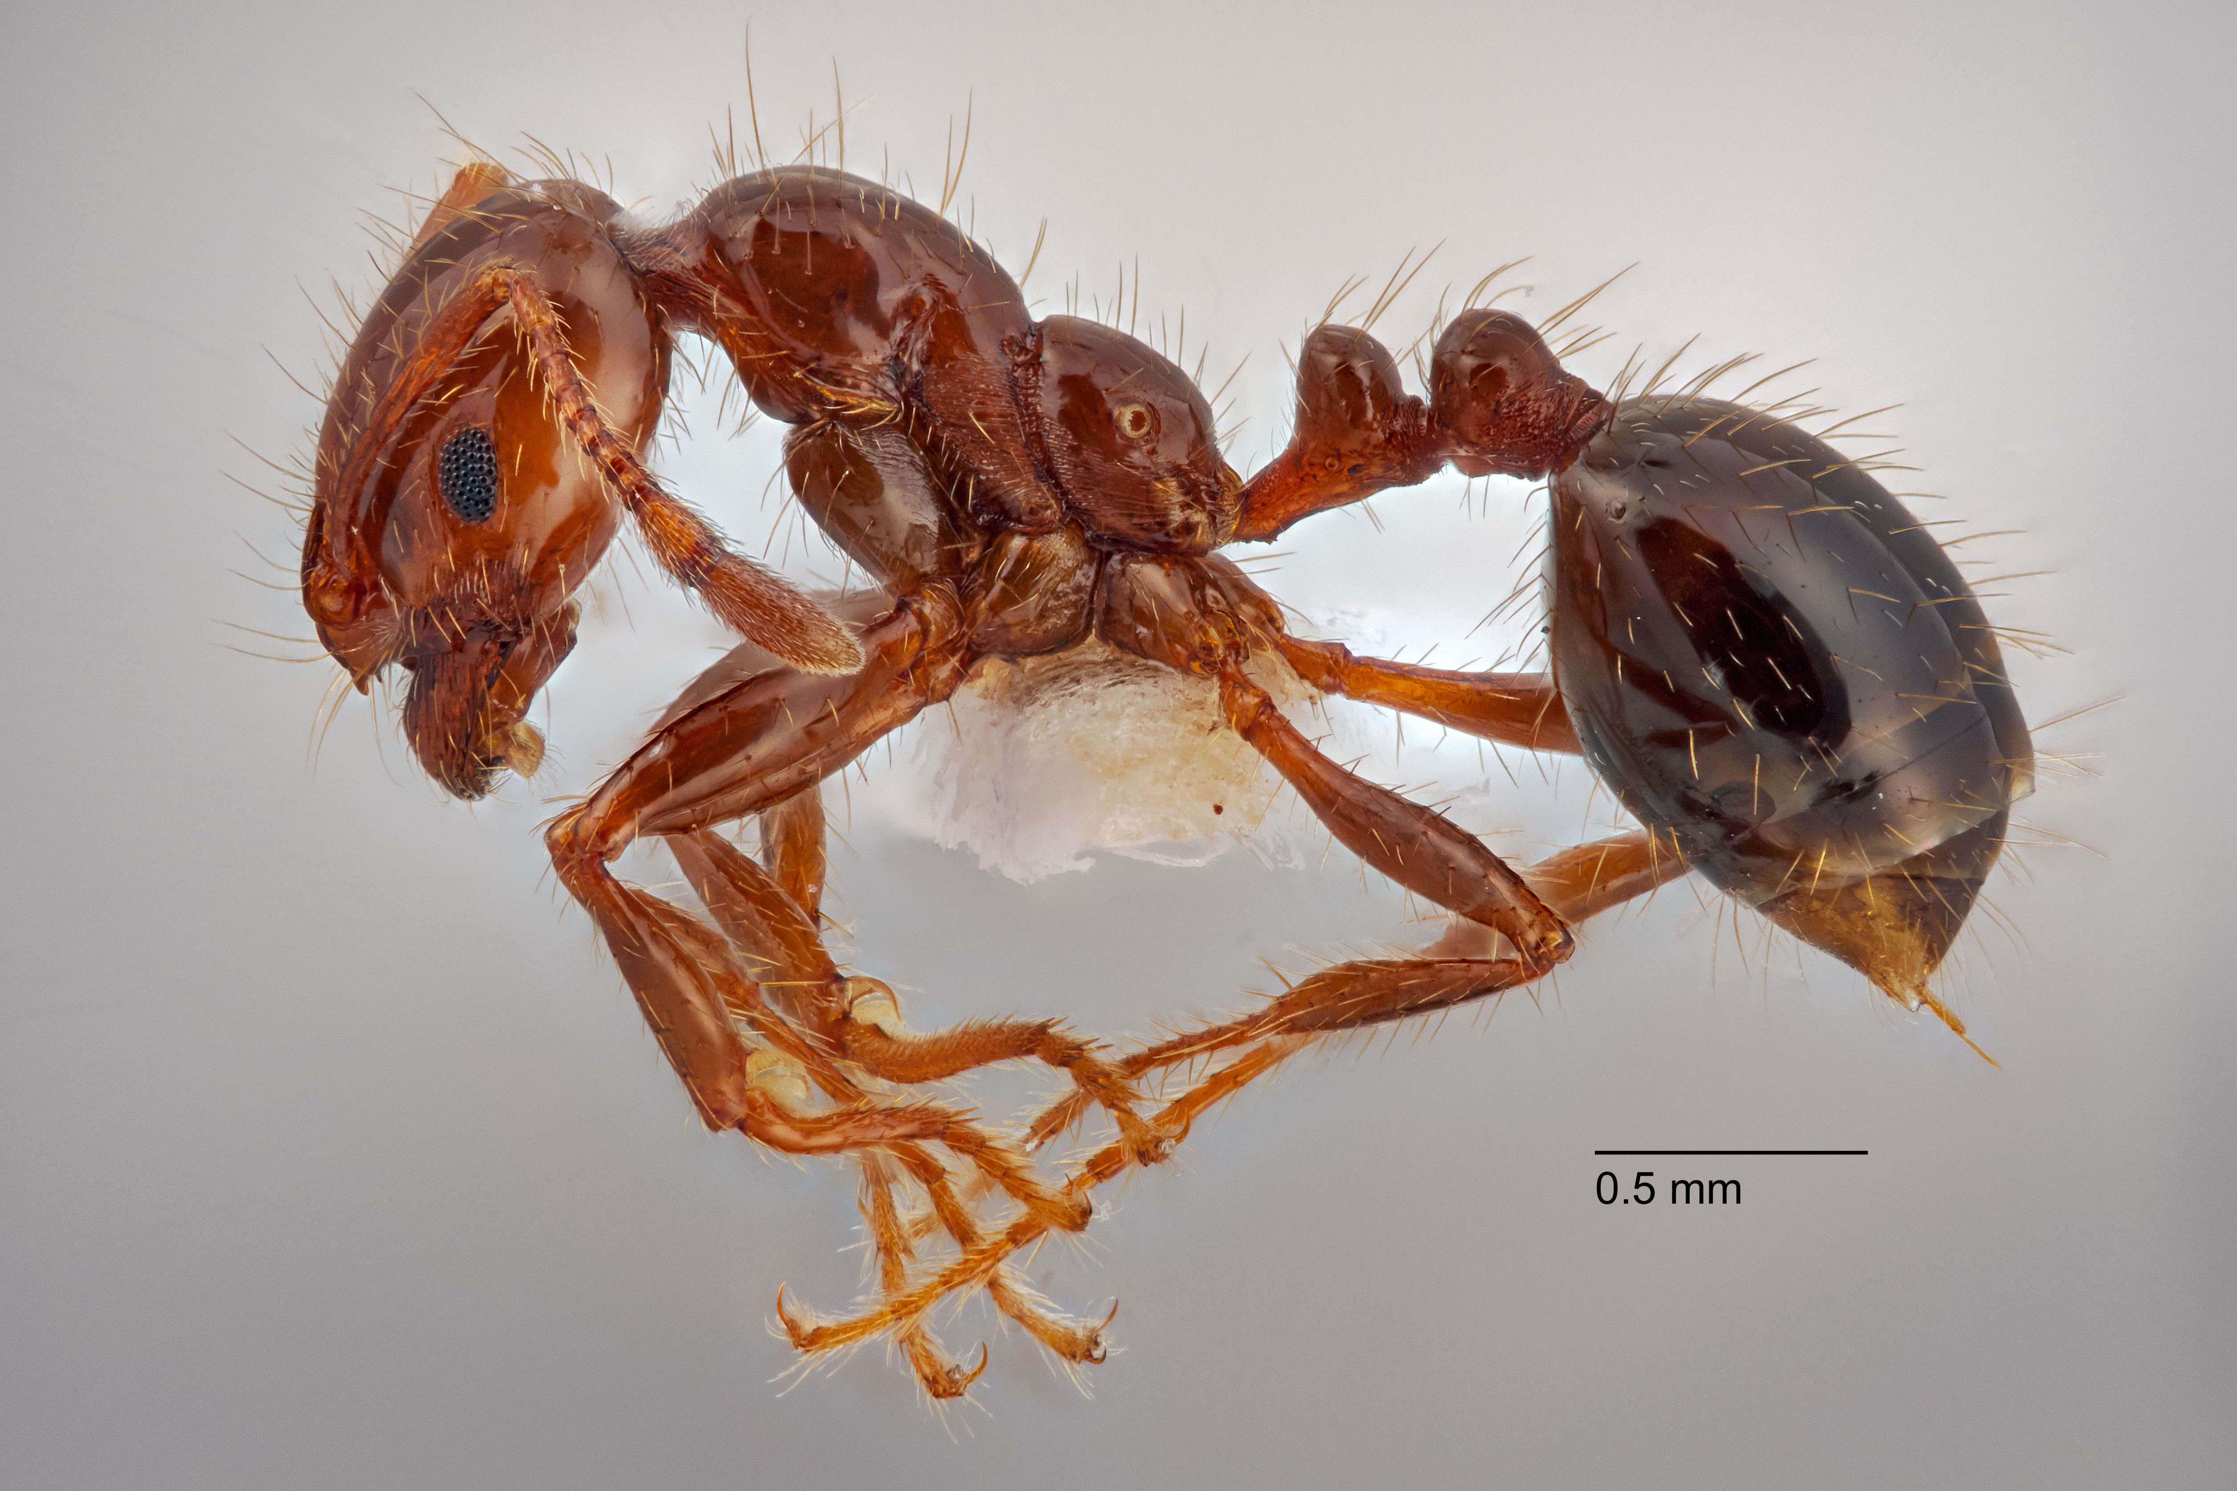 Fig. 1 Side view of a red imported fire ant worker (DAFF and Queensland Museum).

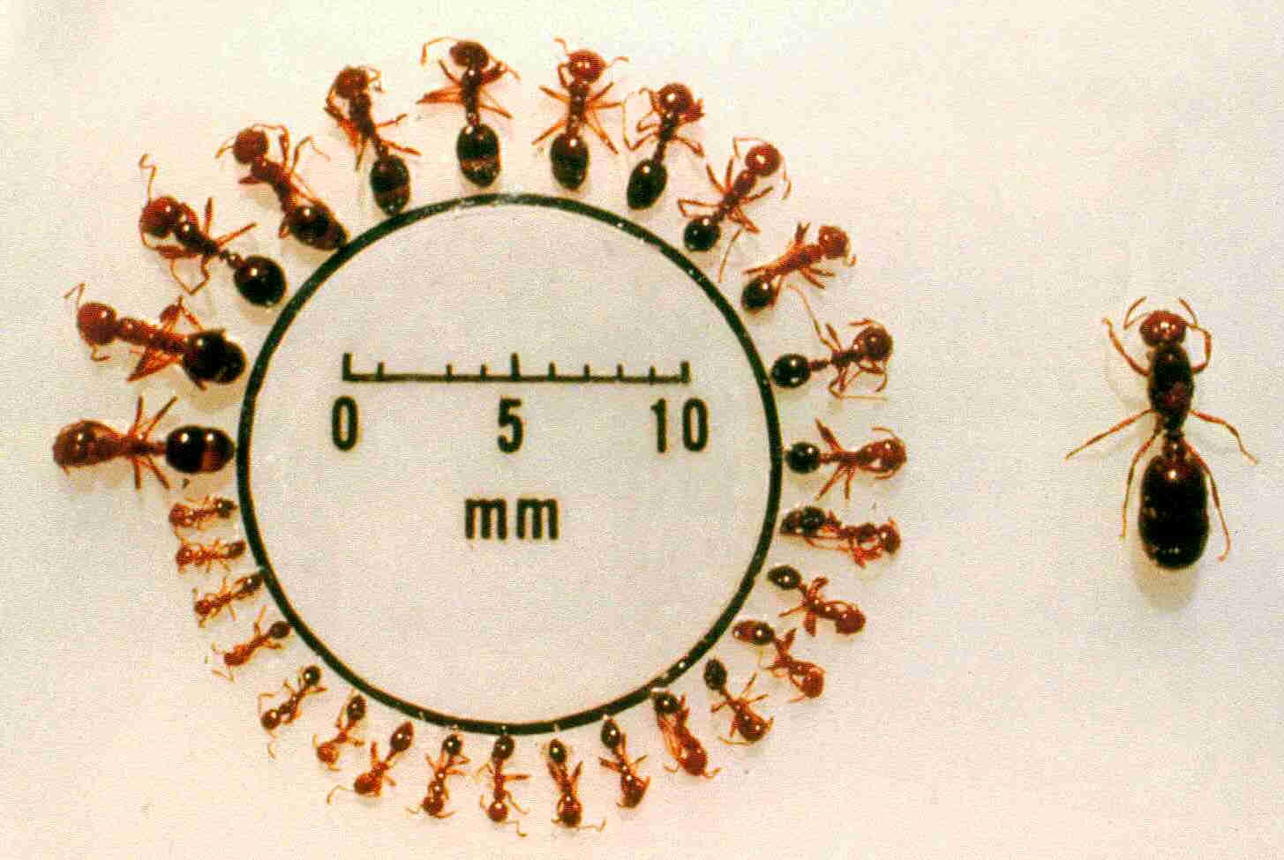Fig. 2 Size variation in red imported fire ant workers (left) and queen (right) (Sanford D. Porter, USDA).

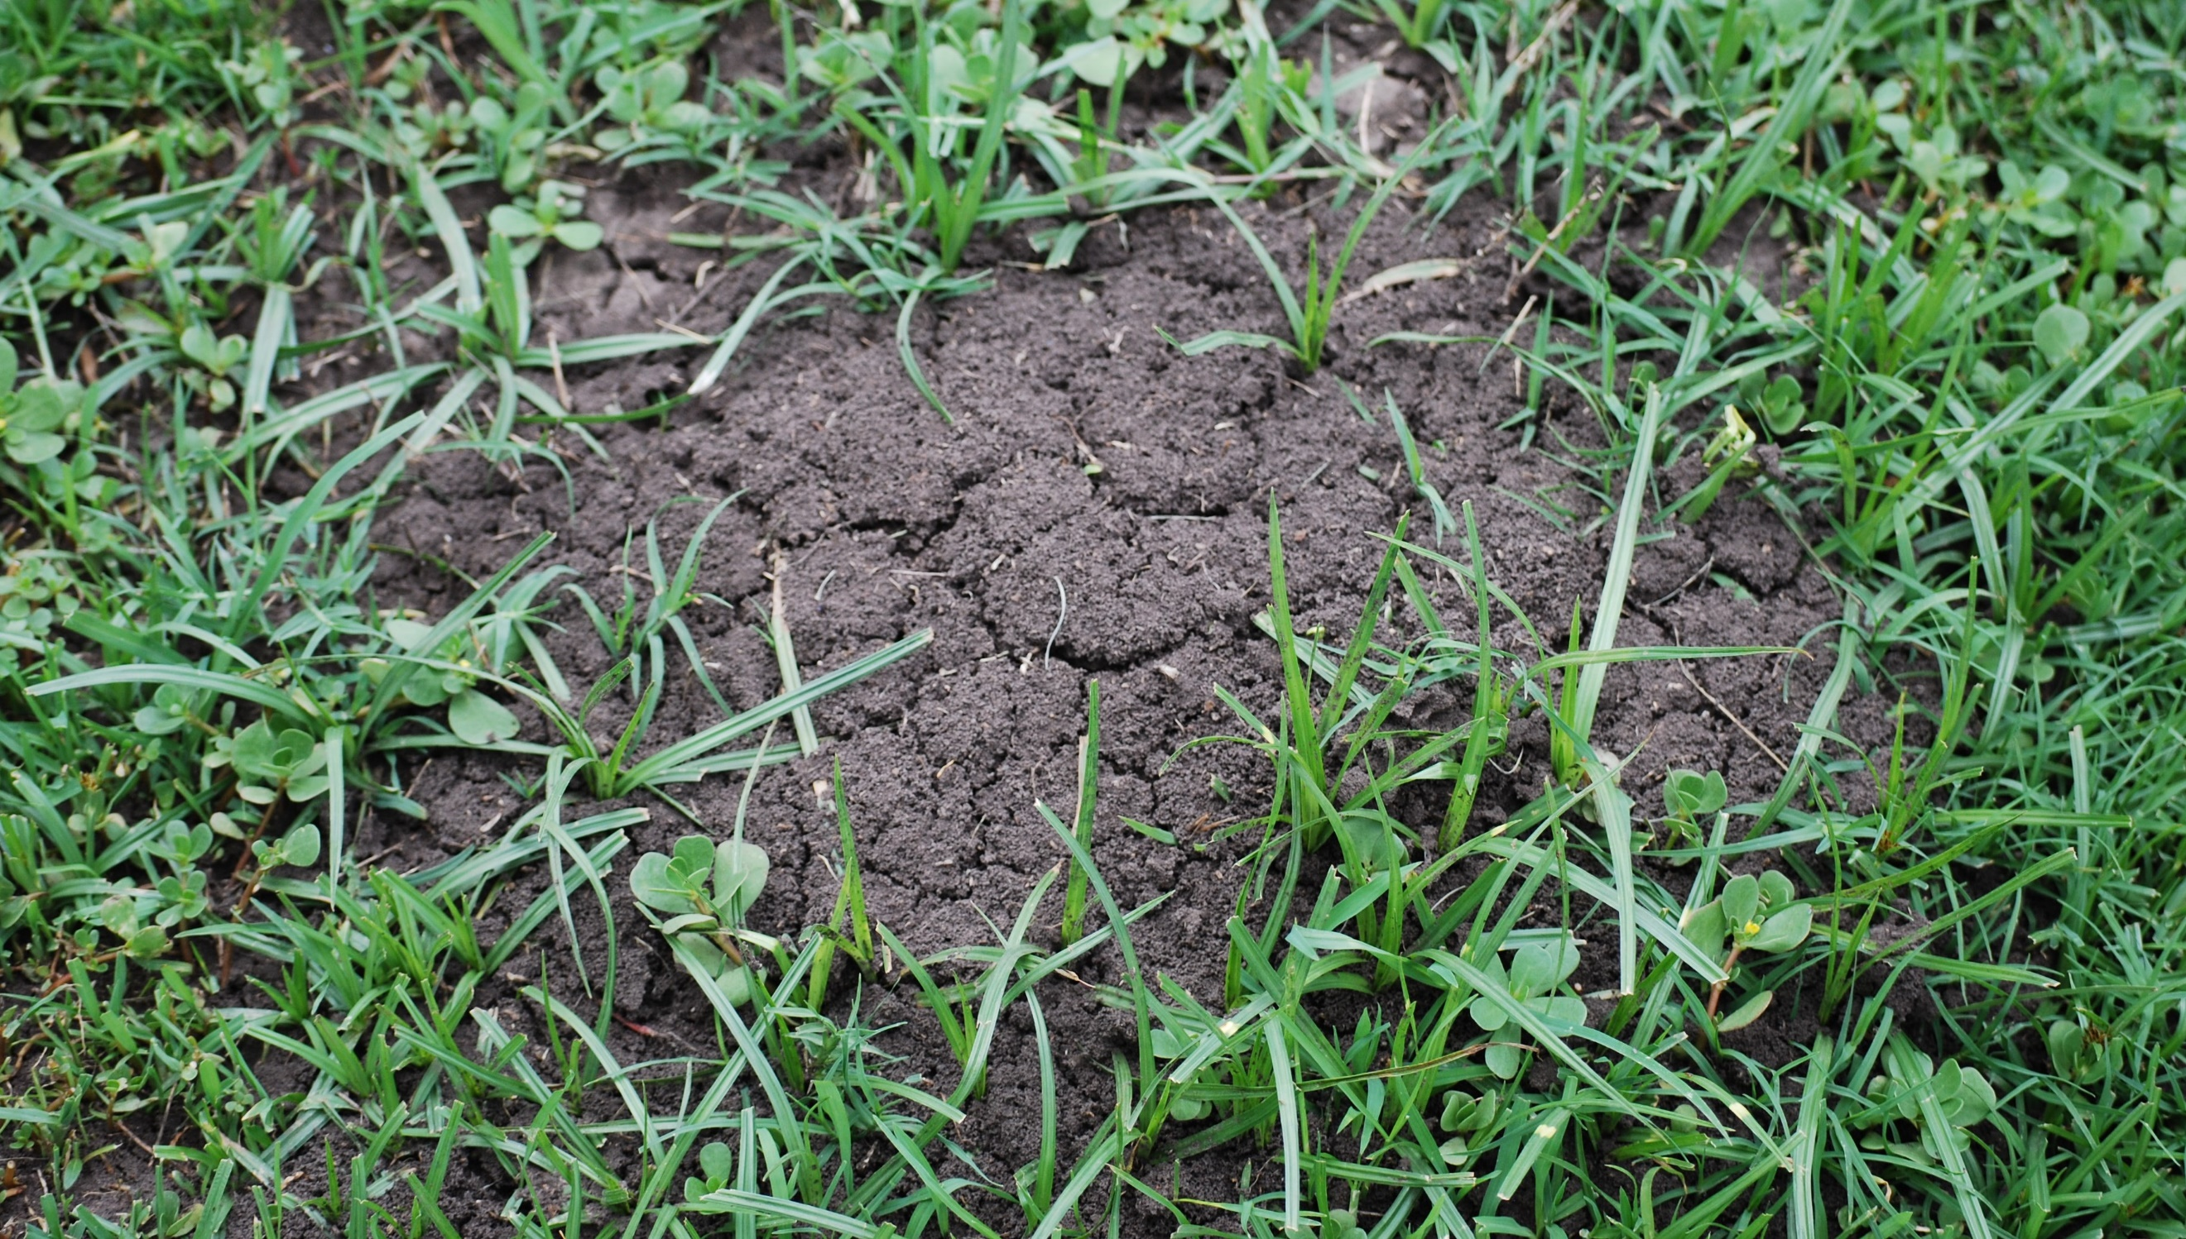Fig. 3 Red imported fire ant nests usually appear as disturbed soil with no obvious entrances (DAFF).

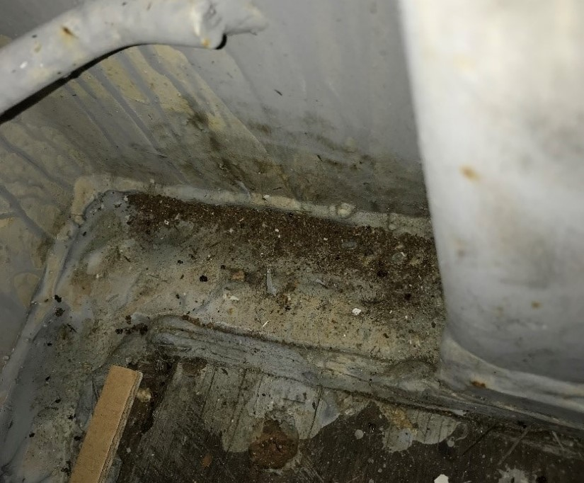Fig. 4 Inside-corner of a shipping container in which ants are intermixed with debris (DAFF).

What to do if you find suspect red imported fire ants
Department officers: Contain the risk, collect specimens into a vial containing 80% ethanol and deliver to a departmental entomologist immediately.
Industry and the public: SEE. SECURE. REPORT.
Secure the goods to limit movement and immediately report your detection to the Department of Agriculture, Fisheries and Forestry on 1800 798 636.
For safety, do not handle specimens.

