# Red sea bream iridoviral disease (RSIVD)

Also known as infection with red sea bream iridovirus (RSIV)

From Aquatic animal diseases significant to Australia: identification field guide, 5th edition

Figure 1 Red sea bream (Pagrus major) from South Korea infected with RSIV

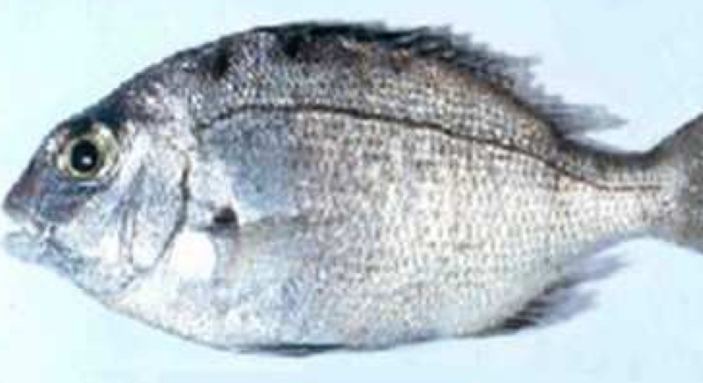

Note: Swollen abdomen due to enlargement of internal organs and fluid accumulation. P. major is a close relative of the Australian snapper.

Source: S I Park.

## Signs of disease

Important: Animals with this disease may show one or more of these signs, but the pathogen may still be present in the absence of any signs.

Disease signs at the farm, tank or pond level are:

* low to high mortality
* lethargic swimming
* obvious opercular movement (increased respiratory effort).

Gross pathological signs are:

* dark skin (change in skin colour is a significant gross sign)
* petechial (pinpoint) haemorrhage of the gills
* pale gills and enlarged spleen.

Microscopic pathological signs are:

* enlarged cells, deeply giemsa positive, in the spleen, heart, kidney, liver and gills of infected fish, which are characteristic of this disease
* small dark spots within fresh wet mounts of gill lamellae (melano-macrophage centres).

## Disease agent

RSIVD is caused by infection with red sea bream iridovirus (RSIV), from the genus Megalocytivirus within the family Iridoviridae.

## Host range

Table 1 Species known to be naturally susceptible to RSIV

| Common name | Scientific name |
| --- | --- |
| Amberjack | Seriola dumerili |
| Barramundi | Lates calcarifer |
| Black rockfish | Sebastes schlegelii |
| Black sea bream or black porgy | Acanthopagrus schlegelii |
| Brown marbled grouper | Epinephelus fuscoguttatus |
| Chicken grunt | Parapristipoma trilineatum |
| Chinese emperor | Lethrinus haematopterus |
| Chinese perch or mandarin fish | Siniperca chuatsi |
| Chub mackerel | Scomber japonicus |
| Cobia | Rachycentron canadum |
| Coral trout | Plectropomus leopardus |
| Crescent sweetlips | Plectorhinchus cinctus |
| Crimson seabream | Evynnis japonica |
| Devil stinger | Inimicus japonicus |
| Estuary cod | Epinephelus tauvina |
| Giant grouper | Epinephelus lanceolatus |
| Girella or rudderfish | Girella punctata |
| Japanese flounder | Paralichthys olivaceus |
| Japanese horse mackerel | Trachurus japonicus |
| Japanese parrotfish | Oplegnathus fasciatus |
| Japanese seabass | Lateolabrax japonicus |
| Japanese spanish mackerel | Scomberomorus niphonius |
| Large yellow croaker | Larimichthys crocea |
| Largemouth bass | Micropterus salmoides |
| Longtooth grouper | Epinephelus bruneus |
| Malabar grouper | Epinephelus malabaricus |
| Northern bluefin tuna | Thunnus thynnus |
| Orange-spotted grouper | Epinephelus coioides |
| Red sea bream | Pagrus major |
| Red-spotted grouper or Hong Kong grouper | Epinephelus akaara |
| Samson fish | Seriola hippos |
| Seabass | Lateolabrax spp. |
| Seven-band grouper | Hyporthodus septemfasciatus |
| Silver trevally | Pseudocaranx dentex |
| Six-bar grouper | Epinephelus sexfasciatus |
| Snapper | Chrysophrys auratus |
| Snubnose dart | Trachinotus blochii |
| Spangled emperor | Lethrinus nebulosus |
| Spotted coralgrouper | Plectropomus maculatus |
| Spotted halibut | Verasper variegatus |
| Spotted knifejaw | Oplegnathus punctatus |
| Tiger grouper hybrid | Epinephelus fuscoguttatus × E. lanceolatus |
| Tiger puffer | Takifugu rubripes |
| Yellow grouper | Epinephelus awoara |
| Yellowback seabream | Evynnis tumifrons |
| Yellowfin seabream | Acanthopagrus latus |
| Yellowtail kingfish | Seriola lalandi |

## Presence in Australia

Exotic disease—not recorded in Australia.

Map 1 Presence of RSIV, by jurisdiction

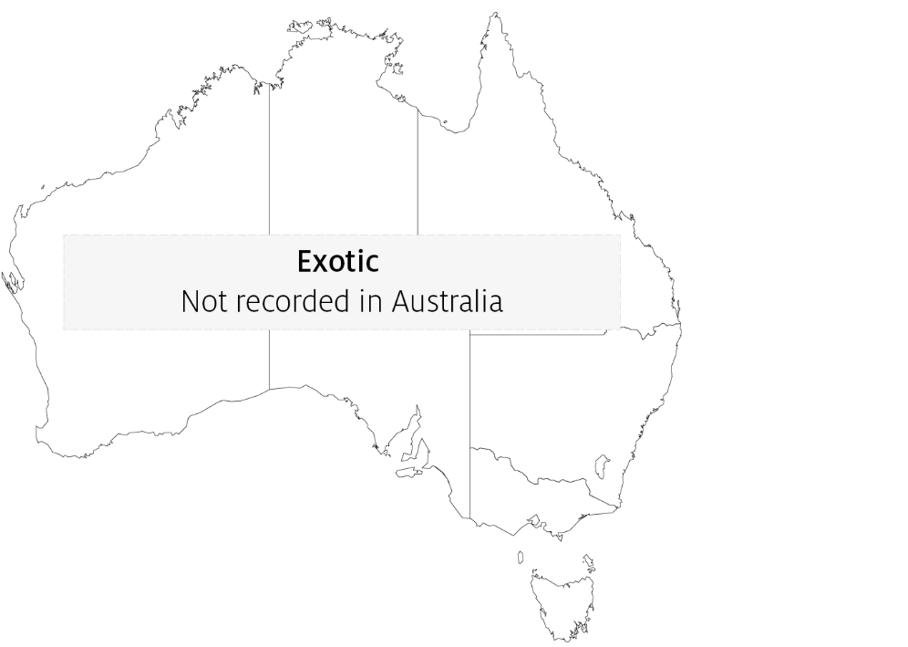

## Epidemiology

* RSIVD is highly contagious.
* Juveniles are more susceptible to disease than adults.
* Mortality is highly variable (0% to 100%) and can depend on water temperature, with higher mortalities occurring at higher water temperatures.
* Transmission is horizontal, via the water column from other infected fish. Vertical transmission has yet to be confirmed.
* Outbreaks of disease occur at water temperatures greater than 20°C, with viral multiplication increasing with water temperatures up to at least 28°C.
* The virus is stable within tissue to –80°C, and can be inactivated by ether, chloroform and formalin.

## Differential diagnosis

The list of similar diseases in the next section refers only to the diseases covered by this field guide. Gross pathological signs may also be representative of diseases not included in this guide. Do not rely on gross signs to provide a definitive diagnosis. Use them as a tool to help identify the listed diseases that most closely account for the observed signs.

## Similar diseases

Epizootic haematopoietic necrosis (EHN), grouper iridoviral disease, infection with infectious spleen and kidney necrosis virus (ISKNV)-like viruses and Tilapia lake virus (TiLV) disease.

## Sample collection

Only trained personnel should collect samples. Using only gross pathological signs to differentiate between diseases is not reliable, and some aquatic animal disease agents pose a risk to humans. If you are not appropriately trained, phone your state or territory hotline number and report your observations. If you have to collect samples, the agency taking your call will advise you on the appropriate course of action. Local or district fisheries or veterinary authorities may also advise on sampling.

## Emergency disease hotline

See something you think is this disease? Report it. Even if you’re not sure.

Call the Emergency Animal Disease Watch Hotline on **1800 675 888**. They will refer you to the right state or territory agency.

## Microscope images

Figure 2 Giemsa positive staining of enlarged cells within tissue section of spleen of fish with RSIVD

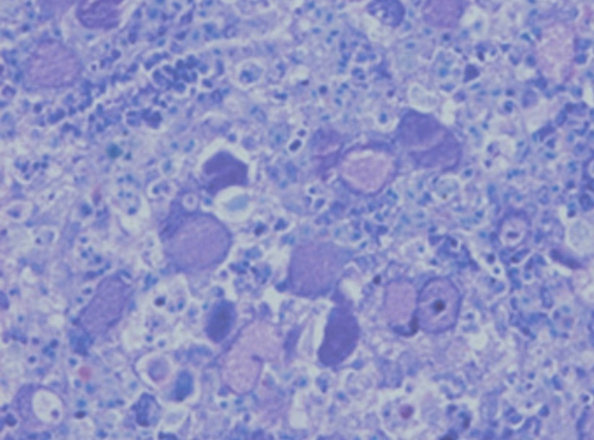

Note: Enlarged cells are characteristic of the disease.

Source: K Nakajima.

## Further reading

CABI Invasive Species Compendium [Red Sea Bream Iridoviral Disease](https://www.cabi.org/ISC/datasheet/66796)

CEFAS International Database on Aquatic Animal Diseases [Red Sea Bream Iridoviral Disease](https://www.cefas.co.uk/international-database-on-aquatic-animal-diseases/disease-data/?id=46)

World Organisation for Animal Health [Manual of diagnostic tests for aquatic animals](http://www.oie.int/en/international-standard-setting/aquatic-manual/access-online)

These hyperlinks were correct at the time of publication.

## Contact details

Emergency Animal Disease Watch Hotline 1800 675 888

Email [AAH@agriculture.gov.au](mailto:AAH@agriculture.gov.au)Website [agriculture.gov.au/pests-diseases-weeds/aquatic](http://www.agriculture.gov.au/pests-diseases-weeds/aquatic)

© Commonwealth of Australia 2020

This work is copyright. It may be reproduced in whole or in part subject to the inclusion of an acknowledgement of the source and no commercial usage or sale.