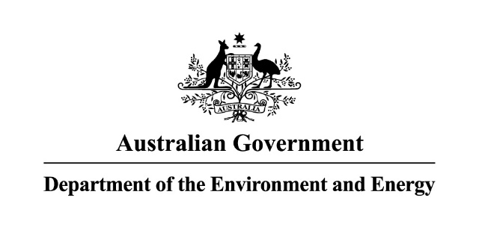 

Reef 2050 Plan

2018 ANNUAL REPORT

Aboriginal and Torres Strait Islander peoples are the Traditional Owners of the Great Barrier Reef area and have a continuing connection to their land and sea country.

© Copyright Commonwealth of Australia, 2018.



Reef 2050 Plan—2018 Annual Report is licensed by the Commonwealth of Australia for use under a Creative Commons Attribution 4.0 Australia licence with the exception of the Coat of Arms of the Commonwealth of Australia, the logo of the agency responsible for publishing the report, content supplied by third parties, and any images depicting people. For licence conditions see: <https://creativecommons.org/licenses/by/4.0/>

This report should be attributed as ‘*Reef 2050 Plan—2018 Annual Report, Commonwealth of Australia 2018*’.

The Commonwealth of Australia has made all reasonable efforts to identify content supplied by third parties using the following format ‘© Copyright, [name of third party]’.

The views and opinions expressed in this publication are those of the authors and do not necessarily reflect those of the Australian Government or the Minister for the Environment.

While reasonable efforts have been made to ensure that the contents of this publication are factually correct, the Commonwealth does not accept responsibility for the accuracy or completeness of the contents, and shall not be liable for any loss or damage that may be occasioned directly or indirectly through the use of, or reliance on, the contents of this publication.

Preface—about this document

This is the third Annual Report of the Reef 2050 Long-Term Sustainability Plan (Reef 2050 Plan). The 2018 Annual Report provides an overview of progress on implementing the Reef 2050 Plan from December 2017 to November 2018.

Detailed action-by-action progress reporting up to December 2017 can be accessed online via the Department of the Environment and Energy’s Monitoring Evaluation Reporting and Improvement Tool (MERIT) website: <https://fieldcapture.ala.org.au/explore/dashboard/reef2050>

An updated Reef 2050 Plan was released in July 2018 as a result of a mid-term review. The updated Plan identifies priorities for immediate action as well as new activities to protect the values of the Reef and improve its resilience. The updated Plan and a comprehensive list of how all actions in the original Plan have been treated is available on the Department of the Environment and Energy’s website at: <http://www.environment.gov.au/marine/gbr/publications/reef-2050-long-term-sustainability-plan-2018>

Detailed reporting on the actions was not undertaken for January to June 2018, due to the changes made during the mid-term review of the Reef 2050 Plan. The online MERIT tool includes a summary of the key achievements during this time.

The next Annual Report will be released at the end of 2019.

Contents

Preface—about this document 3

Contents 4

Ministers’ year in review 5

Advisory bodies review 7

Foreword from the Chair of the Independent Expert Panel 7

Foreword from the Chairman of the Reef 2050 Advisory Committee 8

Foreword from the co-chairs of the Reef 2050 Integrated Monitoring and Reporting Program Steering Group 9

Timeline of key achievements 10

Next steps 21

Ministers’ year in review

The Great Barrier Reef is an iconic World Heritage site of outstanding ecological, cultural and economic significance and we remain committed to our conservation, research and management efforts under the Reef 2050 Plan. Whilst 2018 was a less turbulent year for the Reef with regards to extreme weather events, it remains vulnerable to the ongoing impacts of climate change. The Reef is still struggling to recover from the unprecedented back-to-back years of coral bleaching, outbreaks of crown-of-thorns starfish, severe cyclones and subsequent flood plumes.

The Reef’s scale and natural resilience means it has the capacity to recover from impacts to an extent, given favourable environmental conditions and adequate time free from disturbance. To support this resilience we have significantly boosted our efforts in adaptive management, taken measures to further improve the quality of water coming from the catchments, and increased investment in innovative scientific techniques designed to give the Reef best chance to adapt and recover.

In response to the mass coral bleaching events of 2016 and 2017, we brought forward the midterm review of the Reef 2050 Plan and released the updated Plan in July. The Plan reaffirms our coordinated management approach, and strengthens actions to respond to immediate and long-term pressures to protect the Reef and improve its resilience. We also released the new *Reef 2050 Water Quality Improvement Plan 2017-2022* (Reef 2050 WQIP). This is our most comprehensive plan for managing water quality to date, and accelerates our collective efforts to improve the land use practices of everyone living and working in the catchments adjacent to the Reef.

The Queensland Government delivered on a key commitment under the Reef 2050 Plan by passing vegetation management laws that deliver a boost to the protection of important habitats, including waterways leading to the Great Barrier Reef.

While our efforts and success to date to improve the resilience of the Reef have been substantial, we acknowledge the challenges we are facing and recognise that new solutions are needed. The Great Barrier Reef Marine Park Authority’s *Great Barrier Reef Blueprint for Resilience* outlines 10 initiatives with actions that deliver maximum benefits for Reef resilience, including the establishment of a Reef-wide resilience network that targets efforts on coral reef areas that are of greatest value to the future of the Reef. To further foster innovative solutions, we released the *Boosting Coral Abundance* Innovation Challenge to tap into the wealth of talent and technologies within local, regional and global communities and unearth new ideas to protect and restore the Reef.

We know that driving progress towards our Reef 2050 Plan targets and delivering outcomes for the Reef requires a commitment to solid, direct investment. The Plan is well funded with the Australian and Queensland Governments investing over $2 billion over ten years to ensure the health of the Reef.

In January, the Australian Government committed $60 million for Reef protection activities including the innovative Reef Restoration and Adaptation Program that will scope a program of work to assist recovery, repair and build resilience of the Reef. We bolstered our efforts in April, with the Australian Government announcing a further $500 million – the largest single investment to protect the Reef – to accelerate delivery of the Reef 2050 Plan. The combined funding is increasing efforts to control coral-eating crown-of-thorns starfish; preventing soil, pesticides and nitrogen run-off damaging the Reef; enhance reef restoration and adaptation science activities, improve Reef integrated monitoring and reporting activities and further enhancing Traditional Owner and community engagement in activities to protect the Reef.

A key component is an innovative partnership with the Great Barrier Reef Foundation – a $443.3 million grant delivered through the Australian Government’s Reef Trust. As the leading charity dedicated to the conservation of the Reef, the Foundation has set a target of attracting up to $400 million of additional funds from private donors and partner organisations. The Foundation has delivered the first key milestones under the Partnership agreement, demonstrating its clear plans to scale up work and deliver great outcomes for the Reef.

The Australian and Queensland governments have also boosted investment in the Joint Field Management Program to support rangers to maintain island and marine ecosystems, undertake compliance activities and provide a strong on-water presence. In 2018, the Australian Government announced $47.6 million plus ongoing funding of more than $10 million per year. The Queensland Government is also providing an additional $26 million towards the Joint Field Management Program. This forms part of the Queensland Government’s announcement of $40 million in extra funding for Reef protection, which will also support agricultural producers to transition to improved practices.

This year, we also celebrated the International Year of the Reef which highlights coral reefs and ecosystems around the world. To promote reef stewardship, conservation action and collaborations for Reef restoration, the Great Barrier Reef Marine Park Authority hosted a diverse program of events and projects throughout the year with key partners, local governments and the community. Australia is also playing a global role in protecting, restoring and maintaining coral reefs as an active founding partner of the International Coral Reef Initiative and in 2018 took on the role as co-Chair, jointly with Monaco and Indonesia.

In October, the Intergovernmental Panel on Climate Change (IPCC) published a comprehensive scientific and technical assessment of the latest available climate modelling in the *Special Report on Global warming of 1.5°C*. The IPCC reminds us that corals worldwide, including those of our Great Barrier Reef, are already experiencing the impacts of climate change and will be further affected if temperatures continue to rise. Australia is already taking strong action to reduce emissions through our commitment to the 2030 targets under the Paris Agreement and is focussing our efforts to build Reef resilience through the Reef 2050 Plan.

The Plan’s successful implementation relies on ongoing and productive partnerships between all parties. We recognise and value the connection that Traditional Owners have to the Great Barrier Reef and their sea country. To strengthen our relationships with Traditional Owners, the Australian Government has engaged a consortium of Indigenous and research organisations to advise us how to better reflect Traditional Owners’ aspirations for the Great Barrier Reef and deliver on existing commitments.

We take this opportunity to thank our two advisory bodies – the Reef 2050 Plan Independent Expert Panel and the Reef 2050 Advisory Committee – and also the Reef 2050 Integrated Monitoring and Reporting Program Steering Group. The guidance they provide is invaluable in ensuring that our policies and investment decisions are underpinned by solid stakeholder and scientific advice.

The Reef 2050 Plan is ambitious and we are confident it remains the right framework to respond to the pressures facing the Reef. Now, three years into this 35-year plan, we are proud of the substantial progress we have made. Together we will continue to deliver significant outcomes for the Reef.

The Hon Melissa Price MP  
Australian Minister for the Environment

The Hon Leeanne Enoch MP   
Queensland Minister for Environment and the Great Barrier Reef, Minister for Science and Minister for the Arts

Advisory bodies review

## Foreword from the Chair of the Independent Expert Panel

The Reef 2050 Plan Independent Expert Panel is committed to providing scientific and expert advice to governments on actions and priorities to protect and sustain the Great Barrier Reef now and for future generations.

As this Annual Report shows, the Panel’s role has involved consideration of the state of the reef with a focus on building resilience, providing expert advice on projects to deliver outcomes for the reef, advising on the mid-term review of the Reef 2050 Plan, advising on the early stages of the comprehensive review of the Plan due to be completed in 2020, as well as providing strategic advice on the Australian Government’s partnership with the Great Barrier Reef Foundation.

There is compelling evidence that unchecked global warming will have a seriously destructive effect on the Reef. We repeated our earlier advice that it is critical to reduce emission of CO2 and other greenhouse gases as soon as possible and on a global scale. We stressed the importance the Paris Agreement and have called for increased efforts to respond to climate change to prevent reef ecosystems from failure or collapse. Every effort should be made to set global emission reduction targets to secure an average temperature increase of no more than 1.5°C above pre-industrial levels, or even less.

The need to respond gets more urgent with time, and inadequate local and international responses threaten more than the reefs of the world, even if the sensitivity of the reefs gives early warning signs of what could happen more widely if too little action is taken too late. Local actions – such as improving water quality and decreasing nutrient and sediment run-off are critical to support the Reef and to give it a better chance of recovering from insult – but they are not the cause. As the bleaching and mortality of the northern one-third of the reef in 2015/16 demonstrated clearly, reefs are damaged even in water that is ‘pristine’ if it is too warm for too long.

In February 2018, we provided advice on the mid-term review of the Reef 2050 Plan. We advised that transformational change to management and policy is essential to secure the future of the Reef and the time has passed for relying only on incremental change. We advised that the updated Plan in 2020 should lay the foundations for addressing all these issues in tangible, practical ways. It may lead to hard questions and even harder answers, but reality means they have to be asked and the answers pursued.

In November 2018, we provided advice on the overall approach to the comprehensive review and the overarching program logic. The Panel looks forward to continued engagement on this important work.

We also advised on the draft *Reef 2050 Water Quality Improvement Plan 2017-2022*, which will lay the foundations for future innovations and the step change needed to meet the revised catchment targets. We advised that the Plan should further acknowledge the climate challenges that will effect land management and uncertainty in the current knowledge base that must resolved.

The Reef Trust-Great Barrier Reef Foundation (GBRF) Partnership provides for the Panel to advise Ministers about the strategies and outcomes of GBRF-funded projects. The Panel recommended a set of high-level principles for the GBRF to consider in developing its Investment Strategy. In this advice we emphasised the need to reflect rigorous principles of ethical, open, transparent and effective competition and value for money in the Investment Strategy. We then provided further strategic advice to the Partnership on its draft Investment Strategy in November 2018. The Panel identified the need to ensure actions undertaken by the GBRF are prioritised to ensure they contribute towards the outcomes of the Reef 2050 Plan. The Panel also identified the need to ensure that the best available science is being utilised and emphasised the importance of ensuring integrity is maintained in the decision-making process through mechanisms such as independent peer reviews.

The Reef 2050 Plan remains a strong foundation for future action and we remain committed to it as the right framework to manage the complexity and scale of challenges the Reef faces into the future. The Panel will continue to provide co-ordinated, coherent, innovative and independent advice to initiate and sustain change.

Professor Ian Chubb AC FAA FTSE  
Chair, Independent Expert Panel

## Foreword from the Chairman of the Reef 2050 Advisory Committee

During 2018, the Reef Advisory Committee (RAC) worked with steady purpose to fulfil its role of providing stakeholder perspectives and strategic advice to the Australian and Queensland governments on implementation and review of the Reef 2050 Plan and Reef policy matters. The RAC held three full formal meetings in February, July and October, and a joint function with its fellow advisory body, the Independent Expert Panel, in July. The Reef 2050 Communications Network, established in November 2017 as a specialist sub-group of the RAC, held several meetings including a major workshop in Townsville in September. RAC members also provided intersessional advice on a range of issues.

Although 2018 was a less turbulent year for the Reef, with no cyclone damage, nor repeat of the mass coral bleaching episodes experienced in 2016 and 2017, linked to global warming, RAC members remain greatly concerned about the health of the Reef, its capacity to recover and adapt and its future prospects in a warming world. The issue of climate change and the threat this represents to the Great Barrier Reef is a consistent preoccupation for the RAC as it frames its advice on the Reef 2050 Plan.

In the early part of the year, the Committee’s attention was focused on the mid-term review of the Reef 2050 Plan. Notwithstanding some differences of view about the scope of this review, the Committee was united in its advice that references in the Plan to climate change and climate change action should be changed and strengthened. This clear advice was accepted by Ministers and reflected in the updated Plan released in July 2018. The Committee welcomed the stronger statements in the Plan as well as the new actions included to assist the Reef to adapt.

With the mid-term review completed, RAC attention shifted to preparations for the comprehensive review, due in 2020. This will be a major focus of the Committee’s work over the coming year, in parallel with ongoing effort to achieve and assess progress with implementation of all actions in the Plan. The RAC’s strong interest in evaluating achievement of the Plan’s targets and outcomes makes completion of development of the Reef 2050 Integrated Reporting and Monitoring Program – essential for measuring the effectiveness of the Plan – a high priority for the Committee.

Funding will also continue to be a major area of the Committee’s interest and advice to government. Since inception of the Reef 2050 Plan, the independent advisory bodies have provided guidance on funding needs and priorities and have consistently emphasised the need for greater funds to be committed to the Reef. Accordingly, RAC members welcomed the announcements in 2018 of substantial new amounts of government funding for Reef protection, by both the Australian and Queensland governments, and the opportunity for early engagement with the new Reef Trust Partnership, established between the Australian Government and the Great Barrier Reef Foundation. The Foundation is a member of the RAC and has committed to extensive consultation with the Reef 2050 Plan advisory bodies. At its October meeting, RAC members provided comment on the development of the Reef Trust Partnership Investment Strategy.

During the year, the Committee also welcomed the release of the Reef 2050 Water Quality Improvement Plan, having contributed to its development including through the Reef Water Quality Partnership Committee, a water quality focused working group of the RAC. The Committee has also been interested in the development of the Reef Restoration and Adaptation Program, work to support increased participation by Traditional Owners in implementation of the Reef 2050 Plan and progress in implementing government programs to mitigate climate change.

Reviewing the past year of RAC activity, considering the work completed, underway and ahead, I am impressed anew by the commitment of RAC members to this ambitious project. Many of them have committed their time on a voluntary basis. Others have businesses to manage and full-time jobs, where Reef issues are only one part of their responsibilities. Yet each time we meet – or seek their advice outside the formal meeting framework – they ‘step up’ providing considered, thoughtful advice on behalf of their sectors, organisations and stakeholders. Even though the range of stakeholders is very wide and there are differences of view on some issues, the collaborative spirit that has marked the Committee since its establishment continues to prevail.

As Chairman of the RAC, I thank all members for their contribution to the Committee’s work over the past 12 months and look forward to another year of productive effort in 2019.

The Honourable Penelope Wensley AC  
Chairman, Reef 2050 Advisory Committee

## Foreword from the co-chairs of the Reef 2050 Integrated Monitoring and Reporting Program Steering Group

Coral reefs around the world, including the Great Barrier Reef, are facing a variety of impacts and pressures. The most significant of these is human-induced climate change, which in recent years has resulted in mass coral bleaching events and significant loss of coral cover worldwide.

As impacts and pressures on the Great Barrier Reef accumulate, they will challenge the resilience of the ecosystem and its ability to tolerate and recover from disturbances. This is reflected in the revised Reef 2050 Plan with a strong focus on managing the Reef to support its resilience.

Effectively managing for resilience requires a comprehensive understanding of the Reef system. This includes an understanding of the cause-and-effect relationships between drivers and pressures on the state of the system and impacts on the benefits the system provides. It also requires the use of forecasting tools to inform planning and actions, together with monitoring and diagnostic tools to adjust actions.

Recognising this, the vision of the Reef 2050 Integrated Monitoring and Reporting Program (the program) is to develop a knowledge system that enables resilience-based management of the Great Barrier Reef and its catchment, and provides managers with a comprehensive understanding of how the Reef 2050 Plan is progressing.

Establishing an integrated monitoring program across the Great Barrier Reef and its adjacent catchment is a major undertaking, and a world-first in terms of its complexity and spatial scale. It has required program managers and partners to navigate a wide range of complex and challenging issues — many of which are still being assessed — and draw together multiple environmental, social and economic monitoring and modelling programs.

Program partners have made significant progress towards achieving the program’s vision. Program development commenced in 2016, and a prototype – the first edition of the knowledge system – is scheduled to be complete by June 2019. Key achievements this year include:

* investing in key monitoring gaps to ensure continuity of data sets and provide information for the Great Barrier Reef Outlook Report 2019
* coordinating expert-theme groups to provide monitoring program design recommendations across key components of the Great Barrier Reef: coral reefs, seagrass meadows, marine physical and chemical environment, megafauna, human dimensions, Indigenous heritage, catchments and estuaries, fishing and fisheries, and islands
* undertaking a structured decision-making process involving Reef managers and key partners to consolidate, integrate and refine monitoring program design recommendations provided by expert-theme groups
* undertaking a comprehensive audit of data management practices across existing Great Barrier Reef monitoring programs as a foundation for developing the program’s data and information infrastructure
* completing a functionality upgrade for the Great Barrier Reef Marine Park Authority’s Reef Explorer mapping and visualisation system
* targeting research key to the program with the National Environmental Science Program and Great Barrier Reef Foundation

These achievements build on work already completed and bring the program closer towards achieving its vision. Once established, the program’s knowledge system will provide unparalleled access to information about the Reef’s environment and the threats affecting it. It will enable the early detection of trends and changes, and drive efficient and transparent management decisions. Over time, the knowledge system will evolve based on the findings of Great Barrier Reef Outlook Reports, new technologies and priority management and stakeholder needs.

We look forward to continuing our work with partners as we move towards implementation of the knowledge system in 2019.

Dr Russell Reichelt FTSE   
Chairman  
Great Barrier Reef Marine Park Authority

Jamie Merrick­  
Director-General  
Department of Environment and Science

Timeline of key achievements

December 2017

* The Great Barrier Reef Marine Park Authority launched the Great Barrier Reef blueprint for resilience outlining 10 initiatives with actions that deliver maximum benefits for Reef resilience.
* The Australian Government announced $2.2 million investment in innovative research by the Reef and Rainforest Research Centre to test whether water mixing technology, used in freshwater storages, can reduce coral heat stress at a local level.
* To reduce nitrogen run-off flowing from the Reef’s catchments, the Australian Government announced $4.46 million through the Reef Trust to support sugarcane farmers in the Wet Tropics and Burdekin regions to change farming practices by better matching fertiliser application to crop requirements.

Case study

Blueprint for resilience

The Great Barrier Reef Marine Park Authority’s *Great Barrier Reef blueprint for resilience* signals a new direction for managing the Reef and outlines 10 key actions to strengthen Reef resilience in the face of a changing climate. The blueprint acknowledges that mitigation of greenhouse gas emissions is the key to addressing climate change impacts and emphasises that protecting the Great Barrier Reef in a warming world requires strong action now to build Reef resilience.

The decline in the ecological health of the Reef is unprecedented and represents a genuine crisis. In response to this crisis, the Great Barrier Reef Marine Park Authority convened the Great Barrier Reef Summit – Managing for Resilience in May 2017 to help develop a blueprint to navigate a future characterised by uncertainty and accelerating change. The *Great Barrier Reef blueprint for resilience* was published in December 2017 and incorporates recommendations from the Reef Summit, along with good practice projects across four themes:

* building a resilience network
* delivering on-ground actions to enhance resilience
* empowering people to be part of the solution
* fostering change.

The Great Barrier Reef Marine Park Authority is working with partners to implement the blueprint across the 10 key actions and four themes. The blueprint informed the mid-term review of the Reef 2050 Plan.

Some key initiatives underway as part of implementing the blueprint include:

* identifying a network of resilient reefs
* implementing vessel monitoring systems on commercial fishing vessels to enhance compliance
* investigating which species are most important to the ecological processes supporting Reef functioning and recovery
* supporting the development of Reef restoration solutions that can be logistically and feasibly deployed at a large scale, including for the Reef Restoration and Adaptation Program.

2018 is the International Year of the Reef — an opportunity to celebrate, educate and motivate the community about the value of coral reefs worldwide and the threats they face.

January 2018

* The Australian Government announced an investment of nearly $60 million investment over 18 months for Reef protection activities. This included $6 million for the concept feasibility phase of a Reef Restoration and Adaptation Program, $10.4 million for crown-of-thorn starfish control, $4.9 million to the Joint Field Management Program to strengthen compliance and management and $36.6 million to stop soil, pesticides and nitrogen run-off damaging the Reef.
* A $2.4 million Queensland Government program, which began in Cairns in 2016, now provides access to 200 public moorings on the Great Barrier Reef. The moorings and Reef protection markers help protect remaining coral cover on fringing reefs, and allow reefs to recover from impacts such as cyclones. In 2018, a further 20 moorings were installed in the northern Great Barrier Reef (Townsville to Cooktown) and others were installed in the southern Great Barrier Reef, offshore from Gladstone.
* 50 new research projects were announced under the Australian Government’s National Environmental Science Program. More than a dozen projects are looking at solutions to the challenges faced by the Great Barrier Reef, supporting delivery of the Reef 2050 Plan.
* The Australian Government announced almost $1 million for a consortium of Indigenous and research organisations to advise how to better reflect Traditional Owners’ aspirations for the Great Barrier Reef and deliver on existing commitments.

Case study

Crown-of-thorns starfish control

The Great Barrier Reef Marine Park Authority’s [Great Barrier Reef blueprint for resilience](http://hdl.handle.net/11017/3287) identified coral-eating crown-of-thorns starfish control as one of the most feasible actions to reduce coral mortality on the Great Barrier Reef. After major flood events, excess nutrients running off the land contribute to ‘outbreaks’ of the starfish on dozens of reefs at a time, leading to dramatic reductions of live coral cover.

Culling to reduce the severity of these starfish outbreaks and protect live coral is a priority. The control program is designed to maintain coral cover while the longer-term problems of poor water quality and reducing greenhouse gas concentrations are addressed.

To date, crown-of-thorns starfish densities have been kept below the ecological sustainable threshold for coral growth and recovery on 75 per cent of 57 priority reefs between Port Douglas and Townsville. These reefs were identified for their high ecological and economic value.

Additional funding of $10.4 million over two years will enable expansion of the program, tripling the number of control vessels and providing resources for additional surveillance.

February 2018

* The Queensland Government announced more than $600,000 for a project with graziers in the Burnett Mary region focusing on better land management practices.

CASE STUDY

Addressing sediment and nutrient loss through precision agriculture in Fitzroy region (Reef Alliance)

Farmers in the Fitzroy region have been using information technology and improved farming equipment (precision agriculture) to increase their agriculture production and reduce nutrient and soil loss from their properties. This has improved the quality of water entering the Great Barrier Reef. Projects are being delivered under the Reef Trust Phase Three: Reef Alliance ‘Growing a Great Barrier Reef’ project which supports farmers and graziers across Great Barrier Reef catchments to improve the way they manage their land.

* Projects on three properties – Namgoori, Winglen and Ekullem – are assisting landholders to adopt precision agriculture techniques to ensure that the crops and soil receive exactly what they need for optimum health and productivity. Specialised equipment, software and IT services are used to observe and measure changes in crops which guides immediate and future farming decisions, such as precisely what fields to water and when. Paddock contour improvements are being planned and implemented at Winglen and Ekullem to reduce run-off and nutrient loss, which will lead to reduced fertiliser and chemical losses, improve crop establishment and improve production. These on-ground actions are accelerating progress towards the water quality targets in priority areas, which will increase the resilience of the Reef in a changing climate.

March 2018

* The Great Barrier Reef Marine Park Authority released for public comment its draft Aboriginal and Torres Strait Islander Heritage Strategy for the Great Barrier Reef Marine Park. The Strategy aims to increase understanding of Indigenous heritage values in the Great Barrier Reef and set out how the Authority will partner with Traditional Owners to protect these values. Implementing the Strategy is a new action under the revised Reef 2050 Plan.

April 2018

* The Australian Government announced $500 million in new funding for the Great Barrier Reef. This includes a $443.3 million partnership with the Great Barrier Reef Foundation to drive progress towards meeting the Reef 2050 Plan targets. This includes water quality improvement activities in the Great Barrier Reef catchment; expanding the fight against coral-eating crown-of-thorns starfish; supporting reef restoration, resilience and adaptation science activities; Indigenous and community reef protection activities; and enhancing Reef health monitoring and reporting. The Joint Field Management Program was also boosted with an additional $42.7 million over six years with an ongoing increase of $10.2 million per year after that.
* The Australian Government announced $5 million from its Reef Trust towards the Reef Islands initiative. This collaboration between the Great Barrier Reef Foundation, Queensland and Australian governments aims to protect key island habitat refuges. This funding announcement added to the Queensland Government's existing commitment of $3 million, and a further $6 million leveraged by the Great Barrier Reef Foundation.
* The Queensland Government announced two new Indigenous Land and Sea Ranger positions for Gladstone and Bundaberg, and 12 new positions in Far North Queensland.

CASE STUDY

Reducing gully erosion in the northern Great Barrier Reef (Normanby region)

The Balnggarrawarra Rangers, supported by the Queensland Land and Sea Indigenous Ranger Program, have worked with South Cape York Catchments for many years to control soil erosion on two properties, Melsonby and Normanby Stations. They understand the importance of protecting their waterways and country by minimising soil loss. Through the Australian Government’s Reef Trust Gully Erosion Control Program, the Balnggarrawarra Rangers have been able to build on their existing experience to tackle the high priority alluvial gullies on Normanby Station, which were delivering thousands of tonnes of sediment into the Normanby River each year. This work, funded by Cape York Natural Resource Management, is critically important as gully erosion was identified by the Eastern Cape York Water Quality Improvement Plan as the single largest threat to water quality in the northern Great Barrier Reef. The Normanby catchment has the highest concentration of gullies on Cape York.

The Balnggarrawarra Rangers have taken a holistic approach to the Normanby Station Gully Project. Initially, they worked to improve ground cover across the property through activities such as fire and feral cattle management, and cattle exclusion fencing. Next, they began revegetating by direct seeding native grasses, and built porous check dams in gully floors. Lastly, they used machinery to regrade gully head cuts and create diversion banks.

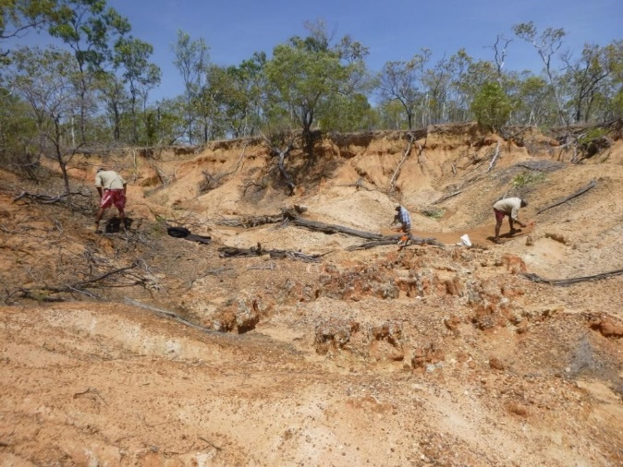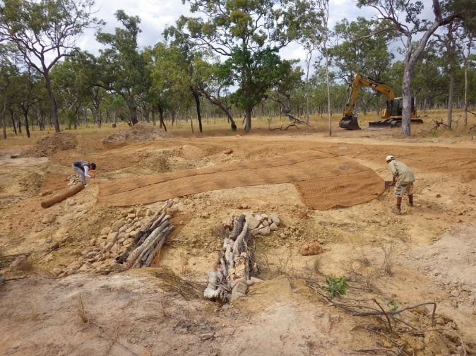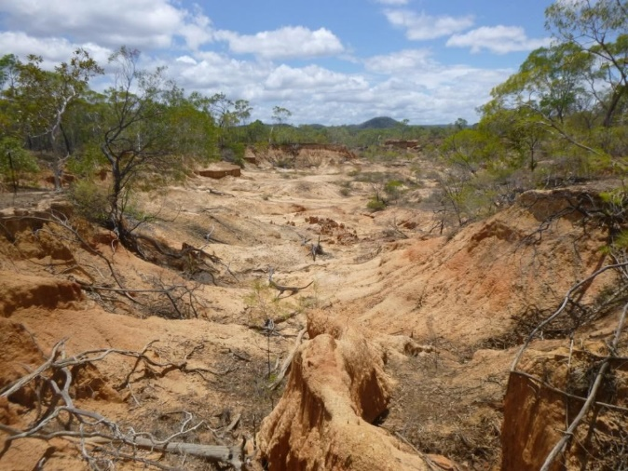

Researchers from Griffith University’s Australian Rivers Institute have assisted the Balnggarrawarra Rangers to design effective monitoring plans. The rangers have monitored sediment loads and flow rates before, during and after the work.

Supported by the Queensland Land and Sea Indigenous Ranger Program, the Balnggarrawarra Rangers will maintain and monitor the completed work. They will also look for new opportunities to rehabilitate gullies, stabilise roads and improve ground cover to protect their river, Princess Charlotte Bay and the Great Barrier Reef.

Balnggarrawarra Rangers undertaking gully remediation work on Normanby Station. Photos courtesy of South Cape York Catchments.

May 2018

* The Queensland Government announced $40 million of new funding over four years to protect the Reef. This includes $26 million for the Joint Field Management Program and $13.8 million to extend the Queensland Reef Water Quality Program to support the transition of graziers, cane and banana growers to improved practices through access to professional advice. That brought the government’s total investment in the Great Barrier Reef to a record $330 million over five years.
* The Queensland Government increased protection for high-value regrowth and remnant vegetation and boosted protection of important habitats, including waterways leading to the Great Barrier Reef, through new vegetation management laws.
* Traditional Owners from across the Reef came together at a workshop to share their insights, advice and aspirations for the Reef, and provide advice on the future roles they want to play in protecting the Reef and their culture. Through this workshop, Traditional Owners also provided advice to inform the program design of the Reef 2050 Integrated Reporting and Monitoring Program.

CASE STUDY

Indigenous Ranger Compliance Enhancement Project

Indigenous ranger projects were first funded in 2007 to create meaningful employment, training and career pathways for Aboriginal and Torres Strait Islander people in land and sea management.

In 2015, the Great Barrier Reef Marine Park Authority piloted an Indigenous Ranger Compliance Enhancement Program. This program aimed to strengthen the compliance capabilities and related technical skills of Indigenous rangers and provide pathways for surveillance and compliance opportunities with government regulatory agencies and other fee-for-service work.

The pilot program concluded at the end of 2017 with 28 Indigenous rangers successfully completing a nationally accredited Certificate IV in Government Investigations (Statutory Compliance). 17 Indigenous rangers were appointed as Marine Park inspectors.

As a result of the success of the pilot program, the Department of the Prime Minister and Cabinet provided funding under the Indigenous Advancement Strategy to extend the training on a national level. The Great Barrier Reef Marine Park Authority received funding to train a further 40 Indigenous rangers by June 2020.

Indigenous ranger projects support Indigenous people to combine traditional knowledge with conservation training to protect and manage their land, sea and culture. These projects also develop partnerships with research, education, philanthropic and commercial organisations to share skills and knowledge, engage with schools, and generate additional income and jobs in the environmental, biosecurity, heritage and other sectors.

June 2018

* The Great Barrier Reef Marine Park Authority released its updated Reef 2050 Integrated Monitoring and Reporting Program Strategy. This revised Strategy provides an overview of progress as well as the pathway ahead. Work across three parallel streams – design, data management, and synthesis and reporting – is well underway with the program expected to ‘go live’ in 2019.
* Twenty-four sugarcane farmers in the Wet Tropics and Burdekin regions will be supported with $3.28 million from the Australian Government to improve fertiliser management practices and complete accreditation under the sugar industry’s Smartcane Best Management Practice program.
* The Queensland Government announced $61.7 million over the next four years to help improve the quality of the state’s land, vegetation, water and Reef. Of this, $19.4 million will be for improved water quality to reduce sediments, nutrients and pesticides flowing into the Great Barrier Reef.

CASE STUDY

Boosting coral abundance on the Great Barrier Reef innovation challenge

In 2018 the Australian and Queensland governments launched the Coral Abundance Innovation Challenge through the Advance Queensland Small Business Innovation Research initiative. The challenge aimed to tap into the wealth of talent and technologies within local, regional and global communities and unearth new ideas to enhance coral abundance on the Great Barrier Reef in response to threats such as coral bleaching.

The challenge was released to the market in January and the successful applicants were announced in July. Six innovators were invited to undertake an eight-month feasibility study, out of an international field of 69 applicants. The selected projects range from large-scale harvesting of naturally occurring coral spawn slicks for release on targeted reefs, to establishing coral settlement structures designed to withstand heavy seas and cyclones, as well as new systems to reduce the exposure of corals to heat stress. The successful applicants are working in partnership with various local entities including charter boat and tourism operators, Indigenous sea rangers and local manufacturing companies to deliver innovative outcomes.

The Great Barrier Reef Marine Park Authority is working directly with applicants where feasibility activities include trials within the Great Barrier Reef Marine Park. At the conclusion of the feasibility study, selected projects will be invited to participate in a proof-of-concept stage.

Details of the winners and their innovative proposals can be found on the [Small Business Innovation Research website](https://advance.qld.gov.au/entrepreneurs-and-startups-industry-small-business/small-business-innovation-research/sbir-challenges).

July 2018

* The updated Reef 2050 Plan was released as a result of the mid-term review of the Plan. The mid-term review was brought forward by the Great Barrier Reef Ministerial Forum following climate-driven, back-to-back mass bleaching events and other severe impacts to the Reef. The revised plan identifies priorities for immediate action as well as new activities to protect the values of the Reef and improve its resilience.
* The new Reef 2050 Water Quality Improvement Plan 2017-2022 (WQIP) was released. The Reef 2050 WQIP guides how industry, government and the community will work together to improve the quality of water flowing to the Great Barrier Reef by addressing all land-based sources of water pollution including run-off from agricultural, urban, industrial and public lands.
* The Reef 2050 Cumulative Impact Management Policy and Net Benefit Policy were released. These complementary policies provide guidance on how to reduce threats and improve the Reef’s resilience in the context of continuing climate change pressures.
* Australia commenced co-chairing the International Coral Reef Initiative with Indonesia and Monaco through to June 2020. The initiative contributes to raising awareness of the importance of and threats to coral reefs and related ecosystems, recognising that they are facing serious threats.

CASE STUDY

Great Barrier Reef Restoration Symposium (#RestoretheReef2018)

From 16 to 19 July 2018, the Great Barrier Reef Restoration Symposium brought together over 250 restoration practitioners, scientists, engineers, environmental managers, non-government organisations and industry partners from around the world. They turned their collective focus towards interventions to help the Great Barrier Reef.

The Symposium was convened by the National Environmental Science Program's Tropical Water Quality Hub. It provided a great example of how the program connects scientists with research users to inform decision making and environmental action.

In line with Reef 2050 Plan actions to build the resilience of the Reef, the aim of the Symposium was innovative. Attendees shared experiences, insights and ideas regarding threats to the Great Barrier Reef that may be responsive to local- or regional-scale intervention, restoration and management.

Delegates made new connections and shared information across a wide variety of disciplines, including those not typically allied with coral reef researchers. Optimism and a sense of growing momentum were common themes among the presentations, especially those showcasing exciting new methods either under development or actively being trialled elsewhere in the world.

Of special importance was the enthusiastic participation of 44 high school students and associated educators in a Young Adults Workshop. This was dedicated to guiding young adults towards future stewardship of the Great Barrier Reef and actively identifying problems, locally-led solutions and appropriate pilot sites. The findings of the Young Adults Workshop are being compiled into a Young Adults Blueprint for Great Barrier Reef Restoration. Videos of the symposium presentations are available at: <https://www.youtube.com/playlist?list=PLUpMpUHjG0iwcZojYnncRJRyGSy1ihmLE>

August 2018

* The Queensland Government announced a new policy on transhipping within the Great Barrier Reef Marine Park World Heritage Area that restricts transhipping operations to areas that are declared ports and prohibits transhipping outside these areas.

September 2018

* The Queensland Ports Association released a report that describes the port sediment characteristics and risks at major ports and how they interact and contribute to broader catchment loads within the World Heritage Area.

CASE STUDY

Reef community networking and supporting the adoption of sustainable practices to protect the Great Barrier Reef

Established in 1999, Local Marine Advisory Committees provide the Great Barrier Reef Marine Park Authority with community advice on, and contribute to, managing the Great Barrier Reef Marine Park. The membership of each Local Marine Advisory Committee is diverse with representatives including Traditional Owners, recreational and commercial fishing, tourism, farming, natural resources, boating, education, research, conservation and shipping. In July 2018, a record 170 community members signed up for the new three-year term.

Local Marine Advisory Committees also involve and support local communities in direct management and conservation of the Reef and promote information exchange within their local communities. Through member collaboration, the Committees also leverage additional actions to support the Reef 2050 Plan. Examples from across the 12 Local Marine Advisory Committees include:

* Cape York created a poster asking spearfishers to avoid taking important herbivorous fish that play a role in supporting Reef recovery. It also ran a campaign and competition in the local media promoting sustainable netting practices.
* Douglas ran a campaign and competition promoting sustainable netting practices for bait netting. It also supported a Council officer to attend a university course in coastal hazard management resulting in the development of a coastal hazard adaptation strategy.
* Cairns supported drain stencilling, to raise awareness of urban pollution. It also supported the citizen science program MangroveWatch, which uses video assessments to monitor mangroves along Cairns shorelines.
* Cassowary Coast produced a popular and informative fishing and boating brochure that included information on turtle nesting, the importance of herbivorous fish and the Eye on the Reef app.
* Hinchinbrook hosted a public meeting to raise the profile of the effects of plastics in the marine environment.
* Townsville supported the Reef Recovery citizen science project that is trialling the removal of brown algae which is dominating potential coral structures in Nelly Bay on Magnetic Island.
* Bowen supported the celebration of 150 years of the Bowen Lighthouse. It set up an information stall on the beach to help the 1000+ Reef walkers get there safely, with minimal impact on the environment.
* The Whitsundays developed a guide to show where spearfishing can and cannot occur. This is one of the Great Barrier Reef’s most visited regions, with a high number of users including spear fishers.
* Mackay supported the Mackay Recreational Fishers Alliance’s school fish program which, over the last 10 years, has educated over 10,000 school children. This covers all aspects of angling — from how to assemble and care for fishing equipment and environmental awareness, to bag and size limits.
* Capricorn Coast led an initiative to provide funding to Tangaroa Blue to develop an app that collects data about marine debris. The data is used to raise awareness, inform management agencies about the state of marine debris in the World Heritage Area and promote change.
* Gladstone supported a school short film competition. It received such a positive response that a Reef Short Film category was incorporated into the Capricorn Film Festival. The films are a great way to raise awareness about threats to the Great Barrier Reef.
* Burnett supported a number of turtle projects in conjunction with the Sea Turtle Alliance. These included purchasing equipment, a Junior Turtle Ranger program, the 4th Australian Marine Turtle Symposium (attended by over 300 representatives including Traditional Owners, local, state and international experts) and display materials to support the reduction of marine plastics. The committee also supports a long-standing citizen science tag and release recreational fishing program.

President of the Sea Turtle Alliance Gary Brandon and Burnett Local Marine Advisory Committee Chair Sue Sargent check the new pullup banners and leaflets made available through a Great Barrier Reef Marine Park Authority Reef Guardian Grant. Photographer: Mike Middleton.

Volunteers from the Sea Turtle Alliance and Kalkie State School promoting the "fantastic not plastic" message at a local shopping centre to reduce marine debris. Photo courtesy of the Sea Turtle Alliance.

Building the next generation of Reef protectors – members of the Mon Repos Junior Turtle Rangers team recording data. Photo courtesy of Queensland Parks and Wildlife Services.

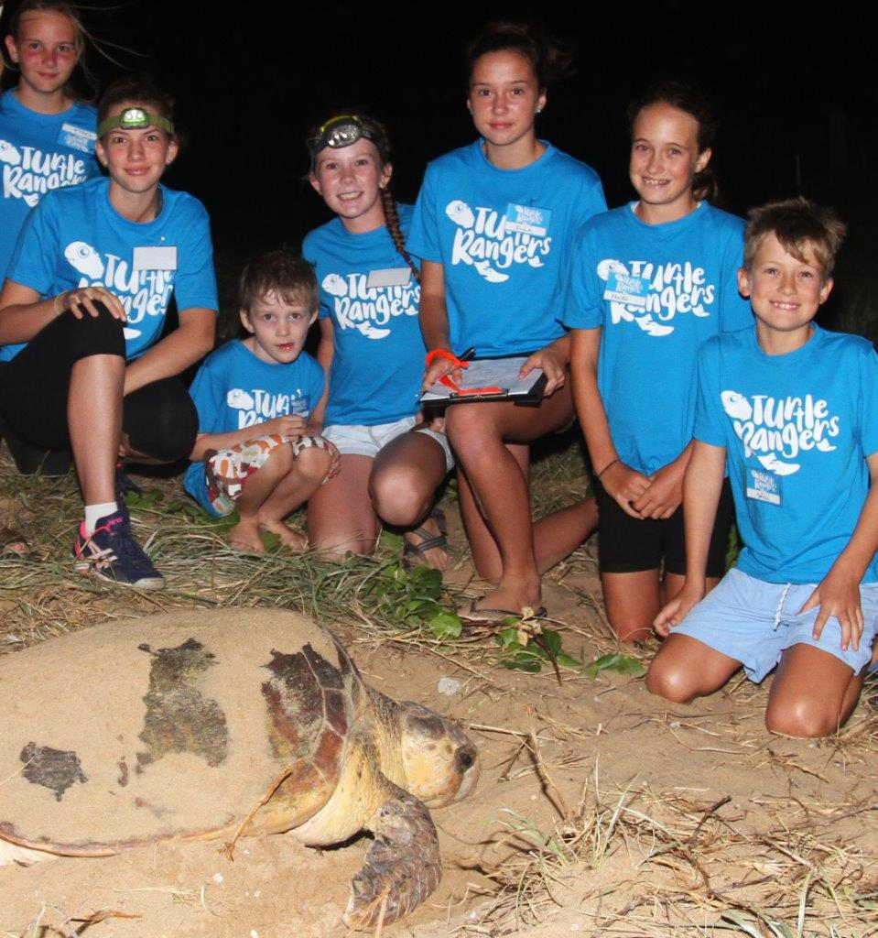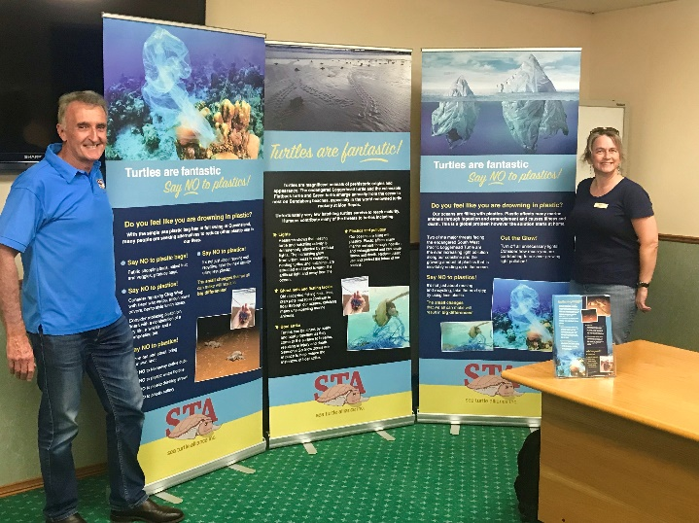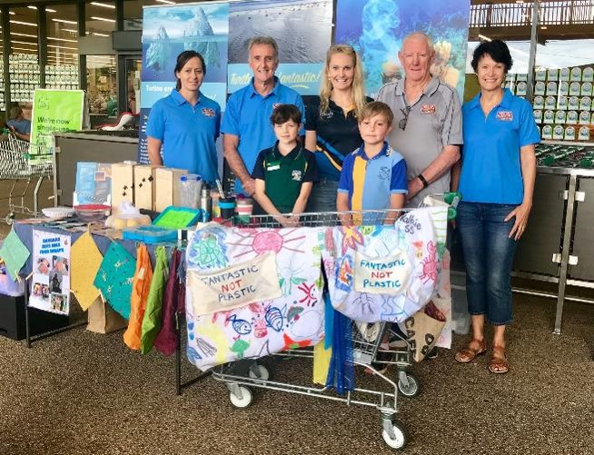

CASE STUDY

Delivering Port actions in partnership

The ports sector has been an active partner since the development of the Great Barrier Reef Strategic Assessment and Reef 2050 Plan. Ports have implemented a range of actions as part of a substantial reform agenda over the last five years.

Following consultation with ports and other stakeholders, the Queensland Government enacted the *Sustainable Ports Development Act 2015* to deliver a legislative framework to protect the Great Barrier Reef and manage port development. In addition, the Great Barrier Reef Marine Park Authority worked with ports to amend the *Great Barrier Reef Marine Park Regulations 1983* to ensure a consistent approach to some of the key port related actions in the Reef 2050 Plan.

Port-related actions delivered by stakeholders working together include:

* [Queensland Maintenance Dredging Strategy](https://www.tmr.qld.gov.au/business-industry/Transport-sectors/Ports/Dredging/Maintenance-dredging-strategy) which provides a framework for the sustainable, leading practice management of maintenance dredging at ports.
* [Guidelines for Long-term Maintenance Dredging Management Plans (LMDMPs)](https://www.tmr.qld.gov.au/business-industry/Transport-sectors/Ports/Dredging/Maintenance-dredging-strategy/Guidelines-for-long-term-maintenance-dredging-management-plans) which are used by ports to develop their LMDMPs in consultation with key stakeholders. The guidelines will be finalised for all Great Barrier Reef ports by the end of December 2018.

The ports sector worked together to produce:

* [Sediments and Dredging at Great Barrier Reef Ports](https://nqbp.com.au/sustainability/research-and-reports/sediments-dredging-gbr-ports) to place port-related sediment into context with other local and regional sources of sediment in the Great Barrier Reef. The report was developed in consultation with researchers, sediment specialists and key interest groups.
* [Ports Australia Dredging Code of Practice](http://www.portsaustralia.com.au/assets/Uploads/Ports-Australia-Dredging-Code-of-Practice.pdf) which establishes environmental principles that Australian ports follow when undertaking dredging and when reusing, relocating or disposing of dredged material.

Ports sector ambient environmental monitoring programs are being embedded in the [Reef 2050 Integrated Monitoring and Reporting Program](http://www.gbrmpa.gov.au/managing-the-reef/reef-integrated-monitoring-and-reporting-program) and regional water quality partnerships at [Mackay-Whitsunday](https://healthyriverstoreef.org.au/), [Townsville](https://drytropicshealthywaters.org/), [Gladstone](http://ghhp.org.au/) and [Cairns](https://wettropicswaterways.org.au/report-card-2018/inshore/inshoresouth/).

Stakeholders, regulators and the ports sector are continuing to work together to deliver [master plans for the priority ports of Townsville, Gladstone, Abbot Point and Hay Point/Mackay](https://www.tmr.qld.gov.au/business-industry/Transport-sectors/Ports/Sustainable-port-development-and-operation/Master-planning-for-priority-ports). Master planning will ensure the Outstanding Universal Value of the Great Barrier Reef World Heritage Area is an intrinsic consideration in future port development, management and governance.

October 2018

* The Queensland Government announced additional investment in agricultural best management practice programs with $6 million for cane growers and $1.95 million for horticulture growers.
* The Australian Institute of Marine Science (AIMS) released the AIMS Strategy 2025 which will guide research and development priorities for the next seven years. The Strategy is linked to AIMS’ responsibilities in the Reef 2050 Plan.

CASE STUDY

Joint Field Management Program

The Joint Field Management Program is a cooperative partnership that is jointly funded by the Australian and Queensland governments to deliver operational and day-to-day management in the Marine Parks and on national park islands. The Joint Field Management Program’s core activities include delivering conservation actions, monitoring ecological and heritage values, responding to incidents, educating and engaging with users, and upholding compliance.

As a result of the additional funding received in 2018, the Joint Field Management Program has enhanced compliance efforts through an increased on-water presence, targeted compliance programs in identified hotspots for illegal fishing, introduced new technology (such as drones), invested in new and improved vessels, and supported the Queensland Government’s program to expand commercial fishing vessel tracking.

In 2018, the Joint Field Management Program delivered direct conservation actions to improve the condition of the Reef including vulnerable green turtle recovery activities at Raine Island, pest and fire management, and Reef intervention projects. Field staff also undertook vital monitoring of ecological and heritage values of the Reef including seagrass monitoring, island health checks, Reef health assessments, cultural heritage inspections, turtle monitoring, crown-of-thorns starfish surveys and bird monitoring. The Joint Field Management Program has increased its crown-of-thorns starfish surveillance to inform control activity, which is critically important in protecting coral cover. New island and marine infrastructure was also installed in 2018.

November 2018

* The Australian Government’s National Environmental Science Program (NESP) supported the inaugural Innovative Nitrogen Use in Sugarcane Forum in Cairns. The Forum brought together growers, scientists and industry to discuss work and research on nitrogen with a focus on sugarcane productivity, profitability and Reef water quality. The event included discussions on a new smartphone app, developed by CSIRO in partnership with the NESP Tropical Water Quality Hub, that will allow farmers to see the effects of their practice decisions on Great Barrier Reef water quality in real-time.
* The third annual water quality synthesis workshop, held in Yeppoon, brought science, policy and on-ground management together to discuss opportunities for collective impact and building momentum for implementing the Reef 2050 Water Quality Improvement Plan.

Next steps

Changes to the Reef 2050 Plan

In July 2018, an updated Reef 2050 Plan was released in response to the findings of the mid-term review and impacts to the Reef from coral bleaching and extreme weather events in 2016 and 2017. The total number of actions in the revised Reef 2050 Plan is now at 70, still split across seven themes: ecosystem health, biodiversity, heritage, water quality, community benefits, economic benefits and governance. New actions include trialling new approaches and technologies to build resilience, initiatives to intensify crown-of-thorns starfish control, strengthening compliance, enhanced protection for key species, testing and deploying materials for Reef restoration, and identifying knowledge gaps.

The focus remains on improving water quality as a key component of enhancing Reef resilience and recovery capacity. At the centre of the Reef Trust’s partnership with the Great Barrier Reef Foundation is $201 million for improving water quality. Significant work to improve the quality of water flowing to the Reef is also being funded through the Australian Government’s Reef Trust and the Queensland Reef Water Quality Program. Local governments are also developing major integrated projects to deliver a coordinated approach across councils to address the quality of water quality entering the Reef. Outcomes from the National Environmental Science Program’s Tropical Water Quality Hub will continue to inform solutions to improve tropical water in the Reef catchment.

Other new actions focus on activities to inform the comprehensive review of the Reef 2050 Plan scheduled for 2020, including undertaking research on climate change trajectories and revising the Plan's structure.

The lead agencies responsible for Reef 2050 Plan actions provide an update on progress every six months. This information is available on the Department of the Environment and Energy’s Monitoring Evaluation Reporting and Improvement Tool (MERIT) website: <https://fieldcapture.ala.org.au/explore/dashboard/reef2050>. The next Reef 2050 Plan progress report will detail progress against the revised Reef 2050 Plan actions for the period July to December 2018.

2020 Comprehensive Review

The Reef 2050 Plan is reviewed and updated every five years, taking into account new information about the Reef environment and the effectiveness of management interventions. As part of the review, the targets, objectives and overall effectiveness of the Plan will be evaluated, with the exception of the water quality targets which were updated during the mid-term review to align with the Reef 2050 Water Quality Improvement Plan. Continued input and advice from the Reef 2050 Advisory Committee, Independent Expert Panel, Traditional Owners, science and industry stakeholders, and the wider community will be integral to the implementation of the Plan. The overall structure will also be reviewed to ensure that actions are appropriate to achieve the desired outcomes.

The 2020 review will be informed by a number of major reports including the 2019 *Great Barrier Reef Outlook Report*, currently due to be tabled in Federal Parliament by September 2019, and *State of Conservation* report to the World Heritage Committee due on 1 December 2019. The *Reef 2050 Plan Investment Framework*, a critical document which guides investment decisions, will also be reviewed.

Great Barrier Reef Foundation Partnership

Efforts to meet the Reef 2050 Plan targets will be strengthened through the Australian Government’s Reef Trust $443.3 million partnership with the Great Barrier Reef Foundation. The Foundation will invest in Reef protection activities over six years to support work underway through the Reef 2050 Plan. The Foundation is proposing to commit up to $25 million for foundational Project Component activities to be delivered across 2018-19 and 2019-20. It has also commenced a detailed planning and design process to deliver funds to a range of partners with Reef protection experience, as well as drive new capacity and partnerships for the Reef. Funds for major projects are expected to flow from 2019.

The funding must be delivered in line with the Reef Trust objectives of improving water quality, restoring coastal ecosystem health and enhancing species protection in the Great Barrier Reef region. Activities will include water quality improvements; reef restoration, resilience and adaptation; measures to fight coral-eating crown-of-thorns starfish; enhanced monitoring and reporting; and community engagement including Indigenous sea country management, coastal clean-up days and awareness raising activities. Add: Further information is available at: <https://www.barrierreef.org/science-with-impact/reef-partnership>.

Reef 2050 Integrated Monitoring and Reporting Program Design

Implementing the Reef 2050 Plan will be informed by an integrated ecological, social and economic monitoring and reporting program. The Reef 2050 Integrated Monitoring and Reporting Program will measure and report on progress towards achieving the outcomes, objectives and targets in the Reef 2050 Plan and guide adaptive management of the Reef and adjacent catchment.

More than 90 monitoring programs operate in the Great Barrier Reef World Heritage Area and adjacent catchment. The intent of the Reef 2050 Integrated Monitoring and Reporting Program is not to duplicate existing arrangements, but to coordinate and integrate monitoring, modelling and reporting programs across disciplines. A fully costed program design for the Reef 2050 Integrated Monitoring and Reporting Program is expected to be completed by mid-2019.