

**Reef 2050 Plan**

Investment Framework

© Copyright Commonwealth of Australia, 2016.

*Reef 2050 Plan—Investment Framework* is licensed by the Commonwealth of Australia for use under a Creative Commons Attribution 4.0 Australia licence with the exception   
of the Coat of Arms of the Commonwealth of Australia, the logo of the agency responsible for publishing the report, content supplied by third parties, and any images depicting people.   
For licence conditions see: https://creativecommons.org/licenses/by/4.0/

This report should be attributed as ‘*Reef 2050 Plan—Investment Framework, Commonwealth of Australia 2016*’.

The Commonwealth of Australia has made all reasonable efforts to identify content supplied by third parties using the following format ‘© Copyright, [name of third party]’.

The views and opinions expressed in this publication are those of the authors and do not necessarily reflect those of the Australian Government or the Minister for the Environment   
and Energy.

While reasonable efforts have been made to ensure that the contents of this publication are factually correct, the Commonwealth does not accept responsibility for the accuracy or completeness of the contents, and shall not be liable for any loss or damage that may be occasioned directly or indirectly through the use of, or reliance on, the contents of this publication.

Aboriginal and Torres Strait Islander peoples are the Traditional Owners of the Great Barrier Reef area and have a continuing connection to their land and sea country.

# Preface

The Australian and Queensland governments developed the *Reef 2050 Long-Term Sustainability Plan* in partnership with stakeholders to respond to pressures affecting the Great Barrier Reef. Released in March 2015, the Reef 2050 Plan is a shared blueprint for improving the long-term health and resilience of the Reef. It outlines actions and targets which will be reviewed on a five-yearly basis as part of an adaptive management approach to protecting the Reef.

The Reef 2050 Plan states that implementation will be underpinned by a robust investment framework that:

1. establishes current investments in Reef protection

2. determines investment priorities for the future

3. sets out a strategy for boosting investment and diversifying its sources.

This Investment Framework delivers on that commitment. Its application is two-fold and expressed explicitly throughout this document:

• **The approach** sets out how to implement these steps in future as part of the Reef’s adaptive management cycle.

• **The results** shows the results of the application of the approach for the current Reef 2050 Plan actions (2015–2020).

For the Australian and Queensland governments, the Framework will be used to channel new investment toward identified priorities, and to inform the use of regulatory and policy levers that, along with investment, are critical tools to support the achievement of these priorities. For the private sector, the Framework identifies partnership opportunities and strategies for their involvement.

An investment baseline developed in 2015 identified that the Australian and Queensland governments were projected to jointly invest more than $2 billion over the next ten years to protect the Reef. This Investment Framework shows that across governments, industry and the community, more than $1.28 billion has *already* been committed for the next five years focused solely on delivering actions in the Reef 2050 Plan.

This figure is conservative, as it takes into account only committed direct investment in Reef 2050 Plan actions. It does not take into account investments that do not directly link to a Reef 2050 Plan action—for example the Clean Energy Finance Corporation’s $1 billion Reef Fund is not included, nor are investments to meet regulatory requirements. Over time, as Reef Fund projects are identified and implemented, they are expected to make a significant contribution towards achieving the objectives of the Reef 2050 Plan.

The analysis underpinning the Investment Framework revealed unmet funding needs. Recognising the long-term and ambitious nature of the Reef 2050 Plan, prioritisation is essential to ensure that resourcing focuses on actions that will make the biggest contribution to improving Reef resilience. The active engagement of Traditional Owners, scientists, community and industry in the Great Barrier Reef and its catchments is important to ensure joint ownership of the priorities. The stakeholder focused Reef 2050 Advisory Committee and the science focused Independent Expert Panel made important contributions to identifying the most important actions for further investment.

A key focus of the Framework is boosting and diversifying sources of investment. This focus is complemented by efforts to reduce the cost of implementing higher-cost actions. While government is currently the biggest investor in Reef health, the innovation and commitment of the private sector has a key role to play. The Investment Framework explores ways that government funding can be used as a catalyst for additional private and philanthropic investment. A Reef Trust Innovative Financial Mechanisms Panel of experts from the philanthropic and investment sectors was established to consider conservation financing options through which government funds are used to leverage new investment. This approach is strongly aligned with current global trends in conservation financing.

Just like the Reef 2050 Plan, the Investment Framework is not an end point. As time goes on, new priorities and issues will require responses. This Investment Framework provides a methodology to identify future funding needs and investment priorities, and to guide investment towards actions that will have the greatest impact. The Framework will continue to be improved upon and will form a key part of the five-yearly adaptive management cycle of the Reef 2050 Plan.

Table of Contents

Preface 2

Overview 4

Overview of the Investment Framework 4

Overview of results for current Reef 2050 Plan actions (2015–2020) 5

1. Establishing existing investment 9

The approach 9

The results for 2015–2020 10

2. Determine future investment priorities 13

The approach 13

The results for 2015–2020 13

3. Strategies to boost funding 15

The approach 15

The results for 2015–2020 16

Next Steps— Adaptive Management 18

The approach 18

The results for 2015–2020 19

Appendix A: Six Priority Areas for investment 20

Appendix B: Prioritisation template 2015 34

Glossary of terms 36

# Overview

## Overview of the Investment Framework

This Investment Framework has been developed to guide investment decisions for the delivery of Reef 2050 Plan actions. This approach is designed to be repeated as part of the Reef 2050 Plan’s five-yearly adaptive management cycle, when new Reef 2050 Plan actions are developed.

The Investment Framework comprises three phases:

1. establish existing investment

2. determine investment priorities for the future

3. identify strategies for boosting investment.

The Investment Framework approach focuses solely on the investments that directly support implementation of Reef 2050 Plan actions. Looking at investment from the level of individual actions is important, as actions are the stepping stones to reaching the Reef 2050 Plan’s targets, objectives, outcomes and vision. 

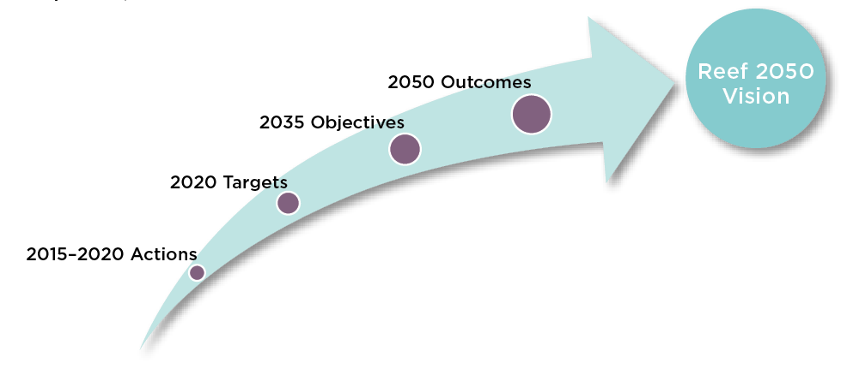

The development of the Investment Framework itself is an action that contributes to the Reef 2050 Vision.

Development of the Investment Framework is required under governance action GA13: Develop an investment baseline and associated investment framework to inform future delivery of actions under the plan.  
This action relates to the 2020 target GT4: investment in action prioritised using evidence-based risk assessment to maximise benefits for Reef Health and resilience.
This links to the 2035 objective GO2: this Plan guides decisions about the Reef made by governments, industry and the community.

### Investment Principles

Future investment decisions regarding the delivery of actions will be guided by the identified priorities and the investment principles outlined in the Reef 2050 Plan:

1. Additionality and complementarity—investments will build on and align with existing efforts.

2. Clear outcomes—investments are focused on delivering results to achieve Plan outcomes.

3. Cost-effectiveness—investments will be well-planned and cost-effective.

4. Collaboration and partnerships—investments will consider opportunities for co-investment, strategic collaborations and partnerships.

5. Evidence-based and scientifically robust—investments will be informed by the best available scientific and expert knowledge.

In the past, decisions around additional investment have generally been made to address specific risks and pressures, in the absence of an overarching agreed framework or priority list. While collaboration between governments and private organisations has occurred in some cases, working towards a shared vision is preferred. This approach enables all investment to be directed to delivering those actions with anticipated high returns on investment for Reef health.

## Overview of results for current Reef 2050 Plan actions (2015–2020)

The chart below provides an overview of results from the application of this approach to the current set of Reef 2050 Plan actions. The overview shows there is a high level of investment in the actions, the identified gaps and priority areas and the strategies to boost and diversify investment that were identified.

1—Establish existing investment
Current committed investment in specific Reef 2050 Plan actions over the next five years
$1.28 billion investment
2 —Determine future investment priorities
Six priority areas identified for future investment
Reef Water Quality Protection Plan actions
Field Management Program actions
Reef 2050 Integrated Monitoring and Reporting Program actions
Crown-of-thorns starfish control
actions
Traditional Owner actions
Fisheries actions

3 —Strategies to boost funding
Examples of sources  of future investment 
Private investment
Philanthropic investment
Australian Government, e.g.:
• CEFC Reef Fund
• Reef Trust
• National Landcare Program
• National Environmental Science Program
Queensland Government, e.g.:
• Queensland Reef Water Quality Program
• Queensland Natural Resource Management Program
• Reef Water Quality Science Program
Examples of strategies  for future investment
Revisiting traditional funding mechanisms
Fostering private and philanthropic partnerships
Developing conservation  finance projects
Using regulatory  and policy levers  to direct  investments
Tapping into  non-financial resourcing
Seeking  co-benefits though complimentary funding sources
Investing in innovation to reduce funding needs

*Figure 1: Key results from the three phases of the Investment Framework for 2015–2020.*

The below table provides an overview of the established funding by source and by the six priority areas. It shows that the majority of funding is already directed towards the priority areas identified.

|  |  |  |  |  |  |  |  |  |
| --- | --- | --- | --- | --- | --- | --- | --- | --- |
|  | **Reef Water Quality Protection Plan**  **(14 actions)** | **Field Management Program**  **(16 actions)** | **Reef 2050 Integrated Monitoring and Reporting**  **(16 actions)** | **Crown-of-thorns starfish control (1 action)** | **Traditional Owner**  **(23 actions)** | **Fisheries**  **(5 actions)** | **Other Reef 2050 actions**  **(76 actions)** | **Total**  **(151 actions)** |
| Australian Government | $212.4 m | $48.1 m | $62.0 m | $10.8 m | $39.4 m | $   - | $343.9 m | $716.6 m |
| Queensland Government | $272.0 m | $41.9 m | $2.5 m | $1.0 m | $23.6 m | $31.9 m | $36.2 m | $409.1 m |
| Other investment | $65.8 m | $5.5 m | $6.7 m | $1.6 m | $1.9 m | $   - | $79.7 m | $161.2 m |
| **Total investment** | **$550.2 m** | **$95.4 m** | **$71.2 m** | **$13.4 m** | **$64.9 m** | **$31.9 m** | **$459.9 m** | **$1,286.8 m** |

*Table 1: overview of current investment in Reef 2050 actions over the next five years.*

Funding needs have been identified for these six priority areas, with the total estimated funding needs ranging from $143 million to $408 million. These funding needs are based on estimations from the lead agencies responsible for delivering the actions and do not represent a comprehensive costings exercise. However, they are useful to guide future decision making by providing a broad sense of funding needs. Strategies have been identified to address these needs including additional government funding (e.g. $95 million still to be assigned to Reef 2050 actions under the National Landcare Program), innovative financing options (e.g. $1 billion under the Clean Energy Finance Corporation’s Reef Fund) and non-financial funding options (e.g. regulatory and policy solutions). **Appendix A** examines the six priority areas in detail.

|  |  |  |  |  |  |  |
| --- | --- | --- | --- | --- | --- | --- |
|  | **Reef Water Quality Protection Plan** | **Field Management Program** | **Reef 2050 Integrated Monitoring and Reporting** | **Crown-of-thorns starfish control** | **Traditional Owner** | **Fisheries** |
| Estimated funding needs | $33–123  million | $41–92  million | $48–$157  million | $10–20 million | $6 – $? million | $5–10  million |

*Table 2: overview of estimated funding gap for the six priority areas for the next five years. Due to the large volume of actions unable to be quantified for the Traditional Owner actions, an upper limit could not be reasonably estimated.*

|  |
| --- |
| The Queensland Water Science Taskforce Costing Report |
| Queensland’s Great Barrier Reef Water Science Taskforce engaged a consortium of experts to estimate the likely costs of achieving water quality targets for nitrogen and sediment. This work was delivered in July 2016 and was done through an assessment of seven policy solutions that considered how much reduction they could achieve and at what cost. The policy solutions investigated were: land management practice change for cane and grazing; improved irrigation practices; gully remediation; streambank repair; wetland construction; changes to land use; and, improved urban stormwater management. Not all catchments were included in the exercise.  The result was a useful tool for examining the possible ways of reaching the ambitious water quality targets through financial investment alone. The costing report identified that the 2025 water quality targets could be reached by investing in projects worth $8.2 billion. However, the report noted that its utility was not in this headline figure, but in the examining of relative costs of the various actions. The peer review of the report recognised that the $8.2 billion figure included some very expensive, high risk actions that the reviewers did not believe to be practical or affordable. For example, $5.6 billion of that figure is associated with just one abatement action (gully remediation) in one catchment (the Fitzroy Basin). Most importantly, the modelling suggested that 50 per cent of the 2025 targets could be achieved with investment of $623 million.  The costings report demonstrates that there is a suite of effective, lower cost actions which can be pursued immediately and will make a significant contribution to the health and resilience of the Great Barrier Reef. These actions align with $573 million of investment committed by the Australian and Queensland governments and their partners over the next five years in water quality actions. The diminishing return on investment for the more expensive interventions makes these options impractical to implement at this time. The costing report affirms we are pursuing effective measures to make immediate gains on water quality. |

# 1. Establishing existing investment

## The approach

This phase of the Investment Framework involves identifying existing direct investments for Reef 2050 Plan actions. It requires working with lead reporting agencies and organisations to estimate the cost of full implementation of each action, while acknowledging there may be uncertainty in estimating such costs.

### Develop shared understanding of the Reef 2050 Plan actions

Ensuring there is a shared understanding of the Reef 2050 actions is critical: if the intent of an action is not understood, determining resourcing required for that action is difficult. This can be resolved by working with lead agencies and partners to develop a more detailed description of the action, and outline key performance indicators for what successful implementation of the action looks like.

### Approach all sources of investment

With a shared understanding of the actions established, as many sources as possible should be approached to provide investment data, including all levels of government, industries, community groups and philanthropic organisations. This investment data should be allocated at an action-by-action level across the five years. Not all investment will be able to be assigned to actions, especially investment in core activities and operations, and investment may need to be split across actions if it contributes to the delivery of multiple commitments.

Not all sources or organisations will be able to comprehensively assign future funding commitments; this will be dependent on the length and stage of the budgetary cycles these sources operate within.

### Work with lead agencies to estimate funding needs

Identification of funding gaps allows partners to plan and work towards meeting future funding needs. Determining gaps should be done with lead reporting agencies, who should be tasked with providing best estimates for full implementation of the action. Estimates are made with the best available knowledge and represent a point in time assessment based on current technology and methods. Identified gaps should be classified using consistent funding ranges, for example:

• No gap: $0

• Low: Less than $1 million

• Low- Medium: $1 million to $5 million

• Medium: $5 million to $10 million

• Medium-High: $10 million to $20 million

• High: $20 million to $100 million

### Acknowledge unknowns

If an action is closely related to another action, it may be more efficient to group those actions for the purpose of estimating funding needs.

It may not be possible to adequately quantify funding needs for all actions at the time of updating the Investment Framework. Preceding work further consultation may need to occur (for example, management arrangements may need to be reviewed or developed before the costs of implementing the commitment can be estimated). It is important to acknowledge where funding needs could not be identified.

### Manage data integrity

Commercial-in-confidence data gathered through this phase must be protected by the organisation undertaking the work. The data should be cross-checked to ensure that no double counting has occurred across different sources. A protected database that records all relevant information should be maintained for future reference.

Investments by private organisations to meet regulatory requirements should not be treated as investment in delivery of Reef 2050 Plan actions. It is important to acknowledge an increased cost to industries and organisations, especially as a result of regulatory changes, although this is considered as a cost of operating and not an additional investment designed to benefit the Reef.

## The results for 2015–2020

The task of establishing existing investment was complex: this is the first time an exercise of this nature has been conducted for the Reef. Two processes were undertaken to help establish existing investment at macro and micro levels.

An initial investment baseline was established to build a ‘top-down’ picture of Reef investment. Released in June 2015, the ‘Reef 2050 Plan—Investment Baseline’ identified approximate investment for 2014-15 financial year at a broad, organisational level. The Investment Baseline showed that in 2014-15, over $485 million was invested in the Great Barrier Reef, with $215.4 million from the Australian and Queensland governments and $270.2 million from other sources. This investment supported a variety of activities across management, research, regulatory expenditure and on-ground delivery and was not specifically linked to Reef 2050 Plan actions.

Following this initial investment baseline process, the Australian and Queensland governments jointly approached over 100 government and non-government organisations to build a picture of current and predicted investment specifically mapped to Reef 2050 Plan actions.

This process identified over $1.28 billion is being invested in the Reef 2050 Plan actions, over the next five years across all sectors. This includes $716 million from the Australian Government, $409 million from the Queensland Government and $161 million from other sources. Local Government, private and philanthropic investment in the Reef is likely to be higher than this estimated figure, but these sectors are often unable to forecast future funding.

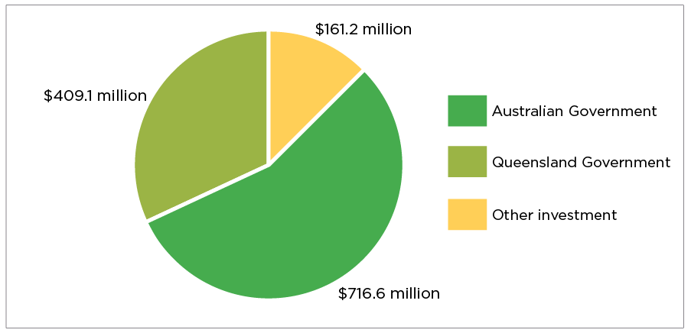

*Figure 2: shows the source of $1.28 billion in funding for the next five years*

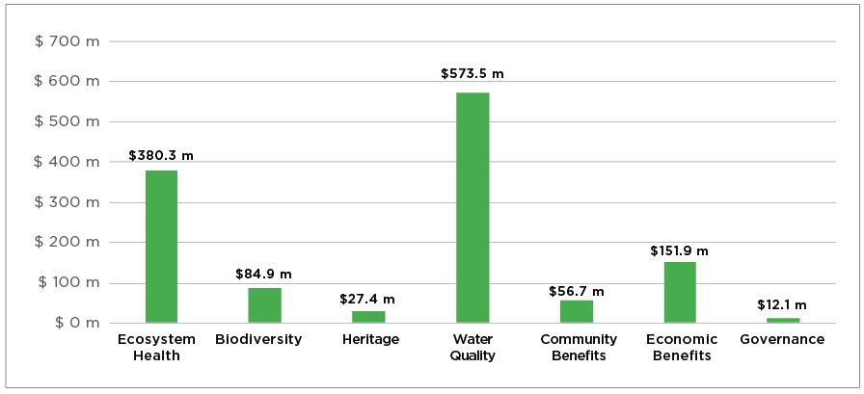

*Figure 3: shows the $1.28 billion in funding by Reef 2050 theme for the next five years*

The bulk of investment is being directed towards one of the biggest threats to the Reef, with $573.5 million allocated to actions to improve water quality. $380.3 million is being invested in ecosystem health actions which recognises the importance of ensuring the integrity of the Reef’s systems. Comparatively, the actions under the governance and heritage themes have much lower levels of investment. For heritage, this reflects that there are few actions within this theme and they relate specifically to historic and cultural heritage. The Reef 2050 Plan is built on the principle that all seven of the themes together contribute to protection of the Reef's natural heritage, including its Outstanding Universal Value and the Reef's natural and cultural heritage is intrinsically linked.

Lead agencies undertook a process to estimate how much funding would be required to fully implement each Reef 2050 action. The results show that 33 actions are already fully funded. This includes actions like reviewing and updating the Reef Water Quality Protection Plan and implementing actions to limit the impact of ports and dredging. 32 actions have a low gap, and very few actions—only nine—are allocated as high or medium-high gaps. 39 actions were unable to be quantified due to reasons outlined below.

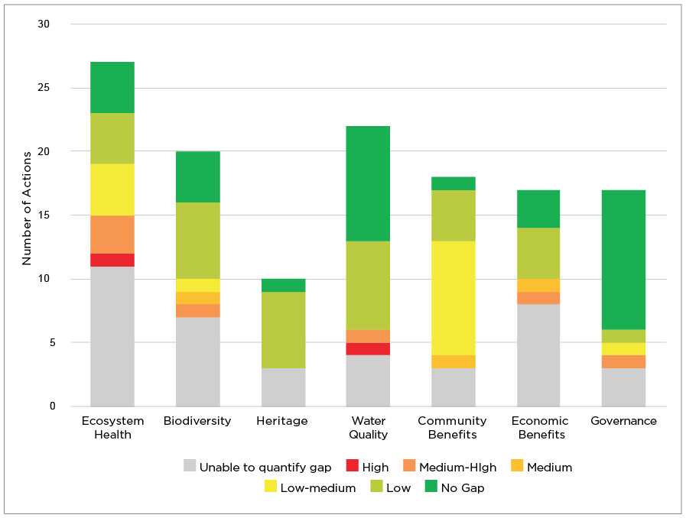

*Figure 4: shows the quantified funding needs across the seven Reef 2050 Plan themes.*

The number of gaps identified, and the quantum of funding estimated to be needed, has highlighted some challenges and opportunities to improve the way investment decisions are made. Estimates were largely made by lead agencies in isolation and were not developed using consistent methods. Delivery of some actions will also contribute to other actions and the funding needs identified did not always account for that. These findings will be used to inform how estimations will be developed in future revisions of the Framework.

At its August 2016 meeting, the Reef 2050 Advisory Committee acknowledged the complexities and challenges of costing the Reef 2050 actions and agreed that future reviews of the Reef 2050 Plan should aim to consolidate some actions and present commitments in a consistent, achievable and measurable format. This will lead to major improvements in the way current investment and funding needs can be mapped.

|  |
| --- |
| Why some gaps couldn’t be quantified |
| Funding needs were not able to be quantified for 39 of the 151 actions. Some actions are straightforward and easily measured, others are more complex. Multiple components Some actions include multiple components that are sequenced. For example action BA7 requires both the development of the National Vessel Strike Strategy, as well as the implementation of that strategy. It is not possible to cost the implementation of a strategy before the strategy is written. Consultation required Some actions can be implemented in different ways and require more consultation to determine the best avenue for implementation. Many of the Traditional Owner actions are unquantified for this reason. Ongoing objectives Some actions are more like ongoing objectives which are likely to have fluctuating investment needs over time. Examples include:  *CBA4: Ensure the impact on Reef health and resilience is considered in planning and developing coastal hazard responses to ensure negative impacts are avoided then mitigated.*  *GA14: Develop, implement and maintain mechanisms and policies to enhance investment in delivering on-ground activities based on good science and evidence that support the Plan’s outcomes and targets.* |

# 2. Determine future investment priorities

## The approach

### Draw on science, community and industry advice at all stages of prioritisation

Prioritisation is a critical part of the Investment Framework to ensure that each dollar spent attracts the biggest return for the Reef. It is a practical step that recognises that all actions cannot be implemented simultaneously and that not all actions are of equal importance in terms of delivery of environmental outcomes for the Reef. As the key advisory bodies under the Reef 2050 Plan, the Reef 2050 Advisory Committee and Independent Expert Panel advise on prioritisation to ensure that everyone who makes investment decisions can be confident they will provide the greatest return on investment for Reef health, and priority actions have support and ownership by key experts and Reef users.

### Sequence all Reef 2050 Plan actions

An initial prioritisation process should be undertaken that considers the full suite of Reef 2050 Plan actions. This will inform the sequencing of implementation across the five year implementation timeframe and will influence later prioritisation processes. Consistent classifications should be used, for example:

• Immediate priorities—to commence within first 18 months

• Medium priorities—to commence within first 30 months

• Future priorities—to commence within period of the plan

This should be guided by the process set out on page 60 of the Reef 2050 Plan, which requires the consideration of:

• Key threats identified in the most recent Great Barrier Reef Outlook Report.

• Best available science, and the feasibility or likelihood that actions can be carried out under current conditions.

• Timeframes for implementation and the objectives and targets the actions will contribute to.

• Relationships between actions and possible groupings to deliver the best outcome.

• Complementary benefits these actions will deliver.

• How the outcomes of the prioritisation process are best integrated into implementation plans.

• Capacity of implementing agencies, organisations and industries.

• Expected timeframes for benefits to be realised.

### Identify priorities for future funding

Once the sequencing and investment levels have been ascertained, all immediate priority actions should be reviewed comparatively in consultation with the Reef 2050 Advisory Committee and Independent Expert Panel to identify and agree priorities for future funding or alternative methods of achieving results. Focus is expected to be on immediate priorities as they will inform or contribute to the delivery of longer-term actions.

### Group priority actions and related actions into implementable priority areas for investment

Linkages between the priority actions should be drawn, where possible, to group ‘like with like’ actions into implementable priority areas for investment.

## The results for 2015–2020

To identify the most crucial funding needs, a number of prioritisation processes were used based on lead agency data and information from stakeholders and advisory bodies. Through a series of meetings and workshops, the Reef 2050 Advisory Committee and the Independent Expert Panel played a key role in identifying funding priorities.

The first focus of the workshops and meetings was to agree sequencing for all 151 actions, using the criteria outlined in **Appendix B**. The template was based on the considerations for prioritisation from the Reef 2050 Plan and prepared with input by the Reef 2050 Advisory Committee and the Independent Expert Panel.

The results show that the majority of actions— 97 of 151 —were classed as needing to be undertaken in the immediate term:     62 were allocated as already prioritised 
  35 were allocated as immediate priority
  27 were allocated as medium priority 
   27 were allocated as future priority
Already prioritised = Already completed, or fully funded and clear timeframes for delivery 
Immediate Priority = Implementation to commence by December 2016 
Medium Priority = Implementation to commence by June 2018
Future Priority = Implementation to commence by June 2020

Most of the actions in the water quality, governance and ecosystem health themes were identified as already prioritised or immediate priorities.

The next step in the prioritisation process involved examining the group of actions which were allocated as immediate priorities through the sequencing process, and that were also allocated as partially funded or unfunded through a gap analysis.

The Reef 2050 Advisory Committee and Independent Expert Panel worked with government agencies to identify the most critical actions requiring investment. Emphasis was placed on actions that would have the greatest return on investment for Reef health.

Six priority areas were identified:

• Reef Water Quality Protection Plan actions

• Field Management Program actions

• Reef 2050 Integrated Monitoring and Reporting Program actions

• Crown-of-thorns starfish control action

• Traditional Owner actions

• Fisheries actions.

Each of these priorities is associated with a single action but most of them also encompass other sub or similar actions to form programs of work. **Appendix A** examines these priority areas in further detail, outlining the known investment for these groupings, priorities for funding and strategies to address them.

# 3. Strategies to boost funding

## The approach

The third phase of the Investment Framework focuses on identifying and developing a range of strategies to boost and diversify investment.

Seeking expert advice is key to the development of new strategies. Advice from Traditional Owners, science, industry, community and the financial sector should be sought to explore options and models for diversification of funding sources and discuss details on how options could be delivered. Strategies should be considered across the following categories.

### Revisiting traditional funding mechanisms

Traditional funding mechanisms like government programs and non-government initiatives can be used to boost funding for priority areas. When opportunities to review funding allocations arise, organisations should draw on expert advice and best available science to determine whether funding is going to the top priorities and, if it could be reallocated to other identified priorities.

### Fostering private and philanthropic partnerships

Fostering partnerships is a key strategy to boosting investment, and this can be encouraged through a number of approaches. Pooling resources across organisations or sectors to scale-up projects is a straightforward option. Mechanisms like dollar-matching schemes can be used to leverage further funding by providing incentive to invest. Co-funding models provide opportunities for a range of organisations to work together to co-fund work on priority actions. Crowd sourcing and financial donations draw together micro-finance from a large volume of partners. This approach is suitable for smaller, tangible projects which are attractive to a broad range of people or suitable for local action.

### Developing conservation finance projects

Currently, market conditions indicate that significant private investment capital is available for conservation; international institutional investors are estimated to hold some $80-90 trillion in assets. There are many investors who are interested in investing in conservation if it can generate reasonable financial returns. Developing conservation finance projects that can provide outcomes for the Reef and make a financial return for investors could unlock some of this available capital investment.

### Using regulatory and policy levers to direct investment

Governments can use regulation and policy to raise standards and direct existing funding to priority areas. This might be in the form of changing legislation or increasing compliance effort to improve standards and drive practice change, introducing, reviewing or increasing levies to generate further funding, or brokering joint policies across government and with the private sector to agree to new ways of operating that benefit the Reef.

### Tapping into non-financial resourcing

Some actions lend themselves to being supplemented by in-kind contributions. Donating access to assets free of charge is one option. This might include in-kind contributions such as boat time to undertake survey work or heavy machinery for gully remediation. Developing and utilising citizen science programs can provide the opportunity to involve communities and partners whilst gathering critical knowledge and information. Citizen science can draw on the knowledge of Reef visitors to make field observations either on their own or through organised community events like Reef Blitz. People who have never visited the Reef can also be involved in citizen science through web platforms which utilise gaming technology to enable users to analyse or verify scientific data.

### Seeking co-benefits through complementary funding sources

There are a number of existing social, environmental and economic funding programs which can be accessed to deliver Reef 2050 actions. For example, infrastructure upgrade projects like road upgrades can be targeted at unsealed roads in Reef catchments, which would reduce sediment running into the Reef. Projects to restore vegetation and habitat can be focused toward Reef catchment areas. Projects designed to support community groups, including Aboriginal and Torres Strait Islander groups, could be aimed at those delivering Reef 2050 actions and benefits to the Reef.

### Investing in innovation to reduce funding needs

In addition to growing overall investments and resources, the Investment Framework examines ways to reduce implementation costs by investing in innovation and better coordination. This can be achieved by investing in research and developing new technologies to find more cost effective and efficient implementation methods. Looking at ways to improve coordination and create efficiencies in the delivery of Reef 2050 actions is another option that requires no further investment to implement.

## The results for 2015–2020

The Australian Government has established a Reef Trust Innovative Financial Mechanisms Panel with experts from leading financial and philanthropic organisations to discuss conservation financing mechanisms which could be piloted for the Great Barrier Reef. Expert advice was sought from the Panel to explore strategies to boost funding and provide input into the development of strategies. The Independent Expert Panel and Reef 2050 Advisory Committee provided advice on matching appropriate strategies to each of the six identified priority areas.

A number of primary sources of investment were identified, which could be drawn on to fund priority areas. These include:

• private investment

• philanthropic investment

• Australian Government investment through:

– CEFC Reef Fund

– Reef Trust

– National Landcare Program

– National Environmental Science Program

• Queensland Government investment.

**Appendix A** examines these priority areas in further detail, outlining the known investment for these groupings, the known funding gaps and appropriate strategies to boost and diversify investment to address them.

|  |
| --- |
| Strategies in Action |
| Since the release of the Reef 2050 Plan, the Australian and Queensland governments have been exploring and testing options for boosting and diversifying funding for Reef activities. |
| Using regulatory and policy levers to direct investment ***Making good practice standard practice in the dredging industry***  Changes to the *Great Barrier Reef Marine Park Regulations 1983* and introduction of Queensland’s *Sustainable Ports Development Act 2015* have significantly strengthened standards and practices relating to dredging at Great Barrier Reef ports. The legislation has restricted capital dredging to the four major existing ports, banned the disposal of capital dredge spoil within the Great Barrier Reef World Heritage Area, and mandated the development of master plans for all four priority ports.  While many ports were already operating at best practice, the introduction of the new legislation now compels all ports to adhere to the same higher standards and practices. The costs of meeting these requirements is largely borne by the ports industry. Initial estimates from the ports sector suggest that the decision to bring dredge material onshore would substantially increase the cost of each new capital dredging project. Depending on the number of new projects over the next 15-20 years, this could result in several hundred million dollars of additional expenditure by the ports sector. |
| Developing conservation finance projects ***Developing investment projects through the $1 billion Reef Fund***  The Australian Government has established a new Reef Fund to provide up to $1 billion of investment finance over 10 years for clean energy projects that also deliver benefits to the health of the Great Barrier Reef. Through the Reef Fund, the Clean Energy Finance Corporation will make available up to $100 million every year for 10 years. The fund will finance projects which directly contribute to the health and resilience of the Great Barrier Reef by reducing land-based run-off and the flow of pollutants reaching the Reef catchment, and projects which indirectly contribute to Reef health by reducing emissions from activities in, and adjacent to, the Reef catchment.  Projects financed through the Reef Fund must be able to earn a commercial return for the taxpayer, while delivering clean energy outcomes and benefits to Reef health. |
| Fostering private and philanthropic partnerships ***Leveraging funding through dollar-for-dollar projects through Reef Trust***  A pilot partnership is underway through the Reef Trust with co-investment from both government and philanthropists. Through its Phase III investment, the Reef Trust is partnering with Greening Australia and its partners, Conservation Volunteers Australia, WetlandCare and BirdLife Australia, to deliver a project to restore and repair priority wetland areas along the Great Barrier Reef coast. The Reef Trust will provide $2 million to match dollar-for dollar funds raised by Greening Australia and its partners from private donors. |
| Tapping into non-financial resourcing ***A citizen science solution to marine observations***  Through the Eye on the Reef program, the Great Barrier Reef Marine Park Authority has been using mobile technology to tap into an immense observations network of Marine Park users. The Eye on the Reef program is an environmental monitoring, education and stewardship program that relies on partnerships with scientists, the tourism industry, Marine Park rangers and other Reef users. Information gathered through the program provides critical knowledge to inform management actions that will support and improve the resilience of the Reef. In the 2015-16 financial year, tourism staff and Reef visitors recorded 2276 sightings of interesting and iconic marine species through the Eye on the Reef sightings network. This included 245 humpback whales, 208 green turtles and 11 whale sharks. |
| Seeking co-benefits through complementary funding sources ***Tapping into infrastructure finance to reduce sediment runoff***  In the Cape York Peninsula, roads, tracks and fence lines have been identified as being among one of the largest direct human impacts, with more than 20,000km of linear disturbance, which cause sediment and nutrient runoff. Using infrastructure finance projects, more than $200 million has been committed by the Australian and Queensland governments to improve critical infrastructure on Cape York. This will include progressively sealing sections of the Peninsula Development Road, which will significantly reduce sediment runoff to the Reef lagoon from unsealed roads. |
| Investment to reduce funding needs ***Investing in water quality innovation***  The Queensland Government has established a $9 million Reef Innovation Fund, which includes the Advance Queensland Small Business Innovation Research pilot that challenges innovators to develop cheaper water monitoring sensors to provide finer scale water quality information to farmers. Current water monitoring equipment can cost tens of thousands of dollars and exploring new technologies and innovations can lead to developing sensors that cost much less. More cost-effective sensors would allow more of the Great Barrier Reef catchments to be monitored and provide real time feedback to farmers about the quality of water leaving their farms. The program is a key Advance Queensland initiative aimed at providing funding and commercial opportunities for innovators to develop cutting edge products and technologies to improve government services and address key challenges, and mirrors similar programs in the US and UK. |

# Next Steps— Adaptive Management

## The approach

Central to the Reef 2050 Plan is the ability to adjust management approaches and respond adaptively to emerging risks and changing circumstances. This involves monitoring the effectiveness of management actions to achieve targets. The Investment Framework is part of this adaptive management cycle.

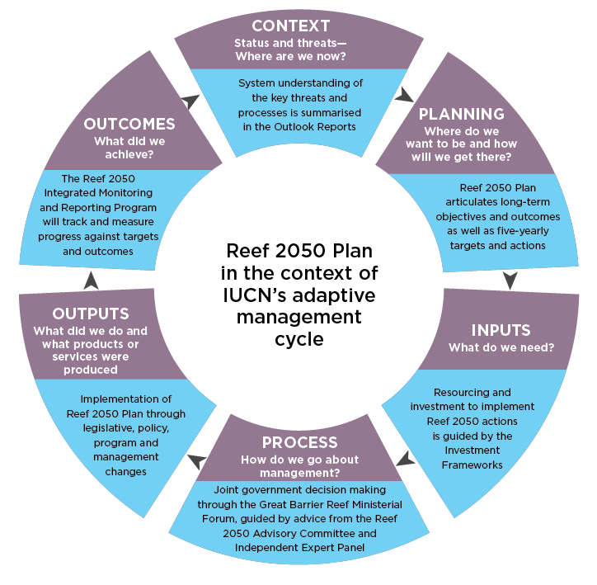

*Figure 5: IUCN’s adaptive management cycle as applied to the Reef 2050 Plan. Management adapts through each circuit of the cycle.*

Adaptive management of the Reef is supported through a five-yearly review cycle of the Reef 2050 Plan. The Investment Framework will be reviewed every five years following the review of the Reef 2050 Plan. The Integrated Monitoring and Reporting Program will inform evaluation of outcomes through the Great Barrier Reef Marine Park Authority’s five-yearly Outlook Reports. A new set of actions and targets will be developed based on this evaluation. The Investment Framework will be revised to ensure investments are directed strategically and are targeted to the updated priority areas.

The next Investment Framework, following the review of the Reef 2050 Plan, will build on the lessons learnt from the first five years of the Reef 2050 Plan.

## The results for 2015–2020

The results of the current Investment Framework will be used to inform decision-making relating to the implementation of the current Reef 2050 Plan actions (2015–2020). This will direct investment to the six identified priority areas in line with the strategies identified in the framework. The Australian and Queensland governments will use the results from the framework to focus investment, use regulatory and policy levers to support the identified priorities, and explore ways to diversify and leverage new investment opportunities. The current results identify partnership opportunities and strategies the private sector could take the lead on, and will also encourage the sector to continue to play a key role in the development of innovative strategies and conservation financing options.

# Appendix A: Six Priority Areas for investment

The following pages consolidate outcomes from the Investment Framework, focusing on the six priority areas for investment that have been identified. They will be used to guide investment to these areas in future.

**Reef Water Quality Protection Plan actions**

Improving the quality of water entering the Reef is pivotal in supporting its health and resilience. The Reef Water Quality Protection Plan is a shared plan to achieve clean water for a healthy reef.

The key action for this grouping is: **WQA2 – Continue improvement in water quality from broadscale land use through implementation of Reef Water Quality Protection Plan 2013 actions.**

**Known investment over the next 5 years:**

Australian Government: $212.4 million

Queensland Government: $272 million*

Other: $65.8 million

**Total investment: $550.2 million\*\***

**Examples of current investment sources:**

✓ $161 million through the Australian Government’s Reef Trust

✓ $265 million by Queensland Government agencies

✓ Landholders co-contributions

✓ Industry investment

✓ Local Government initiatives

**Highlight (WQA4)**

The Reef Alliance brings together the farming industry, regional natural resource management bodies and conservation groups to jointly deliver $45.6 million of Australian Government investment through Reef Trust since December 2015. It provides an integrated Reef wide approach to drive improvements in farming practices and fast track the implementation of innovative practices to improve water quality. Their Reef Trust Phase III project will support more than 1000 farmers and graziers to improve their practices over more than 1.8 million hectares across 33 Great Barrier Reef catchments by mid-2019.

Since 2003, partners have been working in collaboration to address water quality through the Queensland and Australian governments’ shared Reef Water Quality Protection Plan. The plan is regularly updated and a new version is planned for release in mid-2017. The new version will address all land based sources of water pollution and will include revised water targets specific to the 35 catchment basins that enter the Reef lagoon.

In 2016, the Queensland Government commissioned the Great Barrier Reef Water Science Taskforce to provide advice on how to meet the 2025 water quality targets for sediments and nutrients in the Reef 2050 Plan and how to best invest an additional $90 million in water quality improvement activities. It found that there is no silver bullet solution and a mix of tools and approaches will be needed. Its associated costings report used a handful of scenarios to estimate the total cost of achieving the 2025 targets as $8.2 billion. It showed that there is a suite of lower-cost actions that can be pursued immediately, and that future innovations are expected to reduce the cost of meeting the full targets. For example, 50 per cent of the existing targets could be reached for $623 million. The costings report provides another useful tool augmenting with other technical prioritisation tools to better target current and future investments, in particular, once regionally specific water quality targets are identified.

Significant efforts have been made over the last decade to reduce the input of pollutants. Meeting the ambitious water quality targets will require accelerated progress and transformational change in some industries and communities as reflected in the funding needs identified. Existing on-ground efforts align with the low-cost high-impact scenarios identified in the costing work, and investment committed by the Australian and Queensland governments and their partners over the next five years is expected to make a real contribution to meeting the targets.

*\* $45.7 million of Queensland Government investment includes funding for Reef 2050 Monitoring and Integrated Reporting actions.*

*\*\* Total investment in all actions under the water quality theme is $573.5 million. Not all water quality actions are included in this priority area.*

The actions under this priority area focus on implementing the Reef Water Quality Protection Plan. These actions span investment, regulation, standard setting, monitoring and reporting. Actions that are fully funded include the review of the plan and its targets, delivery of innovative approaches through the Reef Trust and support for best management practices approaches. The largest funding needs relate to the high level commitment to implement the plan and related reporting.

**Future sources of investment:**

* Australian Government Reef Trust
* Australian Government CEFC Reef Fund
* Queensland Government agencies
* Private and philanthropic

**Future strategies:**

* Conservation financing projects
* Private and philanthropic partnerships
* Regulatory and policy levers
* Investing in innovation
* Revisiting traditional investment


Fully funded 
WQA1
WQA3
WQA4
WQA10
Less than $1m
WQA9
WQA12
WQA13
$10m to $20m WQA23
$20m TO $100m WQA2
N/A – captured under another action WQA6 WQA8
Unknown
WQA5
WQA7
WQA11
WQA24
Funding needs: $34 - 124 million



**Pathways for future investment**

There are numerous sources of investment that can be used to improve water quality. A five-year joint investment strategy will be developed to support delivery of the Reef Water Quality Protection Plan 2017 and future decisions, including by non-government organisations, should align with this strategy.

Successful programs that demonstrate a high return on investment will need enduring support to ensure lasting effects and long-term management practice and behavioural change. It is important to complement investment in tried and true solutions with investment in innovation. For example, the Queensland Government is providing funding through an innovation fund to pilot and trial new approaches and will be seeking matched funding for proposals. Already, a $4 million partnership with Greening Australia has been announced to trial more innovative gully remediation techniques.

Innovative financing mechanisms can be used to drive water quality improvements and innovation in delivery. For example, in mid-2016, the Australian Government committed $1 billion over ten years for investment financing through the Clean Energy Financing Corporation to activities that deliver an energy efficiency and water quality outcome.

Matched funding more broadly will also be critical. The Australian and Queensland governments have entered into partnerships with philanthropic organisations that are matching funding from other sources. Other avenues for conservation financing mechanisms are being explored to leverage funds through private and philanthropic sources and through delivery partnerships.

In response to the Taskforce’s recommendations, the Queensland Government is investigating setting regulatory pollution load limits which could support a market trading mechanism in the future.

**Field Management Program actions**

The joint field management program plans and executes field operations in the Great Barrier Reef World Heritage Area, delivering practical on-ground actions to protect and maintain well-functioning marine and island ecosystems.

The key action for this grouping is: **GA7(a) – When reviewing relevant agreements, policies, plans, strategies and programs ensure they support the Plan’s outcomes and targets. For example, fund and support ongoing joint field management activities**

**Known investment in Reef 2050 actions over the next 5 years:**

Australian Government: $48.1 million

Queensland Government: $41.9 million

Other: $5.5 million

**Total investment: $95.4 million**

**Examples of current investment:**

✓ $41.9 million from the Queensland Government

✓ $42.1 million from the Australian Government

✓ $6 million from the Australian Government for a new vessel

✓ $5.5 million from private organisations

**Highlight (BA22)**

The joint field management program is working with BHP Billiton, Traditional Owners and the Great Barrier Reef Foundation on a five year $7.95 million project to protect and restore Raine Island’s critical habitat to ensure the future of key protected species including green turtles and seabirds. This project pools funding and resources to target an agreed priority.

The Australian and Queensland governments each provide approximately $8.4 million per year to the Great Barrier Reef Marine Park Authority to support the joint field management program. In mid-2016, the Australian Government announced $6 million for the purchase of a new vessel, the Southern Reef Ranger. This vessel will contribute to the delivery of field management activities and relevant Reef 2050 Plan actions, including improving enforcement and compliance capability.

As part of partnership arrangements under the *Great Barrier Reef Intergovernmental Agreement*, the program is undergoing a periodic review. The review will evaluate the performance of the program and advise on resources, investments and arrangements needed for effective and efficient field management for the next five years.

The funding needs identified relate to actions that could be considered field management activities but have not been fully funded within annual allocations. In addition to these actions, the joint field management program supports the implementation of a further 50 actions, some of which have been funded through other initiatives (for example, the Reef Trust) on a short-term basis such as marine debris clean up, control of crown-of-thorns starfish and mega fauna protection.

The actions under this priority area focus on delivering field management program actions. These actions span compliance, island and habitat protection, visitor management and community engagement. The action that is fully funded relates to the Raine Island Recovery project. The largest funding needs relate to enhanced compliance, island restoration and pest eradication.

**Future sources of investment:**

* Australian Government
* Queensland Government
* Private and philanthropic

**Future strategies:**

* Private and philanthropic partnerships
* Regulatory and policy levers
* Investing in innovation

Fully funded 
BA22
Less than $1m
HA8
CBA8(g)
$1m to $5m
BA12
EHA26
CBA8(f)
GA7(a)
$5m to $10m
CBA8(h)
$10m to $20m
EHA11
EHA32
BA24
N/A – captured under another action
BA13
BA19
Unknown
BA8
BA11
EHA9
Funding needs: $41 - 92 million


**Pathways for future investment**

The joint field management program is a longstanding investment and will remain a key operational need, to be funded by governments.

The joint field management program is undergoing a periodic review which is due for completion in mid-2017. The outcomes of this review will influence the types of strategies used to fill gaps in funding.

Innovation in technology may deliver efficiencies in implementation and reduce costs over time.

The Raine Island Recovery project is demonstrating the effectiveness of delivering priority actions through public-private partnerships. Such projects can provide a strong and measurable social return on investment.

Crowd sourcing programs could be established to fund specific field management actions, capitalising on the ability of such actions to provide a clear environmental and/or social return. Such efforts should be coordinated to ensure they are appropriately targeted and align with the strategic direction of the field management program.

**Reef 2050 Integrated Monitoring and Reporting Program actions**

Integrated modelling, monitoring, and reporting for the Reef and its adjacent catchments will track the progress towards targets, objectives and outcomes of the Reef 2050 Plan and drive adaptive management.

The key action for this grouping is: **GA15 – Develop, implement and operate an Integrated Monitoring and Reporting Program to facilitate adaptive management for the Reef**

**Known investment in Reef 2050 actions over the next 5 years:**

Australian Government: $62.0 million

Queensland Government: $2.5 million

Other: $6.7 million

**Total investment: $71.2 million* ^**

**Examples of current investment:**

✓ $8 million from the Australian Government to establish the program

✓ Contributions from scientific organisations

**Highlight (GA15)**

The eReefs project is a six year $30 million collaborative project that commenced in 2012 to build comprehensive coastal information systems akin to that provided by the Bureau of Meteorology for weather.  It is a world-class innovation developed in partnership by multiple scientific agencies with contributions from leading Australian businesses. eReefs is providing an integrated system of data, models, visualisation, reporting and decision support tools that span the entire Reef area. It is a key supporting tool for design and delivery of the Integrated Monitoring and Reporting Program.

The Reef 2050 Integrated Monitoring and Reporting Program will underpin the Reef 2050 Plan’s adaptive management approach by evaluating whether actions are on track to achieve targets. It will inform the the Great Barrier Reef Marine Park Authority’s Outlook Reports. The design phase is supported by Australian Government investment of $8 million and due to be completed by the end of 2017. This work will identify options for ongoing monitoring, modelling and reporting and will identify associated costs. The funding needs identified have been estimated in the interim.

There is already significant investment in monitoring and modelling for the Reef. Early development of the program has focused on coordinating, aligning and integrating the 100-plus existing monitoring and modelling programs. This work recognises the need for a consistent approach, but also acknowledges that regional variations occur in the condition of values, the pressures affecting these values and management responses. The Paddock to Reef Program is a good example of governments and scientific organisations working together to target key information needs and inform management responses.

*\* Note: Investment in monitoring and reporting for water quality is reported under Reef Water Quality Protection Plan priority area.*

*^ Investment in BA19 not included in headline figures (see Field Management Program actions)*

The actions under this priority area focus on informing the plan’s adaptive management approach. These actions span integrated modelling, monitoring and reporting. Actions that are fully funded include the establishment of a steering group for the program and some water quality standards. The largest funding needs relate to the establishment of the full program and identification of ecologically relevant standards for ecosystem health.

**Future sources of investment:**

* Australian Government National Environmental Science Program
* Queensland Government
* Private and philanthropic

**Future strategies:**

* Private and philanthropic partnerships
* Investing in innovation
* Revisiting traditional investment
* Non-financial resourcing (citizen science)

**Fully funded 
WQA10
GA4
Less than $1m
BA20
HA11
$1m to $5m
CBA13
$5m to $10m
EBA17
$10m to $20m
WQA23
EBA18
GA15
$20m to $100m
EHA6
N/A – captured under another action
EHA15
EHA29
EHA30
BA17
BA19
BA21
CBA6
Unknown
EHA31
WQA24
GA12
Funding needs: $48 - $157 million*^
**

**Pathways for future investment**

The design of the Reef 2050 Integrated Monitoring and Reporting Program is due to be completed by the end of 2017. Once fully operational, the program will increase the cost effectiveness of monitoring and modelling by better integrating systems and ensuring investment supports the right monitoring and modelling to inform a holistic evaluation against indicators from all seven themes of the Reef 2050 Plan.

Funding models that allow for a collaborative approach across the 20 partner agencies will be considered as part of the program design. Additional government funding is expected to be required.

The role of new technologies and automation will be considered as part of the program to reduce the total cost over time. For example, a partnership between Boeing and scientific organisations is trialing the use of drones in the Reef to improve the cost effectiveness and coverage of monitoring.

Continued research and development into innovative approaches to complement traditional information collection, such as using three-dimensional photography, will contribute to reducing costs in the future.

The role of citizen science and use of social media will continue to be examined, and will be particularly relevant to monitoring and evaluating the human dimensions of Reef protection.

**Crown-of-thorns starfish control actions**

According to research by the Australian Institute of Marine Science, crown-of-thorns starfish were responsible for almost half of the decline in coral cover in the past 30 years. Managing outbreaks is important for maintaining coral cover at ecologically and economically important reefs.

The key action for this grouping is: **EHA12: Reduce crown-of-thorns starfish outbreaks by continuing to improve water quality and undertaking a targeted control program as needed. Improve integration and effectiveness of crown-of-thorns starfish research and management**

**Known investment in Reef 2050 actions over the next 5 years:**

Australian Government: $10.8 million

Queensland Government: $1 million

Other: $1.6 million

**Total investment: $13.4 million**

**Examples of current investment sources:**

✓ $10.8 million for control from Reef Trust

✓ $1 million from Skilling Queensland Program

✓ $1.6 million from tourism industry for control and training

**Highlight (EHA12)**

Research into techniques to cull the crown-of-thorns starfish led to the development of a one-shot injection. This greatly reduced the cost of culling compared with the previous method, which required up to twenty-two injections per animal. The research was undertaken by James Cook University and field testing was undertaken by the Great Barrier Reef Marine Park Authority with financial support from the Reef Trust. Improvements in efficiency significantly increase the ecological benefit of every dollar spent on this activity.

Crown-of-thorns starfish are highly adapted coral predators that are native to the Great Barrier Reef. The Australian Government has invested in a holistic approach to controlling the starfish since 2012 including water quality improvements, research and physical culling of the animals. Delivery of the culling effort is coordinated by the Great Barrier Reef Marine Park Authority. Between 2012 and 2015 the crown-of-thorns starfish management program has resulted in almost 370,000 crown-of-thorns starfish culled from 107 reefs. The cumulative pressures of the ongoing outbreak and the 2016 coral bleaching event means the remaining live coral population at these locations is vulnerable to higher levels of predation.

Priority coral reefs are protected through a partnership effort between the Australian Government, the Reef and Rainforest Research Centre and the Association of Marine Park Tourism Operators. Additional government investment has been provided through the Reef Trust and this primarily supports the operation of surveillance and control vessels. Tourism operators complement this investment through operator conducted culling operations and training programs for divers, and subsidised berthage fees. The tourism industry and broader community also contribute to the identification of outbreaks and monitoring the effectiveness of control efforts through the Eye on the Reef program.

Government investment is targeted at research to improve knowledge about the starfish and develop increasingly more effective methods of control, particularly through the National Environmental Science Program’s Tropical Water Quality Hub. The funding needs identified relates to a desired expansion of control activities.

**Future sources of investment:**

* Australian Government National Environment Science Programme
* Queensland Government
* Private and philanthropic

**Future strategies:**

* Regulatory and policy levers
* Private and philanthropic partnerships
* Investing in innovation
* Revisiting traditional investment


$10m to $20m
EHA12
Funding needs: $10 - 20 million


**Pathways for future investment**

Future investment should be coordinated and control efforts aligned with the Great Barrier Reef Marine Park Authority’s Crown-Of-Thorns Starfish Management Strategy and Contingency Plan to ensure that investment from all sources is able to achieve the greatest impact to reduce this threat.

Government investment can act as a catalyst for private and philanthropic contributions. The high numbers of crown-of-thorns starfish can have a direct impact on visitor experiences. Culling activities provide a direct return and satisfaction to philanthropic investors.

Ready access to funding to respond to expanded outbreaks will improve the cost effectiveness of culling efforts. Diversifying the core funding base through partnerships with private and philanthropic organisations will improve response times and coverage.

Continued investment in research through scientific agencies and the National Environmental Science Program’s Tropical Water Quality Hub will improve the effectiveness of control methods as well as reduce their cost. Improving knowledge about biological and ecological dynamics of the starfish could lead to improvements in the way management actions are designed and targeted and will be important for identifying reefs where control efforts will have the greatest effect. Such research could also improve the ability to monitor and detect the spread of the starfish through innovative approaches such as remote three dimensional photography.

**Traditional Owner actions**

Traditional Owners have a continuing connection to their land and sea country in the Great Barrier Reef Region. The cultural and ecological knowledge and practices of Traditional Owners is essential in delivering ecological, social and economic objectives of the Reef 2050 Plan.

The key action for this grouping is: **GA11 – Improve Traditional Owner participation in governance arrangements for protection and management of the Reef**

Current investment from the Australian and Queensland governments supports land and sea partnerships and ranger programs across the Great Barrier Reef Region. Currently, there are 28 rangers under the Queensland Government program and 95 full-time equivalent positions supported under Australian Government programs. Some of the arrangements are also supported by contributions from private and industry organisations.

Actions in the Reef 2050 Plan that are specific to Traditional Owners span all seven themes. In 2015 and 2016, consultations were undertaken with Traditional Owners to prioritise these actions and develop a Reef 2050 Indigenous Implementation Plan. One of the focus areas identified was improved coordination between Traditional Owners, government agencies and partners on Reef 2050 Plan matters. The National Environmental Science Program’s Tropical Water Quality Hub supported a project to explore the history of attempts to secure a more joined-up approach across the Great Barrier Reef and consult with Traditional Owners about effective implementation of the Reef 2050 Plan and of the Topical Water Quality Hub’s Indigenous Engagement and Participation Strategy. The report of this project is available on the Hub’s website.

More funding is needed to deliver fully against the Traditional Owner actions in the Reef 2050 Plan. The quantum of funding needed could not be estimated for the majority of the actions. This is partly due to the nature of some actions, but also highlights the need for more consultation with Traditional Owners to determine the best avenue for future implementation.

**Known investment in Reef 2050 actions over the next 5 years:**

Australian Government: $39.4 million

Queensland Government: $23.6 million

Other: $1.9 million

**Total investment: $64.9 million**

**Examples of current investment sources:**

✓ $39.4 million Australian Government in land and sea partnerships

✓ $23.6 million Queensland Government land and sea partnerships

✓ Contributions from landholders and industry

**Highlight (EHA12)**

Indigenous Land and Sea Rangers use government funding to incorporate traditional knowledge and practices into managing a range of reef impacts on land and sea country. Rangers will be increased in the Gladstone area, with government funding matched by ConocoPhillips.

**Future sources of investment:**

* Australian Government
* Queensland Government
* Private and philanthropic

**Future strategies:**

* Private and philanthropic partnerships
* Revisiting traditional investment
* Investing in innovation (coordination)
* Co-benefits through complementary funding sources

**Fully funded 
HA6
GA2
Less than $1m
EHA1
EHA4
BA1
HA3
CBA1
EBA2
GA7(d)
Unknown
EHA2
EHA3
EHA5
BA2
BA3
BA4
HA1
HA2
HA4
WQA24
CBA2
CBA3
EBA1
EBA2
GA11
Funding needs: $6 - ? million
**

**Pathways for future investment**

A key priority for investment is to improve involvement of Traditional Owners in the delivery of Reef 2050 actions. Investment in coordination and consultation with Traditional Owners will further clarify priorities and funding needs. To be effective, coordination efforts would need broad support from Traditional Owners. Consultation about options will be held in 2017.

Meanwhile, there is increased scope for Traditional Owners to be involved in the development and delivery of on-ground projects. Harnessing local knowledge and skills will improve the environmental outcomes and contribute to Traditional Owner specific actions.

There are existing government programs which could deliver multiple benefits for the Reef. One example is the Australian Government’s Indigenous Enterprise Development Program which supports the establishment of sustainable Indigenous enterprises and builds capacity in Indigenous communities.

**Fisheries actions**

Investing in fisheries actions will improve the health and resilience of the Reef as well as the ecological sustainability and economic viability of the fishing industry.

The key action for this grouping is: **BA23 – Review the regulatory structure of fishing to ensure the sustainability of Queensland’s fisheries**

**Known investment in Reef 2050 actions over the next 5 years:**

Australian Government: Nil

Queensland Government: $31.9 million

Other: Nil

**Total investment: $31.9 million**

**Examples of current investment sources:**

✓ $10 million licence buy back

✓ $10 million reform

✓ $11.7 million stock assessments

✓ $0.2 million to develop charter fishing action plan

**Highlight (BA6)**

The Queensland Government has invested $10 million to establish three new net free areas in estuarine coastal waters near Cairns, Mackay and Rockhampton. The first round of licence buybacks has been finalised, with 27 commercial fishing licences acquired from a nominal target of 46 licences at a cost of $3.31 million. The second round of licence buybacks closed on 19 August 2016 with up to $3.6 million available.

The Queensland Government is responsible for management of the majority of fisheries in the Great Barrier Reef Region and leads many of the related Reef 2050 Plan actions, including the establishment of three net free areas and fisheries reform.

Approximately 60 per cent of the current costs of fisheries management are funded by the community through general government revenue. Recreational and commercial fishers each contribute 20 per cent (or approximately $4.5 million each per annum) through commercial licence fees, vessel registration fees and recreational permit fees to use some stocked impounds.

One significant Reef 2050 Plan action has already been completed—BA6: the implementation of three new net-free fishing zones—with $10 million provided for a structured buyback scheme for commercial fishing authority holders who were directly affected.

The other fisheries actions are underway and are part of a package of fisheries reform outlined in the *Green Paper on fisheries management reform in Queensland*. This paper is a major step in developing a strategic policy to guide the management of Queensland's fisheries resources into the future. The funding need identified relates to future funding needs to implement the outcome of fisheries management reform.

At the national level, the Productivity Commission is undertaking a public inquiry into the regulation of the Australian Marine Fisheries and Aquaculture Sectors. The draft report was released on 31 August 2016 and highlighted the need for wide ranging reform, including improved knowledge about the impacts of recreational and Indigenous customary take. The final report is expected to be completed in December 2016.

The actions under this priority area focus on fisheries management. These actions span net free zones, fisheries reform, stock assessments and a charter fishing action plan. The action that is fully funded is the introduction of three new net free areas. The largest funding need relates to reform of fisheries management.

**Future sources of investment:**

* Queensland Government
* Private and philanthropic

**Future strategies:**

* Private and philanthropic partnerships
* Regulatory and policy levers
* Revisiting traditional investment

Fully funded 
BA6
$5m to $10m
BA23
N/A – captured under another action
EBA12
Unknown
BA18
EBA15
Funding needs: $5 - 10 million


**Pathways for future investment**

The public consultation process on the *Green Paper on fisheries management reform in Queensland* closed in mid-October 2016 and will now inform the development of a strategic policy to guide the reform.

Improvements to the management of fisheries, including moving to harvest strategies that can deliver a maximum economic yield and avoiding the displacement of effort, is expected to optimize the benefits to the industry and community.

Effective fisheries management requires adequate resourcing. The total funding required will depend on the details of the finalised regulatory structure, but is anticipated to be an additional $5–10 million over three years.

How fisheries management is to be funded in the long term is yet to be resolved. Queensland’s commercial fishing fees are the lowest across Australia at just 2 per cent of the industry’s gross value of production.

Moving to a fisheries management system that provides for sustainable, economically viable and resilient fisheries, as proposed by the reforms, will provide benefits for all sectors. As the fisheries reform program develops consideration will be given as to how the costs of improved management and reform will be met.

# Appendix B: Prioritisation template 2015

|  |  |  |  |  |  |  |  |
| --- | --- | --- | --- | --- | --- | --- | --- |
| **PRIORITISING REEF 2050 PLAN ACTIONS** | | | | | | | |
| **Action Number:** | **Action Text:** | | | | | | |
| **Reef 2050 Plan Theme: Biodiversity** | **Workshop Category:** | | | | | | |
| **Linked/Related actions:** | | | **Similar actions:** | | | | |
| **OUTCOMES AND BENEFITS** | | | | | | | |
| 1. What Targets and Objectives in the Reef 2050 Plan does this action contribute to? | | **Targets:** BT1 BT2 BT3 BT4 BT5  **Objectives:** B01 B02 B03 B04 B05 | | | | | |
| 2. How effective will the action (when completed) be in meeting the Targets and Objectives? | | Low | | Medium | High | Unknown | Comments: |
| 3. How well does this action address the threats in the Reef 2050 Plan? | | Low | | Medium | High | Unknown | Comments: |
| 4. What is the feasibility of detecting benefit from this action? | | Low | | Medium | High | Unknown | Comments: |
| 5. What level of complementary benefits will this action deliver, e.g. reducing carbon emissions, increasing jobs growth or social benefits? | | Low | | Medium | High | Unknown | Comments: |
| 6. Will the action have a local, regional or reef-wide benefit? | | Local | | Regional | Reef wide | Unknown | Comments: |
| 7. Do you expect that the benefit/s from this action will be realised in the short, medium or long term? | |  | |  |  |  | Comments: |
| Long term  (by 2050) | | Medium  term  (by 2035) | Short term  (by 2020) | Unknown |
| **COST AND CAPACITY** | | | | | | | |
| 8. What is the cost of completing the action? | | Low | | Medium | High | Unknown | Comments: |
| 9. What is the probability that the action can be completed as specified? | | Low | | Medium | High | Unknown | Comments: |
| 10. Is there sufficient information available now to inform delivery of the action? | | No | | | Yes | | Unknown |
| If not, what information is needed prior to implementing this action? | | Please detail: | | | | | |
| 11. Is there existing work/activities amongst stakeholder groups that will assist to implement this action? | | No | | | Yes | | Unknown |
| If yes, please describe: | | | | | |
| 12. List any stakeholder groups with relevant expertise and / or resources to support delivery of this action. | | Please list: | | | | | |

|  |  |  |  |
| --- | --- | --- | --- |
| **SEQUENCING** | | | |
| 13. Based on your discussions and the above responses, do you consider the action to be an immediate, medium-term or future priority? (i.e. when do you recommend the action be commenced?) | Future priority  (implementation to commence by June 2020) | Medium-term priority  (implementation to commence by June 2018) | Immediate priority  (implementation to commence by December 2016) |
| Other comments: | | | |

# Glossary of terms

**Adaptive management:** a systematic process for continually improving management policies and practices by learning from the outcomes of operational programs.

**Actions** are new activities outlined in the Reef 2050 Plan which, combined with the foundational activities, contribute to achieving the targets for the theme.

**Biodiversity:** the variability among living organisms from all sources including inter alia, terrestrial, marine and other aquatic ecosystems and the ecological complexes of which they are part; this includes diversity within species, between species and of ecosystems.

**Community benefits:** cultural, social and economic benefits such as employment, income, understanding, appreciation, enjoyment, personal connection, health benefits and access to Reef resources.

**Dredging:** digging, excavating or removing material from waterways to deepen channels, create harbours, and keep channels and approaches to ports at defined depths. Dredging can either be capital dredging, for new channels and berths, or maintenance dredging, necessary to maintain existing and approved dredging areas.

**Ecosystem:** a dynamic complex of plant, animal and microorganism communities and their non-living environment interacting as a functional unit.

**Fishing:** for the purposes of this Plan and consistency with the Outlook reporting, the term ‘fishing’ includes recreational, charter and commercial fisheries, plus the Queensland shark control program. Fishing activities associated with traditional use are included as part of traditional use.

**Foundational activities** are existing regulatory, planning, field management and program responses such as the Reef Water Quality Protection Plan already underway in the Reef and its catchments.

**Great Barrier Reef (the Reef):** in this document the Great Barrier Reef or the Reef, is taken to mean the Great Barrier Reef World Heritage Area.

**Great Barrier Reef Region:** the area described in Schedule 1 of the *Great Barrier Reef Marine Park Act 1975.*

**Indicators:** physical, chemical, biological or socio-economic measures that best represent the key elements of a complex ecosystem or an environmental issue.

**Indigenous heritage:** includes all places that are part of Aboriginal and Torres Strait Islander peoples’ spiritual links to the land or which tell the story of Indigenous peoples from time immemorial to the present. It can include sacred sites, ceremonial sites like bora rings and rock art, fish traps, burials, middens, scarred trees, camp sites and semi/permanent settlements.

**Objectives** link targets to outcomes and are expected to be achieved by 2035.

**Outcomes** are a statement of what is expected to be achieved for each theme by 2050, which will collectively contribute towards achieving the vision for the Reef.

**Outstanding Universal Value:** cultural and/or natural significance which is so exceptional as to transcend national boundaries and to be of common importance for present and future generations of all humanity.

**Philanthropic organisations:** refers to not-for-profit organisations.

**Reef Trust:** an Australian Government program, delivered in collaboration with the Queensland Government and the Great Barrier Reef Marine Park Authority. Established to provide innovative, targeted investment to the Great Barrier Reef region, focused on known critical areas for investment—improving water quality and coastal habitat along the Great Barrier Reef, controlling the current outbreak of crown-of-thorns starfish, and protecting threatened and migratory species, particularly dugong and turtles.

**Targets** specify the results being aimed for by 2020. These were developed with a view to being SMART: Specific, Measurable, Achievable, Realistic and Time-bound.

**Threats** are pressures on the health and longevity of the Reef. Key threats are described in the Great Barrier Reef Outlook Report 2014.

**Water quality:** refers to the chemical, physical, biological and radiological characteristics of water. It is a measure of the condition of water relative to the requirements of one or more biotic species and/or to any human need or purpose.

**World Heritage Area:** Great Barrier Reef World Heritage Area.

**World Heritage Convention:** a global instrument for the protection of cultural and natural heritage that aims to promote cooperation among nations to protect heritage around the world that is of such Outstanding Universal Value that its conservation is important for current and future generations