

**Reef 2050 Plan**

Update on progress

Presented to the UNESCO World Heritage Centre and IUCN

1 December, 2016

© Copyright Commonwealth of Australia, 2016.

*Reef 2050 Plan—Update on Progress* is licensed by the Commonwealth of Australia for use under a Creative Commons Attribution 4.0 Australia licence with the exception of the Coat of Arms of the Commonwealth of Australia, the logo of the agency responsible for publishing the report, content supplied by third parties, and any images depicting people. For licence conditions see: https://creativecommons.org/licenses/by/4.0/

This report should be attributed as ‘*Reef 2050 Plan—Update on Progress, Commonwealth of Australia 2016*’.

The Commonwealth of Australia has made all reasonable efforts to identify content supplied by third parties using the following format ‘© Copyright, [name of third party]’.

The views and opinions expressed in this publication are those of the authors and do not necessarily reflect those of the Australian Government or the Minister for the Environment and Energy.

While reasonable efforts have been made to ensure that the contents of this publication are factually correct, the Commonwealth does not accept responsibility for the accuracy or completeness of the contents, and shall not be liable for any loss or damage that may be occasioned directly or indirectly through the use of, or reliance on, the contents of this publication.

Aboriginal and Torres Strait Islander peoples are the Traditional Owners of the Great Barrier Reef area and have a continuing connection to their land and sea country.

# Preface

The Australian and Queensland governments released the Reef 2050 Long-Term Sustainability Plan in March 2015 following consultation with Traditional Owners, scientists and industry, as well as local, regional and international communities.

The Reef 2050 Plan articulates a 35-year blueprint to protect and improve the Reef’s Outstanding Universal Value through a robust scientific adaptive management framework.

It addresses the pressures that are facing the Reef today using the latest knowledge and a contemporary adaptive management framework, building on the previous 25-year strategic plan for the Great Barrier Reef World Heritage Area developed in 1994.

The release of the Reef 2050 Plan marked an important change in direction for the management of the Reef. Australia has an overarching plan that sets out a single, comprehensive and shared strategy for governments, science, industries and communities.

The Reef 2050 Plan was developed in response to the World Heritage Committee’s 2011 decision **35 COM 7B.10** which requested a coordinated and long-term plan for the sustainable management of the Reef.

In 2015, the Reef 2050 Plan was unanimously endorsed by the World Heritage Committee at its 39th Session in Bonn, Germany. In decision **39 COM 7B.7**, the Committee requested that Australia:

*Submit to the World Heritage Centre by 1 December 2016, an update on progress with implementation of the 2050 LTSP to confirm that the inception of the plan has been effective, and the Investment Strategy has been established, for examination by the World Heritage Centre and IUCN.*

This progress update reflects the first 18 months of a 35 year plan, and is not a report on the state of conservation of the Reef. Rather, the purpose of this document is to respond to the specific request of the Committee and to demonstrate inception of the Reef 2050 Plan that builds on the management foundations laid over the past 40 years.

The Great Barrier Reef Marine Park Authority’s 2019 Outlook Report will provide evidence of the effectiveness of the Reef 2050 Plan’s first four years of implementation. It will report on performance against the targets and outcomes of the Reef 2050 Plan and how effective actions have been in protecting the Outstanding Universal Value of the Great Barrier Reef. Further, the Outlook Report will evaluate the condition of the Reef’s ecosystem and its long-term outlook, based on assessments of condition, use, influencing factors, management effectiveness, resilience and risks.

Table of Contents

Preface 2

Foreword 4

Messages 6

Message from Chair of the Reef 2050 Advisory Committee 6

Message from the Chair of the Independent Expert Panel 6

1. Summary of Reef 2050 Plan Inception 8

Status of Reef 2050 actions 8

Status of investment 8

Key changes since the inception of the Reef 2050 Plan 10

2. The Investment Framework 11

Overview of results for current Reef 2050 Plan actions (2015—2020) 11

Current Investments 12

Investment Priorities 13

Strategies to boost funding and diversify sources 14

3. Improving water quality 15

Legislation and regulation 18

Best management practice for the sugar cane industry 19

Investment in on-ground action to improve water quality 20

4. Governance and partnerships 21

Formal governance structures 21

Partnerships delivering actions 22

5. Coral bleaching response 23

6. Adaptive management strategy 25

7. Next Steps 28

Future priorities for implementation 28

Ongoing reporting 28

Reviewing the Plan 28

List of Addenda 29

# Foreword

The Reef 2050 Plan is the first of its kind. No undertaking of comparable scope, complexity and financial commitment has been attempted in a marine environment or World Heritage site.

Our governments have a deep commitment to the Reef 2050 Plan, as do the Traditional Owners and stakeholders within the Great Barrier Reef region. Legislative reform, regulation and investment, underpinned by a comprehensive policy platform, are being drawn on at the Federal, State, industry and community level to drive implementation.

Advice from the Reef 2050 Advisory Committee, comprised of industry and community stakeholders, and the Independent Expert Panel comprised of scientists, has been pivotal in prioritising actions and guiding implementation of the Plan. In policy terms, the Reef 2050 Plan has become a touchstone for all stakeholders to make visible their contributions to improving the health and resilience of the Reef. A fundamental strength of the Plan lies in its collaborative nature.

Good progress has been made in the first 18 months of this 35 year plan. Since its release, our governments have passed two pieces of legislation to manage the impacts of ports and dredging: amendments to the *Great Barrier Reef Marine Park Regulations 1983* and the introduction of the *Sustainable Ports Development Act 2015*. We have banned the sea-based disposal of capital dredge material in the World Heritage Area, restricted new port development to within current port limits and prohibited major capital dredging for port facilities outside the four priority port areas.

At a regulatory level, new Queensland Government compliance arrangements have been implemented for the cane and grazing sectors which are already demonstrating improvements. Work to improve the quality of the water entering the Great Barrier Reef remains our priority. The recently released Reef Report Card 2015 highlights that while the water quality trend line is positive, we need to accelerate our progress towards the ambitious targets that have been set. It is also clear that innovation in land management to achieve agricultural best management practices, and ongoing regulation and compliance, will be needed. Both governments have initiated work focused on behavioural change regarding land management practices.

We have made good progress in the implementation of the Plan’s 151 actions. Only one, EHA20, to strengthen Queensland’s vegetation management legislation, is significantly delayed as it did not pass the Queensland Parliament. While this is a setback in the immediate term, the Queensland Government remains committed to strengthening the State’s land clearing laws. In the meantime, existing land clearing laws prohibit clearing in riparian zones in three priority catchments—the Burdekin, Wet Tropics and Mackay Whitsundays. In addition, the national *Environment Protection and Biodiversity Conservation Act 1999* (EPBC Act) also regulates actions that are likely to result in a significant impact on the Great Barrier Reef and offers important protections in relation to large scale land clearing.

We have finalised the Investment Framework for the Reef 2050 Plan. We have consulted over 100 agencies and organisations and established that $1.28 billion of investment is mapped against Reef 2050 Plan actions over the next five years. This is part of our commitment to invest over $2 billion over the coming decade. Our $1.28 billion investment in Reef 2050 actions does not include other general investments such as the $1 billion Reef Fund.

Importantly, the Investment Framework prioritises the actions in the Plan based on expert advice and stakeholder input, identifies the priority areas where additional funding is most needed, and develops strategies for mobilising private sector and philanthropic investment. For the first time, we have a comprehensive view of the additional investment required, where it is most needed and strategies for how to get there.

A key feature of the Reef 2050 Plan is that it embeds a science-based adaptive management approach through which we adjust our strategies and actions based on what the emerging evidence says about the effectiveness and impact of our efforts. We have established a multi-disciplinary integrated monitoring, modelling and reporting program to inform implementation of the Reef 2050 Plan and help ensure actions and investments are targeted towards the most pressing needs.

Against the backdrop of our implementation of the Reef 2050 Plan, the Great Barrier Reef was severely affected by the global mass coral bleaching event, which was the result of underlying climate change and a particularly strong El Niño effect during the summer of 2015-2016. In this regard, the Reef was not alone, with many other sites around the world experiencing coral bleaching.

The global bleaching event reinforces the point that climate change is the single biggest threat to reefs worldwide—and the Great Barrier Reef is no exception. The risks of most concern are the ocean warming and acidification, and the increased intensity of storm events. At the same time, changes to the drought-flood cycle due to climate change are likely to exacerbate the loss of sediments and nutrients from catchments that experience loss of vegetation (due to more extreme droughts) and greater scouring (due to more intense floods).

Australia recognises that to protect and maintain the health of the Great Barrier Reef in the long term, greenhouse gas emissions need to be reduced. On 10 November 2016 Australia ratified the Paris Climate Agreement making clear our commitment to the global pledge to keep average global surface temperature increases to well below 2.0°C and to pursue efforts to limit the temperature increase to 1.5°C. This means adopting a pathway to significantly reduce greenhouse gas emissions over the next few decades consistent with international agreements to which Australia has committed.

It is critical for reefs worldwide, including the Great Barrier Reef, that international efforts are effective. Australia, along with all countries, is required to do our share to address this significant challenge. Among other things, this means transitioning our energy supply to a lower emissions mix.

Australia will meet and beat our 2020 target. Our 2030 target of a 26 to 28 per cent emissions reduction represents a halving of per capita emissions from 2005 levels. On this metric, Australia’s target is among the strongest of any G20 country. Australia’s progress towards its emissions reduction targets is reported and reviewed in line with our obligations under the UN Framework Convention on Climate Change.

While efforts to reduce global climate change are underway, the focus of the Reef 2050 Plan is on improving the Reef’s resilience to climate change by reducing local pressures. This will give the Reef a greater capacity to recover quickly from climate change related disturbances and survive into the future.

The bleaching event underscores the importance of the Reef 2050 Plan. While this year’s event was serious, the Reef’s scale and resilience mean it can recover. The Australian Institute of Marine Science has shown that in the three years prior to the 2015–2016 bleaching event, coral cover increased by 19 per cent across the Great Barrier Reef Marine Park. These results demonstrate the capacity of the Reef to recover from past disturbances in the absence of new ones, and demonstrate that reducing other pressures on the Reef is crucial to improve its resilience in the face of multiple pressures.

As stewards of the Great Barrier Reef, we understand the complexity and scale of challenges it faces and we remain committed to the Reef 2050 Plan and its successful implementation.

**The Hon Josh Frydenberg MP**   
Australian Minister for the Environment and Energy

**The Hon Dr. Steven Miles MP**   
Queensland Minister for the Environment and Heritage Protection   
and Minister for National Parks and the Great Barrier Reef

# Messages

## Message from Chair of the Reef 2050 Advisory Committee

In assessing what has been achieved at this point in the life of the Reef 2050 Plan and in the work of the Reef 2050 Advisory Committee, stepping back to consider our progress, I have constantly to remind myself of the scale of the challenge before us and that this is a marathon, where we are only completing the first laps.

The Reef 2050 Plan is bold in purpose, scope and ambition, of a scale to match the massive size and complexity of the World Heritage Area it is designed to protect, and the magnitude of the challenges and pressures confronting the Reef. Everyone associated with the Plan knows that its implementation will be difficult, but they also know that Reef 2050 represents the best possible chance for the Reef and that we cannot afford to fail. There is a determination to succeed.

This was the encouraging message I heard from all stakeholders at the first meeting of the Committee, in September, 2015 and that has been reinforced at every meeting since.

Equally encouraging has been the growing acceptance by members of the Committee that maintaining and strengthening the partnership approach that played such an important role in the development of the Plan*—*and is embedded in its design—will be critical to its success. The members represent diverse sectors, organisations and interest groups. Each brings a different perspective and views to the table, but as they have met and worked together over the first 18 months of the life of the Plan, the willingness to discuss difficult issues, in a spirit of genuine cooperation and collaboration, has increased. Not everyone is fully on board or in accord on every issue; inevitably there have been different views about the best way forward- and I expect this will continue- but with goodwill and a shared sense of commitment to the larger task, we have made good progress.

Following completion of the first priority—the prioritisation of the actions in the Plan—the Committee has contributed to the delivery of a number of important commitments in the Plan. Its views and advice, together with that of its partner advisory body, the Independent Expert Panel, have informed development of several major policy papers, including the Guidelines for Decision Makers and is guiding completion of others, among them those on offsets, cumulative impacts and net benefits. Advice from the Committee has identified priorities for funding needs in the development of the Investment Framework, influenced the design of the Reef 2050 Integrated Monitoring and Reporting Program, and of new communication strategies.

This progress is pleasing, but the progress to date does not reduce the urgency to address key issues and risks. We may only be at the beginning of a 35 year marathon effort, but we have to quicken the pace. The bleaching event has given added urgency to our work, with many members calling for stronger action and a greater investment of effort and resources to accelerate progress towards achieving the targets, objectives and outcomes of the Reef 2050 Plan.

This will not be easy to achieve, but as we move into the next implementation phase, I feel confident that the Reef 2050 Advisory Committee will play its part and make an ever more important contribution to enable fulfilment of the Vision of the Plan, to ensure the *Great Barrier Reef continues to improve on it Outstanding Universal Value every decade between now and 2050* and to be a natural wonder for each successive generation.

**The Honourable Penelope Wensley AC**   
Chair, Reef 2050 Advisory Committee

## Message from the Chair of the Independent Expert Panel

The Reef will be challenged on multiple fronts. We need to be alert and to be prepared. It means a long-term commitment to real action*—*such as outlined in the Reef 2050 Plan*—*and to the necessary resources.

The major impacts on the Reef will most likely result from the long term release of substantial quantities of greenhouse gases into the atmosphere. The warming of the atmosphere and of the oceans, along with their decreasing pH (‘acidification’) as they absorb additional carbon dioxide, changes the baseline conditions for the sustainability of the extraordinarily complex ecosystem that is the Reef.

There are effects already. This year saw the most significant coral bleaching event ever recorded for the Reef. The clear implication of global warming is that bleaching conditions are highly likely to become more frequent and more prolonged.

The long-term nature of climate change, coupled with the possible interactions of decadal-scale climate trends with episodic impacts that change year-to-year, such as an El Niño, mean we must maintain the scientific capability to observe and to learn about the Reef in all its complexity.

Whilst global action to address climate change will be paramount, it must be coupled with continued effort to reduce pressures on the Reef*—*to enhance its resilience. Initiatives to improve water quality, reduce direct impacts and increase our knowledge of the health of the Reef are underway and will continue to be important areas of focus.

The progress in reef protection in the first 18 months of the Reef 2050 Plan is establishing a strong foundation for responding to future challenges.

**Professor Ian Chubb AC**Chair, Independent Expert Panel

# 1. Summary of Reef 2050 Plan Inception

## Status of Reef 2050 actions

Australia is implementing the 151 actions outlined in the Reef 2050 Plan. These actions relate to the first five years of the 35 year plan. Each action has been assigned a lead reporting agency along with partner agencies that will help in its implementation. Progress on implementing actions is communicated by the lead reporting agencies regularly through a traffic light reporting system.

The first Reef 2050 Plan Annual Report was released in October 2016 and can be found at www.environment/gov.au/reef2050-progress. The Annual Report documented the status of actions at July 2016. The status of actions below is an update to the Annual Report, representing progress from the inception of the Plan until early November 2016. The actions prioritised under the themes of water quality and ecosystem health are among the most consequential for the future of the Reef and these actions are on track, with the exception of the ecosystem health action to strengthen Queensland’s vegetation management legislation.

32 are completed or in place (implementation is fully completed OR initial implementation has been completed, but part of the action is ongoing)
103 are on track/underway (implementation is meeting expected milestones and progress is 
being made)
3 are delayed/limited progress (major implementation milestones have been delayed by less than 6 months, or only superficial progress has been made)
1 are significant delays or no progress (major implementation milestones have been delayed for longer than six months or no progress has been made)
12 are not yet due (implementation is not yet due to commence)

*Figure 1: summary of progress in implementing the Plan’s 151 actions*

## Status of investment

$1.28 billion will be directly invested in specific Reef 2050 actions over the next five years. This is part of our commitment to invest $2 billion over the next decade.This includes $716.6 million from the Australian Government, $409.1 million from the Queensland Government and $161.2 million from other sources. The majority of investment is directed to the water quality and ecosystem health themes.

*Bar graph
*

*Figure 2: shows the $1.28 billion in funding by Reef 2050 theme*

## Timeline diagramKey changes since the inception of the Reef 2050 Plan

# 2. The Investment Framework

The Reef 2050 Plan Investment Framework has been developed to guide current and future investment in the Reef. It will ensure that investment in the protection of the Reef is targeted at mitigating the key pressures that are within the direct control of governments, industry and the community—pressures that arise primarily from direct human use of the Great Barrier Reef and its adjoining coastal river catchments.

The Investment Framework has been designed to be repeatable, so that it remains an ongoing tool under the adaptive management approach of the Reef 2050 Plan.

The Investment Framework:

• Maps the expenditure of over 100 federal, state and local governments, private and philanthropic organisations to the 151 actions in the Reef 2050 Plan to obtain an accurate assessment of the levels of investment in the Plan.

• Prioritises the critical actions in the Plan that are in need of future funding, based primarily on those actions and activities that will have the greatest impact and benefit for the Reef, drawing on the expertise of the Reef 2050 Advisory Committee and the Independent Expert Panel.

• Establishes strategies for boosting and diversifying investment in the Reef.

Financial, regulatory and policy levers are some of the tools at the government’s disposal when initiating change at the scale that is required across the Great Barrier Reef and its catchments. Continued financial commitment to the Reef 2050 Plan is a critical component of this mix through investments are targeted at the most appropriate actions and interventions.

The Investment Framework is now guiding investment decisions required for the implementation of the Reef 2050 Plan. The Framework is focused on investments that directly support implementation of Reef 2050 Plan actions. Its application is two-fold:

• **The approach** sets out how to implement and repeat the three phases of the Framework in future. The repeatability of the Investment Framework’s approach is a key part of the Plan's adaptive management cycle.

• **The results** for 2015-2020 show over that **$1.28 billion** has been directly allocated to specific Reef 2050 Plan actions of the next five years. This includes $716 million from the Australian Government, $409 million from the Queensland Government and $161 million from other sources. The greatest investment is in actions under the water quality and ecosystem health themes. Six priorities for future funding have been identified as have strategies to boost and diversify funding.

## Overview of results for current Reef 2050 Plan actions (2015—2020)

Funding needs have been identified to six priority areas, with the total estimated funding needs ranging from $143 million to $408 million. These funding needs are based on estimations from the lead agencies responsible for delivering the actions They are useful to guide future decision making by providing a broad sense of funding needs. They were not intended as costings exercises. Strategies have been identified to address these needs including additional government funding (e.g. $95 million still to be assigned to Reef 2050 actions under the National Landcare Program), innovative financing options (e.g. $1 billion under the Clean Energy Finance Corporation’s Reef Fund) and non-financial funding options (e.g. regulatory and policy solutions).

1—Establish existing investment
Current committed investment in specific Reef 2050 Plan actions over the next five years
$1.28 billion investment
2 —Determine future investment priorities
Six priority areas identified for future investment
Reef Water Quality Protection Plan actions
Field Management Program actions
Reef 2050 Integrated Monitoring and Reporting Program actions
Crown-of-thorns starfish control
actions
Traditional Owner actions
Fisheries actions

3 —Strategies to boost funding
Examples of sources  of future investment 
Private investment
Philanthropic investment
Australian Government, e.g.:
• CEFC Reef Fund
• Reef Trust
• National Landcare Program
• National Environmental Science Program
Queensland Government, e.g.:
• Queensland Reef Water Quality Program
• Queensland Natural Resource Management Program
• Reef Water Quality Science Program
Examples of strategies  for future investment
Revisiting traditional funding mechanisms
Fostering private and philanthropic partnerships
Developing conservation  finance projects
Using regulatory  and policy levers  to direct  investments
Tapping into  non-financial resourcing
Seeking  co-benefits though complimentary funding sources
Investing in innovation to reduce funding needs

*Figure 3: Key results from the three phases of the Investment Framework for 2015–2020.*

## Current Investments

An investment baseline developed in early 2015 identified that the Australian and Queensland Governments were projected to jointly invest more than $2 billion over the next ten years to protect the Reef.

In applying the more rigorous approach of the Investment Framework in 2016, it shows that across governments, industry and the community, more than $1.28 billion has already been committed for the next five years. This investment is focused solely on delivering actions in the Reef 2050 Plan.

This figure is conservative, as it takes into account only committed direct investment in Reef 2050 Plan actions. It does not take into account investments that do not directly link to a Reef 2050 Plan action—for example the Clean Energy Finance Corporation’s $1 billion Reef Fund is not included, nor are investments to meet regulatory requirements. In addition, there remains $95 million under the National Landcare Program over six years that has been set aside to support implementation of the Reef 2050 Plan.

*Bar graph
*

*Figure 4: shows the $1.28 billion in funding by Reef 2050 theme for the next five years*

The bulk of Reef 2050 investment is being directed towards one of the biggest threats to the Reef—water quality, with $573 million allocated to these Reef 2050 Plan actions. $380 million is being invested in ecosystem health actions which recognises the importance of ensuring the integrity of the Reef’s systems. Comparatively, the actions under the governance and heritage themes have much lower levels of investment. For heritage, this reflects that there are few actions within this theme and they relate specifically to historic and cultural heritage. The Reef 2050 Plan is built on the principle that together all seven themes contribute to protection of the Outstanding Universal Value of the Reef.

|  |
| --- |
| **Clean Energy Finance Corporation: $1 billion for projects with Reef water quality outcomes** |
| Through the Australian Government $1 billion Reef Fund, the Clean Energy Finance Corporation (CEFC) will make available up to $100 million every year for ten years to support business and other ventures to invest in projects that deliver clean energy outcomes and help improve the Reef resilience.  The CEFC Reef Fund will finance projects which directly contribute to the health and resilience of the Great Barrier Reef by reducing land-based run-off and the flow of pollutants reaching the Reef catchment, and projects which indirectly contribute to Reef health by reducing greenhouse gas emissions from activities in the Reef catchment. As with most investments managed by the CEFC, projects financed through the Reef Fund must be able to earn a commercial return for the taxpayer, while delivering clean energy outcomes and benefits to the Reef health. |

## Investment Priorities

The analysis underpinning the Investment Framework revealed funding needs. Recognising the long-term and ambitious nature of the Reef 2050 Plan, prioritisation is essential to ensure that resourcing focuses on actions that will make the biggest contribution to improving Reef resilience. The active engagement of scientists, community and industry in the Great Barrier Reef and its catchments is important to ensure joint ownership of the priorities.

The stakeholder-focused Reef 2050 Advisory Committee and the science-focused Independent Expert Panel contributed to identifying the most important actions for further investment.

This analysis identified priority investments to be made over the next five years for the implementation of the Reef 2050 Plan. This will be a useful tool in guiding the deployment of existing and future resources to the actions and priorities that will have the most impact for Reef health.

These current priorities are:

• Reef Water Quality Protection Plan actions

• Field Management Program actions

• Reef 2050 Integrated Monitoring and Reporting Program actions

• Crown-of-thorns starfish control action

• Traditional Owner actions, and

• Fisheries actions.

## Strategies to boost funding and diversify sources

A key focus of the Framework is boosting and diversifying sources of investment. This focus is complemented by efforts to reduce the cost of implementing higher-cost actions. While government is currently the biggest investor in Reef health, the innovation and commitment of the private sector has a key role to play. The Investment Framework explores ways that government funding can be used as a catalyst for additional private and philanthropic investment.

A Reef Trust Innovative Financial Mechanisms Panel of experts from the philanthropic and investment sectors has been established to consider conservation financing options through which government funds are used to leverage new investment. This approach is strongly aligned with current global trends in conservation financing.

Just like the Reef 2050 Plan, the Investment Framework is not an end point. As time goes on, new priorities and issues will emerge that will need attention and investment. The Investment Framework provides a methodology to identify future funding needs and investment priorities, and to guide investment towards actions that will have the greatest impact. The Framework will continue to be improved upon and forms a key part of the five-yearly adaptive management cycle of the Reef 2050 Plan.

|  |
| --- |
| **The Queensland Water Science Taskforce Costing Report** |
| Queensland’s Great Barrier Reef Water Science Taskforce engaged a consortium of experts to estimate the likely costs of achieving water quality targets for nitrogen and sediment. This work was delivered in July 2016 and was done through an assessment of seven policy solutions that considered how much reduction they could achieve and at what cost. The policy solutions investigated were: land management practice change for cane and grazing; improved irrigation practices; gully remediation; streambank repair; wetland construction; changes to land use; and, improved urban stormwater management. Not all catchments were included in the exercise.  The result was a useful tool for examining the possible ways of reaching the ambitious water quality targets through financial investment alone. The costing report identified that the 2025 water quality targets could be reached by investing in projects worth $8.2 billion. However, the report noted that its utility was not in this headline figure, but in the examining of relative costs of the various actions. Furthermore, the peer review of the report recognised that the $8.2 billion figure included some very expensive, high risk actions that the reviewers did not believe to be practical or affordable. For example, $5.6 billion of that figure is associated with just one abatement action (gully remediation) in one catchment (the Fitzroy Basin). Most importantly, the modelling suggested that 50 per cent of the 2025 targets could be achieved with investment of $623 million.  The costing report demonstrates that there is a suite of effective, lower cost actions which can be pursued immediately and will make a significant contribution to the health and resilience of the Great Barrier Reef.  These measures are very consistent with $573 million of investment committed by the Australian and Queensland governments and their partners over the next five years in water quality. The diminishing return on investment for the more expensive interventions makes these options impractical to implement at this time. The costing report affirms we are pursuing effective measures to make immediate gains on water quality. The section on water quality in this progress update outlines our approach under the Reef 2050 Plan for pursuing longer term gains. |

# 3. Improving water quality

Poor water quality is a critical pressure for coral reefs and is the second biggest pressure after climate change. It is in the control of property managers. Improving the quality of the water entering the Great Barrier Reef remains a top priority in the Reef 2050 Plan and for investment and other actions, including regulation, from the Australian and Queensland governments.

The 2015 Reef Report Card showed that the measures enacted prior to the Reef 2050 Plan were having some positive effect but that progress was far too slow. Since the inception of the Reef 2050 Plan, important new measures have been implemented and the impact of these will be monitored and reported on in the next few years. Under the Reef 2050 Plan we have:

• Identified $573.5 million in funding over the next five years allocated directly to actions concerning water quality.

• Focused on increased regulatory compliance to minimise sediment, nutrient and pesticide runoff from cane and grazing industries.

• Made progress in uptake of best management practices by sugar cane farmers and graziers, driven by the Reef 2050 Plan.

• Invested in major projects through the Reef Trust and Queensland Government programs that are targeted at the greatest threats to the Reef.

• Costed a suite of water quality policy interventions, identifying how existing resources can best be leveraged to make significant gains.

• Purchased a property for rehabilitation that is currently contributing 40 per cent of the sediment load to the Reef from the Normanby catchment.

• Harnessed existing funds for other purposes (e.g. $1 billion Clean Energy Finance Corporation Reef Fund) to achieve co-benefits in water quality.

Some challenges arose in early implementation of water quality actions over the past 18 months, including the Queensland Parliament’s rejection of laws designed to strengthen vegetation management, slow progress towards the water quality targets as demonstrated in the 2015 Reef Report Card, and non-compliance with Queensland Government regulation by the cane and grazing industries. To address these challenges, we are:

• Continuing to pursue the strengthening of the vegetation management laws at a state level, while undertaking compliance actions for land clearing activities under the national environment legislation, the *Environment Protection and Biodiversity Conservation Act 1999*.

• Directing Reef Trust funding to water quality projects that target the industries and regions that pose the most threat to the Reef. The majority of Reef Trust funding—$110 million of the $210 million total—is now directed towards projects to improve water quality.

• Bringing forward the review of the Reef Water Quality Protection Plan, updating the Scientific Consensus Statement, and revising water quality targets so that they are basin specific, which will allow better targeting of effort and resources to address key pollution ‘hot spots’.

• Implementing the outcomes of the Queensland Water Science Taskforce including investing $33 million in two major integrated projects and better use of extension, education and communication in farming communities.

• Piloting innovative activities such as the use of enhanced efficiency fertilisers, development of inexpensive water quality sensors, and undertaking innovative financing investments.

• Prioritising water quality as a major theme within the Reef 2050 Plan through the development of the Investment Framework and resourcing the water quality actions accordingly in comparison with the Plan’s other themes.

The work of the Queensland Government's Great Barrier Reef Water Science Taskforce found that there is no ‘silver bullet’ for improving water quality and that existing technology and resources will be insufficient to meet long-term targets. Solving this challenge will require ongoing collaboration of all stakeholders and will require innovation and improving our knowledge base. The Reef 2050 Plan is driving efforts in this direction.

Future progress will be aided by a move to more sophisticated, regional target setting for 35 catchments of the Great Barrier Reef. This approach under the Reef Water Quality Protection Plan is being driven by emerging knowledge developed under the Reef 2050 Plan and informed by scientific advice through the Independent Expert Panel.

|  |
| --- |
| **Reviewing the Reef Water Quality Protection Plan** |
| Meeting the longer term targets within the Plan will require new approaches. The Reef Water Quality Protection Plan has been guiding water quality improvements based on solid science for over a decade. It is being reviewed to produce the fourth iteration in mid-2017, expanding its scope to address all land-based sources of water pollution. The Scientific Consensus Statement will be updated including a major science-management-policy synthesis workshop to strengthen the evidence foundation for the Plan. The water quality targets will be refined and set for the 35 river basins. Working in partnership with stakeholders, a five-year investment strategy will be developed to guide activity toward achieving the water quality targets for the Great Barrier Reef.  *“The progress towards targets has been slow but steady. The new approach to target setting for the 35 basins by the middle of 2017 will allow a focused effort on the major water quality issues for each basin. Together with the work already completed for the Water Quality Improvement Plans, a focus on adoption of the most important management practices can be made.*  *Also the new marine modelling and prediction tools available together with improved marine water quality monitoring indicators and metrics currently underway for the inshore marine waters will provide localised impacts of river discharges to be related to the effectiveness of land management practices.*  *The recent years of below average river discharges has resulted in some improvements in inshore seagrasses and corals. The urgency now is to increase adoption of land management practices that will maintain this improvement trend through higher discharge periods.”*  Dr Roger Shaw, Chair of the Reef Water Quality Protection Plan Independent Science Panel Member of the Reef 2050 Independent Expert Panel |

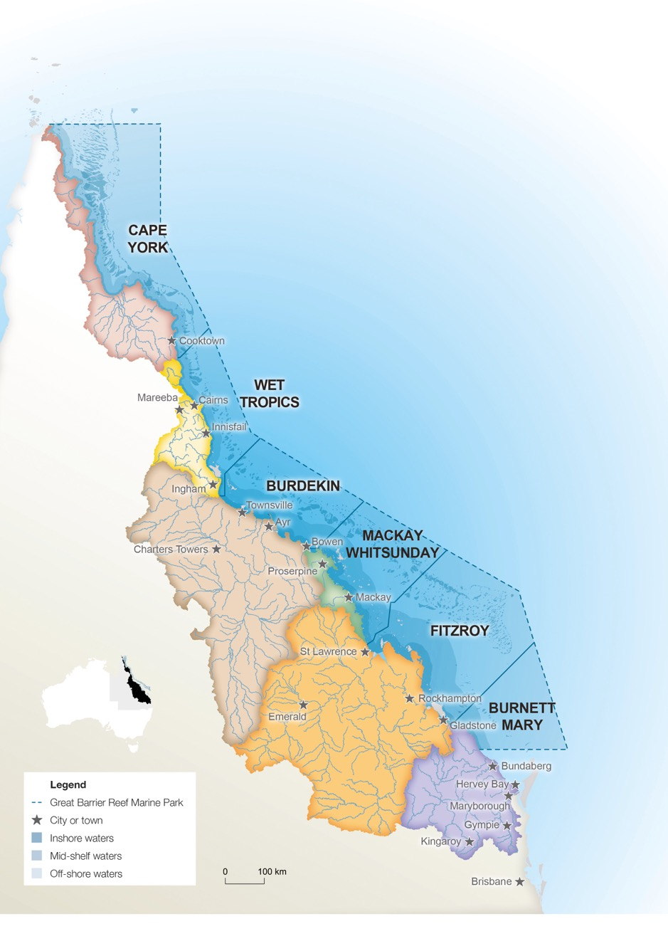

*Figure 5: Map of the Great Barrier Reef Natural Resource Management regions.*

## Legislation and regulation

Reef protection regulations first came into force under Queensland law in 2010 and apply to cattle grazing on properties of more than 2000 hectares and all commercial sugarcane farming in the Burdekin, Mackay Whitsunday and Wet Tropics catchments. However, enforcement of these laws was discontinued in 2011 and instead a voluntary industry led approach supported.

Since the release of the Reef 2050 Plan, the current Queensland Government has reinstated and strengthened its compliance program for these regulations. Eight new officers have been appointed and existing officers have been trained and are undertaking compliance inspections at properties in the catchments.

Under the regulations, it is mandatory for regulated cane farmers to:

• Apply fertiliser at no more than the amount calculated in accordance with a prescribed methodology, taking into account soil testing. Applying fertiliser in accordance with this methodology minimises the risk of nutrient run off from excess application.

• Follow specific controls when using herbicide products containing atrazine, ametryn, hexazinone and diuron, which prevents overspray and run off from herbicide products.

• Keep records of their use of fertilisers and agricultural chemicals to provide evidence to compliance officers of the improvement in practices.

It is mandatory for regulated graziers to:

• Follow specific controls when using herbicide products containing tebuthiuron.

• Apply fertiliser for improved pastures at no more than the amount calculated in accordance with a prescribed methodology, taking into account soil testing.

• Keep records of fertiliser and agricultural chemical use.

Since March 2016, on farm inspections have taken place, with a focus on fertiliser application requirements on cane farms. The inspections are focused on farms that are currently not accredited under the SmartCane Best Management Practice (BMP) program. An accredited cane farmer demonstrates compliance with the regulated standards.

Initial compliance inspections are showing around 40 per cent of growers are not meeting regulatory requirements, suggesting that improvements to water quality will be gained through increased enforcement. Now that the compliance program has been re-established and growers are aware of the legal requirements, stronger enforcement action may become necessary during follow up inspections where non-compliant growers have not improved their practices to meet the legal standards.

One of the Queensland Government’s commitments in the Reef 2050 Plan is to strengthen vegetation management legislation to protect remnant and high value regrowth native vegetation, including riparian zones (EHA20). This commitment will add additional protection to the existing laws limiting land clearing. Current protections include the limitation of clearing in riparian zones in three priority catchments—the Burdekin, Wet Tropics and Mackay Whitsundays.

The strengthening of vegetation clearing laws is an important part of the jigsaw to meet the sediment targets, recognising that the major sediment contributions of hillslope and gully erosion must be addressed.

This commitment was progressed in 2016 with the introduction to the Queensland Parliament of legislation to amend the *Vegetation Management Act 1999* however the amendments were not passed by Parliament. The delivery of this action remains a priority for the Queensland Government and it has committed to passing the legislation within this first phase of the Reef 2050 Plan (i.e. before the Plan is reviewed in 2020).

In additional to state law, federal environment laws regulate actions that are likely to result in a significant impact on matters protected under the EPBC Act, including the Great Barrier Reef. These actions need to be approved before being undertaken.

The Queensland Great Barrier Reef Water Science Taskforce made a number of recommendations to strengthen regulation. This includes setting best practice standards for all industries, improving current best practice standards, mandating catchment load limits and developing a water quality offsets framework to drive nitrogen and sediment reduction.

The Queensland Government has accepted these recommendations in principle and is consulting with stakeholders to implement the recommendations. The Queensland Government will decide whether to initiate further regulatory interventions in 2017. In the meantime, a focus on enforcement of existing regulated standards and increased uptake of the SmartCane best management practice will drive a reduction nitrogen run off.

## Best management practice for the sugar cane industry

Since the commencement of the Reef 2050 Plan, participation in the SmartCane Best Management Practice program has increased with 1433 farms (covering 255 584 ha) completing the initial processes (benchmarking) and 142 farms (covering 42 611 ha) becoming fully accredited. It is expected that this trajectory will continue and many more farms will become accredited over the next two years.

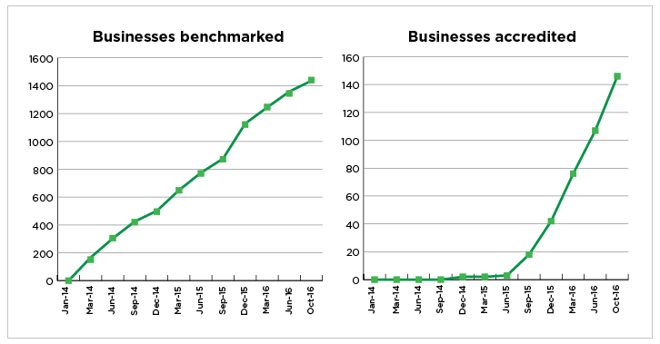

*Figures 6 and 7: Show the number of cane farms benchmarked and becoming accredited through the SmartCane BMP program.*

The table below shows the progress to date in moving to Best Practice Management. With 61 per cent of land now covered, environmental dividends are expected to flow from this. The potential for further gains is also clear.

|  |  |
| --- | --- |
| **Rates of Adoption of BMP** | **Cane** |
| Total number of farmers | 3777 |
| Number of farmers who have participated in BMP | 1371 (37%) |
| Area of land covered by BMP | Approximately 61% |
| Number of farmers who are BMP accredited | 119 (3%) |

|  |
| --- |
| **Great Barrier Reef Report Card 2015** |
| Since 2009, annual reporting indicates that while progress has been slow, we have been steadily trending in the right direction towards the water quality targets. The latest Great Barrier Reef Report Card shows where gains have been made and where more effort is needed. These results don’t reflect all efforts, capturing only the results of one grants program—the Australian Government Reef Programme. Other actions including Queensland Government and Reef Trust investments, will be captured in Report Card 2016.  Report Card 2015 shows almost half the horticulture and grains land across the Great Barrier Reef catchments is already managed using best management practice systems, with more work needed in the sugarcane and grazing industries. The modelled results show an accumulated reduction in sediment of 12.3 per cent and a reduction in pesticides of 33.7 per cent which is more than halfway to the 2018 targets. And while the inshore marine condition remained poor, coral and water quality improved, in part due to some recent drier years, which gave the reef a chance to recover after a number of floods and tropical cyclones. |

## Investment in on-ground action to improve water quality

The Australian and Queensland governments have added to their on ground actions to improve water quality in 2015 and 2016.

The Australian Government’s Reef Trust continues to invest in projects designed to improve water quality and implement innovative practices. Since 2014, more than $110 million has been allocated to water quality investments. Projects are designed to target the highest priority threats and locations, informed by science.

In response to the recommendations of the Queensland Water Science Taskforce, the Queensland Government is investing $33 million for two major integrated projects (one focused on nutrients and pesticides in the Wet Tropics, near Cairns; and one focussed on sediment in the Burdekin catchment, near Townsville). The projects will trial a range of coordinated actions, including landholder education, farm management and land use change that will be specifically designed for each area. Outcomes will be closely monitored and reported on.

The purchase of Springvale station in Cape York by the Queensland Government in June 2016 was also a major step to address water quality. Springvale Station was identified as the source of approximately 40 per cent of gully sediment erosion in the Normanby Catchment. The Queensland Government is working with various partners to trial and implement innovative remediation practices on the property, which could then be applied to other vulnerable Reef catchments.

Building on the investment in Springvale station, recent science has highlighted that sediment from gullies is a significantly greater contributor to sediment going out to the Reef than previously thought. This is a challenge as many gullies are legacy issues and cannot be directly attributed to the land management practices of existing landholders. Additionally, effective remediation techniques can be expensive.

To address this, the Australian and Queensland governments, with partner organisations including the Great Barrier Reef Foundation and Greening Australia have established the Great Barrier Reef Gully and Streambank Joint Program. This $45 million partnership brings together various investments in gully and streambank remediation into a coordinated program to ensure that the greatest sediment reduction is achieved and learnings are shared and applied across sites. It is supported by scientific expertise through the Sediment Working Group, which provides advice to project managers. In addition, the Queensland Government is also mapping the soils vulnerable to erosion in the Fitzroy catchment—an area identified as having significant soil loss through gullies and stream bank erosion. The maps will help program managers and research scientists determine remediation priorities to achieve the biggest water quality improvements.

Innovation in water quality improvements has also been a focus since the inception of the Reef 2050 Plan. The Queensland Government in July 2016 established a $9 million Reef Innovation Fund, and initiatives underway as part of the Reef Innovation Fund include:

• Setting out a challenge to develop cheaper water monitoring sensors to provide finer scale water quality information to farmers.

• Establishing a forum to identify potential water treatment systems (e.g. floating wetlands and bioreactors) for trialling in Reef catchments.

• Exploring the implementation of enhanced efficiency fertilisers in the cane industry in partnership with the Reef Trust.

• Trialling of more cost-effective gully and streambank remediation techniques

# 4. Governance and partnerships

The Reef 2050 Plan marks a shift in how the Australian and Queensland governments and their partners collaborate over solving the problems that currently face the Reef. For the first time, all key interests are in a partnership focused on improving the management of the Great Barrier Reef World Heritage Area across the seven themes of the Plan.

## Formal governance structures

There is a long history of cooperative management and protection of the Reef between the Australian and Queensland governments. This is formalised through the Great Barrier Reef Intergovernmental Agreement which was updated and signed by the Prime Minister of Australia and the Queensland Premier in March 2015. Administering this Agreement is the Great Barrier Reef Ministerial Forum made up of Australian and Queensland Environment Ministers, Australian Government Tourism Minister and Queensland Government Deputy Premier.

The establishment of the Reef 2050 Plan strengthened this governance further through the establishment of three advisory bodies as part of the overarching governance framework.

These advisory bodies provide forums where people with a range of expertise, experiences and ideas collaborate to develop strategies for Reef conservation outcomes. Committee members have direct links with important stakeholder groups, providing opportunities for broader public input into policies and strategies and participation in actions to protect the Reef.

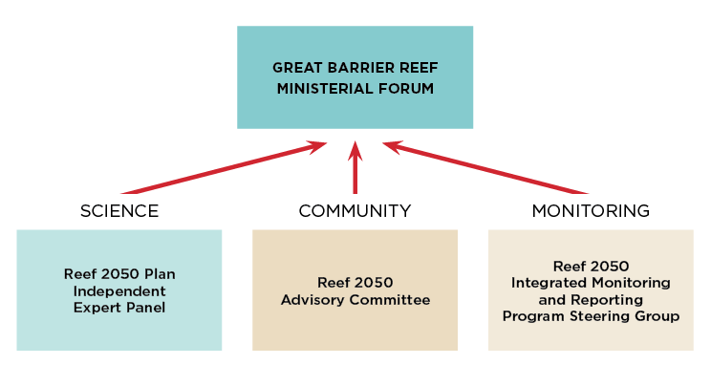

*Figure 8: Primary advisory bodies in the implementation of the Reef 2050 Plan*

*“The new governance arrangements associated with the Reef 2050 Long Term Sustainability Plan (Reef 2050 Plan) is a significant governance innovation as it has the potential to align and integrate effort in all other governance subsystems affecting the Great Barrier Reef. Despite having only been recently established, they are already showing significant benefits in improving the overall system of governance. Key early advances include improved target setting, greater bilateral coordination and deeper partnerships between both governments and the main stakeholders involved in the protection and management of the Great Barrier Reef. Priorities for continuous improvement within these Reef 2050 Plan governance arrangements have also been identified.*

Dr. Allan Dale, Professor of Tropical Regional Development, The Cairns Institute, James Cook University

The scientific integrity of the Reef 2050 Plan is underpinned by the **Independent Expert Panel**, chaired by former Australian Chief Scientist, Professor Ian Chubb AC. This multi-disciplinary group provides advice on Reef Trust investments and implementation of the Reef 2050 Plan. The Panel is performing a valuable role by providing Ministers and management agencies with expert advice on key emerging issues. This year it advised Ministers about the effects of the mass coral bleaching event and appropriate response activities.

*“It's bringing the different disciplines together. We have reef scientists, we have managers, we have people that work in terrestrial, people who work in social and economic sciences and together they bring a lot of diversity of views and I think when you bring those diversity of views that the sum of the parts, it makes up a bigger whole.”*

Dr Andrew Ash, Member—Independent Expert Panel, Chief Research Scientist—CSIRO Agriculture

The **Reef 2050 Advisory Committee** is a representative stakeholder group, chaired by the Hon Penelope Wensley AC, a former Governor of Queensland and Australian Ambassador for the Environment. This 18-member committee is operating effectively in shaping policy development, prioritising the actions under the Plan and building collaboration and community support. It provides the insights of the community, local government, research organisations, Traditional Owners, conservation groups and industries such as fishing, agriculture, resources and ports.

*“I'm an absolute believer in collaboration. It's really the only way that we get things done on the ground. If everybody's going off doing their own things, we're just not getting the value out of the money, and the value out of everybody's efforts on the ground. The partnership is really about bringing everybody together to make decisions about where we all head, and how we might get the best value out of that.”*

Carole Sweatman, Member—Reef 2050 Advisory Committee, CEO—Terrain Natural Resource Management

An **Integrated Monitoring and Reporting Program Steering Group** has brought together monitoring partners and data end users to design and deliver a robust monitoring and reporting program for the Reef 2050 Plan. The Group is overseeing the development and establishment of an integrated monitoring and reporting framework. The Program will report progress on Reef 2050 Plan targets and outcomes across the Plan’s seven themes. The Program will provide key input to the Great Barrier Reef Marine Park Authority’s 2019 Outlook Report.

*“This is a big challenge. The Reef is a very large area, as we all know. It's a very complex system, and it's full of complex challenges that science can't solve, I don't think governments can solve alone. The partnership with end users, with ports, with resources, councils, with farmers, with fishermen, is absolutely essential. And to do our science, those collaborations and those partnerships are also essential. This brings together the people who really can make a difference.”*

Dr. John Gunn, Member—Reef 2050 Advisory Committee and the Integrated Monitoring and Reporting Steering Group, CEO—Australian Institute of Marine Science

## Partnerships delivering actions

The collaborative nature of the Plan extends beyond its governance arrangements. There are many examples of lead agencies working with a range of partners to implement Reef 2050 Plan actions.

**Ships of opportunity**  
Rio Tinto has again partnered with the Great Barrier Reef Foundation and CSIRO to monitor ocean chemistry along the Great Barrier Reef. Rio Tinto has recently committed another $1 million investment which sees its RTM Wakmatha vessel fitted with sensors that collect samples and record data during the ship’s regular voyages from Weipa to Gladstone and back. This is the first large-scale observing system for ocean acidification on the Great Barrier Reef, enabling the changing ocean chemistry along the entire length of the Reef to be monitored for the first time (EHA16).

**Ports code of practice on dredging**  
The ports industry is playing an active role in the implementation of a number of port-related actions within the Plan. Ports Australia led the development of a code of practice for port-related dredging activities. The Queensland Ports Association is leading an action which involves development of a conceptual model of the sediment regime for the four priority ports to better understand the port sediment characteristics and how they interact with the broader catchment (WQA17).

**Working collaboratively with Traditional Owners**A partnership has been established between Queensland Government, Gidarjil Development Corporation and ConocoPhillips (on behalf of Australia Pacific LNG) to support Indigenous land and sea rangers in Gladstone. Under the agreement, the Queensland Government will match funding from ConocoPhillips to enable the Gidarjil Development Corporation to establish a new Land and Sea Ranger team in Gladstone. The team’s work will be tailored to local needs and include strategic weed control, seagrass monitoring, mangrove watch, monitoring marine turtles, cultural heritage surveys and junior ranger activities (CBA3).

# 5. Coral bleaching response

Coral bleaching, due to ocean warming associated with climate change, is one of the most pressing threats to coral reefs worldwide. Mass bleaching events occur during extended periods of elevated sea surface temperatures and have the potential to be widespread, resulting in significant loss of coral.

Since 2014, severe mass coral bleaching has been occurring in most tropical regions across the world in the longest mass bleaching event ever recorded. This global event was triggered by record-breaking sea surface temperatures caused by climate change and amplified by a strong El Niño. For the Great Barrier Reef, this resulted in the worst ever coral bleaching in 2016.

|  |
| --- |
| **Interim findings on the coral bleaching event** |
| The Great Barrier Reef Marine Park Authority’s interim report on the extent of the coral bleaching impacts shows that, as of June 2016, 22 per cent of coral on the Reef had died due to the worst mass bleaching event on record.  Eighty-five per cent of this mortality occurred in the 600 kilometre stretch between the tip of Cape York and just north of Lizard Island. Overall, the area south of Cairns escaped significant mortality.  The Great Barrier Reef Marine Park Authority is currently leading the follow up survey work. The analysis and reporting of this work will take several months to complete, however preliminary findings confirm general spatial patterns of bleaching impacts as described in the interim report. These findings do not yet include information for the Townsville transect. Impacts remain highly variable within and among reefs and regions.  From the Cairns–Port Douglas transect north, coral mortality is greater now than in June 2016, as expected, and more reefs now have greater than 50 per cent bleaching-related mortality. While it appears coral mortality is in line with expectations, it is at the upper end of expectations in areas that experienced the most severe bleaching.  In the Cape Grenville and Princess Charlotte Bay regions (in the Far North), outer-shelf reefs surveyed remain in relatively good condition and have significantly lower mortality than mid-shelf and inshore reefs in these regions. Surveyed outer-shelf reefs in the Lizard region have greater than 50 per cent mortality, as do many other surveyed reefs across the shelf in this region.  The Cairns–Port Douglas region continues to display the greatest variability in mortality levels—some reefs have had substantial mortality of corals and other reefs remain in relatively good condition.  There is already evidence of initial recovery of previously bleached corals on some reefs in the Marine Park. In the southern half, reefs show minimal bleaching-related mortality.  Detailed findings from these latest surveys will be available in early 2017. The interim report on the coral bleaching event is listed as an addendum to this report and is available at www.environment.gov.au/reef2050. |

Each summer season, the Great Barrier Reef Marine Park Authority prepares for the potential impacts of a bleaching event through its Coral Bleaching Risk and Impact Assessment Plan. The plan provides a transparent and consistent decision-making framework during bleaching events to ensure a rapid, robust and coordinated response.

The Authority and key partners recognised and alerted the fact that there would be a high risk of bleaching in 2016, and monitored for early warning signs. As the mass bleaching unfolded, the Authority triggered its Coral Bleaching Risk and Impact Assessment Plan and subsequently it’s largest-ever in-water monitoring effort. The Authority formed an incident management team to coordinate and undertake the surveys, as well as logistics, mapping, data analysis, and stakeholder and broader communications. The incident response was supported by many collaborations and partnerships, and the agency was also a member of Australia's National Coral Bleaching Taskforce.

During the 2016 bleaching event, the three core components of the plan were put into action:

• **Early warning system**—an assessment of the probability of the event was made using an early warning system comprised of climate forecasts, tools that enable near real-time monitoring and site inspections.

• **Incident response**—an incident response system coordinating the governance, planning, operations, logistics, financial and inter-agency liaison arrangements was activated, redirecting resources to where they were most needed. Additional resources were deployed to monitor the extent and impact of the event.

• **Communications strategy**—arrangements for internal and external communications was enacted, enabling accurate, clear and timely communications of the status of bleaching. Regular updates were posted on the Authority’s website enabling anyone to access an up-to-date assessment of the extent of coral bleaching and subsequent coral mortality.

Throughout the bleaching event, in excess of 2600 surveys across 190 reefs were completed to develop a robust understanding of the bleaching. This included 873 surveys comprising a set of seven transects forming a representative sample of reefs along the length and breadth of the Great Barrier Reef to assess the severity of bleaching and allow comparison to previous mass bleaching events. Throughout October and November 2016, the surveys were repeated to determine how much coral died from the event (mortality) and assess early signs of recovery. It is expected the assessment from these latter surveys will be finalised in early 2017.

The initial surveys showed that bleaching was most severe in the northern most part of the Reef (north of Cooktown), decreasing southward. The gradient for mortality was even more pronounced with most mortality occurring in the 600 kilometre stretch between the tip of Cape York and just north of Lizard Island.

Based on this analysis:

• The Great Barrier Reef Marine Park Authority implemented a new policy, ‘Dredging coral reef habitat: operating a facility or carrying out works for the development of marine infrastructure’ to strengthen protection of coral reef habitat from dredging of coral related to development of infrastructure.

• A Coral Stress Response Taskforce was activated with the coral and aquarium fisheries and resource managers to minimise impacts on reef ecosystems under stress from significant bleaching. The sole aquarium supply business operating north of Cooktown voluntarily agreed not to collect in the region pending the results of further reef health surveys. The sea cucumber and tropical rock lobster industries also participated.

• Research institutions permitted to collect coral were encouraged to voluntarily suspend coral collection activities for research purposes in the Far Northern Management Area.

• The Great Barrier Reef Marine Park Authority implemented education initiatives with fishers to reinforce the importance of protecting herbivorous reef fishes to support recovery processes on coral reefs.

Additional scientific research has been commissioned to monitor recovery of the Reef and look at ways we can build resilience to future bleaching and support better recovery of corals. An interim report on the coral bleaching event with more detailed information is available at www.environment.gov.au/reef2050.

The Reef 2050 Independent Expert Panel provided advice to government in early to mid-2016 about the event and the climate change implications and risks for the Great Barrier Reef. The advice highlighted that efforts to address water quality and direct impacts must be combined with sustained global efforts to sharply reduce greenhouse gas emissions to ensure long term health of the Reef. In addition, at the Great Barrier Reef Ministerial Forum in November 2016 Minister’s requested that the state and commonwealth departments and Great Barrier Reef Marine Park Authority provide advice back to the Ministerial Forum on any further action required apart from what is already occurring within the Reef 2050 Plan for the Northern Great Barrier Reef most affected by the bleaching event. They further requested that this advice be informed by science and stakeholder input including the results of the latest surveys and monitoring.

# 6. Adaptive management strategy

Central to the Reef 2050 Plan is the ability to respond adaptively to emerging risks and changing circumstances underpinned by the evaluation of management effectiveness.

Australia has established a multi-jurisdictional and multi-disciplinary integrated monitoring, modelling and reporting program to drive the adaptive management of the Great Barrier Reef. The objectives of the Program are to:

• Enable the early detection of trends and changes in the Reef’s environment, inform the assessment of key threats and future risks and drive adaptive management.

• Inform the evaluation of management effectiveness, including efforts to maintain and enhance ecosystem health; marine biodiversity and coastal habitats; water quality; heritage values and social and economic benefits derived from the environment.

• Ensure investments are focused on actions that will deliver measurable results.

• Inform regional stakeholders and the national and international communities on whether the Reef 2050 Plan is on track to address key threats and deliver its vision.

Early development of the Reef 2050 Integrated Monitoring and Reporting Program has focused on coordinating, aligning and integrating the 100-plus existing monitoring and modelling programs. This work recognises the need for a consistent approach, but also acknowledges that regional variations occur in the condition of values, the pressures affecting these values and management responses.

The Program will include monitoring and reporting of key attributes within the Reef catchment and link to the governance, monitoring and reporting arrangements associated with the Reef Water Quality Protection Plan and the development of regional report cards.

|  |
| --- |
| **eReefs collaboration** |
| The eReefs project is a six year $30 million collaborative project that commenced in 2012. It combines government investment, science, innovation and contributions from the private sector. The eReefs system integrates data, models, visualisation, reporting and decision support tools that span the entire Reef area, from paddock to catchment, estuary, lagoon and ocean. The eReefs system provides a comprehensive picture of water circulation and water quality in the Great Barrier Reef lagoon, as it is, has been and will be, to the Reef’s managers, policy makers, government agencies, researchers, industry and communities. This year, initial development of the eReefs models have been completed and a range of water quality scenarios have been run. |

Work is also underway to inform the development of new online reporting tools to reduce time lags between data collection and the publication of results and to improve the accessibility of data.

The design is due to be completed by the end of 2017 and will ensure that the Program will support the Great Barrier Reef Marine Park Authority’s Outlook Report in 2019 and the review of the Reef 2050 Plan in 2020.

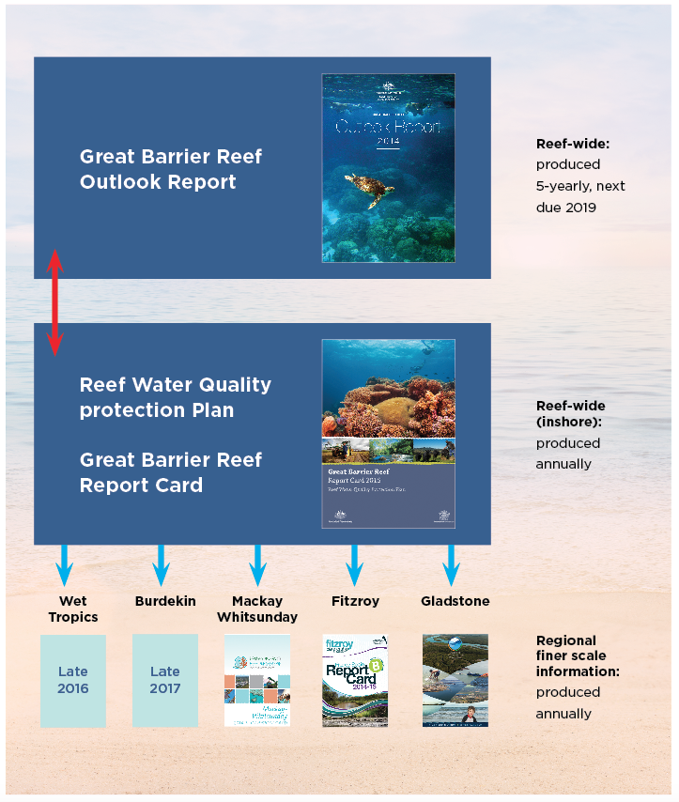

*Figure 9: Adaptive management occurs at Reef-wide, whole-of-catchment and regional scales. Consistent reporting of information at across scales will help better target management activity.*

The Program utilises the International Union for the Conservation of Nature (IUCN) framework for evaluating management effectiveness.

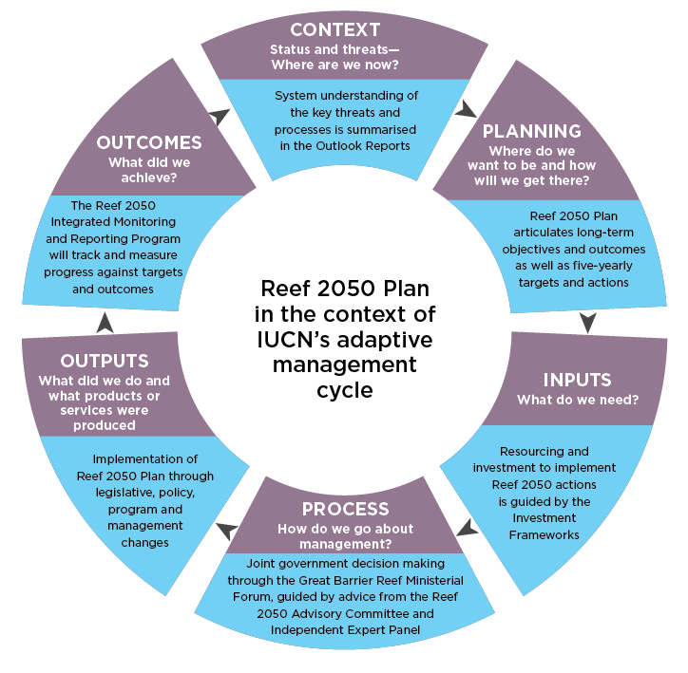

*Figure 10: Adaptive management of the Reef 2050 Plan using the IUCN management effectiveness cycle.*

# 7. Next Steps

## Future priorities for implementation

Future focus areas for implementation from mid 2016-mid 2017 have been identified based on advice from the Independent Expert Panel, Reef 2050 Advisory Committee and the Great Barrier Reef Ministerial Forum. These focus areas are broadly categorised as science and monitoring, investment, Traditional Owner priorities, improving water quality, planning and policies and on ground management. These activities will be underpinned by an ongoing focus on implementing strong foundational management actions to immediately reduce pressures on the Great Barrier Reef, such as boosting compliance with the Marine Parks Zoning Plan. More information on the Implementation Strategy can be found in the Reef 2050 Annual Report and Implementation Strategy 2016.

## Ongoing reporting

Reef 2050 Plan Annual Reports will provide information on the actions and progress towards targets. The five-yearly Outlook Report, next due in 2019, will provide an analysis of the state of the Reef, based on results from the Reef 2050 Integrated Monitoring and Reporting Program.

## Reviewing the Plan

The Reef 2050 Plan will be reviewed and updated on a five-yearly cycle, responding to new information, changing circumstances and emerging issues. Future Outlook Reports and annual reporting will inform progress towards achieving targets, objectives and outcomes and be the principle guides to review the Plan. These reports will ensure that investments are focused on programs and actions that are effectively delivering results.

The first review will occur in 2020, informed by the outcomes of the 2019 Great Barrier Reef Outlook Report. Recognising the scale and multi-faceted nature of the Reef 2050 Plan, an initial mid-term review will be completed in 2018.

# List of Addenda

The below publications are supporting documents to the update on progress. Full versions are available at www.environment.gov.au/reef2050

A. Reef 2050 Investment Framework

B. Annual Report and Implementation Strategy 2016

C. Interim Report on Coral Bleaching