# AustGovt_stacked.jpg

# Australian Government Reef Achievements (2008 – 2013)

© Commonwealth of Australia, 2014.

Australian Government Reef Programme Achievements 2008 – 2013 is licensed by the Commonwealth of Australia for use under a Creative Commons By Attribution 3.0 Australia licence with the exception of the Coat of Arms of the Commonwealth of Australia, the logo of the agency responsible for publishing the report, content supplied by third parties, and any images depicting people. For licence conditions see [here](http://creativecommons.org/licenses/by/3.0/au/).

This report should be attributed as Australian Government Reef Achievements 2008 – 2013, Commonwealth of Australia 2014.

#### Disclaimer

The views and opinions expressed in this publication are those of the authors and do not necessarily reflect those of the Australian Government or the Minister for the Environment.

[Australian Government Reef Achievements (2008 – 2013) 1](#_Toc390346274)

[Background 6](#_Toc390346275)

[The challenge 9](#_Toc390346276)

[Prioritisation 11](#_Toc390346277)

[Engagement 12](#_Toc390346278)

[Load reductions 16](#_Toc390346279)

[Industry Partnerships 18](#_Toc390346280)

[Monitoring and Evaluation 21](#_Toc390346281)

[Research and Development 23](#_Toc390346282)

[Land and Sea Country Indigenous Partnerships Programme 24](#_Toc390346283)

[Crown-of-Thorns Starfish Control 26](#_Toc390346284)

[What’s next? 28](#_Toc390346285)

[Partners 30](#_Toc390346286)

This report provides information on the success of the Australian Government investments to reduce nutrient, pesticide and sediment discharge into the reef from broadscale landuse over the period 2008 to 2013. These activities were supported under the banner of Reef Rescue through to 2013 and will continue to 2018 through the Reef Programme.

The programme supports agricultural land managers to reduce the loads of these pollutants entering the reef from broad-scale land use to increase the resilience of the reef to a range of threats and pressures. The programme is the Australian Government’s contribution to the goals and targets of the Reef Water Quality Protection Plan 2009 (Reef Plan).

## Videos

The following videos provide an overview of the programme and how it assists land managers to implement improved management practices.

[Great Barrier Reef](http://www.youtube.com/watch?v=963wJj01eG4)

Industries:

[Cane sugar](http://www.youtube.com/watch?v=1T-p9NvG7Mo)

[Bananas](http://www.youtube.com/watch?v=9QghhUImmh0)

[Dairy](http://www.youtube.com/watch?v=GfCK0wfz5eE)

[Industry partnerships](http://www.youtube.com/watch?v=ArN_f6_NjOE)

[Grazing](http://www.youtube.com/watch?v=mGesnTde3eQ)

# Background

Since the declaration of the Great Barrier Reef Commonwealth Marine Park in 1975, the Australian Government has worked with countless partners to implement various measures to address pressures on the reef. While the Great Barrier Reef is recognised as one of the best-managed marine protected areas in the world, it is under threat from a range of pressures including outbreaks of crown of thorns starfish, cyclones, floods, and coral bleaching events. These threats were addressed through a suite of investments through the Reef Rescue Programme from 2008 to 2013, including:

* water quality grants for on-ground works, and funding for developing industry partnerships and community participation ($158 million over five years);
* monitoring and reporting ($22 million over five years);
* research and development ($10 million over five years); and
* Land and Sea Country Indigenous Partnerships Programme ($10 million over five years).

Reducing the pollutants from land-based activities that enter the reef lagoon helps to improve the resilience of the reef against other pressures, such as climate change.

This concept was initially developed and proposed by an alliance of regional natural resource management groups, agricultural industry groups and the conservation sector. The proposal presented a return on investment proposition, based upon prior Reef Plan delivery, the science developed through regional Water Quality Improvement Plans and the experience of delivery of past water quality grants programmes.

Programme partners have supported multiple service delivery agents and pathways, developed frameworks to classify agricultural management practices for water quality benefits, established metrics and expert panels to assess grants, and facilitated cross-regional and cross-industry coordination. Importantly, regional processes have been adapted to suit regional contexts (landscapes, farming systems and regional capacity).

At the industry-level, peak agricultural industry groups have worked with regional natural resource management groups to develop and implement industry-specific programmes to deliver grants, training and extension and assisted in the development of management practice frameworks, provided industry-wide coordination and communication activities and supported cross-regional and cross-industry coordination.

An independent evaluation, by Eberhardt Consulting, undertaken in 2011 indicated that the successful delivery of the programme could be attributed to the partnership delivery model and collaborative programme development, which demonstrated the “strength and commitment of this network to lead a community change process”. Through stakeholder surveys and analysis of the first three years, the consultant found that “the devolution of the grants program to regional NRM bodies and the collaborative networks supported with industry groups has been a key [success of the programme]. Devolution has allowed regions to tailor programs to local contexts, leverage additional support and build local capacity and ownership. The collaborative network with agricultural industry groups has provided substantial added value to this process.”

#### Case study summary

### Fitzroy Basin

Water quality grants formed the backbone of the Australian Government’s reef investment. Springsure farmers, David and Adele O’Connor demonstrated just what can be achieved in improving water quality, profitability and productivity.

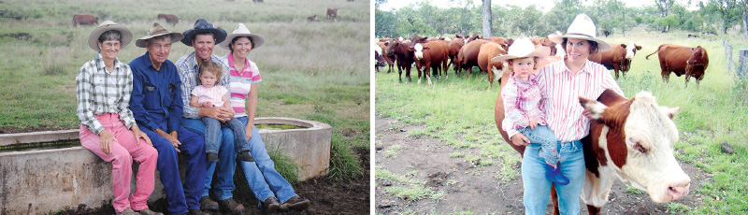

David and Adele O’Connor and family on their property. **Photo**: Queensland Farmers Federation.

[For further details please see Regional Achievements Summaries](http://www.environment.gov.au/topics/marine/great-barrier-reef/protecting-reef#Australian_Government_Reef_programme).

#### Case study summary

### Mackay Whitsundays

Water quality grants formed the backbone of the Australian Government’s reef investment. Marian canefarmer, Rodney Lamb demonstrated just what can be achieved in improving water quality, profitability and productivity.

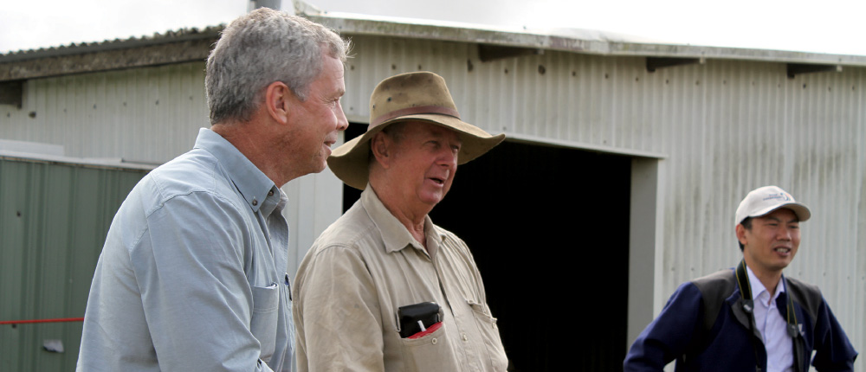

Marian canefarmer, Rodney Lamb (centre) at a field day. **Photo:** Queensland Farmers Federation.

[For further details please see Regional Achievements Summaries](http://www.environment.gov.au/topics/marine/great-barrier-reef/protecting-reef#Australian_Government_Reef_programme).

# The challenge

The Great Barrier Reef is the largest coral reef ecosystem on earth and one of the best managed marine areas in the world. At 348,000 square kilometres, and including some 2,500 individual reefs of varying sizes and shapes and over 900 islands, the reef is one of the richest and most diverse natural ecosystems on Earth. The unique qualities of this property were recognised in 1981 when it was inscribed on the World Heritage List.

The Great Barrier Reef is under pressure from many factors - one of which is the poor quality of water from catchment runoff. Poor water quality affects the health of the reef, causing degradation of inshore reefs and contributing to crown-of-thorns starfish outbreaks. These impacts decrease the Great Barrier Reef’s ability to withstand and recover from the cumulative impacts of other threats, such as climate change and the increasing intensity of extreme weather events.

The Reef Water Quality Protection Plan (Reef Plan), established in 2003, and updated in 2009 and 2013, is a framework for the Australian and Queensland governments to work together - along with industry, regional natural resource management bodies and experts - to improve the quality of water flowing into the Reef.

The Great Barrier Reef catchment comprises six natural resource management regions and 35 major river catchments, which drain 424,000 square kilometres of coastal Queensland. These catchments are spread from the tip of Cape York in the north to Harvey Bay in the Burnett Mary region, in the south. Climate, topography and land use vary significantly across the Great Barrier Reef catchment, from the large dry catchments dominated by rangeland grazing (the Burdekin and Fitzroy) to small, steep, high rainfall catchments with intensive agricultural and coastal development (such as the Wet Tropics and Mackay Whitsunday regions). The priority water quality issues are nutrients and pesticides from intensive agriculture (sugarcane, horticulture and cropping) and sediment and associated particulate nutrients from grazing lands.

Grazing (77 per cent) is the dominant agricultural land use, particularly in the Burdekin and Fitzroy regions. Sugarcane (1.4 per cent) and horticultural crops (0.2 per cent) are more prevalent on the coastal floodplain with high rainfall and irrigation. Grain crops and irrigated cotton are prevalent in the inland areas of the Fitzroy region.

The Reef Plan was designed specifically to help address water quality impacts from agricultural practices, however it is important to note that the 2013 Scientific Consensus Statement indicates that pollutant loads from point sources, including manufacturing, industry, mining, urban environments, waste treatment, ports and shipping, are relatively small but can be locally significant in terms of the declining quality of water entering the reef.

#### Case study summary

### Burnett Mary

Water quality grants formed the backbone of the Australian Government’s reef investment. Monto dairy farmer, Geoff Downie demonstrated just what can be achieved in improving water quality, profitability and productivity.

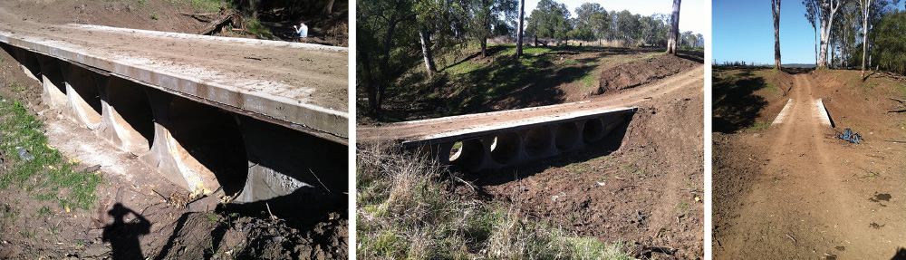

Monto dairy farmer, Geoff Downie’s new creek crossing on Three Moon Creek. **Photo:** Queensland Farmers Federation.

[For further details please see Regional Achievements Summaries](http://www.environment.gov.au/topics/marine/great-barrier-reef/protecting-reef#Australian_Government_Reef_programme).

# Prioritisation

The Australian Government is committed to using the best available science and expert opinion to target investments and prioritise actions to achieve the best outcomes for the reef with the available resources.

In 2008-09 the Australian Government delivered reef investments with a focus on ‘no regrets’ actions, preferentially targeting intensive agriculture close to the reef coast.

During 2008-09 the Australian Government, working with the key scientists and stakeholders, undertook a detailed multi-criteria analysis to help refine priorities. This process resulted in an increased emphasis on rangelands grazing in the Fitzroy and Burdekin regions, decreased priority for dairy (present in Wet Tropics and Burnett Mary regions) and increased funding for the Cape York region for research to define future investment priorities and actions for this region, where information was limited.

Australian Government reef investment priorities are reviewed regularly as new monitoring, modelling and research information becomes available, in line with the principles of adaptive management.

#### Funding for Water Quality Grants by industry based on prioritisation outcomes.

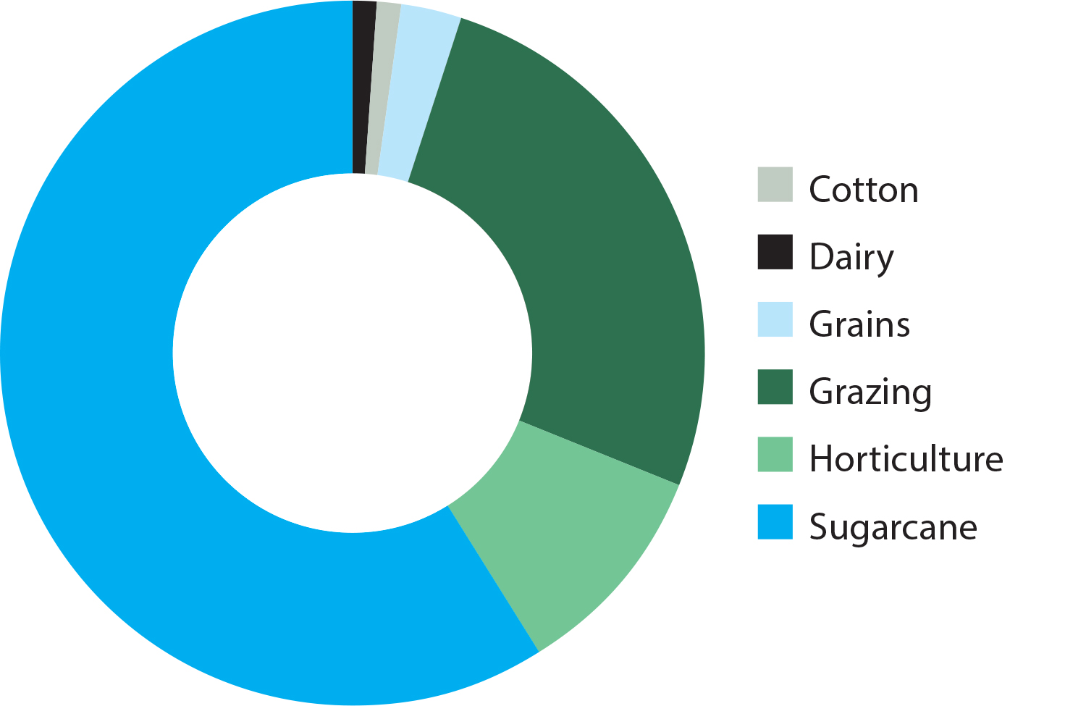

# Engagement

Encouragement of effective partnerships and engagement between key stakeholders, including industry, regional natural resource management groups, research organisations, governments and landholders, is crucial in driving on-ground land management practice change.

Producer engagement promotes the accelerated uptake of on-ground activities and improved practices to ensure the delivery of productivity and water quality outcomes, thereby maximising return on investment and public and private benefits.

Engagement in changing management practices was a key target against which investments over the five years from 2008 to 2013 would be measured.

2008-2013 Management Practice targets:

Increasing by 1300 the number of farmers adopting land management practices improving the quality of water reaching the Reef lagoon.

Increasing by a further 650 the number of pastoralists improving ground cover monitoring and management over an area of 3.8 million hectares where run-off from grazing was significantly contributing to sediment loads, and a decline in the quality of water reaching the Reef lagoon.

### Key achievements

* **4074** land managers (2828 farmers and 1246 graziers) have undertaken training and/or on-ground multi-farm and individual projects to change their farm practices.
* **$76 million** was provided to **3876** land managers for individual on-ground projects to change their farm practices.
* **$16 million** was provided to **200** land managers involved in multi-farm projects to change their farm practices.
* **5160** grants for individual and multi-farm projects were disbursed.
* The physical area where farm practices have been improved represents over **2.3 million hectares** (1.5 million hectares of which is grazing land).

Total number of new landholders in each industry engaged in individual or multi-farm projects and/or training activities since July 2008.

Over the period 2008 to 2013, management practice achievements have exceeded all targets across all industries.

Significant numbers of agricultural producers across the reef catchments have adopted individual improved land management practices which will help reduce the amount of pollutants leaving the catchment and entering the reef.

#### Total number of new landholders in each industry engaged in individual or multi-farm projects and/or training activities since July 2008.

|  | **Number individual landholders** | **Farm area (hectares)** | **Practice improvement (hectares)** |
| --- | --- | --- | --- |
| Cotton | 36 | 143,877 | 36,547 |
| Dairy | 61 | 8,626 | 4,491 |
| Grains | 293 | 661,644 | 206,803 |
| Grazing | 1,238 | 8,187,615 | 1,483,836 |
| Horticulture | 389 | 101,828 | 32,243 |
| Sugarcane | 1,852 | 356,842 | 295,282 |
| **Total** | **3,869** | **9,460,432** | **2,059,202** |

#### Graziers engaged through incentives, training and extension

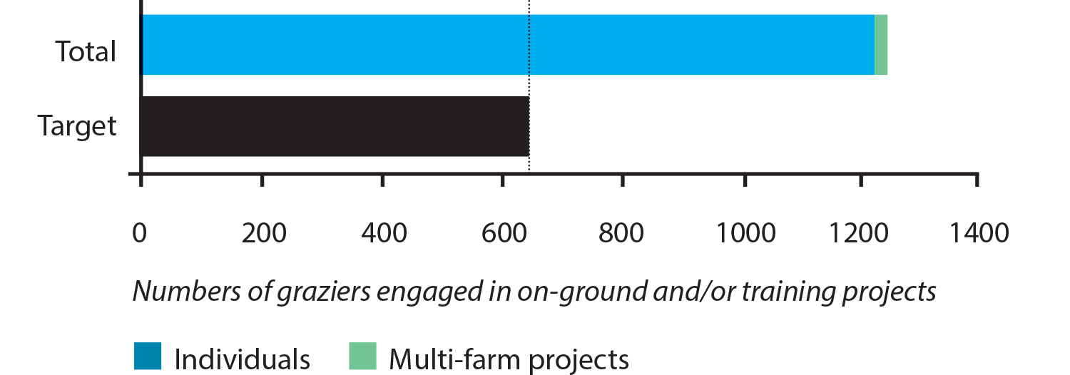

#### Farmers (excluding grazing) engaged through incentives, training and extension

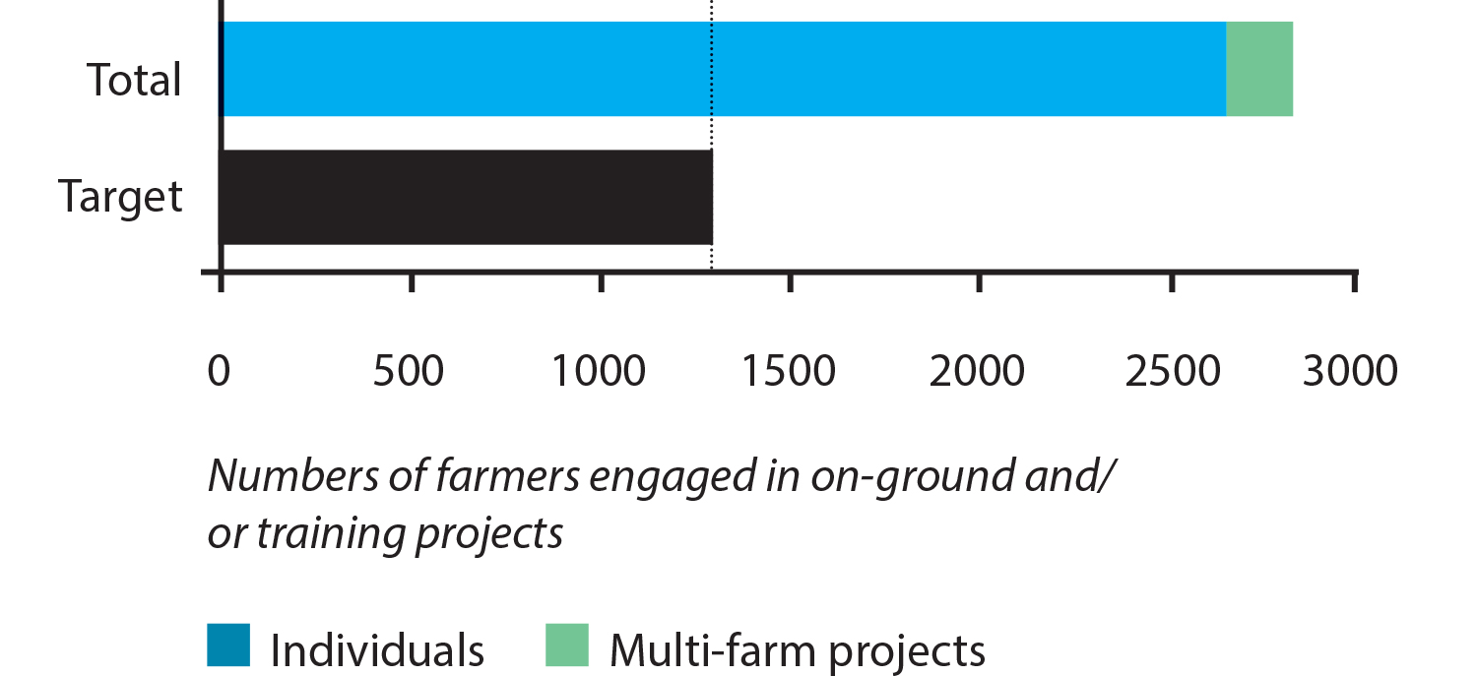

Between 2008 and 2013, the improved management practices implemented by landholders resulted in a reduction in the annual average load of **particulate nitrogen** by **542 tonnes per year**.

Between 2008 and 2013, the improved management practices implemented by landholders resulted in a reduction in the annual average load of **total suspended sediment by 497,400 tonnes per year**. This is equivalent to 24,870 semi-trailers each carrying 20 tonnes of sediment.

* **One in five** landholders farming in the six reef catchments are now engaged and have improved their practices.
* The area they farm covers **a third** of the total agricultural land in these six catchments.
* These farms were specifically targeted for their potential to reduce pollutants and sediment discharge.
* Extent of engagement through incentives and training per industry (Reef Plan Report Card 2012 and 2013 Management Practice results)
  + 17 % graziers
  + 48% canegrowers
  + 59% horticulture producers
  + 46% of dairy producers
* **One in eight** graziers were involved **200,000 hectares** of riparian area have been protected. This is equivalent to the size of **286,000 soccer fields**.
* Over **2000 kilometres** of river frontage has been protected.
* **1470** new watering points have been installed to stop cattle damaging riverbanks.
* Number of graziers involved is nearly double the initial target of 650:
  + These graziers own or lease over **8 million hectares** of grazing land (total property area target was **3.8 million hectares**).
  + They have improved their practices over **2.4 million hectares** of the 8.1 million hectares of land that they own, lease or manage.
  + **21%** of the vast areas of land owned by graziers are therefore under improved practices, which maximise groundcover, and minimise riparian and gully erosion processes.

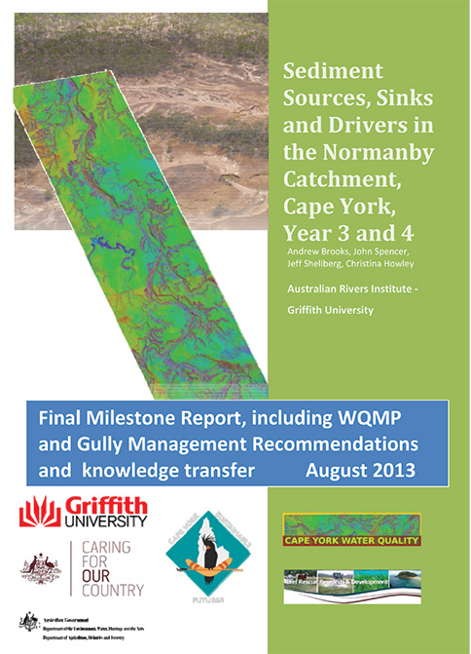

Sediment Sources, Sinks and Drivers in the Normanby Catchment report by Griffith University and partners. Photo: Griffith University

#### Case study summary

### Cape York

Research is imperative in enabling informed decisions based on the relative threats of pollutants to the Great Barrier Reef. Griffith University and partners undertook an investigation into the major sources of sediment in the reef catchments of Cape York to address a significant knowledge gap.

#### Total land area of grazing properties engaged

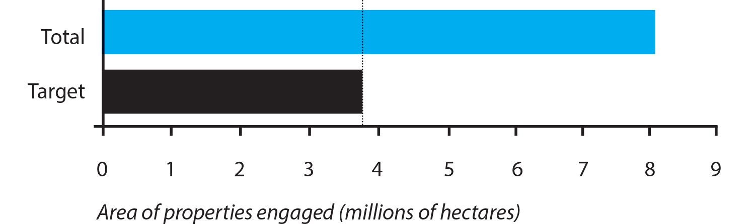

# Load reductions

Water quality targets guiding Australian Government investment from 2008 to 2013 were a subset of the ambitious targets set through the intergovernmental Reef Water Quality Protection Plan 2009.

### 2008-2013 Water Quality Targets:

* Reduce the discharge of dissolved nutrients and chemicals from agricultural lands to the Great Barrier Reef lagoon by 25 per cent.
* Reduce the discharge of sediment and [particulate] nutrients from agricultural lands to the Great Barrier Reef lagoon by 10 per cent.

As a result of land managers implementing improved management practices, the programme has met a minimum of 80 per cent of the targeted modelled reductions in pollutant loads; in all but dissolved inorganic nitrogen which achieved 64 per cent. These achievements may have been significantly higher if all projects had been included in the load reductions estimates (for example investments in horticulture and dairy cannot be modelled at this time).

The 2013 Scientific Consensus Statement suggests that achieving best management practice alone may not be enough to achieve the nitrogen target for Reef Plan and Reef Rescue and that innovative approaches and a broadscale commitment to improved nutrient management will be necessary to achieve the Reef Plan long term targets and goals.

Water quality modelling results based on reported improvements in land management practices indicate a reduction in the amount of key pollutants leaving the reef catchments which will have a positive impact on the health and resilience of the reef in the long term. The modelled results in this report are representative of the project data collected by the natural resource management regions. Load reduction modelling is carried out through the joint Australian and Queensland government Paddock to Reef programme.

### Catchment loads

Differences in annual rainfall may cause the pollutant loads entering the reef lagoon to vary significantly from year to year. Therefore catchment modelling is used to correct the annual pollutant loads by removing the influence of climate and estimate the long term annual load reductions due to the adoption of improved management practices.

Between 2008 and 2013, the improved management practices implemented by landholders resulted in a reduction in the annual average load of **dissolved inorganic nitrogen (DIN) by 847 tonnes per year**.

#### Percentage reduction in dissolved nutrient and chemical (PSII pesticides) loads from 2008-09 baseline

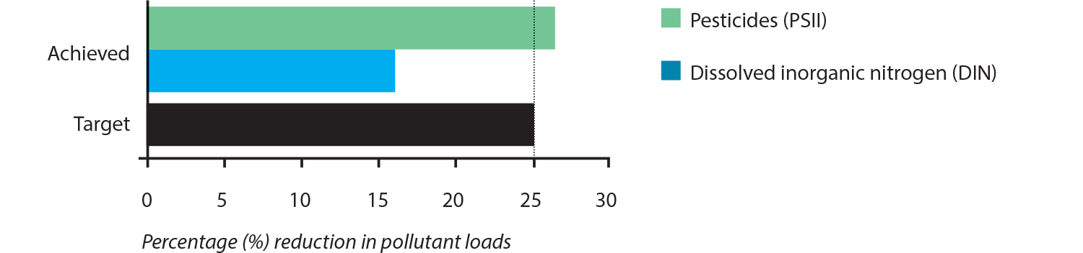

Estimates of progress towards load reduction targets is modelled using well documented methods and assumptions developed through sound scientific research. Long term water quality monitoring at the paddock and catchment scales is used to validate these modelled results. The progress towards the target is measured in terms of the reduction in loads due to improved agricultural practices in the reef catchment area. The load reductions do not include all activities undertaken through the programme and are, therefore, considered an underestimate of total progress. For example, water quality improvements from the 2008-09 baseline for the horticulture and dairy industries were not modelled. This is mainly due to limitations with the water quality modelling which will be addressed in future reporting.

For further information about the methods, [go to this link](http://www.reefplan.qld.gov.au)

#### Percentage reduction in total suspended sediment (TSS) and particulate nutrient loads from 2008-09 baseline

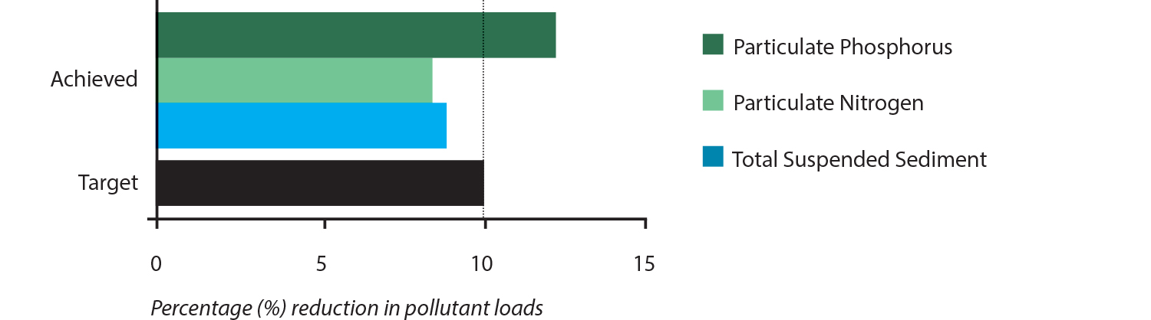

### Costs of pollutant load reductions

The modelled Reef Rescue pollutant load reductions and total costs for the five year programme were used to estimate approximate costs of sediment, dissolved inorganic nitrogen (DIN) and of photosystem II (PSII) pesticide reduction. The values given are approximate costs to the Australian Government, and do not include co-investment by land managers.

**Suspended (fine) sediment reduction**: approximately $130 per tonne from the adoption of improved grazing land management practices.

**Dissolved inorganic nitrogen (DIN) reduction**: approximately $63,000 per tonne from the adoption of improved fertiliser management practices in sugarcane.

**Photosystem II (PSII) inhibiting pesticides reduction:** approximately $3,500 per kilogram from the adoption of improved pesticide management practices in sugarcane.

It is important to note that these costs are for annual average, ongoing load reductions of the ‘active ingredient’ at the end of catchments. For example, for PSII pesticides, the cost of $3500 per kilogram annual average load reduction would be $350 per kilogram over a period of 10 years. Also, for applied fertiliser nitrogen and applied PSII pesticide, on average only a small proportion is lost to the Great Barrier Reef – less than ten per cent for applied nitrogen and less than five per cent for applied pesticide.

#### Case study summary

### Burdekin

Water quality grants formed the backbone of the Australian Government’s reef investment. Bowen graziers, Barry & Leanne O’Sullivan demonstrated just what can be achieved in improving water quality, profitability and productivity.

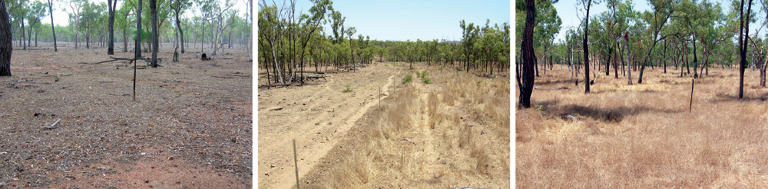

The changes seen on Barry & Leanne O’Sullivan’s property following implementing management changes including fencing to land type and introducing rotational grazing. **Photo:** Queensland Farmers Federation.

[For further details please see Regional Achievements Summaries](http://www.environment.gov.au/topics/marine/great-barrier-reef/protecting-reef#Australian_Government_Reef_programme).

# Industry Partnerships

The Australian Government’s Water Quality Partnerships programme was established with the agricultural industry peak organisations for the purposes of establishing networks and providing communications, training and extension services for the agricultural industries in the Great Barrier Reef catchments. These partnerships played and continue play an important role in supporting the implementation and coordination of on-farm activities funded through the Australian Government Water Quality Grants being delivered by the regional natural resource management organisations. Partners involved during the delivery of the programme have included Canegrowers, Growcom (horticulture), Queensland Farmers Federation, Queensland Dairyfarmers’ Organisation (QDO), AgForce (grazing and grains) and the Queensland Regional Natural Resource Management Groups Collective.

Key achievements delivered under the Water Quality Partnerships include:

* Innovative training and extension services provided to land managers to develop and implement farm planning and management
* Industry and community wide awareness raising and products for water quality improvement and agricultural productivity
* Design and development of best management practice frameworks and toolsets
* Assessment and analysis of best management practices
* Linkages with reef related policy, reporting, research and development, and water quality monitoring and modelling initiatives
* Coordination and reporting of practice change data.

The achievements of all Industry Partners contributed significantly to the outcomes achieved and have resulted in ongoing support for continued water quality outcomes for current Australian Government investment.

An example of the success of the Water Quality Partnerships is demonstrated through Growcom’s involvement. Growcom have greatly assisted the horticulture industry across the Great Barrier Reef catchment to address priority management issues which will have a long term impact on water quality outcomes, farm sustainability and productivity.

Growcom developed (with assistance from stakeholders) the Farm Management System (FMS) Water Quality module which integrates existing resources and programmes, captures data relating to practices and provides a mechanism for providing targeted extension support across the whole horticulture industry.

Growcom directly engaged 65 per cent of the industry in farm management improvement activities and in doing so exceeded its Growcom FMS engagement target by 68 per cent.

**Industry engagement and co-contributions**

During the five-year programme, $92 million of Australian Government grants provided to land managers were matched by $149 million of land-manager co-investment ($105 million in cash and $45 million in-kind).

Industry has co-invested more than $1.62 for every dollar of grant funding received.

Total on-ground project costs amounted to nearly $242 million, $197 million of which was a direct cash injection into regional economies.

Between 2008 and 2013, the improved management practices implemented by landholders resulted in a reduction in the annual average load of Photosystem II (PSII) inhibiting pesticides (PSII) by 4,425 kilograms per year.

Between 2008 and 2013, the improved management practices implemented by landholders resulted in a reduction in the annual average load of particulate phosphorus by 356 tonnes per year.

#### Case study summary

### Wet Tropics

Water quality grants formed the backbone of the Australian Government’s reef investment. Mission Beach banana grower, Ian Barnes demonstrated just what can be achieved in improving water quality, profitability and productivity.

[For further details please see Regional Achievements Summaries](http://www.environment.gov.au/topics/marine/great-barrier-reef/protecting-reef#Australian_Government_Reef_programme).

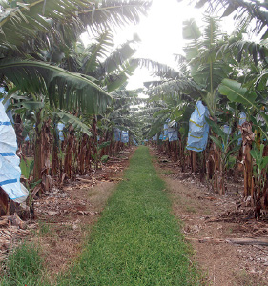

Ian Barnes’ banana plantation. **Photo:** Queensland Farmers Federation.

# Monitoring and Evaluation

### Paddock to Reef Programme

Monitoring, evaluation and reporting over the five years from 2008 to 2013 was conducted under the joint Australian and Queensland government Reef Plan Paddock to Reef Integrated Monitoring, Modelling and Reporting (Paddock to Reef) programme. This was the monitoring and reporting component of Reef Rescue (2008 – 2013).

Further information can be found [here](http://www.reefplan.qld.gov.au/measuring-success/paddock-to-reef.aspx)

The Paddock to Reef programme is a collaboration involving governments, industry bodies, regional natural resource management bodies, landholders and research organisations.

The programme involves monitoring and modelling a range of attributes at a range of scales, including improved management practice adoption, water quality at the paddock, sub-catchment and catchment scales and in adjacent inshore marine areas. This approach provides the ability to link the monitoring and modelling outputs at each scale and across scales.

Paddock monitoring and modelling is an important component of the programme. A range of paddock trials are conducted in various regions to assess the water quality results of different land management practices. Results from some of the trials are detailed in a series of [case studies](http://www.reefplan.qld.gov.au/measuring-success/case-studies/case-studies.aspx).

### Management practice adoption

The objective of collecting management practice information for each industry and region is to determine the extent of change in land management practices that leads to water quality improvements over time. Management practice adoption information provides essential information for the paddock and catchment scale models which, in turn, predict water quality improvement.

### Paddock monitoring and modelling

Paddock scale monitoring provides information on the water quality changes related to specific management practices:

**1. Paddock monitoring** – collecting information about the quality of water leaving paddocks under different management practices.

**2. Rainfall simulation** – collecting run-off from simulated rainfall from a small plot within a paddock. Rainfall simulation captures the variation in response at sites with different soil or land type characteristics.

**3. Paddock modelling** – paddock modelling progressively develops spatial coverage across soil and land types with improved water quality estimations using paddock monitoring and rainfall simulation information.

[Reef Plan hyperlink](http://www.reefplan.qld.gov.au/measuring-success/assets/paddock-to-reef.pdf)

### Marine Monitoring Programme

This programme, delivered by the Great Barrier Reef Marine Park Authority (GBRMPA), is a key component of Paddock to Reef and is a collaborative effort between the government, community, scientists and reef managers. The programme assesses water quality and the condition of seagrass and coral reefs in the inshore Great Barrier Reef lagoon.

GBRMPA is responsible for managing the Marine Monitoring Programme in partnership with the Australian Institute of Marine Science, University of Queensland, James Cook University and the Commonwealth Scientific and Industrial Research Organisation (CSIRO).

These monitoring providers work together to assess water quality, seagrass condition and coral reefs condition.

Each year an annual report card is produced which summarises the health of the Reef and its catchments, actions being taken to reduce the loads of pollutants, and subsequent results.

Further information can be found [here](http://www.gbrmpa.gov.au/about-the-reef/how-the-reefs-managed/reef-2050-marine-monitoring-program).

# Research and Development

The Reef Rescue Research and Development Programme (Reef Rescue R&D) is designed to improve our understanding of the links between land management practices, water quality and environmental impacts on the Great Barrier Reef to support a reduction in the amount of nutrients, chemicals and sediments reaching the reef from agricultural lands.

18 projects were funded, which included research into these priority areas:

* Land management practices that improve water quality outcomes in the sugarcane, grazing, horticulture and dairy sectors;
* The cost - effectiveness of implementing land management practices with water quality benefits;
* The factors affecting the adoption of improved management practices across industries and regions;
* The impact of pesticides on water quality and ecosystems in the Great Barrier Reef; and
* Improved techniques for monitoring and reporting the success of water quality investments in the reef catchments.

The Reef and Rainforest Research Centre (RRRC) coordinated Reef Rescue R&D and provided links between projects within the programme, and to external initiatives.

Reef Rescue R&D forums and regional science forums were held in 2012 and 2013 to share the outcomes of the research with governments and partners implementing on-ground projects to improve water quality and to assist in the prioritisation and design of future projects.

Further information can be found [here](http://www.reefrescueresearch.com.au/).

# Land and Sea Country Indigenous Partnerships Programme

The first phase of the Australian Government’s $10 million Land and Sea Country Indigenous Partnerships programme delivered by the GBRMPA had five key objectives:

* expand Traditional Use of Marine Resources Agreements (TUMRAs) across the Great Barrier Reef Catchment;
* strengthen communications and knowledge sharing;
* enhance compliance;
* engage with communities; and
* build community capacity through grants and sponsorship opportunities.

The TUMRA sub-programme was vital to the overall success of the Programme, as through its development and implementation, Traditional Owners were able to identify and then inform management agencies as to who has the cultural authority to speak for specific land and sea country areas.

The implementation of TUMRAs in the Marine Park directly and indirectly drives co-management strategies, compliance actions and associated compliance support processes. As part of the five-year Programme, enhanced compliance resources and strategies were put in place to address illegal activities that threatened cultural and natural heritage values as well as culturally important species such as dugong and green turtle. During the Programme, Indigenous specific compliance training packages were developed and delivered along the Great Barrier Reef coast and more than 300 people undertook training.

Two funding rounds for Sea Country Grants totalling $1 million were provided to Great Barrier Reef Traditional Owners to support Sea Country management projects. Supported by a Grants Co-ordinator, Traditional Owner groups led important projects that enhanced or supported new sea country management initiatives in the Great Barrier Reef Marine Park.

The first ever Great Barrier Reef Saltwater Women’s gathering, TUMRA Workshop, and an Indigenous Leadership Programme, provided unique opportunities for inclusive shared learning environments and functional connections for Great Barrier Reef Traditional Owners.

#### Key achievements

* Over 70 per cent of Great Barrier Reef Traditional Owner groups were engaged in the management and protection of marine resources and cultural diversity; addressing threats; and enhancing the resilience of the Reef.
* More than 30 per cent of Great Barrier Reef Traditional Owner groups implemented formally recognised management arrangements across seven TUMRAs and one Marine Indigenous Land Use Agreement.
* Agreements cover a total of 46,271 square kilometres of sea country.
* More than 95 Great Barrier Reef Traditional Owners sponsored to attend sea country management related training, events and exchanges domestically and abroad. Participants shared the knowledge, experiences and skills they gained with their communities.

# Crown-of-Thorns Starfish Control

The crown-of-thorns starfish (*Acanthaster planci*) has been identified as one of the key threats to the Great Barrier Reef, with an estimated 42 per cent of all the coral lost on mid-shelf and outer-shelf reefs in the past 27 years, due to starfish outbreaks. Although native to the Great Barrier Reef, under the right conditions crown-of-thorns starfish can reach plague proportions and the damage done to reefs by high numbers of starfish can be catastrophic, often requiring decades to fully recover.

Over 2012 to 2013 the GBRMPA was provided $2 million to engage with the Association of Marine Park Tourism Operators (AMPTO) to undertake tactical management of the current crown-of-thorns starfish outbreak on targeted high value tourist reefs. The Crown-of-thorns Starfish Control Programme aims to maintain coral cover on high value tourist reefs through the removal of adult starfish. By reducing the amount of coral lost to starfish predation, the reefs have a reduced recovery period and can then act as seeder reefs, thereby assisting coral recovery over a greater area.

The Australian Institute of Marine Science (AIMS) and James Cook University (JCU) were also funded to field test and validate a new single injection method for killing crown-of-thorns. Replacing the multiple injection method (up to 20 injections per starfish) of sodium bisulphate with the single injection method has provided a significant increase in the efficiency with which high value tourist reefs can be protected from starfish damage. A number of research institutes such as JCU, the CSIRO and AIMS were also assisted through access to data, specimens and samples and providing berthing on the Programme vessel for researchers to undertake open water studies.

#### Key achievements

* Culling of over 89,000 crown-of-thorns starfish in the first year of the programme   
  (2012 to 2013).
* Establishment of partnerships between the Australian and Queensland governments, AMPTO, AIMS and key academic institutions to more effectively manage crown-of-thorns starfish.
* The validation and operational use of the single injection culling method leading to a significant increase in efficiency, enabling divers to cull significantly more starfish per dive.
* Reduced starfish predation on high value reefs, minimising coral cover loss for the dive tourist industry. By preserving high value reefs local tourism jobs and the tourism industry are protected, contributing significantly to protecting the $5.7 billion reef contribution to the Australian economy.
* Building the capacity of tourism industry staff to undertake control activities at their own sites.
* Significant in-kind support from local businesses.

# What’s next?

### Australian Government Reef Programme

The Australian Government is supporting Reef Programme (formerly Reef Rescue) activities for delivery from 2013 to 2018 as a component of the National Landcare Programme.

Link: [Australian Government Reef Programme](http://www.nrm.gov.au/funding/reef-rescue/)

The programme will contribute to the delivery of the Reef 2050 Plan and will continue to contribute to the Reef Water Quality Protection Plan 2013 (Reef Plan).

Link: [Reef Water Quality Protection Plan 2013](http://www.reefplan.qld.gov.au/about.aspx)

The following components are being supported through the Reef Programme:

* Water Quality Grants and Partnerships
* Systems Repair and Urban Grants
* Water Quality Monitoring and Reporting and Research and Development
* Crown-of-thorns Starfish (COTS) Control
* Land and Sea Country Partnerships
* Critical Operational Support for the GBRMPA

The Australian Government Reef Programme (2013 – 2018) continues to support activities to improve the quality of water entering the Great Barrier Reef by helping agricultural land managers across the reef catchment adopt improved land management practices that will reduce the discharge of nutrients, sediments and pesticides into the reef lagoon.

The programme also supports a wide range of managers and researchers across the Great Barrier Reef catchment, including in urban areas, to undertake research and planning to address threats to the reef caused by declining water quality and climate variability.

### Reef 2050 Long Term Sustainability Plan

The Australian and Queensland governments are currently working together to develop the Reef 2050 Long Term Sustainability Plan (the plan).The plan will outline the vision, outcomes and targets for the Great Barrier Reef World Heritage Area, identify a series of collaborative actions and establish an integrated monitoring programme to measure progress towards outcomes and targets. The plan will build upon a strong foundation of existing programmes and identify areas where further collaborative steps can be taken to improve the health and resilience of the Great Barrier Reef. The result will be an overarching framework guiding the protection and management for the Great Barrier Reef from 2015 to 2050.

### Reef Trust

The Reef Trust is being coordinated jointly between the Australian Government, through the Department of the Environment and the Great Barrier Reef Marine Park Authority (GBRMPA), and the Queensland Government, through the Department of Environment and Heritage Protection.

The Reef Trust will commence operation in 2014 -15. In addition to a $40 million contribution from the Australian Government, funding may also be derived from the pooling of offset funds that target specific impacts on the Great Barrier Reef from development activities. Over time, there will also be opportunity for future funding through private investments and philanthropic contributions.

The Reef Trust is a key mechanism that will assist in the delivery of the Reef 2050 Long Term Sustainability Plan. It will provide cost effective, strategic investment to support on-ground action in the Great Barrier Reef catchments for the long-term protection and conservation of the outstanding universal value of the Great Barrier Reef. Investments will be aligned to key outcomes and targets being developed under the Reef 2050 Long Term Sustainability Plan.

The Reef Trust is being developed and implemented in a phased approach. An interim investment strategy identifies the initial round of investment in high priority actions to be funded from July 2014. The interim strategy has been informed by existing scientific, expert and community advice, gathered through consultation with interested groups and community submissions on the Reef Trust discussion paper. Reef Trust investment will build on existing efforts, programmes and funding commitments, not duplicate them.

The focus of the Reef Trust is on known critical areas for investment – improving water quality and coastal habitat along the Great Barrier Reef, controlling the current outbreak of crown-of-thorns starfish, and protecting threatened and migratory species, particularly dugong and turtles.

Link: [Reef Trust](http://www.environment.gov.au/reef-trust)

# Partners

* Australian Government
* Queensland Government
* Great Barrier Reef Marine Park Authority
* Cape York Sustainable Futures
* Terrain Natural Resource Management
* NQ Dry Tropics
* Reef Catchments
* Fitzroy Basin Association
* Burnett Mary Regional Group
* Queensland NRM Regional Groups Collective
* Canegrowers
* Growcom
* Queensland Farmers’ Federation
* Queensland Dairy Farmers’ Organisation
* Agforce
* WWF
* TropWATER
* Research organisations

We would like to acknowledge the support of the Great Barrier Reef research community.