Summary report: the cost-effectiveness protocol used to assist in the prioritisation of the second phase of
Reef Trust investment

Final Report to the Department of the Environment

Prue Addison and Terry Walshe

April 2015

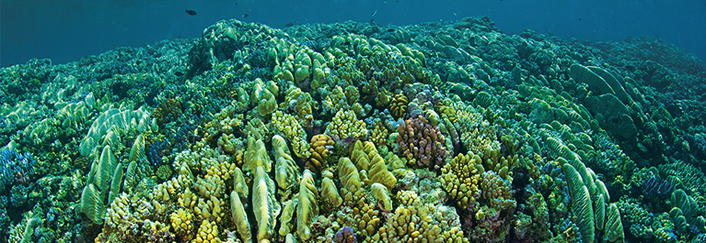

AIMS: Australia’s tropical marine research agency

Executive summary
This report has been prepared by the Australian Institute of Marine Science (AIMS) for the Department of the Environment. It outlines the cost-effectiveness estimation process developed by AIMS that has informed the prioritisation of management interventions for investment under the second phase of Reef Trust. The Reef Trust is a Commonwealth Government programme designed to strategically deliver funding in the Great Barrier Reef and catchments, focusing on known critical areas for investment – improving water quality and coastal habitat along the Reef, controlling outbreaks of crown-of-thorns starfish, and protecting threatened and migratory species, particularly dugong and turtles.
This report provides: (1) an overview of the cost-effectiveness estimation process; (2) a summary of the cost-effectiveness estimates of the nine proposed management interventions under the second phase of Reef Trust; (3) an interpretation of the cost-effectiveness estimates, including a prioritised list of proposed management interventions, ranked in order of cost-effectiveness, to assist the Environment Minister in making decisions on investment through the Reef Trust; and (4) advice on opportunities for improvement in any future application of the cost-effectiveness estimation process.
The cost-effectiveness estimation process follows a series of steps to assist in the prioritisation of management interventions in a transparent and scientifically rigorous way, within the constraints of the resources and time available for decision-making. The cost-effectiveness of each proposed management intervention is estimated by drawing on costings of the management interventions, expert judgement about the environmental benefit of the interventions, and value judgements about the relative importance of Reef Trust natural values. Environmental benefits of management interventions were characterised via four objectives (Reef Trust natural values): seagrass, inshore coral reefs, mid-shelf coral reefs and wetlands.
Experts attended a workshop in December 2014 to estimate the environmental benefits of the nine proposed management interventions. These participants held a cross-section of expertise in the Reef Trust natural values, water quality, and the effectiveness of land or sea-based management interventions in the Great Barrier Reef World Heritage Area (GBRWHA) and in neighbouring catchments. The estimates of cost-effectiveness for the proposed Reef Trust management interventions in the GBRWHA are shown in Figure ES1 and detailed in Section 3 of this report.
A sensitivity analysis of the cost-effectiveness estimates revealed a coarse delineation of proposed interventions, with five interventions consistently achieving higher rankings than the remaining four. Based on the order of most likely cost-effectiveness estimates (blue bars of the cost-effectiveness graph shown in Figure ES1; also verified by the sensitivity analysis in Appendix 8), the top-five ranking proposed interventions are: the rehabilitation of coastal ecosystems (intervention 8), erosion control in priority grazing landscapes (intervention 5), Smartcane best management practice accreditation (intervention 1), farmer led innovative cane management practices (intervention 4), and the expansion of holistic grazing pilot project (intervention 2).
The cost-effectiveness protocol is restricted to an assessment of the estimated return on investment for specified environmental outcomes under the administration of Reef Trust. There is a range of other social and economic factors that will need to be considered when selecting investments under the Reef Trust, alongside consideration of synergies and complementarities with other programs contributing to environmental outcomes for the Great Barrier Reef World Heritage Area. Thus, the results of the cost-effectiveness analysis are intended to be just one line of evidence that the Department of the Environment will use when considering potential investments under the Reef Trust.
Environmental monitoring and assessment will be important for the Department to transparently demonstrate that the selected management interventions are addressing the Reef Trust outcomes: the long term improvement in water quality and coastal habitats in the reef catchments, and protecting species within the GBRWHA. The necessity to use expert judgment in this process means that the estimated environmental benefits of interventions are to some extent speculative. Quantitative monitoring of environmental outcomes will help evaluate the actual benefit of the interventions on the Reef Trust outcomes. Monitoring is the key to adaptive management, whereby re-investment in underperforming interventions can be avoided and greater resources can be allocated to those that exceed expectations. Monitoring data could also be used in predictive models, which could compliment expert judgement to predict the environmental benefits of future management interventions, thus assist future planning and investment decisions in the GBRWHA.
Five key recommendations are made for the future application of the cost-effectiveness process to the Reef Trust: (1) Clarify the description of management interventions (e.g., spatial extent, and anticipated level of adoption of agricultural interventions); (2) Clarify whether maintenance funding will be provided to maintain environmental benefits of interventions in the long term; (3) Consider management interventions at different scales of investment, to explore how varying the scale of investment influences the environmental benefit and thus the cost-effectiveness of the intervention; (4) Decouple local and regional scale benefits to explore whether interventions offer substantial positive benefit at local scales (i.e., within a region); and (5) Allow more time for the experts to understand the decision context and provide consequence estimates.
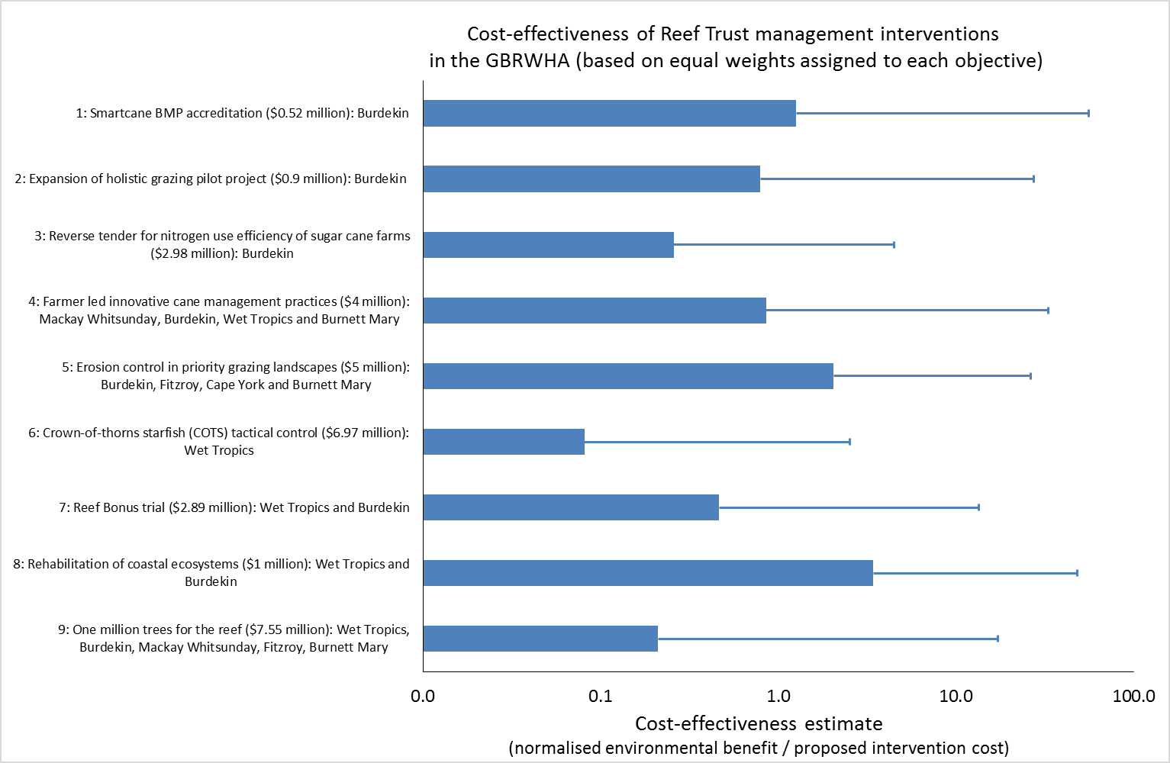
Figure ES1. The cost-effectiveness estimates for the nine proposed interventions, based on equal preference weights assigned to each objective. The most likely cost-effectiveness estimates for each intervention (the solid blue bars) and the best case cost-effectiveness estimates for each intervention (positive error bars) are shown. Note that cost-effectiveness is shown on a log scale.
Table of contents
Glossary of terms 4
1 Introduction 5
2 Methodology 10
2.1 The cost-effectiveness estimation process 10
Step 1 Define the decision context 11
Step 2 Define management objectives 11
Step 3 Develop management alternatives 12
Step 4 Estimate expected consequences 12
Step 5 Evaluate trade-offs and select an alternative 15
2.2 Calculating cost-effectiveness of management interventions 15
3 Results 19
3.1 Summary of the benefits of interventions on attributes 19
3.2 Summary of the benefits of interventions on objectives 24
3.3 The cost-effectiveness of the proposed management interventions 28
4 Discussion 33
4.1 Interpretation of cost-effectiveness estimates for the nine interventions considered under the second phase of Reef Trust 33
4.2 Recommendations for future application of the cost-effectiveness process for Reef Trust management interventions 34
5 Conclusion 38
6 Literature cited 39
7 List of supporting appendices 41

Glossary of terms
Attributes – the water quality parameters (nutrients, sediment and pesticides) and natural values (wetland condition and mid-shelf coral cover) for which experts directly estimated environmental benefits under each of the proposed interventions at the Reef Trust workshop and follow-up meetings.
Attribute benefit – represents the difference between the outcome of the intervention at 2030 (if delivered over the next 3 – 3.5 years), and the most likely outcome of no action at 2030 in a given region for a given attribute (these two estimates were provided by experts at the Reef Trust workshop and follow-up meetings).
Cost-effectiveness estimate – the ratio of the summed objective benefits (i.e., the sum of the benefits on the four objectives) divided by the costs of implementation of each intervention.
Objectives – the Reef Trust natural values (seagrass, inshore coral reefs, mid-shelf coral reefs, and wetlands).
Objective benefit – calculated using an index derived from the five attribute benefits (following equation 3), to represent the difference between the outcome of the intervention at 2030 (if delivered over the next 3 – 3.5 years), and the most likely outcome of no action at 2030 in a given region for a given objective.
Predictive weight –the predicted relative importance of the attributes on the four objectives (Reef Trust natural values).
Preference weight – used in the final cost-effectiveness calculation to reflect the relative importance (value judgement) of the four objectives (Reef Trust natural values).

Introduction
Given the diverse and wide-ranging threats to the Great Barrier Reef World Heritage Area (GBRWHA), strategic prioritisation of management interventions is vital to ensure that threats to the reef are addressed in an effective, efficient and appropriate manner. The Reef Trust was established in 2014 as a funding mechanism for the Department of the Environment (the Department) to invest in management interventions that address the highest priority threats, values and regions of the GBRWHA (as identified within the scope of the Reef Trust; Department of the Environment, 2014a). Under the second phase of Reef Trust, the Department sought to prioritise proposed management interventions based on their cost-effectiveness in a transparent and scientifically rigorous way, within the constraints of the resources and time available for decision-making.
To achieve targeted results from investment and to ensure existing investment is not spread too thinly across the GBRWHA, a process to identify the key threats being faced by the GBRWHA and the priority natural values for protection, improvement and conservation was undertaken in 2014. This process used existing work undertaken for the Great Barrier Reef, drawing heavily on the risk ratings and condition status given to threats and values in the Outlook Report 2014 (GBRMPA, 2014a) and the Great Barrier Reef strategic assessments (GBRMPA, 2014b).
The following criteria were used to determine the threats and values considered as ‘within the scope of the Reef Trust’: natural values needed to align with the three Reef Trust outcomes (water quality, coastal habitats and species protection; as identified in the Reef 2050 Long Term Sustainability Plan; Department of the Environment, 2014b); natural values needed to be listed as either being in Poor or Very Poor condition or Good but deteriorated condition; and the threats to these natural values needed to have a rating of either High or Very High. The resulting list of Reef Trust natural values covered species and habitats such as dugongs, seasnakes, coral reefs, and seagrass habitats (Appendix 1).
The Department prepared an investment framework to provide assistance for developing proposed management interventions for investment under the second phase of Reef Trust. The framework used a 3-tier approach to determining potential Reef Trust investments. The first tier applied an early filtering process based on simple criteria that reflected the essence of the Reef Trust to target investment towards known high priorities within the confines of the defined scope. The second tier assessment was more detailed and aimed to draw out information about the proposed intervention to identify alignment with the Reef Trust principles. This included consideration of previous and current investment, and how the proposed intervention would complement and build on efforts already undertaken. The proposed interventions that addressed tiers 1 and 2 were considered suitable investment prospects for the Reef Trust. The third tier of the investment framework was to assess the cost-effectiveness of the proposed interventions (as presented in this report).
Nine proposed management interventions were put forward for assessment of their cost-effectiveness to inform investment decisions for the second phase of Reef Trust (Table 1). These proposed management interventions were evaluated using estimates of their cost-effectiveness.
The Australian Institute of Marine Science (AIMS) developed a process to assist the Department assess the cost-effectiveness of proposed management interventions and inform investment decisions in the GBRWHA. The cost-effectiveness estimation process follows the steps of structured decision-making (Gregory et al., 2012). Structured decision-making can draw on a broad suite of decision-analysis techniques to aid rigorous, transparent and logical decision-making (Addison et al., 2013), and is increasingly being used to support conservation decision-making around the world (e.g., Runge, 2011; Gregory et al., 2013; Walshe et al., 2013).
This cost-effectiveness estimation process draws on: (1) expert judgement about the environmental benefit of the interventions, (2) value judgements about the relative importance of Reef Trust natural values, and (3) the costings of management interventions. The allocation of Reef Trust resources using cost-effectiveness as a decision criterion can result in optimal or near-optimal outcomes. That is, for a finite budget the greatest cumulative benefit over multiple actions is achieved through selecting the most cost-efficient actions until the budget is exhausted (Weitzman, 1998; Bottrill et al., 2008).
Empirical evidence (e.g., scientific data) is an ideal source of information to predict the environmental benefits of proposed management interventions. However, when empirical evidence about the effectiveness of specific types of management interventions is lacking, carefully elicited expert judgement is a valid alternative (Speirs-Bridge et al., 2010). When using expert judgement to estimate the expected consequences of management interventions, best-practice suggests that better judgments can be expected from multiple experts rather than a single expert (Martin et al., 2012). The Department and AIMS enlisted eleven experts to provide their expert judgement about the environmental benefits of the proposed management interventions considered for investment under the second phase of Reef Trust. These experts were a diverse group of researchers, natural resource managers and planners, who provided a cross-section of expertise in the Reef Trust natural values, water quality, and the effectiveness of land or sea-based management interventions in the GBRWHA and in neighbouring catchments.
Ten experts attended a workshop in Townsville in December 2014 (hereafter the Reef Trust workshop) to estimate the environmental benefits of the nine proposed management interventions. During the workshop, experts discussed the comprehensive list of Reef Trust natural values (Appendix 1) and helped reduce this list to cover key habitats that reflected the Reef Trust natural values and those that were influenced by the proposed management interventions. The final list of environmental objectives included seagrass, inshore coral reefs, mid-shelf coral reefs and wetlands (Table 2). As the majority of the proposed management interventions occurred on land and focussed on improving water quality, the experts agreed that it was necessary to first estimate the effect of the proposed management interventions on water quality attributes such as nutrients, sediment and pesticides (attributes 1 – 3, Table 3).
Experts worked in three groups at the Reef Trust workshop to provide their expert judgment regarding the effect of eight of the interventions (occurring on land and in wetlands) on water quality attributes. Timing constraints meant that the experts were unable to complete the elicitation process for estimating the environmental benefits for the Reef Trust natural values during the workshop.
Following the workshop, experts were invited to comment on whether they considered it necessary to provide estimates of the effectiveness of the proposed interventions on the objectives (seagrass, inshore coral reefs, mid-shelf coral reefs, or wetlands). Eight of the ten experts responded, and all considered that the estimates provided for the water quality attributes made at the workshop would adequately reflect the influence of the eight land-based interventions on two of the environmental objectives: seagrass and inshore coral reefs (Table 2). They considered that it would be worthwhile to provide estimates for two additional attributes (wetland condition and mid-shelf coral cover; Table 3) to contribute to a more comprehensive assessment of the effectiveness of the proposed interventions on the two remaining objectives: wetlands and mid-shelf coral reefs.
In January 2015, two experts provided estimates of the effect of eight of the land-based proposed interventions on wetland condition (all land-based interventions; Table 1), and three experts provided estimates of the effect of crown-of-thorns starfish (COTS) tactical control (intervention # 6; Table 1) on mid-shelf coral cover (as the proposed intervention occurs in the mid-shelf of the GBRWHA).
Experts provided their judgement about the environmental benefits of proposed management interventions, which took the form of quantitative consequence estimates that reflect their conceptual understanding, supported by empirical evidence when available, of cause-and-effect relationships of the management interventions on the attributes.
Following the Reef Trust workshop and subsequent meetings, the experts’ estimates of the environmental benefits of proposed management interventions were pooled and used to estimate the cost-effectiveness of each of the proposed management interventions.
This report provides: (1) an overview of the cost-effectiveness estimation process; (2) a summary of the cost-effectiveness estimates of the nine proposed management interventions under the second phase of Reef Trust; (3) an interpretation of the cost-effectiveness estimates, including a prioritised list of proposed management interventions, ranked in order of cost-effectiveness, to assist the Environment Minister in making decisions for investment through the Reef Trust; and (4) advice on opportunities for improvement in any future application of the cost-effectiveness estimation process.

Table 1. Summary of the nine proposed management interventions considered for investment under the second phase of Reef Trust.
Intervention | Summary | Duration | Cost (AUD) to Reef Trust  GST exclusive
1: Smartcane best management practice (BMP) accreditation: Burdekin | • Grants for farmers to undertake best management practice (BMP), to be accredited at industry or above industry standard.  • This targeted assistance will assist accreditation against the reef water quality related Smartcane BMP modules (e.g., irrigation, soils, nutrients and pesticide management).  • Annual funding for three years would ensure annual review of practices by farmers, helping to maintain compliance with the BMP standards and track management improvement over time.  • Lower cost option compared to grants for infrastructure/equipment and targeting of highest priority practice changes through completion of irrigation, soils, nutrients and pesticide management modules. | 3 years | $517,500
2: Expansion of holistic grazing pilot project: Burdekin | • Extension of ‘holistic grazing’ management approaches across the Burdekin region, linked with grazing best management practice.  • Delivered via direct grant to partner organisation who would engage the landholders, therefore increasing the amount of land managed under a holistic approach.  • There are a variety of assumed benefits of the holistic approach, most notably it is predicted that there will be improved water quality through the reduction of sediment loads leaving the properties. | 3.5 years | $900,000
3: Reverse tender for nitrogen use efficiency of sugar cane farms: Burdekin | • Delivered via a competitive tender, positive financial incentives would be provided to sugar cane farmers in the highest priority sub-catchments of the Burdekin region to improve nitrogen use efficiency and farm sustainability.  • Participating sugar cane farmers can determine their own nitrogen and water use efficiency targets and cost-effective means of achieving those targets. | 3.5 years | $2,982,500
4: Farmer led innovative cane management practices (game changer): Mackay Whitsunday, Burdekin, Wet Tropics and Burnett Mary | • The basis of this project would be farmer based innovation and development of improved nutrient and pesticide management to suit specific land types and landscapes.  • Efficient, cost effective and profitable innovations will then be promoted for wider adoption within the regions (based on appropriate land type and place in the landscape).  • This investment would be managed by one or more regional organisations based on a common formula and would build upon “game changing” work undertaken by Reef Catchments in collaboration with NRM and industry partners. | 3 years | $4,000,000
5: Erosion control in priority grazing landscapes (gully restoration): Burdekin, Fitzroy, Cape York and Burnett Mary | • Through funding guidelines, the Reef Trust partners would seek applications from organisations who wish to undertake the role of delivery partners. The successful applicants will then work with landholders in the regions to pilot low cost, effective techniques guided by the latest available scientific information to address high risk gully hotspots.  • Active gully remediation is possibly research/innovation/A-class (unproven) at this time. Passive gully remediation is B class. Could approach as on-ground trials/demo farms project remediation associated with an extension component, to ensure dissemination of water quality and productivity outcomes and, with water quality and improved BMP development. | 3.5 years | $5,000,000
6: Crown-of-thorns starfish (COTS) tactical control: Cape York, Wet Tropics, Burdekin, Mackay Whitsunday | • The intervention proposes funds from July 2015 for one vessel to continue to undertake tactical control of COTS on high value tourist reefs and development of an Integrated Pest Management approach for management of COTS to reduce predation on coral reefs into the longer-term.  • This COTS control intervention would be delivered by a nominated service provider who would engage a delivery agent for the control. | 3.1 years | $6,970,000

Table 1 cont’d. Summary of the nine proposed management interventions considered for investment under the second phase of Reef Trust.
Intervention | Summary | Duration |  | Cost (AUD)  GST exclusive
7: Reef Bonus trial: Wet Tropics and Burdekin | • Provision of a financial bonus to sugar cane farmers in the lower Burdekin for reducing fertiliser application rates.  • A flexible approach could be used based on growers identifying lower yielding portions of their farms.  • The bonus would be paid retrospectively to farmers. Farmers would be required to maintain fertiliser use records, provide evidence and share their fertiliser use data. | 3.5 years | $2,890,000
8: Rehabilitation of coastal ecosystems: Wet Tropics and Burdekin | • Through a service provider(s), undertake a systems approach to rehabilitating coastal ecosystems to improve connectivity and ecosystem services to the Great Barrier Reef.  • Focus would be on three demonstration creek systems in intensive agricultural production landscapes in the Wet Tropics and Burdekin.  • Different types of intervention such as revegetation, fish passage restoration and weed control will be undertaken in different parts of the system to address connectivity. | 4 years | $1,000,000
9: One million trees for the reef: Wet Tropics, Burdekin, Mackay Whitsunday, Fitzroy, Burnett Mary | • Planting of one million trees across the largest area possible across all the catchments of the Great Barrier Reef. | 3 years | $7,550,000

Table 2. The objectives used to assess the environmental benefits of the proposed management interventions. Note outer coral reefs were not included because the impact of proposed interventions on outer reefs was considered negligible due to distance from river mouths.
Objective | Description
- Seagrass | Seagrass beds provide nursery habitat for several species, contribute to trapping and stabilising large amounts of sediment and nutrient cycling in the GBRWHA. Seagrass habitats occur in estuaries, shallow coastal waters, and in the GBR lagoon – sometimes in association with coral reefs. Seagrass is the main food source for dugongs and some marine turtles.
- Inshore coral reef | Coral reefs provided habitat for hard coral, soft corals, sea fans, sea pens, fish, invertebrates and algae, and contribute strongly to the outstanding universal value of the GBRWHA. Inshore coral reefs occur within approximately 20 kilometres of the coast.
- Mid-shelf coral reef | Coral reefs provided habitat for hard coral, soft corals, sea fans, sea pens, fish, invertebrates and algae, and contribute strongly to the outstanding universal value of the GBRWHA. Mid-shelf coral reefs occur between inshore areas and the outer barrier reefs.
- Wetlands | Natural wetlands are recognised as important coastal habitats that protect the GBRWHA. They slow the overland flow of water, capture and recycle nutrients/sediments that would otherwise enter the GBRWHA. Wetlands also provide important habitats for many animals and plants are integral to some species for key parts of their life cycle.

Table 3. Environmental attributes used to estimate the benefits of the proposed management interventions and no action.
Attribute | Performance measure
- Nutrients | Total load of dissolved inorganic nitrogen (DIN); tonnes/year
- Sediment | Load of total suspended solids, millions tonnes/year. Representing suspended sediment and particulate nutrients.
- Pesticides | Load of total pesticides; kg/year
- Mid-shelf coral | % cover of mid-shelf hard coral
- Wetland condition | Estuarine and freshwater wetland functions and components (index from 1 - 5)

Methodology
The cost-effectiveness estimation process is based on the steps of structured decision-making. These steps promote critical thinking about decisions, providing an organised approach to identifying and evaluating creative alternatives and making defensible choices for complex decisions in the face of uncertainty. Structured decision-making is designed to engage decision-makers, stakeholders and scientists in the decision-making process. The steps of structured decision-making can be supported by a variety of modelling techniques, to incorporate both scientific facts and values, acknowledging that decision-making is rarely a value-free process (Failing et al., 2007; Addison et al., 2013).
The steps of structured decision-making are outlined here with specific reference to the methods used to estimate the cost-effectiveness of the nine proposed management interventions under the second phase of Reef Trust.

The cost-effectiveness estimation process
There are six iterative steps in structured decision-making (Figure 1; Gregory et al., 2012). The first five steps are directly relevant to estimating the cost-effectiveness of proposed management interventions, and are outlined below. The final step of structured decision-making (implement and monitor) is described in the Discussion, as this step is beyond the remit of AIMS’ consultation to the Department.
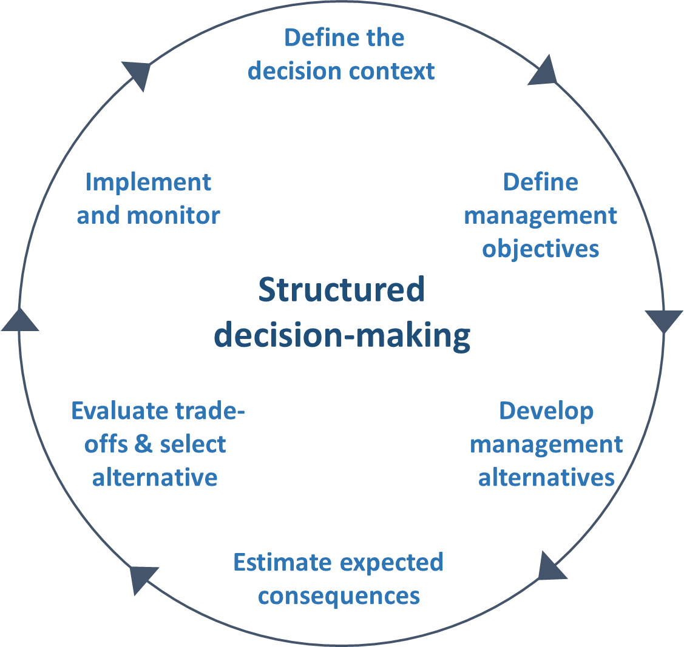
Figure 1. The six iterative steps of structure decision-making, adapted from Gregory et al. (2012).

Step 1 Define the decision context
The decision context was defined by the Department: to prioritise management interventions based on their estimated cost-effectiveness. This prioritised list would then be used to inform investment in a selection of management interventions under the second phase of Reef Trust.

Step 2 Define management objectives
Defining objectives can be surprisingly difficult. Objectives should appeal to decision-makers’ or stakeholders’ fundamental values (Runge & Walshe, 2014). A common mistake is to confuse ‘means’ objectives with ‘fundamental’ or ‘ends’ objectives. Means objectives are intermediate goals that serve as stepping-stones towards the things that are of fundamental concern. For example, the improvement of water quality is a means to the fundamental (end) objective of conserving biodiversity in the GBRWHA. Inclusion of both means and ends leads to double counting, which is an improper approach to assessing cost-effectiveness.
Experts at the Reef Trust workshop helped narrow the list of Reef Trust natural values (Appendix 1) to a shortened list of environmental objectives that reflected key habitats that were directly influenced by the proposed management interventions. The agreed list of objectives were: seagrass, inshore coral reefs, mid-shelf coral reefs and wetlands (Table 2). As the majority of the proposed management interventions occurred on land and focussed on improving water quality, the experts agreed that it was necessary to first estimate the effect of the proposed management interventions on water quality attributes such as nutrients, sediment and pesticides (attributes 1 – 3, Table 3; n.b., these are considered ‘means’ objectives). Experts also agreed on the unit of measurement that would be used to estimate the benefits of the interventions on these attributes, which are referred to as performance measures (Table 3). As the water quality attributes represent ‘means objectives’, these were combined as an index to estimate the effects of the management interventions on the ‘fundamental objectives’ (referred to as objectives here).
Following the Reef Trust workshop, experts agreed that the water quality attributes (means objectives) would adequately reflect the influence of the eight interventions on two of the environmental objectives: seagrass and inshore coral reefs. However, they thought it was also necessary to provide estimates for two additional attributes (wetland condition and mid-shelf coral cover; Table 3) to contribute to a more comprehensive assessment of the effectiveness of the proposed interventions on the two remaining objectives: wetlands and mid-shelf coral reefs.

Step 3 Develop management alternatives
Management alternatives should represent discrete management interventions to benefit the environmental objectives identified in step 2 (Runge & Walshe, 2014). In this case, management alternatives are the proposed interventions that were considered for funding under the second phase of Reef Trust.
Nine proposed management interventions were put forward for consideration by the Reef Trust under phase two of its investment (Table 1). A template (Appendix 2) was prepared to help gather standardised background information about proposed management interventions. The template required details such as a description of the intended goal of the interventions (e.g., to reduce sediment loads entering the GBRWHA), the intervention spatial and temporal scale, and the cost of the intervention. It also required information about the anticipated level of adoption for agricultural practice change interventions, and whether maintenance funding would be required to maintain the environmental benefits beyond the life of the intervention.
It was important that the proposed management interventions were clearly described, as experts were asked to estimate the environmental benefits of these interventions in step 4. The clarity of description of the nine interventions varied substantially, with some proposed management interventions requiring further detail about important aspects such as the anticipated spatial extent and location of the management interventions, and the anticipated level of adoption (for the agricultural practice change interventions).

Step 4 Estimate expected consequences
Estimating the expected consequences of management alternatives on objectives is the traditional domain of predictive science, where data and expert judgment are interrogated and synthesized to provide plausible forecasts (Gregory et al., 2012). When empirical evidence (e.g., scientific data) about the effectiveness of specific types of management intervention is lacking, carefully elicited expert judgement is a valid alternative (Speirs-Bridge et al., 2010).
Experts were asked at the Reef Trust workshop and subsequent meetings to estimate the expected consequences of the nine management interventions and ‘no action’ on attributes defined in step 2 (Table 3). The ‘no action’ management alternative involved the existing level of management in the GBRWHA and catchments, which was assumed to be maintained in the absence of the Reef Trust management interventions until 2030 (i.e., there would be no management interventions funded by Reef Trust management over the next 15 years).
Experts were asked to provide their expert judgement about the environmental benefits of proposed management interventions (which were 3 – 3.5 years in duration; Table 1) over the specified time horizon of 15 years (at 2030). The 15 year time horizon was selected to allow enough time for the environmental attributes to respond to the potential benefits of the proposed management interventions (i.e., taking into account the turnover rate of some of these ecosystems).
Experts were provided with information on the current levels of the environmental attributes, summarised from documented sources (Appendix 3) to assist their estimates of the environmental benefits of the expected consequences of the nine management interventions and ‘no action’ on the five environmental attributes.
The judgements provided by experts were in the form of quantitative consequence estimates that reflected their conceptual understanding of cause-and-effect relationships of the management interventions on the relevant attributes (Table 4). To capture the uncertainty in participants’ judgments and to insulate against overconfidence, the 4-point elicitation technique (Speirs-Bridge et al., 2010) was used. Participants were asked to estimate the following four quantities relating to the environmental benefits of proposed management interventions by 2030 on the attribute performance measures:
- Plausible best case estimate
- Plausible worst case estimate
- Most likely estimate (which should lie between the best and worst case estimates)
- Confidence estimate that the truth will lie between the nominated lower and upper bounds (as a percentage ≥50%)
Experts were asked to make their consequence estimates in each reef catchment where the management interventions are proposed (Table 5): Cape York, Wet Tropics, Burdekin, Mackay Whitsunday, Fitzroy, and Burnett Mary.
Experts worked in three groups (of 3 – 4 people) at the Reef Trust workshop to provide their combined judgment on the effect of eight of the interventions (occurring on land and in wetlands) on water quality attributes. In subsequent meetings, two experts provided their individual estimates of the effect of eight of the land-based proposed interventions on wetland condition (all land-based interventions), and three experts provided estimates of the effect of crown-of-thorns starfish (COTS) tactical control (intervention # 6; Table 1) on mid-shelf coral cover (as the proposed intervention occurs in the mid-shelf region).
This difficult prediction task was made more onerous by considerable ambiguity in the description of several of the proposed interventions. In part, the uncertainty in environmental benefits estimated by the experts stemmed from their variable interpretation of the details of how the interventions would be implemented. In addition, the experts’ uncertainty reflected their views on the technical and social feasibility of implementing the management intervention, the prospects for a run of good (or bad) years (e.g., storms), and uncertainty in the ecological response to the management interventions.
Group and single expert judgements were first standardised to represent 80% confidence bounds. This was done by adjusting the best case and worst case estimates accordingly if these were reflecting experts’ confidence that was lower or higher than 80% (e.g., if an expert provided estimates reflecting 60% confidence, then their best case and worst case estimates were widened to represent 80% confidence estimates). Following standardisation to 80% confidence estimates, the equally weighted group and single expert judgements were then combined to provide an average group estimate of the effectiveness of each management intervention on the relevant attributes. The environmental attribute benefits were then used to estimate the environmental benefit of the management interventions on the objectives (described in detail in section 2.2), and then cost-effectiveness of each management intervention (in step 5).
Table 4. Summary of the combination of management intervention and attribute consequence estimates provided by experts (● = estimate required, - = no estimate required).
Proposed management interventions | Attributes
Proposed management interventions | Nutrients | Sediment | Pesticides | Corals mid-shelf | Natural wetlands
1: Smartcane best management practice (BMP) accreditation | ● | ● | ● | - | ●
2: Expansion of holistic grazing pilot project | - | ● | - | - | ●
3: Reverse tender for nitrogen use efficiency of sugar cane farms | ● | - | - | - | ●
4: Farmer led innovative cane management practices (game changer) | ● | ● | ● | - | ●
5: Erosion control in priority grazing landscapes (gully restoration) | - | ● | - | - | ●
6: Crown-of-thorns starfish (COTS) tactical control | - | - | - | ● | -
7: Reef Bonus trial | ● | - | - | - | ●
8: Rehabilitation of coastal ecosystems | ● | ● | - | - | ●
9: One million trees for the reef | ● | ● | - | - | ●

Table 5. Summary of the GBR regions where each of the proposed management interventions occur (● = intervention occurs in the region, - = intervention does not occur in the region).
Proposed management interventions | GBR region
Proposed management interventions | Cape York | Wet Tropics | Burdekin | Mackay Whitsunday | Fitzroy | Burnett Mary
1: Smartcane best management practice (BMP) accreditation | - | - | ● | - | - | -
2: Expansion of holistic grazing pilot project | - | - | ● | - | - | -
3: Reverse tender for nitrogen use efficiency of sugar cane farms | - | - | ● | - | - | -
4: Farmer led innovative cane management practices (game changer) | - | ● | ● | ● | - | ●
5: Erosion control in priority grazing landscapes (gully restoration) | ● | - | ● | - | ● | ●
6: Crown-of-thorns starfish (COTS) tactical control | - | ● | - | - | - | -
7: Reef Bonus trial | - | ● | ● | - | - | -
8: Rehabilitation of coastal ecosystems | - | ● | ● | - | - | -
9: One million trees for the reef | - | ● | ● | ● | ● | ●

Step 5 Evaluate trade-offs and select an alternative
When multiple objectives are encountered in decision-making, a formal trade-off step is required, whereby decision-makers specify the extent to which a gain in one objective is compensated by loss on another objective. We avoided these difficult judgments in this exercise. Instead, we assigned equal weight to each of the four objectives, and subsequently performed a sensitivity analysis to explore the influence of setting a range of weights on each objective.
Once consequence estimates were elicited from the experts, preference weights assigned, and costing of the management interventions were known, the cost-effectiveness of each management intervention could then be estimated (see section 2.2 for full details).

Calculating cost-effectiveness of management interventions
All judgements provided by experts were entered into the cost-effectiveness spreadsheet (“reeftrust_costeffectiveness_final.xlsx”), where the cost-effectiveness of the nine proposed management interventions was calculated. Appendix 4 provides a full description of the inputs, calculations and outputs of each worksheet contained within the cost-effectiveness spreadsheet (making reference to equations 1 – 5 presented in this section of the Summary Report).
The cost-effectiveness of each intervention is the ratio of the weighted summed objective benefits (i.e., the sum of the benefits on the four environmental objectives (Table 2); hereafter referred to as objectives), divided by the costs of implementation of each intervention. As the experts provided their judgements about the benefit of the management interventions on the attributes (Table 3), there are several steps involved in estimating the cost-effectiveness of each intervention. First, the approach used to calculate cost-effectiveness is explained (equation 1), followed by an explanation of the approach used to calculate objective benefits (which feed into the cost-effectiveness calculation; equations 2 & 3), which were calculated using the experts’ attribute consequence estimates of no action and the proposed management interventions in the different GBR regions (equations 4 & 5).
The additive model of multi-attribute value theory was used to aggregate the environmental benefits of the objectives (von Winterfeldt & Edwards, 1986). A common simplification prior to aggregation is to normalise each objective using a linear value function, with the poorest performance on any single objective i assigned a value of 0 and the best performance assigned a value of 1 across all alternatives. The assumption of linearity avoids the tedious demands of formal elicitation and is reasonable over the local range of consequences associated with most problems (Durbach & Stewart, 2009).
More formally the cost effectiveness, CE of each intervention i is the summation of the normalised benefits of each objective j in each of k GBRWHA regions (normalised objective benefit_{ijk}) multiplied by the preference weight assigned to each objective (preference weight_{j}), and then divided by the cost of the intervention (cost_{i}):
$${CE}_{i}=\frac{100 ×(\sum{{normalised objective benefit}_{ijk} × {preference weight}_{j})}}{{cost}_{i}}$$ | (1)
The preference weights used in the cost-effectiveness calculation were the value judgements that reflect the relative importance of the four objectives (determined in step 5 of structured decision-making; section 2.1). The Department were interested in calculating the cost-effectiveness of the proposed interventions by assigning equal preference weights to the four objectives (i.e., a weight of 0.25 was assigned to each objective in equation 1).
The normalised benefit of each intervention on each objective in each region (normalised objective benefit_{ijk}) was based on the benefit of each intervention on each objective in each region (objective benefit_{ijk}), divided by the range bounded by the best and worst case benefits for a given objective within a given region (best case objective benefit_{ijk} – worst case objective benefit_{ijk}):
$$normalised objective {benefit}_{ijk}= \frac{objective {benefit}_{ijk}}{{best case objective benefit}_{jk}- {worst case objective benefit}_{ jk}}$$ | (2)
The best case benefit (best case objective benefit_{jk}) was the maximum benefit of a given objective within a given region across all interventions. The worst case benefit (worst case objective benefit_{jk}) was the minimum benefit of a given objective within a given region across all interventions.
The benefit of each intervention on each objective in each region (objective benefit_{ijk}) was calculated using an index derived from the five attributes that were estimated by experts (Table 6).
The benefit of each objective was calculated using a weighted linear composite model:
$${objective benefit}_{ijk}= \sum{β_{l}}×{normalised attribute benefit}_{ikl}$$ | (3)
The benefit of each intervention on each objective in each region (objective benefit_{ijk}) was the weighted sum of normalised attribute benefits (normalised attribute benefit_{ijk}) and the predictive weights ($β_{l}$, reflecting the predicted relative importance of the attributes, l, on the four objectives; Table 7).
The benefit of each intervention on the seagrass and inner reef coral objectives in each region was based on an index derived from the three water quality attributes (Table 6 and Table 7; see equation 4). The benefit of each intervention on the mid-shelf coral reef and wetlands objectives was based on one attribute each: mid-shelf coral and wetland condition respectively (Table 6 and Table 7; see equation 5).
Note that the predictive weights for each of the three water quality attributes were provided by experts at the Reef Trust workshop on the basis of a 25% reduction in each water quality attribute (Table 7). This implies, for example, that for the response of seagrass to a reduction of 25% in water quality parameters, sediment is a four-fold more important determinant of the extent and condition of seagrass than pesticides; and, sediment is approximately three-fold more important than nutrients (Table 7).
The attributes, mid-shelf coral cover and wetland condition, were each assigned a predictive weight of 1, when calculating the normalised benefit for the mid-shelf coral reef and wetlands objectives, as only one attribute was contributing to each objective (Table 7).
The normalised attribute benefits (normalised attribute benefit_{ikl}) were calculated as follows:
Water quality attributes (nutrients, sediment and pesticides) - the normalised attribute benefit_{ikl} represents the difference between the outcome of the intervention and the most likely outcome of no action in a given region for a given attribute, divided by a 25% reduction in the most likely outcome of no action for each attribute within each region:
$${normalised attribute benefit}_{ikl}=$$  $$\frac{{outcome of intervention}_{ikl}- {most likely outcome of no action}_{kl}}{\left(0.75×{most likely outcome of no action}_{kl}\right)- {most likely outcome of no action}_{kl}}$$ | (4)
The normalised attribute benefit was first calculated for each of the three expert groups using their standardised 80% confidence intervals (from the Reef Trust workshop), and then averaged across the three groups to provide a final estimate of the normalised attribute benefit_{ikl}.
The normalised attribute benefit was calculated for the most likely, best case and worst case benefit (i.e., using most likely, best case and worst case outcomes of the interventions).
Natural value attributes (mid-shelf coral and wetland condition) - the normalised attribute benefit_{ikl} represent the difference between the outcome of an intervention and the most likely outcome of no action in a given region for a given attribute, divided by the range of the best to worst case outcomes for a given attribute within a given region (best case outcome_{kl} - worst case outcome_{kl}):
$${normalised attribute benefit}_{ikl=}= \frac{{outcome of intervention}_{ikl}-{outcome of no action}_{kl} }{{best case outcome}_{kl}- {worst case outcome}_{kl}}$$ | (5)
The best case benefit_{jk} was the maximum outcome estimated by each expert for a given attribute within a given region across all interventions. The worst case benefit_{jk} was the minimum outcome estimated for a given objective within a given region across all interventions.
The normalised attribute benefit was first calculated for each expert using their standardised 80% confidence intervals, and then averaged across the experts to provide a final estimate of the normalised attribute benefit_{ikl}.
The normalised attribute benefit_{ikl} was calculated for the most likely, best case and worst case benefit estimates provided by the experts (i.e., using most likely, best case and worst case outcomes of the interventions).
Table 6. The objectives (Reef Trust natural values) and the attributes used to estimate each objective.
Objective | Attributes used to estimate each objective
- Seagrass | Index based on: nutrients, sediment, pesticides (attributes 1 – 3 of Table 3)
- Inshore coral reef | Index based on: nutrients, sediment, pesticides (attributes 1 – 3 of Table 3)
- Mid-shelf coral reef | Direct measure: mid-shelf coral cover (attribute 4 of Table 3)
- Wetlands | Index: wetland condition (attribute 5 of Table 3)

Table 7. Predictive weights used in the linear composite model (equation 3).
Attribute name | Predictive weights used to calculate the benefits for each objective
Attribute name | Seagrass | Inner coral reef | Mid-shelf coral reef | Wetlands
- Nutrients | 0.3 | 0.5 | - | -
- Sediment | 1 | 1 | - | -
- Pesticides | 0.25 | 0.2 | - | -
- Mid-shelf coral | - | - | 1 | -
- Wetland condition | - | - | - | 1

Results
In order to estimate the cost-effectiveness of each of the nine proposed management interventions, the following steps were taken: (1) calculating normalised attribute benefits of each management intervention using the pooled expert estimates elicited at the Reef Trust workshop and follow-up meetings (using equations 4 & 5, section 2.2); (2) calculating the normalised objective benefits of each management intervention using the normalised attribute benefit estimates calculated in step 1 (using equations 2 & 3); and (3) combining the normalised objective benefits (from step 2), preference weights and management intervention costs to finally calculate the cost-effectiveness of each management intervention (using equation 1). This results section of the report walks readers through each of these steps in the process of calculating the cost-effectiveness of each of the nine proposed management interventions under the second phase of Reef Trust.

Summary of the benefits of interventions on attributes
The original consequence estimates provided by the experts at the Reef Trust workshop and follow-up meetings are presented in Appendix 5 (water quality benefits), Appendix 6 (wetlands benefits) and Appendix 7 (mid-shelf coral reef benefits). All estimates provided by the experts were informed by the current levels of the attributes from documented sources (see Appendix 3). Anonymity is an important element of unbiased expert judgment. The experts are intentionally not named in this report or any supporting appendices to maintain their anonymity.
The average normalised attribute benefits of each proposed management intervention on the five attributes (nutrients, sediment, pesticides, mid-shelf coral and wetlands) are shown in Figures 2 – 4 (calculated following equations 4 or 5; section 2.2). Note that Figures 2 – 4 show the normalised attribute benefits. To see the original estimates of the benefits of the proposed interventions on each attribute provided by experts, see Appendix 5 – 7.
Figures 2 – 4 highlight that the normalised “most likely” benefits of the interventions (blue bars) on each attribute are most often less than 0.1. This means that the difference between the most likely outcome of the intervention and the most likely outcome of no action is 10% of the range from best to worst outcomes of the attribute documented across all interventions in the region (see section 2.2 for a description of what the worst outcomes represented for each attribute). The magnitude of these modest benefits estimated by the experts was shaped by:
- The limited spatial scale of the interventions relative to the size of the GBRWHA or region. (i.e., the area of land/reef/wetlands targeted within a region, the number of farmers targeted for agricultural practice change).
- An assumption that funding for implementation and maintenance beyond 3.5 years would be unavailable. Should funding be extended, the benefits of the proposed interventions at 2030 would generally be more substantial.
- A lack of clarity around the likely level of uptake and adoption of the agricultural interventions (interventions 1–5 & 7), within the (assumed) funded intervention period (up to 3.5 years) and post intervention until 2030. The experts found this very challenging, and for some interventions they estimated that the level of uptake/adoption might be low.
The modest benefits documented here emphasise the importance of co-investment in other programs alongside Reef Trust and/or increased investment in a subset of Reef Trust interventions that promise higher returns if scaled up (see the Discussion of pay-off curves in section 4.2 for more on this point).
The best case benefits (positive error bars in Figures 2 – 4) estimated by experts highlight the much larger potential benefit of the interventions when comparing the difference between the best case outcome of the intervention and the most likely outcome of no action. In many cases the best case benefits represented 80–100% of the total range (best – worst case) of the attribute documented across all interventions in the region.
The negative error bars are not shown in Figures 2 – 4, as all “worst case” benefits are less than zero (reflecting the possibility of high natural variation and extreme weather).
Assessing the most likely, best case and worst case benefits in Figures 2 – 4, highlights that experts typically considered that the most likely benefits would be small (<0.1), and there is a large amount of uncertainty surrounding their judgements about the best case and worst case outcomes of the interventions and no action as at 2030.

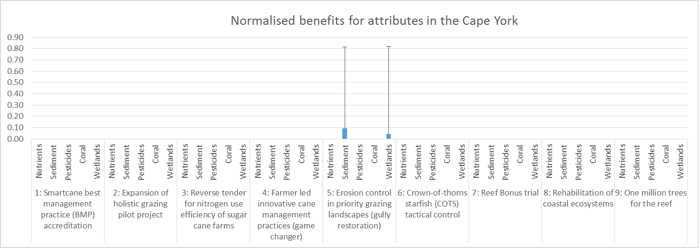
Not applicable
Not applicable
Not applicable
Not applicable
Not applicable
Not applicable
Not applicable
Not applicable
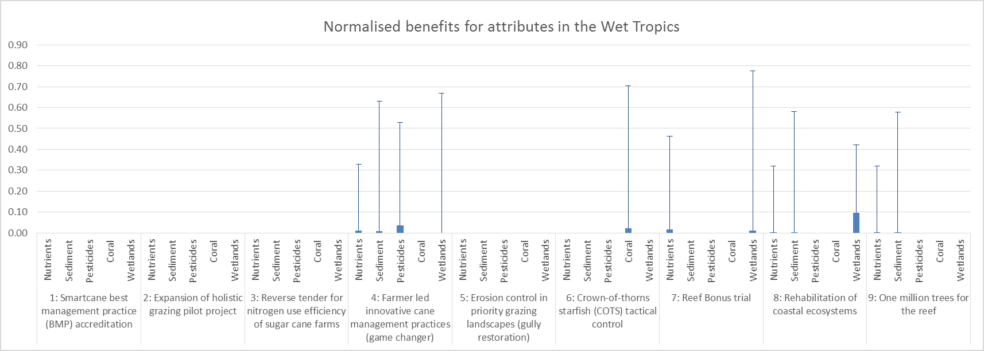
Not applicable
Not applicable
Not applicable
Not applicable
*

Figure 2. The normalised attribute benefits in the Cape York and Wet Tropics regions. The blue bars show the “most likely” benefit, and the positive error bars show the “best case” benefit (best case benefit from the intervention minus most likely benefit from no action). The negative error bars are not shown as all “worst case” benefits = 0. * No estimate provided for wetlands by experts, as they suggested that this intervention focus on the priority regions (based on highest sediment threats) in the first instance (Burdekin, Fitzroy, Burnett Mary) – see Appendix 6 for further details.
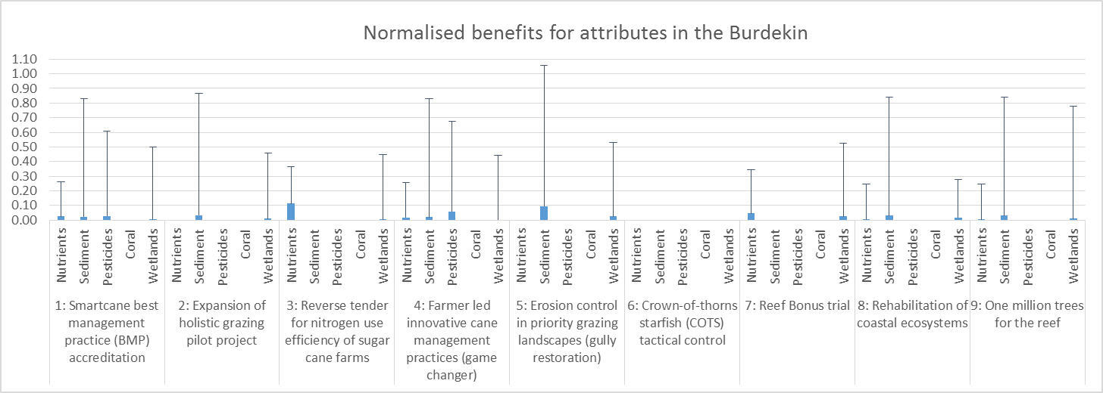
Not applicable
Not applicable
Not applicable
Not applicable
Not applicable
Not applicable
Not applicable
Not applicable
*

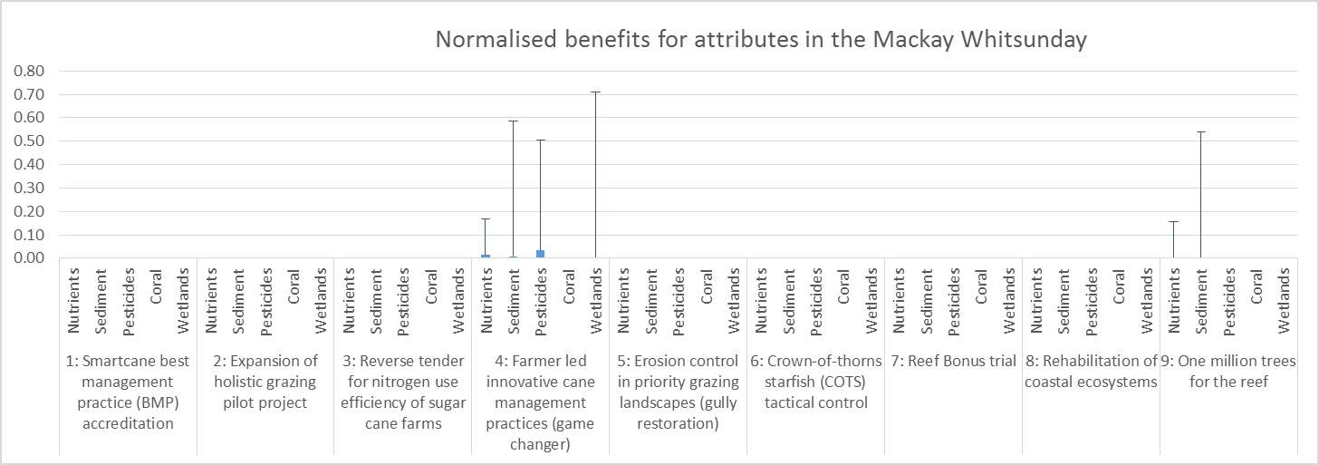
Figure 3. The normalised attribute benefits in the Burdekin and Mackay Whitsunday regions. The blue bars show the “most likely” benefit, and the positive error bars show the “best case” benefit. * No estimate provided for wetlands by experts, as they suggested that this intervention focus on the priority regions (based on highest sediment threats) in the first instance (Burdekin, Fitzroy, Burnett Mary) – see Appendix 6 for further details.
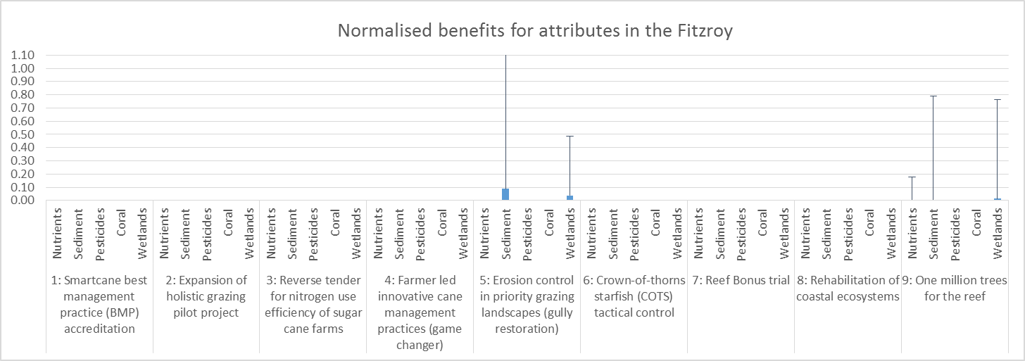
Not applicable
Not applicable
Not applicable
Not applicable
Not applicable
Not applicable
Not applicable
Not applicable
Not applicable
Not applicable
Not applicable
Not applicable
Not applicable
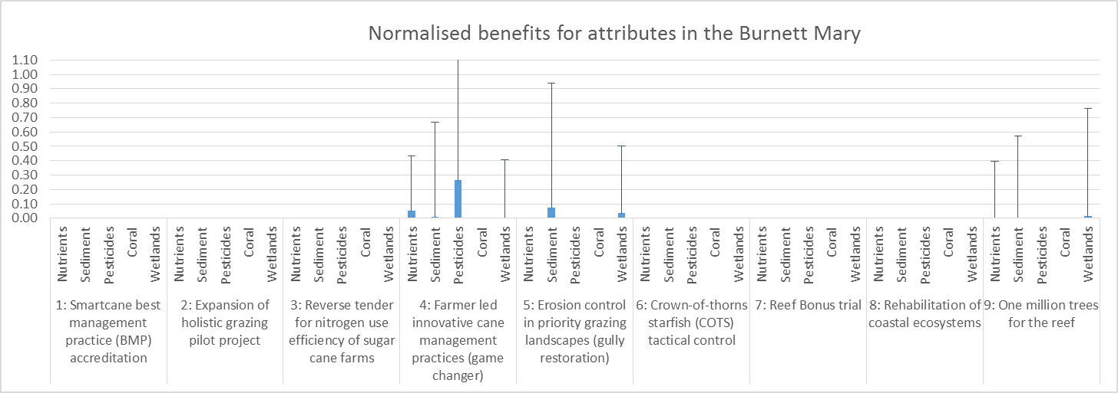
Figure 4. The normalised attribute benefits in the Fitzroy and Burnett Mary regions. The blue bars show the “most likely” benefit, and the positive error bars show the “best case” benefit.

Summary of the benefits of interventions on objectives
The objective benefits of each intervention were constructed using the linear composite model based on the five attributes (following equation 3, section 2.2). Figures 5 – 7 show the normalised objective benefits, which were calculated using equation 2 in section 2.2.
The normalised objective benefits of the interventions (Figures 5 – 7) reflect a similar pattern as the normalised attribute benefits (Figures 2 – 4). Once again the normalised “most likely” objective benefits of the proposed interventions (blue bars) are small (<0.1). This means that the difference between the most likely outcome of the intervention and the most likely outcome of no action on the objectives is only 10% of the total range (best – worst case) of the objective documented across all interventions in the region.
The best case benefits (positive error bars in Figures 5 – 7) estimated by experts highlight the much larger potential benefit of the interventions when comparing the difference between the best case outcome of the intervention and the most likely outcome of no action. The best case benefits represented up to 80% of the total range (best – worst case) of the attribute documented across all interventions in the region.
The negative error bars are not shown in Figures 5 – 7, as all “worst case” benefits are less than zero.
Assessing the most likely, best case and worst case benefits in Figures 5 – 7, again highlights that the predicted benefits of the intervention on the Reef Trust objectives would be modest (<0.1), and there is a large amount of uncertainty surrounding the predicted best case and worst case outcomes of the interventions and no action as at 2030.

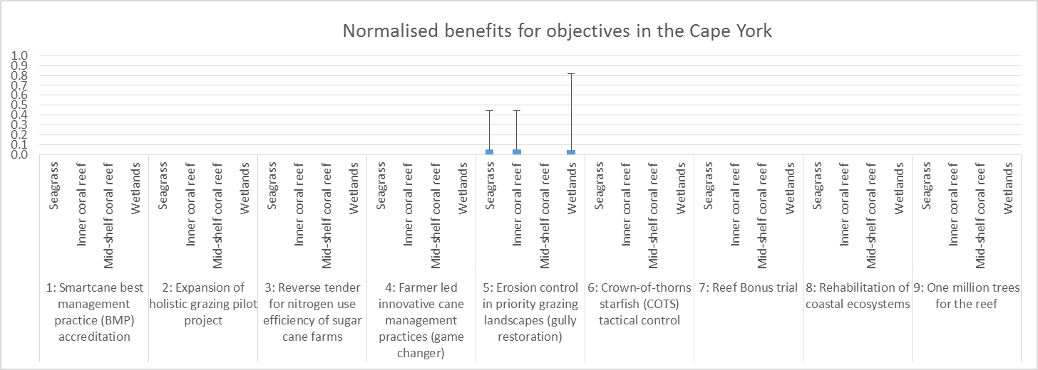
Not applicable
Not applicable
Not applicable
Not applicable
Not applicable
Not applicable
Not applicable
Not applicable
Not applicable
Not applicable
Not applicable
Not applicable
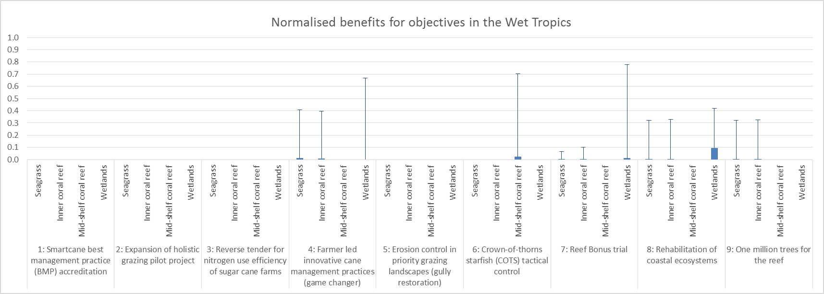
Figure 5. The normalised objective benefits in the Cape York and Wet Tropics regions. The blue bars show the “most likely” benefit, and the positive error bars show the “best case” benefit.
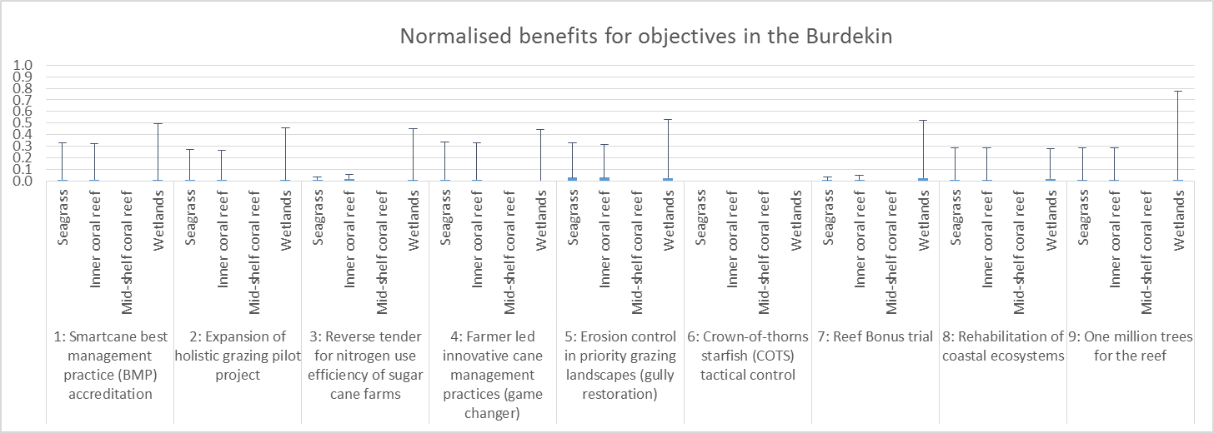
Not applicable
Not applicable
Not applicable
Not applicable
Not applicable
Not applicable
Not applicable
Not applicable
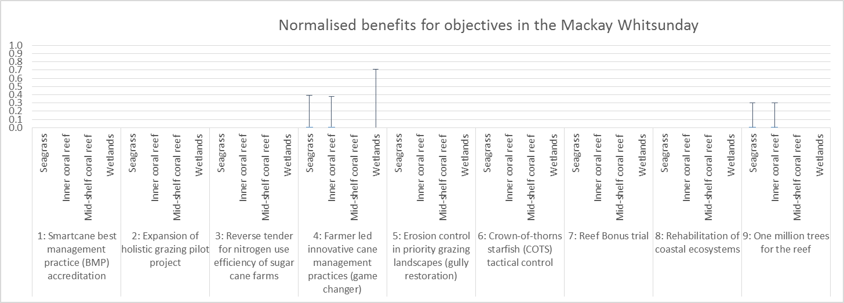
Figure 6. The normalised objective benefits in the Burdekin and Mackay Whitsunday regions. The blue bars show the “most likely” benefit, and the positive error bars show the “best case” benefit.
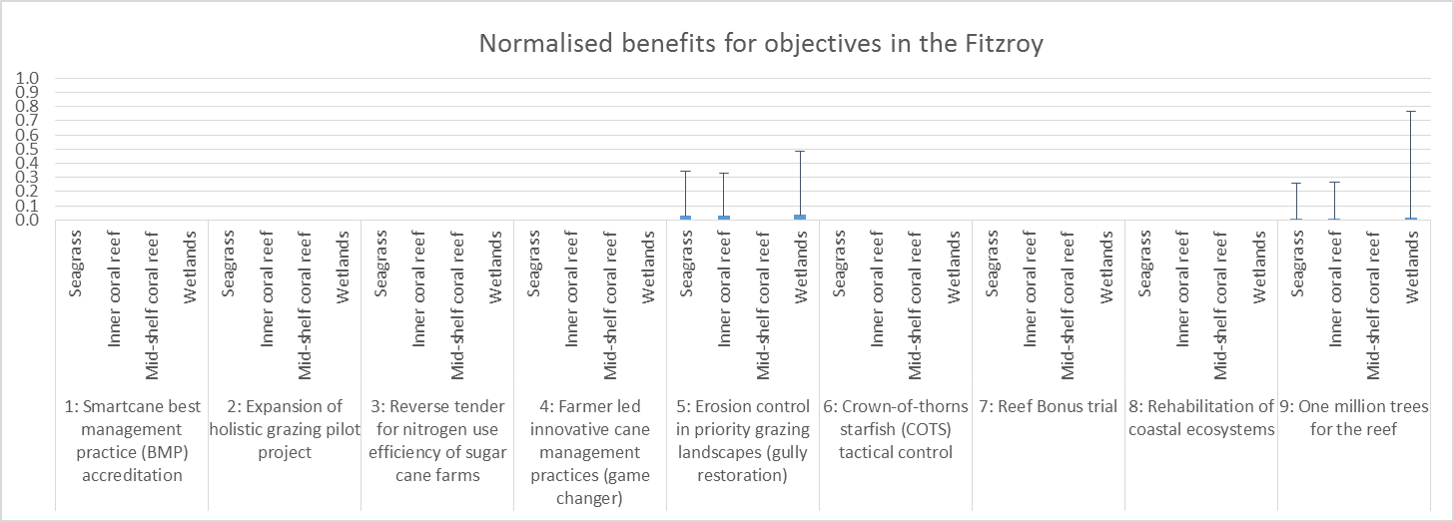
Not applicable
Not applicable
Not applicable
Not applicable
Not applicable
Not applicable
Not applicable
Not applicable
Not applicable
Not applicable
Not applicable
Not applicable
Not applicable
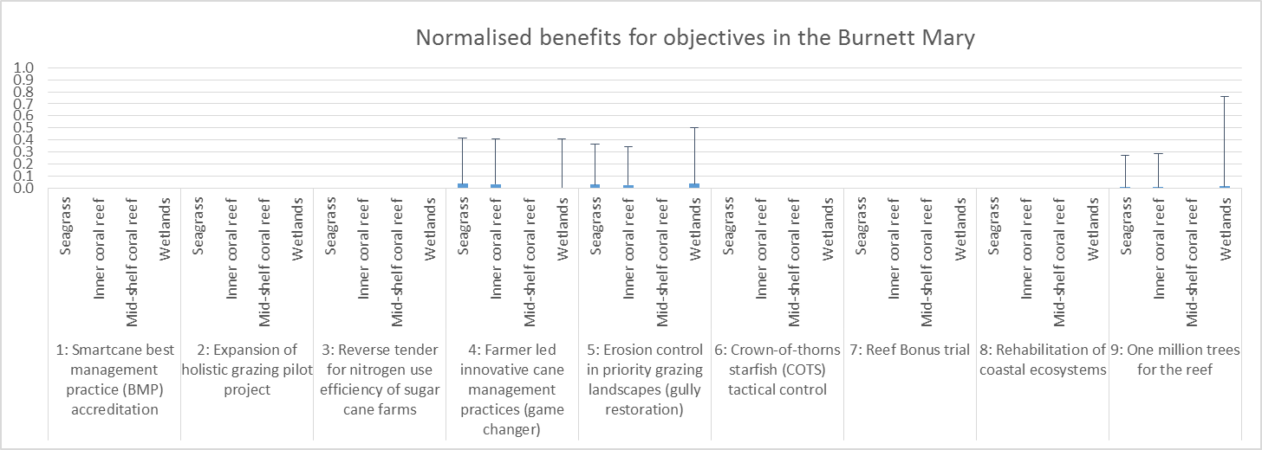
Figure 7. The normalised objective benefits in the Fitzroy and Burnett Mary regions. The blue bars show the “most likely” benefit, and the positive error bars show the “best case” benefit.

The cost-effectiveness of the proposed management interventions
The cost-effectiveness of each intervention was calculated using the summation of the normalised benefits of each objective (shown in Figures 5 – 7) in each of k GBRWHA regions, multiplied by a preference weight of 0.25 for each objective (following the Department assigning equal preference weights (0.25) to the four objectives), and then divided by the cost of the intervention (as outlined in equation 1, section 2.2).
The normalised objective benefits summed across all regions of the GBRWHA are shown in Figure 8 (showing the sum of the regional benefits displayed in Figures 5 – 7). This figure simply shows (a) the most likely and (b) the best case objective benefits of each intervention, which contribute to the numerator of the cost-effectiveness calculation (equation 1).
The final cost-effectiveness estimates for each intervention are shown in Figure 9, which highlights the most likely cost-effectiveness estimates for each intervention (the solid blue bars) and the best case cost-effectiveness estimates for each intervention (positive error bars). These estimates were derived from the most likely and best case benefits on the objectives under each intervention. Note that the negative error bars are not shown in Figure 9, as all “worst case” cost-effectiveness estimates are assigned a value of zero. This is an upside biased treatment of the experts’ worst case estimates, where they believed it possible (mainly due to natural variation and extreme weather) for all of the interventions to have a negative outcome compared to the most likely outcome of no action on the attributes in each GBR region by 2030 (this can be seen in the original estimates provided in Appendices 5 – 7).
There are several ways to interpret the cost-effectiveness estimates (Figure 9) to discern better investments from lesser investments. Under uncertainty, decision-makers can interpret the cost-effectiveness estimates for the proposed interventions in three ways (following Chankong & Yacov, 1983):
- The best-estimate rule: Select the highest performing interventions based on the largest most likely estimates of cost-effectiveness (the solid bars for each intervention). This ignores the uncertainty surrounding the most likely estimates of cost-effectiveness.
- The optimistic rule: Select the highest performing interventions based on the largest best case estimates of cost-effectiveness (the positive error bars for each intervention). This rule maximises exposure to windfall outcomes.
- The pessimistic rule: Select the highest performing interventions based on the largest worst case estimates of cost-effectiveness. This rule minimises exposure to downside surprise. In the context of the large uncertainties encountered in this analysis, the pessimistic rule is an unhelpful decision criterion. It does not distinguish the merit of the proposed interventions because all interventions were assigned a lower (worst case) bound of zero.
In Table 8, the proposed interventions are ranked based on the order of their most likely and best case cost-effectiveness (i.e., following the best guess and optimistic rules for decision making under uncertainty). A sensitivity analysis of the cost-effectiveness estimates (based on 1,000 randomisations of the preference weights assigned to the four objectives; Appendix 8) revealed a coarse delineation of proposed interventions, with five interventions consistently achieving the highest ranking out of the nine interventions (highlighted in Table 8). Following the best-estimate rule (i.e., using the blue bars of the cost-effectiveness graph (Figure 9) and the results of the sensitivity analysis (Appendix 8)), the top-five ranking proposed interventions are: the rehabilitation of coastal ecosystems (intervention 8), erosion control in priority grazing landscapes (intervention 5), Smartcane best management practice accreditation (intervention 1), farmer led innovative cane management practices (intervention 4), and the expansion of holistic grazing pilot project (intervention 2).
The four proposed interventions that rarely attained top-five status using random preference weights in the sensitivity analysis (Appendix 8) were: the reef bonus trial (intervention 7), reverse tender for nitrogen use efficiency of sugar cane farms (intervention 3), one million trees for the reef (intervention 9), and the crown-of-thorns starfish tactical control (intervention 6).
It is important to note that experts were only asked to consider each intervention with a fixed level of investment. If the scale of investment in an intervention is varied, this will influence the likely environmental benefit and thus the cost-effectiveness of the intervention. Please refer to the Discussion of pay-off curves in section 4.2, which addresses the likely non-linear relationship between investment and cost-effectiveness of the interventions.

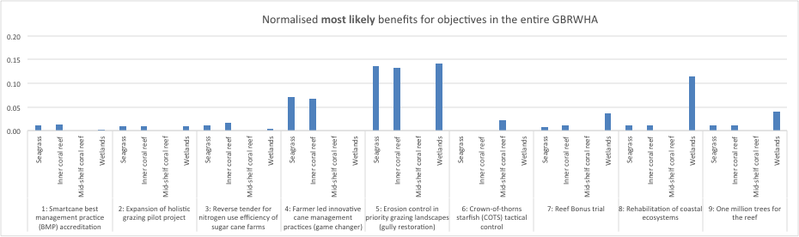
Figure 8a. The normalised most likely benefits for objectives for the entire GBRWHA.

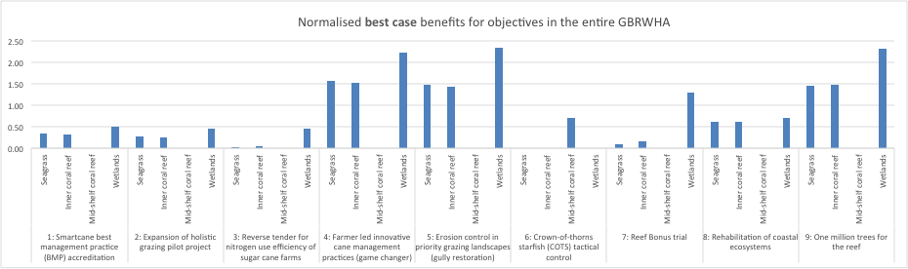
Figure 8b. The normalised best case benefits for objectives for the entire GBRWHA.

Figure 9. Cost-effectiveness estimates for the nine proposed interventions, based on equal preference weights assigned to each objective, displayed on a log scale to promote clarity in the rank order of the interventions. The most likely cost-effectiveness estimates for each intervention (the solid blue bars) and the best case cost-effectiveness estimates for each intervention (positive error bars) are shown. Cost-effectiveness estimates are calculated following equation 1.
Table 8. Summary of the ranking of proposed interventions based on the most likely and best case cost-effectiveness estimates (1 is assigned to the most cost-effective intervention, and 9 is assigned to the least cost-effective intervention).
Intervention | Rank based on most likely cost-effectiveness estimate | Rank based on best case cost-effectiveness estimate
1: Smartcane BMP accreditation ($0.52 million): Burdekin | 3 | 1
2: Expansion of holistic grazing pilot project ($0.9 million): Burdekin | 5 | 4
3: Reverse tender for nitrogen use efficiency of sugar cane farms ($2.98 million): Burdekin | 7 | 8
4: Farmer led innovative cane management practices ($4 million): Mackay Whitsunday, Burdekin, Wet Tropics and Burnett Mary | 4 | 3
5: Erosion control in priority grazing landscapes ($5 million): Burdekin, Fitzroy, Cape York and Burnett Mary | 2 | 5
6: Crown-of-thorns starfish (COTS) tactical control ($6.97 million): Wet Tropics | 9 | 9
7: Reef Bonus trial ($2.89 million): Wet Tropics and Burdekin | 6 | 7
8: Rehabilitation of coastal ecosystems ($1 million): Wet Tropics and Burdekin | 1 | 2
9: One million trees for the reef ($7.55 million): Wet Tropics, Burdekin, Mackay Whitsunday, Fitzroy, Burnett Mary | 8 | 6

Discussion

Interpretation of cost-effectiveness estimates for the nine interventions considered under the second phase of Reef Trust
This cost-effectiveness assessment has focused on assessing environmental objectives (from experts directly estimating attribute benefits). There are a raft of other considerations (e.g., social and economic objectives) that will need to be considered when selecting interventions to invest in through the Reef Trust. Thus, the results of the cost-effectiveness analysis are intended to be just one line of evidence that the Department of the Environment will use when considering investments under the Reef Trust.
As the cost-effectiveness of each intervention is the environmental benefit divided by the cost of the intervention, a small intervention cost can substantially increase the cost-effectiveness estimate for an intervention. This is particularly apparent when looking at intervention 1 (Smartcane BMP), which has comparably low benefits on the objectives (Figure 8), but because this is one of the lowest cost interventions ($0.52 million) the cost-effectiveness of this intervention comes out as the third highest estimate out of the nine interventions (following the best-estimate rule).
The attribute benefits of each intervention in each region estimated by experts (Figures 2 – 4) are important estimates to refer back to when considering what interventions to invest in through the Reef Trust. Equally, the objective benefits that were estimated based on the attribute benefits (following equation 3; section 2.2) are also important to refer back to (Figures 5 – 7), including the summation of the objective benefits across all of the GBRWHA regions (Figure 8). The summation of the benefits of the interventions on seagrass, inshore coral reefs, mid-shelf coral reefs, and wetlands are modest, reflecting the modest levels of investment in the interventions relative to the scale of the GBRWHA and the intensity of its threats (Figure 8).
The analysis clearly indicates there is potential for some interventions to provide greater benefits than others. The cost-effectiveness results (Figure 9; Table 8) and the sensitivity analysis of the model outputs (Appendix 8) can be used to help differentiate between better versus poorer performing management interventions.
Following the selection of the management interventions for investment under the second phase of Reef Trust, the Department can consider the final step of structured decision-making: to implement and monitor the management interventions (Figure 1). It is important during this stage to differentiate between different types of monitoring that can be conducted. Some monitoring programs focus on assessing whether interventions were implemented in the way that was planned. These programs can be referred to as process or output monitoring (Hockings et al., 2006), and can include monitoring things like the number of farmers who were approached to be involved in an agricultural practice change program, or the length of gullies remediated. Whilst important aspects of an intervention to monitor, these programs do not measure the ultimate environmental benefit of the interventions (referred to as outcomes).
Outcome monitoring and assessment should focus on measuring the environmental benefits of the Reef Trust management interventions in the GBRWHA. Outcomes monitoring should include monitoring quantitative environmental outcomes at the site(s) where interventions are in place (e.g., impact site) and control sites to assess what outcomes would have looked like in the absence of the intervention (i.e., impact evaluation; Ferraro, 2009). For example, a monitoring program associated with the COTS control intervention could include measuring the effects of COTS removal on the percentage cover or condition of hard corals in the mid-shelf reefs. Monitoring programs associated with the agricultural practice change interventions should not only focus on monitoring the changes in water quality entering the GBRWHA but also the resulting impact of these changes on wetlands, seagrass and coral habitats. Outcome monitoring and evaluation will be key elements for the Department to transparently demonstrate that the management interventions invested in through the Reef Trust are addressing the Reef Trust outcomes: the long term improvement in water quality and coastal habitats in the reef catchments, and protecting species within the GBRWHA; Department of the Environment, 2014b).
If outcome monitoring reveals that the management interventions surprise on the downside (or upside) relative to what the experts estimated (through their attribute estimates in step 4), the Department will have a sound evidence base upon which it can reconsider its allocations and investments as part of an adaptive approach to management.
The environmental data collected from such monitoring programs could also be used to inform future planning and investment in new interventions in the GBRWHA. Such data could be used in predictive models, which could compliment expert judgement to predict the environmental benefits of future management interventions in the GBRWHA.

Recommendations for future application of the cost-effectiveness process for Reef Trust management interventions
This summary report has outlined the process to estimating cost-effectiveness and refers to the spreadsheet (“reeftrust_costeffectiveness_final.xlsx”; with supporting explanation in Appendix 4), which can be used as a template should the Department wish to assess the cost-effectiveness of management interventions under future phases of investment under the Reef Trust.
The final section of this report raises five key recommendations for consideration by the Department should they wish to repeat this cost-effectiveness process in the future.

Clarify the description of management interventions
A template (Appendix 2) was prepared to help gather standardised background information about each of the proposed management interventions. This template was modelled off other well developed project development processes, such as the Investment Framework for Environmental Resources (INFFER) framework (Pannell et al., 2013). The Reef Trust intervention template required details such as a description of the intended goal of the interventions (e.g., the reduction of sediment loads entering the GBRWHA), the intervention spatial and temporal scale, and the cost of the intervention. It also required information about the anticipated level of adoption for agricultural practice change interventions, and specification of the level of maintenance funding that would be provided to maintain the environmental benefits into the future.
With more time available, improvements could be made to the level of detail and consistency of information about the proposed management interventions. Efforts were made to obtain complete descriptions of the proposed management interventions, however time was a constraint in the development process.
The consequences of the insufficiently defined management interventions were apparent at the Reef Trust workshop. Many experts commented that there was not enough detail provided for them to confidently estimate the environmental benefits of the interventions. The uncertainty associated with some experts’ consequence estimates reflects in part the lack of clarity around the description of what each intervention would exactly entail. For some interventions it was not clear what the intended spatial extent of management would be (e.g., the area of land or number of farms targeted within a region), and little to no description was provided about the anticipated level of uptake and wider adoption of the agricultural interventions (see discussion of adoption below). Where insufficient information was available, experts made their own assumptions about various aspects of these proposals. In some cases experts did not believe that the proposed agricultural interventions were well designed and as a result assumed that the resulting level of uptake/adoption might be low. Whilst some details could be easily provided with more planning time (e.g., area within a region that would be targeted for a specific intervention), others like the level of adoption will remain a challenging aspect of proposed interventions.
There are a range of factors that can influence the adoption of new approaches by farmers, such as social, cultural and economic factors, and many characteristics about the innovation itself (Pannell et al., 2006). Predicting the likely level of adoption of new approaches can be a challenging task, but fortunately tools have been developed to assist project proponents in this task. One such tool is ADOPT (Adoption and Diffusion Outcome Prediction Tool), which is a user-friendly spreadsheet that walks proponents through a number of questions to consider factors that may affect adoption of a proposed intervention (Kuehne et al., 2011).
For future phases of the Reef Trust, it is recommended that up to two months be made available to fully develop and describe proposed management interventions. Up to one month should also be allowed for consultation between the Department and intervention proponents to help ensure detailed and standard information about interventions is collated. The Department should also consider using a tool such as ADOPT (Kuehne et al., 2011), to help with predicting the likely level of adoption of agricultural interventions.

Clarify whether maintenance funding will be provided to maintain environmental benefits of interventions
The interventions considered under the second phase of Reef Trust were proposed for a duration of 3.5 years or less, and in most cases did not include provisions for maintenance – where funding is committed to maintain the environmental benefits over decadal scales. The turn-over rates of marine systems means that some species can take many decades to show recovery and the benefits of management interventions.
The lack of maintenance funding for the proposed management interventions considered under the second phase of Reef Trust is an issue for achieving the Reef Trust goals: the long term improvement in water quality and coastal habitats in the reef catchments, and protecting species within the GBRWHA (Department of the Environment, 2014b). Such short term projects are unlikely to significantly contribute to achieving targets on their own. Should funding be extended for some of the proposed interventions it is possible that the environmental benefits of the interventions at 2030 would be more substantial.
Future intervention proposals should include provision for the environmental benefits of the interventions to be maintained in the long term, or built on with new and improved interventions.

Consider management interventions at different scales of investment
Each of the nine management interventions proposed under the second phase of Reef Trust had a fixed level of proposed investment. Some experts expressed the belief that if the investment in some of these interventions was scaled up or down, then their environmental benefit could be very different. This in turn could result in a substantially different estimate of the cost-effectiveness of an intervention. This intuition is entirely reasonable, and is illustrated in hypothetical pay-off curves in Figure 10. Changing the scale of an intervention may include increasing the spatial extent (e.g., expand an intervention across multiple regions), intensity (e.g., number of farmers targeted), or duration (e.g., the number of years an intervention is undertaken).
By estimating the likely environmental benefit of an intervention at varying levels of investment, a pay-off curve can be constructed. Pay-off curves are an effective means of exploring the non-linear relationship between investment and environmental response (Figure 10). Pay-off curves can be particularly illuminating for decision-makers who may wish to explore the implications of a greater (or lesser) budget for allocation across projects.
As an example, a decision-maker with a small budget may look at Figure 10 and decide that Intervention C is only worth investing in at a low level of investment (1). Even with a more substantial budget, increasing investment in Intervention C will provide little additional return on investment. With a larger budget, a decision-maker may look at Figure 10 and decide to only invest in intervention A, at a much higher level of investment (3), to achieve the greatest return on investment out of all three proposed interventions.
The scope of this project did not include eliciting additional estimates from experts under varying levels of investment of each intervention, however this is recommended for any future application of cost-effectiveness analysis. The imperative for credible characterisation of pay-off curves increases with the level of funding administered under Reef Trust. Future assessments of the cost-effectiveness of management interventions could involve detailed model development, model interrogation and expert judgement about the likely environmental benefit of an intervention at varying levels of investment.
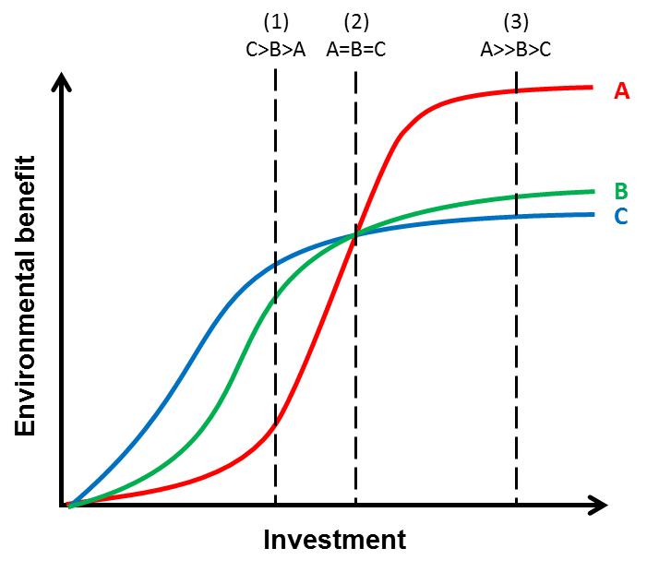
Figure 10. Pay-off curves for three hypothetical management interventions (A, B, and C), illustrating how varying the level of investment in each intervention can influence the environmental benefit, and thus return on investment. The cost-effectiveness of each intervention is the gradient of the curve at any point.

Decouple local and regional scale benefits
Some interventions have the potential to contribute to a substantial positive benefit on the Reef Trust natural values at a local scale (i.e., within a region) either on their own or in combination with the broad suite of actions underway across reef catchments through a range of initiatives led by governments, industry and the community. The scale of the assessment undertaken here is too coarse for capturing localised benefits.
If local benefits are of material consequence, then those responsible for administering Reef Trust should consider trading these local scale pay-offs against the broader-scale pay-offs documented in this report, alongside other concerns beyond the scope of this analysis. Alternatively the interventions invested through the Reef Trust could be treated as pilot studies to illustrate the potential of application at a larger (e.g., catchment-wide or multi-region) scale in the future.

Allow more time for the experts to understand the decision context and provide consequence estimates
The Reef Trust workshop held in December 2014 involved two full days to work through the estimation of the environmental benefits of the nine proposed interventions. This workshop timing and duration was constrained by the project start date with AIMS, and the Department’s operational requirements with regard to Reef Trust timelines.
In hindsight, two full days were not enough time for experts to understand the decision context and to estimate the environmental benefits of the nine proposed interventions, for multiple attributes and objectives, and across up to six regions of the GBRWHA. Whilst a pre-workshop package of information was provided to experts one week prior to the workshop (e.g., containing the agenda, and explanation of the workshop process and intended outputs, and the full descriptions of all interventions), the first half day was still spent discussing the management interventions to help clarify any confusion, and narrowing the scope of the Reef Trust in terms of the four environmental objectives.
To overcome the issues faced at the Reef Trust workshop, the following recommendations are proposed:
- Provide proposed intervention descriptions to experts one month prior to the main elicitation workshop, and hold a teleconference meeting with experts at least two weeks prior to the main elicitation workshop. This should provide ample opportunity for the experts to understand the decision context, the intervention details and ask questions to clarify their understanding of the interventions.
- Allow for more time at the main elicitation workshop – acknowledging that two full days is already a large time commitment given by experts. It may be that smaller workshops (e.g., single day) could be run over a month.
- Access and query relevant models available within government organisations and research institutions. These models may assist experts’ structure and refine their judgments.

Conclusion
The cost-effectiveness estimation process developed by AIMS has now been used to inform investment of interventions under the second phase of Reef Trust. This report has provided an overview of the cost-effectiveness estimation process, a summary of the cost-effectiveness results, and an interpretation of these results to assist the Environment Minister in making decisions on investment through the Reef Trust. As this was the first trial of the cost-effectiveness estimation process with the Department there are likely to be many lessons from this process.
The cost-effectiveness estimation process entails a series of logical steps to assist in the prioritisation of management interventions in a transparent and scientifically rigorous way, within the constraints of the resources and time available for decision-making. There is a range of other social and economic factors that will need to be considered when selecting investments under the Reef Trust, alongside consideration of synergies and complementarities with other programs contributing to environmental outcomes for the Great Barrier Reef World Heritage Area. Thus, the results of the cost-effectiveness analysis are intended to be just one line of evidence that the Department of the Environment will use when considering investments under the Reef Trust.

Literature cited
Addison, P.F.E., Rumpff, L., Bau, S.S., Carey, J.M., Chee, Y.E., Jarrad, F.C., McBride, M.F. & Burgman, M.A. (2013) Practical solutions for making models indispensable in conservation decision-making. Diversity and Distributions, 19, 490–502.
Bottrill, M.C., Joseph, L.N., Carwardine, J., Bode, M., Cook, C.N., Game, E.T., Grantham, H., Kark, S., Linke, S., McDonald-Madden, E., Pressey, R.L., Walker, S., Wilson, K.A. & Possingham, H.P. (2008) Is conservation triage just smart decision making? Trends in Ecology and Evolution, 23, 649–654.
Chankong, V. & Yacov, Y.Y. (1983) Multiobjective decision making: Theory and methodology. Dover Publications, Mineola, New York.
Department of the Environment (2014a) Reef Trust Discussion Paper. Australian Government Department for Environment.
Department of the Environment (2014b) Reef 2050 Long-Term Sustainability Plan - For public consultation. Australian Government, Department of the Environment.
Durbach, I.N. & Stewart, T.J. (2009) Using expected values to simplify decision making under uncertainty. Omega, 37, 312–330.
Failing, L., Gregory, R. & Harstone, M. (2007) Integrating science and local knowledge in environmental risk management: A decision-focused approach. Ecological Economics, 64, 47–60.
Ferraro, P.J. (2009) Counterfactual thinking and impact evaluation in environmental policy. New Directions for Evaluation, 122, 75–84.
GBRMPA (2014a) Great Barrier Reef outlook report 2014. Great Barrier Reef Marine Park Authority, Townsville.
GBRMPA (2014b) Great Barrier Reef region strategic assessment: Strategic assessment report. Great Barrier Reef Marine Park Authority, Townsville.
Gregory, R., Arvai, J. & Gerber, L.R. (2013) Structuring decisions for managing threatened and endangered species in a changing climate. Conservation Biology, 27, 1212–1221.
Gregory, R., Failing, L., Harstone, M., Long, G., McDaniels, T. & Ohlson, D. (2012) Structured decision making: A practical guide to environmental management choices. John Wiley & Sons, Chichester.
Hockings, M., Stolton, S., Leverington, F., Dudley, N. & Courrau, J. (2006) Evaluating effectiveness: A framework for assessing management effectiveness of protected areas. IUCN, Gland, Switzerland and Cambridge, UK.
Kuehne, G., Llewellyn, R., Pannell, D., Wilkinson, R., Dolling, P. & Australasia, I. (2011) ADOPT: a tool for evaluating adoptability of agricultural innovations. 5th World Congress of Conservation Agriculture incorporating 3rd Farming Systems Design Conference. Brisbane, Australia.
Martin, T.G., Burgman, M.A., Fidler, F., Kuhnert, P.M., Low-Choy, S., McBride, M. & Mengersen, K. (2012) Eliciting expert knowledge in conservation science. Conservation Biology, 26, 29–38.
Pannell, D.J., Roberts, A.M., Park, G. & Alexander, J. (2013) Designing a practical and rigorous framework for comprehensive evaluation and prioritisation of environmental projects. Wildlife Research, 40, 126–133.
Pannell, D.J., Marshall, G.R., Barr, N., Curtis, A., Vanclay, F. & Wilkinson, R. (2006) Understanding and promoting adoption of conservation practices by rural landholders. Animal Production Science, 46, 1407–1424.
Runge, M.C. (2011) An introduction to adaptive management for threatened and endangered species. Journal of Fish and Wildlife Management, 2, 220–233.
Runge, M.C. & Walshe, T. (2014) Identifying objectives and alternative actions to frame a decision problem. In: Application of threshold concepts in natural resource decision making, G.R. Guntenspergen (eds), pp. 29–43. Springer, New York.
Speirs-Bridge, A., Fidler, F., McBride, M., Flander, L., Cumming, G. & Burgman, M. (2010) Reducing overconfidence in the interval judgments of experts. Risk Analysis, 30, 512–523.
von Winterfeldt, D. & Edwards, W. (1986) Decision analysis and behavioral research. Cambridge University Press, Cambridge.
Walshe, T., Jarrad, F. & McMahon, K. (2013) Decision support for the West Coast natural values implementation plan. A structured decision-making framework for resource allocation. A report prepared for Parks Victoria.
Weitzman, M.L. (1998) The Noah’s ark problem. Econometrica, 66, 1279–1298.

List of supporting appendices
Appendix 1: Outline of the Reef Trust natural values
Appendix 2: Reef Trust - proposed intervention template
Appendix 3: The current levels of attributes in the GBRWHA regions
Appendix 4: cost-effectiveness spreadsheet notes
Appendix 5. Summary of effectiveness of interventions on water quality attributes
Appendix 6: Summary of effectiveness of interventions on wetlands
Appendix 7: Summary of effectiveness of the crown-of-thorns starfish (COTS) tactical control on mid-shelf coral reefs
Appendix 8: Sensitivity analysis of the cost-effectiveness model outputs

