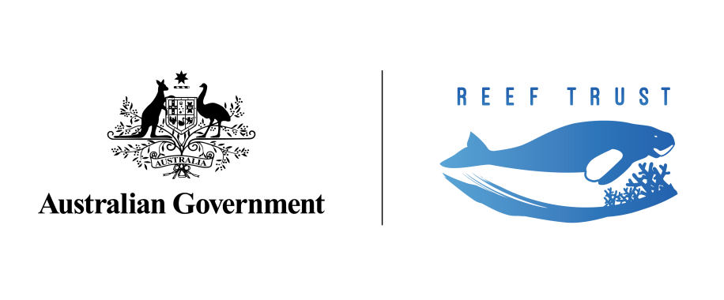 **OVERVIEW:**

**Grant Agreement between the Reef Trust and Great Barrier Reef Foundation**

*This document provides an overview of the Grant Agreement which commenced on 27 June 2018 between the Australian Government’s Reef Trust and the Great Barrier Reef Foundation for the investment of an additional $443.3 million to improve the health and resilience of the Great Barrier Reef.[1]*

**Objective and outcomes:**

* A Grant of $443.3 million (GST exclusive) has been provided to the Great Barrier Reef Foundation (the Foundation) through a comprehensive and robust legal Agreement with the Australian Government Department of the Environment and Energy (the Department).
* The objective of the Agreement is to achieve significant, measurable improvement in the health of the Great Barrier Reef World Heritage Area in accordance with the *Reef 2050 Long Term Sustainability Plan,* underpinned by innovation, science and community engagement. The expected outcomes are:
  1. improved management of the Great Barrier Reef World Heritage Area and relevant activities in adjacent catchments;
  2. protection of the Outstanding Universal Value of the Great Barrier Reef World Heritage Area, including species, habitats and Indigenous values; and
  3. management of key threats to the Great Barrier Reef World Heritage Area, including poor water quality and crown-of thorns starfish outbreaks.

**Activity components:**

* The Agreement requires the Foundation to invest the following amounts (GST exclusive) on activities described in the schedules of the Agreement between 2018-19 to 2023-24:
  1. up to $200,649,000 for water quality improvement activities (Schedule 3);
  2. up to $57,800,000 for crown-of-thorns starfish control activities (Schedule 4);
  3. up to $100,000,000 for reef restoration and adaptation science activities (Schedule 5);
  4. up to $22,349,000 for Indigenous and community reef protection activities (Schedule 6); and
  5. up to $40,000,000 for Reef integrated monitoring and reporting activities (Schedule 7).
* The Foundation has been provided with $22.5 million for administration and scaling up activities (Schedule 2). The Foundation may also use a capped amount of interest earned on the Grant funds for this purpose.

**Delivery requirements:**

* The Foundation is required to achieve the Agreement’s outcomes in a manner that is consistent with:
  1. Government administrative law: especially the *PGPA Act (Reef Trust Special Account 2014) Determination 01* (Cth); and
  2. Government Policy: especially the *Reef 2050 Long-Term Sustainability Plan*, the draft *Reef 2050 Water Quality Improvement Plan 2017-2022*, the *Reef 2050 Plan Investment Framework,* the *Reef Trust Objectives, Outcomes and Investment Principles* and the *Reef 2050 Plan Integrated Monitoring and Reporting Strategy*; and
  3. Plans required to be developed under the Agreement (as discussed below); and
  4. all applicable laws.
* The Foundation will hold Grant funds in an account separate to its other operational accounts.

**Development of guiding documents:**

* The Agreement requires the development of guiding documents to govern the achievement of the Agreement’s outcomes.
* Two of the most important guiding documents are the Investment Strategy and the Annual Work Plan. Through these documents, the Foundation will seek to address the highest priority threats to the Great Barrier Reef, deliver cost-effective on-ground change, complement previous and current investments, generate co-investment and establish delivery partnerships. The Investment Strategy and Annual Work Plans will be published on the Foundation’s website.
* In developing and finalising the Investment Strategy and the Annual Work Plans, the Foundation will consult with the Department, the Reef 2050 Independent Expert Panel, the Reef 2050 Advisory Committee, the Great Barrier Reef Ministerial Forum, Queensland’s Office of the Great Barrier Reef and the Great Barrier Reef Marine Park Authority.
* The Foundation is also required to develop supporting Plans for delivery of the Grant including:
  1. a Resourcing Plan that sets out how it will deploy resources to deliver on its obligations;
  2. a Co-Financing Strategy Plan outlining the Foundation’s approach to raising other contributions from private and philanthropic donors;
  3. a Communication and Stakeholder Engagement Plan to drive collaborative efforts and ensure comprehensive engagement with the community;
  4. a Monitoring and Evaluation Plan to support an adaptive management approach over the life of the Agreement. The Foundation will monitor and evaluate the outcomes of each Activity Component and participate in any formal review or evaluation of the Agreement.

**Accounting and Reporting:**

* The Agreement requires the Foundation to maintain detailed accounts and records, including records of the progress, selection and performance of projects, use of Grant funds and other contributions, and the creation, acquisition and disposal of assets.
* The Foundation will provide written reports to the Department (detailed in Schedule 1), including:
  1. six-monthly progress reports outlining the performance of each Activity Component and the expenditure of the Grant;
  2. audited annual financial reports regarding the expenditure of the Grant and other contributions;
  3. annual reports to the Great Barrier Reef Ministerial Forum on progress against the *Reef 2050 Long‑Term Sustainability Plan*, the Investment Strategy and the relevant Annual Work Plan;
  4. a final report following completion of an Activity Component or earlier termination of the Agreement;
  5. other specific reports for Activity Components as set out in the Schedules to the Agreement; and
  6. other ad-hoc reports as required by the Department throughout the term of the Agreement.
* Each six-monthly progress report and audited annual report is required to include a statement from the Foundation’s authorised person that Grant funds have been spent in accordance with the Agreement.

**Sub- Contracting:**

* The Agreement allows the Foundation to subcontract the delivery of Activities to appropriately qualified and experienced subcontractors using rigorous assessment criteria.
  1. The terms of each subcontract must be consistent with the terms of the Agreement and the Agreement specifies a number of provisions that the Foundation must ensure are included in its subcontracts and funding agreements.

**Governance:**

* The Agreement allows the Department to appoint a Commonwealth Observer to the Foundation’s Board and a Departmental representative to the Foundation’s Partnership Management Committee for the Activity.
  1. The Commonwealth Observer will attend meetings of the Foundation’s Board (subject to certain exceptions described in the Agreement) and report back to the Department.
* The Agreement requires the Foundation to share all relevant information pertaining to the Activity with the Department. The Foundation is required to notify the Department of any proposed or actual material change in its constitution, structure, management or financial position.
* The Agreement requires the Foundation to employ best practice corporate governance arrangements and engage governance and risk management experts to help develop and implement strong governance, anti-corruption, fraud prevention and audit and risk management policies and procedures.
  1. This includes the development of a Fraud Prevention Plan that covers the Foundation and its subcontractors. The Foundation will also prepare a Risk Management Plan that outlines how it will manage and mitigate risks, including appointing a Risk and Compliance officer.
  2. The Agreement prevents persons who have a history of poor governance or financial management from being involved in the management of the Grant or an Activity Component.

**Compliance:**

* As is usual practice in government contracting, the Foundation indemnifies the Department for any loss, cost, damage or claim arising from, amongst other things, the Foundation’s breach of the Agreement or its negligent or unlawful act or omission or wilful misconduct in connection with the Agreement.
* The Agreement also provides for termination or reduction in its scope and outlines the conditions under which a termination event may occur, including as a result of non-performance, breach of obligation, or insolvency or other significant change to the nature of the Foundation.
* The Department may elect to continue all or part of the Activity if the Agreement is terminated for any reason, or if the Foundation so requests it. The Department may recover from the Foundation reasonable costs incurred in exercising these provisions. The Department may also seek to recover for the Government, any Grant funds which are not legally committed or that have not been spent by the Foundation in accordance with the Agreement.
* The Agreement also includes a number of other provisions common to Commonwealth grants regarding assets; intellectual property; confidential information; privacy obligations; conflicts of interest; compliance with legislation; work health and safety; Foundation representations and warranties; insurance policies required to be effected and maintained by the Foundation; dispute resolution procedures; force majeure events; notices; and preparation of an Australian Industry Participation Plan.

1. *This document should not be relied on to describe, qualify or limit the terms and conditions of the Agreement.  For full terms and conditions, please refer to the executed Agreement.* 