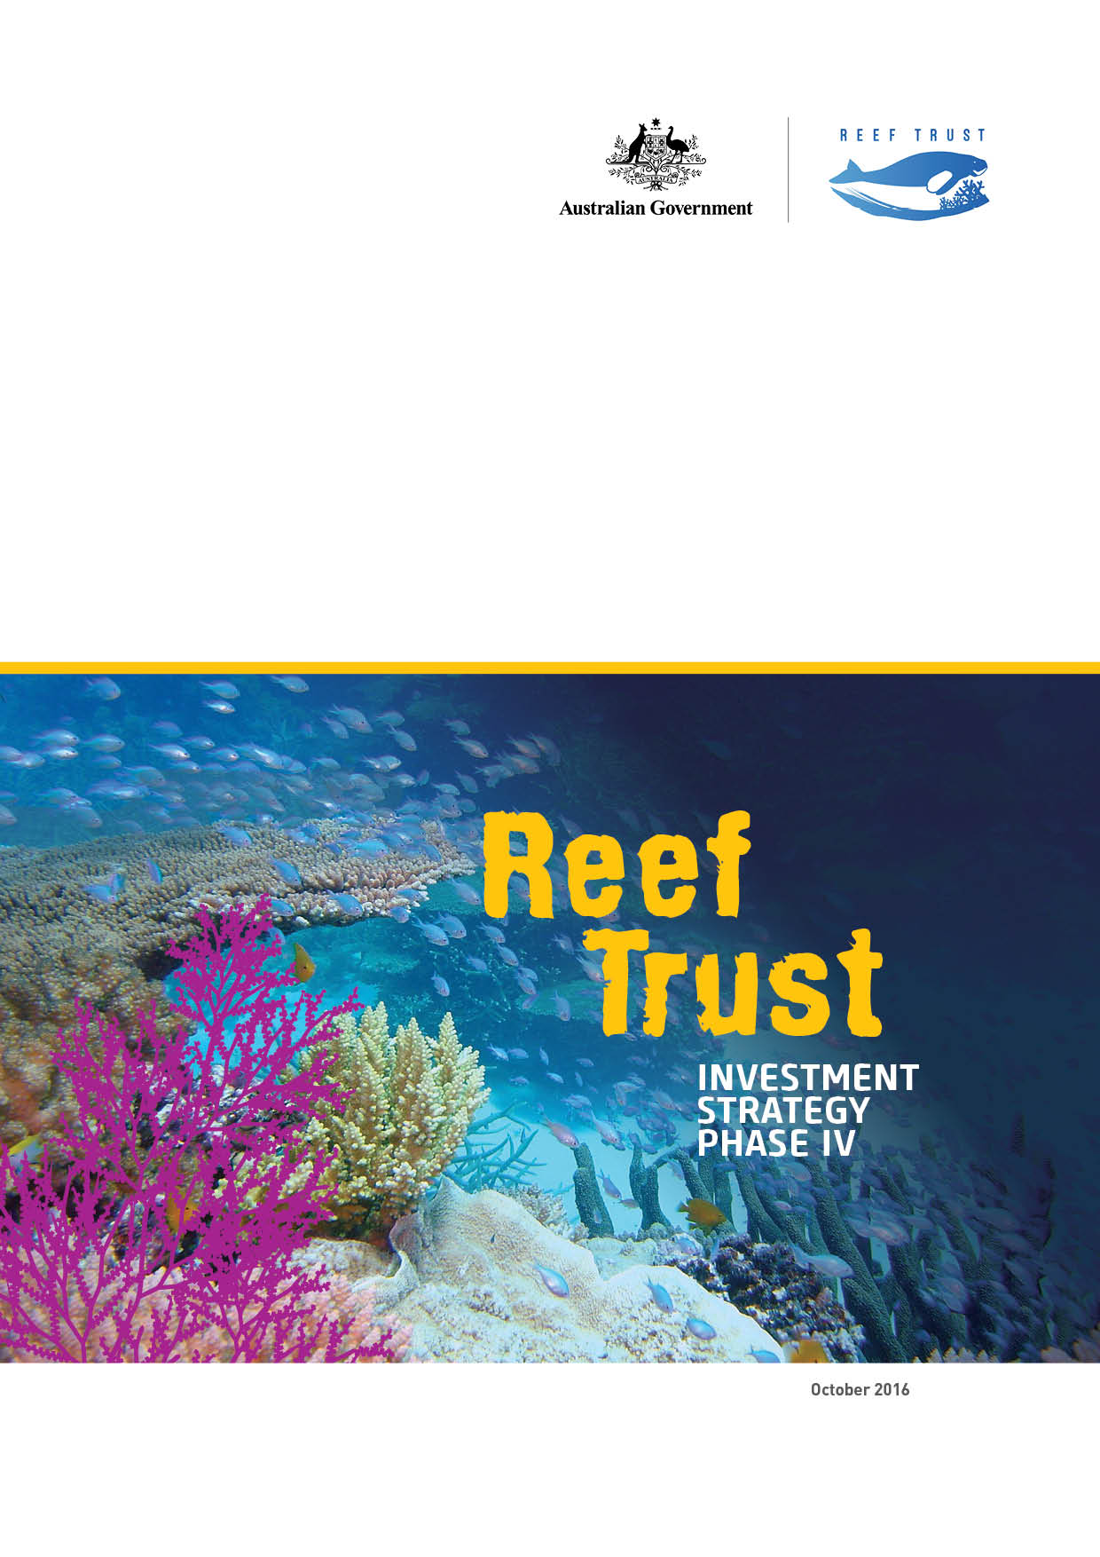This report should be attributed as ‘*Reef Trust Investment Strategy Phase III*, Commonwealth of Australia 2015’.

The Commonwealth of Australia has made all reasonable efforts to identify content supplied by third parties using the following format ‘© Copyright, [*name of third party*] ’.

Images: courtesy of the Department of the Environment and the Great Barrier Reef Marine Park Authority.

© Copyright Commonwealth of Australia, 2016.

***Reef Trust Investment Strategy Phase IV*** is licensed by the Commonwealth of Australia for use under a Creative Commons Attribution 4.0 Australia licence with the exception of the Coat of Arms of the Commonwealth of Australia, the logo of the agency responsible for publishing the report, content supplied by third parties, and any images depicting people.

For licence conditions see: [https://creativecommons.org/licenses/by/4.0](https://creativecommons.org/licenses/by/4.0/)

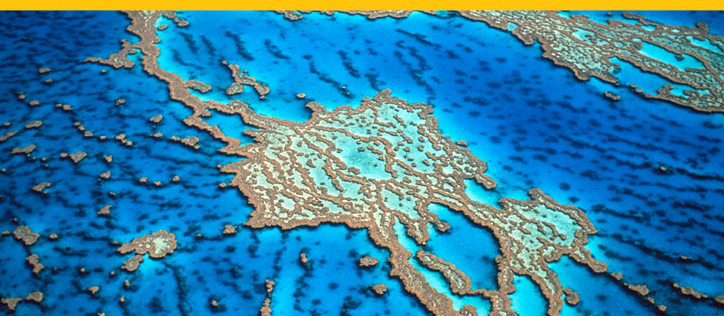

Great Barrier Reef Photo credit: Commonwealth of Australia  
Front Cover image: Colourful Acropora corals and fish on Wheeler Reef Photo credit: Commonwealth of Australia (GBRMPA)

Minister’s Foreword

Australians are passionate about our Great Barrier Reef—a passion that the Australian Government shares and demonstrates through its commitment to the Reef’s long-term protection and conservation.

There is no doubt the Reef is facing a number of serious threats and challenges. Cyclone damage, crown-of-thorns starfish, coral bleaching events, coral disease outbreaks and degraded water quality have reduced coral cover on the Great Barrier Reef. Fundamental to our response is the acceptance by all governments, industries and local communities of the need for an effective and progressive response to the threats faced by the Reef.

The Reef 2050 Plan is the Australian and Queensland governments’ joint response to the challenges currently facing the Great Barrier Reef and sets out an ambitious roadmap for action, building on our long history of jointly managing the Reef.

The Reef Trust is an important initiative under the Reef 2050 Plan. The Australian Government has committed $210 million to the initiative to provide innovative, targeted investment focused on improving water quality, restoring coastal ecosystem health and enhancing species protection in the Great Barrier Reef region.

The Reef Trust Investment Strategy Phase IV is part of the Australian Government’s 2016 election policy to invest in the Great Barrier Reef to tackle the greatest threats to the Reef and target investment to preserve this natural wonder. With the current coral bleaching event causing further negative impacts on the Reef’s coral cover and resilience, improving water quality remains a key priority in boosting the resilience of the Great Barrier Reef to any future coral bleaching events and other impacts of climate change.

Since 2014, the Reef Trust has delivered a range of projects to improve water quality by improving nitrogen-use efficiency on sugar cane farms and reducing sediment runoff in priority grazing landscapes. The Reef Trust has also invested in the targeted culling of the crown-of-thorns starfish on high value reefs, as well as a number of projects to reduce threats to dugongs and turtle species, including injury, illness, marine debris and illegal hunting and poaching.

I am pleased to continue this crucial work through this Phase IV investment strategy. The Australian Government will deliver on its elections commitments to provide $46 million over six years towards reduced nutrient losses through improved farm management practices, reduced gully and stream bank erosion, and increased coral protection on ecologically important reefs.

Through these Phase IV investments, the Australian and Queensland governments will build on our long history of collaborating to protect and manage the Reef by investing up to $7.3 million over four years to trial enhanced efficiency fertilisers. These trials aim to reduce applied nitrogen and subsequent nitrogen losses, and to accelerate the evaluation of the technology.

The Reef Trust will also provide up to $20 million to reduce gully and stream bank erosion across the Reef’s catchments. These investments will enhance and continue our investment in combating one of the highest priority threats to the Reef, sediment run-off. This project will also complement investment by the Queensland Government into gully and stream bank repair through its proposed two major integrated projects in the Wet Tropics and Burdekin, as recommended by the Great Barrier Reef Water Science Taskforce, as well as other gully remediation partnerships.

I am proud of the progress we have made to date through the Reef Trust and this is in no small part due to all sectors working together under the Reef 2050 Plan. We have a clear opportunity and responsibility—to meaningfully engage, listen and learn from one another on the best ways to cooperate to conserve the Reef. I look forward to continuing to strengthen existing partnerships and working with new partners to continue to protect and conserve the extraordinary diversity of plant and animal life that exists within the Great Barrier Reef.

**The Hon Josh Frydenberg**Australia Government  
Minister for the Environment and Energy

Contents

Minister’s Foreword 3

Contents 4

EXECUTIVE SUMMARY 5

PART 1: PHASE IV INVESTMENT 6

1.1 Delivering collaborative investments 6

1.2 Focus on water quality 6

1.3 Species protection 8

PART 2: THE REEF TRUST 11

2.1 About the Reef Trust 11

Delivering on the Reef 2050 Plan: The Reef Trust 11

Reef Trust Objective, Outcomes and Investment Principles 13

How the Reef Trust works 13

Reef Trust Governance 13

Monitoring and reporting 15

Encouraging innovation 15

2.2 Approach to the identification of investments 16

Investment approach 16

Review of best available information—priority reef values, threats and regions 17

Analysis of existing efforts 17

Identification of projects 18

Assessment of Cost-Effectiveness 18

2.3 Diversifying Investment 18

Offsets 18

Private and philanthropic investment opportunities 19

Potential mechanisms for future investments 19

PART 3: STRATEGY TO MANAGE THE REEF TO 2050 21

3.1 The Reef 2050 Plan 21

3.2 Managing the Reef Together 21

3.3 Complementary investment 22

APPENDIX 1 24

APPENDIX 2 28

APPENDIX 3 29

EXECUTIVE SUMMARY

The delivery of The Reef Trust is coordinated jointly between the Australian Government, including the Great Barrier Reef Marine Park Authority (GBRMPA), and the Queensland Government. Established in 2014, the Reef Trust was a component of the Reef 2050 election commitment to develop the Reef 2050 Plan and establish a Reef Trust.

The Reef Trust is one of the key mechanisms assisting in the delivery of the Reef 2050 Plan, and focuses on known critical areas for investment—improving water quality and coastal habitat along the Great Barrier Reef, controlling the current outbreak of crown-of-thorns starfish, and protecting threatened and migratory species, particularly dugong and turtles.

To date, the Reef Trust has committed more than $140 million towards a range of projects to protect and conserve the outstanding universal value of the Reef. These projects are underpinned by the best available science and our collective experiences in delivering the significant existing conservation efforts to date.

This Reef Trust Investment Strategy Phase IV announces the fourth phase of investment under the Reef Trust. This phase of investment builds on three previous phases of investment and will contribute to the long-term sustainable management of the Great Barrier Reef World Heritage Area and the Great Barrier Reef catchments.

The fourth phase of actions focuses predominantly on reducing key pollutants—sediment and nutrients—to strive towards the Reef 2050 Plan’s ambitious targets for improved water quality entering the Reef lagoon. The actions also contribute to improving the health and resilience of coastal habitats and improving marine biodiversity.

Three key water quality projects have been identified for investment through the fourth phase—further reverse auctions for nutrient reduction in the Wet Tropics and Burdekin natural resource management regions; trials of enhanced efficiency fertilisers on sugar cane farms; and management of stream bank and gully erosion. The fourth phase also builds on previous Australian Government investment through committing further funding to combat crown-of-thorns starfish on ecologically important reefs.

Schooling bannerfish at Lady Elliot Island Reef Photo credit: Commonwealth of Australia (GBRMPA)


Schooling bannerfish at Lady Elliot Island Reef Photo credit: Commonwealth of Australia (GBRMPA)

PART 1: PHASE IV   
INVESTMENT

1.1 Delivering collaborative investments

The Reef Trust allows for the joint development and delivery of projects. In this fourth phase of investment, we will work with a range of partners to deliver investments that build on existing activities and are integrated with new and existing initiatives across priority regions and industries. This will include a partnership with the Queensland Government on the trialling of enhanced efficiency fertilisers to reduce environmental losses and improve nitrogen use efficiency.

The Reef Trust will also engage with industry, the corporate sector and philanthropy to encourage greater collaboration and partnership in delivering the fourth phase of investments.

Investments to be delivered through the fourth phase of the Reef Trust is outlined in further detail below. Timeframes for funding of Phase IV projects, as well as projects announced for previous phases of the Reef Trust are outlined in Figure 1 and further detail on existing Reef Trust projects is in Appendix 1. Phase IV projects’ delivery against Reef 2050 Plan actions, targets, objectives and outcomes is represented in Appendix 2.

1.2 Focus on water quality

Declining water quality, influenced by land management practices in the catchments adjacent to the Great Barrier Reef, is one of the most significant threats to the long-term health and resilience of the Reef. The greatest water quality risks to the Reef are from nitrogen discharge, which is understood to be associated with crown-of-thorns starfish outbreaks and their destructive effects on coral reefs, and fine sediment discharge, which reduces the light available to seagrass ecosystems and inshore coral reefs (Scientific Consensus Statement 2013). At its inaugural meeting in August 2015, the Reef 2050 Independent Expert Panel endorsed the approach to the development of investment for Phase III and Phase IV of the Reef Trust with a primary focus on improving water quality.

Phase III investment was announced in December 2015 and further information can be read in the Reef Trust Investment Strategy Phase III (located at [www.environment.gov.au/marine/gbr/publications/phaseiii-investment-strategy](http://www.environment.gov.au/marine/gbr/publications/phaseiii-investment-strategy)).

At its third meeting in April 2016, the Reef 2050 Plan Independent Expert Panel endorsed a programme of investment to be delivered through this fourth phase of investment to address Reef Trust Outcome 1: *improve the quality of water entering the Great Barrier Reef from broad-scale land use to increase the health and resilience for the Great Barrier Reef*.

|  |
| --- |
| Reef Trust Phase IV Investment – Water Quality: $40 million (2016–17 to 2021–22) (Continued) |
| Fertiliser nitrogen loss to the Reef is a key threat, reducing the health and resilience of the Reef  and increasing the frequency of crown-of-thorns starfish outbreaks. A leading source of dissolved inorganic nitrogen reaching the Reef results from a surplus of nitrogen applied to crops that is not  taken up by the plant. Two complementary Phase IV investments aim to decrease nutrient losses  from intensive agriculture.  **Repeated reverse auctions—reducing nitrogen application in priority regions $15 million (2016–17 to 2021-22)**  This project will engage farmers in the Wet Tropics and Burdekin natural resource management regions to improve their nitrogen fertiliser and farm management practices to reduce pollutant run off into the Reef lagoon. The Scientific Consensus Statement 2013 identified the Wet Tropics and the Burdekin natural resource management regions as the highest priority areas contributing to the surplus of dissolved inorganic nitrogen from intensive agriculture that is impacting the Reef’s water quality.  The voluntary project will provide flexibility for farmers to determine their own nitrogen use efficiency targets and cost-effective means of achieving those targets. A market-based competitive tender, delivered via multiple rounds, will be used to allocate funding to maximise value for money and outcomes for the Reef.  This investment builds on previous competitive tender pilots being delivered through the Reef Trust in the Wet Tropics (Phase I) and Burdekin (Phase II). A further tender in these regions, and this time with multiple rounds, will increase the opportunities for farmers to participate in nitrogen reduction activities.  Trialling of enhanced efficiency fertilisers—improving nitrogen use efficiency $5 million + $2.3 million Queensland Government co-investment (2016–17 to 2019–20)  This investment will support the broader trialling of enhanced efficiency fertilisers as a strategy to reduce the loss of nitrogen to the Reef. The Queensland Government will complement Reef Trust funding with up to $2.3 million to support broader trialling of enhanced efficiency fertilisers and accelerate the evaluation of the technology. This is the first time that both governments have pooled funding through the Reef Trust and sets the foundation for further collaboration into the future.  There is widespread industry and researcher support for the trialling of enhanced efficiency fertilisers as an innovative approach to reduce nitrogen losses, improve nitrogen use efficiency (the kilograms of nitrogen applied per ton of cane harvested), and potentially improve economic returns. Funding will build on several small-scale research trials (including through the National Environment Science Program (NESP)) of various enhanced efficiency fertilisers underway on cane farms in the Reef catchments to support targeted, large scale grower trials of these products.  Support for the trialling of enhanced efficiency fertilisers will be provided to cane farmers through  funding of technical advice and extension services to assist growers to develop farm-based nutrient management plans and trial and evaluate the impacts of the enhanced energy fertilisers on farm productivity and profitability.  Addressing stream bank and gully erosion—reducing sediment loss in priority Reef regions: $20 million (2016–17 to 2021–22)  Gully and stream bank erosion are naturally occurring processes; however, with changes to land-use, grazing, cane production and mining, there has been a significant increase in erosion across the landscape alongside the Great Barrier Reef. This has seen an increase in sediment and nutrient run-off into the Reef. As a result of historical land-use change, there have been significant losses and modifications to terrestrial habitats such as wetlands, mangroves and riparian areas that support the Great Barrier Reef and provide habitat and vital ecosystem processes.  This project will address one of the highest threats to the Great Barrier Reef, sediment run-off from gully erosion, focussing on priority areas, and stream bank erosion including in minor streams and drainage lines, large river channels, and high-energy streams in wet coastal catchments. This will be achieved through providing landholders and communities with opportunities to address sediment losses from a range of sources across all Reef catchments.  The project will seek to expand current Reef Trust investment in sediment reduction through broadening the scope of investments in gully remediation and stream bank erosion, and expanding uptake of grazing best management practice and riparian management. The project will also provide for consistent monitoring and evaluation of erosion control techniques to inform ongoing management of gully and stream bank erosion.  This project will also complement investment by the Queensland Government into gully and stream bank repair through its proposed two major integrated projects in the Wet Tropics and Burdekin, as recommended by the Great Barrier Reef Water Science Taskforce, as well as other gully remediation partnerships.  In 2015, an informal sediment working group was established including representation from cross government programs and the research community to inform the alignment and complementarity of programs (such as this Reef Trust project) and research addressing stream bank erosion. Through this Reef Trust investment and others, a consistent approach to monitoring and evaluation, synthesis and communication of outcomes will be taken across the range of erosion related projects currently (or soon to be) underway. A project leaders group will be initiated to address adaptive management of gully erosion which includes projects funded under NESP and Reef Trust, amongst others. |

A marine biologist injects a crown-of-thorns starfish feeding on an acropora plate coral Photo credit: Commonwealth of Australia (GBRMPA)


A marine biologist injects a crown-of-thorns starfish feeding on an acropora plate coral Photo credit: Commonwealth of Australia (GBRMPA)

1.3 Species protection

Crown-of-thorns starfish are a naturally occurring predator of coral. Outbreaks have been one of the major causes of coral death and subsequent reef damage over the past 30 years. Crown-of-thorns starfish outbreaks are thought to be linked to nutrient run-off from central and northern reef catchments.

Alongside the continuing reduction in nutrients, the direct removal of crown-of-thorns starfish is required to protect sites of ecological high-value and of importance to the Great Barrier Reef tourism industry.

At its meeting in April 2016, the Reef 2050 Independent Expert Panel endorsed a project that addresses Reef Trust Outcome 3: *Improve and protect marine biodiversity, including the reduction of crown-of-thorns starfish and protection of listed threatened and migratory species, such as dugongs and turtles*.

|  |
| --- |
| Reef Trust Phase IV Investment – Species Protection: $6 million (2016–17 to 2018–19) |
| **Crown-of-thorns starfish control—protecting coral cover on ecologically important reefs**  Effective, strategic and tactical management of crown-of-thorns starfish outbreaks can support coral reef health and resilience, and consequently the ecological, economic and heritage values of the Reef.  The programme will build on existing Reef Trust resourcing to provide crown-of-thorns starfish control to protect coral on high conservation value reefs, as well as the high value tourism reefs that have been targeted under previous phases of Reef Trust investment.  This investment will help mitigate the impact of crown-of-thorns starfish outbreaks on targeted reefs over the short term through tactical removal of adult crown-of-thorns starfish to protect coral cover, monitoring and surveillance and support for research through the provision of samples, specimens, monitoring data and berthing for researchers. The Australian Government is also supporting medium and long term crown-of-thorns starfish management through improved agricultural land management practices to reduce land based pollutant losses, building community awareness and industry capacity to respond to future starfish outbreaks.  These medium and long term management options will be complemented by an integrated crown-of-thorns starfish management framework being developed by the Great Barrier Reef Marine Park Authority as part of its Reef Resilience Strategy. |

Bright yellow polyps of a Turret coral at night 
Photo credit Commonwealth of Australia (GBRMPA)


Bright yellow polyps of a Turret coral at night Photo credit Commonwealth of Australia (GBRMPA)

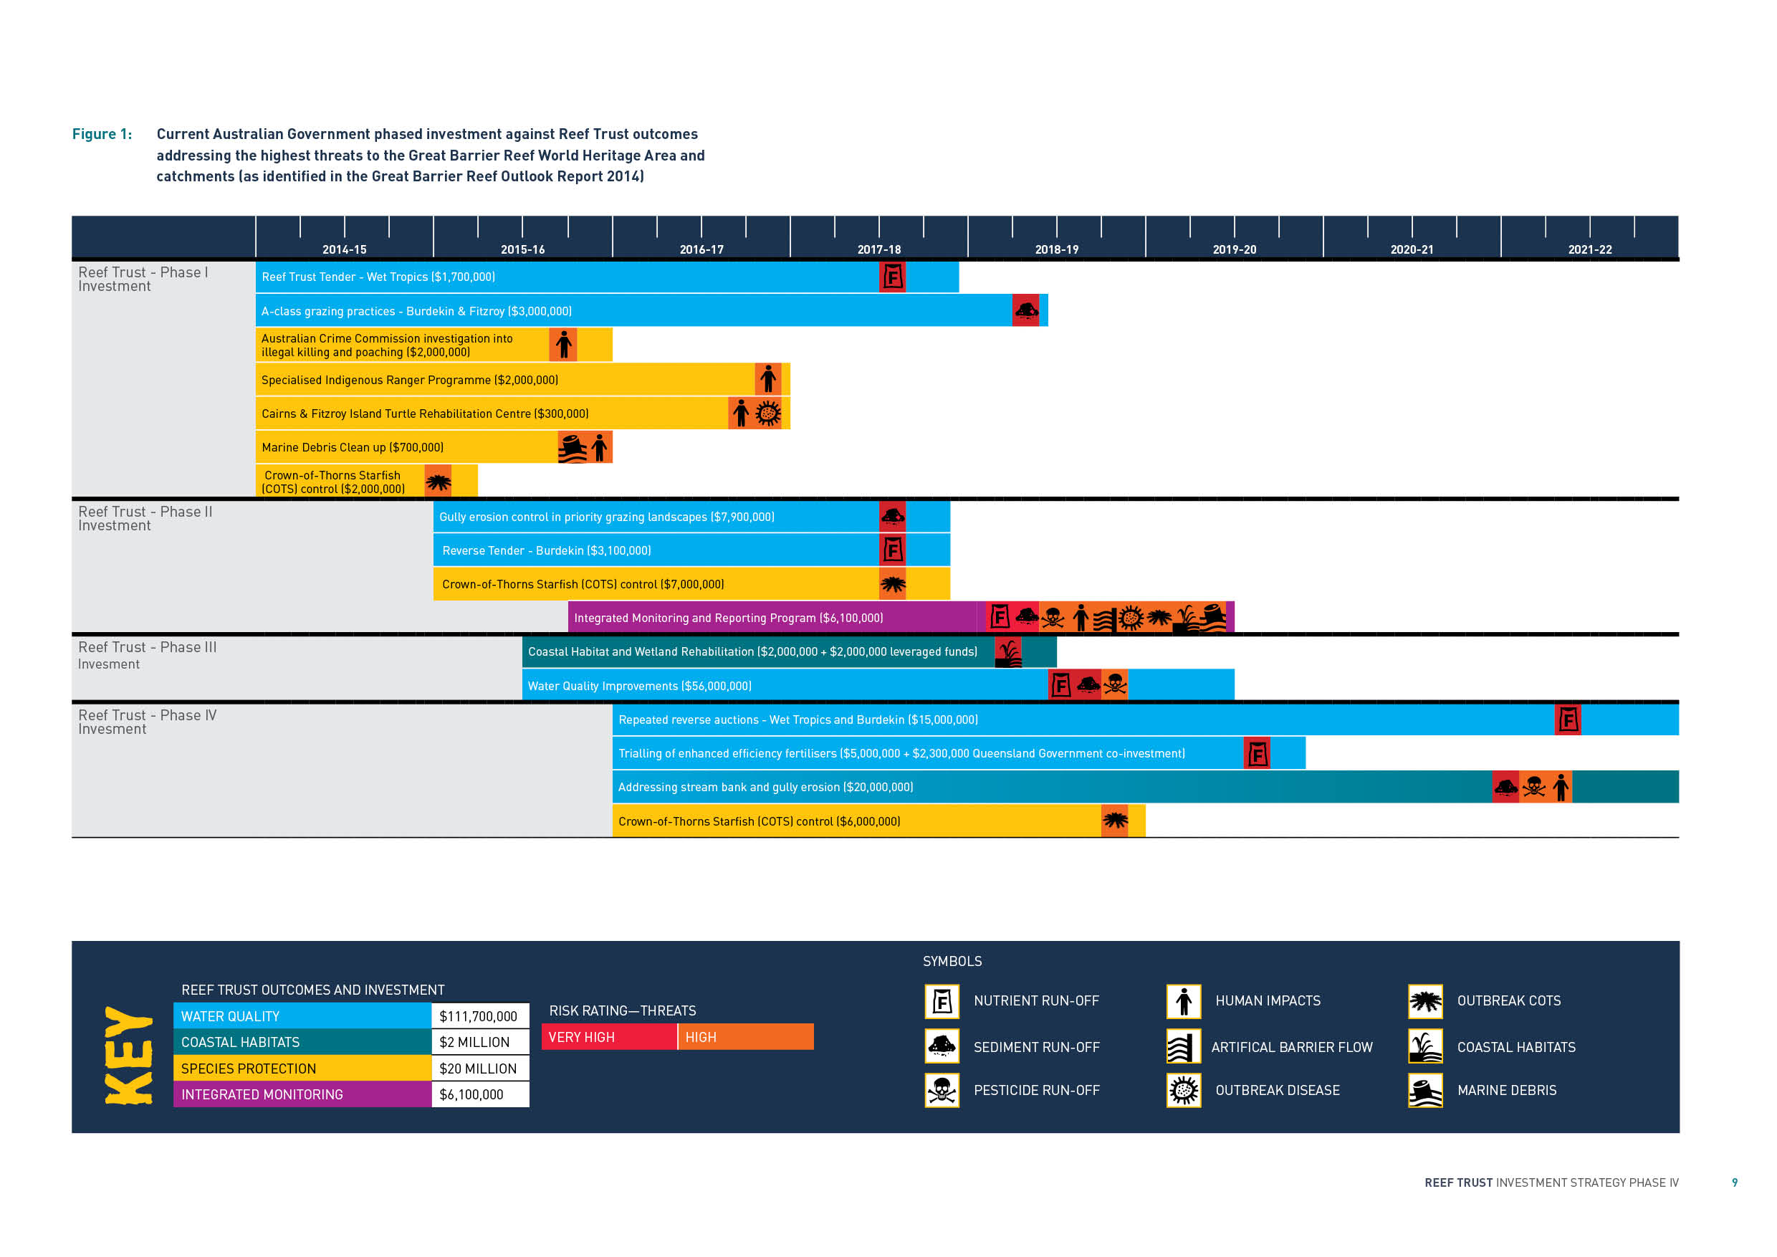

PART 2: THE REEF TRUST

2.1 About the Reef Trust

The Reef Trust is an Australian Government programme established to provide innovative, targeted investment to the Great Barrier Reef region, focussed on improving water quality, restoring coastal ecosystem health and enhancing species protection. The Australian Government has committed $210 million to the Reef Trust since its establishment in 2014. Figure 2 shows significant milestones in the implementation of the Reef Trust.

Delivering on the Reef 2050 Plan: The Reef Trust

The Reef Trust is one of the key mechanisms assisting in the delivery of the Reef 2050 Plan. The Reef Trust contributes significantly to a number of Reef 2050 Plan outcomes and actions. Appendix 3 includes an example of some of the Reef 2050 Plan actions to which the Reef Trust contributes through   
its range of projects.

Reef Trust projects predominantly align with three of the Reef 2050 Plan’s seven overarching themes, Water Quality, Ecosystem Health and Biodiversity, which correspond closely with the Reef Trust objective and outcomes.

Sugarcane farm in the Queensland wet tropics
Photo credit: Naomi Wynd

Sugarcane farm in the Queensland wet tropics Photo credit: Naomi Wynd

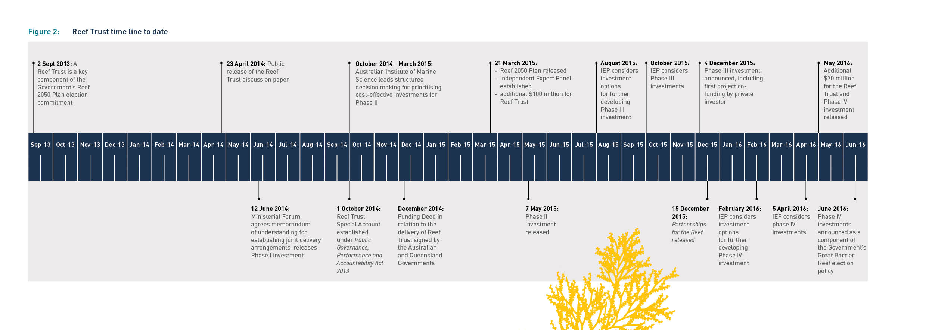

Reef Trust Objective, Outcomes and Investment Principles

The Reef Trust is designed to direct funding in a targeted and strategic way to deliver against the Reef Trust outcomes. Projects and programmes delivered through the Reef Trust are underpinned by a set of investment principles that guide the identification, prioritisation and coordination of investment. The majority of Reef Trust investments work towards Reef Trust outcomes 1–3 (see Figure 3). As Reef Trust funds may also be derived from the pooling of offset funds for actions that have a significant residual impact on matters of national and state environmental significance, outcome 4 aims to ensure that such offsets must be delivered strategically.

How the Reef Trust works

The Reef Trust is being developed and implemented in a phased approach, which enables investments to be targeted towards known key threats underpinned by the most up-to-date information. This means projects are released in phases, providing ongoing access to funding through application and assessment processes. An investment strategy is developed for phases of Reef Trust investment to guide their delivery.

Projects are determined through a rigorous process of prioritisation and informed by discussions with key scientists, experts, on-ground delivery partners, key interest groups and individuals. To date, four phases of Reef Trust investment have been released, committing more than $140 million across 2014–2022.

Releasing the investments in a phased manner allows for evaluation and adaptive management of the Reef Trust’s implementation. This ensures investments are underpinned by the best available information about reef threats and assets, appropriate management practices, behaviour change and practice adoption, and mechanisms for delivery of conservation projects.

To build on the progress being made towards the Reef 2050 Plan targets, the Reef 2050 Independent Expert Panel considers potential investments and advises on their scientific merits and suitability for inclusion in the Reef Trust. The Minister for the Environment makes the final decision on the investments in each phase.

Reef Trust Governance

The Reef Trust is delivered by the Australian Government in collaboration with the Queensland Government. Governance and administrative arrangements are in place to ensure all Reef Trust funds are effectively managed and directed towards priority on-ground actions. These arrangements leverage and complement the broader governance structure and processes for theReef 2050 Plan and the Reef Water Quality Protection Plan 2013.

Funding for the Reef Trust is administered through the Reef Trust Special Account. The Special Account has been established through a legal determination that prescribes purposes for spending of funds. The determination can be viewed at [www.legislation.gov.au](https://www.legislation.gov.au). The Minister for the Environment makes the final decision on investments in each phase. Independent expert advice on Reef Trust funding priorities is provided by the Reef 2050 Independent Expert Panel, chaired by Professor Ian Chubb (former Commonwealth Chief Scientist). The Panel consists of eminent experts from a number of scientific fields and considers and advises on priorities and projects for the Reef Trust.

The Reef 2050 Advisory Committee is also utilised by the Reef Trust to facilitate engagement with the broader community and industry. The Advisory Committee, consisting of senior representatives from key industry and community bodies, provides strategic advice on the implementation of the Reef 2050 Plan, including the Reef Trust.

Oversight and advice on the delivery of the Reef Trust is provided by the Reef Trust Joint Steering Committee, which comprises of senior representatives from the Australian and Queensland governments, including the Great Barrier Reef Marine Park Authority. The Committee is responsible for overseeing administration of Reef Trust, development of investment strategies, and delivery and implementation of Reef Trust projects. In addition, the Committee advises on the alignment and integration of government investment in the reef, emerging issues, projects for potential investment, and ensures that appropriate project management processes are undertaken to deliver Reef Trust projects. A funding deed has been established between the Australian and Queensland governments for the delivery of Reef Trust projects.

The Reef Trust investment prioritisation process and consultation incorporates broader community, science and industry views and experience.

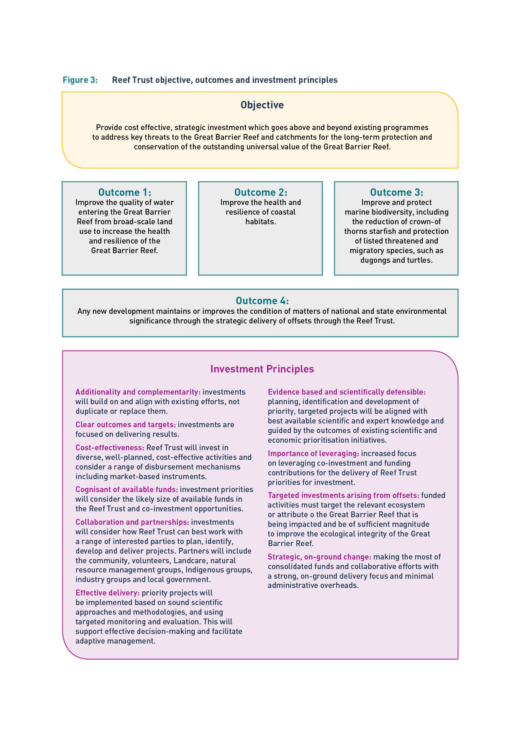

Monitoring and reporting

The Reef Trust Monitoring, Reporting, Evaluation and Adaptive Management Plan (available at [www.environment.gov.au/marine/gbr/reef-trust](http://www.environment.gov.au/marine/gbr/reef-trust)) sets out arrangements to enable the Reef Trust to meet its obligations to report by outcomes, account for the use of public funds, and enable continuous project and programme improvement.

The Australian and Queensland governments’ international obligations in respect to the Great Barrier Reef world heritage status are monitored and reported on through the Reef 2050 Integrated Monitoring and Reporting Program, managed through the Great Barrier Reef Marine Park Authority. The Program supports all seven themes identified in the Reef 2050 Plan, and captures Reef Trust projects contributing to improved water quality, ecosystem health and biodiversity.

The impacts of Reef Trust investments are monitored, where appropriate, through the Australian and Queensland government funded Reef Water Quality Protection Plan Paddock to Reef Integrated Monitoring, Modelling and Reporting Program (Paddock to Reef Program). The Paddock to Reef Program is a collaboration involving governments, industry bodies, regional natural resource management bodies, landholders and research organisations. Comprised of monitoring and modelling activities at the paddock, catchment and marine levels, the program also looks at the impact of the adoption of improved management practices. The Great Barrier Reef Report Card produced through this program provides an assessment of the current state and trends in water quality entering the reef as well as an overview of marine condition including for seagrasses and corals.

Reef Trust projects are reported on every six months through an Australian Government online monitoring, evaluation, reporting and improvement tool. Performance of on-ground activities and progress toward project outcomes are captured to inform adaptive management and contributions towards the targets in the Reef 2050 Plan.

Through these monitoring and reporting processes, the progress and achievements of the Reef Trust and its contributions to the Reef 2050 Plan are clearly captured and allows investments to be actively managed to meet the changing priorities of the reef and its catchments.

Encouraging innovation

The Reef Trust funds projects that encourage and enable land managers to develop innovative practices. For example, through the enhanced efficiency fertiliser project to be implemented during Phase IV, the Reef Trust is supporting sugar cane grower trials of various enhanced efficiency fertilisers. Enhanced efficiency fertilisers are a relatively new technology, with several small-scale research trials of various enhanced efficiency fertilisers currently underway on cane farms in the Reef catchments. Reef Trust support for targeted, large-scale grower trials of these products is an innovative approach to reduce environmental nitrogen losses, improve nitrogen use efficiency (that is, the kilograms of nitrogen applied per ton of cane harvested), and potentially improve economic returns for cane growers. With widespread adoption of the innovative technology across the Reef cane industry, this project is expected to result in up to 20 per cent reduction in nitrogen applied to cane farms and a proportional reduction in nitrogen losses to the Reef.

The Reef Trust also demonstrates its commitment to new approaches for allocating funds by trialling innovative funding mechanisms. Reef Trust projects are delivered through a range of mechanisms, dependent on the specific outcomes sought, allowing for collaboration, innovation and cost-effectiveness. In particular, the Reef Trust encourages greater use of market based instruments to ensure the achievement of the greatest outcomes relative to cost.

For example, the Reef Trust Tenders in the Wet Tropics and Burdekin natural resource management regions have used a competitive reverse tender to allocate financial incentives to sugar cane farmers to improve their nitrogen use efficiency and farm sustainability. The competitive tender allows sugar cane farmers to set their own nitrogen reduction targets and determine the costs required to support the achievement of those reductions. The competitive nature of the process increases cost-effectiveness for achieving environmental outcomes by letting the market determine the amount to be paid for nitrogen reduction.

2.2 Approach to the identification of investments

Investment approach

Reef Trust investment options must be underpinned by the ten Reef Trust principles for investment (see Figure 3). Furthermore, investments must be based on the best available science and complement the extensive efforts across governments, natural resource management organisations, Traditional Owners, and industry to delivery cost effective and strategic on-ground change.

Each phase of Reef Trust investment, including this Phase, is supported by a rigorous process that considers priority threats to be addressed, priority assets to be protected and the most cost-effective and relevant actions that will provide a lasting environmental benefit. Project themes arising from this process are widely distributed to relevant experts and key stakeholders, and revised in response to the feedback received.

Australian and Queensland Government investment in Reef research and monitoring including the Reef Water Quality Protection Plan Paddock to Reef Programme and the Reef Water Quality Science Program has helped to improve the knowledge base across a range of Reef issues over the past five years. Building the most recent science and research into Reef Trust decisions ensures each phase of investment targets the highest priority threats to the Reef.

Projects are aligned to the priority themes identified by the Reef 2050 Plan Independent Expert Panel. For Phases III and IV these themes are: decreasing nutrient losses from intensive agriculture; improving grazing land management; and protecting and restoring sensitive ecosystems. These themes continue to be the highest priorities identified by scientists.

The process to identify investments is summarised in Figure 4 and described in further detail below.

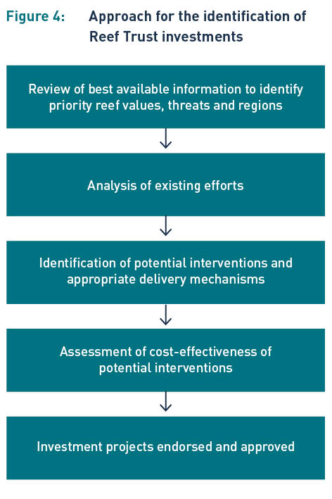

Review of best available information—priority reef values, threats and regions

The significant work undertaken by the Great Barrier Reef Marine Park Authority and scientists to produce the Great Barrier Reef Outlook Report 2014 provides an essential assessment of the current health, pressures, and likely future state of the Reef. These five yearly reports provide a regular, reliable and scientifically based means of assessing overall performance of all measures to protect and manage the Reef.

Likewise, information from the Great Barrier Reef Marine Park Authority’s strategic assessment of the Great Barrier Reef World Heritage Area and the Queensland Government’s strategic assessment of the adjacent coastal zone provide an understanding of the connectivity of the terrestrial and marine environments and how natural and heritage values can be protected into the future. Further, the Scientific Consensus Statement on Water Quality in the Great Barrier Reef 2013and the Reef Water Quality Protection Plan 2013 Prioritisation project reporthave also informed the process to identify priority threats, regions and industries, and the design of potential interventions.

Reef Trust investment is also guided by world-class biodiversity and climate science coming out of programmes such as the Queensland Government’s Reef Water Quality Science Program and the Australian Government’s National Environmental Science Programme. Design and implementation of projects is further guided by regional Water Quality Improvement Plans and other relevant scientific and expert advice.

Analysis of existing efforts

To ensure investments are additional and complementary to existing efforts, analysis of previous and current investment is undertaken to understand whether the identified threats to natural values are being addressed. This analysis considered a range of programmes, such as Reef Programme, existing Reef Trust investments, the Queensland Government’s Reef Water Quality Protection Program and Queensland Natural Resource Management program, as well as existing Australian Government initiatives such as Green Army and 20 Million Trees.

Consideration has also been given to acknowledging where the responsibility, sometimes set through legislation, for addressing threats or protecting natural values rests with other programmes, agencies, industry bodies, or community groups, and where actions are already being delivered to address threats.

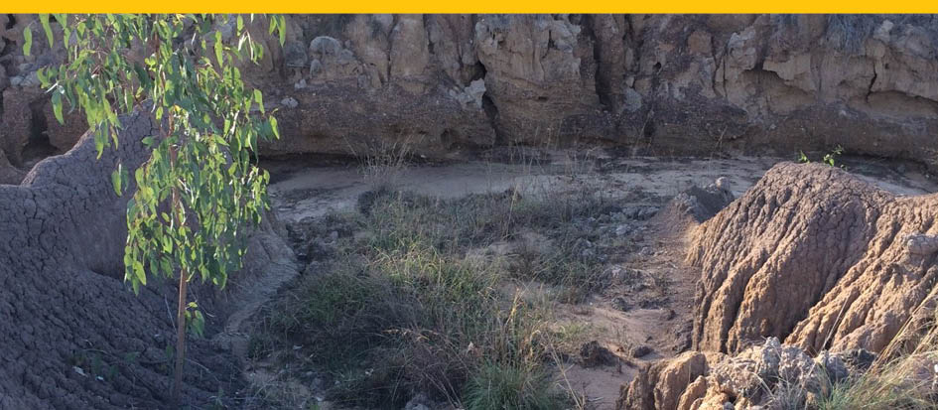

Gully erosion. Photo credit: Tulsi Rajyaguru.

Identification of projects

Reef Trust investment options originate from a range of sources. Reef Trust governance bodies, the Queensland Government and the Great Barrier Reef Marine Park Authority contribute investment ideas based on their expertise and current and previous investments. Likewise, discussions with stakeholders, including natural resource management groups, industry bodies, scientists, researchers and community groups, and submissions from the general public inform the range of proposed projects.

Each of the proposed projects for investment through Phase IV was developed and assessed in light of the Reef Trust outcomes and principles for investments. In developing these projects, advice was drawn from key stakeholders and experts to identify actions that would provide lasting environmental benefits and have a high likelihood of adoption across the relevant industries. The projects that were designed through this iterative process were endorsed by the Reef 2050 Independent Expert Panel members at their meeting in April 2016.

Detailed scientific prioritisation information is available to assist with the spatial and management practice targeting of investments to address these high priority threats, including regional Water Quality Improvement Plans and the results of the Reef Water Quality Protection Plan Paddock to Reef Integrated Monitoring, Modelling and Reporting (Paddock to Reef) Program.

Assessment of Cost-Effectiveness

Information on cost effectiveness, both in terms of specific management actions and delivery mechanisms, as well as essential supporting actions such as farm planning, training and extension has been built up over the course of eight years of large-scale on-ground programme delivery through Reef Programme and Reef Trust. Projects are designed based on actions that can be monitored, modelled and reported through the existing Paddock to Reef programme.

Using advice from the Reef 2050 Independent Expert Panel, the Phase IV project scoping process identified potential projects to increase the efficiency and effectiveness of investments and maximise progress towards achieving the Reef Trust outcomes and targets.

2.3 Diversifying Investment

The Reef Trust is established to be a long-term mechanism for bringing together investment from both government and non-government sources. Looking into the future, the Reef Trust is diversifying its investment base and is inviting industry, financial institutions, community organisations, the corporate and philanthropic sectors and individuals to work with the Reef Trust to support and deliver projects, and to explore other ideas on how to better protect the Reef.

Offsets

Environmental offsets are a regulatory tool used to compensate for the residual adverse significant impacts of an action on the environment, once all feasible avoidance and mitigation measures have been applied. Offsets are designed to achieve long-term environmental outcomes, while providing a degree of flexibility for approval holders to achieve the required environmental outcome.

The Reef Trust provides a mechanism for approval holders to address offset requirements for actions in the Great Barrier Reef World Heritage Area. Through the Reef Trust, offset funding can be pooled and delivered strategically, to provide greater environmental benefit for the impacted protected matters.

Guidance for future proponents on the requirements for providing an offset contribution to the Reef Trust and the method used to calculate the size of the required offset is currently under development.

The Reef Trust offset approach is intended to fit within the framework of the *Environment Protection and Biodiversity Conservation Act 1999* Environmental Offsets Policy, along with the outcomes agreed in the Reef 2050 Plan including the Net Benefit Policy, Cumulative Impact Policy and Great Barrier Reef World Heritage Area Offsets Policy currently being developed by the Great Barrier Reef Marine Park Authority.

Finalised guidance material and associated resources will be available on the Reef Trust website by late 2016.

Incorporating Existing Offsets

The Reef Trust is working with several existing approval holders whose conditions of approval require a financial contribution to a reef programme, such as the Australian and Queensland Governments’ Joint Field Management Program, or funding of conservation initiatives which align with the outcomes of the Reef 2050 Plan and could be delivered by the Reef Trust.

Private and philanthropic investment opportunities

The Australian and Queensland governments have a long history of working successfully together with natural resource management regions, industry, Traditional owners, community and local government to manage and protect the Reef. To address the growing interest from the private and non-government sectors in supporting the delivery of Reef projects, the Reef Trust released Partnerships for the Reef in December 2015.

Partnerships for the Reef, which invites organisations to work with the Australia and Queensland governments through the Reef Trust, showcases how the private and philanthropic sectors can be involved in tackling the key pressures and challenges facing the Reef. It sets out a range of opportunities available for sponsorship, co-investment and collaboration, including six project ideas ready for development and delivery with interested parties.

We are inviting interested organisations, investors and individuals to start a conversation with us on working through the Reef Trust to better protect and conserve the Great Barrier Reef.

Partnerships for the Reef is available on the Department’s website [www.environment.gov.au/marine/gbr/reef-trust](http://www.environment.gov.au/marine/gbr/reef-trust).

Potential mechanisms for future investments

The Reef Trust is exploring conservation financing opportunities for the Great Barrier Reef. Conservation financing is a new and exciting space, both in Australia and internationally. The Reef Trust, and the framework of the Reef 2050 Plan, provides the chance to work outside traditional disbursement methods such as grants, as well as look at ways to leverage funding from the private sector.

The Reef Trust is looking to implement practical, innovative financing options that can be applied to the Reef. The Reef Trust is aiming to pilot a mechanism that supports tangible environmental outcomes aligned with the Reef 2050 Plan and is additional to existing government investment.

The Reef Trust is working with experts from the philanthropic and finance sectors and has established the Reef Trust Innovative Financial Mechanisms Panel. The Panel provides a forum for experts to discuss a range of conservation financing mechanisms which could be piloted for the Great Barrier Reef. The Panel has discussed a range of conservation financing opportunities for the Great Barrier Reef including impact investing or pay for performance models and private equity investment. The Panel has considered the recent experience issuing green bonds in Australia and lessons from sustainability bonds issued in France and Germany.

The Innovative Financial Mechanisms Panel and the ongoing work of the Reef Trust will inform development of the best approach and mechanisms for harnessing future partnerships and private investment to work effectively alongside public investment in the Reef. The use of private and philanthropic funds for government-led conservation projects is an area of continual development and we welcome ideas that support the delivery of Reef Trust outcomes in the Great Barrier Reef World Heritage Area and the Reef catchments.

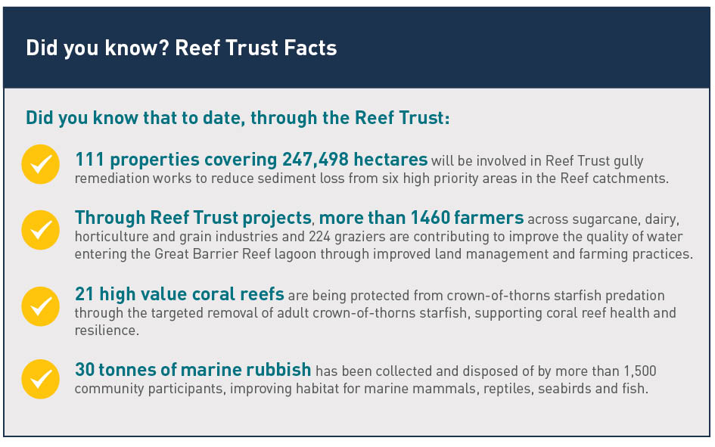

PART 3: STRATEGY TO MANAGE THE REEF   
TO 2050

3.1 The Reef 2050 Plan

The Reef 2050 Plan is the Australian and Queensland Government’s overarching framework for protecting and managing the Great Barrier Reef until 2050. The Plan is a key component of the Australian Government’s response to the recommendations of the United Nations Educational, Scientific and Cultural Organization (UNESCO) World Heritage Committee.

The Reef 2050 Plan was developed by the Australian and Queensland governments with input from scientists, communities, Traditional Owners, industry and non-government organisations. At the core of the Plan is an outcomes framework that will drive progress towards an overarching vision:

*To ensure the Great Barrier Reef continues to improve on its Outstanding Universal Value every decade between now and 2050 to be a natural wonder for each successive generation to come*.

The Reef 2050 Plan outcomes framework identifies tangible outcomes, objectives and measurable targets across seven themes: biodiversity, ecosystem health, heritage, water quality, community benefits, economic benefits and governance. They build on existing targets, such as those in the Reef Water Quality Protection Plan 2013*,* and focus on activities that will safeguard the Outstanding Universal Value of the Reef.

The Reef 2050 Plan prescribes greater coordination, efficiency and effectiveness of all Reef programs and activities. It describes how all levels of government, non-government organisations, industry and community groups can work together to strengthen and develop initiatives for the Reef.

3.2 Managing the Reef Together

There is a strong and long-standing working relationship between successive Australian and Queensland governments in relation to protection and management of the Reef. It was first formalised in 1979 through the Emerald Agreement and a series of collaborative arrangements has evolved over time. The Great Barrier Reef Intergovernmental Agreement 2009 was established to provide a contemporary framework for cooperation between the governments. With the development of the Reef 2050 Plan in 2015, the Australian and Queensland government have updated the 2009 Agreement to establish the updated commitments and arrangements, objectives and respective functions and accountabilities.

The 2015 Agreement reflects the shared vision for the future outlined in the Reef 2050 Plan, and renews the Australian and Queensland governments’ commitment to protecting the Great Barrier Reef World Heritage Area including its Outstanding Universal Value.

The strong collaboration continues today through joint arrangements for the Reef 2050 Plan and the Reef Trust. The Australian Government Department of the Environment, the Great Barrier Reef Marine Park Authority, and the Queensland Government share the responsibility for the implementation of the Reef 2050 Plan to protect the Outstanding Universal Value of the Reef.

The Australian and Queensland governments work closely together to ensure their respective investments are coordinated, complementary and integrated. The Reef 2050 Independent Expert Panel and the Queensland Government Great Barrier Reef Water Science Taskforce have provided advice on the alignment of investments, assisted by the overlapping membership of the two groups.

Flexibility and collaboration by both governments will be enhanced as both the Australian and Queensland governments continue working to develop successive investment projects and deliver these in a staged approach. With this collaborative approach, the development of future projects will continue to be informed by the successes and learnings of previous projects delivered by both governments to improve the health and resilience of the Great Barrier Reef.

Effective collaboration and strong partnerships are the foundation for the on-going protection and conservation of the Reef. The Australian Government recognises the significant contributions of natural resource management regions, peak industry groups, scientists, Traditional Owners, not-for-profit organisations, community and local government to manage and protect the marine and coastal biodiversity and ecosystems of the Great Barrier Reef.

Through Australian Government funding, natural resource management groups have developed six regional Water Quality Improvement Plans that will give coverage of the entire Great Barrier Reef catchment. Information from these plans will continue to inform Reef Trust investment at a regional level. They will also help identify the main issues impacting waterways and the marine environment from land-based activities in each region, and prioritise management actions to meet water quality objectives and targets.

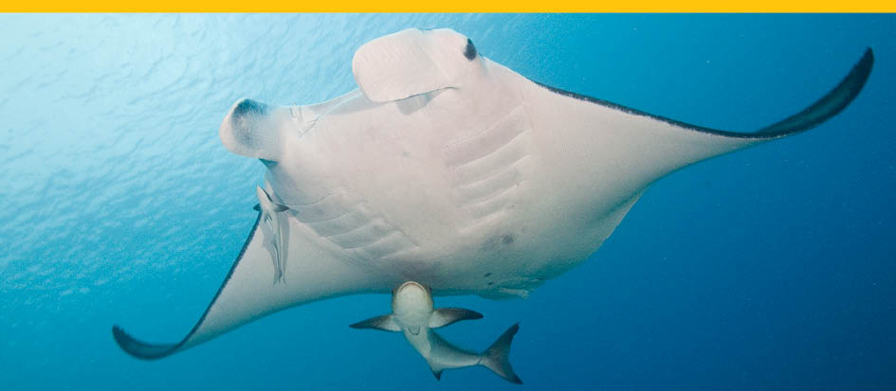

Large manta ray with cobia swimming near Heron Island in the Great Barrier Reef. Photo credit: David Harasti.

3.3 Complementary investment

Each phase of Reef Trust investment builds on and complements existing actions being delivered across the Reef and catchments through Reef Programme, Reef Trust, Queensland Government programmes and other Australian Government programmes, such as 20 Million Trees and the Green Army.

The Australian and Queensland governments work together to ensure their respective investments are coordinated and complementary. The Australian Government Reef Programme is delivered under the intergovernmental arrangements of Reef Water Quality Protection Plan 2013 to ensure coordination and integration with relevant Queensland Government programmes. The Queensland Government has committed to providing $35 million per year to activities that support the Reef Water Quality Protection Plan 2013 outcomes. The Reef Trust complements and builds on existing activities being delivered through these programmes.

In 2015, the Queensland Government committed an additional $90 million over four years to improve water quality in the Great Barrier Reef, which will be available from 2016-2017. The Queensland Government has agreed to the recommendations from the Great Barrier Reef Water Science Taskforce and is now working with stakeholders, experts and community members to implement the suite of recommendations to improve reef water quality. The Taskforce report confirms much of the work being delivered through the Reef Trust and discussions are ongoing between governments to ensure complementarity, coordination and integration of investments.

|  |
| --- |
| Complementary Investment: Green Army, 20 Million Trees,  National Landcare Programme and the Emission Reduction Fund |
| A range of initiatives implemented by the Department of the Environment, including the Green Army, 20 Million Trees, the National Landcare Programme, and the Emissions Reduction Fund, contribute to the conservation of the Reef thereby complementing the investment made through the Reef Trust.  From 2014 to 2019, over $56 million1 cumulatively has been allocated to fund over 250 projects in the Reef catchments through these initiatives. Around 130 of these projects contribute directly to at least one of the Reef Trust’s outcomes with significant anticipated results. For example, through these complementary investments, over 440,000 trees will be replanted across over 5,600 hectares, increasing land cover and subsequently reducing sediment loads from entering the Reef.  Examples of the projects being implemented through these initiatives include:  A Green Army project to conduct water quality sampling and weed eradication in the upper Burdekin catchment to monitor and improve water quality flows into the Reef lagoon  A 20 Million Trees project creating vital habitat linkages in the Wet Tropics World Heritage Area for a range of nationally endangered species, including the Cassowary, Spotted-tail quoll and a number of frogs  A National Landcare Programme project in the Mackay-Whitsunday region to revegetate waterways, resulting in increased system connectivity and improved water quality, reducing stress on seagrass habitat used by dugong and turtles  The diversity of the activities undertaken through these programmes demonstrates the multifaceted approach required to achieve the long-term protection and conservation of the Reef. From invasive species management and revegetation to debris removal and fencing; community events and burning methods—a range of activities are achieving outcomes to boost the health and resilience of the Reef.  More information about the Department’s programmes can be found at www.environment.gov.au. |

1 The Emissions Reduction Fund is excluded from this calculation as contract values are confidential.

APPENDIX 1

| **Project title** | **Cost** | **Project dates** | **Progress to date** |
| --- | --- | --- | --- |
| Phase I: $11.7 million | | | |
| Reef Trust Tender—Wet Tropics project | $1.7 million | 4 years July 2014 – June 2018 | The Reef Trust Tender - Wet Tropics is delivered by Terrain NRM. The Tender offers financial incentives to cane farmers through a competitive tender to determine their own nitrogen use efficiency targets and cost-effective means of achieving those targets. Funding is being provided for improved fertiliser management practices on 22 farms and as at April 2016, all contracted growers have demonstrated their reduced nitrogen application according to project requirements. |
| Promotion of A-class grazing management practices to reduce sediment runoff in the Burdekin and Fitzroy regions | $3 million | 3.5 years July 2014 – December 2018 | This project accelerates the reduction of sediment from grazing lands in the highest priority regions through providing increased extension and technical support. It is delivered by the Queensland Government in partnership with the Fitzroy Basin Association and NQ Dry Tropics. To date, 10 farmers have been contracted in both the Burdekin and Fitzroy and have commenced on-ground changes to their properties.  This project builds on existing work to improve water quality in the Reef through engaging graziers in the Fitzroy and Burdekin regions to enhance their productivity and profitability while reducing their impact on the environment. Using a holistic approach, participants’ business management skills and capacity are being improved through a tailored framework of training, mentoring and support from industry top performers, leading to the adoption of best management practices that minimise sediment run-off into the Reef. Their journey is being documented and shared with the broader grazing industry and Reef community, demonstrating that improved grazing practices can be implemented without impacting on productivity and at the same time improving the health and resilience of the Reef. |
| Crown-of-thorns Starfish control on high value tourism reef | $2 million | 1 year July 2014 – June 2015 | Crown-of-thorns starfish (COTS) outbreaks have been identified as one of the primary threats to coral in the Great Barrier Reef. Through this project, the Reef and Rainforest Research Centre engaged the Association of Marine Park Tourism Operators to undertake the targeted COTS control project, including the coordination of COTS culling activities, monitoring and surveillance, and development of a COTS integrated pest management methodology. This project has concluded and is followed by a further $7 million into COTs control through Phase 2. |
| Specialised Indigenous Rangers Programme | $2 million | 3 years July 2014 – July 2017 | The Specialised Indigenous Rangers Programme addresses marine conservation through strengthened enforcement and compliance in Queensland and the Torres Strait. The programme is delivered by the Department of the Prime Minister and Cabinet in partnership with the Great Barrier Reef Marine Park Authority, Torres Straight Regional Authority and Balkanu Development Corporation. The programme has created five new Indigenous compliance officer positions, three Indigenous community liaison positions and is providing compliance training to 20 Indigenous rangers. |
| Australian Crime Commission investigation into illegal killing and poaching | $2 million | 2 years July 2014 – June 2016 | The Australian Crime Commission Investigation is investigating the practice of illegal poaching and transportation of turtle and dugong meat. A report of the investigation will be provided to the Minister for the Environment and Energy by October 2016. |
| Cairns and Fitzroy Island Turtle Rehabilitation Centre | $300,000 | 3 years July 2014 – June 2017 | The Cairns and Fitzroy Island Turtle Rehabilitation Centre rehabilitates sick and injured turtles and returns them to the marine environment. Turtles rehabilitated and released at the Centre are fitted with tracking devices to monitor survival post release. To date, four turtles have been rehabilitated and released to the marine environment. The Centre has provided a range of training and educational activities to members of the reef community, international visitors, Traditional Owners and volunteers. |
| Marine debris clean up | $700,000 | 2 years July 2014 – June 2016 | This project is cleaning up marine debris across the Reef, protecting iconic marine species and helping to conserve the Reef’s Outstanding Universal Value. The Great Barrier Reef Marine Park Authority has collaborated with community groups, including Reef Guardian councils, fishers, farmers and schools, Traditional Owners, and tourism operators along the Queensland coast to conduct reef clean-up events and raise awareness of the issue to reduce the source and occurrence of marine debris.  Clean-up events are being held to clear waterways, beaches and the reef catchment of litter to prevent wet season rains washing it in to the ocean. To date, 30 tonnes of marine debris has been collected from beaches and waterways across the reef region, bringing together more than 1,500 volunteers across Queensland to participate in co-ordinated clean up events. The data collected through the project is incorporated into the Australian Marine Debris Initiative (AMDI) managed by Tangaroa Blue Foundation and will be used to advise future management and contribute to source reduction plans with local communities and government. |
| Phase II: $18 million + supplementary investment of $6.1 million | | | |
| Gully Erosion Control Programme | $7.9  million | 3 years July 2015 - December 2018 | Gully erosion in the Reef catchments is the main source of fine sediment and associated nutrients entering the reef lagoon. With technical advice from CSIRO, this project funds gully remediation works on properties containing gully hotspots in the Cape York, Burdekin, Fitzroy and Burnett-Mary natural resource management regions. Built into the design of the programme is consideration of the broader management of grazing land adjacent to the identified gullied areas. The programme supports activities such as fencing off gully areas, revegetation, adoption of improved land management practices, and gully reshaping where appropriate. |
| Crown-of-thorns Starfish control on high value tourism reef | $7 million | 3 years July 2015 – June 2018 | GBRMPA has been provided with $7 million over three years to engage with the Reef and Rainforest Research Centre to continue control activities, provide a dedicated surveillance vessel and develop a marine integrated pest management methodology. |
| Reef Trust Tender—Burdekin | $3.1 million | 3 years  July 2015 – June 2018 | The Reef Trust is delivering a second competitive tender to address nitrogen loss entering the Reef. Financial incentives support sugar cane farmers in the Burdekin region to improve their nitrogen and irrigation management practices across their farms. NQ Dry Tropics delivers this project, providing local support to sugar cane farmers and assisting with the implementation of a two-staged competitive tender. |
| Reef 2050 Plan Integrated Monitoring and Reporting Program | $6.1 million | 4 years March 2016 – June 2019  An additional phase II investment | This programme, delivered by GBRMPA, comprises monitoring and reporting within the Great Barrier Reef World Heritage Area and adjacent catchments relevant. The primary objectives of the Reef Integrated Monitoring and Reporting Program are to:  • track the performance of the Reef 2050 Plan actions towards achieving targets, objectives and outcomes; and  • drive adaptive management through an improved understanding of the condition and trend of the Reef’s values together with the drivers, pressures and activities affecting them.  This programme will also receive $1.9 million of National Landcare funding. |
| Phase III: $58 million + $2 million leveraged funds | | | |
| Supporting cane farmers to move beyond industry best practice | $25 million | 4 years January 2016 – June 2019 | Nutrients from fertiliser, and pesticides used in the sugarcane industry are key threats to the quality of water entering the Reef lagoon. This project provides supports cane farmers to move to, and in some cases, beyond industry best practice for nutrient, irrigation, pesticide and soil management. Helping farmers reduce losses of fertiliser, pesticide and topsoil improves farm sustainability, productivity and profitability. |
| Reducing erosion losses from rangelands grazing | $24.5 million | 4 years January 2016 – June 2019 | Very low ground cover and erosion features such as gullies and unstable river channels in grazing landscapes contribute high loads of fine sediment and associated nutrients entering the Reef lagoon. This programme will provide funding for one-on-one training and support to graziers to implement the highest priority actions identified through the farm planning process, with a focus on improving herd management, forage budgeting, setting and adaptively managing stocking rates and improving ground cover. |
| Maintaining water quality improvement momentum in grains dairy and horticulture | $6.5 million | 4 years January 2016 – June 2019 | This project supports the grains, dairy and horticulture industries to continue to reduce nutrient, sediment and pesticide losses from entering the Reef lagoon using a highly targeted and collaborative approach. Funding will provide training and support to land managers, including for delivery of soil and nutrient management plans. Financial support will also be provided to landowners for very high priority, cost effective, proven water quality improvement practices, such as improved nutrient use and irrigation efficiency, and minimising stock access to waterways. |
| Coastal habitat and wetland rehabilitation | $2 million + $2 million leveraged funds | 4 years January 2016 – June 2019 | This project will improve the health and resilience by restoring and repairing priority wetlands and coastal ecosystems along the Great Barrier Reef, and trial an innovative partnership approach. Under this pilot project, the Australian Government will match, dollar-for-dollar, private funds raised by Greening Australia and its partners (Birdlife Australia, Conservation Volunteers Australia and WetlandCare Australia) up to $2 million for wetland and coastal habitat restoration at priority locations along the Great Barrier Reef coast.  Restoration of these sites will enhance nutrient assimilation and sediment trapping and assist to re-establish ecosystem function and improve connectivity for at least 200 hectares of wetlands and coastal ecosystems. This pilot, in collaboration with landholders and experts in natural resource management, will also help identify the most cost effective solutions for repair of Reef wetlands and coastal ecosystems and explore a new approach to diversifying funding for conservation projects for the Reef. |

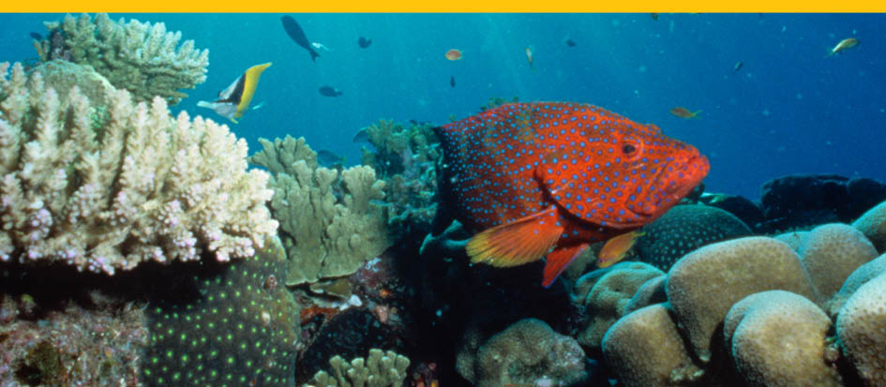

Coral cod in Stevens Reef. Photo credit: Commonwealth of Australia (GBRMPA)

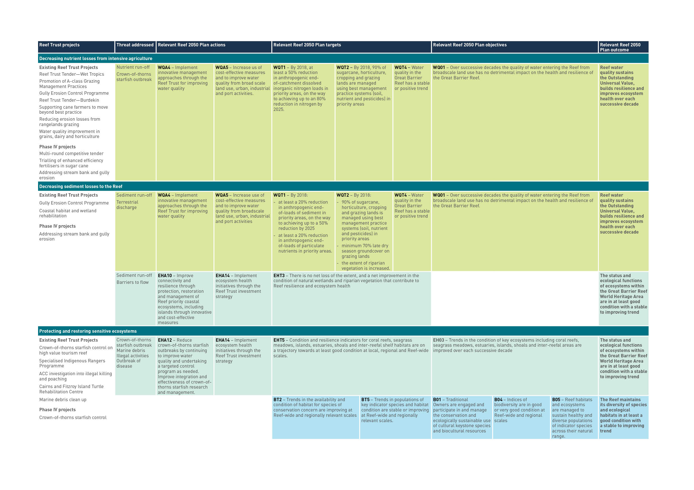APPENDIX 2

APPENDIX 3

EXAMPLE OF REEF TRUST’S CONTRIBUTION TO REEF 2050 PLAN ACTIONS

| **Water Quality** | |
| --- | --- |
| WQA2 | Continue improvement in water quality from broadscale land use through implementation of Reef Water Quality Protection Plan 2013 actions |
| WQA4 | Implement innovative management approaches through the Reef Trust for improving water quality. |
| WQA5 | Increase use of cost-effective measures to improve water quality from broadscale land use, urban, industrial and port activities. |
| WQA24 | Identify and action opportunities for Traditional Owners, industry and community engagement in on-ground water quality improvement and monitoring programs. |
| **Ecosystem Health** | |
| EHA3 | Support Traditional Owner stewardship activities that contribute to Reef health and resilience, including removing and, where possible, identifying the sources of marine debris. |
| EHA6 | Further develop regionally relevant standards for ecosystem health (desired state, critical thresholds and health indicators) that inform and support the Integrated Monitoring and Reporting Program. |
| EHA10 | Improve connectivity and resilience through protection, restoration and management of Reef priority coastal ecosystems including islands through innovative and cost-effective measures. |
| EHA12 | Reduce crown-of-thorns starfish outbreaks by continuing to improve water quality and undertaking a targeted control program as needed. Improve integration and effectiveness of crown-of-thorns starfish research and management. |
| EHA14 | Implement ecosystem health initiatives through the Reef Trust investment strategy. |
| EHA18 | Avoid, mitigate or offset impacts on marine and coastal ecosystems to restore Reef resilience and ecosystem health. |
| EHA27 | Implement on-ground activities to reduce the volume of debris generated in or entering the World Heritage Area, and undertake education and awareness raising activities to minimise the source and occurrence of marine debris. |
| EHA28 | Support best practice and community stewardship activities that contribute to Reef health and resilience. |
| **Biodiversity** | |
| BA1 | Where agreed through Traditional Owner engagement frameworks, apply traditional knowledge and customary use of biological diversity, including the use of community protocols, in managing protected areas. |
| BA3 | Improve Traditional Owner engagement to strengthen participation in decision making at all levels relating to the conservation and cultural use of biodiversity. |
| BA5 | Further develop and implement dugong and turtle protection plans using the Reef Trust and associated initiatives. |

Slashers Reef. Photo credit: Commonwealth of Australia (GBRMPA).

