

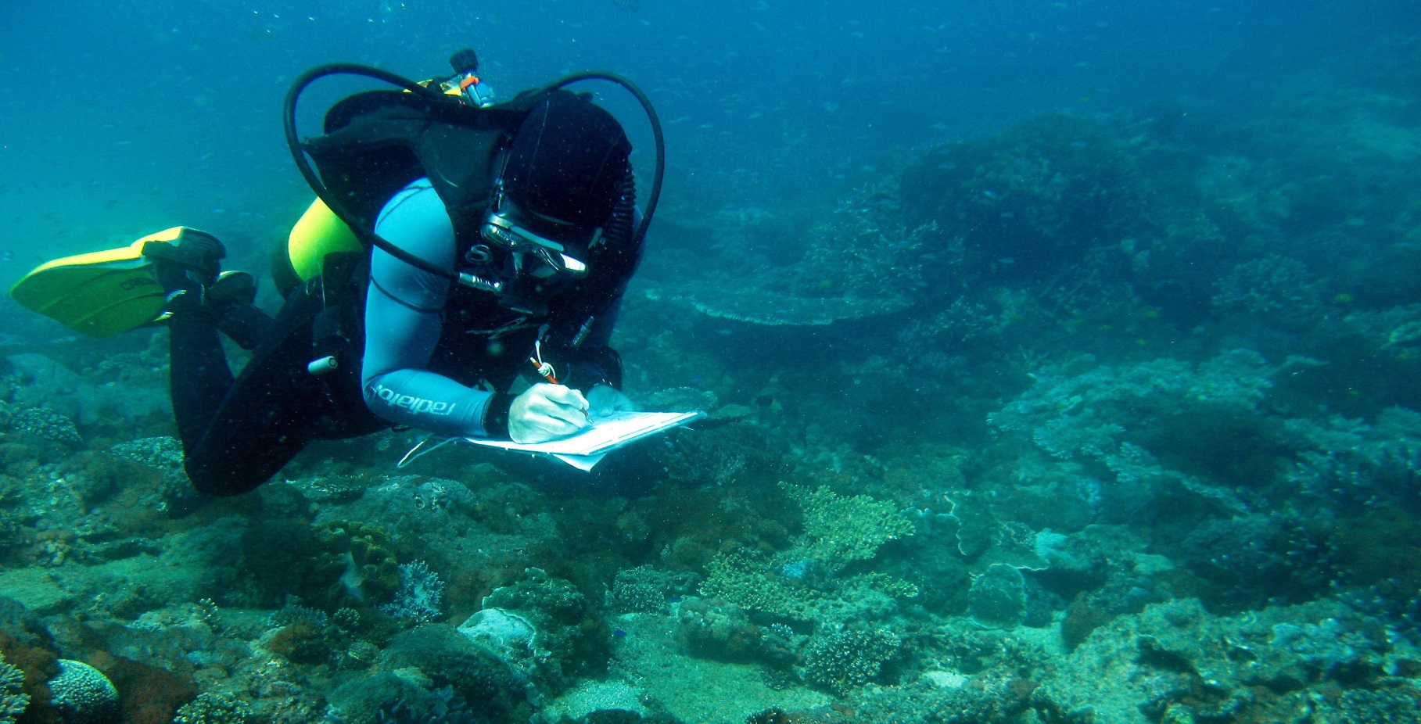Reef Trust Monitoring and Reporting Plan

ii / Reef Trust Monitoring and Reporting Plan

**© Commonwealth of Australia, 2016.**

*Reef Trust Monitoring and Reporting Plan* is licensed by the Commonwealth of Australia for use under a Creative Commons By Attribution 4.0 Australia licence with the exception of the Coat of Arms of the

Commonwealth of Australia, the logo of the agency responsible for publishing the report, content supplied by third parties, and any images depicting people. For licence conditions see: <http://creativecommons.org/licenses/by/4.0/>

This report should be attributed as ‘*Reef Trust Monitoring and Reporting Plan*, Commonwealth of Australia 2016’.

The Commonwealth of Australia has made all reasonable efforts to identify content supplied by third parties using the following format ‘© Copyright, [name of third party] ’.

**Disclaimer**

The views and opinions expressed in this publication are those of the authors and do not necessarily reflect those of the Australian Government or the Minister for the Environment and Energy.

Images

Front cover: Copyright Commonwealth of Australia (GBRMPA)

Back cover: Copyright Department of the Environment and Energy and John Baker

Contents

Introduction 2

Monitoring, reporting, evaluation and adaptive management 3

Performance monitoring 6

Departmental policy and outcomes 6

Departmental contributions to international obligations 6

Program output and outcome performance 7

Impact monitoring 7

Reef Trust performance evaluations and adaptive management 9

Reef Trust program evaluations 9

Project evaluations 9

Accountability 10

Key policy, procedures and process documents 11

Appendix A: Reef Trust Program Logic 12

Appendix B: Reef Trust Key Evaluation Questions 13

Appendix C: Key Performance Indicators 14

1

# Introduction

Recognising the World Heritage status and the outstanding universal value of the Great Barrier Reef (the reef ), the Australian Government announced

in March 2015 the [Reef 2050 Plan](http://www.environment.gov.au/marine/gbr/publications/reef-2050-long-term-sustainability-plan). To support the achievement of this plan the Government has committed $210 million, to date, through the  [Reef Trust](http://www.environment.gov.au/marine/gbr/reef-trust).

The Reef Trust provides innovative, targeted investment focused on achieving the following outcomes which contribute directly to three (biodiversity, ecosystem health and water quality) of the seven themes of the Reef 2050 Plan.

The Reef Trust is designed to direct funding in a targeted and strategic way to deliver against the Reef Trust outcomes:

* **Outcome 1** Improve the quality of water entering the Great Barrier Reef from broad-scale land use to increase the health and resilience of the Great Barrier Reef.
* **Outcome 2** Improve the health and resilience of coastal habitats.
* **Outcome 3** Improve and protect marine biodiversity, including the reduction of

crown-of-thorns starfish and protection of listed threatened and migratory species, such as dugongs and turtles.

* **Outcome 4** Any new development maintains or improves the condition of matters of National and state environmental significance through strategic delivery of offsets through the Reef Trust.

The Reef Trust is being delivered by the Australian Government Department of the Environment and Energy, in collaboration with the Queensland Government, and the Great Barrier Reef Marine

Park Authority. Investments are delivered through a range of partnerships with regional natural resource management organisations, non-government organisations, land managers and community.

Monitoring and reporting the achievements of the Reef Trust against its outcomes and contributions to the Reef 2050 Plan is key to tracking the outcomes of its investments and enables adaptive management of the Trust through successive phases of investment to meet emerging challenges to the health and resilience of the reef.

This version of the Reef Trust Monitoring and Reporting Plan has been amended to reflect progress against Outcome 4, links to the Reef 2050 Plan, and associated Integrated Monitoring and Reporting Program.

2 / Reef Trust Monitoring and Reporting Plan

# Monitoring, reporting, evaluation and adaptive management

In line with the Australian National Audit Office recommendations, this monitoring and reporting plan identifies processes for monitoring and evaluating the Trust through:

* identified actions, outputs and outcomes
* evaluating achievements and impacts
* adaptively managing investment to address the health and resilience of the reef.

Through these processes Reef Trust investments are adaptively managed to contribute to achieving outcomes, contribute to the Reef 2050 Plan’s

long-term sustainable management of the reef, and address emerging threats to the reef.

Monitoring, reporting and evaluation of the Reef Trust is undertaken through a series of processes undertaken by the Department, Biodiversity Conservation Division, Reef Branch, Reef Trust section and by project proponents funded through the Reef Trust. These processes allow the Department to meet its commitment to adaptive management of its policies and programs and ensure accountability.

The principles which underpin the plan are based on the widely adopted elements of monitoring, reporting, evaluation and improvement as set out in the diagram below.

Policy/ program design

Reporting

Program design

Contract management

Investment Strategy

Monitoring

Improvement Evaluation Reporting

Program delivery

3

Investments through the Reef Trust are identified and delivered through a phased approach to enable investments to be targeted toward known key threats. This phased approach is informed by independent expert advice, best available science, and industry and

community consultation. Ongoing evaluation of these investments through reporting and consultation has provided the opportunity for flexibility to respond

to changing environmental and economic challenges facing the reef and its communities.

In addition, the Reef Trust is piloting innovative approaches to investment including by leveraging private and philanthropic investment, and providing a mechanism for approval holders to address offset

requirements for development activities within the Great Barrier Reef World Heritage Area. The relative contributions of these innovative approaches to achieving Reef Trust outcomes and contributing to the delivery of the Reef 2050 Plan are a key consideration of the monitoring and reporting plan.

Reporting on the contributions to water quality improvement and coastal habitat and marine species protection of the Reef Trust investments is undertaken through a nested approach. The diagram below

sets out this process of reporting on management achievements in protecting the outstanding values of the Great Barrier Reef World Heritage Area.

#### Figure 1: Reef Trust Reporting

**Australian Government**

**Reporting**

UNESCO

State Party Report

GBR Outlook

Report

**Reef Trust**

Portfolio

Budget Statements

Paddock to Reef

Reef 2050 Plan

Reporting

Contribution to

ANAO audits

Portfolio

Additional Estimates Statements

Reporting

against Reef Trust Outcomes

**Project**

**Reporting**

Project Activity

Reporting

Departmental

Annual Report

Annual

Public Revision of

Reporting of Investment

Achievements Strategy

Integrated

Monitoring

& Reporting Program

Senate

Estimates Hearings

Program Phase

Evaluations

Reporting

Against International Responsibilities

Reporting

Against National Responsibilities

State of the

Environment Report

4 / Reef Trust Monitoring and Reporting Plan

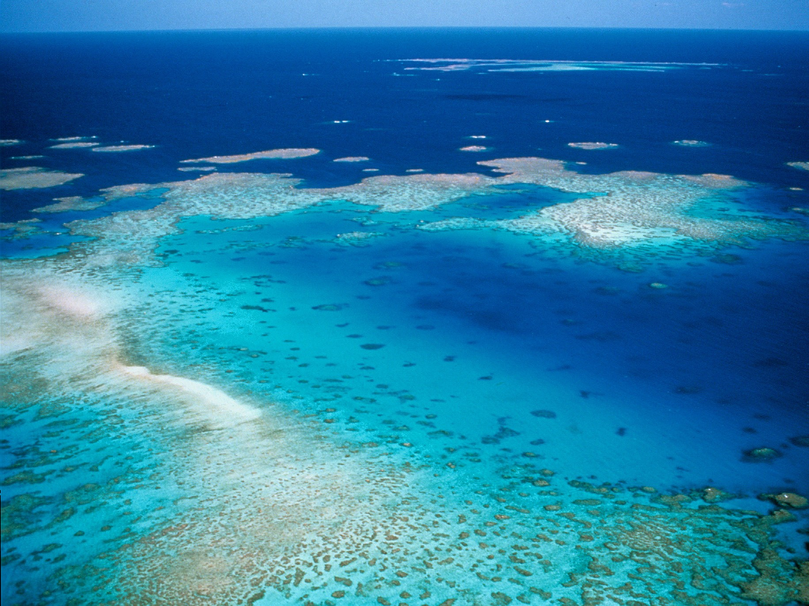

Photo: Slashers Reef, Great Barrier Reef © Copyright Commonwealth of Australia (GBRMPA)

The key elements of this Reef Trust Monitoring and Reporting Plan include:

* **Performance monitoring** of policies and program through collection of qualitative and quantitative data to report against established performance measures and to inform policy and investment decision making
* **Impact monitoring** of the changes in condition, extent, health and resilience of the elements that make up the outstanding universal values of

the reef

* **Evaluation** of the effectiveness, efficiency and appropriateness of interventions, delivery mechanisms and actions implemented
* **Adaptive management** to manage risks, inform evidence based decisions, guide resource allocations and improve program outcomes
* **Accountability** to the Government’s policies, national and international obligations in respect to the management and protection of the outstanding values of the Great Barrier Reef World Heritage Area and for the public funds invested.

These elements are delivered through a series of processes including existing departmental processes, those developed and delivered in consultation with external agencies, those developed specifically for the Biodiversity Conservation Division’s monitoring and reporting requirements, and those developed specifically for the Reef Trust.

5

# Performance monitoring

## Departmental policy and outcomes

The Reef Trust contributes to the Department’s policies and Portfolio Budget Statement Outcome 1:

*Conserve, protect and sustainably manage Australia’s biodiversity, ecosystems, environment and heritage through research, information management, supporting natural resource management, establishing and managing Commonwealth Protected areas and reducing and regulating pollutants and hazardous substances.*

The progress and outcomes of the Reef Trust are evaluated and reported in a number of Departmental statements and reports. These include:

* + [Portfolio Budget Statements](http://www.environment.gov.au/about-us/publications/budget/portfolio-budget-statements-2015-16) establishing annual performance expectations
  + [Annual Performance Statements](http://www.environment.gov.au/about-us/publications/annual-report-2014-15-environment) reporting the level of success in achieving the performance expectations.

In addition the achievements of the Reef Trust are reported in the following:

* + [Senate Estimate Hearings](http://www.aph.gov.au/Parliamentary_Business/senate_estimates)
  + [State of the Environment Report](https://www.environment.gov.au/science/soe/2011)
  + Annual Reef 2050 Plan Report
  + [Great Barrier Reef Outlook Report](http://www.environment.gov.au/news/2014/08/13/great-barrier-reef-outlook-report-2014-0) (five-yearly).

## Departmental contributions to international obligations

The Australian Government’s international obligations, such as under the World Heritage Convention for the management of the Great Barrier Reef World Heritage Area, are summarised in the *Great Barrier Reef Outlook Report*. The Reef 2050 Plan provides an overarching strategy for the management of the Great Barrier Reef. It coordinates actions and guides the adaptive management of the Great Barrier Reef World Heritage Area to 2050.

Delivery against key actions in the Reef 2050 Plan including contributions from Reef Trust investments are reported annually and five yearly through the Outlook report which provides an assessment of the reef ’s health, management and likely future. The most recent [Outlook Report](http://www.environment.gov.au/news/2014/08/13/great-barrier-reef-outlook-report-2014-0) was published in 2014. In addition the status and trends in the condition of the Great Barrier Reef is reported in the [UNESCO State](https://www.environment.gov.au/heritage/publications/state-party-report-gbr-2015)   [Party Report](https://www.environment.gov.au/heritage/publications/state-party-report-gbr-2015) on the state of the conservation of the Great Barrier Reef World Heritage Area (Australia).

6 / Reef Trust Monitoring and Reporting Plan

## Program output and outcome performance

The Reef Trust **program logic** (Appendix A) provides a visual interpretation of the connection between the actions, outputs and four outcomes of the Reef Trust. This also establishes the points where assumptions are made in the choice of actions and outputs to deliver against the Reef Trust outcomes. The Reef Trust program logic also provides the opportunity to

identify key evaluation questions (Appendix B) to test these assumptions and inform options for adaptive management of the program.

Performance of the Reef Trust Outcomes one, two and three are assessed through the effectiveness of projects in completing their outputs and measured and modelled impacts in relation to water quality, health and resilience of coastal habitats and improvements in marine biodiversity.

Monitoring and reporting of Outcome four will consider outcomes from projects implemented with offset funding and evaluate how the activities have addressed the residual adverse environmental impacts of an action on the environment in the Great Barrier Reef World Heritage Area.

Progress of the Reef Trust program investments are monitored six monthly and reported annually

through the [Monitoring, Evaluation, Reporting and](https://fieldcapture.ala.org.au/) [Improvement Tool](https://fieldcapture.ala.org.au/) (MERIT) located on Atlas of Living Australia website.

Monitoring performance against agreed actions and **key performance indicators** (Appendix C) provides the Department with up-to-date project level data to indicate the progress and performance of delivery of project outputs and project outcomes against specified Reef Trust outcomes. Reporting through MERIT enables the Department to meet the Australian National Audit Office’s requirement of reporting by outcomes, enabling continuous improvement and accountability for the use of public funds. While

this site allows public access to location, name and description of projects, it does not allow the public to monitor progress.

## Impact monitoring

The impact of Reef Trust investments are monitored through a number of processes. These include:

* The impacts of investments in water quality, coastal habitat protection and improvements and protection of marine biodiversity will be

monitored through the [Reef 2050 Plan Integrated](http://www.gbrmpa.gov.au/managing-the-reef/reef-2050/reef-integrated-monitoring-and-reporting-program)   [Monitoring and Reporting Program](http://www.gbrmpa.gov.au/managing-the-reef/reef-2050/reef-integrated-monitoring-and-reporting-program)**.** This program will draw on existing monitoring programs and collaboration similar to the Paddock to Reef Program. This is currently under development

to secure essential status and trend information to inform periodical reporting requirements under the Reef 2050 Plan, including the

2019 Outlook report.

7

* + The [Paddock to Reef Integrated Monitoring,](http://www.reefplan.qld.gov.au/measuring-success/paddock-to-reef/)   [Modelling and Reporting Program](http://www.reefplan.qld.gov.au/measuring-success/paddock-to-reef/) which focuses on the impacts of improved water quality.

This is jointly funded by the Australian and Queensland governments, and delivered through collaboration of governments, industry bodies, regional natural resource management bodies, landholders and research organisations. Based on uptake of agricultural management practices,

catchment indicators, catchment loads and Great Barrier Reef health indicators provided by the [Marine Monitoring Program](http://www.gbrmpa.gov.au/managing-the-reef/how-the-reefs-managed/reef-2050-marine-monitoring-program). The outcomes of the water quality monitoring will also inform

the Reef 2050 Plan Integrated Monitoring and Reporting Program.

* [Reef Plan Report Cards](http://www.reefplan.qld.gov.au/measuring-success/report-cards/) are currently being considered to provide an additional level of reporting on improvements in water quality. The Mackay Whitsunday Report card is being developed to test this process.
* Impact monitoring is also undertaken by projects and reported in [MERIT](https://fieldcapture.ala.org.au/). However, this is often limited to the period over which the project receives funding, unless projects have identified opportunities for legacy reporting.

#### Figure 2: Reef Trust impact monitoring

Reef 2050 Plan Integrated Monitoring and Reporting Program

Great Barrier Reef Report Cards

Paddock to Reef Integrated Monitoring, Modelling and Monitoring Program

MERIT Project impact reporting

8 / Reef Trust Monitoring and Reporting Plan

# Reef Trust performance evaluations and adaptive management

**Reef Trust**

**program evaluations**

Periodic evaluation of the Reef Trust is undertaken regularly in the lead-up to identifying the next phase of investments. This regular evaluation provides the opportunity to adaptively manage the program continuously improving the efficiency and effectiveness of the Reef Trust interventions, and review the appropriateness of the policies which underpin the program.

The program undertakes stakeholder consultation processes in developing successive phases of investment. This includes science, industry, regional and non-government organisations and landholders and includes information on existing and emerging gaps and priorities, reflections on past investments and processes and comments on proposed investments. In addition programs are guided by the [Department’s Evaluation Policy and Guidelines](http://www.environment.gov.au/about-us/publications/evaluation-policy-2015-2020) and the [Department’s Corporate Plan](http://www.environment.gov.au/system/files/resources/5089338a-2b9b-4ec3-ba43-2c063aa01dc0/files/corporate-plan-2015-16.pdf) through its performance measures.

A Reef Trust program evaluation will be undertaken against the objective, outcomes, key performance indicators, key evaluation questions, and principles will be undertaken in 2018-19. This evaluation will be informed by the department’s evaluation policy with

a view to assessing the programs overall performance and to inform future delivery of activities to support the implementation of the Reef 2050 Plan.

## Project evaluations

Evaluation of the performance of Reef Trust projects in delivering activities and outputs against the three Reef Trust outcomes is undertaken every six months and at the end of each project through processes established in the Atlas of Living Australia monitoring and reporting process [MERIT](https://fieldcapture.ala.org.au/). The main purpose

of the evaluations is to inform project performance and improvement evaluations. The Department’s project managers can draw on these reports to inform the development of successive investment phases

of the Reef Trust - particularly to inform adaptive management of the Trust to meet evolving issues facing the reef.

9

# Accountability

Accountability and good governance are core to the delivery of Reef Trust outcomes. In accordance with Australian Government legislation and policies, the Reef Trust undertakes a number of steps to ensure accountability through the life of the program:

* + Program and projects established in accordance with the *Public Governance, Performance and Accountability Act 2013*.
  + Proposals assessed for capacity to deliver against policy and Reef Trust outcomes and approved consistent with the Commonwealth Grants Rules and Guidelines.
  + Project budgets, activities and outputs established via Departmental contractual agreements and in [MERIT](https://fieldcapture.ala.org.au/) at the start of the project with progress reviewed six monthly through reporting. Annual project financial reports are independently audited annually as required in the schedules/ contractual arrangements.
  + The Reef Trust’s performance and achievements are reported annually against the [Portfolio](http://www.environment.gov.au/about-us/publications/budget/portfolio-budget-statements-2015-16)   [Budget Statements](http://www.environment.gov.au/about-us/publications/budget/portfolio-budget-statements-2015-16) in the Department’s [Annual](http://www.environment.gov.au/about-us/publications/annual-report-2014-15-environment)   [Performance Statements](http://www.environment.gov.au/about-us/publications/annual-report-2014-15-environment) and Annual Report.
  + Periodic program audits conducted by the Australian National Audit Office to review the performance of a program against its guidelines and adherence to the Australian Government’s governance requirements, protocols and national and international obligations.

10 / Reef Trust Monitoring and Reporting Plan

# Key policy, procedures and process documents

[Annual Performance Statements](http://www.environment.gov.au/about-us/publications/annual-report-2014-15-environment)

[Department of the Environment Corporate Plan](http://www.environment.gov.au/system/files/resources/5089338a-2b9b-4ec3-ba43-2c063aa01dc0/files/corporate-plan-2015-16.pdf)

[MERIT (Monitoring, Evaluation, Reporting and Improvement Tool)](https://fieldcapture.ala.org.au/)  [Great Barrier Reef Outlook Report 2014](http://www.environment.gov.au/news/2014/08/13/great-barrier-reef-outlook-report-2014-0)

[Paddock to Reef Integrated Monitoring and Modelling Program](http://www.reefplan.qld.gov.au/measuring-success/paddock-to-reef/)  [Department of the Environment Portfolio Budget Statements](http://www.environment.gov.au/about-us/publications/budget/portfolio-budget-statements-2015-16)  [Reef 2050 Plan Integrated Monitoring and Reporting Program](http://www.gbrmpa.gov.au/managing-the-reef/reef-2050/reef-integrated-monitoring-and-reporting-program)  [Reef 2050 Long-term Sustainability Plan (Reef 2050 Plan)](http://www.environment.gov.au/marine/gbr/publications/reef-2050-long-term-sustainability-plan)

[Reef Water Quality Protection Plan report cards](http://www.reefplan.qld.gov.au/measuring-success/report-cards/)  [Reef Trust](https://www.environment.gov.au/marine/gbr/reef-trust)

[Senate Estimate Hearings](http://www.aph.gov.au/Parliamentary_Business/senate_estimates)

[State of the Environment Report](https://www.environment.gov.au/science/soe/2011)  [UNESCO State Party Report](https://www.environment.gov.au/heritage/publications/state-party-report-gbr-2015)

11

12 / Reef Trust Monitoring and Reporting Plan

# Appendix A: Reef Trust Program Logic

**Reef Trust Objective**

*Provide cost-effective, strategic investment which goes above and beyond existing programs to address key threats to the Great Barrier Reef and catchments for the long-term protection and conservation of the outstanding universal value of the Great Barrier Reef (GBR).*

**Reef Trust Outcomes**

*Outcome 1*

*Improve the quality of water entering the GBR from broad-scale land use to increase the health and resilience of the GBR.*

*Outcome 4*

*Any new development maintains or improves the condition of matters of national and state environmental significance through the strategic delivery of offsets through the Reef Trust.*

*Outcome 3*

*Improve and protect marine biodiversity, including the reduction of crown-of-thorns starfish and protection of listed threatened and migratory species, such as dugongs and turtles.*

*Outcome 2 Improve the health and*

*resilience of coastal habitats.*

**Reef Trust Intermediate Outcomes (2014–2019)**

Sugarcane, horticulture, cropping and grazing enterprises improving water quality entering the Great Barrier Reef though uptake of best management practice systems (soil, nutrient and pesticides), in priority areas.

Groundcover on grazing lands sustained and erosion reduced through adoption of improved land management practices and the rehabilitation

and remediation of priority degraded areas.

Connectivity of waterways in the reef catchments improved.

Coral cover maintained on the Great Barrier Reef particularly on priority high value tourist reefs.

Turtles rehabilitated at Cairns and Fitzroy Island turtle

rehabilitation centres.

Offset mechanisms effective in pooling funds to address impacts on matters of national environmental significance (MNES) that link to water quality, coastal ecosystems and habitat for specific threatened and migratory species.

Coastal habitats including coastal wetlands and riparian areas rehabilitated, restored and regenerating.

Indigenous rangers and Indigenous community engaged in protecting turtles and dugongs.

Threats to dugongs and turtles reduced including poaching and transportation of illegal turtle and dugong meat.

Extent of riparian vegetation increased.

Minimised source and occurrence of marine debris in the Great Barrier Reef lagoon.

Increased capacity of volunteers, Indigenous and reef community groups, and industry to engage in actions to address threats to the Great Barrier Reef, its catchments, and protection of marine biodiversity including, coral, turtles and dugongs now and into the future.

**Foundational Activities**

Development and delivery of Reef Trust investments for Phases I, II and III. Development of Reef Trust investments for Phase IV.

Development of policy and processes for offset mechanisms.

Development of policy and mechanisms for innovative financing of actions to address Reef Trust outcomes.

Consultation including through the Independent Expert Panel, Independent Science Panel, Queensland Government, Great Barrier Reef Marine Park Authority, science and industry representitives, regional. organisations, non-government organisations and community.

**Program Tools**

Governance Standards Guidelines, Monitoring and Reporting Plan, Program Key Performance Indicators, Project Monitoring and Reporting Plans and the online report tool (MERIT), Funding Agreement, Contract Management and Program Guidelines.

* community includes the following stakeholders: community environment groups, non-government organisations, peak agricultural industry bodies, farmer/producer groups, Indigenous communities and organisations, research organisations, local government and Queensland Government. A general reference to the population of people in the reef catchments and the wider audience.

# Appendix B: Reef Trust Key Evaluation Questions

|  |  |
| --- | --- |
| **Program level key evaluation questions (KEQs)**  **for the Reef Trust.** | **Describe how this project will ensure that evaluation questions will be addressed in a timely and appropriate manner.** |
| **Impact** | Evaluation of:   * In what ways and to what extent has the program contributed to the:   + achievement of the four outcomes of the Reef Trust   + water quality, ecosystem health, biodiversity, themes of the Reef 2050 Plan   + achievement of the Reef Water Quality Protection Plan 2013. * What, if any, unanticipated positive or negative changes or other outcomes have resulted? * To what extent were the changes directly or indirectly produced by Reef Trust’s programs, policies, strategies and interventions? |
| **Effectiveness** | Evaluation of:   * To what extent have the Reef Trust phase investments been completed, program outputs and outcomes been delivered? What has contributed to the achievement of these, or been an impediment? * Were the planned Reef Trust programs, policies, strategies and investment focused effectively to achieve the outcomes? * Have alternate policies, interventions and strategies been identified that might be more effective? |
| **Efficiency** | Evaluation of:   * To what extent has the Reef Trust implemented planned phases of investment and produced deliverables and outcomes according to the work plan and budgets? * To what extent has the Reef Trust achieved value for money? * Have the Department’s resources and those of co-investors been used in the most efficient way? * What could be done differently to improve overall efficiency of Reef Trust management and implementation? |
| **Appropriateness** | Evaluation of:   * To what extent has the Reef Trust aligned with the needs and context of the program partners and participants? * To what extent were the methods employed by the Reef Trust the most appropriate to achieving its intended outcomes and those of the Reef 2050 Plan and Reef Water Quality Protection Plan 2013? |

13

14 / Reef Trust Monitoring and Reporting Plan

# Appendix C: Key Performance Indicators

### Outcome 1: Improve the quality of water entering the Great Barrier Reef from broad-scale land use to increase the health and resilience of the reef

|  |  |  |  |  |
| --- | --- | --- | --- | --- |
| **Intermediate outcomes** | **Targets** | **Key Performance Indicators** | **Data sources** | **Delivery Project** |
| Sugarcane, horticulture, cropping and grazing enterprises improving water quality entering the Great Barrier Reef though uptake of best management practice systems (soil, nutrient and pesticides), in priority areas. | Contribution to at least a 50 per cent reduction in  anthropogenic end of catchment **dissolved inorganic nitrogen** loads in priority areas by 2018, on the way to achieving up to an 80 per cent reduction in nitrogen by 2025. | At least 150 sugar cane farmers in the Wet Tropics register their interest in the competitive tender.  At least 100 eligible tender applications.  Grant contracts successfully executed within required timeframe.  Successful applicants participating in improved nutrient use efficiency practices on farm.  Number of effective communication processes including:   * Information products * Direct advice to farmers * Telephone hotline * Advertising and promotional information * Range of communications implemented.   Quality of yield analyses and associated quality of information provided back to successful and unsuccessful applicants.  Broader industry communications facilitating long-term change. | Post EOI and workshop report Tender assessment site visit reports  Post competitive tender, site visit and contracting report  Six-monthly progress, financial and final reporting through the Australian Government’s online reporting  tool (MERIT)  Paddock to Reef Integrated Monitoring, Modelling and Reporting Program | Phase I: Reef Trust Tender— Wet Tropics (2014–18) |
| Reduced dissolved inorganic nitrogen lost to the reef while maintaining farm yield through contracted reduction in applied fertiliser.  Increased number of farmers across the Burdekin implementing improved nitrogen and irrigation management practices.  Increased uptake of practice farm management through Smartcane BMP. Cost-effective water quality improvement actions. | Phase II: Reef Trust Tender Burdekin (2016–19) |
| Sugarcane, horticulture, cropping and grazing enterprises improving water quality entering the Great Barrier Reef though uptake of best management practice systems (soil, nutrient and pesticides), in priority areas. | Contribution to at least a 50 per cent reduction in anthropogenic end of catchment **dissolved inorganic nitrogen** loads in priority areas by 2018, on the way to achieving up to an 80 per cent reduction in nitrogen by 2025. | Reduced dissolved inorganic nitrogen lost to the reef while maintaining farm yield through contracted reduction in applied fertilizer.  Increased number of farmers across the Burdekin and Wet Tropics implementing improved nitrogen and irrigation management practices.  Increased uptake of practice farm management through Smartcane BMP. Cost-effective water quality improvement actions.  Broader industry communications facilitating long-term change. | Post EOI and Workshop Report Tender assessment site visit reports  Post Competitive Tender, Site Visit and Contracting Report  Six monthly progress, financial and final reporting through the AG’s online reporting tool (MERIT)  Paddock to Reef Integrated Monitoring, Modelling and Reporting Program | Phase IV: Reef Trust Repeated Tenders—Wet Tropics and Burdekin (2017–22) |

15

|  |  |  |  |  |
| --- | --- | --- | --- | --- |
| **Intermediate outcomes** | **Targets** | **Key Performance Indicators** | **Data sources** | **Delivery Project** |
|  |  | TBC | Six-monthly progress, financial and final reporting through MERIT  Paddock to Reef Integrated Monitoring, Modelling and Reporting Program | Phase IV: Supporting Cane Farmer Trials of Enhanced Efficiency Fertilisers in  the Great Barrier Reef Catchments (2016–20) |
| Sugarcane, horticulture, cropping and grazing enterprises improving water quality entering the Great Barrier Reef though uptake of best management practice systems (soil, nutrient and pesticides), in priority areas.  Groundcover on grazing lands sustained and erosion reduced through adoption of improved land management practise and the rehabilitation and remediation of priority degraded areas. | Contribution to at least a 50 per cent reduction in  anthropogenic end of catchment **dissolved inorganic nitrogen** loads in priority areas by 2018, on the way to achieving up to an 80 per cent reduction in nitrogen by 2025.  Contribution to at least 20 per cent reduction in  anthropogenic end of catchment loads of **sediment** in priority areas by 2018, on the way to achieving up to a 50 per cent reduction  by 2025.  Contribution to at least a 20 per cent reduction in  anthropogenic end-of-catchment loads of **particulate nutrients** in priority areas by 2018.  Contribution to least a 60 per cent reduction in end-of-catchment **pesticide** loads in priority areas  by 2018. | The area of land under intensive agricultural use managed by solutions that:   * reduce land based pollutants * increase ground cover through improved stocking rates to match capacity.   The degree of targeting of program activities:   * to areas of sub optimum management practices * to areas with room for improvement * to areas posing the highest risk to the reef from pollutant loss.   The actual and potential physical effectiveness of program activities to reduce land based run off as indicated by monitoring and evaluation.  Perception of the program by industry and environmental management stakeholders.  Cost effectiveness of investment as measured by:   * reduction of land based pollutants: nitrogen, sediment and pesticides * number of growers successfully engaged to undertake water quality improvement activities.   Collation and analysis of program data for integration into monitoring and evaluation frameworks (MERIT and Paddock to Reef) to quantify delivery of outcomes and inform adaptive management of this and future programs.  Development and integration of innovative industry engagement methods and/or on-ground activities into program planning  and implementation.  Legacy of improved practice management adoption as indicated by monitoring and evaluation. | Six-monthly progress, financial and final reporting through the AG’s online reporting tool (MERIT)  Paddock to Reef Integrated Monitoring, Modelling and Reporting Program | Reef Trust Phase III Investment (2016–19):  Supporting cane farmers to move beyond industry best practice for nutrient, irrigation, pesticide and soil management.  Improving grazing land management to reduce erosion losses to the reef (to be delivered jointly with the Grazing BMP program).  Maintaining water quality improvement momentum in reef catchment grains, dairy and horticulture industries. |

16 / Reef Trust Monitoring and Reporting Plan

|  |  |  |  |  |
| --- | --- | --- | --- | --- |
| **Intermediate outcomes** | **Targets** | **Key Performance Indicators** | **Data sources** | **Delivery Project** |
| Sugarcane, horticulture, cropping and grazing enterprises improving water quality entering the Great Barrier Reef though uptake of best management practice systems (soil, nutrient and pesticides), in priority areas.  Groundcover on grazing lands sustained and erosion reduced through adoption of improved land management practise and the rehabilitation and remediation of priority degraded areas. | Contribution to at least 20 per cent reduction in  anthropogenic end of catchment loads of **sediment** in priority areas by 2018, on the way to achieving up to a 50 per cent reduction  by 2025.  Contribution to least a 20 per cent reduction in anthropogenic  end-of-catchment loads of particulate nutrients in priority areas by 2018. | Number of graziers who undertook farm planning, extension and training in priority areas of the Fitzroy and Burdekin regions.  Length of riparian areas protected/fenced.  Hectares of riparian areas are rehabilitated, revegetated and protected. | Six-monthly progress, financial and final reporting through MERIT  Paddock to Reef Integrated Monitoring, Modelling and Reporting Program | Phase I: Reef Trust Saving Our Soils (management practices for grazing lands) (2014–18)  (Note this project does not include rehabilitation and remediation of priority degraded areas) |
| The area of gully erosion managed by solutions that:   * Reduce erosion of soil from active gullies (stabilising existing gullies). * Prevent new gullies from forming (rehabilitating areas showing early signs of gullying (rills and scalding)).   The degree of targeting of programme activities to areas of extensive and active gully erosion in priority management units.  The actual and potential physical effectiveness of program activities to reduce gully sediment yield as indicated by monitoring and evaluation.  Demonstration of resilient and cost-effective treatments to grazing industry stakeholders.  Perception of the program by grazing industry and environmental management stakeholders.  Program Target Outputs include:   * Number of priority land management units with pilot gully remediation actions demonstrating cost effective sediment reduction. * Number land managers adopting improved land management practices. * Hectares of land under improved grazing land management. * Hectares of gullies with exclusion fencing. * Hectares of gullies and associated land revegetated. * Number of extension and training activities undertaken. | Six-monthly progress, financial and final reporting through MERIT  Paddock to Reef Integrated Monitoring, Modelling and Reporting Program  Additional data collected through gully pilot project monitoring  Overall program monitoring conducted by CSIRO | Phase II: Reef Trust Gully Erosion Control Program (2016–18) |
| TBC | Six-monthly progress, financial and final reporting through MERIT  Paddock to Reef Integrated Monitoring, Modelling and Reporting Program  Technical partner reports | Phase IV: Gully and Stream Bank Erosion Control Program (2016–22) |

17

### Outcome 2: Improve the health and resilience of coastal habitats (Intermediate outcomes, targets, data sources and project details will be developed to reflect successive Reef Trust Investment Strategies)

|  |  |  |  |  |
| --- | --- | --- | --- | --- |
| **Intermediate outcomes** | **Targets** | **Key Performance Indicators** | **Data sources** | **Delivery Project** |
| Connectivity of waterways in the reef catchments improved. | To be developed in line with future Reef Trust investment strategies. |  |  |  |
| Coastal habitats including coastal wetlands and riparian areas rehabilitated, restored and regenerating. | Contribution to EHT3 (Reef 2050 Plan).  Project target: Repair and restoration of 200 ha of priority wetland and coastal wetland systems. | Improved condition of 200 ha measured by increased density of key vegetation.  Reduced prevalence of weed and pest species. Increased number of local and migratory bird species. Increased participation of community.  Improved adoption of wetland management practices. Cost-effective restoration processes. | Six-monthly progress, financial and final reporting through MERIT | Phase III: Restoration of Great Barrier Reef wetlands and coastal areas (2015–19) |
| Extent of riparian vegetation increased. | Contribution to EHT3 (Reef 2050 Plan). | TBC | Six monthly progress, financial and final reporting through MERIT  Paddock to Reef Integrated Monitoring, Modelling and Reporting Program | Reef Trust Phase III Investment (2016–19): (see above)  Phase IV: Gully and Stream Bank Erosion Control Program (2016–22) |

18 / Reef Trust Monitoring and Reporting Plan

### Outcome 3: Improve and protect marine biodiversity, including the reduction of crown-of-thorns starfish (COTS) and protection of listed threatened and migratory species, such as dugongs and turtles

|  |  |  |  |  |
| --- | --- | --- | --- | --- |
| **Intermediate outcomes** | **Targets** | **Key Performance Indicators** | **Data sources** | **Delivery Project** |
| Coral cover maintained in the Great Barrier Reef particularly on priority high value reefs. | Priority reefs managed for COTS predation.  Coral cover maintained on high value reefs for tourism purposes.  Divers trained in COTS control techniques.  24 trainee divers trained to assistant instructor level. | Number of priority tourism reefs managed.  Number of additional (broad scale/opportunistic) reefs managed. Frequency of revisitation (average).  Change in CPUE over time (per priority reef and overall).  Change in average coral cover at established monitoring sites (comparisons between start of program and reporting period).  Size of priority tourism area managed (km2) (include size of broader population scale if possible).  Number of adults culled – >15cm (include caveat noting COTS at 11cm can be reproductively active).  Number of juveniles culled/removed <15cm.  Number of divers completing COTS training (trainees).  Number of trainee divers completing assistant instructor training.  Number ecologically important reefs monitoring for condition and for crown-of-thorns starfish management.  Number of reefs in the Southern GBR managed for COTS. | Baseline—GBRMPA surveillance reports and AIMS long-term monitoring program results  Eye on the Reef data  Joint Field Management Program  Tourism industry reports and monitoring of tourist reefs  Association of Marine Park Tourism Operators (AMPTO) control and surveillance voyage reports  Six-monthly progress, financial and final reporting through MERIT  AMPTO control and surveillance voyage reports  AMPTO/Industry Diver training reports | Phase I: Crown-of-thorns Starfish Targeted Control in the Great Barrier Reef (2014–16)  Phase II: COTS Outbreak Management (2015–18)  Phase IV: Crown-of-thorns Outbreak Management Second Culling Vessel (2016–19) |

19

|  |  |  |  |  |
| --- | --- | --- | --- | --- |
| **Intermediate outcomes** | **Targets** | **Key Performance Indicators** | **Data sources** | **Delivery Project** |
| Minimised source and occurrence of marine debris in the Great Barrier Reef lagoon. | Communities with the GBR catchment and the international shipping community aware of marine debris issues.  Community on-ground actions reducing the volume of marine debris in the Great Barrier Reef catchments, beaches and waterways. | Extent of engagement through existing structures (Reef Guardians).  Number of collaborations and partnerships established (councils, fishers, farmers, schools, traditional owners groups).  Extent of community awareness of the impacts marine debris and preventative actions raised through an education campaign.  Annual clean up event report.  Number of people involved in marine debris cleanup activities. Quantities of marine debris collected. | Six-monthly progress reports, financial and final report through MERIT including:   * Partnership and collaboration agreements and arrangements * Awareness raising program, timelines and budget * Reports from awareness raising workshops, education days * Awareness arising materials and processes * Community surveys and feedback * Debris collection records (including type) and collection locations * Baseline – GBRMPA surveillance reports and AIMS Long-term monitoring program results * Eye on the Reef data * Joint Field Management Program * Tourism industry reports and monitoring of reef tourist feedback reports. | Phase I: Great Barrier Reef Marine Park Authority Marine debris clean-up (2014–16) |

20 / Reef Trust Monitoring and Reporting Plan

|  |  |  |  |  |
| --- | --- | --- | --- | --- |
| **Intermediate outcomes** | **Targets** | **Key Performance Indicators** | **Data sources** | **Delivery Project** |
| Threats to dugongs and turtles reduced including poaching and transportation of illegal turtle and dugong meat. | Scale, nature and extent of poaching, illegal killing and transportation of illegal turtle and dugong meat understood.  Incidents of poaching, illegal killing and meat trafficking reduced.  A dugong and turtle protection plan which outlines key actions to reduce the threats to dugongs and turtles developed by [2015].  Turtle [and dugong] protection awareness raising actions available for communities to engage in, including indigenous groups.  GBR community is aware of the threats to turtle populations and engaged in their protection. | Draft and final investigation and assessment of the practice of environmental crime is evaluated and documented.  Planned far north Queensland and remote area community consultations completed.  Number of target packages developed for individuals identified as subjects of investigation.  Number of interventions against illicit wildlife traffickers initiated (where authorised).  Number of intelligence products including a Strategic assessment on environmental crime, operational analysis, intelligence assessments completed.  A dugong and turtle protection plan developed. Distribution and communication of plan to stakeholders. Utilisation of the plan by other funding recipients/ projects.  Number of awareness raising activities.  Number of communication materials developed for the Turtle rehabilitation centres including at the interpretative centre. | Six-monthly progress, financial and final reporting through MERIT including:   * Draft and final investigation reports * Community consultation outcome reports * Subject evidence and investigation reports * Draft and final intelligence reports analysis and assessment reports.   Six-monthly progress, financial and final reporting through MERIT including:   * Draft and final plan * Proposals to uptake the protection plan * Community feedback reports * Community engagement plans. | Phase I: Australian Crime commission investigation into illegal killing and poaching (2014–16) |

21

|  |  |  |  |  |
| --- | --- | --- | --- | --- |
| **Intermediate outcomes** | **Targets** | **Key Performance Indicators** | **Data sources** | **Delivery Project** |
| Turtles rehabilitated at Cairns and Fitzroy Island Turtle Rehabilitation Centres. | One centre upgraded to expand capacity to rehabilitate turtles from the Great Barrier Reef and Cape York which are suffering illness  or injuries.  Volunteers and Indigenous and community groups trained to protect turtles. | Number rescued turtles rehabilitated and released. Number rehabilitated turtles surviving following release. Upgraded infrastructure and equipment at the including:   * new tanks and equipment * upgraded existing filters and pumps * erecting shade cloth secure buildings * providing adequate drainage * turtles treatment supplies * satellite trackers to track and monitor rehabilitated turtles. Number of training courses and workshops.   Number volunteers and Indigenous and community groups trained. Increased community of the protection of turtles.  Number of communication materials and information sources updated and new information sources developed at the interpretive centre at Fitzroy Island Turtle Rehabilitation Centre. | Six-monthly progress reports, financial and final reporting through MERIT including:   * Turtle monitoring, research and tracking reports * Building works and equipment purchase contracts and completion documents * Training materials and information sources * Workshop and training session reports including participant evaluation sheets * Reports of community engagement in turtle protection activities. | Phase I: Cains and Fitzroy Island Turtle Rehabilitation Centre (2014–17) |
| Indigenous rangers and Indigenous community engaged in protecting turtles and dugongs. | A Specialised Indigenous Ranger Program (SIRP) for dugong and turtle conservation along the far north Queensland coast developed and implemented. | Four Indigenous compliance officers are engaged to provide direct compliance support to Indigenous communities and rangers.  Training and support provided to twenty existing Indigenous rangers and they successfully complete certificate level compliance training.  One Indigenous compliance officer employed to develop the compliance capacity of Torres Strait rangers and support rangers in evidence gathering and other field activities.  A local permit system developed by Balkanu Cape York Development Corporation and implemented in up to three Cape York communities, including the employment of three part-time Indigenous permitting officers to manage sustainable hunting practices. | Six-monthly progress, financial and final reporting through MERIT, including:   * Course completion certificates * Employment contracts * Number permits granted * Meeting and workshop reports * Case studies. | Phase I: Specialised Indigenous Ranger Program (2014–16) |

22 / Reef Trust Monitoring and Reporting Plan

### Outcome 4: Any new development maintains or improves the condition of matters of national and state environmental significance through the strategic delivery of offsets through the Reef Trust.

|  |  |  |  |  |
| --- | --- | --- | --- | --- |
| **Intermediate outcomes** | **Targets** | **Key Performance Indicators** | **Data sources** | **Delivery Project** |
| Offset funds are pooled for strategic delivery of activities to address residual significant impacts on matters of national environmental significance (MNES). | Curtis Island Offset arrangement to be implemented from December 2016.  Proponents involved in referrals under the EPBC Act positively consider the Reef Trust as an option for offset delivery. | Policy and financial authorities obtained.  Administrative arrangements with all three approval holders finalised.  Administrative arrangements with delivery partner (Great Barrier Reef Marine Park Authority) finalised. | Financial reporting  Six monthly progress reports, financial and final reporting through MERIT  Departmental annual reporting Portfolio Budget Statements  Mid Year Economic Forecasting Outlook  Financial tracking systems  Expenditure forecasting for whole of Government and Departmental management | Great Barrier Reef Field Management Program (GBRMPA). |
| Offset investment approach is effective in compensating for significant residual impacts on matters of national environmental significance (MNES). | Scientifically and financially robust calculator developed by February 2017.  Clear guidance materials published for stakeholders in early 2017. | Extensive stakeholder consultation undertaken.  Guidance is easy to understand, simple and straightforward.  Tools and guidance are consistent with the *Environmental Protection and Biodiversity Conservation Act 1999* (EPBC Act) Environmental Offsets Policy 2012.  Evidence based calculator tool is fit for purpose and easy to use.  Development of a standard condition for approvals to ensure transparency and consistency in approach. | Stakeholder feedback  Download/view statistics from website of the documents and/ or calculator  Stakeholder survey/s  Feedback from future EPBC Act processes  Project Delivery by Reef Trust | NESP Project 3.12: Development of an offset financial contribution calculator for Reef Trust (2015–2016).  Reef Trust financial offsets calculator (2016–2017).  Dependent on future approvals under the EPBC Act. |
| Future offset arrangements are effective in addressing significant residual impacts on matters of national environmental significance (MNES). | Transparent and clear governance structures for delivery of offsets through the Reef Trust, established by December 2016. | Proponents see Reef Trust as a feasible option for offset delivery.  Offsets funds are used efficiently to provide the most effective outcome for the impacted matter.  Certainty is provided for proponents.  Best available science used to determine the offset project and the project is endorsed by the Independent Expert Panel. | Feedback from proponents  Six monthly progress reports, financial and final reporting through MERIT  Departmental annual reporting Independent Expert Panel feedback  Paddock to Reef Integrated Monitoring, Modelling and Reporting Program (where projects are related to water quality)  Evaluation/reviews of project delivery | NA – dependent on future approvals under the EPBC Act. |

23

### Cross cutting intermediate outcomes enabling increased engagement capacity, knowledge and awareness of volunteers, Indigenous and reef community groups, and industry to engage in actions to address threats to the Great Barrier Reef.

|  |  |  |  |  |
| --- | --- | --- | --- | --- |
| **Intermediate outcomes** | **Targets** | **Key Performance Indicators** | **Data sources** | **Delivery Project** |
| Increased capacity of volunteers, Indigenous and reef community groups, and industry to engage in actions to address threats to the Great Barrier Reef, its catchments, and protection of marine biodiversity including, coral, turtles and dugongs now and into the future. | Divers trained in COTS control techniques.  24 trainee divers trained to assistant instructor level.  Volunteers and Indigenous and community groups trained to protect turtles.  Turtle [and dugong] protection awareness raising actions available for communities to engage in, including indigenous groups.  GBR community is aware of the threats to turtle populations and engaged in their protection.  Communities with the GBR catchment and the international shipping community aware of marine debris issues.  Community on-ground actions reducing the volume of marine debris in the Great Barrier Reef catchments, beaches and waterways.  An increase in agricultural industry engagement in reducing the pollutant loads entering the Great Barrier Reef lagoon. | Number of divers completing COTS training (trainees).  Number of trainee divers completing assistant instructor training. Increased community of the protection of turtles.  Number of communication materials and information sources updated and new information sources developed at the interpretive centre at Fitzroy Island Turtle Rehabilitation Centre.  Number of turtle and dugong awareness raising activities. Number of groups delivering projects.  Number of surveys collected by projects.  Number of datasets collected by projects that contributes to the environmental information base for the reef.  Number of projects providing (formal/informal) training and skills development in leadership mentoring, governance and/or business development for protecting the reef.  Number of training courses and workshops.  Number volunteers and Indigenous and community groups trained.  Number of projects that engage (on a non-paid basis) (Indigenous/ non-Indigenous) community members through activities such  as school activities, workshops, field days, on country visits and communication activities.  Number of projects involving formal partnerships (such as MOUs, signed agreements etc) between Indigenous groups, individuals, government, NGO and business sectors to deliver protection of the reef.  Number of formal partnerships or consultations (individuals/groups) involved in design, delivery, monitoring to guide project implementation.  Number of community/project engagement plans developed and implemented by funding recipients.  Increase in stakeholder and community awareness and understanding of Traditional Owner resource management.  Percentage of each industry engaged in improving agricultural management practices. | Project six-monthly progress reports, financial and final reporting through MERIT including:   * AMPTO control and surveillance voyage reports * AMPTO/ Industry Diver training reports * Training materials and information sources * Workshop and training session reports including participant evaluation sheets * Reports of community engagement in turtle protection activities * Awareness raising program, timelines and budget * Reports from awareness raising workshops, education days * Awareness arising materials and processes * Community surveys and feedback * Debris collection records (including type) and collection locations.   Paddock to Reef Integrated Monitoring, Modelling and Reporting Program. | Phase I:  Crown-of-thorns Starfish Targeted Control in the Great Barrier Reef (2014–16)  Cains and Fitzroy Island Turtle Rehabilitation Centre (2014–17)  Specialised Indigenous Ranger program (2014–16)  Great Barrier Reef Marine Park Authority Marine debris clean-up (2014–16)  Phase II: COTS Outbreak Management (2015–18)  Phase IV: Crown-of-thorns Outbreak Management |

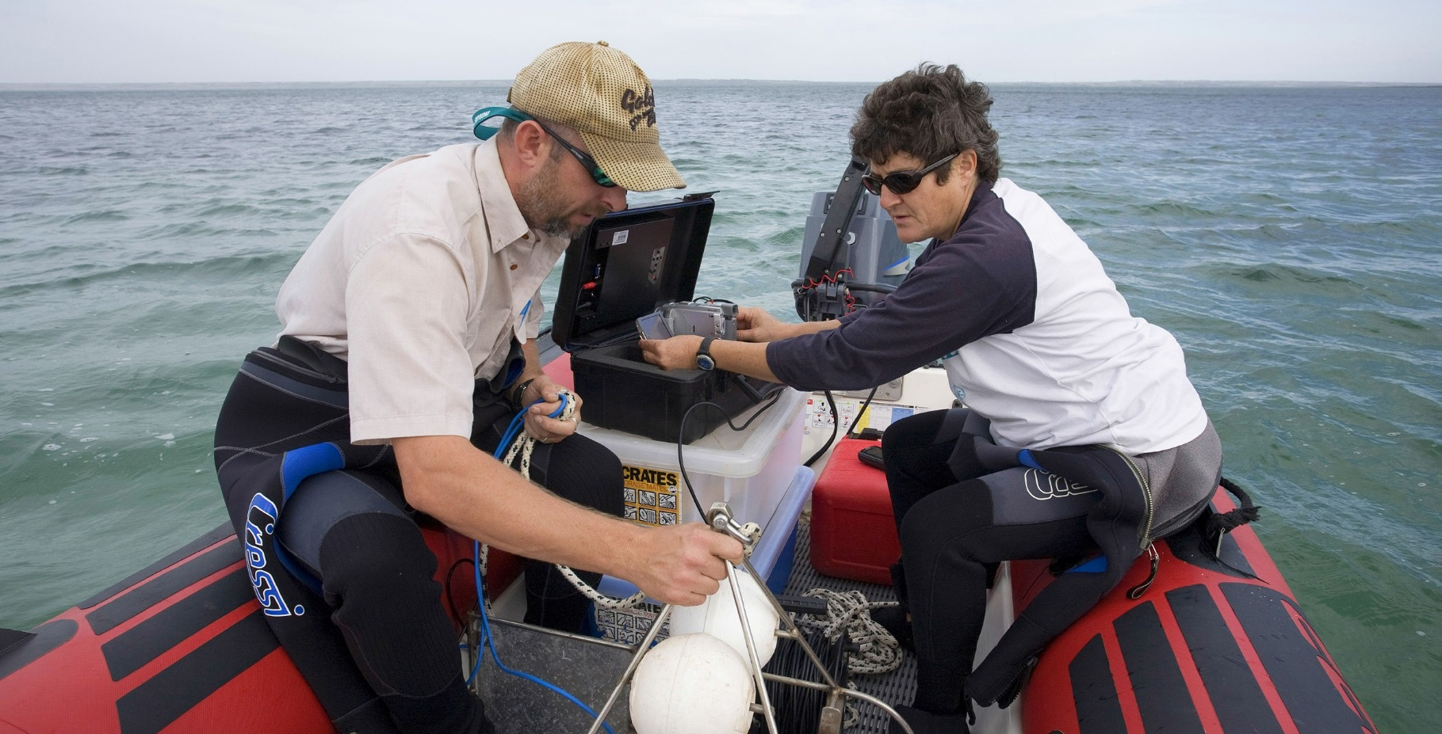

BIO508.0416

**environment**.gov.au