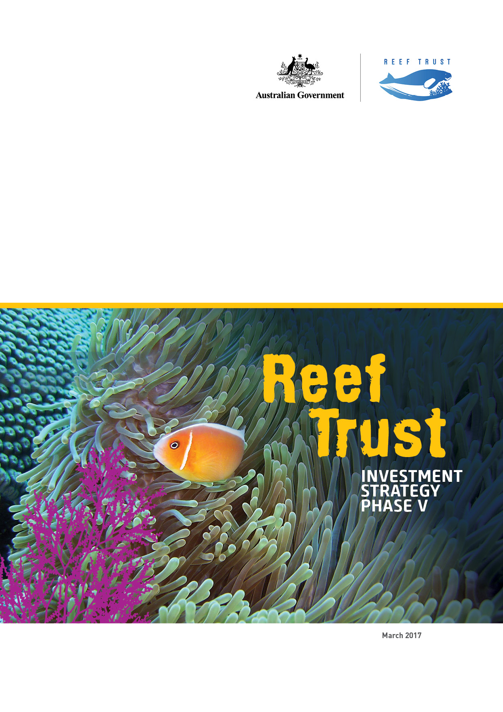This report should be attributed as ‘*Reef Trust Investment Strategy Phase V*, Commonwealth of Australia 2017’.

The Commonwealth of Australia has made all reasonable efforts to identify content supplied by third parties using the following format ‘© Copyright, [*name of third party*] ’.

Images: courtesy of the Department of the Environment and the Great Barrier Reef Marine Park Authority.

© Copyright Commonwealth of Australia, 2017.

***Reef Trust Investment Strategy Phase V*** is licensed by the Commonwealth of Australia for use under a Creative Commons Attribution 4.0 Australia licence with the exception of the Coat of Arms of the Commonwealth of Australia, the logo of the agency responsible for publishing the report, content supplied by third parties, and any images depicting people.

For licence conditions see: [https://creativecommons.org/licenses/by/4.0](https://creativecommons.org/licenses/by/4.0/)

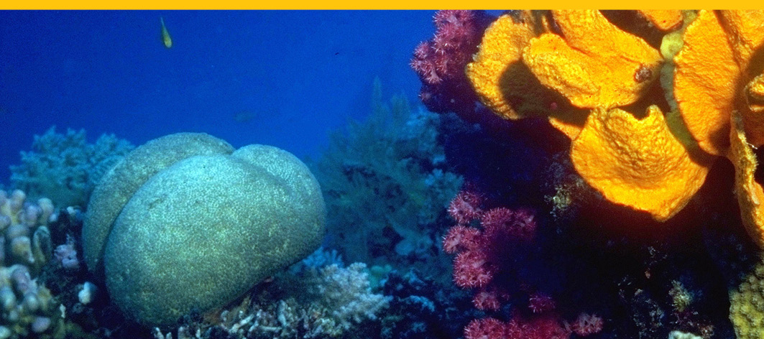

Reefscapes, K.Swalling © copyright Commonwealth of Australia (GBRMPA) Description: a bright orange sponge grows on reef wall amongst corals

Front Cover image: Pink anemone fish © Copyright Department of the Environment and Energy

Minister’s Foreword

The Great Barrier Reef’s extraordinary biodiversity and the interconnectedness of species and habitats make the Great Barrier Reef and surrounding areas one of the most complex natural systems on Earth. The Australian Government is committed to protecting and conserving the outstanding universal value of the Reef and is delivering direct on-ground investment through the Reef Trust to achieve this goal.

The Australian Government has committed $210 million to the Reef Trust to provide innovative, targeted investment focused on improving water quality, restoring coastal ecosystem health and enhancing species protection in the Great Barrier Reef region. These projects are underpinned by the best available science and expertise gained through collectively delivering the significant conservation efforts to date.

In striving to achieve the ambitious targets set in the Reef 2050 Plan, we have been looking above and beyond traditional sources of funding to achieve lasting conservation outcomes for the Great Barrier Reef. We have been working with philanthropists and investors to explore the role of philanthropy and private investment in conserving and protecting the Reef.

The fifth phase of Reef Trust investment builds on four previous phases of investment and has a strong focus on partnerships and co-investment. I am pleased to announce investment through the Reef Trust will include a co-investment partnership with Greening Australia to more than double the current restoration of priority wetland areas adjacent to the Reef.

This phase of investment will also include an exciting new approach to delivery of Reef Trust funding, with significant investment from MSF Sugar and participating sugarcane farmers. This investment will build upon and support investment by the sugarcane industry to improve on-farm nutrient management practices and improve the quality of water entering the Reef lagoon.

This phase of Reef Trust is an exciting step towards more collaborative conservation investment to bring together multiple funding streams to improve the health and resilience of the Great Barrier Reef.

The Reef Trust will continue to work on the development of private investment options in collaboration with business, industry and community partners and I look forward to strengthening existing partnerships and working with new partners to continue to protect and conserve the extraordinary diversity of plant and animal life that exists within the Great Barrier Reef.

Hon Josh Frydenberg signature

**The Hon Josh Frydenberg**Australian Government  
Minister for the Environment and Energy

Contents

MINISTER’S FOREWORD 3

CONTENTS 4

PHASE V INVESTMENTS 5

REEF TRUST CURRENT INVESTMENTS 8

INVESTMENT APPROACH 11

INNOVATION AND ENGAGEMENT 13

COLLABORATION 14

PHASE V INVESTMENTS

Delivering collaborative investments

Since 2014, The Reef Trust has delivered a range of projects to improve water quality by improving   
nitrogen-use efficiency on sugarcane farms and reducing sediment runoff in priority grazing landscapes. The Reef Trust has also invested in the targeted culling of crown-of-thorns starfish on high value reefs, as well as a number of projects to reduce threats to dugongs and marine turtles, including injury, illness, marine debris and illegal hunting and poaching.

The Reef 2050 Plan is the Australian and Queensland governments’ joint response to the challenges currently facing the Great Barrier Reef and sets out an ambitious roadmap for action. The Reef Trust is one of the key mechanisms for delivery of the Reef 2050 Plan and provides innovative, targeted investment to improve water quality, restore coastal ecosystem health and enhance species protection in the Great Barrier Reef Region.

The Reef Trust allows for the joint development and delivery of investment. In this fifth phase of investment, we will work collaboratively with partners in the sugarcane industry and the corporate, not-for profit and philanthropy sectors to leverage additional investment and complement the significant co-investments which have already been committed from outside the Reef Trust.

The Australian Government works closely with the Queensland Government to ensure projects complement and align for maximum improvements to water quality entering the Great Barrier Reef.

At its fifth meeting in October 2016, the Reef 2050 Independent Expert Panel endorsed two projects to be delivered through this fifth phase of investment to address Reef Trust Outcomes 1 and 2:

**Outcome 1:** *Improve the quality of water entering the Great Barrier Reef from broad-scale land use to increase the health and resilience of the Great Barrier Reef*

**Outcome 2:** *Improve the health and resilience of coastal habitats.*

**Improved Health and Resilience of Coastal Habitats**

Coastal habitats, including wetlands, floodplains and saltmarshes are vital to the health of the Great Barrier Reef. They provide connectivity between freshwater and marine habitats and play a role in slowing overland water flow and trapping sediments and nutrients (Great Barrier Reef Outlook Report 2014).

|  |
| --- |
| Coastal Habitat and Wetland Restoration  (2016-17 to 2020-21) |
| $5 million from the Reef Trust with $5 million co-investment from Greening Australia  This restoration project will build upon existing investment and partnership with Greening Australia through Reef Trust Phase III and deliver an additional 500 hectares of restoration of priority wetland sites adjacent to the Great Barrier Reef.  The project will take a whole-of-systems repair approach to identify and deliver solutions to re-establish ecological processes, improve ecosystem connectivity, and enhance nutrient assimilation and sediment trapping.  The Reef Trust will match, dollar-for-dollar, private contributions raised by Greening Australia through their Reef Aid campaign up to $5 million, bringing the total combined project funding to $10 million  over five years.  Greening Australia’s Reef Aid initiative has committed to raising $100 million to support major on-ground restoration in the Great Barrier Reef catchments. As a collaborative program, Reef Aid will seek to raise funds from multiple sources to maximise the value of investment in the Great Barrier Reef and help deliver large scale restoration through partnership and collaboration. |

Cuttlefish, C. Golino © copyright Commonwealth of Australia (GBRMPA)Description: a Cutlefish swims over coral reefs, with brilliant blue ocean waters in background

Description: a Cutlefish swims over coral reefs, with brilliant blue ocean waters in background


Improving the quality of water entering the Great Barrier Reef from broad-scale agriculture

Fertiliser nitrogen loss to the Reef remains a key threat to the health and resilience of the Reef through direct (eutrophication) impacts, with nitrogen also linked to an increased frequency of coral-eating crown-of-thorns starfish outbreaks. A major known source of dissolved inorganic nitrogen reaching the Reef is nitrogen fertiliser applied to sugarcane that is not taken up by the crop. While a number of previous and ongoing investments aim to address nitrogen losses, accelerated progress towards the Reef 2050 Plan target for dissolved inorganic nitrogen will require the continued delivery of a range of investments that will improve fertiliser management practices and nitrogen use efficiency across the industry.

|  |
| --- |
| Project Uplift Farming Systems Initiative  (2016-17 to 2021-2022) |
| $4.5 million from the Reef Trust and an estimated $12.8 million co-investment from sugar industry participants  This project is an industry initiative from the milling sector and includes significant investment from  MSF Sugar, Sugar Research Australia (SRA) and participating sugarcane farmers. This will be a new and unique approach to engage with sugarcane farmers to improve on-farm practices. The project will be led by MSF Sugar who will establish 36 farming groups then assist these groups to transition to new, more efficient farming systems, leading to Smartcane BMP accreditation at ‘above industry standard’. Under this project, the majority of grower groups will be located in the Wet Tropics with a smaller number in the Burnett Mary region.  Reef Trust grant funding for this project will be delivered in conjunction with loan financing to be provided by MSF Sugar and will leverage significant private investment and contributions from participating sugarcane farmers. This project builds on a successful pilot project funded and led by MSF Sugar. |

**Smartcane BMP** is an industry led, government supported world-class best practice system for cane growing across Queensland.

**MSF Sugar** is a leading agribusiness company that includes growing, processing, marketing and exporting raw sugar. MSF Sugar is Australia’s largest sugarcane farmer, second largest raw sugar exporter and the third largest miller.

**The Project Uplift Farming Systems Initiative** is an MSF Sugar initiative that aims to assist growers to adopt farming systems with more sustainable practices, including: improved nutrient management, controlled traffic, minimum till, legume rotation crops, trash blanket and GPS machinery guidance. These practices will contribute to ensuring the long term viability of the industry and improved water quality.

REEF TRUST CURRENT   
INVESTMENTS

The Reef Trust was established in June 2014 and has released four phases of investment to date. Through these phases, the Reef Trust has allocated over $111 million to projects to improve the quality of water entering the Reef from broad scale land use, $2 million to improve the health and resilience of coastal habitats and $19 million to improve and protect marine biodiversity, including the reduction of crown-of-thorns starfish and protection of listed threatened and migratory species, such as dugongs and turtles.

Detailed information on all projects funded through the Reef Trust is available at [www.environment.gov.au/marine/gbr/reeftrust](http://www.environment.gov.au/marine/gbr/reeftrust). Figure 1 below provides an overview of all Reef Trust projects to date.

Photo: Lawrence and Brendan Tento © Copyright Terrain NRM


Photo: Lawrence and Brendan Tento © Copyright Terrain NRM

**Case Study 1 – Wet Tropics reverse tender program**

22 landholders are participating in the Wet Tropics reverse tender program which began in 2014 and will run until 2018. This program provides financial incentives to sugarcane farmers to improve their nitrogen use efficiency and farm sustainability.

Lawrence Tento, a cane farmer in the Herbert catchment, has reduced his nitrogen inputs by over 3,400kg in one year thanks to funding from the Australian Government’s Reef Trust Wet Tropics reverse tender program.

Some of the changes he has implemented include using specially coated controlled release fertiliser, planting legumes to improve soil health and using GPS technology and electromagnetic mapping systems.

“We wanted to do some trials using a range of technologies and methodologies. This kind of reduction in just one year is a big cost saving for us” he said.

Photo: Adrian Darveniza© CopyrightTerrain NRM


**Case Study 2 – Wet Tropics reverse tender program**

Photo: Adrian Darveniza© CopyrightTerrain NRM

Adrian Darveniza, a cane farmer in the South Johnstone, has been conducting trials to reduce applied nitrogen on an area of 110ha, which has resulted in a reduction of more than 40kg/ha of nitrogen (N).

With funding provided through the Australian Government’s Reef Trust Wet Tropics reverse tender program, Adrian purchased a more efficient mill mud spreader. This enables him to spread the mill mud more evenly throughout his whole farm so that lower rates of mill mud can be applied on to the cane stools, resulting in his cane needing lower rates of applied nitrogen. His grant has also helped with the modification of his fertiliser box so that fertiliser can be applied sub-surface.

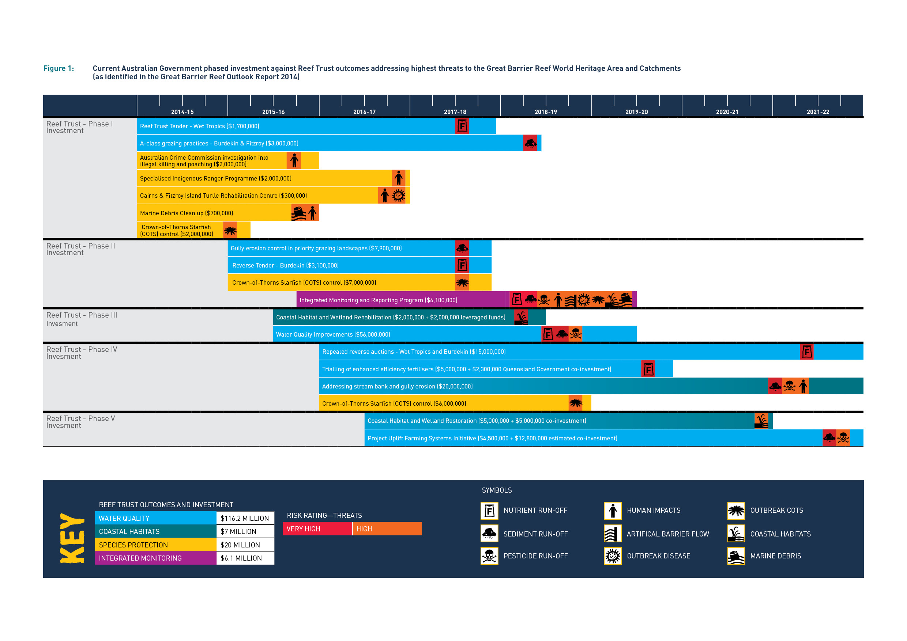

INVESTMENT APPROACH

Reef Trust investments are directed by principles of investment including: ensuring investments are based on the best available science and considering opportunities to build on existing efforts by governments, natural resource management organisations and industry. Investments are designed to direct funding in a targeted and strategic way to deliver against the four Reef Trust outcomes.

The Reef Trust is also developed and implemented in a phased approach which enables investments to be targeted towards known key threats. It also allows investments to be based on the best available science, build on and complement the extensive efforts in the Reef catchments to deliver cost effective and strategic on-ground change, and mitigate the pressures that currently pose the greatest risk to the health of the Reef.

The generalised process for prioritising Reef Trust investment including Phase V, is summarised in the figure 2.

Review of best available information— priority reef values, threats and regions

The significant work undertaken by the Great Barrier Reef Marine Park Authority and scientists to produce the Great Barrier Reef Outlook Report 2014 provides an essential assessment of the current health, pressures, and likely future state of the Reef. The Scientific Consensus Statement on Water Quality in the Great Barrier Reef 2013 and the Reef Water Quality Protection Plan 2013 Prioritisation project report have also informed the process to identify priority threats, regions and industries, and the design of potential interventions.

Reef Trust investment is also guided by world-class biodiversity and climate science coming out of programmes such as the Queensland Government’s Reef Water Quality Program and the Australian Government’s National Environmental Science Programme. Design and implementation of projects is further guided by regional Water   
Quality Improvement Plans and other relevant scientific and expert advice.

Aerial view of Hardy Reef in the Great Barrier Reef, Paradise Ink  © Copyright Department of the Environment and Energy


Aerial view of Hardy Reef in the Great Barrier Reef, Paradise Ink © Copyright Department of the Environment and Energy

|  |
| --- |
| **Reef 2050 Plan Independent Expert Panel** |
| Independent expert advice on Reef Trust funding priorities is provided by the Reef 2050 Independent Expert Panel, chaired by Professor Ian Chubb (former Commonwealth Chief Scientist). The Panel consists of eminent experts from a number of scientific fields and considers and advises on priorities and projects for the Reef Trust.  To build on the progress being made towards the Reef 2050 Plan targets, the Reef 2050 Independent Expert Panel considers potential investments and advises on their scientific merits and suitability for inclusion in the Reef Trust. The Minister for the Environment makes the final decision on the investments in each phase. |

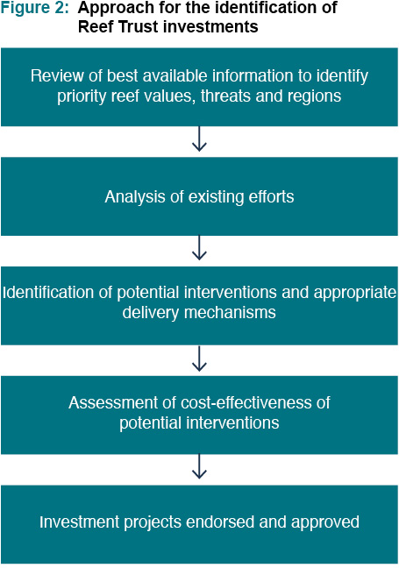Fauna and Flora, K. Anthony © copyright Commonwealth of Australia (GBRMPA) Description: yellow and black Featherstar, attached by cirri to surface of hard coral



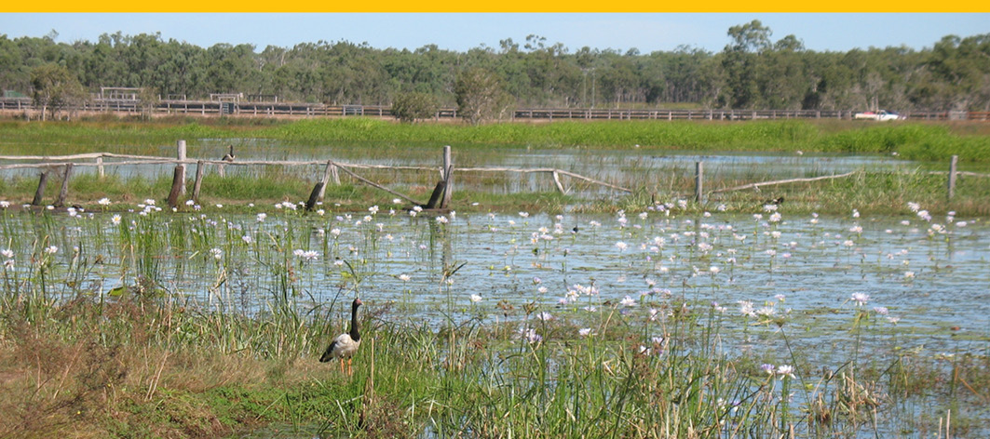

Fauna and Flora, K. Anthony © copyright Commonwealth of Australia (GBRMPA) Description: yellow and black Featherstar, attached by cirri to surface of hard coral

View of various birds around the St Lawrence wetlands, C. Thompson © copyright Commonwealth of Australia (GBRMPA) Description: view of various birds around the St Lawrence wetlands

INNOVATION AND  
ENGAGEMENT

In line with commitments under the Reef 2050 Plan, the Reef Trust has been exploring alternative funding mechanisms, including ways to encourage or attract private and philanthropic investment into high priority conservation activities or projects for the Great Barrier Reef.

In developing the best approaches and mechanisms for harnessing investment from the private sector, advice has been drawn from key stakeholders, business, financial and philanthropic experts. Engagement and advice has been sought to identify actions that will provide additional and lasting environmental benefits, have a high likelihood of adoption across the relevant industries and the potential to receive a significant proportion of ongoing funding from private investment markets.

To engage with experts in the finance and philanthropy sectors, the Reef Trust established the Innovative Financial Mechanisms Panel in late 2015. To date, the panel has met three times to discuss a range of possible conservation financing instruments and opportunities for participation by private investors in Reef conservation activities. Members on the panel include ANZ, Commonwealth Bank, NAB, Credit Suisse, Zurich, Philanthropy Australia and the Great Barrier Reef Foundation.

The Reef Trust has undertaken broader consultation with experts and key stakeholders to elicit a range of potential conservation projects which could be suitable for private or philanthropic investment, test thinking about project design, and to seek advice on technical components and palatability of the project to likely applicant groups.

The Reef Trust has also engaged with key stakeholders and Natural Resource Management organisations, industry representatives, community groups and scientific organisations. New and existing forums have provided input into the identification and design of ways to support and incorporate private investment high priority conservation projects. These have included the Reef Trust Innovative Financial Mechanisms Panel and the Reef 2050 Plan Independent Expert Panel.

|  |
| --- |
| **Clean Energy Finance Corporation: $1 Billion Reef Funding Program** |
| The Clean Energy Finance Corporation (CEFC) provides debt or equity finance for businesses and other ventures to deliver clean energy outcomes, including renewable energy, energy efficiency and low emissions technologies.  Through the Reef Funding Program, the CEFC will make available up to $1 billion of investment finance over 10 years to support projects that deliver clean energy outcomes alongside direct and indirect benefits for the Great Barrier Reef.  Eligible projects will provide direct benefits, such as improved water quality, or indirect benefits by reducing greenhouse gas emissions from activities in the Reef catchment.  As with all CEFC investments, projects financed through the Reef Funding Program must earn a commercial return for the taxpayer, while delivering clean energy outcomes.  The Clean Energy Finance Corporation can be contacted on 1300 002 332 or via [**info@cleanenergyfinancecorp.com.au**](mailto:info%40cleanenergyfinancecorp.com.au?subject=) |

COLLABORATION

Reef Trust investments through this fifth phase will complement and align with the extensive efforts across government, natural resource management organisations and industry to deliver cost effective and strategic on-ground change. It will continue to build on collaborative efforts by the Australian and Queensland governments to achieve targets for land management and water quality improvement outlined in the Reef Water Quality Protection Plan 2013 and the Reef 2050 Plan.

Flexibility and collaboration by both governments will continue to grow as both the Australian and Queensland Governments continue to work together on the design and delivery of Reef conservation projects. With this collaborative approach, the development of future projects will continue to be informed by the successes and leanings of previous projects delivered to improve the health and resilience of the Great Barrier Reef.

The Reef Trust is providing new opportunities for the corporate sector and philanthropists to be involved in supporting priority projects for Reef conservation. The Reef Trust has released Partnerships for the Reef, inviting industry, financial institutions, community organisations, the corporate and philanthropic sectors and individuals to work with the Reef Trust. This invitation sets out a range of sponsorship and investment opportunities available to support Reef conservation efforts. If you are interested in supporting the delivery of priority projects for the Reef, please feel free to contact us via[**reef2050@environment.gov.au**](mailto:reef2050%40environment.gov.au?subject=)

This is a new and exciting area of work for the Reef Trust and we continue to look for opportunities to support and encourage private investment alongside and in addition to government funding for Reef conservation activities. We welcome ideas and proposals for private investment opportunities via [**reef2050@environment.gov.au**](mailto:reef2050%40environment.gov.au%20?subject=)

**For more information visit** [**environment.gov.au/marine/gbr/reef-trust**](http://environment.gov.au/marine/gbr/reef-trust%20)

© Commonwealth of Australia, 2017.

This publication is licensed by Commonwealth   
of Australia under a Creative Commons   
Attribution 4.0 Australia licence.

Reefscapes, B. Cropp © Copyright Commonwealth of Australia (GBRMPA)  Description: pair of Pink Anemonefish swim amongst the tentacles of a Sea Anemone, 
attached to a steep reef slope covered in colourful corals and sponges


Reefscapes, B. Cropp © Copyright Commonwealth of Australia (GBRMPA) Description: pair of Pink Anemonefish swim amongst the tentacles of a Sea Anemone,   
attached to a steep reef slope covered in colourful corals and sponges

Fauna and Flora,A. Chinn © copyright Commonwealth of Australia (GBRMPA) Description: colourful reef fish swim amongst Acropora corals on Wheeler Reef




Fauna and Flora,A. Chinn © copyright Commonwealth of Australia (GBRMPA) Description: colourful reef fish swim amongst Acropora corals on Wheeler Reef

