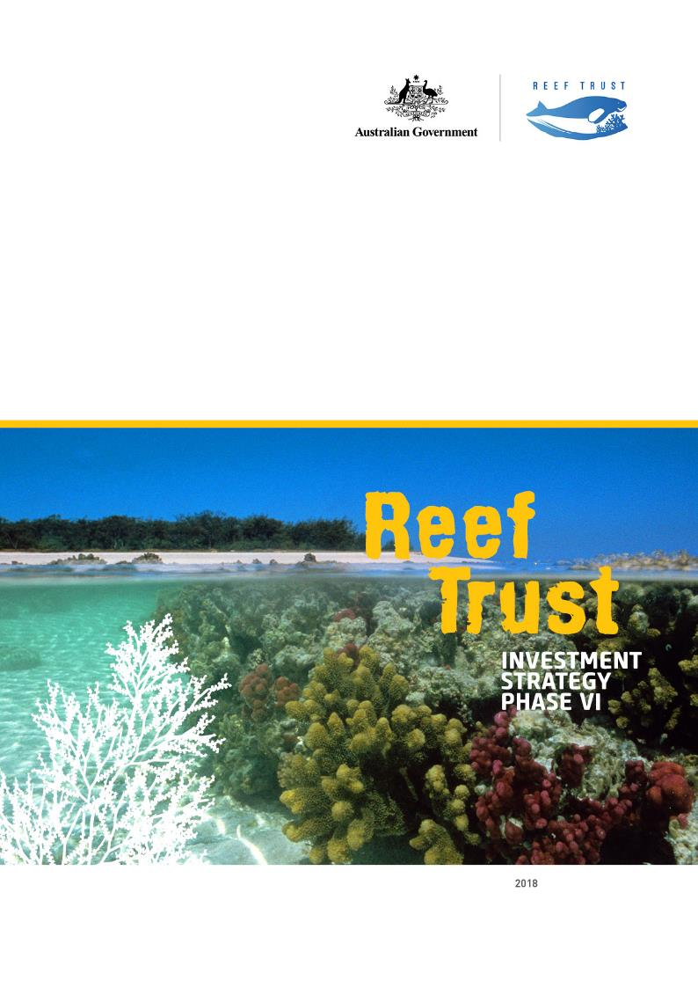 Report should be attributed as:

‘Reef Trust Investment Strategy Phase VI, Commonwealth of Australia 2018’.

The Commonwealth of Australia has made all reasonable efforts to identify content supplied by third parties using the following format ‘© Copyright, [name of third party] ’.

Images: courtesy of the Department of the Environment and Energy, Commonwealth of Australia (GBRMPA) © Copyright Commonwealth of Australia, 2018.

Reef Trust Investment Strategy Phase VI is licensed by the Commonwealth of Australia for use under a Creative Commons Attribution 4.0 Australia licence with the exception of the Coat of Arms of the Commonwealth of Australia, the logo of the agency responsible for publishing the report, content supplied by third parties, and any images depicting people.

For licence conditions see:

<https://creativecommons.org/licenses/by/4.0>

Front Cover image: North West Island Reef, Great Barrier Reef © Copyright Commonwealth of Australia (GBRMPA)

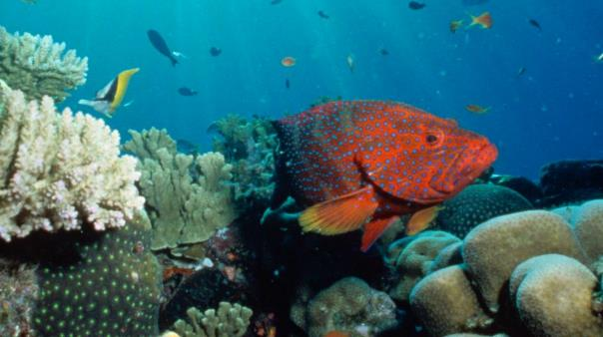

Photo: Coral cod, fish, Stevens Reef, Great Barrier Reef © Copyright Commonwealth of Australia (GBRMPA)

# Foreword

The Great Barrier Reef is one of the world’s great natural icons providing habitat for an extraordinary range of plant and animal life. The Reef protects Queensland’s coastal infrastructure, supports 64,000 jobs and provides $6.4 billion a year to the Australian economy.

The Australian Government is committed to protecting and conserving the Great Barrier Reef, and through the Reef Trust it has committed over $700 million for targeted investments to improve water quality, restore coastal ecosystems and enhance species protection in the Great Barrier Reef region.

The Reef Trust is part of a commitment of over $2 billion by the Australian and Queensland Governments over the coming decade to work towards implementation of the Reef 2050 Long-Term Sustainability Plan.

The sixth phase of the Reef Trust provides up to $15 million for a range of investments targeting on-ground actions to improve the health and resilience of the Great Barrier Reef.

The sixth phase includes:

* Up to $3.5 million, to complement a $3.7 million commitment from the Queensland Government, to deliver locally trusted expert agronomic support to help sugarcane farmers improve fertiliser use efficiency through nutrient management planning and on-farm implementation.
* Up to $5 million to clean-up beaches and waterways along the Great Barrier Reef coast, and deliver actions to prevent litter from entering Great Barrier Reef waterways.
* Up to $5 million from the Australian Government, matched with up to $5 million raised by the Great Barrier Reef Foundation, to restore and conserve priority island ecosystems along the Great Barrier Reef.
* Up to $1.5 million for a collaboration with the Queensland Government to run an ‘Innovation Challenge’ seeking innovative solutions to boost coral abundance on the Great Barrier Reef.

**These investments build on the continuing partnership between governments, natural resource managers, industry, researchers and communities to ensure the Great Barrier Reef remains a global icon for the future.**

|  |  |
| --- | --- |
| **The Hon Josh Frydenberg** Australian Government Minister for the Environment and Energy | **The Hon Melissa Price MP** Australian Government  Assistant Minister for the Environment |

# Contents

Foreword 3

Contents 4

About the Reef Trust 5

Reef Trust Phase VI Investments 8

Improving water quality – Supporting sugarcane farmers to improve fertiliser use efficiency 9

Marine debris – Clean-up and prevention 10

Reef Islands – Restoring and protecting island ecosystems 11

Innovation Challenge – Boosting Coral Abundance 12

Figure 1: Australian Government phased investments against Reef Trust outcomes 13

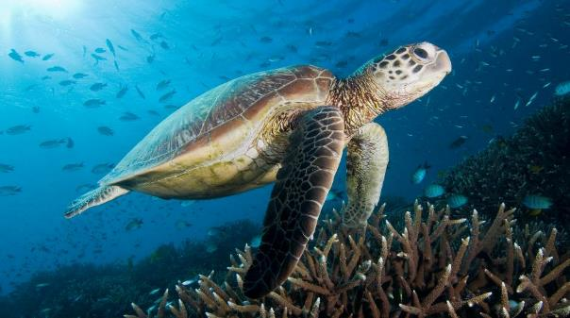

Photo: Green Turtle swimming over a coral reef with sunburst overhead at Heron Island in the Great Barrier Reef by David Harasti © The Department of Environment and Energy

### The Reef Trust’s Objective

To provide cost effective, strategic investment which goes above and beyond existing programs to address key threats to The Great Barrier Reef and catchments for the long term protection and conservation of the outstanding universal value of The Great Barrier Reef.

# About the Reef Trust

### Delivering collaborative investments

The Reef Trust is the Australian Government’s flagship program to support the delivery of the Reef 2050 Plan – the Australian and Queensland Government’s long-term framework for protecting and managing the Great Barrier Reef.

The Australian Government has committed over $700 million through the Reef Trust to date.

On 29 April 2018, the Australian Government announced an additional investment of more than $500 million for protection of the Great Barrier Reef. $443.3 million of this investment will be delivered through the Reef Trust for a six year partnership with the Great Barrier Reef Foundation to reduce water pollution, tackle crown-of-thorns starfish and mitigate the impacts of climate change on Reef health.

The Reef Trust provides cost effective and strategic investment to address key threats to the Great Barrier Reef and conserve the Outstanding Universal Value of this World Heritage-listed icon.

Since 2014, the Reef Trust has invested in known priority areas for investment – improving the quality of water entering the Reef from broad-scale land use, improving the health and resilience of coastal habitats, controlling outbreaks of crown-of-thorns starfish, and enhancing the protection of threatened and migratory species.

### Investment approach

The Reef Trust is delivered in a phased approach. This enables investment to address known and emerging threats and priority areas for investment, and allows for evaluation and adaptive management of the Reef Trust’s implementation. An investment strategy is developed for each phase of Reef Trust investment to guide its delivery.

Reef Trust investments are guided by the best available science, including world-class biodiversity and climate science coming from programs such as the National Environmental Science Programme and the Queensland Government’s Reef Water Quality Science Program. Reef Trust investment decisions are informed by advice from the Reef 2050 Plan Independent Expert Panel chaired by Professor Ian Chubb.

Reef Trust investments are developed in collaboration with the Queensland Government, the Great Barrier Reef Marine Park Authority, and key Great Barrier Reef interest groups.

Reef Trust investments are directed by investment principles. These are that Reef Trust investments: build on and align with existing efforts, focus on on-ground delivery and achieving results, are well-planned and cost-effective, involve collaboration and partnerships wherever possible, are based on robust evidence, and are scientifically defensible.The Reef Trust directs funding to deliver against the following outcomes:

1. Improve the quality of water entering the Great Barrier Reef from broad-scale land use to increase the health and resilience of the Great Barrier Reef.
2. Improve the health and resilience of coastal habitats.
3. Improve and protect marine biodiversity, including the reduction of crown-of-thorns starfish and protection of listed threatened and migratory species, such as dugongs and turtles.
4. Any new development maintains or improves the condition of matters of national and state environmental significance through the strategic delivery of offsets through the Reef Trust.

### Overview of Reef Trust investments: Phases I to VI

Since June 2014, the Australian Government has allocated over $175 million through six phases of Reef Trust investment.

Through the six phases, the Australian Government has allocated over $130 million to improve Reef water quality by reducing sediments, nutrients and pesticides flowing into the Reef lagoon.

Water quality investments include supporting farmers to improve their grazing and farming practices, including providing financial incentives to sugarcane farmers to improve their nitrogen use efficiency and farm sustainability through reverse auctions. Investment also includes reducing sediment run-off from gully and streambank erosion, primarily on grazing land.

A further $26 million has been allocated to enhance protection of marine biodiversity, including through clean-up and reduction of marine debris, turtle rehabilitation, training of Indigenous rangers as compliance and permitting officers, controlling crown-of-thorns starfish, and an innovation challenge to support coral abundance.

$12 million has been allocated to rehabilitate coastal ecosystems, including restoration of wetlands, islands and other coastal habitat. These investments also provide benefits for marine biodiversity.

The Reef Trust is designed to allow for the consolidation of investment from a range of sources. In addition to Australian Government funding, the Reef Trust has leveraged approximately $25 million in co-investment from private and philanthropic organisations. This includes $7 million from Greening Australia, $5 million from the Great Barrier Reef Foundation, and an estimated $12.8 million from MSF Sugar and sugar industry participants to improve on-farm nutrient management practices. A further $2.1 million in co-investment has been provided to the Reef Trust from the Queensland Government for a collaborative investment to trial enhanced efficiency fertilisers for sugarcane growing.

The Reef Trust can also receive environmental offset contributions from proponents under the *Environment Protection and Biodiversity Conservation Act 1999* and use them in the delivery of activities that protect or repair damage to the Great Barrier Reef. To date, the Reef Trust has received $6.3 million in offset payments from three Curtis Island Liquefied Natural Gas plant approval holders, and $1.9 million has been paid out. These funds are being used in the Mackay/Capricorn area of the Reef for a range of activities, including to reduce pressures on vulnerable species, increase Traditional Owner management, improve incident response planning and address the risks of increased shipping.

Further details on Reef Trust investment is at Figure 1 (page 13), and on the Department of the Environment and Energy’s website at www.environment.gov.au/reef-trust.

Caption: The Australian Government has committed over 

Photo: Slashers Reef, Great Barrier Reef  
© Commonwealth of Australia (GBRMPA)



# REEF Trust Phase VI Investments

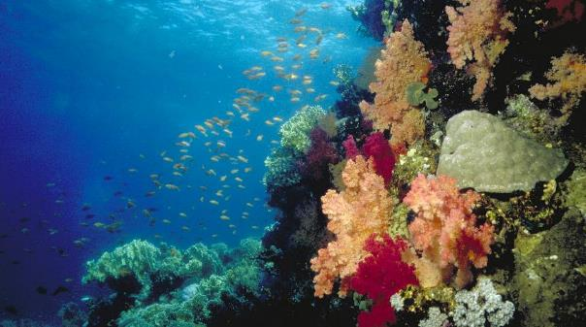

Photo: School of Scalefin Anthias swimming along a reef slope, Great Barrier Reef © Commonwealth of Australia (GBRMPA)

The sixth phase of the Reef Trust provides up to $15 million for four new investments to improve the health and resilience of the Great Barrier Reef.

The scope of Phase VI investments covers three outcomes of the Reef Trust: improving water quality; improving the health of coastal ecosystems; and enhancing the protection of marine biodiversity.

The Reef 2050 Independent Expert Panel provides independent scientific advice to the Australian and Queensland Governments on the implementation of the Reef 2050 Plan, including providing advice on the funding priorities for the Reef Trust. The Independent Expert Panel has endorsed the development of all four investments under Phase VI.

## Improving water quality – Supporting sugarcane farmers to improve fertiliser use efficiency

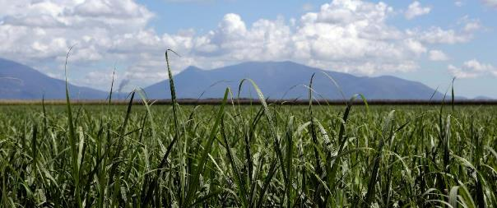

Photo: Young sugar cane sprouting on a property near Ayr in northern Queensland by Mark Mohell © Copyright Department of the Environment and Energy

The Reef Trust will provide $3.5 million to complement the Queensland Government’s commitment of $3.7 million for delivery of complete nutrient management planning services to sugarcane farmers. This project will increase the profitability of participating sugarcane farmers, whilst minimising losses of fertiliser to the Reef.

The 2017 Scientific Consensus Statement – Land use impacts on Great Barrier Reef water quality and ecosystem condition (Scientific Consensus Statement) has identified reducing excess fertiliser application in the Reef catchment as a very high priority. Surplus fertiliser nitrogen is linked to algal blooms in the Reef lagoon and phase shifts from coral to seaweed-dominated ecosystems. In addition, excess nitrogen is thought to cause more frequent outbreaks of coral-eating crown-of-thorns starfish and lower temperature bleaching thresholds in coral.

The sugarcane industry is the major user of fertiliser in the Reef catchment with over 4000 km2 under sugarcane cropping. This project will be managed by the Queensland Government Department of Environment and Science using a delivery model developed and successfully implemented under the Queensland Government’s Reef Water Quality Program in the Burdekin region. It involves highly skilled and locally trusted agronomists and farmer ‘champions’ supporting sugarcane farmers to evaluate the relationship between their fertiliser application rates, yield and profit on their farms. This is undertaken using the ‘SIX EASY STEPS’ nutrient management system developed by Sugar Research Australia.

Sugarcane farmers who have been through this nutrient management planning process develop a better understanding of the optimum rate of fertiliser application on their farm and other key management practices. This results in the long-term adoption of more efficient fertiliser use, more profit for farmers, and less fertiliser being lost to the Reef.

The Reef Trust’s investment builds on over $2 million invested to date, and a further $1.5 million committed, by the Queensland Government. The Reef Trust’s investment will extend delivery of the complete nutrient management approach to more sugarcane farmers in the Burdekin region, and look to extend delivery to sugarcane growers in the Mackay Whitsunday, Wet Tropics and Burnett Mary regions.

## Marine debris – Clean-up and prevention

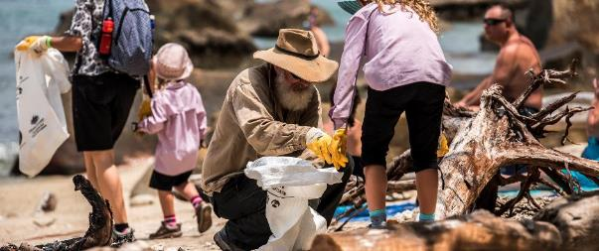

Photo: Reef Trust Phase 1 marine debris project - GBR Clean-up Cairns by Christian Miller © Copyright Commonwealth of Australia (GBRMPA)

The Reef Trust will provide up to $5 million over five years to coordinate clean-up activities and deliver actions to prevent litter from entering Great Barrier Reef waterways. Marine debris is a significant risk to Reef ecosystems and wildlife including turtles, dugongs, corals and seabirds.

The Scientific Consensus Statement indicates that there is widespread contamination of the Great Barrier Reef by marine debris from shipping, fishing, industrial and urban sources. The most common type of marine debris found along the Great Barrier Reef coast is single-use plastic, such as bags, bottles and packaging.

Marine debris can cause injury or death to wildlife through entanglement and ingestion, and can smother coral. It can transport pests and disease, and toxic substances harmful to the environment. Marine debris can negatively affect tourism and coastal amenity values.

This project will build on existing efforts to clean up rubbish from beaches and waterways along the Great Barrier Reef coast. It will also deliver targeted education and awareness raising, and develop actions to prevent the flow of litter from its source.

The project will be undertaken in collaboration with Reef-dependent communities, including Traditional Owners, as well as industries operating in and around the Great Barrier Reef such as tourism, fishing, farming, manufacturing and shipping. The project will be delivered with the assistance of the Great Barrier Reef Marine Park Authority, the Queensland Government, local governments, research organisations and on-ground delivery partners.

The project will build on an earlier investment by the Reef Trust that supported marine debris clean-up and prevention actions (under Phase I). The project will also support the Australian Government’s Threat Abatement Plan for the impacts of marine debris on vertebrate life (to be finalised in 2018), which provides national guidance on actions to prevent and mitigate the impacts of marine debris on vertebrate marine life.

Delivery of this project will be advertised by an open market tender through Austender.

## Reef Islands – Restoring and protecting island ecosystems

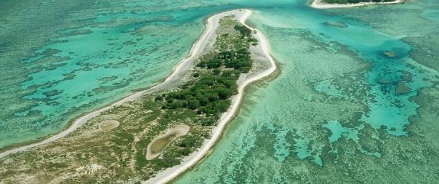

Photo: Fairfax Islands Reef, Great Barrier Reef © Commonwealth of Australia (GBRMPA)

The Reef Trust will provide up to $5 million over five years for on-ground restoration and conservation of island ecosystems in the Great Barrier Reef. The Reef Trust contribution will be matched with $5 million from the Great Barrier Reef Foundation, raised from private donations.

Reef islands and their adjoining reefs provide vital habitat and a refuge for many terrestrial and marine species, including seabirds, turtles, mangroves and corals. This Reef Trust investment will build on existing activities to identify, enhance and restore critical island habitats – boosting their resilience and protecting their biodiversity into the future.

This Reef Trust investment forms part of a broader package of island restoration activities. This work will be led by the Great Barrier Reef Foundation, in collaboration with the Queensland Government, Traditional Owners, the Great Barrier Reef Marine Park Authority, private donors, tourism operators, research organisations and on-ground delivery partners and communities. As part of this broader program, the Queensland Government has contributed an additional $3 million which will be matched by the Great Barrier Reef Foundation.

The package of investment will build on the success of existing initiatives led by the Great Barrier Reef Foundation, such as the Raine Island Recovery Project, which is restoring the world’s largest green turtle nesting site, and improving habitat for seabirds and other critical Reef species.

The investments will deliver a coordinated program of science, innovation, intervention and on-ground works to improve and protect biodiversity on islands in the Great Barrier Reef. The location of works will be subject to a prioritisation process in consultation with project stakeholders.

## Innovation Challenge – Boosting Coral Abundance

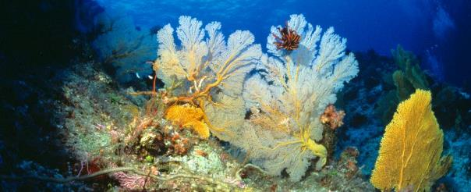

Photo: Gorgonians, Coral, Great Barrier Reef © Copyright Commonwealth of Australia (GBRMPA)

The Reef Trust will provide $1.5 million for a collaboration with the Queensland Government seeking innovative solutions to support the protection, regeneration and recovery of coral populations on the Great Barrier Reef.

Australian and Queensland Government Ministers announced an Innovation Challenge on 16 January 2018, providing a total of $2 million for novel solutions to boost coral abundance on the Great Barrier Reef.

Notwithstanding the extensive efforts underway to address local pressures on the Great Barrier Reef, widespread coral bleaching in the past two years has highlighted the need to identify new solutions to improve the resilience of the Great Barrier Reef to climate change.

In May 2017, the Great Barrier Reef Marine Park Authority hosted the Great Barrier Reef Summit - Managing for Resilience, involving more than 70 leading marine experts from around the world. One of the recommendations of the summit was to urgently increase the use of innovation pilots and trials to develop new approaches to improve coral resilience.

The Innovation Challenge builds on and complements the outcomes of this summit. It provides opportunities for local, regional and global communities to develop new ideas to protect and maintain the ecological functions of the Great Barrier Reef.

Proposals to the challenge could focus on a wide range of solutions – from reducing the exposure of corals to physical stressors, to boosting coral regeneration rates by cultivating reef-building coral larvae that attract other important marine species.

The Innovation Challenge is delivered through the Advance Queensland Small Business Innovation Research mechanism coordinated by the Queensland Government. It offers successful applicants a share of $1 million to undertake feasibility studies. It is anticipated that there will be a number of feasibility studies undertaken, with individual contracts not expected to exceed $250,000. Applications for the feasibility stage closed on 6 March 2018.

## Figure 1: Australian Government phased investments against Reef Trust outcomesFigure 1: Australian Government phased investments against Reef Trust outcomes

Photo: Coral, fish, of the Great Barrier Reef © Copyright Department of the Environment and Energy

