

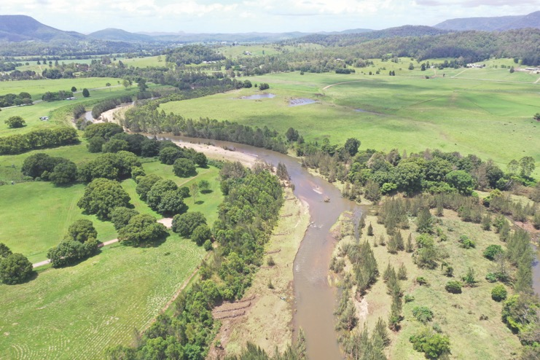

# Reef Trust GULLY AND STREAM BANK TOOLBOX

**3rd Edition, March 2022**

**A technical guide for Gully and Stream Bank Erosion Control Programs in Great Barrier Reef catchments**

**Scott Wilkinson**, CSIRO | **Peter B Hairsine**, The Australian National University | **Rebecca Bartley**, CSIRO

**Andrew Brooks**, Griffith University | **Timothy Pietsch**, Griffith University | **Aaron Hawdon**, CSIRO

**Bob Shepherd**, Queensland Department of Agriculture and Fisheries

 Griffith University logo ANU Enterprise logo

|  |  |  |
| --- | --- | --- |
|  |  |  |



© Commonwealth of Australia 2022

The *Gully and Stream Bank Toolbox* is licensed by the Commonwealth of Australia for use under a Creative Commons Attribution 4.0 Australia licence with the exception of the Coat of Arms of the Commonwealth of Australia, the CSIRO logo, the logo of the agency responsible for publishing the report, content supplied by third parties, and any images depicting people. For licence conditions see: https://creativecommons.org/licenses/by/4.0/.

Attribute this document as: Wilkinson S, Hairsine PB, Bartley R, Brooks A, Pietsch T, Hawdon A, Shepherd R. 2022. *Gully and Stream Bank Toolbox. A technical guide for gully and stream bank erosion control programs in Great Barrier Reef catchments. 3rd Edition.* Commonwealth of Australia.

The Commonwealth of Australia has made all reasonable efforts to attribute content supplied by third parties.

Cover image: Revegetation and pile fields at Charles Street Park on the Mary River. Photographed in January 2022 by Caitlin Mill, MRCCC.

Back cover: Reshaped, rock capped and revegetated gullies at Strathalbyn Station in November 2021, 3 years after construction. These two gullies had a baseline fine sediment yield at the coast of around 1,200 t/year. The woody vegetation

**Table of Contents**

EXECUTIVE SUMMARY 1

Context 1

Identify cost-effective sites 1

Select, design and implement appropriate erosion control treatments 2

Monitor and adapt 2

How to use this Toolbox 2

ACKNOWLEDGEMENTS 3

1 INTRODUCTION 4

1.1 Gully and stream bank erosion defined 4

1.2 Objectives of erosion control 7

2 PLANNING AND IMPLEMENTING EROSION CONTROL 14

2.1 Focus on priority catchments 14

2.2 Identify cost-effective erosion control sites 15

2.3 Concept design and review 25

2.4 Detailed design and review 28

2.5 Construction and implementation 30

2.6 Monitoring and maintenance 30

3 GULLY AND STREAM BANK EROSION CONTROL ACTIVITIES 33

3.1 Introduction 33

3.2 Improving grazing management in gully catchments 33

3.3 Fencing to control livestock access to gully sites 39

3.4 Porous check dams 43

3.5 Gully runoff diversion banks and drainage management 48

3.6 Gully head rock chutes 52

3.7 Gully reshaping and revegetation 56

3.8 Gully reshaping and rock capping 61

3.9 Stream bank fencing and weed control (passive revegetation) 66

3.10 Stream bank revegetation 70

3.11 Engineered stream bank protection and revegetation 74

4 SITE MONITORING 79

4.1 Objectives 79

4.2 Timing of monitoring 79

4.3 Monitoring methods 80

5 GLOSSARY 82

6 ACRONYMS 85

7 REFERENCES 87

APPENDIX A: TREATMENT EFFECTIVENESS 92

A1 Defining erosion control effectiveness 92

A2 The basis of effectiveness values for each erosion control treatment 93

A3 The logic used to determine the effectiveness values 103

A4 Appendix A references 105

APPENDIX B: CATCHMENT CONTRIBUTIONS TO SEDIMENT LOADS 110

APPENDIX C: REGULATORY REQUIREMENTS FOR SOME GULLY AND STREAM BANK WORKS 114

**List of Tables**

Table 1. Erosion control treatments, arranged in order of increasing complexity (unit area cost), for gully erosion (1-7) and for stream bank erosion (8-10). 22

Table B1. Catchment rankings of fine sediment contribution to GBR fine sediment loads from gully and stream bank erosion. 112

Table C1. Some federal, state and local government regulatory requirements that may be relevant to gully and stream bank remediation works 114

**List of Figures**

Figure 1. Two forms of gully erosion that occur in reef catchments. Left: Hillslope gully erosion. Right: Alluvial gully erosion. 5

Figure 2. (A) A major dry-tropics stream with stream bank exposed to rain splash and scour (Bowen River). (B) A minor dry-tropics stream eroding through scour and mass failure of the bank profile, in the upper Burdekin catchment. Note the absence of a distinct riparian vegetation community. The gravel bedload accumulation is causing local channel widening. (C) A large stream in the humid tropics where the stream bank is eroding through scour and mass failure. (D) Meander migration and slumping of poorly vegetated stream banks in a reach of the Mary River. (Google Earth) 6

Figure 3. The required approaches to gully erosion control depend on the gully form and setting. 9

Figure 4. The width of stream bank vegetation and the setback of stream bank fencing from the bank top is determined considering the bank height (see Section 3.9.2) 12

Figure 5. A flowchart of the process for selecting cost-effective project sites for preparing a concept design. The sections of this document relevant to each step are given in brackets. 16

Figure 6. Process for site design, implementation, monitoring and reporting. 26

Figure 7. A typical hillslope gully in the upper Burdekin catchment in 2016 (left), and then after 4 years of stock exclusion (right). The only treatment applied was stock exclusion fencing. 34

Figure 8. Hillslope gully erosion on granodiorite soils in the Don River catchment, resulting from removal of tree cover and heavy grazing pressure. 35

Figure 9. Proportion of catchment with D condition land in 2003 (left) and in 2010 (right). 37

Figure 10. A gully in alluvial soil on Kings Plains in the upper Normanby (left) in 2010, and (right) in 2019 after 2 plus years of livestock exclusion 38

Figure 11. Water points are typically surrounded by bare soil and should be located well away from gullies and stream banks 39

Figure 12. Bare ground around a gully headcut showing an extensive algal mat development (darker coloured areas) between the grass tussocks. Grazing pressure around the gullies will break up these crusts, accelerating erosion and preventing the establishment of grasses on the bare areas. 41

Figure 13. Left: Fences constructed too close to active gully heads will have a limited life. 43

Figure 14. Porous check dam arrangement in longitudinal section. 45

Figure 15. Left: A rapidly eroding gully in the Mary River catchment in August 2017, with an exposed gully bed and banks and degraded vegetation adjacent to the gully as a result of grazing (looking upstream). Right: The same view in June 2018, 10 months after the installation of fencing, excluding grazing from the site and a series of porous check dams, constructed of steel mesh and posts with cuttings of local timber. 47

Figure 16. An illustration of known failure mechanisms for porous check dams. 47

Figure 17. Diversion bank built to divert an 8 ha catchment away from a large gully, which was reshaped and revegetated in the upper Burdekin catchment. 50

Figure 18. Water-spreading structure on a ridge, at the outlet end of the diversion bank shown in the previous figure. 50

Figure 19. Example of road drainage delivering into an alluvial gully (right circle; although road drainage was not the primary cause of the gully). 51

Figure 20. Example of a poorly situated or maintained contour diversion bank (to the left of and behind the tree) that has initiated a new gully at the exit point from the diversion bank 52

Figure 21. A secondary incisional phase progressing up along the floor of an existing alluvial gully, at rates of metres per year. 53

Figure 22. A rock chute installation in the Mary catchment. 56

Figure 23. An erosion plate showing around 80 mm of surface erosion from a single (below average) wet season in the Burdekin catchment 57

Figure 24. Rock check dams used to prevent incision of the bed of a wide reshaped gully 60

Figure 25. An alluvial gully that was reshaped but without soil amelioration or revegetation being applied. 61

Figure 26: This gully in the Normanby River catchment was reshaped and capped with rock in 2016. 63

Figure 27. Timeline of Gully 13 remediation in the lower Burdekin catchment, clockwise from top left. 64

Figure 28. The Treatment 4 gully in August 2020. Grass seed was spread on top of the straw mulch, resulting in seed germinating but drying out. 66

Figure 29. Tributary of the Bowen River, which has a stable bedrock bed. 70

Figure 30. An aerial view of a reach of the central Mary River. 72

Figure 31. Tall riparian vegetation planted in 1984 as part of the reach-scale revegetation shown in Figure 30. 73

Figure 32. A pile in 2021 that was installed 6 years previously and is now rotten 76

Figure 33. A pile field, riprap, fencing and planting project established in 2020 on the Kenilworth reach of the Mary River. 76

Figure 34: Rock groynes and bank reshaping at a site on the O’Connell River in July 2021, 9 months after construction (direction of flow from left to right). 77

Figure A1. The performance of treatments varies over time following construction (thick lines). 92

Figure A2. A flowchart of the logic used in determining the treatment effectiveness value. 104

Figure B1. Catchment management units draining to the GBR lagoon 111

## EXECUTIVE SUMMARY

This Toolbox is a guide to targeting, designing and implementing gully and stream bank erosion control activities in Great Barrier Reef (GBR) catchments. This third edition builds on 7 years of implementing these activities in multiple programs and it aims to inform the ongoing efforts to reduce the amount of fine sediment and associated nutrients delivered to the GBR lagoon. Sub-soil erosion, predominantly from gullies and stream banks, contributes the vast bulk of the fine sediment load delivered to the GBR. The large area and extensive erosion in GBR catchments, and the limited resources available, make it important for erosion control to be targeted to cost-effective sites and implemented using best practice based on best available information. Landholder support and site maintenance increase the likelihood that sediment reductions will persist over the long term.

### Context

Gully and stream bank erosion are natural processes. However, after the introduction of livestock grazing, mining and other catchment disturbances in the period 1850-1900, and increasingly following land-use intensification in the mid-twentieth century, gully erosion became extensive along drainage lines and in floodplains adjacent to some large river channels. Similarly, stream bank erosion rates have accelerated because of vegetation degradation and removal, the installation of weirs and the physical disturbance of stream corridors by livestock. Current land managers have largely inherited these problems, although ongoing degradation or removal of vegetation greatly increases the risk of further gully expansion and stream bank degradation. Funding programs are underway to reduce the amount of sediment supplied from gully and stream bank erosion to the GBR lagoon.

Gully erosion control aims to stabilise headcuts, sidewalls and gully floors. Depending on the erosion rates, the appropriate approach is to use a combination of fencing, revegetation and engineered structures, if required. Tailor these activities to each site. Managing upslope drainage areas can also be used to reduce the concentration of runoff. Application of gypsum and surface cover may be required to protect exposed sodic soils.

Stream systems respond to change in complex ways and a whole-of-system approach is required to achieve long-term erosion control. Stream bank erosion control involves initial exclusion of livestock (where present) followed by strict control of livestock access and re-establishment of woody deep-rooted vegetation on the banks and within channels, along extended stream reaches. Cumulative erosion control benefits are achieved by having a large proportion of the channel network well-vegetated, which protects gully and stream boundaries. A more connected network of riparian vegetation also enhances the condition of terrestrial and freshwater ecosystems and has multiple benefits, including carbon sequestration. Only contemplate engineered stream bank erosion control at sites where rapid erosion is clearly ongoing and cannot be otherwise managed, and where it only covers a small proportion of the reach length treated with revegetation.

### Identify cost-effective sites

This Toolbox describes a process for planning and implementing cost-effective erosion control where a site assessment identifies a favourable ratio of the investment cost relative to the reduction in fine sediment loads delivered to the GBR lagoon. Recent program evaluations indicate that this ratio varies more than tenfold between sites. Identifying cost-effective sites begins by targeting activities to catchments, and hotspot areas within them, in which gully and stream bank erosion make large contributions to GBR fine sediment loads. Datasets are available that identify these catchments and areas as having large gully and stream bank erosion rates, and from which sediment is delivered efficiently through the river network to the coast. Other prioritisation studies may assist this process. To identify individual cost-effective sites and plan erosion control, a benefit-cost assessment process is provided to (i) estimate the fine sediment yield in the absence of treatment, (ii) select a bundle of erosion control treatments that will be capable in reducing that yield in coming decades, and (iii) estimate the cost-effectiveness of planned work. Software is now available to streamline these gully and stream bank site assessments.

The effectiveness of erosion control treatments is defined in terms of proportional reductions in sediment yield expected over 30 years (consistent with the Reef 2050 Long-Term Sustainability Plan). Quantitative and qualitative evidence is collated in an appendix (Appendix A) to support the recommended values. Effectiveness at reducing sediment yield also depends on the duration of site maintenance, being higher if maintenance, independent monitoring and oversight remains ongoing for decades after the conclusion of the construction project, as opposed to if maintenance occurs only for the initial 2-3 years after construction.

### Select, design and implement appropriate erosion control treatments

Erosion control treatments must be selected that best suit each site, in terms of being cost-effective and suitable for the purpose. This Toolbox describes 7 common bundles of erosion control treatments for gully erosion and 3 for stream bank erosion. Many sites are degraded and will require a bundle of rehabilitation treatments to comprehensively address the erosion processes. These different treatment bundles cover a range of complexity and unit area costs. The more intensive treatment bundles comprise a primary treatment, such as earthworks, with supporting treatments, such as control of livestock access to the site. Each treatment is described in terms of its objectives in how it functions to control erosion, what types of locations are suitable, and design and construction considerations. Case studies from the GBR catchments are provided.

Achieving the expected sediment reductions requires that erosion control must be implemented thoroughly, using best practice in design, construction, monitoring and maintenance. An essential component of best practice is documenting a concept design and detailed design for each site, for independent technical review. Having the appropriate skills is essential for planning and undertaking works, to ensure that erosion is safely and effectively controlled. Landholder engagement and agreement are also critical to securing the legacy of the project.

### Monitor and adapt

Site monitoring is important to demonstrate completion of the construction phase, to identify required maintenance actions, to help engage the community, to enable project evaluation, and to continue advancing understanding of how best to achieve erosion control outcomes. Include the following in standard site monitoring: photo points, vegetation monitoring, intactness of project works, grazing management practices, landholder perspectives, and the condition of the land adjacent to the gully or streambank. Mobile device apps have been developed to implement these procedures. The monitoring to date has provided valuable findings, which are reflected in this edition. We acknowledge that application of erosion control activities will continue to evolve as new data and insights are developed. Additional, more detailed and longer-term monitoring is recommended for treatments that are the focus of large investments and where the long-term performance has greater uncertainty. We look forward to continuing working with natural resource management organisations to reduce the amount of sediment and particulate nutrients leaving our catchments and reaching the GBR lagoon. Whether the user is an experienced practitioner in erosion control or new to erosion control in the GBR catchments, here is the process for using this Toolbox:

### How to use this Toolbox

Become familiar with the processes and objectives of erosion control by reading the introduction in Section 1.

Work through the step-by-step site identification and planning process described in Section 2.

Select erosion control treatments, ensuring that they are suitable, correctly sited, designed and planned as described in Section 3.

Plan and implement site monitoring as described in Section 4.

The appendices provide more details on specific topics for the reader seeking more background.

## ACKNOWLEDGEMENTS

The Australian Government's Reef Trust funded this Toolbox to supersede the second edition (Wilkinson et al., 2019). The Toolbox draws on the experience and advice of erosion control delivery partners, which was developed through activities on several hundred properties in GBR catchments. We thank members of all the regional bodies and other delivery partners for their advice and feedback on improvements for this edition. Case studies and photographs were contributed by Mary River Catchment Coordinating Committee and Damon Telfer. Objectives for site monitoring drew on the monitoring and evaluation framework for the Reef Trust Partnership water quality program. Anne Henderson prepared Figure B1. The Queensland Department of Resources provided the data used to prepare Table B1. Damon Telfer and Ian Prosser contributed to a draft of the concept and detailed design requirements. Joely Taylor and Julie Cooney edited the written content. The Department of Agriculture, Water and the Environment provided the graphical production. Ian Prosser, Damon Telfer, Philip Jeston, and Reef Trust team members reviewed drafts of the Toolbox.

**We thank the delivery teams, landholders and community members who shared their experiences.**

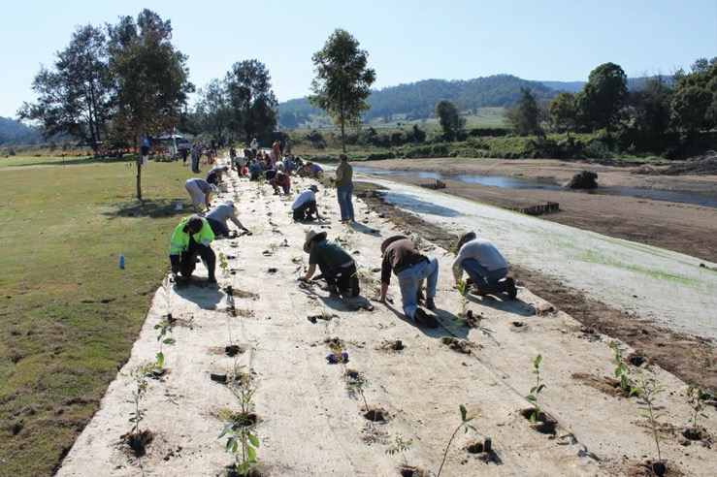

*Community tree planting at Charles Street Park on the Mary River in 2015. The pile fields in the top right of the image are the most downstream ones visible in the front cover image. Photograph by Tim Odgers, seqwater.*

## INTRODUCTION

### Gully and stream bank erosion defined

#### Gully erosion

**Gully erosion** is defined as the incision of the land surface to a depth of more than 0.5 m (Soil Science Society of America, 2008; Thwaites et al., 2021) into valleys and hillslopes that have not always contained deep stream channels, especially prior to the introduction of European land uses. Gullies are widespread in semi-arid climates globally, caused by land use interacting with a combination of drought and flood cycles, and geomorphic and hydraulic controls (for example, Ciesiolka, 1987). Initiation of gully erosion is often triggered by low vegetation cover such as that caused by livestock tracks, excessive grazing pressure and drought-flood cycles. An individual gully starts when a small near-vertical wall is created at a stock track or other vegetation or soil disturbance, in a drainage line and/or where seepage reduces the strength and erosion resistance of soil during and after rainfall. The new gully expands upslope due to the instability of the wall and grows deeper and wider. Direct rainfall onto the gully surface can also drive erosion.

While some gully features were noted by early European explorers, the vast majority of active gullies in Great Barrier Reef (GBR) catchments today developed following the introduction of cattle and sheep grazing and alluvial mining (Wilkinson et al., 2013; Shellberg et al., 2010, 2016), which occurred in the decades after 1850 (Lewis et al., 2021). Before that time, active gully erosion is understood to have been much less common than what we see today, because intact native vegetation and undisturbed soils are more resistant to gully incision (Prosser and Slade, 1994). Most gullies in the catchments of the GBR initiated in an era when the focus was on expanding or intensifying land uses, and therefore gully erosion is a problem that current land managers have mostly inherited. However, some current land management practices, such as excessive livestock grazing pressure, can prolong and worsen gully erosion, and in some instances new gullies continue to form where vegetation is cleared and/or land is overgrazed. Some gullies do not revegetate and self-stabilise even in the absence of livestock grazing, due to exposure of erodible soil and ongoing erosion making the surface unstable.

Today, it is estimated that the length of gullies in GBR catchments totals >87,000 km (Wilkinson et al., 2015a), noting that gullies are not all linear features, and that only a subset of this length is actively eroding (Daley et al., 2021a). While this represents just 0.3% of grazing land, sediment budget modelling informed by sediment source tracing, erosion mapping and load monitoring indicates that gully erosion supplies approximately 50% of the fine sediment (silt and clay, <20 pm particle size) exported from river basins to the GBR lagoon (McCloskey et al., 2021).

There are large variations in erosion rate and fine sediment yield between individual gullies. Recent fine resolution mapping of gullies across 5,300 km2 of the Bowen, Bogie, Lower Burdekin, Fitzroy and Normanby catchments (with land selected for the likelihood of high gully concentrations) found that active gullies covered on average around 1% of the landscape in these areas (Daley et al., 2021a). Of the approximately 26,000 gullies mapped in this area, 50% of the lifetime gully sediment yield was derived from between 4 and 10% (dependent on catchment) of the gully population, the majority of which were alluvial gullies (Daley et al., 2021a).

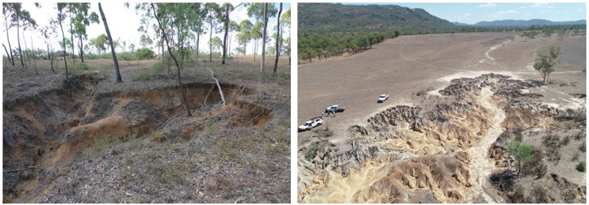

Figure 1. Two forms of gully erosion that occur in reef catchments. Left: Hillslope gully erosion. Right: Alluvial gully erosion.

*Photographs from the Burdekin River basin by Scott Wilkinson and Andrew Brooks*

Gully erosion occurs in 2 general forms within GBR catchments. Hillslope gully erosion is a linear or branching feature along what was a surface flow path or drainage line. Some hillslope gullies are discontinuous along drainage lines, with incised sections separated by indistinct unchannelled sections. Alluvial gully erosion involves incision of floodplain and river frontage country in deeper alluvial sediment deposits adjacent to large streams. Examples of both gully forms are shown in Figure 1. In addition to extending the drainage network upstream, gully erosion can also involve enlargement of natural minor stream channels, in some instances up to several times their prior depth and width. The resulting large channels may also initiate the extension of many gully branches along contributing drainage lines. Thwaites et al. (2021) give more detailed definitions of hillslope and alluvial gully erosion.

Gully erosion can be driven by a combination of surface runoff or seepage from upslope, by direct rainfall on the gully area, by base-level lowering downstream (knick-point retreat), and by scour from water moving through the gully. Mass failure of steep headcuts is also a common erosion mechanism. The erosion dynamics of established hillslope gullies are typically dependent on surface runoff from upslope (for example, Wilkinson et al., 2018). The erosion of large open alluvial gullies and some hillslope gullies that have little vegetation cover can also be significantly affected by rain falling directly on the active gully surface (Daley et al., 2021b).

#### Stream bank erosion

**Stream bank erosion** is the sideways expansion of the stream channel. It is a natural process that occurs even in densely forested systems (Rozo et al., 2014). The occurrence of some stream bank erosion is therefore integral to the functioning of river ecosystems (Pusey and Arthington, 2003) by promoting riparian vegetation succession and creating dynamic habitats crucial for aquatic and riparian plants and animals (Florsheim et al., 2008).

The amount of sediment produced from stream bank erosion tends to vary as a function of stream size (width and depth), discharge, longitudinal slope, bank material erodibility, river planform curvature and vegetation. Stream bank erosion rates increase if the hydraulic force represented by shear stress is increased, or if the erosion resistance is reduced such as by removal of vegetation cover. In south-east Australia there have been many studies of the deepening and widening of stream channels following the introduction of European land uses (for example, Brooks and Brierley, 1997, Brooks et al., 2003; Rutherfurd, 2000; Hoyle, et al., 2008). The Mary River is an example of a river in the GBR catchments that has experienced accelerated stream bank erosion. Dams and weirs can also increase bank erosion by inundating stream banks, and by causing downstream changes to flow patterns and sediment supply (Kondolf, 1997; Rutherfurd, 2000; Rutherfurd et al., 2007). However, some GBR river channels remain relatively stable with acceptable levels of erosion.

Stream bank erosion occurs by 3 mechanisms: (i) mass failure (collapse of stream banks); (ii) fluvial scour; or (iii) rain-driven erosion during a period when the bank is above the water level (Abernethy and Rutherfurd, 1998). These processes are illustrated in Figure 2. In general, stream bank erosion in GBR catchments is through meander migration (where there is erosion on the outside bank), channel widening or deepening (where there is erosion on both banks), or occasionally by channel avulsion (formation of a new channel). Each of these processes has both an erosion and deposition component; however, the erosion processes are the focus of this document.

Stream bank erosion is typically spatially variable even within river reaches, which are defined as lengths of stream with relatively consistent form and sediment transport behaviour. The spatial variability may be associated with variations in bank erodibility and channel geometry, including bends. Stream bank erosion is also very sporadic over time, mostly occurring during and immediately after large discharge events. During large events, stream bank erosion at a point is typically influenced by reach-scale factors including subtle variations in channel width and slope along the river. This has important implications for the scale that stream bank erosion control is planned. Before undertaking stream bank erosion control, it is important to understand the factors influencing the spatial patterns, and also how much the river reach has changed over time to determine the likelihood that the erosion will continue. This can be done with the aid of a series of historical air photos (for example, https://qimagery.information.qld.gov.au/).

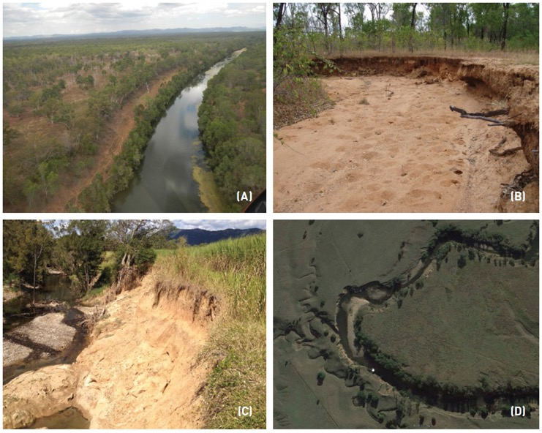

Figure 2.  
(A) A major dry-tropics stream with stream bank exposed to rain splash and scour (Bowen River).  
(B) A minor dry-tropics stream eroding through scour and mass failure of the bank profile, in the upper Burdekin catchment. Note the absence of a distinct riparian vegetation community. The gravel bedload accumulation is causing local channel widening.  
(C) A large stream in the humid tropics where the stream bank is eroding through scour and mass failure.  
(D) Meander migration and slumping of poorly vegetated stream banks in a reach of the Mary River. (Google Earth)

*Photographs by Rebecca Bartley and Andrew Brooks*

| **Where are gully and stream bank erosion most severe?** |
| --- |
| **At landscape scale, gully erosion is more extensive (and more rapid) in areas with:**   * alluvial terrace sediments in savanna landscapes adjacent to larger streams and rivers (i.e. that are not active floodplains in the current climate), which typically contain deeper and less-stable soil materials (for example, Sodosols, Vertosols) * terrain of low to moderate slopes and around river channels, especially deep colluvial (hillslope derived) sodic soils * pockets of local alluvium in headwater regions (for example, sodic blacksoil plains) * where runoff is concentrated in drainage lines and valley bottoms.   **Stream bank erosion rates vary spatially, but are enhanced in the following areas:**   * where stream bank soil is more erodible such as including sandy layers, and not in reaches confined by rock outcrops * on the outside of stream channel bends (meander migration) * where stream bank vegetation (trees, shrubs, grasses) is poor either through clearing or livestock disturbance * where the stream channel has recently widened (for example, through gravel or sand deposition) or has deepened * where disturbances such as sand and gravel extraction quarries, alluvial mining or channel diversions occur * stream bank erosion at any point is affected by the local flow velocity, which is influenced by the amount of vegetation on the banks and in the stream, both locally and for up to kilometres upstream and downstream * stream bank erosion at a site can be influenced by channel constrictions, channel roughness and slope along reaches of kilometres in length. |

Within each river catchment, gully and stream bank erosion can be spatially connected through the drainage network; indeed, it can be difficult to define where a hillslope gully transitions to a minor stream. For example, alluvial gully erosion can occur adjacent to the bank of large stream channels in the dry tropics; in this case the high banks can be dominated by alluvial gully erosion, while the lower inset stream banks and benches may display more typical stream bank erosion driven by scour and mass failure. Stream channel incision (deepening) can also trigger gully erosion upstream. Degraded riparian vegetation can initiate and accelerate both gully and stream bank erosion. Therefore, implementing gully and stream bank erosion control together where they both occur in priority catchments can provide cumulative benefits from reducing both processes.

### Objectives of erosion control

#### Introduction

The aim of the Reef 2050 Water Quality Improvement Plan 2017-2022 (WQIP; The State of Queensland, 2018; https://www.reefplan.qld.gov.au) is that "Good water quality sustains the outstanding universal value of the GBR, builds resilience, improves ecosystem health and benefits communities". This plan sets specific water quality targets for each GBR river basin, averaging to an overall 25% reduction in anthropogenic end-of-catchment fine sediment loads and a 20% reduction in anthropogenic end-of-catchment particulate nutrient loads, by 2025. The targets are written in terms of mean annual sediment loads over decades, and progress towards the targets is estimated using catchment-scale modelling, which is calibrated using a range of monitoring information including sediment tracing and the spatial patterns in erosion and in river sediment loads.

The WQIP sets several principles for implementation:

* Maintaining and enhancing the outstanding universal value of the GBR as the prime consideration. Therefore, the focus is on improving end-of-river loads of pollutants. This means that the primary objective for GBR water quality improvement programs focused on erosion control is cost-effective reduction in river loads of fine sediment and particulate nutrients delivered to the coast.
* Basing decisions on the best available science. This implies reliance on the peer-reviewed literature, mechanisms for input of advice from technical experts to project priorities and implementation, and that management is adaptive and continually improving, informed by the outcomes of monitoring and recent research.
* Delivering a net benefit to the ecosystem, and fostering actions that restore ecosystem health and resilience. Increasing protection and condition of riparian habitat is one way to contribute to this principle and has been an outcome sought in programs of the Australian Government's Reef Trust and other land and water care programs.
* Adopting a partnership approach to management, which includes being informed by engagement with Traditional Owners, industry, regional bodies, local governments and the community.

Consequently, select activities that are more expensive on a unit area basis for water quality improvement only: (i) if erosion is too severe for relevant activities of lower cost to be effective alone; (ii) if relevant activities of lower cost are also applied in a supporting function to increase their effectiveness in the long term; (iii) if they deliver cost-effective sediment reductions; or (iv) if they also achieve valuable ecosystem benefits which cannot be achieved by other means.

This Toolbox focuses on gully and stream bank erosion control because gully and stream bank erosion together supply about three-quarters of the total fine sediment to the GBR lagoon (McCloskey et al., 2021). Gully and stream bank erosion control also require quite different management approaches to those for controlling sheetwash and rill erosion.

Gully and stream bank erosion are spatially concentrated sediment sources that occupy a small proportion of the landscape. This means that erosion control activities can be implemented with less impact on surrounding land uses, although sustainable land management remains an important supporting activity for achieving gully and stream bank erosion control outcomes. Indeed, engaging with landholders to achieve sustainable grazing management is a foundational activity to ensure the legacy of erosion control activities.

To remain effective at delivering long-term sediment reductions, all works need to be maintained and fixed if problems evolve. Maintenance requirements are described in Section 2.6.

#### Gully erosion control

The objectives of gully erosion control are well-established from numerous examples around the world (for example, Geyik, 1986). They are:

1. To stabilise the headcut either by structural control or by reducing runoff and seepage into gullies. Runoff can be physically diverted away from the gully head, although it can be difficult to discharge diverted runoff safely without triggering or accelerating gully erosion where the runoff re-enters the drainage channel network.
2. To reduce sidewall erosion by increasing vegetation cover and biomass within and around the gully, which protects against rain splash and provides root reinforcement; this requires fencing to control livestock access and enable vegetation to grow (passive revegetation). Active revegetation activities (for example, seeding, planting, slope stabilisation, and soil amelioration) and/or rock stabilisation may be necessary also.
3. To stabilise and to increase sediment trapping on the base of the gully by controlling the gradient and increasing the amount of vegetation to slow the flow. Porous check dams (PCDs) may assist this process. Stabilising gully depth is an essential part of reducing further expansions.

The relative importance of these 3 objectives will be site dependent based on where erosion rates are highest (Figure 3).

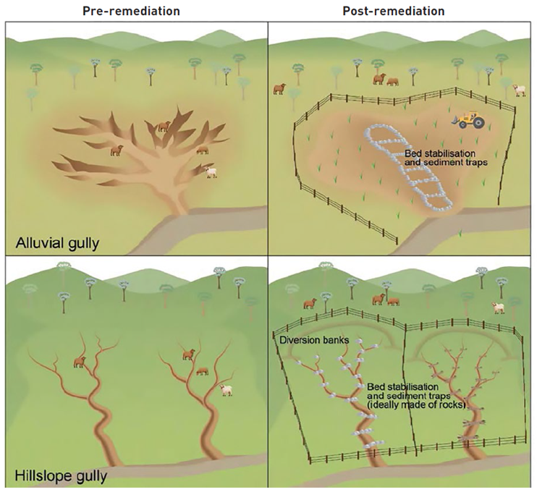

Figure 3. The required approaches to gully erosion control depend on the gully form and setting.

Each site has a unique combination of erosion processes including rain splash, sheet wash, rilling, tunnelling, fluvial scour and mass failure. To reduce the rate of headcut, wall and floor erosion, a site-specific combination of the erosion control activities described in Section 3 is required.

*Image reproduced from Complied by the RRRC 120211*

Ensuring that the surrounding grazing management is sustainable is an important supporting activity to prevent further degradation and to minimise the expansion of gullies. Managing vegetation in and around drainage lines is the most important approach because exposed soils require little runoff to initiate gullies (Prosser and Slade, 1994). Improving soil health is a way to reduce runoff into the gully, although it can require large changes in grazing pressure and take up to decades to achieve substantial impacts on runoff where vegetation has become degraded.

The success or failure of gully erosion control activities based on these objectives depends on how well activities are selected and designed appropriately to suit the terrain, soil and climate of each site. Selecting activities is discussed in Section 2, and details of the remediation measures are described in Section 3. A bundle of several activities is typically required to stabilise the headcut, side walls and floor of large gullies in unstable soil, including engineered structures, reconfigured slopes, PCDs, revegetation, livestock access control and land management changes in the surrounding paddock (for example, Brooks et al., 2016a, 2016b).

It is important that erosion control is implemented consistently within established guidelines. The details and risks of common erosion control activities are described in Section 3. Control the risks associated with applying innovative or new treatments by proposing them initially as trials, and by seeking independent technical review of the objectives, design and implementation.

**Prevention of gullies in non-gullied parts of priority areas is a complementary and important objective, especially areas with duplex (texture contrast) soil types, such as Chromosols (red goldfields) and Sodosols (“spewy" soils with yellow/brown sub-surface clay). These soils have high clay content in the sub-soil that limits infiltration, leading to more frequent saturation of the soil surface and more surface runoff. They are also likely to be dispersive or slaking. Maintaining and improving land condition in areas with sodic sub-soils is particularly important because once these sub-soils are exposed, they are difficult to stabilise.**

#### Stream bank erosion control

**The overall objective of stream bank erosion control is to increase the erosion resistance of stream banks in a way that also dissipates the energy of flow over long (multi-kilometre) reaches of a stream. Treatment of long reaches is preferred because this reduces flow velocity at the bank face more effectively than treating small or isolated sites. A range of approaches to stream bank erosion control may be required within identified reaches. Stream bank erosion control approaches must also be integrated with other objectives, such as ecological protection and improving habitat connectivity. Numerous landholders need to be engaged with when working at reach scale, and there are regulations on management activities in many streams.**

This Toolbox outlines the relevant considerations for common activities whose primary objectives are erosion control. The existence of other values and services provided by streams is acknowledged. Stakeholder consultation is an important component of planning stream bank projects. The Queensland River Rehabilitation Management Guideline (DES, 2022) describes a more holistic planning and implementation process for stream management (see wetlandinfo.des.qld.gov.au) and recognises that rivers are open connected systems that need to be managed in a catchment and reach-based framework. Consider this guideline at the outset of a project to prepare a project plan that takes into account the system at multiple spatial and temporal scales.

Other recommended reading for those considering substantial stream management projects includes A Rehabilitation Manual for Australian Streams (Rutherfurd et al., 2000a, 2000b), the Queensland Soil Conservation Guidelines, Chapter 11 (Carey et al., 2015b), and Stream Bank Management in Great Barrier Reef Catchments (Bartley et al., 2015). We also strongly suggest that you seek professional advice on approaches to stream management issues if you do not have a strong background in this field.

These process-based approaches to stream bank erosion management typically involve the following questions:

* Is there strong evidence that bank erosion rates are well above natural rates, and that they will continue at similar rates?
* What are the likely causes of the increased bank erosion? If you don't know, check with an expert.
* What are the values of the stream to stakeholders?
* What other ecosystem services should be considered, here and elsewhere in the stream system, and how does the stream function to deliver those services?
* What are the erosion control objectives and options?
* How do the objectives and options compare with stakeholder expectations (including landholders) and long-term stream health? Do they address any other hazards present, such as climate or local land use change?
* Is the option being considered going to be cost-effective for improving GBR water quality?
* How will I know if the proposed action will be successful?

##### Revegetation of riparian areas

The lowest cost approach to managing stream erosion, and of reducing the risk of future bank erosion, is to improve riparian vegetation by passive (for example, livestock exclusion and weed control) or active means (for example, planting).

Stream revegetation protects against erosion by:

* protecting the soil surface from rain splash and scour by stream flow, and involves controlling direct disturbance by livestock
* increasing the soil cohesive strength by root reinforcement to protect against mass failure
* reducing the erosive force on the stream bank surface, and especially when present at the reach scale, in-channel and stream bank vegetation slows the velocity of flow near the channel margins.

Many studies have found stream bank revegetation to be effective at controlling erosion. For example:

* The mean erosion rate of banks with riparian vegetation on the Daintree River was 85% lower than that of banks without riparian vegetation (Bartley et al., 2008).
* Stream bank erosion during a large flood event on streams in Victoria was much less at revegetated sites than at comparable sites without intact vegetation (Hardie et al., 2012).
* Riparian fencing on its own, without active revegetation, reduced stream suspended sediment loads by approximately 40% in a study in Ohio, USA (Owens et al., 1996).
* Fencing off and actively revegetating streams reduced sediment yields by 33-80% on a stream in North Carolina, USA (Line et al., 2000).
* Cattle exclusion from riparian areas on a stream in New Zealand resulted in a rapid transition from a wide, shallow stream with an unstable bed and heavily grazed and trampled banks, to a stream with more stable, vegetated banks (Howard-Williams and Pickmere, 2010).
* Studies in New South Wales by Robertson and Rowling (2000) found that seedlings and saplings of dominant *Eucalyptus* tree species were more abundant in areas with no stock access, and the biomass of groundcover plants was an order of magnitude greater in areas with no stock access (see also Jansen and Robertson, 2001).

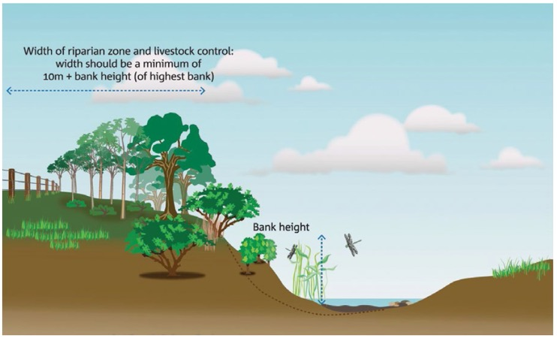

Figure 4. The width of stream bank vegetation and the setback of stream bank fencing from the bank top is determined considering the bank height (see Section 3.9.2)

A typical layout of stream vegetation management for erosion control in a grazing setting includes fencing a suitable distance back from the stream (Figure 4 and methods in Section 3). Extend setbacks where the channel is likely to undergo some normal lateral movement.

The value of riparian revegetation increases with the area and length treated. Research has shown that riparian vegetation is most effective in reducing erosion when buffer width is at least 5-30 m and buffer length >1 km (Feld et al., 2011; Brooks et al., 2014). Revegetating one isolated site (for example, 200 m long) may control erosion at the site but is typically insufficient to address reach-scale instability. Because this approach slows the flow over the reach scale it has benefits that extend outside of the treated locations, in contrast with site-scale works. Therefore, the benefits of extensive stream bank revegetation and connectivity in riparian habitat are best achieved by identifying multi-kilometre reaches of stream with large total baseline sediment yields, which contain clusters of stream bank sites located as continuously as possible along the reach.

##### Engineered stream bank stabilisation

The expense of engineering means that few sites can be stabilised using this style of approach, while cheaper fencing and revegetation can be applied more broadly. As a general principle, only consider engineered stream bank erosion control if: (i) there is evidence of very active erosion; (ii) it can be justified on a cost per tonne of sediment avoided (see Section 2); and (iii) stream bank vegetation is either already extensive along the reach or will be re-established through the project.

Section 3 describes ways in which engineered bank protection can be combined with stream bank revegetation. Fine resolution information about bank properties and hydraulic conditions at the site is required to ensure that the engineering modifications will last (Frothingham, 2008; Simon et al., 2014). Consult a technical expert at the site concept stage. Site-specific erosion control that addresses infrastructure protection will require co-investment from the owner/manager of the asset, as this is not the primary aim of GBR water quality programs.

##### Benefits of vegetation in addition to erosion control

Riparian vegetation also has critical functions in protecting the condition of stream ecosystems and their biodiversity (Rutherfurd et al., 2000a; The State of Queensland, 2018; DES, 2022). Benefits of gully and stream bank vegetation beyond improving downstream water quality and ecosystem condition include providing shade and shelter for livestock, livestock management, clean water for pumping, decrease in insect pests (Price and Lovett, 2002), carbon sequestration (Paul et al., 2018), asset protection, recreation and cultural values (Rutherfurd et al., 2000a).

## PLANNING AND IMPLEMENTING EROSION CONTROL

**This section guides the identification and planning of a portfolio of erosion control sites and appropriate treatments. it describes the processes for detailed planning and implementation, in the context of Government funded programs to efficiently reduce fine sediment loads to the Great Barrier Reef (GBR). identifying and addressing a manageable number of individually significant erosion control sites is important, because having many small sites may result in high overhead costs. Experience is that the most effective projects typically include a combination of highly eroding sites with high-cost treatments and several moderate erosion sites with lower-cost treatments. The ratio of cost to effectiveness and how it can guide site identification and planning is defined below.**

### Focus on priority catchments

The GBR catchments cover a very large area and contain tens of thousands of possible sites for gully and stream bank erosion control. Recent Reef Trust projects used mapping and modelling of sediment sources and the delivery of sediment to the coast to identify priority catchments. Focusing on priority catchments can help to target more detailed spatial analysis to identify cost-effective sites for erosion control. Consider the following factors when making choices of priority catchments:

**River basin sediment load reduction targets:** The GBR WQIP (The State of Queensland, 2018) sets relative (% reduction) and absolute (t/year) sediment load reduction targets, which are also a guide for identifying focus catchments. Updates to Reef Plan load reduction targets occur periodically and should be used where available. While small catchments may have smaller magnitude load reduction targets, they may be worth considering if they contain cost-effective sites and discharge near to marine ecosystem assets. While flood plumes from small catchments do not extend as far offshore as those from large catchments, the fine sediment and attached nutrients are still available for wind and wave remobilisation and redistribution during the subsequent dry season. Over the medium term it will be necessary to address the dominant sources of erosion, not just the easiest to address, if the Reef 2050 Water Quality Improvement Plan (WQIP) targets are to be realised.

**Catchment gully and stream bank contributions to sediment loads:** Achieving large reductions in sediment exports through erosion control at regional and basin scales is more likely to be achieved through erosion control activities in catchments that contribute larger amounts of fine sediment to the GBR coast from gully and stream bank erosion. Such catchments are also more likely to have large numbers of larger sites that are cost-effective for erosion control. Catchment contribution to sediment loads is modelled by the Paddock to Reef Monitoring and Reporting Program (P2R), which is informed by erosion mapping, sediment source tracing and river load monitoring (McCloskey et al., 2021). To help identify priority catchments, Refer to Appendix B, which contains rankings of catchments by gully and stream bank contribution to fine sediment loads, when targeting site identification efforts.

**High or moderate river sediment delivery ratio (RSDR):** The delivery of fine sediment from any site can, over the long term, be reduced by sediment trapping in major reservoirs and floodplains between the site and the GBR lagoon. Erosion control tends to be more cost-effective when located in catchments with higher RSDR, because more of the sediment reduction at site scale is realised at the GBR lagoon. The P2R program models the RSDR. Appendix B lists the average RSDR for selected catchments. Within each catchment the RSDR declines from downstream to upstream, more so in some catchments than others. Sub-catchment RSDR data can be used to identify relatively efficient areas for erosion control within priority catchments. These data are available from the Paddock to Reef team in the Queensland Department of Agriculture and Fisheries: P2R@daf.qld.gov.au, via a P2R Dropbox folder.

**Target the dominant erosion source:** The relative split of planned investment between gully and stream bank erosion control in the priority areas should consider the relative significance of gully and stream bank erosion as sediment sources, in terms of their catchment contribution rankings as listed in Appendix B. However, also verify the relative opportunity for gully and stream bank erosion control through field visits to priority catchments.

**Willing landholders:** Having landholders in the intended project area who are willing to engage with erosion control projects is essential to successful project implementation. A program of landholder engagement is typically required to build capacity, understanding, acceptance and input into the objectives of the program of works. Erosion control projects require access to sites and monitoring of outcomes including ongoing control of livestock access over several years, which are typically documented in a land management agreement. If networks have not yet been established, then determine whether they can be within the project planning period, or consider partnering with organisations already operating in the area. Involving keen landholders early can assist spreading the message about the project. Continuing to expand community engagement with erosion control objectives is an important benefit of projects also. Achieving large sediment reductions will require working more broadly than only at convenient sites or with landholders that have already been well-engaged with natural resource management programs.

### Identify cost-effective erosion control sites

#### Method and definitions

The objective of site identification is to deliver a reduction in fine sediment load to the GBR lagoon that makes the whole project cost-effective. Within the priority catchments and areas identified in 2.1, the recommended approach to identifying the most cost-effective sites in terms of $ per tonne of fine sediment reduction is: (i) to identify sites with large erosion rates; (ii) to assess their baseline (no-treatment) sediment yields; and (iii) to identify and cost suitable treatments and so calculate cost-effectiveness for each candidate site. Compare the resulting cost-effectiveness estimates with thresholds that are acceptable to the program funder to determine whether to proceed to proposal and design. If the cost-effectiveness is deemed excessive then consider lower-cost activities or other sites (Figure 5).

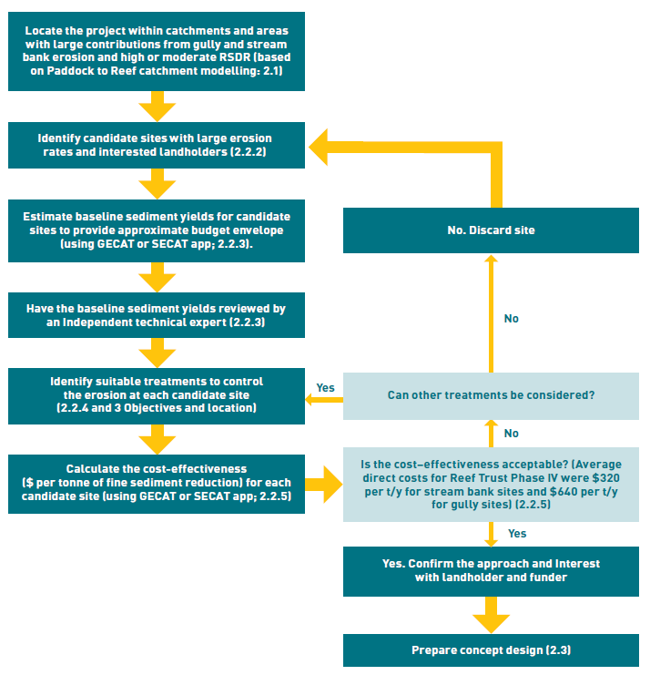

Figure 5. A flowchart of the process for selecting cost-effective project sites for preparing a concept design. The sections of this document relevant to each step are given in brackets.

Sediment reductions are estimated as a mean annual value over the 30 years following treatment (for example, 2020-2050), consistent with the time frame of the Reef 2050 Long-Term Sustainability Plan 2021-2025 (Commonwealth of Australia, 2021), and the associated Reef 2050 Water Quality Improvement Plan (The State of Queensland, 2018). This period is also sufficiently long that the climate over the period will contain a typical spread of wet and dry years and can be well-represented by the mean annual historical climate over recent decades. They are calculated as a proportion of the baseline (no-treatment) sediment yield, with that proportion defined as the effectiveness of the erosion control treatment.

The costs considered in cost-effectiveness are the program's funds required for designing and implementing the activities ($), as a ratio to the long-term estimated reduction in mean annual fine sediment load delivered to the GBR lagoon (t/year) see the box next page. Cost-effectiveness can vary greatly between individual sites, even those of similar size (Wilkinson et al., 2019). It is therefore important to assess the possible sediment reductions and likely costs for each candidate site before committing substantial resources into preparing a concept plan (Figure 5). The GECAT (Gully Erosion Control Assessment Tool) and SECAT (Stream Bank Erosion Control Assessment Tool) apps are recommended for calculating cost-effectiveness in a defensible and repeatable way – see the box below.

| **Estimating cost‑effectiveness** |
| --- |
| There are 6 steps in calculating cost‑effectiveness of a prospective erosion control site:    The first 5 steps calculate the fine sediment reduction (t/year) from the proposed activities, while the sixth step calculates cost‑effectiveness as the $ cost per t/year of sediment reduction.   1. The historical erosion rate is the volumetric growth rate of the area of gully or stream that will be controlled (m3/year). It is typically estimated as the difference in volume between the beginning and end of a recent historical period. 2. The baseline erosion rate is the average rate expected to occur over the coming 30 years without treatment. It differs from the historical erosion rate if climate during the recent period differed from the long‑term average, or if the erosion is evolving over time independent of climate (for example, decaying). 3. The baseline sediment yield (t/year) is the product of the baseline erosion rate, the soil dry bulk density (t/m3) and the proportion that is <20 μm particles. 4. The erosion control effectiveness is a proportion of the baseline yield that is estimated to be reduced by the primary erosion control treatment. This accounts for more intensive treatments having a larger effect (Table 1). 5. The fine sediment reduction (t/year) is the estimated water quality improvement at the point of interest (the river mouth) accounting for delivery from the site through the river system. 6. Cost‑effectiveness is the $ cost per t/year of fine sediment reduction. The cost is the program funds required for designing and implementing the activities including site design, labour and materials. Include the costs of site identification, communication, monitoring and administration in assessing the cost of delivery based on the advice of the funder, either at planning stage or during project evaluation.   These steps can be calculated in a guided process using the GECAT (Gully Erosion Control Assessment Tool) or SECAT (Stream Bank Erosion Control Assessment Tool) apps, available from the Paddock to Reef team in the Queensland Department of Agriculture and Fisheries: P2R@daf.qld.gov.au. Use the apps to identify candidate sites, and then refined following site visits and during design. They accommodate a range of data types and a setup guide, user guides and supporting data for each app are publicly available through the P2R Dropbox folder.  Hillslope erosion sediment reductions from supporting activities to improve grazing practices elsewhere on the property can be estimated using the Projector tool available from P2R@daf.qld.gov.au. |

The availability of suitable skills in the project team is critical to all stages of site identification, design, construction, monitoring and reporting (see box below).

| **Skills needs** |
| --- |
| It is important to secure the right skills and expertise for erosion control. Locating, designing and constructing erosion control correctly is essential for works to give good value water quality improvement, and for works to be effective through droughts and floods. Experience shows that poorly located or designed structures will fail, and that the use of machinery in the hands of an unskilled and uninformed operator can be disastrous for erosion.  The expertise to identify cost‑effective erosion control sites includes:   * the involvement of stream rehabilitation specialists in assessing erosion processes at the reach scale is essential to ensure strategic site selection for engineered stream bank erosion control * spatial analysis (GIS) working with Lidar digital elevation model differencing and/or historical air photos * calculating sediment reductions using the GECAT and SECAT apps * grazing land management extension and landholder engagement.   The specific technical expertise that is required to manage, design and implement erosion control will depend on the on‑ground activities. Higher levels of expertise and experience are typically required for more costly treatments (see Table 1). Qualifications, training and experience are typically required in one or more of the following:   * writing concept design and detailed design reports and responding to queries from funders or reviewers * project management including planning, purchase, delivery and installation of inputs such as fencing, rock, mulch, gypsum, seed and technical consultants * professional extension staff experienced in landholder engagement, in grazing land management and property management * for earthworks and hydraulic structure design, industry certifications are one indicator of qualifications, competency and experience, which are especially relevant for large sites >$200,000. For example, Certified Professional in Erosion and Sediment Control (CPESC, International Erosion Control Association); EIANZ CEnvP Geomorphology Specialist; Certified Professional Soil Scientist (CPSS) * Registered Professional Engineer Queensland (RPEQ) certification (Board of Professional Engineers of Queensland) is required for design and construction of hydraulic structures and earthworks where there is a risk to public safety (for example, if structural failure brings a risk of flash flooding of public roads or undermining of buildings or bridges). It is also relevant for design of large waterway hydraulic engineering, such as with site cost >$200,000. It may also be required by regulations in certain situations * soil sampling and chemical analysis (exchangeable sodium percentage (ESP), pH, cation exchange capacity (CEC)), and designing chemical amelioration (gypsum or lime), particularly for dispersive and sodic soils where engineered structures or earthworks are contemplated * site surveying by registered surveyors to ensure that construction occurs to the specification * ensure all on‑ground construction is supervised by suitably skilled and experienced project personnel for consistency with the design specification, and that adaptations are made to account for unexpected site conditions * ensure all machinery operators are proficient and capable of doing the tasks required * revegetation of grasses, shrubs and trees as suits the site, including weed control * repeatable site monitoring of vegetation cover and land condition at consistent locations, such as using the Gully Monitoring Tool (GMT), Stream Bank Monitoring Tool (SMT) and Land Condition Assessment Tool (LCAT) apps (see Section 4). |

#### Identify candidate sites with large erosion rates

Based on experience in Reef Trust Phase IV, a critical aspect to achieving cost-effective gully and stream bank control at whole-project scale is to identify at least a subset of sites that have large baseline sediment yields in recent decades, and therefore the potential for large sediment reductions. Individual sites with larger sediment yields tend to have either a larger gully area (>0.1 ha) or longer stream bank length (>200 m), and large erosion rates. As well as individual gully sites, consider clusters of gully sites that can be treated together to reduce fixed overhead costs such as site identification, planning, equipment mobilisation, monitoring and landholder engagement. This enables sites with smaller sediment reductions, or that are less cost-effective, to be included in order to increase the overall sediment reduction in a project. Evaluate the overall cost-effectiveness of tackling many sites that all have small individual sediment reductions before proceeding.

Datasets that may assist identifying candidate sites with large historical erosion rates include:

* Mapping of gully extent; 3 datasets are available:
* Queensland Department of Resources gully mapping from aerial photos, as used in Paddock to Reef catchment modelling (available from ReefCoordination@resources.qld.gov.au)
* Semi-automated gully mapping from airborne Lidar digital elevation models (DEMs) of selected highly gullied areas (Daley et al., 2021a). These data include synoptic estimates of gully sediment yields for around 26,000 gullies (https://maps.eatlas.org.au/).
* Automated gully and erosion hazard mapping from airborne Lidar digital elevation models (DEMs) of selected highly gullied areas (Walker et al., 2022). These data include overview maps of gully erosion hazard, which may assist identifying gullies that have large potential to expand, and non-gullied areas that would most benefit from actions to prevent gully erosion such as improved grazing land management (https://data.csiro.au/collection/csiro:52249).
* Repeat Lidar DEMs are available for some areas, including corridors along some major streams (https://elevation.fsdf.org.au/). Elevation differences between sequential Lidar DEMs can indicate recent erosion rates where the change in elevation is larger than the uncertainty (the limit of detection of erosion is typically 0.3 m; discussed further in Section 2.2.3).
* Base the identification of stream bank erosion control sites on reach-scale geomorphic assessment to ensure that the appropriate reach is identified, and that there is sufficient erosion across the entire reach to justify the project. As described in Section 1.2.3, the goal is to address erosion processes across the whole reach, which will typically include a mix of sites with larger and smaller erosion rates.
* Historical air photos help to identify sites and estimate historical erosion rates; portals include:
* Qlmagery (https://qimagery.information.qld.gov.au/)
* Queensland Globe Website (also useful for accessing information on soils, water courses, roads and infrastructures) (https://qldglobe.information.qld.gov.au/).
* Google Earth Pro (View: Historical Imagery)
* Ground cover imagery from VegMachine (https://vegmachine.net/) or other portals.
* Soil properties, which in some areas differ strongly in erodibility and nutrient content (Australian Soil Resource Information System; http://www.asris.csiro.au/).
* Geomorphic assessments and walking the landscape to assist identifying erosion that is just starting, active, or mature and stable.

Important steps at this stage are: (i) visiting candidate sites to ensure that they are eroding as assessed above: (ii) contacting landholders, who may consider being involved with the project; and (iii) including a land management agreement covering site access for construction and monitoring and post-construction site management including controlling livestock access.

#### Estimate baseline sediment yields

For promising candidate sites, complete the first 3 steps shown in the cost-effectiveness box in Section 2.2.1. Use the GECAT Survey123 app for gullies, or the SECAT Survey123 app for stream banks; these apps and latest user guides are available from the Paddock to Reef team in the Queensland Department of Agriculture and Fisheries: P2R@daf.qld.gov.au. A setup guide and latest user guides for each app are currently available from the P2R Dropbox folder.

1. The **historical erosion rate** is the erosion rate of the erosion feature or features to be treated over the past approximately 10 plus years, in gross cubic metres per year. Where a DEM of difference is used (the preferred method if available), apply an erosion limit of detection (LoD) to the analysis. The appropriate LoD depends on the source Lidar point density, the DEM resolutions, the surface slopes and roughness (steeper and rougher slopes require a larger LoD), and the amount of vegetation cover. For 1 m resolution DEMs, which are accurately aligned vertically and horizontally at the site as demonstrated using multiple cross-sections, the LoD is typically 0.3-0.5 m. At open sites with little vegetation cover, the LoD may be reduced to 0.2-0.3 m by creating site-specific DEMs at 0.5 m resolution, or finer, from point cloud data and demonstrating they are registered to each other horizontally and vertically. If repeat Lidar is unavailable then the preferred method to estimate the historical erosion rate is as the erosion volume between a single Lidar DEM and an estimated prior land surface, over the area newly eroded during the period since a historical air photo. The least preferred method is to measure erosion widths and depths in the field, because the irregular geometry of erosion limits the accuracy of this approach. A DEM from drone photogrammetry may be a suitable substitute for a Lidar DEM at open sites without dense vegetation. Fine-resolution DEMs are also useful for designing erosion control activities, by defining erosion depth and slope angles and gully catchment area.
2. The **baseline erosion rate** is a forward prediction of the long-term erosion rate of the feature or features to be treated in gross cubic metres per year, which is what will happen in the absence of treatment over the coming 30-year period. Baseline erosion rate is determined from the historical erosion rate by adjusting the baseline trajectory for climate variations, and the expected changes (often decay) in erosion rate over time as described in the GECAT and SECAT user guides. For example, gully and stream bank erosion are highly episodic depending on the peak intensity and duration of each event, and so erosion in a single large event or short period is a poor predictor of future erosion rates.
3. The **baseline fine sediment yield** is the product of the baseline erosion rate (m3/year), the soil dry bulk density (t/m3), and the sub-soil silt and clay content (the proportion of <20 pm particles).
4. **Dry bulk density** can be estimated from data available from the Paddock to Reef team in the Queensland Department of Agriculture and Fisheries: P2R@daf.qld.gov.au, through the P2R Dropbox or from site soil samples.
5. The **silt and clay content** can be based on the Paddock to Reef spatial datasets available from the P2R Dropbox at this stage, or if site soil samples have been analysed use that data, as described in the GECAT and SECAT user guides. As the detailed design stage will require collecting on-site soil information, it is ideal if the project can collect their own data now to save later revision of the sediment reduction.

**River sediment delivery ratio (RSDR):** The RSDR is the proportion of the baseline sediment yield and the sediment reduction at the site that is transported to the GBR lagoon. This is the most current value from the Paddock to Reef Monitoring, Modelling and Reporting Program (P2R) catchment modelling for the sub-catchment containing the site, which is available from P2R@daf.qld.gov.au, or the P2R Dropbox. The sub-catchment RSDR values decrease upstream within each catchment, and this variation may have a significant influence on site baseline sediment yields in some catchments. If a gully site is not directly connected to a major stream, then reduce the RSDR by 0.1 for every 100 m of unchannelised land between the gully outlet and the drainage network. For example, if the outlet is 200 m from a stream section with an RSDR of 0.6, then apply an adjusted RSDR of 0.4 to the baseline sediment yield.

**Independent review of baseline sediment yield:** The site baseline sediment yield can vary by orders of magnitude between sites, and so greatly influences the sediment reduction, which can be achieved and the budget envelope for cost-effective erosion control. It is therefore important to establish the baseline sediment yield as accurately as possible in the planning process, particularly for large sites. As such, it is recommended considering an informal but independent technical review of the baseline sediment yields before preparing a concept design, to establish whether the budget envelope is sufficient to undertake the envisaged erosion control. This review would be typically funded at the program level independent of the project, as for review of concept and detailed designs. Review of the baseline sediment yield is critical, either here or at concept design stage.

It is accepted that significant technical effort is required to estimate baseline sediment yield of candidate sites before committing to fund erosion control. However, recent programs have found that baseline yield can differ greatly between sites that appear similar in the erosion extent, form and landscape setting, and that this can significantly influence cost-effectiveness (for example, Wilkinson et al., 2019).

#### Identify suitable treatments

**Select the minimum-cost treatments capable of controlling the erosion:** The erosion control treatment or bundle of treatments must be capable of reliably controlling the erosion. Guidance on the objectives and suitable locations for each erosion control treatment is summarised in Table 1 (3rd column) and detailed in Section 3. Design to minimise the risk of failure, such as by ensuring hydraulic structures can withstand a one in 50-year runoff event, and that known limitations are followed. Based on experience in Reef Trust Phase IV, cost-effective treatment of sites with a range of erosion rates (for example, t/ha/year of gully area or stream bank length) can be achieved, provided that the intensity and unit costs of the treatment are adjusted to suit the site (see discussion of cost-effectiveness in Section 1.2.1).

**Adapt the design of the treatments to suit the site conditions:** The treatments must be designed to be fit-for-purpose at the scale and context of the erosion processes at the site. Ensure consistency with restoring ecosystem health and resilience.

**Determine the effectiveness:** The effectiveness for common erosion control activities (proportional reductions from the baseline sediment yield) are listed in Table 1. If the primary treatment is to be different in different subsections of the site, then either assess the sediment reduction from each subsection separately or justify an intermediate effectiveness value and review this independently.

Most water quality programs fund initial maintenance for the first 2 or 3 wet seasons after construction, switching thereafter to a voluntary and in-kind approach. In that case, the initial maintenance column in Table 1 applies, which factors in some decline in erosion control performance over the 30 years over effectiveness is defined. Maintenance regimes are fully described in Section 2.6. If the funding program includes ongoing maintenance for subsequent decades, so that performance will not decline over time, then up to an additional 0.1 effectiveness may apply (see Section 2.6).

To achieve the stated effectiveness values, meet the following conditions:

1. **The primary erosion control treatment must cover the full spatial extent over which baseline sediment yield is calculated**. Do not use baseline sediment yields of whole features where only a subsection is treated.
2. **Implement all supporting activities fully** (Table 1, 4th column). Activities with darker shading (for example, 1 and 2) are foundational activities that can be used on their own. More expensive activities (for example, 3 and 6) must be implemented as bundles including these supporting activities.
3. **Design and construct erosion control using best-quality industry practice**. Guidance on design and construction procedures is provided in Section 3 for each treatment. To minimise risk of failure it is recommended that engineered hydraulic structures be designed to withstand at least a one in 50-year runoff event. Minimise the area of vegetation disturbed by construction.
4. **Control risks of failure by using an independent technical review of planned designs and site monitoring.**
5. **Plan and implement monitoring and maintenance**, as described in Section 4.

The effectiveness values consider available knowledge on the function of the treatment over a 30-year period, and the risks of performance being affected by land management practices, by extreme climatic events and by variable revegetation outcomes. The values provided are best estimates based on global reviews, on quantitative published studies in GBR catchments and on local experience in recent programs, as described in Appendix A. At some sites, the effectiveness of a treatment may be influenced by unusual site conditions. Effectiveness may be adjusted to suit a site if that can be adequately justified to an independent technical reviewer by referencing quantitative studies that contrast with those provided in Appendix A. One recognised case is that a rock chute provides lower proportional sediment reduction for a long gully than a short gully, because the headcut is a smaller proportion of the baseline sediment yield for a long gully, which also has considerable wall erosion.

Other erosion control activities not described in Section 3 can be considered; however, ensure the funder and appropriate technical experts review these for their cost-effectiveness and long-term viability. Conditions may be placed on their use such as initially applying them only at trial scale and requiring additional monitoring.

Table 1. Erosion control treatments, arranged in order of increasing complexity (unit area cost), for gully erosion (1-7) and for stream bank erosion (8-10).

Each primary treatment has defined conditions for when to apply it, which are further detailed in Section 3. Implement each primary treatment as a bundle with the relevant supporting treatments listed. The estimates of erosion control effectiveness are defined for 2 maintenance regimes as described in Section 3, based on documented local and global studies (see Appendix A). Refer to footnotes.

| **Erosion control treatment** **(darker colours denote foundational activities, which should also support more intensive activities shown in lighter colours)** | **Relative unit area cost/ technical complexity** | **Conditions when to consider applying the treatment** | **Recommended supporting treatment (those in brackets apply in some cases)** | **Estimated effectiveness (assuming recommended supporting treatments are undertaken if required)** | | **Specification, see section** |
| --- | --- | --- | --- | --- | --- | --- |
| **Initial maintenanceD** | **Ongoing maintenanceD** |
| 1. Improving grazing management in gully catchmentsA | $ | On properties with land in poor condition, and on which other erosion control activities are also implemented. | 2 | 0.1 | 0.2 | 3.2 |
| 2. Fence to control livestock access to gully sites | $$ | Essential prerequisite for all activities where livestock are present (may result in additional watering point being required). | 1 | 0.1 | 0.2 | 3.3 |
| 3. Porous check dams | $$$ | To revegetate floors of gullies with small catchment areas <6 ha. Requires gully wall protection in highly dispersive soils. Also used as a supporting activity to maintain floor stability in intensively treated gullies. | 1, 2 | 0.2 | 0.3 | 3.4 |
| 4. Gully runoff diversion banks and drainage managementB | $$$ | Where overland flow or road runoff is contributing to erosion and diversion can be safely implemented. Contour ripping only under limited conditions. | 1, 2, (3) | 0.4 | 0.5 | 3.5 |
| 5. Gully head rock chutes | $$$$ | At rapidly moving gully headcuts (e.g. >1 m/year over last 10+ years). | 1, 2, 3, 4 | 0.6  0.8E | 0.7  0.9E | 3.6 |
| 6. Gully reshaping and revegetation | $$$$ | Large rapidly eroding gullies with dispersive/ slaking soils – EATC class 1 & 2. | 1, 2, 3, 4, (5) | 0.6 | 0.7 | 3.7 |
| 7. Gully reshaping and rock capping | $$$$ | Large, rapidly eroding alluvial gullies with dispersive/slaking soils – EATC class 1 & 2 EATC class 1 & 2, poor control of livestock access. | 1, 2, 3, (4, 5) | 0.8 | 0.9 | 3.8 |
| 8. Stream bank fencing and weed control | $$ | Essential wherever livestock present (may cause additional watering point to be required). Suitability depends on having local seed sources and effective weed and livestock management. | 1 | 0.1 | 0.2 | 3.9 |
| 9. Stream bank revegetation (planting) | $$$ | Where existing woody vegetation cover is <25% foliage projected cover, weed problem is manageable with active planting, and/or where more immediate reduction of erosion rate is required. | 1, 8, (10) | 0.2 | 0.3 | 3.10 |
| 10. Engineered stream bank protection and revegetation, or bed protection and revegetation | $$$$ | Only if extensive section of bank erosion with rates >1 m/year – requires consultation and approval from technical team. | 1, 8, (9) | 0.6 | 0.7 | 3.11 |

A Apply to the sediment yield of gullies directly affected by this change. Does not add to the effect of any other gully erosion control activities. May have additional effects on reducing hillslope erosion, which can be estimated using the Paddock to Reef Projector tool

B If the drainage work reduces runoff into the gully by a large proportion (>0.5) then the effectiveness can alternatively be 0.2 in addition to the effectiveness of in-channel treatments, subject to technical review

C Emerson aggregate test (EAT)

D Maintenance options for each bundle of treatment are described in the sections referred to in the far right-hand column. The technical information used to set effectiveness values is described in Appendix A

E Apply only if gully is a linear extensional type of gully and length is <50 m and ongoing wall erosion will therefore be negligible relative to hillslope erosion. Only applies to the headward extension component of the erosion directly associated with the chute.

#### Calculate the cost-effectiveness

The cost used for cost-effectiveness calculations may depend on the project contractual arrangements. There are 2 approaches for calculating cost in the above site assessment process:

**Direct costs:** This represents only the project cost of achieving sediment reduction at a site including site design, construction supervision, labour and materials.

**Complete costs:** This covers the complete project costs of achieving sediment reduction including site design, construction supervision, labour and materials (direct costs), but also the indirect costs of site identification, communication, monitoring, reporting and project administration. Complete costs represent the delivery efficiency of the project. The indirect costs can be difficult to determine at the site planning stage in ongoing projects that fund a range of outcomes because they may be apportioned to sites based on the estimated number of sites to be delivered by the project. Alternatively, indirect costs can be estimated as a proportion of complete project costs. For example, in the Reef Trust Phase IV program, project direct costs were approximately 75% of the complete project delivery costs.

Do not include in-kind support from landholders or volunteer organisations when calculating cost-effectiveness, even if this improves the cost-effectiveness at some sites. However, funding organisations or delivery partners may require the in-kind support to be collated for reporting processes.

The program funder may advise on expected levels of cost-effectiveness. The average direct cost-effectiveness in the Reef Trust Phase IV was typically $320/t/year for stream bank sites and $640/t/year for gully sites (Figure 5). This equated to complete project cost-effectiveness of approximately $420/t/year for stream bank sites and $850/t/year for gully sites. These averages include only sites that had high or moderate RSDR (>0.35).

### Concept design and review

Once a promising candidate site is identified, discuss again with the landholder their level of support and confirm this on site. For example, confirm if the landholder supports the project proceeding and are prepared to exclude livestock from the project area for several years to enable revegetation, followed by an extended period where livestock access is controlled to maintain high levels of ground cover. The delivery project teams must determine the required cost-effective treatment treatments, in consultation with the landholder.

Ensure the proposed work is consistent with broader objectives for catchment management. For example, an individual streamside landholder may envisage hard engineering at a particular site. However, the delivery partner needs to consider landholder perspectives alongside what is most cost-effective at catchment scale for the medium to long-term health of the site and reef, and also what approach is compatible with other objectives for stream management. For example, rather than constraining individual points of stream adjustment, as described in Section 1.2.3, best practice for stream bank erosion control is to establish extensive reaches of well-vegetated riparian zone within which the channel has room to move. This vision can contrast with individual landholder objectives.

With an urgent need to continue to improve water quality entering the GBR, and the investment of public funds, it is important that project activities are targeted and effective. To assist with this process, there are several reasons for documenting the plan:

1. **define the expected outcomes** against which monitoring results will be compared
2. **demonstrate that decisions are based on best available science**
3. **enable review** within the project team and by an independent technical expert
4. **facilitate consultation with the landholder**
5. assist the funder and the Paddock to Reef Monitoring, Modelling and Reporting Program to **estimate erosion reductions** from activities funded by the program
6. **facilitate the communication of projects** to stakeholders (for example, through fact sheets or field days).

Once a promising candidate site has been identified, usually in consultation with the funder or their independent technical expert, the recommended process for reporting, review, construction and site monitoring is described in Figure 6.

1. Delivery partner prepares concept design (2.3)
2a. Independent technical review of concept design report (2.3) (blue box)
2b. Delivery partner revises the concept design as required
3. Concept design is endorsed (2.3) (blue box)
4. Delivery partner prepares detailed design (2.4)
5a. Independent technical review of detailed design report (2.4) (blue box)
5b. Delivery partner revises the detailed design as required
6. Detailed design is endorsed (2.4) (blue box)
7. Materials are ordered and construction is undertaken (2.5)
8. Completion of work reported to the funder and Paddock to Reef
9. Monitoring & maintenance is undertaken and reported (2.6,4)

Figure 6. Process for site design, implementation, monitoring and reporting.

Activities that are the responsibility of an independent technical expert are in blue boxes. Numbers in brackets are sections of this document relevant to each step.

Erosion control programs will benefit from technical expert advice and review of site identification, sediment reduction estimates, the selection and design of treatments, oversighting the monitoring of site implementation, and the program-level evaluation of outcomes. For example, findings from the Reef Trust Phase II Gully Erosion Control Program (Wilkinson et al., 2019) continue to influence practice, including: (i) the criticality of estimating baseline sediment yields due to large variations between individual gullies; (ii) the value of validating cost-effectiveness estimates so that they can inform future programs; and (iii) the benefits of site monitoring and maintenance in the initial post-construction years to secure outcomes and improve practices.

**Prepare a concept design report** documenting the inputs of technical specialists, for review by an independent technical expert, that covers:

1. **The site identification** basis for selection as a project site, such as the relative severity of erosion hazard, vegetation condition, RSDR, and spatial relation to other previous and planned sites.
2. **The erosion context** of the site, including:
3. maps clearly depicting the erosion area, entire project area, proposed works area, existing infrastructure including fencing, roads, watering points, and ideally the locations of photographs included
4. several captioned photographs of the erosion area including the proposed works area
5. gully dimensions
6. soil types, vegetation cover and type
7. history of erosion using a temporal analysis of aerial imagery covering the project area
8. a summary of climate variability over a recent historical period over which erosion rates are known compared with the long-term average climate
9. historical and current site management and proposed changes to site management, if any.
10. **The historical erosion rate** of the erosion feature or features to be treated in gross cubic metres per year, and the methods and assumptions used to calculate the value. Export the GECAT or SECAT output table from ArcGIS Online and copy into the report.

Where a DEM of difference is used (the preferred method if available, otherwise DEM capping and/or air photo analysis may be appropriate as described in the GECAT and SECAT user guides), report:

1. the year of capture of each dataset
2. an evaluation of the erosion LoD applied to the analysis, to justify the value that has been selected in Section 2.2.3.
3. **The baseline erosion rate** of the erosion feature or features to be treated in gross cubic metres per year, justified by the historical record of climate variations as described in the GECAT and SECAT user guides, and also expected changes in erosion rate over time (these rates typically decay as erosion matures). Describe the quality of relevant data available and justify the choice of method for estimating the baseline erosion rate.
4. **The baseline fine sediment yield**, using the silt and clay content and bulk density determined in Section 2.2.3. Describe all data sources. Also report the slaking or dispersion properties of soil.
5. **The river sediment delivery ratio** used to determine the proportion of the sediment reduction that is transported to the GBR lagoon, as described in Section 2.2.3. Ensure the RSDR data are up to date with those available from the P2R team (currently Report Card 2019).
6. **The rationale** for and objectives of the proposed activities.
7. **The proposed remediation approach**, including a map of the erosion control activities to be used and explain why the approach is suitable for the site.
8. A brief outline of **how the site will be managed after construction** in terms of maintenance and controlling livestock access.
9. **The landholder perspective**, including how the project integrates with, adds to, benefits or changes land management and grazing on the property, the degree to which the landholder is willing to support and maintain this project, and why they support the project. The purpose of documenting this is to identify shared successes.
10. **The effectiveness of erosion control activities** as a proportional reduction from the baseline sediment yield over the coming 30 years, using the values and approach given in Table 1. If a variation from those values is proposed, then explain the rationale and the justification for the variation, based on the spatial completeness of works, evidence of performance under similar conditions at other sites, and the likelihood of performance through the expected climate variability given the planned site management regime.
11. **The fine sediment reduction** as calculated by GECAT or SECAT.
12. **The proposed budget estimate** itemised at least by each erosion control activity (noting that complete costings are required in the detailed design).
13. **The cost-effectiveness** in $/t/year fine sediment reduction at the river mouth.

Ensure the concept design report undergoes review by an independent technical expert such as a program technical partner (Figure 6), to control the risks from incorrect siting or remediation approach. The review considers the following questions:

* Is the basis of the site selection sound and is the site suitable for erosion control?
* Has the analysis of the likelihood of ongoing erosion at the site considered the following factors:
* Rainfall, drought and flood history at the site?
* Erosion history at the site and likelihood of changes in coming decades?
* The presence of any geological or erosion process controls that may impact future erosion rate or trajectory?
* Is the baseline volumetric assessment of erosion supported by the available evidence?
* Are the project objectives clear and achievable?
* Is the design approach the most suitable for the site?
* Is the estimate of the fine sediment reduction associated with the project activities appropriate and justified given the available information? Are the conditions listed in Section 2.2.4 all met?
* What is the likelihood the sediment reduction will be achieved within the project period and secured over the baseline period?

Ensure any necessary revisions are made, then the technical expert or program manager can endorse the design to proceed to the detailed design (Figure 6).

### Detailed design and review

Plan and implement all activities considering **work health and safety obligations**. The delivery partners must finalise all **regulatory requirements,** such as securing relevant permits to undertake activities including vegetation management, before the detailed design is completed for review, or in parallel in consultation with the technical reviewer. Some regulatory requirements are listed in Appendix C but this is not an exclusive list.

Ongoing **engagement and agreement with the landholder** is essential during the detailed design process, to ensure that the planned works will be integrated with other property management processes, and that post-construction site management will protect the erosion control outcomes.

Design and construction of large erosion control structures requires the **involvement of a range of specialists** and specific review procedures to manage safety and financial risks, for example:

* Use of qualified and experienced specialists for the design and construction of hydraulic structures, stream channel works and earthworks (see skills needs box in Section 2.2.1). These include CPESC certified professionals, registered surveyors, qualified engineers or geomorphologists.
* Use of CHUTE (Keller, 2003) or equivalent procedures for rock chute rock size selection.
* Where structural failure would pose a risk to public safety, ensure that a professional with RPEQ registration and waterway and erosion control experience (see skills needs box in Section 2.2.2) certifies the design and construction methods This includes determining the design peak runoff estimation (for rock chutes, gully reshaping and engineered bank erosion control), geotechnical assessment, design, and oversight of construction.
* Ensure an independent technical expert reviews the site design, as described in Figure 6.

**The detailed design report** includes all the information explaining how the sediment reduction will be achieved, how the work has been designed and will be constructed, how the effectiveness of the works will be monitored, and how the site is to be maintained to secure the sediment reductions. This is typically prepared after endorsement of the concept design because of the effort and cost involved. Preparation of a detailed design involves up to several visits to the site to develop a detailed understanding of the erosion issues and their dimensions and how the location relates to property infrastructure. Ensure the length and detail of a detailed design report is commensurate with the size and complexity of the planned work. Cover the following aspects in the detailed design report.

1. Resolution of any issues identified in the concept design stage.
2. Updates to the sediment reduction in the form of an updated export from GECAT or SECAT apps, including:
3. Refined erosion rate estimates if new data are available or the planned extent of work changes
4. Data on soil properties. At sites with investment <$30,000, data on the P2R Dropbox can be used to determine silt/clay content (<20 pm) and soil bulk density. For larger sites, laboratory analysis of at least one soil sample for silt/clay content (<20 pm) by gravimetric method (preferred) or laser diffraction, as described in the GECAT and SECAT user guides. At sites with investment >$200,000, analyse at least 3 soil samples for silt/clay content (<20 pm). Ensure samples are representative of the spatial variability of the site through the depth profile and planform of the active erosion. Analyse samples for chemical stability using standard agricultural tests, where soil chemical amelioration may be required (for example, if the soil is dispersive). Include the spatial locations of sampling and a justification that it is representative of the site, and the laboratory analysis report of the chemical properties analysed in the report. Ensure new information on soil properties is used to refine the sediment reduction estimated at the concept design stage.
5. Refinements to effectiveness if planned erosion control treatments or details have changed.
6. Detailed description and justification of the planned erosion control treatments, including:
7. Maps of the extent of each treatment relative to the erosion and existing infrastructure.
8. Details of earthworks including technical specifications and methods that are required to show that the design is likely to be successful at reducing erosion, including soil chemistry reports and proposed amelioration if required, and geotechnical slope stability analysis for unusual configurations such as steeper or longer gully batter slopes and for stream bank reshaping.
9. Design details for planned hydraulic structures, including the design criteria used and technical specifications including drawings. Some important design details to include are listed in Section 3.
10. The revegetation plan for the site including species selection and establishment methods.
11. A schedule of quantities for all works proposed.
12. A detailed project budget itemising each erosion control activity, and all aspects of project delivery and implementation.
13. A statement on the required regulatory approvals, including any cultural heritage at the site and how approval requirements will be managed (refer to Appendix C).
14. A layout map of the monitoring locations, and a description of the proposed monitoring methods for each location, including the program minimum requirements, such as Gully and Stream Bank Toolbox monitoring using the GMT or SMT Survey123 apps, as described in Section 4. Ensure pre-treatment monitoring is done and reported as part of the detailed design.
15. A description of the post-construction site management regime in terms of maintenance and land management activities such as control of livestock access as described in Section 2.6, including the scope, duration and nature of a written landholder management agreement and the obligations and responsibilities of each party. A land management agreement typically includes, but is not limited to, access for construction and monitoring, initial exclusion and subsequent control of livestock access from sites, minimum ground cover or biomass levels, and fence maintenance.

Review by an independent technical expert (Figure 6) will help to control risks of incorrect design or implementation procedures, or integration with the environmental and property contexts. Questions to be addressed by an independent technical review of a detailed design include:

* **Concept design comments:** Have the comments upon the concept design provided by the review of that report been addressed in the detailed design?
* Have **learnings from previous works** and naturally stabilised erosion features been considered in the details of the design?
* **Design quality:** Are industry standard methods for design and construction used, and are they fit-for-purpose? Where there are deviations from industry standards, are they substantiated?
* **Design effectiveness:** Is the design likely to produce the intended outcome and does the design method suit the treatment effectiveness ratio used in the sediment reduction calculations?
* **Are there any risks associated with the proposed works**, considering dependence on ongoing site maintenance such as control of livestock access?
* Will the proposed post-construction **site maintenance** regime give a high likelihood that revegetation components will be successful so that the revegetation can contribute to securing the ongoing sediment reductions?
* Have required **regulatory approvals** been identified, are the required approvals secured or are they able to be secured within the project and implementation time frame?
* **Project budget:** Is the project budget for implementation appropriate and reasonable, are the works as proposed cost-effective, and does the project represent fair value?

Once any necessary revisions have been made, ensure a technical expert endorses the detailed design before it proceeds to construction (Figure 6).

### Construction and implementation

Ensure the construction follows the specifications given in the endorsed detailed design. Confirm any deviations from the design that may influence the effectiveness or structural stability with the technical reviewer and funder.

Ensure that construction and implementation are consistent with the relevant parts of Section 3. Schedule sufficient time for ordering materials and ensure they meet the specification. Ensure that the appropriate skills are on hand during construction (see skills needs box in Section 2.2.1). This includes the skills to inspect the construction thoroughly at specified hold points for consistency with design dimensions and specifications and to determine the action required to correct any deviations from the specification.

Plan and implement all activities with work health and safety obligations in mind. Implement construction so as to minimise its environmental impact, such as by minimising the area of vegetation disturbance (IECA, 2022).

The sediment reduction is reported to the Paddock to Reef Program once construction is complete and the revegetation and pasture growth has established (after at least one wet season).

### Monitoring and maintenance

Monitor and maintain all project sites for at least 2 or ideally 3 years after construction, to report the completion of the erosion control treatments, to demonstrate their full establishment, and to identify any teething issues and implement required corrective actions. Factor in these initial years of monitoring and maintenance into project proposals. Monitoring objectives and procedures are described in Section 4, and customised apps for mobile devices are available to implement these procedures consistently.

Site maintenance includes:

* Oversight of all aspects of the monitoring and maintenance that is independent of the landholder, frequently during the project and then at least annually.
* Monitoring, as described in Section 4, with annual inspections of the rock stability and for existence of scour or tunnel erosion.
* A maintenance regime tailored to the local conditions.
* Maintenance, and reinstatement if necessary, of the livestock integrity of fences, including costs of repairs with respect to tree fall, fires, floods, and feral and native animals.
* Control of livestock access to maintain a high erosion control functionality of vegetation (for example, high ground cover levels, and tree cover in the case of stream bank revegetation). When vegetation is well-established, and there is no longer a risk to the engineering structures, short periods of dry-season grazing may occur within the fenced area to manage fire risk or vegetation composition.
* Weed control to ensure the intended vegetation remains dominant and healthy.
* Remediating drainage to prevent runoff concentration, especially within earthworks areas such as from stock tracks or rills on formed batter slopes, and retrofit with batter chutes or contour dams if required.
* Maintenance of the integrity of erosion control structures. Patch rock scour. If geotextile has been exposed, then protect it with new filter material before placement of new rock. Reinstate structures if failure occurs in a major climatic event.
* Dig out, fill and compact tunnel erosion to match the surrounding soil bulk density.
* Exclude livestock from areas being treated with engineering structures for as long as possible. In contrast to the revegetation options, engineering works are at risk of failure and engineering designs can be compromised if stock access the area and undermine the structures. When vegetation is well-established, and there is no longer a risk to the engineering structures, short periods of dry-season grazing may occur within the fenced area to manage fire risk or vegetation composition.
* Ensure fence integrity and management of livestock grazing, and possibly other components, involve a written agreement with the landholder.
* Ongoing maintenance of vegetation around structures is essential to mitigate the effects of large events. It may be necessary to augment the surface treatments in subsequent years to ensure that a complete ground cover is maintained, and the grass community fully established, and supplementary seeding may also be required to fill gaps.

The cost of this initial maintenance is typically 1-4% of the total construction cost. In many cases, funding for this initial maintenance and monitoring will cease at the conclusion of projects that implement gully and stream bank erosion control 2 or 3 years after construction, and it becomes a voluntary in-kind effort of the landholder after this time, with no external oversight or structured monitoring. Under this **initial maintenance** regime, it can be expected that the erosion control performance will decline over time at a proportion of sites due to reversion to poor ground cover levels and failure of hydraulic structures in extreme events. The effectiveness values for initial maintenance account for this, as detailed in Appendix A.

**Delivery projects and stakeholders are encouraged to explore mechanisms to fund ongoing independent monitoring and maintenance beyond the life of construction projects. In this way, the erosion control functions can persist at their optimum level of performance to secure the full legacy of the capital investment, landholder engagement can be facilitated, and the long-term effectiveness of erosion control can become better understood over time.**

An ongoing maintenance regime is distinct from the maintenance included in many grant-style programs, which is funded only for the initial post-construction years during the project. Ongoing maintenance for 30 years following construction is estimated to increase the long-term treatment effectiveness by 0.1 from that under initial maintenance, as described in Table 1 and Appendix A. Ongoing maintenance programs of shorter duration can be estimated to have a proportionally smaller effectiveness. Programs funding ongoing maintenance are not currently widely available, but the approach as described here may help to facilitate its future expansion. One program, which includes ongoing maintenance of gully rehabilitation sites, is Reef Credit (https://eco-markets.org.au/reef-credits).

The cost-effectiveness of ongoing maintenance as a stand-alone activity is not yet understood, but will depend on the baseline sediment yield and whether it can be integrated with other natural resource management activities such as stewardship programs. Change in landholders is one risk to this approach, but the offer of ongoing maintenance may also facilitate continuation of engagement with the new landholders.

Ongoing monitoring can also provide considerable value for improving understanding of erosion control effectiveness in the long term, for delivery agencies, funders and the public. This is described in more detail in Section 4.1.

## GULLY AND STREAM BANK EROSION CONTROL ACTIVITIES

### Introduction

**This section describes in detail how to plan and implement each of the gully and stream bank erosion control activities listed in Table 1. It provides details to support the planning steps in Sections 1 and 2, and guidance on implementing rehabilitation works. The skills described in Section 2 also underpin the design and construction described here.**

This specification is not exhaustive and is not intended to be a complete manual for erosion mitigation. Delivery partners (and other land managers interested in addressing erosion and sediment losses) are encouraged to also consult other relevant references, including other relevant material. References for planning and implementing multiple gully and or stream bank erosion control treatments described in this Section 3 include:

* Reef Plan Paddock to Reef Grazing Water Quality Risk Framework 2017-2022 (The State of Queensland, 2017; https://www.reefplan.qld.gov.au/measuring-success/paddock-to-reef/management-practices/))
* Lessons for gully management: a synthesis of key findings from the NESP Tropical Water Quality Hub research (Compiled by the RRRC, 2021; https://nesptropical.edu.au/wp-content/uploads/2021/08/Project-6.4-Case-Study-Booklet-1-Gully-Management-online-version.pdf)
* Gully Erosion: Options for Prevention and Rehabilitation (Day and Shepherd, 2019; https://bmrg.org.au/resources/bmrg-publications)
* Soil Conservation Guidelines for Queensland, Chapter 11 and Chapter 13 (Carey et al., 2015b, 2015c; https://www.publications.qld.gov.au/dataset/soil-conservation-guidelines)
* Catchments and Creeks factsheets on waterways (Catchments and Creeks Pty. Ltd., 2010; https://www.catchmentsandcreeks.com.au/fact-sheets/M-waterways.html)
* Alluvial Gully Prevention and Rehabilitation Options for Reducing Sediment Loads in the Normanby Catchment and Northern Australia (Shellberg and Brooks, 2013)
* Managing Alluvial Gully Erosion; and Alluvial Gully Systems Erosion Control and Rehabilitation Workshop (Brooks et al., 2016a, 2016b)
* Department of Transport and Main Roads: Roadworks, Drainage, Culverts and Geotechnical Technical Specifications (Department of Transport and Main Roads, 2022; https://www.tmr.qld.gov.au/business-industry/Technical-standards-publications/Specifications/3-Roadworks-Drainage-Culverts-and-Geotechnical)
* The WetlandInfo website (https://wetlandinfo.des.qld.gov.au/) lists resources relevant to stream management in Queensland, including the Queensland River Rehabilitation Management Guideline (DES, 2022)
* Best Practice Erosion and Sediment Control documents including principles, factsheets and field guides (IECA, 2022; https://www.austieca. com.au/publications/best-practice-erosion-and- sediment-control-bpesc-document)

Erosion control activities other than the ones described may be used provided they address the objectives and strategy described in Section 1, their suitability can be justified, and they are demonstrated to be cost-effective. Check the performance of new treatments with independent technical experts and the funder and trial at small scale.

### Improving grazing management in gully catchments

#### Objectives

**Improving grazing management to stay within sustainable levels of forage consumption is recommended in all instances where gullies have formed. This is a recommended supporting treatment for all gully erosion control sites (Table 1). These practices improve the performance of other rehabilitation treatments applied directly to the gully.**

Excessive past (or ongoing) grazing pressure can be a major driver of gully and stream bank erosion. There is a direct relationship between gully headward extension and annual runoff (Wilkinson et al., 2018) and so it is reasonable to assume that reductions in runoff would reduce gully sediment yields. Changes in grazing practices that increase vegetation cover and improve soil condition (Figure 7) can reduce runoff volumes by impeding the overland flow of water to allow more time for water to infiltrate into the soil (McIvor et al., 1995; Owens et al., 2003), and at the very least will reduce ongoing degradation. Therefore, improving grazing land management is an important supporting activity to gully and stream bank erosion control that may be included in property or project planning. Many regional water quality improvement plans (WQIPs) (for example, Burdekin, Mackay/Whitsunday and Burnett Mary) recognise the water quality benefits of improved grazing management practices for stream banks and gullied areas. Considered management of grazing also protects the legacy of more intensive erosion control activities. Extension and infrastructure that support a change in grazing management may also be regarded by landholders as a benefit to offset in-kind costs of engagement associated with implementing gully and stream bank erosion control actions.

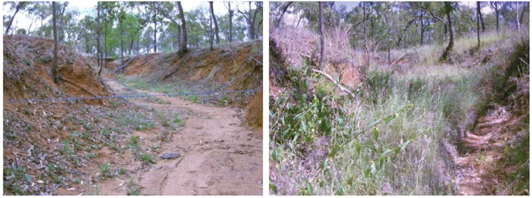

Figure 7. A typical hillslope gully in the upper Burdekin catchment in 2016 (left), and then after 4 years of stock exclusion (right). The only treatment applied was stock exclusion fencing.

The vegetation regeneration was from natural seed dispersal. This treatment resulted in a doubling of (primarily coarse) sediment deposition on the gully floor (Bartley et al., 2020).

*Photographs by Aaron Hawdon*

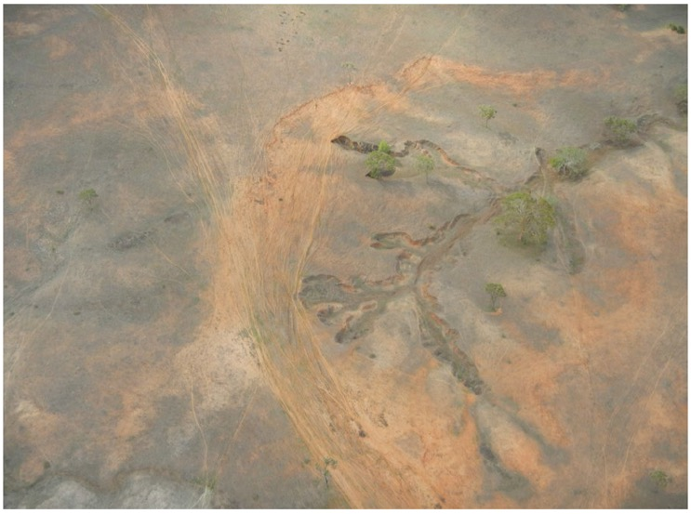

Figure 8. Hillslope gully erosion on granodiorite soils in the Don River catchment, resulting from removal of tree cover and heavy grazing pressure.

Gullies such as this will require stock exclusion for a period of time and major changes in ongoing livestock access to enable revegetation of the gully channel and banks. Significant changes to grazing land management in the gully catchment and livestock track drainage management will reduce surface runoff into the gully heads in the very long term. Porous check dams can also help to revegetate the gully floor.

*Photograph by Andrew Brooks*

On its own, this activity is unlikely to substantially reduce gully or stream bank erosion in the short term (Figure 8). However, more conservative forage management and spelling or rest regimes have been shown to reduce runoff volumes over 5-10 year time frames in areas of higher fertility and times of average or above average rainfall (Owens et al., 2003; Connolly et al., 1997; Silburn et al., 2011; Thornton and Elledge, 2021), particularly if deep-rooted perennial grasses are restored. Response times can be much longer if vegetation is degraded, rainfall is below average and soil is less fertile (Hawdon et al., 2008; Bartley et al., 2014).

There are 3 main approaches to improving grazing management as described below: (i) improving forage management, (ii) fencing to improve grazing management, and (iii) managing water points to achieve sustainable consumption of forage and maintain or improve forage productivity.

#### Improving forage management

Improving grazing management to achieve sustainable consumption of forage and maintain or improve forage productivity is an essential supporting activity for all erosion control projects (see Table 1). By improving forage management, the effectiveness of other complementary treatments is improved.

Improving forage management involves engaging the landholder to support gully and stream bank erosion control activities, either within a fenced area including gullies or stream banks, or in paddocks draining into gullies or adjacent to fenced stream banks, or elsewhere on properties requiring gully and stream bank erosion control.

Improving forage management:

* is an essential accompaniment to other erosion control activities at sites where gully fencing does not cover the entire gully catchment
* is required where recovery or stabilisation of land in poor or very poor condition is the objective (McIvor, 2012), and
* a forage budget is typically used to match stock numbers against available forage in a particular area to ensure land condition or productivity is not adversely affected. The budget is constructed for a defined length of time, usually annually or for a growing season, and reviewed periodically during that time so that small adjustments can be made if required
* stocking rates are within levels that sustain vegetation cover and land condition. Forage utilisation targets can range from 10 to 35% of the annual herbage growth (10% in low-fertility land types common in degraded areas), to sustain the perennial composition of forage (Hunt et al., 2014)

Resources are available to support training and grazing management:

* FutureBeef (https://futurebeef.com.au/)
* Meat & Livestock Australia Edgenetwork Grazing Land Management courses (https://www.mla.com.au/extension-training-and-tools/edgenetwork/)
* FORAGE (https://www.longpaddock.qld.gov.au/forage/). FORAGE incorporates several products such as SILO climate data, satellite imagery and AUSSIEGRASS modelled pasture growth, delivering them by email as easy to understand PDF property-scale reports, to help decision-making in grazing land and environmental management
* Stocktake GLM (https://stocktakeglm.com.au/); a forage budgeting and land condition monitoring app
* consider commercial training and service providers.

Spatial information can greatly assist property planning processes related to improved forage management, including:

* available soil mapping and distribution
* land type and regional ecosystem mapping
* current and historical ground cover (that can be supported by soil and vegetation distribution), for example, https://vegmachine.net.
* fencing infrastructure supporting grazing management.

Other things to consider:

* including graziers beyond those hosting erosion control projects in workshops and training where that helps to achieve program objectives
* include forage management in documented agreements with landholders

Ensure the detailed design report (see Section 4.3) specifies:

* the landholder training being used
* form and duration of landholder agreement (written, verbal)
* agreed approach to setting stocking rates and desired outcomes, such as forage utilisation rates, minimum forage biomass levels before destocking, and planned rest periods
* time period over which grazing management will be managed. Supporting revegetation may require large changes in the initial years, but in most cases grazing within sustainable limits will require ongoing commitment to forage budgeting and adjusting livestock numbers

Use the Land Condition Assessment Tool (LCAT) for site monitoring of land condition and include ground cover and composition, and ideally forage biomass, as described in Section 4.3.

**Case study:** Weany Creek, upper Burdekin River catchment

The stocking rate was reduced from 4 ha/animal equivalent (AE) to 10 ha/AE in the Weany Creek catchment for a decade. The total bare denuded area decreased by more than half over this time (see Figure 9). Property average cover increased by 27% relative to a nearby property where no changes to grazing practice occurred (Bartley et al., 2014). However, due to the contribution of persistent scalds and gullies in the catchment, which dominated catchment sediment yield, annual runoff amount as a proportion of rainfall and sediment yields did not decline over 10 years, indicating that in this setting forage management alone was unsuitable for gully erosion control but was a useful supporting treatment.

Figure 9: Maps of the proportion of catchment with D condition land in 2003 (left) and in 2010 (right).

Figure 9. Proportion of catchment with D condition land in 2003 (left) and in 2010 (right).

Data based on Quickbird imagery (Bartley et al., 2014)

**Case study:** Kings Plains, upper Normanby River catchment

Livestock were excluded from river terraces that were dissected by alluvial gullies. Grazing pressure was progressively reduced over 4 years, and then completely excluded for 2 years. By the end of this time, ground cover increased substantially (Figure 10). Inside alluvial gullies, monitoring of quadrats found that median values of perennial grass cover increased from 10% in 2012 to 23% in 2017 for active gully slopes, and from 35% in 2012 to 70% in 2017 for inactive gully hillslopes. Total cover, tussock count and pasture biomass also increased, as did net deposition at plots. Follow up monitoring will be required to confirm long-term outcomes. Note that forage management was insufficient to control erosion of the most active sections of gully scarps, which continued to erode except where they were controlled by other treatments including runoff diversion banks (Shellberg and Hughes, 2019).

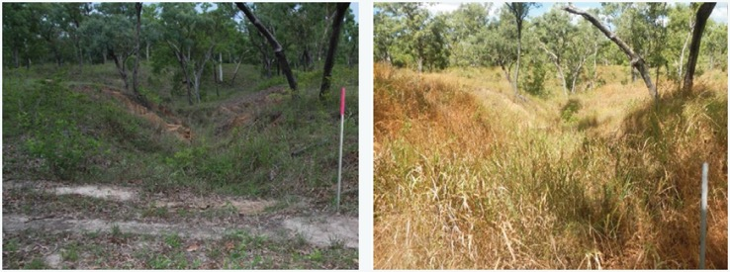

Figure 10. A gully in alluvial soil on Kings Plains in the upper Normanby (left) in 2010, and (right) in 2019 after 2 plus years of livestock exclusion

*Photographs by Jeff Shellberg*

#### Fencing to improve grazing management

As a part of planning erosion control, additional fencing and water points to support a change in grazing management may be required (Section 3.3 describes fencing gullies and stream banks). Considerations include:

* Where linear branching gullies are extensive across entire paddocks (for example, gully spacing of <500 m, such as occurs on red goldfields soils with many drainage lines or in plains country with dispersive soils), it may not be feasible to fence around all gullies. In this scenario, paddock subdivision fencing may be used for managing grazing within the gullied paddocks (for example, enable pasture spelling and lower forage utilisation rates).
* Paddock subdivision to improve forage management, such as to enable pasture spelling in areas draining to gullies (where they have been fenced separately), typically has a private benefit alongside a water quality benefit, and should have landholder co-investment.
* Regularly check additional fencing to ensure it is maintained in a stock-proof condition.

#### Managing water points

Water points are high stock traffic areas where soil is typically bare and compacted and large quantities of excrement accumulate (Figure 11). Generally, water points are connected to a network of stock tracks that convey overland flow rapidly across the land surface, which can accelerate gully and stream bank erosion if tracks converge on those features.

Manage water points by locating new livestock watering points in other parts of the landscape well away from gullies and stream banks. Moving or installing watering points can be a relatively expensive measure. A typical reason to fund a water point will be where new gully fencing prevents access to what was previously the only permanent water in the paddock. Otherwise, caution must be exercised in funding this activity for water quality, even on a co-investment basis, as adding watering points can result in an increase in grazing pressure and exacerbate land degradation and gully erosion. Additional water points can also attract more native grazing animals. Regular maintenance checks are required.

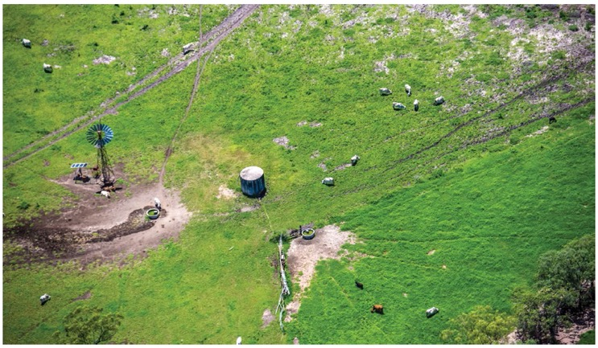

Figure 11. Water points are typically surrounded by bare soil and should be located well away from gullies and stream banks

*Photograph by Matt Curnock (supported by JCU, CSIRO, GBRMPA, NESP, NQ Dry Tropics, Queensland Government)*

### Fencing to control livestock access to gully sites

#### Objective

**Fencing is an essential component of all gully rehabilitation and stream bank rehabilitation projects (see Table 1). On its own, fencing serves to manage grazing and allow vegetation to recover, thereby increasing the stability of gullies.**

Gullies and scalded areas can often be preferred areas by cattle due to the slightly higher salt content of the soil in these features. Gullies require higher levels of vegetation biomass and control of livestock access than other areas of the landscape because:

* Gullies generally have steeper slopes than hillslope surfaces, reducing soil stability and increasing runoff energy.
* Soil around gullies may be weakened by being saturated more frequently and for longer than areas higher in the landscape.
* Gullies are exposed to much higher runoff volumes and shear stresses due to concentration of surface runoff from the hillslope area upslope.
* Many gullies have exposed dispersive or slaking sub-soils, which are less stable when exposed to rainfall and runoff.
* Bare ground often fringes the margins of gullies, and these areas, along with the bare ground between tussocks, is often covered with algal mats (known as cryptogamic crusts), which protect bare ground from rain splash impacts and are a primary coloniser facilitating grass growth (Figure 12). Stock hooves break these crusts, exposing the slaking soils to direct rain splash impacts.

The main objectives of fencing are to:

* control livestock access to erosion-prone areas
* enable complete livestock exclusion for several growing seasons following construction of erosion control works and associated revegetation, until vegetation is fully established
* prevent livestock access to gullies during the wet season, and limit to short periods of grazing during the dry season to manage fire risk or vegetation composition, once revegetation is completely established and effective. Fencing also enables the area in and around gullies to be managed with higher biomass levels than surrounding paddocks so it does not revert to its previously eroded state.

If gullies are contained within larger paddocks, the grazing pressure in gullies is frequently observed to be above sustainable levels. In contrast, once gullies are securely fenced, conscious decisions are required to graze these areas, so that higher biomass levels can be maintained. Revegetation without fencing or livestock management is an ineffective investment as livestock will eat new seedlings and new vegetation growth. In areas of permanent cropping, fencing around an erosion control site may be unnecessary.

**Note:** This treatment is a prerequisite supporting activity at all gully control sites where livestock are present, or likely to be present in the future.

Gully fencing has co-benefits for grazing land management by:

* excluding cattle from areas that are difficult to muster and that present an animal welfare risk
* assisting paddock subdivision, enabling better management of grazing pressure and allowing for wet season spelling to improve land condition
* demonstrating best practice management change.

If the areas of gully fencing are small relative to the surrounding paddocks, they can be largely excluded with little impact on overall property grazing management.

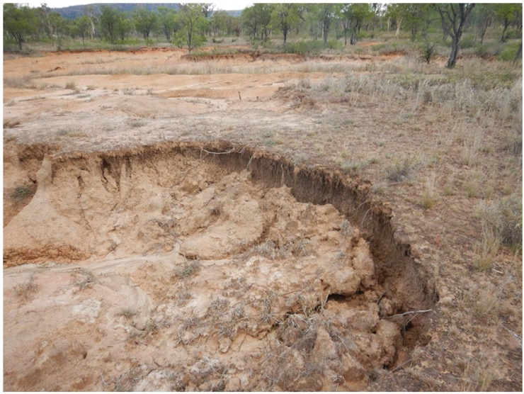

Figure 12. Bare ground around a gully headcut showing an extensive algal mat development (darker coloured areas) between the grass tussocks. Grazing pressure around the gullies will break up these crusts, accelerating erosion and preventing the establishment of grasses on the bare areas.

*Photograph by Andrew Brooks*

#### Location

When locating the fencing, there are several issues to consider:

* Do not include unnecessarily large areas that may increase the need to graze more frequently within the fenced area.
* Integrating gully fencing with stream bank/ riparian fencing is strongly recommended where gullies are connected to streams.
* Incorporate as many gullies as possible in relation to the length of the fence to be installed.
* Plan the fencing location with the support of the landholder, because they will be responsible for its use and maintenance in the long term.
* Avoid fencing in flood-prone areas or use alternative fencing designs where appropriate.
* Consider existing fences and associated gates in the design of new fencing.
* Agree the **grazing regime within the fenced area** with the landholder and specify this in the detailed design report (see Section 3.2.2).
* Clearly state the intended life of all new fences installed (whether project duration or permanent).
* Provide a new off-stream water point if fencing will remove livestock access to existing water points. Refer to the considerations listed in Section 3.2.4.
* Use at least a 20 m setback around the active gully head and side branches (more if possible) to allow for ongoing erosion and to encompass erosion-prone areas such as scalds. Ensure that the fence encloses all areas where other gully erosion control activities are undertaken.
* Where linear branching gullies are extensive across entire paddocks (for example, gully spacing of <500 m, such as occurs on red goldfields soils with many drainage lines or in plains country with dispersive soils), it may not be feasible to fence around all gullies. In this scenario, paddock subdivision fencing may be combined with forage management within the gullied paddocks (for example, enable wet season spelling and lower forage utilisation rates). In these circumstances, ensure that fencing has landholder co-investment.
* Livestock exclusion is not capable of controlling erosion of large alluvial gullies in erodible soil without additional soil and structural treatments (Brooks et al., 2016a, 2021; Doriean et al., 2021).

#### Design and construction

Factors to consider in implementation:

* The first and foremost consideration for fences around erosion control sites is that they are stock proof. Ensure these fences are of robust construction (that is, effective at excluding livestock) when forage biomass in and around the gully is much higher than in the paddock (for example, shorter panel widths with more droppers and additional strands of wire beyond a standard subdivision fence).
* Livestock access is prevented at the downstream end with a secure flood gate if the fence crosses a channel.
* Keep tree felling or disturbing ground vegetation to erect the fence to the absolute minimum required to access the site by vehicle and erect the fence. Where possible, low impact tree-to-tree fencing can be used to minimise disturbance (Figure 13). Do not undertake earthworks or disturb the ground vegetation cover other than as required to access the site. If the use of machinery is unavoidable, use a stick rake instead of a dozer blade.
* Complete fencing after any earthworks are completed, but before revegetation (either active or passive) around gullies or physically disturbed and deteriorated riparian areas.
* For sites where some grazing continues within the erosion control area (after an initial no-graze period and modified from historical patterns and by the new fencing), ensure that a documented agreement with the landholder includes specification of the grazing regime planned for the erosion control area. Grazing management ensures that vegetation condition is sufficient for erosion control, and is ideally specified as:
* low stocking rates (for example, consumption of approximately 10% of standing biomass) and always maintain a substantial forage biomass
* the timing of grazing (for example, dry season only).
* If the fenced area does not have a water point, consider including a spear gate to allow cattle to escape.
* If temporary electric fencing is proposed it must be:
* combined with reduced forage utilisation grazing management in the surrounding paddock (see Section 3.2)
* maintained regularly. Electric fencing units are available that provide back-to-base notification of fence breaches, which may reduce the surveillance burden to landholders.
* Where existing fencing and gates have resulted in stock tracks or cattle pads that lead to overland flow into gullies or streams, remediate those stock tracks by installing small diversion banks or otherwise as appropriate.
* Ensure that any clearing related to fence line construction complies with state government vegetation management regulations (see Table C1 in Appendix C).
* Achieving the objectives requires that grazing in the fenced area is carefully controlled, and this continues during the ongoing site monitoring (see Section 4).

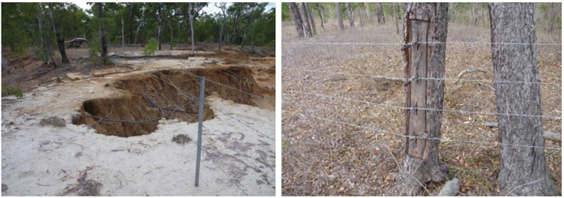

Figure 13. Left: Fences constructed too close to active gully heads will have a limited life. Right: An example of tree-to-tree fencing making use of live trees as strainer posts to minimise disturbance when establishing exclusion fences.

*Photographs by John Spencer*

#### Monitoring

Site monitoring after establishing the treatment is an essential part of a successful project. Section 4 gives a detailed description of the monitoring used during a funding program. Monitoring permits feedback to inform adaptation of the local design of similar treatments, as well as triggering repairs.

To help determine if the fencing is facilitating an increase in vegetation, monitor the ground cover and composition as described in Section 4.2.

### Porous check dams

#### Objectives

**Porous check dams (PCDs) are suited for revegetation of the floor of hillslope gullies where the catchment area is less than 6 ha and where sub-soils are not highly dispersive. PCDs can also be applied as a supporting activity to stabilise the gully floor level as a part of a bundle of treatments for hillslope and alluvial gullies as described in Sections 3.5 to 3.8.**

Typically gully floor sediment deposits have a very small proportion by weight of silt and clay particles (Bartley et al., 2007), leaving them too dry, unstable and nutrient poor to sustain much vegetation apart from weeds, which die off during droughts (Wilkinson et al., 2013). The main purpose of installing porous check dams (PCDs, sometimes called leaky weirs or silt trap weirs) is to stabilise the base level of the gully by slowing the flow and reducing the energy slope. PCDs can either achieve this objective by structural means alone, or by initiating the establishment and persistence of vegetation on the gully floor.

Revegetation can occur by enhancing the deposition of litter, fine sediment, nutrients and seeds on the upstream side, to improve soil condition in the base of gullies. In the long term, PCDs may assist the gully to partially fill with sediment but this is a supplementary outcome that will not occur in many cases. If PCDs do not trigger revegetation, then they can only store a finite volume of sediment. PCDs have been widely used in gully management both worldwide, and in Australia and have been trialled in the Great Barrier Reef (GBR) catchments (Day and Shepherd, 2019; Koci et al., 2021).

A practical guide to designing and installing PCDs is given in Day and Shepherd (2019; pp. 32-41). An introductory video is: Introduction to Check Dams: An Erosion Control Practice – RUVIVAL Toolbox – YouTube.

#### Location

PCDs can be located by following these general principles:

* Always use PCDs in combination with fencing to allow vegetation to become established in the gully.
* If the goal is to assist revegetation of the gully floor, ensure the catchment area above a PCD is no more than preferably 2 ha for shallow soils (for example, red goldfields, sodic and granite-derived soils), and no more than 6 ha in low relief landscapes with deep permeable soils (for example, dark cracking clay). Experience in GBR catchments shows that siting PCDs in larger catchment areas is likely to lead to failure to trap fine sediment, and to structural failure.
* PCDs have limited capacity to trap sediment and will therefore have a larger relative effect on the sediment yield of linear or branching hillslope gullies of modest depth (less than 3 m) and erosion rate (<1 m/year) where they are accompanied with improved grazing management in the gully catchment.
* PCDs are more effective in soils with an Emerson aggregate test (EAT) greater than class 2. They are less effective in fine-textured soils (for example, basaltic Vertosol), particularly dispersive soils (for example, Sodosol alluvium), because very fine sediment tends not to settle out. More solidly constructed check dams are required in these settings to reduce the risk of outflanking.
* PCDs work best when installed as a series along the gully length.
* Avoid locating PCDs in the steep section of gully immediately below gully headcuts where they will trap little sediment, unless they are for grade control protection of structures.
* Avoid placing PCDs in sections with steep gully walls, which are an indicator of ongoing gully widening that will result in flow going around the structure (outflanking).
* PCDs can also be placed on existing zones of sediment deposition to enhance the accumulation of sediment and encourage grass growth.
* Placing PCDs downstream of wide gully sections will increase the total sediment deposition.
* PCDs are best located on straight segments of gullies where flows are not likely to impact the sidewalls of the gullies and outflanking can be minimised.
* PCDs are not effective at stabilising headcut erosion because the energy of runoff over a headcut will typically overcome the resistance of gully floor vegetation, which PCDs aim to enhance.
* PCDs placed upstream of the gully head do not significantly slow headcut advance and will have an insignificant effect on the volume of runoff into the gully.
* PCDs are not typically required when gully floors are already vegetated.

PCDs can also be an important supporting activity within and downstream of alluvial gullies that have been reshaped to maintain stability of the gully floor level and prevent ongoing incision. Stabilising the gully floor level with PCDs is especially important in gullies subjected to increased runoff from the effect of diversion banks. The use of PCDs as a supporting activity does not provide additional erosion control effectiveness above that for the relevant primary activity.

#### Design

Design of PCDs should consider the following:

* Always fence gullies containing PCDs to avoid stock damage to the structures and vegetation in the base of the gully.
* Keep the PCD height to typically 0.4 m height and always <0.5 m, to reduce the risk of failure.
* In sodic soil consider reducing the PCD height and spacing to avoid outflanking (and combine with soil treatments and revegetation).
* For larger gully catchment areas and runoff volumes (assuming the gully slope is flat enough that PCDs will enable fine sediment deposition), the following are typically required:
* keying PCDs into the gully sidewalls and floor
* including energy dissipating aprons on the gully floor downstream of each PCD. These aprons are normally constructed on coarse rocks.
* Ensure the crest of the PCDs is approximately 0.1 m higher on the sides of the gully to divert higher flow velocities to the centre of the gully and away from the gully walls.
* When multiple PCDs are used in each gully (which is recommended), ensure they are spaced so that the base (toe) of each PCD is no higher than the crest of the next PCD downstream to prevent scour downstream of each check dam. Use a survey level to determine the correct spacing. For example, in a gully with bed slope of 0.02 (2%), check dams of 0.5 m height will be spaced closer than 25 m (slope = check dam height/max spacing; Figure 14).

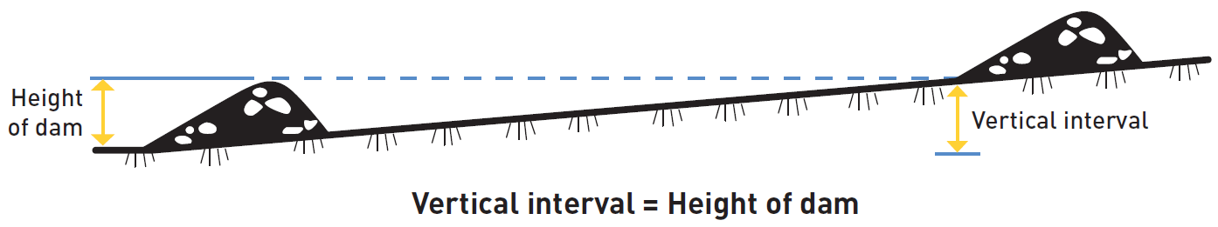

Figure 14. Porous check dam arrangement in longitudinal section.

Runoff is slowed such that some fine sediment and seeds are deposited upstream (to the right) of each check dam, improving the moisture and nutrient status. To prevent scour downstream of check dams ensure they are spaced so the crest of each check dam is at least as high as the base (toe) of the next one upstream.

*Reproduced from Berton (1989), cited in Critchley and Siegert (1991)*

#### Construction

PCD construction requires specialist skills including experience with locating, designing and constructing PCDs. In general:

* Soil tests are highly recommended before building PCDs, which assist in identifying whether gully wall and floor soils are slaking, dispersive or sodic. The EAT can identify soil dispersion and slaking levels. In more erodible soils, give greater attention to keying PCDs into the gully floor and walls to prevent structural failure.
* Especially at larger catchment areas and in erodible soils, ensure check dams are keyed into the gully floor and walls by approximately 0.5 m by digging a trench and then replacing and compacting the soil around the structure after construction. This may be unnecessary in wide gullies and more stable soils at small catchment areas, particularly if aprons are constructed on the upstream and downstream sides.
* Ensure the delivery partners or specialists set out and mark the PCD locations using levels.
* Avoid heavy machinery use as the risk of soil disturbance and further gully erosion increases as well as the introduction of weed seeds.
* Ensure construction materials are durable and leave only small gaps between adjacent elements. Select these materials to ensure long-term stability considering the catchment area. Options include:
* Especially at larger catchment areas and where maintaining gully floor level is critical, rock of graded sizes is the preferred material. Ensure rocks are large enough and angular to not be washed away in large runoff events (1:20 years or 1:50 years depending on the importance of maintaining bed stability considering other treatments). Ensure the rocks are of mixed sizes with minimal rocks smaller than 5 cm in diameter. An additional benefit of rock is that if a small amount of scour occurs under the structure, the rock will tend to settle down into the created hole rather than allowing a scour hole to develop. Timber structures can also be damaged by wildfire.
* Log structures tied to vertical posts inset and anchored into the base of the gully, which can be supported with rock at the base to prevent scour.
* Fallen timber or rock wrapped into bundles using wire mesh. Construction starts with laying the mesh across the base of the gully. The ends of the mesh are positioned so that the completed structure will be firmly against the gully wall with either end well above flow level. The fallen timber or rock is then piled in a sausage-like shape along the mesh. The mesh is then closed over the timber or rocks and secured with fencing wire. Finally, star pickets are driven through the centre of the barrier at approximately 2 m intervals, to anchor the check dam to the base of the gully.
* Ensure wire netting is durable. Conventional chicken wire can fail due to rusting after 4 years.
* Especially at catchment areas >2 ha, install a scour apron on the downstream side. Rocks or weed matting can be used as a scour apron and keyed into the bed sediment.
* Avoid weed matting barriers or sandbags used for temporary erosion control on construction sites as they are less durable and porous.
* Other examples are described in:
* Soil Conservation Guidelines for Queensland Chapter 13 (Carey et al., 2015c)
* Gully Erosion Part 2 (Catchments and Creeks Pty Ltd, 2010; https://www.catchmentsandcreeks.com.au/fact-sheets/M-waterways.html).

The significant manual labour component in constructing timber and wire PCDs in situ makes them less popular with some landholders than structures constructed with machinery, such as rock structures.

Section 4 gives a detailed description of site monitoring. Ensure monitoring points include the flow path downstream of the check dams to assess any scour impacts. Establish monitoring locations at PCD locations to record the vegetation cover and composition immediately upstream of PCDs as measure of success.

#### Examples of porous check dams

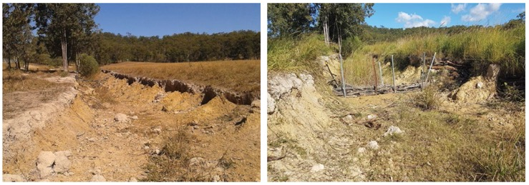

Figure 15. Left: A rapidly eroding gully in the Mary River catchment in August 2017, with an exposed gully bed and banks and degraded vegetation adjacent to the gully as a result of grazing (looking upstream). Right: The same view in June 2018, 10 months after the installation of fencing, excluding grazing from the site and a series of porous check dams, constructed of steel mesh and posts with cuttings of local timber.

Silt has deposited and *Setaria*(clumping grass, exotic) is growing upstream of the porous check dam, while African stargrass (Cynodon aethiopicus, an exotic stoloniferous grass) is in the foreground. The gully has a 6-ha catchment and small scour holes occurred around the structure. A further 9 porous check dams were installed upstream of the one shown.

*Photographs from the Mary River Catchment Coordinating Committee*

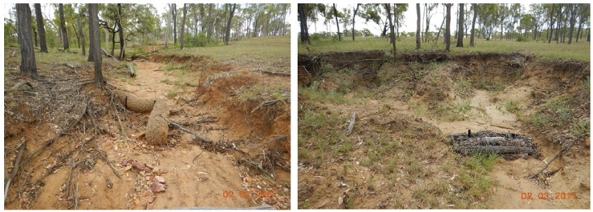

Figure 16. An illustration of known failure mechanisms for porous check dams.

In these cases, the failures were attributed to the catchment areas being too large given the high rainfall and shallow soil. In addition, the coir log check dam was not adequately secured, and the material has poor durability (left). The ends of the timber and wire check dam were either not keyed into the bank or wrapped up the bank to above the flow level (right).

*Photographs by Greening Australia*

### Gully runoff diversion banks and drainage management

#### Objectives

The aim of runoff diversion banks is to divert runoff water away from gully heads and into natural waterways or stable areas that are not susceptible to erosion (Geyik, 1986). Roads, tracks and other compacted areas of soil are known to produce high levels of runoff, and carefully designed drainage of these surfaces can help reduce concentrated flow reaching existing gullies and minimise the chance of new gullies forming. However, there is a risk of starting a new gully where the water is diverted, so the placement and construction of these features needs expert support. Where maintenance of road drainage provides a private benefit, ensure there is co-investment from the landholder.

Typically, road drainage causes gully erosion due to either poor design or poor land condition. Reducing grazing pressure is an important complementary activity to reduce erosion risk.

#### Location

Consider the following when deciding whether diversion banks and drainage management are suitable for a location:

* Diversion banks can be particularly useful where an existing linear feature such as a road or track is concentrating hillslope runoff into a gully head.
* Only consider diversion banks if there is somewhere for the flow to be diverted that will have a low risk of initiating a new gully elsewhere or accelerating an existing gully. Broad ridges adjacent to eroded drainage lines and gullies are ideal for safely spreading diverted runoff water from small catchments.
* The practical limit for the runoff diversion catchment area is about 20 ha.
* Road drainage is unlikely to be cost-effective except where runoff into active gullies is dominated by road drainage.
* Road drainage is more likely to be important in steeper areas with erodible soils.
* Ripping along the contours can temporarily reduce the volume of runoff generated from a catchment to support a comprehensive revegetation effort. However, this activity is costly and has environmental risks and is not generally encouraged. Confine ripping to small, degraded areas of catchment draining into a gully treated with other treatments. Avoid areas:
* within 20 m of gullies
* with slaking or dispersive sub-soils, or self-mulching soils (that is, most active gully sites)
* require tree removal.
* There is a risk that the use of heavy machinery may damage catchment vegetation.
* Water diversion structures require long-term maintenance including cleaning drains and water-spreading structures, otherwise they can cause gully erosion (Nichols et al., 2018), and several GBR projects have been working to repair such erosion from old dams, ponded pastures and contour banks.

#### Design and construction

Soil testing is recommended prior to undertaking any earthworks. Design and construction should also include the following elements:

##### Diversion banks

* Calculate the peak runoff expected and design diversion banks for a one in 50-year runoff event to minimise the risk of diversion bank failure and consequential erosion. Section 3.6.3 lists some relevant methods.
* Ensure the cross-section of diversion banks is sufficiently wide and with batter slopes not exceeding 1:2 to reduce the risk of piping erosion.
* Do not install diversion banks where the gradients are greater than one-tenth of the land slope on which the bank is located (and do not exceed a 5% gradient).
* Locate diversion banks onsite using survey techniques. Ensure the grade along the channel is free draining without low points.
* To avoid piping erosion, grub out and remove vegetation from the foundation area, and compact fill well during bank construction.
* Construct water-spreading ponds with a level sill at diversion bank outlets to reduce the energy of diverted runoff water.
* Stockpile and replace topsoil over the channel to increase the chances of grass establishment. This is critical to avoid new erosion problems, especially if dispersive erodible soils are exposed. Diversion banks are designed as grass channels, therefore establishing and maintaining a vigorous grass cover is essential.
* Include diversion banks or detention structures, together with their runoff discharge areas, inside the gully fencing or otherwise manage these areas at high biomass to maximise water infiltration.
* Ensure maintenance includes identifying and filling cracks or slumps to prevent concentrated overflow and cleaning out water-spreading ponds, if necessary.

##### Road drainage

* Road drainage takes several forms including cross drains (also locally called speed bumps or "whoa boys") and culvert pipes (less common in grazing areas).
* Constructing drainage along roads reduces the risk of erosion by overland runoff from roads. Local councils may have locally applicable guidelines. The specific drain spacing will depend on local factors. A rule of thumb measure is every 50 m for slopes <3% and every 25 m for slopes >3%.
* Flat drains (rather than 'v' drains) are more likely to reduce the velocity of water flow, to carry a greater body of water at lower risk of erosion, and they are easier to install and maintain.
* Ensure drain slopes are <0.3%. Drains with slopes >0.5% will have greater potential to erode.
* Maintenance includes cleaning out deposition basins.

##### Contour ripping

* Combine ripping with livestock exclusion for at least 2 years until revegetation has established. Manage subsequent grazing to ensure high biomass levels.

Consult other comprehensive and practical references on designing and constructing these structures, including the Soil Conservation Guidelines for Queensland (Carey et al., 2015c), and Gully Erosion: Options for Prevention and Rehabilitation (Day and Shepherd, 2019).

#### Case studies

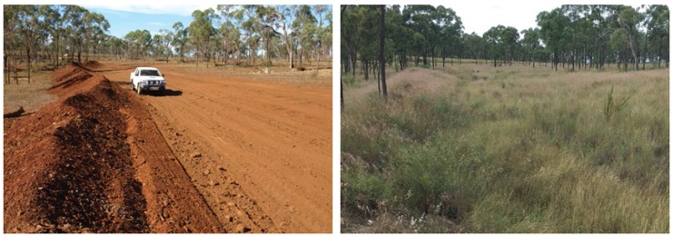

Figure 17. Diversion bank built to divert an 8 ha catchment away from a large gully, which was reshaped and revegetated in the upper Burdekin catchment.

Left: Newly constructed diversion bank with topsoil (light brown soil) replaced across the channel area in May 2016. Right: Same location in April 2019. Livestock were excluded from the area for 3 years to assist revegetation.

*Photographs by Bob Shepherd*

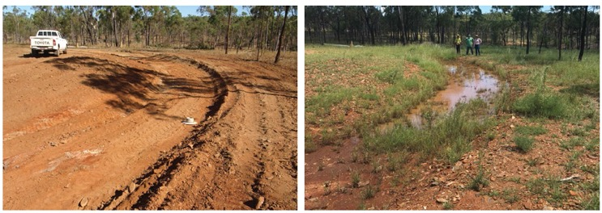

Figure 18. Water-spreading structure on a ridge, at the outlet end of the diversion bank shown in the previous figure.

Left: May 2016 after construction. Right: March 2017. Topsoil was spread over the structure after construction to assist revegetation.

*Photographs by Bob Shepherd*

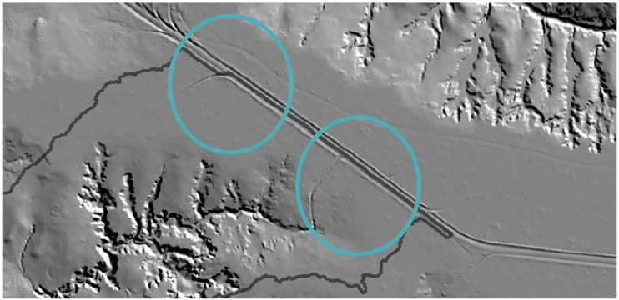

Figure 19. Example of road drainage delivering into an alluvial gully (right circle; although road drainage was not the primary cause of the gully).

Road drains further from the gully have to date not resulted in a connecting channel (left circle)

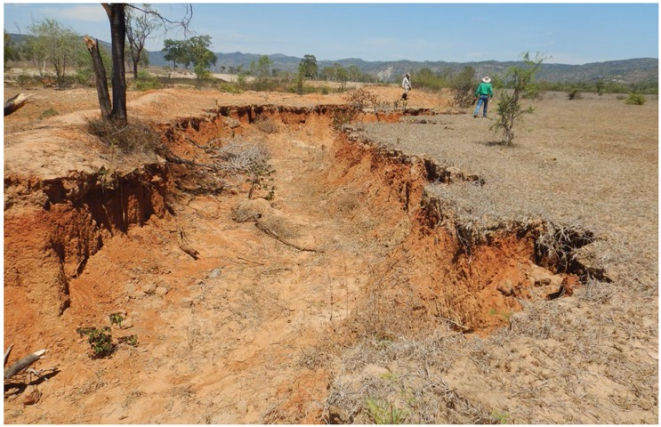

Figure 20. Example of a poorly situated or maintained contour diversion bank (to the left of and behind the tree) that has initiated a new gully at the exit point from the diversion bank

*Photograph by Andrew Brooks*

### Gully head rock chutes

#### Objective

Gully head rock chutes are high-cost structures that may be suitable for gullies with rapidly advancing heads.

A rock chute is a rock ramp designed by an engineer or qualified specialist used to prevent the continued upslope movement of a gully headcut, or a secondary deeper incision within a degraded area (Figure 21). Rock chutes are preferred over solid concrete drop structures, which are more expensive and are more likely to fail by scour from downstream or tunnelling upslope.

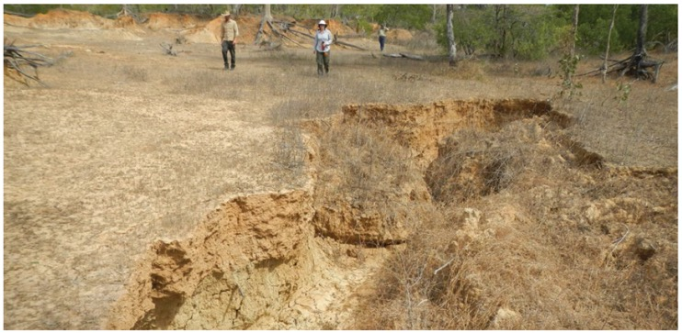

Figure 21. A secondary incisional phase progressing up along the floor of an existing alluvial gully, at rates of metres per year.

This is the sort of site where a rock chute is cost-effective. The primary gully headwall can be seen in the background.

*Photograph by Andrew Brooks*

#### Location

Due to the cost of construction, rock chutes are more cost-effective when used to stabilise gully heads that are very active (for example, at least tens of centimetres and often metres of headcut erosion per year). The larger the contributing catchment area above active gully heads, the larger the future benefit from halting gully headcut erosion with a rock chute. In some areas of deeper soil gully heads may represent a secondary incisional phase into the floor of an existing gully feature, which generates high rates of runoff (Figure 21).

Rock chutes are used where reshaping and revegetating a gully headcut into a grass chute is insufficient to stabilise erosion due to the large runoff volume, or where a variable climate reduces vegetation erosion resistance, and/or where dispersive and low-fertility soils are exposed that make revegetation difficult. In mature gullies, where the headcut is near the gully catchment boundary, it is likely that the runoff volume is smaller and the headcut erosion rate is slower. In such situations rock chutes typically have poor cost-effectiveness.

Rock chutes are sometimes used as a supporting activity to safely deliver water from diversion banks into an existing gully floor or stream channel.

#### Design

It is critical that rock chutes are designed using a standard and recognised procedure. It is cheaper to build rock chutes right the first time than to repair them (based on experience from many failed structures). Common causes of rock chute failure include outflanking or scouring around rock chutes by surface runoff, or tunnelling and scouring of under-sized rock from the face of the structure, or the side batter slopes in large events.

Rock chute design involves determining the design rock size, which must be large enough to be stable during a design peak runoff, and this can be an iterative process of adjusting the rock chute width and length. The design peak runoff is preferably of a 50-year annual recurrence interval (ARI). Please note the requirement for Registered Professional Engineer Queensland (RPEQ) registration for engineering projects where there is a risk to public safety as described in Section 2.4. The following are some of the procedures that have been used to design rock chutes in Queensland (refer to the reference list):

Design peak runoff estimation:

* Australian Rainfall and Runoff: A Guide to Flood Estimation (Ball et al., 2019)
* The Rational Method: Queensland Soil Conservation Guidelines Chapter 4 (Carey et al., 2015a).
* Grid-based two-dimensional hydrologic models, especially in the case of complex catchments such as those containing large embankments or storages. When calculating design peak runoff, dams within a catchment will generally be assumed to be full prior to the event, unless dam storage volume is large relative to the design event volume.

Design rock size:

* CHUTE manual and tool (https://toolkit.ewater.org.au/Tools/CHUTE; Keller et al., 2003)
* Queensland Soil Conservation Guidelines Chapter 13 (Carey et al., 2015c)
* Rock sizing for waterways factsheet version 4 (Catchments and Creeks Pty. Ltd., 2020).

A trained specialist must assess the need for soil amelioration and geotextile under the rock as gullies are frequently associated with slaking and dispersive soils. This typically includes laboratory analysis of soil chemistry, which requires careful sampling design as described in Section 2.4.

Protect the interface between rock armouring and the foundation and/or geotextile with filter material, such as 25-mm screenings.

Gabion baskets or rock-filled wire mattresses can enable use of rock of smaller sizes. However, do not use these in situations where high sediment loads are expected from upstream, which can remove the wire protective coating and result in rusting and failure of the structure. Concrete mats are another possible solution, which are concrete blocks wired together; however, regard the use of these in dispersive soil as experimental, with more intensive monitoring and accounting for higher risk of failure when estimating effectiveness.

The use of heavy machinery in construction will result in disturbance of the gully and its immediate surrounds, thus introducing new erosion risks. Therefore, a revegetation plan for the surrounding area is required as part of the design and is included in the detailed design report. This includes fencing to control livestock access and active revegetation, and a variety of grasses and woody vegetation.

Where runoff enters the gully at multiple locations, rock chutes are frequently supported by runoff diversion banks to direct runoff across the slope to the chute crest and prevent erosion of other parts of the gully that may then bypass the chute.

In rare circumstances, an alternative to a rock chute is a gully head dam. Gully head dams are not standard practice because they are less stable than a rock chute and are more expensive, since an engineered dam bywash is usually required, which resembles a rock chute. There are substantial risks that the gully head will continue to erode upstream of the dam, or that the dam bywash will breach the dam or widen the gully downstream, especially in erodible soil (Carey et al., 2015c). Failure of the dam wall is a risk in erodible soil. Therefore, gully head dams must be well-engineered and constructed on the basis of quantitative estimates of peak runoff volume for a design event of 50-year ARI or greater. Fence gully head dams and pump the water to water point(s) higher in the landscape. Only consider a gully head dam if landholder co-investment makes that a much more cost-effective alternative than a gully head rock chute.

##### Design elements:

To help ensure that rock chutes are well‑designed, include the following elements in the detailed design for a rock chute:

1. Design peak runoff:
2. state the design reference documents and method
3. catchment area; use a Lidar DEM where it is available; consult Geoscience Australia via http://elevation.fsdf.org.au/, and/or the Queensland Spatial Catalogue (The State of Queensland, 2021; https://qldspatial.information.qld.gov.au)
4. peak runoff recurrence interval selected (years)
5. associated design peak rainfall intensity, including time of concentration and source
6. associated runoff coefficient
7. resulting peak runoff volume rate estimate.
8. Rock material design:
9. state the method used to calculate the minimum D50 (middle length, i.e. B‑axis, of the median rock size) that can resist scour for the design peak runoff and given chute dimensions
10. required rock properties include: (i) rock specific gravity, (ii) strength, (iii) angularity, and (iv) size gradation (degree of sorting) as D100 and D20 (m) or D90/D50 ratio = 1.8, and so on
11. factor of safety achieved with the size and specific gravity of the rock.
12. Description and justification of the configuration, including:
13. soil properties
14. use of geofabric or not, and why; one function is to control the risk of tunnel erosion under the structure
15. use of soil amelioration or not, and why
16. use or not of abutments or contour banks to direct flow over the chute crest, and why.
17. Dimensions and diagrams of the rock chute including plan view, long section elevation, and cross‑section elevations, including the upstream crest and the downstream apron.
18. Estimated rock quantity.

#### Construction

Engineered grade control structures can take months to design, plan and implement, particularly if regulatory approvals are required. The skill and experience of contractors building rock chutes also influences the work quality and cost.

Points to consider for rock chute construction include:

1. Establish the requirement for state and local government approvals (as summarised in Table C1 in Appendix C).
2. Inspect the rock material to ensure its suitability and consistency with the specified median diameter (D50) and size mix ahead of committing to construction.
3. Ensure the design is set out at the site ahead of construction so the planform and elevations are consistent with the design; construction expertise and supervision experience is important at this step.
4. Ensure the construction is overseen by the technical specialists who designed the structure or by experienced site supervisors able to check any required adjustments with the designer. This includes inspecting the dimensions and completeness at defined stages, such as completion of the foundations and placement of geotextile.
5. Minimise the area disturbed by heavy machinery and thoroughly revegetate the disturbed, and follow other aspects of best practices (for example IECA, 2022; Department of Transport and Main Roads, 2022).

Section 4 gives a detailed description of site monitoring. Include the flow path downstream of the rock chute as monitoring points to assess any scour impacts. Ensure monitoring includes the intactness of the structure, including evidence of surrounding tunnel erosion and the surrounding vegetation condition.

#### Case study

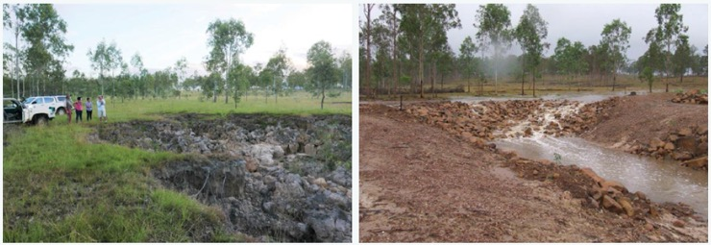

Figure 22. A rock chute installation in the Mary catchment.

Left: Before construction in April 2016. The gully had an extensive catchment area, and the gully head was advancing across a small floodplain with highly dispersive sub-soil. Right: After the first major rainfall event in March 2019 (note the same clump of trees on the left of both images). The first runoff event had a 2-year flow recurrence interval, following 126 mm of rain over 3 days including 83 mm within a few hours. Total cost of the rock chute was $55,000, plus the land manager provided approximately $100,000 in-kind contribution primarily in the cartage of rock material from a quarry on the property. The estimated direct cost per tonne of sediment saved was $340/t/year fine sediment reduction at the river mouth, or $1,153/t/year including the in-kind costs.

*Photographs by Scott Wilkinson (left) and Owen Thompson (right)*

### Gully reshaping and revegetation

#### Objectives

**Gully reshaping and revegetation is a high-cost rehabilitation option that may be suitable for rapidly growing gullies in highly dispersive soils, where livestock access can be effectively controlled.**

Some alluvial gullies and hillslope gullies erode rapidly due to their unstable soils and absence of significant vegetation. Figure 23 shows an example where rain splash has eroded a location on the gully bed over a single wet season. These gullies are resistant to natural regeneration of vegetation due to poor soil structure and fertility. The objective is to change the gully into a stable landform where runoff is diffuse and at low velocity. This is achieved by reshaping earthworks, soil amelioration, and covering the soil with mulch and/or crushed rock, so that it is suitable for the growing of vegetation and not subject to rain splash. The objective for this treatment is shared with gully reshaping and rock capping, and large alluvial gully erosion control projects may involve areas of both (see Telfer, 2021).

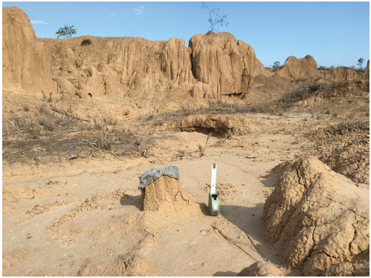

Figure 23. An erosion plate showing around 80 mm of surface erosion from a single (below average) wet season in the Burdekin catchment

*Photograph by James Daley*

#### Location

Reshaping and surface stabilisation is the only viable option to effectively treat most active alluvial gullies, particularly those in dispersive or slaking soil materials of poor fertility that will not recover through natural regeneration, even when cattle and other disturbance factors are permanently removed.

Some hillslope gullies can also be reshaped, even in part, to enable more complete revegetation.

Experience in recent projects shows that this high-cost approach has reasonable cost-effectiveness where the baseline sediment yield is also high. To assess whether a new site is one of these instances, a careful and detailed assessment of existing erosion rates and a detailed costing is required. Cost on a unit area basis can range from $10,000 to 30,000/ha depending on gully depth, making this potentially cost-effective for gullies with fine sediment yields >20 t/ha/year and ideally much larger, and for those that cannot be treated using more passive approaches.

Revegetation surface treatments are typically lower cost than rock capping, and in that case can be applied to gullies with relatively lower erosion rates for the same cost-effectiveness. However, the cost differential is dependent on the proximity to sources of the soil amendments relative to rock capping material and can be reversed in some situations.

Revegetation surface treatment typically provides less erosion resistance than rock capping and so is suited to sites with lower batter slopes and lengths. Refer also to Section 3.8.2 to assist the decision-making about which of these treatments is more suited to controlling erosion at an identified site.

#### Design

Gully reshaping must be implemented only in combination with other gully erosion control activities: "In regions with heavy rains, filling, shaping and diversions alone will not suffice to control gullies. Additional gully control and slope stabilisation measures, such as capping, check dams and revegetation should be undertaken" (Geyik, 1986). Therefore, gully reshaping is usually supported by control of livestock access by fencing, and often also by diversion banks, rock chutes and/or rock check dams in the gully floor.

Reshaping may only be required on part of a large gully, with other treatments being more cost-effective in parts such as further away from the gully head or where the gully is less deep, or the soil is more stable.

Given this treatment is targeted to gullies in dispersive or slaking soil materials, the constructed slopes of most reshaped gullies will require chemical treatment with either gypsum or lime (depending on pH) to neutralise soil sodicity, and so develop a stable surface capable of supporting revegetation. Organic soil ameliorants can also assist revegetation. Determine the dispersibility and chemical nature of the sub-surface soil materials by representative sampling and laboratory analysis for exchangeable sodium percentage (ESP), the exchangeable magnesium percentage, Ca:Mg ratio, pH and cation exchange capacity (CEC; see also Sections 2.2.3 and 2.4). Ensure a suitably qualified professional[1] does the soil analysis and sets the application rates for gypsum or lime, especially for large projects. Reshaping sodic soils without neutralising sodicity and re-establishing a stable surface soil and vegetation cover increases erosion rates above the rates of untreated gullies (Shellberg and Brooks 2013; Brooks et al., 2016a, 2016b; Telfer, 2021).

The soil materials should also be analysed to determine the average particle size distribution (sand, silt and clay content) so as to estimate the baseline sediment yield.

Tunnel erosion occurs through excessive sub-surface water movement in dispersive and highly slaking soils. In soils prone to tunnelling, the risk of future tunnelling is only reduced by all incipient tunnels being excavated to their maximum depth and extent, until all evidence of the tunnel erosion is removed. Treat the resultant cut-and-fill landform with gypsum or lime to neutralise dispersibility/slaking. Compact filled material using standard civil construction wet compaction methods. Avoid dry compaction in cohesive soils.

Select the surface treatment considering the scale of the gully, and the resultant slope lengths and gradients. Using mulch and irrigation to support revegetation ahead of the first wet season rains can reduce the risk of failure in the initial wet season. However, mulching on its own is the least robust surface cover option, and is prone to local rilling, especially on long batter slopes. Mulch will also be washed away if the site is subject to backwater flooding. More robust surface protection is required on longer and steeper batter slopes, such as intermediate slope check dams to reduce effective slope length. Managing drainage of the contributing catchment area is also critical for the stability of the reshaped surface.

Other design considerations include:

* Seeding directly with rapidly growing grasses is a cheaper alternative than planting.
* Seek local professional advice for active revegetation techniques and species.
* Perennial tussock grasses with large basal area and root mass are preferred where available, because they assist rainfall penetration and provide litter. Creeping stoloniferous grasses can be used to provide total cover within gully channels.
* Woody shrubs and trees are important for maintaining soil water and nutrient balance and generating litter, which provides protection against rain splash and creates micro dams to slow runoff. Consider including native local shrubs, which provide the added benefit of excluding stock and trapping organic matter beneath their dense canopy.
* Mobbing of cattle in a gully to bring nutrients and organic matter and churn the soil surface has been demonstrated to support revegetation of one very small gully on black cracking clay soil. However, it is unlikely to be effective in sodic soil or in deep gullies. It is unlikely to be effective on actively eroding surfaces, due to the propensity of cattle to form pads and to break up cryptogamic crusts.
* A polymer soil binder was found to assist revegetation of very sodic soil at a site in the Normanby River catchment and could be trialled elsewhere.
* Weed control, such as by mulching or weed mats, can be important to allow planted vegetation to establish.
* Avoid surface ploughing near gullies because of the exposure of erodible soils to further erosion.

##### Supporting treatments

The reshaped area will be more steeply sloping than the residual surface upslope of the gully, and hence more vulnerable to erosion. To maintain the integrity of the reshaped area do not use it for routine grazing. Permanent and secure fencing for ongoing control of livestock access is required. Manage grazing conservatively, as described in Section 3.3. Cattle can form pads in a very short period of time (days), and such pads are all that are required to initiate new gullying once rains commence.

Defining the catchment area draining into the active gully scarp and the flow pathways is critical for determining whether the upslope flow must be safely diverted or delivered through the reshaped gully using a rock chute. Catchment areas can be difficult to determine where the upslope areas are very flat, and monitoring runoff patterns during the initial wet seasons may be required, particularly if diversion banks are not installed.

Due to the large catchment areas draining from reshaped gullies, rock PCDs are often required to slow runoff on the floor of reshaped gullies (Figure 24). Increase the PCD's length and width as the catchment area increases.

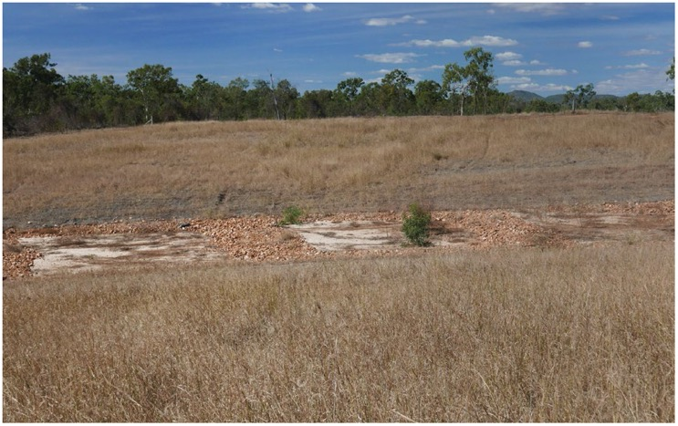

Figure 24. Rock check dams used to prevent incision of the bed of a wide reshaped gully

*Photograph by Scott Wilkinson*

#### Construction

When planning a gully reshaping project address the following considerations, in addition to those listed in Sections 2.3 and 2.4:

* access to suitable materials to the site (gypsum rock of specified size, mulch, grass seed, and so on)
* approval requirements (for example, vegetation clearance regulations and working on waterways)
* all topsoil (no matter how little is present) must be stripped, stockpiled and replaced to maximise pasture growth, or leave patches with topsoil undisturbed
* technical supervision of construction, including excavation of tunnel erosion
* compaction of soil in areas of fill should be done in layers and using appropriate levels of moisture (wet compaction).

Section 4 describes procedures for site monitoring. Ensure monitoring includes the flow path within and downstream of the reshaped area, any check dams installed, the intactness of the batter slopes, evidence of surrounding tunnel erosion, and the surrounding vegetation condition.

#### Case study

Figure 25 provides an example of an alluvial gully after it was reshaped but without ameliorating the soil or revegetating the surface. Elsewhere, this approach was found to increase erosion rates above pre-treatment levels (Shellberg and Brooks, 2013; Brooks et al. 2016a; 2016b).

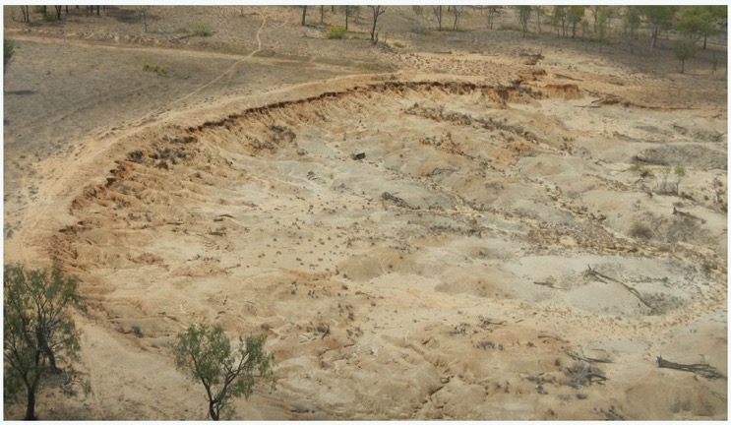

Figure 25. An alluvial gully that was reshaped but without soil amelioration or revegetation being applied.

A berm was built around the upslope edge of the gully in the belief that overland flow was driving the erosion process, but the rain falling directly on the gully surface resulted in ongoing erosion (Daley et al., 2021b). The berm is being undercut by rainfall dispersing the exposed sub-soils.

*Photograph by Andrew Brooks*

The reshaping and revegetation aspects of the case studies in Section 3.8.5 are also relevant here.

### Gully reshaping and rock capping

#### Objectives

**Gully reshaping and rock capping is a high-cost rehabilitation option that may be suitable for rapidly growing gullies in highly dispersive soils, where livestock access cannot be effectively controlled.**

The objective of this treatment is to change the gully into a stable landform where runoff is diffuse and at low velocity. This is achieved by reshaping earthworks, soil amelioration, and covering the soil with crushed rock so that it is not subject to rain splash. Depending on the specification of the rock capping, revegetation of the capped surface may also be possible, with the capping helping to protect the surface from rill erosion or gully re-incision.

The objective for this treatment is shared with gully reshaping and revegetation, and large alluvial gully erosion control projects may involve areas of both (see Telfer, 2021).

#### Location

Use reshaping and rock capping at sites with very erodible soils, especially sites that will be exposed to ongoing grazing pressure where revegetation may not be sustainable into the long term. Large alluvial gullies are more likely to be suitable for this approach. This treatment is known to be effective for gullies that are inundated by back-watering from the adjacent creek or river, where surface mulch and revegetation may be damaged (see Brooks et al., 2021). Site access, proximity to a suitable rock source, and ability to spread the substantial equipment mobilising costs across a large gully area or multiple closely spaced sites, will heavily influence the cost. Reshaping and rock capping is visually striking and may be regarded as aesthetically undesirable for some locations.

#### Design

Planning a gully reshaping and rock capping project involves the same considerations as for reshaping and revegetation, as listed in Section 3.7.3.

In addition, determine if the size and thickness of the rock material is sufficient to provide stability, considering the batter slope lengths and gradients, the rock density and size mixture, and the properties of the underlying soil material. Geofabric may be required underneath the rock capping, particularly at the gully headcut, other areas of concentrated flow, or where sandy soil units are encountered.

The reshaped area will be more steeply sloping than the residual surface upslope of the gully, and hence more vulnerable to erosion. To maintain the integrity of the reshaped area, do not use this area for routine grazing. Secure fencing for ongoing control of livestock access is required.

#### Construction

The considerations for gully reshaping and rock capping include those for reshaping and revegetation (Section 3.7.4). Where there is evidence of pipe or tunnel erosion, excavate tunnels to their maximum depth and back upslope until all evidence of the tunnel erosion is removed. Depending on the sodicity and associated dispersibility of the sub-surface soil materials, the resultant slopes of most reshaped gullies will require chemical treatment with either gypsum or lime (depending on pH) to stabilise soil sodicity, and so develop a stable surface. Reshaping sodic soils without stabilising sodicity and re-establishing a stable surface increases erosion rates above the rates of untreated gullies (Shellberg and Brooks 2013; Brooks et al., 2016a, 2016b).

It may be appropriate to de-build access tracks, established specifically to provide access for heavy machinery (for example, dozers, water trucks, scrapers), following construction. It would be prudent to retain access for smaller machinery (for example, 5T excavator) to facilitate routine maintenance.

Suitably qualified specialists able to advise on gully reshaping and capping projects include those with professional training in the field of geomorphology and/or soil conservation, and/or those certified by one of the professional bodies listed in Section 2.2.1.

#### Case studies

**Case study:** Normanby gully reshaping

This gully in the Normanby River catchment had area of 0.3 ha, with a catchment area of 14 ha. The soil is highly dispersible and very sodic alluvium, with poor fertility. It was reshaped and rock capped in 2016 including the incorporation of gypsum, placement of geofabric, and check dams on the gully floor.

The capping material was obtained from a quarry on the property. Advantages of rock capping rather than revegetation for this site include stabilising the very erodible soil, and due to the difficulties in controlling livestock access to this heavily treed near-riparian location. Site monitoring has indicated that the effectiveness of the erosion control reached approximately 0.8 after 3 years (Doriean et al., 2021). Prior to treatment, 80% of the sediment yield at the gully outlet was sourced from the 0.3 ha of active gully, and 20% from the 13.6 ha of gully catchment. After rehabilitation, all sediment was sourced from the gully catchment, indicating that the sediment sourced from the active gully was close to zero at this time.

The remediation was funded by the Reef Trust Phase II program and undertaken by Cape York NRM. A time-lapse of construction is available at https://www.youtube.com/watch?v=dCbV1BggnKI. Figure 26 illustrates the remediation outcomes 5 years after construction.

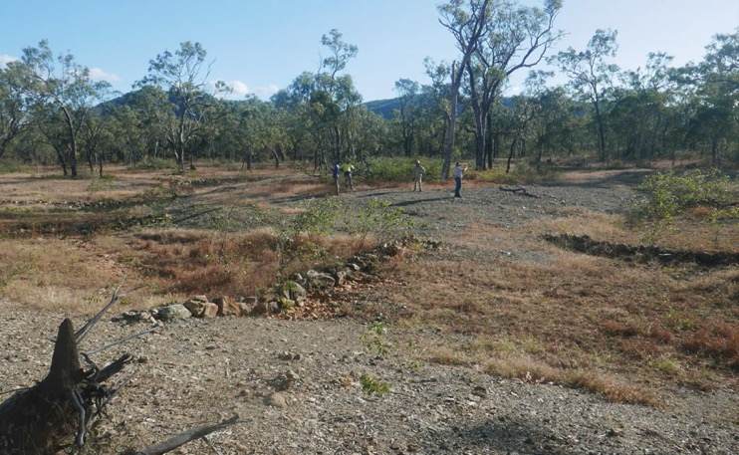

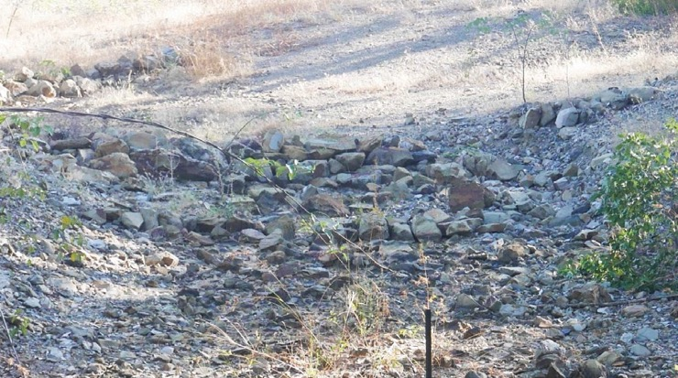

Figure 26: This gully in the Normanby River catchment was reshaped and capped with rock in 2016.

The top photo in June 2021 is looking upstream towards the two arms of the gully, which converge at the bottom right of the image. The grass on the gully floor has grown in fine sediment deposited between the check dams. Rubber vine *(Cryptostegia grandiflora)* is also becoming established. The rock capping remains stable 5 years after construction. One exception is minor scouring where the most downstream check dam has breached (bottom photo, right of image). This check dam requires rebuilding with larger rock keyed into the rock capping at the sides and base (planned). Other ongoing maintenance could include controlling the rubber vine to prevent it from excluding other vegetation and controlling livestock access to enable revegetation in and around the reshaped area.

*Photographs by Scott Wilkinson*

**Case study:** Gully 13

Several approaches to rehabilitating large alluvial gullies have been trialled at Strathalbyn Station in the lower Burdekin River catchment. The treatments and monitoring results are thoroughly described in Telfer (2021) and Brooks et al. (2021). The objective of the remediation was to halt the expansion of the gullies and stabilise them. The earthworks, surface treatments and revegetation were tailored to the soil type, erosion processes and gully dimensions, and to the materials available nearby. Gully 13 was in sodic and dispersive Sodosol soil, with an area of 8 ha and a baseline sediment yield to the GBR lagoon estimated at approximately 1,053 tonnes per year of sub-20 pm sediment. The reshaping and revegetation project was planned with a cost-effectiveness of $959 per t/y of sediment reduction. A layer of rock capping prevented rill erosion on the batter slopes, which were up to 1:6 gradient and 30-90 m in length.

The Great Barrier Reef Foundation and the Queensland Government Office of the Great Barrier Reef funded the project under a grant managed by Greening Australia. Design and implementation were by Fruition Environmental and Rock-it Science Pty Ltd. A timeseries of photos over 3 years illustrates the remediation process and initial revegetation (Figure 27).

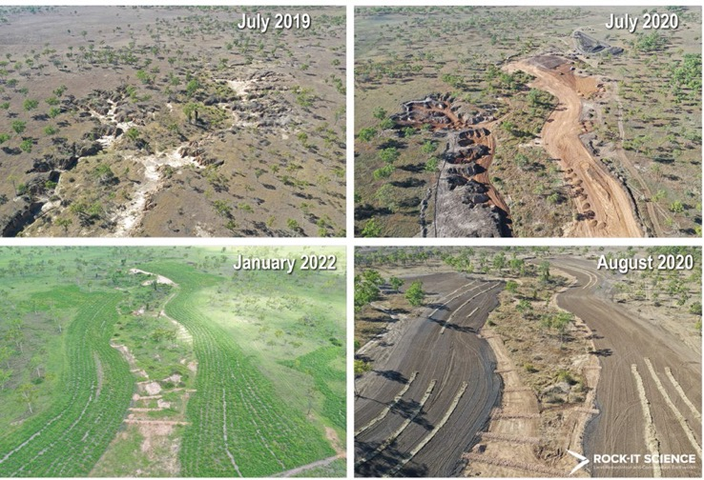

Figure 27. Timeline of Gully 13 remediation in the lower Burdekin catchment, clockwise from top left.

A: July 2019: The scarp height varied from 2 m up to more than 4 metres. B: July 2020: Topsoil was removed and stockpiled (on the left and right edges of the earthworks area). Tunnel erosion was excavated (left of photo). The gully landform was reshaped with GPS machine guidance using similar amounts of cut-and-fill earthworks (right of photo). Compaction on the areas of fill was done at optimum moisture levels. A stockpile of composted bagasse is visible in the top right corner. C: August 2020: The finished landform surface had gypsum incorporated to a depth of 200 mm, followed by capping with crushed gravel sourced from an on-property quarry. The capping was top-dressed with 100 mm of fertile Vertosol soil sourced from an on-property borrow pit above a ponded pasture area (tested for suitability) and then covered with a blanket of composted bagasse. High rates of a grass and legume seed mixture were applied using an air seeder mounted on power harrows, which mixed the seed into the soil and bagasse layers to assist germination and survival. Hay bale bunds were installed on the contour to disperse runoff where batter slopes were considered long or where runoff concentration was likely. Most of the gully floor vegetation was retained. Porous rock check dams were installed to control within-gully runoff and to encourage deposition and eventual natural vegetation regeneration. The remediation was completed over 6 weeks during the middle of the dry season. D: January 2022: The vegetation provided high ground cover, while the location of hay lines remains visible. The lower ground cover in the bottom right-hand corner of the photo shows the function of gully fencing in controlling livestock access. The site was being lightly grazed in the dry season only, to retain 70% ground cover and to prevent stock pad formation from concentrating runoff and causing rill erosion. A small area in the far right of the photo shows an experiment where a low relief scald was remediated using a tractor and power harrows, revegetation with mulch and grass and legume seed, and livestock exclusion. The landholder is participating in site monitoring by collecting event water quality samples by helicopter.

*Photographs by Damon Telfer*

**Case study:** Treatment 4 gully

Remediation of this gully occurred in 2018, two years prior to that of Gully 13. The approach was like that used in Gully 13, but the outcome remains interesting in two ways. Firstly, the grass revegetation was poorer, which was attributed to failure to incorporate the seed into the mulch layer after it was spread on top, resulting in the seed germinating but later drying out. This observation led to the use of power harrows when revegetating Gully 13. Secondly, over the two years after construction, woody vegetation seed naturally regenerated on the landform surface. These aspects are illustrated in Figure 28. Remediation of the Treatment 4 gully was funded by the Queensland Government Office of the Great Barrier Reef and Greening Australia's Reef Aid program and managed by Greening Australia. Remediation design and implementation was by Fruition Environmental Pty Ltd.

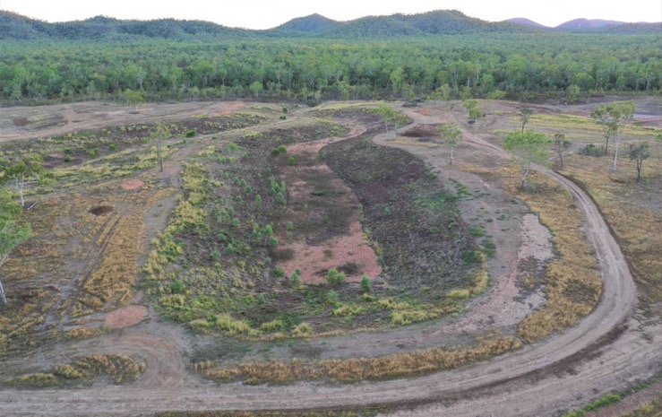

Figure 28. The Treatment 4 gully in August 2020. Grass seed was spread on top of the straw mulch, resulting in seed germinating but drying out.

The woody vegetation on the left and closest batter slopes (primarily poplar gum, *Eucalyptus platyphylla),* had seeded naturally. Note that locating roads on the edge of gullies can risk concentrating upslope runoff if present. The site is yet to experience an extreme rainfall event.

*Photograph by Damon Telfer*

These case studies have been well-monitored over the 2-5 years since construction. However, as noted in Appendix A, there has been no longer-term monitoring studies of gully reshaping, rock capping and revegetation in GBR catchments, but there are known risks to their longer-term performance. Therefore, ongoing monitoring over the coming decade is warranted at sites where those treatments have been employed.

### Stream bank fencing and weed control (passive revegetation)

#### Objectives

Stream banks and riparian zones require higher levels of vegetation biomass than other areas of the landscape because:

* stream banks generally have steeper slopes than hillslope surfaces, reducing soil stability and increasing runoff energy
* the soil around stream banks may be weakened by being saturated more frequently and for longer in wet seasons
* stream banks are exposed to much higher runoff volumes and shear stresses in high stream flows and locally.

The main objectives of fencing and weed control are to:

* establish and maintain high levels of ground cover and biomass to control erosion by sheetwash, rilling or scour
* establish and maintain vegetation with a range of rooting depths to control erosion by mass failure
* enable complete livestock exclusion following construction of erosion control and associated revegetation, until vegetation is fully established
* after the revegetation is completely established and effective, to prevent livestock access to stream banks during the wet season, and to limit to short periods of grazing during the dry season for the purpose of managing fire risk or vegetation composition
* to protect the general stability of stream banks to reduce the risk of future erosion and help restore ecosystem health and resilience, especially in reaches where engineered stream bank protection is planned or existing.

If stream banks are fenced, and provided fences are maintained, conscious decisions are required to graze these areas to maintain higher biomass levels. Revegetation without fencing or livestock management is an ineffective investment as livestock will eat new seedlings and new vegetation growth. In areas of permanent cropping without cattle, fencing around an erosion control site may be unnecessary.

**Note:** This treatment is a prerequisite supporting activity at all stream bank erosion control sites where livestock are present or likely to be present in the future.

Stream bank fencing can have co-benefits for grazing land management by:

* excluding cattle from rough areas to reduce animal injuries and simplify mustering
* assisting paddock subdivision, enabling better management of grazing pressure to improve land condition
* excluding these areas, if they are small relative to the surrounding paddocks, with little impact on property grazing management.

There is much similarity in this treatment to gully fencing (Section 3.3), but some features are specific to stream banks.

#### Location

When locating the fencing there are several issues to consider:

* Fencing location needs to be planned with the support of the landholder because they will be responsible for its operation and maintenance in the long term.
* Avoid fencing in flood-prone areas, or use alternative fencing designs, where possible.
* Establishing trees on the top of the bank contributes to long-term stream bank stability.
* Consider the location of existing fences and associated gates in the design of new fencing.
* The **grazing regime within the fenced area** needs to be agreed with the landholder and specified in the detailed design report (see Section 3.2.2).
* Clearly state the intended life of all new fences installed (whether project duration or permanent).
* If fencing will remove livestock access to existing water points, then a new off-stream water point may be provided. Refer to the considerations listed in Section 3.2.4.
* Fencing and weed control can be effective in areas infested by dense stands of woody weeds, for example of chinee apple *(Ziziphus mauritiana),* rubber vine *(Cryptostegia grandiflora), Parkinsonia* spp., prickly acacia *(Vachellia nilotica)* or bellyache bush *(Jatropha gossypiifolia),* provided that such weeds are comprehensively controlled (see design considerations).
* Natural regeneration is very slow in degraded landscapes, especially in areas of low rainfall and low-fertility soils, or where natural vegetation has been completely removed historically. The presence of box, sandalwood or ironbark species are indicators that the soil type may be of poor quality, and that additional treatment is required to support vegetation growth. Seek specialist expertise as these areas may require active revegetation.
* Fencing and weed control is more appropriate than active revegetation if it can reasonably be expected that desirable vegetation, including a variety of grass, tree and shrub species with a range of rooting depths, will naturally regenerate from local and upstream seed sources if livestock access is managed and weeds are controlled.

Locate stream bank fencing where it will rarely flood, particularly if streamflow velocities are significant. Riparian zones of insufficient width lead to poor plant cover, erosion and/or weeds (Paul et al., 2018). The high bank of the watercourse is often a suitable location for fencing and allows sufficient setback. Based on the work of Abernethy and Rutherfurd (1999), the fence line setbacks from the bank top are established as a minimum of **5 m** (or the minimum width under the *Vegetation Management Act 1999* (Qld)) plus the **bank height** in metres and adding an estimate **of the erosion rate to continue over a 20-year period of tree growth** (m). The calculation should follow Equation 1 below:

|  |  |  |  |  |
| --- | --- | --- | --- | --- |
| **Stream bank erosion control width (m) =** | 5 m (or the minimum width under the *Vegetation Management Act* *1999* (Qld)) NB, this is for tree clearance only (it does not apply for grazing land management) | + bank height (m) | + allowance for continued erosion over 20‑year period of tree growth | (Equation 1) |

In many cases, this equation will approximate to 3-5 times the bank height.

#### Design

Factors to consider in implementation:

* The first and foremost consideration for fences around erosion control sites is that they are stock proof. Ensure these fences are robustly constructed (that is, small dropper spacing, and additional strands will be needed beyond a standard subdivision fence) given that forage biomass in and around the stream bank can become much higher than in the paddock.
* Livestock access is prevented at the downstream end with a secure flood gate if the fence crosses a channel.
* Where the stream may have grazing livestock in it in periods of low flow (from neighbouring properties), a temporary fence at the base of the bank may need to be considered.
* Weed control must remove infestations of woody and problem herbaceous weeds and continue until natural vegetation has regenerated. Methods may include fire, herbicides, biological agents and mechanical treatments.
* In some cases, woody weeds removed by mechanical means can be used as brush to protect regenerating areas from grazing by livestock, and feral or native animals.
* In some cases, control of feral animals such as pigs and deer is required to enable vegetation to regenerate.

#### Implementation

* Keep tree felling and disturbing ground vegetation to the absolute minimum required to access the site by vehicle and erect the fence. Where possible, low impact tree-to-tree fencing can be used to stabilise disturbance. Do not undertake earthworks or disturb the ground vegetation cover other than as required to access the site.
* Complete fencing before revegetation (either active or passive).
* For sites where some grazing continues within the erosion control area (after an initial no-graze period and modified from historical patterns and by the new fencing), ensure a documented agreement with the landholder includes specification of the grazing regime planned for the erosion control area. This grazing management will ensure vegetation condition is sufficient for erosion control, and is ideally specified as:
* keep stocking rates low (for example, consumption of approximately 10% of standing biomass); always maintain a substantial forage biomass.
* the timing of grazing; dry season grazing only is strongly recommended.
* Where the fenced area will not have a water point consider including a spear gate to allow cattle to escape.
* Temporary electric fencing is not recommended for stream bank fencing.
* Where existing fencing and gates have resulted in stock tracks or cattle pads that lead to overland flow into gullies or streams, remediate those stock tracks by installing small diversion banks or otherwise as appropriate.
* Ensure that any clearing related to fence line construction complies with state government vegetation management regulations (see Table C1 in Appendix C).
* Achieving the objectives requires that grazing in the fenced area is carefully controlled. This is ensured through ongoing site monitoring (see Section 4).

Site monitoring after establishing the treatment is an essential part of a successful project. Section 4 gives a detailed description of site monitoring.

#### Case studies

Figure 29 provides an example of where stream bank fencing and weed control (and associated passive revegetation) would be a suitable remediation strategy to reduce the contribution of fine sediment from stream banks in the long term.

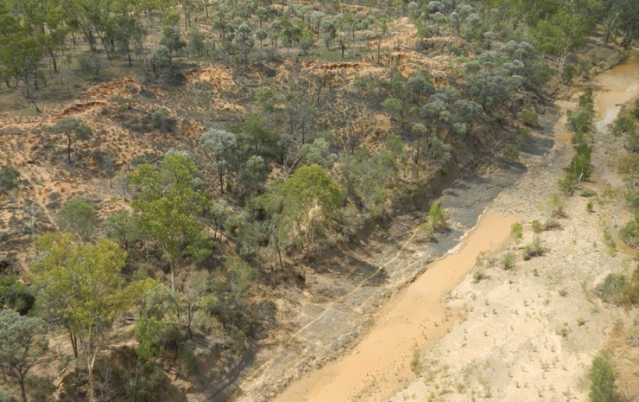

Figure 29. Tributary of the Bowen River, which has a stable bedrock bed.

The key erosion issues are the steep upper edge of the inset channel bank, alluvial gully erosion on the upper bank, and the livestock tracks and grazing pressure. Livestock exclusion would enable the remnant vegetation to respond well and also encourage more vegetation establishment in the channel.

*Photograph by Andrew Brooks*

### Stream bank revegetation

#### Objectives

The main objective of the active revegetation of stream banks, such as through planting, is to improve land and soil condition by increasing (native) vegetation cover and biomass and root reinforcement. It can also help to restore stream ecosystem health and resilience. Active revegetation is where the desired vegetation species are planted or seeded. This treatment is normally bundled with fencing and weed management. Compared with passive revegetation, active revegetation is generally found to be more reliable and quicker at establishing the desired mix of stream bank vegetation. This activity includes fencing and the control of weeds and pest animals where required to maintain vegetation condition. For stream banks, the primary objective of revegetation is to maintain a mix of grasses, trees and shrubs on the banks and within the channel area that is subject to flow inundation. This will reduce but not eliminate bank erosion.

Particularly at lower rainfall sites (for example, western savanna areas), ensure woody stem densities when planting are ideally low enough to allow grass growth between tree plantings, but clearing existing native tree cover is actively discouraged, even if it is thicker than ideal.

An important objective of stream bank fencing and active revegetation, as described in Section 1.2.3, is to improve the general stability of stream banks within reaches where engineered stream bank protection is used.

#### Location

One of the challenges with revegetation is determining the size of the area or buffer to be restored. Typically, the area will focus within the fence that controls livestock access to an erosion control site (see Section 3.3.2). Revegetation also includes the rehabilitation of stock tracks and disturbed areas such as livestock camps.

In general, the same principles outlined for passive revegetation (see Section 3.9.2) apply to active revegetation. Please refer to Section 3.9.2 for specific advice on selecting the location of sites for active revegetation. In general, sites that have the following characteristics will be more amenable to active rather than passive revegetation:

* high (>3 m) banks with no existing trees on the bank face or bank top
* highly degraded sites with poor vegetation, and thus a poor seed bank, upstream or upslope.

#### Implementation

The main considerations when implementing active revegetation at a stream bank site include:

* Controlling stream bank toe erosion, such as by rock armouring (Section 3.11), is critical if it will not be adequately controlled by revegetation, for example in larger streams.
* Bank reshaping may be required to create a stable batter slope (for example, 1:2.5) where the existing bank surface is too steep or rugged. This will provide a stable surface to facilitate efficient revegetation of extensive stream bank areas. Seek technical advice as to whether reshaping is necessary.
* Revegetation may be implemented in strategic phases (for example, establishing grasses followed by shrubs and trees).
* Careful consideration needs to be given to the vertical zonation of shrubs and riparian trees when planting on stream banks. Some riparian vegetation such as reeds (for example, *Lomandra* spp.) and rushes (for example, *Phragmites* spp.) require continual access to sub-surface moisture to survive and thrive and are effective at the bank toe, while deep-rooted woody species and grasses are planted further up the bank face. Use species native to the local area wherever feasible. In some cases, local seed collection for endemic species may be required.
* Tighter spacing of revegetation can shorten the time until canopy closure is reached, to reduce subsequent maintenance requirements.
* In situations where local native grasses are not available, exotic grasses can be used effectively as erosion control provided they are already established in the local area.
* Do not use vegetation that is likely to attract grazing animals or to require livestock grazing to prevent it outcompeting other functional groups for revegetation. In particular, avoid using buffel grass *(Cenchrus ciliaris)* and exotic legumes (for example, *Stylosanthus* spp.). These species are also likely to enhance the risk of fire.
* Avoid species that may become weeds in the area for revegetation.
* Careful timing of seeding and planting with weather patterns will reduce the risk of revegetation failing.
* Monitoring and maintenance in the initial few years is critical to achieving success, since the maintenance requirements are dependent on local weather and site management.
* Irrigation may be required through the first dry season or two, to assist establishment.
* Replacement of unsuccessful seedlings or replanting may be required if initial plantings die.
* Weed control is critical during vegetation establishment and may require a specialist approach.
* Off-stream watering points are required only if proposed fencing excludes livestock from existing water points.
* Use the Salinity Management Handbook (The State of Queensland, 2011) as a reference to identify appropriate species with salt tolerance when it is considered that the salinity problem has not reached extreme levels. Assess the revegetation of areas prone to salinity before proceeding as there is a high risk of failure.

Section 4 gives a detailed description of site monitoring.

#### Case studies

Reach-scale revegetation along large rivers requires establishing sites on multiple properties and can take many years. Figures 30 and 31 show an example of a multi-kilometre reach of the Mary River where tall deep-rooted riparian vegetation has been re-established. Successive fencing and active planting projects have protected a high proportion of the length of stream banks, including several meander bends.

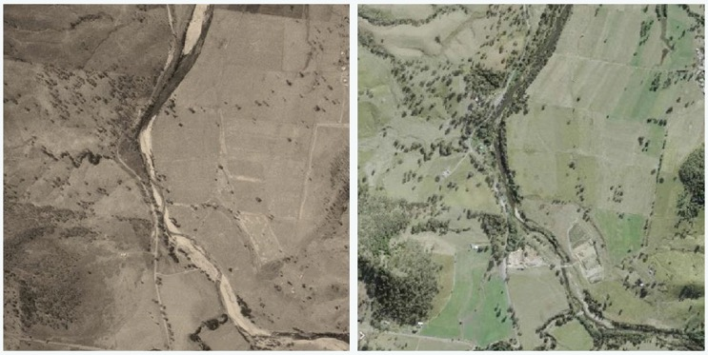

Figure 30. An aerial view of a reach of the central Mary River.

The left-hand image was taken in 1977 showing sparse riparian vegetation and exposed sand and gravel deposits. The right-hand image was taken in 2020 showing the result of a succession of riparian restoration projects along the stream.

*Photographs reproduced from QImagery ©State of Queensland 2022*

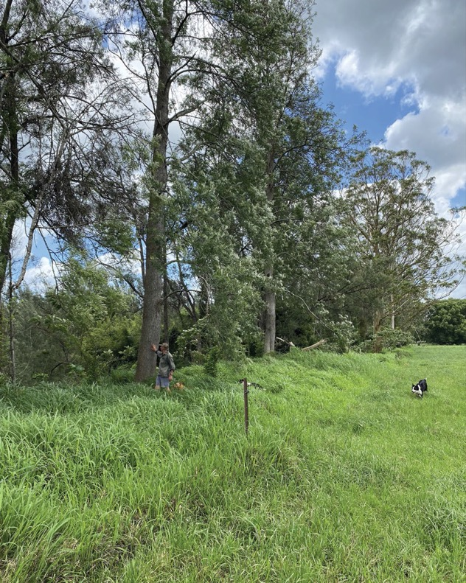

Figure 31. Tall riparian vegetation planted in 1984 as part of the reach-scale revegetation shown in Figure 30.

Note the fence setback and the variety of tree species.

*Photograph by E Watson, October 2021*

### Engineered stream bank protection and revegetation

#### Objectives

This section outlines some of the considerations for engineered stream bank protection, which needs much more careful planning than livestock exclusion fencing and passive or active revegetation activities. Vegetation is a critical component of all stream bank remediation due to the long-term roughness it provides to slow flow velocity near the bank surface and its function to help restore stream ecosystem health and resilience. In some cases, engineering structures are required to support the establishment of vegetation on former actively eroding stream banks. This can include stabilising toe erosion with rock revetement or groynes, providing a uniform surface on which to establish vegetation, or by reducing shear stresses on the bank face with pile fields or groynes.

Engineered stream bank protection at isolated sites can appear to be cost-effective at face value, especially where infrastructure assets are threatened. However, it can rarely be justified in isolation as a cost-effective way to improve water quality compared with vegetation-focused rehabilitation approaches. There are risks of extreme events damaging engineered stream bank protection. Therefore, the erosion control outcomes of engineered stream bank protection at isolated sites are best secured by combining with revegetation of extensive reaches surrounding those sites. This whole-of-river management requires consideration of stream channel behaviour and the setting of objectives at valley scale. The resultant approach can involve revegetating the channel and banks over extended reaches and giving the river room to move where necessary. Transitioning to this strategic approach requires ongoing communication and landholder engagement by professional extension staff, as inevitably the impacts of a naturally active, minimally constrained river channel will fall disproportionately on some, while the benefits accrue to others. Also, it can be more difficult to quantitatively evaluate the long-term benefits of broad-scale interventions within current knowledge and program timetables.

#### Location

Only undertake engineered stream bank erosion control as part of a broader (valley) planning process, as described in Section 1.2.3. A frequent scenario is that stream bank erosion control planning is initiated in response to erosion in a recent large flow event. Often there is a landholder expectation that individual sites of large erosion will be controlled. However, such sites may not be the highest priority for engineered stream bank erosion control. Hard engineering works may simply divert the problem to banks further downstream, setting up a cascade of bank erosion problems, each presenting as a local crisis to the landholder impacted. When stabilising for coastal water quality improvement (total erosion across the stream network), the solution is to move away from treating isolated symptoms and towards managing the river at reach scale. This contrasts with a local asset protection approach (for example, a single river bend migrating into area used for agriculture, roads or grazing).

#### Design

It is important to develop a template for the desired condition of the stream early in the design process. For example, a process for natural channel design is available in Rutherfurd et al. (2000b). No single bank protection treatment has been found to be consistently effective at reducing bank erosion, and different combinations of treatments suit different sites and contexts. However, involving experienced stream rehabilitation specialists can reduce the risk of long-term failure.

Options and considerations for engineered stream bank protection are described in Rutherfurd et al. (2000b). Ensure the selected option addresses the specified objectives of river rehabilitation based on the Queensland Stream Rehabilitation Management Guideline (DES, 2022). The most common options for engineered stream bank stabilisation are:

* Rocking of the bank toe to prevent toe erosion, in conjunction with revegetation of the bank face.
* Timber pile retards or pile fields reduce the flow velocities adjacent to the bank face and enhance existing deposition processes so that woody vegetation can re-establish and help to protect the bank. Use local knowledge to source durable wood pile material; however, do not regard these as permanent structures as they typically decay after 7-15 years (see Figure 32). They are often combined with bank reshaping, stock exclusion and replanting and require a detailed design and approval process. Consequently, the objective is to establish a stable and extensive tree and plant root network that provides resistance to scour during the period that the pile field is stabilising the bank face (Figure 33). Pile fields are rarely effective at controlling erosion of the bank toe. To enable revegetation at the bank toe, pile fields must have sufficient sediment supply and provide the hydraulic conditions in which deposition can occur. Pile fields are unlikely to cause sediment deposition and revegetation and stabilise the bank toe if the toe is permanently or semi-permanently inundated, such as in a weir backwater or a river subject to seasonal regulated flows for irrigation. Pile fields in this latter situation on the Murray River in New South Wales have failed to prevent ongoing bank retreat (Rutherfurd et al., 2007). An alternative to driving straight piles into the stream bed is to use clumps of large logs cabled together, termed engineered log jams.
* Rock groynes are sometimes used in high-energy situations, to deflect high velocity flow away from the bank toe. These also tend to create scour pool habitat adjacent to the end of each groyne. Detailed descriptions are provided in Rutherfurd et al. (2000b). A case study is given in Section 3.11.5.
* Rock armouring or revetment, which is suited to preventing scour of the bank face in higher energy situations.
* Full-width structures across the bed of a stream channel are sometimes used to stabilise the depth of a deepening stream and reduce the severity of deepening upstream, which can trigger channel widening (Rutherfurd et al., 2000b). Examples include rock riffles, and timber piles driven into the channel bed known as pin ramps.

There are detailed design procedures available for each of these structure types (for example, Rutherfurd et al., 2000b). Ensure an experienced engineer with RPEQ certification designs the engineered structures for stream bank erosion control.

Extensive riparian revegetation for kilometres upstream and downstream, as described in Sections 3.9 and 3.10, is highly desirable to provide long-term reduction in bank shear stress at sites where engineered stream bank erosion control is used. Active revegetation of the bank face at the site is also essential wherever feasible. This combined engineering and vegetative approach is analogous to the way in which grazing land management supports engineered gully erosion control.

#### Construction

Schedule construction so that it will be completed well before the end of November, so that the bank surface can be seeded and grassed or mulched well before rainfall occurs.

Exposure of engineered stream bank protection structures to large runoff events means it is critical construction is completed by experienced and professional contractors.

Section 4 gives a detailed description of site monitoring.

#### Case studies

**Case studies:** Mary River pile field

In the Kenilworth reach of the Mary River a timber pile field was installed in approximately 2015 (Figures 32). The pile timber is now rotten, and its erosion control effect has declined. Not all piles rot this rapidly but it serves to reinforce the point that these are not permanent structures.

At a second and more recent site on the Mary River, pile fields were combined with selected use of riprap, fencing and revegetation, primarily to protect utility infrastructure but also to reduce downstream sediment loads (Figure 33).

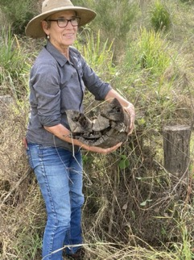

Figure 32. A pile in 2021 that was installed 6 years previously and is now rotten

*Photograph taken by Peter Hairsine*

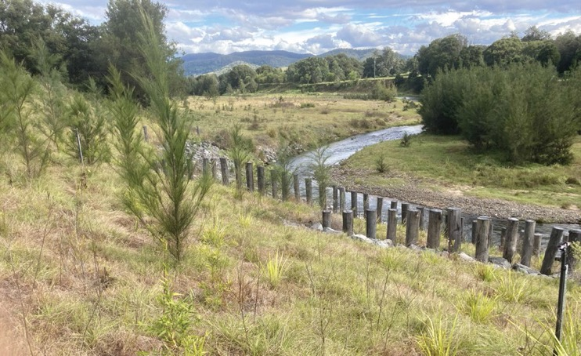

Figure 33. A pile field, riprap, fencing and planting project established in 2020 on the Kenilworth reach of the Mary River.

This project had dual objectives of stabilising a streambank to protect local assets and to reduce the delivery of sediment downstream. The project was co-funded, with Reef Trust funding revegetation of this site and of large extents of the reach either side of the engineering works.

*Photograph taken in 2021 by Peter Hairsine*

**Case study:** O'Connell River rock groynes

Following the February 2019 North Queensland monsoon flood event, the Disaster Relief Funding Assistance (DRFA) program jointly funded by the Australian and Queensland Governments approved several projects on the O'Connell River. Reducing fine sediment export to the GBR lagoon was one program objective, with others including the protection of public assets, infrastructure, and agricultural land. At the site profiled below, historical air photographs indicated long-term stream bank erosion. The 6 m bank height meant that stream power was very high. The reach was relatively straight, with a planar bed with few pools. The project objectives agreed between the funders, project team and landholder were to mitigate bank erosion by directing flows away from and revegetating the eroding bank, to dissipate stream energy, and to promote scour pool development towards the channel centre. The project was managed and implemented by Reef Catchments and Rock-it Science Pty Ltd.

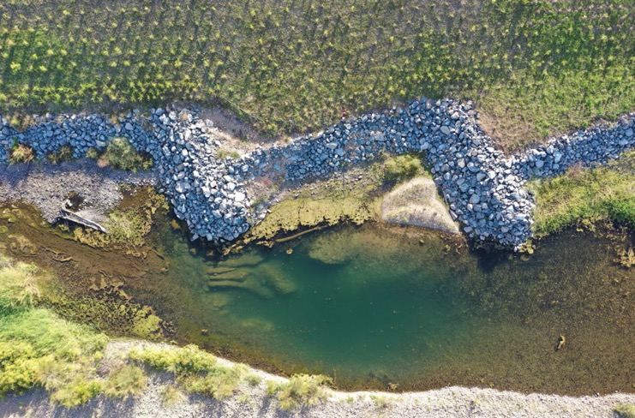

Figure 34: Rock groynes and bank reshaping at a site on the O’Connell River in July 2021, 9 months after construction (direction of flow from left to right).

The scour pool shown developed over the 2020-21 wet season and had a maximum depth of 2.5 m. Note also the deposition of gravels on the upstream side of the right-hand groyne. Design equations required a median rock diameter for the groynes of 1.1 m. The groynes were keyed into the bed by 2.5 m based on the predicted bed scour depth at the design flowrate (which had a 1:20 year recurrence interval). The crest height of the groynes was approximately 0.6 m above the opposite bar surface so that the reshaped bank was relatively more protected from scour. Rock revetment was installed between the groynes to reduce the risk of groynes being outflanked. The reshaped bank was fenced and revegetated in November-December 2020.

*Photograph by Damon Telfer*

Sites such as these case studies should be accompanied by extensive revegetation along the stream reach. As noted in Appendix A, there have not been any long-term monitoring studies of rock groynes, pile fields, stream bank reshaping and revegetation in GBR catchments. Therefore, ongoing monitoring over the coming decade is warranted at sites where those treatments have been employed.

## SITE MONITORING

### Objectives

Given the importance of improving water quality entering the GBR and the investment of public funds, it is essential that the implementation of the project activities and their impacts are monitored and evaluated. Therefore, an essential part of the project activities is to record and report the implementation and response to activities at project sites. This can help to identify requirements for site maintenance. Collating data and experiences across sites can enable the identification of trends in behaviour and in turn inform improvements in the approach.

Site monitoring has several objectives (adapted from the monitoring and evaluation guidelines used in the Reef Trust Partnership water quality program):

1. **To evaluate the performance of projects and programs:**
2. To confirm the completion and integrity of on-ground activities within each project and provide a credible record of activities.
3. To identify any ongoing maintenance issues so that the program activities achieve their maximum potential.
4. To enable adaptation of site selection, of the use, design and construction of erosion control treatments, and of the design of future water quality improvement programs.
5. **To increase understanding around broader issues relevant to water quality improvement in the GBR:**
6. To collate experiences and identify trends across sites in the success of activities in achieving their intended outcomes, to help identify improvements in the selection, design and implementation of erosion control activities approach (adaptive management).
7. To increase the understanding of the effectiveness of different restoration approaches.
8. To improve understanding of how landholders can be engaged more positively.
9. To provide a baseline for subsequent monitoring and research of longer-term outcomes on vegetation, erosion, land management and grazing-related outcomes.
10. **To engage people in water quality improvement activities:**
11. To increase landholder awareness of the processes that lead to the degradation of water quality and build motivation to adapt land management practices.
12. To facilitate communications by projects to stakeholders (for example, through fact sheets or field days).

Site monitoring within projects usually focuses on leading edge variables (for example, vegetation, integrity of the works, and so on) to indicate whether the remediation is trending in the right direction (for example, is vegetation growing, are the engineering works holding) and the likelihood of potential long-term success. Monitoring is more detailed at sites with larger works. On occasion, especially at large sites or where the approach is unusual, additional monitoring can be commissioned to also measure reductions in sediment yield. For example, complementary research programs can provide more detailed measurements at selected sites to determine whether estimated sediment load reductions are achieved. This can require substantial additional investment.

Monitoring in recent programs has advanced objectives 1 and 2 above, for example by improving understanding of the conditions affecting the implementation and erosion control effectiveness of several treatments as described in the Section 3 case studies and Appendix A of this document.

### Timing of monitoring

Monitoring is designed to be reasonably rapid to undertake in the field (approximately 30 minutes for 2 people) and require limited experience. Comparisons between sites and over time should be undertaken by those doing the monitoring and reviewed by a separate person not involved in the monitoring. Each site should ideally be monitored at least 3 times during the project:

1. Before site activities commence, generally after an independent technical expert has reviewed the concept design and during preparation of the detailed design (see Section 2.4). Ideally this is early in the dry season between March and May so that results are comparable with later years.
2. Shortly after treatment. For essential activities undertaken at all sites (for example, controlling stock access) this will mostly be photo point measurements, provided treatment occurred within the same dry season as the before-treatment monitoring. If the activities involved physical revegetation or earthworks, monitor the effects of this disturbance as described in Section 4.3.
3. At the end of each subsequent wet season (between March and May) following completion of erosion control activities. Seasonal rainfall and runoff drive erosion and the responses to revegetation activities. Measurement at the end of the wet season is also ideal to indicate the effectiveness and integrity of remediation activities.
4. Where possible, also repeating the photo point and landscape condition assessment components of site monitoring late in the dry season (between September and November). This monitoring will capture the lowest vegetation biomass in the annual cycle to help measure recovery and guide forage management.

### Monitoring methods

It is ideal to monitor all the treated gullies and stream bank sites in each paddock or property that erosion control works are planned and undertaken. If this is not affordable and there are multiple small features that are all similar in erosion rates and treatments, then monitor at least one gully or stream bank that is typical of all the features and treatments. For erosion control treatments that rely principally on revegetation for their effect (that is, improving grazing in gully catchments, fencing to control livestock access, porous check dams (PCDs), revegetation of stream banks), ensure the monitoring points isolate the effect of treatment from external factors, like variability in the weather and stocking rates where possible. This can be achieved by using a before after control impact (BACI) design in which some gullies or stream banks on each property are left untreated for comparison over time, and both the treated and untreated erosion sites are monitored before and after the erosion control activities are completed.

The standard monitoring design includes:

1. Land condition assessments (LCAs) immediately upslope of the gully head or stream bank, and in the paddock outside any planned fence location. Tools such as the Land Condition Assessment Tool (LCAT) are available from the Queensland Department of Agriculture and Fisheries by email (P2R@daf.qld.gov.au), noting that these tools are best used across many (>5) years to detect changes. LCA indicates the outcomes of changes in grazing practices including livestock access.
2. Current grazing management practice surrounding the gully or stream bank, to enable interpretation of LCAs.
3. Gully head location relative to a permanent reference marker, to enable any erosion between monitoring dates to be estimated (for gully sites only).
4. Monitoring the erosion control outcomes at 3 or more locations within the site:
5. ground cover, as a measure of revegetation
6. vegetation composition, as a measure of revegetation
7. intactness of structural erosion control treatments
8. photo point monitoring as a broad and easy to interpret indicator of site condition and to assist reporting and communication.
9. Rainfall in the last 12 months from a farm record or nearest Bureau of Meteorology station, for interpretation of above metrics for both structural and vegetation-focused erosion control treatments.
10. Landholder perspectives of the project activities including the current and planned approach to site management, to assist understanding of perceived benefits of the project. For example: a new fence will keep the cattle out of the creek, that country isn't growing anything anyway, keen to fix up an eyesore, paddock subdivision enabling pasture spelling, infrastructure or environmental benefits that are valued by the landholder, or problems created by the project.
11. A narrative summary of site monitoring outcomes to date, such as the overall changes in ground cover and findings about the erosion control approach or maintenance required. This is the core of any monitoring report and provides an overall assessment of the successes and problems experienced at the time of monitoring.

Include a map of the spatial layout of monitoring locations across the site in monitoring reports.

Record and report monitoring results on the GMT or SMT apps for mobile devices (Gully Monitoring Tool and Stream Bank Monitoring Tool, respectively) that use the above monitoring methods. The apps are administered by and available from the Paddock to Reef team in the Queensland Department of

Agriculture and Fisheries: P2R@daf.qld.gov.au. A setup guide and the latest user guides for each app are currently available from the P2R Dropbox folder. Reporting can be done by downloading the results from the apps as described in the setup guide.

Consider additional and more detailed monitoring beyond these standard methods to increase understanding of water quality improvement processes and to deepen the information that can inform adaptive management. Such methods may include, for example, measuring erosion rates by capture and analysis of repeat DEMs (digital elevation models), measuring runoff volumes and sediment concentrations, conducting more detailed vegetation surveys, using repeat aerial photography, and comparing erosion processes at treated sites with those at comparable non-treated sites nearby. This additional monitoring may potentially involve partnering with a research provider. The importance of additional monitoring and for longer-term monitoring is highest for treatments attracting larger investments and which are less widely used internationally, for example gully reshaping and some engineering stream bank protection treatments. The long-term outcomes of gully and stream bank revegetation also warrants additional and longer-term monitoring, due to the local specifics of the land uses, climates and species, and the progressive nature of revegetation outcomes.

## GLOSSARY

**Abutment:** A structure that is normally built adjacent to the crest of a weir or rock chute to direct water to flow over the weir or chute crest.

**Alluvial gully:** A form of gully erosion that involves incision of floodplain and river frontage country in deeper alluvial sediment deposits adjacent to large streams, often having irregular planform shape and occurring in very erodible soil material (contrast with hillslope gully).

**Alluvium:** Soil formed from sediment deposition in and around stream or river channels (such as a floodplain or alluvial fan).

**Batter:** A sloping earthen wall formed by earthworks.

**Batter chute:** A rock chute built in a batter to convey surface runoff to the base of the batter without erosion occurring, often combined with a diversion bank on the surface above the batter.

**Bank toe:** The lowest part of a stream bank, which is exposed to the scouring action of most river flows.

**Berm (see also Diversion bank):** An earthen bank that redirects water flow.

**Block fences:** Fences that are used to prevent stock moving up channels, including gullies and streams.

**Bund:** An earthen bank that redirects water across a low-gradient hillslope, either away from a gully or into a gully head rock chute. Alternatively, an earthen bank designed to hold water on the hillslope to allow infiltration into the soil.

**Bywash:** A channel that connect the spillway of a weir or dam to the stream channel. Bywashes maybe be stabilised using grasses and fencing or using rock armouring.

**Chromosol:** Soils with strong texture contrast between A horizon and B horizon subsoils. The latter are often red, but are not strongly acid or sodic.

**Coir log:** A porous artificial log occasionally used in constructing porous check dams (see example in Figure 16).

**Cryptogamic crust:** A biological soil crust that reduces soil erodibility by binding soil particles and is beneficial for plants and soil invertebrates through atmospheric nitrogen fixation and other nutrient contributions.

**Dispersive (including dispersibility):** Relates to the behaviour of soil when exposed to water. Can be associated with chemical or physical properties of soils. For a dispersive soil, soil crumbs break into fine particles upon wetting, causing discolouration of the water. The degree of this breakdown is a measure of dispersability (see Emerson aggregate test).

**Diversion bank:** An earthen bank that redirects water flow across the hillslope, typically from the head of a gully into a more stable drainage line (see also Berm). See Section 3.5.

**Duplex soil:** A soil with a distinct contrast in soil properties between the layers, where the sub-soil is typically more erodible than the topsoil.

**Emerson aggregate test:** A field implementable rapid test to determine the dispersion of soil crumbs.

**Energy dissipating apron:** The downstream component of a rock chute structure where fast moving flow is slowed to a less erosive flow through interaction with a low gradient, rough rock surface.

**Engineering:** The use of structures such a rock chutes that are relatively expensive and require formal engineering design.

**Forage utilisation:** The proportion of available forage biomass that is either planned to be or has been consumed by livestock.

**Fluvial scour:** The process by which the action of flowing water removes soil from a stream bank or other soil surface.

**Gabion basket:** A heavy-duty wire basket that is filled with rocks and used in the construction of erosion control structures including rock chutes.

**Geofabric (or geotextile):** A thick permeable fabric of polymer threads, typically used to prevent the passage of fine soil particles to either hold soil in place such as under rock chutes, or to trap fine sediment.

**Groyne:** A linear artificial barrier built to reduce shear stress on the bank. Groynes are aligned approximately transverse to the stream channel, extending from the lower bank or bank toe out into the river. Typically built of rock or timber piles.

**Gully:** An incision of the land surface to a depth of more than 0.5 m into valleys and hillslopes that did not always contain deep stream channels, prior to the introduction of European land uses (see Alluvial gully and Hillslope gully).

**Headcut:** An abrupt vertical drop at the head of a gully channel, typically exposed to a concentration of surface runoff. Headcut erosion results in the gully lengthening as the headcut location moves upslope.

**Hillslope gully:** A gully formed in a hillslope drainage line (contrast with alluvial gully).

**Initial maintenance:** A site maintenance regime that involves funded maintenance for the initial 2-3 years following construction for the duration of a multi-year project, and then maintenance that is undertaken by the landholder on a voluntary basis following a project. This form of maintenance was used in recent Reef Trust programs.

**Knick-point:** A cross-section of a river or channel where there is a sharp increase in channel bed slope. It is normally associated with accelerated bed scour and propagates upstream.

**Mass failure:** The movement of soil blocks primarily driven by gravity, such as collapse of material that has been undercut by scour (cantilever failure) or slumping/sliding. It primarily occurs on stream banks and gully walls.

**Maintenance:** The repair and checking of the functioning of remediation measures that may continue after the completion of the project (see Initial maintenance and Ongoing maintenance in Section 2.6 and Appendix A).

**Ongoing maintenance:** Ongoing maintenance is used in the Toolbox to describe funded monitoring and maintenance of an erosion control site that is ongoing for 10-30 years following an erosion control construction project. See Section 2.6 and Appendix A.

**Outflanking:** Outflanking is the process of flow scouring around a hydraulic structure, such as a porous check dam. It normally leads to the failure of the structure.

**Pile fields (alt. retards):** Rows of piles (wooden or concrete) that are driven into the stream bed. The piles are aligned approximately transverse to the channel so as to reduce flow shear at the toe of a stream bank.

**Porous check dam:** A low (less than 0.5 m high) porous structure used to slow flow in the base of a gully (see Section 3.4).

**Rain splash:** Rain splash is the eroding action of raindrops impacting directly on a soil surface.

**Reach:** Here defined as a stretch of stream generally kilometres in length and having relatively uniform natural or imposed form and boundary conditions that indicates the stretch should be treated as a single unit. For example, "the above-gorge alluvial reach", or the "lowland meandering reach" or "above the dam reach" or "bedrock confined reach".

**Revetment:** Revetment is the use of riprap or rock armouring to protect the toe of stream banks.

**Rilling:** A form of hillslope erosion where shallow channels (<50 cm deep) form in the surface of the soil.

**Riparian:** Located on or next to the bank of a stream.

**Riprap:** A layer of erosion protection, commonly large rock armouring, used to protect the lower parts of stream banks or stream beds from fluvial scour.

**Rock armouring (alt. revetment):** Riprap to protect the toe and lower section of stream banks. Sometimes termed rock beaching.

**Scald:** An area of hillslope that has had the vegetation and topsoil removed by erosion.

**Scarp:** The steeply sloping face of a gully including the headcuts and sidewalls, especially of wide or irregularly shaped gullies.

**Scour (or Fluvial scour):** The eroding action of water flow removing sediment from a soil surface.

**Setback:** The horizontal distance a fence is positioned away from the edge of a gully or stream bank.

**Sheet wash:** Erosion of the surface soil by water. It is driven by the actions of raindrop impact and overland flow to remove sediment from the surface of the soil and transport it downhill.

**Slaking:** The process of soil crumbs breaking down into smaller particles during rapid wetting.

**Sodic:** A soil where the percentage of sodium cations on the clay surfaces is typically greater than 6%.

**Sodosol:** A soil type that is both duplex and dispersive, with a sodic layer.

**Soil amelioration:** Application and mixing of materials with soil to improve soil structure, such as to promote aggregation and reduce dispersion. Gypsum is a commonly used material.

**Stock:** Domestic grazing animals, frequently cattle.

**Stock track (or livestock track):** Areas of compacted soil that are often unvegetated. They are formed by stock trampling and are frequently located in high stock traffic areas such as gates and watering points.

**Stream bank:** The edge of a stream or river channel.

**Toe:** The lowest part of a stream bank.

**Vertosol:** A broad class of soils with a high proportion of expansive clays.

## ACRONYMS

**AE:** Adult Equivalent. A standard measure of cattle nutrient requirements (grazing load) widely used in grazing systems for determining carrying capacity. It is typically calculated as the ratio of an individual animals metabolisable energy requirements relative to that of a steer of approximately 450 kg liveweight, with bulls and lactating cows each representing >1.0 AE and young animals representing <1.0 AE.

**ARI:** Average recurrence interval. A measure of the expected frequency of a hydrologic event. Normally calculated using the methods described at https://arr.ga.gov.au/arr-guideline.

**ASRIS:** The Australian Soil Resource Information System. An approach for estimating soil properties at any Australian location. It is used in the Toolbox where local samples are not collected. The methods and online resource are available at https://www.asris.csiro.au/.

**BACI:** Before after control impact. A term used to describe a research and monitoring approach.

**CEC:** Cation exchange capacity. CEC is a measure of how many cations can be retained on soil particle surfaces.

**CHUTE:** A hydraulic design program for the design of rock chute structures used for stabilising river and stream beds. The documentation and software are available at https://toolkit.ewater.org.au/Tools/CHUTE.

**CPESC:** Certified Professional in Erosion and Sediment Control (International Erosion Control Association).

**CPSS:** Certified Professional Soil Scientist (Australian Soil Science Society).

**CSIRO:** The Commonwealth Scientific and Industrial Research Organisation.

**DEM:** Digital elevation model. A digital representation of topography of a landscape. The elevation can be specified on a horizontal grid of a range of resolutions, typically 1-25 m.

**DEM of difference:** The difference in elevation between 2 DEMs of the same landscape. Measures the change of elevation (either net erosion or net deposition) for the grid of points.

**EAT:** Emerson aggregate test (https://www.environment.nsw.gov.au/resources/soils/testmethods/eat.pdf).

**EIANZ CEnvP:** Certificate in Environmental Practice Specialist Geomorphologist (Professional Geomorphologist certification developed by the Australian and New Zealand Geomorphology Group and Environment Institute of Australia and New Zealand).

**ESP:** Exchangeable sodium percentage. An attribute of the clay in soil that influences its stability.

**GBR:** The Great Barrier Reef is the world largest coral reef.

**GBR catchments:** The Great Barrier Reef catchments are the watersheds that drain to the lagoon adjacent to the Great Barrier Reef.

**GECAT:** Gully Erosion Control Assessment Tool. A piece of software used to prospectively assess sediment reductions from gully erosion control sites according to the methods described in Section 2.

**GIS: Geographic information system.**

**GMT:** Gully Monitoring Tool. Software used to assist the monitoring of gully erosion control sites according to the approach described in Section 4.

**LCA:** Land condition assessment, which is a term used to describe the interaction between rangeland vegetation, soil health, and grazing pressure.

**LCAT:** Land Condition Assessment Tool. Software used to assist the assessment of soil and land condition. See Section 4.

**LDC:** Landholders Driving Change. A program in the Burdekin natural resource management region.

**Lidar:** Light detection and ranging. A scanning technology mounted on aircraft or satellites to measure the topography of a landscape (see also DEM).

**LoD:** Limit of detection.

**NESP:** National Environmental Science Program. A federally funded research program with several research projects relevant to the Toolbox. See https://www.awe.gov.au/science-research/nesp.

**PCD:** Porous check dam. A short (less than 0.5 m high) porous structure used to slow flow in the base of a gully.

**P2R:** The Paddock to Reef Monitoring, Modelling and Reporting Program. A program run by the Queensland Government concerning non-point source pollution to the Great Barrier Reef.

**RPEQ:** Registered Professional Engineer Queensland A professional standards registration maintained by the Board of Professional Engineers of Queensland.

**RSDR:** River sediment delivery ratio. The proportion of fine sediment (nominally <20 μm) that is delivered from each sub-catchment to the river mouth, accounting for deposition in reservoirs and floodplains.

**SECAT:** Stream Bank Erosion Control Assessment Tool. A piece of software used to prospectively assess sediment reductions from gully erosion control sites according to the methods described in Section 2.

**SMT:** Stream Bank Monitoring Tool. Software used in the Toolbox to assist the monitoring of stream bank erosion control sites according to the approach described in Section 4.

**WQIP:** Reef 2050 Water Quality Improvement Plan. An initiative of the Australian and Queensland Governments.

## REFERENCES

Abernethy B, Rutherfurd I. 1998. Where along a river's length will vegetation most effectively stabilise stream banks? Geomorphology, 23: 55-75. https://doi.org/10.1016/S0169-555X(97)00089-5.

Abernethy B, Rutherfurd ID. 1999. Guidelines for stabilising streambanks with riparian vegetation. 99/10, Cooperative Research Centre for Catchment Hydrology, Melbourne.

Ball J, Babister M, Nathan R, Weeks W, Weinmann Retallick M, Testoni I (eds). 2019. Australian rainfall and runoff: a guide to flood estimation. Commonwealth of Australia, Engineers Australia. http://arr.ga.gov.au.

Bartley R, Hawdon A, Post DA, Roth CH. 2007. A sediment budget for a grazed semi-arid catchment in the Burdekin Basin, Australia. Geomorphology, 87: 302-321. http://dx.doi.org/10.1016/j.geomorph.2006.10.001.

Bartley R, Keen RJ, Hawdon AA, Hairsine PB, Disher MG, Kinsey-Henderson AE. 2008. Bank erosion and channel width change in a tropical catchment. Earth Surface Processes and Landforms, 33: 2174-2200. http://dx.doi.org/10.1002/esp.1678.

Bartley R, Corfield JP, Hawdon AA, Kinsey-Henderson AE, Abbott BN, Wilkinson SN, Keen RJ. 2014. Can improved pasture management reduce runoff and sediment loss to the Great Barrier Reef? The results of a 10-year study in the Burdekin catchment, Australia. Rangeland Journal, 36: 67-84. http://dx.doi.org/10.1071/RJ13013.

Bartley B, Henderson A, Wilkinson S, Whitten S, Rutherfurd I. 2015. Stream bank management in the Great Barrier Reef catchments: a handbook. CSIRO. https://doi.org/10.4225/08/584d954a6685a.

Bartley R, Hawdon A, Henderson A, Abbott B, Wilkinson S, Goodwin N, Ahwang K. 2020. Quantifying the effectiveness of gully rehabilitation on water quality: results from demonstration sites in the Burdekin catchment. Milestone report for NESP Project 5.9 and LDC Project LRP17-003 and LME17-009, Dec 2020. https://nesptropical.edu.au/wp-content/uploads/2021/01/NESP-TWQ-Project-5.9-Final-Report.pdf.

Berton S. 1989. A detailed guide to specifications and use of permeable rock dams in West Africa (in French). GRET, Paris.

Brooks AP, Brierley GJ. 1997. Geomorphic responses of lower Bega River to catchment disturbance, 1851-1926. Geomorphology, 18: 291-304.

Brooks AP, Brierley GJ, Millar RG. 2003. The long-term control of vegetation and woody debris on channel and flood-plain evolution: insights from a paired catchment study in southeastern Australia. Geomorphology, 51(1-3), 7-29.

Brooks AP, Olley J, Iwashita F, Spencer J, McMahon J, Curwen G, Saxton N, Gibson S. 2014. Reducing sediment pollution in Queensland rivers: towards the development of a method to quantify and prioritise bank erosion in Queensland rivers based on field evidence from the upper Brisbane, O'Connell and Normanby rivers. Appendices to Final Report to Qld State Government, Department of Science Information Technology Innovation and the Arts, Griffith University. 332 pp.

Brooks A, Spencer J, Curwen G, Shellberg J, Garzon-Garcia A, Burton, Iwashita F. 2016a. Reducing sediment sources to the Reef: managing alluvial gully erosion. Report to the National Environmental Science Programme. Reef and Rainforest Research Centre Limited, Cairns. 375. http://nesptropical.edu.au/wp-content/uploads/2016/06/NESP-TWQ-1.7-FINAL-REPORT-COMPLETE-10-06-16.pdf.

Brooks A, Pietsch T, Thwaites R, Loch R, Pringle Eccles S, Baumgartl T, Biala J, Spencer J, Zund P, Spedding T, Heap A, Burrows D, Andrewartha R, Freeman A, Lacey S, Higham W, Goddard M. 2016b. Alluvial Gully Systems Erosion Control & Rehabilitation Workshop; Communique from a 3 day workshop help at Collinsville, August 8-10, 2016. Report to the National Environmental Science Programme. Reef and Rainforest Research Centre Limited, Cairns. 19.

Brooks AP, Spencer J, Doriean NJC, Thwaites R, Garzon-Garcia A, Hasan S, Daley J, Burton J, Zund P. 2021. NESP Project 3.1.7 Final Report: Effectiveness of alluvial gully remediation in Great Barrier Reef catchments. Report to the National Environmental Science Program. Reef and Rainforest Research Centre Limited, Cairns. 205 pp. https://nesptropical.edu.au/index.php/final-reports-round-3/.

Carey B, Stone B, Shilton P, Norman P. 2015a. Chapter 4. The Empirical version of the Rational Method. In: Soil Conservation Guidelines for Queensland, 3rd Edition. Queensland Department of Science, Information Technology and Innovation. https://www.publications.qld.gov.au/dataset/soil-conservation-guidelines.

Carey B, Stone B, Shilton P, Norman P. 2015b. Chapter 11. Stream stability. In: Soil Conservation Guidelines for Queensland, 3rd Edition. Queensland Department of Science, Information Technology and Innovation. https://www.publications.qld.gov.au/dataset/soil-conservation-guidelines.

Carey B, Stone B, Shilton P, Norman P. 2015c. Chapter 13. Gully erosion and its control. In: Soil Conservation Guidelines for Queensland, 3rd Edition. Queensland Department of Science, Information Technology and Innovation. https://www.publications.qld.gov.au/dataset/soil-conservation-guidelines.

Catchments and Creeks Pty. Ltd. 2010. Factsheets on waterways. https://www.catchmentsandcreeks.com.au/fact-sheets/M-waterways.html.

Catchments and Creeks Pty Ltd. 2020. Rock sizing for waterway and gully chutes. Version 4. 9 pp. https://www.catchmentsandcreeks.com.au/fact-sheets/esc rock sizing.html.

Ciesiolka C. 1987. Catchment management in the Nogoa watershed. AWRC Research Project 80/128.

Compiled by the RRRC. 2021. Lessons for gully management: a synthesis of key findings from the NESP Tropical Water Quality Hub research. Report to the National Environmental Science Program. Cairns. 20 pp. https://nesptropical.edu.au/wp-content/uploads/2021/08/Project-6.4-Case-Study-Booklet-1-Gully-Management-online-version.pdf.

Connolly RD, Ciesiolka CAA, Silburn DM, Carroll 1997. Distributed parameter hydrology model (Answers) applied to a range of catchment scales using rainfall simulator data. IV Evaluating pasture catchment hydrology. Journal of Hydrology, 201: 311-328. http://dx.doi.org/10.1016/S0022-1694(97)00052-8.

Critchley W, Siegert K. 1991. Water harvesting. FAO. <http://www.fao.org/docrep/u3160e/u3160e00.htm#Contents>.

Daley J, Stout JC, Curwen G, Brooks AP, Spencer J. 2021a. Development and application of automated tools for high resolution gully mapping and classification from lidar data. Report to the National Environmental Science Program. Reef and Rainforest Research Centre Limited, Cairns. pp: 169. https://nesptropical.edu.au/index.php/final-reports-round-5/.

Daley JS, Brooks AP, Spencer J, Stout J. 2021b. Worn down and wasting away: the impact of splash erosion in alluvial gullies. In: Boyd T, Coker M, Gregor S, Miller A, Morris A, Russell K, Rutherford ID, Vietz GJ, Walker J, Wood A. (Eds). Proceedings of the 10th Australian Stream Management Conference, 481-487.

Day B, Shepherd B. 2019. Gully erosion: options for prevention and rehabilitation (experiences from the Burnett & Mary River Catchments, Queensland). Burnett Mary Regional Group for Natural Resource Management Ltd. https://bmrg.org.au/wp-content/uploads/2019/08/BMRGGullyErosionManual.pdf.

Department of Transport and Main Roads. 2022. Specifications category 3 – Roadworks, drainage, culverts and geotechnical. The State of Queensland. https://www.tmr.qld.gov.au/business-industry/Technical-standards-publications/Specifications/3-Roadworks-Drainage-Culverts-and-Geotechnical.

DES. 2022. Queensland River Rehabilitation Management Guideline. Department of Environment and Science, Brisbane. (in press).

Doriean NJC, Bennett WW, Spencer JR, Garzon-Garcia A, Burton JM, Teasdale PR, Welsh DT, Brooks AP. 2021. Intensive landscape-scale remediation improves water quality of an alluvial gully located in a Great Barrier Reef catchment. Hydrol. Earth Syst. Sci., 25: 867-883. https://doi.org/10.5194/hess-25-867-2021.

Feld CK, Birk S, Bradley DC, Hering D, Kail J, Marzin A, Melcher A, Nemitz D, Pedersen ML, Pletterbauer F, Pont D, Verdonschot PFM, Friberg N. 2011. From natural to degraded rivers and back again: a test of restoration ecology theory and practice. In: Woodward G (ed). Advances in ecological research, Vol. 44. Elsevier Academic Press Inc, San Diego. 119-209.

Florsheim JL, Mount JF, Chin A. 2008. Bank Erosion as a Desirable Attribute of Rivers. BioScience, 58: 519-529. https://doi.org/10.1641/b580608.

Frothingham KM. 2008. Evaluation of stability threshold analysis as a cursory method of screening potential streambank stabilization techniques. Applied Geography, 28(2): 124-133. http://dx.doi.org/10.10167i.apgeog.2007.07.006.

Geyik MP. 1986. FAO watershed management field manual – gully control. FAO conservation guide 13/2. Food and Agriculture Organization of the United Nations. <http://www.fao.org/docrep/006/ad082e/AD082e00.htm#cont>.

Hardie R, Ivezich M, Phillipson S. 2012. Can riparian revegetation limit the scale and extent of flood related stream erosion in Victoria, Australia? In: Grove J, Rutherfurd ID (eds). 6th Australian Stream Management Conference. 190-196.

Hawdon A, Keen R, Post D, Wilkinson S. 2008. Hydrologic recovery of rangeland following cattle exclusion. In: Schmidt J, Cochrane T, Phillips C, Elliott S, Davies TR, Basher L (eds). Sediment dynamics in changing environments (Proceedings of a symposium held in Christchurch, New Zealand, December 2008). IAHS Publ. 325. IAHS Press. 532-539.

Howard-Williams C, Pickmere S. 2010. Thirty years of stream protection: long-term nutrient and vegetation changes in a retired pasture stream. Science for Conservation, 300: 49 pp.

Hoyle J, Brooks AP, Brierley GJ, Fryirs K, Lander J. 2008. Spatial variability in the timing, nature and extent of channel response to typical human disturbance along the Upper Hunter River, New South Wales, Australia. Earth Surface Processes and Landforms, 33(6): 868-889.

Hunt LP, McIvor JG, Grice AC, Bray SG. 2014. Principles and guidelines for managing cattle grazing in the grazing lands of northern Australia: stocking rates, pasture resting, prescribed fire, paddock size and water points – a review. The Rangeland Journal, 36: 105-119. http://dx.doi.org/10.1071/RJ13070.

IECA. 2022. Best practice erosion and sediment control. International Erosion Control Association Australasia. https://austieca.com.au/publications/best-practice-erosion-and-sediment-control-bpesc-document.

Jansen A, Robertson AI. 2001. Relationship between livestock management and the ecological condition of riparian habitats along an Australian floodplain river. Journal of Applied Ecology, 38(1), 63-75.

Keller RJ. 2003. Guidelines for the Design of Rock Chutes using CHUTE. Cooperative Research Centre for Catchment Hydrology. https://toolkit.ewater.org.au/Tools/CHUTE/documentation.

Koci J, Wilkinson SN, Hawdon AA, Kinsey-Henderson AE, Bartley B, Goodwin NR. 2021. Rehabilitation effects on gully sediment yields and vegetation in a savanna rangeland. Earth Surface Proc. and Landforms, 6: 1007-1025. https://doi.org/10.1002/esp.5076.

Kondolf GM. 1997. Hungry water: effects of dams and gravel mining on river channels. Environmental Management, 21: 533-551. https://idp.springer.com/authorize?redirecturi=https://link.springer.com/10.1007/s002679900048&clientid=springerlink&responsetype=cookie.

Lewis SE, Bartley R, Wilkinson SN, Bainbridge ZT, Henderson AE, James CS, Irvine SA, Brodie JE. 2021. Land use change in the river basins of the Great Barrier Reef, 1860 to 2019: a foundation for understanding environmental history across the catchment to reef continuum. Marine Pollution Bulletin, 166: 112193. https://doi.org/10.1016/j.marpolbul.2021.112193.

Line DE, Harman WA, Jennings GD, Thompson EJ, Osmond DL. 2000. Nonpoint-source pollutant load reductions associated with livestock exclusion. Journal of Environmental Quality, 29: 1882-1890.

McCloskey GL, Baheerathan R, Dougall C, Ellis R, Bennett FR, Waters D, Darr S, Fentie B, Hateley LR, Askildsen M. 2021. Modelled estimates of fine sediment and particulate nutrients delivered from the Great Barrier Reef catchments. Marine Pollution Bulletin, 165: 112163. https://doi.org/10.1016/j.marpolbul.2021.112163.

McIvor JG, Williams J, Gardener CJ. 1995. Pasture management influences runoff and soil movement in the semi-arid tropics. Aust. J. Exp. Agric., 35: 55-65. http://dx.doi.org/10.1071/EA9950055.

McIvor JG. 2012. Sustainable management of the Burdekin grazing lands. The State of Queensland. 108 pp.

Nichols MH, Magirl C, Sayre NF, Shaw JR. 2018. The geomorphic legacy of water and erosion control structures in a semiarid rangeland watershed. Earth Surface Processes and Landforms, 43: 909­918. http://dx.doi.org/10.1002/esp.4287.

Owens LB, Edwards WM, VanKeuren RW. 1996. Sediment losses from a pastured watershed before and after stream fencing. Journal of Soil and Water Conservation, 51(1): 90-94.

Owens JS, Silburn DM, McKeon GM, Carroll C, Willcocks J, deVoil R. 2003. Cover-runoff equations to improve simulation of runoff in pasture growth models. Australian Journal of Soil Research, 41: 1467-1488. http://dx.doi.org/10.1071/SR03047.

Paul KI, Bartley R, Larmour JS, Davies MJ, Crawford Westley S, Dryden B, James CS. 2018. Optimizing the management of riparian zones to improve the health of the Great Barrier Reef. Report to the National Environmental Science Program. Reef and Rainforest Research Centre Limited, Cairns. 79 pp. https://nesptropical.edu.au/wp-content/uploads/2018/09/NESP-TWQ-Project-3.1.4-Final-Report.pdf.

Prosser IP, Slade CJ. 1994. Gully formation and the role of valley-floor vegetation, southeastern Australia. Geology, 22: 1127-1130. https://doi.org/10.1130/0091-7613(1994)022<1127:GFATRO>2.3.CO;2.

Pusey BJ, Arthington AH. 2003. Importance of the riparian zone to the conservation and management of freshwater fish: a review. Marine and Freshwater Research, 54: 1-16. https://doi.org/10.1071/MF02041.

Robertson A.I, Rowling RW. 2000. Effects of livestock on riparian zone vegetation in an Australian dryland river. River Research and Applications, 16(5), 527-541.

Rozo MG, Nogueira ACR, Castro CS. 2014. Remote sensing-based analysis of the planform changes in the Upper Amazon River over the period 1986-2006. Journal of South American Earth Sciences, 51: 28-44. https://doi.org/10.1016/j.jsames.2013.12.004.

Rutherfurd ID. 2000. Some human impacts on Australian stream channel morphology. In: Brizga S, Finlayson B (eds). River management: the Australasian Experience. John Wiley and Sons. 11-49.

Rutherfurd ID, Jerie K, Marsh N. 2000a. A rehabilitation manual for Australian streams Volume 1. Land and Water Australia. https://arrc.com.au/stream-bank-erosion-and-flood-management-pack-thank-you/.

Rutherfurd ID, Jerie K, Marsh N. 2000b. A rehabilitation manual for Australian streams Volume 2. Land and Water Australia. https://arrc.com.au/resources/lp-stream-bank-erosion-and-flood-management/.

Rutherfurd I, Vietz G, Grove J, Lawrence R. 2007. Review of erosion control techniques on the River Murray between Hume Dam and Lake Mulwala. 66 pp.

Shellberg J, Brooks A, Spencer J. 2010. Land-use change from indigenous management to cattle grazing initiates the gullying of alluvial soils in northern Australia. In: 19th World Congress of Soil Science, Soil Solutions for a Changing World, http://www.soilscienceaustralia.com.au, pp: 3992-3995.

Shellberg JG, Brooks AP. 2013. Alluvial gully prevention and rehabilitation options for reducing sediment loads in the Normanby catchment and northern Australia. In: Final report for the Australian Government's Caring for Our Country – Reef Rescue initiative, Griffith University, Australian Rivers Institute. 314 pp. http://www.capeyorkwaterquality.info/references/cywq-223.

Shellberg JG, Spencer J, Brooks AP, Pietsch TJ. 2016. Degradation of the Mitchell River fluvial megafan by alluvial gully erosion increased by post-European land use change, Queensland, Australia. Geomorphology, 266: 105-120. http://dx.doi.org/10.1016/j.geomorph.2016.04.021.

Shellberg J, Hughes T. 2019. Kings Plains Station gully rehabilitation program: Final report. Reef Trust Phase II Gully Erosion Control Program and South Endeavour Trust.

Silburn DM, Carroll C, Ciesiolka CAA, deVoil RC, Burger P. 2011. Hillslope runoff and erosion on duplex soils in grazing lands in semi-arid central Queensland. I. Influences of cover, slope, and soil. Soil Research, 49: 105-117. http://dx.doi.org/10.1071/SR09068.

Simon A, Bankhead N, Wilson P. 2014. Channel and bank stability of the Burnett River in the aftermath of the 2011 and 2013 floods. In: Vietz G, Rutherfurd ID, Hughes R (eds). 7th Australian Stream Management Conference, Townsville.

Soil Science Society of America. 2008. Glossary of Soil Science Terms. 10.2136/2008. Glossary soil science terms. https://www.soils.org/publications/soils-glossary.

Telfer D. 2021. Innovative Gully Remediation Project final synthesis report. Fruition Environmental Pty Ltd. 85 pp. https://www.greeningaustralia.org.au/wp-content/uploads/2021/08/210508IGRPSynthesis-Report.pdf.

The State of Queensland. 2011. The salinity management handbook Second Edition. Department of Environment and Resource Management. 188 pp. https://publications.qld.gov.au/dataset/salinity-management-handbook.

The State of Queensland. 2017. Grazing Water Quality Risk Framework 2017-2022. https://www.reefplan.qld.gov.au/measuring-success/paddock-to-reef/management-practices/.

The State of Queensland. 2018. Reef 2050 Water Quality Improvement Plan 2017-2022. https://www.reefplan.qld.gov.au/about/.

The State of Queensland. 2021. Queensland Spatial Catalogue. https://qldspatial.information.qld.gov.au.

Thornton CM, Elledge AE. 2021. Heavy grazing of buffel grass pasture in the Brigalow Belt bioregion of Queensland, Australia, more than tripled runoff and exports of total suspended solids compared to conservative grazing. Marine Pollution Bulletin, 171: 112704. https://doi.org/10.1016/j.marpolbul.2021.112704.

Thwaites R, Brooks A, Spencer J, Pietsch T. 2021. What type of gully is that? The need for a classification of erosion gullies. Earth Surface Processes and Landforms. https://doi.org/10.1002/esp.5291.

Walker S, Wilkinson S, Levick S. 2022. Metre-resolution gully and erosion hazard mapping from airborne LiDAR in catchments of the Great Barrier Reef. CSIRO. https://doi.org/10.25919/7dsj-2r16. https://data.csiro.au/collection/csiro:52249.

Wilkinson SN, Kinsey-Henderson AE, Hawdon AA, Ellis TW, Nicholas DM. 2013. Gully erosion and its response to grazing practices in the Upper Burdekin catchment. CSIRO Water for a Healthy Country. https://publications.csiro.au/rpr/pub?pid=csiro:EP132482.

Wilkinson SN, Bartley R, Hairsine PB, Bui EN, Gregory L, Henderson AE. 2015a. Managing gully erosion as an efficient approach to improving water quality in the Great Barrier Reef lagoon. CSIRO. https://doi.org/10.4225/08/584d95410e1bd.

Wilkinson S, Hairsine P, Brooks A, Bartley R, Hawdon Pietsch T, Shepherd B, Austin J. 2019. Gully and Stream Bank Toolbox 2nd Edition – A technical guide for the Reef Trust Phase IV Gully and Stream Bank Erosion Control Program. Commonwealth of Australia. 94 pp.

Wilkinson SN, Kinsey-Henderson AE, Hawdon AA, Hairsine PB, Bartley R, Baker B. 2018. Grazing impacts on gully dynamics indicate approaches for gully erosion control in northeast Australia. Earth Surface Processes and Landforms, 43: 1711-1725. http://dx.doi.org/10.1002/esp.4339.

Wilkinson SN, Hairsine PB, Hawdon AA, Austin J. 2019. Technical findings and outcomes from the Reef Trust Gully Erosion Control Programme. CSIRO. 48 pp. https://doi.org/10.25919/5d111dba0a72a.

## APPENDIX A: TREATMENT EFFECTIVENESS

This appendix provides detailed background to the treatment effectiveness values introduced in Section 2.2.4 and specified in Table 1. The first component of this appendix (A1) defines erosion control effectiveness in the context of this document and the Reef 2050 Long-Term Sustainability Plan 2021-2025 (Commonwealth of Australia, 2021). The available knowledge to inform the choice of effectiveness values for each bundle of erosion control treatments is then described. Finally, the process used to determine the values of effectiveness by combining and weighting the various sources of information is described.

The steps set out in this appendix acknowledge that the available applicable research studies and relevant documented case studies are extensive but incomplete. Expert opinion is used to interpret the available information and estimate treatment effectiveness.

### A1 Defining erosion control effectiveness

Effectiveness is the proportional reduction in the mean annual fine sediment yield averaged over the coming 30-year post-treatment period, from the section of a gully or stream bank site that will have its erosion controlled, resulting from activities funded through an erosion control program. The timeline and averaging represented is shown in Figure A1. The 30-year duration (for example, 2020-2050) is consistent with the time frame of the Reef 2050 Long-Term Sustainability Plan 2021-2025 (Commonwealth of Australia, 2021) and the resulting Reef 2050 Water Quality Improvement Plan (The State of Queensland, 2018). It is also sufficiently long that the climate over the period can be expected to contain a typical spread of wet and dry years, so that it can be well-represented by the mean annual historical climate over recent decades.

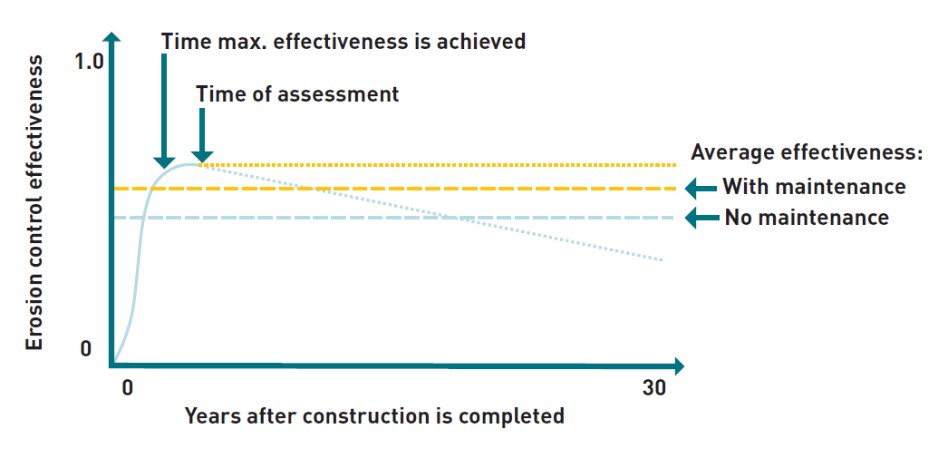

Figure A1. The performance of treatments varies over time following construction (thick lines).

Performance typically increases rapidly to a maximum value following construction; this process will take longer for vegetation-focused treatments than for engineering-focused treatments. Most site-specific research assessments have occurred within the first 5 years of treatment. Alternate trajectories in later years (dotted lines) represent different post-project maintenance scenarios. Effectiveness (thin horizontal dashed lines) is defined as the ratio of (average post-treatment fine sediment yield)/(baseline fine sediment yield)

Figure A1 shows several features that are common to the behaviour of all gully and stream bank treatment but occur to varying degrees:

1. The effectiveness values each relate to a bundle of multiple treatment activities as described in Table 1, comprising the primary erosion control activity together with any of the listed supporting activities that are relevant to enable the primary activity to persist and perform. For example, gully reshaping as a primary activity can require support by diversion banks and rock chutes to deliver upslope runoff to the gully floor without scouring, by fencing to assist in maintaining vegetation cover on the reshaped area, and by gully floor check dams to prevent incision of the gully floor. The referenced studies that do not implement the bundles as described are interpreted relative to the bundles as specified.
2. Effectiveness values in Table 1 are the average values across the 30 years.
3. Considering the methods of action for each erosion control activity, they all have a maximum performance (efficacy) that is less than 100% (so that the post-implementation sediment yield is greater than zero). For example:
4. Revegetation reduces but does not eliminate surface erosion.
5. An engineered gully head rock chute is intended to reduce headcut erosion by approximately 100%, but some downstream wall erosion will continue.
6. Diverting runoff away from a gully headcut tends to result in some continued erosion of the receiving drainage channel, and some gully wall erosion continues through direct rainfall.
7. Recognising uncertainty in performance over 30 years no values greater than 0.8 are assigned, and values typically fall into bands of 0.2.
8. Effectiveness values account for the treatment taking some time to achieve maximum performance. Engineering structures such as rock chutes have immediate effect but there is also the vegetative component of this bundle that takes some time to have an effect. There is an elevated erosion risk in the first wet season in the disturbance area of treatments involving earthworks, although it is assumed that construction is timed outside of the wet season to avoid catastrophic erosion. Where trees are to be restored, such as to stabilise stream banks, the time to reach a high density of deep roots is of the order of 5-10 years. So, the time to reach maximum performance may range from a few months (for example, where grass complements rock structures) to decades (for example, where trees are required to regrow inside a fenced area).
9. When the maximum performance of a treatment is achieved during the project period, project monitoring and other post-treatment visits will enable the maintenance of the treatment (including minor repair of structures and exclusion of stock from the perimeter of the gully or stream bank).
10. After the completion of a rehabilitation project (typically 3-5 years) there will be a range of maintenance applied to treatments. These include no maintenance, full maintenance, and all degrees in between these end members. Anecdotally, the degree of post-project maintenance is influenced by cost, the need to access available forage in the fenced area and changes to land ownership.
11. Where maintenance of the treatment is ongoing as described in Section 2.6 (for example, a landholder is paid to maintain fences, exclude stock access and repair damage to structures), the average effectiveness assumes that the maximum performance will be maintained for the full 30 years.

### A2 The basis of effectiveness values for each erosion control treatment

The effectiveness values of the recommended bundles of treatments are provided in Table 1. The knowledge base used by the authors to determine these values consists of:

1. Systematic peer-reviewed publications in the areas of gully rehabilitation (Bartley et al., 2020a; Frankl et al., 2021) and stream bank management (Rutherfurd et al., 2000b; Bartley et al., 2015; Hughes, 2016; Paul et al., 2018; Bigham, 2020). The duration of studies included in these reviews varied widely but included many greater than 10 years.
2. Recent research projects that quantitatively monitored the performance of specific bundles of gully erosion control measures within the Great Barrier Reef (GBR) catchment for 2-4 years (Bartley et al., 2020b; Brooks et al., 2021; Compiled by the RRRC, 2021). These were influential in setting effectiveness values for gully fencing, porous check dams (PCDs), headcut runoff diversion and gully reshaping.
3. The expert opinion of the authors based on observations from 28 gully and 12 stream bank erosion control sites implemented across the GBR catchments as part of the Reef Trust program primarily during 2015-2021, with the implementation of each site monitored for 2-5 years using indicators of stability such as photo points and ground cover. This assessment extended the spatial coverage of information on implementation integrity across a diverse range of environments. The monitoring associated with the Reef Trust sites was generally not of sufficient experimental design or duration to estimate effectiveness values directly but assisted interpretation of how to apply research findings to the conditions typical of GBR water quality improvement programs, including the impact of maintenance.

The information from these sources was weighted considering the following:

* The rigour of the monitoring and the associated analysis. Specifically, peer-reviewed published case studies, cases measuring sediment yield directly, cases having a long period of record (>10 years) and cases with an adjacent untreated control gully or stream bank site, were all weighted higher than other case studies.
* The degree to which studies represented conditions typical of those at GBR erosion control sites in terms of climate, soil, rainfall, land use and maintenance regime. It is likely that research studies have a higher degree of treatment maintenance due to their degree of oversight, relative to initial maintenance at other sites.

The logic of combining information sources depended on the availability of suitable studies and documented observations. This logic is described in Appendix A3.

#### A2.1 Difference between initial and ongoing post-project maintenance

Below are given 2 effectiveness values and the accompanying basis for each bundle of primary erosion control treatment and its supporting treatments. One value applies to the case that post-project site monitoring, maintenance and independent oversight is externally contracted/ funded to be ongoing (for example, Reef Credits approach), in which case maximum performance persists for 30 years. The other value applies to the case that maintenance is funded only in the initial 2 or 3 post-construction years and is subsequently voluntary and unfunded, in which case erosion control performance declines over time. The difference in effectiveness over 30 years between initial and ongoing maintenance is 0.1. Two approaches were used to estimate this difference:

1. Qualitative estimates were made of the maximum effectiveness at the end of a project and the expected effectiveness 30 years after construction as shown in Figure A1, for selected sites in GBR catchments for which sufficient post-implementation information was available. This was based on review of structural performance and vegetation vulnerability to livestock access, weeds and pest animals. A total of 31 sites were included in this analysis, from the Burnett-Mary (19), Burdekin (7), Cape York (6), Fitzroy (2) and Wet Tropics (2) natural resource management regions. Most of these sites were Reef Trust sites. There were 9 rock chute sites included, and otherwise 1-6 sites per erosion control treatment. One treatment was not represented in this analysis (gully reshaping and rock capping). To analyse the impact of post-project maintenance on effectiveness, only sites where erosion control measures were designed and constructed successfully and consistent with Toolbox Section 3 guidance were included. For all treatments, the resulting average difference between maximum effectiveness and average effectiveness over 30 years was 0.1, except for improved grazing in gullies and gully catchments (0.0 at one site, which was managed primarily for conservation and not widely representative), and for stream active revegetation (0.18 at 4 sites on the Mary River).
2. A statistical approach was applied across all treatments based on assumptions about the proportion of sites impacted by conditions that degrade performance:
3. For treatments with the effect being primarily delivered by engineered structures (diversion bank, rock chute, check dam, gully reshaping and rock capping, engineered bank protection), it is assumed under initial maintenance that no structural repairs will be undertaken, and so rainfall/runoff events result in lower effectiveness, which is estimated as: over 27 years each site has a 27/50 likelihood of experiencing one event larger than a 1:50 year event, which is commonly used as the design event for engineered structures (see Section 3). Using a design event is a standard engineering approach for hydraulic structures including large dams. This event will occur (on average) halfway through the 27-year period. Based on anecdotal observations of partial failure of several structures in large runoff events, it is assumed that effectiveness across all exposed structures will decline by one-third for the remaining half of the period, or put another way, that one-third of structures will be rendered completely ineffective for the remainder of the 27 years while two-thirds of structures will remain sufficiently intact to not reduce their effectiveness. Therefore, the 30-year effectiveness is 27/50 x 'V x 1/3 = 0.09 below the maximum effectiveness in the immediate post-treatment years. This is rounded to 0.1 considering uncertainties, and that livestock access to engineered structures also elevates the risk of failure over time, for example through stock tracks removing vegetation cover and concentrating runoff across the area of earthworks including reshaped gullies and runoff diversion banks.
4. For treatments with the primary activity being revegetation (fence and water point, reshaped and vegetated gully and revegetated stream bank), it is assumed that the high erosion control functionality of vegetation (for example, high ground cover levels, and tree cover in the case of stream bank revegetation) will persist for the full 30 years at only half the sites, associated with control of livestock access, weeds and pest animals. At the other half of sites, it is assumed vegetation function will decline over 30 years to very low levels resulting in loss of one-third of the erosion control effect at those sites. This assumption is based on observations at sites in recent programs, and performance difficulties experienced elsewhere with voluntary natural resource management (Measham and Lumbasi, 2013). The effect is to reduce effectiveness over 30 years below the effectiveness in the immediate post-treatment years by = V x V x 1/3 = 0.08 (rounded to 0.1). For revegetation treatments with maximum effectiveness of 0.2-0.3 (see below), a reduction in effectiveness of 0.1 equates to 33-50% of the maximum effectiveness of those treatments.

There was consistency between the 2 approaches for 6 of 8 treatments. Considering uncertainties in the approach, a uniform difference of 0.1 was adopted across all treatments between 30-year effectiveness under ongoing externally contracted (and funded) monitoring, maintenance and independent oversight, relative to initial maintenance only. More research of long-term effectiveness is ideally required to further test these assumptions and adequately represent the 2 distributions of post-project site management.

#### A2.2 Basis of the effectiveness values for each erosion control primary treatment

The effectiveness values in Table 1 assume that each treatment is located, designed and constructed consistent with guidance in Section 3 and industry best practice. They also assume that all relevant supporting activities listed in Table 1 are fully implemented to form the treatment bundle.

1. **Improved grazing management in gully catchments**

***Published international studies***

Grazing management, and the number and density of animals in an area, is known to have an influence on runoff and erosion at various scales (Gifford and Hawkins, 1978; Wilcox et al., 2008). Hadley (1974) reported that grazing control alone can potentially reduce runoff by as much as 30% and sediment yield by 40% from experimental plots. Considering the direct relationship between gully headward extension and runoff (Oostwoud Wijdenes and Bryan, 2001; Wilkinson et al., 2018), it can be asserted that improved grazing management and subsequent reductions in hillslope runoff would result in gully sediment yield reductions of similar magnitude for most hillslope gullies. It is acknowledged, however, that alluvial gullies, which are driven by local rainfall rather than runoff, may not respond to grazing management.

Effectiveness is the proportional reduction in sediment yield of existing gullies. Therefore, although avoiding degradation of vegetation in drainage lines has a significant effect on preventing gully incision (Prosser and Slade, 1994; Prosser et al., 1995), avoiding new incision is not relevant to effectiveness. The benefits for gully prevention will depend on the degree and trajectory of existing degradation and the gully erosion risk.

***Published studies in GBR catchments***

Most of the GBR studies that have focused on the effect of changed grazing practices on increased vegetation cover and the subsequent increase in infiltration and reduction in runoff volumes have been conducted in paddocks rather than gullies (McIvor et al., 1995; Connolly et al., 1997; Owens et al., 2003; Thornton and Elledge, 2021). A study in the upper Burdekin, which measured event runoff from two approximately 10 km2 catchments with a long history of heavy grazing, determined that heavy grazing had 26 and 57% more runoff than from a nearby catchment with a multi-decade history of light or zero grazing pressure (Koci et al., 2020). However, runoff responses to reductions in grazing pressure are smaller when the starting condition is more degraded and can take long time periods. At these same sites, there was no detectable reduction in annual runoff over 17 years (Koci et al., 2020).

***Observations on implementation in GBR catchments***

For this treatment we also drew on observations from 2 Reef Trust projects, one in the Normanby and one in the upper Burdekin, as well as considerable personal experience in interacting with landholders in recent decades.

Despite considerable published evidence supporting the benefits of grazing management having large and long-term benefits for reducing surface runoff, the anecdotal evidence suggests that these conditions are hard to secure and maintain and are dependent on favourable climate, pasture composition, management decisions, financial incentives, market conditions and regulation (Rolfe et al., 2020). For example, reducing grazing pressure on degraded hillslopes where tussock grasses have been replaced with Indian couch resulted in recovery of only approximately 15% of the native perennial cover, and although reductions in rainfall-runoff ratios were observed for early wet season events, no detectable reduction in runoff was observed at the annual scale, and no detectable reduction in catchment sediment yields (Bartley et al., 2014).

Implementation of planned improvement in grazing management failed at a majority of other sites indicating a high dis-adoption risk with the treatment. Therefore, there is considerable uncertainty, and it could take >30 years to approach the recovery of vegetation function, and so the average effectiveness over the first 30 years following the change is much lower than some of the other studies suggest.

***Summary***

Managing grazing pressure within sustainable levels is considered an important supporting activity for all gully management activities and is likely to reduce initiation of new gullies, which is accounted for elsewhere. However, achieving reductions in runoff by reducing grazing pressure is a longer-term and less certain prospect depending on the type of gully and degree of degradation in soil and pasture composition.

**Considering the long recovery timescales and acknowledging the long-term effects of improved ground cover on runoff, the average effectiveness of this practice over 30 years is estimated at 0.1, or 0.2 with ongoing monitoring, maintenance and independent oversight as described in Section 2.6.**

1. **Fencing to control livestock access to gully sites**

***Published international studies***

The use of fencing to control livestock access is known to result in higher levels of vegetation cover and associated landscape condition in grazed environments (Prober et al., 2011; Hunt et al., 2014; Zhang and Zhao, 2015). The specific issue of fencing and livestock access in gullied environments is less clear, although 8 years of livestock exclusion led to a 78% sediment yield reduction after 17 years in a semi-arid gullied catchment in Colorado, USA (Heede, 1979).

***Published studies in GBR catchments***

Improvements in gully vegetation cover have been observed following several years of livestock exclusion in the Normanby catchment (from 10-23% on active gully slopes) (Shellberg and Hughes, and for several gullied sites in the Burdekin catchment (Bartley et al., 2020c). However, livestock exclusion from large alluvial gullies without additional soil and structural treatments was found to be largely ineffective at controlling erosion (Brooks et al., 2016 2021; Doriean et al., 2021).

***Observations on implementation in GBR catchments***

For this treatment we also drew on observations from 2 Reef Trust projects, one in the Normanby and one in the upper Burdekin, as well much personal experience in interacting with landholders over the last few decades.

Complete livestock exclusion from gullies is rarely implemented in GBR catchments as a stand-alone practice. More typical is exclusion for 1-3 years as a supporting activity to enable revegetation of disturbed areas associated with other gully rehabilitation treatments. Anecdotal observation from the Reef Trust program is that many landholders re-introduce livestock within the first 2-3 years of construction. Experience in the Normanby catchment indicates that vegetation cover on active gullies in erodible soil are little affected by livestock exclusion (Brooks et al., 2016) but that this practice can be somewhat effective in smaller or less-active gullies only (see case studies in Section 3.2.2). Site monitoring in the Burdekin and Fitzroy regions indicates that vegetation recovery is frequently very poor due to the degree of initial degradation, variable seasons, and some ongoing livestock access. After decades of livestock exclusion, high rates of vegetation cover on gully walls can result in gully sediment yields being approximately half those of gullies exposed to grazing (Wilkinson et al., 2018), but the lengthy response time reduces effectiveness over 30 years.

***Summary***

Managing grazing access to rehabilitated gully sites is an important supporting activity for all gully management activities. Selective re-introduction of small numbers of stock into the rehabilitation area for very short periods of time to control weeds and fuel loads may be appropriate, but the timing of grazing access needs to be well-managed and should not occur within the wet season. Ideally, grazing management is discussed as part of the site selection process. This activity is effective in smaller hillslope gullies only.

**Managing livestock access using fencing can have long-term effects on improved ground cover and surface erosion; however, on its own, the average effectiveness of this activity over 30 years is estimated at 0.1, or 0.2 with ongoing monitoring, maintenance and independent oversight as described in Section 2.6.**

1. **Small porous check dams**

***Published international studies***

PCDs have been a common gully management tool across many parts of the world and are generally aimed at trapping sediment liberated from erosion, rather than treating the erosion source. They can be constructed from a range of materials and come in many shapes and sizes, from large concrete check dams to smaller porous or leaky weir type structures. In the GBR catchments, we are only using and recommending small PCDs and do not support larger concrete structures used in many areas overseas. Relative reductions in sediment yield using check dams or similar structures (either compared to a control or pretreated condition) vary considerably and range from 7-99% in Spain (Boix-Fayos et al., 2008; Bellin et al., 2011); 50-65% in the USA (Gellis et al., 1995; Polyakov et al., 2014; Norman and Niraula, 2016); approximately 50% in China (Wei et al., 2017); and between 30% (Adimas et al., 2021) and approximately 77% in Ethiopia (Nyssen et al., 2006). Research in China indicates that once more than 3% of the drainage area of a gully is treated with check dams, the average sediment reduction can be as high as 60% (Ran et al., 2008). The reported time scales over which check dams were likely effective varied from as little as 3 years in France (Rey and Labonne, 2015) to 65 years in the drier rangelands of the USA (Gellis et al., 1995). The material used for the check dams likely plays an important role in the response (for example, timber versus stone versus concrete). In general, the sediment trapping efficiency of check dams is inversely proportional to the erosion rate as well as the time they have been established. This is because, if the check dams stay intact, they all fill up eventually. Check dams built in the lower sections of gullies are considered better at trapping fine sediment compared with check dams in upstream sections primarily due to reduced flow velocities in lower reaches (Hassanli et al., 2009; Abedini et al., 2012).

***Published studies in GBR catchments***

A more recent study in the upper Burdekin that fenced off the gully and installed 6 PCDs, found that fine sediment was reduced by approximately 7%, and by approximately 19% when combined with a hillslope diversion bank (Koci et al., 2021). Approximately 30% of the gully catchments were also disc ploughed and seeded without obvious effect on gully erosion. At a similar National Environmental Science Program (NESP) monitoring site in the Don catchment, PCDs were effective at trapping coarse sand-size sediment and supporting vegetation re-establishment when partnered with stock management; however, trapping of fine-grained sediment was limited (Bartley et al., 2020c).

***Observations on implementation in GBR catchments***

PCDs have been installed at many sites in Reef Trust projects. For this treatment we also drew on observations from 9 Reef Trust projects, 3 in the lower Burdekin catchment, 2 in the Mary catchment, one in the Normanby catchment and 3 in the Don catchment, as well as a 25-year-old project in the Burnett catchment.

PCDs have been observed to assist revegetation of the floor of gullies with catchment areas <6 ha. Even at small catchment areas, a proportion of check dams have failed to trap sediment due to being insufficiently keyed into the gully bed and banks or being too porous to trap fine-grained sediment. In granitic soils, check dams primarily capture coarser sediment sizes. Effective gully check dams fill up after approximately 10 years, with reduced effectiveness likely after this time. Insufficient control of livestock access at many sites has impaired gully revegetation. The use of check dams in many gullies with catchment areas >6 ha has been unsuccessful either due to structural failure or insufficient hydraulic effect to enable sediment deposition, but because these situations are outside of the Toolbox guidelines they are excluded from this analysis. Check dams remain an important supporting activity where prevention of bed degradation is required, such as in reshaped gullies.

***Summary***

Gully check dams trap little fine sediment at most sites and have limited sedimentation capacity. Check dams are only effective at catchment areas <6 ha. Only deploy gully check dams in conjunction with grazing management, fencing, diversion banks and other supporting activities aimed at reducing the gully erosion rate.

**The average effectiveness of this practice over 30 years in gullies with catchment areas <6 ha is estimated at 0.2, or 0.3 with ongoing monitoring, maintenance and independent oversight as described in Section 2.6.**

1. **Gully runoff diversion banks and drainage management**

***Published international studies***

Flow diversion and drainage management has been a common treatment globally to reduce the erosive energy driving gully erosion. Some of the common treatments include vegetated soil bunds and infiltration ditches (for example, Dagnew et al., 2015); hillslope banks or buffer strips (for example, Frankl et al., 2018); and reafforestation of severely gullied areas (Gomez et al., 2003; Mathys et al., 2003; Vanacker et al., 2007; Marden et al., 2014). A study in Ethiopia reported a reduction of the total monthly sediment yields by approximately 80% within 2 years after the hillslopes were intensively treated with vegetated soil bunds and infiltration ditches above the gullies; however, there was no statistical change in the average monthly measured sediment concentrations at the gully outlet (Dagnew et al., 2015). This was mainly because the gully walls were not treated and still contributed sediment downstream. Another challenge was that the implemented soil bunds were half filled with sediment 2 years after construction.

Hence, the long-term effectiveness of these structures for capturing runoff without maintenance is uncertain (Taye et al., 2015).

***Published studies in GBR catchments***

In a more recent NESP and Landholders Driving Change (LDC) funded project on a property in the Bogie catchment, a gully was treated using several hillslope flow diversion banks with 2 drains, permanent fencing (although no livestock management), and a single very small rock chute. The effectiveness in the first (drier than average) wet season after treatment was approximately 100% relative to an untreated control; however, after the second wet season, the water quality results were no longer statistically different at the treatment relative to the before-treatment data, or the control site, suggesting 0% effectiveness. Considering the relative sediment yields in these 2 years of post-treatment monitoring, the effectiveness of this treatment is 20-50% (Bartley et al., 2020b). At another site in the upper Burdekin, the combined effectiveness of porous check dams, fencing off and a hillslope diversion bank was found to be more effective at reducing unit area fine sediment (approximately 19%) compared with sites with check dams and fencing only (approximately 7%; Koci et al., 2021).

***Observations on implementation in GBR catchments***

For this treatment we also drew on observations from 2 Reef Trust projects, both in the Normanby catchment, as well much personal experience in interacting with landholders over the last few decades. The implementation of flow diversion banks and drainage management has also been observed in other projects in the Burnett, Fitzroy and Burdekin catchments. The intactness of these structures was observed to degrade over time. Design by an engineer or qualified soil conservation professional using established procedures is required. Failure by piping was a high risk if the foundation area was not grubbed, there were low points along the created drainage path, or the bank was not sufficiently wide. Attention to revegetating the banks is required. The siting and design of flow diversion structure lengths needs to avoid the diverted runoff creating additional gullies in other locations.

***Summary***

When well-designed and used in conjunction with fencing and grazing management to create higher biomass to intercept diverted flow, runoff diversion can be a moderately effective treatment for reducing gully sediment yields.

**The average effectiveness of this practice over 30 years is estimated at 0.4, or 0.5 with ongoing monitoring, maintenance and independent oversight as described in Section 2.6.**

1. **Gully head rock chutes**

***Published international studies***

There are limited published studies that evaluate the effectiveness of rock chutes on gully erosion in isolation. An investigation into the performance of geoengineering structures in Nigeria highlighted that while they may work in the short term, numerous problems with poor engineering of structures has caused multiple failures and the emergence of new gully sites proximal to existing gullies (Ene and Okogbue, 2014).

***Published studies in GBR catchments***

Rock chutes in three adjacent gullies in the Normanby River catchment had an estimated effectiveness of 0.75-0.95 in the third year after construction (Brooks et al., 2021).

***Observations on implementation in GBR catchments***

For this treatment we also drew on observations from 8 Reef Trust projects, 4 in the Mary catchment, one in the Normanby, 2 in the Fitzroy catchment and one in the Herbert River catchment, as well as two 25- plus-year-old projects in the Burnett.

The effectiveness of 2 rock chutes installed in the Burnett catchment in 1995 was estimated at 0.75 and 0.9, respectively, based on structural intactness and ground cover. In recent GBR projects, rock chutes that were designed using the CHUTE program or equivalent and constructed in accordance with the design have remained intact through large events (Wilkinson et al., 2019). Some rock chutes have needed repair after early events, and to correct minor construction errors. Several rock chutes built in GBR catchments without engineering design have failed in events of approximately 1:5 year average recurrence interval (ARI) (Scott Wilkinson, pers. comm.). It was observed that effectiveness was reduced by continued wall erosion downstream of gully heads treated with rock chutes particularly where wall erosion was not controlled by other measures. The existence of a long-established engineering design procedure for rock chutes reduces the uncertainty in their long-term performance.

***Summary***

Correct engineering design, installation and maintenance of rock chutes are also critical to long-term effectiveness.

**The average effectiveness of rock chutes designed to a 1 in 50-year runoff event over 30 years is estimated at 0.8 if it is demonstrated that baseline wall erosion downstream has been negligible, or 0.9 with ongoing livestock management, off-site stock watering, ongoing maintenance and independent oversight. For gullies longer than 100 m or where substantial wall erosion downstream will continue, an effectiveness of 0.6 should be applied, or 0.7 with ongoing livestock management, off-site stock watering, ongoing maintenance and independent oversight as described in Section 2.6.**

1. **Gully reshaping and revegetation**

***Published international studies***

Landscape reshaping (gully smoothing) and revegetation is typically more expensive than other treatments and has traditionally been the domain of mine site and road rehabilitation. There are very few international published papers on the effectiveness of these treatments on water quality. In some areas reshaping is undertaken to improve land for agricultural food production, although the long-term effectiveness of this approach is often poor, as farming is resumed on the rehabilitated surface (Pani, 2016; Ranga et al., 2016). In one study, reshaping combined with runoff retention and revegetation was estimated to reduce sediment loss by 82% (Sharpley et al., 1996).

***Published studies in GBR catchments***

On Strathalbyn Station, reshaping and revegetation, combined with runoff diversion and gully floor rock armouring, resulted in reduction in sediment yields from 2 gullies over 2 years of 60-70%, estimated from multiple monitoring treatments (treatments 2 and 6; Brooks et al., 2021). Reshaping and revegetation of a gully in deep soil at a site in the Bowen catchment (Mt Wickham) resulted in a reduction in annual sediment yields for the initial 3 post-treatment years of 85-91%, but rock contour banks on the reshaped slopes, grade control structures in the gully channel and good vegetation establishment due to well-timed rainfall were large contributors to this result (Bartley et al., 2020b). The long-term performance risks for gully reshaping and revegetation are indicated by experimental plots in erodible soil in the Normanby catchment; the batter slope was 1:10 and surface stabilisation treatment options included gypsum and straw or compost and seed. Plots typically had a 30-80% reduction in sediment yield over 4 years, but ground cover was poor after livestock were re-introduced and rilling redeveloped (Brooks et al., 2016). In that study, reshaping without surface treatments was found to increase sediment yield above the untreated baseline case.

***Observations on implementation in GBR catchments***

For this treatment we also drew on observations from 6 Reef Trust projects, 5 in the Burdekin and one in the Fitzroy catchment. Experience at Reef Trust sites in the Normanby, Burdekin and Herbert catchments that have not been subject to research monitoring is that revegetation is fully successful at some sites in the short term but is only partly successful at a proportion of sites, with the most common problems being livestock incursions and poor wet seasons impairing revegetation. During better wet seasons, rilling of the reshaped surface can occur in the initial events while vegetation is establishing. Stock tracks are often the initiation point for rilling and larger knick-points.

***Summary***

Gully reshaping and revegetation, generally undertaken with a series of supporting treatments, is generally effective at reducing sediment yields. However, heavy rainfall can cause surface rilling, and potentially surface re-incision or undercutting at the slope toe. Vegetation establishment and persistence is dependent on variable annual rainfall and ongoing control of grazing pressure.

**The 30-year effectiveness is estimated at 0.6, or 0.7 with ongoing livestock management, off-site stock watering, ongoing maintenance and independent oversight as described in Section 2.6. Gully reshaping without revegetation or rock capping is not recommended and is not covered by this effectiveness value.**

1. **Gully reshaping and rock capping**

***Published international studies***

Like reshaping and revegetation, reshaping and rock capping has traditionally been the domain of mine site rehabilitation, road construction and other intensive industries. Therefore, there are no known published international studies that have assessed the effectiveness of these treatments on gully sediment yield.

***Published studies in GBR catchments***

Reshaping and rock capping of a gully in the Normanby catchment resulted in approximately 80% reduction in fine sediment over 4 years (Doriean et al., 2021; Brooks et al., 2021). A combination of finer rock sheeting covered with organic mulch and revegetation can be very effective, with the rock sheeting partly forming the function of a stabilisation treatment for highly erodible soil. Reshaping and rock capping combined with mulch and revegetation of 8 gullies at Strathalbyn had an effectiveness of 93-98% over 2 years (Brooks et al., 2021). Similarly, a series of rock contour banks on the reshaped surface, and good vegetation establishment, were essential to the 85-91% reduction in annual sediment yields for the initial 3 post-treatment years at Mt Wickham (Bartley et al., 2020b). Rock check dams and rock capping of the gully floor are of comparable effectiveness at supporting rock capping in the control of batter toe erosion, provided that rock sizes and check dam designs are sufficient for large runoff events (Brooks et al., 2021).

***Observations on implementation in GBR catchments***

For this treatment we also drew on observations from several sites in the Normanby catchment.

Reshaping and rock capping is expensive and has therefore been used at only very actively eroding gullies in recent GBR water quality improvement programs. Rock capping is more likely to be used in preference to revegetation at sites with very erodible soils or sites that will be exposed to grazing pressure, where the erosion risk is higher. Rock capping of reshaped surfaces in the Normanby and Burdekin resulted in a significant decline in sediment yield. At one site in the Normanby, effectiveness was measured to be approximately 0.90 after 1 year. Rock-capped areas are anticipated to be more resistant to cattle impacts than comparable areas of reshaping and revegetation, hence the high observed effectiveness could be anticipated to persist for longer than where revegetation has occurred. On the other hand, capped-only surfaces are resistant to natural vegetation regeneration, giving them less resilience to imperfections in construction or subsequent concentrations in runoff. Low infiltration capacity may cause higher runoff and subsequent scour along flow lines on the gully floor or in drainage channels downslope of the site. The performance through extreme climate events and over decades including effects of livestock access is not yet understood.

***Summary***

Gully reshaping and rock capping is generally very effective at reducing sediment yields, often immediately following construction. However, the inability to establish vegetation, the absence of long-term international or local peer-reviewed studies, and the risk of re-incision in large rainfall events reduces the overall effectiveness below values observed in the short term.

**The 30-year effectiveness is estimated at 0.8, or 0.9 with ongoing livestock management, off-site stock watering, ongoing maintenance and independent oversight as described in Section 2.6. Gully reshaping without revegetation or rock capping is not recommended and is not covered by this effectiveness value.**

1. **Stream bank fencing and weed control**

***Published international studies***

Passive stream bank management generally involves using fencing to reduce livestock access, which reduces direct erosion from cattle traffic (Packett, 2020) and promotes natural vegetation establishment, assuming an available seed source. Reviews of riparian management and stream bank erosion have been conducted for some areas (for example, New Zealand; Hughes, 2016); however, the authors highlight that quantitative studies evaluating the effectiveness of riparian interventions are rare, and poor experimental design precludes obtaining robust results for many studies (Cooperman et al., 2007). For the studies available, excluding livestock from small streams has been found to reduce bank retreat by 36-87% (Zaimes et al., 2008), soil loss by 40% (Owens et al., 1996), and suspended sediments by 47-87% over a 12-year period (Carline and Walsh, 2007). The value of riparian vegetation improvement increases with the area and length treated, and riparian vegetation is most effective when buffer width is 5-30 m and buffer length >1 km (Feld et al., 2011). Tree density often peaks 15-25 years after restoration and active management of the riparian zone such as weed control should occur for at least 10 years following initial setup (Lennox et al., 2011).

***Published studies in GBR catchments***

There are few published studies evaluating the effectiveness of riparian fencing on stream bank erosion in the GBR. Several published studies demonstrate the benefits of intact riparian areas, including on the Daintree River where erosion rates on stream banks with riparian vegetation were 85% lower than on sites without riparian vegetation (Bartley et al., 2008). Similarly, in south-east Queensland, the sediment yield per unit area from a catchment containing no remnant vegetation is predicted to be between 50-200 times that of a fully vegetated channel network (Olley et al., 2015). However, NESP research suggests that reaching pre-disturbance riparian vegetation conditions is challenging and is dependent on having riparian buffers of an adequate width, low or no grazing, a local seed source and favourable rainfall conditions for tree growth (Paul et al., 2018).

***Observations on implementation in GBR catchments***

For this treatment also we drew on observations over 2 years from one Reef Trust project in the Mary catchment, as well as much personal experience in interacting with landholders over the last few decades. It was observed that vegetation regeneration would likely be progressive over at least 20 years. The effect of passive revegetation will be negligible where erosion is severe.

***Summary***

It is acknowledged that riparian fencing is likely to be effective at maintaining stream bank condition; however, there is a lack of data on how effective passive riparian management is on reducing stream bank erosion on high-energy tropical rivers in the long term.

**If stream bank fencing is installed, the average effectiveness of this practice over 30 years is estimated at 0.1, or 0.2 with ongoing livestock management, off-site stock watering, ongoing maintenance and independent oversight as described in Section 2.6.**

1. **Stream bank/bench/bar active revegetation**

***Published international studies (including other areas in Australia)***

Active riparian revegetation is generally more expensive than passive approaches such as fencing, and therefore it is often used in more intensively managed agricultural areas with reliable rainfall. Like passive stream bank management, there is considerable evidence promoting the benefits of intact riparian vegetation on reducing stream bank erosion (for example, Zaimes et al., 2008; Purvis and Fox, 2016); however, there is less evidence from studies using revegetation. A study from Victoria found that revegetated sites had 80% less occurrence of bank erosion than unvegetated sites with comparable stream power (Hardie et al., 2012). Fencing off and actively revegetating streams was found to reduce sediment yields by 33-80% (Line et al., 2000). A study that evaluated changes 17 years after land conversion found that rapid growth of vegetation stabilised the banks and improved water quality, improved wildlife habitat and increased shading of the channel, resulting in better fish passage (Howard-Williams and Pickmere, 2010).

While vegetation can have a significant effect in areas with relatively low bank erosion rates, revegetation is unlikely to be suitable on its own for locally controlling very active bank erosion at individual sites in large streams (Rutherfurd et al., 2000). Establishing vegetated corridors within which large rivers can freely move is nevertheless valuable over the long term as eroding banks harvest large and small woody debris from the floodplain, improving geomorphic stability.

***Published studies in GBR catchments***

There are published studies from the GBR catchments on the benefits of intact rainforest riparian vegetation on water quality in catchments such as the Mulgrave (Connolly et al., 2015; Leonard and Nott, 2015) and Daintree River catchments (Bartley et al., 2008). However, there are no known published studies in the GBR catchments that have measured the effectiveness of active riparian revegetation on stream bank erosion. This is likely because the time scale required for such a study would be in the order of >5-10 years, and such an experiment would be difficult to design to isolate riparian management effects from other influences.

***Observations on implementation in GBR catchments***

For this treatment we drew upon experience from one 26-year-old project in the Mary catchment and multiple O'Connell River sites in recent Reef Trust programs. These sites highlight the importance of extending the maintenance of revegetation sites for at least 3 years following initial planting.

It was observed that vegetation establishment time frames are long, and that erosion resistance will increase progressively over >10 years.

***Summary***

**If stream bank fencing and active revegetation is undertaken, the average effectiveness of this practice over 30 years is estimated at 0.2, or 0.3 with ongoing stock management, off-site stock watering, maintenance and independent oversight as described in Section 2.6.**

1. **Engineered stream bank protection and revegetation**

***Published international studies***

No single bank protection treatment has been found to be consistently effective at reducing bank erosion, and different combinations of treatments suit different sites and contexts. These may include bank shaping, revegetation, grade control, bank toe rock, riprap, timber piles and bioengineering (Bigham, 2020). A study in the USA found that "permeable spurs" (a form of timber pile fields) reduced erosion rates by "more than 70% following installation" (Dave and Mittelstet, 2017). Toe protection reduced erosion by 69-100% at a site in the USA (Simon et al., 2009). Given that the objective of pile fields is to establish riparian vegetation, replacing their function over time, the erosion reduction provided by established riparian forest provides an upper limit of pile field effectiveness of 59-91% (Zaimes et al., 2008). These studies indicate maximum performance, while the intactness of engineered bank erosion structures was found to decline within 5-10 years (Miller and Craig Kochel, 2013). Therefore, effectiveness over 30 years will be 0.1 less due to the likelihood of damage to engineered structures by large flow events (see Section A2.1).

Pile fields can reduce shear stresses on a (typically reshaped) bank face until vegetation is established and flood resistant. However, establishment of vegetation and control of erosion at the bank toe by pile fields is dependent on deposition of fine and coarse sediment to above the baseflow water level. This requires a water level that is low enough to expose the bank toe except during flood peaks, which does not occur in weir pools or in reaches subject to flow regulation. It also requires high loads of sediment, which is less likely downstream of dams where sediment supply is curtailed or where sediment is very fine, or on the outside of meander bends. A study of timber pile fields in the Murray River found that across tens of treated sites, after approximately 10 years none had achieved success in terms of preventing bank erosion, inducing sediment deposition, or resulted in establishment of woody vegetation at the bank toe (Rutherfurd et al., 2007).

Because rivers are dynamic systems that can compensate for site-specific management changes, there is some uncertainty whether erosion control at site scale is fully realised at reach scale. For example, the energy gradient (slope) is interdependent along river reaches rather than individual meander bends. In addition, bank toe protection can increase velocity and scour within reaches (Shields et al., 2000). Pile fields dissipate some flow energy locally, but only a small proportion of the total stream power (Bigham, 2020).

***Published studies in GBR catchments***

There are no known published studies evaluating the effectiveness of engineered stream bank protection combined with revegetation in the GBR catchments.

***Observations on implementation in GBR catchments***

For this treatment we also drew on observations from 2 Reef Trust projects, both in the Fitzroy catchment. Vegetation establishment on these reshaped stream banks has generally progressed well over 2 years. However, the short duration of monitoring and relatively small stream flows experienced to date at these sites are not yet sufficient to indicate long-term effectiveness. At a site on the Fitzroy River, erosion over the first 2 years after construction was greater than expected, particularly of sandy fill material that was used to establish a consistent batter slope between pile fields, although this has stabilised now that the fill has eroded away. It has been observed that timber piles at some sites in the Mary River were rotten after 6 years, giving a life of <11 years.

***Summary***

The GBR climate is relatively more energetic than the temperate areas where many of the international studies were undertaken, and the few observations of recent sites in GBR catchments cover a restricted range of flow conditions. Therefore, we estimate average effectiveness for sites in GBR catchments over the short term and at site scale as 0.7 in ideal conditions. Accounting for the impacts of large flow events, the site-scale effectiveness over 30 years without ongoing maintenance is estimated as 0.6.

**The average effectiveness of stream bank engineered protection over 30 years is estimated at 0.6, or 0.7 with ongoing maintenance of livestock access control, off-site stock watering, maintenance and independent oversight as described in Section 2.6.**

### A3 The logic used to determine the effectiveness values

The number of sites, duration (relative to 30 years), and representativeness of GBR environmental conditions (climate, terrain, soil) and GBR management conditions (land use, treatment design) of the available published research studies, and those of qualitative observations of implementation from past GBR erosion control programs, affected the relative weighting of published effectiveness estimates and expert opinion.

Figure A2 below describes how the authors combined the available quantitative evidence and qualitative observations to estimate the effectiveness values in Table 1 (see the main text). The axes on the flowchart are intended to show the degree of expert opinion and research evidence that were used for each estimation. The authors used the flowchart to answer successive questions, beginning with question 1. A green answer box provides the method used following the outcome of the questions. In this way the method of determining the effectiveness values varied depending on the available and suitable knowledge base for each bundle of treatments.

Text for rounded blue question rectangles:

Q1: Is there a similar (soil/topography/climate/ land use) research study (studies)?

Q2: Was the maintenance of treatment for the research study (studies) similar to the intended application? (Most research studies and demonstration sites have a high degree of treatment maintenance).

Q3: Did the research study (studies) have a duration approaching 30 years?

Q4: Are there documented observations of similar treatments in the GBR?

Q5: Was the maintenance of treatment for the observations similar to the intended application? (There is a large variation in the degree of maintenance within the many landholders described in Appendix A).

Q6: Do the documented observations have a duration similar to the intended applications?

Text for green action rectangles:

A. Use the study/studies to quantitatively estimate the treatment effectiveness.

B. Adjust the results of the quantitative studies with consideration of the observed long-term qualitative studies to estimate the treatment effectiveness.

C. Compare the treatment persistence in the study (studies) with the expected persistence in practice over 30 years. Use expert opinion to adjust effectiveness to allow for this effect.

D. Interpolate effectiveness between other treatments of similar approach using quantitative studies and qualitative observations.

E. Combine the suitable observations, weighting for similar soil, topography, climate and land use that are close to the intended application. Use expert judgement to project treatment effectiveness out to 30 years and to allow for a varied maintenance regime in the intended application.

F. Combine the suitable observations, weighting for similar soil, topography, climate and land use that are close to the intended application. Use expert judgement to project treatment effectiveness out to 30 years.

G. Combine the suitable observations, weighting for similar soil, topography, climate and land use that are close to the intended application.

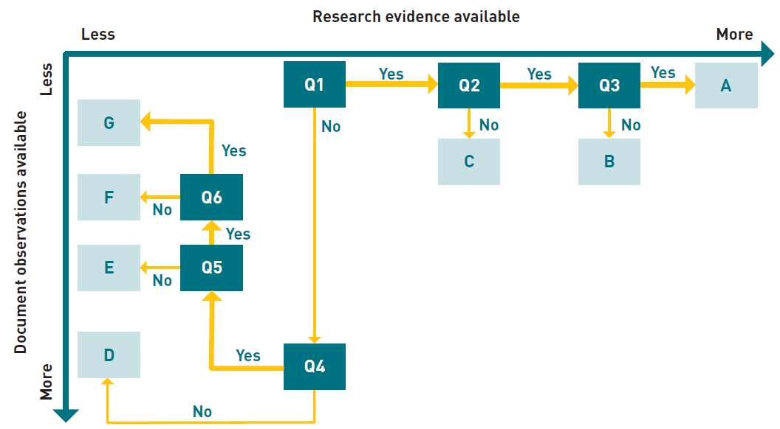

Figure A2. A flowchart of the logic used in determining the treatment effectiveness value.

For each treatment, the process began with question 1 and moved through the questions in sequence until an action box was reached. The available evidence is described in Section A2. The axes indicate the degree of reliance on research evidence, and on documented observations. Expert opinion played a larger role where less information was available from these sources.

### A4 Appendix A references

Abedini M, Md Said MA, Ahmad F. 2012. Effectiveness of check dam to control soil erosion in a tropical catchment (The Ulu Kinta Basin). CATENA, 97: 63-70. https://doi.org/10.10167i.catena.2012.05.003.

Adimas N, Mekonnen M, Tsegaye D, Senamaw A. 2021. Gully erosion and effectiveness of its treatment measures, Upper Abay Basin, in the Northwest Highlands of Ethiopia. In: Melesse AM, Abtew W, Moges SA (eds). Nile and Grand Ethiopian Renaissance Dam: past, present and future. Springer International Publishing. 397-421. https://doi.org/10.1016/10.1007/978-3-030-76437-121.

Bartley R, Keen RJ, Hawdon AA, Hairsine PB, Disher MG, Kinsey-Henderson AE. 2008. Bank erosion and channel width change in a tropical catchment. Earth Surface Processes and Landforms, 33: 2174-2200. https://doi.org/10.1016/10.1002/esp.1678.

Bartley R, Corfield JP, Hawdon AA, Kinsey-Henderson AE, Abbott BN, Wilkinson SN, Keen RJ. 2014. Can changes to pasture management reduce runoff and sediment loss to the Great Barrier Reef? The results of a 10-year study in the Burdekin catchment, Australia. The Rangeland Journal, 36: 67-84. http://dx.doi.org/10.1071/RJ13013.

Bartley R, Kinsey-Henderson A, Wilkinson S, Whitten S, Rutherfurd I. 2015. Stream bank management in the Great Barrier Reef catchments: a handbook. Report to the Department of the Environment (Reef Program). https://publications.csiro.au/rpr/download?pid=csiro:EP15849&dsid=DS1.

Bartley R, Poesen J, Wilkinson S, Vanmaercke M. 2020a. A review of the magnitude and response times for sediment yield reductions following the rehabilitation of gullied landscapes. Earth Surface Processes and Landforms, 45: 3250-3279. https://doi.org/10.1016/10.1002/esp.4963.

Bartley R, Hawdon A, Henderson A, Abbott B, Wilkinson S, Goodwin N, Ahwang K. 2020b. Quantifying the effectiveness of gully remediation on water quality: results from demonstration sites in the Burdekin catchment. Report to the National Environmental Science Program. Reef and Rainforest Research Centre Limited, Cairns. 146 pp. https://bit.ly/3nGzieF.

Bartley R, Hawdon A, Henderson A, Abbott B, Wilkinson S, Goodwin N, Ahwang K. 2020c. Quantifying the effectiveness of gully rehabilitation on water quality: results from demonstration sites in the Burdekin catchment. Milestone report for NESP Project 5.9 and LDC Project LRP17-003 and LME17-009, Dec 2020. https://nesptropical.edu.au/wp-content/uploads/2021/01/NESP-TWQ-Project-5.9-Final-Report.pdf.

Bellin N, Vanacker V, van Wesemael B, Sole-Benet A, Bakker MM. 2011. Natural and anthropogenic controls on soil erosion in the Internal Betic Cordillera (southeast Spain). Catena, 87: 190-200. https://doi.org/10.1016/10.1016/j.catena.2011.05.022.

Bigham KA. 2020. Streambank stabilization design, research, and monitoring: the current state and future needs. Transactions of the ASABE, 63: 351-387. https://doi.org/10.13031/trans.13647.

Boix-Fayos C, de Vente J, Martmez-Mena M, Barbera GG, Castillo V. 2008. The impact of land use change and check-dams on catchment sediment yield. Hydrological Processes, 22: 4922-4935. https://doi.org/10.1016/10.1002/hyp.7115.

Brooks A, Curwen G, Spencer J, Shellberg J, Garzon-Garcia A, Burton J, Iwashita F. 2016. Reducing sediment sources to the Reef: managing alluvial gully erosion. Reef and Rainforest Research Centre. 375 pp.

Brooks AP, Spencer J, Doriean NJC, Thwaites R, Garzon-Garcia A, Hasan S, Daley J, Burton J, Zund P. 2021. NESP Project 3.1.7 Final Report: Effectiveness of alluvial gully remediation in Great Barrier Reef catchments. Report to the National Environmental Science Program. Reef and Rainforest Research Centre Limited, Cairns. 205. https://nesptropical.edu.au/index.php/final-reports-round-3/.

Carline RF, Walsh MC. 2007. Responses to riparian restoration in the Spring Creek watershed, central Pennsylvania. Restoration Ecology, 15: 731-742.

Commonwealth of Australia. 2021. Reef 2050 Long-Term Sustainability Plan 2021-2025. https://www.awe.gov.au/parks-heritage/great-barrier-reef/long-term-sustainability-plan.

Connolly NM, Pearson RG, Loong D, Maughan M, Brodie J. 2015. Water quality variation along streams with similar agricultural development but contrasting riparian vegetation. Agriculture, Ecosystems & Environment, 213: 11-20. http://dx.doi.org/10.1016/j.agee.2015.07.007.

Connolly RD, Ciesiolka CAA, Silburn DM, Carroll 1997. Distributed parameter hydrology model (answers) applied to a range of catchment scales using rainfall simulator data. IV Evaluating pasture catchment hydrology. Journal of Hydrology, 201: 311-328. http://dx.doi.org/10.1016/S0022-1694(97)00052-8.

Cooperman M, Hinch S, Bennett S, Branton M, Galbraith R, Quigley J, Heise B, Resumen. 2007. Streambank restoration effectiveness: lessons learned from a comparative study. Fisheries, 32: 278-291. https://doi.org/10.1016/10.1577/1548-8446(2007)32[278:SRELFA12.0.CQ;2.

Dagnew DC, Guzman CD, Zegeye AD, Tibebu TY, Getaneh M, Abate S, Zemale FA, Ayana EK, Tilahun SA, Steenhuis TS. 2015. Impact of conservation practices on runoff and soil loss in the sub-humid Ethiopian Highlands: The Debre Mawi watershed. Journal of Hydrology and Hydromechanics, 63: 210-219. https://doi.org/10.1515/johh-2015-0021.

Dave N, Mittelstet AR. 2017. Quantifying effectiveness of streambank stabilization practices on Cedar River, Nebraska. Water, 9: 930.

Doriean NJC, Bennett WW, Spencer JR, Garzon-Garcia A, Burton JM, Teasdale PR, Welsh DT, Brooks AP. 2021. Intensive landscape-scale remediation improves water quality of an alluvial gully located in a Great Barrier Reef catchment. Hydrol. Earth Syst. Sci., 25: 867-883. https://doi.org/10.5194/hess-25-867-2021.

Ene GE, Okogbue CO. 2014. Construction and performance of geo-engineering structures for combating gully erosion in south-eastern Nigeria. In: 12th International IAEG Congress. 857-864.

Feld CK, Birk S, Bradley DC, Hering D, Kail J, Marzin A, Melcher A, Nemitz D, Pedersen ML, Pletterbauer F, Pont D, Verdonschot PFM, Friberg N. 2011. From natural to degraded rivers and back again: a test of restoration ecology theory and practice. In: Woodward G (ed). Advances in ecological research, Vol 44. Elsevier Academic Press Inc. 119-209. https://doi.org/10.1016/10.1016/b978-0-12-374794-5.00003-1.

Frankl A, Pretre V, Nyssen J, Salvador P-G. 2018. The success of recent land management efforts to reduce soil erosion in northern France. Geomorphology, 303: 84-93. https://doi.org/10.1016/j.geomorph.2017.11.018.

Frankl A, Nyssen J, Vanmaercke M, Poesen J. 2021. Gully prevention and control: techniques, failures and effectiveness. Earth Surface Processes and Landforms, 46: 220-238. https://doi.org/10.1002/esp.5033.

Gellis AC, Cheama A, Laahty V, Lalio S. 1995. Assessment of gully-control structures in the Rio Nutria watershed, Zuni reservation, New Mexico. Water Resources Bulletin, 31: 633-646.

Gifford GF, Hawkins RH. 1978. Hydrologic impact of grazing on infiltration: a critcial review. Water Resources Research, 14: 305-313.

Gomez B, Branbury K, Marden M, Trustrum NA, Peacock DH, Hoskin PJ. 2003. Gully erosion and sediment production: Te Weraroa Stream, New Zealand. Water Resources Research, 39: 1187. https://doi.org/10.1016/10.1029/2002WR001342.

Hadley RF. 1974. Sediment yield and land use in the southwest United States. In: Effects of man on the interface of the hydrological cycle with the physical environment (Proceedings of the Paris Symposium, September 1974). IAHS Publ. 113, 96-98.

Hardie R, Ivezich M, Phillipson S. 2012. Can riparian revegetation limit the scale and extent of flood related stream erosion in Victoria, Australia? In: Grove J, Rutherfurd ID (eds). 6th Australian Stream Management Conference. 190-196.

Hassanli AM, Nameghi AE, Beecham S. 2009. Evaluation of the effect of porous check dam location on fine sediment retention (a case study). Environmental Monitoring and Assessment, 152: 319-326. https://doi.org/10.1016/10.1007/s10661-008-0318-2.

Heede BH. 1979. Deteriorated watersheds can be restored: a case study. Environmental Management, 3: 271-281.

Howard-Williams C, Pickmere S. 2010. Thirty years of stream protection: long-term nutrient and vegetation changes in a retired pasture stream. Science for Conservation, 49.

Hughes AO. 2016. Riparian management and stream bank erosion in New Zealand. N. Z. J. Mar. Freshw. Res., 50: 277-290. https://doi.org/10.1016/10.1080/00288330.2015.1116449.

Hunt LP, McIvor JG, Grice AC, Bray SG. 2014. Principles and guidelines for managing cattle grazing in the grazing lands of northern Australia: stocking rates, pasture resting, prescribed fire, paddock size and water points – a review. The Rangeland Journal, 36: 105-119. http://dx.doi.org/10.1071/RJ13070.

Koci J, Sidle RC, Kinsey-Henderson AE, Bartley B, Wilkinson SN, Hawdon AA, Jarihani B, Roth CH, Hogarth L. 2020. Effects of reduced grazing pressure on sediment and nutrient yields in savanna rangeland streams draining to the Great Barrier Reef. Journal of Hydrology, 582: 124520. https://doi.org/10.1016/j.jhydrol.2019.124520.

Koci J, Wilkinson SN, Hawdon AA, Kinsey-Henderson AE, Bartley R, Goodwin NR. 2021. Rehabilitation effects on gully sediment yields and vegetation in a savanna rangeland. Earth Surface Processes and Landforms, 46: 1007-1025, https://doi.org/10.1002/esp.5076.

Lennox MS, Lewis DJ, Jackson RD, Harper J, Larson S, Tate KW. 2011. Development of vegetation and aquatic habitat in restored riparian sites of California's north coast rangelands. Restoration Ecology, 19: 225-233. http://dx.doi.org/10.1111/j.1526-100X.2009.00558.x.

Leonard S, Nott J. 2015. Rapid cycles of episodic adjustment: understanding the Holocene fluvial archive of the Daintree River of Northeastern Australia. The Holocene. http://dx.doi.org/10.1177/0959683615580860.

Line DE, Harman WA, Jennings GD, Thompson EJ, Osmond DL. 2000. Nonpoint-source pollutant load reductions associated with livestock exclusion. Journal of Environmental Quality, 29: 1882-1890.

Marden M, Herzig A, Basher L. 2014. Erosion process contribution to sediment yield before and after the establishment of exotic forest: Waipaoa catchment, New Zealand. Geomorphology, 226: 162-174. http://dx.doi.org/10.1016/j.geomorph.2014.08.007.

Mathys N, Brochot S, Meunier M, Richard D. 2003. Erosion quantification in the small marly experimental catchments of Draix (Alpes de Haute Provence, France). Calibration of the ETC rainfall-runoff- erosion model. CATENA, 50: 527-548. https://doi.org/10.1016/S0341-8162(02)00122-4.

McIvor JG, Williams J, Gardener CJ. 1995. Pasture management influences runoff and soil movement in the semi-arid tropics. Aust. J. Exp. Agric., 35: 55-65.

Measham TG, Lumbasi JA. 2013. Success factors for community-based natural resource management (CBNRM): lessons from Kenya and Australia. Environmental Management, 52: 649-659. http://dx.doi.org/10.1007/s00267-013-0114-9.

Miller JR, Craig Kochel R. 2013. Use and performance of in-stream structures for river restoration: a case study from North Carolina. Environmental Earth Sciences, 68: 1563-1574. http://dx.doi.org/10.1007/s12665-012-1850-5.

Norman LM, Niraula R. 2016. Model analysis of check dam impacts on long-term sediment and water budgets in Southeast Arizona, USA. Ecohydrology & Hydrobiology, 16: 125-137. http://doi.org/10.1016/j.ecohyd.2015.12.001.

Nyssen J, Poesen J, Veyret-Picot M, Moeyersons J, Haile M, Deckers J, Dewit J, Naudts J, Teka K, Govers G. 2006. Assessment of gully erosion rates through interviews and measurements: a case study from northern Ethiopia. Earth Surface Processes and Landforms, 31: 167-185. http://dx.doi.org/10.1002/esp.1317.

Olley J, Burton J, Hermoso V, Smolders K, McMahon J, Thomson B, Watkinson A. 2015. Remnant riparian vegetation, sediment and nutrient loads, and river rehabilitation in subtropical Australia. Hydrological Processes, 29: 2290-2300. http://dx.doi.org/10.1002/hyp.10369.

Oostwoud Wijdenes DJ, Bryan R. 2001. Gully-head erosion processes on a semi-arid valley floor in Kenya: A case study into temporal variation and sediment budgeting. Earth Surface Processes and Landforms, 26: 911-933. http://dx.doi.org/10.1002/esp.225.

Owens JS, Silburn DM, McKeon GM, Carroll C, Willcocks J, deVoil R. 2003. Cover-runoff equations to improve simulation of runoff in pasture growth models. Australian Journal of Soil Research, 41: 1467-1488. http://dx.doi.org/10.1071/sr03047.

Owens LB, Edwards WM, Van Keuren RW. 1996. Sediment losses from a pastured watershed before and after stream fencing. J. Soil Water Conserv., 51: 90-94.

Packett R. 2020. Riparian erosion from cattle traffic may contribute up to 50% of the modelled streambank sediment supply in a large Great Barrier Reef river basin. Marine Pollution Bulletin, 158: 111388. https://doi.org/10.1016/j.marpolbul.2020.111388.

Pani P. 2016. Controlling gully erosion: an analysis of land reclamation processes in Chambal Valley, India. Development in Practice, 26: 1047-1059. http://dx.doi.org/10.1080/09614524.2016.1228831.

Paul KI, Bartley R, Larmour JS, Davies MJ, Crawford D, Westley S, Dryden B, James CS. 2018. Optimizing the management of riparian zones to improve the health of the Great Barrier Reef. Report to the National Environmental Science Program. Reef and Rainforest Research Centre Limited, Cairns. 79 pp. https://nesptropical.edu.au/wp-content/uploads/2018/09/NESP-TWQ-Project-3.1.4-Final-Report.pdf.

Polyakov VO, Nichols MH, McClaran MP, Nearing MA. 2014. Effect of check dams on runoff, sediment yield, and retention on small semiarid watersheds. J. Soil Water Conserv., 69: 414-421. http://dx.doi.org/10.2489/jswc.69.5.414.

Prober SM, Standish RJ, Wiehl G. 2011. After the fence: vegetation and topsoil condition in grazed, fenced and benchmark eucalypt woodlands of fragmented agricultural landscapes. Australian Journal of Botany, 59: 369-381. http://dx.doi.org/10.1071/bt11026.

Prosser IP, Slade CJ. 1994. Gully formation and the role of valley-floor vegetation, <southeastern Australia. Geology, 22: 1127-1130. https://doi.org/10.1130/0091-7613(1994)Q22<1127:GFATRO>2.3.CO;2.

Prosser IP, Dietrich WE, Stevenson J. 1995. Flow resistance and sediment transport by concentrated overland flow in a grassland valley. Geomorphology, 13: 71-86. http://dx.doi.org/10.1016/0169-555x(95)00020-6.

Purvis RA, Fox GA. 2016. Streambank sediment loading rates at the watershed scale and the benefit of riparian protection. Earth Surface Processes and Landforms, 41: 1327-1336. http://dx.doi.org/10.1002/esp.3901.

Ran DC, Luo QH, Zhou ZH, Wang GQ, Zhang XH. 2008. Sediment retention by check dams in the Hekouzhen-Longmen Section of the Yellow River. International Journal of Sediment Research, 23: 159-166. https://doi.org/10.1016/S1001-6279(08)60015-3.

Ranga V, Poesen J, Van Rompaey A, Mohapatra SN, Pani P. 2016. Detection and analysis of badlands dynamics in the Chambal River Valley (India), during the last 40 (1971-2010) years. Environmental Earth Sciences, 75: 183. http://dx.doi.org/10.1007/s12665-015-5017-z.

Rey F, Labonne S. 2015. Resprout and survival of willow *(Salix)* cuttings on bioengineering structures in actively eroding gullies in marls in a mountainous climate: a large-scale experiment in the Francon Catchment (Southern Alps, France). Environmental Management, 56: 971-983. http://dx.doi.org/10.1007/s00267-015-0542-9.

Rolfe J, Star M, Curcio A. 2020. Can extension programs improve grazing management in rangelands: a case study in Australia's Great Barrier Reef catchments. The Rangeland Journal, 42: 447-459. https://doi.org/10.1071/RJ20098.

Compiled by the RRRC. 2021. Lessons for gully management: a synthesis of key findings from the NESP Tropical Water Quality Hub research. Report to the National Environmental Science Program. Reef and Rainforest Research Centre Ltd. Cairns. 20 pp. https://nesptropical.edu.au/wp-content/uploads/2021/08/Project-6.4-Case-Study-Booklet-1-Gully-Management-online-version.pdf.

Rutherfurd I, Vietz G, Grove J, Lawrence R. 2007. Review of erosion control techniques on the River Murray between Hume Dam and Lake Mulwala. 66 pp.

Rutherfurd ID, Jerie K, Marsh N. 2000. A rehabilitation manual for Australian streams Volume 2. Land and Water Australia. https://arrc.com.au/stream-bank-erosion-and-flood-management-pack-thank-you/.

Sharpley A, Smith SJ, Zollweg JA, Coleman GA. 1996. Gully treatment and water quality in the Southern Plains. J. Soil Water Conserv., 51: 498-503.

Shellberg J, Hughes T. 2019. Kings Plains Station gully rehabilitation program: Final report. Reef Trust Phase II Gully Erosion Control Program and South Endeavour Trust.

Shields FD, Knight SS, Cooper CM. 2000. Warmwater stream bank protection and fish habitat: A comparative study. Environmental Management, 26: 317-328.

Simon A, Pollen-Bankhead N, Mahacek V, Langendoen E. 2009. Quantifying reductions of mass-failure frequency and sediment loadings from streambanks using toe protection and other means: Lake Tahoe, United States1. JAWRA Journal of the American Water Resources Association, 45: 170-186. https://doi.org/10.1111/j.1752-1688.2008.00268.x.

Taye G, Poesen J, Vanmaercke M, van Wesemael B, Martens L, Teka D, Nyssen J, Deckers J, Vanacker V, Haregeweyn N, Hallet V. 2015. Evolution of the effectiveness of stone bunds and trenches in reducing runoff and soil loss in the semi-arid Ethiopian highlands. Zeitschrift Fur Geomorphologie, 59: 477-493. http://dx.doi.org/10.1127/zfg/2015/0166.

The State of Queensland. 2018. Reef 2050 Water Quality Improvement Plan 2017-2022. https://www.reefplan.qld.gov.au/about/.

Thornton CM, Elledge AE. 2021. Heavy grazing of buffel grass pasture in the Brigalow Belt bioregion of Queensland, Australia, more than tripled runoff and exports of total suspended solids compared to conservative grazing. Marine Pollution Bulletin, 171: 112704. https://doi.org/10.1016/j.marpolbul.2021.112704.

Vanacker V, Molina A, Govers G, Poesen J, Deckers J. 2007. Spatial variation of suspended sediment concentrations in a tropical Andean river system: the Paute River, southern Ecuador. Geomorphology, 87: 53-67. https://doi.org/10.1016/j.geomorph.2006.06.042.

Wei Y, He Z, Li Y, Jiao J, Zhao G, Mu X. 2017. Sediment yield deduction from check-dams deposition in the weathered sandstone watershed on the North Loess Plateau, China. Land Degrad. Dev., 28: 217-231. http://dx.doi.org/10.1002/ldr.2628.

Wilcox BP, Huang Y, Walker JW. 2008. Long-term trends in streamflow from semiarid rangelands: uncovering drivers of change. Glob. Change Biol., 14: 1676-1689. http://dx.doi.org/10.1111/M365-2486.2008.01578.x.

Wilkinson SN, Kinsey-Henderson AE, Hawdon AA, Hairsine PB, Bartley R, Baker B. 2018. Grazing impacts on gully dynamics indicate approaches for gully erosion control in northeast Australia. Earth Surface Processes and Landforms, 43: 1711-1725. https://doi.org/10.1016/10.1002/esp.4339.

Wilkinson SN, Hairsine PB, Hawdon AA, Austin J. 2019. Technical findings and outcomes from the Reef Trust Gully Erosion Control Programme. CSIRO. 48. https://doi.org/10.25919/5d111dba0a72a.

Zaimes GN, Schultz RC, Isenhart TM. 2008. Streambank soil and phosphorus losses under different riparian land-uses in Iowa. Journal of the American Water Resources Association, 44: 935-947. http://dx.doi.org/10.1111/j.1752-1688.2008.00210.x.

Zhang YY, Zhao WZ. 2015. Vegetation and soil property response of short-time fencing in temperate desert of the Hexi Corridor, northwestern China. Catena, 133: 43-51. http://dx.doi.org/10.1016/j.catena.2015.04.019.

## APPENDIX B: CATCHMENT CONTRIBUTIONS TO SEDIMENT LOADS

There are 35 river basins draining to the Great Barrier Reef (GBR) lagoon. The Paddock to Reef Monitoring and Reporting (P2R) program subdivides the Burdekin, Fitzroy and Burnett basins into several catchments each, recognising they are connected by extensive river systems including large reservoirs that affect the sediment connectivity to the GBR lagoon. The resulting 50 catchment management units are mapped in Figure B1.

For each catchment, the P2R program spatially model budgets of fine sediment sources, internal losses to deposition, and loads exported to the GBR lagoon (McCloskey et al., 2021). The contribution of gully and of stream bank erosion from each catchment to the GBR lagoon depends on the catchment area, the erosion rates, and the connectivity through the river network to the coast, represented as the river sediment delivery ratio (RSDR). The area-specific contribution (t/km2/ year) is an indication of the efficiency of sediment reduction that may be achieved from controlling a given proportion of gullies or stream banks in the catchment. Total contribution (t/year) is an indication of the magnitude of opportunity to reduce sediment loads in a catchment.

Table B1 ranks catchments by total and area-specific contribution, for gully and stream bank erosion. Large numbers of cost-effective erosion control sites are more likely to be found in catchments with high rankings (1, 2, 3 and so on) on either total or area-specific contribution. Highly ranked catchments are therefore a priority However, catchments with low rankings may also contain sites at which erosion control could be cost-effective.

The RSDR is an indicator of the efficiency of erosion control in a catchment: values near 1.0 indicate that almost all sediment reduction achieved at the site scale will be realised at the GBR lagoon, while values <0.5 indicate that less than half of the sediment reduction achieved at site scale will be realised at the GBR lagoon.

In Table B1, catchments with area-specific contributions from gully and stream bank erosion >9 t/km2/year and RSDR >0.35 are highlighted as those more likely to contain numbers of cost-effective erosion control sites. It is recommended that these rankings be considered in targeting of site identification activities.

These data may not accurately represent the landscape features and water quality processes required to adequately assess other applications.

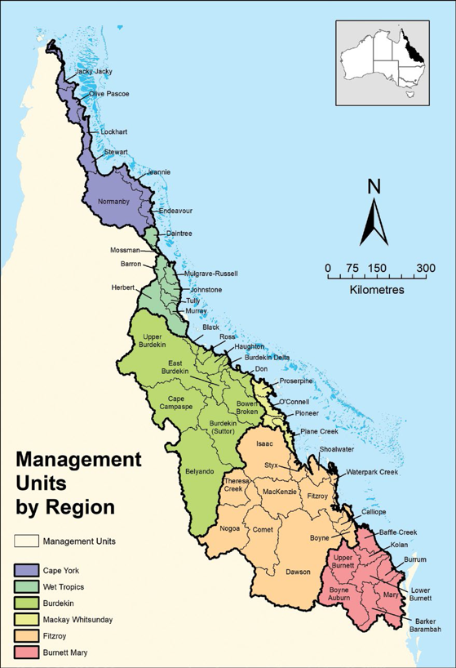

Figure B1. Catchment management units draining to the GBR lagoon

Table B1. Catchment rankings of fine sediment contribution to GBR fine sediment loads from gully and stream bank erosion.

Only the 29 catchments with aggregate gully and stream bank contribution of >4 t/km2/year are shown. Catchments with lower number rankings (1, 2, 3 and so on) are more likely to contain large numbers of cost-effective gully and stream bank erosion control sites. RSDR is the average river sediment delivery ratio for the catchment unit. The catchments highlighted below have RSDR >0.35 and process contributions >9 t/km2/year. This table is derived from data provided by the State of Queensland Department of Resources and is reproduced with permission.

| **Catchment un****it** | **NRM region** | **Area km2** | **RSDR** | **Process** | **Rank of Contrib. t/km2/y** | **Rank of Contrib. kt/y** | **Process** | **Rank of Contrib. t/km2/y** | **Rank of Contrib. kt/y** | **Rank of G+SB Contrib. t/km2/y** |
| --- | --- | --- | --- | --- | --- | --- | --- | --- | --- | --- |
| East Burdekin | BU | 3331 | 0.92 | Gully | 1 | 3 | Stream bank | 5 | 5 | 1 |
| Bowen Bogie | BU | 11718 | 0.78 | Gully | 2 | 1 | Stream bank | 14 | 4 | 2 |
| Pioneer | MW | 1664 | 0.76 | Gully | 35 | 41 | Stream bank | 1 | 7 | 3 |
| Don | BU | 3466 | 0.91 | Gully | 3 | 5 | Stream bank | 20 | 21 | 4 |
| Fitzroy | FI | 11339 | 0.62 | Gully | 10 | 9 | Stream bank | 2 | 1 | 5 |
| O'Connell | MW | 2305 | 0.92 | Gully | 34 | 39 | Stream bank | 3 | 6 | 6 |
| Burdekin Delta | BU | 961 | 0.94 | Gully | 12 | 31 | Stream bank | 6 | 17 | 7 |
| Herbert | WT | 9852 | 0.71 | Gully | 21 | 16 | Stream bank | 4 | 2 | 8 |
| Haughton | BU | 3840 | 0.83 | Gully | 4 | 7 | Stream bank | 22 | 24 | 9 |
| Upper Burdekin | BU | 40413 | 0.35 | Gully | 5 | 2 | Stream bank | 24 | 9 | 10 |
| Barron | WT | 2188 | 0.59 | Gully | 25 | 29 | Stream bank | 7 | 12 | 11 |
| Johnstone | WT | 2317 | 0.52 | Gully | 44 | 44 | Stream bank | 8 | 13 | 12 |
| Styx | FI | 2995 | 0.91 | Gully | 8 | 12 | Stream bank | 18 | 20 | 13 |
| Black | BU | 1041 | 0.93 | Gully | 6 | 21 | Stream bank | 27 | 44 | 14 |
| Mary | BM | 9420 | 0.75 | Gully | 26 | 22 | Stream bank | 9 | 3 | 15 |
| Tully | WT | 1668 | 0.92 | Gully | 45 | 45 | Stream bank | 10 | 18 | 16 |
| Mulgrave-Russell | WT | 1975 | 0.89 | Gully | 47 | 46 | Stream bank | 11 | 16 | 17 |
| Ross | BU | 1647 | 0.46 | Gully | 7 | 17 | Stream bank | 39 | 47 | 18 |
| Lower Burnett | BM | 5683 | 0.62 | Gully | 16 | 19 | Stream bank | 15 | 11 | 19 |
| Calliope | FI | 2177 | 0.79 | Gully | 9 | 24 | Stream bank | 17 | 23 | 20 |
| Proserpine | MW | 2513 | 0.85 | Gully | 17 | 26 | Stream bank | 16 | 19 | 21 |
| Plane | MW | 2547 | 0.89 | Gully | 39 | 40 | Stream bank | 12 | 15 | 22 |
| Murray | WT | 1125 | 0.97 | Gully | 46 | 47 | Stream bank | 13 | 25 | 23 |
| Mackenzie | FI | 13128 | 0.33 | Gully | 18 | 14 | Stream bank | 19 | 8 | 24 |
| Shoalwater | FI | 3616 | 0.95 | Gully | 20 | 25 | Stream bank | 21 | 22 | 25 |
| Kolan | BM | 2891 | 0.58 | Gully | 23 | 27 | Stream bank | 23 | 26 | 26 |
| Isaac | FI | 22226 | 0.16 | Gully | 14 | 8 | Stream bank | 26 | 14 | 27 |
| Dawson | FI | 50734 | 0.17 | Gully | 13 | 4 | Stream bank | 31 | 10 | 28 |
| Normanby River | CY | 24381 | 0.37 | Gully | 11 | 6 | Stream bank | 43 | 29 | 29 |

G = gully; GBR = Great Barrier Reef; NRM = natural resource management; RSDR = river sediment delivery ratio; SB = stream bank NRM regions = Burnett Mary (BM); Burdekin (BU); Cape York NRM (CY); Fitzroy (FI); Mackay Whitsunday (MW); Wet Tropics (WT)

## APPENDIX C: REGULATORY REQUIREMENTS FOR SOME GULLY AND STREAM BANK WORKS

Table C1. Some federal, state and local government regulatory requirements that may be relevant to gully and stream bank remediation works

|  |  |  |  |
| --- | --- | --- | --- |
| Matters of National Environmental Significance including listed threatened species and ecological communities | *Environment Protection and Biodiversity Conservation Act 1999* (Cth) | Department of the Environment (Australian Government) | Ph: 1800 803 772 https://www.awe.gov.au |
| Vegetation clearing or removal | *Vegetation Management Act 1999* (Qld) | Department of Natural Resources, Mines and Energy (Queensland Government) | Ph: 13 QGOV (13 74 68) https://www.resources.ald.gov.au |
| Interference with overland flow  Earthworks, significant disturbance | *Water Act 2000* (Qld)  *Soil Conservation Act 1986* (Qld) | Department of Natural Resources, Mines and Energy (Queensland Government) | Ph: 13 QGOV (13 74 68) https://www.resources.ald.gov.au |
| Mining and environmentally relevant activities  Infrastructure development (coastal)  Heritage issues  Protected plants and protected areas | *Environmental Protection Act 1994* (Qld)  *Coastal Protection and Management Act 1995* (Qld)  *Queensland Heritage Act 1992*  *Nature Conservation Act 1992* (Qld) | Department of Environment and Science (Queensland Government) | Ph: 13 QGOV (13 74 68) https://www.des.ald.gov.au |
| Indigenous cultural heritage | *Aboriginal Cultural Heritage Act 2003* (Qld)  *Torres Strait Islander Cultural Heritage Act 2003* (Qld) | Department of Aboriginal and Torres Strait Islander Partnerships (Queensland Government) | Ph: 13 QGOV (13 74 68) https://www.dsdsatsip.qld.gov.au |
| Interference with fish passage in a watercourse, mangroves  Forestry activities | *Fisheries Act 1994* (Qld) *Forestry Act 1959* (Qld) | Department of Agriculture and Fisheries (Queensland Government) | Ph: 13 QGOV (13 74 68) https://www.daf.qld.gov.au |
| Development and planning processes | *Planning Act 2016* (Qld)  *State Development and Public Works Organisation Act 1971* (Qld) | Department of State Development, Manufacturing, Infrastructure and Planning (Queensland Government) | Ph: 13 QGOV (13 74 68) https://www.statedevelopment.qld.gov.au |
| Road corridor permits | *Transport Infrastructure Act 1994* (Qld) | Department of Transport and Main Roads (Queensland Government) | Ph: 13 QGOV (13 74 68) https://www.tmr.qld.gov.au/ |
| State government owners' consent for Crown land and road reserves | *Planning Act 2016* (Qld) | Department of Natural Resources, Mines and Energy (Queensland Government), SLAM | Ph: 13 QGOV (13 74 68) https://www.resources.qld.gov.au |
| Local government requirements | *Local Government Act 2009* (Qld)  *Planning Act 2016* (Qld) | Your relevant local government office |  |

1. For example:

   EIANZ CenvP Specialist Geomorphologist (Professional Geomorphologist certification developed by the Australian and New Zealand Geomorphology Group and EIANZ)

   Certified Professional Soil Scientist (CPSS, Australian Soil Science Society)

   Certified Professional in Erosion and Sediment Control (CPESC, Australian Institute of Engineers).